Recommendation ITU-R F.2173-0
(02/2026)
F Series: Fixed service
Radio-frequency channel and block arrangements for fixed service systems operating in the 92-94 GHz, 94.1-100 GHz, 102-109.5 GHz and 111.8-114.25 GHz ranges

Foreword
The role of the Radiocommunication Sector is to ensure the rational, equitable, efficient and economical use of the radio-frequency spectrum by all radiocommunication services, including satellite services, and carry out studies without limit of frequency range on the basis of which Recommendations are adopted.
The regulatory and policy functions of the Radiocommunication Sector are performed by World and Regional Radiocommunication Conferences and Radiocommunication Assemblies supported by Study Groups.

INTELLECTUAL PROPERTY RIGHTS
ITU draws attention to the possibility that the practice or implementation of this Recommendation may involve the use of a claimed Intellectual Property Right. ITU takes no position concerning the evidence, validity or applicability of claimed Intellectual Property Rights, whether asserted by ITU members or others outside of the Recommendation development process.
As of the date of approval of this Recommendation, ITU had received notice of intellectual property, protected by patents, which may be required to implement this Recommendation. However, implementers are cautioned that this may not represent the latest information and are therefore strongly urged to consult the appropriate ITU-R patent information available at https://www.itu.int/en/ITU-R/study-groups/Pages/itu-r-patent-information.aspx.

Series of ITU-R Recommendations
(Also available online at https://www.itu.int/publ/R-REC/en)
Series | Title
BO | Satellite delivery
BR | Recording for production, archival and play-out; film for television
BS | Broadcasting service (sound)
BT | Broadcasting service (television)
F | Fixed service
M | Mobile, radiodetermination, amateur and related satellite services
P | Radio-wave propagation
RA | Radio astronomy
RS | Remote sensing systems
S | Fixed-satellite service
SA | Space applications and meteorology
SF | Frequency sharing and coordination between fixed-satellite and fixed service systems
SM | Spectrum management
SNG | Satellite news gathering
TF | Time signals and frequency standards emissions
V | Vocabulary and related subjects

Note: This ITU-R Recommendation was approved in English under the procedure detailed in Resolution ITU-R 1.

Electronic Publication
Geneva, 2026
© ITU 2026
All rights reserved. No part of this publication may be reproduced, by any means whatsoever, without written permission of ITU.

RECOMMENDATION ITU-R F.2173-0
Radio-frequency channel and block arrangements for fixed service systems operating in the 92-94 GHz, 94.1-100 GHz, 102-109.5 GHz
and 111.8-114.25 GHz ranges
Question ITU-R 247-1/5
(2026)
Scope
This Recommendation describes channel and block arrangements in the portions of the frequency range 92.0-114.25 GHz allocated to the fixed service. The arrangements are based on a 250 MHz basic channel raster from which Nx250 MHz channel size can be defined and are proposed for either frequency division duplex (FDD) or time division duplex (TDD) applications. Alternative duplex schemes, such as flexible frequency division duplex (fFDD) or full duplex (FD) may also be considered.
Keywords
92-114.25 GHz, FDD, flexible FDD, Full Duplex, Channel Raster
Acronyms/Abbreviations
EESS Earth Exploration Satellite service
FD Full Duplex
FDD Frequency division duplex
fFDD flexible FDD
FS Fixed service
P-P Point-to-point
RR Radio Regulations
TDD Time division duplex
Related ITU-R Recommendations
Recommendation ITU-R P.676 – Attenuation by atmospheric gases
Recommendation ITU-R P.838 – Specific attenuation model for rain for use in prediction methods
Recommendation ITU-R F.1519 – Guidance on frequency arrangements based on frequency blocks for systems in the fixed service
Report ITU-R F.2558 – Studies on unwanted emission levels outside the allocated bands for fixed service systems operating in frequency bands from 94.1 GHz to 174.8 GHz for the protection of Earth exploration-satellite service (passive) operating in adjacent bands where footnote No. 5.340 of the Radio Regulations applies
NOTE – In every case the latest edition of the Recommendation/Reports in force should be used.
The ITU Radiocommunication Assembly,
considering
a) that there is a need for very high capacity fixed links for backhauling of mobile cells and other high capacity (multi Gbit/s) data links;
b) that the propagation characteristics of the 92-94 GHz, 94.1-100 GHz, 102-109.5 GHz and 111.8-114.25 GHz are ideally suited for use of short range FS links with various occupied bandwidths in very high density networks for applications in particular for backhaul/fronthaul for next generation mobile networks;
c) that FS applications may require different radio-frequency channel arrangements;
d) that advanced point-to-point system technologies permit to use radiofrequency channels either unpaired (TDD or FD) or paired as narrow duplex systems (fFDD);
e) that, in some cases, a flexible sub-band or block arrangement can accommodate various FWS technologies,
recognizing
a) that ITU RR No. 5.340 prohibits all emissions, inter alia, in the bands 86-92 GHz, 100-102 GHz, 109.5-111.8 GHz and 114.25-116 GHz, therefore care should be taken to limit the out-of-band emissions from FS operating in the frequency bands 92-94 GHz, 94.1-100 GHz, 102-109.5 GHz and 111.8 - 114.25 GHz into those adjacent bands;
b) that Resolution 750 (Rev.WRC-19) contains the limits for protection of EESS (passive) in the band 86-92 GHz from FS operating in the band 92-94 GHz;
c) that Recommendation ITU-R F.1519 provides guidance on frequency arrangements based on frequency blocks for systems in the fixed service;
d) that the frequency bands 92-94 GHz, 94.1-100 GHz, 102-109.5 GHz and 111.8-114.25 GHz are allocated to the fixed service,
noting
that Report ITU-R F.2107 provides characteristics and applications of fixed wireless systems operating in frequency ranges between 57 GHz and 134 GHz,
recommends
1 that the preferred radio-frequency channel or block arrangement for the 92-94 GHz, 94.1-100 GHz, 102-109.5 GHz and 111.8-114.25 GHz bands should consider using the basic 250 MHz channel raster arrangement given in Annex 1;
2 that the radio-frequency channels or blocks should be defined with channel or block size multiple of 250 MHz, composed by one single basic frequency slot or by the aggregation of 2 or more consecutive basic slots, while taking into account appropriate spectrum efficiency;
3 that pre-defined channels of 250 MHz, or multiples thereof, either paired or unpaired assignments, should be considered in the frequency range 92-94 GHz, 94.1-100 GHz, 102-109.5 GHz and 111.8-114.25 GHz, with the flexible channel arrangements illustrated in Annex 2;
4 that to use block-based assignment, derived by channel aggregation, in line with the examples shown in Annex 3, Administrations should consider blocks to be multiple of 250 MHz wide and their use to allow any appropriate channel size and duplex method.

Annex 1
Radio-frequency channel arrangement in the band 92-114.25 GHz
Basic channel raster
Figure 1 shows the subdivision of the overall range into 250 MHz elementary slots; at least 125 MHz guard bands are provided.
Through this Annex, for simplicity, each channel is assumed to occupy a single frequency slot.
FIGURE 1
Basic channels raster for FS use in the 92-114.25 GHz band
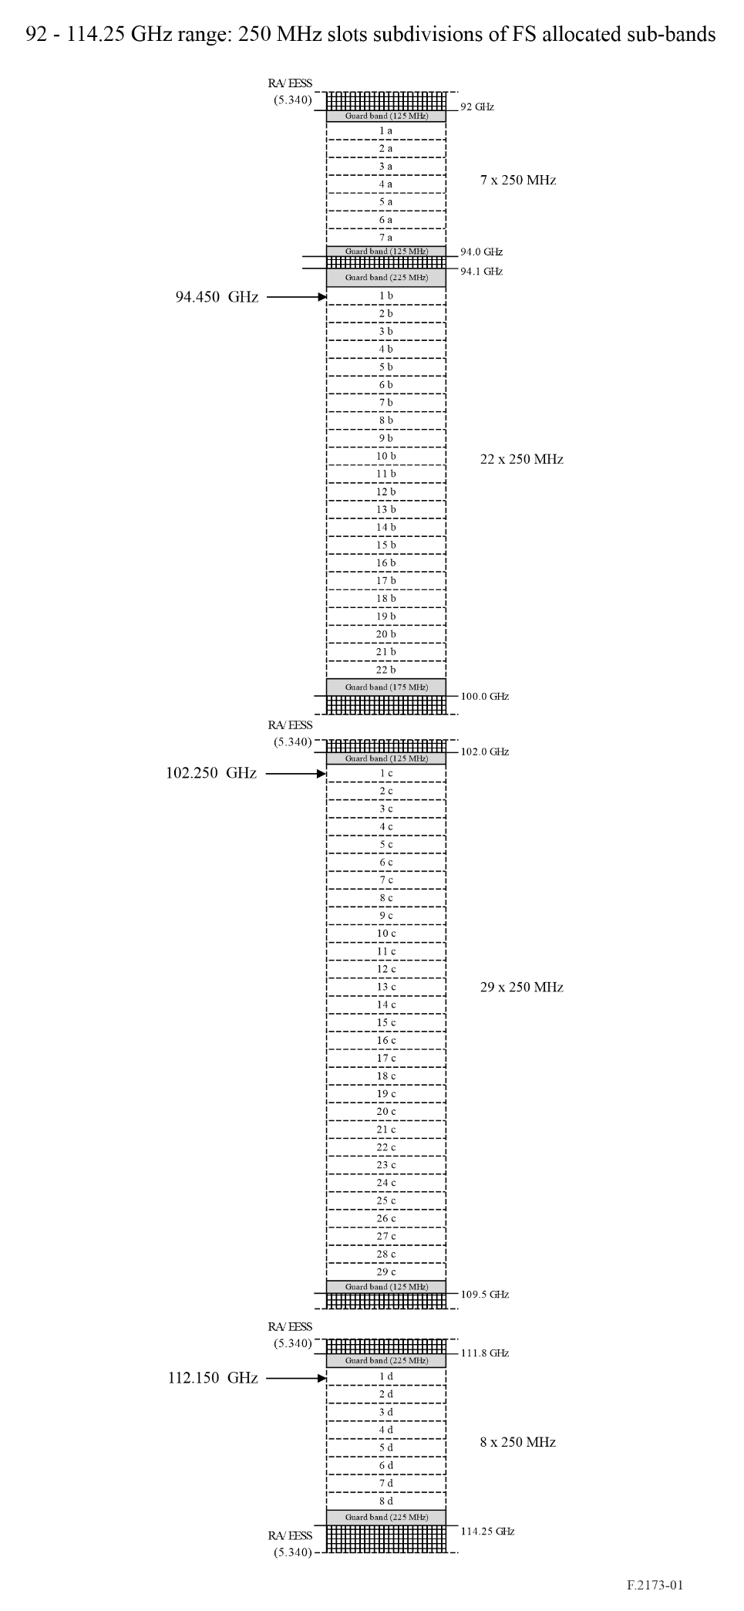
Centre frequency of channels can be obtained as shown in Table 1.
TABLE 1
Centre frequency of the 250 MHz width channels
Channels centre frequency formula | Number of channel (N) | Sub-band reference | Reference Figure
FN = 92 + N · 0.250 GHz | N: 1 to 7 | Sub-band “a” | Fig. 1
FN = 94.1 + 0.1 + N · 0.250 GHz | N: 1 to 22 | Sub-band “b” | Fig. 1
FN = 102 + N · 0.250 GHz | N: 1 to 29 | Sub-band “c” | Fig. 1
FN = 111.8 + 0.1 + N · 0.250 GHz | N: 1 to 8 | Sub-band “d” | Fig. 1

Annex 2
Block based use examples in the 130-174.8 GHz RF band
Through this Annex, for simplicity, each channel is assumed to occupy a single frequency slot described in Annex 1.
Due to the odd coupling of the three sub-bands available, some channels have to remain unpaired.
FIGURE 2
Example showing channels used as FDD in the 92-114.25 GHz band
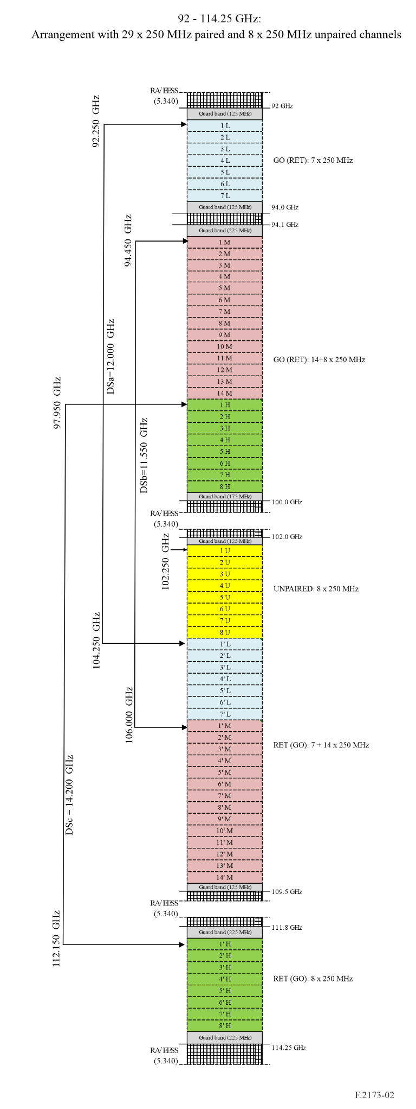
Go/return channels are subdivided in three sets (L, M and H) and one unpaired set (U) as shown in Fig. 2 Centre frequencies can be obtained by the following formulas.
Centre frequencies for channels with suffix L in Fig. 2
Duplex separation (DS): 12 GHz
FL_{N} = 92 + N · 0.250 GHz N: 1 to 7 (channels within sub-band “a”)
F’L_{N} = 102 + 2 + N · 0.250 GHz N: 1 to 7 (channels within sub-band “c”)
Centre frequencies for channels with suffix M in Fig. 2
Duplex separation: 11.550 GHz
FM_{N} = 94.1 + 0.1 + N · 0.250 GHz N: 1 to 14 (channels within sub-band “b”)
F’M_{N} = 102 + 3.75 + N · 0.250 GHz N: 1 to 14 (channels within sub-band “c”)
Centre frequencies for channels with suffix H in Fig. 2
Duplex separation: 14.200 GHz
FH_{N} = 94.1 + 3.6 + N · 0.250 GHz N: 1 to 8 (channels within sub-band “b”)
F’H_{N} = 111.8 + 0.1 + N · 0.250 GHz N: 1 to 8 (channels within sub-band “d”)
Centre frequencies for channels with suffix U in Fig. 2
FU_{N} = 102 + N · 0.250 GHz N: 1 to 8 (channels within sub-band “c”)

Annex 3
Paired block-based use in the 92-114.25 GHz band
Aggregation of channels
According to recommends 4, channels can be aggregated for composing blocks of frequencies. For a more flexible use, blocks may preferably be paired; however, partially unpaired use might be convenient in certain cases.
Block size
Block size should be integer multiple of the basic 250 MHz channel size; in the example given in Fig. 3, block sizes of 1 750/2 000 MHz are considered. In principle, inside a specific sub-band no upper limit is given to block size, provided that the blocks’ duplex separation (DS) is maintained.
Paired block example
Figure 3 shows an example of implementation of blocks to the overall band.
It has to be noted that the unpaired channel might be attached to block L’ for more asymmetric usage.
FIGURE 3
Example showing the use of channels aggregated in four paired blocks and one unpaired block
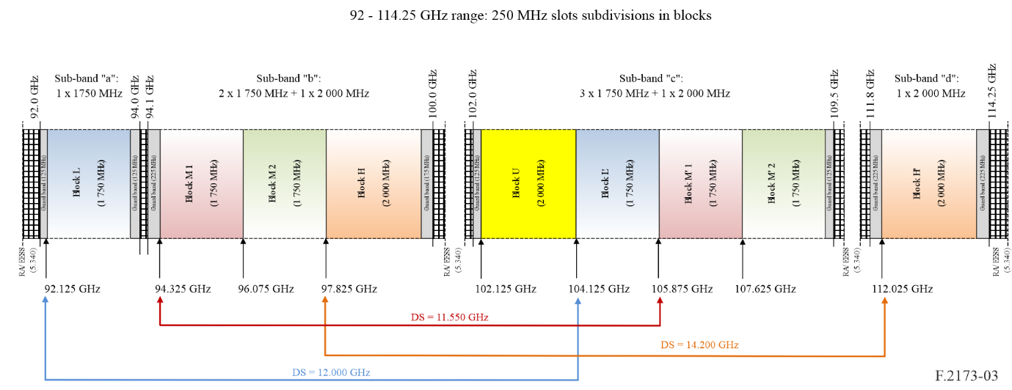
Use of the channels/blocks
Provided that the 250 MHz basic channels raster or its aggregations are respected, channels inside the block(s) can be freely used in conventional FDD in paired blocks, or with go/return placement inside same block(s) (e.g. in TDD, full duplex (FD) or flexible frequency division duplex (fFDD)), in the same or each paired block.
Inside blocks, symmetric or asymmetric combination of channels for go/return can be possible. Examples of go/return coexistence inside same block(s) in fFDD for symmetric /asymmetric case are shown in Figs 4 and 5 respectively.
Examples of conventional FDD use for symmetric /asymmetric case are shown in Figs 6 and 7 respectively.
FIGURE 4
Examples of In-block fFDD use for symmetric go/return channel size
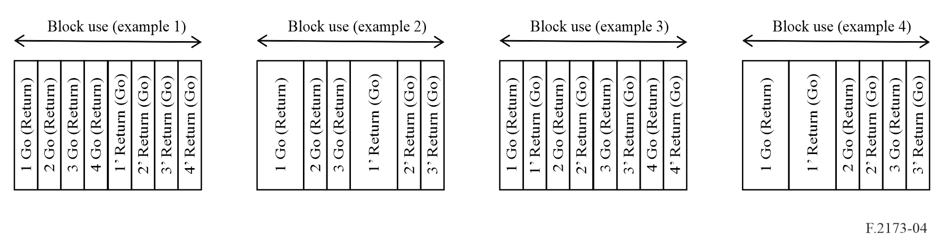
FIGURE 5
Examples of In-block FDD (fFDD) use for asymmetric go/return channel size
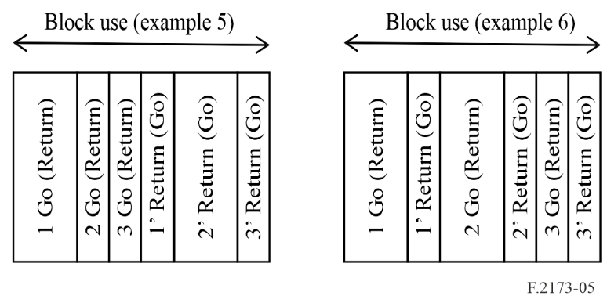
FIGURE 6
Example of paired blocks FDD use for symmetric go/return channel size
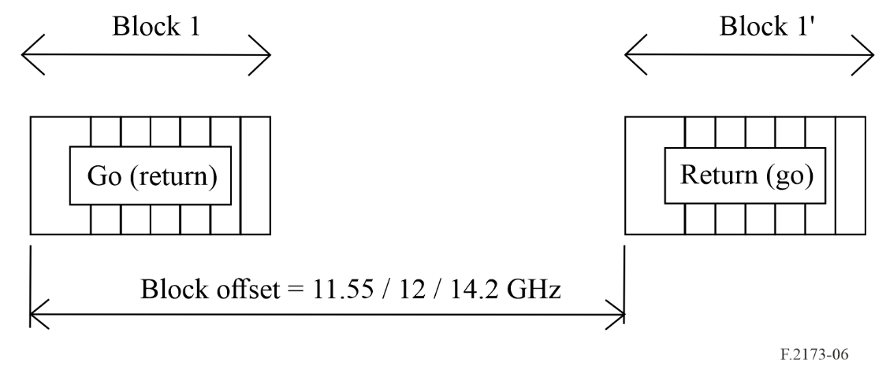
FIGURE 7
Example of paired blocks FDD use for asymmetric go/return channel size
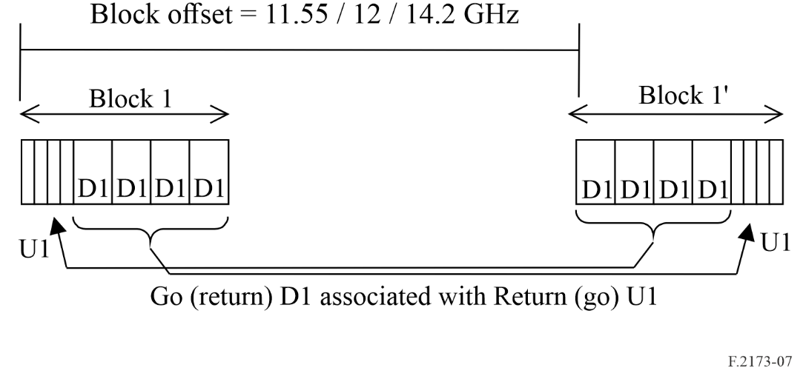

Flexible Frequency Division Duplex (fFDD) systems allow required TX/RX isolation without traditional RF duplex filters, but through separate TX/RX antennas and/or digital cancellation capability, allowing narrower duplex spacing.
Full Duplex (FD) systems use the same channel for go/return (as TDD systems), but for 100% of the time; they should provide necessary TX/RX isolation through separate TX and RX antennas and digital cancellation, rather than through duplex filter as in conventional FDD systems.
Full Duplex (FD) systems use the same channel for go/return (as TDD systems), but for 100% of the time; they should provide necessary TX/RX isolation through separate TX and RX antennas and digital cancellation, rather than through duplex filter as in conventional FDD systems.
While in conventional FDD systems TX/RX isolation is obtained through RF duplex filter, in flexible frequency division duplex (fFDD) systems the isolation could be obtained through separate TX/RX antennas and/or digital cancellation (similar to XPIC technology); this enhance the TX/RX isolation capability and permits narrower duplex spacing.

