Recommendation ITU-R F.2172-0
(02/2026)
F Series: Fixed service
Radio-frequency channel and block arrangements for fixed service systems operating in the 130-134 GHz, 141-148.5 GHz, 151.5-164 GHz and 167-174.8 GHz ranges

Foreword
The role of the Radiocommunication Sector is to ensure the rational, equitable, efficient and economical use of the radio-frequency spectrum by all radiocommunication services, including satellite services, and carry out studies without limit of frequency range on the basis of which Recommendations are adopted.
The regulatory and policy functions of the Radiocommunication Sector are performed by World and Regional Radiocommunication Conferences and Radiocommunication Assemblies supported by Study Groups.

INTELLECTUAL PROPERTY RIGHTS
ITU draws attention to the possibility that the practice or implementation of this Recommendation may involve the use of a claimed Intellectual Property Right. ITU takes no position concerning the evidence, validity or applicability of claimed Intellectual Property Rights, whether asserted by ITU members or others outside of the Recommendation development process.
As of the date of approval of this Recommendation, ITU had received notice of intellectual property, protected by patents, which may be required to implement this Recommendation. However, implementers are cautioned that this may not represent the latest information and are therefore strongly urged to consult the appropriate ITU-R patent information available at https://www.itu.int/en/ITU-R/study-groups/Pages/itu-r-patent-information.aspx.

Series of ITU-R Recommendations
(Also available online at https://www.itu.int/publ/R-REC/en)
Series | Title
BO | Satellite delivery
BR | Recording for production, archival and play-out; film for television
BS | Broadcasting service (sound)
BT | Broadcasting service (television)
F | Fixed service
M | Mobile, radiodetermination, amateur and related satellite services
P | Radio-wave propagation
RA | Radio astronomy
RS | Remote sensing systems
S | Fixed-satellite service
SA | Space applications and meteorology
SF | Frequency sharing and coordination between fixed-satellite and fixed service systems
SM | Spectrum management
SNG | Satellite news gathering
TF | Time signals and frequency standards emissions
V | Vocabulary and related subjects

Note: This ITU-R Recommendation was approved in English under the procedure detailed in Resolution ITU-R 1.

Electronic Publication
Geneva, 2026
© ITU 2026
All rights reserved. No part of this publication may be reproduced, by any means whatsoever, without written permission of ITU.

RECOMMENDATION ITU-R F.2172-0
Radio-frequency channel and block arrangements for fixed service systems operating in the 130-134 GHz, 141-148.5 GHz, 151.5-164 GHz and 167-174.8 GHz ranges
Question ITU-R 247-1/5
(2026)
Scope
This Recommendation describes channel and block arrangements in the portions of the frequency range 130.0-174.8 GHz allocated to the fixed service. The arrangements are based on a 250 MHz basic channel raster from which N × 250 MHz channel size can be defined and are proposed for either frequency division duplex (FDD) or time division duplex (TDD) applications. Alternative duplex schemes, such as flexible frequency division duplex (fFDD) or full duplex (FD) may also be considered.
Keywords
130-174.8 GHz, FDD, flexible FDD, Full Duplex, Channel Raster
Acronyms/Abbreviations
DS Duplex separation
EESS Earth exploration satellite service
FD Full duplex
FDD Frequency division duplex
fFDD flexible FDD
FS Fixed service
P-P Point-to-point
RR Radio Regulations
TDD Time division duplex
Related ITU-R Recommendations
Recommendation ITU-R P.676 – Attenuation by atmospheric gases
Recommendation ITU-R P.838 – Specific attenuation model for rain for use in prediction methods
Recommendation ITU-R F.1519 – Guidance on frequency arrangements based on frequency blocks for systems in the fixed service
Report ITU-R F.2558 – Studies on unwanted emission levels outside the allocated bands for fixed service systems operating in frequency bands from 94.1 GHz to 174.8 GHz for the protection of Earth exploration-satellite service (passive) operating in adjacent bands where footnote No. 5.340 of the Radio Regulations applies
NOTE – In every case the latest edition of the Recommendation/Reports in force should be used.
The ITU Radiocommunication Assembly,
considering
a) that there is need for very high capacity fixed links to provide backhauling of mobile cells and other multi-Gbit/s data links;
b) that the propagation characteristics of the frequency bands 130-134 GHz, 141-148.5 GHz, 151.5-164 GHz and 167-174.8 GHz are ideally suited for use of short-range FS links with various occupied bandwidths in very high-density networks for applications in particular for backhaul/fronthaul for next generation mobile networks;
c) that FS applications may require different radio-frequency channel arrangements;
d) that advanced point-to-point system technologies permit to use radiofrequency channels either unpaired (TDD or FD) or paired as narrow duplex systems (fFDD);
e) that, in some cases, a flexible sub-band or block arrangement can accommodate various FWS technologies;
f) that, as the propagation loss difference in the 130-134 GHz, 141-148.5 GHz, 151.5-164 GHz and 167-174.8 GHz is within the range of 1 dB for the hop lengths of up to 1 km, this also suggests the possibility of using these bands together for FDD links with large duplex separation, if necessary;
g) that narrower duplex separation is also possible with advanced digital cancellation techniques and, when considering the very short wavelength in these bands, a small separate transmitter/receiver (TX/RX) antenna integral to the same equipment is feasible,
recognizing
a) that ITU RR No. 5.340 prohibits all emissions, inter alia, in the bands 148.5-151.5 GHz, 164-167 GHz, therefore care should be taken to limit the out-of-band emissions from FS operating in the bands 141-148.5 GHz, 151.5-164 GHz and 167-174.8 GHz into those adjacent bands;
b) that Recommendation ITU-R F.1519 provides guidance on frequency arrangements based on frequency blocks for systems in the fixed service;
c) that the frequency bands 130-134 GHz, 141-148.5 GHz, 151.5-164 GHz and 167-174.8 GHz are allocated on a primary basis to fixed service, as well as other co-primary services,
recommends
1 that the preferred radio-frequency channel or block arrangement for the 130-134 GHz, 141-148.5 GHz, 151.5-164 GHz and 167-174.8 GHz for FS links should consider using the basic 250 MHz channel raster arrangements given in Annex 1;
2 that flexible aggregation of those 250 MHz basic channels for composing wider channels, while taking into account appropriate spectrum efficiency, should be considered;
3 that to use block-based assignment, derived by channel aggregation, in line with the example shown in Annex 2, blocks should be multiple of 250 MHz wide and their use should permit any suitable channel size and duplex method as shown in the examples given in Annex 2;
4 that traditional FDD duplex channels, may be assigned in the bands 130-134 GHz, 141-148.5 GHz, 151.5-164 GHz and 167-174.8 GHz, used as paired bands, with the adoption of suitable duplex spacing > 15 GHz; Annex 3, should be considered as an example.

Annex 1
Radio-frequency channel arrangement in the band 130-174.8 GHz
Basic channel raster
Figure 1 shows the subdivision of the available bands into 250 MHz elementary channels; at least 125 MHz guard bands are provided.
Figure 1
Basic channels raster for FS use in the 130-174.8 GHz band
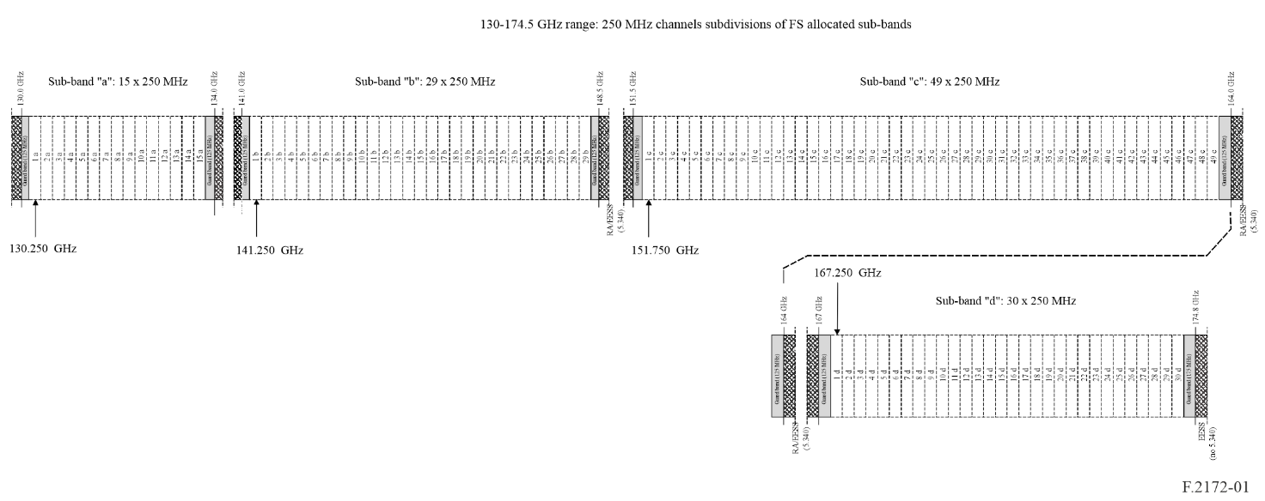
Centre frequency of channels can be obtained as follows:
F_{N} = 130 + N × 0.250 GHz N: 1 to 15 Sub-band “a”
F_{N} = 141 + N × 0.250 GHz N: 1 to 29 Sub-band “b”
F_{N} = 151.5 + N × 0.250 GHz N: 1 to 49 Sub-band “c”
F_{N} = 167 + N × 0.250 GHz N: 1 to 30 Sub-band “d”

Annex 2
Block based use examples in the 130-174.8 GHz RF band
Aggregation of channels
Figure 2 provides an example of use of blocks covering the overall band.
FIGURE 2
Example showing use of channels aggregated in blocks
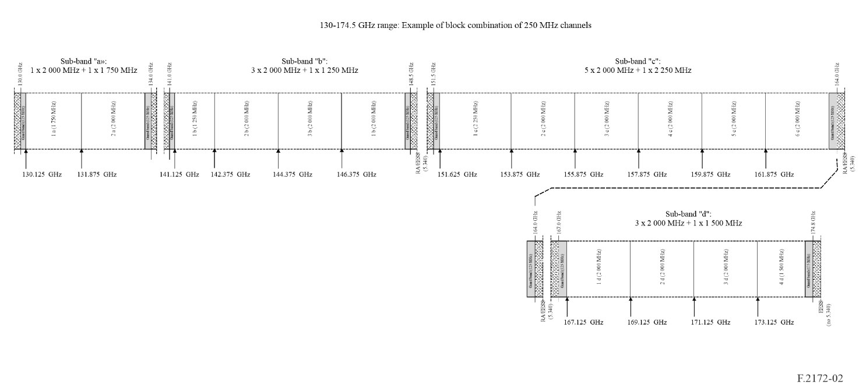
Block size
Block size should be integer multiple of the basic 250 MHz channel size, in principle, no upper limit is given to block size, inside a specific sub-band. In the example given in Fig. 2, an average size of 2 000 MHz (8 basic channels) is considered.
Use of the channels/blocks
Provided that the 250 MHz raster or its aggregations are respected, channels inside the block(s) can be freely used in conventional FDD paired blocks, where the two blocks are used each one for a single direction of the link, or with possible use of go/return channels inside same block(s) (e.g. by switching the overall block between the two directions, as in TDD, or by using continuously the block for both directions, as flexible frequency division duplex fFDD and full duplex FD).
Within each block, symmetric or asymmetric combination of channels for go/return can be possible.
Blocks can be used either alone or paired with suitable spacing > 15 GHz; e.g. in the example of Fig. 2 pairing block 2b with block 4c (with 15.5 GHz duplex spacing) or block 2a with block 2c (with 22 GHz duplex spacing).
Examples of go/return coexistence inside same block(s) in fFDD for symmetric /asymmetric case are shown in Fig. 3 and Fig. 4 respectively.
Examples of conventional FDD use for symmetric /asymmetric case are shown in Fig. 5 and Fig. 6 respectively.
FIGURE 3
Examples of In-block fFDD use examples for symmetric go-return channel size
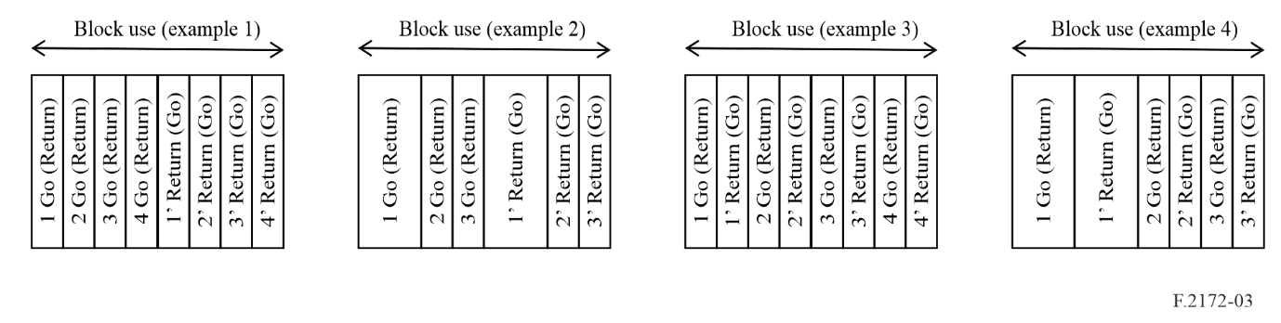
FIGURE 4
Examples of In-block fFDD use examples for asymmetric go-return channel size
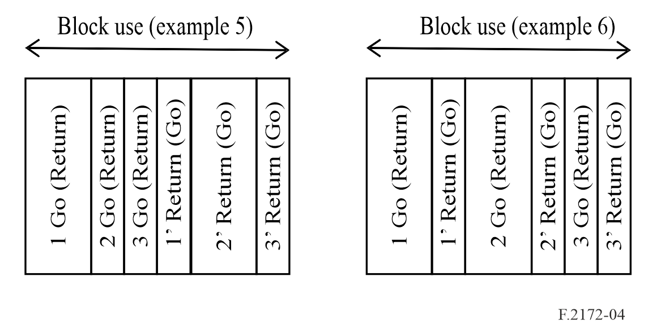
FIGURE 5
Example of paired blocks FDD use for symmetric go-return channel size
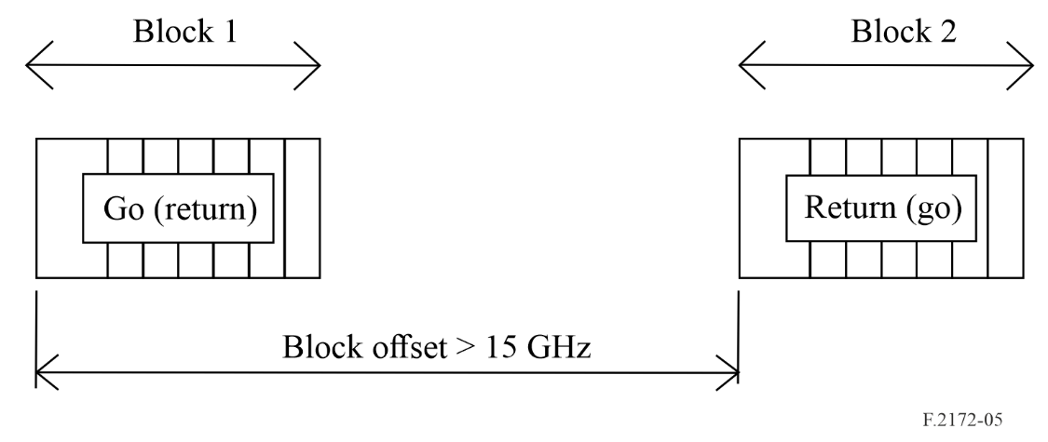
FIGURE 6
Example of paired blocks FDD use for asymmetric go-return channel size
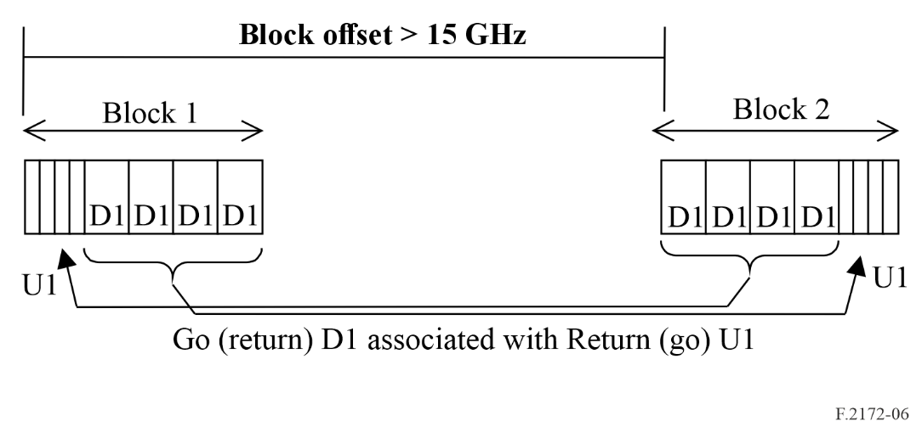

Annex 3
Possible example of channel arrangement for FDD use
in the 130-174.8 GHz RF band
Figure 7 present an example of channel arrangements for FDD use, complying with the recommended duplex spacing >15 GHz. Due to the odd coupling of the four sub-bands available, large portions have to remain unpaired; in this example the higher sub-band d is kept fully unpaired. However, different solutions could be envisaged.
Unpaired channels could still be aggregated into unpaired blocks for TDD, FD or fFDD use.
FIGURE 7
Example showing use of channels as FDD in the 130-174.8 GHz band
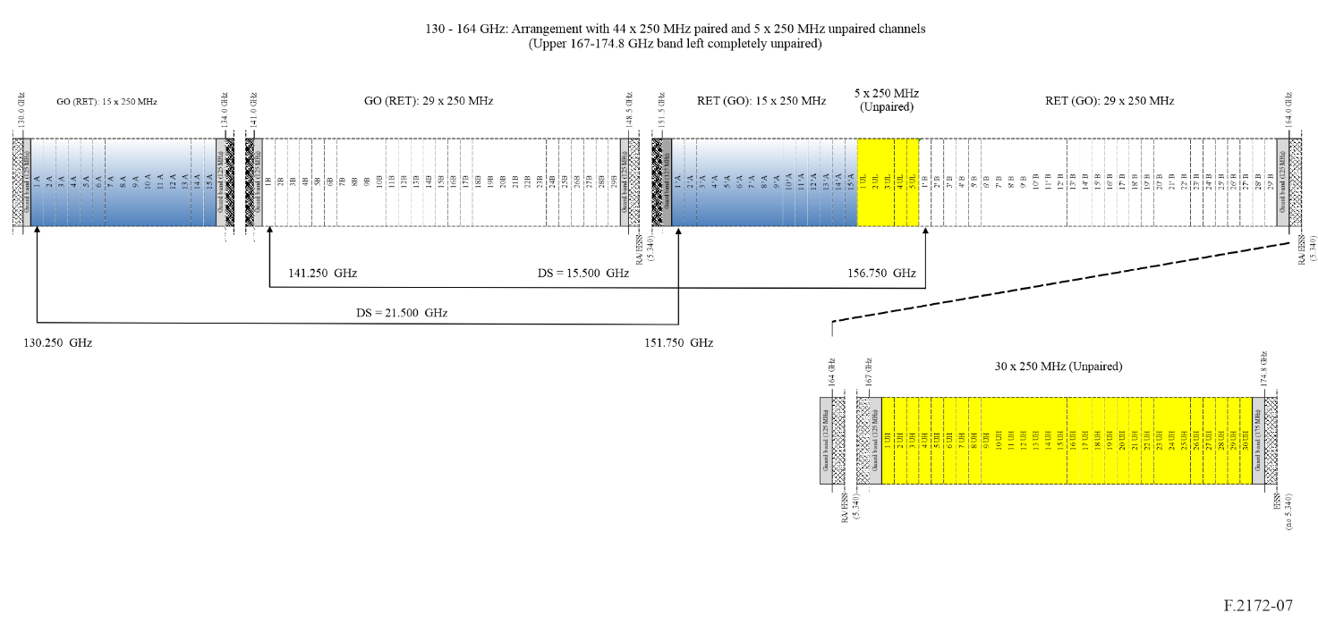
Go/return channels are subdivided in two sets (A, B) and two unpaired set (UL and UH) as shown in Fig. 7. Centre frequencies can be obtained by the following formulas.
Centre frequencies for channels with suffix A in Fig. 7
Duplex separation (DS): 21.5 GHz
FA_{N} = 130 + N × 0.250 N: 1 to 15 (channels within sub-band 130-134 GHz)
F’A_{N} = 151.5 + N × 0.250 GHz N: 1 to 15 (channels within sub-band 151.5-164 GHz)
Centre frequencies for channels with suffix B in in Fig. 7
Duplex separation (DS): 15.5 GHz
FB_{N} = 141 + N × 0.250 GHz N: 1 to 29 (channels within sub-band 141-148.5 GHz)
F’B_{N} = 151.5 + 5 + N × 0.250 GHz N: 1 to 29 (channels within sub-band 151.5-164 GHz)
Centre frequencies for channels with suffix UL in in Fig. 7
FUL_{N} = 151.5 + 3.75 + N × 0.250 GHz N: 1 to 5 (channels within sub-band 151.5-164 GHz)
Centre frequencies for channels with suffix UH in in Fig. 7
FUH_{N} = 167 + N × 0.250 GHz N: 1 to 30 (channels within sub-band 167-174.8 GHz)

Flexible Frequency Division Duplex (fFDD) systems allow required TX/RX isolation without traditional RF duplex filters, but through separate TX/RX antennas and/or digital cancellation capability, allowing narrower duplex spacing.
Full Duplex (FD) systems use the same channel for go/return (as TDD systems), but for 100% of the time; they should provide necessary TX/RX isolation through separate TX and RX antennas and digital cancellation, rather than through duplex filter as in conventional FDD systems.
Full Duplex (FD) systems use the same channel for go/return (as TDD systems), but for 100% of the time; they should provide necessary TX/RX isolation through separate TX and RX antennas and digital cancellation, rather than through duplex filter as in conventional FDD systems.
While in conventional FDD systems TX/RX isolation is obtained through RF duplex filter, in flexible frequency division duplex (fFDD) systems the isolation could be obtained through separate TX/RX antennas and/or digital cancellation (similar to XPIC technology); this enhance the TX/RX isolation capability and permits narrower duplex spacing.

