Recommendation ITU-R F.2005-1
(02/2022)
Radio-frequency channel and block arrangements for fixed wireless
systems operating in the 42 GHz
(40.5 to 43.5 GHz) band

F Series
Fixed service

Foreword
The role of the Radiocommunication Sector is to ensure the rational, equitable, efficient and economical use of the radio-frequency spectrum by all radiocommunication services, including satellite services, and carry out studies without limit of frequency range on the basis of which Recommendations are adopted.
The regulatory and policy functions of the Radiocommunication Sector are performed by World and Regional Radiocommunication Conferences and Radiocommunication Assemblies supported by Study Groups.

Policy on Intellectual Property Right (IPR)
ITU-R policy on IPR is described in the Common Patent Policy for ITU-T/ITU-R/ISO/IEC referenced in Resolution ITU-R 1. Forms to be used for the submission of patent statements and licensing declarations by patent holders are available from http://www.itu.int/ITU-R/go/patents/en where the Guidelines for Implementation of the Common Patent Policy for ITU-T/ITU-R/ISO/IEC and the ITU-R patent information database can also be found.

Series of ITU-R Recommendations
(Also available online at http://www.itu.int/publ/R-REC/en)
Series | Title
BO | Satellite delivery
BR | Recording for production, archival and play-out; film for television
BS | Broadcasting service (sound)
BT | Broadcasting service (television)
F | Fixed service
M | Mobile, radiodetermination, amateur and related satellite services
P | Radiowave propagation
RA | Radio astronomy
RS | Remote sensing systems
S | Fixed-satellite service
SA | Space applications and meteorology
SF | Frequency sharing and coordination between fixed-satellite and fixed service systems
SM | Spectrum management
SNG | Satellite news gathering
TF | Time signals and frequency standards emissions
V | Vocabulary and related subjects

Note: This ITU-R Recommendation was approved in English under the procedure detailed in Resolution ITU-R 1.

Electronic Publication
Geneva, 2022

© ITU 2022
All rights reserved. No part of this publication may be reproduced, by any means whatsoever, without written permission of ITU.

RECOMMENDATION ITU-R F.2005-1
Radio-frequency channel and block arrangements for fixed wireless systems
operating in the 42 GHz (40.5 to 43.5 GHz) band
(Question ITU-R 247-1/5)
(2012-2022)
Scope
This Recommendation provides radio-frequency channel arrangements for point-to-point (P-P) fixed wireless systems operating in the 42 GHz (40.5 to 43.5 GHz) band, which may be used for high, medium and low capacity systems. The preferred radio-frequency channel arrangements are based on multiples of basic channels of 7 MHz width merged to form higher channel widths up to 224 MHz. Additional option for block arrangement suitable for deployment of a variety of fixed wireless access (FWA) systems using multipoint technology as well as PP links for infrastructure and access purpose. Third option for a flexible mixed use of the above deployment methodology is also described.
Keywords
Fixed service, point to point, channel bandwidth, channel arrangement, 42 GHz
Abbreviations
BFWA Broadband fixed wireless access
FDD Frequency division duplex
FS Fixed service
FSS Fixed-satellite service
MP Multipoint
MP-MP Multipoint-to-multipoint
P-MP Point-to-multipoint
P-P Point-to-point
RAS Radio astronomy service
RR Radio Regulations
TDD Time division duplex
Related ITU Recommendations and Reports
Recommendation ITU-R F.746 – Radio-frequency arrangements for fixed service systems
The ITU Radiocommunication Assembly,
considering
a) that the 40.5 to 43.5 GHz band is allocated worldwide to the fixed service (FS) on a primary basis;
b) that in the Radio Regulations (RR) the 40.5 to 43.5 GHz band is identified for high-density applications in the FS;
c) that there is particular need for point-to-point (P-P) links for large data capacity transport, e.g. for mobile networks applications, the deployment of which is expected to rapidly grow;
d) that the deployment of P-P links may result in greater spectrum efficiency when using conventional link-by-link coordination within a dedicated radio-frequency channel arrangement;
e) that for the deployment of broadband services, it is most desirable to deploy in the 40.5 to 43.5 GHz band digital systems of high capacity, but need for medium and low capacity connection are not excluded;
f) that multipoint (MP) systems (point-to-multipoint (P-MP) or multipoint-to-multipoint (MP-MP)) can provide broadband fixed wireless access (BFWA) services in the range 40.5-43.5 GHz including telephony, video, media streaming and data services;
g) that, in some cases, it may be desirable to achieve flexible frequency assignment plans that can accommodate both frequency division duplex (FDD) and time division duplex (TDD) MP traffic requirements, as well as point-to-point (P-P) links, in particular for transport applications in BFWA networks and in mobile networks;
h) that, when the FS needs, synthesized in considering g), are dominant, sufficient capacity and flexibility for deployment of multiple systems within a desired service area may be achieved by the aggregation of a variable number of contiguous frequency slots to form a block assignment;
i) that the assignment of adjacent blocks to different BFWA operators may require setting general coexistence criteria in order to reduce the need for coordination between them; but coordination should nevertheless be encouraged in order to maximize the efficient use of the blocks;
j) that with paired block assignment, both time division duplex (TDD) systems and frequency division duplex (FDD) MP systems could be indifferently accommodated, provided that appropriate coexistence criteria can be met;
k) that, in order to enhance the efficient use of the assigned block(s), according to present and future available technology, the operator should freely define and modify suitable channel arrangement(s) within the block(s) according to the selected technology(ies);
l) that when the higher spectrum efficiency of P-P links coordinated deployment within a channel arrangement and the higher flexibility of services permitted by a block assignment plan are both equally desirable, a flexible subdivision of the band between both methodologies is possible;
m) that the radio astronomy service (RAS) is also allocated with a primary status in the range 42.5-43.5 GHz; in some locations appropriate measures will be needed in the planning and deployment of MP BFWA and P-P systems around radio astronomy stations to protect the radio astronomy service;
n) that the transport capacity required for fixed wireless links is continuously growing,
recognizing
that Recommendation ITU-R SM.1540 provides guidelines for managing the unwanted emissions in the out-of-band domain falling into adjacent allocated bands,
noting
that the Radio Regulations identifies the 40.5 to 42 GHz band as being available in Region 2 also for high-density applications in the fixed-satellite service (FSS) and appropriate sharing should also be envisaged,
recommends
1 that administrations wishing to use a radio-frequency channel arrangement for conventional coordinated deployment of P-P links in the 40.5-43.5 GHz frequency band should consider the radio-frequency channel arrangement in Annex 1;
2 that administrations wishing to adopt mixed and flexible use of different technologies, for both BFWA and P-P links, within the band should:
2.1 consider the guidance in Annex 2 when considering the positioning of assigned blocks within the band;
2.2 consider providing suitable measures for inter-block coexistence as well as for adjacent bands protection;
2.3 assign blocks in a manner that might assist future expansion of successful services, without further regulatory requirements on the actual channel arrangements inside the blocks;
3 that administrations wishing to adopt a flexible use of the band for both assignment methodologies, assigned P-P links according to recommends 1 and blocks of frequency according to recommends 2, should consider the use of flexible band subdivision in Annex 3;
4 that for international coordination purpose, it is necessary that neighbouring administrations commonly agree to select one of the two options presented in Annex 3. For this purpose, option A of Annex 3 is considered preferable whenever RAS coordination is required in the band 42.5-43.5 GHz because of the easiness coordination with P-P systems. Option B may be agreed when there are restrictions in using Option A.

Annex 1
Radio-frequency channels arrangement according to recommends 1
Derivation of centre frequency of radio-frequency channels
The radio-frequency channel arrangement for carrier separations of 224 MHz, 112 MHz, 56 MHz, 28 MHz, 14 MHz and 7 MHz, with duplex spacing 1 500 MHz, shall be derived as follows:
Let fo be the reference frequency = 42 000 MHz;
f$_{n}$ be the centre frequency of an RF channel in the lower half of the band (MHz);
f′n be the centre frequency of an RF channel in the upper half of the band (MHz);
then the frequencies of individual channels are expressed by the following relationships:
a) for systems with a carrier spacing of 224 MHz with interleaved arrangement by granularity of 112 MHz:
lower half of band: fn = fo – 1 450 + 112 n MHz
upper half of band: f′n = fo + 50 + 112 n MHz
where:
n = 1, 2, 3, ..., 11
b) for systems with a carrier spacing of 112 MHz:
lower half of band: fn = fo – 1 506 + 112 n MHz
upper half of band: f′n = fo − 6 + 112 n MHz
where:
n = 1, 2, 3, ..., 12
c) for systems with a carrier spacing of 56 MHz:
lower half of band: f$_{n}$ = fo – 1 478 + 56 n MHz
upper half of band: f′n = fo + 22 + 56 n MHz
where:
n = 1, 2, 3, ..., 25
d) for systems with a carrier spacing of 28 MHz:
lower half of band: f$_{n}$ = fo – 1 464 + 28 n MHz
upper half of band: f′n = fo + 36 + 28 n MHz
where:
n = 1, 2, 3, ..., 50
In addition, the use of channel with index n = 0 may be considered with the agreement of the administrations concerned;
e) for systems with a carrier spacing of 14 MHz:
lower half of band: f$_{n}$ = fo – 1 457 + 14 n MHz
upper half of band: f′n = fo + 43 + 14 n MHz
where:
n = 1, 2, 3, ..., 101
In addition, the use of channels with index n = −1 and 0 may be considered with the agreement of the administrations concerned;
f) for systems with a carrier spacing of 7 MHz:
lower half of band: f$_{n}$ = fo – 1 453.5 + 7 n MHz
upper half of band: f′n = fo+ 46.5 + 7 n MHz
where:
n = 1, 2, 3, ..., 202
In addition, the use of channels with index n = −3, −2, −1 and 0 may be considered with the agreement of the administrations concerned.
TABLE 1
Calculated parameters according to Recommendation ITU-R F.746
XS  (MHz) | n | f₁  (MHz) | f_{n}  (MHz) | f′₁  (MHz) | f′_{n}  (MHz) | Z₁S  (MHz) | Z₂S  (MHz) | YS  (MHz) | DS  (MHz)
224 | 1, ..., 11 | 40 662 | 41 782 | 42 162 | 43 282 | 162 | 218 | 380 | 1 500
112 | 1, ..., 12 | 40 606 | 41 838 | 42 106 | 43 338 | 106 | 162 | 268 | 1 500
56 | 1, ..., 25 | 40 578 | 41 922 | 42 078 | 43 422 | 78 | 78 | 156 | 1 500
28 | 1, ..., 50 | 40 564 | 41 936 | 42 064 | 43 436 | 64 | 64 | 128 | 1 500
14 | 1, ..., 101 | 40 557 | 41 957 | 42 057 | 43 457 | 57 | 43 | 100 | 1 500
7 | 1, ..., 202 | 40 553.5 | 41 960.5 | 42 053.5 | 43 460.5 | 53.5 | 39.5 | 93 | 1 500
XS: separation between centre frequencies of adjacent channels.
YS: separation between centre frequencies of the closest go and return channels.
Z₁S: separation between the lower band edge and the centre frequency of the lowest channel in the lower sub-band.
Z₂S: separation between centre frequency of the highest channel in the upper sub-band and the upper band edge.
DS: duplex spacing (− fn).

Figure 1
Occupied spectrum from 40.5 to 43.5 GHz
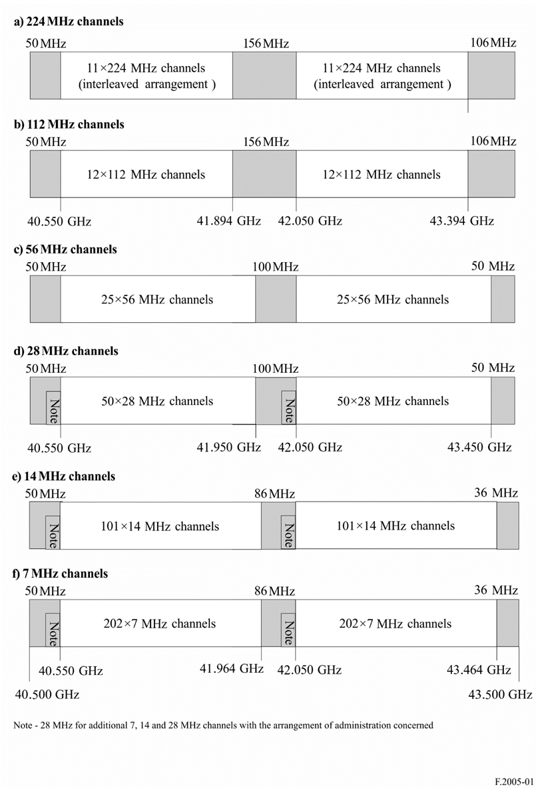

Annex 2
Guidance for the preferred construction of frequency blocks assignment plan for BFWA and P-P links according to recommends 2
Steps leading to a recommended assignment plan
1) Consider any constraints brought about by the need to share with other services.
2) Consider appropriate measure for inter-block coexistence as well as for adjacent bands protection.
3) Consider the appropriate block size, B for assignment. Although it is difficult to determine an absolute value for the optimum block size, considering the broadband nature of modern digital BFWA or of the required P-P links, it is anticipated that blocks of at least 250 MHz would seem to be an appropriate starting point for consideration. However, a smaller granularity (e.g. in the order of 20/25 MHz or 28/56 MHz), when consistency is desired with the radio-frequency channel arrangement in recommends 1, may assist in defining the proper sizes of the blocks.
4) Consider the following guidelines in order to develop an appropriate frequency block assignment plan:
– Paired equal blocks offset by 1.5 GHz should be assigned to each operator irrespective of the technology.
– For FDD systems, the definition of a single duplex spacing for systems of 1 500 MHz is convenient for P-P systems, whilst allowing TDD, which may operate in both upper and lower sub-bands blocks.
– For a generic coexistence enhancing, in the case of deployment of FDD systems only the upper sub-band should be used for the transmission from the terminals to the central station and the lower sub-band for the transmission from the central station to the terminals.
– If the entire band is not assigned, careful consideration should be given to the initial placement of operators to allow appropriate space for future new or expanded assignments.
Each block may contain a technology specific channelization scheme and guard bands.
Figure 2 below gives an example scheme based on such principle where five different operators have been allocated different size of paired blocks.
Figure 2
Example scheme based on the concept of paired equal blocks
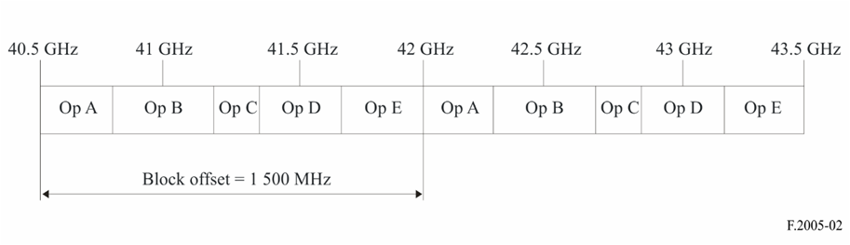
It provides administrations the possibility to allocate the spectrum without a need to predetermine the technology (either for P-P or MP systems) to be used by the different operators and gives these latter the flexibility to deploy, mix or modify the technology they use:
– for FDD systems, it accommodates all systems with a duplex spacing of 1.5 GHz (see Fig. 3);
– for TDD systems (either P-P or MP), the two blocks are used separately by the operator to deploy same or different types of systems (see Fig. 4);
– a mixture of both FDD and TDD systems is possible either within blocks or in neighbouring blocks.
Figure 3
Application with FDD P-P and P-MP systems (for one operator)
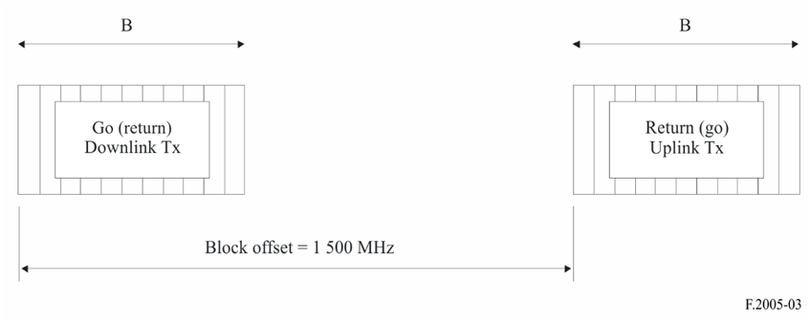
Figure 4
Application with TDD systems (for one operator)

Annex 3
Flexible band segmentation, according to recommends 3, for joint use of block
and radio-frequency channel arrangements
A flexible joint use of the two methodologies described in recommends 1 and 2 may be obtained initiating the deployment of blocks (according to recommends 1) from the lowest frequency borders upwards and of coordinated P-P radio-frequency channels from the highest frequency borders downwards (option A, see Fig. 5) or vice versa (option B, see Fig. 6).
Figure 5
Flexible deployment method: option A (preferred)
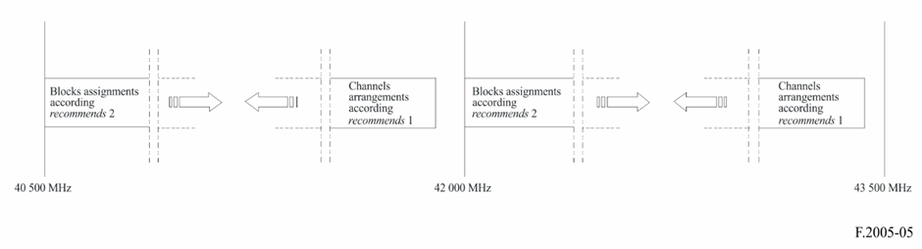
Figure 6
Flexible deployment method: option B
