Recommendation ITU-R F.1821-1
(02/2026)
F Series: Fixed service
Characteristics of advanced digital High Frequency radiocommunication systems in the fixed and mobile service

Foreword
The role of the Radiocommunication Sector is to ensure the rational, equitable, efficient and economical use of the radio-frequency spectrum by all radiocommunication services, including satellite services, and carry out studies without limit of frequency range on the basis of which Recommendations are adopted.
The regulatory and policy functions of the Radiocommunication Sector are performed by World and Regional Radiocommunication Conferences and Radiocommunication Assemblies supported by Study Groups.

INTELLECTUAL PROPERTY RIGHTS
ITU draws attention to the possibility that the practice or implementation of this Recommendation may involve the use of a claimed Intellectual Property Right. ITU takes no position concerning the evidence, validity or applicability of claimed Intellectual Property Rights, whether asserted by ITU members or others outside of the Recommendation development process.
As of the date of approval of this Recommendation, ITU had received notice of intellectual property, protected by patents, which may be required to implement this Recommendation. However, implementers are cautioned that this may not represent the latest information and are therefore strongly urged to consult the appropriate ITU-R patent information available at https://www.itu.int/en/ITU-R/study-groups/Pages/itu-r-patent-information.aspx.

Series of ITU-R Recommendations
(Also available online at https://www.itu.int/publ/R-REC/en)
Series | Title
BO | Satellite delivery
BR | Recording for production, archival and play-out; film for television
BS | Broadcasting service (sound)
BT | Broadcasting service (television)
F | Fixed service
M | Mobile, radiodetermination, amateur and related satellite services
P | Radio-wave propagation
RA | Radio astronomy
RS | Remote sensing systems
S | Fixed-satellite service
SA | Space applications and meteorology
SF | Frequency sharing and coordination between fixed-satellite and fixed service systems
SM | Spectrum management
SNG | Satellite news gathering
TF | Time signals and frequency standards emissions
V | Vocabulary and related subjects

Note: This ITU-R Recommendation was approved in English under the procedure detailed in Resolution ITU-R 1.

Electronic Publication
Geneva, 2026
© ITU 2026
All rights reserved. No part of this publication may be reproduced, by any means whatsoever, without written permission of ITU.

RECOMMENDATION ITU-R F.1821-1
Characteristics of advanced digital High Frequency* radiocommunication systems in the fixed and mobile service
(2007-2026)
Scope
This Recommendation describes advanced digital systems and networked protocols, and specifies the typical RF characteristics of wideband modems (single-channel, multichannel and Digital Radio Mondiale (DRM)) used for emerging advanced digital systems. Wideband modems include two major systems, multichannel operations and Digital Radio Mondiale operations. Tables of characteristics within the Annex to this Recommendation provide the values that should be considered for sharing and compatibility studies.
Keywords
AGILE HF, MESH Network, Cognitive Radio, Automatic Link Establishment
Abbreviations
AGILE Advanced, global, integrated, low-latency, and enhanced
ALE Automatic link establishment
CRS Cognitive radio system
CSMA Carrier sense multiple access
DRM Digital Radio Mondiale
DSSS Direct sequence spread spectrum
HF High frequency
HFTP HF token passing
HFWAN High frequency WAN
ISB Independent sideband
kbit/s kilobits per second
LSB Lower sideband
MULTICAST IP Routing protocol technique for data distribution
NVIS Near vertical incidence skywave
OFDM Orthogonal frequency division multiplex
OTH Over the horizon
PSK Phase-shift keying
QAM Quadrature amplitude modulation
SDR Software defined radio
S/N Signal to noise ratio
SINAD Signal to interference ratio including noise and distortion
SSB Single side band
TDMA Time division multiple access
USB Upper sideband
WAN Wide area network
WTRP Wireless token ring protocol
Definitions and descriptions
AGILE-HF – High frequency (HF) radio system that negotiates the radio frequency (RF) environment while mitigating harmful interference to users in or adjacent to desired operational frequencies, as further described in § 3.1.
Cognitive Radio – A radio system employing technology that allows the system to obtain knowledge of its operational and geographical environment, established policies and its internal state; to dynamically and autonomously adjust its operational parameters and protocols according to its obtained knowledge in order to achieve predefined objectives; and to learn from the results obtained.
Ground wave – Radio wave basically determined by the properties of the ground which propagates in the troposphere, and which is mainly due to diffraction around the Earth.
MESH Network – A mesh network is a local network topology in which the infrastructure nodes connect directly, dynamically, and non-hierarchically to as many other nodes as possible and cooperate with one another to use/share spectral link space and to efficiently route data from/to clients.
Seawave – Groundwaves over water.
Related ITU-R Recommendations and Reports
Recommendation ITU-R F.339 – Bandwidths, signal-to-noise ratios and fading allowances in complete systems
Recommendation ITU-R P.533 – Method for the prediction of the performance of HF circuits
Recommendation ITU-R BS.1514 – System for digital sound broadcasting in the broadcasting bands below 30 MHz
Recommendation ITU-R F.1610 – Planning, design and implementation of HF fixed service radio systems
Recommendation ITU-R F.1611 – Prediction methods for adaptive HF system planning and operation
Recommendation ITU-R F.1761 – Characteristics of HF fixed radiocommunication systems
Recommendation ITU-R F.1762 – Characteristics of enhanced applications for high frequency (HF) radiocommunication systems
Recommendation ITU-R F.1778 – Channel access requirements for HF adaptive systems in the fixed and land mobile services
Report ITU-R BS.458 – Characteristics of systems in LF, MF and HF broadcasting
Report ITU-R F.2087 – Requirements for high frequency (HF) radiocommunication systems in the fixed service
Report ITU-R F.2484 – Cooperative frequency competition model and the corresponding algorithms and protocols for improving the HF sky-wave electromagnetic environment
The ITU-R Radiocommunication Assembly,
considering
a) that there is an increasing use of advanced digital systems in the HF bands;
b) that such advanced systems are not standardized and may have different operational technical characteristics;
c) that the lack of uniformity, in the arrangement and designation of the channels in multichannel transmitters for long-range circuits operating on frequencies below about 30 MHz, may give rise to certain difficulties when one transmitting station has to work with several receiving stations;
d) that there is an increasing use of spectrum in the frequency range 2-30 MHz for Wideband High Frequency (AGILE-HF) applications, such as e-mail (with and without attachments), Internet access, large file transfer and live video streaming, which provide a communications path for exchanging this enhanced digital information;
e) that such AGILE-HF systems are not standardized in use and may have different operational and technical characteristics,
recognizing
that the frequency range 2 to 30 MHz is also allocated to other services on a primary basis,
recommends
that the technical and operational characteristics of advanced digital radiocommunication systems described in the Annex are representative of those systems operating in the frequency range 2-30 MHz for use in sharing and compatibility studies.

Annex
TABLE OF CONTENTS
Page
1 Introduction 6
2 Wideband modems 7
2.1 Direct Sequence Spread Spectrum (DSSS) approach 7
2.2 Single-channel approach 8
2.3 Multichannel approach 8
2.4 Digital Radio Mondiale (DRM) 10
3 Networked systems 11
3.1 AGILE HF networks 11
4 Multicast technologies 13
4.1 Time Division Multiple Access (TDMA) 13
4.2 Carrier Sense Multiple Access (CSMA) 13
4.3 Token Passing Protocols 13
5 Summary 17
Attachment to the Annex – Characteristics for advanced digital radiocommunication systems, such as ISB, contiguous and non-contiguous channels operating in the 2-30 MHz 18

1 Introduction
HF systems have specific attributes that make them a viable solution for many radiocommunication objectives. They provide a highly versatile means of radiocommunications to a broad base of users and such equipment can be easily transported to remote and lightly populated areas. There are two technologies that are examples of advanced digital HF systems. This Recommendation specifies the characteristics of these types of systems.
Overall, the maturation of system configuration, advanced technology, and enhanced capabilities afford AGILE-HF (Advanced, Global, Integrated, Low-latency and Enhanced HF Networks) the ability to operate in environments not traditionally allocated for wider bandwidth operations.
For the purpose of this Recommendation spectrum efficiency is defined as an objective with three parts. The first part is to achieve maximum throughput (bits/Hertz/s), the second part is to maximize the number of users, per frequency net, and the third part is to maximize the ability of fixed communications operations to achieve performance and mission goals. Several approaches can be sought to accomplish this objective.
Recently, several wideband approaches have been proposed to increase the capability of HF radio communications. These approaches use contiguous (up to 48 kHz), and non-contiguous (within up to 200 kHz) signalling test bandwidths exceeding the single side band (SSB) voice channel bandwidth of 3 kHz, in some cases by as much as a factor of 16.
This Annex contains an Attachment that provides typical technical characteristics of advanced digital HF and AGILE-HF Systems operating within the frequency band 2-30 MHz (see Attachment).
While the HF band is advantageous for long-distant communication applications, it is also a critical and affordable option together with satellite communications. The challenge with these emerging advanced digital HF networks is to seek increased bandwidth, while not impeding incumbents within the frequency band or countries dedicated legacy frequency needs. Advanced HF technologies can support digital HF networks that can enable a shared environment while maximizing utilization below 30 MHz.

2 Wideband modems
Radio frequency characteristics are presented in the Tables in the Attachment to the Annex.
HF waveform designed to optimize data movement in varying spectral environments is as old as modulation and demodulation (MODEM) itself. Standards for different modulation methods and patterns have centred either on best effort, high-reliability or spectrally noisy situations. Recently interest in waveforms that compensate for natural and unnatural jamming or detection have been called for and technology groups have assembled to create them. Academies and Technologists have offered some of the most innovative approaches to high E_{b}/N₀; low detection techniques, typically based on a spreading the waveform across wideband HF (WBHF) that in field trials shows a responsive and resilient extensibility with high transmission reliability.

2.1 Direct Sequence Spread Spectrum (DSSS) approach
Some of these new offerings are based in Direct Sequence Spread Spectrum (DSSS) spectrum techniques whereby the original data signal is multiplied with a pseudo random noise spreading code. This spreading code has a higher chip rate (this is the bitrate of the code), which results in a wideband time-continuous scrambled signal. Spread spectrum using DSSS gives high immunity to interference which sustains links better in contested frequency bands.
FIGURE 1
Typical DSSS waveform design
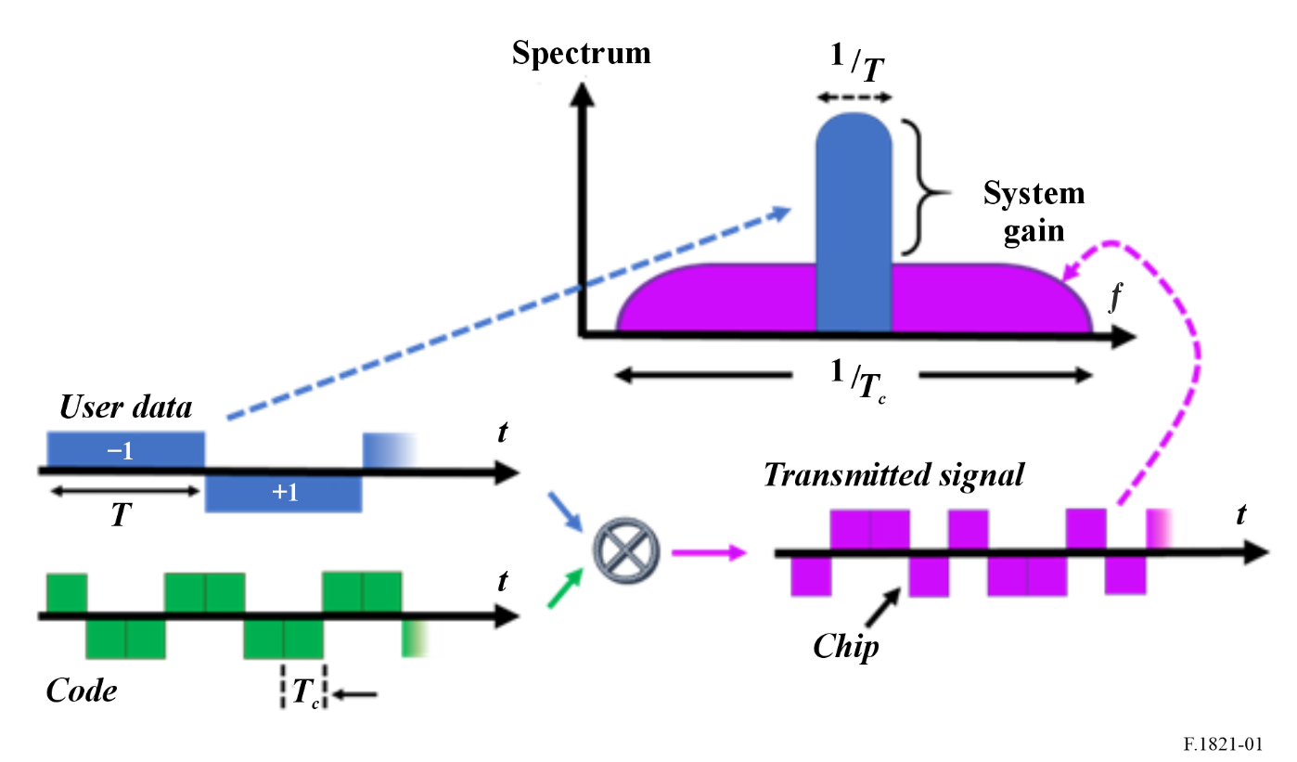

2.2 Single-channel approach
This approach will use a single-channel in one nominal 3 kHz channel USB or LSB (selectable).

2.3 Multichannel approach

2.3.1 Independent Sideband (ISB) operation
There are modems that convey data in multiple independent sidebands simultaneously. Such modems contain independent PSK/QAM modulators for each audio channel (for information on modulation, see Recommendation ITU-R F.763-5), but employ a single forward error correction encoder, whose output bit stream is distributed over the individual channels for transmission. When these channels are carried by contiguous frequencies, the signal to noise ratio (S/N) of the channels tend to be similar, although channel errors are not perfectly correlated. Thus, some improvement in output is achieved using receiver diversity.

2.3.1.1 Independent sideband (ISB) operation in non-contiguous channels
When contiguous channels are not available in sufficient quantity to support operational data requirements, operation in non-contiguous channels is necessary. In this case, channel S/N values may vary significantly so the distribution of a single coded bit stream over the complete set of channels is not optimal. Instead, separate coded bit streams are generated for each set of channels. Flow control operates independently for each set of channels so that overall data throughput is maintained near the maximum possible for the frequencies in use.

2.3.2 Contiguous multichannel HF Equipment
Multiple channelling arrangements are possible as shown below:
– Two nominal 3 kHz channels in the USB or LSB (two independent channels in the same sideband – sideband selectable).
– One nominal 6 kHz channel in the USB or LSB (selectable).
– Two nominal 3 kHz channels in the USB and two in the LSB (four independent 3 kHz channels – two in each sideband).
– One nominal 6 kHz channel in the USB and one in the LSB (two independent 6 kHz channels – one in each sideband).
– One nominal 12 kHz channel in the USB or LSB (selectable).
– One nominal 3 kHz channel in the USB and one in the LSB (two independent 3 kHz channels – one in each sideband).
When four-channel independent sideband operation is required, the four individual 3 kHz channels should be configured as shown in Fig. 2, which also shows the amplitude response for these four channels. Channels A2 and B2 should be inverted and displaced with respect to channels A1 and B1 as shown in the Figure. This can be accomplished by using subcarrier frequencies of 6 290 Hz above and below the centre carrier frequency, or by other suitable techniques that produce the required channel displacements and inversions.
The suppression of any subcarriers used should be at least 40 dB below the level of a single tone in the A2 or B2 channel modulating the transmitter to 25% of peak envelope power as shown in Fig. 2. The RF amplitude versus frequency response for each ISB channel is within 2 dB between 250 Hz and 3 100 Hz, referenced to each channel’s carrier (either actual or virtual). Referenced from each channel’s carrier, the channel attenuation should be at least 40 dB at 50 Hz and 3 250 Hz, and at least 60 dB at 250 Hz and 3 550 Hz.
Group delay distortion should not exceed 1 500 μs over the ranges 370 Hz to 750 Hz and 3 000 Hz to 3 100 Hz, and 1 000 μs over the range 750 Hz to 3 000 Hz and 150 μs for any 100 Hz frequency increment between 570 Hz and 3 000 Hz. Absolute delay should be less than 10 ms over the frequency range of 300 Hz to 3 050 Hz. Measurements are from end-to-end (transmitter audio input to receiver audio output) with the radio equipment configured in a back-to-back configuration.
Figure 2
Four-channel independent sideband operation
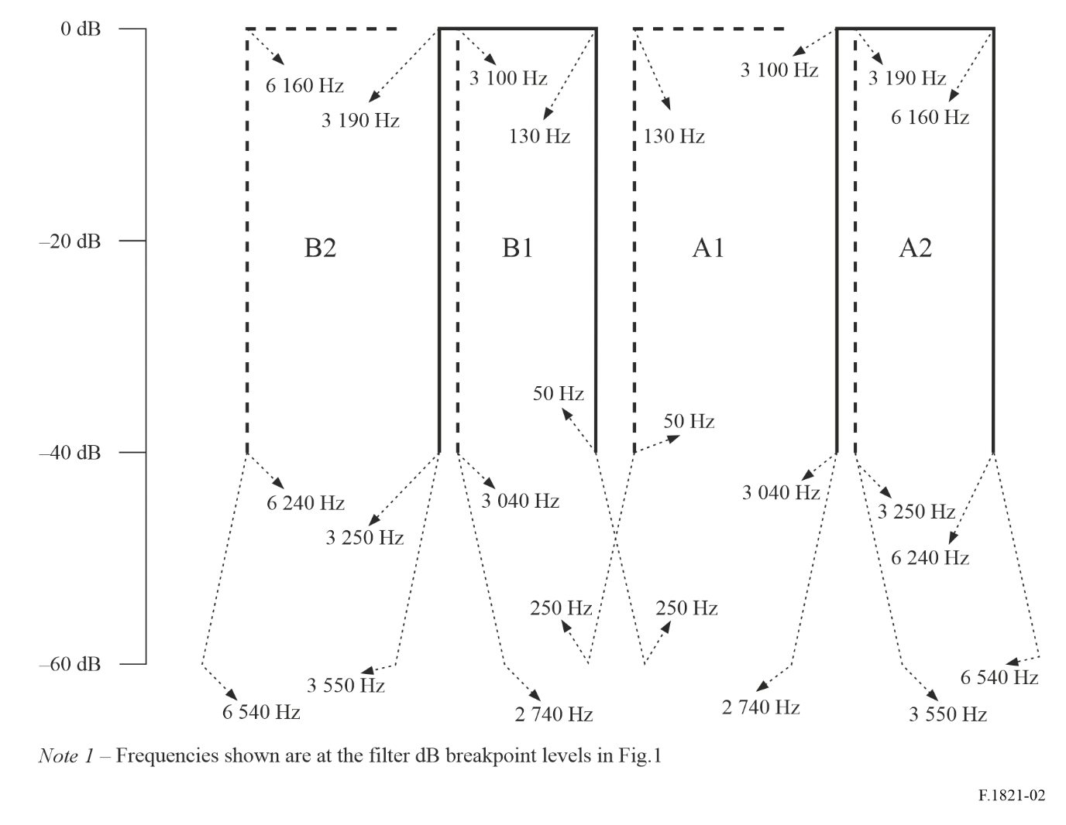

2.3.3 Non-contiguous Multichannel HF equipment
Some systems permit to reach data rate requirements by simultaneous use of up to 16 non-contiguous traditional SSB channels arranged in an (non-overlapping) arbitrary way.
The modulation of such an equipment consists in a set of elementary 3 kHz wide modulators, arranged in a frequency division multiplex. Any elementary modulation is processed and applied to a subcarrier whose frequency value is chosen according to the allocated channels.
All channels shall be contained within a working bandwidth of up to a maximum of 200 kHz.
Each of the channels shall be modulated independently with a common modulation rate of 2 400 bauds. The transmit data clocks for all channels shall be synchronized so that there is no drift.
The frequency of the suppressed carrier shall be the reference frequency, noted f₀.
The amplitude versus frequency response of the transmitter or the receiver over the frequency range (f₀ + 300 Hz) to (f₀ + 3 050 Hz) shall be within 3 dB for all types of equipment. The attenuation shall be at least 20 dB from f₀ to (f₀ − 415 Hz), at least 40 dB from (f₀ − 415 Hz) to (f₀ − 1 000 Hz), and at least 60 dB below (f₀ − 1 000 Hz). Attenuation shall be at least 30 dB from (f₀ + 4 000 Hz) to (f₀ + 5 000 Hz) and at least 60 dB above (f₀ + 5 000 Hz).

2.4 Digital Radio Mondiale (DRM)
The DRM system is a narrow bandwidth orthogonally coded digital data transmission system that has the capability to tailor its transmission characteristics to match the service objectives and radio propagation factors. Each of the various subcarriers is modulated using quadrature amplitude modulation (QAM) in order to carry the information content, which also incorporates forward error correcting code elements. Two primary QAM constellations are used: 64-QAM and 16-QAM. In addition, a quadrature phase-shift keying (QPSK) modulation mode is available for highly robust signalling. The data is also interleaved in time over the subcarriers in order to counter time and frequency selective fading. The European Telecommunications Standards Institute has published the DRM option in its “Data Applications Directory” which can be accessed at http://pda.etsi.org/pda/queryform.asp. In the search function for this webpage enter “data application directory”.

3 Networked systems
Different types of networking protocols could be implemented to support advanced HF systems, such as, and not limited to, Token ring, Time Division Multiple Access (TDMA) and Carrier Sense Multiple Access (CSMA).
The purpose of this section is to describe some networking capabilities that could apply.

3.1 AGILE HF networks
AGILE-HF Systems will operate across portions of the 2 to 30 MHz frequency band to support digital voice (point-to-point and point to multi-point), data transfer and database replication (e.g. financial transactions, logistics, medical records, law enforcement data), remote sensor reporting (e.g. tsunami or meteorological buoys, ice shelf diagnostics, seismic monitoring), emergency management and disaster relief applications along with many other applications such as email, FTP file transfer, chat rooms and video calls across thousands of miles.
Deployment of AGILE-HF (see Fig. 3) networks can be accomplished through the use of Mesh Networks. A mesh network is a group of devices that act as a single Wi-Fi network; and can provide real-time video, high speed data transfers, email, internet access and other network-based services. Within this network all of the devices (points) act as a single network. AGILE-HF systems use RF as the means of connecting the points within the AGILE MESH network providing global connectivity.
An AGILE-HF ALE Mesh Network provides for sensing the occupancy of a frequency and has a-priori knowledge programmed information with regional operational restrictions on channel use; it can calculate and select a frequency based on availability and then release it when finished and select another later.
FIGURE 3
Global AGILE-HF network example
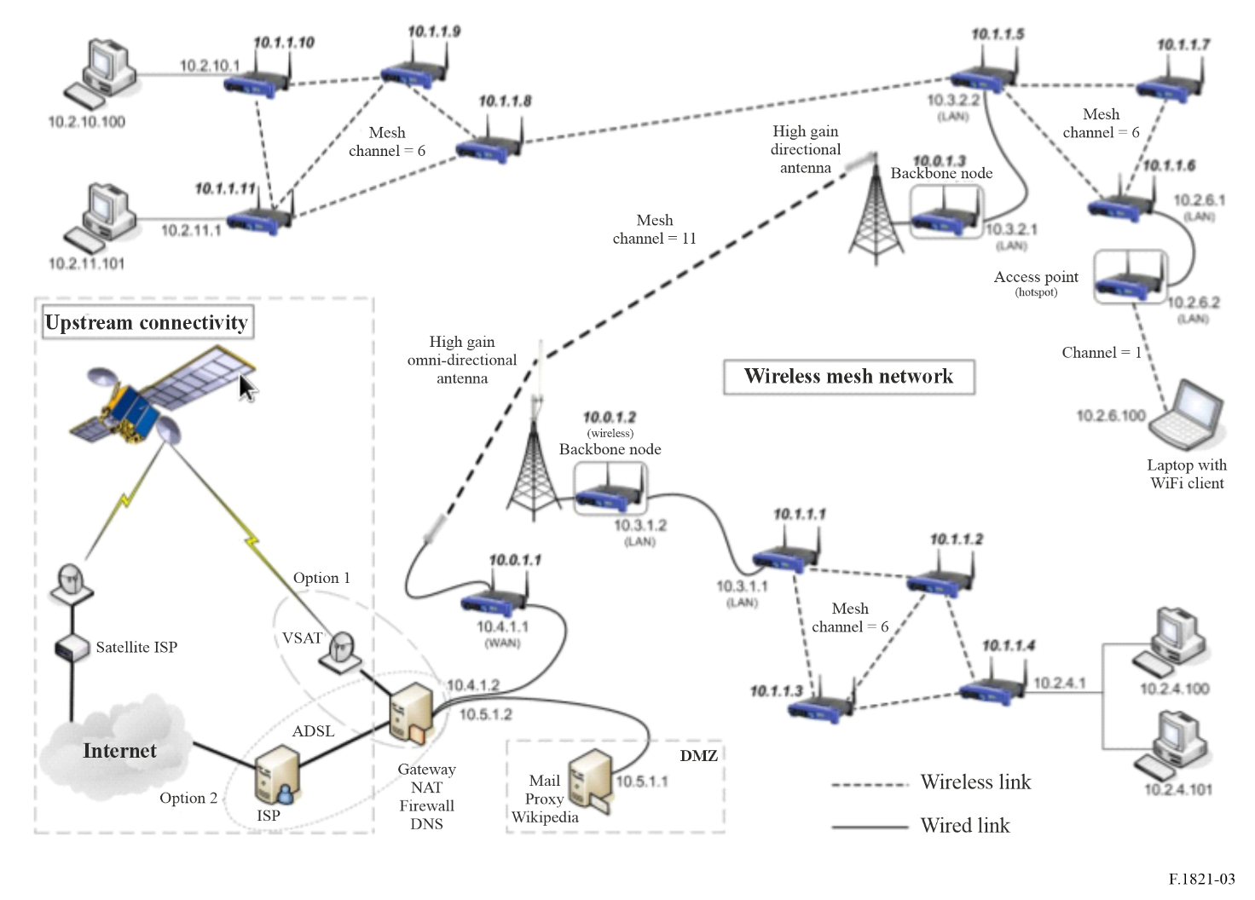
“Sub-nets” within an AGILE-HF Mesh network provide extensibility of the “local” mesh into a farther ranging Wideband HF Mesh (WHFM) with durability of data transport by having layers of single frequency “subnets” to route or reroute information on. The first premise in this description is that all members with emission capacity (radio silence disabled) in any WHFM have a common capacity to receive, catalogue and report local configuration of their node, including spectral conditions – to all other enabled nodes. The second premise is that some number of nodes have more than one AGILE-HF radio and therefore can participate in more than one Mesh “subnet”.
Each “sub-net” in an AGILE-HF Mesh is on a particular frequency for a specific period of time and can adapt its channel bandwidth to reach nodal members of its “subnet” based on their configuration (both hardware and spectral conditions) and that those nodes with dual AGILE-HF radios can gather and re-report this same data from other “subnets” that are on a different frequency.
Any node can be aware of other nodes it can connect through either directly-link or neighboured-link within its frequency “subnet”; and it can identify and use those nodes within it “subnet” that have two or more AGILE-HF radios to extend connections to nodes on other “subnets” which are on a different frequency than its own. And since it has configuration knowledge of nodes on that extended “sub-net” the originating node has record of “sub-net” time-to-live parameters either pre-set or real-time calculated based upon frequency occupation and spectral conditions.
Many AGILE-HF nodes are constantly manoeuvring, so they can join a “subnet” of the network and make use the extensibility as described above. At some time later they can switch frequencies and join the secondary “sub-net” (or even a tertiary, should the second subnet also have dual connection to a third “sub-net”). This capability provides a persistent connection within the AGILE-HF Mesh Network with a high degree of “link durability”.
Descriptions of HF Token Ring, HF multicast, HF Token Mesh and HF ALE Mesh can be found in the corresponding following sections.

4 Multicast technologies
Sharing data access within an HF network can be achieved using a range of multiple access technologies.
Multicasting is an efficient mechanism for disseminating messages through HF Wireless Networks, Multicast IP Routing protocols are used to distribute data (for example, audio/video streaming broadcasts) to multiple recipients. Using multicast, a source can send a single copy of data to a single multicast address, which is then distributed to an entire group of recipients. Multicasting can provide a potentially bandwidth efficient transfer capability, especially when there are many recipients of a message in the same radio network.
Moreover, as a consequence of the long-range nature of HF propagation, many nodes are in direct connectivity with each other, which favours the application of multicast principles.

4.1 Time Division Multiple Access (TDMA)
Time-division multiple access (TDMA) is a frequency channel access method.
It allows several users to share the same frequency channel by dividing the signal into different time slots. The users transmit in rapid succession, one after the other, each using their own time slot. This allows multiple stations to share the same radio frequency channel while using only a part of its channel capacity.
Fixed TDMA protocols are based on static time slot allocation and will be generally inefficient in the context of HF networks to achieve a satisfactory trade-off between latency and link capacity. To improve that, adaptive TDMA principle would be preferred, due to the fact that it permits variations in the time slot allocation to adapt to variations in the traffic generated by the nodes.

4.2 Carrier Sense Multiple Access (CSMA)
Carrier-sense multiple access (CSMA) is also a frequency channel access method.
The Carrier-Sense Media Access (CSMA) is based on a node’s ability to listen to the channel in order to detect another transmission, before initiating a transmission on a shared frequency channel.
If a carrier is sensed, the node waits for the transmission in progress to end before initiating its own transmission. Using CSMA, multiple nodes may, in turn, send and receive on the same frequency channel. Transmissions by one node are generally received by all other nodes connected to the channel.
CSMA provides simple yet effective access sharing mechanism for a limited number of nodes in the HF network, and for a limited traffic load.

4.3 Token Passing Protocols
Robust token management schemes are conducive for sharing data channels in HF networks where packet loss rates can be driven to extreme levels due to unforeseen variations in propagation. Network performance can be seriously degraded if nodes are out of contact. Data rates are degraded under these circumstances. Propagation perturbations can reduce efficiency in spectrum usage by HF networks.
Token passing can provide efficient medium access control in heavily loaded networks. However, it has been perceived to be too fragile for use in networks with non-negligible packet loss rates. In this Recommendation, a token management approach is presented that quickly recovers from common token loss and duplication scenarios, and deals efficiently with changes in network connectivity and membership.
Token passing protocols generally provide mechanisms for nodes to enter and leave the network. When token passing is to be used in a WAN, the characteristics of the wireless medium introduces additional token management issues:
– The node holding the token may lose connectivity to its successor, which can result in a lost token.
– The node holding the token can lose connectivity to the rest of the network. The network loses the token.
– A network may become partitioned. One subnetwork must create a new token.
– A node may be reachable only by one other node, so a ring topology is not possible if that node is to be included.
– Nodes from two or more rings using the same channel may come within range of each other. This results in interference unless the rings merge or change channel(s).
– Merging of rings or recovery from a lost token may result in multiple tokens in a ring.
The approach to recovery from connectivity problems places nodes that are not members of an active token-passing ring into a disconnected or floating state in which they either wait to be invited to join the remaining ring or periodically solicit other connected nodes to join with them.
The long link turnarounds inherent in fielded HFWAN technology result in token rotation times on the order of a minute. For example, if link turnaround times are 2 s and we allow each of N nodes to transmit for up to 8 s when it receives the token, we achieve a throughput efficiency of at most 80% with a token rotation time (latency) of up to 10N s.
If we limit solicitations to join the ring to one per token rotation, and rotate the authority to solicit among the nodes, each node will solicit once in N token rotations.
With ten nodes in a ring, use of the (non-HF oriented) wireless token ring protocol (WTRP) would result in disconnected nodes remaining out of the network for around 10 min (if there are no colliding responses to the eventual SOLICIT_SUCCESSOR); this is not an attractive mode of operation for a dynamic network in the fixed and mobile service.
The time required for WTRP to reform a new ring from the disconnected remains of two colliding rings would be at least that long: a small ring might emerge quickly, but the remaining nodes would then go silent and wait to be invited to join.
The recovery times for HFTP are more attractive. In the case of a lost link, HF requires N slots (whose duration equals a packet plus a turnaround time) to identify a relay. Thereafter, one additional packet time and turnaround time are required in each token rotation. In an example ten-node network, this amounts to a pause of less than 30 s while identifying the relay, and lengthening the token rotation time by a bit over 2%.
In the case of colliding rings, HFTP networks will experience packet collisions until one of the nodes initiates the ring merger, while WTRP nodes will go silent as soon as they detect the foreign ring. However, once a MERGE_RINGS request is received and accepted, the merging rings will resume normal data transfers after (N + 1) packet + turnaround times (i.e. after the SET_SUCCESSOR and the fast token rotation of the DOUBLE_TIME_TOKEN). This amounts to less than 30 s in an example ten-node network, even faster data transfers when wider bandwidths are used.

4.3.1 HF Token Ring
A Token Ring Network (also known as IEEE Standard 802.5) is a data link for a local area network (LAN) in which all devices are connected in a circular or closed loop and pass tokens from host to host (see Fig. 4). A token is a frame of data that is transmitted between network points. Within the Token Ring only a host that holds a token can send data.
FIGURE 4
Token ring
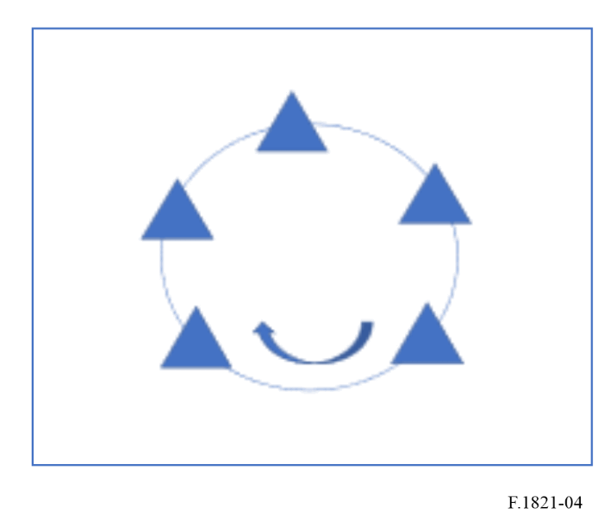
Wireless Token Ring protocol is the base protocol of HF Token Ring Protocol, which is a robust, self-healing, self-coordinating, and distributed MAC layer protocol for ad-hoc networks. The MAC protocol through which mobile stations can share a common broadcast channel is essential in an ad hoc network. Due to the existence of hidden terminals and partially connected network topology, contention among stations in an ad-hoc network is not homogeneous. Some stations can suffer severe throughput degradation in access to the shared channel when load of the channel is high, which also results in unbounded medium access time for the stations. This challenge is addressed as quality of service (QoS) in a communication network.

4.3.2 HF Token Ring Mesh Networks
An HF ALE Mesh does not need to be as rigidly structured as HF token ring Mesh. A HF Mesh would share its pool of frequencies using a listen before transmit channel access protocol. ALE sounding would be used to provide the connectivity information.
An HF Token Ring or an HF Token Ring Mesh Network could be formed by incorporating a routing protocol with either a network of ALE radios or one or token-passing fixed-frequency rings:
– ALE inherently uses multiple frequencies, although only a subset of the ALE frequency pool will be usable for each link in a network.
– Each token-passing ring will normally operate on a single frequency so achieving multiple-frequency operation will require the linking of multiple rings to form the mesh.
Multiple radios per node would be required in a multi-ring token mesh so that relay nodes could simultaneously listen in all of their connected networks (which operate asynchronously).
An example token mesh is shown in Fig. 5. The arrows show the successor-predecessor relationships in each ring. Note that one node acts as a gateway between rings A and B, and B and C.
FIGURE 5
Mesh token ring
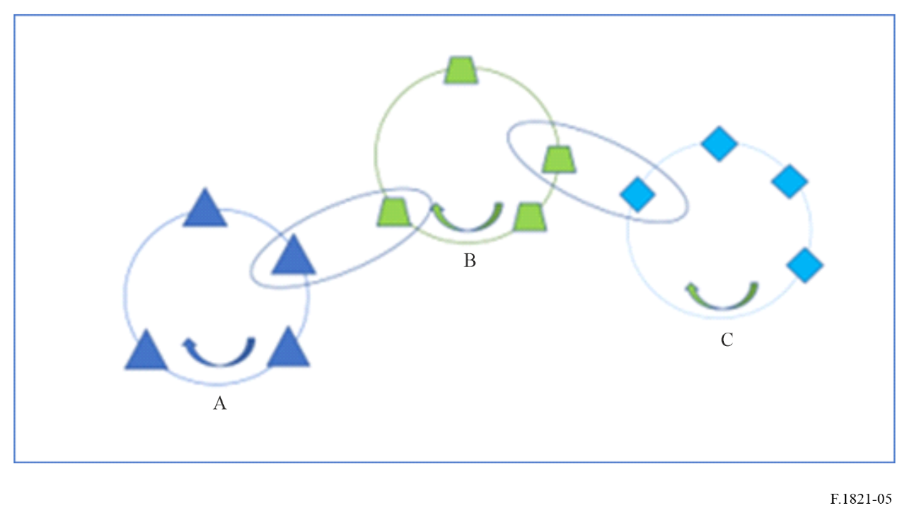
Token passing rings are formed on the fly and re-formed as necessary. To avoid interference, each ring operates on a distinct frequency. Each node is assumed to have a separate radio for each ring in which it participates. A clear advantage of a mesh of HF token LANs over LOS mesh networks is that neighbouring nodes would not interfere with each other.

4.3.3 HF ALE Mesh Network
An HF ALE Mesh does not need to be as rigidly structured as HF token ring Mesh. A HF Mesh would share its pool of frequencies using a listen before transmit channel access protocol. ALE sounding would be used to provide the connectivity information normally obtained by the routing protocol. ALE sounding can include statistics from the nodal token passing process.
An HF ALE Mesh Network relays traffic through an ad-hoc network of HF nodes as shown in Fig. 6. Connectivity in HF networks is not necessarily governed by the geographic location of the nodes. Distant stations that are farther away can be easier to reach than those that are nearby. In Fig. 6 the dark blue nodes are within near vertical incident skywave (NVIS) range of each other; skywave links have been established between other pairs of nodes (green, white dark blue and light blue) by pairwise usable frequency) to form indirect routes.
FIGURE 6
HF ALE mesh network
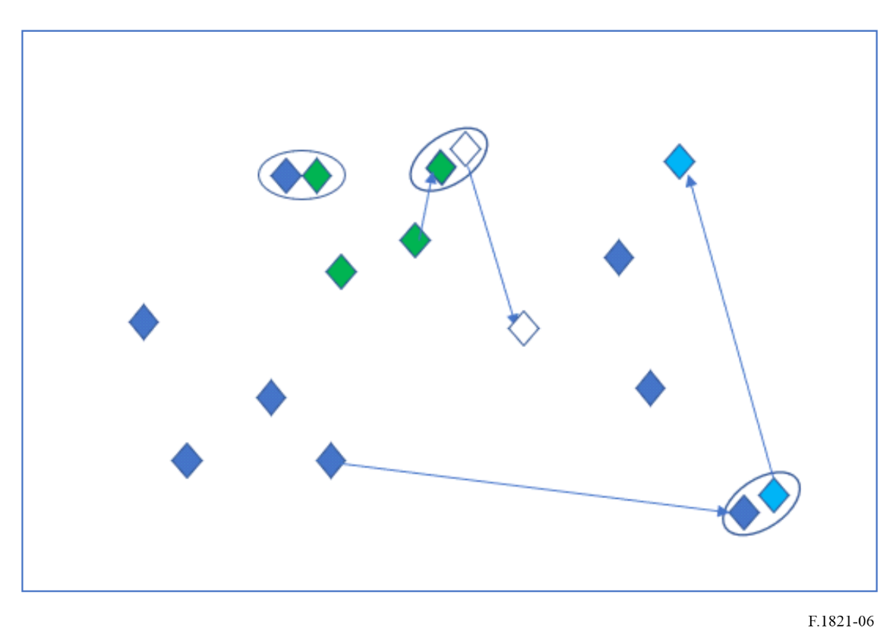

5 Summary
HF radio offers beyond-line-of-sight wireless radiocommunications for applications ranging from extended line-of-sight within a small region to global coverage supporting commercial aviation and maritime distress and e-mail messages. The long-haul links available using transportable HF equipment also provide quick communications into disaster areas where the terrestrial infrastructure may have been severed or destroyed.
Despite this ability to communicate beyond line-of-sight, vagaries of propagation and other environmental effects can sometimes produce outages on some HF links while leaving others intact. Thus, reliability in HF networks is enhanced when indirect routing is supported. Most routes in an HF network usually require only a single link. However, in cases where multiple routing options are necessary to maintain quality of service, a single-relay routing mechanism should be useful.
When multiple HF nodes wish to share a channel for efficient one-to-many as well as one-to-one communications, a channel access protocol is needed. Token Ring Mesh, TDMA, CSMA and ALE Mesh Networks can support this capability. One approach uses a token passing protocol. The narrow-bandwidth, high-delay, and high-loss characteristics of the HF channel place especially stringent operational requirements on token passing protocols.
When operational data transmission requirements exceed the rates that can be achieved in nominal 3 kHz allocations, mechanisms that spread the data transmission over a multitude of such channels may be employed. Wideband modems are available which significantly increase data throughput of a network. Independent sideband operation can support multichannel operation to increase bandwidth while maintaining spectral efficiency.

Attachment
to the Annex
Characteristics for advanced digital radiocommunication systems, such as ISB, contiguous and non-contiguous channels operating in the 2-30 MHz
The parameters listed in the Tables below are typical for systems using the given propagation modes.
TABLE 1
Typical characteristics of advanced digital HF radiocommunication systems (ISB and Contiguous channels systems)
Parameter | Propagation mode
Parameter | Groundwave/Seawave | Sky wave
Parameter | Groundwave/Seawave | NVIS | Oblique incidence
Frequency range (MHz) | Groundwave 2-15  Seawave 3-30 | 2-15 | 3-30
Approximate service area (km) | Up to 40 km (ground)  Up to 370 km (sea) | Up to 300 km | Greater than 300 km
Antenna polarization | Vertical/Horizontal | Vertical/Horizontal | Vertical/horizontal
Antenna directivity gain (dBi) | 0-3 | 0-6 | 0-15
Maximum e.i.r.p. (dBW) | 31 | 27 | 54
S/N (dB) (See Note 1) | SSB 17  DRM 18 | SSB 25  DRM 26 | SSB 26  DRM 26
Necessary bandwidths and types of emission (See NOTE 2) | SSB/ISB: 3, 6, 9, 12, 18, 24, and 48 kHz  3K00J2D, 6K00J2D, 9K00J2D, 12K0J2D, 18K0J2D, 24K0J2D and 48K0J2D
Necessary bandwidths and types of emission (See NOTE 2) | DRM: 3, 4.5, 5, 9, 10 and 20 kHz  3K00J2D, 4K50J2D, 5K00J2D, 9K0J2D, 10K0J2D, 20K0J2D
NOTE 1 – More detailed information on required S/N can be found in Recommendation ITU-R F.339.
NOTE 2 – For emission type the last letter (D) refers to data transmissions. If emission is not data (D), substitute (E) for voice, (C) for facsimile, (W) for combination or (X) for cases not otherwise covered.

TABLE 2
Typical characteristics of advanced digital HF radiocommunication systems (non-contiguous multichannel systems)
Parameter | Propagation mode
Parameter | Groundwave/Seawave | Skywave
Parameter | Groundwave/Seawave | NVIS | Oblique incidence
Frequency range (MHz) | Groundwave 2-15  Seawave 3-30 | 2-15 | 3-30
Approximate service area | Up to 40 km (ground)  Up to 370 km (sea) | Up to 300 km | Greater than 300 km
Antenna polarization | Vertical/Horizontal | Vertical/Horizontal | Vertical/Horizontal
Transmitting antenna directivity gain (dBi) | 0-3 | 0-6 | 0-15
Transmitter power PX (dBW) | 10-30 | 10-22 | 10-40
S/N per channel (dB) (See Note 1) | 17 | 25 | 25
Necessary bandwidth | SSB: 3 kHz,  ISB: 6 kHz
Type of emission per channel (See Note 2) | 3K00J2D
Sensitivity for 10 dB SINAD in 3 kHz (dBm) | −110 to −130
Receiver IF filter bandwidth (kHz) | > 200 kHz
NOTE 1 – 1 second interleaver, 16 channels.
NOTE 2 – For emission type the last letter (D) refers to data transmissions. If emission is not data (D), substitute (E) for voice, (C) for facsimile, (W) combination or (X) for cases not otherwise covered.

TABLE 3
Typical RF characteristics of AGILE-HF systems (transmitter for ISB and contiguous channels systems)
AGILE advanced HF transmitter parameters | Groundwave/  Seawave | Skywave/  NVIS | Skywave/  Oblique Incidence
Frequency range (MHz) | 2-30  Groundwave 2-15  Seawave 3-30 | 2-15 | 3-30
Channel bandwidth (kHz) | Variable 3-48 | Variable 3-48 | Variable 3-48
Transmitter power (dBW) | 30 | 22 | 40
Feeder loss (dB) | 2.2 | 1.5 | 1.1
Antenna directivity gain (dBi) | 0-3 | 0-6 | 0-15
Antenna height above ground level (AGL) to the centre of the antenna (m) | 20-60 | 1-4 | 1-4
Antenna polarization | Horizontal/Vertical | Horizontal/Vertical | Horizontal/Vertical
TABLE 3 (end)
AGILE advanced HF transmitter parameters | Groundwave/  Seawave | Skywave/  NVIS | Skywave/  Oblique Incidence
Antenna type | Broadband omni | Narrowband monopole | Narrowband dipole  Broadband Dual Fan-Wire
Maximum e.i.r.p. (dBW) | 31 | 27 | 54
Modulation | AM/FM/PSK/FSK/  QAM/OFDM | AM/FM/PSK/FSK/  QAM/OFDM | FM/PSK/FSK/  QAM/OFDM

TABLE 4
Typical RF characteristics of AGILE-HF systems (transmitter for non-contiguous multichannel systems)
AGILE advanced HF transmitter parameters | System supporting Groundwave | System supporting Seawave | System supporting Skywave/  NVIS | System supporting Skywave/  Oblique incidence
Frequency range (MHz) | 2-15 | 3-30 | 2-15 | 3-30
Individual SSB Channel bandwidth (kHz) | 3 | 3 | 3 | 3
Number of simultaneous non-contiguous SSB channels | Up to 16 | Up to 16 | Up to 16 | Up to 16
Aggregated non-contiguous bandwidth (kHz) | Up to 200 | Up to 200 | Up to 200 | Up to 200
Transmitter power (dBW) | 30 | 30 | 22 | 40
Feeder loss (dB) | < 1 | < 1 | < 1 | < 1
Antenna directivity gain (dBi) | 0-3 | 0-3 | 0-6 | 0-15
Antenna height above ground level (AGL) to the centre of the antenna (m) | 5 to 10 | 5 to 12 | 2 to 12 | > 12
Antenna polarization | Vertical/  Horizontal | Vertical/  Horizontal | Vertical/  Horizontal | Vertical/  Horizontal
Antenna type | Whip | Whip | Dipole/Loop | Dipole/Loop
Maximum e.i.r.p. (dBW) | 33 | 33 | 28 | 55
Modulation | AM/FM/PSK/FSK/QAM/  OFDM | AM/FM/PSK/  FSK/QAM/  OFDM | FM/PSK/QAM/OFDM | FM/PSK/FSK/  QAM/OFDM
Typical minimum path length (km) | 0 to 40 | 0 to 300 | 0 to 1 000 | 300 to 5 000

TABLE 5
Typical RF characteristic of AGILE-HF (receiver of ISB and Contiguous channels Systems)
AGILE HF receiver parameters | Groundwave/  Seawave | Skywave/NVIS | Skywave/Oblique incidence
Frequency range (MHz) | 2-30  Groundwave 2-15  Seawave 3-30 | 2-15 | 3-30
Bandwidth (kHz) | Variable 3-48 | Variable 3-48 | Variable 3-48
Sensitivity (dBm)
SSB for 10 dB SINAD | −110 to −130 | −110 to −130 | −110 to −130
ISB for 10 dB SINAD | −125 to −130 | −125 to −130 | −125 to −130
CW for 10 dB SINAD | −110 to −130 | −110 to −130 | −110 to −130
S/N (dB) (see Note)
PSK | 5 | 12 | 14
FSK | 8 | 18 | 18
QAM | 14 | 24 | 24
OFDM | 16 | 26 | 30
Feeder loss (dB) | 2.2 | 1.5 | 1.1
Antenna directivity gain (dBi) | 0-3 | 0-6 | 0-15
Antenna height above (AGL) ground level to the centre of the antenna (m) | 20-60 | 1-4 | 1-4
Antenna polarization | Horizontal/Vertical | Horizontal/Vertical | Horizontal/Vertical
NOTE – S/N listed here depend on bandwidth for systems that operate under the indicated propagation modes.
TABLE 6
Typical RF characteristics of AGILE-HF systems (receiver of non-contiguous multichannel systems)
AGILE HF receiver parameters | System supporting Groundwave | System supporting Seawave | System supporting Skywave/  NVIS | System supporting Skywave/  Oblique incidence
Frequency range (MHz) | 2-15 | 3-30 | 2-15 | 3-30
Bandwidth (kHz) | 200 | 200 | 200 | 200
Receiver noise factor (dB) | 10-20 | 10-20 | 10-20 | 10-20
Feeder loss (dB) | < 1 | < 1 | < 1 | < 1
Antenna directivity gain (dBi) | 0-3 | 0-3 | 0-6 | 0-15
Antenna height AGL to the centre of the antenna (m) | 1 to 10 | 1 to 12 | 3 to 12 | 3 to 20
Antenna polarization | Vertical/  Horizontal | Vertical/  Horizontal | Vertical/  Horizontal | Vertical/  Horizontal
Typical minimum path length (km) | 0 to 40 | 0 to 300 | 0 to 1 000 | 300 to 5 000

* In the frequency range of 2-30 MHz.
Report ITU-R SM.2152 – Definitions of Software Defined Radio (SDR) and Cognitive Radio System (CRS), Section two "Definition of Cognitive Radio System (CRS) “Cognitive radio system (CRS).
See Recommendation ITU-R V.573 reflected at the ITU Terms and Definitions database.
See Recommendation ITU-R P.2146.
Some systems described in this Recommendation operate from 2 MHz, noting HF starts at 3 MHz.
For more details, see Recommendation ITU-R P.533.
Analysis of Multiple Frequency HF Networks Versus Single Frequency Toke Ring Networks”; Gillespie, Trinder; 2006 10th IET International Conference on Ionospheric Radio Systems and Techniques; IRST 2006.
HF Radio Mesh Networks; Eric E. Johnson, http://tracebase.nmsu.edu/hf/papers/hf_mesh.pdf.
“Third-Generation and Wideband HF Radio Communications”; Johnson, Koski, Furman, Jorgenson and Nieto; 2013 Artech House.
“Analysis of Multiple Frequency HF Networks Versus Single Frequency Token Ring Networks”; Gillespie, Trinder; 2006 10th IET International Conference on Ionospheric Radio Systems and Techniques; IRST 2006.

