Recommendation ITU-R F.1762-1
(02/2026)
F Series: Fixed service
Characteristics of enhanced applications of High Frequency radiocommunication systems in the fixed and mobile service

Foreword
The role of the Radiocommunication Sector is to ensure the rational, equitable, efficient and economical use of the radio-frequency spectrum by all radiocommunication services, including satellite services, and carry out studies without limit of frequency range on the basis of which Recommendations are adopted.
The regulatory and policy functions of the Radiocommunication Sector are performed by World and Regional Radiocommunication Conferences and Radiocommunication Assemblies supported by Study Groups.

INTELLECTUAL PROPERTY RIGHTS
ITU draws attention to the possibility that the practice or implementation of this Recommendation may involve the use of a claimed Intellectual Property Right. ITU takes no position concerning the evidence, validity or applicability of claimed Intellectual Property Rights, whether asserted by ITU members or others outside of the Recommendation development process.
As of the date of approval of this Recommendation, ITU had received notice of intellectual property, protected by patents, which may be required to implement this Recommendation. However, implementers are cautioned that this may not represent the latest information and are therefore strongly urged to consult the appropriate ITU-R patent information available at https://www.itu.int/en/ITU-R/study-groups/Pages/itu-r-patent-information.aspx.

Series of ITU-R Recommendations
(Also available online at https://www.itu.int/publ/R-REC/en)
Series | Title
BO | Satellite delivery
BR | Recording for production, archival and play-out; film for television
BS | Broadcasting service (sound)
BT | Broadcasting service (television)
F | Fixed service
M | Mobile, radiodetermination, amateur and related satellite services
P | Radio-wave propagation
RA | Radio astronomy
RS | Remote sensing systems
S | Fixed-satellite service
SA | Space applications and meteorology
SF | Frequency sharing and coordination between fixed-satellite and fixed service systems
SM | Spectrum management
SNG | Satellite news gathering
TF | Time signals and frequency standards emissions
V | Vocabulary and related subjects

Note: This ITU-R Recommendation was approved in English under the procedure detailed in Resolution ITU-R 1.

Electronic Publication
Geneva, 2026
© ITU 2026
All rights reserved. No part of this publication may be reproduced, by any means whatsoever, without written permission of ITU.

RECOMMENDATION ITU-R F.1762-1
Characteristics of enhanced applications of High Frequency* radiocommunication systems in the fixed and mobile service
(2006-2026)
Scope
This Recommendation describes the typical technical characteristics for radiocommunication systems operating in the frequency range 2-30 MHz to provide enhanced digital applications.
Keywords
Enhanced applications, channel bandwidth, video streams, file transfer, voice over IP
Abbreviations
BPSK Binary phase shift keying
e.i.r.p. Equivalent isotropically radiated power
FSK Frequency shift keying
HF High frequency
NVIS Near vertical incidence skywave
OFDM Orthogonal frequency division multiplexing
PSK Phase shift keying
PX Peak envelope power
PY Mean power
QAM Quadrature amplitude modulation
RF Radio frequency
SINAD Signal to interference ratio including noise and distortion
SSB Single sideband modulation
S/N Signal-to-noise ratio
VoIP Voice over Internet protocol
Terms and definitions
Ground wave A radio wave basically determined by the properties of the ground which propagates in the troposphere, and which is mainly due to diffraction around the Earth
Seawave Groundwaves over water
Skywave The propagation of radio waves reflected or refracted back toward Earth from the ionosphere
Related ITU-R Recommendations and Reports
Recommendation ITU-R BS.80 – Transmitting antennas in HF broadcasting
Recommendation ITU-R F.240 – Signal-to-interference protection ratios for various classes of emission in the fixed service below about 30 MHz
Recommendation ITU-R SM.326 – Determination and measurement of the power of amplitude-modulated radio transmitters
Recommendation ITU-R F.339 – Bandwidths, signal-to-noise ratios and fading allowances in complete systems
Recommendation ITU-R V.573 – Radiocommunication vocabulary
Recommendation ITU-R BS.705 – HF transmitting and receiving antennas characteristics and diagrams
Recommendation ITU-R F.1610 – Planning, design and implementation of HF fixed service radio systems
Recommendation ITU-R F.1611 – Prediction methods for adaptive HF system planning and operation
Recommendation ITU-R BS.1698 – Evaluating electromagnetic fields from terrestrial broadcasting transmitting systems to assess human exposure to non-ionizing emissions
Recommendation ITU-R F.1761 – Characteristics of HF fixed radiocommunication systems
Recommendation ITU-R F.1778 – Channel access requirements for HF adaptive systems in the fixed and land mobile services
Recommendation ITU-R F.1821 – Characteristics of advanced digital high frequency (HF) radiocommunication systems
Recommendation ITU-R P.2146 – Sea surface bistatic scattering
Report ITU-R BS.458 – Characteristics of systems in LF, MF and HF broadcasting
Report ITU-R F.2061 – HF fixed radiocommunications systems
Report ITU-R F.2062 – Enhanced high frequency digital radiocommunication systems capable of providing enhanced applications
Report ITU-R F.2087 – Requirements for high frequency (HF) radiocommunication systems in the fixed service
Report ITU-R F.2484– Cooperative frequency competition model and the corresponding algorithms
The ITU Radiocommunication Assembly,
considering
a) that some high frequency (HF) systems can be used to provide enhanced applications for electronic messaging systems (e-mail), digital voice, IP based applications and large file transfer providing a communications path to the Internet for exchanging information;
b) that the increasing use of spectrum in the HF bands for enhanced applications such as electronic messaging systems, both with and without attachments, should be taken into account;
c) that such HF systems are not standardized in use and may have different operational technical characteristics;
d) that with electronic messaging, and other enhanced applications for HF systems, equipment interoperability is an important issue,
recognizing
that the frequency range 2 to 30 MHz is also allocated to several other services on a primary basis,
noting
a) that such HF systems are capable of providing routine and emergency public protection and disaster relief;
b) that HF digital networks utilizing increased contiguous channel bandwidths or non-contiguous multichannel equipment can be used as a mechanism for providing enhanced applications;
c) that additional information on such HF systems capable of providing enhanced applications can be found in Report ITU-R F.2062,
recommends
that the technical and operational characteristics of those systems providing enhanced applications, including electronic messaging and other Internet capability, described in the Annex should be considered representative of those systems operating in the frequency range between 2 and 30 MHz.

Annex
Characteristics of radio systems operating in the frequency range 2-30 MHz
to provide enhanced applications

TABLE OF CONTENTS
Page
1 Introduction 3
2 HF Transmitter/Receiver RF technical characteristics 4
3 Typical HF Antenna Patterns 7
4 Emission characteristics 8

1 Introduction
Enhanced applications that can be supported over HF include:
a) messaging, also known as e-mail,
b) voice over Internet protocol, also known as VoIP,
c) interactive Internet applications;
d) large file transfer; and
e) real-time video streams over HF.
In the event of the collapse or overload of normal telecommunication operation due to natural disasters (e.g. earthquakes) and other emergencies, applications for enhanced HF systems using fixed, transportable and mobile stations could provide emergency links during the first phase of the alarm or during the coordination of the relief operation.

2 HF transmitter/receiver RF technical characteristics
Tables 1 to 6 contain technical characteristics of representative HF systems capable of providing enhanced applications. Table 1 provides common technical characteristics for several parameters of the HF systems provided in Tables 2 to 6. These characteristics are sufficient for general calculation to assess the compatibility between these systems and systems operating in other services.
In Table 2, protection ratios are specified as the ratio of wanted-to-unwanted average powers (PY). This contrasts with Recommendation ITU-R F.240 where the ratios are expressed in peak envelope powers (PX). Conversion from PX to PY is waveform dependent for both wanted and unwanted signals. Conversion factors can be obtained from Recommendation ITU-R SM.326.
The parameters in Table 1 apply to the Groundwave, Seawave, Skywave and Near Vertical Incidence Skywave (NVIS) systems that are listed in Table 2.
Table 6 is dedicated to enhanced systems using non-contiguous multichannel equipment. These enhanced systems permit the simultaneous use of up to 16 non-contiguous traditional single-sideband modulation (SSB) channels arranged in an (non-overlapping) arbitrary way. The modulation of such an equipment consists in a set of elementary 3 kHz wide modulators, arranged in a frequency division multiplex. Any elementary modulation is processed and applied to a subcarrier whose frequency value is chosen according to the allocated channels. All channels shall be contained within a working bandwidth of up to a maximum of 200 kHz.
TABLE 1
Typical radio frequency characteristics for HF systems
Parameter | Value
Necessary bandwidth (kHz) | 3
Feeder loss (dB) | 1
Receiver bandwidth (kHz) | 3
Receiver maximum RF bandwidth (kHz)  (Contiguous channel bandwidth) (See Note) | 3-48
Receiver maximum RF bandwidth (kHz)  For n-number of non-contiguous channels | up to 200
Typical receiver noise figure (dB) | 10-20
NOTE – This parameter describes the range of RF bandwidth for the case of systems aggregating multiple channels simultaneously, either in contiguous or non-contiguous manner.

TABLE 2
Typical radio frequency characteristics of HF systems (See Note)
Parameter | System
Mode of operation | Groundwave/ Seawave | Skywave  (oblique) | NVIS  Near vertical
Frequency range (MHz) | Groundwave 2-15  Seawave 3-30 | 3-30 | 2-15
Transmitter power PX (dBW) | 10-30 | 0-26 | 10-26
Antenna directivity gain (dBi) | 6 | 3 | 0
Maximum e.i.r.p. (dBW) | 33 | 26 | 23
Antenna polarization | Vertical/  Horizontal | Vertical/ Horizontal | Vertical/ Horizontal
Protection ratio PY (dB) | 21 | 28 | 10
S/N (Recommendation ITU-R F.339) | 21 | 28 | 10
NOTE – The S/N in Table 2 are for a binary phase shift keying (BPSK) system with a 3 kHz channel bandwidth.
TABLE 3
Typical RF characteristic of enhanced HF systems for channel bandwidths of 3 to 48 kHz
(transmitter for ISB and contiguous channels systems)
Enhanced HF transmitter parameters | Groundwave/  Seawave | Skywave/NVIS | Skywave/Oblique incidence
Frequency range (MHz) | 2-30  Groundwave 2-15  Seawave 3-30 | 2-15 | 3-30
Channel bandwidth (kHz)  (see Note) | Variable 3-48 | Variable 3-48 | Variable 3-48
Transmitter power (dBW) | 30 | 22 | 40
Feeder loss (dB) | 2.2 | 1.5 | 1.1
Antenna directivity gain (dBi) | 0-3 | 0-6 | 0-15
Antenna height above ground level to the centre of the antenna (m) | 20-60 | 1-60 | 1-4
Antenna polarization | Horizontal/Vertical | Horizontal/Vertical | Horizontal/Vertical
Antenna type | Broadband Omni | Narrowband Monopole | Narrowband Dipole Broadband Dual Fan-Wire
Maximum e.i.r.p. (dBW) | 31 | 27 | 54
Modulation | AM/FM/PSK/FSK/ QAM/OFDM | AM/FM/PSK/FSK/ QAM/OFDM | FM/PSK/FSK/QAM/ OFDM
NOTE – Channel bandwidths of 24 kHz within the 3-30 MHz frequency range have been recognized and defined in Recommendation ITU-R F.339, existing Table 4a.

The parameters in Table 4 apply to Groundwave, Skywave and NVIS Systems operating within the 2-30 MHz frequency range. Additional parameters are listed in Table 5.
TABLE 4
Typical receiver characteristics of enhanced HF systems for channel bandwidths of 3 to 48 kHz (See Note) (ISB and contiguous channels systems)
Enhanced HF receiver parameters | Values
Channel bandwidth (kHz) | from 3 to 48
Variable (3 kHz to 12 kHz) | 12
Variable (3 kHz to 18 kHz) | 18
Variable (3 kHz to 24 kHz) | 24
Variable (3 kHz to 48 kHz) | 48
Filter bandwidth (kHz) | 48
Sensitivity (dBm)
SSB for 10 dB SINAD | −110 to −130
ISB for 10 dB SINAD | −125 to −130
CW for 10 dB SINAD | −110 to −130
NOTE – Channel bandwidths of 3, 6, 9, 12, 15, 18, 21, 24, 27, 30, 33, 36, 39, 42, 45 or 48 kHz can also be applicable, as a function of the application.

TABLE 5
Typical RF characteristic of enhanced HF systems for channel bandwidths of 3 to 48 kHz
(receiver of ISB and contiguous channels systems)
Enhanced HF receiver parameters | Groundwave/ Seawave | Skywave/ NVIS | Skywave/Oblique incidence
S/N (dB) (See Note)
PSK | 5 | 12 | 14
FSK | 8 | 18 | 18
QAM | 14 | 24 | 24
OFDM | 16 | 26 | 30
Feeder loss (dB) | 2.2 | 1.5 | 1.1
Antenna directivity gain (dBi) | 0-3 | 0-6 | 0-15
Antenna height above ground level to the centre of the antenna (m) | 20-60 | 1-4 | 1-4
Antenna polarization | Horizontal/Vertical | Horizontal/Vertical | Horizontal/Vertical
Antenna type | Broadband Omni | Narrowband Monopole | Broadband Dual Fan-Wire
NOTE – The S/N in Table 5 are given in a waveform’s necessary bandwidth and are typical of systems that operate under the indicated propagation modes.
TABLE 6
Typical characteristics of enhanced HF systems (non-contiguous multichannel systems)
Parameter | Propagation mode
Parameter | Groundwave/  Seawave | Skywave
Parameter | Groundwave/  Seawave | NVIS | Oblique incidence
Frequency range (MHz) | Groundwave 2-15  Seawave 3-30 | 2-15 | 3-30
Approximate service area (km) | Up to 40 (ground)  Up to 370 (sea) | Up to 300 | Greater than 300
Antenna polarization | Vertical/Horizontal | Vertical/horizontal | Vertical/horizontal
Transmitting antenna gain (dBi) | 0-3 | 0-6 | 0-15
Transmitter power PX (dBW) | 10-30 | 10-22 | 10-40
S/N per channel (dB) (See Note 1) | 17 | 25 | 25
Necessary bandwidth (kHz) | SSB: 3, ISB: 6
Type of emission (See Note 2) | 3K00J2D
Sensitivity for 10 dB SINAD in 3 kHz (dBm) | −110 to −130
Type of modulation | AM/FM/PSK/FSK/QAM/OFDM
Receiver IF filter bandwidth (kHz) | > 200 kHz
NOTE 1 – One second interleaver, 16 channels.
NOTE 2 – For emission type the last letter (D) refers to data transmissions. If emission is not data (D), substitute (E) for voice, (C) for facsimile, (W) combination or (X) for cases not otherwise covered.

3 Typical HF antenna patterns
HF Systems utilize a variety of antenna types as a function of operational range. For short range applications, conventional whip antennae are typically mounted on man-packs and vehicles. Medium range Skywave NVIS applications utilize loop, bent whips and dipoles. Long range use large vertical whip antennas, yagi and log-periodic antennas. Dipoles that are higher above ground are also used for long range applications.
Antenna patterns for typical HF antenna types; Whip, Loop, Bent Whip, Dipole and Log-Periodic, can be found in Recommendation ITU-R BS.705. Additional antenna patterns can be found in the Annex 1 to Recommendation ITU-R BS.705 and include curtain antennas with different feeding arrangements and reflector types, tropical antennas, horizontal and vertical log-periodic, rhombic, quadrant, cross dipole and vertical monopoles. Attachments 1 and 2 to the Annex to Recommendation ITU-R BS.1698 compare calculated field strengths near broadcasting antennas and measurements. Additional information and data regarding HF Broadcasting antennas can be found in Recommendation ITU-R BS.80.

4 Emission characteristics
Table 7 provides the emission masks for HF systems utilizing channel bandwidths of up to 48 kHz, where Type A applies to fixed transmitter installations on land-based sites, maritime and aircrafts (both fixed wing and rotary). The transmit power is typically greater than 150 W PX. Type B radio systems apply to transmitters that are mounted and/or dismounted on vehicles. The transmit power is typically up to 150 W PX. Requirements for unwanted emissions are defined to achieve reasonable non-interference conditions between receivers and distant transmitters. Figures 1 and 2 illustrate these spectrum masks that can be applicable to any system utilizing the channel bandwidths that are listed in Tables 1 to 5.
TABLE 7
Emission Mask for HF Systems with channel bandwidths of up to 48 kHz
Measurement frequency (Hz) | Spectral power density limit (dBc/Hz)
Measurement frequency (Hz) | Type B transmitters | Type A transmitters
$$f_{c}-1.0B≤f_{m}≤f_{c}-0.5B-500 Hz$$  $$f_{c}+0.5B+500 Hz≤f_{m}≤f_{c}+1.0B$$ | −65 | −75
$$f_{c}-2.5B≤f_{m}≤f_{c}-1.0B$$  $$f_{c}+1.0B+500 Hz≤f_{m}≤f_{c}+1.0B$$ | −70 | −80
$$f_{c}-4.0B≤f_{m}<f_{c}-2.5B$$  $$f_{c}+2.5B<f_{m}≤f_{c}+4.0B$$ | −85 | −95
$${MIN\{0.95f}_{c},f_{c}-0.25 MHz\}<f_{m}<(f_{c}-4.0B)$$  $$(f_{c}+4.0B)<f_{m}<MAX\{1.05f_{c},f_{c}+0.25 MHz)$$ | −95 | −105
$$f_{m}<MIN\{0.95f_{c},f_{c}-0.25 MHz\}$$  $$f_{m}<MIN\{0.95f_{c},f_{c}-0.25 MHz\}$$ | −125 | −125
where:
$f_{m}$ = frequency of measurements (Hz)
$f_{c}$ = centre frequency of bandwidth (Hz)
B = necessary bandwidth (Hz)
Figure 1
Type B transmitters
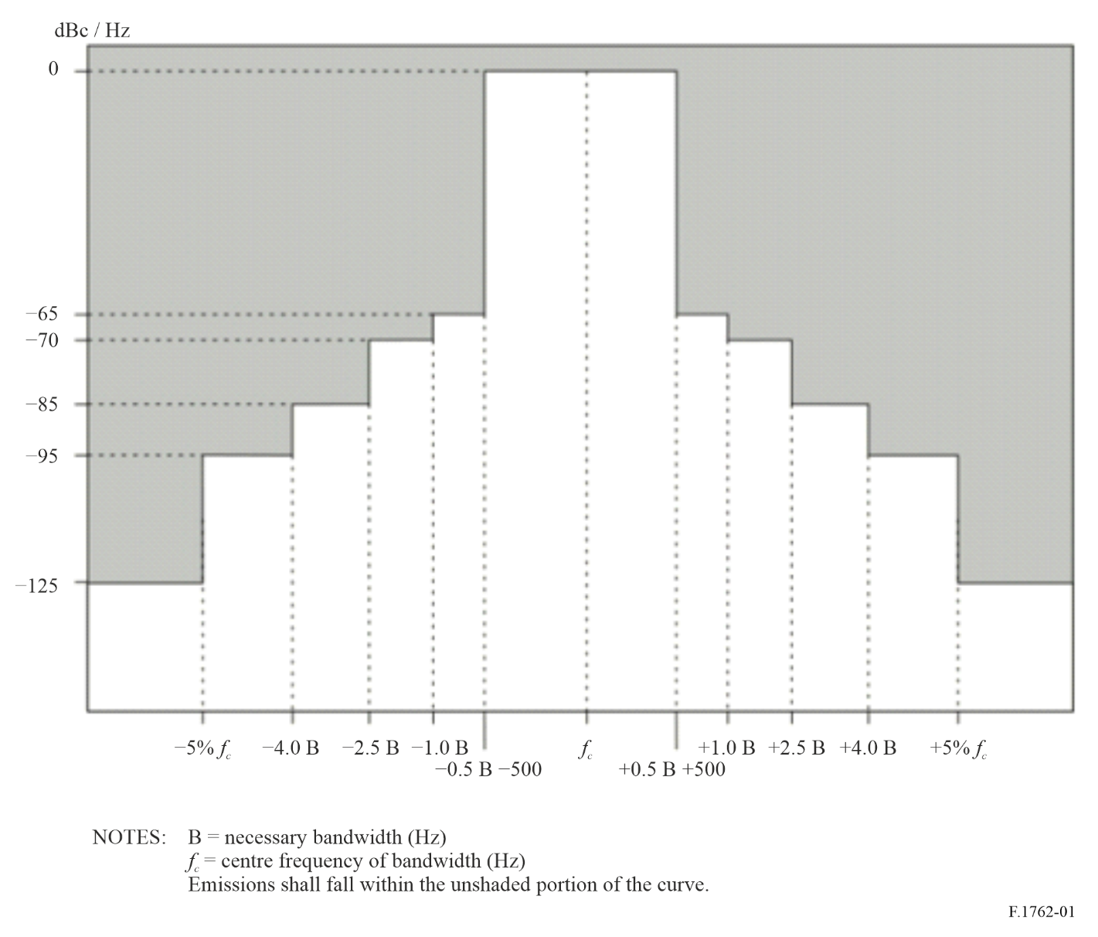
Figure 2
Type A transmitters
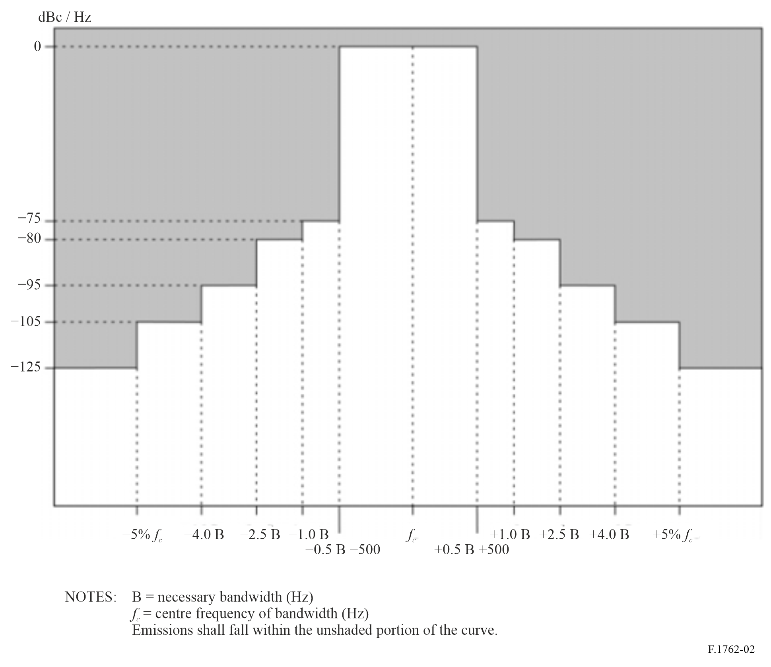
Table 8 illustrates the spectrum mask that can be applicable to any enhanced system using non-contiguous multichannel equipment.
When the transmitter is driven to rated PX with a non-contiguous multichannel transmission waveform, the power spectral density of the transmitter broadband emission shall not exceed the levels given in the following spectrum mask table.
Spectral density is specified in dBc/Hz, with the reference representing the rated PX of the transmission of the total waveform (including all individual 3 kHz channels).
Type B and Type A transmitter typologies follow the above term in § 4.
TABLE 8
Emission mask for HF systems using non-contiguous multichannel equipment
Measurement frequency | Spectral power density limit [(dBc/Hz)
Measurement frequency | Type B  transmitters | Type A  transmitters
2 000 Hz ≤ f_{d} ≤ 3 000 Hz | −65 | −75
3 000 Hz < f_{d} ≤ 4 500 Hz | −70 | −80
4 500 Hz < f_{d} ≤ 12 kHz | −85 | −95
12 kHz < f_{d} < Max{250 kHz, 5% f_{c} kHz} | −95 | −105
Max {250 kHz, 5% f_{c} kHz} < f_{d} | −125 | −125
where:
f_{d} = frequency difference to the closest carrier centre frequency
f_{c} = centre frequency of bandwidth.

For Type B radio systems, the power of any discrete frequency (non-harmonic) spurious emission shall be at least 40 dB below the peak envelope power within ±12 kHz of each individual 3 kHz carrier frequency and at least 50 dB below the peak envelope power at any other frequency.
For Type A radio systems, the power of any such spurious emission shall be at least 40 dB below the peak envelope power within ±12 kHz of each individual carrier frequency, at least 60 dB below the peak envelope power between ±12 kHz and ±5% removed from each individual carrier frequency, and at least 80 dB below the peak envelope power at any other frequency. These shall be measured when the HF transmitter is transmitting modulated 3 kHz channels multicarrier signals at full rated PX power.
Figures 3 and 4 illustrate spectrum mask that can be applicable to any enhanced system using non-contiguous multichannel equipment.
FIGURE 3
Spectrum mask for enhanced systems using non-contiguous multichannel equipment
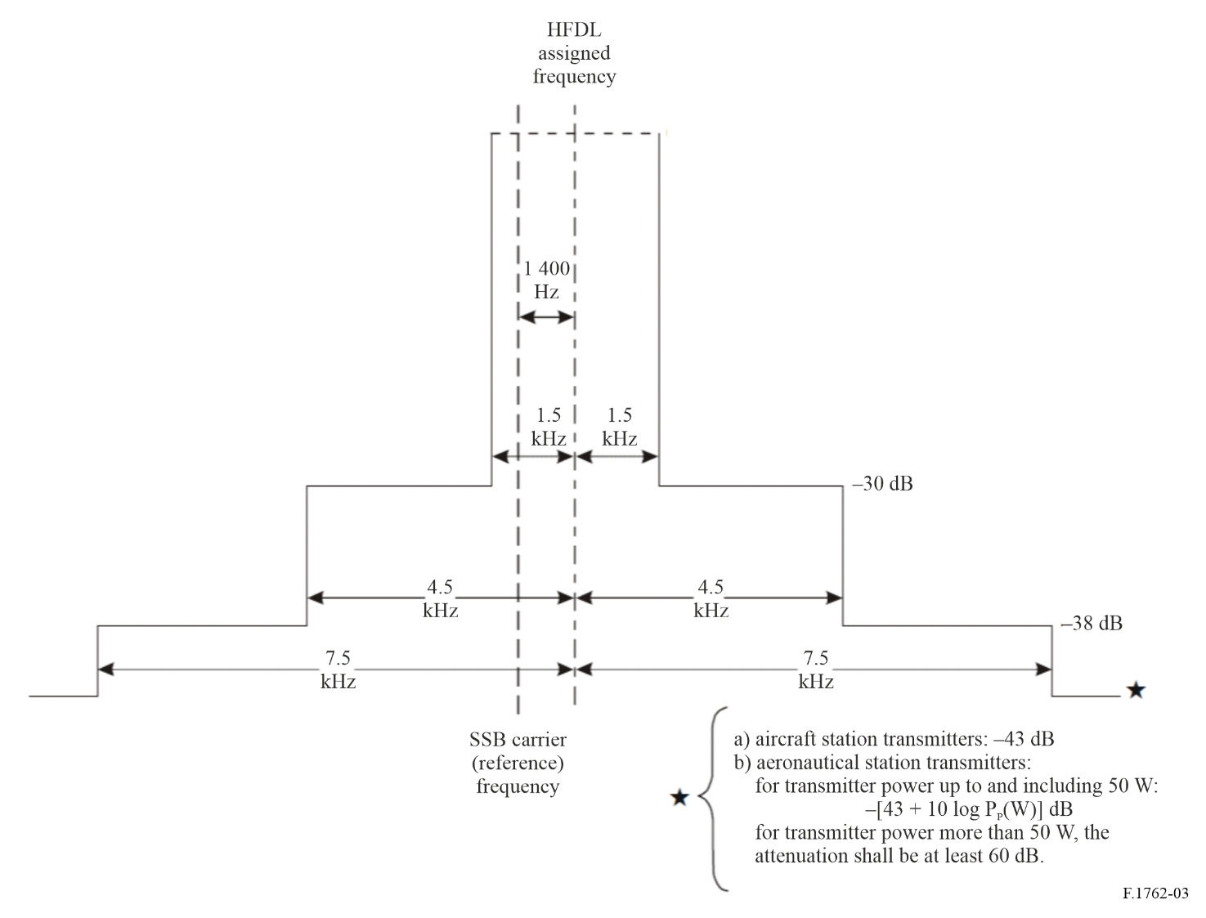
FIGURE 4
Spectrum mask for enhanced systems using non-contiguous multichannel equipment
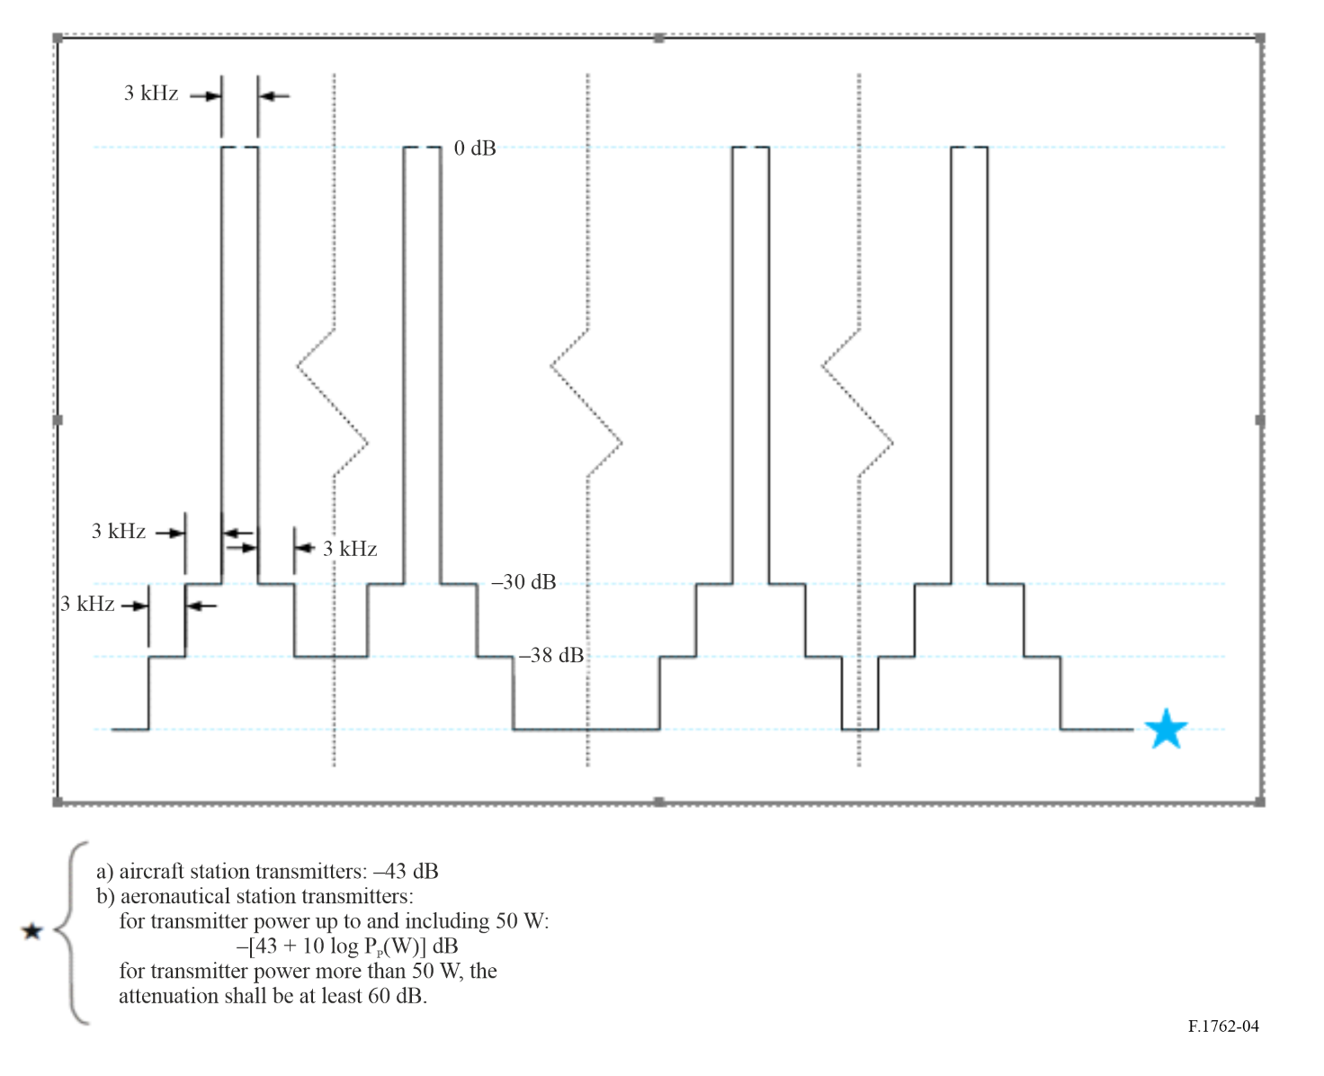

* in the frequency range 2-30 MHz
See Recommendation ITU-R V.573-4 (2000) reflected at the ITU Terms and Definitions database.
See Recommendation ITU-R P.2146.
Some systems described in this Recommendation are operated from 2 MHz, noting that HF starts at 3 MHz.
See Recommendation ITU-R BS.705.

