RECOMMENDATION ITU-R F.1247*
TECHNICAL AND OPERATIONAL CHARACTERISTICS OF SYSTEMS IN THE
FIXED SERVICE TO FACILITATE SHARING WITH THE SPACE RESEARCH,
SPACE OPERATION AND EARTH EXPLORATION-SATELLITE SERVICES
OPERATING IN THE BANDS 2 025-2 110 MHz AND 2 200-2 290 MHz
(Questions ITU-R 118/7 and ITU-R 113/9)
(1997)
Rec. ITU-R F.1247
The ITU Radiocommunication Assembly,
considering
a) that the bands 2 025-2 110 MHz and 2 200-2 290 MHz are allocated to the fixed, mobile, space research (SR), space operation (SO) and Earth exploration-satellite (EES) services on a primary basis;
b) that a variety of point-to-point and point-to-multipoint fixed service (FS) systems operate in the 1-3 GHz range and are described in Recommendations ITU-R F.758, ITU-R F.759 and ITU-R M.1143;
c) that, as a result of the World Administrative Radio Conference for Dealing with Frequency Allocations in Certain Parts of the Spectrum (Malaga-Torremolinos, 1992) (WARC-92), other services were allocated in the 1-3 GHz range which has created incompatible sharing conditions with the FS;
d) that the SR, SO and EES services have operated satisfactorily for many years with the FS in the bands 2 025-2 110 MHz and 2 200-2 290 MHz but, should large numbers of FS systems be introduced, it will be important to identify preferred FS technical and operational characteristics to ensure long term compatibility;
e) that the SR, SO and EES services operate space-to-space radiocommunication links in the bands 2 025-2 110 MHz and 2 200-2 290 MHz, in addition to Earth-to-space and space-to-Earth links, respectively;
f) that these links, particularly the space-to-space links of a data relay satellite (DRS) network, are designed to operate with margins on the order of 2 dB to 4 dB;
g) that the protection criteria for Earth-to-space and space-to-Earth links may be found in Recommendations ITU-R SA.363 and ITU-R SA.609, and the protection criteria for DRS links may be found in Recommendation ITU-R SA.1155;
h) that the number of FS systems in these bands may increase to an extent that practical sharing criteria that are less stringent than Recommendation ITU-R SA.1155 may need to be used as given in Recommendation ITU-R SA.1274;
j) that satellite links are susceptible to interference from the emissions of fixed service systems within a field-of-view that is of large geographical extent;
k) that a limited number of DRS networks, as described in Recommendation ITU-R SA.1018, are either operating or planned for deployment in the geostationary orbit, as listed in Recommendation ITU-R SA.1275;
l) that specifying particular orbit locations to be protected rather than the orbital arc will impose less burden on the FS for band sharing, particularly for those stations located at high latitudes;
m) that studies summarized in Annex 1 have shown that technical means may be utilized by the FS to reduce the potential for unacceptable interference to the SR, SO and EES services,
recommends
1 that FS stations in the bands 2 025-2 110 MHz and 2 200-2 290 MHz, where practicable, use:
1.1 automatic transmit-power control (ATPC) such that the mean power is a minimum 10 dB below the maximum transmitter power;
1.2 the lowest practical transmitter power spectral density;
1.3 transmitting antennas with good radiation patterns taking into account Recommendation ITU-R F.699;
2 that, as far as practicable, point-to-point FS stations operating in the band 2 200-2 290 MHz avoid radiating at an e.i.r.p. spectral density greater than + 8 dB(W/MHz) towards geostationary DRS locations specified in Recommendation ITU-R SA.1275;
2.1 that the e.i.r.p. spectral density of FS stations which employ ATPC may be increased above + 8 dB(W/MHz) in the direction of the specified geostationary DRS location for less than 0.1% of the month (see Note 7);
2.2 that FS stations which are unable to comply with recommends 2 should operate towards the lower part of the band 2 200-2 290 MHz;
3 that point-to-multipoint FS stations in the bands 2 025-2 110 MHz and 2 200-2 290 MHz, where practicable:
3.1 avoid radiating an e.i.r.p. density (for a non-faded path) per link exceeding 5 dB(W/MHz) for both central and out-stations of high power/low density systems for more than 0.1% of the month taking into account ATPC (see Note 7);
3.2 use at the central station omnidirectional transmitting antennas with minimal gain above the horizontal plane.
NOTE 1 – recommends 2 applies also to point-to-point links between or within point-to-multipoint systems.
NOTE 2 – The e.i.r.p. spectral density radiated towards a geostationary DRS should be calculated as the product of the transmitted power spectral density and the gain of the antenna in the direction of the DRS. In the absence of a radiation pattern for the FS antenna, the reference radiation pattern of Recommendation ITU-R F.699 should be used. The calculation should take into account the effects of atmospheric refraction and the local horizon. A method for calculating separation angles is given in Annex 2 of Recommendation ITU-R F.1249.
NOTE 3 – recommends 2 also applies to out-stations of point-to-multipoint (P-MP) systems employing directional antennas with a maximum gain in excess of 14 dBi.
NOTE 4 – In a high power/low density P-MP system operating in intermittent transmission modes such as TDMA, the out-stations may increase their e.i.r.p. density levels by a factor corresponding to the number of subscribers connected to the out-stations belonging to a central station up to a maximum of 9 dB(W/MHz) (see § 3.7 of Annex 1).
NOTE 5 – recommends 3.1 applies primarily to lower density systems. For higher density systems, the appropriate power levels are lower. For example, parameters for a low power system used by at least one administration operates at typical non-faded e.i.r.p. densities per link in the order of – 5 dB(W/MHz) for central stations and – 14 dB(W/MHz) for out-stations, taking into account ATPC, where practicable.
NOTE 6 – In accordance with Recommendation ITU-R SA.1275, the current orbital locations which require protection are:
16.4º E, 21.5º E, 47º E, 59º E, 85º E, 90º E, 95º E, 113º E, 121º E, 160º E and 177.5º E,
16º W, 32º W, 41º W, 44º W, 46º W, 49º W, 62º W, 139º W, 160º W, 170º W, 171º W and 174º W.
NOTE 7 – It should be noted that the time percentages in recommends 2.1 and 3.1 do not directly relate to the DRS time percentage sharing criteria as given in Recommendation ITU-R SA.1274. Further study is required to determine if the percentage of time may be adjusted. This study should take into account that fixed systems that use ATPC
activation by deep fading conditions may have difficulties complying with performance objectives during shallow fading conditions. Restoring performance during these shallow fading events may require ATPC activation for percentages of time greater than 0.1% of the month.
NOTE 8 – This Recommendation applies to new FS stations installed after 1 January 1998.

ANNEX 1
Technical characteristics of fixed service systems to facilitate sharing
with the space services in the bands 2 025-2 110 MHz
and 2 200-2 290 MHz

1 Introduction
Studies have shown that interference may be caused by the emissions of FS systems to space networks operating in the SR, SO and EES services (the space science services) in the bands 2 025-2 110 MHz and 2 200-2 290 MHz (the 2 GHz bands). The space network consists of space-to-space links between a DRS in geostationary-satellite orbit (GSO) and a low-orbiting satellite. The DRS transmits to a low-orbiting satellite in the band 2 025-2 110 MHz and receives transmissions from the low-orbiting satellite in the band 2 200-2 290 MHz. Thus, the low-orbiting satellite is susceptible to interference from emissions in the band 2 025-2 110 MHz and GSO DRSs are susceptible to interference from the emissions in the band 2 200-2 290 MHz. Low-orbiting satellites may also communicate with ground stations in the ground network using Earth-space links. These links, which use the band 2 025-2 110 MHz to transmit to a low-orbiting satellite and the band 2 200-2 290 MHz to receive from a low-orbiting satellite, are not as susceptible to interference as the links for low-orbiting satellites operating in the space network.
Section 2 summarizes the interference environment as might be seen by low-orbiting satellites and GSO DRSs if there is intense use of the 2 GHz bands by the FS. Section 3 summarizes the interference mitigation techniques that could be employed by the FS to reduce levels of potential interference. Section 4 presents a summary of the effectiveness of the various mitigation techniques to reduce the level of potential interference to satellites operating in the space network.

2 Potential interference to satellites operating in the space network
Monte Carlo simulations have been used to evaluate the interference to space science services systems from a potentially large number of FS systems. It was assumed that the FS systems were line-of-sight point-to-point systems consisting of 13 stations per section; that used digital modulation techniques and employed high-gain antennas.
The deployment of the FS systems was assumed to correspond to the locations of some 1 245 major cities of the world. Excluded from the list were cities of the United States of America since the bands are extensively used for other applications. These assumptions result in more than 16 000 point-to-point stations being deployed throughout the world.
There are 13 stations per route. The routes are assumed to be centred at each of the major cities. A trendline is established that is uniformly distributed between 0° and 360°. From this point the geographic position vector and the antenna pointing vector at each station on the route is generated assuming the stations are separated by 50 km. The azimuth angle at each station is the sum of the trendline angle and a random angle uniformly distributed between ± 12.5°. At every other station that is not an end station, it is assumed that there are two co-channel transmitting antennas: one pointing at the preceding station along the route and the other pointing at the next station along the route. The antennas at the end stations point toward the adjacent station. Each antenna has an elevation angle of 0°, exhibits an on-axis gain of 33 dBi, and an off-axis radiation pattern that conforms to the improved pattern given in Recommendation ITU-R F.699. The transmitter power spectral density at each transmitting station is assumed to be _ 35 dB(W/kHz) which is consistent with 64-QAM digital systems.
The effect of the global deployment of these 13 station sections of radio-relay routes on low-orbiting satellites operating in the band 2 025-2 110 MHz is determined by calculating the aggregate interference power received by these satellites as a function of the latitude and longitude of the sub-satellite point of the satellite position vector. It is assumed that the interference to the low-orbiting satellite is coupled into the receiving system through antenna side lobes which exhibit 0 dBi gain.
A contour plot of the results of a Monte Carlo simulation for a satellite at an altitude of 300 km is shown in Fig. 1. The intensity of the received interference is shown as a function of the latitude and longitude of the satellite and reaches a peak value of – 151.7 dB(W/kHz). From the contour plot, it is seen that interference is experienced over the land masses and that the interference is static, that is, for each subsatellite point there is associated an invariant level of interference.

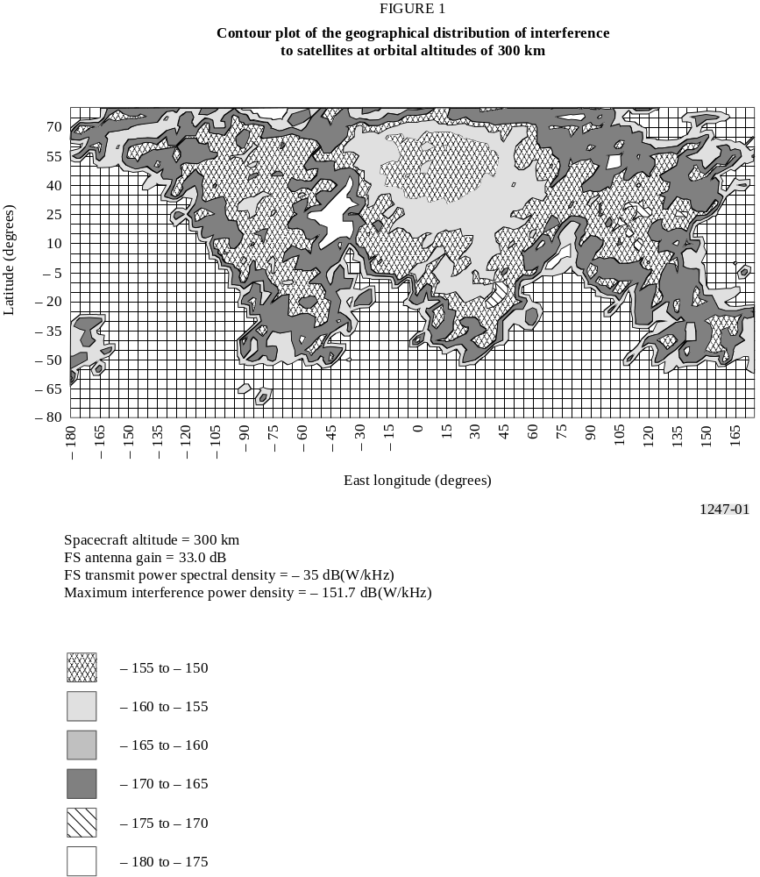
FIGURE 1..[1247-01] = 18 cm

A similar Monte Carlo simulation has been used to determine the interference to DRSs receiving in the band 2 200-2 290 MHz. Identical assumptions were used regarding the characteristics and deployment of point-to-point P-P radio-relay systems using high-gain antennas. The point of departure for the analysis is the use of the GSO by the DRS and the use of high-gain steerable receiving antennas on the DRS. For the analysis, the independent variables are the longitude of the sub-satellite point of the geostationary DRS (it is assumed that the orbital inclination is zero), and the roll and pitch angles of the steerable antennas. (The roll and pitch angles are defined in a spherical coordinate system centred on the DRS. The x-axis is directed towards the centre of the Earth, the y-axis points in the direction of the satellite velocity vector, and the z-axis is parallel to the Earth’s axis of rotation. Defining the local coordinate system in this way, rotation about the x-axis is called yaw, rotation about the y-axis is called roll, and rotation about the z-axis is called pitch.)
The DRS network operated by the United States of America consists of several operational and on-orbit standby DRSs located at orbital locations that include 41°, 46°, 171° and 174° W longitude. These satellites use two types of high-gain tracking antennas: the S-band multiple access antenna (SMA) with an on-axis gain of 28.0 dBi; and the S-band single access antenna (SSA) with an on-axis gain of 36.8 dBi.
The DRS antennas are assumed to have off-axis radiation patterns that conform to those given in Recommendation ITU-R S.672 for satellite antennas with circular symmetry and first-side lobe levels down 20 dB from the peak on-axis gain.
The FS stations are deployed in the same manner as described previously. The interference to the SMA and SSA antennas of a DRS located at a specified orbital location is determined for each antenna pointing angle within the range of ± 13° in pitch and ± 11° in roll in increments of 1°. The aggregate interference from the emissions of the visible radio-relay stations is calculated for each SMA or SSA beam position. An example of the results is shown in Fig. 2 for the SSA antenna on a DRS at an orbital location of 41° W longitude. The figure shows that a maximum interference level of – 150.7 dB(W/kHz) will be received and that the interference will be in excess of – 170 dB(W/kHz) over a relatively large portion of the scan angles. Again, it is noted that the temporal distribution of the interference is invariant. A particular level of interference is associated with each antenna pointing angle.

3 Interference mitigation techniques
Several interference mitigation techniques that might be used by the FS have been evaluated. Techniques applicable to both the 2 025-2 110 MHz and 2 200-2 290 MHz bands are:
– automatic transmit-power control (ATPC),
– lowest practical transmitted power spectral density,
– transmitting antenna mounting location,
– transmitting antennas with good radiation patterns.
Techniques applicable to the upper band (i.e. 2 200-2 290 MHz) are:
– limit the e.i.r.p. spectral density radiated towards the orbital locations of DRS satellites,
– assign high power FS stations channels towards the lower part of the band 2 200-2 290 MHz.
Suitable interference mitigation techniques for DRS satellites are currently under study.

3.1 Automatic transmit-power control
ATPC is one of the most effective means to reduce the interference environment experienced by satellites operating in a DRS network. Each dB reduction in the nominal transmitter power delivered to the antenna results in a dB reduction in interference. The use of up to 20 dB of ATPC by all types of FS stations has been shown to yield a substantial and needed reduction in the interference environment.

3.2 Transmitted power spectral density
Receiving systems in DRS networks are particularly sensitive to interference because of small link margins (e.g. 2 dB to 4 dB) used on space-to-space links. Low transmitter power spectral density is an effective means to reduce the degree of interference.
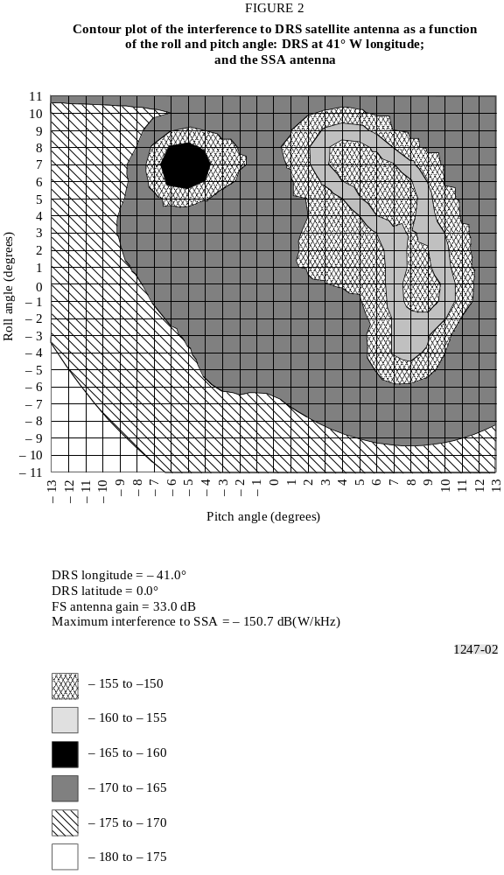
FIGURE 2..[1247-02] = 20 cm

3.3 Transmitting antenna mounting location
In a number of cases, particularly in point-to-multipoint systems, FS stations will be located in areas that are low-lying, cluttered by adjacent buildings or surrounded by foliage. These factors tend to introduce an excess loss to the propagation path at low elevation angles. One study has considered that there is an additional 20 dB attenuation at 0° elevation, decreasing linearly to 0 dB at 10°. It is assumed that this mechanism applies only to multipoint outstations, with all other links being located in elevated or uncluttered environments.
Low-gain antennas, such as flat-plate antennas, used in low-power multipoint systems will typically be installed on the wall of a building. It was therefore assumed in one study that the additional loss due to building blockage would apply to interferers located behind the plane of the antenna. This has been modelled as an additional loss of 20 dB for arrival angles greater than 90° from boresight.
Where building blockage and foliage loss occur simultaneously, the additional isolation will be limited by scattering and diffraction effects. For this case, it was assumed that the total loss due to both mechanisms is limited to 30 dB.

3.4 Transmitting antenna radiation patterns
Transmitting antenna radiation patterns of FS stations affect the magnitude of the interference environment. The use of antennas that conform to or exceed the performance of Recommendation ITU-R F.699 will reduce the interference environment.

3.5 E.i.r.p. spectral density radiated towards the orbital locations of DRS satellites
The e.i.r.p. spectral density of an FS transmitting station radiated towards a geostationary DRS receiving antenna operating in the 2 200-2 290 MHz band needs to be specified to ensure that the interference is not in excess of the sharing criteria in Recommendation ITU-R SA.1274 (i.e. – 147 dB(W/MHz) for no more than 0.1% of the time). The appropriate value of e.i.r.p. spectral density may be determined in the following way. Assume that the service area of a DRS antenna beam is limited to a rectangle of 20° in the East-West direction and 12° in the North-South direction as shown in Fig. 3. Assuming that the probability is uniform of the user satellite occupying any position within the service area, then the percentage of the time that a DRS antenna will point towards a specific FS station is the ratio of the spot area of the DRS antenna beam to the area of DRS service area. An interference probability of 0.1% implies a DRS antenna bandwidth of 0.3°. For a DRS antenna with a gain of 36 dBi, the gain at 0.3° off-boresight will be about the same as the boresight gain. Using these assumptions, the e.i.r.p. spectral density radiated towards a geostationary DRS by a single FS station should not exceed
e.i.r.p. ≤ – 147 + 191 – 36 + 3 – 3 = + 8 dB(W/MHz)
where – 147 dB(W/MHz) is the sharing criteria, 191 dB is the free space loss, 36 dBi is the DRS antenna boresight gain and 3 dB is an allowance for polarization discrimination between the DRS and FS antennas. The background interference from fixed and mobile service systems has been assumed as equal to the worst-case single interference entry and a factor of 3 dB has been included.

3.6 FS stations channel assignments in the 2 200-2 290 MHz band
The DRS systems are designed to support the full bandwidth between 2 200-2 290 MHz. Most DRS user spacecraft operate currently in the upper part of the band, a few in the middle and at least one in the lower part. Within the next decade most users, which do not require a multiple access link, are expected to be assigned frequencies in the middle part of the band. (The distribution of frequency assignments to satellites operating in the ground network is quite different.)
It is expected that only a few DRS users will occupy the lower part of the band. This might offer some flexibility in assigning high power FS transmissions which are otherwise incompatible with DRS sharing criteria to the lower part of the band.

3.7 E.i.r.p. spectral density considerations for point-to-multipoint systems
A number of contributions have been received regarding transmission characteristics of P-MP systems. In one country at least 400 systems comprising a total of around 10 000 stations have been manufactured which operate at e.i.r.p. spectral densities between 4 and 7 dB(W/MHz) for the central stations and 11 and 19 dB(W/MHz) for the out-stations. These systems operate in the frequency bands 1 427-1 530 MHz (25%), 2 025-2 300 MHz (5%) and 2 300-2 655 MHz (70%) and it is expected that the characteristics for new 2 GHz systems will be similar. Other contributions on P-MP
characteristics specify values between – 10 and 12 dB(W/MHz) for central stations and between 8 and 12 dB(W/MHz) for out-stations. Without ATPC, the e.i.r.p. density range for central stations is thus between – 10 and 12 dB(W/MHz) and for out-stations between 8 and 19 dB(W/MHz). With a minimum of 10 dB ATPC, e.i.r.p. density values of around 5 dB(W/MHz) would certainly satisfy transmit power requirements for central stations and to a large extent also for out-stations.
For high power/low density TDMA systems, the average loading at the out-stations is expected to be on the order of 40% of capacity which would permit the maximum e.i.r.p. density at an out-station to be increased by about 4 to 9 dB(W/MHz). For an average loading in excess of 4% the acceptable increase can be based on the ratio between the actual number of subscribers per central station and the maximum number of subscribers.

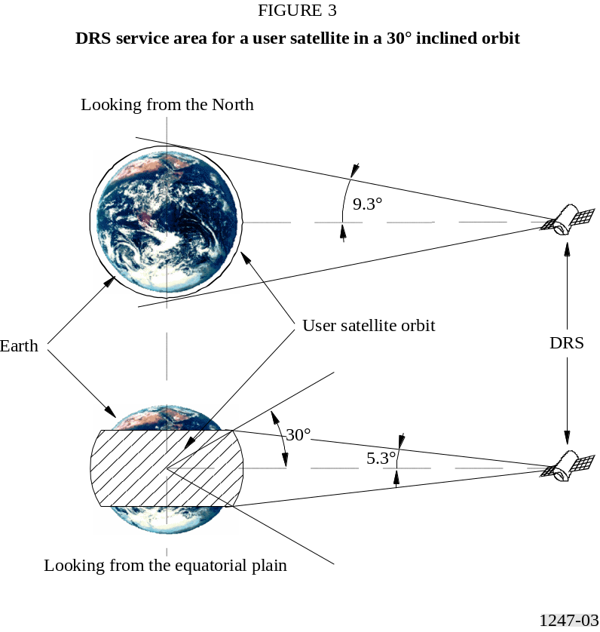
FIGURE 3..[1247-03] = 10 cm

4 Summary
Of key interest is the cumulative interference environment seen by spacecraft taking into account the identified mitigation techniques. Table 1 gives an overview of the sharing situation in the 2 025-2 110 MHz band for a 300 km orbiter and the effect of various interference mitigation techniques. The P-P radio-relay systems have similar power levels compared to the high power P-MP systems and the results, assuming about the same number of stations, will be approximately the same. The interference situation becomes less critical with increasing orbit heights.
Automatic power control of FS stations has a significant positive impact on the cumulative interference levels into satellites. The reduction of interference is practically proportional to the average level by which the power on all links is reduced. It is consequently highly recommended that automatic power control be used wherever possible. Power levels should in general be as low as technically practicable as there is a direct impact on the interference levels.
The relaxation of the DRS protection requirements by 4 dB has obviously the same effect for all types of FS systems and contributes significantly to a reasonable sharing environment.
TABLE 1
Summary of the effectiveness of interference mitigation techniques applicable to low-orbiting satellites
operating in the space network, 300 km orbital altitude, and receiving in the band 2 025-2 110 MHz

 | P-P radio-relay  systems | P-MP high  power (1) systems | P-MP low  power (2) systems
Expected number of installations within the next decade per MHz (worldwide) | 5 000 | 5 000 | 500 000
Cumulative mean interference level (dB(W/MHz)) | – 139 | – 139 | – 132
Excess with respect to the sharing criteria  (– 147 dB(W/MHz)) | 8 | 8 | 15
Expected effect of mean power reduction due to ATPC (dB) | 10 | 10 | 10
Effect of increasing the DRS PFD towards the low-orbiting satellite (dB) | 6 | 6 | 6
Expected sharing level excess using the above measures (dB) | – 8 | – 8 | – 1
(1) Low density.
(2) High density.
Table 2 gives an overview of the sharing situation for the geostationary DRS and the expected effect of various interference mitigation techniques. The P-P radio-relay systems have similar power levels compared to the high power P-MP systems but their number is significantly higher.
TABLE 2
Summary of the effectiveness of interference mitigation techniques applicable to
geostationary DRS satellites and receiving in the band 2 200-2 290 MHz

 | P-P radio-relay  systems | P-MP high  power (1) systems | P-MP low  power (2) systems
Expected number of installations within the next decade per MHz (worldwide) | 12 000 | 5 000 | 500 000
Cumulative mean interference level (dB(W/MHz)) | – 132 | – 136 | – 129
Excess with respect to the sharing criteria  (– 147 dB(W/MHz)) | 15 | 11 | 18
Expected effect of mean power reduction due to ATPC (dB) | 10 | 10 | 10
Effect of increasing the LEO PFD towards the data relay satellite (dB) | 3 | 3 | 3
Effect of antenna off-pointing from the geostationary orbit | 3 | 2 | 1
Expected sharing level excess using the above measures (dB) | – 1 | – 4 | 4
(1) Low density.
(2) High density.
Automatic power control of FS stations again significantly reduces cumulative interference levels into satellites and should be implemented wherever possible. Power levels should in general be as low as technically practicable as there is a direct impact on the interference levels. The power spectral density should be as low as possible. High data rate transmissions are preferred from an interference point of view.
The relaxation of the DRS protection requirements by 4 dB contributes again to an increased sharing potential.
Antenna off-pointing can reduce the interference level by up to 35 dB for the 2.4 m antenna. An off-pointing angle of 4° should be considered as a minimum resulting in 12 dB interference attenuation with respect to the maximum level. Main beam interference is thus avoided for a typical 2.4 m FS P-P station. Further off-pointing is, of course, also desirable but the additional attenuation as a function of the off-pointing angle is significantly reduced. It is realized, though, that off-pointing has only a limited effect as it will in many cases not be feasible for implementation with point-to-multipoint systems. Central stations often have an omnidirectional antenna pattern and out-stations have no choice but to point towards the central station, irrespective of the resulting constellation.
The most critical case appears to be the low power high density P-MP system. It should be noted that the effect of attenuation along the path and the mounting location of P-MP stations (see § 3.3) will in practice further reduce the interference potential of these systems. It can be seen that the band 2 200-2 290 MHz is more vulnerable than the 2 025-2 110 MHz.
It should also be noted that the above FS systems have been assessed on an exclusive basis. The cumulative effect has to be taken into account when calculating the overall interference level.

* This Recommendation was jointly developed by Radiocommunication Study Groups 7 and 9, and future revision should be undertaken jointly.

