Recommendation ITU-R BT.814-3
(12/2017)
Specifications of PLUGE test signals and alignment procedures for setting of brightness and contrast of displays

BT Series
Broadcasting service
(television)

Foreword
The role of the Radiocommunication Sector is to ensure the rational, equitable, efficient and economical use of the radio-frequency spectrum by all radiocommunication services, including satellite services, and carry out studies without limit of frequency range on the basis of which Recommendations are adopted.
The regulatory and policy functions of the Radiocommunication Sector are performed by World and Regional Radiocommunication Conferences and Radiocommunication Assemblies supported by Study Groups.

Policy on Intellectual Property Right (IPR)
ITU-R policy on IPR is described in the Common Patent Policy for ITU-T/ITU-R/ISO/IEC referenced in Annex 1 of Resolution ITU-R 1. Forms to be used for the submission of patent statements and licensing declarations by patent holders are available from http://www.itu.int/ITU-R/go/patents/en where the Guidelines for Implementation of the Common Patent Policy for ITU-T/ITU-R/ISO/IEC and the ITU-R patent information database can also be found.

Series of ITU-R Recommendations
(Also available online at http://www.itu.int/publ/R-REC/en)
Series | Title
BO | Satellite delivery
BR | Recording for production, archival and play-out; film for television
BS | Broadcasting service (sound)
BT | Broadcasting service (television)
F | Fixed service
M | Mobile, radiodetermination, amateur and related satellite services
P | Radiowave propagation
RA | Radio astronomy
RS | Remote sensing systems
S | Fixed-satellite service
SA | Space applications and meteorology
SF | Frequency sharing and coordination between fixed-satellite and fixed service systems
SM | Spectrum management
SNG | Satellite news gathering
TF | Time signals and frequency standards emissions
V | Vocabulary and related subjects

Note: This ITU-R Recommendation was approved in English under the procedure detailed in Resolution ITU-R 1.

Electronic Publication
Geneva, 2017

© ITU 2017
All rights reserved. No part of this publication may be reproduced, by any means whatsoever, without written permission of ITU.

RECOMMENDATION ITU-R BT.814-3
Specifications of PLUGE test signals and alignment procedures for setting
of brightness and contrast of displays
(1992-1994-2007-2017)
Scope
This Recommendation defines test signals and alignment procedures for the adjustment of displays used for programme production and monitoring. The signal may be used to set displayed image values for standard definition television, high definition television and ultra high definition television including the PQ and HLG high dynamic range television systems.
Keywords
PLUGE, display adjustment, HDR, HDR-TV, brightness, contrast
The ITU Radiocommunication Assembly,
considering
a) that precision picture monitors are used in a variety of applications including subjective laboratory testing and control room monitoring of operational systems;
b) that variations in the set-up and adjustment of displays may lead to variations in displayed pictures;
c) that special signals that assist with the set-up and adjustment of monitors have been developed and have been in operational use for many years,
recommends
1 that the PLUGE test signal (see Note 1) described in Annex 1 should be used for setting of displays used for subjective assessments, and for operational monitoring of systems described in Recommendations ITU-R BT.1700 and ITU-R BT.601;
2 that the PLUGE test signal described in Annex 2 should be used for setting of displays used for subjective assessments, and for operational monitoring of systems described in Recommendations ITU-R BT.709, ITU-R BT.2020 and ITU-R BT.2100;
3 that the procedure to be followed for the use of the PLUGE test signal should be as described in Annex 3,
further recommends
that further studies on methods for black level adjustment of HDR displays be conducted and that informative Annexes 4 and 5 of this Recommendation be updated to reflect improved methods.
NOTE 1 – The acronym, PLUGE, was originally derived from “Picture Line Up Generating Equipment”.

Annex 1 (Normative)
Specifications of PLUGE signal for SDTV
The PLUGE signal (see Fig. 1) is composed of:
a) three closely spaced narrow vertical stripes on the left-hand side of the picture. The central vertical stripe is at waveform black level. The left-hand stripe is slightly darker, and the right-hand stripe is slightly lighter than the central stripe;
b) a broad bar signal located on the right-hand side of the picture. It is divided into four areas, one at white level and the other three at descending grey levels. This grey scale is in approximately equal steps, as seen by eye, over a contrast range of 30:1. The peak white area is sufficiently large to enable the peak luminance to be set by a measuring instrument;
c) a uniform background surrounding the vertical stripes and the broad bar described above. Two different levels for this background are specified according to the application:
– for operational monitoring the background level is set to signal black level;
– for subjective assessments the background level is set to the grey level shown in Table 1. This background level has been optimized to give a picture display of subjective quality similar to that used in sequences used in subjective assessment.
figure 1
PLUGE active field and waveform
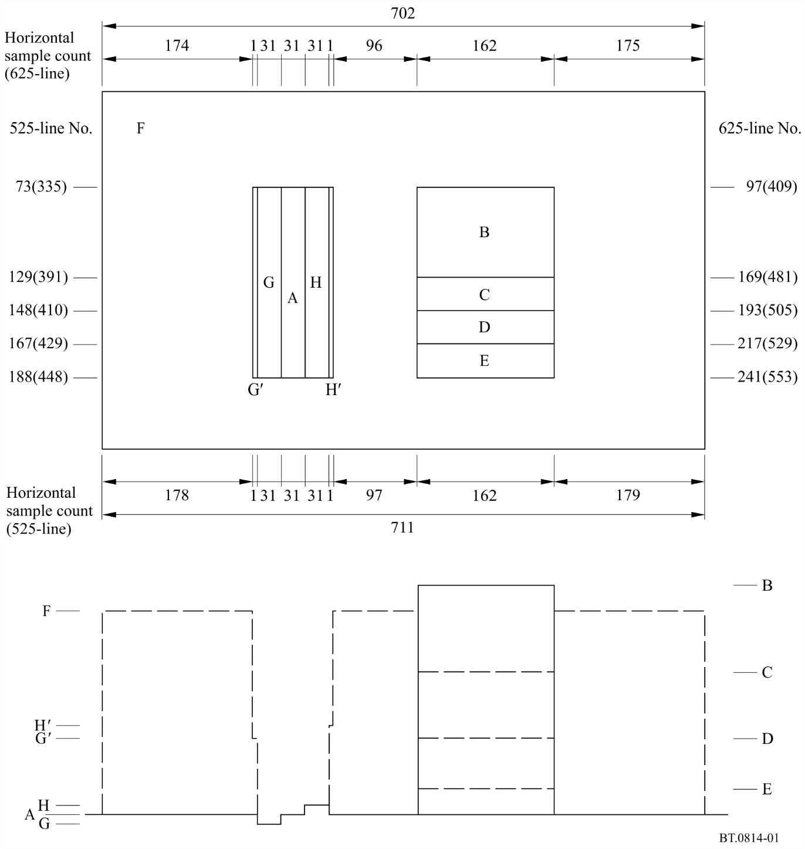
To take account of the characteristics of the human eye, the luminance specified for the vertical stripes described in c) is slightly different for the two applications (see Table 1).
To ensure that in analogue composite systems the colour decoder of a display is working in its colour mode, it is recommended that a standard colour burst is included in the analogue waveform.
The horizontal sample count is less than the 720 horizontal samples defined in Recommendation ITU-R BT.601. The PLUGE signal should be centred within the active line of digital and analogue systems ±2 samples.

TABLE 1
Levels of waveform
 | Operational monitoring |  |  | Subjective assessment monitoring
 | %  Level mV  digital |  |  | %  Level mV  digital
 | 625-line | 525-line |  | 625-line | 525-line
A black level | 0%  0 mV  (16)64 | 0%  0 mV  (16)64 | 7.5%  54 mV  (16)64 | 0%  0 mV  (16)64 | 0%  0 mV  (16)64 | 7.5%  54 mV  (16)64
B white level | 100%  700 mV  (235)940 | 100%  714 mV  (235)940 | 100%  714 mV  (235)940 | 100%  700 mV  (235)940 | 100%  714 mV  (235)940 | 100%  714 mV  (235)940
C grey level 3 | 63.0%  441 mV  (154)616 | 63.0%  450 mV  (154)616 | 65.8%  470 mV  (154)616 | 63.0%  441 mV  (154)616 | 63.0%  450 mV  (154)616 | 65.8%  470 mV  (154)616
D grey level 2 | 35.2%  246 mV  (93)372 | 35.2%  251 mV  (93)372 | 40.0%  286 mV  (93)372 | 35.2%  246 mV  (93)372 | 35.2%  251 mV  (93)372 | 40.0%  286 mV  (93)372
E grey level 1 | 15.1%  105 mV  (49)196 | 15.1%  108 mV  (49)196 | 21.4%  153 mV  (49)196 | 15.1%  105 mV  (49)196 | 15.1%  108 mV  (49)196 | 21.4%  153 mV  (49)196
F background level | 0%  0 mV  (16)64 | 0%  0 mV  (16)64 | 7.5%  54 mV  (16)64 | 70.3%  492 mV  (170)680 | 70.3%  502 mV  (170)680 | 72.5%  518 mV  (170)680
G black stripe level | –1.8%  –13 mV  (12)48 | –1.8%  –13 mV  (12)48 | 5.8%  42 mV  (12)48 | –2.7%  –19 mV  (10)40 | –2.7%  –20 mV  (10)40 | 5.0%  35 mV  (10)40
mid-level between  G' black stripe and  background levels | NA | NA | NA | 33.8%  237 mV  (90)360 | 33.8%  237 mV  (90)360 | 38.8%  277 mV  (90)360
H grey stripe level | 1.8%  13 mV  (20)80 | 1.8%  13 mV  (20)80 | 9.2%  66 mV  (20)80 | 2.7%  19 mV  (22)88 | 2.7%  20 mV  (22)88 | 10.0%  72 mV  (22)88
mid-level between  H' grey stripe and  background levels | NA | NA | NA | 36.5%  256 mV  (96)384 | 36.5%  256 mV  (96)384 | 41.3%  295 mV  (96)384
Note 1 – The 10 bit digital levels are defined as the primary values, and the rest are derived. The 8 bit digital levels are in parentheses.
Note 2 – Digital levels are expressed in the same way as described in Recommendation ITU-R BT.601.
Note 3 – For the subjective assessment monitoring waveform, mid-levels between stripes and background are introduced to avoid ringing due to the sharp transition of the waveform.
Note 4 – NA: the mid-level is not applied, and the level for this area is the same as the background.

Annex 2 (Normative)
PLUGE for HDTV, UHDTV and HDR-TV systems
A PLUGE signal for HDTV, UHDTV and HDR displays is shown in Figs 2 and 3. Corresponding sample numbers (horizontal) are given in Table 4 and line numbers are given in Table 5 for HDTV SDR and HDR image formats and sample numbers (vertical) are given in Table 6 for UHDTV SDR and HDR image formats. Code values of signal levels are given in Table 2 for SDR and in Table 3 for HDR.
The central Higher level patch is used to set the luminance level of the display by means of the user gain control.
In the case of HDR, the code value of the central Higher level patch is identical for both PQ and HLG. This differs from that of the peak white luminance level of PLUGE signals for SDR.
Two types of signal can be used to set the brightness of the black level of the display by means of the user black level lift control.
The signal on the left-hand side of the picture consists of narrow horizontal stripes (a width of 10 scanning lines). The stripes extend from approximately 2% above the black level of the waveform to approximately 2% below the black level. The signal on the right-hand side of the picture consists of two coarse stripes (a width of 138 lines) one stripe is approximately 2% above black level the other is approximately 2% below black level. This signal is suitable for setting display values.
TABLE 2
Code values for HDTV and UHDTV (SDR)
Parameter values, Figs 2 and 3  for SDR | 8-bit digital value | 10-bit digital value | 12-bit digital value
Higher level | 235 | 940 | 3 760
Black level | 16 | 64 | 256
Slightly lighter level | 20 | 80 | 320
Slightly darker level | 12 | 48 | 192
TABLE 3
Narrow range code values for HDR
Parameter values, Figs. 2  and 3 for HDR | 10-bit digital value | 12-bit digital value
Higher level^{1, 2} | 399 | 1 596
Black level | 64 | 256
Slightly lighter level | 80 | 320
Slightly darker level | 48 | 192
NOTE 1 – This level corresponds to 38.2% PQ and HLG and results in the same luminance for both PQ and HLG signals (approximately 27 cd/m²) when displayed on a PQ display or on an HLG display with peak luminance of 1 000 cd/m² (a “1 000 cd/m² display”).
NOTE 2 – Luminance value LH of the Higher level for an HLG display of peak luminance Lw is derived using the HLG EOTF in Table 5 of Recommendation ITU-R BT.2100 in conjunction with the system gamma obtained in accordance with Note 5e of Recommendation ITU-R BT.2100, and may be calculated as follows:
FIGURE 2
PLUGE signal for adjusting black level
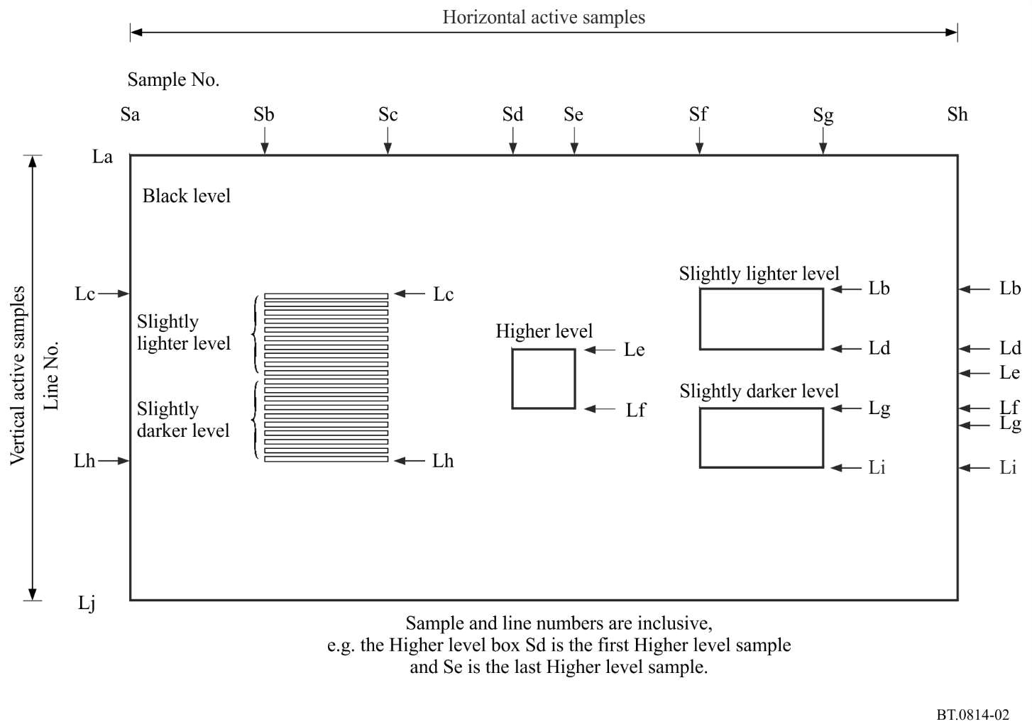

TABLE 4
Sample numbers (horizontal) for corresponding image formats
Sample number (horizontal) | HDTV | 4K UHDTV | 8K UHDTV
Sa | 0 | 0 | 0
Sb | 312 | 624 | 1 248
Sc | 599 | 1 199 | 2 399
Sd | 888 | 1 776 | 3 552
Se | 1 031 | 2 063 | 4 127
Sf | 1 320 | 2 640 | 5 280
Sg | 1 607 | 3 215 | 6 431
Sh | 1 919 | 3 839 | 7 679
TABLE 5
Line numbers for HDTV image formats
Line number as per Rec. ITU-R BT.709 | HDTV (interlaced) | HDTV (progressive)
La | 21, 584 | 42
Lb | 183, 746 | 366
Lc | 194, 756 | 387
Ld | 254, 817 | 509
Le | 255, 818 | 510
Lf | 326, 889 | 653
Lg | 327, 890 | 654
Lh | 388, 950 | 776
Li | 398, 961 | 797
Lj | 560, 1 123 | 1 121
TABLE 6
Sample numbers (vertical) for UHDTV image formats
Sample number (vertical)  as per Rec. ITU-R BT.2020 | 4K UHDTV | 8K UHDTV
La | 0 | 0
Lb | 648 | 1 296
Lc | 690 | 1 380
Ld | 935 | 1 871
Le | 936 | 1 872
Lf | 1 223 | 2 447
Lg | 1 224 | 2 448
Lh | 1 469 | 2 939
Li | 1 511 | 3 023
Lj | 2 159 | 4 319
FIGURE 3
Analogue waveform of the signal for adjusting black level
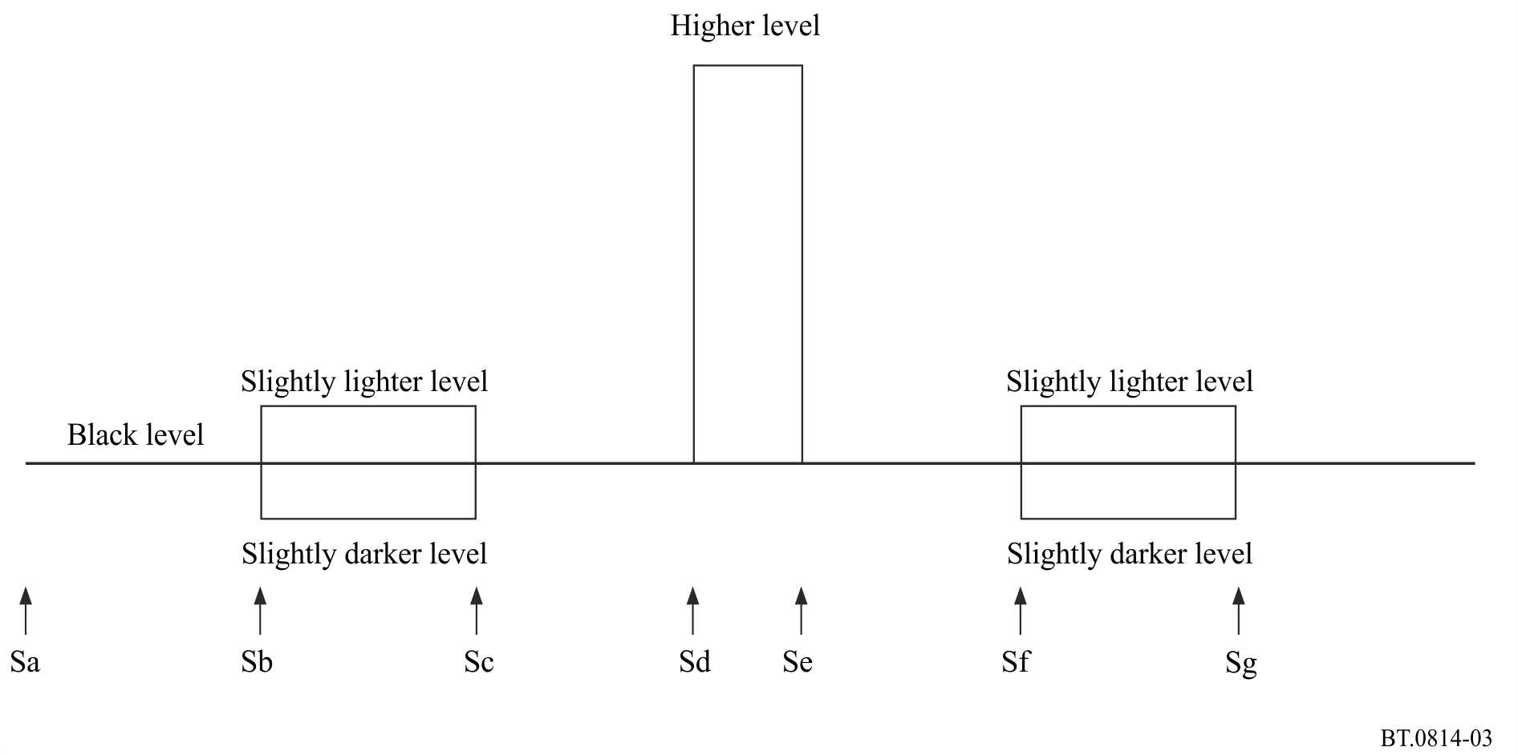

Annex 3 (Normative)
Procedure for use of PLUGE test signals

1 Standard Dynamic Range (SDR) Television
The adjustments described below are very dependent on the viewing conditions and it is preferable to conform to the conditions for viewing distance and ambient illumination contained in Recommendations ITU-R BT.2022 and ITU-R BT.2035:
– using a photometer, the user gain control (legacy “contrast” control) is adjusted such that the centre of the white area (100% video level) reaches the desired luminance of the display;
– the user black level lift control (legacy “brightness” control) is adjusted such that the blackest stripe just disappears, whilst the brighter stripe remains visible.

2 High Dynamic Range (HDR) Television
The adjustments described below must be conducted in the following order and are very dependent on the viewing conditions. It is preferable to conform to the conditions for the reference viewing environment contained in Recommendation ITU-R BT.2100:
1. in the case of HLG only, the display’s system gamma control is adjusted in accordance with the target nominal peak luminance of the display, appropriate for the viewing environment, according to Note 5e of Recommendation ITU-R BT.2100;
2. for both PQ and HLG, using a photometer, the user gain control is adjusted such that the centre of the Higher level area has the nominal luminance value corresponding to code value specified in Table 3;
3. in the case of HLG only, a further adjustment to the system gamma can be made to compensate for non-reference viewing environments. See Note 5f of Recommendation ITU-R BT.2100 and Annex 5;
4. for both PQ and HLG, the user black level lift control is adjusted such that the blackest stripe just disappears, whilst the brighter stripe remains visible. In a non-reference viewing environment, a black level control for a PQ display may be applied as described in Annex 4 with respect to the PQ EOTF specified in Recommendation ITU-R BT.2100.

Annex 4 (Informative)
Black level control for PQ displays
To enable the PQ PLUGE adjustment, the signal that is applied in the PQ EOTF is replaced by the signal:
where:
E' denotes a non-linear PQ colour value {R', G', B'}
F_{D} is the luminance of an adjusted displayed linear component {R_{D}, G_{D}, B_{D}} in cd/m²
is the variable for user black level lift control
is a gain to maintain the display peak luminance L_{w} whilst is changed.
L_{w} is the display peak luminance, adjusted by the user gain control.

Annex 5 (Informative)
HLG display gamma adjustment in a non-reference viewing environment
Note 5f of Recommendation ITU-R BT.2100 recognises that the HLG display gamma may need to be reduced in brighter viewing environments, to compensate for the differences in the adaptation state of the eye. The following equation can be used to determine how the display gamma may be adjusted in non-reference viewing environments:
$$γ_{bright}=γ_{ref}-0.076\log_{10}{(\frac{L_{amb}}{5})}$$
where:
γ_{bright} = system gamma for display surrounds greater than 5 cd/m²
γ_{ref} = system gamma for reference environment, calculated according to Recommendation ITU-R BT.2100-1 Note 5e
L_{amb} = ambient luminance level in cd/m².
By adjusting the display gamma to compensate for non-reference viewing environments in this way, more consistent results may be achieved in a wide range of production environments.

______________

Recommendation ITU-R BT.1700 – Characteristics of composite video signals for conventional analogue television systems.
Recommendation ITU-R BT.601 – Studio encoding parameters of digital television for standard 4:3 and wide-screen 16:9 aspect ratios.
Recommendation ITU-R BT.709 – Parameter values for the HDTV standards for production and international programme exchange.
Recommendation ITU-R BT.2020 – Parameter values for ultra-high definition television systems for production and international programme exchange.
Recommendation ITU-R BT.2100 – Image parameter values for high dynamic range television for use in production and international programme exchange.
Sample and line numbers are as represented in Recommendation ITU-R BT.709 for HDTV and as in Recommendation ITU-R BT.2020 for UHDTV.
The PQ EOTF is specified in Recommendation ITU-R BT.2100.

