Recommendation ITU-R BT.2144-0
(05/2022)
Guidance for the introduction of new DTTB systems, technologies and applications
in the broadcasting service

BT Series
Broadcasting service (television)

Foreword
The role of the Radiocommunication Sector is to ensure the rational, equitable, efficient and economical use of the radio-frequency spectrum by all radiocommunication services, including satellite services, and carry out studies without limit of frequency range on the basis of which Recommendations are adopted.
The regulatory and policy functions of the Radiocommunication Sector are performed by World and Regional Radiocommunication Conferences and Radiocommunication Assemblies supported by Study Groups.

Policy on Intellectual Property Right (IPR)
ITU-R policy on IPR is described in the Common Patent Policy for ITU-T/ITU-R/ISO/IEC referenced in Resolution ITU-R 1. Forms to be used for the submission of patent statements and licensing declarations by patent holders are available from http://www.itu.int/ITU-R/go/patents/en where the Guidelines for Implementation of the Common Patent Policy for ITU-T/ITU-R/ISO/IEC and the ITU-R patent information database can also be found.

Series of ITU-R Recommendations
(Also available online at http://www.itu.int/publ/R-REC/en)
Series | Title
BO | Satellite delivery
BR | Recording for production, archival and play-out; film for television
BS | Broadcasting service (sound)
BT | Broadcasting service (television)
F | Fixed service
M | Mobile, radiodetermination, amateur and related satellite services
P | Radiowave propagation
RA | Radio astronomy
RS | Remote sensing systems
S | Fixed-satellite service
SA | Space applications and meteorology
SF | Frequency sharing and coordination between fixed-satellite and fixed service systems
SM | Spectrum management
SNG | Satellite news gathering
TF | Time signals and frequency standards emissions
V | Vocabulary and related subjects

Note: This ITU-R Recommendation was approved in English under the procedure detailed in Resolution ITU-R 1.

Electronic Publication
Geneva, 2022

© ITU 2022
All rights reserved. No part of this publication may be reproduced, by any means whatsoever, without written permission of ITU.

RECOMMENDATION ITU-R BT.2144-0
Guidance for the introduction of new DTTB systems,
technologies and applications in the broadcasting service
(2022)
Scope
This Recommendation provides guidance for the introduction of new Digital Terrestrial Television Broadcasting (DTTB) systems, technologies and applications in the broadcasting service. An appropriate method may be chosen depending on the requirements and situations in a country or region.
Keywords
Digital Terrestrial Television Broadcasting, introduction of new systems
Abbreviations/Glossary
Acronym Definition
C/N Carrier-to-noise ratio
DTTB Digital terrestrial television broadcasting
FDM Frequency-division multiplexing
HDTV High-definition television
IBB Integrated broadcast-broadband
LDM Layered-division multiplexing
MFN Multi-frequency network
MIMO Multiple-input multiple-output
MPEG Moving pictures expert group
PMSE Programme making- and special events
PSM Public service media
QoS Quality of service
SDM Space division multiplexing
SDTV Standard definition television
SFN Single-frequency network
SISO Single-input single-output
TDM Time-division multiplexing
UHDTV Ultra-high definition television
Related ITU Recommendations, Reports
Recommendation ITU-R BT.1877 – Error-correction, data framing, modulation and emission methods and selection guidance for second generation digital terrestrial television broadcasting systems
Report ITU-R BT.2400 – Usage scenarios, requirements and technical elements of a global platform for the broadcasting service
Report ITU-R BT.2485 – Advanced network planning and transmission methods for enhancements of digital terrestrial television broadcasting
The ITU Radiocommunication Assembly,
considering
a) that a long time has passed since the world first launched terrestrial digital television services and that the transition from analogue to digital television broadcasting globally has either been completed or is currently underway;
b) that new systems, technologies, and applications for broadcasting aim to deliver television, sound and multimedia programmes more efficiently and to provide the audience with new audio-visual experiences;
c) that a crucial issue is how best such new systems, technologies and applications can be introduced in the broadcasting service where the first generation of DTTB systems are in operation, without giving adverse effects to the audience;
d) that it is also important to consider methods that can ensure continuous advancements of broadcasting in the future;
e) that several scenarios may be possible in terms of timelines of the process, parties involved and public policies to drive transitions,
recognizing
a) that Resolution ITU-R 70 resolves to develop Recommendations and Reports for the introduction of new systems, technologies and applications for broadcasting to achieve global harmonization of specifications;
b) that Resolution ITU-R 71 resolves that a roadmap for ITU-R activities for broadcasting should be developed by the relevant Radiocommunication Study Group to ensure that this work is progressed effectively and efficiently;
c) that Recommendation ITU-R BT.1877 specifies second generation digital terrestrial television broadcasting systems,
recommends
that the guidance provided in the Annex should be considered for the introduction of new DTTB systems, technologies and applications in the broadcasting service.

Annex
Guidance for the introduction of new DTTB systems, technologies
and applications in the broadcasting service
TABLE OF CONTENTS
Page
Policy on Intellectual Property Right (IPR) ii
Annex Guidance for the introduction of new DTTB systems, technologies and applications in the broadcasting service 3
1 Introduction 4
2 Requirements for the implementation of new DTTB systems, technologies and applications 4
2.1 Receiver-related requirements 5
2.2 Service-related requirements 5
2.3 Spectrum-related requirements 5
3 Scenarios and methods for transition 6
3.1 Method A: Introducing a new service in the same channel used for existing services 6
3.2 Method B: Introducing a new service in a different channel that is not used for existing services 10
3.3 Comparison of features of the methods 12

1 Introduction
Over 20 years have passed since the world’s first launch of DTTB. With the advent of new systems, technologies and applications for broadcasting that aim at delivering television, sound and multimedia programmes more efficiently and providing the audience with new audio-visual experiences, a crucial issue is how best such new systems, technologies and applications can be introduced in the broadcasting service where the first generation of DTTB systems are in operation, without giving adverse effects to the audience. It is also important to consider methods that can ensure the continuous advancement of broadcasting in the future.
Several scenarios may be possible in terms of timelines of the process, parties involved and public policies to drive transitions.

2 Requirements for the implementation of new DTTB systems, technologies and applications
Each country and region may have different requirements for introducing a new system due to different situations in the usage of the frequency band allocated to broadcasting, e.g. the number of channels used and unused and the intended new services and applications that may have different transmission capacity requirements, and different transmission systems and technologies adopted in the existing broadcasting service (e.g. DTTB Systems A, B, C and D; video source coding of MPEG-2, MPEG-4; video formats of SDTV and HDTV; sound formats of stereo and 5.1 multichannel).
In general, the requirements that need to be specified for the implementation of new digital terrestrial broadcasting systems, technologies and applications can be grouped into three parts: receiver-related requirements, service-related requirements and spectrum-related requirements.
To be generally accepted, any new digital terrestrial broadcasting system should fulfil the requirements of both Public Service Media (PSM) and Commercial Broadcasters.
The general requirements for broadcasters are:
– The ability to provide content free-to-air (no additional cost for viewers/listeners).
– Delivery of the content to the public without blocking or filtering the service offer, i.e. no gatekeeping.
– Content and service integrity: no modification of the content or service by third parties. For example, television content and additional services (e.g. subtitles, IBB applications, etc.) must be displayed on the screen, unaltered and without unauthorized overlays.
– Quality of service (QoS) is to be defined by the broadcaster, including the availability of a network, its robustness, up-time and reliability.
– QoS for each user shall be independent of the size of the audience.
– The broadcasting service shall not be subject to discrimination compared to equivalent services.
– Geographical availability of the service (e.g. national, regional, local) is to be defined by the broadcaster.
– A distribution network needs to support at least a minimum service offer (e.g. a minimum number of programmes) as defined by the broadcaster. These services should be available concurrently to all users within designated geographical areas.
– Ease of use: straightforward accessibility and prominence of the broadcasting offer.
– Low barrier for access to broadcasting content and services for people with disabilities (e.g. subtitles, audio description and signing).
– Option for anonymous reception of free-to-air content.
– In case a broadcast service provider has collected, upon agreement of the end-user, usage data and/or audience analytics, the broadcaster providing the content should have unconstrained access to this data.
– The ability to reach audiences in emergency situations.
Furthermore, the distribution system should support different implementation options tailored to specific commercial requirements and several national factors, such as specific market situation, regulation and target audience amongst others.

2.1 Receiver-related requirements
The introduction of new broadcasting systems, technologies and applications must guarantee the audiences will be able to continue receiving broadcast services. Wide deployment of new receivers capable of receiving new broadcast signals is essential. This may require a period of transition, simulcasting services by both the legacy and new systems.
To facilitate the technological transition, receivers of the new system made available during the simulcast period should be also capable of receiving the previous system. The more transparent the integration between the two technologies at the receiver (e.g. accessing the programme services transmitted in both technologies through the same user interface and in the same channel line-up, avoiding the duplicate display in the line-up of the same programme service in both technologies by automatically removing from the line-up the equivalent programme services in the previous technology, if any), the more convenient this transition will be for the general public.

2.2 Service-related requirements
Picture and sound quality and formats and the number of programmes, together with auxiliary services, will determine the required transmission capacity for each programme service. The quality of the new service must be significantly higher than the previous service for the technological transition to be attractive to users.
The objectives/motivations for introducing new systems, technologies and applications will determine the number of physical channels, the number of programme services in a channel and the total transmission capacity required for the DTTB system.
There should be a distinction between the service-related requirements during the simulcast period and after the completion of the technology transition. If the receivers of the new system are also compatible with the previous system, it may not be necessary to simulcast all the existing programme services. It is desirable, though, that at least the most popular programme services in which there are noticeable quality gains in the new system be among the first to be made available with the novel technology to increase its attractiveness.
Reception mode (fixed, portable, handheld and mobile), target area/population coverage and service availability in locations and in time determine the transmission parameters.

2.3 Spectrum-related requirements
The number of physical channels currently used for the existing service and the number of unused channels, together with the requirements identified above, will determine the fundamental strategy for introducing a new DTTB system. Requirements for network planning include spectrum needed to implement DTTB networks that meet all the requirements above, spectrum usage mode (MFN or SFN), target frequency bands and possible new signal bandwidths. Regional Agreements, where applicable (e.g. GE06) should be considered.
Finally, co-existence with other primary or secondary systems in the same or adjacent bands need also to be studied under this category of requirements.

3 Scenarios and methods for transition
Depending on the current spectrum usage and the requirements for introducing new systems, technologies and applications, different scenarios need to be developed, from which a method that best meets the requirements and situations in a country/region may be chosen. Methods for the coexistence of new and existing broadcasting services in a transition period should also be addressed.
Two general methods can be assumed in introducing new systems and services simultaneously with existing broadcasting services:
– Method A: Introducing a new service (system) in the same channel used for existing services. This method may be used in circumstances where a vacant channel cannot be identified or created to introduce a new service.
– Method B: Introducing a new service (system) in a different channel that is not used for existing services. This method may be used in circumstances where a vacant channel can be identified or created to introduce a new service.
In both methods, the existing services must continue to function with existing receivers that support only the existing system, including video/audio source coding, multiplexing and transmission schemes. In addition, because new services employ new and advanced video/audio source coding, multiplexing and transmission schemes, new receivers are required to support these services.
Although various types of new services can be considered, HDTV and UHDTV are assumed for the existing service and the new service, respectively, to simplify the description in this section. Figure 1 shows a block diagram of the existing HDTV service.
Figure 1
Existing service
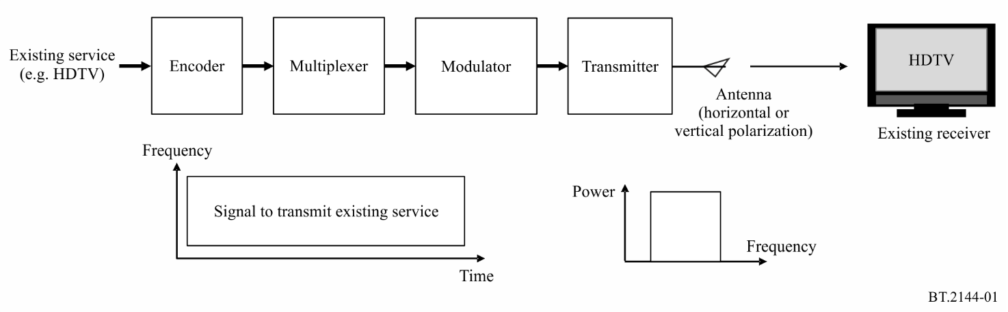

3.1 Method A: Introducing a new service in the same channel used for existing services
Two types of methods can be assumed for introducing new services in the same channel used for existing services: (1) multiplexing in a higher layer above the physical layer, and (2) multiplexing in the physical layer.

3.1.1 Method A1: Multiplexing in the transport layer
Both existing and new services can be multiplexed in the transport layer. Figure 2 shows a block diagram of this method. As the transmission technology remains unchanged, multiplexing methods above the physical layer split transmission capacity between the existing and new services.
(1) Existing service
When the same parameters for the physical layer are used, the service area is unaffected, but the capacity is reduced, resulting in quality degradation.
(2) New service
Since the parameters for the physical layer are common for both existing and new services, the service area is the same for both services. During the simulcast period, the capacity for a new service depends on the payload allocation. A newer video coding technology, with higher efficiency, is employed for the new service.
Figure 2
Multiplexing above the physical layer
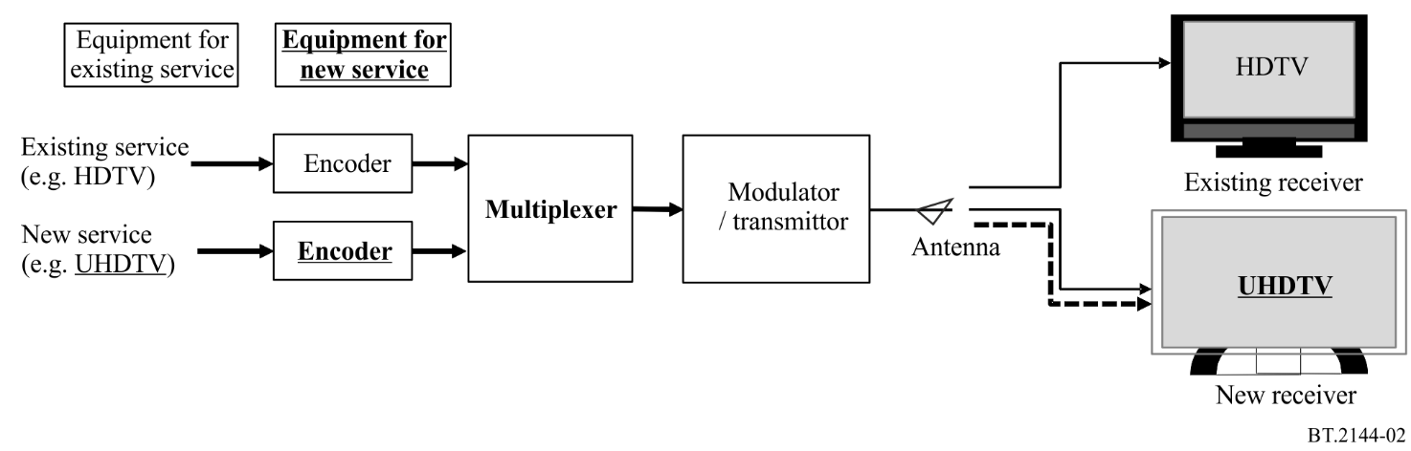

3.1.2 Multiplexing in the physical layer
Multiplexing in the physical layer means employing hierarchical transmission; that is, frequency-division multiplexing (FDM), time-division multiplexing (TDM), or layered-division multiplexing (LDM). Space-division multiplexing – multiple-input multiple-output (SDM–MIMO), which uses different polarizations, can also be employed along with hierarchical transmission. Both existing and new services can be transmitted in the same channel by allocating each payload to different physical layers using the hierarchical transmission function.

3.1.2.1 Method A2: TDM and FDM
Figure 3 shows a block diagram for multiplexing existing and new services using the TDM or FDM. This method can only be used when the existing service employs TDM or FDM. New and advanced source coding and multiplexing schemes may be used for new services. The payloads of the existing and new services are multiplexed using TDM or FDM.
(1) Existing service
When the transmission parameters for the existing service are not changed, the service area of the existing service remains the same. However, its transmission capacity is reduced, resulting in quality degradation.
(2) New service
The service area and transmission capacity of the new service depend on modulation parameters and error correction technologies. Thus, using advanced modulation and error correction technologies is necessary to ensure a well-balanced service area and capacity for the new service. Coding technologies with higher efficiency can improve the quality of service within a limited capacity during the simulcast period.
Figure 3
TDM or FDM
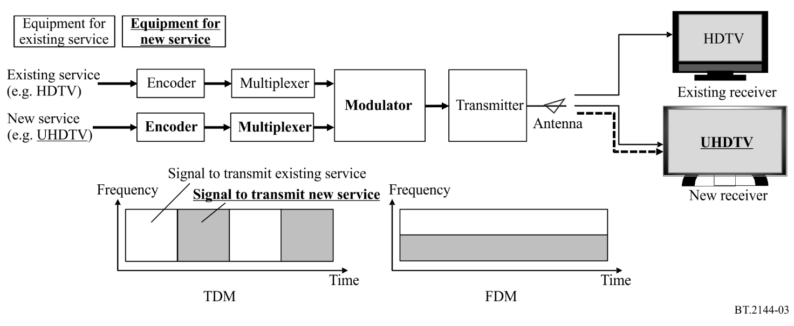

3.1.2.2 Method A3: LDM
Figure 4 shows a block diagram for multiplexing existing and new services using the LDM. Figure 4 (a) shows the method for multiplexing signals with synchronization inside the modulator. Figure 4 (b) shows another method to multiplex signals without synchronization; this method can be used for any of the existing broadcasting systems and can be combined with TDM and FDM. New services can use a new broadcasting system and an extended bandwidth. The signal of the new service is introduced in the lower layer and superimposed with the existing broadcast signal in the upper layer. LDM may be more efficient than FDM and TDM especially operating with a different required C/N between upper layer and lower layer. But its use implies greater receiver complexity.
(1) Existing service
To increase robustness against interference from the new service, transmission parameters of the existing service must be changed. This, however, reduces the capacity if the existing broadcast service area is to be retained. If the parameters of the physical layer applied to the existing service remain unchanged, the service area is reduced due to interference from the signal of the new service.
(2) New service
To reduce the interference with the existing service, the transmission power of the new service must be decreased, thereby reducing the service area. To achieve the same service area as the existing service even with the reduced transmission power, transmission parameters with higher robustness need to be employed, which reduces the transmission capacity.
Figure 4
LDM
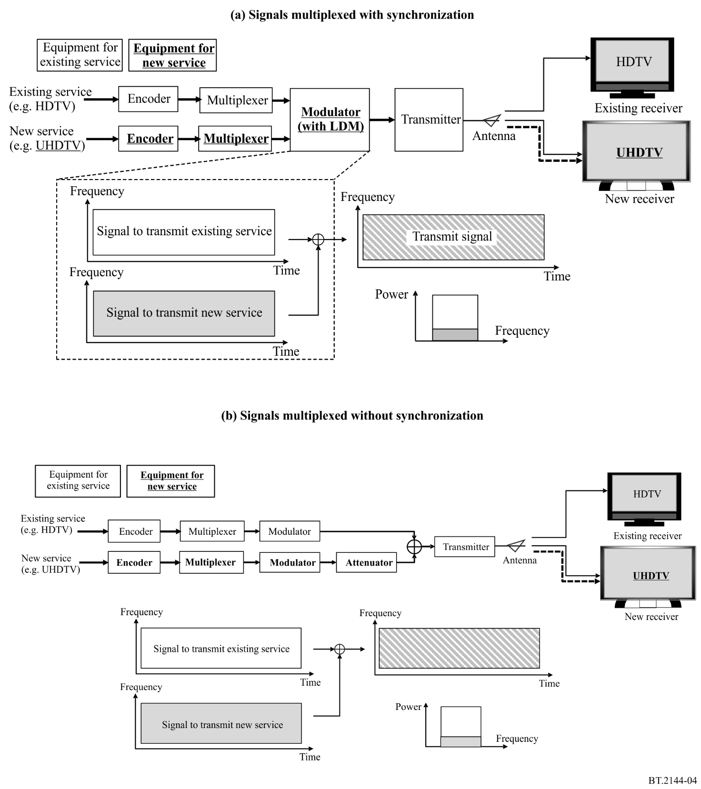

3.1.2.3 Method A4: SDM-MIMO
Figure 5 shows a block diagram for multiplexing existing and new services using SDM-MIMO. This method can be utilized for any of the existing broadcasting systems and can be combined with TDM and FDM. New services employing the new broadcasting system and an extended bandwidth can be transmitted using opposite polarization. This method may be more efficient than FDM and TDM, but it should be noticed that it relies on the polarization discrimination that can be obtained when the polarization of the receiving antennas conforms to that of the wanted signal, which generally can only be assumed for the case of fixed outdoor reception. In the case of portable/mobile DTTB reception, no polarization discrimination can be assumed for the receiving antennas, so this method cannot be applied.
(1) Existing service
To increase robustness against interference from the new service, transmission parameters for the existing service must be changed. This, however, reduces the capacity if the existing broadcast service area is to be retained. If the parameters of the physical layer applied to the existing service remain unchanged, the service area is reduced due to interference from the signal of the new service.
(2) New service
To reduce the interference with the existing service, the transmission power of the new service must be reduced, thereby reducing the service area. To retain the same service area as the existing service even with the decreased transmission power, transmission parameters with higher robustness needs to be employed, which reduces the transmission capacity.
Figure 5
SDM-MIMO
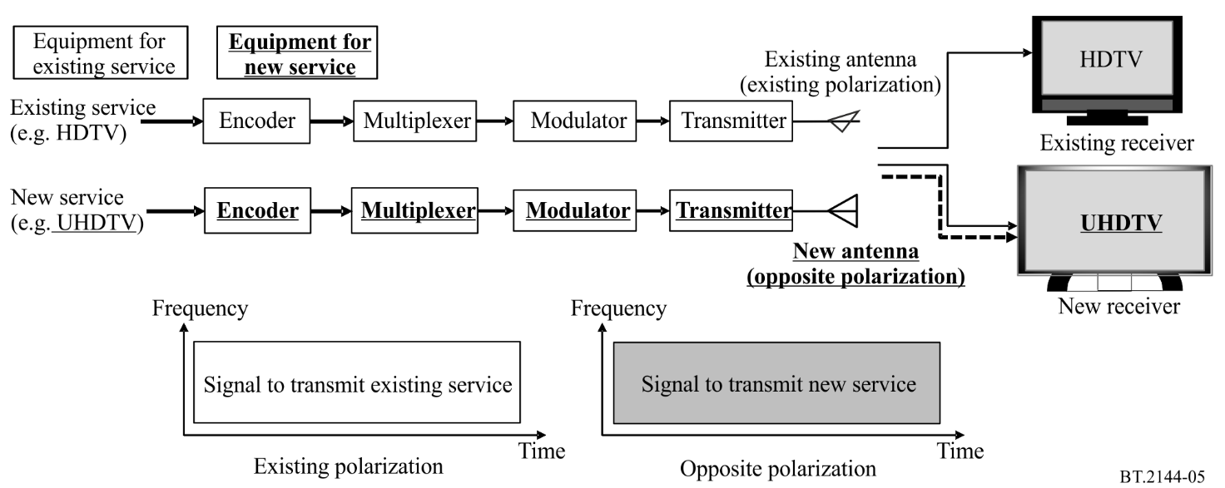

3.2 Method B: Introducing a new service in a different channel that is not used for existing services

3.2.1 Method B1: Introducing a new service in a different channel when there are not enough channels available for simulcasting
If there are not enough channels available for simulcasting, new services may be introduced in different channels if some channels used for the existing service are released by multiplexing more programme services on the same physical channel. Figure 6 shows a block diagram for the method of introducing a new service in a different channel when there are not enough channels available for simulcasting. In such cases, a new broadcasting system comprising new, advanced source coding, multiplexing and modulation technologies, as well an extended bandwidth, can achieve a better quality of service. A new antenna is required when the new service employs SDM-MIMO or the existing antenna does not support the new channel. The number of physical channels required for the new service can be reduced either by maximizing their capacity or by reducing their frequency reuse factor. In the first case, more programme services can be multiplexed on the same physical channel, while in the second case the same physical channel can be reused by independent local multiplexers within a shorter distance. In the limit, in the case of reuse-1, the same physical channel can be used by adjacent independent stations, allowing the network to be reconfigured for a different geographical segmentation of the service area at any time, without the need for channel re-planning.
(1) Existing service
The service area remains unchanged. The capacity for each programme service and quality of service are reduced due to the multiplexing of more programme services on the same physical channel.
(2) New service
The service area of the new service can be created similar or different to the existing service by selecting an appropriate set of transmission parameters. A significantly better transmission capacity and quality of service than existing services can be attained using advanced transmission and coding technologies. If during the simulcast phase more programme services of the new service are multiplexed on the same physical channel due to limited spectrum availability, they would have less capacity and quality of service than what would be the case after the transition is completed.
Figure 6
Introduction using a separate channel when there are not enough channels available for simulcasting
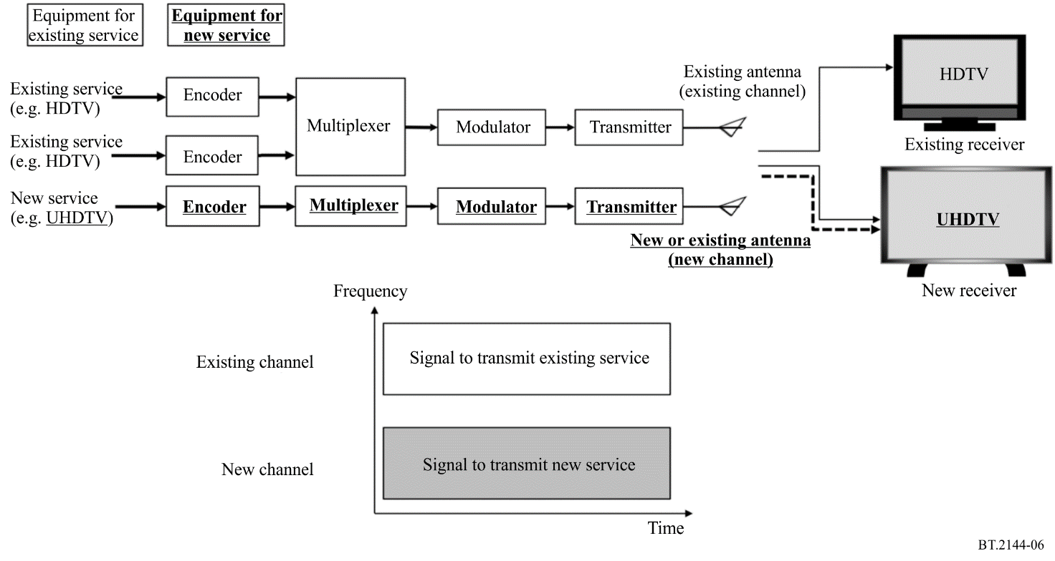

3.2.2 Method B2: Introducing a new service in a different channel when there are enough channels available for simulcasting
If there are enough vacant channels or if enough channels can be made available by replanning the existing networks (e.g. by making more intensive use of SFNs), new services may be introduced in these channels by ensuring appropriate planning conditions. Figure 7 shows a block diagram for the method of introducing a new service in a different channel when there are enough channels available for simulcasting. Similar to the case of Method B1, a new broadcasting system comprising new, advanced source coding, multiplexing and modulation technologies, as well an extended bandwidth, can achieve a better quality of service. A new antenna is required when the new service employs SDM-MIMO or the existing antenna does not support the new channel. Likewise, the number of physical channels required for the new service can be reduced either by maximizing their capacity or by reducing their frequency reuse factor.
(1) Existing service
The service area, capacity and quality of service remain unchanged.
(2) New service
The service area of the new service can be created similar or different to the existing service by selecting an appropriate set of transmission parameters. A significantly better transmission capacity and quality of service than existing services can be attained using advanced transmission and coding technologies.
Figure 7
Introduction using a separate channel when there are enough channels available for simulcasting
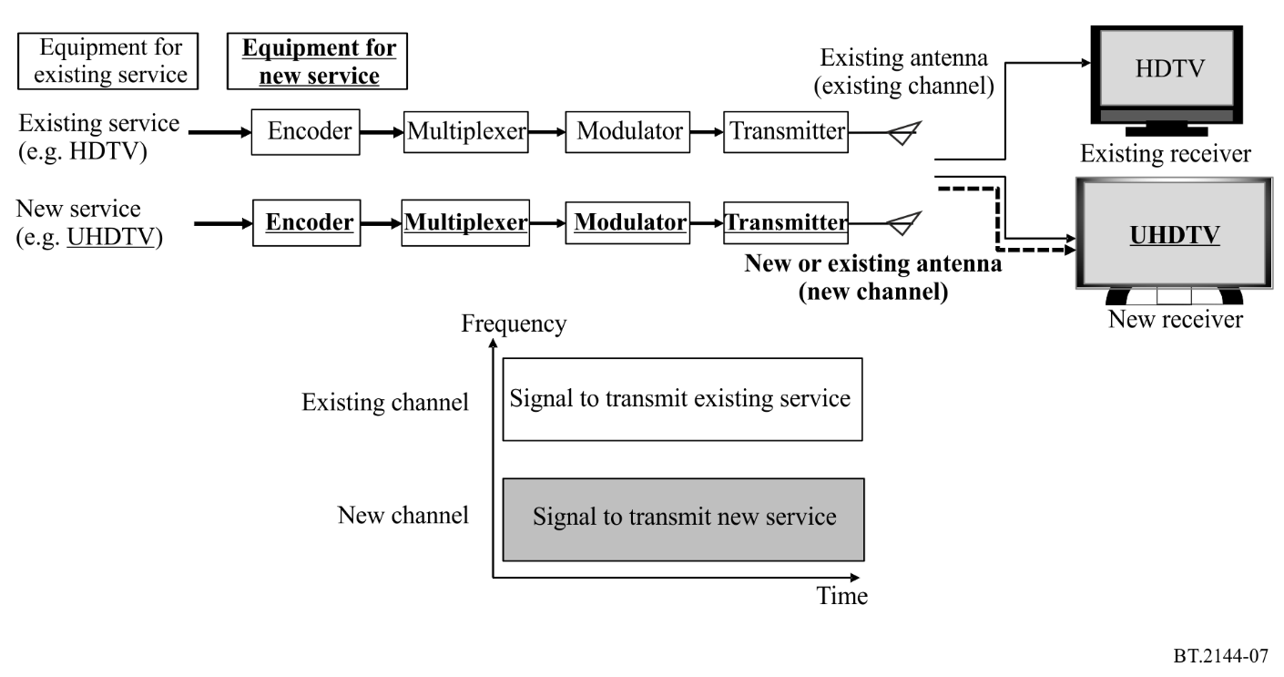

3.3 Comparison of features of the methods
Table 1 compares the features of the methods during simulcast discussed in the previous sections in terms of broadcast service areas, transmission capacity and associated quality of service.
Table 2 compares the features of the new service operation after complete transition.

TABLE 1
Comparison of features of the methods during simulcast
Method |  | A1 |  | A2 |  | A3 |  | A4 |  | B1 |  | B2
Transmission | Channel for introducing the new service | Same channel used for the existing service |  |  |  |  |  |  |  | Different channel, not used for the existing service
 | Multiplexing between existing and new services | Transport layer |  | Physical layer |  |  |  |  |  | −
 |  |  |  | FDM, TDM |  | LDM⁽¹⁾ |  | SDM-MIMO⁽²⁾
 | Transmission scheme for the new service | Same as the existing service |  | Able to use a higher-efficiency transmission technology |  | Able to use a higher-efficiency transmission technology, bandwidth can also be extended
 | Video/audio source coding scheme for the new service | Able to use a higher-efficiency source coding technology
Existing service operation during simulcast | Service area | Same as the existing area | Same as the existing area |  | Same as, or narrower than the existing area ⁽³⁾ |  | Same as, or narrower than the existing area ⁽³⁾ |  | Same as the existing area |  | Same as the existing area
 | Transmission capacity | Smaller than the existing capacity | Smaller than the existing capacity, higher than Method A1 |  | Same as, or smaller than the existing capacity ⁽³⁾, higher than Method A2 |  | Same as, or smaller than the existing capacity ⁽³⁾, higher than Method A2 |  | Smaller than the existing capacity |  | Same as the existing capacity
 | Video/audio service quality | Lower than the existing service quality | Lower than the existing service quality, higher than Method A1 |  | Same as, or lower than the existing service quality ⁽³⁾, higher than Method A2 |  | Same as, or lower than the existing service quality ⁽³⁾, higher than Method A2 |  | Lower than the existing service quality |  | Same as the existing service quality
TABLE 1 (continued)
Method |  | A1 | A2 | A3 | A4 | B1 | B2
New service operation during simulcast | Service area | Same as the existing area | Can be similar or different to the existing service ⁽⁴⁾ | Can be similar or different to the existing service ⁽⁴⁾ | Can be similar or different to the existing service ⁽⁴⁾ | Can be similar or different to the existing service ⁽⁴⁾ | Can be similar or different to the existing service ⁽⁴⁾
 | Transmission capacity | Lower than the existing capacity | Can be increased from the existing capacity ⁽⁴⁾ | Can be increased from the existing capacity ⁽⁴⁾, higher than Method A2 | Can be increased from the existing capacity ⁽⁴⁾, higher than Method A2 | Can be increased over the existing capacity ⁽⁴⁾, higher than Method A3 | Can be increased over the existing capacity ⁽⁴⁾, higher than or equal to Method B1
 | Video/audio service quality | Can be higher than the existing service | Can be higher than the existing service, higher than Method A1 | Can be higher than the existing service, higher than Method A2 | Can be higher than the existing service, higher than Method A2 | Can be higher than the existing service, can be higher than Method A3 | Higher than the existing service, higher than or equal to Method B1
Notes to Table 1:
⁽¹⁾ LDM may be more efficient than FDM and TDM especially operating with a different required C/N between upper layer and lower layer, but its use implies greater receiver complexity.
⁽²⁾ SDM-MIMO may be more efficient than FDM and TDM, but it is not applicable to portable/mobile DTTB reception.
⁽³⁾ Owing to interference from the transmitted signal of the new service, the service area will be narrower than the existing area if the transmission parameters of the existing service remain unchanged; this can provide the same capacity and quality as the existing service. Alternatively, if the transmission parameters of the existing service are changed to retain the existing service area, the transmission capacity and quality will be degraded.
⁽⁴⁾ There is a trade-off between the service area and transmission capacity.

TABLE 2
Comparison of features of the new service operation after complete transition
Method | A1 | A2 | A3 | A4 | B1 | B2
Transmission scheme | Same as the existing service | Able to use a higher-efficiency transmission technology | Able to use a higher-efficiency transmission technology, bandwidth can also be extended
Video/audio source coding scheme | Able to use a higher-efficiency source coding technology
SISO/MIMO | SISO | SISO | SISO | SISO | SISO or MIMO | SISO or MIMO
Service area | Same as the existing area | Can be similar or different to the existing service ⁽¹⁾ | Can be similar or different to the existing service ⁽¹⁾ | Can be similar or different to the existing service ⁽¹⁾ | Can be similar or different to the existing service ⁽¹⁾ | Can be similar or different to the existing service ⁽¹⁾
Transmission capacity | Same as the existing capacity | Can be increased from the existing capacity ⁽¹⁾, higher than during simulcast, higher than Method A1 | Can be increased from the existing capacity ⁽¹⁾, higher than during simulcast, higher than Method A2 | Can be increased from the existing capacity ⁽¹⁾, higher than during simulcast, higher than Method A2 | Can be increased from the existing capacity ⁽¹⁾, higher than during simulcast, higher than Method A2 | Can be increased from the existing capacity ⁽¹⁾, same as during simulcast, higher than Method A2
Service quality | Higher than the existing service, higher than during simulcast | Higher than the existing service, higher than during simulcast, higher than Method A1 | Higher than the existing service, higher than during simulcast, higher than Method A2 | Higher than the existing service, higher than during simulcast, higher than Method A2 | Higher than the existing service, higher than during simulcast, higher than Method A2 | Higher than the existing service, same as during simulcast, higher than Method A2
⁽¹⁾ There is a trade-off between the service area and transmission capacity.

______________

