Recommendation ITU-R BT.2123-0
(01/2019)
Video parameter values for advanced immersive audio-visual systems
for production and international
programme exchange in broadcasting

BT Series
Broadcasting service
(television)

Foreword
The role of the Radiocommunication Sector is to ensure the rational, equitable, efficient and economical use of the radio-frequency spectrum by all radiocommunication services, including satellite services, and carry out studies without limit of frequency range on the basis of which Recommendations are adopted.
The regulatory and policy functions of the Radiocommunication Sector are performed by World and Regional Radiocommunication Conferences and Radiocommunication Assemblies supported by Study Groups.

Policy on Intellectual Property Right (IPR)
ITU-R policy on IPR is described in the Common Patent Policy for ITU-T/ITU-R/ISO/IEC referenced in Resolution ITU-R 1. Forms to be used for the submission of patent statements and licensing declarations by patent holders are available from http://www.itu.int/ITU-R/go/patents/en where the Guidelines for Implementation of the Common Patent Policy for ITU-T/ITU-R/ISO/IEC and the ITU-R patent information database can also be found.

Series of ITU-R Recommendations
(Also available online at http://www.itu.int/publ/R-REC/en)
Series | Title
BO | Satellite delivery
BR | Recording for production, archival and play-out; film for television
BS | Broadcasting service (sound)
BT | Broadcasting service (television)
F | Fixed service
M | Mobile, radiodetermination, amateur and related satellite services
P | Radiowave propagation
RA | Radio astronomy
RS | Remote sensing systems
S | Fixed-satellite service
SA | Space applications and meteorology
SF | Frequency sharing and coordination between fixed-satellite and fixed service systems
SM | Spectrum management
SNG | Satellite news gathering
TF | Time signals and frequency standards emissions
V | Vocabulary and related subjects

Note: This ITU-R Recommendation was approved in English under the procedure detailed in Resolution ITU-R 1.

Electronic Publication
Geneva, 2019
© ITU 2019
All rights reserved. No part of this publication may be reproduced, by any means whatsoever, without written permission of ITU.

RECOMMENDATION ITU-R BT.2123-0
Video parameter values for advanced immersive audio-visual systems
for production and international programme exchange in broadcasting
(2019)
Scope
Advanced immersive audio-visual (AIAV) systems will provide viewers with immersive experiences with an unprecedented degree of presence by enabling a wide field of view of their desired direction. In order to produce high-quality comfortable images, AIAV systems require video system parameters that go beyond the levels of UHDTV as well as additional system parameters to support omnidirectional image representation. This Recommendation specifies AIAV system parameters for production and international programme exchange.
Keywords
Immersive media, virtual reality, 360º video, system parameters, projection mapping
The ITU Radiocommunication Assembly,
considering
a) that virtual reality, 360º video, and other immersive media technologies have caught the attention of the content providers, audiences, and the associated consumer technology vendors;
b) that television and radio programme makers and others are exploring advanced immersive systems to enhance the audiences’ experience of their content;
c) that currently immersive media content is usually acquired and produced to the requirements of specific delivery or distribution technologies;
d) that currently no worldwide standards or recommended practices exist for production, mastering, and exchange of virtual reality, 360º video, and other immersive programmes in broadcast;
e) that broadcasters are distributing a wide variety of content to audiences via an increasing number of interactive delivery platforms;
f) that making virtual reality 360º images high quality and comfortable requires having a significantly high spatial resolution;
g) that specifying parameter values of audio-visual components for advanced immersive audio-visual (AIAV) systems for production of professional linear content facilitates producing a variety of AIAV content,
recommends
that for production and international exchange of AIAV content, the specifications described in this Recommendation should be used.

1 Picture characteristics for 360ºimages in three degrees of freedom (3DoF) applications
Picture characteristics are shown in Tables 1 through 3 for 360º images in 3DoF applications.
TABLE 1
Image spatial and temporal characteristics
Parameter | Values
Projection method of a sphere to a rectangular image | Equirectangular projection  (see details in Annex 1)
Pixel count of mapped images  Horizontal × vertical | 30 720 × 15 360 ^{(1), (2)}  (30K × 15K)
Pixel aspect ratio | 1:1 (square pixels)
Frame frequency (Hz) | 120, 120/1.001, 100, 60, 60/1.001, 50
Image format | Progressive
⁽¹⁾ These values are based on typical human spatial angular acuity for viewers not to perceive a pixel structure when viewing part of a 360° image. A pixel count of 30K × 15K is required for a full 360° image. Other pixel counts may be used when actual system design is undertaken.
⁽²⁾ A hemisphere or a part of a 360° image may be represented by taking a part of 30K × 15K pixels.

TABLE 2
System colorimetry
Parameter |  | Values
 |  | Optical spectrum (informative) | Chromaticity coordinates  (CIE, 1931)
 |  |  | x | y
Primary colours | Red primary (R) | monochromatic 630 nm | 0.708 | 0.292
 | Green primary (G) | monochromatic 532 nm | 0.170 | 0.797
 | Blue primary (B) | monochromatic 467 nm | 0.131 | 0.046
Reference white |  | D65 per  ISO 11664-2:2007 | 0.3127 | 0.3290
Colour Matching Functions |  | CIE 1931
TABLE 3
Signal format
Parameter | Values
Signal format | R’G’B’, Y'C'_{B}C'_{R} (non-constant luminance), IC_{T}C_{P}
Derivation of R'G'B', Y'C'_{B}C'_{R}, and IC_{T}C_{P} (HDR only) | Standard dynamic range (SDR): As per Rec. ITU-R BT.2020  High dynamic range (HDR): As per Rec. ITU-R BT.2100
Bit depths | 10 or 12 bits per component
Colour sub-sampling | As per Table 8 of Rec. ITU-R BT.2100
Digital integer representation | As per Table 9 of Rec. ITU-R BT.2100  (SDR: narrow range, HDR: narrow or full range)
NOTE – Constant Intensity IC_{T}C_{P} signal format was initially introduced in 2016 in Recommendation ITU-R BT.2100. This signal format should not be used for programme exchange unless all parties agree.

2 Presentation characteristics for 360º images
Informative presentation characteristics for 360º images are shown in Annex 2.

Annex 1
(normative)
Omnidirectional video projection

1 Projection structure and coordinate system
The projection structure is a unit sphere.
The coordinate system specified in this section should be used to indicate the orientation of the projection structure or the spherical location of a point. In the latter case, the roll angle may be absent or ignored.
NOTE 1 – It is assumed that the coordinate systems for different media types were aligned during content production.
NOTE 2 – The specified coordinate system is the same as the reference coordinate system for actuators specified in ISO/IEC 23005-5.
Figure 1 specifies the coordinate axes used for defining yaw (φ), pitch (θ), and roll angles. Yaw rotates around the Y (vertical, up) axis, pitch around the X (lateral, side-to-side) axis, and roll around the Z (back-to-front) axis. Rotations are extrinsic, i.e. around the X, Y, and Z fixed reference axes. The angles increase clockwise when looking from the origin towards the positive end of an axis.
Figure 1
Principal axes for yaw, pitch, roll angles
Yaw rotates around Y (vertical, up) axis, pitch around X (lateral, side-to-side) axis, roll around Z (back-to-front)
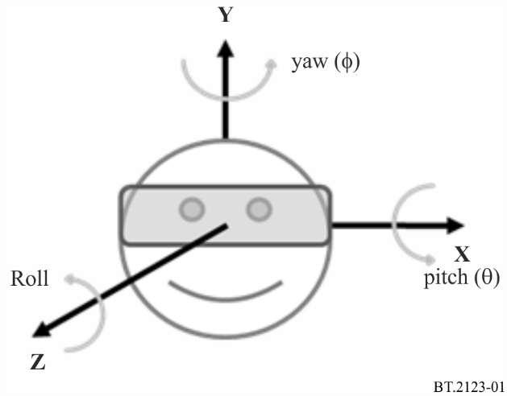
Yaw angle (φ) indicates the rotation angle around the Y axis in degrees.
Type: floating point decimal values
Range: in the range of −180, inclusive, to 180, exclusive
Pitch angle (θ) indicates the rotation angle around the X axis in degrees.
Type: floating point decimal values
Range: in the range of −90, inclusive, to 90, inclusive
Roll angle indicates the rotation angle around the Z axis in degrees.
Type: floating point decimal values
Range: in the range of −180, inclusive, to 180, exclusive

2 Omnidirectional projection formats
Inputs to this clause are:
– Picture width (w) and Picture height (h), which are the width and height, respectively, of the equirectangular panorama picture in samples, and
– the centre point of a sample location (i, j) along horizontal and vertical axes, respectively.
Outputs of this clause are:
– angular coordinates (φ, θ) for the sample in degrees relative to the coordinate axes specified in § 1.
The angular coordinates (φ, θ) for the luma sample location, in degrees, are given by the following equirectangular mapping equations, as shown in Fig. 2.
φ = ( i ÷ w − 0.5 ) * 360
θ = ( 0.5 − j ÷ h ) * 180
Figure 2
Sampling coordinate definition
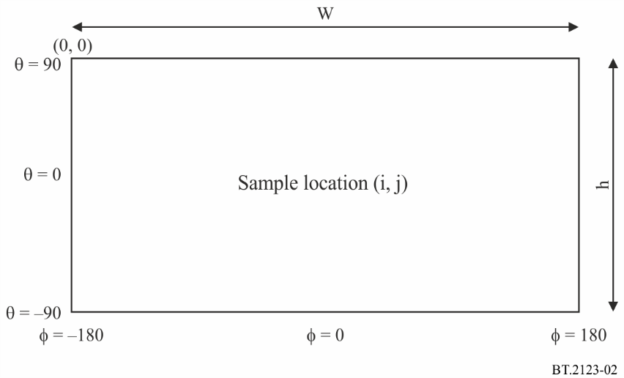

Annex 2
(informative)
Presentation characteristics for 360º images
Presentation of 360º images on a head-mounted display (HMD) requires the display resolution of 7 680 × 4 320 (8K × 4K) for the field of view of about 100º for end users not to perceive a pixel structure.

The term “Immersive” in the context of this Recommendation is deemed to include any format or medium or platform that offers or engages an audience in a way that enables any form of interaction or control of the content’s presentation.
Programme material in which a user can freely look around in any direction having three degrees of freedom (3DoF) (yaw, pitch, and roll). A typical use case is a user sitting in a chair looking at 3D VR/360° content presented on a head-mounted display (HMD). Figure 1 provides further detail.
This Annex is based on the specifications in ISO/IEC 23090-2 Omnidirectional Media Format.

