Recommendation ITU-R BT.2111-1
(06/2019)
Specification of colour bar test pattern for high dynamic range television systems

BT Series
Broadcasting service
(television)

Foreword
The role of the Radiocommunication Sector is to ensure the rational, equitable, efficient and economical use of the radio-frequency spectrum by all radiocommunication services, including satellite services, and carry out studies without limit of frequency range on the basis of which Recommendations are adopted.
The regulatory and policy functions of the Radiocommunication Sector are performed by World and Regional Radiocommunication Conferences and Radiocommunication Assemblies supported by Study Groups.

Policy on Intellectual Property Right (IPR)
ITU-R policy on IPR is described in the Common Patent Policy for ITU-T/ITU-R/ISO/IEC referenced in Resolution ITU-R 1. Forms to be used for the submission of patent statements and licensing declarations by patent holders are available from http://www.itu.int/ITU-R/go/patents/en where the Guidelines for Implementation of the Common Patent Policy for ITU-T/ITU-R/ISO/IEC and the ITU-R patent information database can also be found.

Series of ITU-R Recommendations
(Also available online at http://www.itu.int/publ/R-REC/en)
Series | Title
BO | Satellite delivery
BR | Recording for production, archival and play-out; film for television
BS | Broadcasting service (sound)
BT | Broadcasting service (television)
F | Fixed service
M | Mobile, radiodetermination, amateur and related satellite services
P | Radiowave propagation
RA | Radio astronomy
RS | Remote sensing systems
S | Fixed-satellite service
SA | Space applications and meteorology
SF | Frequency sharing and coordination between fixed-satellite and fixed service systems
SM | Spectrum management
SNG | Satellite news gathering
TF | Time signals and frequency standards emissions
V | Vocabulary and related subjects

Note: This ITU-R Recommendation was approved in English under the procedure detailed in Resolution ITU-R 1.

Electronic Publication
Geneva, 2019
© ITU 2019
All rights reserved. No part of this publication may be reproduced, by any means whatsoever, without written permission of ITU.

RECOMMENDATION ITU-R BT.2111-1
Specification of colour bar test pattern for
high dynamic range television systems
(2017-2019)
Scope
This Recommendation specifies reference test patterns for the high dynamic range television systems specified in Recommendation ITU-R BT.2100.
Keywords
Colour bars, HDR, HDR-TV, HLG, PQ, test pattern, test signal
The ITU Radiocommunication Assembly,
considering
a) that test patterns provide a convenient means of assessing chrominance and luminance performance in a television system;
b) that such a test pattern may be useful when broadcasting in multiple formats or when converting between formats;
c) that the use of a test pattern can simplify test procedures and reduce the opportunity for misinterpretation of signal parameters and misalignment of systems,
noting
that Recommendation ITU-R BT.2100 specifies image parameter values for high dynamic range television for use in production and international programme exchange,
recommends
that the test patterns defined in Annex 1 should be implemented and may be used for production and distribution purposes in high dynamic range television (HDR-TV) systems.

Annex 1
(normative)
Specifications of test pattern

1 Normative references
Recommendation ITU-R BT.471 ‒ Nomenclature and description of colour bar signals
Recommendation ITU-R BT.709 ‒ Parameter values for the HDTV standards for production and international programme exchange.
Recommendation ITU-R BT.2100 ‒ Image parameter values for high dynamic range television for use in production and international programme exchange

2 Purpose
The reference test pattern has several purposes:
– quality control of chrominance and luminance through the production chain;
– checking and adjusting the chrominance and luminance alignment of broadcast equipment, particularly video monitors;
– general testing of equipment for video production, emission and presentation;
– establishing that a video circuit is active and that associated audio is available.
It is not intended that this test pattern be used for black level adjustment, which is best set using a PLUGE signal.

3 System types
The pattern described in this Recommendation is intended for use with Recommendation ITU-R BT.2100. These systems are distinguished by the proportions of their colour encoding (or “colorimetry”) and by their resolution.

4 Sections of test pattern
The various sections of the test pattern for the HLG system with narrow range coding are shown in Fig. 1; the pattern for the PQ system with narrow range coding is shown in Fig. 2, and the pattern for the PQ system with full range coding is shown in Fig. 3. A colour diagram is shown in Fig. 4. See also Attachments 1 and 2.
FIGURE 1
Test pattern details for HLG narrow range
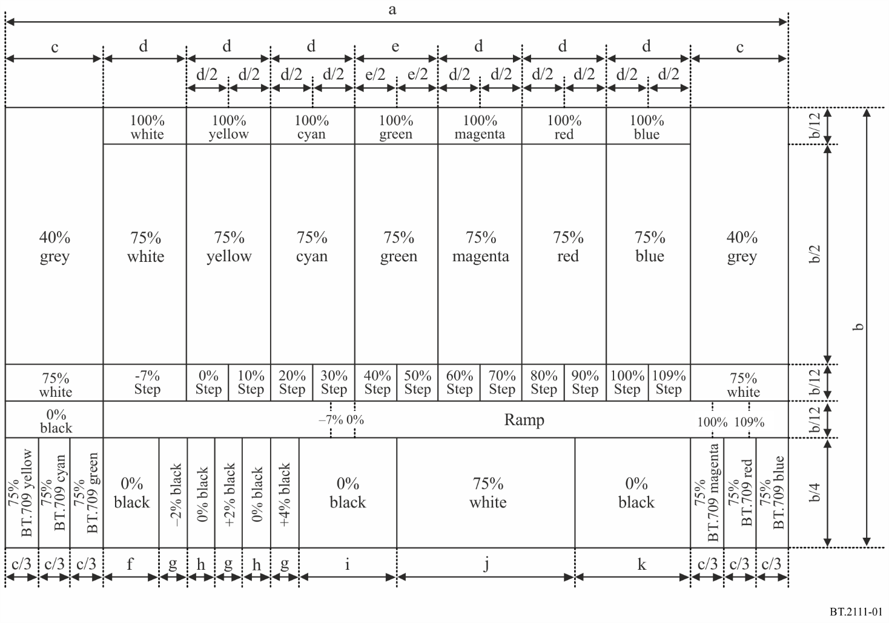
FIGURE 2
Test pattern details for PQ narrow range
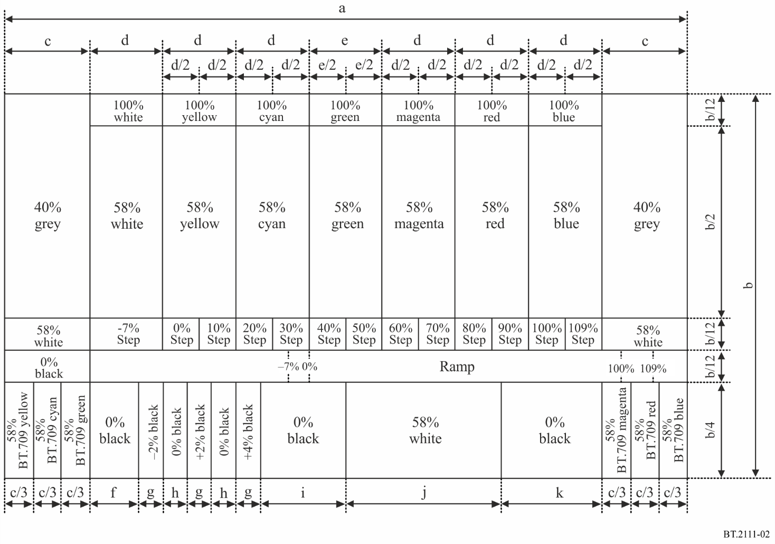
FIGURE 3
Test pattern details for PQ full range
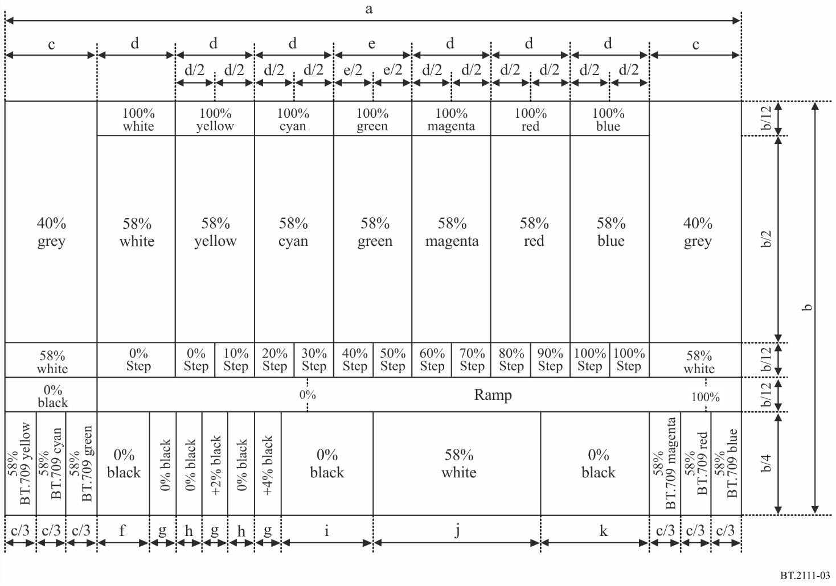
TABLE 1
Bar size to 2K, 4K and 8K format
Bar size  (pixel) | 2K | 4K | 8K
a | 1920 | 3840 | 7680
b | 1080 | 2160 | 4320
c | 240 | 480 | 960
d | 206 | 412 | 824
e | 204 | 408 | 816
f | 136 | 272 | 544
g | 70 | 140 | 280
h | 68 | 136 | 272
i | 238 | 476 | 952
j | 438 | 876 | 1752
k | 282 | 564 | 1128

FIGURE 4
Colour diagram of the test pattern
TABLE 2
Signal level for HLG narrow range
 | 10 bits |  |  | 12 bits
Image Area | R´ | G´ | B´ | R´ | G´ | B´
100% White | 940 | 940 | 940 | 3 760 | 3 760 | 3 760
100% Yellow | 940 | 940 | 64 | 3 760 | 3 760 | 256
100% Cyan | 64 | 940 | 940 | 256 | 3 760 | 3 760
100% Green | 64 | 940 | 64 | 256 | 3 760 | 256
100% Magenta | 940 | 64 | 940 | 3 760 | 256 | 3 760
100% Red | 940 | 64 | 64 | 3 760 | 256 | 256
100% Blue | 64 | 64 | 940 | 256 | 256 | 3 760
75% White | 721 | 721 | 721 | 2 884 | 2 884 | 2 884
75% Yellow | 721 | 721 | 64 | 2 884 | 2 884 | 256
75% Cyan | 64 | 721 | 721 | 256 | 2 884 | 2 884
75% Green | 64 | 721 | 64 | 256 | 2 884 | 256
75% Magenta | 721 | 64 | 721 | 2 884 | 256 | 2 884
75% Red | 721 | 64 | 64 | 2 884 | 256 | 256
75% Blue | 64 | 64 | 721 | 256 | 256 | 2 884
40% Grey | 414 | 414 | 414 | 1 656 | 1 656 | 1 656
−7% Step | 4 | 4 | 4 | 16 | 16 | 16
0% Step | 64 | 64 | 64 | 256 | 256 | 256
10% Step | 152 | 152 | 152 | 608 | 608 | 608
20% Step | 239 | 239 | 239 | 956 | 956 | 956

TABLE 2 (end)
 | 10 bits |  |  | 12 bits
Image Area | R´ | G´ | B´ | R´ | G´ | B´
30% Step | 327 | 327 | 327 | 1 308 | 1 308 | 1 308
40% Step | 414 | 414 | 414 | 1 656 | 1 656 | 1 656
50% Step | 502 | 502 | 502 | 2 008 | 2 008 | 2 008
60% Step | 590 | 590 | 590 | 2 360 | 2 360 | 2 360
70% Step | 677 | 677 | 677 | 2 708 | 2 708 | 2 708
80% Step | 765 | 765 | 765 | 3 060 | 3 060 | 3 060
90% Step | 852 | 852 | 852 | 3 408 | 3 408 | 3 408
100% Step | 940 | 940 | 940 | 3 760 | 3 760 | 3 760
109% Step | 1 019 | 1 019 | 1 019 | 4 076 | 4 076 | 4 076
 | See Fig. 5 and Table 5
75% BT.709 Yellow | 713 | 719 | 316 | 2 852 | 2 876 | 1 264
75% BT.709 Cyan | 538 | 709 | 718 | 2 152 | 2 836 | 2 872
75% BT.709 Green | 512 | 706 | 296 | 2 048 | 2 824 | 1 184
75% BT.709 Magenta | 651 | 286 | 705 | 2 604 | 1 144 | 2 820
75% BT.709 Red | 639 | 269 | 164 | 2 556 | 1 076 | 656
75% BT.709 Blue | 227 | 147 | 702 | 908 | 588 | 2 808
0% Black | 64 | 64 | 64 | 256 | 256 | 256
−2% Black | 48 | 48 | 48 | 192 | 192 | 192
+2% Black | 80 | 80 | 80 | 320 | 320 | 320
+4% Black | 99 | 99 | 99 | 396 | 396 | 396

TABLE 3
Signal level for PQ narrow range
 | 10 bits |  |  | 12 bits
Image Area | R´ | G´ | B´ | R´ | G´ | B´
100% White | 940 | 940 | 940 | 3 760 | 3 760 | 3 760
100% Yellow | 940 | 940 | 64 | 3 760 | 3 760 | 256
100% Cyan | 64 | 940 | 940 | 256 | 3 760 | 3 760
100% Green | 64 | 940 | 64 | 256 | 3 760 | 256
100% Magenta | 940 | 64 | 940 | 3 760 | 256 | 3 760
100% Red | 940 | 64 | 64 | 3 760 | 256 | 256
100% Blue | 64 | 64 | 940 | 256 | 256 | 3 760

TABLE 3 (end)
 | 10 bits |  |  | 12 bits
Image Area | R´ | G´ | B´ | R´ | G´ | B´
58% White | 572 | 572 | 572 | 2 288 | 2 288 | 2 288
58% Yellow | 572 | 572 | 64 | 2 288 | 2 288 | 256
58% Cyan | 64 | 572 | 572 | 256 | 2 288 | 2 288
58% Green | 64 | 572 | 64 | 256 | 2 288 | 256
58% Magenta | 572 | 64 | 572 | 2 288 | 256 | 2 288
58% Red | 572 | 64 | 64 | 2 288 | 256 | 256
58% Blue | 64 | 64 | 572 | 256 | 256 | 2 288
40% Grey | 414 | 414 | 414 | 1 656 | 1 656 | 1 656
−7% Step | 4 | 4 | 4 | 16 | 16 | 16
0% Step | 64 | 64 | 64 | 256 | 256 | 256
10% Step | 152 | 152 | 152 | 608 | 608 | 608
20% Step | 239 | 239 | 239 | 956 | 956 | 956
30% Step | 327 | 327 | 327 | 1 308 | 1 308 | 1 308
40% Step | 414 | 414 | 414 | 1 656 | 1 656 | 1 656
50% Step | 502 | 502 | 502 | 2 008 | 2 008 | 2 008
60% Step | 590 | 590 | 590 | 2 360 | 2 360 | 2 360
70% Step | 677 | 677 | 677 | 2 708 | 2 708 | 2 708
80% Step | 765 | 765 | 765 | 3 060 | 3 060 | 3 060
90% Step | 852 | 852 | 852 | 3 408 | 3 408 | 3 408
100% Step | 940 | 940 | 940 | 3 760 | 3 760 | 3 760
109% Step | 1 019 | 1 019 | 1 019 | 4 076 | 4 076 | 4 076
Ramp | See Fig. 5 and Table 5
58% BT.709 Yellow | 568 | 571 | 381 | 2 272 | 2 284 | 1 524
58% BT.709 Cyan | 484 | 566 | 571 | 1 936 | 2 264 | 2 284
58% BT.709 Green | 474 | 564 | 368 | 1 896 | 2 256 | 1 472
58% BT.709 Magenta | 536 | 361 | 564 | 2 144 | 1 444 | 2 256
58% BT.709 Red | 530 | 350 | 256 | 2 120 | 1 400 | 1 024
58% BT.709 Blue | 317 | 236 | 562 | 1 268 | 944 | 2 248
0% Black | 64 | 64 | 64 | 256 | 256 | 256
−2% Black | 48 | 48 | 48 | 192 | 192 | 192
+2% Black | 80 | 80 | 80 | 320 | 320 | 320
+4% Black | 99 | 99 | 99 | 396 | 396 | 396

TABLE 4
Signal level for PQ full range
 | 10 bits |  |  | 12 bits
Image Area | R´ | G´ | B´ | R´ | G´ | B´
100% White | 1 023 | 1 023 | 1 023 | 4 095 | 4 095 | 4 095
100% Yellow | 1 023 | 1 023 | 0 | 4 095 | 4 095 | 0
100% Cyan | 0 | 1 023 | 1 023 | 0 | 4 095 | 4 095
100% Green | 0 | 1 023 | 0 | 0 | 4 095 | 0
100% Magenta | 1 023 | 0 | 1 023 | 4 095 | 0 | 4 095
100% Red | 1 023 | 0 | 0 | 4 095 | 0 | 0
100% Blue | 0 | 0 | 1 023 | 0 | 0 | 4 095
58% White | 593 | 593 | 593 | 2 375 | 2 375 | 2 375
58% Yellow | 593 | 593 | 0 | 2 375 | 2 375 | 0
58% Cyan | 0 | 593 | 593 | 0 | 2 375 | 2 375
58% Green | 0 | 593 | 0 | 0 | 2 375 | 0
58% Magenta | 593 | 0 | 593 | 2 375 | 0 | 2 375
58% Red | 593 | 0 | 0 | 2 375 | 0 | 0
58% Blue | 0 | 0 | 593 | 0 | 0 | 2 375
40% Grey | 409 | 409 | 409 | 1 638 | 1 638 | 1 638
0% Step | 0 | 0 | 0 | 0 | 0 | 0
10% Step | 102 | 102 | 102 | 410 | 410 | 410
20% Step | 205 | 205 | 205 | 819 | 819 | 819
30% Step | 307 | 307 | 307 | 1 229 | 1 229 | 1 229
40% Step | 409 | 409 | 409 | 1 638 | 1 638 | 1 638
50% Step | 512 | 512 | 512 | 2 048 | 2 048 | 2 048
60% Step | 614 | 614 | 614 | 2 457 | 2 457 | 2 457
70% Step | 716 | 716 | 716 | 2 867 | 2 867 | 2 867
80% Step | 818 | 818 | 818 | 3 276 | 3 276 | 3 276
90% Step | 921 | 921 | 921 | 3 686 | 3 686 | 3 686
100% Step | 1 023 | 1 023 | 1 023 | 4 095 | 4 095 | 4 095
Ramp | See Fig. 6 and Table 6
58% BT.709 Yellow | 589 | 592 | 370 | 2 356 | 2 370 | 1 480
58% BT.709 Cyan | 491 | 586 | 592 | 1 964 | 2 345 | 2 368
58% BT.709 Green | 478 | 584 | 355 | 1 915 | 2 339 | 1 420
58% BT.709 Magenta | 551 | 347 | 584 | 2 206 | 1 389 | 2 336
58% BT.709 Red | 544 | 334 | 225 | 2 178 | 1 337 | 900
58% BT.709 Blue | 296 | 201 | 582 | 1 184 | 805 | 2 328
0% Black | 0 | 0 | 0 | 0 | 0 | 0
+2% Black | 20 | 20 | 20 | 82 | 82 | 82
+4% Black | 41 | 41 | 41 | 164 | 164 | 164
FIGURE 5
HLG/PQ narrow range signal levels of the ramp
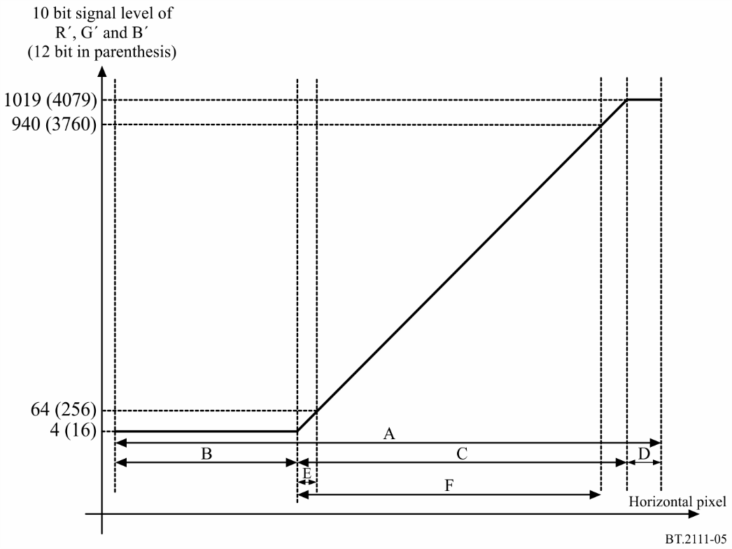
TABLE 5
HLG/PQ Narrow Range Ramp width to 2K, 4K and 8K format
Width  (pixel) | 2K |  | 4K |  | 8K
 | 10 bits | 12 bits | 10 bits | 12 bits | 10 bits | 12 bits
A | 1 680 | 1 680 | 3 360 | 3 360 | 6 720 | 6 720
B | 559 | 559 | 1 118 | 1 117 | 2 236 | 2 233
C⁽¹⁾ | 1 014 | 1 015 | 2 028 | 2 031 | 4 056 | 4 062
D | 107 | 106 | 214 | 212 | 428 | 425
E⁽²⁾ | 59 | 59 | 118 | 119 | 236 | 239
F⁽³⁾ | 935 | 935 | 1 870 | 1 871 | 3 740 | 3 743
⁽¹⁾ C corresponds to the signal level range from 5 to 1 018 in 10 bits and from 17 to 4 078 in 8K 12 bit, 18 to 4078 in 4K 12 bit, and 20 to 4076 in 2K 12 bits.
⁽²⁾ E corresponds to the signal level range from 5 to 63 in 10 bits and from 17 to 255 in 8K 12 bit, 18 to 254 in 4K 12 bit, and 20 to 252 in 2K 12 bits.
⁽³⁾ F corresponds to the signal level range from 5 to 939 in 10 bits and from 17 to 3 759 in 8K 12 bit, 18 to 3758 in 4K 12 bit, and 20 to 3756 in 2K 12 bits.

FIGURE 6
PQ full range signal levels of the ramp
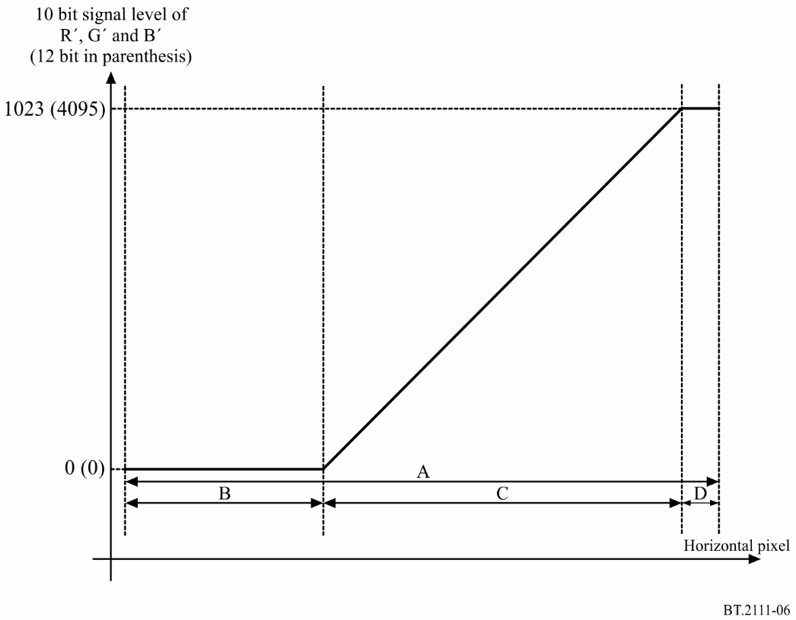

TABLE 6
PQ Full Range Ramp width to 2K, 4K and 8K format
Width  (pixel) | 2K |  | 4K |  | 8K
 | 10 bits | 12 bits | 10 bits | 12 bits | 10 bits | 12 bits
A | 1 680 | 1 680 | 3 360 | 3 360 | 6 720 | 6 720
B | 551 | 551 | 1 102 | 1 101 | 2 204 | 2 201
C⁽¹⁾ | 1 022 | 1 023 | 2 044 | 2 047 | 4 088 | 4 094
D | 107 | 106 | 214 | 212 | 428 | 425
⁽¹⁾ C corresponds to the signal level range from 1 to 1 022 in 10 bits and from 1 to 4 094 in 8K 12 bit, 2 to 4094 in 4K 12 bit, and 4 to 4092 in 2K 12 bits.

Attachment 1
to Annex 1
(informative)
Sections comprising the HLG test pattern
figure 7
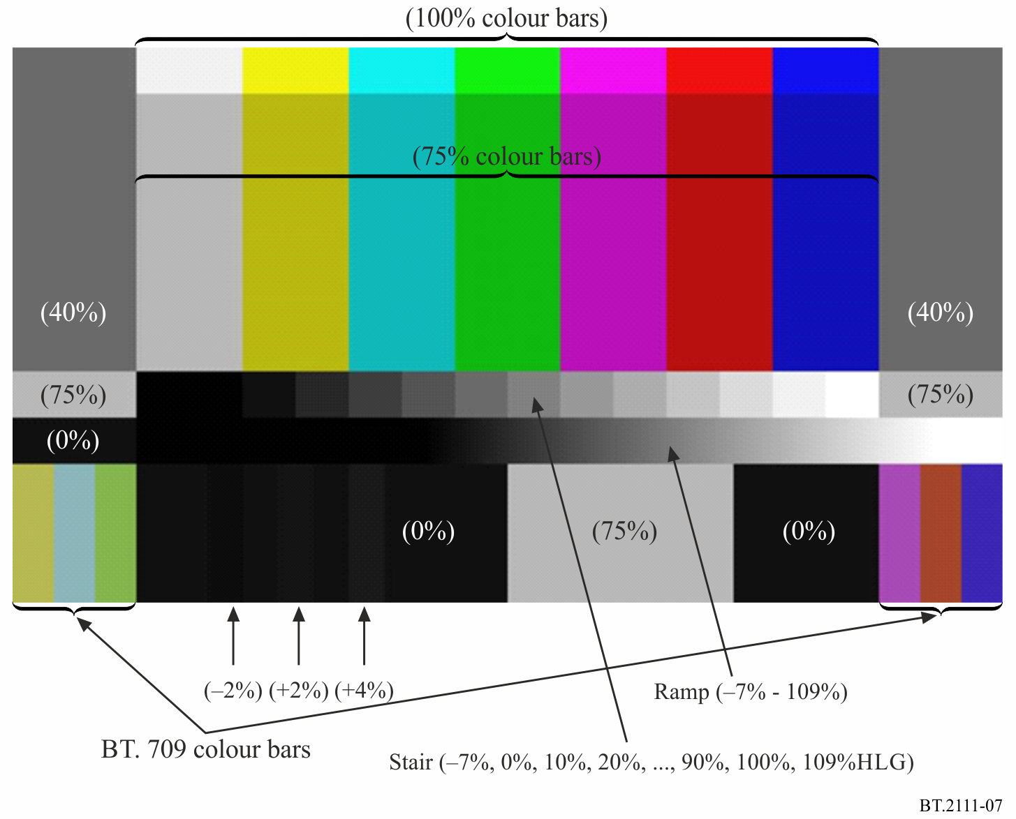
Colour Bars: The main colour bars are 75%HLG, with 100%HLG colour bars at the top.
BT.709 Colour Bars: Generated by using the HLG OETF and a linear matrix. BT.709 colour bars are placed at the left and right bottom to avoid overlaps with the main colour bars on a waveform monitor.
Ramp: Levels are from −7%HLG to 109%HLG. 0% video level is at the left edge of the Green bar.
Stair: Levels are from −7%HLG to 109%HLG. Left edge of the 0% step is at the left edge of the Yellow bar. 10% interval between 0%HLG and 100%HLG. The width of each step is a half of the colour bar. The step signal and the ramp signal are placed not to overlap on a waveform monitor.
Black signal: consisting of 0%, −2%, 0%, +2%, 0%, +4% and 0% video levels are placed at the lower left away from the bright areas for better visibility.
Grey bars (right and left): These areas may optionally be used to include other patterns for specific needs.

Attachment 2
to Annex 1
(informative)
HLG waveform on a waveform monitor
Figure 8 shows the HLG waveform of the test pattern on a waveform monitor.
FIGURE 8
Waveform on waveform monitor
(Red, Green, and Blue, respectively)
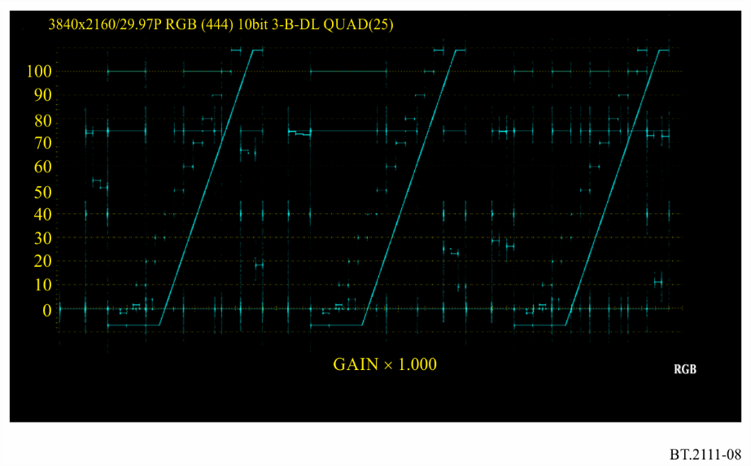

It is desirable that implementers should include in this test signal some visual identification of the signal format (HLG narrow range, PQ narrow range, or PQ full range). The test pattern includes grey bars (top right and top left) that may optionally be used for this and/or other purposes.

