Recommendation ITU-R BT.1893-1
(10/2015)
Assessment methods of impairment caused to digital television reception
by wind turbines

BT Series
Broadcasting service
(television)

Foreword
The role of the Radiocommunication Sector is to ensure the rational, equitable, efficient and economical use of the radio-frequency spectrum by all radiocommunication services, including satellite services, and carry out studies without limit of frequency range on the basis of which Recommendations are adopted.
The regulatory and policy functions of the Radiocommunication Sector are performed by World and Regional Radiocommunication Conferences and Radiocommunication Assemblies supported by Study Groups.

Policy on Intellectual Property Right (IPR)
ITU-R policy on IPR is described in the Common Patent Policy for ITU-T/ITU-R/ISO/IEC referenced in Annex 1 of Resolution ITU-R 1. Forms to be used for the submission of patent statements and licensing declarations by patent holders are available from http://www.itu.int/ITU-R/go/patents/en where the Guidelines for Implementation of the Common Patent Policy for ITU-T/ITU-R/ISO/IEC and the ITU-R patent information database can also be found.

Series of ITU-R Recommendations
(Also available online at http://www.itu.int/publ/R-REC/en)
Series | Title
BO | Satellite delivery
BR | Recording for production, archival and play-out; film for television
BS | Broadcasting service (sound)
BT | Broadcasting service (television)
F | Fixed service
M | Mobile, radiodetermination, amateur and related satellite services
P | Radiowave propagation
RA | Radio astronomy
RS | Remote sensing systems
S | Fixed-satellite service
SA | Space applications and meteorology
SF | Frequency sharing and coordination between fixed-satellite and fixed service systems
SM | Spectrum management
SNG | Satellite news gathering
TF | Time signals and frequency standards emissions
V | Vocabulary and related subjects

Note: This ITU-R Recommendation was approved in English under the procedure detailed in Resolution ITU-R 1.

Electronic Publication
Geneva, 2015

© ITU 2015
All rights reserved. No part of this publication may be reproduced, by any means whatsoever, without written permission of ITU.

RECOMMENDATION ITU-R BT.1893-1
Assessment methods of impairment caused to digital television
reception by wind turbines
(Question ITU-R 69-1/6)
(2011-2015)
Scope
This Recommendation provides methods to assess the potential impairment caused to digital television reception by wind turbine installation consisting of a single or multiple machines.
NOTE 1 – Recommendation ITU-R BT.805 provides “Assessment or impairment caused to analogue television reception by a wind turbine”.
The ITU Radiocommunication Assembly,
considering
a) that severe degradation of television reception can be caused by reflections from moving objects such as the blades of a wind turbine;
b) that these effects are particularly serious because the impairment caused can be quasi-permanent, being reduced only during periods when the wind turbine is not rotating;
c) that it is important to have available a simple method for calculating the potential impairments which could be caused by the installation of any proposed wind turbine;
d) that reflection cancellation techniques are being investigated and that these may offer some amelioration of the impairment caused by wind turbines;
e) that reflected signals may have different effects on digital television signals;
f) that reflected signals may have different effects depending on the digital modulation systems;
g) that wind turbine blades are typically made of composite materials which have different reflection coefficients than metal;
h) that the design of wind turbine blades may include additional elements that may also impact televisions signals;
i) that scattering from wind turbine pylons must also be taken into account;
j) that the location of wind turbines and their scattering patterns have an impact on the level of impairment in the vertical and horizontal plane;
k) that the number of wind turbines at a location will have an impact on scattering patterns,
noting
a) that Report ITU-R BT.2142 provides an extensive analysis of the effect of the scattering of digital television signals from wind turbines;
b) that the method given in Annex 1 is a simplified version of the complete analysis in Part A of Report ITU-R BT.2142;
c) that Report ITU-R BT.2142 provides an in depth explanation of the method given in Attachments 2, 3 and 4 that addresses issues identified in further recommends 1, 2 and 3 of Recommendation ITU-R BT.1893-0 on the impact of pylon scattering, the effect of rotating blades, non-metallic blade composition, and the elevation pattern for scatter,
recommends
1 that the method given in Annex 1 may be used to assess the potential interference from a single wind turbine to digital television reception;
2 that the method given in Annex 2 may be used to obtain a channel model to characterize multipath propagation in the presence of multiple wind turbines in the UHF broadcasting band;
3 that the method given in Annex 3 may be used to develop an assessment of the potential interference from a wind farm to digital television reception (DVB-T),
encourages
administrations to draw the attention of the relevant authorities in their countries to this Recommendation.

Annex 1
Simplified model of impairment caused to television reception
by a wind turbine
Figure 1 shows the plan view of the wind turbine problem of backscatter.
At any receiving location, R, the wanted field strength is FSR. At the wind turbine site, WT, the field strength is FSWT. It is assumed that the receiving location is at distance r (m) from the blade of the wind turbine. A “scattering coefficient”, ρ, which includes the free-space path loss for the path from the wind turbine site to the receiving location, may be defined as:
where:
and:
: mean width of the blade (m)
λ : wavelength (m)
A: blade area (m²)
θ₀: angle of the incident signal at the blade
θ: angle of the scattering signal from the blade.
The maximum value of this scattering coefficient due to a blade in the vertical position occurs when both the incident and scattering directions are normal to the blade and is given by:

FIGURE 1

In the case of a free-space path, of length r (m) between the wind turbine and the receiving location, the unwanted field strength may be calculated as:

FSWT + 20 log ρ

The scattering coefficient ρ only accounts for backscatter from the blades. It must be noted that the metallic support pylon also contributes significant static backscatter. Forward scatter from the blades may be significant, but has a lower amplitude than backscatter and is more complicated to calculate. Forward scatter from the pylon is minimal. It should also be noted that scattering pattern changes by at least 10 dB as the blades rotate. For full analysis, refer to Report ITU-R BT.2142.
The receiving antenna directivity discrimination as a function of β (as shown in Fig. 1) is given in Recommendation ITU-R BT.419 and this should be applied to determine the ratio of the wanted to unwanted signal for any specific receiving location.
An example of the use of this method is given in Attachment 1.

Attachment 1
to Annex 1
Example of use of simplified assessment method
As shown in Fig. 1 of Annex 1, identify the point of any receiver location, near the site of a proposed wind turbine.
As a first step, calculate or, preferably, measure the field-strength values, FSR, at the various receiver locations.
It is unlikely to be necessary to extend the investigation area to more than about 10 km from the proposed wind turbine site (or sites, if there are multiple turbines). However, if there are special circumstances, for example buildings which are screened from the wanted transmitter but which are line-of-site to the wind turbine, then the area may need to be extended.
Calculate or, preferably, measure the field strength, FSWT, at the wind turbine site, near the height of the centre of rotation of the blades.
For each of the receiving points, R:
– calculate the scattering coefficient, ρ, for the path between the wind turbine and the receiver;
– calculate the unwanted field strength using FSWT + 20 log ρ;
– calculate the wanted field strength FSR;
– calculate the wanted-to-unwanted signal ratio, taking account of the receiving antenna directivity discrimination;
– using the information of Attachment 2, assess the potential impairment to digital television reception given the calculated wanted-to-unwanted signal ratio at the receiving point.
The results of the study may then be presented in the form of a map showing the areas/locations where reception impairment may occur.
It should be noted that the process is more complicated if there are multiple wind turbines on a given site as there are then several possible sources of impairment at each receiving location. Report ITU-R BT.2142 provides example predictions for a large wind farm.

Annex 2
Channel model to characterize signal propagation in the presence
of a wind farm in the UHF broadcasting bands
Introduction
It should be noted that the channel model is independent of the television standard, and as such, it can be used to estimate the potential impact of a wind farm on any television service provided in the UHF band.
The channel model for propagation in the presence of wind turbines is a Tapped-Delay Line model with a number of paths, with:
– corresponding delays;
– mean amplitudes, and
– Doppler spectrum associated to each path to account for the variability caused by the rotation of the blades.
In the channel model, all these components are adaptable to the particular features of any case under study. More precisely, these parameters are specified for each reception location in the coverage area of a potentially affected transmitter.
To do so, a digital terrain database can be used to divide the coverage area into small grids of a given size (pixel). For each of the center locations of these pixels, the parameters of the channel model for those specific conditions would be obtained, as explained below. This process is easily implementable in planning tools, and provides a fast overview of the potential degradation due to the wind farm.
The adaptation of the channel model to the particular characteristics of a case under study requires some input data, which is gathered in Table 1. Accordingly, the necessary parameters which are obtained from the input data of Table 1 are included in Table 2.
TABLE 1
Input data to adapt the channel model to the specific features of a case under study
 | Type | Description
For each wind turbine | Position | Geographical coordinates, terrain height (m)
 | Mast dimensions | Vertical dimension of the mast (m)  Lower and upper diameters of the mast (m); uppermost diameter of the mast (just below the nacelle) and the diameter of the base of the mast (at ground level).
 | Blades length l | Longitudinal dimension of the blades (m)
 | Maximum rotation rate, ω_{max} | Maximum rotation rate of the blades (rpm)
Transmitter | Position | Geographical coordinates, including terrain height (m)
 | Transmitter antenna pattern | Transmitter antenna radiation pattern
 | Antenna height | Above ground level height of the geometric centre of the antenna within the telecommunication tower where it is allocated (m)
 | Frequency, f | Working frequency within the UHF band (Hz)
 | Power, P_{t} | Maximum transmitter power (W)
Receiver | Position | Geographical coordinates, including terrain height (m)
 | Receiver antenna pattern | Receiver antenna pattern
 | Receiving antenna height | Height above ground level (m)

TABLE 2
Data calculated from the input data of Table 1
Symbol | Description
R_{Tx-WTi} | Transmitter to wind turbine distance (m) for wind turbine WT
R_{WTi-Rx} | Wind turbine WT, wind turbine to receiver distance (m)
R_{Tx-Rx} | Transmitter to receiver distance (m)
G_{Tx-WTi} | Radiation pattern gain of the transmitter toward i-th wind turbine (numerical with respect to isotropic antenna)
G_{Rx-WTi} | Receive antenna gain toward i-th wind turbine (numerical with respect to isotropic antenna)
G_{Tx-Rx} | Transmitter antenna gain of toward the receiver (numerical with respect to isotropic antenna)
G_{Rx-Tx} | Maximum gain of the receive antenna (numerical with respect to isotropic antenna)
r | Mean radius of the mast (m), calculated as the arithmetical mean of lower and upper radii
L | Length of the slanted surface of the mast, which is a truncated right circular cone (m); it can be approximated to the vertical height of the mast
ϕ_{r} | Bistatic angle in the horizontal plane (transmit antenna-wind turbine-receive antenna) measured as in plan view, for each wind turbine (radians)
θ_{t} | Angular position of the television transmit antenna in the vertical plane measured from the zenith, with respect to each wind turbine, taking as reference points the transmit antenna height and the half-height point of the mast (radians)
θ_{r} | Angular position of the television receive antenna in the vertical plane measured from the zenith, with respect to each wind turbine, taking as reference points the half-height point of the mast and the receive antenna height (radians)

Figure 2 shows a view of the general wind farm interference situation.
figure 2
View of the general wind farm interference situation
Number of paths
The number of paths is on a first approach, the total number of wind turbines of the wind farm, plus a static path corresponding to the signal from the transmitter. Depending on the results obtained for their delays and amplitudes, as explained in the following subsections, the number of paths may be reduced.
Relative delays of the paths
For each wind turbine, the relative delay τ_{i} (s) of the scattered signal is calculated as a function of the distance difference between the direct path (television transmit antenna – television receive antenna) and the path of the scattered signal (television transmit antenna – wind turbine-television receive antenna) according to equation (1).
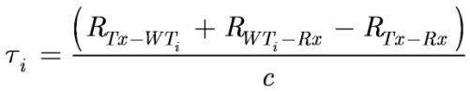 (1)
where:
R_{Tx-WTi} : transmit antenna to i-th wind turbine distance (m)
R_{WTi-Rx} : i-th wind turbine to receive antenna distance (m)
R_{Tx-Rx} : transmit antenna to receive antenna distance (m)
c : speed of light (m/s).
Mean amplitude of the paths
The static path with relative delay zero (i.e. the direct transmit antenna to receive antenna path) is taken as a reference, in such a way that its mean amplitude is 0 dB. Then the mean relative amplitude of each time-varying path is given by the power ratio between the power of the signal scattered from the corresponding wind turbine P_{Tx-WTi-Rx} and the power of the direct signal from the transmitter P_{Tx-Rx}.
The direct power from the transmit antenna in the reception location, P_{Tx-Rx}, is calculated as a function of the transmit antenna to receive antenna distance R_{Tx-Rx}, the transmit antenna to receive antenna gain in the direction of the receive antenna G_{Tx-Rx}, the maximum gain of the receive antenna G_{Rx-Tx} and the wavelength λ, including the corresponding additional propagation losses L_{prop} (such as diffraction losses due to terrain features), as shown in equation (2).
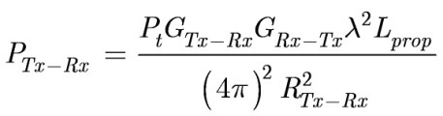 (2)
where:
P_{t} : maximum transmitter power (W)
G_{Tx-Rx}: transmit antenna gain in the direction of the receive antenna (dimensionless)
G_{Rx-Tx}: maximum gain of the receive antenna (dimensionless)
L_{prop} : propagation losses (dimensionless)
R_{Tx-Rx} : transmitter to receiver distance (m)
λ : wavelength (m).
For each wind turbine, the power of the scattered signal in the receiver location P_{Tx-WTi-Rx} is calculated using the bistatic radar equation, according to equation (3).
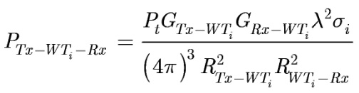 (3)
where:
P_{t} : maximum transmitter power (W)
G_{Tx-WTi}: transmit antenna gain in the direction toward the wind turbine i (dimensionless)
G_{Rx-WTi}: receive antenna gain in the direction toward the wind turbine i (dimensionless)
σ_{i}: bistatic radar cross section (RCS) of the mast in the receive antenna direction (m²)
R_{Tx-WTi} : transmit antenna to i-th wind turbine distance (m)
R_{WTi-Rx} : i-th wind turbine to receive antenna distance (m)
λ : wavelength (m).
The RCS of the mast in the receive antenna direction σ_{i} (m²) is obtained as:
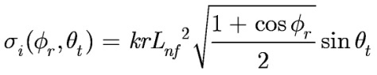 (4)
where:
k: wave number k=2π/λ (m⁻¹)
r: tower radius (m)
σ_{i}: bistatic radar cross section (RCS) of the mast in the receive antenna direction (m²)
ϕ_{r}: receive antenna angular position in the horizontal plane measured at the wind turbine under consideration in an anti-clockwise direction from the direction of the transmit antenna (see Fig. 2)
θ_{t}: transmit antenna angular position in the vertical plane (see Fig. 2)
λ : wavelength (m).
For the distances where the effect of the turbines may be of consideration, far field condition in the context of signal scattering is not usually fulfilled, since normally
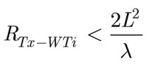 (5)
where:
R_{Tx-WTi} : transmit antenna to i-th wind turbine distance (m)
L: tower length (m)4.
In such cases, near field effects of signal scattering can be included by considering a near field tower length L_{nf} (m), given by:
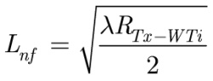 (6)
where:
R_{Tx-WTi} : transmit antenna to i-th wind turbine distance (m)
λ : wavelength (m).
The relative position of the transmit antenna, the wind turbine and the receive antenna is calculated (taking as a reference the half-height point of the mast) as a function of the incidence angle in the vertical plane (θ_{t}) as well as the reception angles in the horizontal and vertical planes (ϕ_{r}, θ_{r}). Note that the considered coordinate system does not depend on the blade position or orientation, as it is referenced to the horizontal position of the transmit antenna (ϕ_{t} = 0°), as shown in Fig. 3.
figure 3
Coordinate system for the scattering model
It should be noted that the propagation model is valid for back scattering in the following angle range:
–120° < ϕ_{r} <120°, which defines the bistatic angle range in the horizontal plane that limits the backscattering region (i.e. forward scattering occurs ±60° behind the wind turbine)
70° < θ_{t} < 110° and 160° – θ_{t} < θ_{r} < 200°– θ_{t}, which impose a vertical limit related to the physical optics theory, where the accuracy of RCS estimations err by wider margins as the direction of observation moves farther away from the specular direction.
It should be noted that the scattering model is valid when at least a significant part of the mast is illuminated by the transmitted signal. Therefore, the transmit antenna pattern should be analyzed and, in case that condition is fulfilled, it is recommended to take the maximum gain of the section of the antenna pattern that impinges on the mast for the parameter G_{Tx-WTi}.
As for the receiver gain, it should be considered that the antenna will normally be oriented towards the transmitter and thus, broadly speaking, G_{Rx-WTi} will be lower than the receive antenna unless the wind turbines lie on a path between the television transmit and receive antennas. Characteristics of directivity and polarization of antennas for the reception of television broadcasting can be found in Recommendation ITU-R BT.419.
The mean amplitude of each path is given by the ratio of both powers expressed in dB, as given by equation (7):
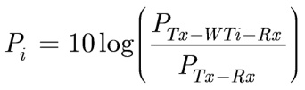 (7)
Paths with power ratios lower than –45 dB shall be omitted.
Doppler Spectra
For the characterization of the Doppler spectra, three representative cases of empirical Power Spectral Densities (PSDs) are provided, in order to characterize potential situations of high, medium and low degree of time variability, which correspond to different rotation rates and rotor orientations.
These Doppler spectra are adapted to each reception location by means of the maximum bistatic Doppler frequency f_{B_max} (Hz), which depends on the relative position of the transmit antenna, the wind turbine and the receive antenna ϕ_{r}, the maximum rotation frequency of the wind turbine ω_{max} (rad/s) and the blade length l, according to (8).
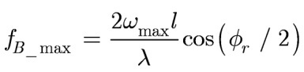 (8)
In the case of wind turbines, f_{B_max} corresponds to ϕ_{r} = 0º and blades rotating within the plane Transmit antenna-WT-Receive antenna.
To account for the different wind conditions that will probably be faced for a certain reception location, it is recommended that all the PSDs provided in Table 3 are analyzed for the system under study. In this way, the user of the channel model can obtain an overview of the different situations that may be encountered without the need for accurate estimations of specific wind directions or wind speeds. If a worst case estimation is desired, “high variability” should be used in the calculations.

TABLE 3
Doppler PSDs for the channel model (expressed in dB/Hz), as a function of
Doppler frequency (f), where δ(f) is Dirac’s delta function
High variability
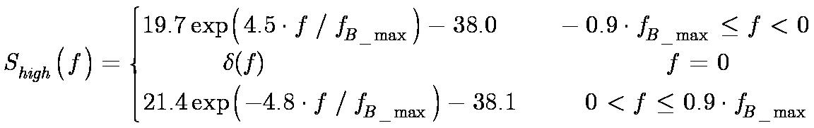
Medium variability
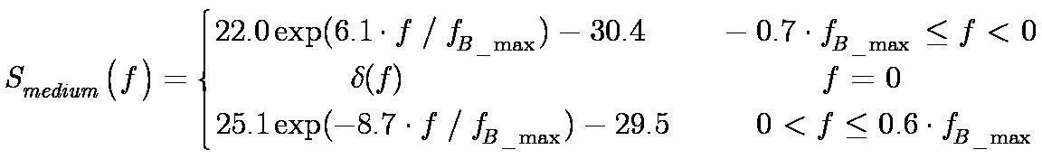
Low variability
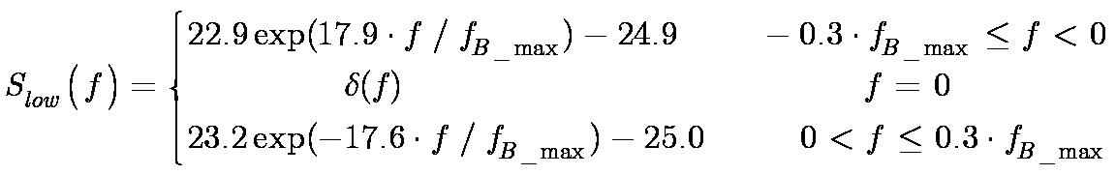

It is unlikely to be necessary to extend the investigation area to more than about 15 km from the proposed wind turbine site (or sites, if there are multiple turbines). However, if there are special circumstances, for example, receive antennas which are screened from the wanted transmit antenna but which are line-of-sight to the wind turbine, then the area may need to be extended.
Once the channel model has been particularized to the particular conditions of a case under study, the most complete way to estimate the impact on a certain service is to develop some simulations of the effect of the resulting time-varying channel model on the corresponding reception threshold. This implies obtaining a realization of the channel model, i.e. obtaining the successive channel impulse responses that characterize the signal propagation in the presence of a wind farm. The complex time varying paths that correspond to the signal scattering from each wind turbine can be obtained generating a set of white Gaussian processes, whose power spectral densities are shaped by a shaping filter whose amplitude transfer function is 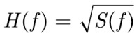, where S(f) is the Doppler power spectrum.
The resulting filter must have a normalized power of 1, so that the individual path gains have to be properly scaled to account for the different powers of the taps according to the calculated mean amplitude.

Annex 3
Estimation of the impact on DVB-T reception
The potential impact of a wind farm on DVB-T reception quality can be expressed by means of the threshold carrier-to-noise ratios (C/N) required for quasi error free condition as a function of the propagation channel characteristics.
In most of the situations where the impact of a wind farm to DVB-T reception quality was analyzed, the threshold C/N ratios obtained were similar to those expected in environments in the absence of wind farms.
More precisely, in the forward scattering region of the wind turbines, where the transmit antenna, one or more turbines and the receive antenna are lined-up (±60° behind the wind turbine), the DVB-T reception quality may not be affected though further work of analysis is needed in order to confirm this point, especially in the vicinity of 0°.
In the case of the backscattering region, the propagation conditions can be characterized by a multipath channel model as described in Attachment 2. In these situations, an increase in the threshold C/N ratio is more likely when the wind turbines are located near the receive antenna or in the vicinity of the TV transmit antenna (less than 2 km). In those situations where the scattered signals from wind turbines are significant in amplitude and variability, the threshold C/N ratio necessary for QEF condition is higher. The threshold C/N ratio tends to increase with the amplitude and the time-variability of the multipath due to wind turbines.
In order to characterize the multipath channel in the backscattering region for further relating these characteristics to the potential degradation of the television service, two parameters are defined: multipath energy and mean standard deviation. These parameters can be calculated from estimated data according to the channel model described in Annex 2 and, more specifically, by obtaining the individual path complex gains as described above; or using empirical scattering signals (see Report ITU-R BT.2142 for further details).
The multipath energy of the channel, P_{mult} (adim.), is defined as the sum of the normalized mean received power from each wind turbine. The mean value of each path is calculated as a representative central value (median value) of the path because the scattering signals vary as blades rotate. Therefore, the multipath energy of the impulse response is given by equation (9).
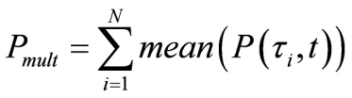 (9)
where:
i = 1 and i = N: indices of the first and last paths above a relative power threshold level of −45 dB with respect to the direct path
P(τ_{i},t): time-varying received power from path i normalized with respect to the main path.
The mean standard deviation, std_{mean}, (dimensionless) is calculated as the mean of the standard deviations of the time varying signals scattered by each wind turbine in a certain measurement or simulation. Hence, it provides a measure of the time variability of the channel. The mean standard deviation is given by equation (10).
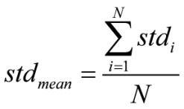 (10)
where:
i = 1 and i = N: indices of the first and last paths above a relative power threshold level of –45 dB with respect to the direct path
std_{i}: standard deviation of the time varying normalized received power from path I (dB).
Figure 4 presents some empirical threshold C/N ratios with respect to multipath energy (expressed in dB), obtained from measurements in the area of influence of a wind farm. These observations were performed with the following DVB-T configuration: 8k, 64-QAM modulation and 2/3 FEC code rate.
The size of the bubbles is determined by the values of the mean standard deviation. The bubbles are also depicted from light grey to black as a function of the mean standard deviation to provide a clearer representation.
figure 4
Backscattering region. Required C/N ratios as a function of
the characteristics of the multipath channel
As a significant result, all the measurement with multipath energy levels above −15 dB feature C/N thresholds higher than 19.3 dB (the theoretical threshold for a Ricean channel), even in those situations where the blades were static and thus the mean standard deviation was low. Broadly speaking, measurements with multipath energy levels below −15 dB feature higher threshold C/N ratios for higher mean standard deviation values. Table 4 summarizes the maximum increments in the C/N threshold ratios with respect to the Ricean C/N threshold as a function of multipath energy.
TABLE 4
Maximum increment of the C/N thresholds over the theoretical Ricean C/N threshold
P_{mult} Multipath energy (dB) | Maximum increase in (dB) of the required C/N for a Ricean channel
P_{mult} ≥ –15 | 9.1
–15 > P_{mult} ≥ –25 | 6.6
–25 > P_{mult} ≥ –35 | 2.4
P_{mult} < –35 | 0

As a conclusion, the time-varying multipath due to wind turbines may cause DVB-T reception problems in the above-mentioned situations, especially in case of reception in non-line-of-sight to the transmitter but in line-of-sight to the wind farm. These results may be used as guideline in order to estimate the potential degradation caused by a wind farm on a DVB-T service.
It should be noted that the multipath energy and the mean standard deviation describe the multipath channel in presence of a wind farm independently of the television standard. As such, these parameters can be used to relate the characteristics of the propagation channel to the impact to any DTV service provided in the UHF band if a similar study to the one developed for the DVB-T service was carried out.
Report ITU-R BT.2142-2 (Attachment 4) includes full explanation about this matter.

Sites with multiple wind turbines are commonly referred to as “Wind Farms”.
This analysis assumes that the wind turbine blades are metallic and approximately triangular. However, typically blades are fibreglass or other composite materials which results in 6 to 10 dB less scattering than metallic blades.
If the mast is a truncated right circular cone, the mast radius r is calculated as the mean radius of the cone, and the mast length L is the length of the slanted surface of the truncated cone.

