Recommendation ITU-R BT.1790-1
(06/2022)
Requirements for monitoring of broadcasting chains during operation

BT Series
Broadcasting service
(television)

Foreword
The role of the Radiocommunication Sector is to ensure the rational, equitable, efficient and economical use of the radio-frequency spectrum by all radiocommunication services, including satellite services, and carry out studies without limit of frequency range on the basis of which Recommendations are adopted.
The regulatory and policy functions of the Radiocommunication Sector are performed by World and Regional Radiocommunication Conferences and Radiocommunication Assemblies supported by Study Groups.

Policy on Intellectual Property Right (IPR)
ITU-R policy on IPR is described in the Common Patent Policy for ITU-T/ITU-R/ISO/IEC referenced in Resolution ITU-R 1. Forms to be used for the submission of patent statements and licensing declarations by patent holders are available from http://www.itu.int/ITU-R/go/patents/en where the Guidelines for Implementation of the Common Patent Policy for ITU-T/ITU-R/ISO/IEC and the ITU-R patent information database can also be found.

Series of ITU-R Recommendations
(Also available online at http://www.itu.int/publ/R-REC/en)
Series | Title
BO | Satellite delivery
BR | Recording for production, archival and play-out; film for television
BS | Broadcasting service (sound)
BT | Broadcasting service (television)
F | Fixed service
M | Mobile, radiodetermination, amateur and related satellite services
P | Radiowave propagation
RA | Radio astronomy
RS | Remote sensing systems
S | Fixed-satellite service
SA | Space applications and meteorology
SF | Frequency sharing and coordination between fixed-satellite and fixed service systems
SM | Spectrum management
SNG | Satellite news gathering
TF | Time signals and frequency standards emissions
V | Vocabulary and related subjects

Note: This ITU-R Recommendation was approved in English under the procedure detailed in Resolution ITU-R 1.

Electronic Publication
Geneva, 2022

© ITU 2022
All rights reserved. No part of this publication may be reproduced, by any means whatsoever, without written permission of ITU.

RECOMMENDATION ITU-R BT.1790-1
Requirements for monitoring of broadcasting chains during operation
(Questions ITU-R 44/6 and ITU-R 109/6)
(2007-2022)
Scope
This Recommendation describes broadcasters’ requirements for operational monitoring in digital broadcasting chains. Monitoring issues are first categorized into status monitoring and quality monitoring, and the requirements are itemized in each category.
Keywords
Broadcast chains, quality monitoring, status monitoring
The ITU Radiocommunication Assembly,
considering
a) that broadcasting chains consist of contribution and distribution networks which include production, post-production, satellite, terrestrial emissions, internet and other hybrid distribution processing;
b) that the whole delivery chain is composed of a multiplicity of cascaded processing devices such as converters, encoders, switches, gateways, multiplexers, modulators and receivers among others;
c) that digital audio-visual and audio services have rapidly developed based on advances in digital signal processing, compression and communication technologies;
d) that digital compression coding technologies have enabled the widespread growth of high-quality multichannel audio-visual services;
e) that digital broadcasting technologies are becoming more complex including not only purely broadcast technologies but also multipoint and point-to-point technologies;
f) that monitoring approaches and technologies are in continuous development due to appearance of new software and hardware elements with high speed processing;
g) that due to some unification of transmission protocols and widespread use of telecommunication network infrastructure the delivery of monitoring information via non-broadcast networks is possible;
h) that a unified approach for monitoring for every step in a broadcasting chain would facilitate the development of reliable, efficient and cost-effective monitoring systems for broadcasting chains;
i) that broadcasters are seeking to provide guidance to equipment manufacturers on the operational monitoring requirements in broadcasting chains,
recommends
that the broadcaster’s requirements for operational monitoring described in Annex 1 should be taken into account for the development of monitoring systems in broadcasting chains.

Annex 1
Requirements for monitoring of broadcasting chains during operation

1 Introduction
Digital compression coding technologies have enabled the widespread growth of high-quality multichannel audio-visual services. Audio-visual signals after digital coding processing have characteristics different from those of conventional analogue signals, e.g. the perceptual quality depends on the content and the characteristics of the original signal, and degradation due to digital compression coding and transmission errors often occurs locally.
Digital broadcasting systems often involve complex paths and may contain additional data services which can make it difficult to locate the cause of failures or of quality reduction. Multi-point (multi-layer) monitoring may be required, which could include image compression technologies, objective quality estimation devices, transport stream analysers, transmission and platform performance analysers, making operational detection and correction very time consuming.
It has become difficult to manage the quality of digital broadcasting systems by the conventional methods used for monitoring analogue systems or subjective evaluation, and a new monitoring approach and methodology is needed. This Recommendation describes user requirements for operational monitoring for digital broadcasting chains based on the quality monitoring/assessment technologies to be introduced in broadcasting stations and communication carriers.
Users of the Recommendation are encouraged to access the latest version of ITU-R Recommendations and Reports relevant to objective and subjective quality assessment and measurement, when deciding on the operational procedural requirements for their systems and installations.

2 Types of monitoring
Operational monitoring confirms whether a signal is in the desired operational state or conforms to a given standard or specification. In this Recommendation, operational monitoring specifically refers to in-service signals and is categorized into:
– Status monitoring of the performance of physical signals, and
– Perceptual quality monitoring of audio-visual content.

2.1 Status monitoring
Status monitoring is defined as the monitoring of a physical signal’s in-service conformance to a given standard and/or specification.
Equipment and networks necessary for digital broadcasting chains are also included in the monitored to ensure they are functioning appropriately. Applications of status monitoring includes:
– contribution networks;
– live relay and news gathering;
– production, post-production and mastering, in a broadcasting station;
– primary/secondary distribution and emission.

2.2 Perceptual quality monitoring
Quality monitoring assesses whether the perceptual quality for a service (video, audio, data) conforms to a given quality level (which depends on the applications intended by the providers). Quality monitoring can include broadcast reception in addition to those for status monitoring. It is important to include monitoring of the received signal because system and signal degradations can accumulate at each stage and sometimes lead to degradation of final quality, even if each process in a broadcasting chain conforms to the standard.

3 Operational monitoring issues
Ideally, operational monitoring should take place within the central switching or operational area. Figure 1 gives a high-level overview of a broadcasting chain. It is possible to use remote communications to enable monitoring of systems physically in a remote location.
Figure 1
High-level overview of broadcast chain monitoring
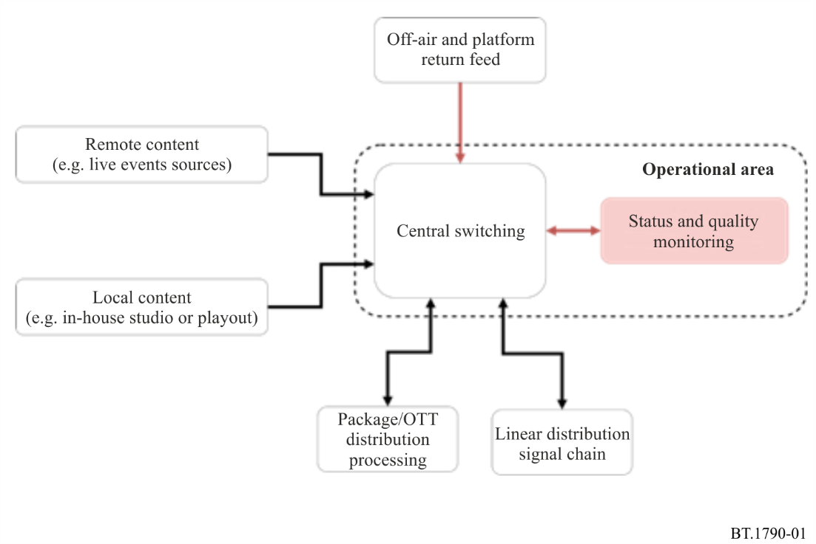

3.1 Status monitoring issues
– Errors can occur in video and audio signals even if the signals conform to standards and equipment is functioning normally.
– Black signals, silent signals or pure tone sound signals may lead to false alarms by automatic monitoring equipment even though they may be intentional.
– Single Frequency Networks (SFNs) for terrestrial broadcasting require an accurate reference signal for timing, frequency and phase for correct operation. When these signals suffer from low accuracy (for example, when GPS receivers malfunction) the performance of the SFN over a wide area may be affected. It is therefore desirable to monitor the accuracy of these reference signals.

3.2 Quality monitoring issues
– The quality of digitally encoded video and audio signals depends on the characteristics of the original signal. Degradation particular to digital coding, such as blockiness are very different to analogue degradation. Older quality criteria used for analogue signals are not necessarily appropriate for judging the quality of digitally coded audio-visual signals.
– The appearance of service failures is often random and degradation can be absent for very long periods. Operative monitoring of perceptual and transmission quality is therefore desirable.
– In digital broadcasting, various levels of quality of services can be provided in the same channel, according to bit rates and content. Quality criteria may differ depending on services.
– There may be problems in synchronizing video processing and audio processing.
– Reception quality may be dependent on receivers due to different performance behaviours especially in the case of transmission path errors.

4 User requirements for operational monitoring
To effectively operationally monitor and measure a broadcast chain, measurement point planning is very important. Measurement and test signal inject points should be arranged to allow the chain to be measured and tested easily and accurately. Figure 2 gives a simplified overview of possible measurement points in part of a broadcast.
Figure 2
Example of broadcast chain monitoring and measurement points
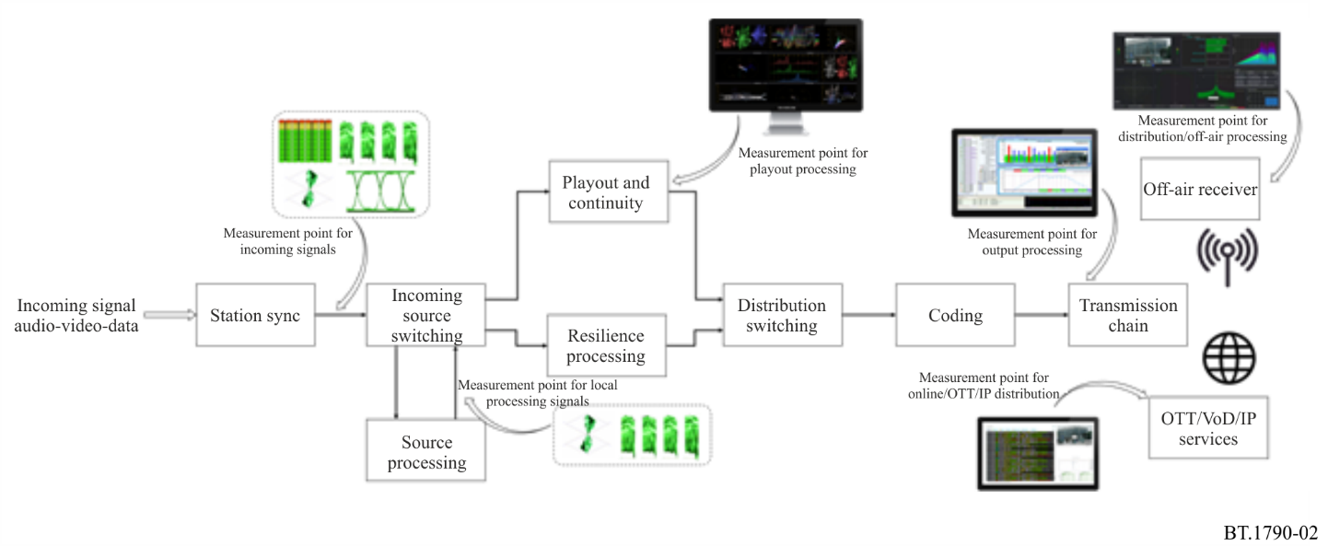

4.1 Common requirements for status and quality monitoring
Digital broadcasting systems make it important that requirements for status and quality monitoring within a system are documented and understood by operators. Examples include (but are not limited to):
– Capability of in-service monitoring and required capacity resource in the system stream.
– Applicability to the television system levels in use such as multimedia, SDTV, HDTV, UHDTV and 3DTV, and the associated sound system and levels in use such as mono, stereo, 3/2 multichannel sound and advanced sound systems.
– Applicability to the number and type of audio channels in use.
– Applicability to any mezzanine or inter-system contribution coding bit rates in use, irrespective of variable bit rate (VBR) or constant bit rate (CBR).
– Applicability to the distribution or transmission bit rates in use.
– Applicability to the coding parameters and tools (e.g. profile/level, picture structure, range of motion vectors) in use.
– Applicability to different signal processing such as compression coding/decoding, standards or format conversion, aspect ratio conversion and others.
– Applicability to different types of programme content (e.g. news, sport, movies).
– Applicability to the system configurations in use.
– Traceability of the causes of malfunction, failure and degradation.
– Availability of precise information for reserve or resilience switching based on the results of monitoring.

4.2 Requirements for status monitoring
In digital broadcasting chains, even if the monitored signal conforms to its specification and each piece of equipment is functioning normally, errors sometimes occur in a later stage of the chain.
The user requirements for status monitoring are as follows:
– Ability to judge whether the signal including RF characteristics and syntax conforms to its specification.
– Ability to perform multi-layer status monitoring for complex analysis of system status.
– Ability to detect and report errors in the signal paths and processing.
– Ability to monitor the functional status of equipment including malfunction alerts.
– Ability to detect errors and malfunctions precisely in a short time (preferably in real-time).
– Ability to monitor each processing device or signal path in the broadcasting chain including contribution, primary distribution and emission.
– Ability to check auxiliary data (e.g. data broadcasting contents, closed captions and EPG).
– Applicability to different formats of bit-streams (e.g. MPEG-TS and IP/GSE) and RF signals, in addition to baseband video and audio signals.
– Ability to detect errors which may not be immediately apparent to operators (e.g. occasional bit error).
– Ability to automatically scan auxiliary data (e.g. data broadcasting contents and closed captions) to see whether they are as intended.

4.3 Requirements for quality monitoring
For quality management of digital broadcasting, conventional subjective quality assessment methods and waveform-based measurement methods are not sufficient due to possibility of failures in syntax/logic or on other levels. There can also be issues in the relative delay between video and audio due to the processes such as codecs, A/D and D/A processing among others.
The user requirements for quality monitoring are as follows:
– Ability to evaluate quantitatively the perceptual quality with the use of objective quality estimation or other related approaches.
– Ability to perform systematically an objective quality assessment with a precision close to subjective quality assessment by humans.
– Ability to perform perceptual quality assessment using only bit-streams (e.g. TS).
– Ability to perform perceptual quality assessment using only the signals concerned (i.e. non-reference methods).
– Ability to evaluate an overall audio-visual quality (e.g. A/V relative timing).
– Ability to detect the occurrence point of quality degradation.
– Ability to perform perceptual quality assessment using only baseband signals.
– Repeatability (i.e. evaluation result should not be affected by the successive signals).
– Ability to evaluate quality in a short time or instantaneously.
– Ability to evaluate quality continuously due to fact that degradations can be absent for very long periods of time.

4.4 Requirements for monitoring equipment
Equipment for monitoring status and quality must be highly functional and compact, as digital broadcasting systems are becoming increasingly advanced and complicated.
The scope of applications for status and quality monitoring is very wide and the requirements for monitoring equipment depend on the cases.
The common requirements are as follows:
– The monitoring method should not disturb the monitored signals.
– Simultaneous measurement of multiple signals or channels in use.
– Easy maintenance.
– Acoustic quietness.
– Ability to continuously log assessment results for later analysis.
– Compatibility and interoperability between different devices or signal processing from different manufacturers.
– Flexibility and extendibility to allow more monitored signals and items when required.
– Easy selection of displayed items between multiple items to be monitored.
– User-friendly visualization of the status and errors.
– Real-time and continuous usability.
– Ability to integrating a monitoring network with centralized or distributed monitoring operations if required or desirable.
– Use of IP (or other digital) communication protocols for operative transmission of telemetric data to or between monitoring centres.

