Recommendation ITU-R BT.1774-3
(02/2025)
BT Series: Broadcasting service (television)
Use of satellite and terrestrial broadcast infrastructures for public warning, disaster mitigation and relief

Foreword
The role of the Radiocommunication Sector is to ensure the rational, equitable, efficient and economical use of the radio-frequency spectrum by all radiocommunication services, including satellite services, and carry out studies without limit of frequency range on the basis of which Recommendations are adopted.
The regulatory and policy functions of the Radiocommunication Sector are performed by World and Regional Radiocommunication Conferences and Radiocommunication Assemblies supported by Study Groups.

Policy on Intellectual Property Right (IPR)
ITU-R policy on IPR is described in the Common Patent Policy for ITU-T/ITU-R/ISO/IEC referenced in Resolution ITU-R 1. Forms to be used for the submission of patent statements and licensing declarations by patent holders are available from https://www.itu.int/ITU-R/go/patents/en where the Guidelines for Implementation of the Common Patent Policy for ITU-T/ITU-R/ISO/IEC and the ITU-R patent information database can also be found.

Series of ITU-R Recommendations
(Also available online at https://www.itu.int/publ/R-REC/en)
Series | Title
BO | Satellite delivery
BR | Recording for production, archival and play-out; film for television
BS | Broadcasting service (sound)
BT | Broadcasting service (television)
F | Fixed service
M | Mobile, radiodetermination, amateur and related satellite services
P | Radiowave propagation
RA | Radio astronomy
RS | Remote sensing systems
S | Fixed-satellite service
SA | Space applications and meteorology
SF | Frequency sharing and coordination between fixed-satellite and fixed service systems
SM | Spectrum management
SNG | Satellite news gathering
TF | Time signals and frequency standards emissions
V | Vocabulary and related subjects

Note: This ITU-R Recommendation was approved in English under the procedure detailed in Resolution ITU-R 1.

Electronic Publication
Geneva, 2025

© ITU 2025
All rights reserved. No part of this publication may be reproduced, by any means whatsoever, without written permission of ITU.

RECOMMENDATION ITU-R BT.1774-3
Use of satellite and terrestrial broadcast infrastructures for
public warning, disaster mitigation and relief
(Questions ITU-R 56-4/6, 136-3/6, 290/4)
(2006-2007-2015-2025)
Scope
This Recommendation provides characteristics of satellite and terrestrial broadcasting systems used for disaster mitigation and relief operations. Detailed descriptions of these systems are given in Annex 1 as guidance, and may also be found in § 5 of Report ITU-R BT.2299 ‒ Broadcasting for public warning, disaster mitigation and relief.
Keywords
Public warning, emergency warning system (EWS), automatic receiver activation
Acronyms
AEAS Automatic emergency alert service
AFSK Audio frequency shift keying
ATSC Advanced Television Systems Committee
ATSC 3.0 Advanced Television Systems Committee 3.0
CAP Common alerting protocol
CMAF Common media application format
CMAS Commercial mobile alert system
DBPSK Differential binary phase shift keying
EAS Emergency alert system
ETSI European Telecommunications Standards Institute
EU-ALERT European Public Warning System
EWS Emergency Warning System
FIDC Fast information data channel
FSK Frequency shift keying
FTA Free-to-air
IPAWS Integrated Public Alert and Warning System
ISD Inter-site distance
ISDB-T Integrated services digital broadcasting-terrestrial
ISDB-T_{SB} Integrated services digital broadcasting-terrestrial for sound broadcasting
KPAS Korean Public Alert System
LTE Long term evolution
MCI Multiplex configuration information
NAAD National alert aggregation and dissemination
PMT Programme Map Table
PWS Public Warning System
RDS Radio Data System
ROM Receive-only mode
RT Radio text
SAME Specific area message encoding
SAP Secondary Audio Programme
SFN Single frequency network
SOREM Senior Officials Responsible for Emergency Management
T-DMB Terrestrial digital multimedia broadcasting
TMCC Transmission and multiplexing configuration control
TS Transport stream
TTS Text-to-speech
URI Uniform resource identifier
WARN Warning alert and response network
WEA Wireless emergency alert
XML eXtensible markup language
XSD XML schema definition

The ITU Radiocommunication Assembly,
considering
a) the recent natural tragedies due for example, to earthquakes and their consequences, alongside the possible role of communications in public warning, disaster mitigation and relief;
b) that all administrations recognize the need to organize information dealing with public warning, disaster mitigation and relief;
c) that in cases, when the “wired” or “wireless” telecommunication infrastructure is significantly or completely destroyed by a disaster, broadcasting services can often still be employed for public warning, disaster mitigation and relief operation;
d) that broadcast frequency bands are largely globally harmonized and could be used for disseminating public alert messages and advice to large sections of the population;
e) that broadcast frequency bands could be used for coordination of relief activities by disseminating information from relief planning teams to the population and provide information on the well-being of individuals, especially from the affected area;
f) that within the terrestrial broadcasting infrastructure there are a number of systems offering communication services that allow global or regional coverage;
g) that users of the broadcasting services are expected to be using both portable and fixed terminals for emergency services, especially in sparsely populated, uninhabited or remote areas;
h) that within the broadcasting services there is a great and growing need to determine standard international routing procedures for emergency traffic;
i) that many administrations have already established emergency communication traffic procedures including means for secure control of their utilization;
j) that distress, emergency, safety and other communications are defined in the Radio Regulations (RR);
k) that individual broadcasters will always have their own security control over their programme material and their network;
l) that many stations operating in the broadcasting service can operate without externally provided power for some time (up to weeks);
m) that sound and television broadcasting organizations have developed techniques often referred to as “electronic news gathering” for the dissemination of information in programmes called “news bulletins” to inform the public of the extent of disasters and the recovery efforts being undertaken,
recognizing
a) that Resolution ITU-R 55-4 (Dubai, 2023), ITU-R studies of disaster prediction, detection, mitigation and relief, resolves that Study Groups should “undertake studies and develop Recommendations and Reports, as necessary, related to the management of radiocommunications in disaster prediction, detection, alerting, mitigation, and relief”;
b) that the broadcasting infrastructure is actually used to reach several billion people in a short period of time;
c) that in some countries, such alert systems such as the emergency warning system (EWS) or emergency alert broadcasting have been implemented in which broadcasting stations are connected to governmental or international organizations which issue disaster forecasts;
d) that a single transmitter operating in the LF, MF and HF frequency bands as well as space stations of the BSS cover large service areas;
e) that the RR foresee provisions by means of which BSS feeder links subject to Appendix 30A can be converted into FSS links (e.g. for VSAT operations in an emergency area);
f) that in some cases, a broadcasting station has its own seismometers in the country, analyses the seismic intensities, and voluntarily issues precautions to the public through broadcasts;
g) that ITU-R has established studies into spectrum usage and users requirements for terrestrial electronic news gathering in Radiocommunication Study Group 6,
noting
that Report ITU-R BT.2299 ‒ Broadcasting for public warning, disaster mitigation and relief, provides a compilation of supporting evidence that broadcasting plays a critically important role in disseminating information to the public in times of emergencies,
recommends
1 that responsible agencies should prepare procedures and routines to send information on public warning, disaster mitigation and relief to transmitting or network distribution centres in accordance with agreed technical signal protocols;
2 that broadcast transmitters and receivers should be equipped to receive material prepared by the responsible agencies;
3 that systems for transmission and reception should include the possibility for forcing suitably equipped and suitably primed receivers (whether switched on or in standby mode) to present programme material for disaster mitigation and relief without intervention from the listener or viewer; so that all citizens can become informed of a possible disaster within the shortest possible period of time; with a robust mechanism against abuse of this feature;
4 that for recommends 1 to 3, public warning systems on broadcasting as given in Annex 1 may be considered;
5 that for recommends 1 to 4, the common emergency warning system control signals for analogue broadcasting as given in Annex 2 may also be considered by administrations implementing a public warning system;
6 that for recommends 1 to 4, the common emergency warning system control signals for digital broadcasting as given in Annex 3 may also be considered by administrations implementing a public warning system;
7 that in case of public warning, disaster mitigation and relief, broadcasting transmitters should disseminate information advising at a local, national level and/or, potentially, even across national borders as appropriate;
8 that Administrations should coordinate where possible with sound and television broadcasting organizations the application of electronic news gathering resources in the disaster area to maximize the potential for using the information gathered in a timely and coordinated fashion to assist the disaster mitigation and relief efforts.
NOTE – The revision of this Recommendation made by Study Group 6 is only related to the terrestrial parts.

TABLE OF CONTENTS
Page
Annex 1 – Public warning systems for broadcasting 6
1 Introduction 6
2 Outline of public warning systems for broadcasting 6
3 Emergency warning system for analogue broadcasting 6
4 Emergency warning system for digital broadcasting 7
Attachment 1 (Informative) to Annex 1 – Examples of public warning systems
for broadcasting 7
1 Introduction 7
2 Emergency Warning System 7
2.1 EWS for analogue sound broadcasting 7
2.2 Digital emergency warning system (digital EWS) 9
2.3 Bibliography 14
3 Emergency Alert System 14
3.1 Specification for FM radio alarm broadcasting 14
3.2 Automatic emergency alert service (AEAS) for terrestrial digital multimedia
broadcasting (T-DMB) 15
4 Broadcast interrupt public warning systems 18
4.1 AFSK Signaling 18
4.2 Common Alerting Protocol (CAP) Signalling 19
4.3 Accessible Emergency Information Signalling 21
4.4 Bibliography 22
5 ATSC 3.0 Advanced Emergency Information System 22
5.1 Introduction and background 22
5.2 ATSC 3.0 AEI Functions in Support of Public All-Hazards Warning 23
5.3 ATSC 3.0 AEI operations 24
5.4 Accessibility capabilities for the visually impaired 24
5.5 Receiver configurations 25
5.6 Bibliography 25
6 Public Warning Systems for LTE-based 5G broadcast system 26
6.1 Public Warning System in 3GPP networks 26
6.2 LTE-based 5G Broadcast System extended with Public Warning Systems 27
Annex 2 – Common emergency warning system control signal for analogue
sound broadcasting 30
1 Introduction 30
2 Audible baseband EWS control signal 30
2.1 Start signal 30
2.2 End signal 31
2.3 Common fixed code 32
Annex 3 – Common emergency warning system control signal for digital broadcasting 34
1 Common Alerting Protocol (CAP) Signalling 35
2 Structure of the CAP alert message 35
3 References 36

Annex 1
Public warning systems for broadcasting

1 Introduction
This Annex presents an overview of public warning systems in the broadcasting service.

2 Outline of public warning systems for broadcasting
Broadcasters have two functions in disaster management. One is gathering or receiving information from disaster radiocommunication networks connected to administrative organizations. The exclusive line connected to administrative organizations is preferably to be used for urgent alerts and such information as earthquake and tsunami data. The other function is delivering information to the general public. Some municipalities in some countries may have a multicasting system to outdoor receivers with loudspeakers in their own disaster radiocommunication network. However, it may be difficult to hear the sound indoors, especially in bad weather such as storms or heavy rain. Therefore, disaster alerts and information via broadcasting is particularly useful in such situations.

3 Emergency warning system for analogue broadcasting
The system should use relatively simple equipment to ensure stable operations. In an emergency, the Emergency Warning System (EWS) control signal, which is an analogue signal, automatically activates the receivers equipped with the EWS function even when they are standby.
Depending on its characteristics, the EWS control signal might also be used as an alarm sound to draw the attention of listeners/viewers to the emergency broadcasting programme. Broadcasters operating analogue platforms can transmit the EWS control signal. The EWS control signal could include an area code as well as a time code, keeping the receiver protected from intentionally fake control signals.
For a specific EWS for analogue sound broadcasting, an EWS control signal as described in Annex 2 is recommended, for automatic activation of receivers compliant with the systems described in Attachment 1 to Annex 1 for public warning, disaster mitigation and relief.

4 Emergency warning system for digital broadcasting
In digital broadcasting, the EWS control signal is transmitted by multiplexing with the broadcast signal. It automatically activates the receivers equipped with the EWS function when they are in standby mode. The EWS control signal should be robust against the abuse of this feature. It is foreseen that digital broadcast receivers will be installed in mobile terminals such as cellular phones, being an effective way to send emergency information to such terminals. Therefore, it would be advantageous for such terminals to be equipped with the EWS function.

Attachment 1
to Annex 1
(informative)
Examples of public warning systems for broadcasting

1 Introduction
This Attachment presents a system overview and the current status of public warning systems in the broadcasting service in some countries/regions.

2 Emergency Warning System
This section describes the Emergency Warning System (EWS), for public warning systems via broadcasting platforms.

2.1 EWS for analogue sound broadcasting

2.1.1 Overview
The composition of a typical emergency warning system is shown in Fig. 1. In an emergency situation, the control signal breaks into the programme signal, to activate the EWS receivers automatically, even when they are in standby mode. The audio level of the control signal is higher than the normal programme signal level. The control signal can also be used for the alarm sound. The system configuration should be simple for quick and reliable activation.
Figure 1
Composition of emergency warning system for analogue broadcasting
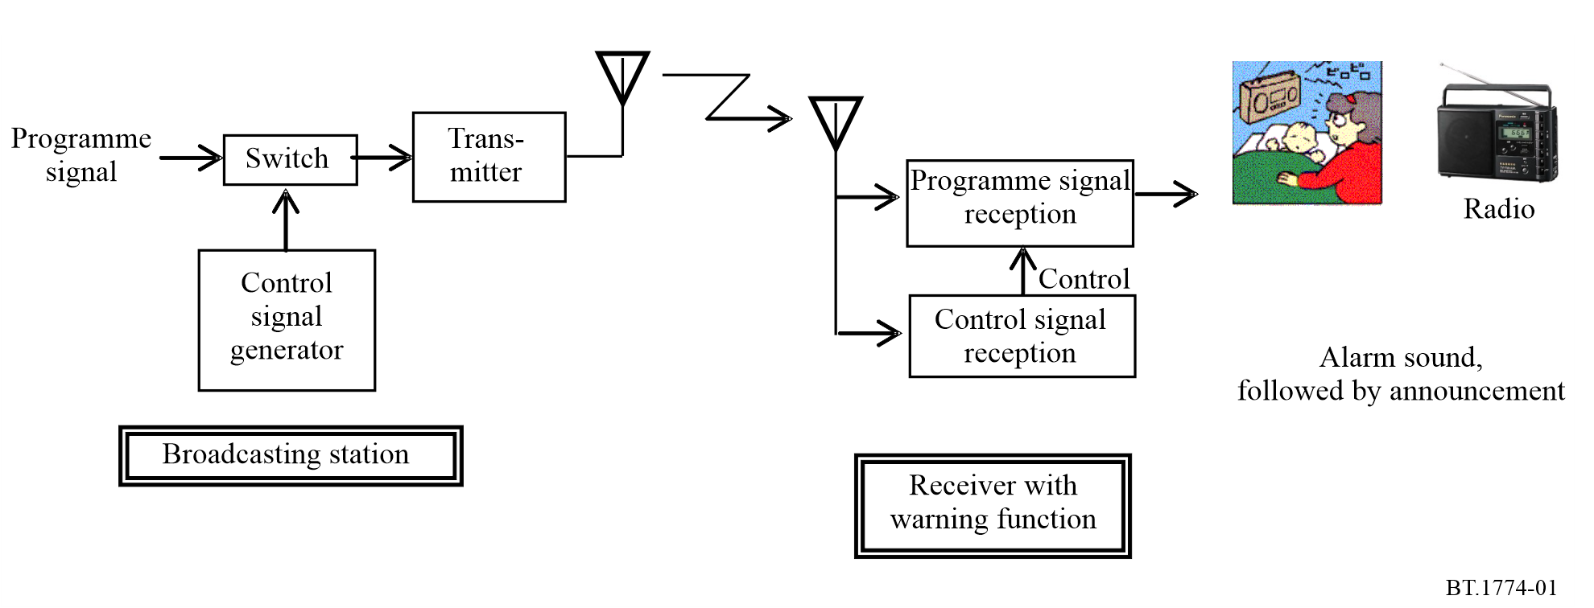
When the EWS receiver detects the control signal, the alarm will sound, to draw the attention of listeners to the emergency broadcast. The control signal can be transmitted to MW and FM receivers. The control signal includes an area code as well as a time code, thereby protecting the EWS receiver against malicious or fake control signals.

2.1.2 Operation of EWS
The following table shows the two different start signals which can be used according to the emergency situation.
 | Example emergency situation | Start signal | Area code
(1) | Large-scale earthquake warning | Category I | Nationwide
(2) | Medium-scale earthquake warning | Category I | Prefecture or wide area
(3) | Tsunami warning | Category II | Nationwide, or regional
Note 1: Category I activates all EWS receivers in the service area. Category II activates only the relevant EWS receivers.
Note 2: In cases (1) and (2), broadcasters transmit the Category I start signal. In case (3), broadcasters transmit the Category II start signal, as inland users do not need to evacuate.
Note 3: After the emergency warning message, broadcasters transmit the end signal, which may be used to return EWS receivers to their previous state.

2.1.3 Specification and configuration of EWS signal
The modulation method of the EWS signal is the frequency shift keying (FSK) method with a space frequency of 640 Hz and a mark frequency of 1 024 Hz. The allowable frequency deviation is plus or minus ten parts per million in each case. The transmission speed of the EWS signal is 64 bit/s and the deviation is ten parts per million. Signal distortion is below 5%. The configurations of the Category I start signal and Category II start signal are shown in Fig. 2, and that of the end signal is shown in Fig. 3.
Figure 2
Configuration of Category I and II start signal
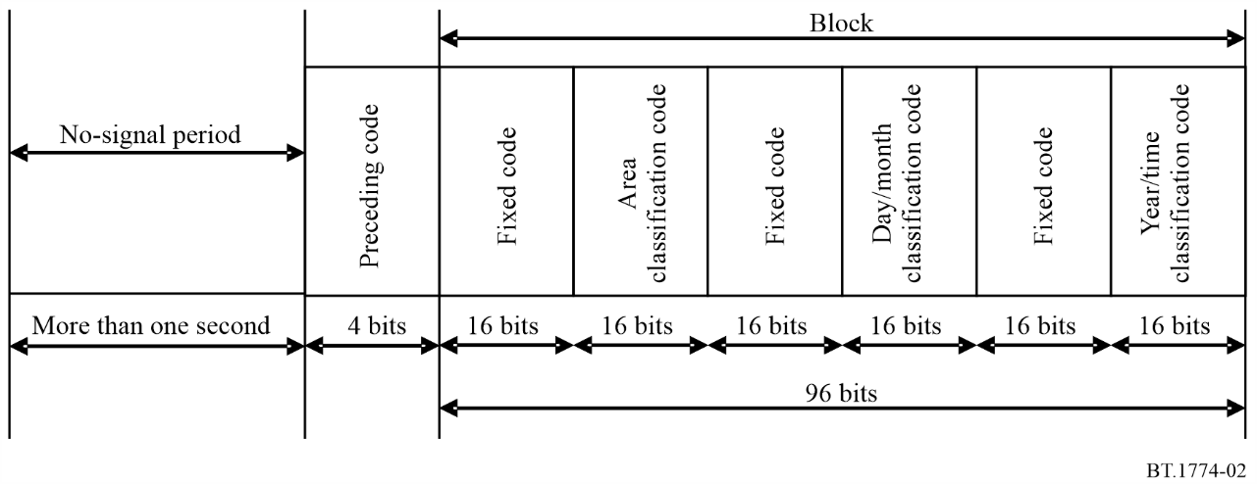
Figure 3
Configuration of end signal
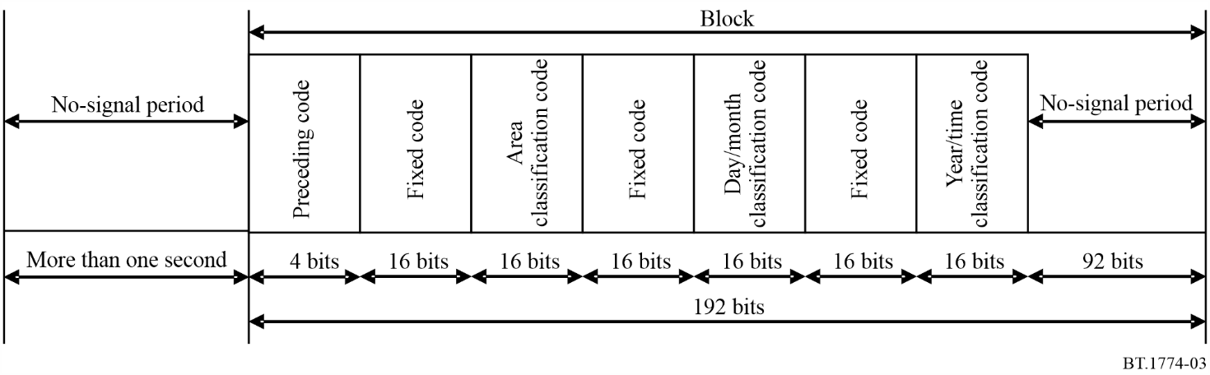
Notes to Figs. 2 and 3:
Note 1: Fixed code consists of a 16-bit code inherent in the EWS signal. It is used to extract the EWS signals from sound signals. Furthermore, it is used to distinguish between the Category I and Category II start signal.
Note 2: Area classification code is used for EWS receiver operation in specified regions. The purpose of this code is to avert the activation of EWS receivers in other areas by abnormal propagation of broadcasts.
Note 3: Year/month/day/time classification code is used to transmit real-time information to prevent the activation of receivers by fake signals. It is recorded and retransmitted after the EWS signals have been transmitted.

2.2 Digital emergency warning system (digital EWS)
This section introduces details regarding the digital emergency warning system (digital EWS) using digital television broadcasting.
In digital television broadcasting, the EWS signal is transmitted by multiplexing it with the broadcast signal, in the same way as with analogue sound broadcasting. Television receivers can also be turned on automatically when they detect the EWS signal, even if they are in standby mode.

2.2.1 Technical specifications of digital EWS
The emergency information descriptor may be used only for integrated services digital broadcasting-terrestrial for sound broadcasting (ISDB-TSB) recommended in Recommendation ITU-R BS.1114 (System F), integrated services digital broadcasting-terrestrial (ISDB-T) recommended in Recommendation ITU-R BT.1306 (System C), broadcasting-satellite service (sound) system recommended in Recommendation ITU-R BO.1130 (System E), and ISDB-S recommended in Recommendation ITU-R BO.1408. The emergency information descriptor for EWS is placed in the Descriptor 1 field of the programme map table (PMT), which is periodically placed in the transport stream (TS). The details of the emergency information descriptor is shown in Fig. 4.
Figure 4
Structure of TS, PMT and emergency information descriptor
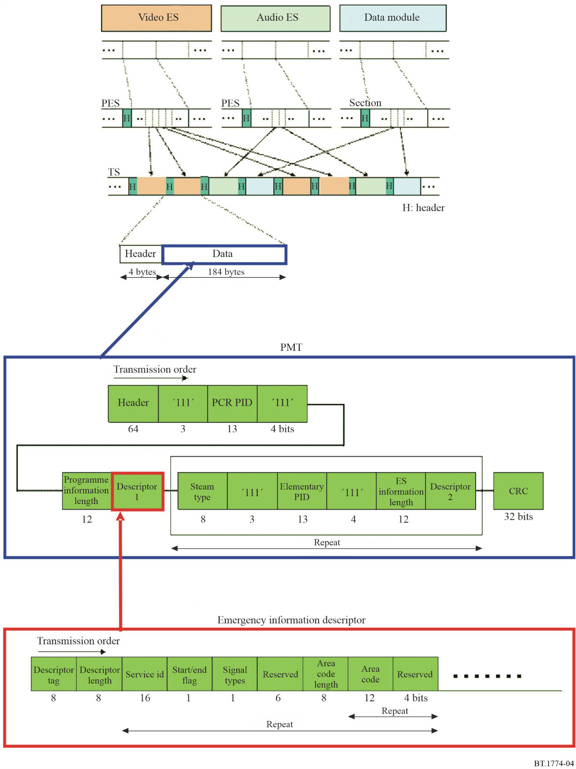
Notes to Fig. 4:
1 ES (elementary stream) is encoded video and audio, etc.
2 PES (packetized elementary stream) is the unit for packets of elementary streams.
3 TS (transport stream) is a 188 byte stream within the PES, including 32 bytes of the header.
4 PID (packet identifier) indicates what the transmitted packet is.
5 CRC (cyclic redundancy check) is a type of hash function used to produce a checksum, which is a small number of bits, from a large block of data, such as a packet of network traffic or a block of a computer file, in order to detect errors in transmission or storage.
6 Descriptor tag shall be 0xFC, representing the emergency information descriptor.
7 Descriptor length shall be a field that writes the number of data bytes following this field.
8 Service id shall be used to identify the broadcast programme number.
9 Start/end flag shall be ‘1’ when the transmission of the emergency information signal starts (or is currently in progress) and ‘0’ when the transmission ends.
10 Signal types must be ‘0’ for Category I and ‘1’ for Category II start signals.
11 Area code length shall be a field that indicates the number of data bytes following the field.
12 Area code shall be a field which indicates the area code.

2.2.2 Mobile reception
The advantages of digital reception on a mobile terminal, such as a cellular phone include:
– development of congestion-free transmission paths even in times of disaster;
– development of stable information transmission even in times of emergency or disaster, through start-up control;
– development of communication paths according to areas and targets.

2.2.3 Automatic activation of handheld receivers by EWS signals
The emergency warning mechanism of digital terrestrial television broadcasting is similar to that of analogue sound broadcasting. Broadcasting differs from telecommunications in that it can send information to a large number of handheld receivers at the same time. The ability to activate handheld receivers to receive emergency information can potentially help to reduce the damage caused by a disaster. For this to be effective, the handheld receiver will have to be in the constant standby mode for receiving the EWS signals. If the power consumption is too high, it will be difficult to maintain standby for long periods. Figure 5 shows a conceptualisation of digital EWS for mobile reception.
Figure 5
A concept of digital EWS for mobile reception
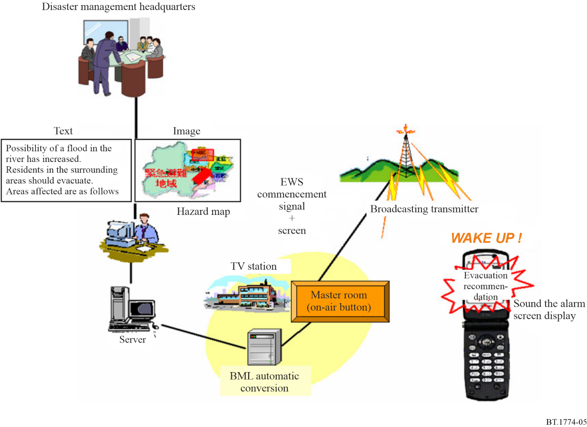
Figure 6 shows handheld receiver activation using EWS signals for digital terrestrial television broadcasting.
An EWS signal is indicated by bit 26 of the Transmission and Multiplexing Configuration Control (TMCC) signal comprising 204 bits in System C of Recommendation ITU-R BT.1306. In the case of Mode 3 (number of carriers: 5 617), the number of TMCC carriers is 52 in total for 13 segments, or four carriers per segment. The TMCC signals modulated by differential binary phase shift keying (DBPSK) are transmitted at an interval of approximately 0.2 s.
For remote activation, the EWS signals in one or more TMCC carriers are to be continuously monitored by each receiver. Furthermore, continuous monitoring shall be achieved without substantially shortening the standby time of handheld receivers. To reduce the power consumption of handheld receivers, the following schemes can be employed:
– Handheld receivers extract only TMCC carriers,
– Handheld receivers monitor only the EWS signals by limiting time slots.
Handheld and fixed receivers are using EWS signals in TMCC for remote activation.
Figure 6
Handheld receiver activation using EWS signals of digital terrestrial broadcasting
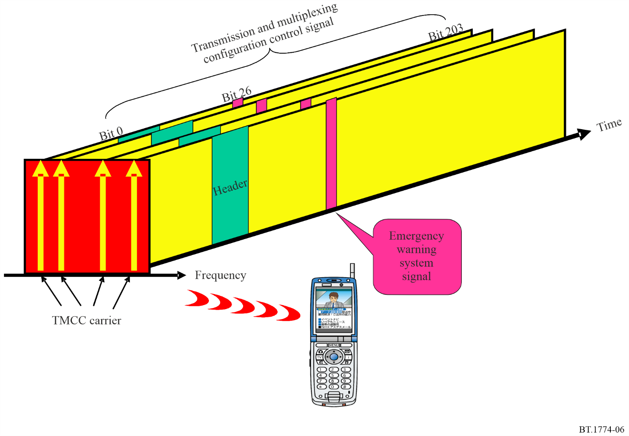

2.3 Bibliography
The information on § 2 is available in the following references:
[1] ARIB Standard, BTA R-001 Receiver for Emergency Warning System (EWS): (http://www.arib.or.jp/english/).
[2] ARIB Standard, ARIB STD-B31 Transmission System for Digital Terrestrial Television Broadcasting: (http://www.arib.or.jp/english/).
[3] ARIB Standard, ARIB STD-B32 Video Coding, Audio Coding and Multiplexing Specifications for Digital Broadcasting: (http://www.arib.or.jp/english/).
[4] ARIB Technical Report, ARIB TR-B14 Operational Guidelines for Digital Terrestrial Television Broadcasting: (http://www.arib.or.jp/english/).

3 Emergency Alert System

3.1 Specification for FM radio alarm broadcasting
This specification employs the Radio Data System (RDS) Radio Text (RT) feature to deliver the emergency message without interruption of the main programme. After differential encoding of the message, it is inserted in the amplitude modulated auxiliary subcarrier, which is the third harmonic (57 kHz) of the baseband pilot signal. The data rate is about 1 187.5 bit/s. The main function is similar to the analogue TV standard, except that the message is presented with audio, using an optional Text-To-Speech (TTS) system, instead of closed-caption text. Table 1 illustrates the message format.
TABLE 1
Emergency message format for FM radio
Control code | Start code | Date and time | Duration | Number of area | Area1 | . . . | AreaN | Event code | Checksum | Presentation time | Text | End of presentation | End code
Hex | 24 |  | xx | xx | xx/xx/xx/xx | . . . | xx/xx/xx/xx | 01 - FF |  | 02 |  | 03 | 40
Size in Byte | 1 | 5 | 1 | 1 | 4 | . . . | 4 | 1 | 1 | 1 | variable | 1 | 1

3.2 Automatic emergency alert service (AEAS) for terrestrial digital multimedia broadcasting (T-DMB)
The AEAS message format is designed to be short with essential information for swift delivery. In serious situations, detailed information, such as event descriptions and evacuation instructions in text or in other multimedia formats, will be followed in other services. The AEAS message format provides fields for the short text message and/or the external links. The AEAS provides targeted service according to the location of the receiver. Figure 7 illustrates the protocols stack necessary for the delivery of AEAS.
Figure 7
Protocol stack for the automatic emergency alert service
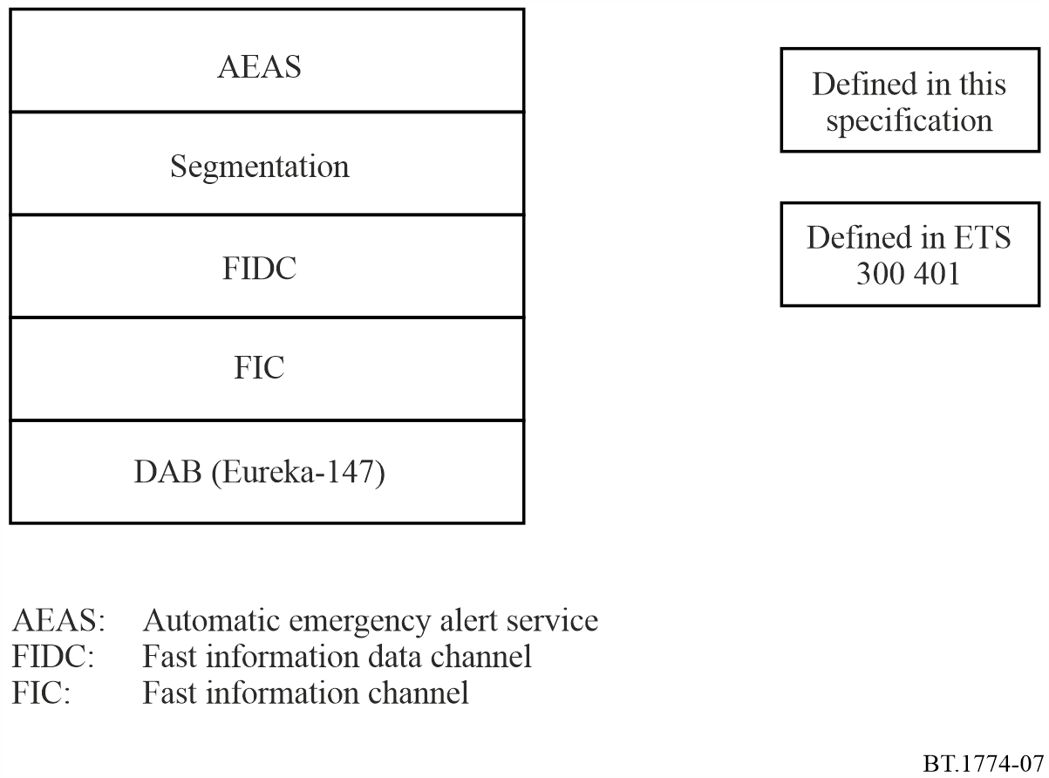

3.2.1 AEAS message format
An AEAS message contains information associated with an event, e.g. natural disasters and incidents. Table 2 illustrates the structure of the AEAS message.
TABLE 2
AEAS message format
EventCode | Severity | d&t | tGeocode | nGeocode | rfu | Geocodes | Desc&Link
3 bytes | 2 bits | 28 bits | 3 bits | 4 bits | 3 bits | variable | variable

The following are the syntax and semantics of each field:
– EventCode: This field shall contain the event code which is defined in Annex 1 of the standard. The major portions of the EventCode are quoted from USA’s FCC Rule 47 Part 11.
– Severity: This 2-bit field shall indicate the severity of the event, as in Table 3:
TABLE 3
Severity
Severity | Semantics
00 | “Unknown” – Severity unknown
01 | “Moderate” – Possible threat to life or property
10 | “Severe” – Significant threat to life or property
11 | “Extreme” – Extraordinary threat to life or property

– d&t (date and time): This 28-bit field shall indicate the date and time when the emergency information is announced by an originator. The first 17 bits shall be the modified Julian data and the next 11 bits shall be the UTC code (short form), which is defined in ETS 300 401 v1.4.1 section 8.1.3.1.
– tGeocode (Geocode type): This 3-bit field shall indicate the type of geocode used in the message.
An AEAS message shall include only one type of Geocode. When tGeocode is 000, nGeocode shall be set to 0000 and no Geocode shall be included in the message.
– Geocodes: This field shall include one or more geographic codes delineating the affected area of the AEAS message. The type and the number of geocodes are defined in tGeocode and nGeocode fields, respectively. The length of the geocode shall be fixed and defined implicitly.
– Desc&Link: This variable length field shall present short human readable text and an external link associated with the AEAS message. The text includes description of the event and instruction for targeted recipients. The external link shall be surrounded by double quotes (“). The external field may be used for any additional information for the message, for example, uniform resource identifier (URI) for web or other DMB services. The URI shall be full and absolute.

3.2.2 AEAS message segmentation
An AEAS message shall be delivered via fast information data channel (FIDC) (FIG 5/2). The AEAS message shall be segmented into several FIGs. The data field of a FIG shall contain one, and only one segment of the AEAS message. For this purpose, a 2-byte segment header shall be used, as shown in Table 4.
TABLE 4
Segment header fields
Current | nSegment | AEASId
4 bits | 4 bits | 8 bits

– Current (n): This 4-bit field shall be the (n + 1)th sequence number of the current segment.
– nSegment (m): This 4-bit field shall be the total number of segments of the AEAS. The total number is (m + 1). Since a FIG can accommodate at most 26 bytes of AEAS message, therefore, the maximum size of an AEAS message is 26 bytes/FIG × 16FIG = 416 bytes.
– AEASId: This Id enables an AEAS receiver to assemble an AEAS message from FIG segments. In addition, the Id prevents the AEAS receiver from presenting duplicate AEAS messages. Since, during an emergency, an AEAS message will be emitted repeatedly, the AEAS receiver should always remember the AEASId that has been presented. However, if the AEASId is managed by a local authority, a mobile receiver can face with problematic situations: the same AEAS message has different AEASId, or two different AEAS messages have the same AEASId. In order to avoid these situations, the AEASId shall be nationally managed by a central authority, so that identical emergency information should always have a same AEASId nationwide.
TABLE 5
AEASId fields
OriginL  (Originator level) | MsgId  (Message Id)
3 bits | 5 bits

– OriginL (Originator level): This 3-bit field shall indicate the originator group of the AEAS message. It represents three levels of government, i.e. national, state and local governments.
TABLE 6
List of originator level
OriginL | Description
000 | National Government
001 | Large city, Province
010 | Small city, County
100~111 | Future use

– MsgId: This 5-bit, modulo 32 counter shall be incremented by one for each successive AEAS message.

3.2.3 Delivery of AEAS message
AEAS messages and the associated signalling are encoded in the fast information data channel (FIDC), specifically in Extension 2 of FIG type 5 (FIG 5/2). Figure 8 shows the structure of the FIG 5/2.
The following definitions apply to the flags D1 and D2:
D1: This 1-bit flag shall be reserved for future use of the Type 5 field.
D2: This 1-bit flag shall signal whether the Type 5 field contains AEAS message or just padding.
0: padding.
1: presence of AEAS message.
The TCId shall be 000.
When there is no emergency, the padding message with D2 = 0 shall be transmitted every 0.5 second or less. The size of padding is 29 bytes, so that the FIG with the padding message can occupy a whole fast information block (FIB). The padding message signals the presence of the AEAS service in the current ensemble. It also guarantees the necessary bandwidth for immediate insertion of the AEAS message. Signalling of AEAS with multiplex configuration information (MCI) shall not be used. When emergency information arrives from the management office, associated AEAS messages shall be generated and emitted immediately. The AEAS message has the highest priority over other broadcasting services. During the emergency, the AEAS message shall continue to be emitted repeatedly. When a receiver receives the AEAS message, it shall immediately present the emergency information with highest priority over other services.
Figure 8
Structure of FIG Type 5
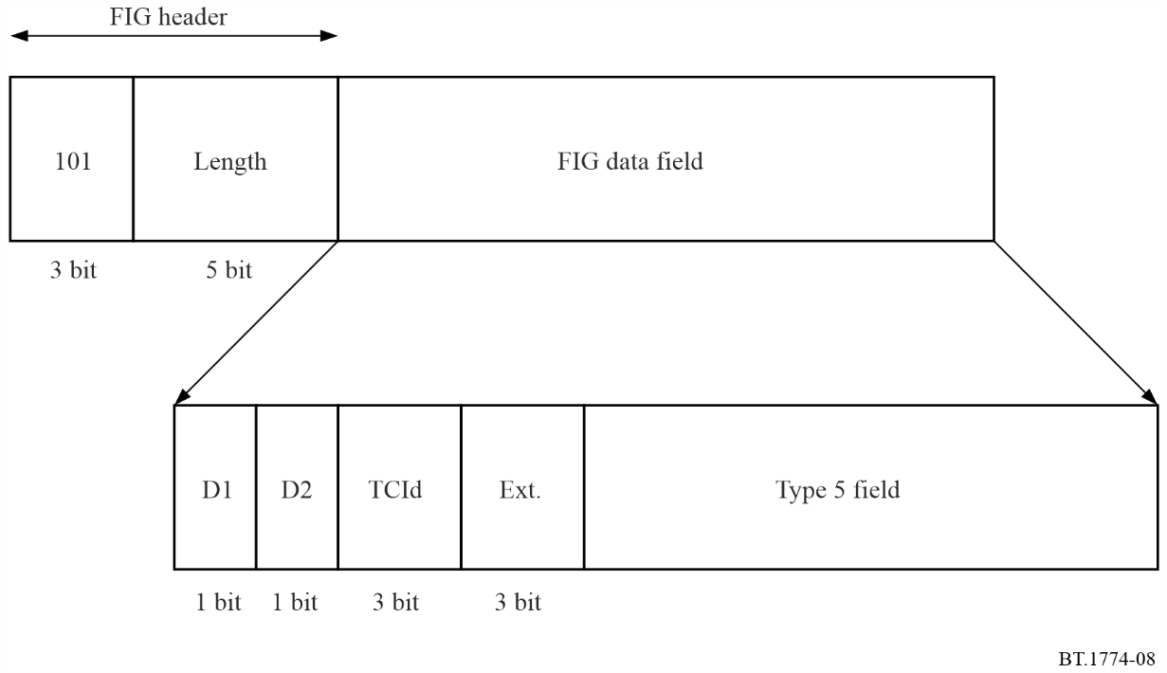

4 Broadcast interrupt public warning systems
This section presents an overview of public warning “broadcast interrupt” systems utilized in conjunction with broadcast television and radio services in several regions.

4.1 AFSK Signalling
A method used in national warning systems signal emergency messaging in broadcast media consists of transmission of AFSK-encoded information, usually accompanied by an aural message.
A principal example of this approach is the Emergency Alert System (EAS) used in the United States which incorporates Specific Area Message Encoding (SAME). SAME is also used in other North American and Caribbean nations. SAME is an Audio Frequency Shift-Keying (AFSK) protocol used in North America to send digitally encoded information about alerts, advisories, and warnings. Canada and Mexico both utilize SAME in some fashion for weather and disaster alerts.
Messages in this protocol are composed of four parts: a digitally encoded SAME header, an attention signal, an audio announcement, and a digitally encoded end-of-message marker. The SAME FSK signal itself is 1 200 Hz wide with a 260 Hz shift. Each individual bit lasts 1 920 μs (1.92 ms) each, giving a bit rate of 520.8333 bit/s. The attention signal in the EAS is specified at 1 050 Hz for NOAA Weather Radio, 853 Hz and 960 Hz together for commercial broadcast stations.
The SAME header is the most critical part of the EAS public warning protocol. The header contains information about who originated the alert (the president, state or local authorities, the National Weather Service (NOAA/NWS), or the broadcaster), a short, general description of the event (tornado, flood, severe thunderstorm), the areas affected (up to 32 areas), the expected duration of the event (in minutes), the date and time it was issued (in UTC), and an identification of the originating station:
– SAME header: SAME header uses AFSK at a rate of 520.83 bits per second to transmit the codes. It uses two frequencies – 2 083.3 Hz (Mark frequency) and 1 562.5 Hz (space frequency). Mark and space-time must be 1.92 milliseconds. Key information in the header includes originator, type of alert, region for which alert is issued, and date/time for which the alert is applicable.
– Attention signal. Single tone (1 050 Hz) or dual audio tone (853/960 Hz). Commercial broadcast operations use dual tone (853 and 960 Hz together), while the single tone (1 050 Hz) is used by NOAA weather radio. It is designed to attract the immediate attention of listeners, as well as to signal certain types of weather.
– Actual audio, video, or text message.
– SAME end-of-message marker. It indicates the end of the emergency alert.
For broadcast radio media, the aural portion of the alert message is typically inserted into the broadcast audio programming. For broadcast visual media, the textual portion of the alert message is derived from the information in the SAME header, concatenated into a human-readable phrase, and the aural portion is inserted into the main program audio.

4.2 Common Alerting Protocol (CAP) signalling
The Common Alerting Protocol (CAP) is an XML digital standard format for exchanging emergency alerts, allowing a consistent alert message to be disseminated simultaneously over multiple communications pathways. CAP data structure is backward-compatible with existing alert formats including the SAME used in NOAA Weather Radio and the broadcast EAS.
In addition to the basic CAP standard, individual nations have developed supplemental CAP “profile” technical specifications. For example:
– In the United States, the Federal Emergency Management Agency developed the US-IPAWS profile to ensure compatibility with existing warning systems used in that country. FEMA formally adopted CAP and the IPAWS Profile to implement the Integrated Public Alert and Warning System (IPAWS).
– In Canada, the national alerting system formally adopted CAP and a CAP Canada profile (CAP-CP) to integrate its National Alert Aggregation and Dissemination (NAAD) System. Similarly, other nations have developed their own national and regional CAP profiles.
In a broadcast environment, CAP messages received from official sources can be used to create emergency alert messages that are inserted into audio and/or video programming before transmission.
– For broadcast radio media, the referenced audio media of the CAP message is typically inserted into the broadcast audio programming. Where audio media is not available, text-to-speech capabilities may be utilized to provide the aural message from specific elements in the CAP message.
– For broadcast television media, the relevant textual elements of the CAP message provide the alert message, and the aural portion is inserted into the main program audio.
Properly crafted CAP messages can provide the data elements needed to construct these four parts of an EAS alert. In this way, CAP provides an alternative method for distributing EAS alerts into the EAS system outside of the traditional EAS “daisy-chain”. Since CAP can provide extra descriptive details that cannot be encoded into an EAS audio alert, these details can be available at the point of reception to enable not only triggering of the EAS system, but also for broadcast from this point.
Figure 9 shows the general processing steps and flow of data during CAP to broadcast interrupt translation in the EAS of the United States. A similar approach is utilized in Canada.
Figure 9
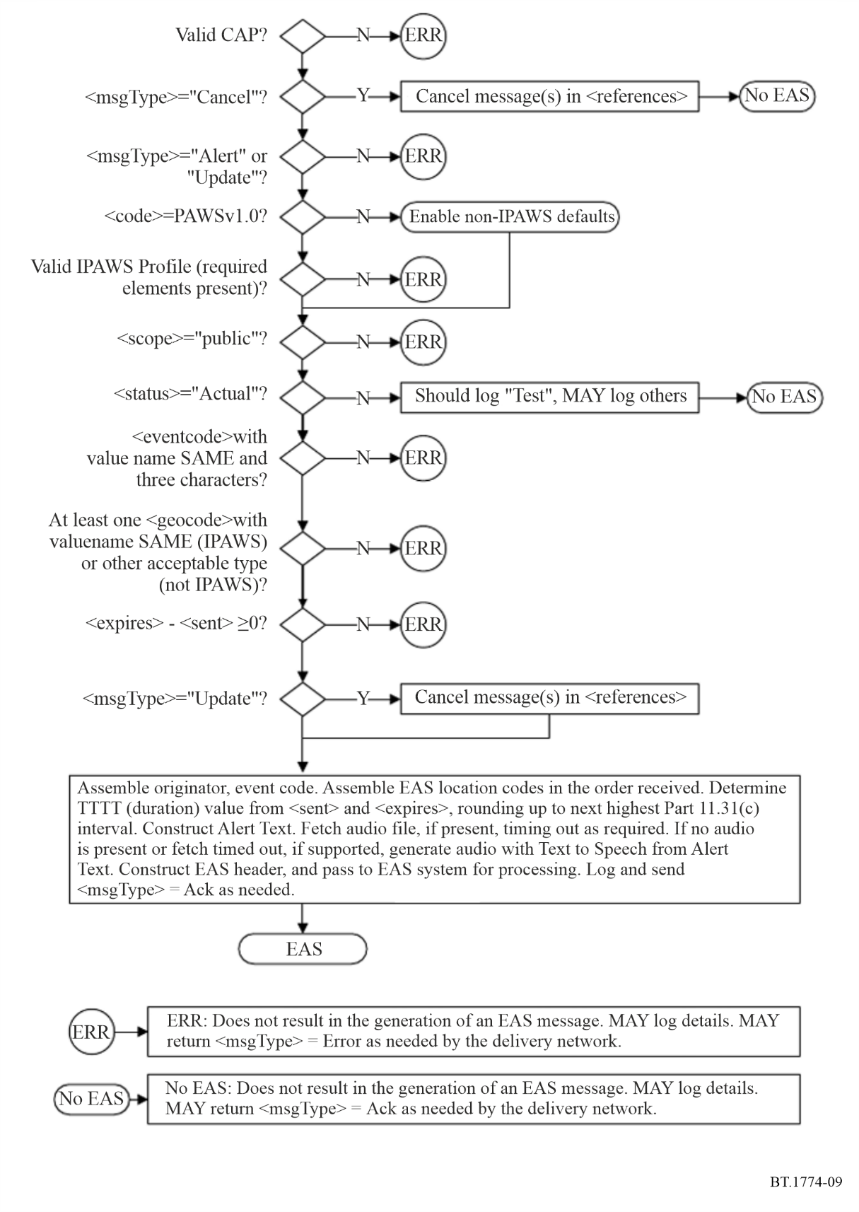

4.3 Accessible Emergency Information Signalling
In North America and the Caribbean, conventional analogue (e.g. NTSC) and first generation digital (i.e. ATSC 1.0) television audio permit the inclusion of a secondary audio program (SAP) which is typically used for the provision of an additional language audio, but which is also occasionally used to provide emergency descriptive audio in either a primary or secondary language.
The ATSC 3.0 audio system supports the inclusion and signalling of audio (speech) that provides aural representations of emergency information provided by broadcasters in on-screen text displays (e.g. static, scrolling or “crawling” text). Sometimes referred to as an “emergency track,” this ATSC 3.0 capability permits the provision of emergency information in audio format in multiple selectable languages.

4.4 Bibliography
The information on § 4 is available in the following references:
[1] ATSC: “ATSC Audio Common Elements,” Part 1, Doc. A/342:2023-03, Advanced Television Systems Committee, Washington, DC, 28 March 2023.
[2] ECIG Recommendations for a CAP EAS Implementation Guide, EAS CAP Industry Group - ECIG EAS-CAP Implementation Guide Subcommittee Version 1.0, 17 May 2010.
[3] Recommendation ITU-T X.1303 bis – Common alerting protocol (CAP 1.2), March 2014.
[4] Common Alerting Protocol, v. 1.2 USA Integrated Public Alert and Warning System Profile Version 1.0, Committee Specification 01, Organization for the Advancement of Structured Information Standards (OASIS), 13 October 2009.

5 ATSC 3.0 Advanced Emergency Information System

5.1 Introduction and background
ATSC 3.0, also known as “NextGen TV”, represents a major leap from previous digital transmission systems, with support for a wide range of data services.
One of those data services that is native to the ATSC 3.0 system is Advanced Emergency Information, also referred to as the “AEI” service within the ATSC standards. The addition of advanced emergency messaging capability and the accompanying rich-media emergency information represents a compelling application for ATSC 3.0. The ATSC 3.0 AEI system enables broadcasters to deliver timely, in-depth emergency related information to their viewers.
One of many major differences between AEI and traditional broadcast interrupt system is that the emergency information is processed at the receiver, while broadcast interrupt systems insert aural and/or visual messaging into the broadcast programming stream(s) before station transmission.
The ATSC 3.0 AEI system is capable of sending public-facing AEI messages intended for consumers, and non-public-facing messages, intended for first responders or other restricted audiences. The ATSC 3.0 AEI system provides a mechanism for delivering rich media via broadcast and/or broadband, such as evacuation maps, images alerts, weather radar maps and videos. It includes a “wake-up” function that allows receivers in stand-by mode to detect when an emergency message has been initiated by a station.
Specifically, the ATSC 3.0 Advanced Emergency Information (AEI) system is a capability within ATSC 3.0 for transmitting urgent notices related to emergency information, with messages structured in a specific Advanced Emergency Information Message Format, and transmitted in an Advanced Emergency Information Table (AEAT) as a Low Level Service (LLS). Signalling information which is carried in the payload of IP packets with a well-known address/port dedicated to this function is referred to as Low Level Signalling (LLS). The types of LLS information, each in the form of an LLS Table and defined in the ATSC 3.0 Standard include the XML-based Advanced Emergency Information Table.
An Advanced Emergency Information Table may include one or more messages at any given time. Each message has its own unique identifier, and includes a wide range of information that may be flexibly used to convey urgent information to audiences:
– the issuer of the message;
– the intended audience;
– whether the message is new, an update, or a cancellation;
– a priority level for the message;
– the message category (such as “Emergency”, “Weather”, “Health”, “School”, “Transit”);
– an indicator whether the receiver should “wake up” from a standby state;
– the effective and expiration times of the message;
– a short description of the event;
– a longer text description of the event;
– multimedia resources, including audio, video and other media assets, HTML pages;
– an indicator for any emergency-related live A/V Service which is delivered via broadcast stream.
The AEA message provides support for multiple languages and priorities, and accessibility support via its text, audio and media features.

5.2 ATSC 3.0 AEI Functions in Support of Public All-Hazards Warning
Advanced Emergency Information provides an emergency notification mechanism in ATSC 3.0, which is capable of forwarding a broad range of emergency data, which can include urgent bulletins, advisories, all-hazard warnings, emergency-related messaging, and other urgent information over an ATSC 3.0 system. This annex describes one manner in which the AEA may function in support of external public warning alerts sources
Figure 10 provides a basic example of data flows of emergency alert information, where a station has received an emergency alert message, e.g. from an external (governmental) source.
Figure 10
Emergency Information signal flows
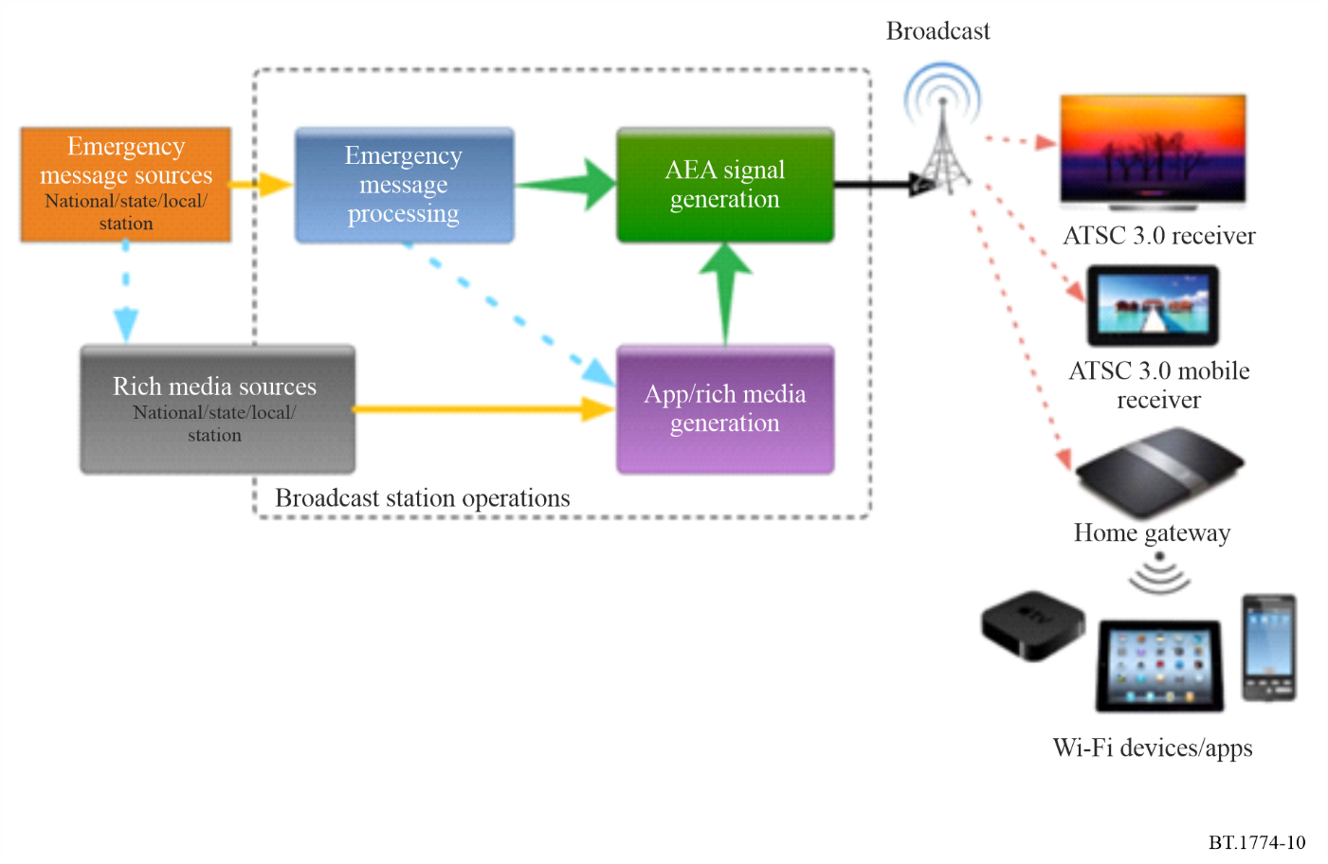
In the example above, the television broadcaster has received a public warning message by means of a CAP message, EAS AFSK data tones, or other method. With the exception of mandatory event types, the broadcaster has the option of not broadcasting a received alert message, or it may be passed on (after processing) within the broadcaster’s program content to the public.
If the broadcaster decides to disseminate the contents of a particular incoming public warning message, it can be included in the broadcast multiplex (as “ATSC 3.0 AEI” in the Figure). The AEI message may represent:
– the same textual and audio content as in the original source message;
– additional multimedia that may have been sent by the Originating Authority;
– additional textual content or multimedia inserted by the broadcaster, to supplement the conventional EAS display.
The text of the AEI message may be edited within the broadcast plant before being passed to viewers, for example to add additional information. The broadcaster also has the option to add rich media elements such as graphics or multimedia (e.g. video or audio clips).to assist authorities in conveying complete urgent information to the public.

5.3 ATSC 3.0 AEI operations
One of the benefits of AEI is its flexibility. Broadcasters can develop policies for use of the AEA system and might work together with the emergency management community as these policies are considered. For example, an AEI message about an imminent threat may be auto-forwarded through the station to the air, or may be curated in the station by station news/weather personnel.
Additionally, AEI allows for more robust messaging and “opt in” messaging by the user so that additional information can be provided. In a U.S. implementation, this could be information that a station would not necessarily put on a crawl over programming. For example, an event might be simply a thunderstorm watch, which might only warrant a TV crawl every 5 to 10 minutes, but with AEA a great amount of rich media showing a developing storm could be provided.
ATSC 3.0 includes an interactive application standard which enables a receiver or broadcaster application to perform a wide variety of functions on the consumer device using media files, JavaScript logic, and more on receivers that have the runtime environment implemented. One of the functions of a broadcast receiver application can be to subscribe to table updates for the AEI. The broadcast application can present AEI material to a viewer by accessing and parsing the AEI table (AEAT). The rich media elements are associated with the emergency message and are input into the AEI signal flow. The AEI components (application, messages and rich media) are then broadcast, with the AEI messages transmitted in the Low-Level Service, and associated rich media transmitted as broadcast data.
The broadcast application can allow the viewer to use AEI message parameters to help filter the messages to those most relevant to a respective viewer. For example, messages may be filtered based on target audience, priority, urgency, location, language, and message category. These settings can be checked by the receiver before an AEI message is sent to a broadcast application.

5.4 Accessibility capabilities for the visually impaired
The ATSC 3.0 AEI system provides methods for associating aural representations of text fields which can aid the visually impaired. Broadcasters can signal audio files intended for this purpose in the Media element of the message.

5.5 Receiver configurations
ATSC 3.0 incorporation has been demonstrated or announced for a variety of consumer devices, including:
– televisions;
– set top boxes/home gateway devices;
– mobile phones;
– Android/iOS device adapters;
– tablet receivers;
– automotive receivers;
– PC accessory cards;
– external adapters for PCs;
– other specialized devices for public safety.

5.6 Bibliography
The information on § 5 is available in the following references:
[1] ATSC Implementation Team Document, “ATSC 3.0 Advanced Emergency Information System Implementation Guide,” Doc. AEA-IT-024r31, 20 February 2019" http://www.atsc.org
[2] ATSC: “ATSC Standard: ATSC 3.0 System,” Doc. A/300:2023-03, Advanced Television Systems Committee, Washington, DC, 28 March 2023.
[3] ATSC: “ATSC Standard: System Discovery and Signalling,” Doc. A/321:2023-03, Advanced Television Systems Committee, Washington, DC, 31March, 2023.
[4] ATSC: “ATSC Standard: Scheduler / Studio to Transmitter Link,” Doc. A/324:2023-03, Advanced Television Systems Committee, Washington, DC, 28 March 2023.
[5] ATSC: “ATSC Standard: Signalling, Delivery, Synchronization, and Error Protection,” Doc. A/331:2023-03, Advanced Television Systems Committee, 28 March 2023.
[6] ATSC: “ATSC Standard: Audio Watermark Emission,” Doc. A/334:2023-03, Advanced Television Systems Committee, Washington, DC, 28 March 2023.
[7] ATSC: “ATSC Standard: Video Watermark Emission,” Doc. A/335:2023-03, Advanced Television Systems Committee, Washington, DC, 28 March 2023.
[8] ATSC: “ATSC Standard: Content Recovery in Redistribution Scenarios,” Doc. A/336:2023-23, Advanced Television Systems Committee, Washington, DC, 28 March 2023.
[9] ATSC: “ATSC Standard: Application Event Delivery,” Doc. A/337:2023-03, Advanced Television Systems Committee, Washington, DC, 28 March 2023.
[10] ATSC: “ATSC Standard: Companion Device,” Doc. A/338:2023-03, Advanced Television Systems Committee, Washington, DC, 28 March 2023.
[11] ATSC: “ATSC Standard: Interactive Content,” Doc. A/344:2023-05, Advanced Television Systems Committee, Washington, DC, 19 May 2023.
[12] ATSC: “ATSC Standard: ATSC 3.0 Security and Service Protection,” Doc. A/360:2022-11, Advanced Television Systems Committee, Washington, DC, 14 November 2022.
[13] Edward Czarnecki, “ATSC 3.0: A New Value-Added Approach for Emergency Information,” TV Technology, 5 July 2017. https://www.tvtechnology.com/atsc/atsc-30-a-new-valueadded-approach-for-emergency-information
[14] “Recommended Practice for ATSC 3.0 Television Sets, Application Runtime Environment” (CTA-CEB32.8-A), Consumer Technology Association, Washington, DC, November 2022.

6 Public Warning Systems for LTE-based 5G broadcast system
Since 3GPP Public Warning System (PWS) service uses SIBs to transport public warning messages, those 3GPP specifications are applied in Long term evolution (LTE) and 5G systems. Accordingly, ETSI TS 103 720 V1.2.1 describes the enabled technologies for PWS services. It contains the reference architecture, warning message delivery procedures, receiver functionalities, some scenarios, and emergency media service.
Based on the LTE deployment experiences, if a region would specify the requirements, the LTE-based 5G Broadcast system can support the PWS.

6.1 Public Warning System in 3GPP networks

6.1.1 Overview
There has been an interest to ensure that the public has the capability to receive timely and accurate alerts, warnings and critical information regarding disasters and other emergencies, irrespective of what communications technologies they use. As has been learned from disasters such as earthquakes, tsunamis, hurricanes and wildfires; such a capability is essential to enable the public to take appropriate action to protect their families and themselves from serious injury, or loss of life or property. This interest is to enhance the reliability, resiliency, and security of Warning Notifications to the public by providing a mechanism to distribute Warning Notifications over 3GPP systems for PWS.
3GPP defines requirements of the PWS in GPP TS 22.268.
There are systems depends on countries such as the Earthquake and Tsunami Warning System, the Commercial Mobile Alert System (CMAS), the European Public Warning System (EU-ALERT) and the Korean Public Alert System (KPAS).

6.1.2 Earthquake and Tsunami Warning System
Warning Notifications are expected to be delivered to the users while satisfying the following requirements:
– Quick Warning Notification delivery after the occurrence of Earthquake or Tsunami.
– Accurate Warning Notification delivery.
Provisioning of delivery of Primary and Secondary Notification may be required:
– Primary Notification shall be delivered within 4 seconds to the UE in the Notification Area even under congestion situation.
– Secondary Notification is delivered to the users in the Notification Area even under congestion situation.

6.1.3 CMAS
The Warning Alert and Response Network (WARN) Act was passed by the United States Congress in September 2006 and was signed into law on 13 October 2006, known then as CMAS. CMAS was later renamed as Wireless Emergency Alert (WEA).
In addition to the General Requirement, some requirements are specified for the deployment of CMAS. These CMAS specific requirements are based on the FCC Report and Orders and other documents. [1], [2], [3], [4], [8] and [10].

6.1.4 EU-ALERT
The generic name for the European Public Warning System is EU-ALERT. The letters EU will be replaced by characters identifying a particular country (e.g. NL-ALERT signifying the Netherlands, UK-ALERT signifying the United Kingdom). Such a strategy will allow each country to configure their own Public Warning System to meet their specific national requirements whilst adhering to a common core specification.
In addition to the General Requirements, EU-ALERT specific requirements are further specified in ETSI TS 102 900 [6].

6.1.5 Korean Public Alert System (KPAS)
Telecommunications Technology Association (TTA) has specified a Korean Public Alert System (KPAS) which is based on PWS in [7]. That specification includes the support of KPAS messages via the LTE Warning Message Delivery functionality. The KPAS specification [7] also specifies application layer functionality to handle the transmission of CBS data from CBE to CBC and support for transmission of the same public alert message to UEs belonging to different mobile network operators in Republic of Korea. The specification requires that the system KPAS shall transmit the public alert message with high priority in order to provide up-to-date information on emergency situations. (e.g. in Tsunami situation, it is recommended to deliver message between CBC and UE in several seconds.).
In addition to the General Requirements specified in Clause 4, the following requirements are specified for the KPAS [7].

6.2 LTE-based 5G Broadcast System extended with Public Warning Systems

6.2.1 LTE-based 5G Broadcast System
Several 3GPP specifications have been extended or newly developed over several releases to address the use cases and requirements for dedicated broadcast networks. With the completion of Release 16, a comprehensive set of 3GPP specifications is available that fulfils the use cases and requirements for a Broadcast system, including:
– Support of Free-to-Air (FTA) and Receive-Only Mode (ROM) services over 3GPP.
– Network dedicated to linear television and radio broadcast.
– Single Frequency Network (SFN) deployments with Inter-Site Distance (ISD) significantly larger than a typical ISD associated with typical cellular deployments.
– Support for mobility scenarios including speeds of up to 250 km/h to support receivers in cars, with external omni-directional antennas.
– Support for common streaming distribution formats such as Dynamic Streaming over HTTP (DASH), Common Media Application Format (CMAF) and HTTP Live Streaming (HLS).
– Support for IP-based services such as IPTV or adaptative bitrate (ABR) multicast.
– Support for different file delivery services such as scheduled delivery or file carousels.
With all these efforts, LTE-based 5G terrestrial broadcast system has all the standards which enable the PWS service. With that, ETSI developed a technical specification TS 103 720 V1.2.1(06/2023) “5G Broadcast System for linear TV and radio services; LTE-based 5G terrestrial broadcast system” [12]. It specifies LTE-based 5G terrestrial broadcast system, including the radio and the core parts of the system. 3GPP developed LTE based 5G Broadcast technology is the radio part, profiled in ETSI TS 103 720 V1.2.1.
LTE-based 5G terrestrial broadcast system has been adopted in Recommendation ITU-R BT.2016 as Multimedia System L[14].

6.2.2 Reference architecture for LTE-based 5G Broadcast System extended with PWS
ETSI TS 103 720 V1.2.1 specifies the reference architecture for LTE-based 5G Broadcast System extended with PWS. It is shown in Fig. 11.
Figure 11
Reference architecture for LTE-based 5G Broadcast System extended with PWS
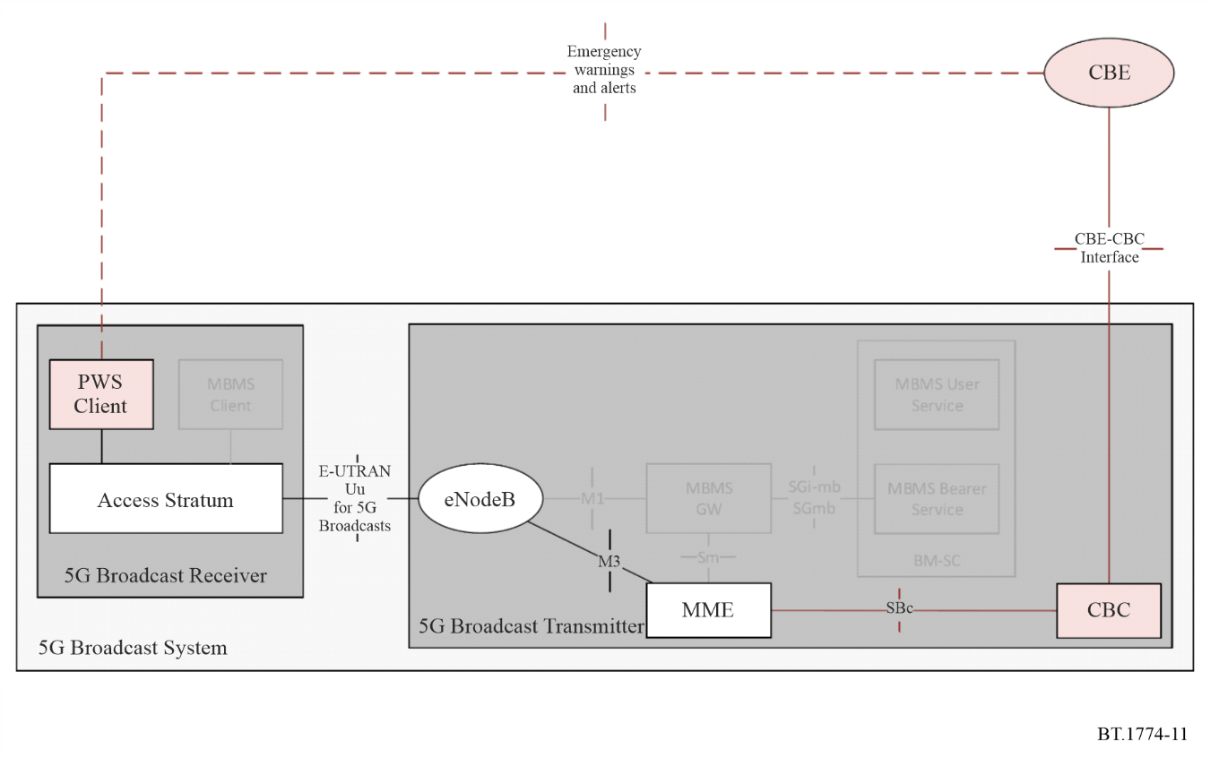
The extensions to support the PWS in the LTE-based 5G Broadcast System are as follows:
1) The 5G Broadcast Transmitter shall include:
a) For the CBE-CBC interface, the support of a specific profile of the Common Alerting Protocol (CAP), version v1.2 as defined in OASIS Standard CAPv1.2 is supported, but other protocols may be used.
b) The RAN extensions specified in ETSI TS 136 300, ETSI TS 136 304, ETSI TS 136 306, ETSI TS 136 331 and ETSI TS 136 413 as further specified in the present document.
2) The 5G Broadcast Receiver shall include:
a) Support for the profile of E-UTRAN Uu (as defined in ETSI TS 136 300, ETSI TS 136 304, ETSI TS 136 306, ETSI TS 136 331 and ETSI TS 136 413) specified in the present document.
b) A PWS Client as defined in ETSI TS 123 041 that supports the processing and presentation of public warning messages and emergency alerts independent of an application.
The warning message delivery procedure given in ETSI TS 103 720 V1.2.1 is shown in Fig. 12.
Figure 12
Systems Warning message delivery procedure in 5G Broadcast
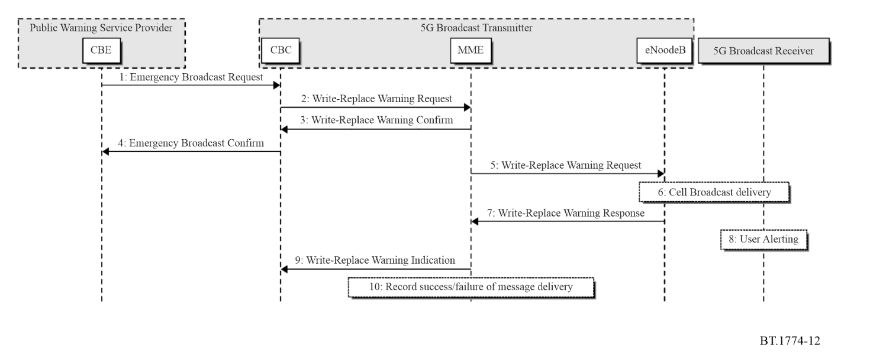
More details of Public Warning service supported by LTE based 5G broadcast system can be found in ETSI TS 103 720 V1.2.1.

6.2.3 Bibliography
The information on § 6 is available in the following references:
[1] FCC 08-99: “Federal Communications Commission First Report and Order In the Matter of The Commercial Mobile Alert System”; 9 April 2008.
[2] FCC 08-164: “Federal Communications Commission Second Report and Order and Further Notice of Proposed Rulemaking In the Matter of The Commercial Mobile Alert System”; 8 July 2008.
[3] FCC 08-184: “Federal Communications Commission Third Report and Order and Further Notice of Proposed Rulemaking In the Matter of The Commercial Mobile Alert System”; 7 August 2008.
[4] J-STD-100: “Joint ATIS/TIA-CMAS Mobile Device Behavior Specification”; 30 January 2009.
[5] 3GPP TR 21.905: “Vocabulary for 3GPP Specifications”.
[6] ETSI TS 102 900: “European Public Warning System (EU-ALERT) using the Cell Broadcast Service”.
[7] TTA TTAK.KO-06.0263: “Requirements and Message Format for Korean Public Alert System over Mobile Network”.
[8] FCC 16-127, Federal Communications Commission Report and Order and Further Notice of Proposed Rulemaking In the Matter of Wireless Emergency Alerts Amendments to Part 11 of the Commission’s Rules Regarding the Emergency Alert System; 29 September 2016.
[9] 3GPP TS 23.038; “Alphabets and language-specific information”.
[10] FCC 18-4, Federal Communications Commission Second Report and Order and Second Order on Reconsideration In the Matter of Wireless Emergency Alerts and Amendments to Part 11 of the Commission’s Rules Regarding the Emergency Alert System; 30 January 2018.
[11] 3GPP TS 22.071: “Location Services (LCS); Service description; Stage 1”.
[12] ETSI TS 103 720 V1.2.1 (2023-06): 5G Broadcast System for linear TV and radio services.
[13] 3GPP TS22.268v17.0.0(2022-03): “Public Warning System (PWS) requirements”.
[14] Recommendation ITU-R BT.2016, “Error-correction, data framing, modulation and emission methods for terrestrial multimedia broadcasting for mobile reception using handheld receivers in VHF/UHF bands”.

Annex 2
Common emergency warning system control signal
for analogue sound broadcasting

1 Introduction
The EWS described in this Annex enables a public warning to be issued in the case of an emergency due to natural disasters, etc. via analogue sound platforms. As analogue sound broadcasting is one of the most widespread broadcasting services, this is an especially effective way to alert the public.
The control signal of this EWS for public warnings activates receivers that are in standby mode. Automatic activation of the receivers depends on keeping a part of the receiver circuit always alive, in order to monitor the emission of the control signal.

2 Audible baseband EWS control signal
In an emergency, the EWS control signal breaks into the programme signal (analogue radio), to automatically activate EWS receivers, even when they are in standby mode. The audio part of the EWS control signal is also used as an alarm sound to draw the attention of all the listeners to the emergency broadcast that will follow the EWS control signal.
The EWS control signal is an FSK modulated signal that employs two audio frequencies, 640 Hz and 1 024 Hz, and is capable of transmitting 64 bit/s data. It is preferable that the modulation level for the EWS control signal is about 80% in order for the EWS control signal to be detected reliably.
The EWS control signal comprises two kinds of signals; a start signal and an end signal. The audible start signal denotes the beginning of the emergency broadcast and activates EWS receivers. An audible end signal denotes the end of the emergency broadcast, and the activated receiver may return to its previous state.

2.1 Start signal
The structure of the start signal is shown in Fig. 13. The start signal comprises an Unmodulated signal period, Preceding code, Fixed code and Arbitrary code. The Unmodulated signal period allows the EWS control signal to be clearly distinguished from the broadcast program by silence.
The Preceding code can be used as an indication as to whether the signal is a start signal or end signal. The Fixed code is the most important code in the EWS control signal. The Fixed code has the following two functions: 1. Receiver activation, 2. Timing reference for the Arbitrary code. The Arbitrary code carries additional information such as the time or location of the event. BLOCK-S, as shown in Fig. 13 comprises Fixed and Arbitrary codes and should be transmitted repeatedly – at least four times. This multiple transmission of the Fixed codes prevents mis-activation of receivers and also ensures activation of receivers in a poor reception environment.
The specification of each code is as follows:
– The Unmodulated signal period lasts more than one second
– The Preceding code for the start signal is “1100”
– The Fixed code is a 16-bit code word that starts with “00” and ends with “01”
– The Arbitrary code is a 16-bit code word that starts with “01” or “10”, and ends with “00” or “11”. The remaining 12 bits can be any bit patterns, providing for quick and reliable receiver operation.
The first and last two bits of the Fixed and Arbitrary codes are set so that no identical bit pattern for the Fixed and Arbitrary codes ever appears.
Figure 13
Structure of start signal
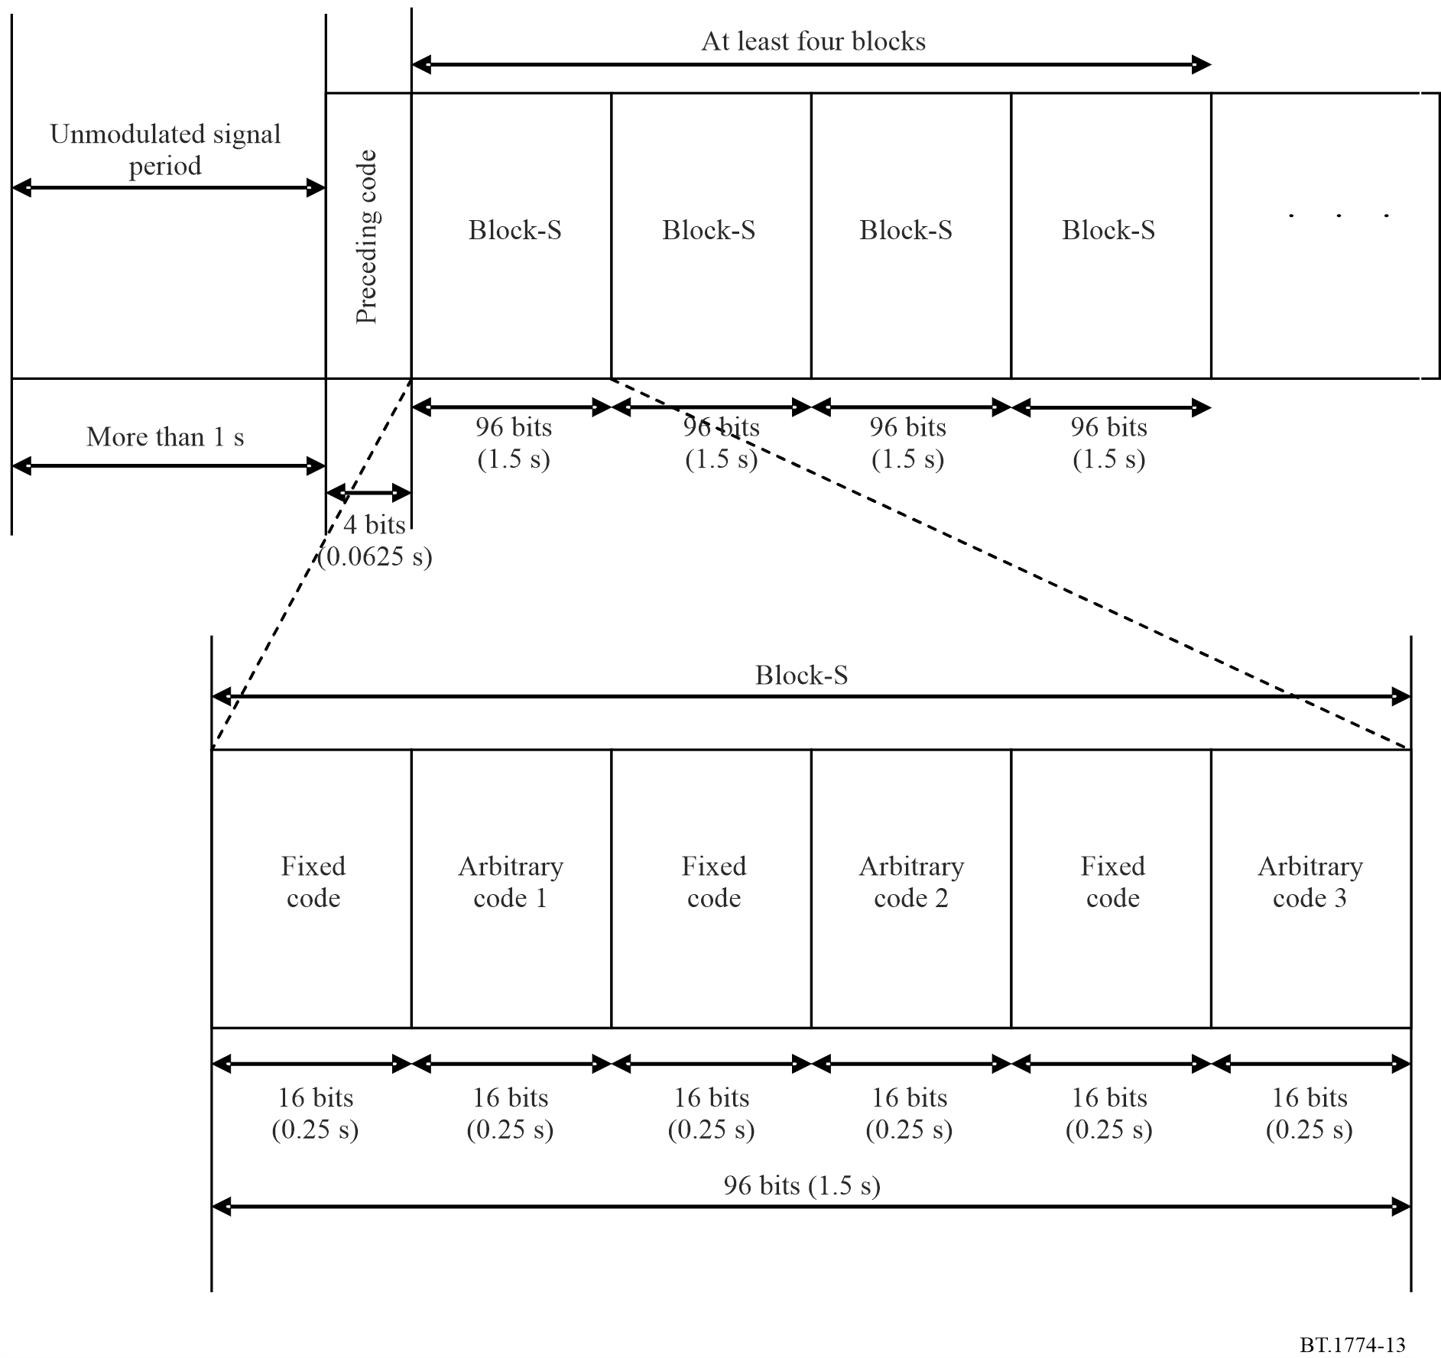

2.2 End signal
An end signal informs the EWS receiver of the end of the emergency broadcast. The activated receiver returns to its previous state after receiving the end signal. The structure of the end signal shown in Fig. 14 is similar to that of the start signal. The Fixed code employed in the end signal is identical to that of the start signal. The Preceding code of the end signal is “0011”.
To prepare for an actual emergency, it is important to test the automatic activation of the receivers with regularly scheduled (such as monthly) test broadcasts that include the EWS control signal. In such test broadcasts, it is necessary for the receivers to turn off at the end of the test. If a mobile receiver does not turn off, the power source will be exhausted and this could leave its battery unusable when an actual disaster occurs. The end signal can be used to prevent this from happening.
Figure 14
Structure of end signal
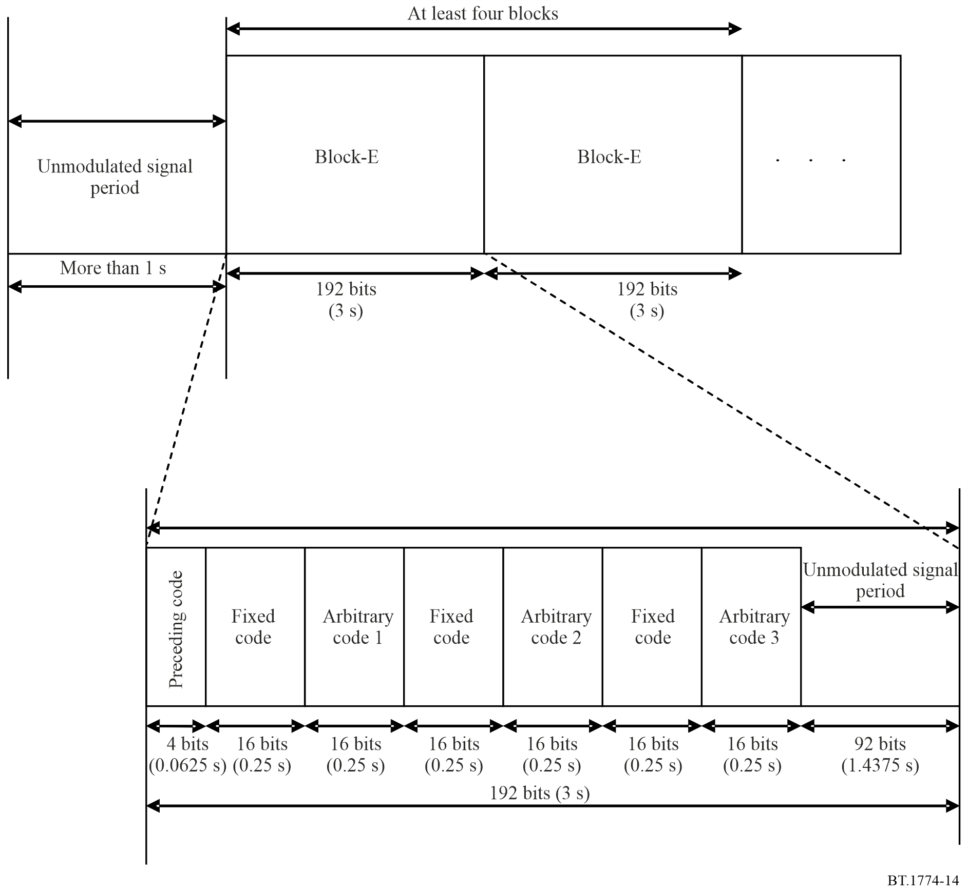

2.3 Common fixed code
Some disasters may affect more than one country. Once such a disaster occurs, the emergency warning information needs to be distributed widely, even across national borders. A common EWS control signal is therefore considered desirable. To detect the EWS control signal, an EWS receiver continuously calculates the cross-correlation between the given Fixed code and the input signal. A high correlation indicates the detection of the Fixed code by the receiver. To prevent incorrect detection, the Fixed code should have the following features.
– The number of bits with values “1” and “0” should always be equal. A Fixed code that contains long continuous streams of ones or zeros produces continuous 640 Hz or 1 024 Hz sound components. As these sound components may exist in some broadcasting programmes, such codes are not suitable for use as Fixed codes.
– The bit pattern of a Fixed code should not appear anywhere else within the combination of the Fixed code and any consecutive Arbitrary code. If the bit pattern of this Fixed code reappears, both the correct reference position and the false bit pattern position are detected as EWS reference positions by the receiver. If the detection of multiple reference positions may occur, this is not suitable for demodulation of the Arbitrary codes.
The Fixed codes shown in this Annex satisfy the features above. One of the codes listed in Table 7 should be selected. It is recommended to use the code “0010 0011 1110 0101” as the common Fixed code of the EWS control signal for analogue sound broadcasting. The remaining codes can be used, for example, as regional Fixed codes for particular countries or regions.
TABLE 7
List of Fixed codes
No. | Fixed code
1 | 0010 0011 1110 0101
2 | 0000 1011 0011 1101
3 | 0000 1011 1100 1101
4 | 0000 1100 1011 1101
5 | 0000 1110 0110 1101
6 | 0000 1110 1011 1001
7 | 0000 1110 1110 1001
8 | 0000 1111 0011 0101
9 | 0000 1111 0101 1001
10 | 0000 1111 0110 0101
11 | 0001 0001 1110 1101
12 | 0001 0011 1110 0101
13 | 0001 0100 1110 1101
14 | 0001 0100 1111 1001
15 | 0001 0110 1110 0101
16 | 0001 1010 0111 1001
17 | 0001 1010 1110 1001
18 | 0001 1011 1100 0101
19 | 0001 1110 1100 0101
20 | 0001 1110 1101 0001
21 | 0001 1111 0010 0101
22 | 0001 1111 0010 1001
23 | 0010 0001 1101 1101
24 | 0010 0011 0101 1101
25 | 0010 0110 0011 1101
26 | 0010 0111 1001 0101
27 | 0010 0111 1100 0101
28 | 0011 0000 1011 1101
29 | 0011 0000 1111 0101
30 | 0011 0111 1000 0101
31 | 0011 1011 0000 1101
TABLE 7 (end)
No. | Fixed code
32 | 0011 1011 0100 0101
33 | 0011 1100 1000 1101
34 | 0011 1100 1001 0101
35 | 0011 1100 1010 1001
36 | 0011 1100 1011 0001
37 | 0011 1110 0010 0101
38 | 0011 1110 0010 1001
39 | 0011 1110 0100 0101
40 | 0011 1110 0101 0001

Code No. 1 in the Table above, “0010 0011 1110 0101” is recommended as the common Fixed code of the EWS control signal for analogue sound broadcasting.

3 Specification for analogue FM radio alarm broadcasting
This specification employs the Radio Data System (RDS) radio text (RT) feature to deliver the emergency message without interruption to the main programme. After differential encoding of the message, it is inserted in the amplitude modulated auxiliary subcarrier, which is the third harmonic (57 kHz) of the baseband pilot signal. The data rate is about 1 187.5 bit/s. The message is presented with audio, using an optional Text-To-Speech (TTS) system. Table 8 illustrates the message format.
TABLE 8
Emergency message format for FM radio
Control code | Start code | Date and time | Duration | Number of area | Area1 | . . . | AreaN | Event code | Checksum | Presentation time | Text | End of presentation | End code
Hex | 24 |  |  | xx |  | . . . |  |  |  | 02 |  | 03 | 40
Size in Byte | 1 | variable | variable | 1 | variable | . . . | variable | variable | variable | 1 | variable | 1 | 1

Annex 3
Common emergency warning system control signal
for digital broadcasting

1 Common Alerting Protocol (CAP) Signalling
The Common Alerting Protocol (CAP) version 1.2 as specified in Recommendation ITU-T X.1303 bis is a simple but general format for exchanging all-hazard emergency alerts and public warnings over all kinds of networks. CAP allows a consistent warning message to be disseminated simultaneously over many different warning systems, thus increasing warning effectiveness while simplifying the warning task. CAP facilitates the detection of emerging patterns in local warnings of various kinds, such as those that might indicate an undetected hazard or hostile act. CAP provides a template for effective warning messages based on best practices identified in academic research and real-world experience.
CAP provides an open, non-proprietary digital message format for various types of alerts and notifications. CAP provides the following capabilities:
– flexible geographic targeting using latitude/longitude shapes and other geospatial representations in three dimensions;
– multilingual and multi-audience messaging;
– phased and delayed effective times and expirations;
– enhanced message update and cancellation features;
– template support for framing complete and effective warning messages;
– compatible with digital encryption and signature capability; and
– facility for digital images and audio.
Both an XML schema definition (XSD) schema and an abstract syntax notation one (ASN.1) specification for the common alerting protocol are provided in Recommendation ITU-T X.1303 bis.

2 Structure of the CAP alert message
Each CAP alert message consists of an <alert> segment, which may contain one or more <info> segments, each of which may include one or more <area> and/or <resource> segments. Under most circumstances, CAP messages with a <msgType> value of "Alert" should include at least one <info> element. (See the document object model diagram in Fig. 15).
• <alert>
The <alert> segment provides basic information about the current message: its purpose, its source and its status, as well as a unique identifier for the current message and links to any other, related messages. An <alert> segment may be used alone for message acknowledgements, cancellations or other system functions, but most <alert> segments will include at least one <info> segment.
• <info>
The <info> segment describes an anticipated or actual event in terms of its urgency (time available to prepare), severity (intensity of impact) and certainty (confidence in the observation or prediction), as well as providing both categorical and textual descriptions of the subject event. It may also provide instructions for appropriate response by message recipients and various other details (hazard duration, technical parameters, contact information, links to additional information sources, etc.). Multiple <info> segments may be used to describe differing parameters (e.g. for different probability or intensity "bands") or to provide the information in multiple languages.
• <resource>
The <resource> segment provides an optional reference to additional information related to the <info> segment within which it appears in the form of a digital asset such as an image or audio file.
• <area>
The <area> segment describes a geographic area to which the <info> segment in which it appears applies. Textual and coded descriptions (such as postal codes) are supported, but the preferred representations use geospatial shapes (polygons and circles) and an altitude or altitude range, expressed in standard latitude/longitude/altitude terms in accordance with a specified geospatial datum.
FIGURE 15
Document object model
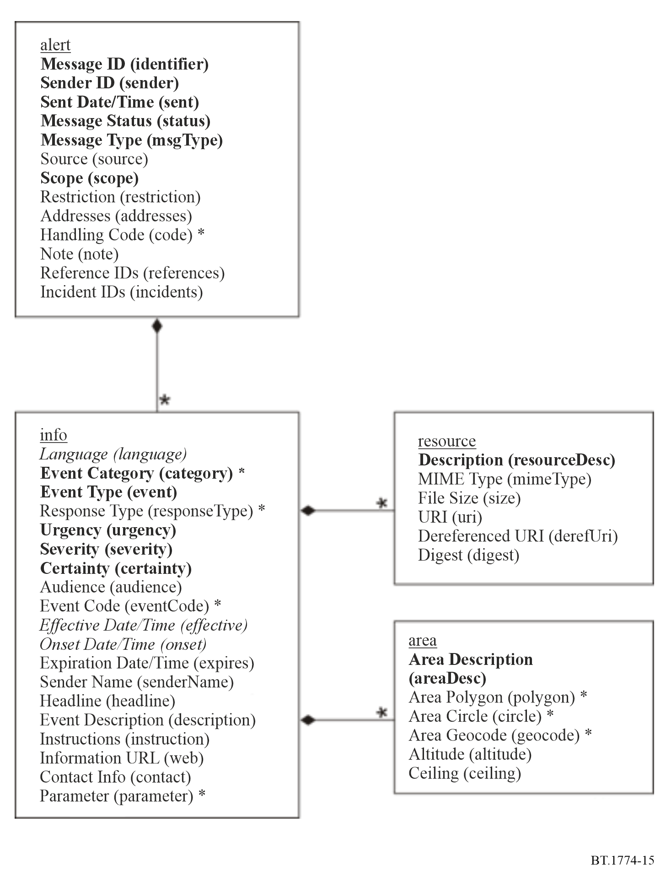
NOTE – In the Figure above, elements in boldface are mandatory; elements in italics have default values that will be assumed if the element is not present; asterisks (*) indicate that multiple instances are permitted.

3 References
[1] Recommendation ITU-T X.1303 bis – Common alerting protocol (CAP 1.2), March 2014.

US Code of Federal Regulations, title 47, part 11, Emergency Alert System (EAS).
The US specification for its CAP profile can be found at Common Alerting Protocol, v. 1.2 USA Integrated Public Alert and Warning System Profile Version 1.0, Committee Specification 01, Organization for the Advancement of Structured Information Standards (OASIS), 13 October 2009. The guidance for translation of CAP messages into EAS (SAME) format alerts is provided at ECIG Recommendations for a CAP EAS Implementation Guide, EAS CAP Industry Group ECIG EAS-CAP Implementation Guide Subcommittee Version 1.0, 17 May 2010.
See the Canadian Profile of the Common Alerting Protocol CAP-CP, CAP-CP 1.0 Specifications Committee (SC), Senior Officials Responsible for Emergency Management (SOREM). Specific broadcast implementation guidance is provided via the National Public Alerting System: Common Look and Feel Guidance, Version 2.0, Federal/Provincial/Territorial Public Alerting Working Group of Senior Officials Responsible for Emergency Management.

