Recommendation ITU-R BT.1702-2
(10/2019)
Guidance for the reduction of photosensitive epileptic seizures caused by television

BT Series
Broadcasting service
(television)

Foreword
The role of the Radiocommunication Sector is to ensure the rational, equitable, efficient and economical use of the radio-frequency spectrum by all radiocommunication services, including satellite services, and carry out studies without limit of frequency range on the basis of which Recommendations are adopted.
The regulatory and policy functions of the Radiocommunication Sector are performed by World and Regional Radiocommunication Conferences and Radiocommunication Assemblies supported by Study Groups.

Policy on Intellectual Property Right (IPR)
ITU-R policy on IPR is described in the Common Patent Policy for ITU-T/ITU-R/ISO/IEC referenced in Resolution ITU-R 1. Forms to be used for the submission of patent statements and licensing declarations by patent holders are available from http://www.itu.int/ITU-R/go/patents/en where the Guidelines for Implementation of the Common Patent Policy for ITU-T/ITU-R/ISO/IEC and the ITU-R patent information database can also be found.

Series of ITU-R Recommendations
(Also available online at http://www.itu.int/publ/R-REC/en)
Series | Title
BO | Satellite delivery
BR | Recording for production, archival and play-out; film for television
BS | Broadcasting service (sound)
BT | Broadcasting service (television)
F | Fixed service
M | Mobile, radiodetermination, amateur and related satellite services
P | Radiowave propagation
RA | Radio astronomy
RS | Remote sensing systems
S | Fixed-satellite service
SA | Space applications and meteorology
SF | Frequency sharing and coordination between fixed-satellite and fixed service systems
SM | Spectrum management
SNG | Satellite news gathering
TF | Time signals and frequency standards emissions
V | Vocabulary and related subjects

Note: This ITU-R Recommendation was approved in English under the procedure detailed in Resolution ITU-R 1.

Electronic Publication
Geneva, 2019
© ITU 2019
All rights reserved. Guidance for the reduction of photosensitive epileptic seizures caused by television No part of this publication may be reproduced, by any means whatsoever, without written permission of ITU.

RECOMMENDATION ITU-R BT.1702-2
Guidance for the reduction of photosensitive epileptic seizures
caused by television
(2005-2018-2019)
Scope
Extensive studies on the subject of photosensitive epilepsy, which have taken place around the world, have led to formulation of this Recommendation. The guidance proposed in this Recommendation is for the protection of the vulnerable section of the viewing population who have photosensitive epilepsy, and who are therefore prone to seizures triggered by flashing lights, including certain types of flashing television images. Broadcasting organizations are encouraged to raise awareness among programme producers of the risks of creating television image content which may induce photosensitive epileptic seizures in susceptible viewers. Annexes 1 to 5 provide additional information on this subject.
Keywords
Epilepsy, flashing images, photosensitive, seizures
The ITU Radiocommunication Assembly,
considering
a) that several cases of individual or collective photosensitive epileptic seizures in vulnerable persons, in particular children, induced by flickering television images have been reported from various parts of the world;
b) that while television images displayed on television receivers do not themselves cause photosensitive epilepsy, they can be a trigger of seizures in individuals who happen to be prone to photosensitive epilepsy;
c) that it is useful to identify measures to help avoid the inadvertent creation of material for transmission on broadcast television that would be likely to induce photosensitive epileptic seizures;
d) that measures should be proportionate to the risks and should not place undue burdens on broadcasting organizations or programme producers;
e) that the impact of measures on broadcasters or programme producers may vary with their programme genres;
f) that, to be applied effectively, such measures should be simple and easy to understand by non-technical programme producers:
– that in the case of some live programming, such as news, programme production is often beyond the control of the broadcaster;
– that measurement results to check compliance with the guidelines depend on a number of measurement parameters;
– that the viewing environment and the display device, which can affect the likelihood of problems arising in susceptible viewers, may be different depending on a style of living around the world;
g) that the risk of seizures cannot be eliminated for the most susceptible viewers:
– that a small number of highly susceptible viewers may benefit from protection by means of filtering applied in the receiver;
– that due to the complexity of the end-to-end broadcast chain that involves many organizations and technologies, from capture, through production, mastering, broadcast, reception to display, and considering the viewing environment, no single organization has end-to-end control over this effect,
recommends
1 that broadcasting organizations should be encouraged to provide guidance to programme producers of the risks of creating television image content which may induce photosensitive epileptic seizures in susceptible viewers of television broadcasts;
2 that producers of programme material for television broadcasting, consumer equipment manufacturers, and viewers, should refer to the technical guidance information provided in the Annexes,
further recommends
1 that further studies are required recognizing that different programme genres exist in broadcasting environments;
2 that due to the complexity of the issues involved, appropriate international medical organizations (e.g. World Health Organization) should be consulted, and routinely informed on this issue.

Annex 1
Guidelines for production organizations
on flashing images in television
Flickering or intermittent images and certain types of regular pattern can cause problems for some viewers who have photosensitive epilepsy. Consideration of information from leading medical opinion in this area [1] [2] [3] [4] [5] [6] [7] [8] and the experience of broadcasting organizations have led to drawing up guidelines aimed at reducing the risk of exposure to potentially harmful stimuli.
Television is by nature a flickering medium. Transmitted pictures are refreshed at typically 50 or 60 times each second, in which case interlaced scanning generates flicker 25 or 30 times each second. It is therefore impossible to eliminate the risk of flashing images on television causing convulsions in viewers with photosensitive epilepsy. To reduce risk, the following guidelines on visual content should be applied when flashing or regular patterns are clearly discernible in normal domestic viewing conditions. It should be noted that the level of any cumulative risk arising from successive sequences of “potentially harmful” flashes over a prolonged period is unknown. If, as medical opinion suggests, the risk of seizures increases with the duration of flashing, it has been calculated that a sequence of flashing images lasting more than 5 s might constitute a risk even when it complies with the guidelines below.
Potentially harmful flash occurs when there is a pair of opposing changes in luminance (i.e. an increase in luminance followed by a decrease, or a decrease followed by an increase) as detailed below:
– When screen luminance of the darker image is below 160 cd/m², a potentially harmful sequence of flashes occurs where there is a difference of 20 cd/m² or more between the screen luminance of the darker and the brighter images (see Notes 1 and 2). This is applicable for both standard dynamic range (SDR) and high dynamic range (HDR) programmes.
– When screen luminance of the darker image is not less than 160 cd/m², a potentially harmful sequence of flashes occurs where there is a difference of more than 1/17 Michelson contrast (see Note 5). For the purpose of this measurement, the Michelson contrast is defined as (L_{HIGH} – L_{LOW})/(L_{HIGH} + L_{LOW}) [9], where L_{LOW} is the luminance of darker image and L_{HIGH} is the luminance of brighter image of a flash. This is applicable for HDR programmes only.
Irrespective of luminance, a transition to or from a saturated red is also potentially harmful.
Isolated single, double, or triple flashes are acceptable, but a sequence of flashes is not permitted when both the following occur:
– the combined area of flashes occurring concurrently occupies more than one quarter of the displayed (see Note 3) screen area; and
– there are more than three flashes (i.e. six changes in luminance as described above) within any one-second period. For clarification, successive flashes for which the leading edges are separated by 360 ms or more are acceptable in a 50 Hz environment, or separated by 334 ms or more are acceptable in a 60 Hz environment, irrespective of their brightness or screen area.
Rapidly changing image sequences (for example, fast cuts) are provocative if they result in areas of the screen that flash, in which case the same constraints apply as for flashes.
NOTE 1 – Video waveform luminance is not a direct measure of display screen brightness. For the purpose of determining electrical measurements to check compliance with these guidelines, the relationship between video signal level and screen luminance may be assumed as described in Annex 2.
NOTE 2 – For the purpose of measurements to check compliance with these guidelines by assuming a relationship between video signal level and screen luminance, SDR pictures are assumed to be displayed with peak white corresponding to a screen luminance of 200 cd/m2 and HDR pictures with Hybrid Log-Gamma (HLG) format are assumed to be displayed with peak white corresponding to a screen luminance of 1 000 cd/m².
NOTE 3 – It may be assumed that overscan on modern domestic television receiver displays will normally be in the range 3.5% to ± 1% of the overall picture width or height (as indicated in Recommendation ITU-R BT.1848-1).
NOTE 4 – The use of automatic video analysers to help alert production staff to potential guideline violations in video material can be beneficial.
NOTE 5 – Figure 1 shows a Michelson contrast against luminance of darker image of a flash. Flashes with the luminance contrast indicated by the area above the curve is potentially harmful. This curve consists of two regions, below and above 160 cd/m² for the darker image of a flash. In the region below 160 cd/m², the curve is defined by the absolute difference of 20 cd/m². In the region above 160 cd/m², the curve is defined by the relative contrast. There is no discontinuities at 160 cd/m² since the relative contrast of the flash with 160 cd/m² of the darker image and 20 cd/m² of difference between darker and brighter images is 1/17 = ((160 + 20) – (160))/((160 + 20) + 160). Figure 2 is a re-plot of Fig. 1 showing the luminance contrast between darker and brighter images of flash into the luminance difference.
FIGURE 1
Michelson relative contrast vs. luminance of darker image of a flash
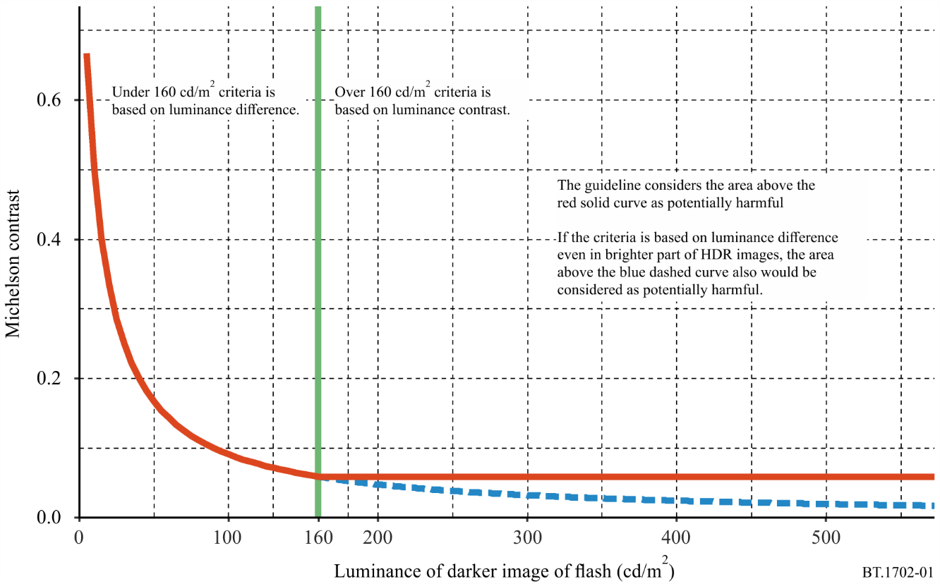
FIGURE 2
Luminance difference vs. luminance of darker image of a flash
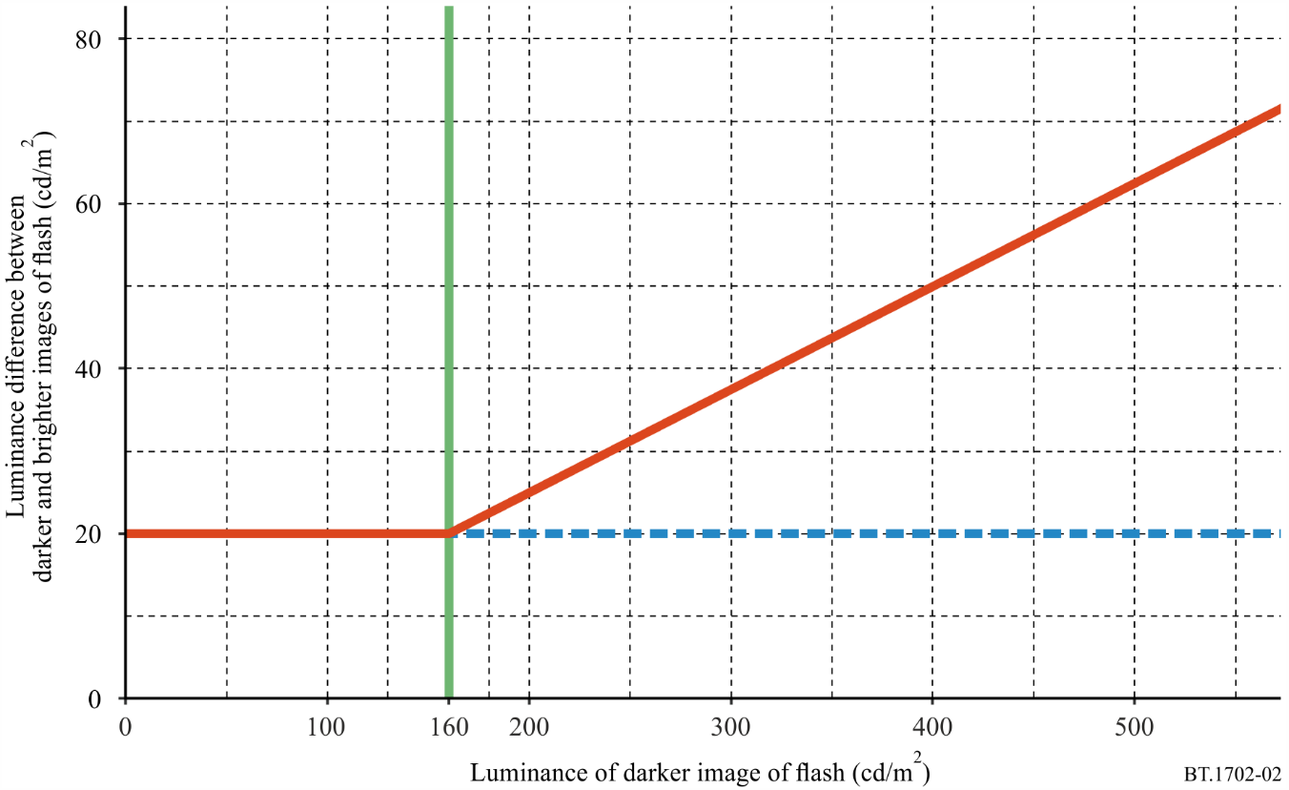

References

[1] ABRAMOV, V. A., KRAPIVINA E. N. and MISHENKOV, S. L. [July 2000] Ecological problems of teleradio broadcasting, Seminar of Moscow A.S. Popov’s Scientific Technical Society on Broadcasting and Telecommunication, Velikie Luky.
[2] BINNIE, C. D., EMMETT J., GARDINER, P., HARDING G. F. A., HARRISON D. and WILKINS, A. J. [2001] Characterizing the Flashing Television Images that Precipitate Seizures, Proc. IBC2001.
[3] BINNIE, C. D., EMMETT, J., GARDINER, P., HARDING, G. F. A., HARRISON, D. and WILKINS, A. J. [July/August 2002] Characterizing the Flashing Television Images that Precipitate Seizures, SMPTE J.
[4] CLIPPINGDALE, C. and ISONO H. [October 1999] Photosensitivity, Broadcast Guidelines and Video Monitoring. Proc. IEEE International Conference on Systems, Man & Cybernetics SMC’99, Tokyo, Japan.
[5] HARDING, G. F. A. [March 1998] TV can be bad for your health. Nature Medicine, Vol. 4, 3.
[6] HARDING, G. F. A. and JEAVONS, P. M. [1994] Photosensitive Epilepsy. ISBN: 0 898683 02 6.
[7] NEMTSOVA, S. R. [2001] The research on main characteristics of audiovisual systems with position of ecological protection of information consumer. Dissertation for the doctorate on technical sciences, Moscow, Russia.
[8] WILKINS, A. J. [1995] Visual Stress. ISBN: 0 19 852174 X.
[9] PELLI, D. G. and BEX, P. [2013] Measuring Contrast Sensitivity. Vision Research, Vol. 90, Pages 10-14.

Annex 2
Guidelines for luminance measurement
Screen luminance may be measured using a hand-held spot photometer with a CIE (International Commission on Illumination) characteristic designed for making measurements from a television screen. The display conditions are those of the “home viewing environment” described in Recommendation ITU-R BT.500. For accurate results, the display brightness and contrast should first be set up using PLUGE (see Recommendation ITU-R BT.814). In that case, peak white should be corresponding to a screen luminance of 200 cd/m² for SDR television, 1 000 cd/m² for Hybrid Log-Gamma (HLG), and 10 000 cd/m² for Perceptual Quantisation (PQ).
Table 1 and Fig. 3 may be consulted if electrical measurements are more convenient. This shows the typical relationship between luminance (monochrome) signal level and the emitted light output of a television display.
There are measurement uncertainties associated with both methods. Nevertheless, flashing images or regular patterns described as being potentially harmful can be expected to be obviously discernible. Such potentially harmful images occur only rarely during the course of programme material with scenes that appear natural or represent real life; examples include photographers’ flashlights or strobe lights in a disco. Part of the purpose of this guidance is to assist programme producers to avoid inadvertently creating video effects that contain flashing images or patterns likely to be harmful.
TABLE 1
Three types of Luminance Level
10-bit code value | Normalised video level | Screen luminance (cd/m²) |  |  | 10-bit code value | Normalised video level | Screen luminance (cd/m²)
 |  | SDR | PQ | HLG |  |  | SDR | PQ | HLG
64 | 0.00 | 0.00 | 0.00 | 0.00 | 520 | 0.52 | 41.74 | 113.17 | 56.04
80 | 0.02 | 0.01 | 0.01 | 0.02 | 540 | 0.54 | 46.27 | 141.60 | 62.87
100 | 0.04 | 0.09 | 0.04 | 0.13 | 560 | 0.57 | 51.07 | 176.66 | 70.77
120 | 0.06 | 0.27 | 0.11 | 0.36 | 580 | 0.59 | 56.15 | 219.85 | 79.94
140 | 0.09 | 0.57 | 0.22 | 0.76 | 600 | 0.61 | 61.52 | 273.03 | 90.57
160 | 0.11 | 0.99 | 0.41 | 1.33 | 620 | 0.63 | 67.17 | 338.45 | 102.91
180 | 0.13 | 1.56 | 0.70 | 2.09 | 640 | 0.66 | 73.12 | 418.90 | 117.23
200 | 0.16 | 2.29 | 1.11 | 3.06 | 660 | 0.68 | 79.36 | 517.82 | 133.86
220 | 0.18 | 3.18 | 1.68 | 4.26 | 680 | 0.70 | 85.90 | 639.46 | 153.18
240 | 0.20 | 4.25 | 2.47 | 5.68 | 700 | 0.73 | 92.75 | 789.06 | 175.64
260 | 0.22 | 5.50 | 3.52 | 7.36 | 720 | 0.75 | 99.91 | 973.13 | 201.74
280 | 0.25 | 6.95 | 4.91 | 9.29 | 740 | 0.77 | 107.37 | 1 199.76 | 232.10
300 | 0.27 | 8.59 | 6.73 | 11.49 | 760 | 0.79 | 115.15 | 1479.00 | 267.41
320 | 0.29 | 10.44 | 9.09 | 13.97 | 780 | 0.82 | 123.26 | 1823.40 | 308.49
340 | 0.32 | 12.51 | 12.12 | 16.74 | 800 | 0.84 | 131.68 | 2248.67 | 356.30
360 | 0.34 | 14.80 | 15.98 | 19.79 | 820 | 0.86 | 140.43 | 2774.49 | 411.94
380 | 0.36 | 17.31 | 20.88 | 23.16 | 840 | 0.89 | 149.52 | 3425.63 | 476.71
400 | 0.38 | 20.06 | 27.05 | 26.83 | 860 | 0.91 | 158.93 | 4233.32 | 552.13
420 | 0.41 | 23.04 | 34.80 | 30.83 | 880 | 0.93 | 168.69 | 5237.10 | 639.93
440 | 0.43 | 26.27 | 44.48 | 35.15 | 900 | 0.95 | 178.78 | 6487.17 | 742.19
460 | 0.45 | 29.75 | 56.55 | 39.80 | 920 | 0.98 | 189.22 | 8047.52 | 861.28
480 | 0.47 | 33.48 | 71.56 | 44.80 | 940 | 1.00 | 200.00 | 10 000.00 | 1 000.00
500 | 0.50 | 37.48 | 90.16 | 50.14
* Video signal level normalized, black at V = 0, to white at V = 1 (Recommendation ITU-R BT.1886). For content mastered per Recommendation ITU-R BT.709 10-bit digital code values (D) map to V as per the following equation: V = (D-64)/876.
Figure 3
Screen luminance vs video signal level
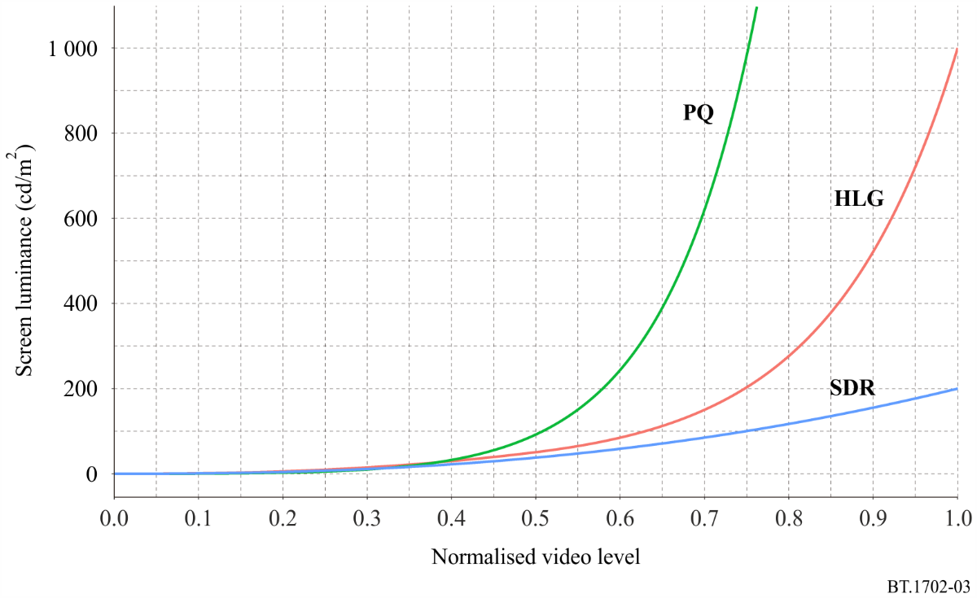

NOTE 1 – A luminance signal level with the 10-bit code value of 400 results in screen luminance of 20.1 cd/m² for SDR, 377 results in 20.1 cd/m² for PQ, and 362 results in 20.1 cd/m² for HLG. If the brighter image of a flash is above this level, then it is potentially harmful if the light output between the brighter and darker images differs by 20 cd/m² or more.
NOTE 2 – A luminance signal level with the 10-bit code value of 863 results in screen luminance of 160.4 cd/m² for SDR, 552 results in 161.7 cd/m² for PQ, and 687 results in 160.7 cd/m² for HLG. If the darker image of a flash is below this level, then it is potentially harmful if the light output between the darker and brighter images differs by 20 cd/m² or more. If the darker image of a flash is above this level, then it is potentially harmful if the screen luminance whose Michelson luminance contrast is 1/17 or more.

Annex 3
Example framework for a unified measurement specification
Measurement results to check compliance with the guidelines depend on a number of measurement parameters. Since it is desirable for international programme exchange that consistent measurement specification be applied uniformly worldwide, it needs further study to develop a unified specification conforming to the guidance. The flowchart in Fig. 4 illustrates an example framework for such a measurement specification. Schematics and detailed definitions for each block will be required. It is likely that more explicit definitions and detection criteria will also be required in specifying guidance on the use of saturated red colour.
Figure 4
Example framework for unified measurement specification
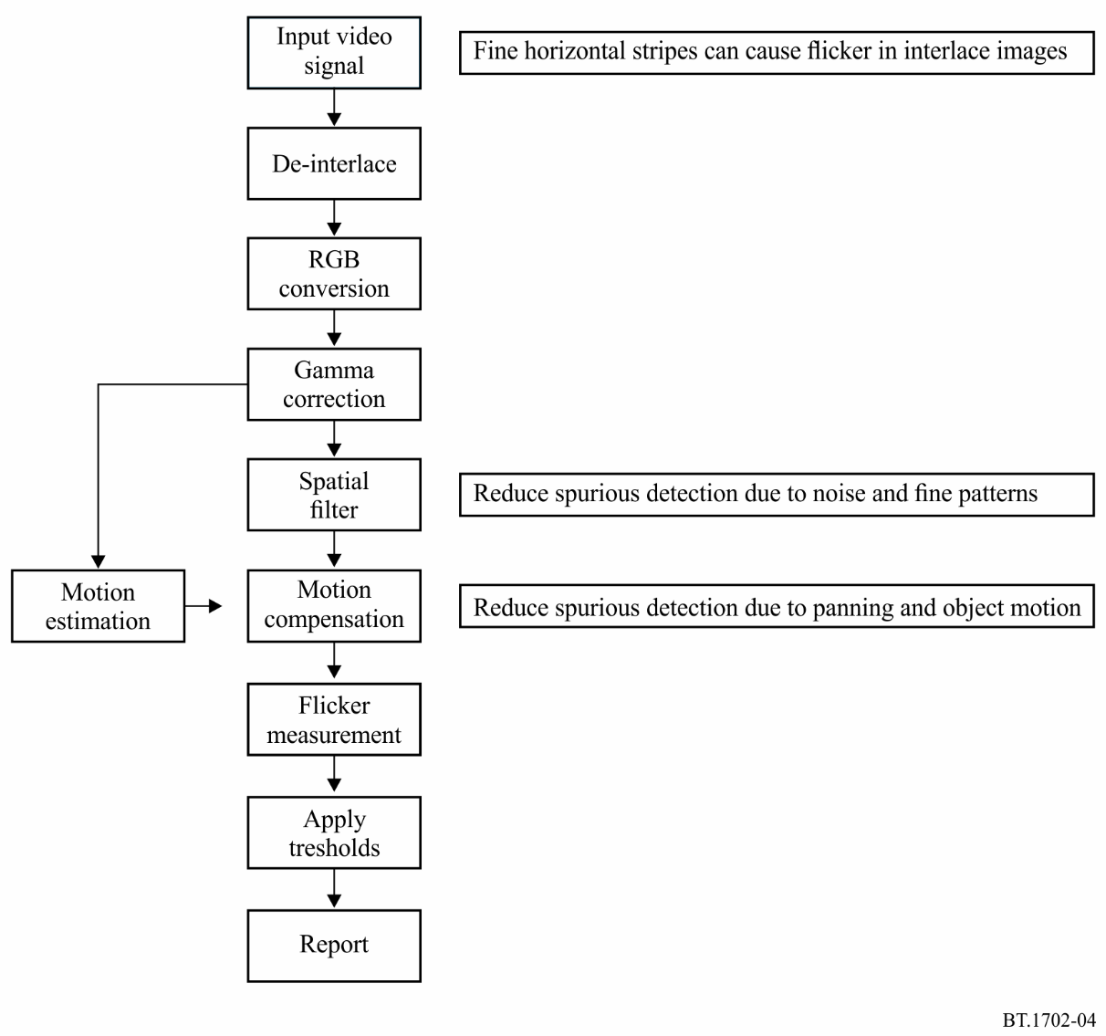

Annex 4
Guidelines for filtering techniques to reduce flashing images in television
Measures to reduce the risk of the transmission of potentially harmful stimuli, as described in Annex 1, can be expected to provide a high degree of protection for the overwhelming majority of individuals with photosensitivity.
However, for a very small number of highly susceptible individuals, measures to reduce temporal stimuli prior to transmission would place unacceptable constraints on the quality of the images broadcast, to the disbenefit of the majority of viewers. In order to make it possible for such highly susceptible individuals to be able to watch television without significant risk of seizure, filtering techniques may be applied in the receiver.
The optional inclusion of measures in receivers has the advantage of providing protection against flashing images that may from time to time arise inadvertently from a range of possible video sources.
Two types of measures have been identified.
Adaptive temporal filtering
Adaptive temporal filtering should reduce the frame-to-frame or field-to-field stimuli in the region 10-30 Hz. The exact parameters of such filtering are left to manufacturers to devise, but could typically be expected to provide a 20 dB or more reduction at temporal frequencies of 10 Hz or greater. There will be trade-offs between the effectiveness of protection, and image blur.
Compound optical filters
For a small number of extremely photosensitive viewers, a compound optical filter may be used to effect a substantial reduction in photoparoxysmal response. Such a filter can allow highly susceptible viewers to continue to watch television or computer displays who would otherwise be unable to do so.
An effective filter is likely to comprise a compound optical filtering arrangement, one filter reflecting long-wavelength red light selectively, and the other absorbing light evenly in the visible spectrum (neutral density).

Annex 5
Technical guidance information on viewing environments
While the implementation of technical guidance to limit potentially provocative flicker in television images is valuable in reducing the number of television-induced cases of photosensitive epilepsy, other factors in addition to programme content also affect the likelihood of problems arising:
– Viewing environment: a given section of programme material is more likely to cause problems for photosensitive viewers if viewed in a darker room; on a brighter or larger screen; or if the viewer is closer to the screen.
– Viewer age profile: photosensitivity is reported as most prevalent among children and young people below the age of 20 years, the prevalence falling with increasing age.
A combination of these factors may further exacerbate the likelihood of problems arising, and the provision of advice to viewers (and the parents of younger viewers) on appropriate viewing environments may be a valuable preventative measure in itself.
Accordingly, consideration should be given on providing advice for watching television in a well-lit room from a distance of at least two metres, particularly regarding programmes aimed at younger viewers such as animations.

This Recommendation should be brought to the attention of the World Health Organization.

