Recommendation ITU-R BT.1698-1
(05/2023)
BT Series: Broadcasting service (television)
Evaluating electromagnetic fields from terrestrial broadcasting transmitting systems to assess human exposure to non-ionizing emissions

Foreword
The role of the Radiocommunication Sector is to ensure the rational, equitable, efficient and economical use of the radio-frequency spectrum by all radiocommunication services, including satellite services, and carry out studies without limit of frequency range on the basis of which Recommendations are adopted.
The regulatory and policy functions of the Radiocommunication Sector are performed by World and Regional Radiocommunication Conferences and Radiocommunication Assemblies supported by Study Groups.

Policy on Intellectual Property Right (IPR)
ITU-R policy on IPR is described in the Common Patent Policy for ITU-T/ITU-R/ISO/IEC referenced in Resolution ITU-R 1. Forms to be used for the submission of patent statements and licensing declarations by patent holders are available from http://www.itu.int/ITU-R/go/patents/en where the Guidelines for Implementation of the Common Patent Policy for ITU-T/ITU-R/ISO/IEC and the ITU-R patent information database can also be found.

Series of ITU-R Recommendations
(Also available online at https://www.itu.int/publ/R-REC/en)
Series | Title
BO | Satellite delivery
BR | Recording for production, archival and play-out; film for television
BS | Broadcasting service (sound)
BT | Broadcasting service (television)
F | Fixed service
M | Mobile, radiodetermination, amateur and related satellite services
P | Radiowave propagation
RA | Radio astronomy
RS | Remote sensing systems
S | Fixed-satellite service
SA | Space applications and meteorology
SF | Frequency sharing and coordination between fixed-satellite and fixed service systems
SM | Spectrum management
SNG | Satellite news gathering
TF | Time signals and frequency standards emissions
V | Vocabulary and related subjects

Note: This ITU-R Recommendation was approved in English under the procedure detailed in Resolution ITU-R 1.

Electronic Publication
Geneva, 2023

© ITU 2023
All rights reserved. No part of this publication may be reproduced, by any means whatsoever, without written permission of ITU.

RECOMMENDATION ITU-R BT.1698-1
Evaluating electromagnetic fields from terrestrial broadcasting transmitting systems to assess human exposure to non-ionizing emissions
(2005-2023)
Scope
This Recommendation is intended to provide a basis for the derivation and estimation of the values of electromagnetic fields (EMF) from a broadcasting station that occur at particular distances from the transmitter site. Using such information, responsible organizations can then develop appropriate assessment methods for levels that may be used to protect humans exposed to electromagnetic fields. The actual levels to be applied in any regulation will naturally depend on decisions reached by responsible health agencies, domestic and worldwide.
Keywords
Exposure limits, RF-EMF, exposure assessment, exposure evaluation, terrestrial broadcasting transmitting systems
Abbreviations/Glossary
EMF Electromagnetic Fields
ERP Effective Radiated Power, relative to a half wave dipole
HF High Frequency (also known as Short Wave)
HR, HRS HF curtain antennas; Height (H), Rows (R), Slewable (S)
ICNIRP International Commission on Non-Ionizing Radiation Protection, a non-governmental organization formally recognised by WHO
LF Low Frequency (also known as Long Wave)
MF Medium Frequency (also known as Medium Wave)
MOM Method of Moments
RF Radio Frequency
RMS Root Mean Square
SAR Specific Absorption Rate
Z₀ Characteristic Impedance of Free Space
Related ITU Recommendations, Reports and Handbooks

ITU-R Recommendations – BS Series: Broadcasting service (sound):
BS.705: HF transmitting and receiving antennas characteristics and diagrams
BS.1195: Transmitting antenna characteristics at VHF and UHF
BS.1386: LF and MF transmitting antennas characteristics and diagrams

ITU-R Reports – SM Series: Spectrum management:
Report ITU-R SM.2452: Electromagnetic field measurements to assess human exposure

ITU-R Handbook – Study Group 1: Spectrum management:
Handbook on Spectrum Monitoring (section 5.6 ‘Non-ionizing radiation measurements’)

ITU-T Recommendations – K Series: Protection against interference:
K.52: Guidance on complying with limits for human exposure to electromagnetic fields
K.61: Guidance on measurement and numerical prediction of electromagnetic fields for compliance with human exposure limits for telecommunication installations
K.70: Mitigation techniques to limit human exposure to EMFs in the vicinity of radiocommunication stations
K.83: Monitoring of electromagnetic field levels
K.91: Guidance for assessment, evaluation and monitoring of human exposure to radio frequency electromagnetic fields
K.100: Measurement of radio frequency electromagnetic fields to determine compliance with human exposure limits when a base station is put into service
K.113: Generation of radiofrequency electromagnetic field level maps
K.121: Guidance on the environmental management for compliance with radio frequency EMF limits for radiocommunication base stations
K.122: Exposure levels in close proximity of radiocommunication antennas
K.145: Assessment and management of compliance with radio frequency electromagnetic field exposure limits for workers at radiocommunication sites and facilities
ITU-D Question 7/2 – Strategies and policies concerning human exposure to electromagnetic fields:
Output Report on ITU-D Question 7/2, October 2021.
The ITU Radiocommunication Assembly,
considering
a) that radio frequency high level energy may have unsafe effects on the human body;
b) that radio frequency energy may induce harmful electric potentials in conducting material;
c) that radio frequency high level energy may produce indirect health effects when interfering with medical devices;
d) that radio frequency energy may lead to unintentional ignition of inflammable or explosive material;
e) that determination of hazardous exposure levels and electric potentials, in terms of spectrum content, intensity, cumulative effects, etc., are being made by competent authorities;
f) that determination of areas where radio frequency fields and electric potentials exceed safe levels are being made by competent authorities;
g) that persons not associated with such systems may be exposed inadvertently to electromagnetic fields or to electric potentials;
h) that workers operating terrestrial broadcasting systems may be required to work in close proximity to the source of such radio frequency emissions,
recommends
that Annex 1 to this Recommendation should be used to evaluate the electromagnetic fields generated by terrestrial broadcasting transmitting systems, to assess human exposure to non-ionizing emissions.

Annex 1
Evaluating electromagnetic fields from terrestrial broadcasting transmitting systems to assess human exposure to non-ionizing emissions
TABLE OF CONTENTS
Page
Policy on Intellectual Property Right (IPR) ii
Annex 1 – Evaluating electromagnetic fields from terrestrial broadcasting transmitting systems to assess human exposure to non-ionizing emissions 3
1 Introduction 5
2 Characteristics of electromagnetic fields 6
2.1 General electromagnetic field characteristics 6
2.2 Field strength exposure levels near broadcasting antennas 10
2.3 Mixed frequency field 12
2.4 EMF inside buildings 12
3 Calculation 13
3.1 Procedures 13
3.2 Closed solutions 13
4 Measurements 14
4.1 Procedures 14
4.2 Instruments 15
4.3 Comparison between predictions and measurements 17
5 Precautions at broadcasting transmitting stations and in their vicinity 17
5.1 Precautions to control the direct health effects of RF high level emissions 17
5.2 Precautions to control indirect RF exposure hazards 19
Attachment 1 to Annex 1 – Examples of calculated field strengths near broadcasting antennas 20
1 Example A – Electric and magnetic field strength plots 20
Page
2 Example B – Determination of the magnetic field strength in the near-field zone of high power MF/LF antennas 26
3 Example C – Near electromagnetic field of HF transmitting curtain antennas 27
3.1 Introduction 27
3.2 Near electric and magnetic fields of curtain antennas 27
4 Conclusions 29
Attachment 2 to Annex 1 – Comparison between predictions and measurements 30
1 Foreword 30
1.1 Model used for antenna system 30
1.2 Advantages and limitations of the antenna system model 31
2 Comparison between prediction and measurements 32
2.1 Numerical analysis of wire structures: Example 32
2.2 18 MHz 41
2.3 Comparison between measurements and predictions of the field strength in the near zone 48
3 Conclusions 49
Attachment 3 to Annex 1 – International limits and levels 50
Attachment 4 to Annex 1 – Further detail on modulation 51
1 Characteristics of radio emission 51
2 Expressing transmitter power and field strength in terms of modulation type 52
Attachment 5 to Annex 1 – Additional evaluation methods 54
1 Numerical procedures 54
1.1 Method of Moments (MOM) 55
1.2 Fast Fourier Transform/Conjugate Gradient method (FFT/CG) 56
1.3 Finite-Difference Time-Domain method (FDTD) 56
1.4 Multiple Multipole method (MMP) 56
1.5 Impedance method 56
2 Field strength calculations 56
3 Dosimetry 59
3.1 Specific Absorption Rate (SAR) calculations 59
Page
3.2 SAR measurement 59
4 Body current measurement 61
4.1 Induced body currents 61
4.2 Contact current measurement 62
4.3 Touch voltage measurement 63
Attachment 6 to Annex 1 – Electromedical implanted and portable devices 63
1 Electromedical devices 63
2 Implanted and portable devices 63
Attachment 7 to Annex 1 – Additional references 64

1 Introduction
For many years the subject of the effects of electromagnetic exposure has been considered and attempts have been made to quantify particular limits that could be used to protect humans from undesirable effects. Studies in many countries by various organizations have resulted in various administrative regulations. It is noteworthy and understandable that no single standard has emerged from all the efforts in this regard.
The World Health Organization (WHO) notes [6] that many countries currently adhere to the guidelines recommended by:
– The International Commission on Non-Ionizing Radiation Protection (ICNIRP); and
– The Institute of Electrical and Electronics Engineers, through the International Committee on Electromagnetic Safety (IEEE ICES).
This Recommendation is intended to provide a basis for the derivation and estimation of the values of electromagnetic exposure from a broadcast station that occur at particular distances from the transmitter site. Using such information, responsible organizations can then develop appropriate measurement techniques that may be used to ensure EMF levels protect humans from undesirable exposure to harmful emissions. The actual values to be applied in any regulation will naturally depend on decisions reached by responsible health agencies, domestic and worldwide.
It is noted that this ITU-R Recommendation and ITU-T Recommendations cover similar material, but with an emphasis on different aspects of the same general subject. For example, Recommendations ITU-T K.52 – Guidance on complying with limits for human exposure to electromagnetic fields, and ITU-T K.61 – Guidance to measurement and numerical prediction of electromagnetic fields for compliance with human limits for telecommunication installations, provide guidance on compliance with exposure limits for telecommunication systems. See section ‘Related ITU Recommendations, Reports and Handbooks’ for the most relevant additional material.

2 Characteristics of electromagnetic fields

2.1 General electromagnetic field characteristics
This section gives an overview of the special characteristics of electromagnetic fields (EMF) that are relevant to this Recommendation, especially the distinction between the near field and the far field. Simple equations are derived for calculating the power density and the field strength in the far field, and the section concludes by defining the terms polarization and interference patterns.

2.1.1 Electromagnetic field components
The EMF radiated from an antenna is comprised of various electric and magnetic field components, which attenuate with distance, r, from the source. The main components are:
– the far field (Fraunhofer), also called the radiation field, in which the magnitude of the fields diminishes in free space conditions, at the rate of 1/r;
– the radiating near field (Fresnel), also called the inductive field. The field structure of the inductive field is highly dependent on the shape, size and type of the antenna although various criteria have been established and are commonly used to specify this behaviour;
– the reactive near field (Rayleigh), also called quasi-static field, which diminishes at the rate of 1/r³.
As the inductive and quasi-static components attenuate rapidly with increasing distance from the emission source, they are only of significance in the vicinity of the transmitting antenna – in the so-called near-field region.
The radiation field, on the other hand, is the dominant element in the so-called far-field region. It is the radiation field which effectively carries a radio or television signal from the transmitter to a distant receiver.

2.1.2 Far-field
In the far-field region, an EMF is predominantly plane wave in character. This means that the electric and magnetic fields are in phase, and that their amplitudes have a constant ratio. Furthermore, the electric fields and magnetic fields are situated at right angles to one another, lying in a plane, which is perpendicular to the direction of propagation.
It is often assumed that far-field conditions apply at distances greater than 2D²/λ where D is the maximum linear dimension of the antenna, and λ is the wavelength.
However, care must be exercised when applying this condition to broadcast antennas for the following reasons:
– it is derived from considerations relating to planar antennas;
– it is assumed that D is large compared with λ.
Where the above conditions are not met, a distance greater than 10 λ should be used for far-field; see also Annex A of IEC 62232 [5].

2.1.2.1 Power density
The power density vector, the Poynting vector S, of an EMF is given by the vector product of the electric, E, and magnetic, H, field components:
$S=E×H$ (1)
In the far-field, in ideal conditions where no influence of the ground or obstacles is significant, this expression can be simplified because the electric and magnetic fields, and the direction of propagation, are all mutually orthogonal. Furthermore, the ratio of the electric, E, and magnetic, H, field strength amplitudes is a constant, Z₀, which is known as the characteristic impedance of free space and is about 377 Ω (or 120π Ω).
Thus, in the far-field, the power density, S, in free space is given by the following scalar equation:
$S={E^{2}}/{Z_{0}}=H^{2}Z_{0}$ (2)
The power density, at any given distance in any direction, can be calculated in the far field using the following equation:
$S=P{G_{i}}/{(4π r^{2})}$ (3)
where:
S : power density (W/m²) in a given direction
P : power (W) supplied to the emission source, assuming a lossless system
G_{i} : antenna gain of the emission source in the relevant direction, relative to an isotropic radiator
r : distance (m) from the emission source.
The product PG_{i} in equation (3) is known as the e.i.r.p. which represents the power that a fictitious isotropic radiator would have to emit in order to produce the same field intensity at the receiving point.
For power densities in other directions the antenna pattern must be taken into account.
In order to use equation (3) with an antenna whose gain G_{a} is quoted relative to a reference antenna of isotropic gain G_{r}, such as a half wave dipole or a short monopole, the antenna gain G_{i} must be replaced by the product of G_{r} ⋅ G_{a}, as in equation (4). The relevant factor G_{r} is given in Table 1.
$S=P{G_{r}{ G}_{a}}/{(4π r^{2})}$ (4)
TABLE 1
Isotropic gain factors for different types of reference antenna
Reference antenna  type | Isotropic gain  factor, G_{r} | Isotropic gain  (dBi) | Typical applications where reference antenna type is relevant
Isotropic radiator | 1.0 | 0.0 | HF broadcasting
Half wave dipole | 1.64 | 2.15 | VHF and UHF broadcasting
Short monopole | 3.0 | 4.80 | LF and MF broadcasting

Thus, when the gain of the antenna G_{d} (G_{a} = G_{d}) is expressed relative to that of a half wave dipole:
$S=1.64{PG_{d}}/{(4π r^{2})}$ (5)
where:
G_{d} : gain of the antenna relative to a half wave dipole.
Similarly, when the gain of the antenna G_{a} = G_{m} is expressed relative to that of a short monopole:
$S=3.0{PG_{m}}/{(4π r^{2})}$ (6)
where:
G_{m} : gain of the antenna relative to a short monopole.

2.1.2.2 Field strength
Equations (2) to (10) assume plane wave (far-field) free space conditions and are not applicable to near-field calculations.
If equation (2) is inserted into equation (3) to eliminate S, and a factor C is introduced to take account of the directional characteristic of the emission source, then equation (7) is obtained for the electric field strength (E) in the far field of an emission source:
$E=\sqrt{\frac{Z_{0}}{4π}}\frac{\sqrt{PG_{i}}}{r} C = \frac{C}{r}\sqrt{30PG_{i}}$ (7)
where:
E : electric field strength (V/m)
Z₀ = 120 π (circa 377) Ω, the characteristic impedance of free space
P : power fed to the radiation source (W), assuming a lossless system
C : factor (0 ≤ C ≤1), which takes account of the directional characteristic of the antenna (in the main direction of radiation, C = 1).
If the gain of the antenna is expressed relative to a half wave dipole or a short monopole, rather than relative to an isotropic radiator, then the factors G_{d} or G_{m}, respectively, should be used in place of G_{i}, as shown in equations (8) and (9).
$E=\sqrt{\frac{Z_{0}}{4π}}\frac{\sqrt{1.64PG_{d}}}{r}C=\frac{C}{r}\sqrt{49.2PG_{d}}$ (8)
$E=\sqrt{\frac{Z_{0}}{4π}}\frac{\sqrt{3PG_{m}}}{r}C=\frac{C}{r}\sqrt{90PG_{m}}$ (9)
In order to calculate the magnetic field strength in the far-field of a radiation source, equation (10) is used:
$H=E/{Z_{0}}$ (10)
where:
E : electric field strength (V/m)
H : magnetic field strength (A/m)
Z₀ = 377 Ω (120π), the characteristic impedance of free space.

2.1.3 Near-field
The field structure in the near-field region is more complex than that described above for the far-field. In the near-field, there is an arbitrary phase and amplitude relationship between the electric and magnetic field strength vectors, and the field strengths vary considerably from point to point. Consequently, when determining the nature of the near-field, both the phase and the amplitude of both the electric and magnetic fields must be calculated or measured. In practice, however, this may prove very difficult to accomplish.

2.1.3.1 Power density and field strength
It is not easy to determine the Poynting vector in the near-field because of the arbitrary phase and amplitude relationship mentioned above. The E and H amplitudes, together with their phase relationship, must be measured or calculated separately at each point, making the task particularly complex and time-consuming.
Using analytical formulas, an estimation of the field strength in the near-field is only feasible for simple ideal emitters such as the elementary dipole. In the case of more complex antenna systems, other mathematical techniques must be used to estimate field strength levels in the near-field region. These other techniques allow relatively precise estimations of the field strength, the power density and other relevant characteristics of the field, even in the complex near-field region.

2.1.4 Polarization
Polarization is defined as the direction of the electric field vector, referenced to the direction of propagation of the wave front.
In broadcasting, different types of polarization are used. The main types are vertical and horizontal (with respect to a wave front which is travelling parallel to the surface of the Earth) although other types of polarization are used such as slant and elliptical.

2.1.5 Modulation
Modulation is a very special characteristic of the emission from a broadcasting transmitter. Modulation may need to be taken into consideration when carrying out measurements or calculations to determine whether or not the limits are being exceeded.
Broadcasters have for many years been using Modulation Dependent Carrier Level control (MDCL) techniques such as Amplitude Modulation Companding (AMC) in order to reduce their transmission costs. Where such techniques have been employed EMF assessments should be conducted in the same way as an AM transmission with the carrier at its nominal AM output.
For an ordinary AM transmission the peak RF output is related to the modulation depth. The modulation often results in a signal varying in both amplitude and frequency. For this reason temporal averaging is usually required in determining the values to be used in measurement and calculation. This requirement is also acknowledged in relevant Standards. The Radio Regulations (RR) (Volume 2, Appendix 1) classify the emissions from radio transmitters according to the required bandwidths, and the basic and optional characteristics of the transmission. See Attachment 4 for further details on how to deal with different modulation types.

2.1.6 Interference patterns
Both natural and man-made structures can re-radiate an EMF. The re-radiated field adds vectorially to the direct field. This can result in interference patterns, which are comprised of localized maxima and minima of the field strength. The interference pattern is even more complex if there are multiple re-radiations of the field.
Interference patterns depend on the frequency of the radiation source. The higher the frequency, the smaller the wavelength and hence the closer, spatially, the maxima and minima. At UHF television frequencies, the local maxima and minima may be separated by only tens of centimetres.
Several overlapping patterns occur in the case of multiple emission sources, e.g. if several radio and television channels are transmitted from the same site.

2.2 Field strength exposure levels near broadcasting antennas
In this section, the field strength levels which are found in the vicinity of typical LF/MF, HF, VHF UHF, SHF and EHF broadcasting antennas are discussed.

2.2.1 LF/MF bands (150-1 605 kHz)
At LF and MF, the frequencies are below whole-body resonance frequencies. In the case of direct effects of the EMF, the limit (also defined as “derived”) levels for both the electric E and magnetic, H fields values are relatively high. However, in many cases, high values are present only very close to the transmitting antenna. This is especially true at the lower end of the LF/MF range, and for those standards/guidelines, which have specified higher derived levels. At the upper end of the band, however, the relevant distances may extend to the order of a few hundred metres. It should be realized that this increase in distance is due, in part at least, to the reduction in reference levels at the upper end of the MF band. During transmissions, access to the mast/tower must be avoided, owing to the high field strengths and the risk of electric shock.

2.2.2 HF bands (3-30 MHz)
Measurements suggest that in large areas around a high power HF transmitting station the EMF will exceed the derived electric field strength levels, especially near open wire feeders. At many broadcasting stations, these feeders are enclosed by trunking to reduce the EMF, but this cannot be done around the transmitting antennas themselves. Thus, some parts of the land containing the antennas will have to become “exclusion areas” and maintenance schedules will have to be planned to avoid times when the antennas are transmitting. This will be difficult on many HF stations where, for programming requirements, the EMF patterns may change every 15 minutes. The field strength in front of an HF antenna tends to increase with height above the ground. This is partly because the main beam has an angle of elevation of around 10 to 15 degrees, but mainly results from the boundary conditions at the surface of the ground. Most HF broadcast antennas are horizontally polarized, in which case the electric field strength at the ground would be zero for an infinitely conducting earth. In practice however, owing to the finite conductivity of the ground, there is a small horizontal component of the electric field.
It is important to realize that the near field of an HF antenna array may extend to a considerable distance. This is not only because of the size of the antennas, but also because uneven terrain can result in a very large effective aperture for the antenna. This results in field strength measurements falling below the derived levels at locations close to the antenna, then rising again with increasing distance from the antenna. However, once the far-field region is entered, the field strength levels follow the normal pattern of decreasing with increased distance from the antenna.
In the vicinity of a horizontally polarized HF curtain array, it must not be assumed that the EMFs are necessarily co-polar – vertically polarized components may be found too; i.e. no assumption can be made about the polarization of any RF hazards arising in the near field.

2.2.3 VHF/UHF bands (30 MHz-3 GHz)
Normally, at high power broadcasting VHF/UHF sites, the antennas are generally located about 100 m above ground level, mounted on masts or self-supporting towers. At ground level, therefore, the field strengths are relatively low, owing to the distance from the antenna and also to the narrow beamwidth transmitted in the vertical plane.

2.2.4 SHF (3-30 GHz) and EHF (30 to 300 GHz)
The frequency bands 11.7-12.5 40.5-41, 41-42.5, 74-76 GHz are allocated to the Broadcasting Service. At these frequencies, propagation attenuation requires that the terrestrial broadcasting transmitters are close to the receivers.
In the following sub-sections the systems used in broadcasting are described.

2.2.4.1 Field area definitions
For dish antennas with diameter D >> λ the following definitions are used, see also ETSI TR 102 457 [7]:
Near-field region – In the near-field, or Fresnel region, of the main beam, the power density can reach a maximum before it begins to decrease with distance. The maximum value of the near-field power density on axis depends only on power fed to antenna, the diameter D, of the antenna, and the efficiency of antenna.
Transition region – The power density in the transition region decreases inversely with distance from the antenna.
Far-field region – The power density in the far-field free space, or Fraunhofer region, of the antenna pattern decreases inversely as the square of the distance.
The various zones of a parabolic antenna (used mainly for point-to-point assessments) are shown in Fig. 1. The following approach is only valid along the main axis of the antenna.
Figure 1
Power density of a parabolic antenna on the axis of parabola
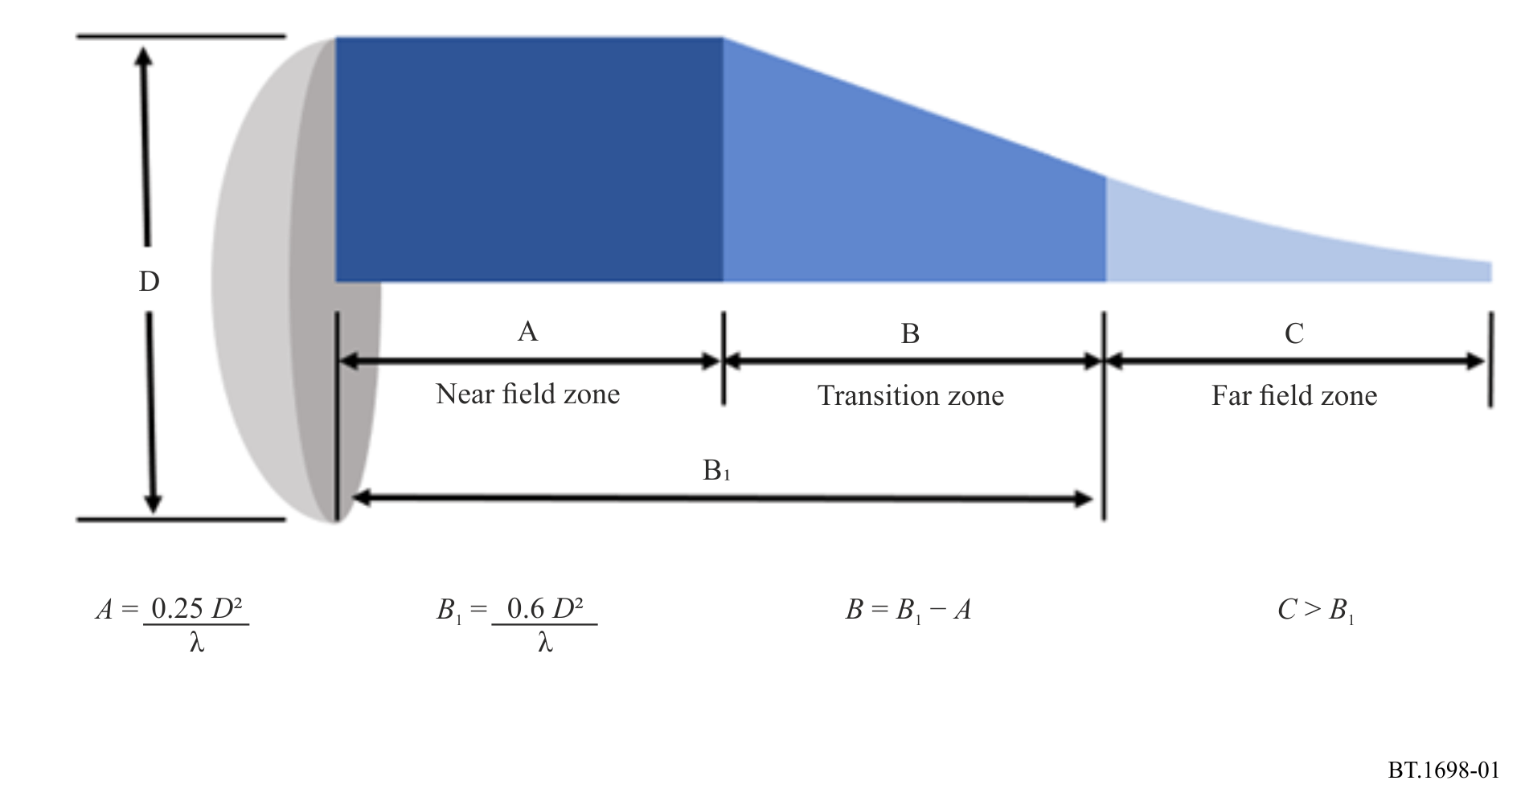
The radiation of a parabolic antenna in the near-field zone occurs along the entire length of the zone in the form of a cylinder with a diameter D. The maximum of the EMF and its power density are constant throughout the near-field zone.
This is expressed by the equation:
$S\left({W/m}^{2}\right)=\frac{16ηP}{{πD}^{2}}$ (11)
where:
η : efficiency of parabolic antenna (0.55 is used)
P : power of transmitter (W)
D : diameter of parabolic antenna (m).
The density S is maximal throughout the near-field zone.
From point 1 (beginning of the transition zone) the density S decreases linearly with the distance r to point 2, where the far-field zone begins.
In the far-field free space zone, S decreases with the square of distance according to the equation:
$S\left({W/m}^{2}\right)=\frac{GP}{4{π r}^{2}}$ (12)
where:
G : gain of parabolic antenna with respect to an isotropic source
r : distance from the parabolic antenna (m).
The density S is maximal on the axis of the parabolic antenna.

2.3 Mixed frequency field
It is common to have more than one transmitter (using different transmitting frequencies) located at the same transmitter site. In this case it is necessary to consider a total (combined) effect of human exposure to RF energy. On the other hand, effects are frequency dependent, and therefore, after calculation of the relevant parameters (S, E and H), the combined effect should be taken into account.
For thermal effects, exposure limits are given in terms of specific absorption rate (SAR) (see Attachment 3), which means that appropriate power densities should be determined. In the case of a multi-frequency transmitter site, the total power density is recommended to be the sum of the power density at each transmitting frequency:
(13)
where S_{i} is power density at the frequency f_{i} (i = 1, 2, … n), with the condition that:
(14)
where L_{i} is the power density reference level, at the frequency f_{i} (i = 1, 2, … n).
This is the basic principle, but there are some differences in how the principle is applied (see Attachment 3).

2.4 EMF inside buildings
The materials of a building and infrastructure inside a building have a very strong influence on the EMF, causing variations of the resulting field, from point to point, even in the same room. Spatial variations in the EMF are caused by multiple reflections of the incident wave, and therefore, the polarization of the resulting field may differ from that of the incident wave.
Metallic objects and ducts (lines and tubes), cause re-radiation (acting as a secondary source), and change the intensity of the EMFs in their vicinity.
All these conditions make assessment of the exposure difficult. A rather large number of parameters should be taken into consideration when carrying out calculations or measurements.
To achieve an acceptable accuracy in the calculation of exposure it is necessary to choose an appropriate model for representing the environment.
Accuracy of measurement depends on the size and detection type of the probe, as well as the location of the person who is doing measurements relative to the radiation source and probe. See Report ITU-R SM.2452 – Electromagnetic field measurements to assess human exposure, Recommendation ITU-R P.1238, Recommendation ITU-R P.2109 and Recommendation ITU-T K.61.
The critical issue is not simply the value of the exposure limits themselves, but the way in which calculations and measurement should be carried out and that is the main goal of this Recommendation.

3 Calculation
Analytical procedures can only be used to calculate the electromagnetic properties for a few special cases and geometries. To solve general problems, numerical techniques have to be applied. Commercial programs can be used according to the case. Physical and geometrical optics do not apply in the near-field; additional information and guidelines about EMF exposure calculation methods can be found in IEC 62232 [5].

3.1 Procedures
Analytical and numerical calculation methods can predict the external or internal fields from an electromagnetic emitter. Calculations are useful to estimate the level of the field strengths in a certain exposure situation in order to determine if measurements are needed and what equipment should be used. Calculations can also be a complement to measurements and be used to verify that the results from the measurements are reasonable.
In some situations, for example for complicated near-field exposure conditions when expensive SAR measurement equipment is not available, calculations can replace measurements.
The accuracy and quality of the calculations will depend on the analytical or numerical method used and on the accuracy of the description of the electromagnetic source(s) and physical objects between the emitter and the prediction point that may affect the fields. For SAR calculations, the accuracy of the body model will also affect the quality of the results.
To be able to make a calculation, the source parameters must be known or estimated.
Examples of broadcasting source parameters are frequency, power, antenna pattern, gain and altitude above ground.

3.2 Closed solutions
In the far-field region of a transmitting source, where the EMF are predominantly plane wave in character, analytical expressions can be used to estimate the field strengths. In the main direction of an antenna, the Friis free space equation can be used to calculate the power density:
$S=\frac{PG}{4π d^{2}}$ (15)
where:
S : power density in (W/m²)
P : mean output power (W)
G : antenna far-field gain relative to an isotropic radiator
d : distance from radiator(m).
The relation between power density and electric and magnetic field strengths is given by the following equation:
$S=\frac{E^{2}}{Z_{0}}=H^{2}Z_{0}$ (16)
where:
E : electric field strength (V/m) (RMS)
H : magnetic field strength (A/m) (RMS)
Ζ₀ : the intrinsic impedance of free space, 120 π (377) Ω.
Hence, using the above equations, the field strengths can be calculated:
$E=\sqrt{\frac{P G Z_{0}}{4π d^{2}}}=\frac{5.5\sqrt{PG}}{d}$
$H=\sqrt{\frac{PG}{4π d^{2}Z_{0}}=\frac{\sqrt{PG}}{68.8d}}$
These equations are only valid in the far-field region of the radiating source, i.e. when d > 2D²/λ, where D is the largest dimension of the radiating structure and λ is the wavelength. Field strength attenuation or enhancement due to reflection, material transmission, and diffraction is not taken into account. Using the equations above in the near-field region, or in directions other than the main direction will generally give too large a value unless a near-field correction factor or a radiation pattern factor is introduced.

4 Measurements

4.1 Procedures
Measurement methods are critical, especially for near and low frequency fields; see Report ITU-R SM.2452 – Electromagnetic field measurements to assess human exposure, Recommendation ITU-T K.61, EN 50496 [8] and EN 50 554 [9]. For the lower frequency bands, the method of measurement is a very sensitive and complex matter, since the distance of the test point (from the source of emission) usually is much smaller than the wavelength. For this reason, for measurements, the frequency range of 10 kHz – 300 GHz is divided into four main broadcasting bands: LF/MF, HF, VHF/UHF and SHF/EHF bands. Following ICNIRP 2020 Guidelines for limiting exposure to electromagnetic fields (100 kHz to 300 GHz) [1], E and H are used only up to 2000 MHz; while the incident power density is used only above 30 MHz.

4.1.1 LF/MF bands
In order to verify the theoretical results, field strength measurements in the near zone use special instruments (field strength meters) with three orthogonal positioned short dipoles. It is recommended not to use any instrument requiring a power supply cable.
To prevent a disturbing influence from the person performing the measurement, the measuring instrument shall be attached to an insulated rod. The distance between instrument and operator should be determined by taking into account whether there are any changes on the instrument scale caused by any movement of the operator. That distance is dependent on the frequency of the measured signal.
In performing this kind of measurement, it is necessary to take into account the possible influences of all objects in the vicinity and, particularly, those that may create re-radiation effects.
When the purpose of a measurement is to verify results obtained from theoretical computation, the test points should be selected along a radial direction and at height between 1 and 2 m.
More detailed explanation is given in Recommendation ITU-R BS.1386.

4.1.2 HF bands
Detailed explanation is given in Recommendation ITU-R BS.705.

4.1.3 VHF/UHF bands
Detailed explanation is given in Recommendation ITU-R BS.1195.

4.1.4 SHF/EHF bands
Taking into account the wavelength and distances from the emission sources, standard method of measurement shall be applied.

4.2 Instruments

4.2.1 Introduction
The measurement of exposure fields, in the frequency range 10 kHz – 300 GHz, requires significant effort for the spatial and time variability of the field to be determined.
It is necessary to use adequate instrumentation and a valid measurement set up. It is important to know the characteristics of measurement instruments because these characteristics determine the appropriate choice of instrument. Frequency dependent characteristics, such as cable interactions, out-of-band uncalibrated responses, and shaped frequency response are particularly important for broadband instruments. Other field properties need to be matched with instrument characteristics; for example, reactive or radiative, polarization and modulation, or number of field sources.
Human exposures to EMFs are commonly measured in units of power density, but other measures such as the induced current in the body, may be more relevant, and these are some of the critical aspects for protection or control that the engineer must resolve. In many cases there is no simple mathematical ratio between the electric and magnetic fields and therefore, in this situation, each must be measured.
The measurement instruments to use in this case are:
– instruments to measure the value of the field strengths E and H;
– instruments to measure current.

4.2.1.1 General
The basic components of these instruments are:
– the probes;
– the connection cables, that transfer the signal from the probe to the reading and calculation unit;
– the reading and calculation unit.

4.2.1.2 Probes
The theoretical isotropic probe has a spherical radiation pattern. Most probes are isotropic, or omnidirectional in three dimensions, to measure the energy from all directions.
The probes must exhibit the following characteristics:
– respond to the intended fields, E or H, without responding to the unintended fields;
– generally, the probe is electrically small and less than λ/10 for the maximum frequency of operation; however, special evaluations have shown that some probes may be electrically large;
– respond predictably to variations of environmental conditions, such as temperature and humidity.
It is very important that, during the measurement, isotropic probes are positioned such that the connection can decrease field perturbation at the probe by the connection cables. This field perturbation is more commonly a problem when measuring medium wave or lower frequency electric fields.

4.2.1.3 Cables
The cables used to connect the probe and the reading and calculating instrument must be noise free and prevent coupling of the field to the measurement unit.
It is very important to note that it is possible for the cables to act as an antenna and modify the field at the probe to cause an incorrect reading. It is sometimes possible to resolve this problem by setting the cables, during the test, perpendicular to the electric field; the use of suppression ferrites on the measuring cable can mitigate these effects.

4.2.2 Characteristics of the measurement instruments for electric and magnetic field
Generally, the measurement of exposure to EMF is executed in the frequency domain. There are two principal groups of instruments.

4.2.2.1 Wideband instrument types and specifications
With broadband instruments (see Fig. 2) we can measure the total field in a given frequency range (i.e. bandwidth), but it is not possible to distinguish the contribution of a single frequency source, when several sources are radiating simultaneously.
FIGURE 2
Broadband instruments
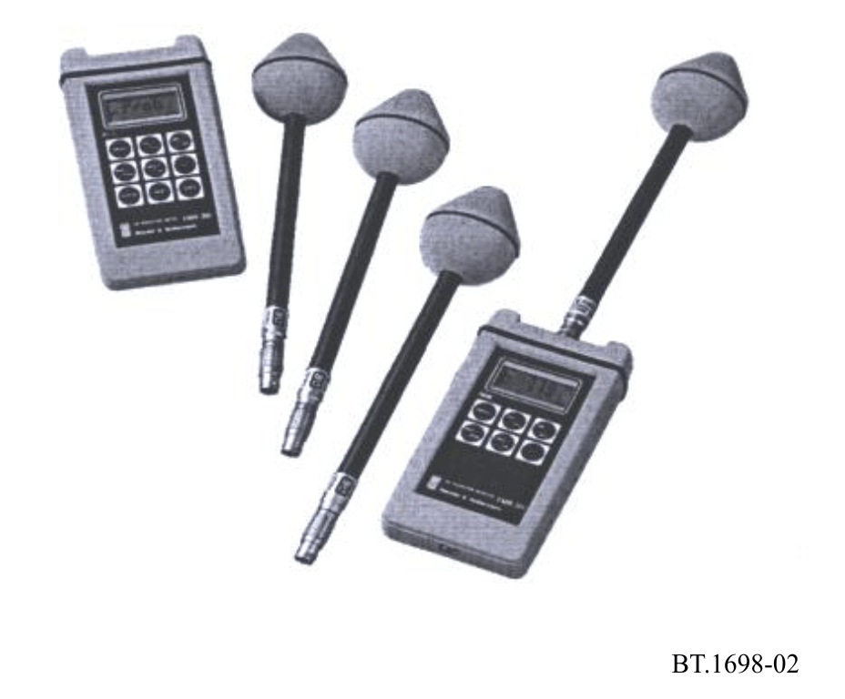
Broadband instruments are made with sensors that can be non-isotropic to measure a single spatial component of the field, or can be isotropic to measure all three components of the field at the same time. These instruments can measure the total level of the instantaneous electric or magnetic field, or the RMS field value or the average power density value in a time period, typically 6 minutes in accordance with exposure standards. Broadband instruments can be divided into the following classes, depending on the detector used:
– diode;
– bolometer;
– thermocouple.
These instruments can be used in both situations, near-field and far-field.

4.2.3 Narrow band instrument types and specifications
Narrow band instruments are selective in frequency and can measure the EMF strength at a range of different frequencies. Narrow band receivers are particularly helpful in the case of multiple sources, because it is possible to evaluate the contribution of each source to the total field. By means of a non-isotropic sensor or antenna it is possible to evaluate the direction and the polarization of the field. Care must be taken in the set up since fields can change rapidly in space relative to the antenna size, especially in the presence of reflective objects like walls, earth, metallic poles and structures. It is important to observe that by changing the measurement point the detected field strength may be completely different. Also the measurement can be influenced by the antenna position and connecting cables.
When the measurement of the EMF is executed in the time domain, it is necessary to use instruments with appropriate analysis characteristics (for frequency and resolution) to obtain good results in the spectral analysis by Fourier’s transform.
The system consists of the following basic components:
– A calibrated antenna, that converts the electric field for a dipole antenna or magnetic field for a loop antenna to a wave on the transmission line.
– A calibrated connecting transmission line or coaxial cable.
– A selective receiver, typically a spectrum analyser or measuring receiver, that measures using a tuning circuit, the signal strength received as a function of frequency. The spectrum analyser gives the values of the voltage or power in the frequency domain.
During these measurements, it is important to ensure the measuring instruments do not disturb the field being measured.

4.3 Comparison between predictions and measurements
The comparison between predictions and measurements indicate that results of measurements are in good agreement with results obtained by theoretical computation. For more details, see Attachment 2.

5 Precautions at broadcasting transmitting stations and in their vicinity
This section outlines the precautions that should be taken around broadcasting transmitting stations to control the potential risks due to RF exposure. These risks fall into two main categories, the first being the direct risk to human health due to exposure to high levels of RF emissions, including shocks, burns and the possible malfunctioning of medical implants. The second category comprises indirect risks where RF emissions could cause explosions, fires or interfere with the safe working of machines, cranes, vehicles, etc.

5.1 Precautions to control the direct health effects of RF high level emissions
Two groups of people are considered in terms of the precautions that can reasonably be taken. The first group is employees at, or regular official visitors to, transmitting stations. Whilst this group may be at a more frequent risk, the extent to which control measures can be applied is much greater than that for the second group, being members of the general public.

5.1.1 Employee (occupational) precautionary measures

5.1.1.1 Physical measures
If appropriate, some form of protective barrier should be provided to restrict access to any area where either the exposure limits are exceeded or contact with exposed RF conductors is possible. Access to such areas must only be possible with the use of a key or some form of tool. Mechanical or electrical interlocking should be provided to enclosures where access for maintenance is needed.
Other physical measures such as warning lights or signs should also be used in addition to, but not instead of, protective barriers.
The risk of shock or burns from RF voltages induced in conducting objects, such as fences and support structures, should be minimized by efficient and properly maintained RF earthing or grounding arrangements. Particular attention should be paid to the earthing of any temporary cables or wire ropes, such as winch bonds.
Where such objects need to be handled in an RF field, additional protection from shocks or burns should be provided by the wearing of heavy-duty gloves and through effective labelling.

5.1.1.2 Operational procedures
RF exposure risk assessments must be carried out by suitably trained and experienced staff at construction and also when any significant changes are made to a transmitting station. The initial objective must include the identification of the following:
– the areas where people may be exposed to reference levels;
– the different groups of people, e.g. employees, site sharers, general public, who may be exposed;
– the consequences of fault conditions, such as leakage from RF flanges, antenna misalignment or operational errors.
An initial check on the RF exposure levels can be done by calculation or mathematical modelling, but some sample measurements should also be carried out for verification purposes. In most cases, however, measurements will be needed to determine RF exposure levels more accurately. The actual quantities to be measured (E field, H field, power density, induced current) should be determined based on the specific circumstances. These include station frequencies, field region (near/far field) being measured and whether it is proposed to check compliance with basic restrictions (SAR) or only reference levels. These circumstances will also largely determine whether the three individual field components should be measured separately or whether an isotropic instrument should be used. RF exposure surveys should then be carried out by staff trained in the use of such instruments, following prescribed measurement procedures, and recording results in a specified format.
A nominated competent person should be made responsible for the identification and provision of suitable measuring instruments within any organization or company. Such measuring instruments must always be used in accordance with manufacturers’ instructions and be subject to regular functional (operation with a check source) and calibration. Labels showing expiry dates must be fixed to instruments following such tests or calibration. Records of calibration should be kept, including whether adjustments and/or repairs were needed on each occasion. This information should then be used to determine the interval between calibrations.
Working procedures should be implemented that ensure that RF exposure limits are not exceeded. Employees should be trained in appropriate RF safety procedures. Maintenance work, in areas subject to access restrictions due to high RF exposure levels, should be planned around scheduled transmission breaks or emission pattern changes where possible. However, there should always be a balance between exposure to RF emissions and other risks, such as working on masts at night, even when floodlit. Where necessary, transmitters should be switched to reduced power or turned off to allow safe access for maintenance or repair work.
Prohibited areas on transmitting stations must be clearly defined and marked, and “permit to work” systems should be implemented. Appropriate arrangements should be put in place for any systems, antennas, combiners or areas shared by other organizations. All staff who regularly work in areas with high levels of RF exposure should be issued with some form of personal alarm or RF hazard meter.
Records must be kept of exposure above specified RF exposure levels. Companies or organizations responsible for operating transmitting stations should monitor the health of staff who regularly work in areas with high levels of RF exposure and take part in epidemiological surveys, where appropriate.
Details of general policies and procedures relating to RF exposure safety should be included in written safety instructions and given to all appropriate staff. In addition, local instructions for each transmitting station should be issued to ensure compliance with such policies and procedures.
Safety training should also include the nature and effects of RF exposure, the medical aspects and safety standards.
Specific attention is required for workers who are particularly sensitive to EMFs, such as pregnant women, workers bearing passive or active medical devices. For workers bearing Active Implantable Medical Devices (AIMD), detailed guidance is available from regional guidelines, such as the CENELEC documents of the series EN 50527 – Procedure for the assessment of the exposure to electromagnetic fields of workers bearing active implantable medical devices. See also Attachment 6 to Annex 1.

5.1.2 Precautionary measures in relation to the general public

5.1.2.1 Physical measures
Similar considerations apply to the general public, as those detailed in § 5.1.1.1 for employees. Particular attention should be given to areas where RF exposure limits could be exceeded under fault conditions. Protective barriers should be provided in the form of perimeter fencing, suitably earthed where needed. Additional hazard warning signs may be necessary.

5.1.2.2 Operational procedures
Risk assessments, carried out under § 5.1.1.2, must take into account the possibility of members of the public having medical implants. A procedure for providing health hazard information to such potential visitors should be adopted with appropriate restricted access procedures. Basic RF safety instructions should be provided for regular site visitors.
The need to carry out RF exposure surveys beyond site boundaries must be considered, in particular where induced voltages in external metallic structures (cranes, bridges, buildings, etc.) may cause minor burns or shock. In carrying out such surveys the possibility of the field strength increasing with distance, usually due to rising terrain, should be taken into account. Where necessary, a procedure for monitoring planning applications or other development proposals should be implemented.

5.2 Precautions to control indirect RF exposure hazards
Indirect effects of RF exposure, such as ignition hazards to flammable substances, may occur at levels well below reference levels particularly at MF/HF. This is because flammable substances may be stored on a site having associated conducting structures, such as pipe work, that could act as a fairly efficient receiving antenna. Actual risks are, however, rare, but may include industrial processing plants, fuel storage facilities and petrol filling stations. Detailed evaluation is, however, far from simple. The general procedure recommended below is, therefore, based on progressive elimination. The detailed precautions adopted will however need to take account of any national standards or legislation in the country concerned.
An initial assessment should be carried out, based on practical, worst case estimates, of the minimum separation needed between a particular type of transmitter and a conducting structure to avoid such a hazard. The first step in doing this is to determine the minimum field strength that might present an ignition hazard for the particular transmitter frequencies in use. This is a function of the type of flammable substance and the perimeter of any loop formed by metallic structures, usually pipe work, and can most easily be determined from tables or graphs. The vulnerable area should then be determined from this minimum field strength by calculation, mathematical modelling or from tables/graphs.
If the vulnerable area, as determined above, contains any such sites on which flammable substances are stored, or if any are being planned, a more detailed assessment should then be made. This should be based on the actual dimensions of any metallic structures, the gas category of the flammable substance(s) being stored and the measured field strength. This detailed assessment should be carried out by calculation of the extractable power from the metallic structure to determine whether this exceeds the minimum ignition energy of the flammable substance. Should this be the case, then the extractable power should be measured and any necessary modifications to the structure and/or other safeguards implemented.
In a similar category to ignition hazards, is the possible detonation of explosive materials. This will very rarely be encountered but detailed guidance is available from regional guidelines, such as the CENELEC document PD CLC/TR 50426:2004. (Assessment of inadvertent initiation of bridge wire electro-explosive devices by radio frequency radiation Guide). Other indirect effects that should be considered include interference to the safety systems of vehicles, machines, cranes etc. close to, or within the boundaries of, transmitting stations.
Where necessary, precautions similar in principle to those described in § 5.1.2 may need to be applied.

Attachment 1
to Annex 1
Examples of calculated field strengths near broadcasting antennas

1 Example A – Electric and magnetic field strength plots
According to § 3, numerical calculations of electric and magnetic field strength distribution near broadcasting transmitting antennas can be done in order to determine the field strengths at certain points or areas. This includes, especially, the near-field zone where the field structure is generally very complicated. Calculations can also be done in order to verify the field contours (lines or surfaces with constant field strength) where relevant limiting values (levels) of EMF restrictions are kept. In this way it is possible (e.g. for planning purposes) to estimate how extended relevant zones may be, where protection measures may or must be performed.
In the following Figures, some calculation results of examples of MF and HF broadcasting transmitting antennas are given as plots.
Figure 3 details a simulation of a directional MF antenna; the antenna is composed of two masts, each a half wavelength tall; one of them fed, the other is a passive reflector. Figure 3 shows the model; reference axes are 50 m long.
FIGURE 3
Simulation of a directional MF antenna
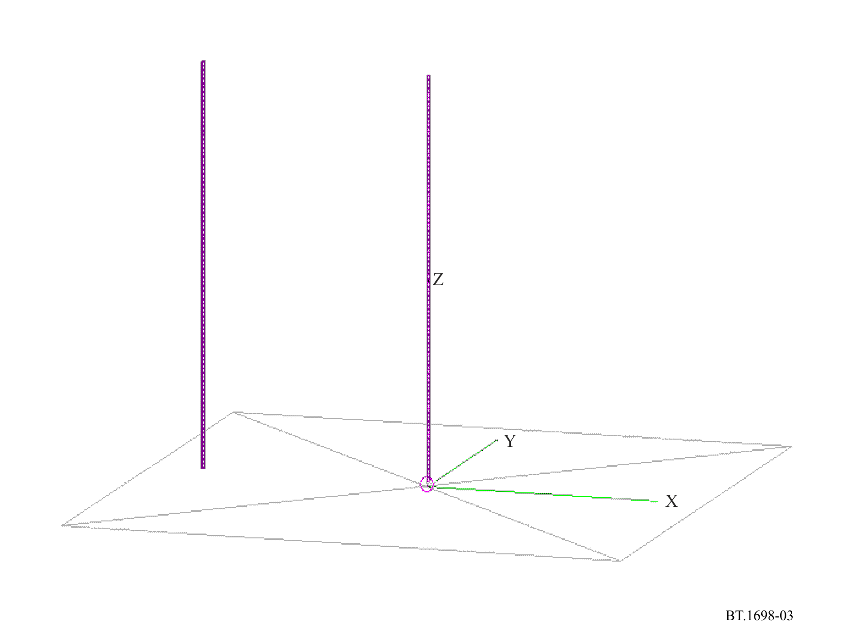
Figure 4 shows the electric field strength calculated 1.5 m above ground, with 500 kW input.
FIGURE 4
Electric field strength calculated 1.5 m above ground, with 500 kW input
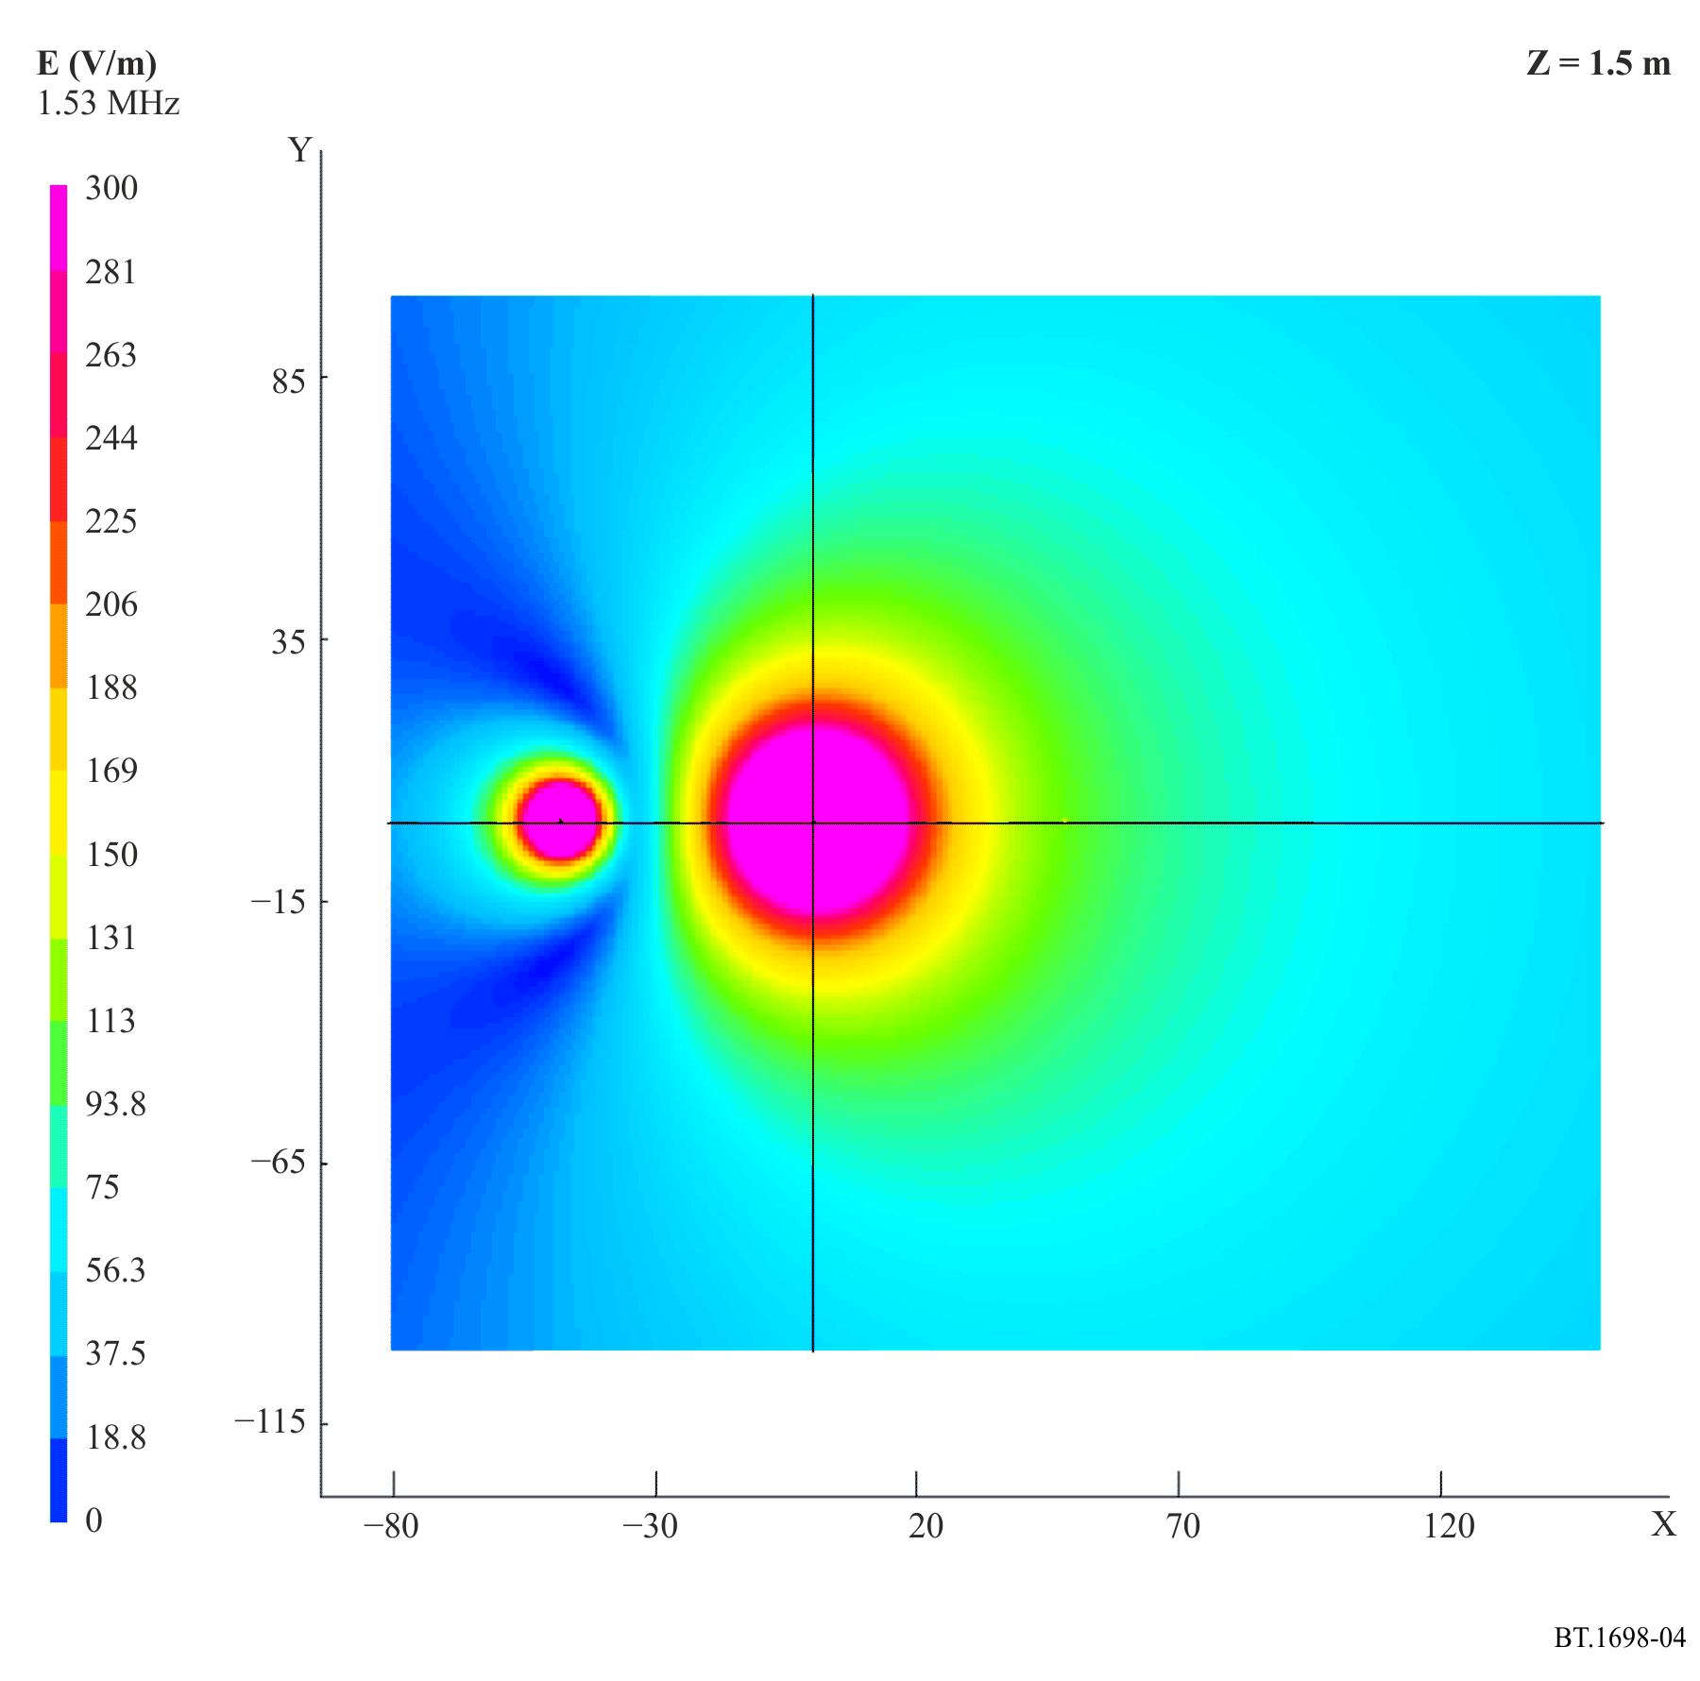
Figure 5 shows the magnetic field strength calculated 1.5 m above ground, with 500 kW input.
FIGURE 5
Magnetic field strength calculated 1.5 m above ground, with 500 kW input
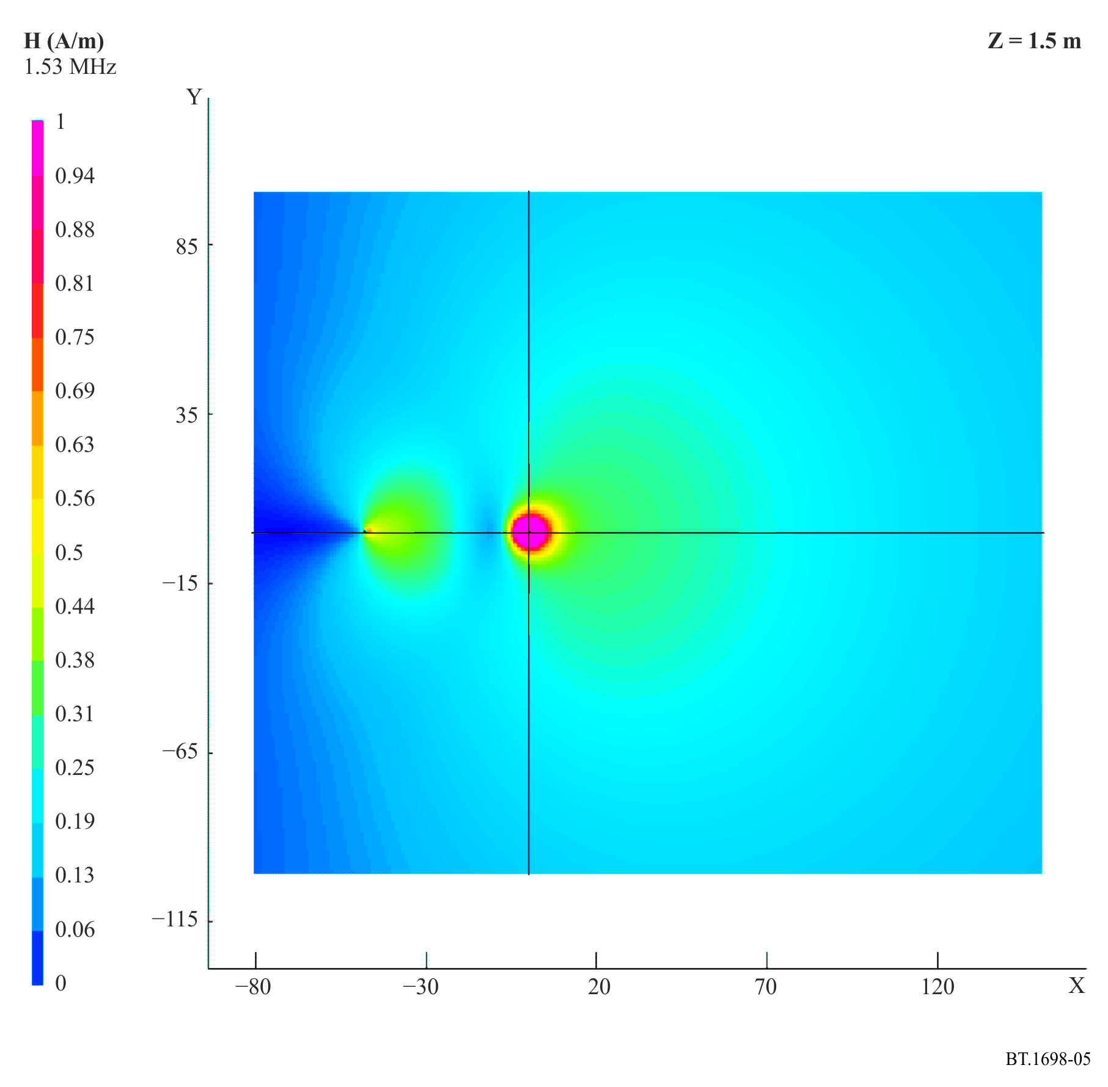
Figure 6 represents the model of a typical HF 4/4/1 curtain HF antenna with an aperiodic reflector one wavelength above ground (AHR(S) 4/4/1). There are four rows of elements, each comprising four dipoles. The active radiating elements of the antenna, the reflector and a simplified supporting structure are taken into account in the model and the results showing the resulting electric field and magnetic field are shown in Figs 7 and 8 respectively at 1.5 m above ground. Axes (in green) are 50 m long as a reference.
Note that the levels do not simply fall monotonically with increasing distance from the array.
Figure 6
Model of a typical AHR(S) 4/4/1 antenna
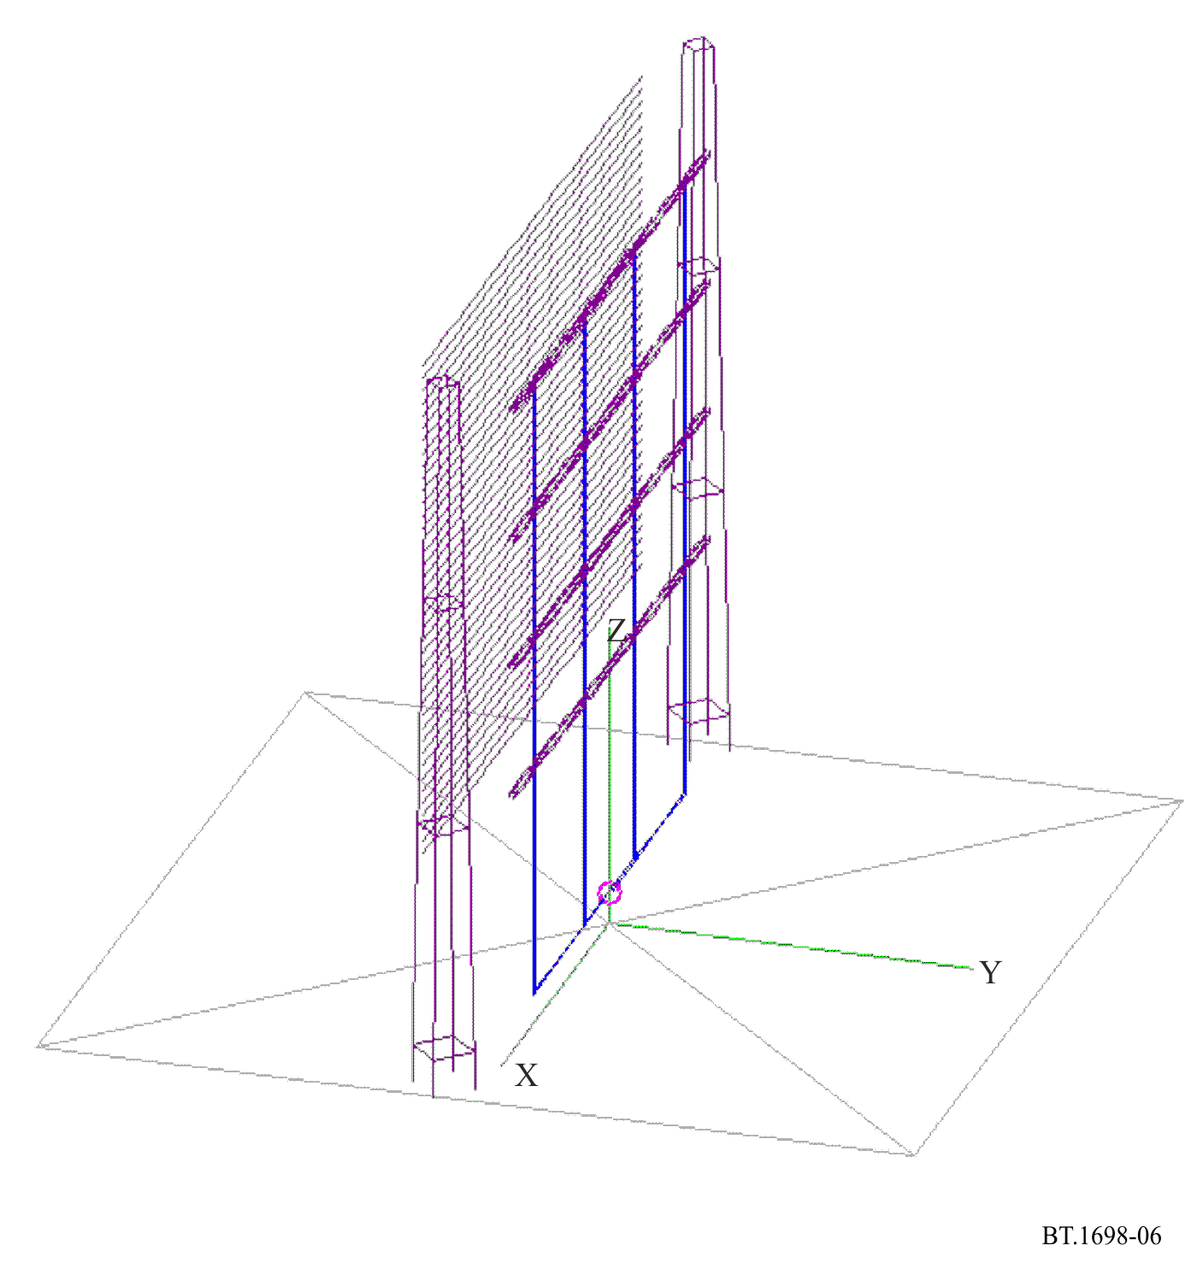
Figure 7
Electric field strength (V/m) computed at 1.5 m above ground; typical ARS 4/4/1 curtain antenna.
Input power 500 kW at 7 MHz
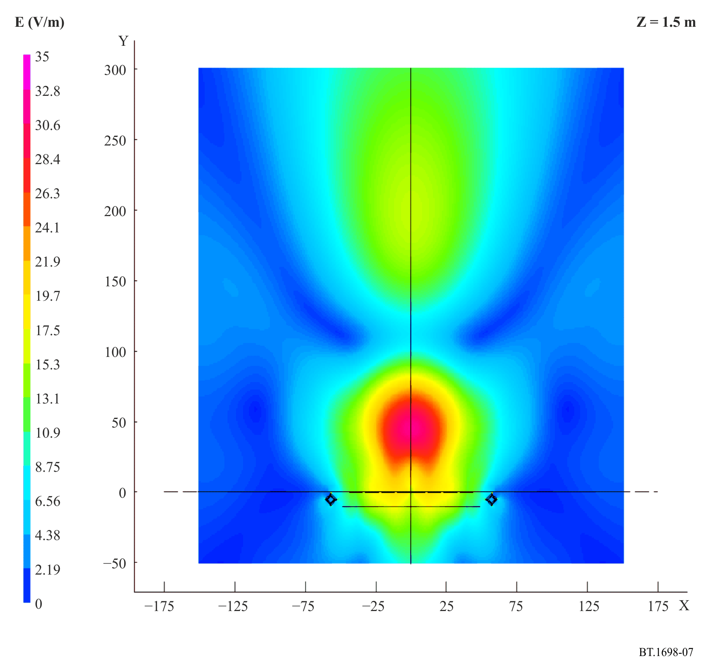
Figure 8
Magnetic field strength (A/m) computed at 1.5 m above ground; typical ARS 4/4/1 curtain antenna.
Input power 500 kW at 7 MHz
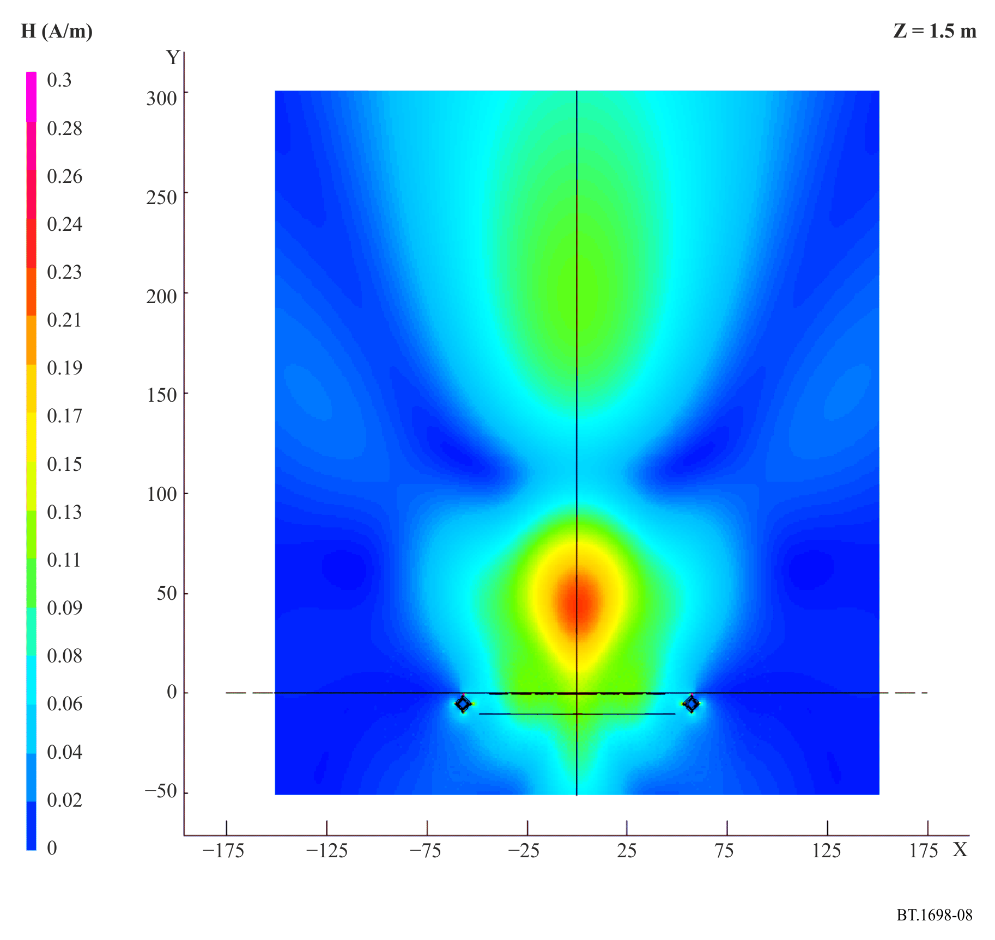

2 Example B – Determination of the magnetic field strength in the near-field zone of high power MF/LF antennas
This example determines the magnetic field strength in the near-field zone of MF and LF mast antennas (monopoles), solving Hallen’s integral equation.
In frequency bands below 10 MHz, the physical relationship between E and H in the EMF is much more complex. This is in contrast to higher frequencies, where the EMF has characteristics of the field in the far zone even at very short distances from the emission source, and where the concept of the radiated power density (Poynting vector intensity) is very useful. In fact, in the near-field zone, whatever the frequency, the simple relationship between the electric and magnetic fields no longer exists: the two fields are not in phase and their ratio is not 377 Ω. But, for frequencies as low as 10 MHz and below, the near-field zone is greater than for higher frequencies.
Clearly, the measured field strengths will depend on the type of transmitting antenna, transmitter power and distance from the transmitting antenna. For example, in the case of the high power transmitted E-component, field strengths on a typical LF/MF site may range from a few V/m to over 250 V/m. Very close to the transmitting antenna the field strength may be of the order of 1 000 V/m.

3 Example C – Near electromagnetic field of HF transmitting curtain antennas

3.1 Introduction
This example deals with more complicated antenna structures, referred to as curtain antennas. These antennas are very important for short wave (HF) high power transmitting purposes. They are, actually, arrays of horizontal dipoles arranged in a vertical plane.
The general trend towards increasing power and gain of transmitting antennas is very pronounced in HF broadcasting. Transmitter powers up to 500 kW and antenna gain (in the direction of the maximum of emission) of over 20 dB (with respect to a half wave dipole) are not uncommon in large transmitting centres for global coverage. A 500 kW transmitter modulated at 100% (see Attachment 4 to Annex 1) with an antenna of 20 dB gain produces an effective radiated power (ERP) of 75 MW (in the direction of maximum emission).
Attachment 5 (§ 2.1) briefly describes the numerical technique which can be used to compute near electric and magnetic fields of high power antennas.
In § 3.2, results are given for the fields in the vicinity of HF curtain antennas.

3.2 Near electric and magnetic fields of curtain antennas
There are a variety of high power transmitting antennas used in short wave broadcasting, such as horizontal dipoles (usually forming a directive array or curtain), rhombic antennas, and vertical monopoles. The dipoles in a curtain antenna are usually half wave dipoles, either simple, or folded, fed by currents of approximately equal amplitude (but sometimes of different phases) to produce the desired emission pattern. The antenna usually has a passive reflector, which in most practical cases consists of a wire mesh (aperiodic reflector), but can also be an array of tuned dipoles. Curtain arrays are labelled H(R)(S) m/n/h, where H denotes an array of horizontal dipoles arranged in a vertical plane; R denotes a reflector (if present); S denotes a phase shift (if present) between the currents feeding adjacent collinear dipoles in order to slew the azimuth of the main beam; m denotes the number of collinear dipoles in each row; n denotes the number of parallel dipoles stacked vertically (usually at a distance of half a wavelength), i.e. the number of rows (bays); and h denotes the height of the lowest row above the ground (in wavelengths). For more information see Recommendation ITU-R BS.705.
Curtain arrays have excellent properties, including a high gain (more than 20 dB), i.e. a highly directive emission pattern, and high power-handling capabilities (up to 500 kW). Hence, they play a very important role in large HF transmitting stations. The central problem in this Recommendation is developing an accurate and efficient technique for the evaluation of these fields.
A typical antenna field of an HF broadcasting station has several horizontally polarized antennas. In some cases there are also quadrant antennas, with an omnidirectional characteristic. A typical curtain antenna contains 16 folded dipoles each, arranged in four bays of four elements (HRS 4/4/h). Sometimes curtain antennas have an aperiodic reflector, made of thin horizontal wires or an array of tuned dipoles (see Fig. 9).
FIGURE 9
HF curtain arrays
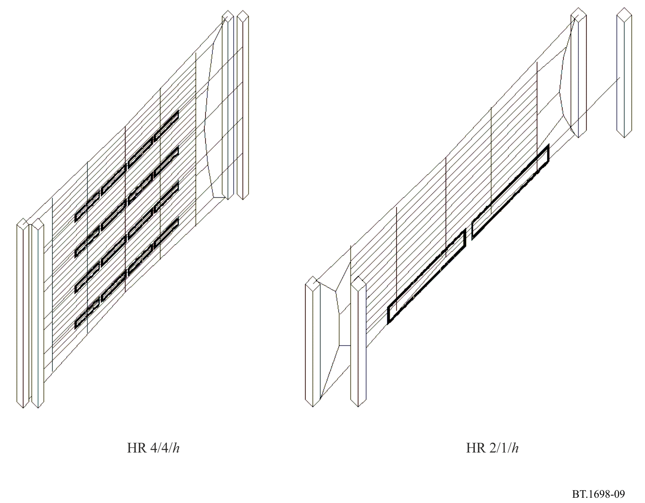
In the literature, there are few papers dealing with the calculation of the electric and magnetic fields of HF curtain antennas, but all of them are based on the sinusoidal approximation of the current distribution along dipoles, and on the assumption that the currents feeding dipoles have identical amplitudes. The goal is to provide a more rigorous analysis, using a more accurate approximation for the current distribution, and taking into account the coupling between the elements of the array, i.e. by feeding the elements by equal amplitude voltages.
It has been shown experimentally (and confirmed theoretically using the sinusoidal approximation for the current distribution) that approximating the real soil by a perfectly conducting plane yields accurate results. This simplification is important, as it can treat antennas only above a perfect ground. The present analysis was also expedited by taking simple dipoles instead of folded dipoles. This approximation was established to yield accurate results. The length of a simple dipole is taken to be somewhat shorter than half a wavelength at the design frequency, based on data taken from the dimensions of the actual curtains. The distance between feed points of adjacent antennas is always a half wavelength, both horizontally and vertically. The distance between the dipoles and the reflector is exactly one quarter of a wavelength. The reflector was modelled by introducing negative images (in the vertical plane) of the original dipoles. The distance between the original dipoles and their respective images is thus a half wavelength.
The near electric and magnetic fields were evaluated in the direction of the maximum of the emission pattern (as the field in the direction of side lobes was found to be substantially weaker). The fields were evaluated at elevations of z = 2 m, for the evaluation of exposure hazards for the broadcast station staff, who may walk in the antenna field, and z = 5 m for the general population, taking into account people living in two storey dwellings.
FIGURE 10
The “equivalent” Poynting vector of the HRS 4/4/1 antenna when dipoles are fed by a) identical currents
and b) identical voltages, along with experimental data (dots)
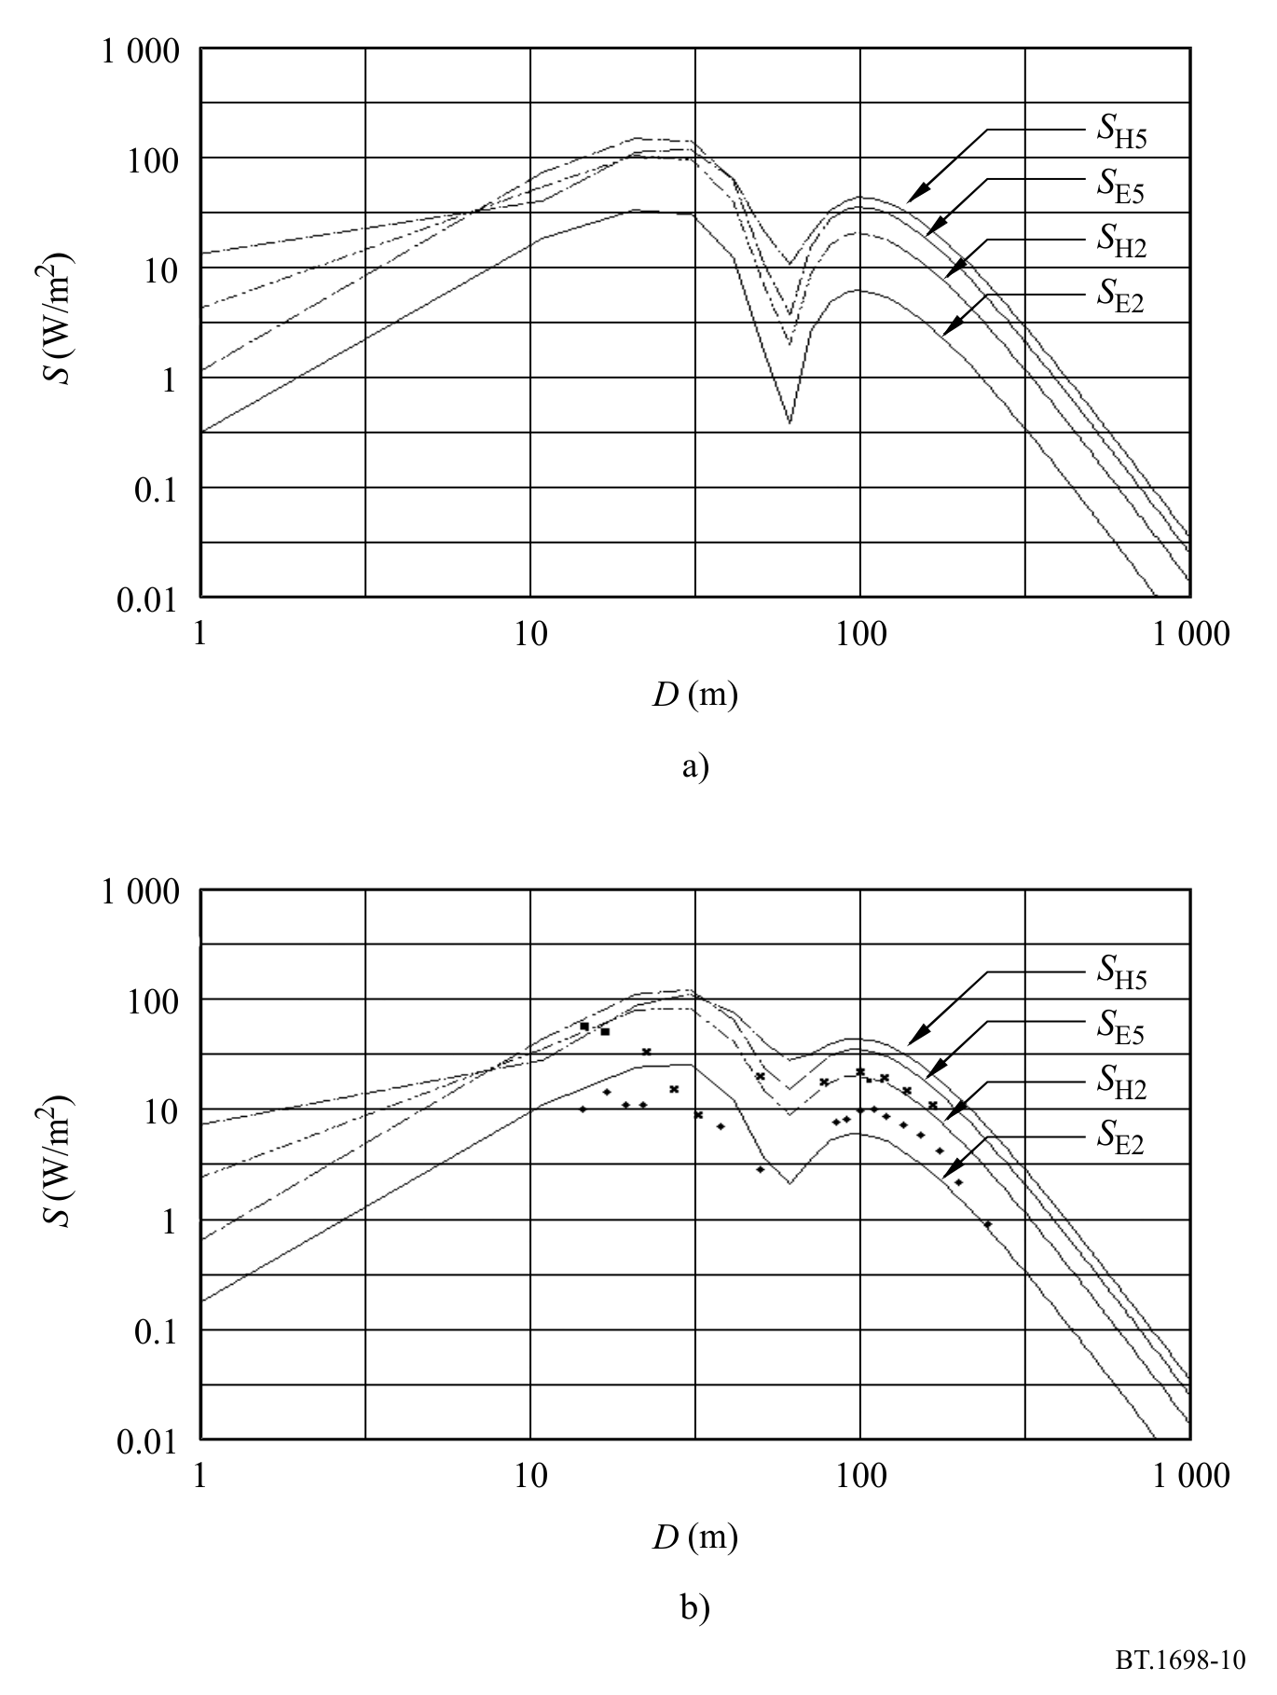
Analysis results were first compared with the results for a HRS 4/4/1 antenna. The operating frequency of the antenna was 15.245 MHz, and the fed power 500 kW. Figure 10 a) shows the results for the “equivalent” Poynting vector, when the dipoles are assumed to be fed by identical currents. Figure 10 b) shows the same results, but taking the dipoles to be fed by identical voltages, along with measured data at z = 2 m. The agreement between the theoretical and experimental data is fair. It is obvious that feeding the antenna with equal voltages results in a better prediction of the actual field, in particular near the dip at 70 m distance from the antenna.

4 Conclusions
Near electric and magnetic fields in the vicinity of high power transmitting, HF curtain antennas have been investigated theoretically. Safety zones for humans in the vicinity of these antennas were determined. The results for the near fields of curtain antennas are presented using a rigorous theory, and they are found to be in good agreement with experimental data published elsewhere.

Attachment 2
to Annex 1
Comparison between predictions and measurements

1 Foreword
Simulation and measurements have been performed by different personnel independently in order to avoid reciprocal influences in work and in results.
The antenna system has been only partially simulated as it is particularly complex (see § 1.1 for the antenna model).
Measurements and predictions have been performed on an antenna system, represented in Figs 11 and 12, capable of operation in the short wave band. Comparisons were made at 13 MHz and 18 MHz.
FIGURE 11
An example of a HF array
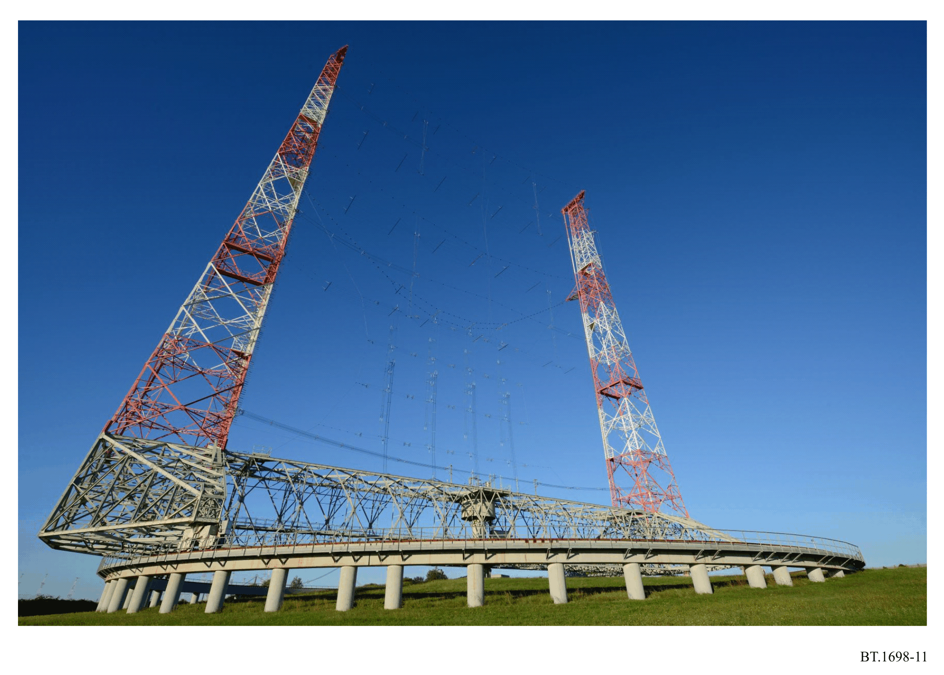

1.1 Model used for antenna system
The antenna system shown in Fig. 12 is made of a horizontally polarized array of 16 folded dipoles in front of a reflector realized by a wired network. Dipoles are fed by bifilar lines forming a complex impedance matching network; all bifilar lines of the impedance matching network, represented in Fig. 10, are mainly vertical (orthogonally to dipoles); some horizontal lines are relatively short and are orthogonal, both to dipoles and feeders, along the direction of propagation. At the antenna base are other bifilar lines used to split the RF power among the four dipole “columns”.
FIGURE 12
Detail of the radiation elements and part of the matching network
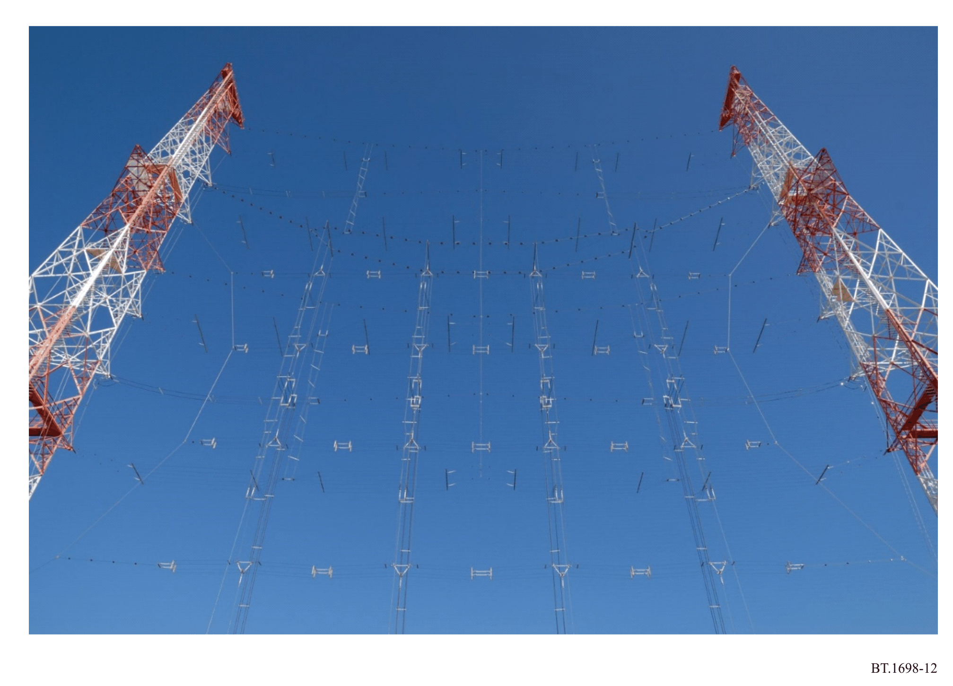
In order to simplify the model and avoid unnecessary details and consequent longer calculation time, the entire system has been modelled as a simple 16 dipole array as in Fig. 13, each fed by its own voltage generator correctly phased with all the others, with no need to model the matching/ feeding network. Furthermore, each folded dipole, consisting of two parallel wires folded at the edges, has been modelled as a single wire folded dipole, of an adequate cross section to obtain the identical value of impedance.
Finally, each dipole has been represented by 24 segments, each of a length not more than /20, as in Fig. 14.

1.2 Advantages and limitations of the antenna system model
The most important advantage is the extreme simplicity of the model realized versus the complexity of the real antenna system. With this model, it is possible to obtain a relatively low calculation time.
Another advantage is the possibility of easily adjusting the model, if necessary, in order to better represent the real system. In fact, generally the result of a first comparison between simulations and measurements represents good feedback to perform some adjustments on the first model. The most important limitation in the simple model adopted is the impossibility to correctly take into account the contribution of the complex matching/feeding network to the x, y, z components of the fields. In fact a certain amount of power is radiated by the bi-filar matching lines that work in a standing wave regime. For this reason, the vertical component of the E field does not appear (z component), as well as the horizontal component in the direction of propagation (y component), except in some cases where the values are quite low; a similar behaviour is visible for the x component of the H field. This is because the prediction was made without considering vertical radiators and radiators in the direction of propagation. In the measurement results, to the contrary, both the vertical (z) and the horizontal (y) components of the E field are present, as well as the horizontal (x) component of the H field, causing some problems in a direct comparison. The most reasonable solution is to consider these two components as generated by the amount of power that does not reach the dipole arrays; their contribution to the measured field should be considered inside the horizontal (x) component in the result of simulation. In other terms, the horizontal contribution (x) resulting from the simulation must be compared with the global result of the measurements, obtained as the square root of the sum of the square of contributions measured on the x, y, z axis.
FIGURE 13
Dipole array model and its orientation in the three-axis system X, Y, Z
Each dipole is fed by its own voltage generator, in phase with all the others. Contributes Ex, Ey, Ez, Hx, Hy, Hz of E and H fields in the evaluation point have the same orientation of axis X, Y Z
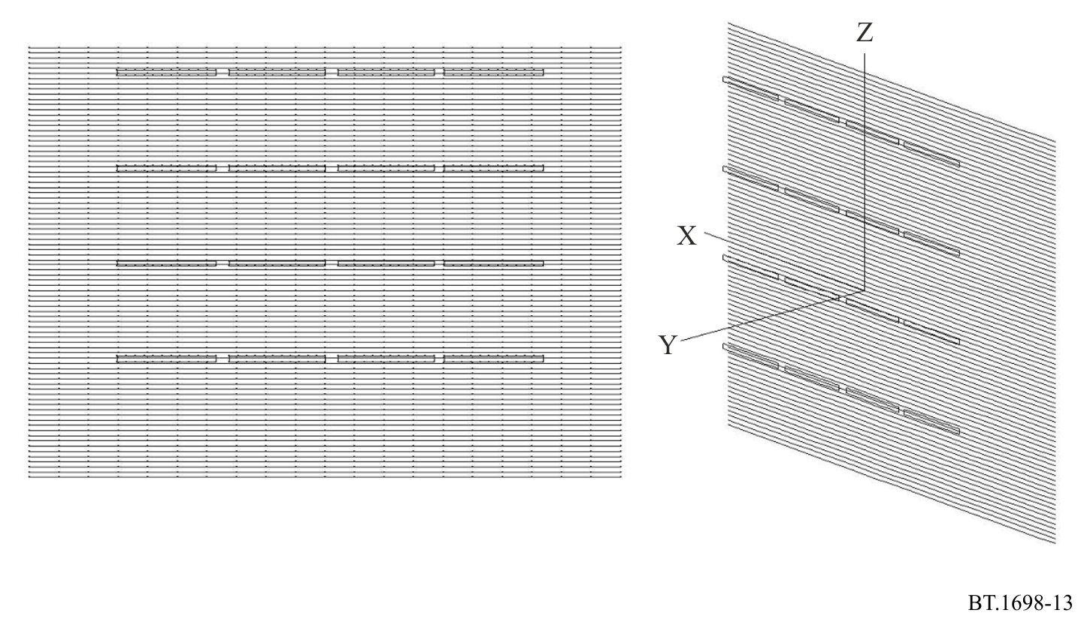
FIGURE 14
Single dipole model. Dipole is modelled by 24 segments each shorter that λ/20. Excitation is applied at the centre of the upper or lower arm, at the middle point of the central segment
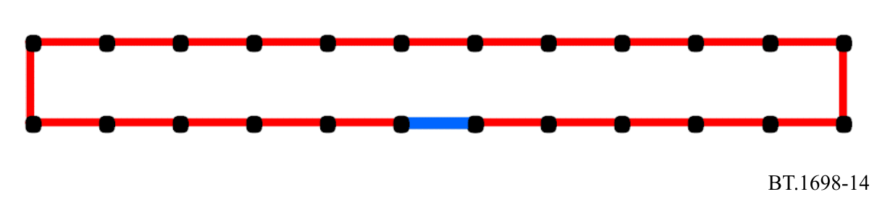

2 Comparison between prediction and measurements

2.1 Numerical analysis of wire structures: Example

2.1.1 Predictions

2.1.1.1 Notes about the model
In order to best fit the previously described model to the real antenna system, it is necessary to know the right amount of power at the input of each dipole, taking into account losses in the transmission line.
In order to apply the appropriate voltage value at each dipole, the input impedance of each dipole has been calculated. The values are represented in Fig. 15.
FIGURE 15
Input impedance of dipoles obtained from simulation, normalized to 600 Ω.
Note the little – but not nonexistent – dispersion of resistance values near 600 Ω
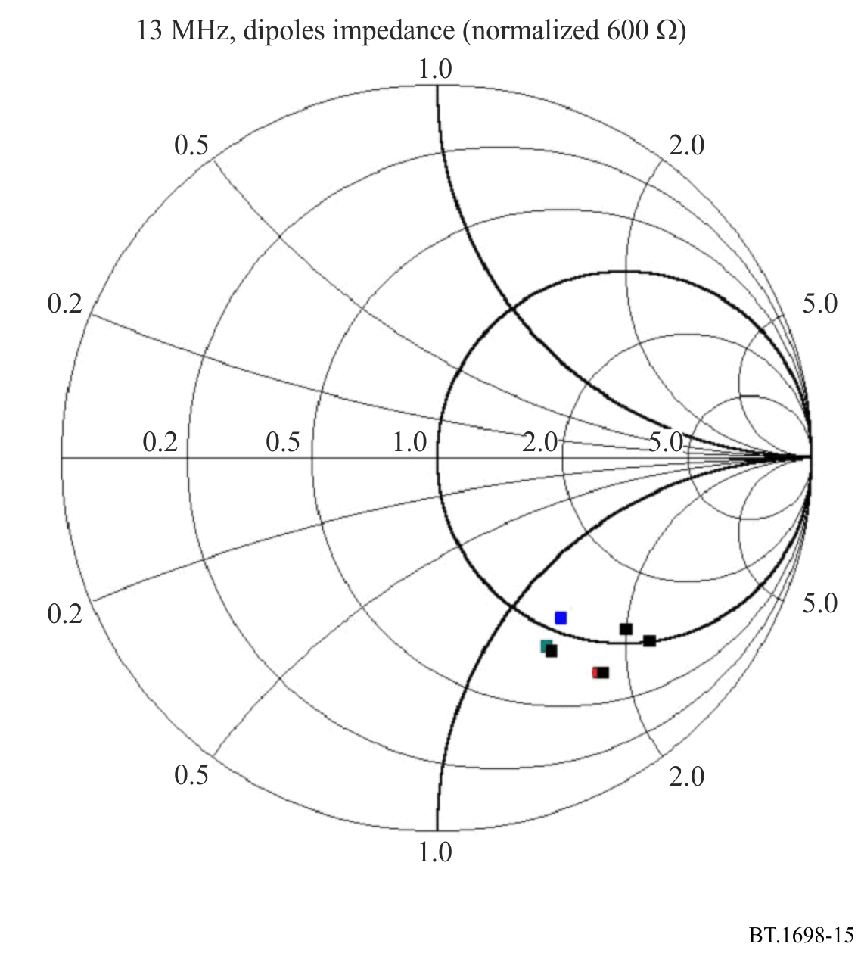
Then, for each dipole, a common value of resistance equal to 600 Ω has been adopted, this being the average value obtained from the simulation. Note that this decision may be the cause of inaccuracy in the prediction’s results.
In order to compensate the mismatch, mainly due to the reactive component and the consequent reflection of power towards the transmitter, an adequate increase of power has been considered. Consequently, an adequate voltage has been applied at each dipole.

2.1.1.2 Far-field evaluations
In order to best compare the behaviour of the model with real antennas, given in Figs 11 and 12, the radiation diagrams were calculated. The results are shown in Fig. 16 (horizontal plane), Fig. 17 (vertical plane) and Fig. 18 (frontal view).
FIGURE 16
Radiation diagram on horizontal plane
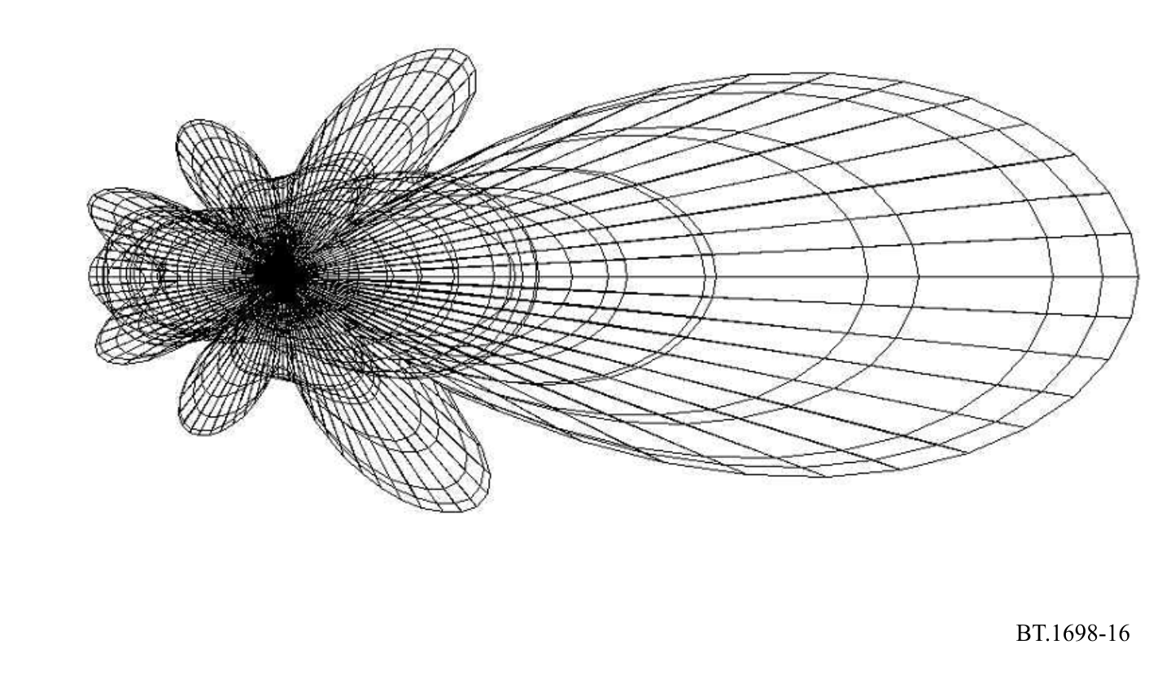
FIGURE 17
Radiation diagram on vertical plane
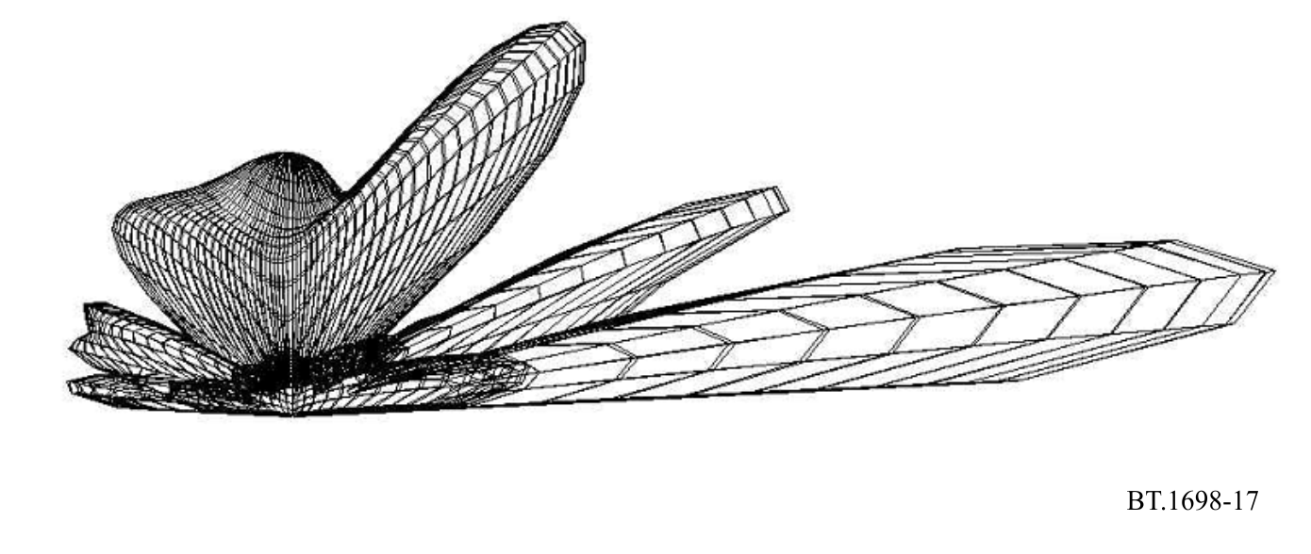
FIGURE 18
Radiation diagram, front view
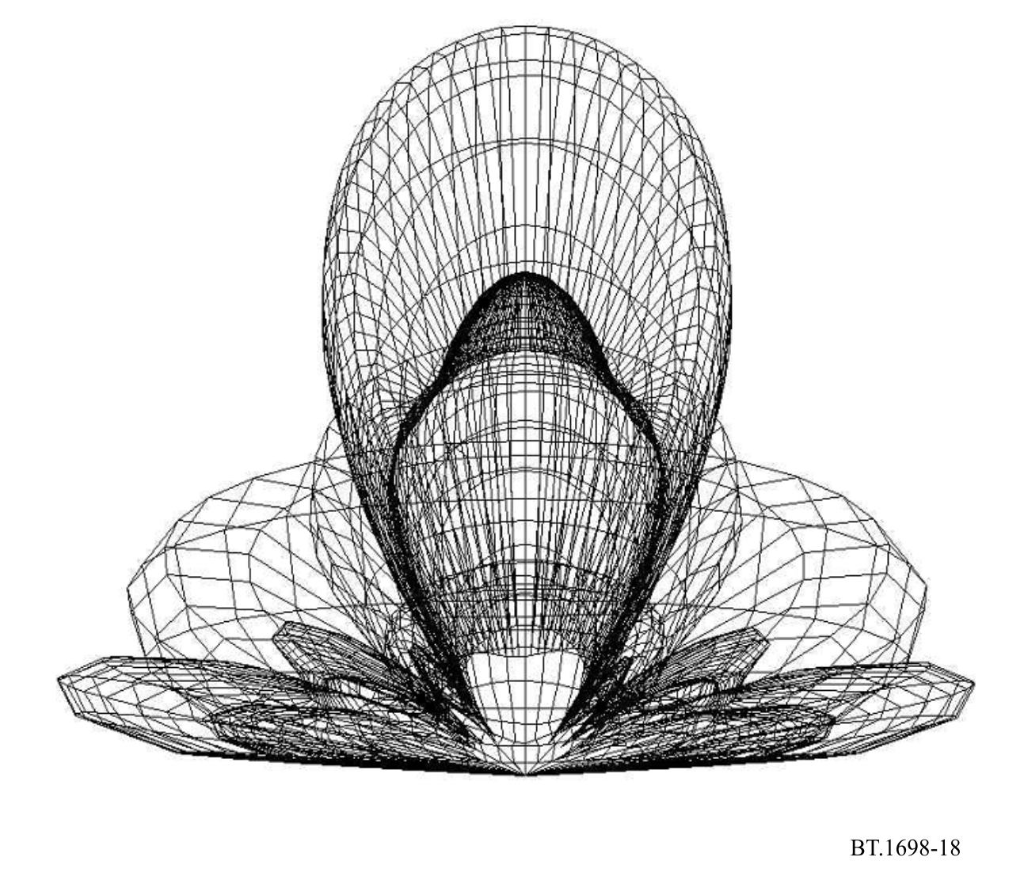

2.1.1.3 Results of prediction of the field strength in the near zone
A prediction was made calculating the x, y, z components of the E and H fields in the direction of the antenna’s maximum gain (Y axis) at 2 m above ground (Z axis = 2). The calculated values are represented in Fig. 19 (E field) and Fig. 20 (H field). The strong influence of the terrain both in the evaluations and in the measurements may introduce an additional difference between the two results. In order to show the strong influence of the terrain, the E and H fields values have also been calculated varying the height of the evaluation point above ground (Z axis) from 0 up to 9 m at a fixed distance of 60 m (Y = 60). The behaviour is illustrated in Fig. 21 (E field) and Fig. 22 (H field).
FIGURE 19
Calculated E field strength in the near zone
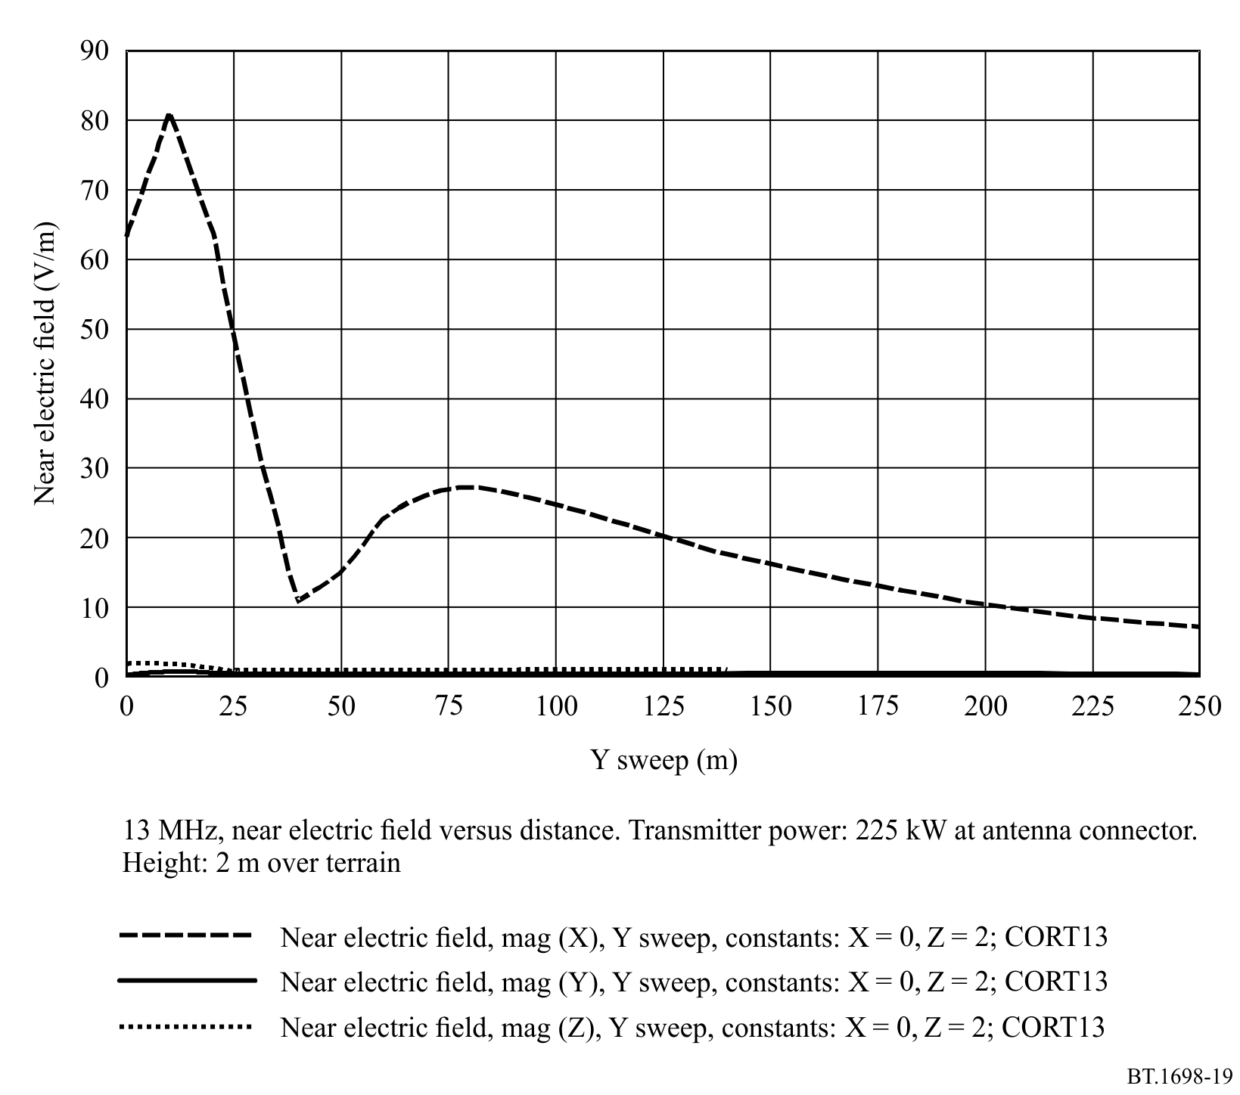
The most important contribution is the x component. The horizontal axis represents the distance in metres from the antenna (Y sweep). Z is fixed at 2 m (height above ground). The intensity of the E field’s components is represented in V/m on the vertical axis.
FIGURE 20
Calculated H field strength in the near zone
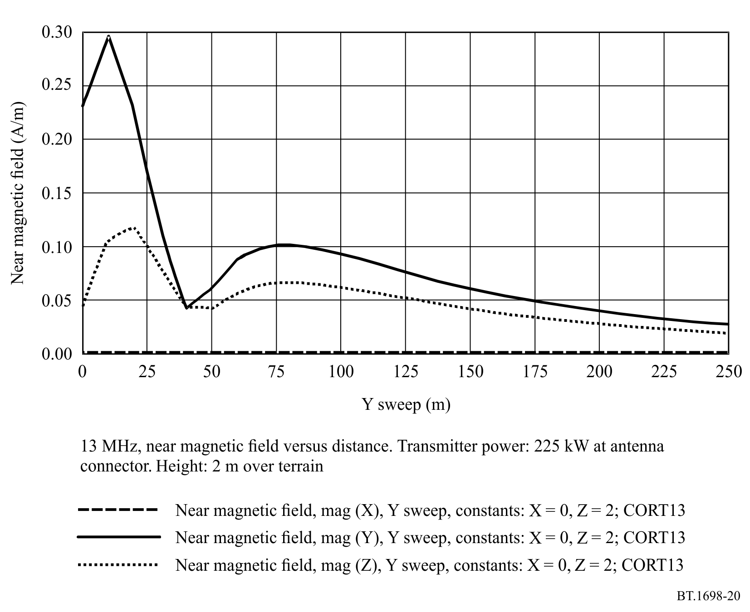
The main contribution is the y component. The z component is lower, while the x component is 0. The horizontal axis represents the distance in metres from the antenna (Y sweep). Z is fixed at 2 m (height above ground). The intensity of the H field’s components is represented in A/m on the vertical axis.
FIGURE 21
Calculated E field strength at a distance of 60 m from antenna (Y = 60) at different heights between 0 and 9 m
(Z sweep)
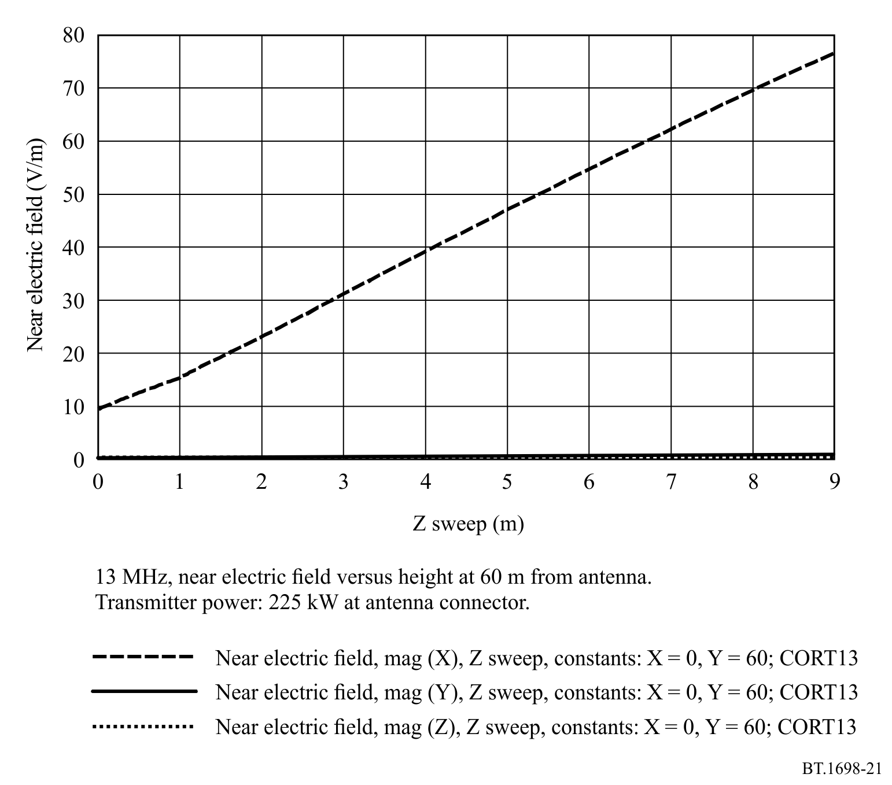
The strong relationship between E values and height (only x component of E field is present) is evident.
FIGURE 22
Calculated H field strength at a distance of 60 m from antenna (Y = 60) at different heights between 0 and 9 m
(Z sweep)
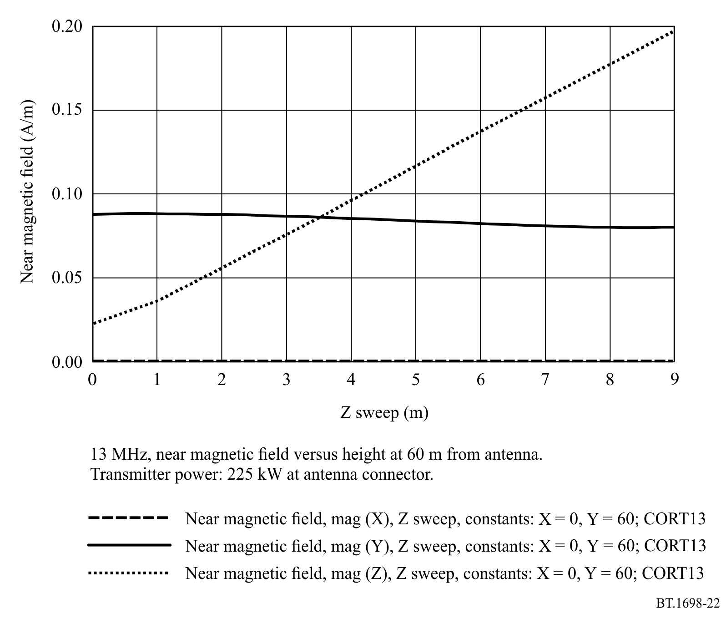
The strong relationship between H values and height (both z and y components of H field are present, y component’s value is fairly constant) is also evident.

2.1.2 Measurements
Measurements have been performed using a broadband field strength meter installed over a dielectric trolley moved by an operator placed far away from the antenna site. By this means any perturbation of the E/H fields is avoided.

2.1.2.1 Results of measurements
Measured values are presented in Fig. 23 (E field) and Fig. 24 (H field). Figures 23 and 24 are directly comparable with Figs 19 and 20 respectively.
FIGURE 23
Measured E field
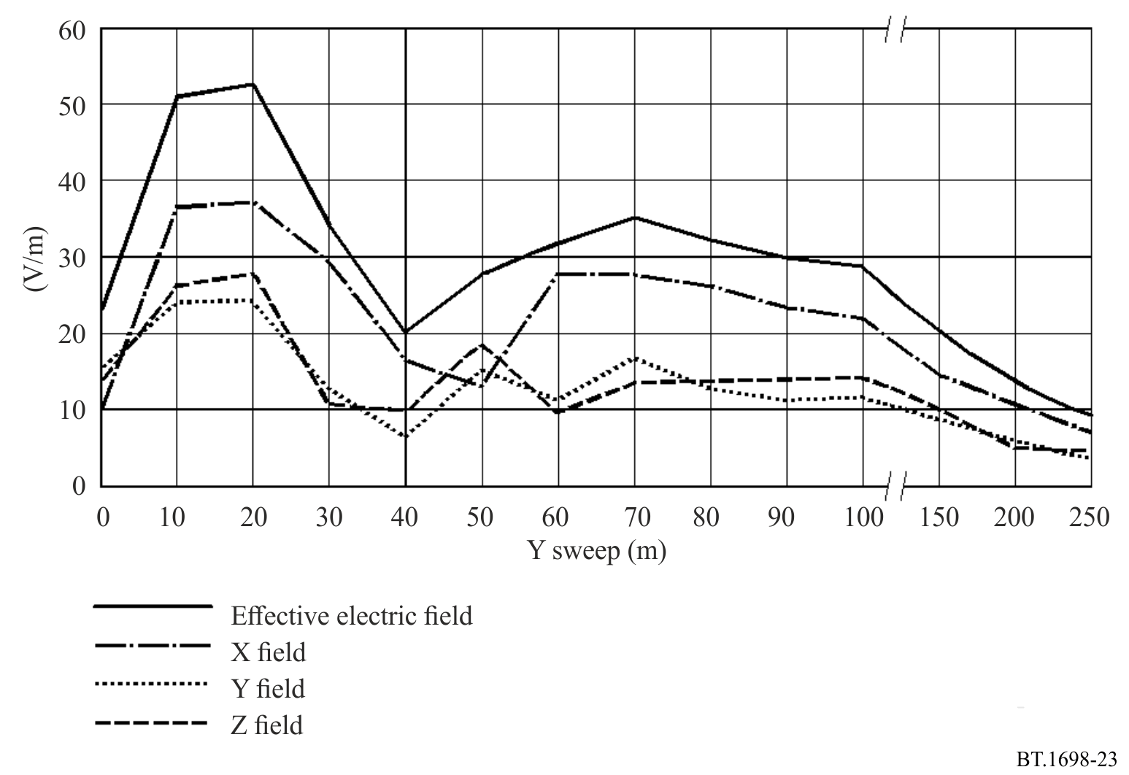
The horizontal axis represents the distance in metres from the antenna (Y sweep). The intensity of the E field’s components is represented in V/m on the vertical axis. All the three components x, y, z of the E field are present, and the upper line represents the global value.
FIGURE 24
Measured H field
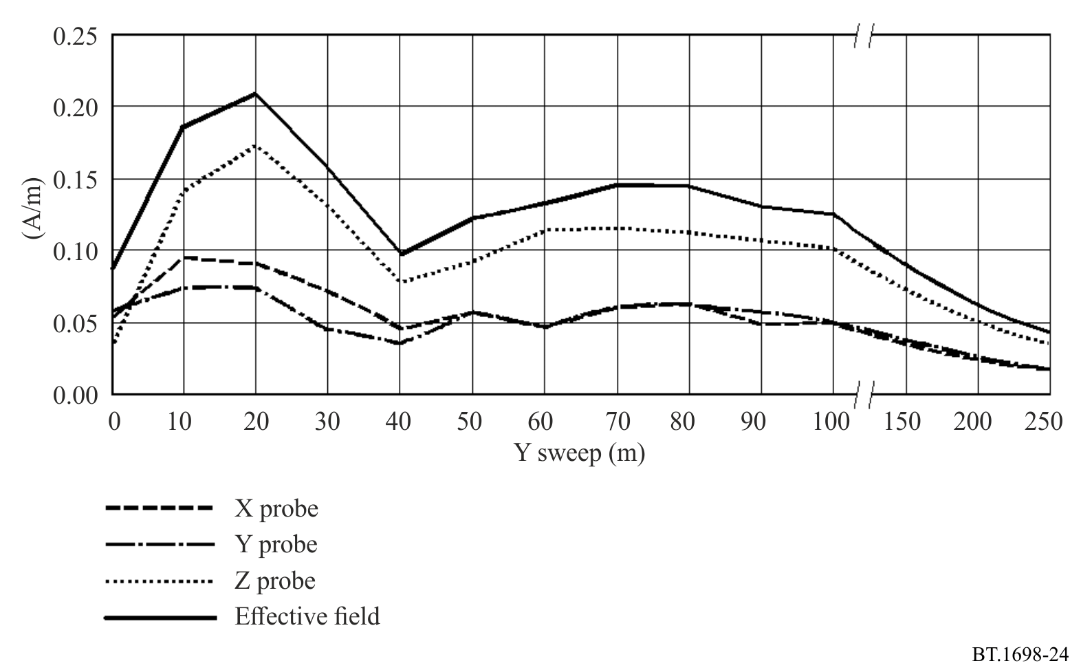
The horizontal axis represents the distance in metres from the antenna (Y sweep). The intensity of the H field’s components is represented in A/m on the vertical axis. All the three components x, y, z of the H field are present, and the upper line represents the global value.

2.2 18 MHz

2.2.1 Predictions

2.2.1.1 Notes about the model
In order to best fit the previously described model to the real antenna system, it is necessary to know the right amount of power at the input of each dipole, taking into account transmission line losses and losses due to mismatch.
In order to apply the appropriate voltage value at each dipole, in the simulation the input impedance of each dipole has been calculated. The values are represented in Fig. 25.
FIGURE 25
Input impedance of dipoles, normalized to 180 Ω
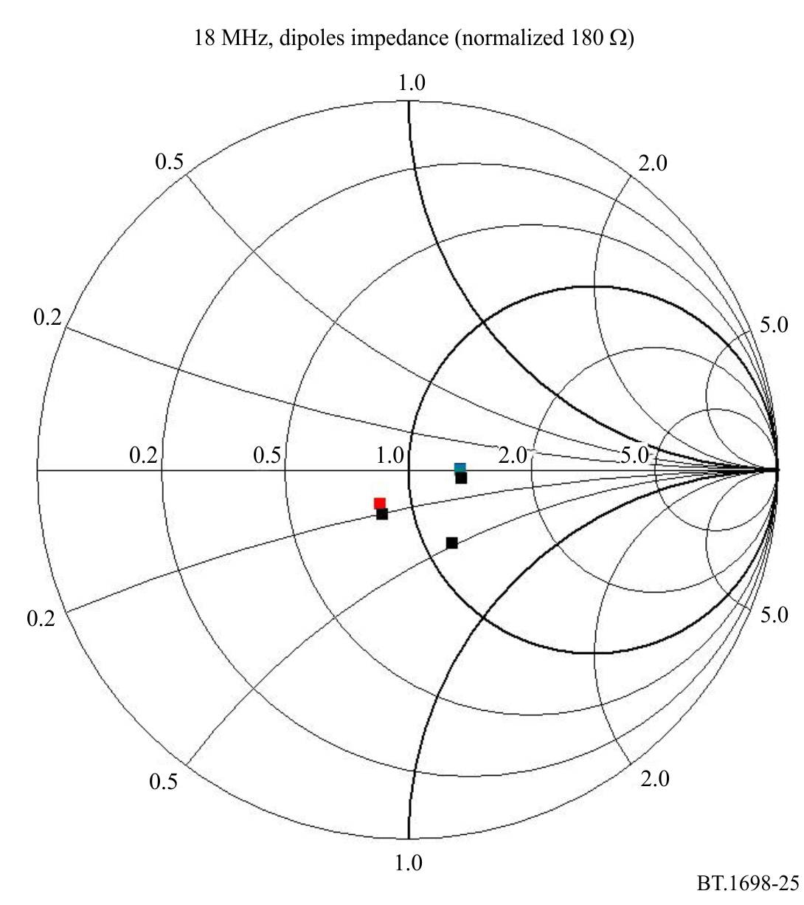
Then, for each dipole, a common value of resistance equal to 180 Ω has been adopted, this being the average value obtained from the simulation. Note that this decision may be the cause of the inaccuracy in the prediction results.
Due to the low reactive components of the complex input impedance, no adjustments to transmitter power are necessary in order to compensate for power losses due to the mismatch, and consequent reflection, between transmitter and antenna.
Note the little – but not non-existent – dispersion of resistance values near 180 Ω and the substantial absence of reactive components.

2.2.1.2 Far-field evaluations
In order to best compare the behaviour of the model with real antennas, given in Figs 11 and 12, the radiation diagrams have been calculated. The results are shown in Fig. 26 (horizontal plane), Fig. 27 (vertical plane) and Fig. 28 (frontal view).
FIGURE 26
Radiation diagram on horizontal plane
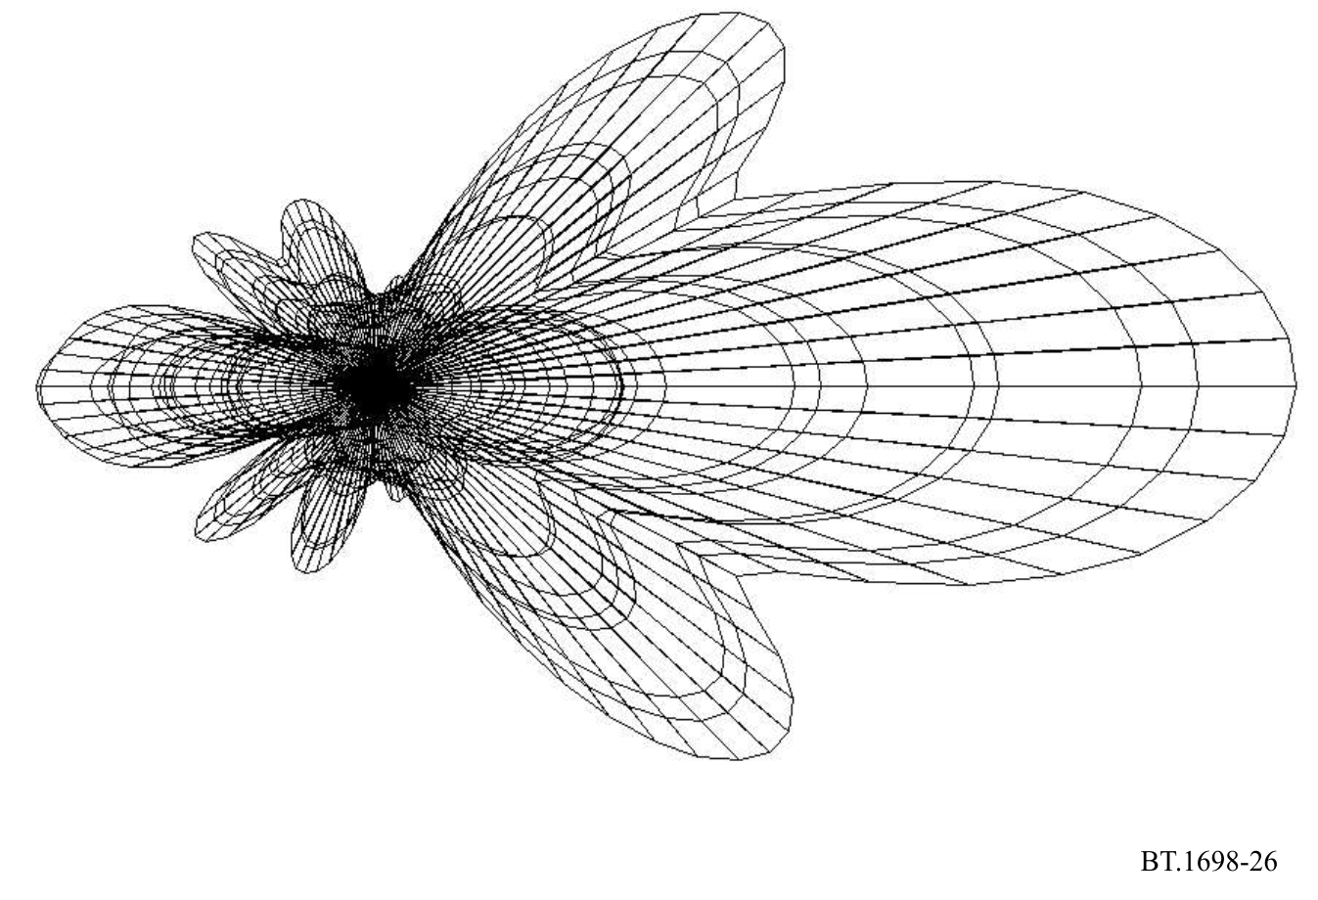
FIGURE 27
Radiation diagram on vertical plane
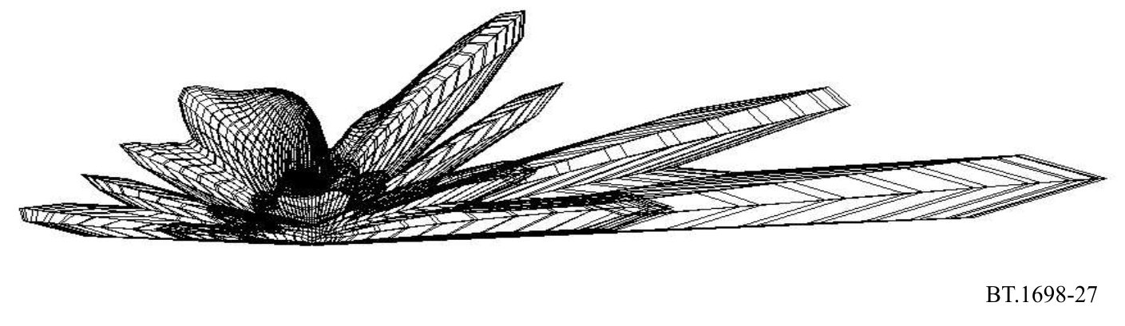
FIGURE 28
Radiation diagram, front view
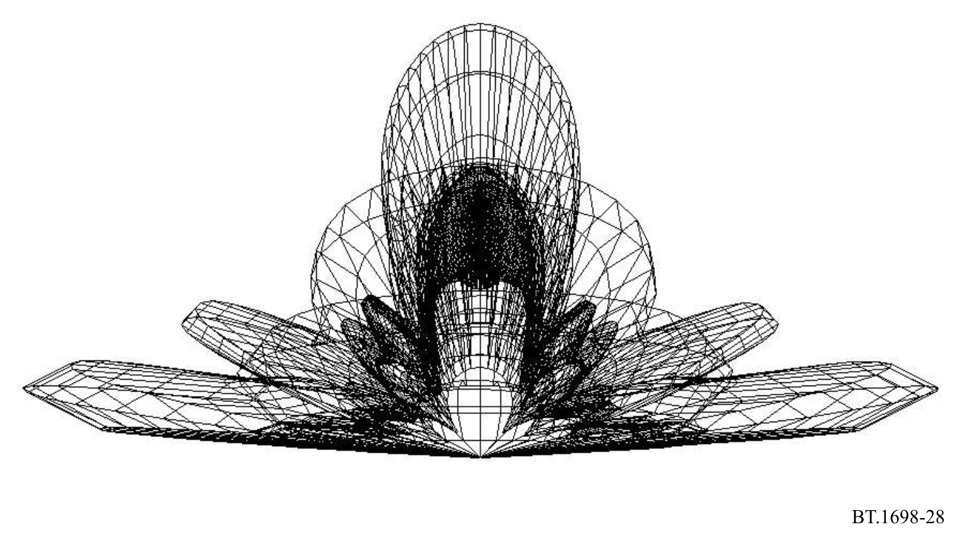

2.2.1.3 Results of prediction of the field strength in the near zone
A prediction was made calculating the x, y, z components of the E and H fields in the direction of the antenna’s maximum gain (Y axis) at 2 m above ground (Z axis = 2). The calculated values are represented in Fig. 29 (E field) and Fig. 30 (H field). The strong influence of the terrain both in the evaluations and in the measurements may introduce an additional difference between the two results. In order to show the strong influence of the terrain, the E and H field values have also been calculated varying the height of the evaluation point above ground (Z axis) from 0 up to 9 m at a fixed distance of 60 m (Y = 60). The behaviour is illustrated in Fig. 31 (E field) and Fig. 32 (H field).
FIGURE 29
Calculated E near electric field strength in the near zone
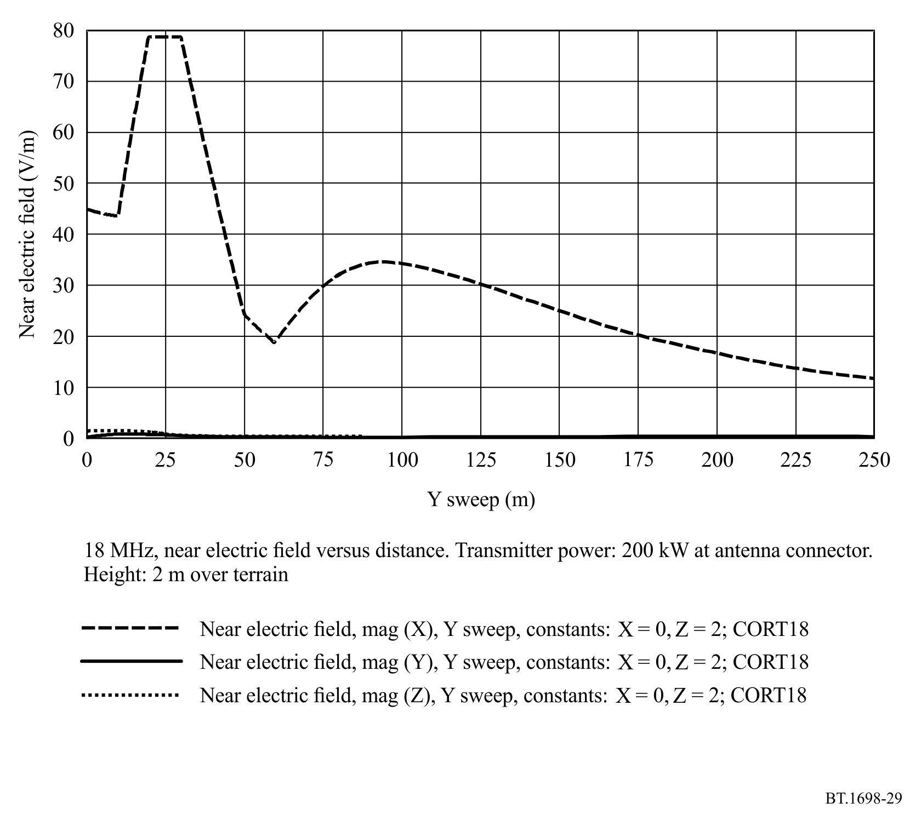
The most important contribution is the x component. The horizontal axis represents the distance in metres from the antenna (Y sweep). Z is fixed at 2 m (height above ground). The intensity of the E field’s components is represented in V/m on the vertical axis.
FIGURE 30
Calculated H near magnetic field strength in the near zone
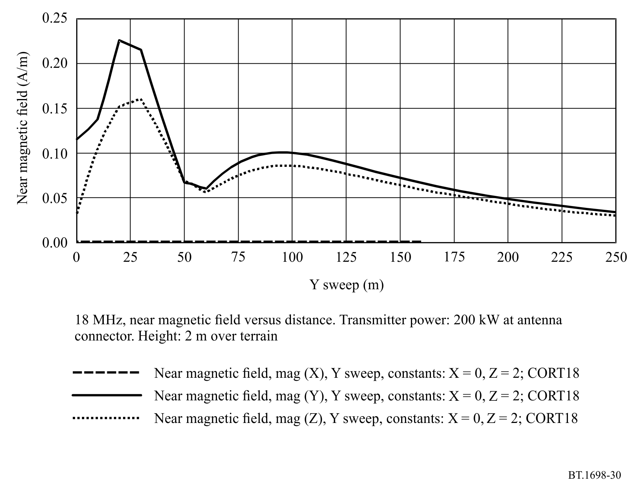
The main contribution is the y component. The z component is lower, while the x component is 0. The horizontal axis represents the distance in metres from the antenna (Y sweep). Z is fixed at 2 m (height above ground). The intensity of the H field’s components is represented in A/m on the vertical axis.
FIGURE 31
Calculated E field strength at a distance of 60 m from antenna (Y = 60) at different heights between 0 and 9 m
(Z sweep)
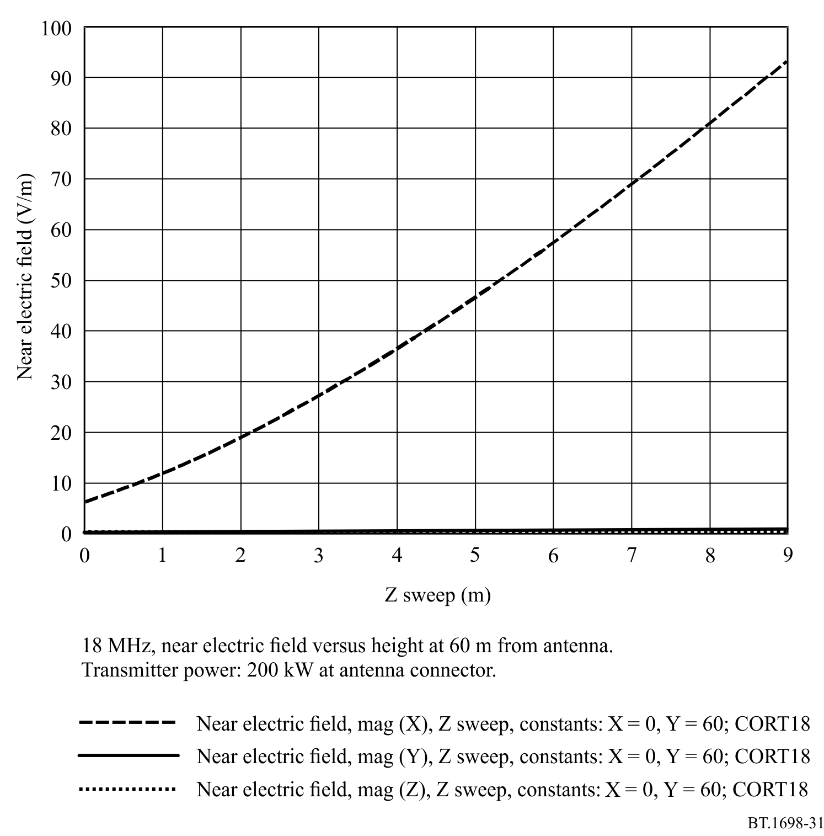
The strong relationship between E values and height (only x component of E field is present) is evident.
FIGURE 32
Calculated H field strength at a distance of 60 m from antenna (Y = 60) at different heights between 0 and 9 m
(Z sweep)
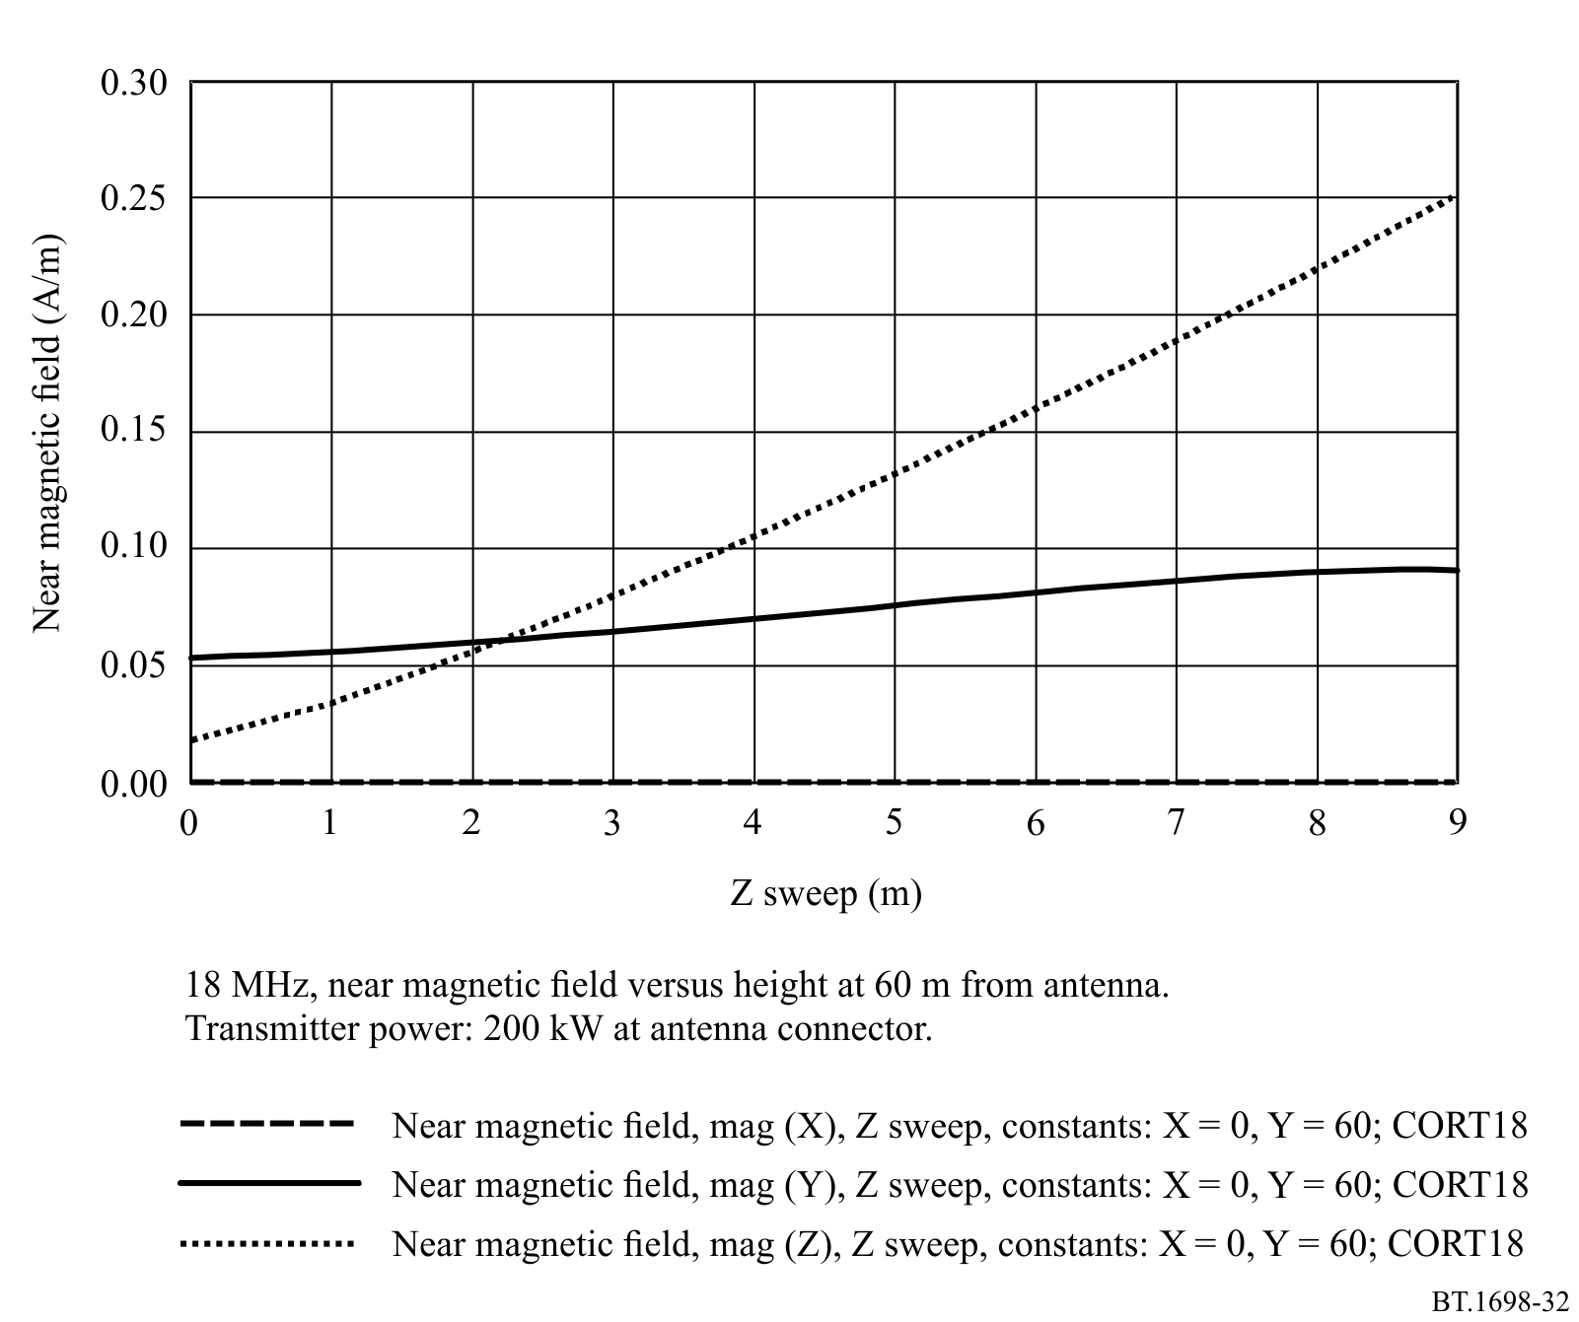
The strong relationship between H values and height (both z and y components of the H field are present, the y component’s value is quite constant) is evident.

2.2.2 Measurements
Measurements have been performed using a broadband field strength meter installed over a dielectric trolley moved by an operator placed far away from the antenna site. By this means any kind of perturbation on the E/H fields is avoided.

2.2.2.1 Results of measurements
Measured values are presented in Fig. 33 (E field) and Fig. 34 (H field). Figures 33 and 34 are directly comparable with Figs 28 and 29, respectively.
FIGURE 33
Measured E Field Strength In The Near Zone
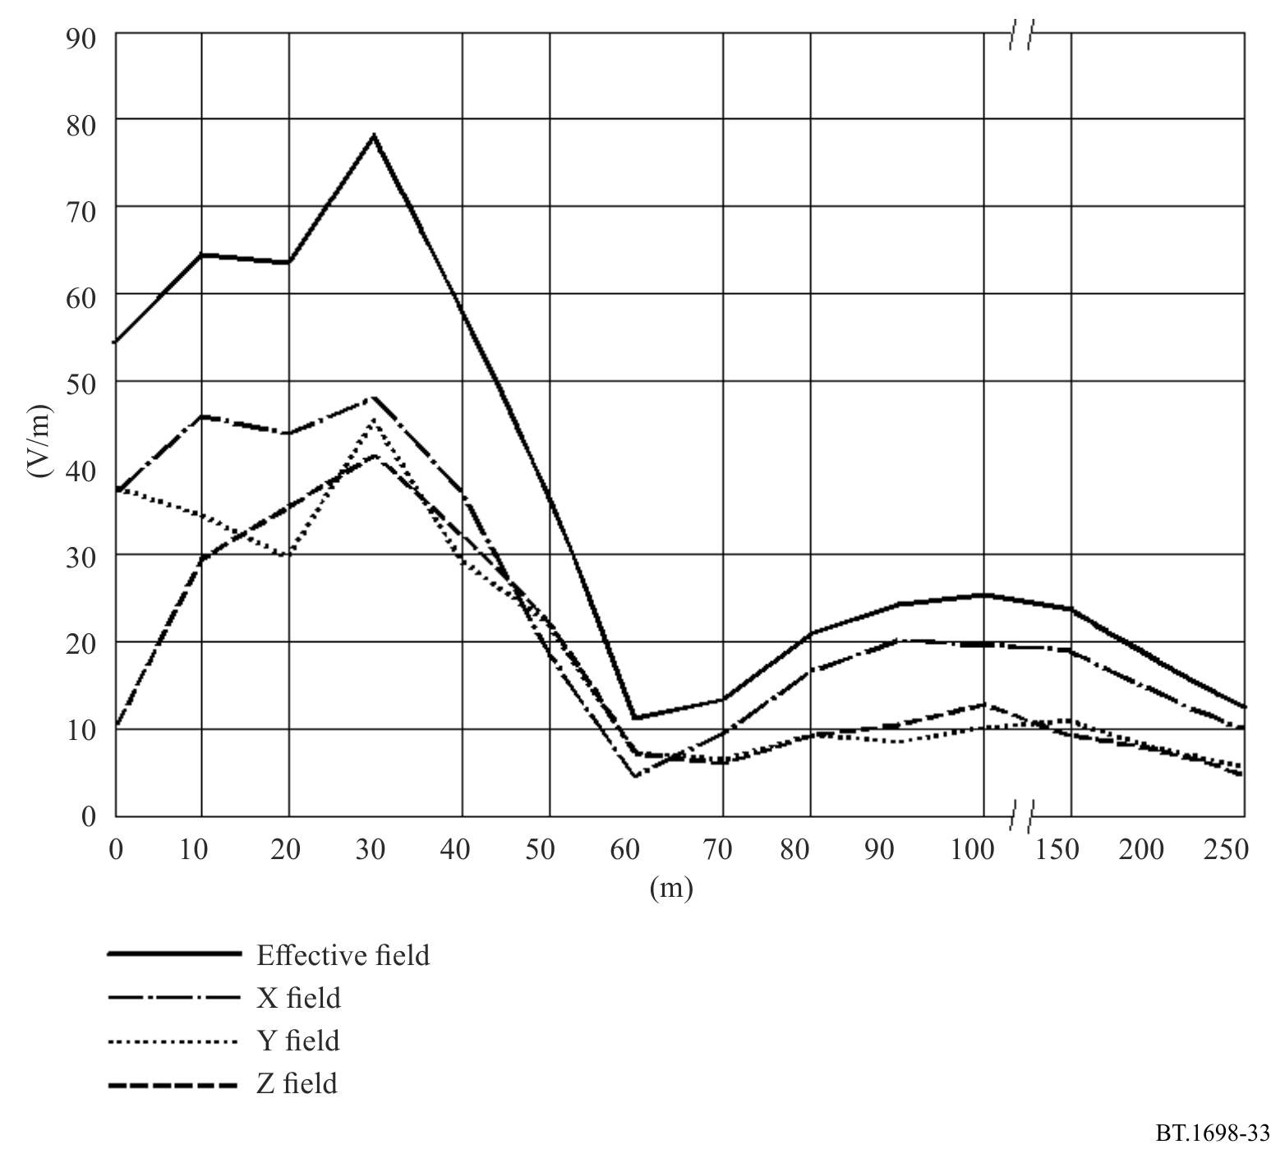
The horizontal axis represents the distance in metres from the antenna (Y sweep). The intensity of the E field’s components is represented in V/m on the vertical axis. All three components x, y, z of the E field are present, and the upper line represents the global value.
FIGURE 34
Measured H field strength in the near zone
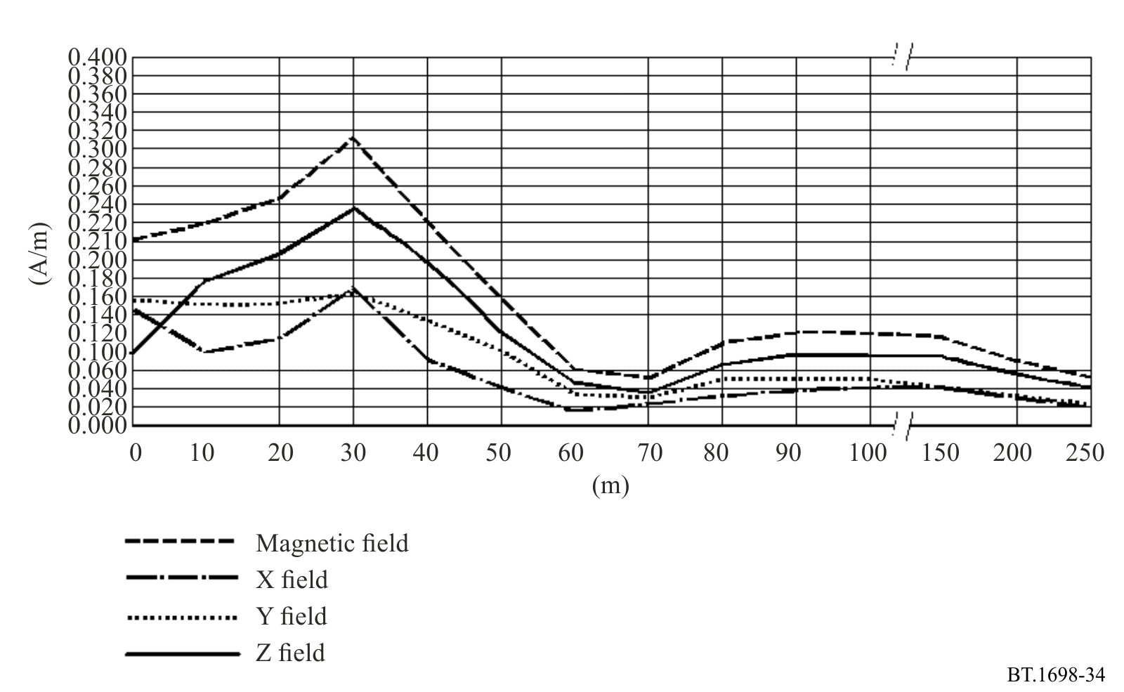
The horizontal axis represents the distance in metres from the antenna (Y sweep). The intensity of the H field’s components is represented in A/m on the vertical axis. All three components x, y, z of the H field are present, and the upper line represents the global value.

2.3 Comparison between measurements and predictions of the field strength in the near zone

2.3.1 13 MHz
At a distance less than 40 m the prediction has given values, of both E and H field, higher than the measured ones; the maximum values of E and H were found at a distance of 10-20 m from the antenna, in both the simulation results and in the measurements.
Both in the predicted and in the measured values, there is an evident “minimum” at 40 m from the antenna, deeper in the prediction than in the measurement.
The second “maximum” reaches its peak, in both cases, at 75 m from the antenna; in this case the values obtained from simulations are lower than the measured ones.
At longer distances, 250 m from the antenna, all fields approach similar values between prediction and measurement.

2.3.2 18 MHz
At a distance less than 40 m the prediction has given values, of both E and H field, higher than the measured ones; the maximum values of E and H were found at a distance of 10 to 20 m from the antenna, in both the simulation results and in the measurements.
A second “maximum” is reached at 100 m, both in prediction and measurement, for E and H fields, with a lower value for the measured E field. At a distance higher than 60 m from the antenna the H field assumes the same value both in prediction and in measurement.

3 Conclusions
The comparison between the measured and predicted values of the E and H fields, both at 13 MHz and 18 MHz, gives interesting results.
Values are, generally, not in full agreement, as would seem to be expected; however, there are no substantial differences between them, when compared with the uncertainty of instrumentation, uncertainty in the planarity of the Earth’s surface near the antenna (not taken into account in simulations, even when it is clear the field’s intensity has a strong dependence on the height of the measurement point) and the imposed simplicity of the model. Differences are bigger near the antenna (i.e. the first maximum at about 10 m), up to 50%, and decrease with increasing distance; at 250 m the differences are quite small.
The reasons for these differences are to be found in the difficulties in near-field measurements, the uncertainty inherent in the instrumentation, the simplicity of the model, the presence of some objects near the antenna (metallic structures, the two lattices supporting the dipoles and matching network) that have not been taken into account in the model, as well as the matching network and its emissions. Finally, terrain has been modelled with its typical electrical values.
In order to carry out E and H field predictions using a model, we recommend the following:
Antenna model: physical dimensions of radiating and passive elements need to be carefully investigated as well as the complex input impedance of the system. In order to simplify a complex system, i.e. an array of radiators, it may be convenient to substitute the matching and feeding network with an equal number of voltage generators applied at the input of each radiator. If the matching network is not considered, then it is necessary to compensate for the eventual mismatch between generators and radiators by the introduction of artificial matching elements or simple networks, or adjusting the power assigned to the transmitter. The final result is quite insensitive to the presence of small mismatches that do not require modelling.
Segment subdivision: it is sufficient to represent filar antenna systems with segments not longer than /20.
Terrain model: it is necessary to give the exact values of permittivity and conductivity, especially in the case of a horizontally polarized E field.
Transmitter power: it is important to take into account losses in transmission lines, matching network, resistance of junctions, mismatches to the load. In some cases, it is opportune to artificially adjust the exact value of power in order to take into account various causes of losses without complicating the model of the antenna system.
Height of measurement points above ground: in many cases this parameter is very important if the scope is a comparison between measurements and predictions. In fact, the strong influence of height may be noted in the value of fields, and, if the terrain is modelled as a plane, large errors may be encountered, by comparison with measurement. In all these cases in which radiators are in the vicinity of the terrain and the terrain is not quite level, the results of predictions must be taken with prudence.
Selection of code: the simulation based on Method of Moments (MOM) seems to be useful and easy to use in cases of wire antennas, of which physical and electrical characteristics are well known. It is possible and quite easy to simplify the model according to a minimum number of rules, without the loss in precision of the results.

Attachment 3
to Annex 1
International limits and levels
As mentioned in the introduction, there is no single global standard used for setting limits. However, both the ICNIRP guidance and the IEEE standard take a similar approach. This is to set limits in terms of basic restrictions (such as Specific Absorption Rate) which are difficult to measure in practice; then additional reference levels are provided in terms of field strengths which can be measured more easily and may be used to assist with determining compliance.
Recommendation ITU-T K.91 – Guidance for assessment, evaluation and monitoring of human exposure to radio frequency electromagnetic fields, Appendix I ‘Exposure limits’ builds on ICNIRP (2010 [2] and 2020 [1]) Guidelines, the IEEE C95.1-2019 [3] standard and the ITU-D Question 7/2 Report 2021. Appendix I specifies the ICNIRP (2010) and (2020) guidelines in force, elaborates the tables and figures of ICNIRP (2020), details the IEEE C95.1-2019 standard and explains the simultaneous exposure to multiple sources.
FIGURE 35
ICNIRP (2020) Table 5, power density for occupational versus general/public exposures at 30 MHz-300 GHz
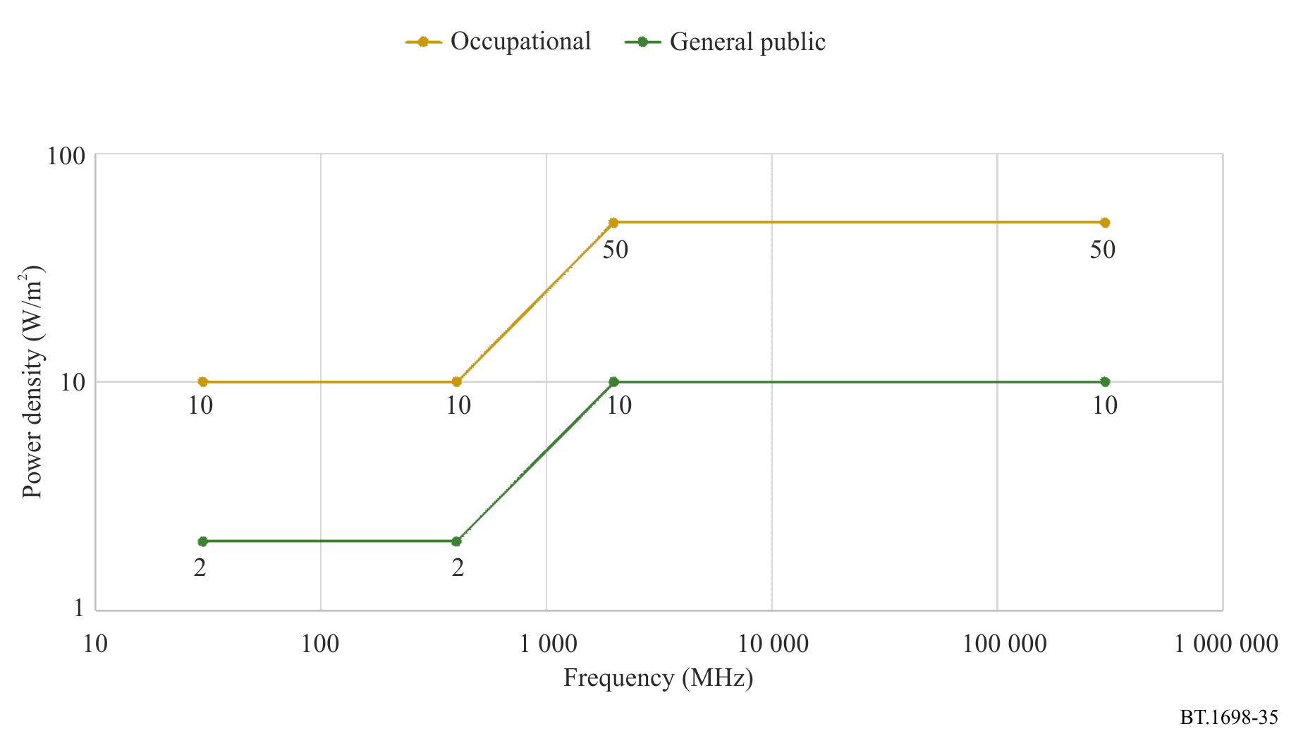
The preceding Fig. 35 and following Fig. 36, [4] revised 2021 Chapter 9 depict the differences between the ICNIRP (2020) field strength and power density exposure levels of occupational and general public exposure, averaged over 30 minutes and the whole body. The power density ratio of 5 in ICNIRP (2020) Table 5 (e.g. at 30-400 MHz, Watts ratio 50/10) results in a V/m ratio 61.0/27.7 = 2.2 ≈ √5.
FIGURE 36
Comparing ICNIRP (2020) Table 5, field strength for occupational and general/public exposure,
at 0.1 MHz-2 000 MHz, averaged over 30 minutes and the whole body
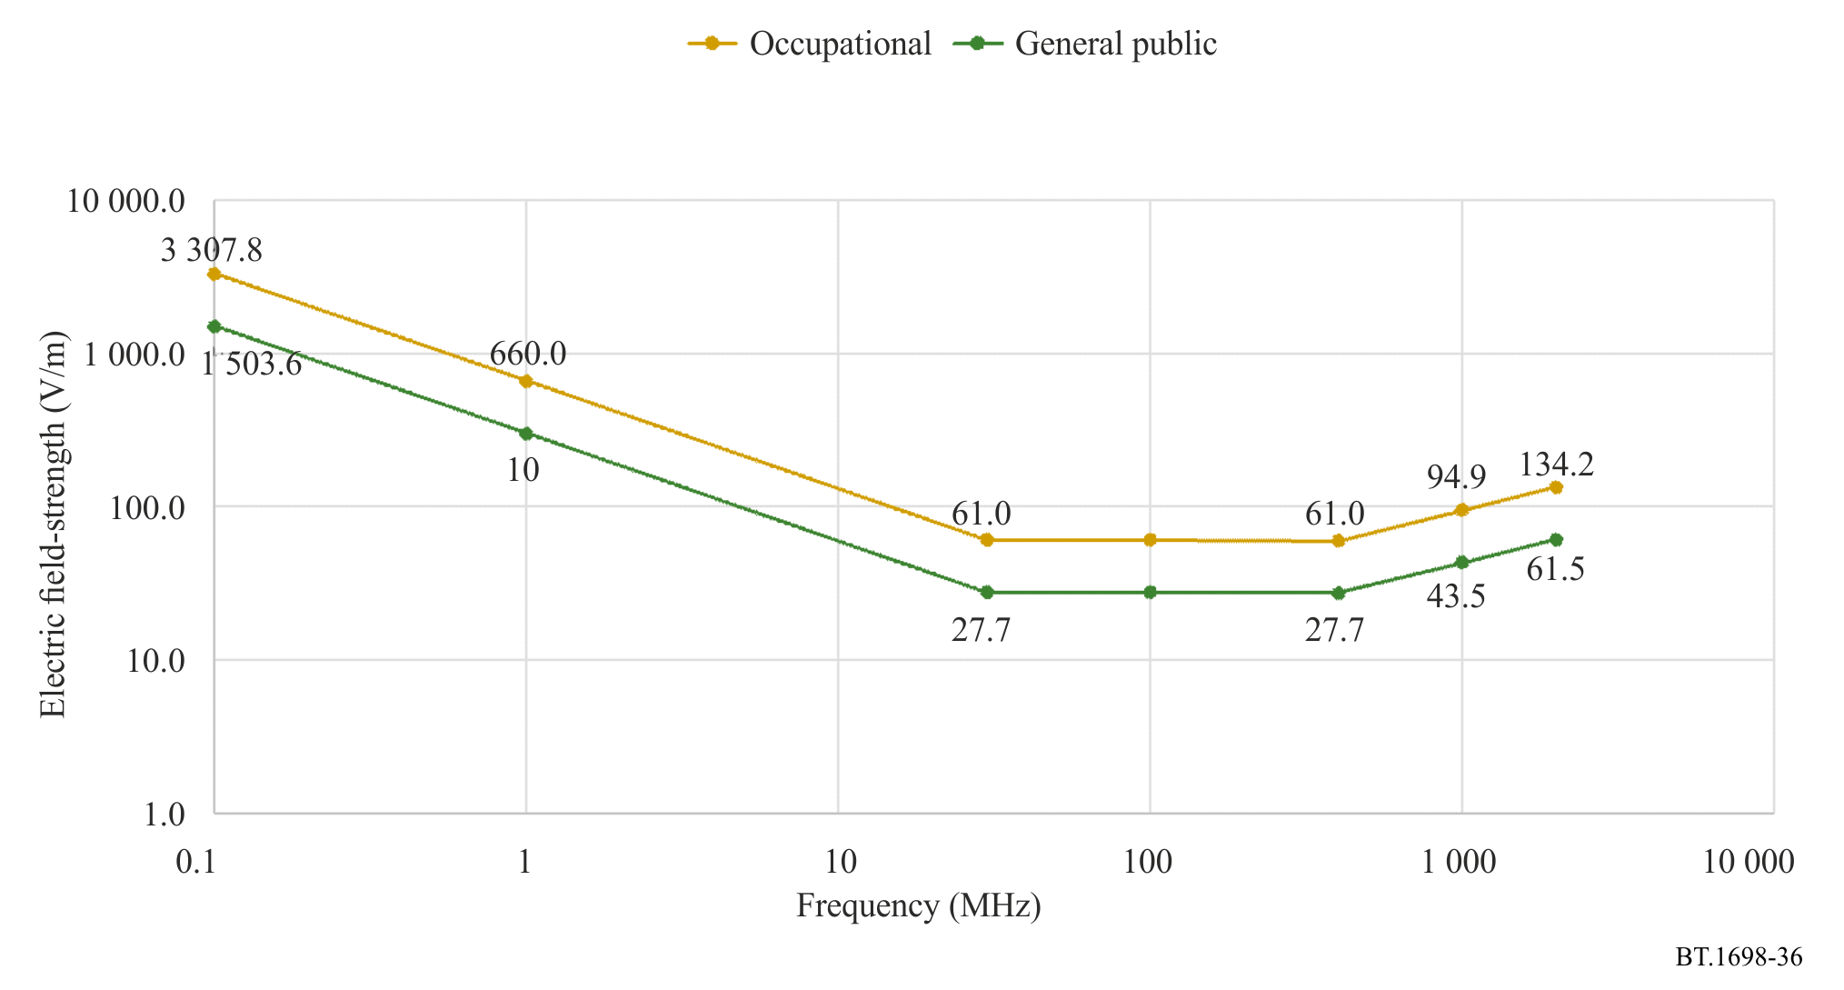
In April 2022, ICNIRP published a new statement, “A Description of ICNIRP’s Independent, Best Practice System of Guidance on the Protection of People and the Environment from Exposure to Non-Ionizing Radiation”.

Attachment 4
to Annex 1
Further detail on modulation

1 Characteristics of radio emission
The Radio Regulations (RR) classify the emissions from radio transmitters according to the required bandwidths, and the basic and optional characteristics of the transmission. The complete classification consists of nine characters but only three basic characteristics are relevant to the consideration of RF safety considerations. These are:
– the type of modulation of the main carrier Character 5
– the nature of the signal(s) which modulate(s) the main carrier Character 6
– the type of information to be transmitted Character 7
Table 2, which is based on information given in the RR, lists the various characters which are used.
TABLE 2
Characters, relevant to broadcasting, used to define the class of emission,
based on information given in the RR
Character 5  Type of modulation of  the main carrier |  | Character 6  Nature of the signal(s) modulating the main carrier |  | Character 7  Type of information  to be transmitted
A | Amplitude modulation: double sideband | 1 | Single channel containing:  analogue information | E | Telephony  including sound broadcasting
R | Amplitude modulation: single sideband, reduced or variable level carrier | 7 | Two or more channels containing: quantized or digital information | F | Television (video)
J | Amplitude modulation: single sideband, suppressed carrier | 9 | Two or more channels containing:  a mix of analogue and digital channels
C | Amplitude modulation: vestigial sideband
X | Cases not otherwise covered

Table 3 contains details of the most common classes of emission for the broadcasting service.
TABLE 3
Most common classes of emission for the broadcasting service
Broadcasting system | Description of emission | Class of emission
Analogue television pictures | VSB | C3F
Analogue television sound | FM or AM sound | F3E or A3E
ATSC | VSB | C7W
DVB-T/T2/H | COFDM | X7F
ISDB-T | SOFDM | X7F
ISDB-T (Multimedia system F) | OFDM | X7W
T-DMB | COFDM | X7W
T-DAB | COFDM | X7E
DRM | COFDM | X7E
HF/MF/LF sound broadcasting | AM | A3E / A8E
FM sound broadcasting | FM | F3E / F8E

2 Expressing transmitter power and field strength in terms of modulation type
Information about the transmitter power supplied to the antenna and the type of modulation can be obtained from the transmission authority, which is responsible for operating the equipment at a particular site. It is important to know whether the transmitter power is expressed in terms of the carrier power, P_{c}, the mean power, P_{m}, or the peak power, P_{p}, so that the measured or calculated values can be compared accurately with the reference levels.
As an example, an MF sound broadcasting transmitter (i.e. a type A3E emission) is considered. It is assumed that the calculations or measurements take account of the carrier power only, but the reference levels take account of the modulation components also (in terms of transmitter power, this corresponds to the mean power). Furthermore, it is assumed that only RMS values are used.
In order to compare the calculated or measured values with the reference levels, one of the following transformations must be made:
– the calculated/measured values must be modified to include the modulation components; or
– the derived levels must be modified to correspond with the carrier-only power values, i.e. without modulation components.
Table 4 gives multiplication factors which relate one type of power notation to another (these different notations for power are defined in the RR). In the case of an A3E transmission, shown as A*E in Table 4, it can be seen that the mean power, P_{m}, is 1.5 times the carrier power, P_{c}.
Table 4 assumes a modulation depth of 100%. In practice, the modulation depth of a broadcast transmitter will often be lower than this. Again, taking the example of an A3E transmission but with modulation depth m, where m = 1, represents 100%, the peak power will be (1 + m)²P_{c} and the mean power [1 + 2(m/2)²]P_{c}.
Note: the above values relate to powers and so the square root of the conversion factors given in Table 4 must be used when dealing with field strengths. Thus, in the above example of AM radio, the carrier-only RMS field strength should be multiplied by $\sqrt{1.5}$ to give the RMS field strength, which includes the modulation components. Conversely, the derived level (including modulation components) should be divided by $\sqrt{1.5}$ to give an equivalent derived level for the carrier only.
The RMS value of the field strength in the far-field can be calculated from the known power, using equation (7); the appropriate type of power to use (i.e. P_{m}, or P_{p}) is shown in Table 5.
TABLE 4
Relationship between carrier, average, peak and maximum instantaneous power,
for different classes of emission (worst case figures)
Class of emission  (basic characteristics)  ^{(1), (2)} | Known power type
 | Carrier power, P_{c} |  |  | Mean power, P_{m} |  |  | Peak power, P_{p}
 | Factor for the  determination of: |  |  | Factor for the  determination of: |  |  | Factor for the  determination of:
 | P_{c} | P_{m} | P_{p} | P_{c} | P_{m} | P_{p} | P_{c} | P_{m} | P_{p}
A*E | 1 | 1.5 | 4 | 0.67 | 1 | 2.67 | 0.25 | 0.38 | 1
C*F ⁽³⁾  Negative modulation  Positive modulation | – | – | – | – | 1  1 | 1.85  1.42 | – | 0.54  0.87 | 1  1
F*...⁽⁴⁾ | 1 | 1 | 1 | 1 | 1 | 1 | 1 | 1 | 1
X7E | 1 | 1 | 1 | 1 | 1 | 1 | 1 | 1 | 1
GX7F | 1 | 1 | 1 | 1 | 1 | 1 | 1 | 1 | 1
X7W | 1 | 1 | 1 | 1 | 1 | 1 | 1 | 1 | 1
TABLE 4 (end)
Class of emission  (basic characteristics)  ^{(1), (2)} | Known power type
 | Carrier power, P_{c} |  |  | Mean power, P_{m} |  |  | Peak power, P_{p}
 | Factor for the  determination of: |  |  | Factor for the  determination of: |  |  | Factor for the  determination of:
 | P_{c} | P_{m} | P_{p} | P_{c} | P_{m} | P_{p} | P_{c} | P_{m} | P_{p}
⁽¹⁾ See Table 1 for further information on the 3-symbol code, which is used to describe the three basic characteristics of a transmission type.
⁽²⁾ An * indicates that the 2nd characteristic (i.e. the nature of the modulating signal) is not relevant to the consideration of hazards.
⁽³⁾ Carrier power, P_{c}, is not clearly defined.
⁽⁴⁾ The 3rd characteristic is not relevant to the consideration of hazards.
These factors are given for X7E, X7F and X7W when measuring over the whole channel power (e.g. 1.5 MHz for DAB and 8 MHz for DVB).

TABLE 5
Relationship between certain field strength notations and power notations
To calculate | Use power expressed as
The effective value of the equivalent field strength | Average transmitter power, P_{m}
The average value of the equivalent field strength which occurs during a period of peak RF oscillation | Peak power, P_{p}
Peak (maximum) value of the equivalent field strength | Peak power, P_{p}⁽¹⁾
⁽¹⁾ The peak value of the equivalent field strength is determined from the peak power, P_{p}, using the peak/r.m.s. correction factor. This factor is 21/2 for a sinusoidal carrier.

Attachment 5
to Annex 1
Additional evaluation methods

1 Numerical procedures
This section gives a brief overview of various numerical methods. Note that numerical methods are also discussed in Recommendation ITU-T K.61. There are some commercial programs available, for example, CST, HFSS and WIPL-D.
Analytical procedures can only be used to calculate the electromagnetic properties for a few special cases and geometries. To solve general problems, numerical techniques have to be applied. The most common numerical procedures to calculate the EMF from a transmitting source or the internal fields and the specific absorption rate in biological bodies, are listed below. Which of the numerical techniques most appropriate for a certain problem, depends on the frequency range considered, the geometrical structures to be modelled, and the type of exposure situation (near-field or far-field).
Some usual numerical modelling methods are given below:
– Physical Optics (PO)
– Physical Theory of Diffraction (PTD)
– Geometrical Optics (GO)
– Geometrical Theory of Diffraction (GTD)
– Uniform Theory of Diffraction (UTD)
– Method of Equivalent Currents (MEC)
– Method of Moments (MOM)
– Multiple Multipole method (MMP)
– Finite-Difference Time-Domain method (FDTD)
– Finite Element Method (FEM)
– Impedance method.
An assessment must be carried out, for each application, to establish which one of the above methods is the most suitable for solving a given problem. For example, physical and geometrical optics do not apply in the near-field.
Each of these procedures enables the amplitude and phase of the following EMF field quantities to be determined, at every point in space, where the radiating and scattering elements may be either ideal conductors or dielectric bodies:
– electric field strength;
– magnetic field strength;
– power density;
– current;
– voltage;
– impedance.

1.1 Method of Moments (MOM)
The MOM is often used in the design of broadcast antenna systems (transmitter output power, antenna gain, etc.) and in calculating their resultant EMFs. It enables calculations to be made at both the transmitting and receiving ends, as well as in the near and far-fields of the antenna.
Technical structures with up to three dimensions can be modelled, taking into account their material parameters (complex dielectric constant) as well as that of the ground. The modelling works with wires that are thin with respect to the wavelength and, in principle, is able to represent surfaces too. The limitation of this method lies in the fact that the modelling of extended and complicated structures may become too time – and memory – consuming for the computer.
The MOM is a technique which has been extensively used to solve electromagnetic problems and to make SAR calculations in block models of biological bodies. In the MOM, the electric fields inside a biological body are calculated by means of a Green’s function solution of Maxwell’s integral equations.

1.2 Fast Fourier Transform/Conjugate Gradient method (FFT/CG)
The FFT/CG method is a further development of the MOM. Iterative algorithms based on FFT and the gradient procedure are used to solve linear equations derived from the MOM.

1.3 Finite-Difference Time-Domain method (FDTD)
The FDTD is a numerical method to solve Maxwell’s differential curl equations in the time domain. It can be used to calculate internal and external EMF and SAR distribution in biological bodies for both near-field or far-field exposures. In FDTD, both time and space are discretized, and a biological body is modelled by assigning the permittivity and conductivity values to the space cells it occupies. The computer memory required is proportional to the number of space cells. FDTD is considered the most promising SAR calculation method, but for accurate calculations very powerful computers are needed.

1.4 Multiple Multipole method (MMP)
MMP is based on analytical solutions to field equations which have a multipole at one point in space, and is used in conjunction with the Generalized Multipole method (GMP). The MMP procedure is especially suitable for the simulation of so-called “lossy scattering” bodies, which are near to radiation sources, i.e. within the immediate near-field.

1.5 Impedance method
The impedance method has been successfully used to solve dosimetric problems where quasistatic approximations can be made. For calculations of SAR in human bodies, this method has proven to be very effective at frequencies up to 40 MHz. In the impedance method, the biological body is modelled by a three-dimensional network of complex impedances.

2 Field strength calculations
Most of the methods listed above can be used to calculate field strength levels from electromagnetic radiators. The accuracy of the results depends very much on how well the radiator (for example antenna) is modelled. If objects near the radiator, between the radiator and the prediction point, or close to the point of field strength prediction affect the field strength levels significantly, such objects should also be modelled.
2.1 Numerical analysis of wire structures: Example
This provides an overview of a possible approach for determining the field strength levels in the vicinity of an HF curtain antenna, based on formulating the so-called two potential equation for the current distribution along the wires. This equation is solved using the MOM with a polynomial approximation for the current.
An arbitrary structure, located in a vacuum, and assembled from perfectly conducting straight wire segments is considered. According to the boundary conditions, on the wire surfaces, the tangential component of the total electric field must be zero, i.e.:
${\left(E+E_{i}\right)}_{tan}=0$ (17)
where:
E : electric field produced by the currents and charges of the wire structure
E_{i} : impressed electric field, which models the excitation to the system.
The impressed field can be, for example, the electric field of a plane wave incident on the structure (when analysing scatterers or receiving antennas), or a field located in a small region at the antenna terminals, which models the generator driving the antenna (when analysing transmitting antennas).
The electric field produced by the wire currents and charges can be expressed in terms of the magnetic vector potential, A, and electric scalar potential, V, as:
$E=-jω A-grad V$ (18)
where:
ω : angular frequency (ω = 2π f).
The two potentials, in turn, can be expressed in terms of the densities of the surface currents (J_{s}) and charges (ρ_{s}), which are related by the continuity equation. Next, the surface currents and charges are approximated by line currents and charges (thin wire approximation), and the wire structure is divided into N segments (each of them having a local axis, s_{m}). Finally, the two potential equation (also called the vector scalar potential equation) for the current distribution is obtained in the form:
(19)
where:
: intensity of the current along a wire segment
: free space phase coefficient
: corresponding Green’s function
r_{a} : approximate average distance between the point on the surface of the wire element ds_{m} and the field point.
Equation (19) is an integral-differential equation for the current distribution, and it can only be solved numerically. To that purpose, the general guidelines of the MOM are followed, and approximate the unknown function I_{m} (s_{m}) by a series of known functions (basis functions), with unknown weighting coefficients. The simple power functions are chosen as the basis functions, which amount to the polynomial approximation of the current distribution, i.e.:
(20)
where:
h_{m} : segment length
I_{mi} : weighting coefficients.
Equation (19) cannot be satisfied exactly at all points along the wire segments, but only approximately. According to the MOM, a set of weighting functions is selected, and the inner products of equation (19) and these functions are evaluated. The weighting functions are taken to be pulses. Each pulse is a unity constant, defined on a short sub-segment, and zero otherwise. A typical distribution of the pulses is shown in Fig. 37.
FIGURE 37
Typical distribution of pulse weighting functions used in program AWAS
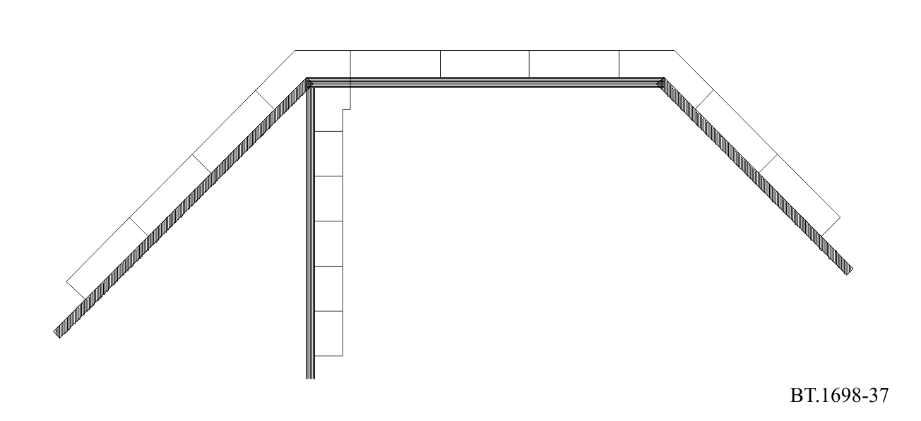
For a pulse defined on the sub-segment (s_{p1}, s_{p2}) along the axis of the wire segment p, the evaluation of the inner product results in the equation (21):
(21)
In this equation, u_{p} is the unit vector of the wire segment p, and Z′ is the impedance per unit length of a possible impedance loading distributed along the segment. When evaluated for all the pulses, equations of the form (21) comprise a system of linear equations in I_{mi}, which can be solved numerically.
Once the coefficients I_{mi} are known, the approximate current distribution along the wire segments is determined, and various characteristics of the wire structure can be evaluated. This part of the Recommendation deals primarily with the near electric and magnetic fields. The electric field can be evaluated in terms of the two potentials, in a similar way as when deriving the two potential equation, i.e.:
(22)
The magnetic field can be expressed in terms of the magnetic vector potential as:
(23)
When this potential is expressed in terms of the wire currents, one finally obtains:
(24)

3 Dosimetry
The application of dosimetric concepts enables to link the external (i.e. outside the body) and internal field strengths, induced current density and the energy absorption rate in tissues. The development of experimental and numerical dosimetry has been complementary. Both approaches necessitate approximations to the simulation of human exposure; however, the development of tissue equivalent materials and minimally disturbing probes in the experimental domain and the use of anatomically realistic models for computational purposes have improved the understanding of the interaction of RF fields with the body.
Whereas current density and internal electric field strength are the quantities most clearly related to the biological effects at low frequencies, it is the SAR, which becomes the more significant quantity as frequencies increase towards wavelengths comparable to the human body dimensions.
In most exposure situations the SAR can only be inferred from measured field strengths in the environment using dosimetric models. At frequencies below 100 MHz non-invasive techniques have been used to measure induced current, and in extended uniform fields, external electric field strengths have been related to induced current as a function of frequency. In the body resonance region, exposures of practical significance arise in the reactive near-field where coupling of the incident field with the body is difficult to establish owing to non-uniformity of the field and changing alignment between field and body. In addition, localized increases in current density and SAR may arise in parts of the body as a consequence of the restricted geometrical cross-section of the more conductive tissues.
Dosimetric quantities can be calculated by use of suitable numeric procedures and calculational models of the human body. On the other hand, such quantities can be measured using suitable physical models (phantoms).

3.1 Specific Absorption Rate (SAR) calculations
Due to the difficulty of measuring the whole body averaged or local peak SAR in many exposure situation, numerical calculations, several of the numerical techniques mentioned above can be used for estimation of the SAR distribution in a biological body exposed to either near-field or far-field electromagnetic radiation, for example the FDTD, MOM, and the MMP.
Which of these methods is most appropriate for a particular problem, depends, e.g. on the frequency, the exposure conditions, the size of the exposed object, the required accuracy, and the maximum tolerable calculation time. Each method requires experience in biophysics and numerical analysis.
To use any of these models, a three-dimensional geometric numerical model of the exposed body, or part of the body, is required. The electrical properties at the exposure frequency should be known for different parts of the body. Depending on the required accuracy, models with different complexity may be used. In some situations, simple shapes like spheres and cylinders are appropriate to model the body. The dielectric properties of human tissues are given in the literature. Using magnetic resonance (MR) images of a human body, very complex and accurate numerical body models can be developed. MR models with several different tissue types and a spatial resolution of less than a few millimetres have been used for FDTD calculations of the SAR distribution in humans exposed to EMFs from handheld radio transmitters. Commercial software packages are available to carry out such modelling.

3.2 SAR measurement
The Specific Absorption Rate (SAR) (W/kg) is the basic limit quantity of most RF exposure regulations and standards. SAR is a measure of the rate of electromagnetic energy dissipated per unit mass of tissue: power absorbed per unit mass.
The SAR may be specified as the value normalized over the whole body mass (sometimes referred to as the “whole body averaged SAR”) or the localized value over a small volume of tissue (localized SAR).
SAR can be ascertained from the internal quantities in three ways, as indicated by the following equation:
$\text{SAR} = \frac{σE^{2}}{ρ} = C_{i} \frac{d_{T}}{d_{t}} = \frac{J^{2}}{σρ}$ (25)
where:
E : internal electric field strength in the body tissue (V/m^{–1})
: conductivity of body tissue (S/m^{–1})
: density of body tissue (kg/m^{–3})
C_{i} : heat capacity of body tissue (J/kg^{–1} °C^{–1})
d_{T}/d_{t} : time derivative of temperature in body tissue (°C/s^{–1})
J : induced current density in the body tissue (A/m²).
The local SAR in an incremental mass (dm) is defined as the time derivative of the incremental absorbed energy (dW) divided by the mass:
$SAR=d/{d_{t}}$ dW/dm (26)
This quantity value is important from two standpoints; the resulting non-uniform distribution of energy absorption when exposed to a uniform plane wave, and the localized energy absorption arising from non-uniform fields in close proximity to a source of exposure.
Exposure regulations or standards contain derived electric and magnetic field limits. The underlying dosimetric concept assures that compliance with the (external) derived levels will assure compliance with the basic SAR limits. However, external or internal SAR measurements can also be used to show compliance. For partial body near-field exposure conditions, the external EMFs may be difficult to measure, or may exceed the derived limits, although the local SAR is below the basic limits. In these cases internal SAR measurements in body models have to be conducted. The most important methods to measure SAR will be described below.

3.2.1 Electric field measurement
The SAR is also proportional to the squared RMS electric field strength E (V/m) inside the exposed tissue:
$SAR={σE^{2}}/ρ$ (27)
where:
σ (S/m) : conductivity
ρ (kg/m³) : mass density of the tissue material at the position of interest.
Using an isotropic electric field probe, the local SAR inside an irradiated body model can be determined. By moving the probe and repeating the electric field measurements in the whole body or in a part of the body, the SAR distribution and the whole body or partial body averaged SAR values can be determined. A single electric field measurement takes only a few seconds, which means that three dimensional SAR distributions can be determined with high spatial resolution and with a reasonable measurement time (typically less than an hour).

3.2.2 Temperature measurement
The SAR is proportional to the initial rate of temperature rise d_{T}/d_{t} (K/s) in the tissue of an exposed object:
$SAR={c Δ_{T}}/{Δ_{t}}$ (28)
where c is the specific heat capacity of the tissue material (J kg^{–1} K^{–1}). Using certain temperature probes, the local SAR inside an irradiated body model can be determined. One or more probes are used to determine the temperature rise ΔT during a short exposure time Δt (typically less than 30 s to prevent heat transfer). The initial rate of temperature rise is approximated by ΔT/Δt, and the local SAR value is calculated for each measurement position. By repeating the temperature measurements in the whole body or in a part of the body, the SAR distribution and the whole body or partial body averaged SAR values can be determined.
Three dimensional SAR distribution measurements are time consuming due to the large number of measurement points. To achieve a reasonable measurement time the number of points has to be limited. This means that it is difficult to measure strongly non-uniform SAR distributions accurately. The accuracy of temperature measurements may also be affected by thermal conduction and convection during measurements, or between measurements.

3.2.3 Calorimetric measurement
The whole body average SAR can be determined using calorimetric methods. In a normal calorimetric measurement, a full size or scaled body model at thermal equilibrium is irradiated for a period of time. A calorimeter is then used to measure the heat flow from the body, until the model is at thermal equilibrium again. The obtained total absorbed energy is then divided by the exposure time and the mass of the body model, which gives the whole body SAR. The calorimetric twin well technique uses two calorimeters and two identical body models. One of the models is irradiated, and the other one is used as a thermal reference. This means that the measurement can be performed under less well controlled thermal conditions than a normal calorimetric measurement.
Calorimetric measurements give rather accurate determinations of whole body SAR, but do not give any information about the internal SAR distribution. To get accurate results a sufficient amount of energy deposition is required. The total time of a measurement, which is determined by the time to reach thermal equilibrium after exposure, may be up to several hours. Partial body SAR can be measured by using partial body phantoms and small calorimeters.

4 Body current measurement
Measurement devices for body current may be carried out in two categories:
– measurement devices for body to ground current;
– measurement devices for contact current.

4.1 Induced body currents
Internal body currents that are induced in persons occur from partial or whole body exposure of the body to RF fields in the absence of contact with objects other than the ground.
The two principal techniques used for measuring body currents include clamp-on type (solenoidal) current transformers for measuring current flowing in the limbs, and parallel plate systems that permit the measurement of currents flowing to ground through the feet.
Clamp-on current transformer instruments have been developed that can be worn.
The meter unit is mounted either directly on the transformer or connected through a fibre optic link to provide a display of the current flowing in a limb around which the current transformer is clamped. Current sensing in these units may be accomplished using either narrow band techniques, e.g. spectrum analysers or tuned receivers (which offer the advantage of being able to determine the frequency distribution of the induced current in multi-source environments, or broadband techniques using diode detection or thermal conversion).
Instruments have been designed to provide true r.m.s. indications in the presence of multiple frequencies and/or amplitude modulated waveforms.
The upper frequency response of current transformers is usually limited to about 100 MHz; however, air cored transformers (as opposed to ferrite cored) have been used to extend the upper frequency response of these instruments. Whilst air cored transformers are lighter and therefore useful for longer term measurements, they are significantly less sensitive than ferrite cored devices.
An alternative to the clamp-on device is the parallel plate system. In this instrument, the body current flows through the feet to a conductive top plate, through some form of current sensor mounted between the plates, and thereby to ground. The current flowing between the top and bottom plates may be determined by measuring the RF voltage drop across a low impedance resistor. Alternatively, a small aperture RF current transformer or a vacuum thermocouple may be used to measure the current flowing through the conductor between the two plates.
Instruments with a flat frequency response between 3 kHz and 100 MHz are available.
There are several issues that should be considered when selecting an instrument for measuring induced current.
Firstly, stand-on meters are subject to the influence of electric field induced displacement currents from fields terminating on the top plate. Investigations have shown that apparent errors arising in the absence of a person are not material to the operation of the metres when a person is present.
Secondly, the sum of both ankle currents measured with clamp-on type meters tends to be slightly greater than the corresponding value indicated with plate type meters. The magnitude of this effect, which is a function of the RF frequency and meter geometry is not likely to be material. Nonetheless, the more accurate method of assessing limb currents is the current transformer. The precise method of measurement may depend upon the requirements of protection guidelines against which compliance assessments are made.
Thirdly, the ability to measure induced currents in limbs under realistic grounding conditions such as found in practice need to be considered. In particular, the differing degree of electrical contact between the ground and bottom plate of the parallel plate system and the actual ground surface may affect the apparent current flowing to ground.
Measurements can be made using antennas designed to be equivalent to a person. This enables a standardized approach to be used and permit current measurements to be made without the need for people to be exposed to potentially hazardous currents and fields.

4.2 Contact current measurement
The current measurement device has to be inserted between the hand of the person and the conductive object. The measurement technique may consist of a metallic probe (definite contact area) to be held by hand at one end of the probe while the other end is touched to the conductive object. A clamp-on current sensor (current transformer) can be used to measure the contact current which is flowing into the hand in contact with the conductive object.
Alternative methods are:
– the measurement of the potential difference (voltage drop) across a non-inductive resistor (resistance range of 5-10 Ω) connected in series between the object and the metallic probe held in the hand;
– a thermocouple milliammeter placed directly in series.
The wiring connections and the current meter must be set up in such a way that interference and errors due to pick-up are minimized.
In the case where excessively high currents are expected an electrical network of resistors and capacitors can simulate the body’s equivalent impedance.

4.3 Touch voltage measurement
The touch voltage (no load voltage) is measured by means of a suitable voltmeter or oscilloscope for the frequency range under consideration. The measurement devices are connected between the conductive object charged by field induced voltage and a reference potential (ground). The input impedance of the voltmeter must not be smaller than 10 k Ω.

Attachment 6
to Annex 1
Electromedical implanted and portable devices

1 Electromedical devices
Electromagnetic compatibility (EMC) is a general concern for electronic equipment and particularly electronic medical devices. If electromedical devices are used in the presence of strong terrestrial broadcasting stations, they may malfunction. The risk of such malfunction increases if the field strengths are great enough. The risk of malfunction depends upon several variables, such as the level of field strength, which is dependent on distance between the transmitting antenna and the device, the transmitter power, the frequency of emission, the type of modulation of the radiated signal, the effect of cable coupling as well as the electronic device’s own RF immunity.
It may be possible to reduce, or eliminate, RF interference to electromedical devices by suitable RF screening or electronic filtering. Applied techniques derived from those commonly used for EMC are suitable. Special limits, that may be significantly lower than the limits for the general population, may apply to medical devices, implanted or not, and to medical instrumentation.

2 Implanted and portable devices
EMF can cause RF interference to active implanted or portable medical devices. Insulin pumps and cardiac pacemakers belong to this class and there may be an increasing number of these devices. Also, the range and the number of different devices appears to be increasing, e.g. portable monitors, prosthetic aids for sight and motion. Generally speaking, pacemakers and other medical devices could suffer interference from emitted EMF. However in the case of electromedical implanted devices, RF interference problems have not yet been completely solved.

Attachment 7
to Annex 1
Additional references

[1] ICNIRP 2020, Guidelines for limiting exposure to electromagnetic fields (100 kHz to 300 GHz).
[2] ICNIRP 2010, Guidelines for limiting exposure to time‐varying electric and magnetic fields (1 Hz – 100 kHz).
[3] IEEE C95.1-2019, Standard for Safety Levels with Respect to Human Exposure to Electric, Magnetic, and Electromagnetic Fields, 0 Hz to 300 GHz.
[4] Mazar 2016, Radio Spectrum Management: Policies, Regulations and Techniques, Chapter 9, 2021.
[5] IEC 62232, Determination of RF field strength, power density and SAR in the vicinity of radiocommunication base stations for the purpose of evaluating human exposure.
[6] WHO (2020, February), Radiation: 5G mobile networks and health.
[7] ETSI TR 102 457, Fixed Radio Systems; Evaluation of the Electro Magnetic Field (EMF) radiated by Line-of-Sight (LoS) fixed radio stations using parabolic dish directional antennas.
[8] EN 50496, Determination of workers’ exposure to electromagnetic fields and assessment of risk at a broadcast site.
[9] EN 50554, Basic standard for the in-situ assessment of exposure to radio frequency electromagnetic fields in the vicinity of a broadcast site.

Based on Nos. 1.137 and 1.138 of the RR the term “emission” represents the “radiation” produced by a radio transmitting station.
Generally, the characteristic impedance of a medium is given by where μ is the magnetic permeability (= 1.2566... × 10^{–6} F/m in free space), and ε is the permittivity (= 8.85418 × 10^{–12} H/m in free space).
Mazar 2016, Wiley ‘Radio Spectrum Management: Policies, Regulations and Techniques’ (revised 2021) Chapter 9 Figs 9.6 and 9.7. See also Figure I.1 in Recommendation ITU-T K.91.

