RECOMMENDATION ITU-R BT.1361*
Worldwide unified colorimetry and related characteristics
of future television and imaging systems
(Question ITU-R 1-3/11)
(1998)
The ITU Radiocommunication Assembly,
considering
a) that colorimetric parameters vary among existing television systems;
b) that computer graphics are finding application in television programme production, while television displays are used with computers;
c) that interoperability between different television systems and other imaging systems such as a motion picture film and computer graphics is required;
d) that unified colorimetry is desirable for interoperability to minimize conversion between different television systems and imaging systems;
e) that although existing television displays can reproduce a large proportion of the colours contained in natural scenes, a wider colour gamut is required to reproduce all natural surface colours;
f) that new display devices capable of reproducing a wider colour gamut are being introduced;
g) that the reproducible colour gamut may vary between displays by reason of application, cost and performance;
h) that in selecting colorimetric parameters of a television system, it is essential that the system provides full colour information, and should not be limited by the reproducible gamut on a particular display;
j) that the colour gamut of a system can be extended by allowing negative and greater than 100% RGB signal values, while maintaining compatibility with conventional systems;
k) that while colorimetric parameters and related characteristics have been specified for conventional colour gamut in Recommendation ITU-R BT.709, a single Recommendation specifying a unique set of colorimetric parameters and related characteristics is required for all future television systems;
l) that the adoption of a worldwide unique set of colorimetric parameters and related characteristics will assist in developing efficiencies in international exchange and spectrally efficient unified transmission systems;
m) that the adoption of a worldwide unique set of colorimetric parameters and related characteristics will ultimately result in economic benefits for broadcasters and the broadcast/receiver industry, this in turn will assist organizations operating within countries having developing economies,
recommends
1 that the colorimetric parameters and related characteristics as described in Table 1, Table 2 and Table 3 of this Recommendation be used for all future television and imaging systems.
TABLE 1
Colorimetric parameters and related characteristics
Parameter |  | Values
1 | Primary colours |  | Chromaticity coordinates (CIE, 1931)
 |  |  | x | y
 |  | Red | 0.640 | 0.330
 |  | Green | 0.300 | 0.600
 |  | Blue | 0.150 | 0.060
2 | Reference white |  | Chromaticity coordinates (CIE, 1931)
 | (equal primary signal) | D65 | x | y
 |  |  | 0.3127 | 0.3290
3 | Opto-electronic transfer characteristics(1)
 |  | where L is a voltage normalized by the reference white level and proportional to the implicit light intensity that would be detected with a reference camera colour channel; E' is the resulting non-linear primary signal.
(1) The non-linear pre-correction of the signal region below L = 0 and above L = 1 is applied only for systems using an extended colour gamut. Systems using a conventional colour gamut apply correction in the region between L = 0 and L = 1. A detailed explanation of the extended colour gamut system is given in Annex 1.
TABLE 2
Analogue encoding equations
Parameter |  | Equations
 |  | Conventional and extended colour gamut systems
4 | Luminance and colour-difference equations | 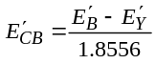  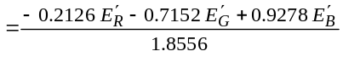  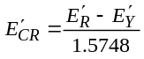  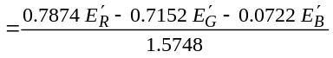
TABLE 3
Digital encoding equations

Parameter |  | Equations
 |  | Conventional colour gamut system | Extended colour gamut system⁽¹⁾
5 | Quantization of RGB, luminance and colour-difference signals(2), (3) | 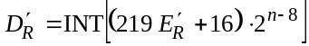  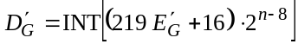  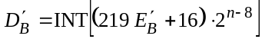 | 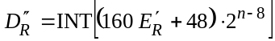  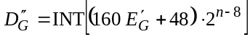  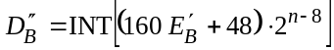
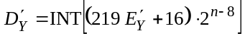
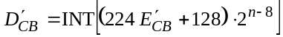
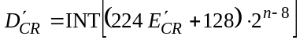
6 | Derivation of luminance and colour-difference signals via quantized RGB signals(4) | 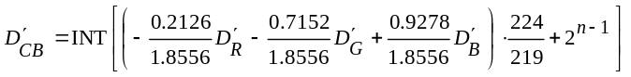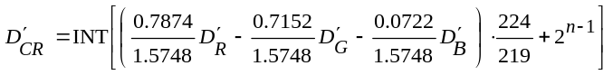 | 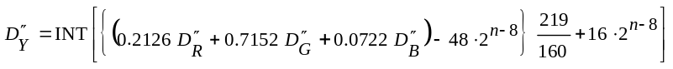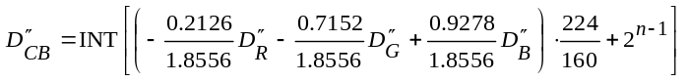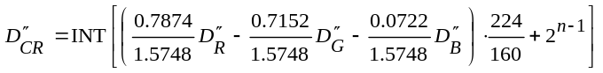
(1) A detailed explanation is given in Annex 1.
(2) “n” denotes the number of the bit-length of the quantized signal.
(3) The operator INT returns the value of 0 for fractional parts in the range of 0 to 0.4999... and +1 for fractional parts in the range of 0.5 to 0.9999..., i.e. it rounds up fractions above 0.5.
(4) Annex 2 specifies a procedure to obtain integer coefficients for digital implementation.

ANNEX 1
Extended colour gamut system using negative RGB signals
The reproducible colour gamut on a television display is limited to that area inside a triangle on the chromaticity diagram composed of the three primary colours of the display. This is due to the fact that negative light emissions of the primary colours cannot be realized with an actual display system. However, colours outside the triangle can be transmitted when negative and greater than 100% values are allowed as extended primary RGB signals. Current cameras normally develop extended gamut RGB signals in the process of linear matrixing to optimize colorimetric analysis, but the extended values are usually clipped in the subsequent processes to conform to the signal format of the system.
The colour gamut extension method using negative RGB signals provides compatibility with conventional systems, resulting in a smooth transition to the new wide gamut system.

Signal range
The required signal range of a television system is determined by reference primaries, opto-electronic transfer characteristics (gamma curve), and the colour gamut to be handled by the system. An exceptional signal range is required to reproduce the full range of pure spectral colours even with a wide gamut set of primaries. A realistic approach is to limit reproduction to the gamut of real surface colours as determined by Pointer.
Levels of analogue gamma pre-corrected RGB signals for the Pointer colours are shown in Fig. 1 (a)-(c). The Pointer colours provide the most highly saturated real surface colours for 36 hues (every 10°) and 16 lightness levels. In the Figure, 16 curves are drawn for different lightness levels, and it can be seen that these RGB signals exhibit negative and greater than 100% values. When these analogue RGB signals are converted into analogue luminance and colour difference signals using equations 4, Table 2, the resulting levels are shown in Fig. 2 (a)-(c). It can be seen that the levels are now contained within the normal dynamic range of 0-100% for luminance and ± 50% for colour difference. Thus for analogue signals there is a direct compatibility between conventional gamut systems and the equivalent colours in an extended gamut system.
For digital representation, it is necessary when quantizing extended gamut RGB signals to use different scaling factors and DC offset from those used for conventional gamut, as shown by equations 5, Table 3, i.e. 160 and 48 instead of 219 and 16. This is because the levels of the gamma pre-corrected extended gamut RGB signals exceed the dynamic range specified in Recommendations ITU-R BT.601 and BT.1120, indicated by the dashed lines in Fig. 1 (a)-(c). However, as with the analogue signals, quantized luminance and colour difference signals for conventional gamut and extended gamut are both accommodated within the dynamic ranges specified in Recommendations ITU-R BT.601 and ITU-R BT.1120, as indicated by the dashed lines in Fig. 2 (a)-(c). It follows that for compatibility, conversion from quantized RGB signals to quantized luminance and colour difference signals require different scaling factors as shown by equations 6, Table 3.
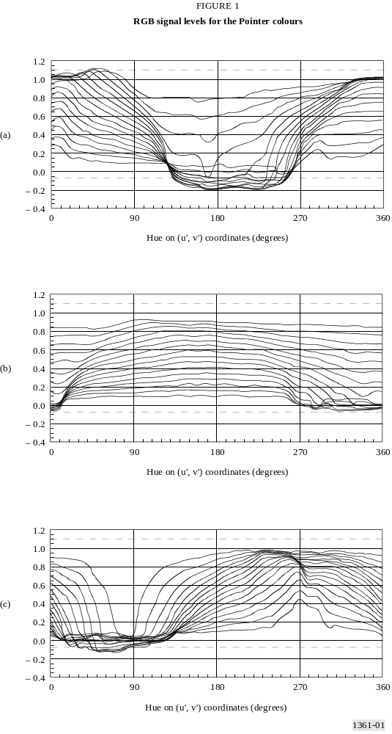
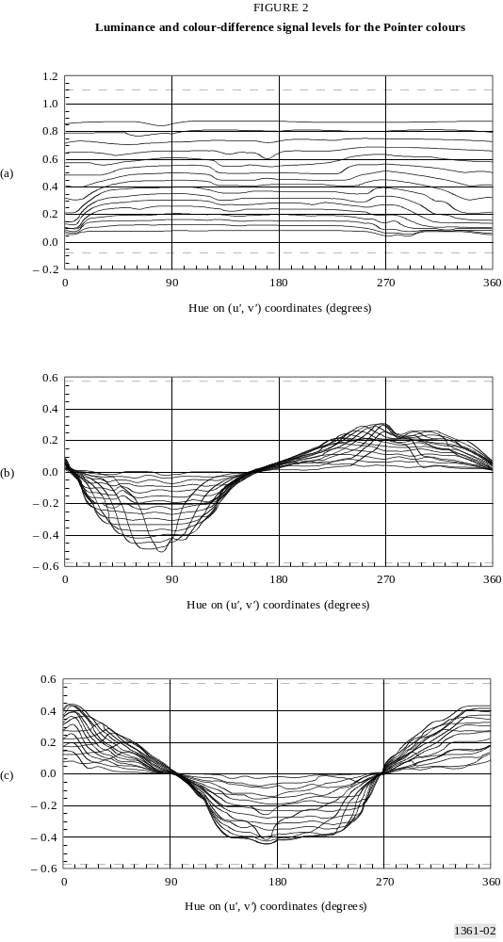
ANNEX 2
Derivation of integer coefficients of luminance
and colour-difference equations
Digital systems may introduce computation errors in the luminance and colour-difference signals due to the finite bit-length of the equation coefficients. Also, digital luminance and colour-difference signals may take slightly different values depending on the signal processing sequence, i.e. the discrepancy between signals quantized after analogue matrixing and signals digitally matrixed after quantization of RGB signals. To minimize such errors and discrepancies, the integer coefficients for the digital equations should be optimized. The optimization procedure and the resultant integer coefficients for several bit-lengths are given in the following.

1 Conventional colour gamut system
In the following, m and n denote the bit-lengths of the integer coefficients and digital signals, respectively.

1.1 Digital equations
The digital luminance equation for the conventional colour gamut system is described as follows:
(1)
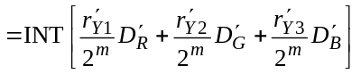 (2)
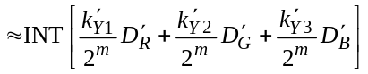 (3)
where r' and k' denote the real values of the coefficient and the integer coefficients, respectively, given below.
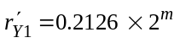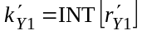
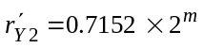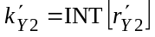
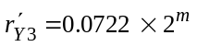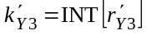
The digital colour-difference equations for the conventional colour gamut system are described as follows:
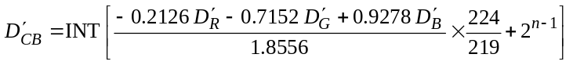 (4)
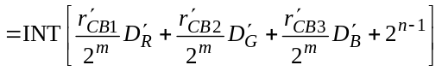 (5)
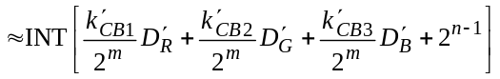 (6)
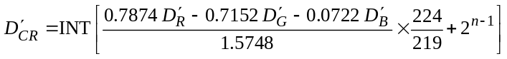 (7)
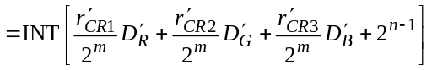 (8)
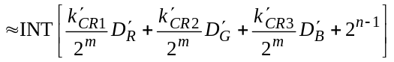 (9)
where:

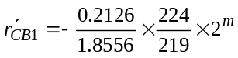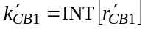
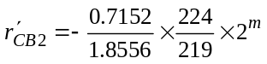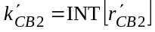
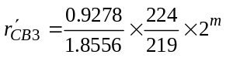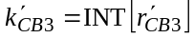
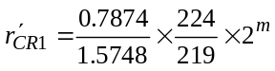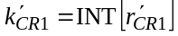
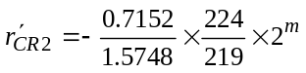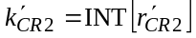
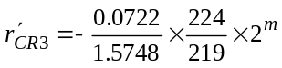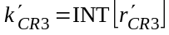

1.2 Optimization procedure
Equation (3) shows the digitally matrixed luminance signal which includes computation errors due to the finite bit-length of the integer coefficients. When the coefficient bit-length is increased, the argument (the value in [ ]) of equation (3) gets close to that of equation (2), resulting in the reduced errors or discrepancies between the equations. Therefore, the difference between the arguments of equations (2) and (3) can be regarded as a measure of the integer coefficient optimization. As the difference of arguments depends on input RGB signals, “Least Square Error” optimization is defined, in which the integer coefficients are adjusted in such a way that the sum of the squared difference over all inputs falls into the minimum value, that is, the value of equation (10) is minimized.
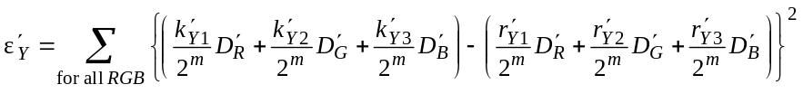 (10)
In addition to providing the minimum r.m.s. errors, this LSE optimization automatically minimizes the peak error that takes place at a particular input colour (a particular combination of input RGB signals), as well as the discrepancy between different signal processing sequences (analogue-matrixing and digital-matrixing).
The optimization procedure is as follows:
Step 1: For the initial value of each integer coefficient 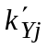 (j = 1, 2, 3), take the nearest integer to the real value of the coefficient 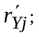
Step 2: With the initial integer coefficients, calculate the r.m.s. errors or the squared difference sum (equation (10)) over the input RGB signal range, e.g., 16 through 235 for an 8-bit system (a simple calculation method without using summation is described in § 1.3);
Step 3: Examine the r.m.s. errors when increasing/decreasing each integer coefficient by one. 27 (=33) combinations must be evaluated in total, because each coefficient can take three values, i.e. increased, decreased and unchanged from the initial value.
Step 4: Select the combination of the coefficients that gives the minimum r.m.s. error. This combination is the resultant optimized one.
The same procedure is applied for the colour-difference equations, using equations (11) and (12).
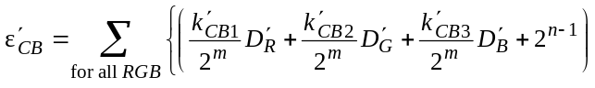
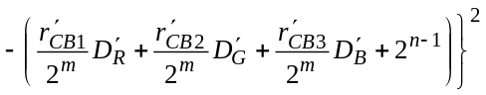 (11)
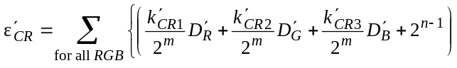
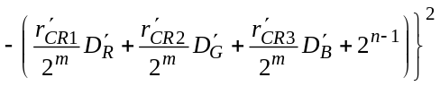 (12)

1.3 Simple calculation method for squared difference sum
By expressing the difference between integer and real coefficients value as δij = k'ij – r'ij, and the digital RGB signals as Xj, the sum of the squared differences of equations (10)-(12) can be written as the following:
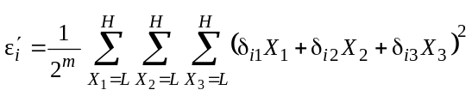 (13)
where L and H denote the lower and upper boundaries of the input signal range, respectively, for which the integer coefficients are to be optimized.
As L and H are constant in the digital system under consideration, the summations for Xj are also constant. Then equation (13) can be expressed as a function only of δij.
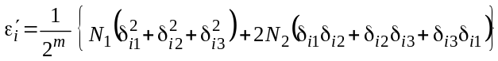 (14)
where:
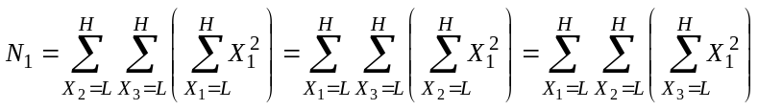
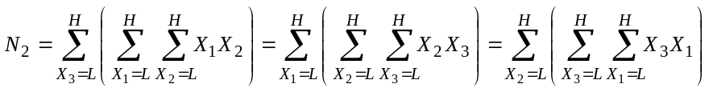
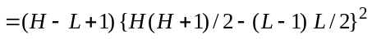
Thus the calculation of r.m.s. errors or equations (10)-(12) can be simply performed by equation (14).

2 Extended colour gamut system

2.1 Digital equations
The digital luminance equation for the extended colour gamut system is described as follows:
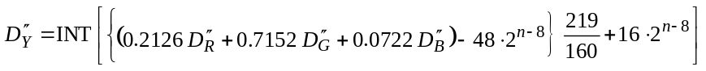 (15)
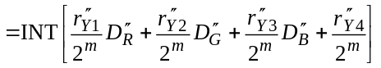 (16)
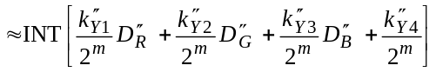 (17)
where r" and k" denote real values of the coefficient and integer coefficients, respectively, given below.
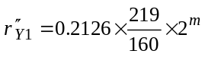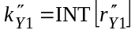
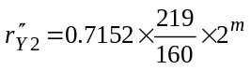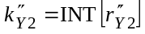
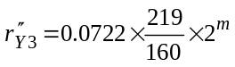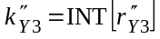
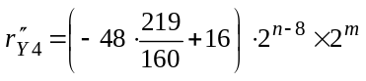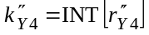
The digital colour-difference equations for the extended colour gamut system are described as follows:
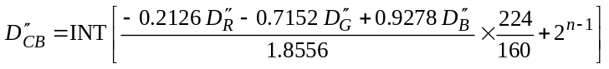 (18)
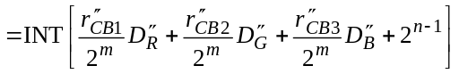 (19)
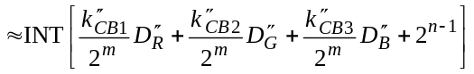 (20)
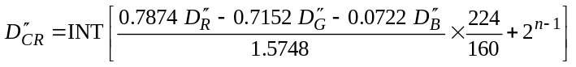 (21)
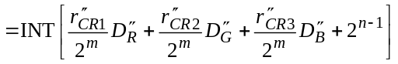 (22)
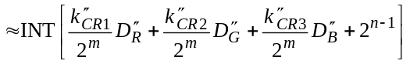 (23)
where:
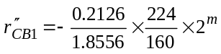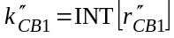
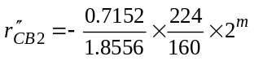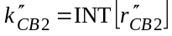
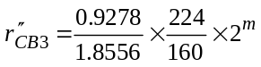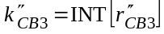
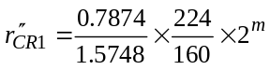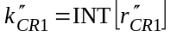
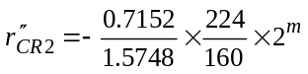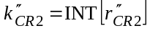
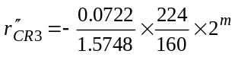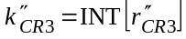

2.2 Optimization procedure
The optimization procedure is the same as that for the conventional colour gamut system, using equations (24)-(26). Note that for the luminance equation, the number of combinations to be evaluated for the r.m.s. error becomes 81 (= 3⁴) instead of 27, because there are four coefficients to be optimized.
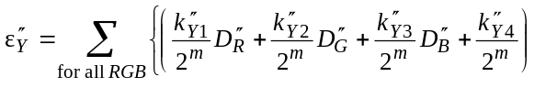
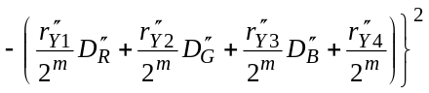 (24)
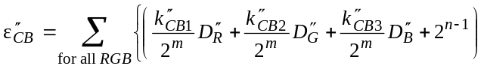
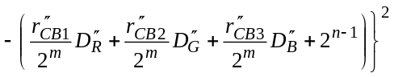 (25)
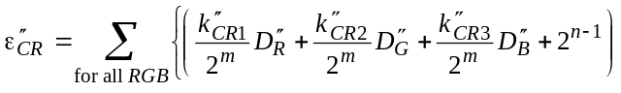
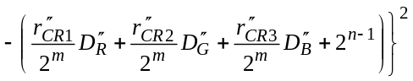 (26)

2.3 Simple calculation method for squared difference sum
Similarly to the conventional colour gamut system, equation (27) is obtained for the luminance equation of the extended colour gamut system.
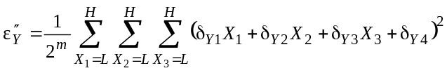
(27)
where N1 and N2 are given in equation (14), and
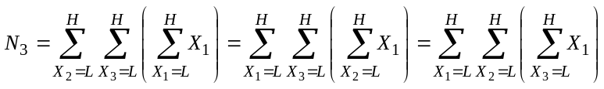
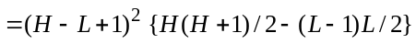
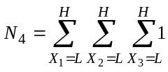
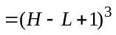
For the colour-difference equations, the same equation as that for the conventional colour gamut system (equation (14)) is applied.

3 Optimized integer coefficients
The resultant optimized integer coefficients are listed below for the coefficient bit-lengths of 8-16.
TABLE 4
Optimized integer coefficients for conventional colour gamut system
Coeff.  bits | Denominator | Luminance Y |  |  | Colour-difference CB |  |  | Colour-difference CR
m | 2m | 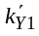 | 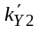 | 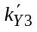 | 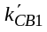 | 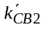 | 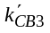 | 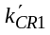 | 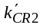 | 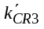
8 | 256 | 54 | 183 | 19 | –30 | –101 | 131 | 131 | –119 | –12
9 | 512 | 109 | 366 | 37 | –60 | –202 | 262 | 262 | –238 | –24
10 | 1 024 | 218 | 732 | 74 | –120 | –404 | 524 | 524 | –476 | –48
11 | 2 048 | 435 | 1 465 | 148 | –240 | –807 | 1 047 | 1 047 | –951 | –96
12 | 4 096 | 871 | 2 929 | 296 | –480 | –1 615 | 2 095 | 2 095 | –1 903 | –192
13 | 8 192 | 1 742 | 5 859 | 591 | –960 | –3 230 | 4 190 | 4 189 | –3 805 | –384
14 | 16 384 | 3 483 | 11 718 | 1 183 | –1 920 | –6 459 | 8 379 | 8 379 | –7 611 | –768
15 | 32 768 | 6 966 | 23 436 | 2 366 | –3 840 | –12 918 | 16 758 | 16 758 | –15 221 | –1 537
16 | 65 536 | 13 933 | 46 871 | 4 732 | –7 680 | –25 836 | 33 516 | 33 516 | –30 443 | –3 073
TABLE 5
Optimized integer coefficients for extended colour gamut system
Coeff.  bits | Denominator | Luminance Y |  |  |  | Colour-difference CB |  |  | Colour-difference CR
m | 2m | 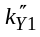 | 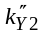 | 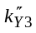 | 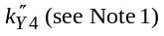 | 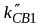 | 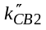 | 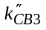 | 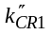 | 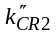 | 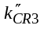
8 | 256 | 74 | 251 | 25 | –12 723 | –41 | –138 | 179 | 179 | –163 | –16
9 | 512 | 149 | 501 | 51 | –50 893 | –82 | –276 | 358 | 358 | –325 | –33
10 | 1 024 | 298 | 1 003 | 101 | –203 571 | –164 | –553 | 717 | 717 | –651 | –66
11 | 2 048 | 596 | 2 005 | 202 | –814 285 | –329 | –1 105 | 1 434 | 1 434 | –1 302 | –132
12 | 4 096 | 1 192 | 4 009 | 405 | –3 257 139 | –657 | –2 210 | 2 867 | 2 867 | –2 604 | –263
13 | 8 192 | 2 384 | 8 019 | 810 | –13 028 557 | –1 314 | –4 420 | 5 734 | 5 734 | –5 208 | –526
14 | 16 384 | 4 768 | 16 039 | 1 619 | –52 114 227 | –2 628 | –8 841 | 11 469 | 11 469 | –10 417 | –1 052
15 | 32 768 | 9 535 | 32 078 | 3 238 | –208 456 909 | –5 256 | –17 682 | 22 938 | 22 937 | –20 834 | –2 103
16 | 65 536 | 19 071 | 64 155 | 6 476 | –833 827 635 | –10 512 | –35 363 | 45 875 | 45 875 | –41 669 | –4 206
NOTE 1 – The value of 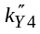 depends on the signal bit-lengths n, and the values listed are those for the cases m = n. It is confirmed that the optimized values are identical with the initial nearest integers in m + n bits precision, when m and n are within 8-16.
NOTE 2 – The underlined italic indicates the values modified from the initial nearest integer by the optimization.
NOTE 3 – For the conventional colour gamut system, the RGB signal region used in the optimization is the nominal signal range of Recommendation ITU-R BT.601 and its extensions, i.e. the range 16 × 2n–8 – 235 × 2n–8 for an n-bit system. For the extended colour gamut system, it is the maximum signal range of Recommendation ITU-R BT.601 and its extensions, i.e. 1 × 2 n–8 – 254 × 2 n–8.

* Radiocommunication Study Group 6 made editorial amendments to this Recommendation in 2002 in accordance with Resolution ITU-R 44.

