Recommendation ITU-R BS.643-4
(12/2022)
Radio data system for automatic tuning and other applications in FM radio receivers for use with the pilot-tone system

BS Series
Broadcasting service (sound)

Foreword
The role of the Radiocommunication Sector is to ensure the rational, equitable, efficient and economical use of the radio-frequency spectrum by all radiocommunication services, including satellite services, and carry out studies without limit of frequency range on the basis of which Recommendations are adopted.
The regulatory and policy functions of the Radiocommunication Sector are performed by World and Regional Radiocommunication Conferences and Radiocommunication Assemblies supported by Study Groups.

Policy on Intellectual Property Right (IPR)
ITU-R policy on IPR is described in the Common Patent Policy for ITU-T/ITU-R/ISO/IEC referenced in Resolution ITU-R 1. Forms to be used for the submission of patent statements and licensing declarations by patent holders are available from http://www.itu.int/ITU-R/go/patents/en where the Guidelines for Implementation of the Common Patent Policy for ITU-T/ITU-R/ISO/IEC and the ITU-R patent information database can also be found.

Series of ITU-R Recommendations
(Also available online at http://www.itu.int/publ/R-REC/en)
Series | Title
BO | Satellite delivery
BR | Recording for production, archival and play-out; film for television
BS | Broadcasting service (sound)
BT | Broadcasting service (television)
F | Fixed service
M | Mobile, radiodetermination, amateur and related satellite services
P | Radiowave propagation
RA | Radio astronomy
RS | Remote sensing systems
S | Fixed-satellite service
SA | Space applications and meteorology
SF | Frequency sharing and coordination between fixed-satellite and fixed service systems
SM | Spectrum management
SNG | Satellite news gathering
TF | Time signals and frequency standards emissions
V | Vocabulary and related subjects

Note: This ITU-R Recommendation was approved in English under the procedure detailed in Resolution ITU-R 1.

Electronic Publication
Geneva, 2022

© ITU 2022
All rights reserved. No part of this publication may be reproduced, by any means whatsoever, without written permission of ITU.

RECOMMENDATION ITU-R BS.643-4*
Radio data system for automatic tuning and other applications in FM radio receivers for use with the pilot-tone system
(1986-1990-1995-2011-2022)
Scope
This Recommendation specifies the main parameters and operational requirements for the use of the radio data system (RDS) for VHF/FM broadcasting.
Keywords
FM broadcasting, Radio Data System
The ITU Radiocommunication Assembly,
considering
a) that, in VHF/FM broadcasting, the density of transmissions in many parts of the world is increasing to the extent that tuning to a given programme service is becoming more and more difficult, particularly for listeners using FM portable or car radios;
b) that, on the other hand, technologies offer the possibility of adding auxiliary data signals to the sound-programme signals which offer a wide variety of methods for identifying the transmissions, thereby facilitating the implementation of assisted and automatic tuning in radio receivers;
c) that such radio-data signals can be added to existing VHF/FM broadcasts in such a way that they are inaudible, thus achieving good compatibility with reception of the normal stereophonic or monophonic sound-programme signals;
d) that inexpensive receiver technology optimized in miniaturization processes is available to implement assisted or automatic tuning using radio-data signals;
e) that such a system offers the flexibility to implement a wide range of optional applications to suit the particular needs of individual broadcasting organizations;
f) that many countries have implemented this system on their broadcasts,
recommends
1 that broadcasters wishing to introduce the transmission of supplementary information for station and programme identification in FM broadcasting and other applications, should use the radio-data system (RDS), as specified in Annex 1;
2 the following notes should be considered as part of the Recommendation.
NOTE 1 – Information regarding the operational characteristics of RDS is given in Annex 2.
NOTE 2 – The most recent version of the international RDS standard is IEC 62106 (2018 and later, all parts). In North America although the structure and coding is identical, there are minor differences in implementation of certain features. RDS in North America is called RBDS, specified in IEC 62106-9.
NOTE 3 – Since RDS was first specified by the European Broadcasting Union (EBU) in 1984. Billions of RDS receivers were and are still produced worldwide with retail prices held very low due to RDS decoder silicon embedded in FM receiver chips and software defined radio technology costing very little in large quantities.

Annex 1
Specifications of the radio data system*

1 Modulation of the data channel
1.1 Basic sub-carrier frequency (mandatory): 57 kHz, locked in phase or in quadrature to the third harmonic of the pilot tone 19 kHz (±2 Hz) in the case of stereophony. (Frequency tolerance: ±6 Hz.)
1.2 Three additional sub-carriers (optional): 66.5 kHz, 71.25 kHz and 76.0 kHz, phase locked to the basic sub-carrier 57 kHz.
1.3 Sub-carrier level: the recommended nominal deviation of the main FM carrier due to each modulated sub-carrier is ±2 kHz. However, in practice for the basic sub-carrier it can be as low as ±1.2 kHz; many EBU broadcasters with wide dynamic range (e.g. classical music) services prefer this lower value to ensure best signal-to-noise performance. The decoder should, however, be designed to work with sub-carrier levels corresponding to between ± 1 kHz and ± 7.5 kHz deviation.
The peak frequency deviations of the additional data streams on the upper sub-carriers need to be optimised. Since the amplitude of the RDS2 data stream increases with the peak frequency deviation, a larger deviation would imply better BER performance. However, larger deviations would increase the multiplex signal bandwidth (and consequently the FM signal bandwidth), which is constrained by Recommendation ITU-R BS.450. Therefore, a trade-off is necessary to optimise the peak frequency deviations of the RDS2 data streams subject to the bandwidth constraint.
1.4 Method of modulation: the sub-carriers are amplitude-modulated by the shaped and biphase-coded data signal. The sub-carrier is suppressed (see Figs 1a to 1c for the basic sub-carrier).
1.5 Clock frequency and data rate: the basic clock frequency is obtained by dividing the transmitted sub-carrier frequency by 48. Consequently, the basic data rate is 1 187.5 bit/s ± 0.125 bit/s.
1.6 Differential coding: when the input data-level from the coder at the transmitter is 0, the output remains unchanged from the previous output bit, and when an input 1 occurs, the new output bit is the complement of the previous output bit.

2 Baseband coding
2.1 Coding structure: the largest element in the structure is called a “group” of 104 bits. Each group comprises four blocks of 26 bits. Each block comprises an information word and a checkword, of 16 and 10 bits respectively.
2.2 Order of bit transmission: all information words, checkwords and addresses have their most significant bit transmitted first.
2.3 Error protection: the 10-bit cyclic redundancy checkword, to which a 10-bit offset word is added for synchronization purposes, is intended to enable the receiver/decoder to detect and correct errors which occur in reception.
2.4 Synchronization of blocks and groups: the data transmission is fully synchronous and there are no gaps between the groups or blocks. The beginning and end of the data blocks may be recognized in the decoder by using the fact that the error-checking decoder will, with a high level of confidence, detect block synchronization slip. The blocks within each group are identified by different offset words added to the respective 10-bit checkwords.
FIGURE 1
Spectrum and time-functions of RDS signals
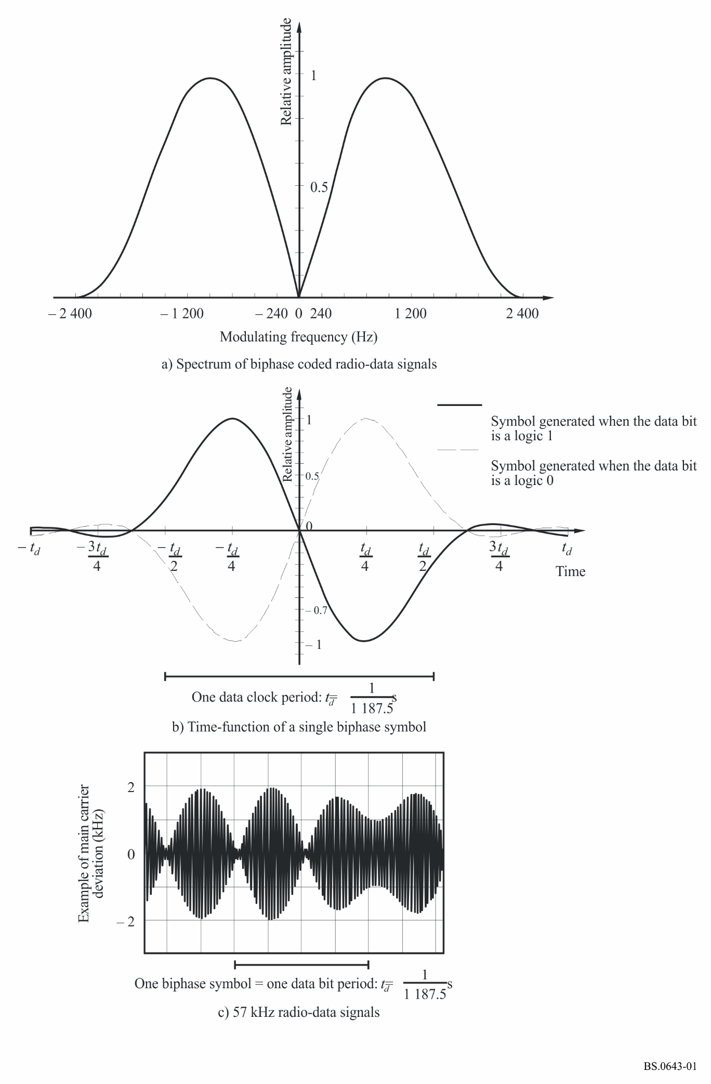
2.5 Message format on the basic sub-carrier: the first five bits of the second block of every group are allocated to a five-bit code which specifies the application group type and its version. The group types specified are given in Table 1. There is also the open data application feature ODA to add applications not yet defined. This allows applications to use specified groups on a regulated basis. This requires to register the particular ODA using the procedure detailed in IEC 62106-3.
A large part of the data-transmission capacity of the RDS system on the basic sub-carrier will be used for features relating to the automatic or assisted tuning functions of an FM receiver. Such messages are repeated frequently so that a short data-acquisition time for tuning or retuning may be achieved. Many of the relevant codes occupy fixed positions within every group. They can therefore be decoded without reference to any block outside the one which contains this information.
2.6 On the upper sub-carriers a new group type C, detailed in IEC 62106-2, is used. Each of these groups has the capacity for transporting 7 bytes or 56 bits. Using the RDS2 file transfer protocol RFT, files associated to ODAs of up to 163 kB can be transmitted. The respective ODA specifies in each case how to use the transmitted file in the receiver/decoder. Each ODA uses an application AID. A receiver not implementing the respective ODA-AID can discard the respective data received.
FIGURE 2
Message format and addressing on the basic sub-carrier

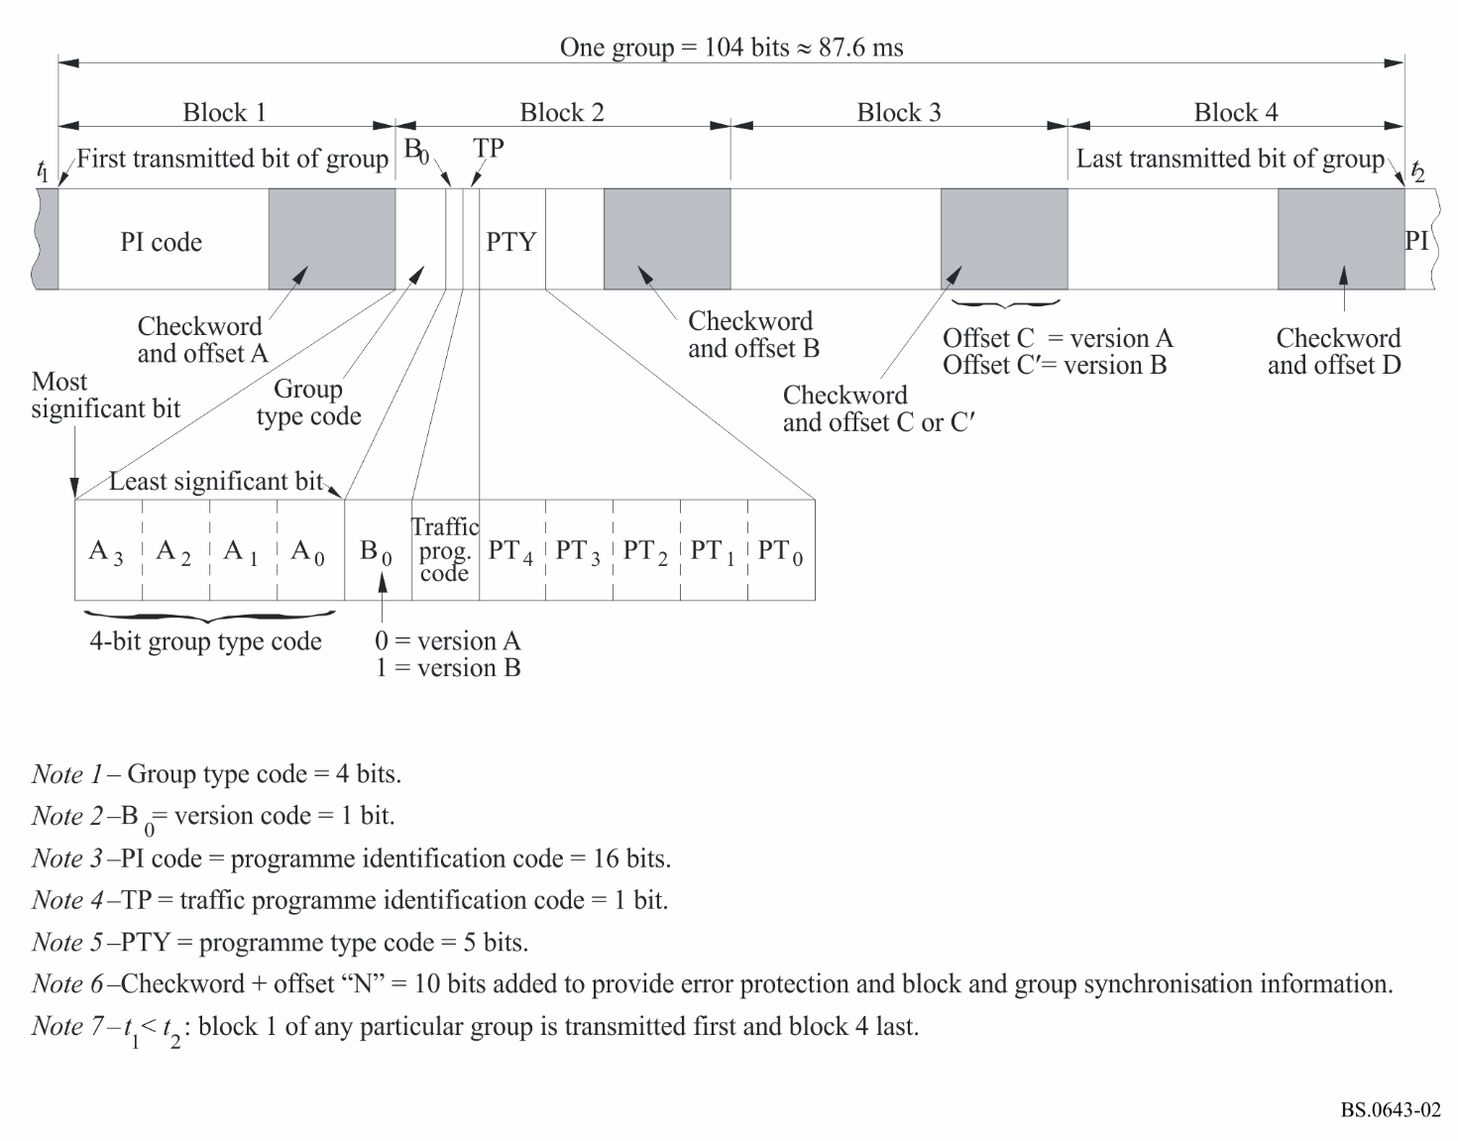
The group type C structure used on the upper sub-carriers is illustrated in Fig. 3.
FIGURE 3
Message format and Function header used for group identification on the upper sub-carriers
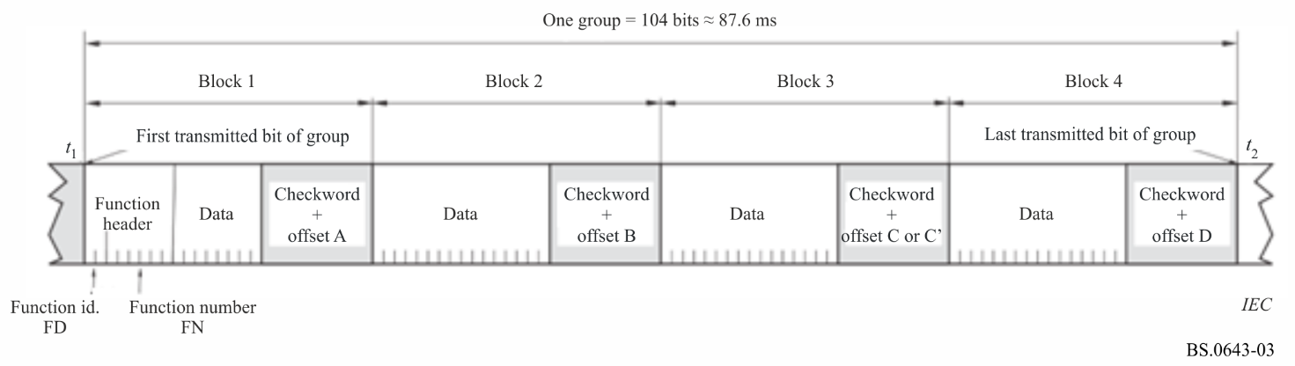
NOTE – The Function Header (FH) fully determines the identification of the group.
TABLE 1
Example of group type codes used on the basic sub-carrier
Group type |  |  |  |  |  | Applications
Decimal  value | Binary code
 | A₃ | A₂ | A₁ | A₀ | B₀
0 | 0 | 0 | 0 | 0 | X (1) | Basic tuning and switching information
2 | 0 | 0 | 1 | 0 | X | Radiotext
3 | 0 | 0 | 1 | 1 | 0 | Open data application identification
4 | 0 | 1 | 0 | 0 | 0 | Clock-time and date
14 | 1 | 1 | 1 | 0 | X | Enhanced other networks information
15 | 1 | 1 | 1 | 1 | 0 | Long programme service name
15 | 1 | 1 | 1 | 1 | 1 | Fast basic tuning and switching information
(1) X indicates that value may be “0” (version A) or “1” (version B).
Note: Groups not listed here may be used to carry ODA data.

Table 2 explains the abbreviations used and the features to which they are relevant.
TABLE 2
List of abbreviations and features
Tuning functions | Other functions
PI: Programme identification | TA: Traffic announcement flag
PS: (Short) programme service name | DI: Decoder identification
LPS: Long programme service name | RT/RT+/eRT: Radiotext/radiotext plus/enhanced radiotext
AF: List of alternative frequencies | CT: Date and time
TP: Traffic programme identification | ODA: Open data application
PTY: Programme type | TMC: Traffic message channel
EON: Enhanced other networks information | RDS2: Using one, two or all three upper sub-carriers
ECC: Extended country code | RFT: RDS2 file transfer protocol

2.7 Repetition rates: Table 3 indicates the appropriate repetition rates for some of the main applications, when and if they are implemented by the broadcaster.
TABLE 3
Appropriate repetition rates
Applications | Group types which contain this information | Appropriate repetition rate per second
Programme identification (PI) code | All | 11.4⁽¹⁾
Programme type (PTY) code | All | 11.4⁽¹⁾
Traffic programme (TP) identification code | All | 11.4⁽¹⁾
Programme service (PS) name | 0A, 0B | 1⁽²⁾
Alternative frequency (AF) code pairs | 0A | 4⁽²⁾
Traffic announcement (TA) code | 0A, 0B, 15B | 4
Decoder identification (DI) code | 0A, 0B, 15B | 1
Music/speech (M/S) code | 0A, 0B, 15B | 4
Radiotext (RT) message | 2A, 2B | 0,2⁽³⁾
Enhanced other networks information (EON) | 14A, 14B | Up to 2⁽⁴⁾
(1) Valid codes for this item will normally be transmitted with at least this repetition rate whenever the transmitter carries a normal broadcast programme.
(2) A total of four 0A groups are required to transmit the entire PS name and therefore four 0A groups will be required per second. The repetition rate of group type 0A may be reduced if more capacity is needed for other applications. A minimum of two type 0A groups per second is necessary to ensure correct functioning of PS and AF features. It should be noted that in this case transmission of the complete PS will take 2 s. However, under typical reception conditions the introduction of errors will cause the receiver to take 4 s or more to acquire the PS name for display. PS is static and must not be used for text transmission.
(3) A total of 16 type 2A groups are required to transmit a 64 character radiotext message and therefore 3.2 type 2A groups will be required per second. For certain character sets composed of a 2-byte character code, the enhanced Radiotext feature is more suitable.
(4) The maximum cycle time for the transmission of all data relating to all cross-referenced programme services shall be less than 2 min.

Annex 2
Operational characteristics of the radio data system “RDS”

1 Compatibility with existing VHF/FM broadcasts
The frequency, level and method of modulation of the sub-carriers used to convey the data signals have been carefully chosen so as to avoid interference to reception of the main stereo or mono programme signals. Because of the extreme importance of these compatibility considerations, extensive and prolonged field-trials have been conducted in several countries. It has been found that over a wide variety of propagation conditions, and with a wide variety of receivers, good compatibility is achieved. However, in some locations where the received signals are affected by severe multipath propagation, interference to the main programme signal may occur. In such circumstances, however, even in the absence of RDS signals, the quality of the received programme signal is usually poor due to distortion.

2 Reliability of reception of radio-data signals
When assessing the reliability of reception of radio-data signals it is important to divide the applications of the RDS system into two categories: those using short and frequently repeated messages, for example, automatic tuning functions; and those using longer messages which are repeated rarely, for example, radiotext (RT) messages.
In the case of field-strength limited reception conditions, as might be experienced in a fixed domestic installation, and with the recommended RDS injection level of ± 2 kHz, adequately reliable reception of short messages is possible for an input e.m.f. to the receiver down to about 15 dB(μV) (from a 50 Ω source) whilst adequately reliable reception of the longer messages required an input e.m.f. of about 20 dB(μV). It should be stressed that the values given above depend on the noise figure of the receiver which is typically about 7 dB. These input voltages correspond to bit error-ratio in the received signal before error correction of 1 × 10^{–2} and 1 × 10^{–4}, respectively. Under these field-strength limited conditions, the bit error-ratio in the received signal decreases exponentially with increasing receiver antenna input level. Furthermore, for RDS injection levels at the transmitter in the specified range ± 1 kHz to ± 7.5 kHz, the receiver antenna input signal level needed to attain a given error-ratio increases almost proportionally with decreasing injection level and vice versa. For example, decreasing the injection level from ± 2 kHz to ± 1 kHz increases the antenna input e.m.f. needed by an RDS receiver to attain a given bit error-ratio by 6 dB.
In determining the best level for the injected RDS signals, it was found that a compromise had to be found between compatibility with the main programme signals on the one hand and reliability of RDS signal reception on the other. Overall, the recommended RDS injection level corresponding to ± 2 kHz deviation per sub-carrier of the main FM carrier was found to give the best compromise over a wide range of reception conditions.
In the case of mobile reception in vehicles, multipath propagation is often found to be the dominant impairment to RDS signal reception. In order to obtain information about the performance of the RDS system under multipath limited reception conditions, extensive field trials were carried out in several countries.
In these field trials, which were conducted on roads where reception of signals from the local broadcast transmitter was severely impaired by multipath propagation, it was found that the frequently repeated messages needed for the automatic tuning functions of RDS receivers could be reliably received even though the received programme signal was often severely impaired by distortion and noise. As in the case of field-strength limited reception conditions, reception reliability was found to improve with increasing RDS injection level at the transmitter. However, it was found that adequate performance was maintained down to the minimum injection level of ± 1 kHz allowed by the specifications of the RDS system.
The RF protection ratio needed by the RDS system against interference from unwanted broadcast signals in the same or adjacent channels was determined by laboratory measurements using a procedure similar to that used to derive the protection ratios given in Recommendation ITU-R BS.412. The results of these measurements for steady interference are given in Fig. 4 for RDS using the basic sub-carrier only. It may be noted that for transmissions using the recommended channel spacing of 100 kHz, the protection ratio needed by the RDS system is much less than that needed for the stereo programme signal. Figure 4 shows that RDS protection ratios are close to those for monophonic programme signals; these can be improved, if desired, by using an increased level of RDS sub-carrier.
The existing protection ratios needed for the monophonic and stereophonic broadcasting services were found to be unaffected by the inclusion of an RDS sub-carrier in the interfering signal. This was found to be true for deviation of the main carrier, by the sub-carrier, of up to ± 7.5 kHz.
FIGURE 4
Comparison of protection ratios for monophony and stereophony given in Recommendation ITU-R BS.412
with those measured for the radio-data system RDS using only the basic sub-carrier
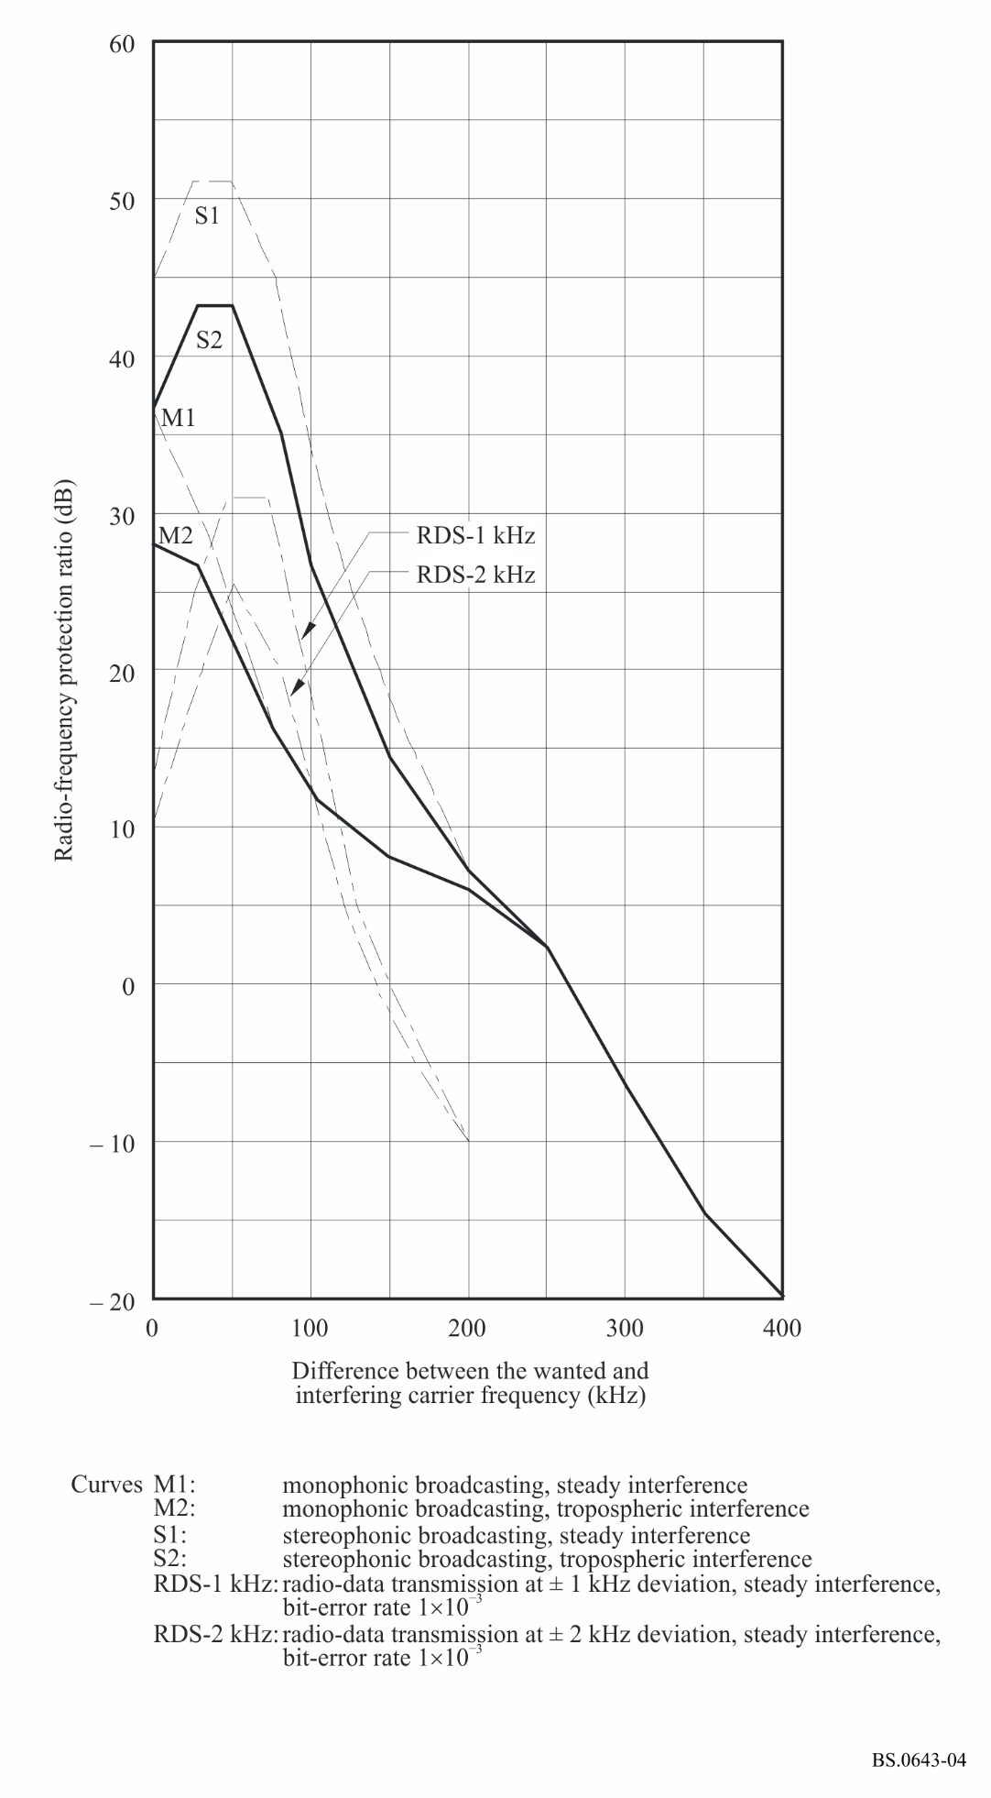

* This Recommendation should be brought to the attention of the International Electrotechnical Commission (IEC).
* The characteristics published here are only a summary drawn from a more detailed text which is published separately as the IEC 62106 standard.
The phase lock requirements are detailed in IEC 62106-1. They are needed to facilitate the demodulation using DSP technology The symbol shifting used reduces the peak deviation of the RDS2 data signal by an amount of 25%.

