Recommendation ITU-R BS.2076-3
(02/2025)
BS Series: Broadcasting service (sound)
Audio definition model

Foreword
The role of the Radiocommunication Sector is to ensure the rational, equitable, efficient and economical use of the radio-frequency spectrum by all radiocommunication services, including satellite services, and carry out studies without limit of frequency range on the basis of which Recommendations are adopted.
The regulatory and policy functions of the Radiocommunication Sector are performed by World and Regional Radiocommunication Conferences and Radiocommunication Assemblies supported by Study Groups.

Policy on Intellectual Property Right (IPR)
ITU-R policy on IPR is described in the Common Patent Policy for ITU-T/ITU-R/ISO/IEC referenced in Resolution ITU-R 1. Forms to be used for the submission of patent statements and licensing declarations by patent holders are available from https://www.itu.int/ITU-R/go/patents/en where the Guidelines for Implementation of the Common Patent Policy for ITU-T/ITU-R/ISO/IEC and the ITU-R patent information database can also be found.

Series of ITU-R Recommendations
(Also available online at https://www.itu.int/publ/R-REC/en)
Series | Title
BO | Satellite delivery
BR | Recording for production, archival and play-out; film for television
BS | Broadcasting service (sound)
BT | Broadcasting service (television)
F | Fixed service
M | Mobile, radiodetermination, amateur and related satellite services
P | Radiowave propagation
RA | Radio astronomy
RS | Remote sensing systems
S | Fixed-satellite service
SA | Space applications and meteorology
SF | Frequency sharing and coordination between fixed-satellite and fixed service systems
SM | Spectrum management
SNG | Satellite news gathering
TF | Time signals and frequency standards emissions
V | Vocabulary and related subjects

Note: This ITU-R Recommendation was approved in English under the procedure detailed in Resolution ITU-R 1.

Electronic Publication
Geneva, 2025

© ITU 2025
All rights reserved. No part of this publication may be reproduced, by any means whatsoever, without written permission of ITU.

RECOMMENDATION ITU-R BS.2076-3
Audio definition model
(2015-2017-2019-2025)
Scope
This Recommendation describes the structure of a metadata model that allows the format and content of audio files to be reliably described. This model, called the Audio Definition Model (ADM), specifies how XML metadata can be generated to provide the definitions of tracks in an audio file.
Keywords
ADM, Audio Definition Model, BW64, Metadata, Wave-file, WAVE, object-based, channel-based, scene-based, renderer, XML, XSD, format, immersive
The ITU Radiocommunication Assembly,
considering
a) that Recommendation ITU-R BS.2051 – Advanced sound system for programme production, highlights the need for a file format that is capable of dealing with the requirements for future audio systems;
b) that Recommendation ITU-R BS.1909 – Performance requirements for an advanced multichannel stereophonic sound system for use with or without accompanying picture, outlines the requirements for an advanced multichannel stereophonic sound system;
c) that it is desirable that there is a single standard for a metadata model for defining audio content that file and streaming formats could adopt,
recommends
that the Audio Definition Model described in Annex 1 should be used for the following cases in programme production and international exchange:
– applications requiring a generic metadata model for, and a formalized description of, custom/proprietary audio formats and content (including codecs);
– generating and parsing audio metadata with general-purpose tools, such as text editors;
– an organizationʼs internal production developments, where multi-purpose metadata needs to be added;
– a human-readable and hand-editable file for describing audio configurations (such as describing a mixing studio channel configuration) in a consistent and translatable format is needed.

Table of Contents
Page
Annex 1 Audio Definition Model 4
1 Introduction 4
2 Background 4
2.1 Cooking analogy 4
2.2 Brief overview 5
3 Overview description of the ADM 5
3.1 Format 7
3.2 Content 7
4 Common definitions 9
5 ADM elements 9
5.1 audioTrackFormat 9
5.2 audioStreamFormat 10
5.3 audioChannelFormat 11
5.4 audioBlockFormat 13
5.5 audioPackFormat 26
5.6 audioObject 31
5.7 audioContent 38
5.8 audioProgramme 42
5.9 audioTrackUID 48
5.10 profileList 49
5.11 tagList 50
5.12 audioFormatExtended 52
5.13 Time parameters format 53
6 Use of IDs 53
7 <chna> Chunk 56
8 Coordinate system 57
9 Common parameter descriptions for all typeDefinitions 58
9.1 gain 59
9.2 importance 59
9.3 jumpPosition and interpolationLength 59
9.4 headLocked 61
9.5 headphoneVirtualise 61
10 Parameter descriptions for typeDefinition of ‘Objects’ 62
10.1 diffuse 62
10.2 channelLock 62
10.3 zoneExclusion 62
10.4 objectDivergence 63
10.5 screenRef and audioProgrammeReferenceScreen 63
11 Parameter descriptions for typeDefinition of ‘HOA’ 64
11.1 order and degree 64
11.2 normalization 65
11.3 nfcRefDist 66
11.4 screenRef 66
11.5 Ambisonics Channel Numbering 66
12 Relationship and application of gain parameters in the ADM 67
13 Application of position-related parameters in the ADM 69
14 References 72
Annex 2 (informative) Examples of ADM usage 73
1 Channel-based example 73
1.1 Summary of elements 73
1.2 Element Relationships 74
1.3 Sample code 75
2 Channel-based example optimized for PCM 77
2.1 Summary of elements 77
2.2 Element Relationships 78
2.3 Sample code 79
3 Object-based example 80
3.1 Summary of elements 80
3.2 Element Relationships 81
3.3 Sample code 82
4 Scene-based example 84
4.1 Summary of elements 84
4.2 Element Relationships 85
4.3 Sample code 86
5 Personalized audio example 88
5.1 Summary of elements 89
5.2 Element Relationships 91
5.3 Sample code 92
6 22.2 multichannel programme with an alternative dialogue example 99
6.1 Summary of elements 99
6.2 Element relationships 102
6.3 Sample code 103
7 Example of the use of the Matrix type 117
7.1 Summary of elements 117
7.2 Element Relationships 118
7.3 Sample code 118
Annex 3 (informative) Overview of changes in this edition (Recommendation ITU-R BS.2076-3) 120

Annex 1
Audio Definition Model

1 Introduction
Audio for broadcasting and cinema is evolving towards an immersive and interactive experience, which requires the use of more flexible audio formats. A fixed channel-based approach is not sufficient to encompass these developments and so combinations of channel, object and scene-based formats have been developed. Report ITU-R BS.2266 [1] and Recommendations ITU-R BS.1909 [2] and ITU-R BS.2051 [3] highlight these developments and the need for the production chain to accommodate them.
The requirement for allowing different types of audio to be distributed, whether by file or by streaming, is that whatever file/stream format is used, metadata should co-exist to fully describe the audio. Each individual track within a file or stream should be able to be correctly rendered, processed or distributed according to the accompanying metadata. To ensure compatibility across all systems, the Audio Definition Model is a Recommendation that will make this possible.

2 Background
The purpose of this model is to formalise the description of audio. It is not a format for carrying audio. This distinction will help in the understanding of the model.

2.1 Cooking analogy
To help explain what the ADM actually does, it may be useful to consider a cooking analogy. The recipe for a cake will contain a list of ingredients, instructions on how to combine those ingredients and how to bake the cake.
The ADM is like a set of rules for writing the list of ingredients; it gives a clear description of each item, for example: 2 eggs, 400g flour, 200g butter, 200g sugar.
The ADM provides the instructions for combining ingredients but does not tell you how to do the mixing or baking; in the audio world that is the role of the renderer.
The ADM is compatible with wave-file based formats such as the BW64 format specified in Recommendation ITU-R BS.2088 [7] and the BWF as defined by the ITU in Recommendation ITU-R BS.1352 [4].
When Recommendation ITU-R BS.2088 is used, the <chna> chunk of the BW64 file is like the bar code on the packet of each of the ingredients; this code allows us to look up the model’s description of each item. The bag containing the actual ingredients is like the 'data' chunk of the BW64 file that contains the audio samples.
From the BW64 file point of view, one would look at the bar codes on each ingredient in the bag, and use that to look up the description of each item in the bag. Each description follows the structure of the model. There might be ingredients such as breadcrumbs, which could be divided into its own components (flour, yeast, etc.); which is like having an audio object containing multiple channels (e.g. ‘stereoʼ containing ‘left’ and ‘right’).
See Report ITU-R BS.2388 – Usage guidelines for audio definition model and multichannel audio files [10] that describes in detail the use of ADM.

2.2 Brief overview
This model uses XML as its specification language. When used with BW64 files [7], the XML may be embedded in specific chunks, for example the <axml> chunk, of the file.
The model is divided into two sections, the content part, and the format part. The content part will describe the language of dialogue, the loudness, etc.
The format part describes the technical nature of the audio so it can be decoded or rendered correctly. Format elements may be defined before having any audio signals, whereas the content parts can usually only be completed after the signals have been generated.

3 Overview description of the ADM
The overall diagram of the UML model for the ADM is shown in Fig. A1-1. This shows how the elements relate to each other and illustrates the split between the content and format parts. It also shows the <chna> chunk of a BW64 file and how it connects the tracks in the file to the model.
Where a BW64 file contains a number of audio tracks, it is necessary to know what each track is. The <chna> chunk contains a list of numbers corresponding to each track in the file. Hence, for a 6-track file, the list is at least 6 long. For each track there is an audioTrackFormatID number and an audioTrackUID number (notice the additional ‘U’ which stands for ‘unique’). The reason the list could be longer than the number of tracks is that a single track may have different definitions at different times so will require multiple audioTrackUIDs and references.
The audioTrackFormatID is used to look up the definition of the format of that particular track. The audioTrackFormatIDs are not unique; for example, if a file contains five stereo pairs, there will be five identical audioTrackFormatIDs to describe the ‘left’ channel, and five to describe the ‘right’ channel. Thus, only two different audioTrackFormatIDs will need to be defined. However, audioTrackUIDs are unique (hence the ‘U’), and they are there to uniquely identify the track. This use of IDs means that the tracks can be ordered in any way in the file; their IDs reveal what those tracks are.
Figure A1-1
Overall UML Model
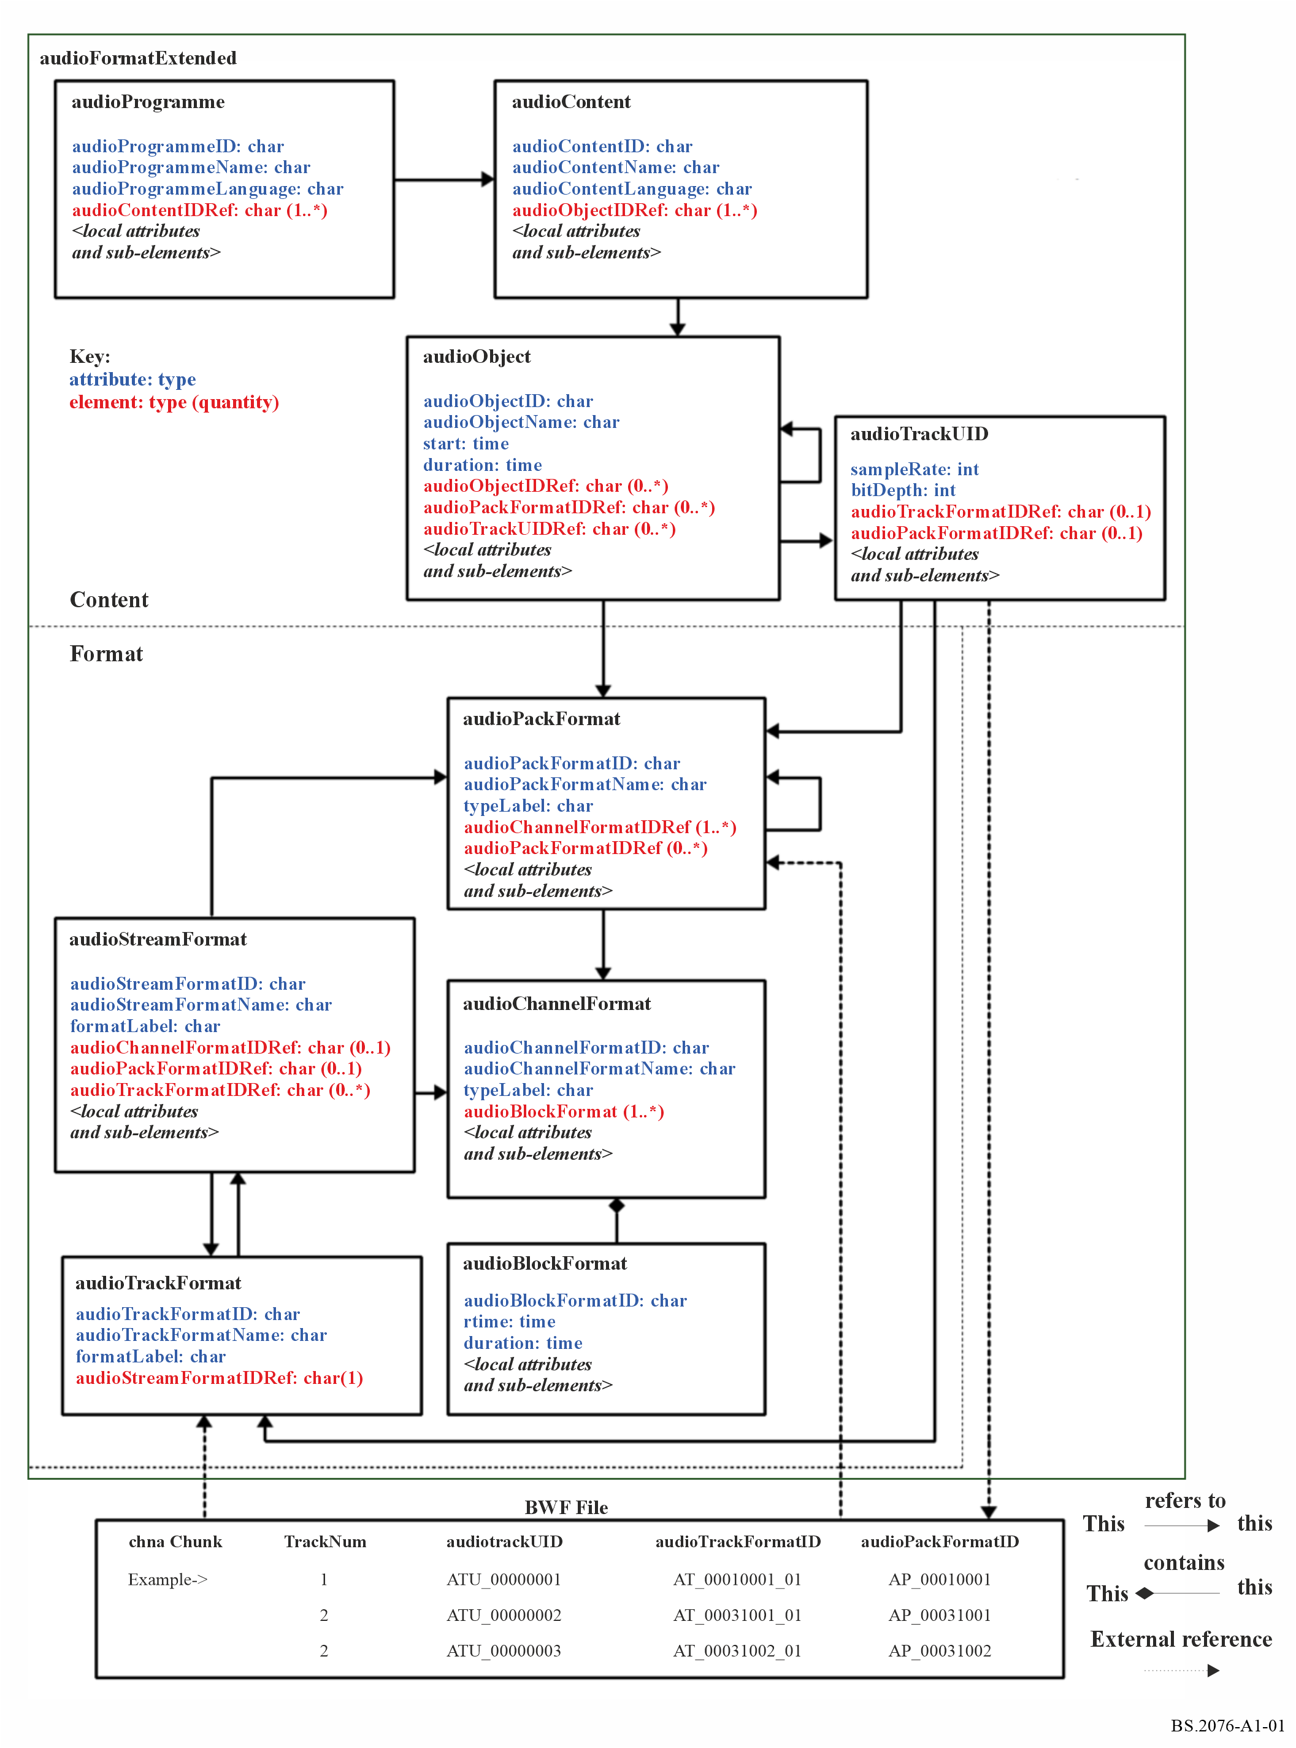

3.1 Format
The audioTrackFormatID identifies the format of the track. The audioTrackFormat shall also contain a reference to an audioStreamFormatID, which allows identification of the combination of the audioTrackFormat and audioStreamFormat. An audioStreamFormat describes a decodable signal.
The audioStreamFormat references one or more audioTrackFormats. The combination of audioStreamFormat and audioTrackFormat reveals whether the signal has to be decoded or not.
The next stage is to determine what type of audio the stream is; for example, it may be a conventional channel (e.g. ‘front left’), an audio object (e.g. something named ‘guitar’ positioned at the front), a HOA (Higher Order Ambisonics) component (e.g. ‘X’) or a group of channels. Inside audioStreamFormat there shall be a reference to either an audioChannelFormat or audioPackFormat that will describe the audio stream. There shall only be one of these references.
If audioStreamFormat contains an audioChannelFormat reference (i.e. audioChannelFormatIDRef) then audioStreamFormat is one of several different types of audioChannelFormat. An audioChannelFormat is a description of a single waveform of audio. In audioChannelFormat, the typeDefinition attribute shall be set such that it identifies the channel type.
The typeDefinition attribute can be set to ‘DirectSpeakers’, ‘HOA’, ‘Matrix’ ‘Objects’ or ‘Binaural’. For each of those types, there is a different set of sub-elements to specify the static parameters associated with that type of audioChannelFormat. For example, the ‘DirectSpeakers’ type of channel has the sub-element ‘speakerLabel’ for allocating a loudspeaker to the channel.
To allow audioChannelFormat to describe dynamic channels (i.e. channels that may change over time), audioBlockFormat is used to divide the channel along the time axis. The audioBlockFormat element may contain a start time (relative to the start time of the parent audioObject) and duration. Within audioBlockFormat the time-dependent parameters that describe the channel depend upon the audioChannelFormat type.
For example, the ‘Objects’ type of channel has the sub-elements ‘azimuth’, ‘elevation’ and ‘distance’ to describe the location of the sound. The number and duration of audioBlockFormats is not limited, there could be an audioBlockFormat for every sample if something moves rapidly, though that might be a bit excessive! At least one audioBlockFormat shall be required, static channels shall have one audioBlockFormat containing the channel’s parameters.
When an audioStreamFormat is representing a single channel of audio (such as for PCM), the audioStreamFormat shall contain a single reference to an audioChannelFormat, and it shall not contain any references to audioPackFormats.
When an audioStreamFormat is representing multiple audio channels that are combined in a coded bitstream (e.g. an MPEG-1 Layer II bitstream), the audioStreamFormat shall reference a single audioPackFormat, and not reference any audioChannelFormats.
For example, ‘stereo’, ‘5.1’, ‘1st order Ambisonics’ would all be examples of an audioPackFormat. Note that audioPackFormat just describes the format of the audio. For example, a file containing 5 stereo pairs will contain only one audioPackFormat to describe ‘stereo’. It is possible to nest audioPackFormats; a ‘2nd order HOA’ could contain a ‘1st order HOA’ audioPackFormat alongside audioChannelFormats for the R, S, T, U & V components.

3.2 Content
Using an audio scene with five stereo pairs as an example, the audioTrackFormat defines which audio tracks are left and right, not which ones belong together, nor what is represented in them. AudioObject is used to determine which tracks belong together and where they are in the file. This element links the actual audio data with the format, and this is where audioTrackUID comes in.
For example, for a stereo pair in PCM, an audioObject contains references to two audioTrackUIDs; therefore, those two tracks will contain the associated essence. The audioObject contains a reference to an audioPackFormat, which defines the format of those two tracks as a stereo pair.
As there are five stereo pairs in this example, 5 audioObject elements are needed. Each one shall contain the same reference to a stereo audioPackFormat, but shall contain different audioTrackUID references, as each stereo pair is carrying different audio. The order of audioTrackUIDRefs is not important in an audioObject, as the format definition through audioTrack, audioStreamFormat, audioChannelFormat and audioPackFormat determines which track is which.
The audioObject element may also contain start and duration attributes. This start time is the time when the signal for the object starts in a file or recording. Thus, if start is “00:00:10.00000”, the signal for the object shall start 10 seconds into the track in the audio file.
As audioPackFormat can be nested, it follows that audioObjects can be nested. Therefore, the audioObject shall contain not only references to the two audioTrackUIDs carrying the stream, but also references to two audioObjects, one for the 5.1 and one for the 2.0.
AudioObject is referred to by audioContent, which gives a description of the content of the audio; it has parameters such as language (if there is dialogue) and the loudness parameters. Some of the values for these parameters can only be calculated after the audio has been generated, so they are not in the format part.
AudioProgramme brings all the audioContent together; it combines them to make the complete ‘mix’.
For example:
– an audioProgramme may contain audioContent for ‘narrator’ and another one for ‘background music’;
– an audioProgramme for France may contain audioContents called ‘dialogue-fr’ and ‘backgroundMusic’, and another audioProgramme for the UK which contains audioContents called ‘dialogue-en’ and the same ‘backgroundMusic’.
Multiple audioProgramme elements can be defined in one ADM XML tree representation. This facilitates the description of a presentation that represents a predefined number of meaningful mixes that users can choose from. Each audioProgramme element may reference just a subset of audioContent elements of the ADM XML tree. This is one method to enable the ADM to describe personalised audio.
For example:
– Following the previous example for audioProgramme, a single ADM XML tree can contain both French and English audioProgramme elements.
– An ADM XML tree describing a sports programme can contain audioProgramme elements for a home team and an away team. The home team audioProgamme may contain audioContent elements for a ‘home team biased commentary’, and another one for ‘ambience’. The away team audioProgramme may contain audioContent for an ‘away team biased commentary’ and the same ‘ambience’.
TABLE A1-1
Alternative mixes
 | Ambience | Neutral commentary | Home team biased commentary | Away team biased commentary
Default mix | • | •
Home team | • |  | •
Away team | • |  |  | •

Another approach to this example is to use a single audioProgramme containing the four audioContent elements (‘ambience’, ‘neutral commentary’, ‘home team biased commentary’ and ‘away team biased commentary’) and associated four audioObject elements, and allow user interaction to be used to select the audioObject elements for commentary.

4 Common definitions
For many situations, particularly in channel and scene-based work, many of the required formats will be common. For example, mono, stereo and 5.1 all have common definitions and it would be inefficient to generate and carry a mass of XML every time one of these formats needs to be described. Common definitions are specified in Recommendation ITU-R BS.2094 [8].
This set is defined in Recommendation ITU-R BS.2094 [8] and is also available as an attached XML file. This reference file does not have to be included in a file using the ADM but can be externally referred to. Therefore, a file should not need to carry the XML of the format if only common definitions are used. When audioProgramme, audioContent and audioObject are used, or custom definitions are required, then the file shall carry ADM XML code.

5 ADM elements
Each of the elements within the ADM is described in the following subsections.

5.1 audioTrackFormat
The audioTrackFormat element describes the format of a single set of samples or data in a single track in a storage medium. It is used to describe what format the data is in, allowing a renderer to decode the signal correctly. It is referred from the audioStreamFormat element, which is used to identify the combination of tracks required to decode the track data successfully.
For PCM audio an audioStreamFormat will refer to a single audioTrackFormat and so the two elements are effectively describing the same thing. In this case, the audioTrackFormat and the audioStreamFormat should be omitted. Then the audioTrackUID shall refer to the corresponding audioChannelFormat. For coded audio, multiple audioTrackFormats will have to be combined in a single audioStreamFormat to generate decodable data.
Software that parses the model can start from either audioTrackFormat or audioStreamFormat. To allow for this flexibility audioTrackFormat can also refer back to the audioStreamFormat.
If the audioStreamFormat references an audioTrackFormat then the audioTrackFormat shall refer back to the same audioStreamFormat.

5.1.1 Attributes
TABLE A1-2
AudioTrackFormat attributes
Attribute | Description | Example | Required
audioTrackFormatID | ID for track, see § 6. The yyyy digits of AT_yyyyxxxx_zz represent the type of audio contained in the track. The yyyyxxxx digits shall match the audioStreamFormat yyyyxxxx digits | AT_00010001_01 | Yes
audioTrackFormatName | Name for track | PCM_FrontLeft | Yes
formatLabel | Descriptor of the format | 0001 | Optional
formatDefinition | Description of the format | PCM | Optional

5.1.2 Sub-elements
TABLE A1-3
audioTrackFormat sub-elements
Sub-element | Description | Example | Quantity
audioStreamFormatIDRef | Reference to an audioStreamFormat | AS_00010001 | 1 (see Note below)

NOTE – Earlier versions (Recommendations ITU-R BS.2076-0 and ITU-R BS.2076-1) of this Recommendation specified the above quantity as “0 or 1”, but this was an error. As some existing ADM files (based on Recommendations ITU-R BS.2076-0 or ITU-R BS.2076-1) may lack this sub-element, any software that reads ADM files should tolerate audioStreamFormatIDRef being absent.

5.1.3 Sample code

<audioTrackFormat audioTrackFormatID="AT_00010001_01" audioTrackFormatName="PCM_FrontLeft" formatDefinition="PCM" formatLabel="0001">
<audioStreamFormatIDRef>AS_00010001</audioStreamFormatIDRef>
</audioTrackFormat>

5.2 audioStreamFormat
An audioStreamFormat is a combination of one or more track formats required to render a channel, object, HOA component or pack. The audioStreamFormat establishes a relationship between audioTrackFormats and the audioChannelFormats or audioPackFormat. Its main use is to allow non-PCM encoded tracks, where one or more audioTrackFormats must be combined to represent a decodable signal that covers several audioChannelFormats (by referencing an audioPackFormat). For PCM audio, the audioStreamFormat and the audioTrackFormat should be omitted (see § 5.1). If they are not omitted, the audioStreamFormat may refer to a single audioTrackFormat and shall refer to a single audioChannelFormat.
Software that reads ADM files should be aware that existing ADM files (based on Recommendation ITU-R BS.2076-2 and earlier) for PCM audio may contain a single audioStreamFormat elements that reference a single audioTrackFormat and a single audioChannelFormat element. If so, then the yyyyxxxx parts of AT_yyyyxxxx_zz, AS_yyyyxxxx, and AC_yyyyxxxx should be identical.

5.2.1 Attributes
TABLE A1-4
audioStreamFormat attributes
Attribute | Description | Example | Required
audioStreamFormatID | ID for the stream, see § 6. The yyyy digits of AS_yyyyxxxx represent the type of audio contained in the stream. The xxxx digits shall match the audioChannelFormat xxxx digits, if an audioChannelFormat is being referenced. | AS_00010001 | Yes
audioStreamFormatName | Name of the stream | PCM_FrontLeft | Yes
formatLabel | Descriptor of the format | 0001 | Optional
formatDefinition | Description of the format | PCM | Optional

5.2.2 Sub-elements
TABLE A1-5
audioStreamFormat sub-elements
Sub-element | Description | Example | Quantity
audioChannelFormatIDRef | Reference to audioChannelFormat | AC_00010001 | 0 or 1
audioPackFormatIDRef | Reference to audioPackFormat | AP_00010003 | 0 or 1
audioTrackFormatIDRef | Reference to audioTrackFormat | AT_00010001_01 | 0…* (see Note below)

NOTE – Earlier versions (Recommendations ITU-R BS.2076-0 and ITU-R BS.2076-1) of this Recommendation specified this quantity as “1”. Software that reads ADM files should be aware that some existing ADM files (based on Recommendations ITU-R BS.2076-0 or ITU-R BS.2076-1) may only have the audioTrackFormatIDRef sub-element within audioStreamFormat, but may lack the audioStreamFormatIDRef sub-element within audioTrackFormat (see § 5.1.2).
Only one of audioPackFormatIDRef or audioChannelFormatIDRef can be used, not both in the same element.

5.2.3 Sample code

<audioStreamFormat audioStreamFormatID="AS_00010001" audioStreamFormatName="PCM_FrontLeft" formatDefinition="PCM"
formatLabel="0001">
<audioTrackFormatIDRef>AT_00010001_01</audioTrackFormatIDRef>
<audioChannelFormatIDRef>AC_00010001</audioChannelFormatIDRef>
</audioStreamFormat>

5.3 audioChannelFormat
An audioChannelFormat represents the format of a single sequence of audio samples on which some action may be performed, such as movement of an object, which is rendered in a scene. It is sub-divided in the time domain into one or more audioBlockFormats.

5.3.1 Attributes
TABLE A1-6
audioChannelFormat attributes
Attribute | Description | Example | Required
audioChannelFormatName | Name of the channel format | FrontLeft | Yes
audioChannelFormatID | ID of the channel format, see § 6 for the use of the audioChannelFormatID in typical channel configurations. The yyyy digits of AC_yyyyxxxx represent the type of audio contained in the channel. | AC_00010001 | Yes
typeLabel | Descriptor of the type of channel | 0001 | Optional ⁽¹⁾
typeDefinition | Description of the type of channel | DirectSpeakers | Optional ⁽¹⁾
⁽¹⁾ At least one of typeLabel or typeDefinition is required.

The typeDefinition of the audioChannelFormat specifies the type of audio it is describing, and also determines which parameters are used within its audioBlockFormat children.
Currently, there are five different typeDefinitions:
TABLE A1-7
typeDefinitions
typeDefinition | typeLabel | Description
DirectSpeakers | 0001 | For channel-based audio, where each channel feeds a speaker directly
Matrix | 0002 | For all other typeDefinitions, where signals are matrixed together, such as Mid-Side, Lt/Rt
Objects | 0003 | For object-based audio where channels represent audio objects (or parts of objects), so include positional information
HOA | 0004 | For scene-based audio where Ambisonics and HOA are used
Binaural | 0005 | For binaural audio, where playback is over headphones
User Custom | 1yyy to Fyyy | For user custom types.

5.3.2 Sub-elements
TABLE A1-8
audioChannelFormat sub-elements
Sub-element | Description | Attributes | Quantity
audioBlockFormat | Time division of channel containing dynamic metadata | See § 5.4 | 1...*
frequency | Describes the high and/or low cut-off frequency for the audio in Hz | typeDefinition =  “lowPass" or “highPass" | 0...2
The optional frequency parameter allows a frequency range of the audio to be described. This can be either low-pass or high-pass, or by combining both to achieve band-pass and band-stop. One use of this is for LFE channels where a low-pass frequency limit (e.g. 120 Hz) can be described.

5.3.3 Sample code

<audioChannelFormat audioChannelFormatID="AC_00010001" audioChannelFormatName="FrontLeft" typeDefinition="DirectSpeakers">
<audioBlockFormat ...>
...
</audioBlockFormat>
</audioChannelFormat>

5.4 audioBlockFormat
An audioBlockFormat represents the format of a time-limited range of samples within an audioChannelFormat.

5.4.1 Attributes
TABLE A1-9
audioBlockFormat attributes
Attribute | Description | Example | Required
audioBlockFormatID | ID for block, see § 6. | AB_00010001_00000001 | Yes
rtime | Start time of block (relative to the start time of the parent audioObject) The start time is in the time format as described in § 5.13. | 00:00:00.00000 or  00:00:00.00000S48000 | Optional  Default when not present: 00:00:00.00000
duration | Duration of block. The duration is in the time format as described in § 5.13. | 00:00:05.00000 or  00:00:05.00000S48000 | Optional  Default when not present:  Unbounded duration

The last eight hexadecimal digits in the audioBlockFormatID shall contain the index for the block within the channel, starting at 00000001 for the first block.
If rtime is not used then the block starts at 00:00:00.00000. If duration is not used then the block lasts for the whole duration of the channel.
If there is only one audioBlockFormat within an audioChannelFormat, the characteristics of the parent audioChannelFormat are considered to be static over time, therefore rtime and duration may be omitted. When there is more than one audioBlockFormat within an audioChannelFormat, the characteristics of the parent audioChannelFormat are intended to be dynamic over time, therefore both rtime and duration shall be present.
Most of the sub-elements within audioBlockFormat are dependent upon the typeDefinition or typeLabel, as shown in Table A1-10, of the parent audioChannelFormat element.
Time restrictions imposed by the audioObject element shall apply to both dynamic and static metadata regardless of typeDefinitions. Currently, there are five different defined typeDefinitions:
TABLE A1-10
typeDefinitions
typeDefinition | typeLabel | Description
DirectSpeakers | 0001 | For channel-based audio, where each channel feeds a speaker directly
Matrix | 0002 | For all other typeDefinitions, where signals are matrixed together, such as Mid-Side, Lt/Rt
Objects | 0003 | For object-based audio where channels represent audio objects (or parts of objects) and so include positional information
HOA | 0004 | For scene-based audio where Ambisonics and HOA are used
Binaural | 0005 | For binaural audio, where playback is over headphones
User Custom | 1yyy to Fyyy | For user custom types.

5.4.2 Sample code

<audioBlockFormat audioBlockFormatID="AB_00010001_00000001" rtime="00:00:00.00000" duration="00:00:05.00000">
...
</audioBlockFormat>

5.4.3 Sub-elements
TABLE A1-11
Common audioBlockFormat sub-elements for all typeDefinitions
Sub-element | Attribute | Description | Units | Example | Quantity | Default
gain | gainUnit | Definition of a gain value in the audioBlockFormat. An optional gainUnit attribute (either ‘linear’ or ‘dB’) can be used to define the unit of the gain value. The default unit is ‘linear’. For a detailed description of the application of this gain value see § 12. | gain value, default is linear value | 0.5 (linear),  −6 (dB) | 0 or 1 | 1.0
importance |  | Importance of the audioChannelFormat, defined for the duration of the current audioBlockFormat. | 0 to 10 | 10 | 0 or 1 | 10

TABLE A1-11 (end)
Sub-element | Attribute | Description | Units | Example | Quantity | Default
jumpPosition |  | If jumpPosition is set to 0, then interpolation of the time-variant parameters will take the entire duration of the block.  If jumpPosition is set to 1 and the interpolationLength attribute is not present, then the time-variant parameters will change instantly from the previous block’s time-variant parameters. If the interpolationLength attribute is used and the jumpPosition value is 1, then the interpolation will take as long as the specified value. The sub-element jumpPosition and its interpolationLength attribute affect the interpolated parameters as defined in § 9.3. | 1/0 flag | 1 | 0 or 1 | 0
jumpPosition | interpolationLength | If the interpolationLength attribute is used, and the jumpPosition value is 1, then the interpolation will take as long as the specified value. The interpolation length shall be no longer than the block’s duration. The time format is described in § 5.13. | ss.zzzzz or zzzzzSfffff | 0.05125 or 2460S48000 | 0 or 1 | 0 (only applies with jumpPosition=1)

TABLE A1-12
Common audioBlockFormat sub-elements for typeDefinitions
excluding “Binaural” and “Matrix”
Sub-element | Attribute | Description | Units | Example | Quantity | Default
headLocked |  | Indicates if the perceived location of the audio element is locked to the head (flag = 1) or not locked (flag = 0)  See § 9.4 | 0/1 flag | 1 | 0 or 1 | 0
headphoneVirtualise | bypass | Specifies whether the object should be virtualised using a headphone virtualiser or not (1=renderer to stereo, 0=renderer with headphone virtualiser)  See § 9.5 | 1/0 flag | 1 | 0 or 1 | 0
headphoneVirtualise | DRR | Direct to Reverberant Ratio in dB.  See § 9.5 | dB | 100 | 0 or 1 | 130  (anechoic-all direct)

5.4.3.1 If audioChannelFormat.typeDefinition == “DirectSpeakers”
For channel-based systems, this is the metadata used to describe the channel. If the channel is intended to be played out through a specific loudspeaker, then use speakerLabel to indicate the label of that loudspeaker.
While both the maximum and minimum values for the three position elements are available (using the bound attribute), they should be avoided, as the exact position should normally be specified by omitting the bound attribute.
TABLE A1-13
audioBlockFormat sub-elements for DirectSpeakers (polar)
Sub-element | Attribute | Bound  attribute | Description | Units/  Values | Example | Quantity
speakerLabel |  | N/A | The label of the loudspeaker that the DirectSpeaker (channel) is intended to be played back on | – | M-030 | 0...*
position | coordinate=“azimuth” |  | Exact azimuth location of sound | Degrees | −30.0 | 1
position | coordinate=“azimuth” | max | Max. azimuth location of sound | Degrees | −22.5 | 0 or 1
position | coordinate=“azimuth” | min | Min. azimuth location of sound | Degrees | −30.0 | 0 or 1
position | coordinate=“elevation” |  | Exact elevation location of sound | Degrees | 0.0 | 1
position | coordinate=“elevation” | max | Max. elevation location of sound | Degrees | 5.0 | 0 or 1
position | coordinate=“elevation” | min | Min. elevation location of sound | Degrees | 0.0 | 0 or 1
position | coordinate=“distance” |  | Exact normalized distance from origin | Normalized to 1 | 1.0 | 0 or 1
position | coordinate=“distance” | max | Max. normalized distance from origin | Normalized to 1 | 0.8 | 0 or 1
position | coordinate=“distance” | min | Min. normalized distance from origin | Normalized to 1 | 0.9 | 0 or 1
position | screenEdgeLock |  | Defines a speaker position at a screen edge | Left, right, top, bottom | Left | 0 … 2

TABLE A1-14
audioBlockFormat sub-elements for DirectSpeakers (Cartesian)
Sub-element | Attribute | Bound  attribute | Description | Units/  Values | Example | Quantity
speakerLabel |  | N/A | The label of the loudspeaker that the DirectSpeaker (channel) is intended to be played back on or virtual loudspeaker in the Cartesian cube, see Rec. ITU-R BS.2094. | – | M_FL | 0...*
cartesian |  | N/A | Specifies coordinate system, if the flag is set to 1 the Cartesian coordinate system is used, otherwise spherical coordinates are used. | 1/0 flag | 1 | 1
position | coordinate=“X” |  | Exact X location of sound | Relative units | −0.2 | 1
position | coordinate=“X” | max | Max. X location of sound | Relative units | 0.5 | 0 or 1
position | coordinate=“X” | min | Min. X location of sound | Relative units | −0.5 | 0 or 1
position | coordinate=“Y” |  | Exact Y location of sound | Relative units | 1.0 | 1
position | coordinate=“Y” | max | Max. Y location of sound | Relative units | 1.0 | 0 or 1
position | coordinate=“Y” | min | Min. Y location of sound | Relative units | −1.0 | 0 or 1
position | coordinate=“Z” |  | Exact Z location of sound | Relative units | 0.0 | 0 or 1
position | coordinate=“Z” | max | Max. Z location of sound | Relative units | 0.8 | 0 or 1
position | coordinate=“Z” | min | Min. Z location of sound | Relative units | 0.9 | 0 or 1
position | screenEdgeLock |  | Defines a speaker position at a screen edge | Left, right, top, bottom | Left | 0 … 2

The screenEdgeLock attribute allows a speaker to be positioned on the edge of the screen. For classical frontal display, the attribute can be used in combination with the coordinate=“elevation” and/or the coordinate=“azimuth” attribute (for polar coordinates); or with the coordinate=”X” and/or the coordinate=”Z” (for Cartesian coordinates). It is set to a string stating at which edge of the screen to the speaker position should be assumed to be (if screen-size information is available), so it is either “left”, “right”, “top”, “bottom”. The coordinate attribute must still be included so it is clear which dimension is being set, and to provide an alternative position should the screen not exist or no screen-size information be available.
The example XML code below illustrates how a speaker positioned on the right edge of the screen can be defined (with an alternative position of −29.0 degrees should the screen not exist).

<audioBlockFormat ...>
<speakerLabel>M-SC</speakerLabel>
<position coordinate="azimuth" screenEdgeLock=”right”>-29.0</position>
<position coordinate="elevation">0.0</position>
<position coordinate="distance">1.0</position>
</audioBlockFormat>

If two screenEdgeLock positions are required (for corners of the screen) then the two position ADM elements shall be used as shown in the example below. This is because XML does not allow multiple attributes of the same name within the same element.

<position coordinate="azimuth" screenEdgeLock=”right”>-29.0</position>
<position coordinate="elevation" screenEdgeLock=”top”>15.0</position>
The distance measure is normalized, but an absolute reference distance is available in audioPackFormat. These coordinates are based on the polar system, as this is the common way of describing channel and speaker locations. However, it is also possible to use the Cartesian coordinate system by using different coordinate attributes (‘X’, ‘Y’ and ‘Z’); and this system is described in more detail in § 8.

5.4.3.1.1 Sample code

<audioBlockFormat ...>
<speakerLabel>M-30</speakerLabel>
<position coordinate="azimuth">-30.0</position>
<position coordinate="elevation">0.0</position>
<position coordinate="distance">1.0</position>
</audioBlockFormat>

5.4.3.2 If audioChannelFormat.typeDefinition == “Matrix”
This is for matrix channels, such as mid-side and Lt/Rt. The matrix element contains a list of coefficient sub-elements which each refer to other channels and a multiplication factor. All the matrix coefficients in this list should be added together to generate the matrix equation.
There are three types of matrix that can be defined: encoding, decoding and direct:
– An encoding matrix will be typically used to describe how the audio signals have been encoded to generate matrixed audio signals.
– A decoding matrix will be typically used to describe how the audio signals can be converted from matrixed audio signals to another type of output (typically, but not restricted to the “DirectSpeakers” typeDefinition). This could be the reverse process of the encoding matrix. The encoding matrix can reference a decoding matrix to connect related matrices.
– A direct matrix can convert between the same typeDefinition channels (e.g. channel-based to channel-based) directly (such as channel-based downmixing).
The audioPackFormat (see § 5.5.4) contains sub-elements that group Matrix channels and allow cross-referencing between encoding and decoding matrices:
– For example, the encoding matrix element of a ‘Side’ channel will contain two matrix coefficient sub-elements, one with the value 0.5 referring to "Left" and the other with a value of −0.5 referring to ‘Right’; this gives Side=0.5*Left-0.5*Right.
– An example of a decoding matrix would be Left=0.5*Mid+0.5*Side, where ‘Left’ becomes a channel-based output.
– A direct matrix example would be a 5.1->LoRo downmix where Lo=Left+0.7071*Centre+0.7071*LeftSurround & Ro=Right+0.7071*Centre+0.7071*RightSurround.
– The values for gain and phase shift can either be constants (using gain and phase) or they may be variables (using gainVar and phaseVar) that allow the renderer to decide the value, maybe via another source of metadata.
TABLE A1-15
audioBlockFormat sub-elements for Matrix
Sub-element | Attribute | Description | Quantity | Default
outputChannel  FormatIDRef ⁽¹⁾ | – | For defining a decoding or direct matrix, this is the output audioChannelFormat that defines the channel being decoded to. | 0 or 1
matrix | – | See Table A1-16. | 1
⁽¹⁾ This element name has been editorially changed from outputChannelIDRef. Therefore, ADM parsing software should be aware that outputChannelIDRef might occur in some files instead of outputChannelFormatIDRef and should be able to read both.

TABLE A1-16
matrix sub-elements
Sub-element | Attribute | Description | Units | Example | Quantity | Default
coefficient | gainUnit | Unit for attribute of ‘gain’. If gainUnit is not used, ‘linear’ unit is assumed. |  | linear / dB | 0 or 1 | ‘linear’
coefficient | gain | Multiplication factor of another channel. Constant value.  Type: float | Linear or logarithmic gain value⁽¹⁾ | −0.5 | 0...*  Note: no more than one use of each attribute can be specified. | 1.0
coefficient | gainVar | Multiplication factor of another channel. Variable.  Type: string (reference to float) | A variable representing a linear gain value⁽¹⁾ | clev |  | -

TABLE A1-16 (end)
Sub-element | Attribute | Description | Units | Example | Quantity | Default
coefficient | phase | Phase shift of another channel. Constant value.  Type: float | degrees | 90 |  | 0
coefficient | phaseVar | Phase shift of another channel. Variable.  Type: string (reference to float) | A variable representing a value in degrees | ph |  | -
coefficient | delay | Time delay of another channel. Constant value  Type: float | ms (float) | 10.5 |  | 0.0
coefficient | delayVar | Time delay of another channel. Variable  Type: string (reference to float) | A variable representing a time in ms | del |  | -
coefficient |  | Reference to another audioChannelFormat ID |  | AC_00010001 | 1...*
⁽¹⁾ A negative linear gain value implies an inversion of the signal.

5.4.3.2.1 Sample code

<audioBlockFormat ...>
<outputChannelIDRef>AC_00010001</outputChannelIDRef>
<jumpPosition interpolationLength="0.50000">1</jumpPosition>
<matrix>

<coefficient gain="0.5">AC_00021001</coefficient>

<coefficient gain="0.5">AC_00021002</coefficient>
</matrix>

</audioBlockFormat>

5.4.3.3 If audioChannelFormat.typeDefinition == “Objects”
For object-based audio where the position of the audio object may change dynamically. As well as the coordinates of the object, there are parameters for the object’s size, and whether it is a diffuse or coherent sound.
The channelLock parameter informs a renderer to send the object’s audio to the nearest speaker or channel, rather than the usual panning, interpolation, etc. The jumpPosition parameter will ensure the renderer can control the temporal interpolation of the position values, so the object will move in space in the time specified by the interpolationLength attribute, rather than move smoothly to the next position over the whole duration of the block.
The position elements use the coordinate attribute to specify which axis is used. The primary coordinate system is the polar coordinate system, which uses azimuth, elevation and distance axes. However, it is possible to specify other axes for other coordinates such as X, Y and Z for the Cartesian coordinate system. This is described in more detail in § 8.
Several parameter definitions depend upon the coordinate system used, so they are each described in Tables A1-17 and A1-18.
For a polar/spherical coordinate system:

TABLE A1-17
audioBlockFormat sub-elements for Objects (polar)
Sub-element | Attribute | Description | Units | Example | Quantity | Default
position | coordinate=  “azimuth” | azimuth “theta” of sound location | degrees  (−180 ≤ theta ≤ 180) | −22.5 | 1
position | coordinate=  “elevation” | elevation “phi” of sound location | degrees  (−90 ≤ phi ≤ 90) | 5.0 | 1
position | coordinate=  “distance” | distance “r” from origin, where 1 is on the unit sphere surface | relative distance value | 0.9 | 0 or 1 | 1.0
width |  | horizontal extent | degrees  (0 to 360) | 45 | 0 or 1 | 0.0
height |  | vertical extent | degrees  (0 to 360) | 20 | 0 or 1 | 0.0
depth |  | distance extent | Ratio  (0 to 1) | 0.2 | 0 or 1 | 0.0
objectDivergence | azimuthRange | Adjusts the balance between the object’s specified position and two other positions specified by the azimuthRange value (symmetrical on both sides of the object at the object’s position +/– azimuthRange). A value of 0 for the objectDivergence means no divergence.  The positionRange attribute shall not be used. | 0 to 1.0 for objectDivergence,  0.0 to 180.0 (angle) for azimuthRange | 0.5, 60.0 | 0 or 1 | 0.0, 0.0
zoneExclusion (“zone” sub-elements) |  | Indicates which speaker/room zones the object should not be rendered through. | see “zone”  sub-elements |  | 0 or 1
zone  (sub-element of zoneExclusion) | minElevation  maxElevation  minAzimuth  maxAzimuth | Specifies the circular projection onto the sphere for spherical coordinates. Multiple zone elements can be used to specify more complex exclusion shapes. | −180 to 180 float for the spherical azimuth attribute and  −90 to 90 float for the spherical elevation attribute.  String for a label to describe the exclusion zone | maxElevation = 30  minElevation = −30  minAzimuth = −30  maxAzimuth = 30  “Centre front” | 1…*
For a Cartesian coordinate system, where the position and size values are relative to the cube, where 1 or −1 are on the surface of the unit cube:
TABLE A1-18
audioBlockFormat sub-elements for Objects (Cartesian)
Sub-element | Attribute | Description | Units | Example | Quantity | Default
position | coordinate=“X” | left/right dimension | Relative units | −0.2 | 1
position | coordinate=“Y” | back/front dimension | Relative units | 0.1 | 1
position | coordinate=“Z” | bottom/top dimension | Relative units | −0.5 | 0 or 1 | 0.0
width |  | X-width | Relative units  (0 to 1) | 0.03 | 0 or 1 | 0.0
depth |  | Y-width | Relative units  (0 to 1) | 0.05 | 0 or 1 | 0.0
height |  | Z-width | Relative units  (0 to 1) | 0.07 | 0 or 1 | 0.0
objectDivergence | positionRange | Adjusts the balance between the object’s specified position and two other positions specified by the positionRange value (symmetrical on both sides of the object at the object’s position +/– positionRange along the X-axis).  A value of 0 for the objectDivergence means no divergence.  The azimuthRange sub-element shall not be present. | 0 to 1.0 for objectDivergence,  0.0 to 1.0 for positionRange | 0.5, 0.25 | 0 or 1 | 0.0, 0.0
zoneExclusion (“zone” sub-elements) |  | Indicates which speaker/room zones the object should not be rendered through. | see “zone”  sub-elements |  | 0 or 1
zone  (sub-element of zoneExclusion) | minX  maxX  minY  maxY  minZ  maxZ | Specifies the corner points of a cuboid in the 3D space that will be excluded from rendering for Cartesian coordinates. Multiple zone elements can be used to specify more complex exclusion shapes. | −1.0 to 1.0 float for each Cartesian attribute.  String for a label to describe the exclusion zone | minX=–1.0  maxX=1.0  minY=–1.0  maxY=0.0  minZ=–1.0  maxZ=1.0  “Rear half” | 1…*

The screenEdgeLock attribute also exists with the position element, which is described in § 5.4.3.1.
The following parameters are independent of the coordinates system used:
TABLE A1-19
audioBlockFormat sub-elements for Objects
Sub-element | Attribute | Description | Units | Example | Quantity | Default
cartesian |  | Shall be set to 0 to indicate that spherical coordinates are used. Shall be set to 1 to indicate that Cartesian coordinates are used. | 1/0 flag | 1 | 0 or 1 | 0
diffuse |  | Describes the diffuseness of an audioObject  (if it is diffuse or direct sound) | 0.0 to 1.0 | 0.5 | 0 or 1 | 0
channelLock | maxDistance | If set to 1 a renderer can lock the object to the nearest channel or speaker, rather than normal rendering. The optional maxDistance attribute defines the radius of a sphere around the object’s position. If one or more speakers exist in the defined sphere or on its surface, the object snaps to the nearest speaker. If maxDistance is undefined, a default value of infinity is assumed, meaning that the object should snap to the nearest of all speakers (unconditioned channelLock). § 10.2 | 1/0 flag for channelLock,  float value for maxDistance in the range from 0.0 to $2\sqrt{3}$ | 1, 1.0 | 0 or 1 | 0 (channel  Lock),  infinity (maxDistance)
screenRef |  | Indicates whether the object is screen-related (flag is equal to 1) or not (flag is equal to 0) | 1/0 flag | 0 | 0 or 1 | 0

5.4.3.3.1 Sample code

<audioBlockFormat ...>
<position coordinate="azimuth">-22.5</position>
<position coordinate="elevation">5.0</position>
<position coordinate="distance">0.9</position>
<depth>0.2</depth>
</audioBlockFormat>

5.4.3.4 If audioChannelFormat.typeDefinition == “HOA”
In scene-based audio, a sound scene is represented by a set of coefficient signals. These coefficient signals are the linear weights of spatial orthogonal basis functions (such as spherical or circular harmonics functions). The scene can then be reproduced by rendering these coefficient signals to a target loudspeaker layout or headphones. The program production is decoupled from the reproduction and allows the creation of mixed program material while being agnostic to the number and position of the target loudspeakers. An example of scene-based audio is Higher-Order Ambisonics (HOA).
The definition of audioChannelFormat.typeDefinition == “HOA” is used for scene-based coefficient signals (or components) that use (higher-order) Ambisonics (HOA). Each component can be described by either a combination of degree, order values, and normalization, or an equation.
The HOA components are defined by the degree, order, and normalization values. Degree, order, and normalization are specified in § 11.
If the optional equation sub-element is used, it is recommended that C-style mathematical notation be used for the equation element (e.g. ‘cos(A)*sin(E)’). Its purpose is to allow an informative description of customized or experimental HOA components that cannot be described by the order, degree, and normalization parameters alone.
The normalization, nfcRefDist and screenRef parameters occur in both the audioPackFormat (see § 5.5.5.1) and audioBlockFormat. Therefore, the values of these parameters should be matched in both elements if they are referenced to each other. However, when the parameters are specified within an audioBlockFormat differ from those in the audioPackFormat, the audioBlockFormat values shall take priority over those given in the audioPackFormat.
TABLE A1-20
audioBlockFormat sub-elements for HOA
Sub-element | Description | Units | Example | Quantity | Default | Required
equation | An equation to describe the HOA component |  | cos(A)*sin(E) | 0 or 1 |  | Optional, used only for descriptive/informative purposes.
order | Order of the HOA component |  | 1 | 0 or 1 |  | Yes
degree | Degree of the HOA component |  | −1 | 0 or 1 |  | Yes
normalization | Indicates the normalization scheme of the HOA component (N3D, SN3D, FuMa). |  | N3D | 0 or 1 | SN3D | Optional
TABLE A1-20 (end)
Sub-element | Description | Units | Example | Quantity | Default | Required
nfcRefDist | Indicates the reference distance of the loudspeaker setup for near-field compensation (NFC). If no nfcRefDist is defined or the value is 0, NFC is not necessary. | metre | 2 | 0 or 1 | 0 | Optional
screenRef | Indicates whether the component is screen-related (flag is equal to 1) or not (flag is equal to 0) | 1/0 flag | 0 | 0 or 1 | 0 | Optional

5.4.3.4.1 Sample code

<audioBlockFormat ...>
<degree>1</degree>
<order>1</order>

<normalization>N3D</normalization>
</audioBlockFormat>

5.4.3.5 If audioChannelFormat.typeDefinition == “Binaural”
Given that binaural consists of two channels, the left and right ear, the attribute audioChannelFormatName shall be set to either “LeftEar” or “RightEar”.
NOTE – Previous versions of this Recommendation, up to and including Recommendation ITU-R BS.2076-2, specified that audioChannelFormatName shall be set to either “leftEar” or “rightEar”. Software that reads ADM files should tolerate these previously specified values.
For “Binaural”, only the common audioBlockFormat sub-elements specified for all typeDefinitions, as indicated in Table A1-11, are available.

5.4.3.5.1 Sample code

<audioBlockFormat .../>

5.5 audioPackFormat
The audioPackFormat groups together one or more audioChannelFormats that belong together.
Examples of audioPackFormats are ‘stereo’ and ‘5.1’ for channel-based formats. It can also contain references to other packs to allow nesting. The typeDefinition is used to define the type of channels described within the pack. The typeDefinition/typeLabel shall match those in the referred audioChannelFormats. The sub-elements within audioPackFormat are dependent upon the typeDefinition or typeLabel of the audioPackFormat element.

5.5.1 Attributes
TABLE A1-21
audioPackFormat attributes
Attribute | Description | Example | Required
audioPackFormatID | ID for the pack, see § 6 for the use of the audioPackFormatID in typical channel configurations. The yyyy digits of AP_yyyyxxxx represent the type of audio contained in the pack. | AP_00010001 | Yes
audioPackFormatName | Name for the pack | stereo | Yes
typeLabel | Descriptor of the type of channel | 0001 | Optional ⁽¹⁾
typeDefinition | Description of the type of channel | DirectSpeakers | Optional ⁽¹⁾
importance | Importance of a pack. Allows a renderer to discard a pack below a certain level of importance. 10 is the most important, 0 is the least. | 10 | Optional
⁽¹⁾ At least one of typeLabel or typeDefinition is required.
There are five different defined typeDefinitions:
TABLE A1-22
typeDefinitions
typeDefinition | typeLabel | Description
DirectSpeakers | 0001 | For channel-based audio, where each channel feeds a speaker directly
Matrix | 0002 | For channel-based audio where channels are matrixed together, such as Mid-Side, Lt/Rt
Objects | 0003 | For object-based audio where channels represent audio objects (or parts of objects), so include positional information
HOA | 0004 | For scene-based audio where Ambisonics and HOA are used
Binaural | 0005 | For binaural audio, where playback is over headphones
User Custom | 1yyy to Fyyy | For user custom types.

5.5.2 Sub-elements
TABLE A1-23
audioPackFormat sub-elements
Sub-element | Description | Example | Quantity
audioChannelFormatIDRef | Reference to an audioChannelFormat | AC_00010001 | 0...*
audioPackFormatIDRef | Reference to an audioPackFormat | AP_00010002 | 0...*
absoluteDistance | Absolute distance in metres | 4.5 | 0 or 1
There is an overall absolute distance parameter, which can be used with the normalized distance parameters specified with the audioBlockFormats, to give absolute distances to each block.
One example of the usage of the absoluteDistance parameter may be to indicate the assumed reference decoding distance (in metres) of a scene-based audio stream. This reference distance may be used in binaural rendering of the rendered soundfield.
If absoluteDistance is negative or undefined, distance based binaural rendering is not intended.

5.5.3 Sample code

<audioPackFormat audioPackFormatID="AP_000010002" audioPackFormatName="stereo" typeLabel="0001">
<audioChannelFormatIDRef>AC_00010001</audioChannelFormatIDRef>
<audioChannelFormatIDRef>AC_00010002</audioChannelFormatIDRef>
</audioPackFormat>

5.5.4 If audioPackFormat.typeDefinition == “Matrix”
If the typeDefinition of the audioPackFormat is set to Matrix, then there are extra sub-elements available to allow the definition of encoding (e.g. Left/Right to Mid/Side), decoding (e.g. Mid/Side to Left/Right) and direct (e.g. Lo/Ro) matrices.
The matrix can either be an encoding, a decoding matrix or a direct matrix. An encoding matrix converts an input audioPackFormat of any type into a matrix-encoded audioPackFormat. A decoding matrix takes matrix-encoded audioPackFormat and converts into a channel-based output audioPackFormat. Related encoding and decoding matrices can be cross-referenced.
“DirectSpeakers” would be the most commonly used for the case of channel-based matrix encoding/decoding and downmixing. For example, Stereo to Mid/Side would be the encoding matrix, and Mid/Side to Stereo would be the decoding matrix.
The diagram in Fig. A1-2 shows how encoder and decoder matrix audioPackFormats relate to each other, as well in the input and output audioPackFormats and audioChannelFormats.
Figure A1-2
Encode/Decode Matrix relationships
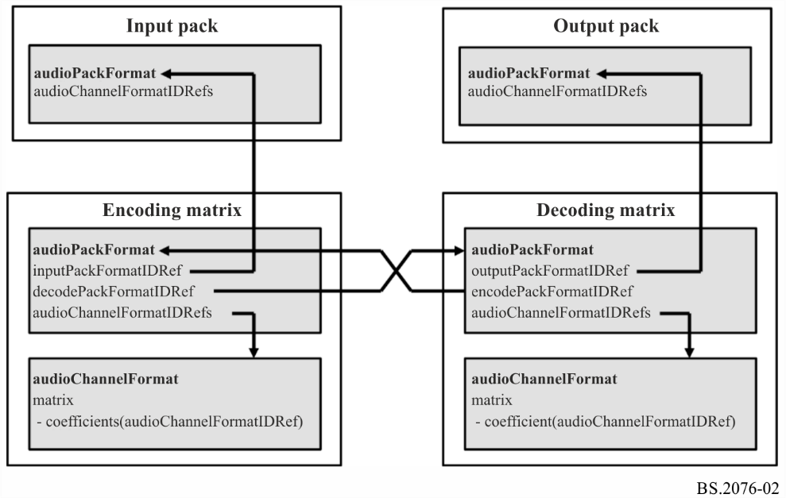
The diagram in Fig. A1-3 shows how a direct matrix audioPackFormat relates to input and output audioPackFormats and audioChannelFormats.
Figure A1-3
Direct matrix relationships
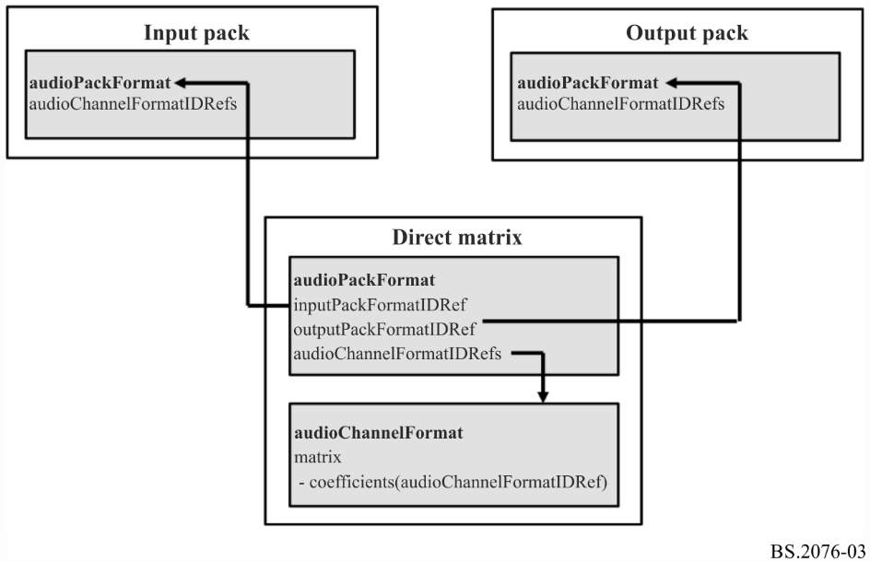

5.5.4.1 Matrix Sub-elements
The encoding matrix contains an inputPackFormatIDRef, which references a channel-based input pack. It can also contain a list of decodePackFormatIDRefs, which are references to corresponding decoding matrices.
The decoding matrix contains an outputPackFormatIDRef, which reference a channel-based output pack. It can also contain a list of encodePackFormatIDRefs, which are references to corresponding encoding matrices.
The direct matrix contains an inputPackFormatIDRef, which references a channel-based input pack and an outputPackFormatIDRef, which reference a channel-based output pack.
TABLE A1-24
audioPackFormat sub-elements for Matrix

Sub-element | Description | Example | Quantity
encodePackFormatIDRef | Reference to an encoding matrix audioPackFormat from a decoding matrix. | AP_00020001 | 0…*
decodePackFormatIDRef | Reference to a decoding matrix audioPackFormat from an encoding matrix. | AP_00020101 | 0 …*
inputPackFormatIDRef | Reference to a channel-based (DirectSpeakers) input audioPackFormat. | AP_00010002 | 0 or 1
outputPackFormatIDRef | Reference to a channel-based (DirectSpeakers) matrix decoded audioPackFormat. | AP_00010002 | 0 or 1

5.5.4.2 Sample code

<audioPackFormat audioPackFormatID="AP_00021001" audioPackFormatName="MidSide_Encode" typeLabel="0002" typeDefinition="Matrix">
<decodePackFormatIDRef>AP_00021101</decodePackFormatIDRef>
<inputPackFormatIDRef>AP_00010002</inputPackFormatIDRef>
<audioChannelFormatIDRef>AC_00021001</audioChannelFormatIDRef>
<audioChannelFormatIDRef>AC_00021002</audioChannelFormatIDRef>
</audioPackFormat>

<audioPackFormat audioPackFormatID="AP_00021101" audioPackFormatName="MidSide_Decode" typeLabel="0002" typeDefinition="Matrix">
<encodePackFormatIDRef>AP_00021001</encodePackFormatIDRef>
<outputPackFormatIDRef>AP_00010002</outputPackFormatIDRef>
<audioChannelFormatIDRef>AC_00021101</audioChannelFormatIDRef>
<audioChannelFormatIDRef>AC_00021102</audioChannelFormatIDRef>
</audioPackFormat>

5.5.5 If audioPackFormat.typeDefinition == “HOA”
If the audioPackFormat element is of HOA type then the following sub-elements can be defined. These parameters provide defaults for the audioBlockFormat parameters corresponding to the HOA-type audioChannelFormat definitions within this audioPackFormat. The normalization, nfcRefDist and screenRef parameters occur in both the audioPackFormat and audioBlockFormat (see § 5.4.3.4). Therefore, the values of these parameters should be matched in both elements if they are referenced to each other. However, when the parameters are specified within an audioBlockFormat differ from those in the audioPackFormat, the audioBlockFormat values shall take priority over those given in the audioPackFormat.

5.5.5.1 HOA Sub-elements
TABLE A1-25
audioPackFormat sub-elements for HOA
Sub-element | Description | Units | Example | Quantity | Default | Required
normalization | Indicates the normalization scheme of the HOA content (N3D, SN3D, FuMa). |  | N3D | 0 or 1 | SN3D | Optional
nfcRefDist | Indicates the reference distance of the loudspeaker setup for near-field compensation (NFC). If no nfcRefDist is defined or the value is 0, NFC is not necessary. | metre | 2 | 0 or 1 | 0 | Optional
screenRef | Indicates whether the content is screen-related (flag is equal to 1) or not (flag is equal to 0) | 1/0 flag | 0 | 0 or 1 | 0 | Optional

5.6 audioObject
An audioObject establishes the relationship between the content, the format via audio packs, and the assets using the track UIDs. AudioObjects can be nested and so they can refer to other audioObjects.

5.6.1 Attributes
TABLE A1-26
audioObject attributes
Attribute | Description | Example | Required | Default
audioObjectID | ID of the object, see § 6. | AO_1001 | Yes | -
audioObjectName | Name of the object | dialogue_stereo | Yes | -
start | Start time for the object, relative to the start of the audioProgramme. The start time is in the time format as described in § 5.13. | 00:00:00.00000 or  00:00:00.00000S48000 | Optional | 00:00:00.00000
duration | Duration of object. The duration is in the time format as described in § 5.13. | 00:02:00.00000 or  00:02:00.00000S48000 | Optional | duration of audioProgramme
dialogue | If the audio is not dialogue set a value of 0; if it contains only dialogue a value of 1; if it contains both then a value of 2. | 0 | Optional | 2
importance | Importance of an object. Allows a renderer to discard an object below a certain level of importance. 10 is most important, 0 least. | 10 | Optional | 10
interact | Set to 1 if a user can interact with the object, 0 if not. | 1 | Optional | 0
disableDucking | Set to 1 to disallow automatic ducking of object, 0 to allow ducking | 0 | Optional | 0

5.6.2 Sub-elements
TABLE A1-27
audioObject sub-elements
Sub-element | Attribute | Description | Units/Type | Example | Quantity
audioPackFormatIDRef |  | Reference to an audioPackFormat for format description | ID String | AP_00010001 | 0…*
audioObjectIDRef |  | Reference to another audioObject | ID String | AO_1002 | 0…*
audioObjectLabel | language | The object description in the language specified by the language attribute. The language attribute can be used for definition of multiple audioObject labels in different languages. See Table 1-28. | String | “Dialogue”  language=”en” | 0…*

TABLE A1-27 (end)
Sub-element | Attribute | Description | Units/Type | Example | Quantity
audioComplementary ObjectGroupLabel | language | The complementary object group description in the language specified by the language attribute. The language attribute can be used for definition of multiple audioComplementaryObjectGroup labels in different languages. See Table A1-29. | String | “主音声”  language=“jp” | 0…*
audioComplementary ObjectIDRef |  | Reference to another audioObject that is complementary to the object, e.g. to describe mutually exclusive languages. | ID String | AO_1003 | 0…*
audioTrackUIDRef |  | Reference to an audioTrackUID (when using a BW64 file according to [7] this is listed in the <chna> chunk) | ID String | ATU_00000001 | 0…*
audioObjectInteraction |  | Specification of possible user interaction with the object. | - | - | 0 or 1
gain | gainUnit | Definition of a gain value to be applied to all audio samples referenced by the audioObject. The default value is 1.0. An optional gainUnit attribute (either ‘linear’ or ‘dB’) can be used to define the unit of the gain value. The default unit is ‘linear’. For a detailed description of the application of this gain value see § 12. | Linear or logarithmic gain value | 0.5 (linear),  −6.0 (dB) | 0 or 1
headLocked |  | Indicates if the perceived location of the audio element is locked to the head (flag = 1) or not locked (flag = 0)  See § 9.4  Default Value is 0 | 0/1 flag | 1 | 0 or 1
positionOffset  (when polar coordinates are used | coordinate=  “azimuth” | Apply an offset to the “azimuth” angle to all elements in the audioObjects. | Degrees | 30.0 | 0 or 1
positionOffset  (when polar coordinates are used | coordinate=  “elevation” | Apply an offset to the “elevation” angle to all elements in the audioObjects. | Degrees | 15.0 | 0 or 1
positionOffset  (when polar coordinates are used | coordinate=  “distance” | Apply an offset of “distance” to all elements in the audioObjects. | Normalised distance | 0.9 | 0 or 1
positionOffset  (when Cartesian coordinates are used) | coordinate=  “X” | Apply an offset of “X” axis to all elements in the audioObjects. | Normalised value | −0.2 | 0 or 1
positionOffset  (when Cartesian coordinates are used) | coordinate=  “Y” | Apply an offset of “Y” axis to all elements in the audioObjects. | Normalised value | 0.1 | 0 or 1
positionOffset  (when Cartesian coordinates are used) | coordinate=  “Z” | Apply an offset of “Z” axis to all elements in the audioObjects. | Normalised value | −0.5 | 0 or 1
mute |  | Status of the audioObject to play back or not. Set to 0 if the object is played back (default). Set to 1 if the object is muted. |  | 1 | 0 or 1
alternativeValueSet | alternativeValueSetID | An alternative set of parameters that will be used if the alternativeValueSetID is referenced by an audioProgramme or audioContent element.  See § 5.6.5 for sub-elements. |  |  | 0…*

If the value of audioTrackUIDRef is set to ATU_00000000 then it shall not refer to a track in the file, but refers to a silent or empty track. For multichannel formats where some of the channels are not being used, instead of storing zero value samples in the file, this silent track should be used to save space in the file.
TABLE A1-28
audioObjectLabel attributes
Attribute | Description | Example | Required
language | The language attribute can be used for definition of multiple audioObject labels in different languages. The language code is given as a 2- or 3-character code as specified by ISO 639-1 or ISO 639-2. Both ISO 639-2/B and ISO 639-2/T may be used. | eng | No

The audioComplementaryObjectGroupLabel element contains a textual label for a set of mutually exclusive audioObjects, e.g. language tracks that contain the same dialogue in different dub versions.
The audioComplementaryObjectGroupLabel element when present shall only be included in one corresponding parent audioObject for each set of mutually exclusive contents. It shall be included in the same parent audioObject that also contains the audioComplementaryObjectIDRef sub-elements.
TABLE A1-29
audioComplementaryObjectGroupLabel attributes
Attribute | Description | Example | Required
language | Attribute defining the language of the parent audioComplementaryObjectGroupLabel. The language code is given as a 2- or 3-character code as specified by ISO 639-1 or ISO 639-2. Both ISO 639-2/B and ISO 639-2/T may be used. | eng | No

5.6.3 audioComplementaryObjectIDRef
The audioComplementaryObjectIDRef element contains a reference to another audioObject that is complementary to the parent audioObject. A list of audioComplementaryObjectIDRefs can therefore be used to describe mutually exclusive content, e.g. language tracks that contain the same dialogue in different dub versions (“XOR” relationship).
To avoid cross-references between audioComplementaryObjectIDRefs of several audioObjects, the audioComplementaryObjectIDRef sub-element shall only be included in one corresponding parent audioObject for each set of mutually exclusive contents. The parent audioObject with the audioComplementaryObjectIDRefs shall be the one that contains the default version of the set of mutually exclusive contents.

5.6.4 audioObjectInteraction sub-element
An audioObjectInteraction sub-element describes possible user interaction with the corresponding parent audioObject element. If the interact attribute of the parent audioObject element is not present or is set to 0, the audioObjectInteraction sub-element shall not be present. If the interact attribute of the parent audioObject element is present and set to 1, there is no requirement on whether the audioObjectInteraction sub-element shall be present or not. If the interact attribute is set to 1 and the audioObjectInteraction sub-element is not present, this shall indicate that on-off interaction, unlimited gain interaction and unlimited position interaction are enabled for the audioObject element (see also §§ 12 and 13).
Previous versions of this Recommendation, up to and including Recommendation BS.2076-2, did not explicitly prohibit the presence of an audioObjectInteraction element when the interact attribute of the audioObject element is not set to 1. When it is known that the metadata adheres to versions up to and including Recommendation BS.2076-2, any audioObjectInteraction sub-element shall be ignored when the interact attribute of the parent audioObject element is not present or not set to 1.
These restrictions also apply analogously for the audioObjectInteraction sub-element of alternativeValueSet sub-elements (see § 5.6.5).
The audioObjectInteraction element has the following attributes and sub-elements.
TABLE A1-30
audioObjectInteraction attributes
Attribute | Description | Example | Required
onOffInteract | Set to 1 if a user can switch the object on or off,  0 if not. | 1 | Yes
gainInteract | Set to 1 if a user can change the gain of the object, 0 if not. | 1 | Optional
positionInteract | Set to 1 if a user can change the position of the object, 0 if not. | 0 | Optional

TABLE A1-31
audioObjectInteraction sub-elements
Sub-element | Attribute | Bound  attribute | Description | Units | Example
gainInteractionRange | N/A | min | Minimum linear gain factor or logarithmic gain offset of a possible user gain interaction.  For a detailed description of the application of this gain-related parameter see § 12. (NOTE: The earlier versions of this Recommendation contained the following formulae to describe the application of the minimum bound of the gain interaction range “Linear gain:  gainMin = gain (or 1.0 if not defined) * gainInteractionRangeMin”. This formula was not correct as it was undefined to what ADM element or parameter “gain” in the formula was referring. In the current version (Rec. ITU-R BS.2076-2), this erroneous formula was removed. The gainInteractionRange boundaries should be interpreted as described in § 12.) | Linear or logarithmic (dB) gain value | 0.5

TABLE A1-31 (end)
Sub-element | Attribute | Bound  attribute | Description | Units | Example
 | N/A | max | Maximum linear gain factor or logarithmic gain offset of possible user gain interaction. For a detailed description of the application of this gain-related parameter see § 12. (NOTE: The earlier versions of this Recommedation contained the following formulae to describe the application of the maximum bound of the gain interaction range (Linear gain:  gainMax = gain (or 1.0 if not defined) * gainInteractionRangeMax”.  This formula was not correct as it was undefined to what ADM element or parameter “gain” was referring in the formula. In the current version (Rec. ITU-R BS.2076-2), this erroneous formula was removed. The gainInteractionRange boundaries should be interpreted as described in § 12. | Linear of logarithmic (dB) gain value | 1.2
 | gainUnit |  | Unit for attribute of ‘gain’. If gainUnit is not used, ‘linear’ unit is used. |  | linear / dB
positionInteractionRange  (when polar coordinates are used) | coordinate= “azimuth” | min | Minimum azimuth offset value of possible user position interaction | Degrees | –30.0
positionInteractionRange  (when polar coordinates are used) | coordinate= “azimuth” | max | Maximum azimuth offset value of possible user position interaction | Degrees | +30.0
positionInteractionRange  (when polar coordinates are used) | coordinate= “elevation” | min | Minimum elevation offset value of possible user position interaction | Degrees | –15.0
positionInteractionRange  (when polar coordinates are used) | coordinate= “elevation” | max | Maximum elevation offset value of possible user position interaction | Degrees | +15.0
positionInteractionRange  (when polar coordinates are used) | coordinate= “distance” | min | Minimum normalized distance of possible user position interaction | 0 to 1 | 0.5
positionInteractionRange  (when polar coordinates are used) | coordinate= “distance” | max | Maximum normalized distance of possible user position interaction | 0 to 1 | 0.5
positionInteractionRange  (when Cartesian coordinates are used) | coordinate= “X” | min | Minimum X-axis offset value of possible user position interaction | Normalized Units | –0.5
 | coordinate= “X” | max | Maximum X-axis offset value of possible user position interaction | Normalized Units | +0.5
 | coordinate= “Y” | min | Minimum Y-axis offset value of possible user position interaction | Normalized Units | –0.2
 | coordinate= “Y” | max | Maximum Y-axis offset value of possible user position interaction | Normalized Units | 0.0
 | coordinate= “Z” | min | Minimum Z-axis offset value of possible user position interaction | Normalized Units | 0.1
 | coordinate= “Z” | max | Maximum Z-axis offset value of possible user position interaction | Normalized Units | 0.4

5.6.4.1 Sample code

<audioObjectInteraction onOffInteract="1" gainInteract="1" positionInteract="1">
<positionInteractionRange coordinate="elevation" bound="min">
-10.0
</positionInteractionRange>
<positionInteractionRange coordinate="elevation" bound="max">
+10.0
</positionInteractionRange>
<positionInteractionRange coordinate="azimuth" bound="min">
-30.0
</positionInteractionRange>
<positionInteractionRange coordinate="azimuth" bound="max">
+30.0
</positionInteractionRange>
</audioObjectInteraction>

If an audioObject allows interaction, the result of a user-imposed change to an attribute that can be set by the user shall be within the limits of the interaction range of that audioObject. In this context, a “change” is the difference between a condition before and after the interaction.
The resultant overall playback gain of a sound source is the combination of the attributes of the gain sub-elements of the audioBlockFormat and all changes caused by interaction in the hierarchy of audioObjects that refer to the audioBlockFormat (see § 12).

5.6.5 alternativeValueSet sub-element
The alternativeValueSet sub-element allows an alternative set of parameters for the audioObject to be defined. The parameters defined in this sub-element shall take precedence over the same parameters in the parent audioObject element. The parameters defined in the parent audioObject that have not been defined in the alternativeValueSet shall be used in that alternativeValueSet. Multiple alternativeValueSets can be defined in an audioObject to allow multiple variations to be defined. Table A1-32 lists the sub-elements that are contained within alternativeValueSet, and each has the same specification of the same sub-elements in the parent audioObject as listed in Table A1-27.
TABLE A1-32
alternativeValueSet sub-elements
Sub-element | Note
audioObjectLabel | See Tables A1-27, A1-30 and A1-31 for attributes, descriptions, examples, units and quantities.
audioObjectInteraction
gain
headLocked
positionOffset
mute

The restrictions on the presence of the audioObjectInteraction sub-element in the alternativeValueSet element depend on the interact attribute of the parent audioObject element. If the interact attribute of the parent audioObject element is not present or is set to 0, the audioObjectInteraction sub-element in the alternativeValueSet element shall not be present. If the interact attribute of the parent audioObject element is present and set to 1, there is no requirement on whether the audioObjectInteraction sub-element in the alternativeValueSet element shall be present or not. If the interact attribute of the parent audioObject element is set to 1 and the audioObjectInteraction sub-element in the alternativeValueSet element is not present, the audioObjectInteraction sub-element in the parent audioObject element shall be used. In this case, if the audioObjectInteraction sub-element in the parent audioObject element is also not present, this shall indicate that on-off interaction, unlimited gain interaction and unlimited position interaction are enabled for the audioObject element when the alternativeValueSet element is active (see also §§ 12 and 13).
Previous versions of this Recommendation, up to and including Recommendation ITU-R BS.2076-2, did not explicitly prohibit the presence of an audioObjectInteraction sub-element in the alternativeValueSet element when the interact attribute of the parent audioObject element is not set to 1. When it is known that the metadata adheres to versions up to and including Recommendation ITU-R BS.2076-2, any audioObjectInteraction sub-element shall be ignored when the interact attribute of the parent audioObject element is not present or not set to 1.

5.6.5.1 alternativeValueSetID attribute
The alternativeValueSet sub-element shall use an alternativeValueSetID attribute and the ID shall be in this format: AVS_wwww_zzzz, where ‘w’ and ‘z’ are hexadecimal digits. The ‘wwww’ shall match the ‘wwww’ of the parent audioObjectID, and the ‘zzzz’ shall be a unique value for each alternativeValueSet sub-element used within the parent audioObject.
The alternativeValueSetID may be referenced from either audioProgramme or audioContent.

5.6.5.2 Sample code

<audioObject audioObjectID="AO_1001" audioObjectName="Effects">
<gain>1.0</gain>
<alternativeValueSet alternativeValueSetID=”AVS_1001_0001”>
<gain>1.5</gain>
</alternativeValueSet>
<alternativeValueSet alternativeValueSetID=”AVS_1001_0002”>
<gain>0.5</gain>
</alternativeValueSet>
…
</audioObject>

5.6.6 Sample code

<audioObject audioObjectID="AO_1001" audioObjectName="Dialogue_stereo">
<audioPackFormatIDRef>AP_00010001</audioPackFormatIDRef>
<audioTrackUIDRef>ATU_00000001</audioTrackUIDRef>
<audioTrackUIDRef>ATU_00000002</audioTrackUIDRef>
</audioObject>

5.6.7 Nested audioObjects and timing parameters
When audioObject elements are nested the start time of the audioObject is still relative to the start of the programme, not the relative to the audioObject that refers to it. To ensure that any audioObject that is referred from another audioObject shall not have a start time earlier than the referent, nor does it have an end time (i.e. start + duration) after the referent.
An audioObject element shall not reference itself, nor can a loop of references be used (e.g. AO_1001 -> AO_1002 -> AO_1003 -> AO_1001 would be a loop and therefore illegal).

5.7 audioContent
An audioContent element describes the content of one component of a programme (e.g. background music), and refers to audioObjects to tie the content to its format. This element includes loudness metadata.

5.7.1 Attributes
TABLE A1-33
audioContent attributes
Attribute | Description | Example | Required
audioContentID | ID of the content, see § 6. | ACO_1001 | Yes
audioContentName | Name of the content | Music | Yes
audioContentLanguage | Language of the content (as a String).  It is recommended to use a language code to identify the language. The language code should be given as a 2- or 3-character code as specified by ISO 639-1 or ISO 639-2. Both ISO 639-2/B and ISO 639-2/T may be used. | en | Optional

5.7.2 Sub-elements
TABLE A1-34
audioContent sub-elements
Sub-element | Attribute | Description | Example | Quantity
audioContentLabel | language | The content description in the language specified by the language attribute.  The language attribute can be used for definition of multiple audioContent labels in different languages. It is recommended to use a language code to identify the language. The language code should be given as a 2- or 3-character code as specified by ISO 639-1 or ISO 639-2. Both ISO 639-2/B and ISO 639-2/T may be used. | “News”  language=”en” | 0…*
audioObjectIDRef |  | Reference to audioObject | AO_1001 | 1…*
loudnessMetadata |  | See § 5.7.4 |  | 0…*
dialogue |  | If the audio is not dialogue set a value of 0; if it contains only dialogue set a value of 1; if it contains both then set a value of 2. | 0 | 0 or 1
alternativeValueSetIDRef |  | Reference to an alternativeValueSet within an audioObject. | AVS_1001_0001 | 0…*

As it is possible to include multiple alternativeValueSetIDRef sub-elements within an audioContent element, it shall be ensured that the alternativeValueSetIDRef only references one alternativeValueSet within the same audioObject. This should be done by inspecting the alternativeValueSet ID digits. The ID has the format: AVS_wwww_zzzz, where wwww matches the digits in the audioObject ID. Therefore, to ensure an audioObject is not referenced multiple times, each alternativeValueSetIDRef in an audioContent shall have unique wwww digits.

5.7.3 dialogue
This optional element specifies the kind of content that is included in the parent audioContent. The Dialogue sub-element can take the values 0 (no dialogue), 1 (pure dialogue) or 2 (mixed). It has an attribute that specifies the type of content using defined lists (enumerators) of content kinds.
The attribute is dependent on the value of the Dialogue element.
TABLE A1-35
dialogue attributes
Value of dialogue | Attribute | Description | Example
0 | nonDialogueContentKind | ID of the contained content kind (enumerator, see specification below) | 0
1 | dialogueContentKind | ID of the contained content kind (enumerator, see specification below) | 0
2 | mixedContentKind | ID of the contained content kind (enumerator, see specification below) | 0
TABLE A1-36
dialogue types
nonDialogueContentKind | Description
0 | Undefined
1 | Music
2 | Effects
3 | Music and Effects
dialogueContentKind | Description
0 | Undefined
1 | (storyline) Dialogue
2 | Voiceover
3 | Spoken subtitle

TABLE A1-36 (end)
dialogueContentKind | Description
4 | Audio description/visually impaired
5 | Commentary
6 | Emergency
mixedContentKind | Description
0 | Undefined
1 | Complete main
2 | Mixed
3 | Hearing impaired
4 | Complete main with audio description/visually impaired

5.7.4 loudnessMetadata attributes and sub-elements
TABLE A1-37
loudnessMetadata attributes
Attribute | Description | Example
loudnessMethod | The method used to determine the loudness. | “ITU-R BS.1770”
loudnessRecType | The loudnessRecType indicates which regional recommended practice was followed in the loudness correction of the audio | “EBU R128”
loudnessCorrectionType | The correction type is used to indicate what correction has been applied to the audio, for example, file-based or real-time. | “File-based”

The audio could be corrected or normalized by numerous means, relating to loudness algorithm, regional recommended practice followed, and by what correction type. The loudnessMethod indicates the method used to determine the loudness (e.g. a value based on Recommendation ITU-R BS.1770). The loudnessRecType indicates the regional recommended practice that was followed as a character string, such as “EBU R128”, “ATSC A/85”, “ARIB TR B32” or “FreeTV OP59”. The loudnessCorrectionType specifies how the audio has been correlated: in an off-line file-based or a real-time process.
TABLE A1-38
loudnessMetadata sub-elements
Sub-element | Description | Units/Type | Example | Quantity
integratedLoudness | Integrated loudness value | LKFS/LUFS | −23.0 | 0 or 1
loudnessRange | Loudness range | LU | 10.0 | 0 or 1
maxTruePeak | Maximum true-peak | dBTP | −2.3 | 0 or 1
maxMomentary | Maximum momentary loudness | LKFS/LUFS | −19.0 | 0 or 1
maxShortTerm | Maximum short- term loudness | LKFS/LUFS | −21.2 | 0 or 1
dialogueLoudness | Loudness of the average dialogue | LKFS/LUFS | −24.0 | 0 or 1
renderer | This sub-element defines the renderer configuration that has been used for the measurement of the other sub-elements in the parent loudnessMetadata element. See Tables A1-39 and A1-40. | – | – | 0 or 1
NOTE – Recommendation ITU-R BS.1770 uses LKFS for loudness units, and the EBU uses LUFS. Both units are identical, and the model does not require the units to be expressed in the metadata.
TABLE A1-39
renderer attributes
Attributes | Description | Example | Required
uri | Renderer uri used for loudness measurement. | urn:itu:bs:2127:0:itu_adm_renderer | Optional
name | Renderer name used for loudness measurement. | “Rec. ITU-R BS.2127" | Optional
version | Version number of the renderer. | “1.0.0” | Optional
coordinateMode | Specifies the coordinate system path used during rendering, irrespective of the underlying composition coordinate system. Allowable values are “polar” or “cartesian”. | “polar” | Optional

TABLE A1-40
renderer sub-elements
Sub-element | Description | Example | Quantity
audioPackFormatIDRef | Reference to an audioPackFormat element of type ‘0001’ (DirectSpeakers). This sub-element defines the loudspeaker layout that has been used for rendering. | AP_00010002 | 0 or 1
audioObjectIDRef | Reference to audioObject elements. This sub-element can be used to define audioObject elements that have been used for rendering. | AO_1001 | 0 … *

5.7.5 Sample code

<audioContent audioContentID="ACO_1001" audioContentName="Music">
<audioContentLabel language="eng">Music</audioContentLabel>
<audioContentLabel language="deu">Musik</audioContentLabel>
<audioObjectIDRef>AO_1001</audioObjectIDRef>
<loudnessMetadata>
<integratedLoudness>-23.0</integratedLoudness>
<maxTruePeak>-2.3</maxTruePeak>
</loudnessMetadata>
</audioContent>

5.8 audioProgramme
An audioProgramme element refers to a set of one or more audioContents that are combined to create a full audio programme. It contains start and end times for the programme, which can be used for alignment with video times. Loudness metadata is also included to allow the programme’s loudness to be recorded.
When more than one audioProgramme is included in a file, and there is no other information to decide which one to choose for playback, then the default audioProgramme shall be the one with the lowest ID value.

5.8.1 Attributes
TABLE A1-41
audioProgramme attributes
Attribute | Description | Example | Required
audioProgrammeID | ID of the programme, see § 6. | APR_1001 | Yes
audioProgrammeName | Name of the programme |  | Yes
audioProgrammeLanguage | Language of the dialogue content contained in this programme (as a String).  It is recommended to use a language code to identify the language. The language code should be given as a 2- or 3-character code as specified by ISO 639-1 or ISO 639-2. Both ISO 639-2/B and ISO 639-2/T may be used. | fr | Optional
start | Start time for the programme. The start time is in the time format as described in § 5.13. | 00:00:10.00000 or  00:00:10.00000S48000 | Optional  If start is not present, it shall be assumed the start is 00:00:0.00000
end | End time for the programme.  The end time is in the time format as described in § 5.13. | 00:10:00.00000 or  00:10:00.00000S48000 | Optional  If end is not present, it shall be assumed it is the end of file
maxDuckingDepth | Indicates the maximum amount of automatic ducking allowed for every audioObject in the programme. Range is 0 to −62 dB |  | Optional

5.8.2 Sub-elements
TABLE A1-42
audioProgramme sub-elements
Sub-element | Attribute | Description | Example | Quantity
audioProgrammeLabel | language | The programme description in the language specified by the language attribute.  The language attribute can be used for definition of multiple audioProgramme labels in different languages. The language code should be given as a 2- or 3-character code as specified by ISO 639-1 or ISO 639-2. Both ISO 639-2/B and ISO 639-2/T may be used. | “Venue”  language=”en” | 0…*
audioContentIDRef |  | Reference to content | ACO_1001 | 1…*
loudnessMetadata | - | See § 5.8.4 |  | 0 … *
audioProgrammeReferenceScreen | - | Specification of a reference/  production/monitoring screen size for the audioProgramme, see § 5.8.3. If the reference screen-size is not given, a default screen-size is implicitly defined (see § 10.5). |  | 0 or 1
authoringInformation |  | See § 5.8.6 |  | 0 or 1
alternativeValueSetIDRef |  | Reference to an alternativeValueSet within an audioObject. | AVS_1001_0001 | 0…*

As it is possible to include multiple alternativeValueSetIDRef sub-elements within an audioProgramme element, only one alternativeValueSet shall be referenced within the same audioObject. This should be done by inspecting the alternativeValueSet ID digits. The ID has the format: AVS_wwww_zzzz, where wwww matches the digits in the audioObject ID. Therefore, to ensure an audioObject is not referenced multiple times, each alternativeValueSetIDRef in an audioProgramme shall have unique wwww digits.

5.8.3 audioProgrammeReferenceScreen
An audioProgrammeReferenceScreen element describes a reference/production/monitoring screen that was used by the content creator during the production of the content of this audioObject. The screen can be described using either polar coordinates or Cartesian coordinates, but not both (see Fig. A1-4).
TABLE A1-43
audioProgrammeReferenceScreen attributes
Attribute | Description | Example
aspectRatio | Aspect ratio of the screen (proportional relationship between its width and its height (with respect to the image dimensions)) | 1.78, 1.6

For when polar coordinates are used:
TABLE A1-44
audioProgrammeReferenceScreen sub-elements
Sub-element | Coordinate  Attribute | Description | Units | Example
screenCentrePosition | azimuth | Azimuth angle of the centre of the screen | degrees | +30.0
screenCentrePosition | elevation | Elevation angle of the centre of the screen | degrees | −15.0
screenCentrePosition | distance | Normalized distance to the centre of the screen. Default is 1.0 | Normalized units (0.0 to 1.0) | 1.0
screenWidth | azimuth | Width of the screen in polar coordinates  (azimuth opening angle theta) | degrees  (0 < theta ≤180) | +58.0 or +96.0

For when Cartesian coordinates are used:
TABLE A1-45
Sub-element | Coordinate  Attribute | Description | Units | Example
screenCentrePosition | X | X-coordinate of the centre of the screen | Normalized units  (abs(X) ≤ 1) | −0.3
screenCentrePosition | Y | Y-coordinate of the centre of the screen | Normalized units  (abs(Y) ≤ 1) | −0.2
screenCentrePosition | Z | Z-coordinate of the centre of the screen | Normalized units  (abs(Z) ≤ 1) | 1.0
screenWidth | X | Width of the screen in Cartesian coordinates  (width of the screen on the X-axis) | 0 < X ≤ 2 | 0.8

5.8.4 loudnessMetadata attributes and sub-elements
TABLE A1-46
loudnessMetadata attributes
Attribute | Description | Example
loudnessMethod | The method used to determine the loudness. | “ITU-R BS.1770”
loudnessRecType | The loudnessRecType indicates which regional recommended practice was followed in the loudness correction of the audio | “EBU R128”
loudnessCorrectionType | The correction type is used to indicate what correction has been applied to the audio, for example, file-based or real-time. | “File-based”

The audio could be corrected or normalized by numerous means, relating to loudness algorithm, regional recommended practice followed, and by what correction type. The loudnessMethod indicates the method used to determine the loudness (e.g. a value based on Recommendation ITU-R BS.1770). The loudnessRecType indicates the regional recommended practice that was followed as a character string, such as “EBU R128”, “ATSC A/85”, “ARIB TR B32” or “FreeTV OP59”. The loudnessCorrectionType specifies how the audio has been correlated: in an off-line file-based or a real-time process.
TABLE A1-47
loudnessMetadata sub-elements
Sub-element | Description | Units/Type | Example | Quantity
integratedLoudness | Integrated loudness value | LKFS/LUFS | −23.0 | 0 or 1
loudnessRange | Loudness range | LU | 10.0 | 0 or 1
maxTruePeak | Maximum true-peak | dBTP | −2.3 | 0 or 1
maxMomentary | Maximum momentary loudness | LKFS/LUFS | −19.0 | 0 or 1
maxShortTerm | Maximum short- term loudness | LKFS/LUFS | −21.2 | 0 or 1
dialogueLoudness | Loudness of the average dialogue | LKFS/LUFS | −24.0 | 0 or 1
renderer | This sub-element defines the renderer configuration that has been used for the measurement of the other sub-elements in the parent loudnessMetadata element. See Tables A1-48 and A1-49. | – | – | 0 or 1

NOTE – Recommendation ITU-R BS.1770 uses LKFS for loudness units, and the EBU uses LUFS. Both units are identical, and the model does not require the units to be expressed in the metadata.
TABLE A1-48
renderer attributes
Attributes | Description | Example | Required
uri | Renderer uri used for loudness measurement. | urn:itu:bs:2127:0:itu_adm_renderer | Optional
name | Renderer name used for loudness measurement. | “Rec, ITU-R BS.2127” | Optional
version | Version number of the renderer. | “1.0.0” | Optional
coordinateMode | Specifies the coordinate system path used during rendering, irrespective of the underlying composition coordinate system. Allowable values are “polar” or “cartesian”. | “polar” | Optional

TABLE A1-49
renderer sub-elements
Sub-element | Description | Example | Quantity
audioPackFormatIDRef | Reference to an audioPackFormat element of type ‘0001’ (DirectSpeakers). This sub-element defines the loudspeaker layout that has been used for rendering. | AP_00010002 | 0 or 1
audioObjectIDRef | Reference to audioObject elements. This sub-element can be used to define audioObject elements that have been used for rendering. | AO_1001 | 0 … *

5.8.5 Sample code

<audioProgramme audioProgrammeID="APR_1001" audioProgrammeName="Documentary">
<audioProgrammeLabel language="eng">Default Mix</audioProgrammeLabel>
<audioProgrammeLabel language="deu">Standard Mix</audioProgrammeLabel>
<audioContentIDRef>ACO_1001</audioContentIDRef>
<audioContentIDRef>ACO_1002</audioContentIDRef>
</audioProgramme>

5.8.6 authoringInformation
TABLE A1-50
authoringInformation sub-elements
Sub-element | Description | Quantity
referenceLayout | The reference layout describes the loudspeaker layout for which the content of the audioProgramme was originally produced for. In that sense it represents the optimal loudspeaker layouts from the content creator's point of view. See Table A1-51. | 0 …*
renderer | See Tables A1-52 and A1-53. | 0 … *
TABLE A1-51
referenceLayout sub-elements
Sub-element | Description | Example | Quantity
audioPackFormatIDRef | Reference to an audioPackFormat used as the reference layout during production. The referenced layout can either be part of the Common Definitions in Recommendation ITU-R BS.2094 or contained in the local ADM code itself. In case a reproduction technique is used during production that makes use of a virtual loudspeaker setup (e.g. binaural rendering or soundbar rendering), the referenceLayout should reference the virtual loudspeaker layout. | AP_00010003 | 1

TABLE A1-52
renderer attributes
Attributes | Description | Example | Required
uri | Renderer uri used in production and monitoring. | urn:itu:bs:2127:0:itu_adm_renderer | Yes
name | Renderer name used in production and monitoring. | “Rec, ITU-R BS.2127” | Optional
version | Version number of the renderer. | “1.0.0” | Optional
coordinateMode | Specifies the coordinate system path used during rendering, irrespective of the underlying composition coordinate system. Allowable values are “polar” or “cartesian”. | “polar” | Optional
TABLE A1-53
renderer sub-elements
Sub-element | Description | Example | Quantity
audioPackFormatIDRef | Reference to an audioPackFormat used in production and monitoring. | AP_00010003 | 1…*

5.8.7 Sample code
<audioFormatExtended version= “ITU-R_BS.2076-3”>
<audioProgramme audioProgrammeID=“APR_1001” audioProgrammeName=“MyProgramme”>
<authoringInformation>
<renderer uri=“urn:itu:bs:2127:0:itu_adm_renderer”>
<audioPackFormatIDRef>AP_00010003</audioPackFormatIDRef>
<audioPackFormatIDRef>AP_00010017</audioPackFormatIDRef>
</renderer>
</authoringInformation>
</audioProgramme>
</audioFormatExtended>

5.9 audioTrackUID
The audioTrackUID uniquely identifies a track or asset within a file or recording of an audio scene. This element contains information about the bit-depth and sample-rate of the track. For PCM audio, the audioStreamFormat and the audioTrackFormat should be omitted; then the audioTrackUID shall refer to the corresponding audioChannelFormat. The audioTrackUID element also contains sub-elements that allow the model to be used for non-BW64 applications by performing the job of the <chna> chunk.

5.9.1 Attributes
TABLE A1-54
audioTrackUID attributes
Attribute | Description | Example | Required
UID | The actual UID value, see § 6. | ATU_00000001 | Yes
sampleRate | Sample rate of track in Hz | 48000 | Optional
bitDepth | Bit-depth of track in bits | 24 | Optional

5.9.2 Sub-elements
TABLE A1-55
audioTrackUID sub-elements
Sub-element | Description | Example | Quantity
audioMXFLookUp  (Deprecated) | This sub-element was deprecated in Rec. ITU-R BS.2076-3 and therefore shall not be used. Other methods to package ADM into MXF exist and shall be used. |  | 0
audioTrackFormatIDRef | Reference to an audioTrackFormat description | AT_00010001_01 | 0 or 1
audioChannelFormatIDRef | Reference to an audioChannelFormat description. This element is used only if an audioTrackFormat is omitted for PCM audio. | AC_00010001 | 0 or 1
audioPackFormatIDRef | Reference to an audioPackFormat description | AP_00010002 | 0 or 1
NOTE – The sub-element audioMXFLookUp was deprecated in Recommendation ITU-R BS.2076-3 and therefore shall not be used. Other methods to package ADM into MXF exist and shall be used.

5.9.3 Sample code
When a composition contains related audioTrackFormat, audioStreamFormat, and audioChannelFormat elements, audioTrackUID references audioTrackFormat.

<audioTrackUID UID="ATU_00000001" sampleRate="48000" bitDepth="24">
<audioTrackFormatIDRef>AT_00031001_01</audioTrackFormatIDRef>
<audioPackFormatIDRef>AP_00031001</audioPackFormatIDRef>
</audioTrackUID>
For PCM only applications where audioTrackFormat and audioStreamFormat elements are not present in the composition, audioTrackUID references audioChannelFormat.

<audioTrackUID UID="ATU_00000001" sampleRate="48000" bitDepth="24">
<audioChannelFormatIDRef>AC_00031001</audioChannelFormatIDRef>
<audioPackFormatIDRef>AP_00031001</audioPackFormatIDRef>
</audioTrackUID>

5.10 profileList
The profileList shall represent which constraint specifications the ADM is compliant with.

5.10.1 Sub-elements
TABLE A1-56
profileList sub-elements
Sub-element | Description | Example | Quantity
profile | Each profile specification shall specify how the profile string shall be set for the respective profile. It shall indicate a reference (e.g., a document reference) to the respective profile to which the ADM metadata is compliant. | “ITU-R BS.XXXX” | 1 … *
NOTE – If multiple profile elements are present, then the ADM is constrained by the most constrained parts of each profile.
TABLE A1-57
profile attributes
Attribute | Description | Example | Required
profileName | The profileName attribute string shall be set for the respective profile. It shall indicate the name of the respective profile to which the ADM metadata is compliant. | “Production Profile” | Yes
profileVersion | The profileVersion attribute string shall be set for the respective profile. It shall indicate the version of the respective profile to which the ADM metadata is compliant. | “1.0.0” | Yes
profileLevel | The profileLevel attribute string shall be set for the respective profile. It shall indicate the level of the respective profile to which the ADM metadata is compliant. | “1” | Yes

5.11 tagList
The tagList element contains one or more tagGroup sub-elements. Each tagGroup sub-element defines a group of one or more tags which are associated with one or more ADM elements.
TABLE A1-58
tagList sub-elements
Sub-element | Description | Example | Quantity
tagGroup | A group of tag elements and any associated ADM elements. | See Table A1-59 | 1 … *

The tag sub-element can be used to attach descriptive text, keywords and short names to selected ADM elements. Application standards and profiles may define a restricted controlled vocabulary for tag values. Applications may use tag values for automatic selection, discarding, and searching of ADM elements. For example, tag values for an audioProgramme element can be used to define a target platform and/or playback environment for the audioProgramme. Tag values can be also used to indicate features of ADM elements.
The values of the tag sub-elements and their class attributes provide additional information and shall not influence the way ADM elements are parsed or interpreted. Additionally, the contents of the tag elements shall not be used to duplicate or replace any other existing ADM elements.
TABLE A1-59
tagGroup sub-elements
Sub-element | Attribute | Description | Example | Quantity
tag | – | The tag value. | “Legacy 2.0”, “AdvSS/NGA”,  “mobile”, “Event X”,  “unfinished”, “Effects”,  “Music”, “Team Y”,  “final”, etc. | 1 … *
tag | class | The class attribute can be used to assign the tag to a category | “platform”, “format”, “genre” | 0 or 1
audioProgrammeIDRef | – | Reference to an audioProgramme element associated with the tag sub-elements. | “APR_1001” | 0 … *
audioContentIDRef | – | Reference to an audioContent element associated with the tag sub-elements. | “ACO_1001” | 0 … *
audioObjectIDRef | – | Reference to an audioObject element associated with the tag sub-element. | “AO_1001” | 0 … *

In each tagGroup element, there shall be at least one audioProgrammeIDRef sub-element or at least one audioContentIDRef sub-element or at least one audioObjectIDRef sub-element.

5.11.1 Sample code
<tagList>
<tagGroup>
<tag class="format">Stereo</tag>
<tag class="program genre">Sport</tag>
<audioProgrammeIDRef>APR_1001</audioProgrammeIDRef>
</tagGroup>
<tagGroup>
<tag class="format">NGA 5.1+2dialogues</tag>
<tag class="program genre">News</tag>
<audioProgrammeIDRef>APR_1002</audioProgrammeIDRef>
<audioProgrammeIDRef>APR_1003</audioProgrammeIDRef>
</tagGroup>
<tagGroup>
<tag class="format">NGA 5.1+2dialogues</tag>
<tag class="program genre">News</tag>
<audioProgrammeIDRef>APR_1004</audioProgrammeIDRef>
<audioProgrammeIDRef>APR_1005</audioProgrammeIDRef>
</tagGroup>
<tagGroup>
<tag class="dialogue type">boosted dialogue</tag>
<audioObjectIDRef>AO_1012</audioObjectIDRef>
<audioObjectIDRef>AO_1013</audioObjectIDRef>
</tagGroup>
</tagList>

5.12 audioFormatExtended
audioFormatExtended is the parent element, containing all the ADM elements.

5.12.1 Sub-elements
TABLE A1-60
audioFormatExtended sub-elements
Sub-element | Description | Quantity
audioProgramme | Description of the whole audio programme. | 0…*
audioContent | Description of the content of some audio within the programme. | 0…*
audioObject | The link between the actual audio tracks and their format. | 0…*
audioPackFormat | A description of a pack of channels that relate together. | 0…*
audioChannelFormat | A description of an audio channel. | 0…*
audioStreamFormat | A description of an audio stream. | 0…*
audioTrackFormat | A description of an audio track. | 0…*
audioTrackUID | The unique identifier for an actual audio track. | 0…*
profileList | Description of profile compliance. | 0 or 1
tagList | Descriptive text, keywords and shortnames for ADM elements | 0 or 1

None of elements in Table A1-60 are mandatory within an ADM file. For example, a file that only consists of Common Definition tracks would not contain any audioTrackFormat, audioStreamFormat, audioChannelFormat and audioPackFormat elements. While it is preferable for ADM files to contain at least one audioProgramme and audioContent element, it is still valid for them to be omitted (for example in temporary or test files).

5.12.2 Attributes
TABLE A1-61
audioFormatExtended attributes
Attribute | Description | Example | Required
version | ADM Recommendation name and revision number | “ITU-R_BS.2076-3” | Yes
The version name is used to indicate which version of the ADM is used. If the version attribute is missing then the ADM is assumed to be Recommendation ITU-R BS.2076-0, as this version of the ADM did not contain this version attribute. For any later version of the ADM, then the version attribute should be included with the relevant name.
The version name for this particular update of the Recommendation is “ITU-R_BS.2076-3”.

5.12.3 Sample code

<audioFormatExtended version=”ITU-R_BS.2076-3”>
...
</audioFormatExtended>

5.13 Time parameters format
The time-based time formats in this document show five decimal places for the seconds (either ‘ss.zzzzz’ or ‘hh:mm:ss.zzzzz’), but this is a minimum number of decimal places, for example 01:34:16.25000. It is acceptable to use more decimal places, and this is advised when sampling rates over 48 kHz are being used. Nine decimal places (i.e. hh:mm:ss.zzzzzzzzz) gives nanosecond precision.
For the longer form fractional sample-based time format (hh:mm:ss.zzzzzSfffff), the ‘z’ digits represent the numerator of a fraction, and the fffff digits represent the denominator. The number of ‘z’s must match the number of ‘f’s. (i.e. ‘hh:mm:ss.zzzzzS48000’, ‘hh:mm:ss.zzzzzzS192000’). The value of ‘zzzzz’ should be less than the value of ‘fffff’ to ensure a fraction less than one. Both values shall not be negative, and fffff shall be greater than zero. For example, 01:34:16.12000S48000 is the same as 01:34:16.25000.
For the shorter sample-based format ‘zzzzzSfffff’, the number of digits may be variable (i.e. ‘0S48000’ or ‘500000S48000’). The value of ‘zzzzz’ can be more than the value of ‘fffff’ if the time being represented is greater than a second. Both values shall not be negative, and fffff shall be greater than zero.

6 Use of IDs
The ID attributes in each of the elements have three main purposes: to allow the elements to reference each other, to provide a unique identification for each defined element, and to provide a logical numerical representation of the contents of the element. The IDs for each element follows the following format:
TABLE A1-62
Element ID formats
Element | ID format
audioPackFormat | AP_yyyyxxxx
audioChannelFormat | AC_yyyyxxxx
audioBlockFormat | AB_yyyyxxxx_zzzzzzzz
audioStreamFormat | AS_yyyyxxxx
audioTrackFormat | AT_yyyyxxxx_zz
audioProgramme | APR_wwww
audioContent | ACO_wwww
audioObject | AO_wwww
alternativeValueSet | AVS_wwww_zzzz
audioTrackUID | ATU_vvvvvvvv
The yyyy part is a four-digit hexadecimal number that represents the type of element it is, by using the typeLabel values. There are five defined type label values and the possibility to define user custom types:
TABLE A1-63
typeDefinitions
typeDefinition | typeLabel | Description
DirectSpeakers | 0001 | For channel-based audio, where each channel feeds a speaker directly
Matrix | 0002 | For channel-based audio where channels are matrixed together, such as Mid-Side, Lt/Rt
Objects | 0003 | For object-based audio where channels represent audio objects (or parts of objects), so include positional information
HOA | 0004 | For scene-based audio where Ambisonics and HOA are used
Binaural | 0005 | For binaural audio, where playback is over headphones
User Custom | 1yyy to Fyyy | For user custom types.

The xxxx part is a four-digit hexadecimal number, which shall identify the description within a particular type. Values in the range 0001-0FFF are reserved for common definition such as ‘FrontLeft’ or ‘Stereo’. Common definitions are specified in Recommendation ITU-R BS.2094 [8]. Values in the range 1000-FFFF are for custom definitions, which will be particularly used in object-based audio where all the objects will be custom definitions.
The audioChannelFormatID values in the range 0001-0FFF specify the channel with respect to the channel label and channel configuration. The set of defined common definitions for audioChannelFormatIDs for typical speaker positions is found in Recommendation ITU-R BS.2094 [8]. Some examples of these common definitions are shown in Table A1-64.
TABLE A1-64
Examples of common definition channel labels
Sub-element | ID of channel | Name of channel | speakerLabel
audioChannelFormatID | AC_00010001 | FrontLeft | M+030
audioChannelFormatID | AC_00010002 | FrontRight | M-030
audioChannelFormatID | AC_00010003 | FrontCentre | M+000
audioChannelFormatID | AC_00010004 | LowFrequencyEffects | LFE
audioChannelFormatID | AC_00010005 | SurroundLeft | M+110
audioChannelFormatID | AC_00010006 | SurroundRight | M-110

The audioPackFormatID specifies the channel configuration. The set of defined common definitions for audioPackFormatIDs for typical speaker configurations is found in Recommendation ITU-R BS.2094 [8]. Some examples of the common definitions are shown in Table A1-65.
TABLE A1-65
Examples of common definition for audioPackFormat
Sub-element | ID of pack | Name of pack
audioPackFormatID | AP_00010002 | Stereo_(0+2+0)
audioPackFormatID | AP_00010003 | 5.1_(0+5+0)

In audioBlockFormat the zzzzzzzz part is an 8-digit hexadecimal number that acts as an index/counter for the blocks within the channel. This index shall start at 1 for the first block. The yyyyxxxx values shall match those of the parent audioChannelFormat ID.
In audioTrackFormat the zz part is a 2-digit hexadecimal number that acts as an index/counter for the tracks within the stream. This index shall start at 1 for the first track. The yyyyxxxx values shall match those of the reference audioStreamFormat ID.
In audioTrackUID the vvvvvvvv part is a unique 8-digit hexadecimal number that acts as a counter.
The audioProgramme, audioContent, audioObject and alternativeValueSet do not have a type and so have no yyyy values. As there is initially no intention to have common definitions for these elements the values for wwww will be in the hexadecimal range 1000-FFFF because they will always be custom values. However, keeping the common range of values (0001-0FFF) set aside for now may be useful in future; for example, EBU R 123 configurations may use them.
IDs with a zero value shall not be used for any definitions, as they are reserved for elements that should be ignored and are undefined. For example, AT_00000000_00 is for an audioTrackFormat that has no definition and should be ignored. This can be useful for audio files that contain unused tracks (e.g. an 8-track file containing 5-channel audio), so the <chna> chunk can reference AT_00000000_00 in the audioTrackFormat fields for those unused tracks.
Both upper and lower-case hex digits (a-f and A-F) must be supported when reading IDs. Therefore, IDs with the same digits, but with a different case are treated to be identical. For example, AC_0001000a and AC_0001000A are the same ID.

7 <chna> Chunk
While the ADM is designed to be a general model, its relationship with the BW64 file specified in Recommendation ITU-R BS.2088 is important. The following describes how a BW64 file access’s the ADM metadata via a new RIFF chunk called <chna>. An overview of this new chunk is given here.
The ADM is linked to the BW64 file using the audioTrackFormat, audioPackFormat and audioObject (via audioTrackUID) elements. The BW64 file defines a new chunk called <chna> (short for ‘channel allocation’), which contains a set of IDs for each track in the file. These IDs either refer to elements, or be referred to from an element.
Each track in the chunk contains the following IDs:
• audioTrackFormatID – the ID of the description of a particular audioTrackFormat element. As audioTrackFormat also refers to audioStreamFormat and either audioPackFormat or audioChannelFormat, this ID is enough to describe the format for a particular track. For PCM audio, the audioTrackFormat and the audioStreamFormat should be omitted. In this case, the audioChannelFormatID is referenced by the <chna> chunk in the BW64 file and uses the format AC_yyyyxxxx_00, (the “00” suffix pads out the string to match the required number of bytes in the <chna> chunk’s “trackRef” field (see Clause 8.2 in Recommendation ITU-R BS.2088-1).
• audioPackFormatID – the ID of the description of a particular audioPackFormat. As most audioChannelFormats need to be assigned to an audioPackFormat (e.g. ‘FrontLeft’ channel in ‘5.1’ pack), it must be specified in the <chna> chunk with this ID.
• audioTrackUID – the unique ID that identifies the track. The content descriptor audioObject requires knowledge of which tracks in the file are being described, so contains a list of audioTrackUID references which correspond to audio tracks in the file.
The typeDefinition that audioPackFormatID references does not have to match the typeDefinition that the audioTrackFormatID references for each track. A situation where they may differ is when an encoding matrix definition is being used, where the audioTrackFormatIDs will refer to the ‘DirectSpeakers’ input channels to the matrix, and the audioPackFormatID will refer to ‘Matrix’ type encoding matrix pack.
To enable tracks to contain more than one audioTrackFormatID, in order to allow different formats in the track at different times, the track number can be allocated multiple IDs. An example of such as allocation is below:
TABLE A1-66
<chna> chunk example
Track No | audioTrackUID | audioTrackFormatID | audioPackFormatID
1 | 00000001 | 00010001_01 | 00010002
1 | 00000002 | 00031001_01 | 00031001
2 | 00000003 | 00010002_01 | 00010002
2 | 00000004 | 00031002_01 | 00031002

Here, track number two has two audioTrackUIDs as the audioTrackFormats and audioPackFormats assigned to it are used at different times in the file. The times of allocation would have to be found be inspecting the audioObject elements that cover those audioTrackUIDs. An example of this is a programme where tracks 1 and 2 contain the theme tune which lasts for the first minute of the file. These tracks are free after this first minute, so some audio objects from the main body of the programme are stored in them subsequently. As the theme tune and the audio objects have completely different formats and contents they require different audioTrackUIDs.

8 Coordinate system
The position elements in audioBlockFormat, for both the ‘DirectSpeakers’ and ‘Objects’ typeDefinitions, allow different axes to be specified in the coordinate attribute. A polar coordinate system, which uses azimuth, elevation and distance is used. The azimuth and elevation angle may also be used for the equation sub-element for scene-based audio (c.f. § 5.4.3.4). To ensure consistency when specifying positions each of the polar axes should be based on these guidelines:
– The origin is in the centre, where the sweet-spot would be (although some systems do not have a sweet-spot, so the centre of the space should be assumed).
– Azimuth – angle in the horizontal plane with 0 degrees as straight ahead, and positive angles to the left (or anti-clockwise) when viewed from above.
– Elevation – angle in the vertical plane with 0 degrees horizontally ahead, and positive angles going up.
– Distance – a normalized distance, where 1.0 is assumed to be the default radius of the sphere.
Cartesian coordinates, which is also used for object-based audio, and is supported by using X, Y and Z as the coordinate attributes. It is recommended that normalized values be used here, where the values 1.0 and −1.0 are on the surface of the cube, with the origin being the centre of the cube.
The direction of each axis should be:
– X – left to right, with positive values to the right.
– Y – front to back, with positive values to the front.
– Z – top to bottom, with positive values to the top.
Figure A1-4
Coordinate systems used for Objects
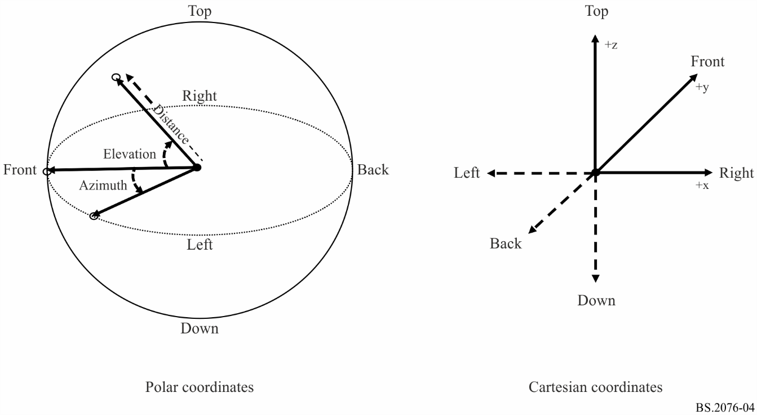
If normalized distances are used in the coordinate system they can be scaled to an absolute distance by multiplying by the absoluteDistance parameter in the audioPackFormat.
For scene-based audio, the coordinate system is also Cartesian based, but the axes are different. The reason for the different axes for scene-based audio is a legacy of the development of Ambisonics, which has always used these axes. In this case the direction of each axis is:
– X – front to back, with positive values to the front.
– Y – left to right, with positive values to the left.
– Z – top to bottom, with positive values to the top.
To avoid confusion with the other Cartesian system, it is recommended the axes be labelled ‘X_HOA’, ‘Y_HOA’ and ‘Z_HOA’. However, the HOA component definitions are unlikely to include coordinate information and so this information is primarily to ensure the rendering is correctly done.
The spherical coordinate system for scene-based audio is used according to Fig. A1-5.
Figure A1-5
Spherical and Cartesian coordinate system as used for HOA
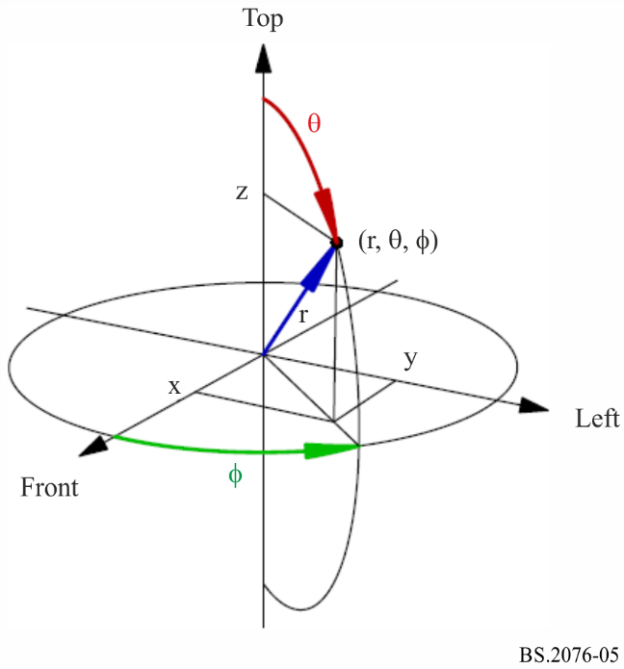

9 Common parameter descriptions for all typeDefinitions
There are three parameters that are common to all the typeDefinitions:
– importance defined in audioBlockFormat, audioPackFormat and audioObject;
– gain occurs in both audioBlockFormat and audioObject;
– jumpPosition and interpolationLength occurs in audioBlockFormat.
There are two parameters that are common to typeDefinitions excluding “Binaural” and “Matrix”:
– headLocked occurs in both audioBlockFormat and audioObject;
– headphoneVirtualise occurs in audioBlockFormat.

9.1 gain
The gain parameter is a linear or logarithmic gain and controls the level of the referenced audio signal. At rendering/playback the level of signal will be multiplied by the gain value. If the gain parameter is not set, a value of 1.0 is assumed, so the audio signal’s level is not adjusted.
Ideally, the waveform that is being described should be at the desired level, so the gain parameter is not required (or set to 1.0), rather than relying on the gain parameter to adjust levels.
For a detailed description of the relationship and application of gain parameters in the ADM, see § 12.

9.2 importance
The importance parameter allows a processor to compromise audio tracks below a certain level of importance, with 10 being the most important, and 0 the least. This parameter for example may be useful when the size of the ADM metadata needs to be reduced and allow prioritisation to be made on what compromises can be made.
When the importance parameter is used in audioObject it can be used to remove less important sounds when the number of objects or tracks needs to be reduced. For example, some background sound effects can be discarded to ensure main dialogue objects are retained.
When the importance parameter is used in audioPackFormat it can be used to compromise on spatial audio quality. Nested audioPackFormats can be used to exploit this feature. For example, an audio object with a main direct sound (in a parent audioPackFormat with high importance) and additional reverb sounds (in a child audioPackFormat with low importance), could have the reverb sound discarded which retains the main sound, but compromises quality.
The importance parameter in audioBlockFormat can be used in a similar way to audioPackFormat to allow spatial quality to be compromised, but care must be taken that the sound is not adversely repositioned as a result of discarding channels.

9.3 jumpPosition and interpolationLength
If the jumpPosition flag is set to 0 then the renderer will interpolate a moving object between positions over the full duration of the block. If it is set to 1 it will jump to the new position instantly. If the interpolationLength attribute is used when jumpPosition is 1, then the interpolation period is set to the interpolationLength value. The interpolationLength shall be no longer than the block’s duration.
The interpolationLength parameter allows the interpolation of a moving object to be done over a shorter time period than the next update time. This allows the control of the crossfading of objects that may be desirable due to processing done to objects. If the value is set to zero then the object will jump position without interpolation. If this attribute is not included when jumpPosition is set to 1, then the interpolation length will be set to 0.
It is recommended that audioBlockFormat sizes are chosen to be small enough to avoid the use of the interpolationLength parameter for smoothly moving objects.
To help illustrate how jumpPosition and interpolationLength are interpreted, the following diagrams show a sequence of audioBlockFormats and how a dynamic parameter’s value varies over time. The first example, in Fig. A1-6, shows when jumpPosition is set to zero (or not used), so the parameter (arbitrary parameter ‘x’ in this case) is interpolated over the duration of the entire audioBlockFormats. As the first block has a jumpPosition of zero and is not proceeded by another block the x value is only known at the end of the block, therefore the position at the start of the first block is effectively undefined. If this situation occurs, then the position at the start of the first block is made the same as the end of the block.
Figure A1-6
Interpolation with no jumpPosition
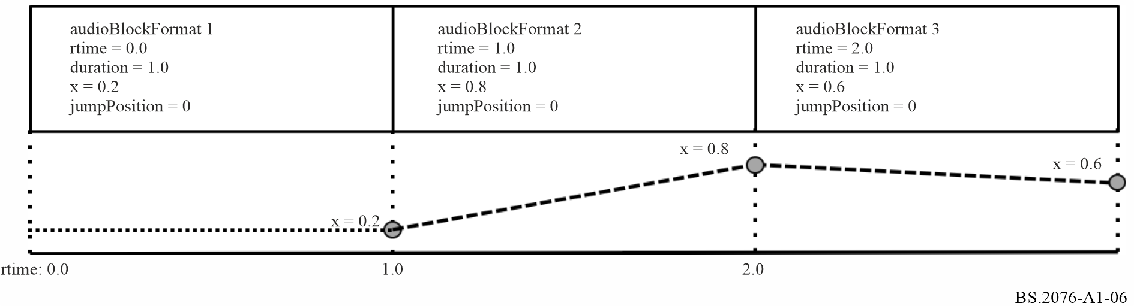
The second example, in Fig. A1-7, shows how the value of x varies when jumpPosition is set to 1 and no interpolationLength is set. The value of x is set at the beginning of the block and maintains that value throughout its duration. This also shows that the first block has a defined position from the beginning, and thus illustrates that it is recommended to set jumpPosition to 1 for the first block in a sequence.
Figure A1-7
Interpolation with jumpPosition set
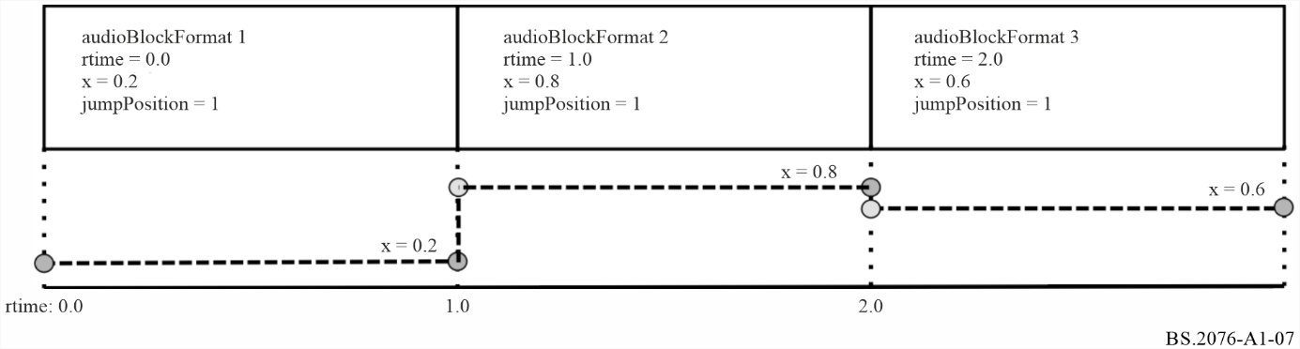
The third example, in Fig. A1-8, shows how the use of the interpolationLength attribute varies the value of x over the sequence of blocks. In this example, each interpolationLength is set to 0.3, so the value of x is interpolated over the first 0.3 seconds of the block, and then is locked to the defined value for the remainder of the block. The first block has an undefined value of x for the first 0.3 seconds.
Figure A1-8
Interpolation with interpolationLength used with jumpPosition
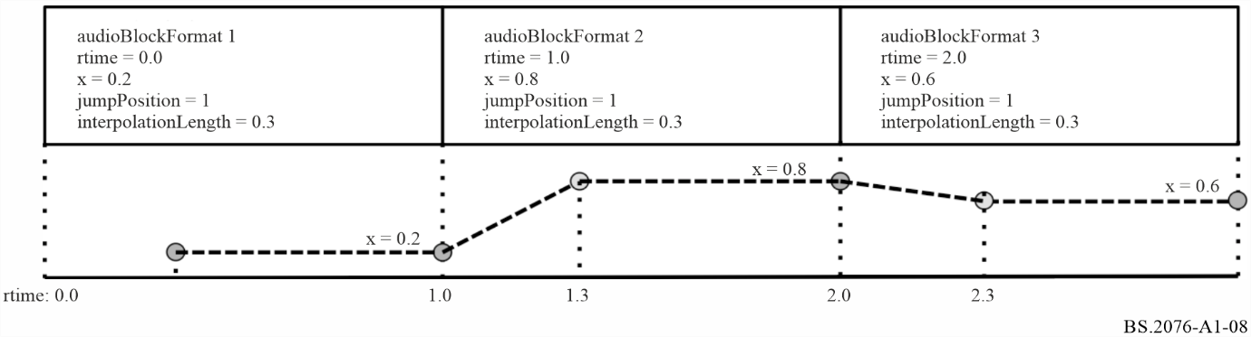
The fourth example, in Fig. A1-9, shows how zero length blocks can be used to make a position jump, but also allow for interpolation to follow immediately. By having a first block of zero length it can ensure an initial position is always present.
Figure A1-9
Interpolation using zero length blocks
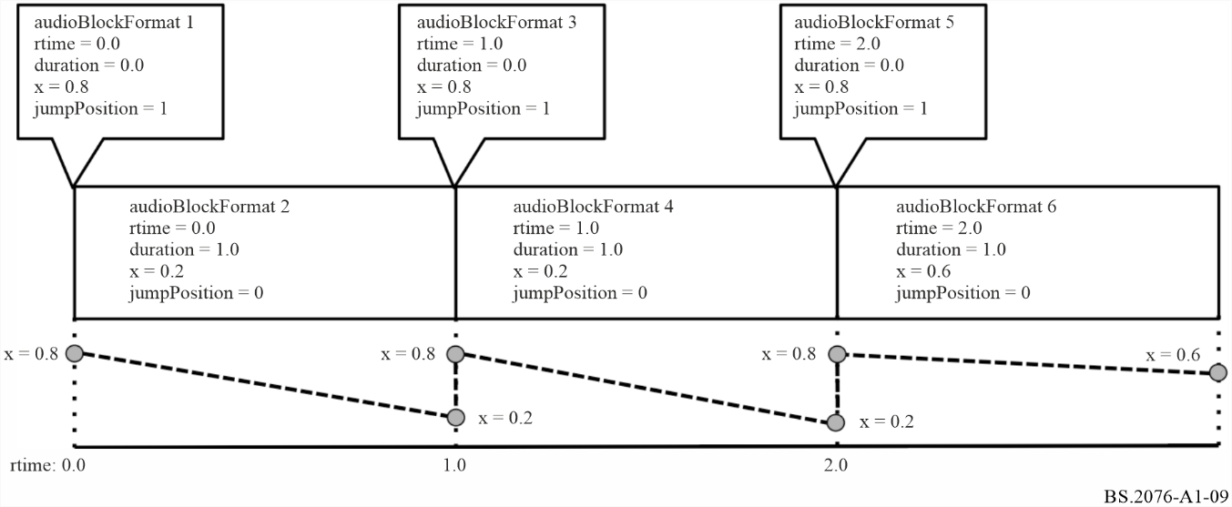
To ensure undefined behaviour of the first block is avoided, then the position specified in the first block covers the entire length of the block (regardless of the jumpPosition and interpolationLength properties).
The following parameters can be interpolated: position, width, height, depth, diffuse, and objectDivergence (including azimuthRange and positionRange) for typeDefinition of “Objects”, gain attribute of coefficient sub-element of matrix sub-element for typeDefinition of "Matrix", gain for all typeDefinitions.
The other parameters in audioBlockFormat should not be interpolated and should remain constant for the duration of the block.

9.4 headLocked
The headLocked flag indicates that an audio object should lock to the listener’s head when the head is moved (yaw/pitch/roll). Therefore, a headphone renderer which uses head tracking should not track the object if headLocked is set to “1”. Figure A1-10 depicts the concept of enabled and disabled head-locked audio elements.
The default state (when headLocked is not present) is for head-locking to be off, so the scene of objects remains fixed relative to the moving head (the middle diagram in Fig. A1-10).
If headLocked is present in the audioOject and the audioBlockFormat, the value defined in the audioBlockFormat shall take precedence over the audioObject value.

9.5 headphoneVirtualise
The headphoneVirtualise element specifies whether the content of the audioChannelFormat should be rendered with headphone virtualisation. The element consists of two attributes: “bypass” and “DRR” (Direct-to-Reverberant ratio).
The bypass attribute is a 1/0 flag that signals whether the content should be rendered using a headphone virtualiser (value of 0) or renderer to stereo (value of 1).
The DRR attribute defines the Direct-to-Reverberant-Ratio (DRR) in dB. This can be given in the range of −130 dB to 130 dB with 130 dB meaning anechoic (all direct sound).
Figure A1-10
Intended behaviour for head-locked audio elements
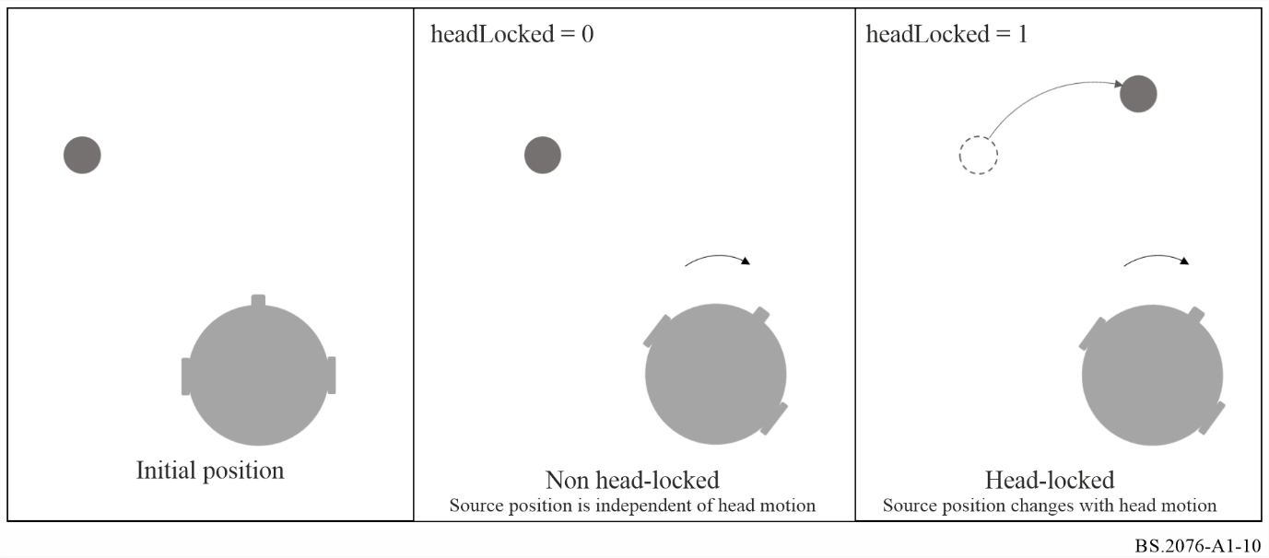

10 Parameter descriptions for typeDefinition of ‘Objects’
These parameters are found in the audioBlockFormat when the typeDefinition is ‘Objects’.

10.1 diffuse
The diffuse value between 0.0 and 1.0 describes the diffuseness of a sound, where 0.0 (the default) is a direct non-diffuse sound, and 1.0 a completely diffuse sound.

10.2 channelLock
If the channelLock flag is set to 1 then the renderer will send the audio signal to the nearest (in terms of 3D position) channel or speaker position. A typical application for this is where the exact location of the object is not critical, but the need for un-processed reproduction of that signal takes priority.
The optional maxDistance attribute defines the radius r, 0 ≤ r ≤ 2, of a sphere around the object’s position. If one or more speakers exist in the defined sphere or on its surface, the object snaps to the nearest speaker. If maxDistance is undefined, a default value of infinity is assumed, meaning that the object should snap to the nearest of all speakers (unconditioned channelLock).

10.3 zoneExclusion
The zoneExclusion parameter is used to dynamically reconfigure the object renderer to “mask out” certain speaker zones during playback. This guarantees that no loudspeaker belonging to the masked zones will be used for rendering the applicable object. Typical zone masks used in production today include sides and rear. Multiple zone sub-elements within zoneExclusion can be set simultaneously to mask out more than one zone. The default is that all zones are enabled and when zoneExclusion is set to one or more of the indicated zones, those are “masked out” during playback. The sub-element zone is used to define the coordinates of the zone in the unit-cuboid.
Zones are defined in the Cartesian coordinate system using the sub-element zone by specifying the corner points of a unit-cuboid in 3D space by: minX, maxX, minY, maxY, minZ, maxZ. In the spherical coordinate system the zone is defined by: minAzimuth, maxAzimuth, minElevation, maxElevation.
For example: minX= −1.0, maxX=1.0, minY= −1.0, maxY= –1.0, minZ= −1.0, maxZ=1.0 specifies the rear wall.

10.4 objectDivergence
The objectDivergence parameter (0.0 to 1.0) indicates the amount an object is split symmetrically into a pair of virtual objects, so that a phantom object is created in the position of the original object. The spread of the signal between the virtual objects should not create an image shift from the original object position and should be power preserving across virtual objects and the original. The azimuthRange and positionRange attributes allow the relative positions of virtual objects to be specified. This can either be an angle where spherical coordinates are being used, or a distance value where Cartesian coordinates are being used. When spherical coordinates are used, a value of 45 degrees would place virtual objects 45 degrees to the left and right of the specified object. The default angle is 0 degrees if this attribute is not used. When Cartesian coordinates are used, a value of 0.5 would place the virtual objects at x-0.5,y,z and x+0.5,y,z if x,y,z is the location of the specified object. The default distance is 0.0.
The values of objectDivergence should be interpreted as:
TABLE A1-67
objectDivergence values
Value | Description
0 | No divergence with only the original object being present.
1 | Maximum divergence where this would represent virtual objects being created azimuthRange degrees on either side of the original position.

Example: With an LCR loudspeaker layout and the object positioned directly at the C position, and the LR virtual objects specified by using an azimuthRange of 30 degrees. An objectDivergence value of 0 indicating no divergence, only the centre speaker would be firing. A value of 0.5 would have all three (LCR) loudspeakers firing equally, and a value of 1 would have the L and R loudspeakers firing equally.

10.5 screenRef and audioProgrammeReferenceScreen
The screenRef flag is used to indicate whether the corresponding audio signal (e.g. object or HOA signal) is screen-related or not. The screenRef flag can be used by a renderer for special processing of all screen-related objects taking into account the size of a local reproduction screen compared to the production screen-size.
If a renderer uses the screenRef flag to enable a special processing, it should use the reference/monitoring/production screen-size of the currently rendered audioProgramme as the reference screen.
If the flag is set and no audioProgrammeReferenceScreen element is included in the corresponding currently rendered audioProgramme, the reference production/monitoring screen is implicitly defined on the basis of Recommendation ITU-R BT.1845 – Guidelines on metrics to be used when tailoring television programmes to broadcasting applications at various image quality levels, display sizes and aspect ratios [6].
TABLE A1-68
Default screen size
Azimuth of left bottom corner of screen | 29.0°
Elevation of the left bottom corner of screen | −17.3°
Aspect ratio | 1.78 (16:9)
Polar angular width of the screen | 58°  (as defined by image system  3840 × 2160)

These spherical values can be transferred to Cartesian coordinates assuming a reference distance of 1.0 by first transferring the values above to the “standard” azimuth/elevation convention (0° azimuth is in front of the right ear, positive values are counted counter-clockwise; 0° elevation is directly above the head, positive values are counted downwards to the front) and then using the trigonometric functions to gain the Cartesian coordinates. The screen is assumed to have its centre touching the unit sphere. This results in the following values (orientation of the Cartesian coordinate axes as in § 8):
TABLE A1-69
Default screen size in Cartesian coordinates
X-coordinate of the centre of the screen | 0.0
Y-coordinate of the centre of the screen | 1.0
Z-coordinate of the centre of the screen | 0.0
Aspect ratio | 1.78
Width of the screen | 1.1086

NOTE – The maths to convert from the polar coordinate screen to Cartesian coordinates is:
$d=\frac{1}{\sqrt{{\left(\frac{1}{a^{2}}\right)tan}^{2}\left(\frac{w}{2}\right)+1}}$
where:
d : Y-coordinate of the centre of the screen
a : aspect ratio
w : polar angle of the screen width.
$x=2d\tan\left(\frac{w}{2}\right)$
where:
x : Cartesian screen width
w : polar angle of the screen width.

11 Parameter descriptions for typeDefinition of ‘HOA’
These parameters are found in the audioBlockFormat when the typeDefinition is ‘HOA’.

11.1 order and degree
The meaning of order and degree values is based on the following definition of real-valued spherical harmonics:
$Y_{n}^{m}\left(θ,ϕ\right)= N_{n}^{\left|m\right|}P_{n}^{\left|m\right|}\left(\cos\left(θ\right)\right)\left\{\begin{aligned}\sqrt{2}\cos\left(mϕ\right), for m>0 \\ 1, for m=0 \\ -\sqrt{2}\sin\left(mϕ\right), for m<0\end{aligned}\right.$
where:
$n$ : order value
$m$ : degree value
$ϕ$ : azimuth
$θ$ : elevation
$N_{n}^{\left|m\right|}$ : normalization parameter for the given order and degree
$P_{n}^{\left|m\right|}$ : associated Legendre function for the given order and degree.
The associated Legendre functions $P_{n}^{m}\left(x\right)$ are defined as:
$P_{n}^{m}\left(x\right)= {\left(1-x^{2}\right)}^{\frac{m}{2}}\frac{d^{m}}{{dx}^{m}}P_{n}\left(x\right), m≥0$
with the Legendre polynomial $P_{n}\left(x\right)$ and without the Condon-Shortley phase term ${\left(-1\right)}^{m}.$

11.2 normalization
When the normalization is specified as N3D, the following equation is given:
${N_{N3D}}_{n}^{\left|m\right|}=\sqrt{(2n+1)\frac{\left(n-|m|\right)!}{\left(n+|m|\right)!}.}$
N3D normalization yields a set of orthonormal basis functions. With N3D normalization the higher-order components ($n≥0$) can have an energy greater than that of the $n=0$ component, which risks causing clipping distortions when audio data is stored in integer sample formats.
When the normalization is specified as SN3D, the following equation is given:
${N_{SN3D}}_{n}^{\left|m\right|}=\sqrt{\frac{\left(n-|m|\right)!}{\left(n+|m|\right)!}.}$
SN3D normalization applies a weighting to the HOA components according to the order such that the energy does not exceed that of the $n=0$ component.
When the normalization is specified as FuMa, the signal was stored with the Furse-Malham (FuMa) weighting. This system of weighting is designed for coefficients not to exceed an absolute value of 1 in panning. It also has a −3 dB weighting of the n = 0 component. It is only defined up to order 3.
TABLE A1-70
HOA FuMa normalization
Order ($n$) | Degree ($\left|m\right|$) | ${N_{FuMa}}_{n}^{\left|m\right|}$Normalization  (relative to ${N_{SN3D}}_{n}^{\left|m\right|}$)
0 | 0 | $$\frac{1}{\sqrt{2}} {N_{SN3D}}_{n}^{\left|m\right|}$$
1 | 0 | $${N_{SN3D}}_{n}^{\left|m\right|}$$
1 | 1 | $${N_{SN3D}}_{n}^{\left|m\right|}$$
2 | 0 | $${N_{SN3D}}_{n}^{\left|m\right|}$$
2 | 1 | $$\frac{2}{\sqrt{3}}{N_{SN3D}}_{n}^{\left|m\right|}$$
2 | 2 | $$\frac{2}{\sqrt{3}}{N_{SN3D}}_{n}^{\left|m\right|}$$
3 | 0 | $${N_{SN3D}}_{n}^{\left|m\right|}$$
3 | 1 | $$\sqrt{\frac{45}{32}}{N_{SN3D}}_{n}^{\left|m\right|}$$
3 | 2 | $$\frac{3}{\sqrt{5}}{N_{SN3D}}_{n}^{\left|m\right|}$$
3 | 3 | $$\sqrt{\frac{8}{5}}{N_{SN3D}}_{n}^{\left|m\right|}$$

To reduce the risk of clipping with integer sample formats the SN3D normalization is the default option. Due to its greater dynamic range, N3D normalization is recommended for floating-point sample formats where there is practically no risk of clipping.

11.3 nfcRefDist
The nfcRefDist indicates the reference distance (in metre) that has been used during the scene-based audio production. This reference distance may be used for the audio rendering for nearfield compensation (NFC) [9].
If the nfcRefDist is not defined or set to zero, nearfield-compensated rendering is not intended.

11.4 screenRef
The screenRef flag is used to indicate whether the scene-based programme is screen-related or not.
The screenRef flag can be used by a renderer for special adaptation of the scene-based content taking into account the size of a local reproduction screen in relation to the production screen-size.
See § 10.5 for additional information regarding the production screen-size parameter.

11.5 Ambisonics Channel Numbering
An often-used convention for channel ordering based on order and degree components is the so-called Ambisonics Channel Number (ACN):
$ACN = n^{2}+n+m.$
The order and degree components can be easily retrieved from the $ACN$ number:
$n=\left\lfloor \sqrt{ACN}\right\rfloor$,
$m=ACN-n^{2}-n.$

12 Relationship and application of gain parameters in the ADM
The following elements of the ADM are relevant to calculate the final gain of a specific audio sample:
– gain sub-element of audioBlockFormat: Defines a gain value (either linear or logarithmic) that should be applied to all audio samples corresponding to the parent audioBlockFormat. If the gain parameter is not set, a linear value of 1.0 is assumed. Ideally the waveform (represented e.g. by PCM samples) should be at the desired level, so the gain parameter is not required (or set to 1.0). The gain parameter in audioBlockFormat is useful when a single audio track is being used by multiple audioChannelFormat definitions, each requiring different levels.
– gain sub-element of audioObject: Defines a gain value (either linear or logarithmic) that should be applied to all audio samples corresponding to the parent audioObject. The gain parameter in audioObject can for instance be used for user interactivity. Then it describes the initial playback gain of the audioObject during rendering. For example, it might be required that a particular audioObject is usually muted, so it will be given a gain of zero (-inf dB). It can also be used to ensure that different audioProgrammes using a different combination of audioObjects maintain a desired loudness level. If the gain parameter is not set, a linear value of 1.0 (0 dB) is assumed.
– gainInteractionRange sub-element of audioObjectInteraction: The audioObjectInteraction sub-element of audioObject can be used to define in which boundaries a user can interactively influence the audioObject. With relation to gain, it is possible to allow or forbid any gain interaction at all. If gain interaction is allowed, the gainInteractionRange sub-element of audioObjectInteraction defines minimum and maximum boundaries for the gain interaction (either as linear or logarithmic values). Any change to an attribute that can be set by the user should be within the limits of the interaction range.
During rendering/playback, all the different gain parameters and related ADM metadata have to be combined in a specific way to ensure the correct playback level is chosen for specific set of audio samples or an audio source.
Figure A1-11
User gain can take any values without gain range set
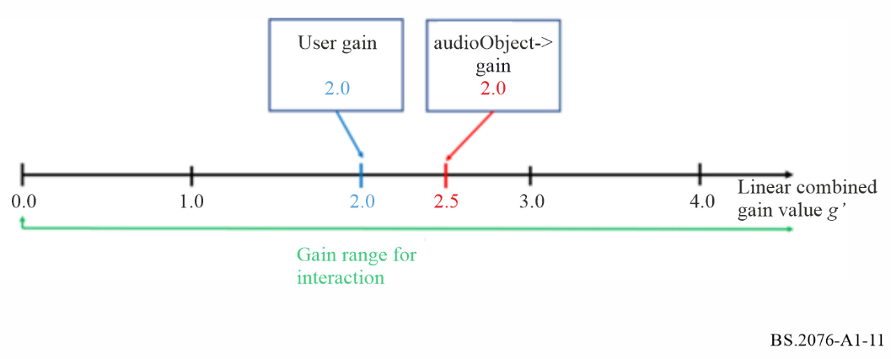
Figure A1-12
User gain within the values set by gainInteractionRange bounds
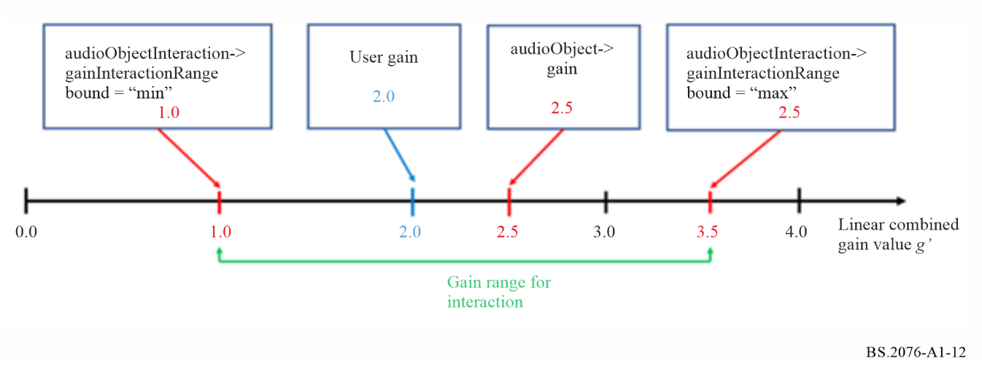
The following defines how the total gain value $g_{total}$ is determined for each audio sample.
First it is determined whether gain interactivity is enabled:
1 If the interact attribute of the audioObject element is not present or is present and set to 0, then gain interactivity is disabled.
2 If the interact attribute of the audioObject element is present and set to 1:
2.1 If the audioObjectInteraction sub-element of the audioObject element is not present, then gain interactivity is enabled.
2.2 If the audioObjectInteraction sub-element of the audioObject element is present:
2.2.1 If the gainInteract attribute of the audioObjectInteraction element is not present or is present and set to 0, then gain interactivity is disabled.
2.2.2 If the gainInteract attribute of the audioObjectInteraction element is present and set to 1, then gain interactivity is enabled.
If gain interactivity is disabled, gain value $g'$ as used below is set to the value of the gain sub-element of the audioObject element, or to 1.0 (0 dB) if the gain sub-element is not present.
If gain interactivity is enabled, the following variables are defined:
$g_{min}$ …value of the audioObjectInteraction->gainInteractionRange sub-element with attribute bound=”min”; if no audioObjectInteraction element is present or no gainInteractionRange sub-element with attribute bound=”min” is present, then $g_{min}$is set to 0.0 (-inf dB)
$g_{max}$ …value of the audioObjectInteraction->gainInteractionRange sub-element with attribute bound=”max”; if no audioObjectInteraction element is present or no positionInteractionRange sub-element with attribute bound=”max” is present, then $g_{max}$is set to inf (inf dB)
$g_{User}$ …gain value imposed by user interaction; if the user did not set a gain value, the value of the gain sub-element of the audioObject element is used as a default; if the gain sub-element is not present, the default value for $g_{User}$ is 1.0 (0 dB)
With these variables, gain value $g'$ is calculated as follows:
$$g^{'}= min⁡(g_{max},\max\left(g_{min},g_{User}\right))$$
If an alternativeValueSet sub-element is active for an audioObject element, the applicable values to be used in the procedure above depend on the precedence and inheritance of gain and audioObjectInteraction sub-elements between the parent audioObject element and its active alternativeValueSet sub-element (see § 5.6.5).
Summary of common scenarios with gain interactivity:
– If gain interactivity is disabled, the gain sub-element can be used to assign any static gain level to the audioObject.
– If gain interactivity is enabled, $g_{User}$ is set to the value of the gain sub-element which serves as a default until the user changes the gain value.
– If gain interactivity is enabled and no gainInteractionRange sub-elements are present, the user can adjust the gain without any constraints. This is illustrated in Fig. A1-11. In this case, the combined gain value is simply $g^{'}=g_{User}$.
– If gain interactivity is enabled and any gainInteractionRange sub-elements are present, the user can adjust the gain value $g^{'}$ within the limits imposed by the gainInteractionRange sub-elements. This is illustrated in Fig. A1-12.
The resulting overall playback gain value then is
$g_{total}= g_{block} ∙g'$
with $g_{block}$ being the audioBlockFormat->gain value. This is illustrated in Fig. A1-13.
All gain values referred to in the calculations in this section are considered as linear gain values.
Linear and logarithmic gain values can be translated as follows:
$g_{log}\left[dB\right]=20 ∙\log_{10}{(g_{lin})}$
$g_{lin}= {10}^{(\frac{g_{log}\left[dB\right]}{20})}$
A linear value of 0.0 is equivalent to a logarithmic value of negative infinity (“-inf”).
Figure A1-13
Application of audioBlockFormat gain and gain value g’
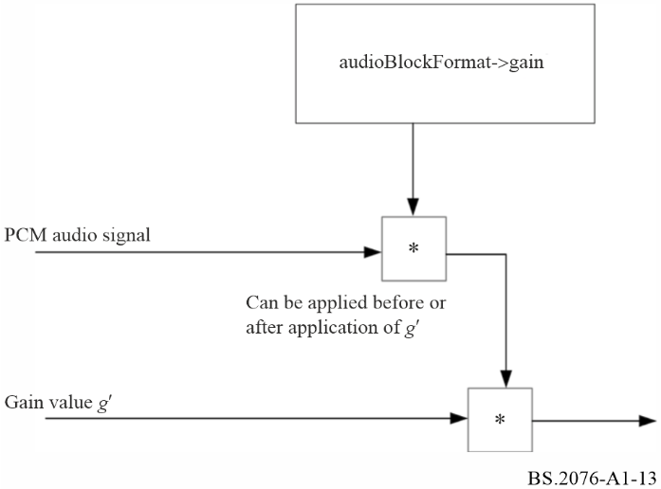

13 Application of position-related parameters in the ADM
The following elements of the ADM are relevant to calculate the final position to which a specific audio sample should be rendered:
– position sub-element of audioBlockFormat (for typeDefinition=“DirectSpeakers” and typeDefinition=“Objects”): This element defines the position of either a loudspeaker (typeDefinition=“DirectSpeakers”) or a single sequence of audioChannelFormat samples representing an object. The position can be given either by azimuth, elevation and normalised distance (polar/spherical coordinates) or normalised X, Y, Z values (Cartesian coordinates).
– positionOffset sub-element of audioObject: This defines position offset values that should be applied to the position metadata of all audio corresponding to the parent audioObject. It describes the initial playback position offset of the audioObject during rendering.
– positionInteractionRange sub-element of audioObjectInteraction: This element defines the bounds in which a user-side position interaction is possible. It gives minimum and maximum values for a possible user interaction with respect to azimuth, elevation and distance (spherical coordinates) or X, Y, Z (Cartesian coordinates).
During rendering/playback, all the different position-related parameters and related ADM metadata shall be combined in a specific way to ensure the correct rendering position is chosen for specific set of audio samples or an audio source.
Figure A1-14
Application of audioObject position offset values (polar coordinates) without positionInteractionRange sub-elements set
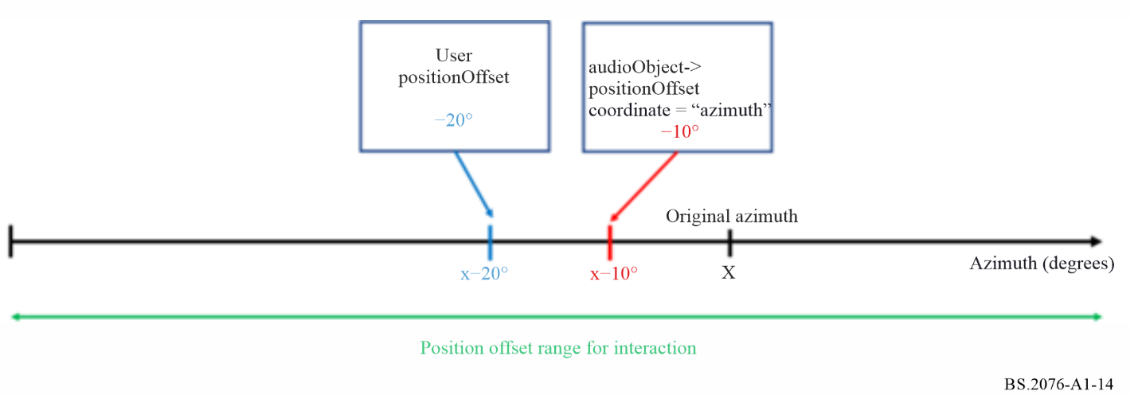
Figure A1-15
Application of audioObject position offset values (polar coordinates)
with positionInteractionRange sub-elements set
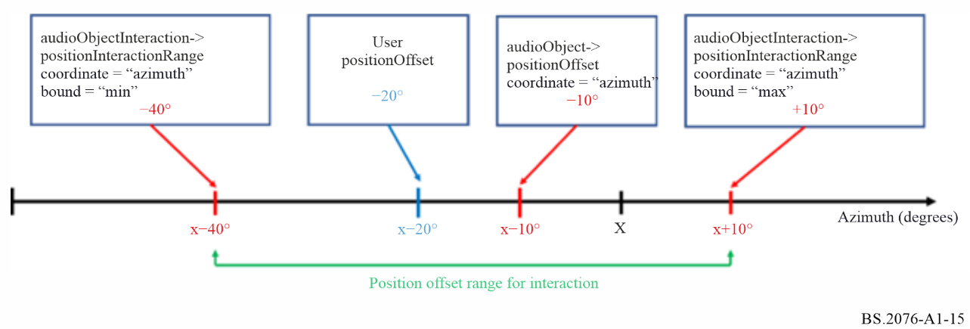
The following specifies how the total position value $p_{total}$ for any single selected coordinate (azimuth, elevation, distance, or X,Y,Z) is determined for each audioBlockFormat.
First, it is determined whether position interactivity is enabled for the selected coordinate:
1 If the interact attribute of the audioObject element is not present or is present and set to 0, then position interactivity is disabled for the selected coordinate.
2 If the interact attribute of the audioObject element is present and set to 1:
2.1 If the audioObjectInteraction sub-element of the audioObject element is not present, then position interactivity is enabled for the selected coordinate.
2.2 If the audioObjectInteraction sub-element of the audioObject element is present:
2.2.1 If the positionInteract attribute of the audioObjectInteraction element is not present or is present and set to 0, then position interactivity is disabled for the selected coordinate.
2.2.2 If the positionInteract attribute of the audioObjectInteraction element is present and set to 1:
2.2.2.1 If the audioObjectInteraction element does not include positionInteractionRange sub-elements for any coordinate, then position interactivity is enabled for the selected coordinate.
2.2.2.2 If the audioObjectInteraction element includes positionInteractionRange sub-elements with bound=”min” and bound=”max” for the selected coordinate, then position interactivity is enabled for the selected coordinate.
2.2.2.3 Otherwise, position interactivity is disabled for the selected coordinate
If position interactivity is disabled for a selected coordinate, then variable $p'$ as used below is set to the value of the positionOffset sub-element for the selected coordinate (or to 0.0 if the positionOffset sub-element is not present for that coordinate).
If position interactivity is enabled for a selected coordinate, the following variables are defined:
$p_{min}$ …value of the audioObjectInteraction->positionInteractionRange sub-element with attribute bound=”min” for the selected coordinate; if no audioObjectInteraction element is present or no positionInteractionRange sub-elements are present, then $p_{min}$is set to -inf
$p_{max}$ …value of the audioObjectInteraction->positionInteractionRange sub-element with attribute bound=”max” for the selected coordinate; if no audioObjectInteraction element is present or no positionInteractionRange sub-elements are present, then $p_{max}$is set to inf
$p_{User}$ …positionOffset value imposed by user interaction; if the user did not set a positionOffset value, the value of the positionOffset sub-element for the selected coordinate is used as a default; if the positionOffset sub-element is not present for that coordinate, the default value for $p_{User}$ is 0.0.
With these variables, the combined positionOffset value p’ is calculated as follows:
$p^{'}= min⁡(p_{max},\max\left(p_{min},p_{User}\right))$
If an alternativeValueSet sub-element is active for an audioObject element, the applicable values to be used in the procedure above depend on the precedence and inheritance of positionOffset and audioObjectInteraction sub-elements between the parent audioObject element and its active alternativeValueSet sub-element (see § 5.6.5).
Summary of common scenarios with position offset interaction:
– Position interactivity is enabled for all coordinates without any constraints, if the interact attribute of the audioObject element is present and set to 1 and there is no audioObjectInteraction sub-element, or if the audioObjectInteraction sub-element is present with the positionInteract attribute set to ‘1’ and without positionInteractionRange sub-elements for any coordinate. In this case, the user can adjust the position offset value along all coordinate directions without any constraints. This is illustrated exemplarily for the azimuth coordinate in Fig. A1-14.
– Position interactivity is enabled for only one or more selected coordinates if the interact attribute of the audioObject element is present and set to 1 and the audioObjectInteraction sub-element is present with the positionInteract attribute is set to ‘1’ and positionInteractionRange sub-elements present only for the selected coordinates. In this case, the user can adjust the position along the selected coordinates according to the limits imposed by the positionInteractionRange sub-elements but cannot adjust the position along any other coordinate. This is illustrated exemplarily for the azimuth coordinate in Fig. A1-15.
– If position interactivity is disabled for a coordinate, the corresponding positionOffset sub-element can be used to assign any static positionOffset to the audioObject along that coordinate.
– If position interactivity is enabled for a coordinate, $p_{User}$ is set to the value of the corresponding positionOffset sub-element which serves as a default until the user changes the positionOffset value.
The resulting overall position value then is
$p_{total}=p_{block}+p'$
with $p_{block}$ being the corresponding audioBlockFormat->position value.
For the distance coordinate, the following additional operation is performed:
$p_{total}^{'}= max⁡(0,p_{total})$

14 References
[1] Report ITU-R BS.2266 – Framework of future audio broadcasting systems
[2] Recommendation ITU-R BS.1909 – Performance requirements for an advanced multichannel stereophonic sound system for use with or without accompanying picture
[3] Recommendation ITU-R BS.2051 – Advanced sound system for programme production
[4] Recommendation ITU-R BS.1352 – File format for the exchange of audio programme materials with metadata on information technology media
[5] Recommendation ITU-R BS.1770 – Algorithms to measure audio programme loudness and true-peak audio level
[6] Recommendation ITU-R BT.1845 – Guidelines on metrics to be used when tailoring television programmes to broadcasting applications at various image quality levels, display sizes and aspect ratios
[7] Recommendation ITU-R BS.2088 – Long-form file format for the international exchange of audio programme materials with metadata
[8] Recommendation ITU-R BS.2094 – Common definitions for the Audio Definition Model
[9] Daniel J. Spatial sound encoding including near field effect: Introducing distance coding filters and a viable, new ambisonic format. In 23rd International AES Conference: Signal Processing in Audio Recording and Reproduction 2003
[10] Report ITU-R BS.2388 – Usage guidelines for audio definition model and multichannel audio files

Annex 2
(informative)
Examples of ADM usage
This Annex 2 contains a selection of examples of metadata that uses the ADM. These are to help illustrate how the ADM is used, but not be considered as references for audio definitions.

1 Channel-based example
The most common use of audio is still channel-based, where tracks within a file each represent a static audio channel. This example demonstrates how to define two tracks, streams and channels; and a pack for stereo. The track and stream definitions are for PCM audio. Two objects are defined, both stereo, but containing different content so there are 4 tracks used. This example uses a programme called ‘Documentary’ containing ‘Music’ and ‘Speech’ each defined as separate stereo objects.
The format-related elements in this example represent a tiny subset of the common reference set of definitions. In practice, this XML code would be part of the common reference file and would not have to be included in the BWF file. All that would be required is a <chna> chunk with the references to the audioTrackFormats and audioPackFormats and any extra XML required for audioObject, audioContent and audioProgramme.

1.1 Summary of elements
These are the elements in the format part of the description:
TABLE A2-1
Channel-based example format elements
Element | ID | Name | Description
audioTrackFormat | AT_00010001_01 | PCM_FrontLeft | Defines track as PCM
audioTrackFormat | AT_00010002_01 | PCM_FrontRight | Defines track as PCM
audioStreamFormat | AS_00010001 | PCM_FrontLeft | Defines stream as PCM
audioStreamFormat | AS_00010002 | PCM_FrontRight | Defines stream as PCM
audioChannelFormat and  audioBlockFormat | AC_00010001  AB_00010001_00000001 | FrontLeft | Describes channel as front left with a position and speaker reference
audioChannelFormat and  audioBlockFormat | AC_00010002  AB_00010002_00000001 | FrontRight | Describes channel as front right with a position and speaker reference
audioPackFormat | AP_00010002 | Stereo | Defines a stereo pack referring to two channels.

These are the elements in the content part of the description:
TABLE A2-2
Channel-based example content elements
Element | ID | Name | Description
audioObject | AO_1001 | Music | Object for ‘Music’, stereo format
audioObject | AO_1002 | Speech | Object for ‘Speech’, stereo format
audioContent | ACO_1001 | Music | Music content
audioContent | ACO_1002 | Speech | Speech content
audioProgramme | APR_1001 | Documentary | Programme ‘Documentary’ containing ‘Music’ and ‘Speech’ content

1.2 Element Relationships
The diagram in Fig. A2-1 shows how the defined elements relate to each other. The top half of the diagram covers the elements that describe the two-channel stereo format. The <chna> chunk in the middle shows how the four tracks are connected to the format definitions. The content definition elements are at the bottom of the diagram, with the audioObject elements containing the track UID references to the UIDs in the <chna> chunk.
Figure A2-1
Channel-based example diagram
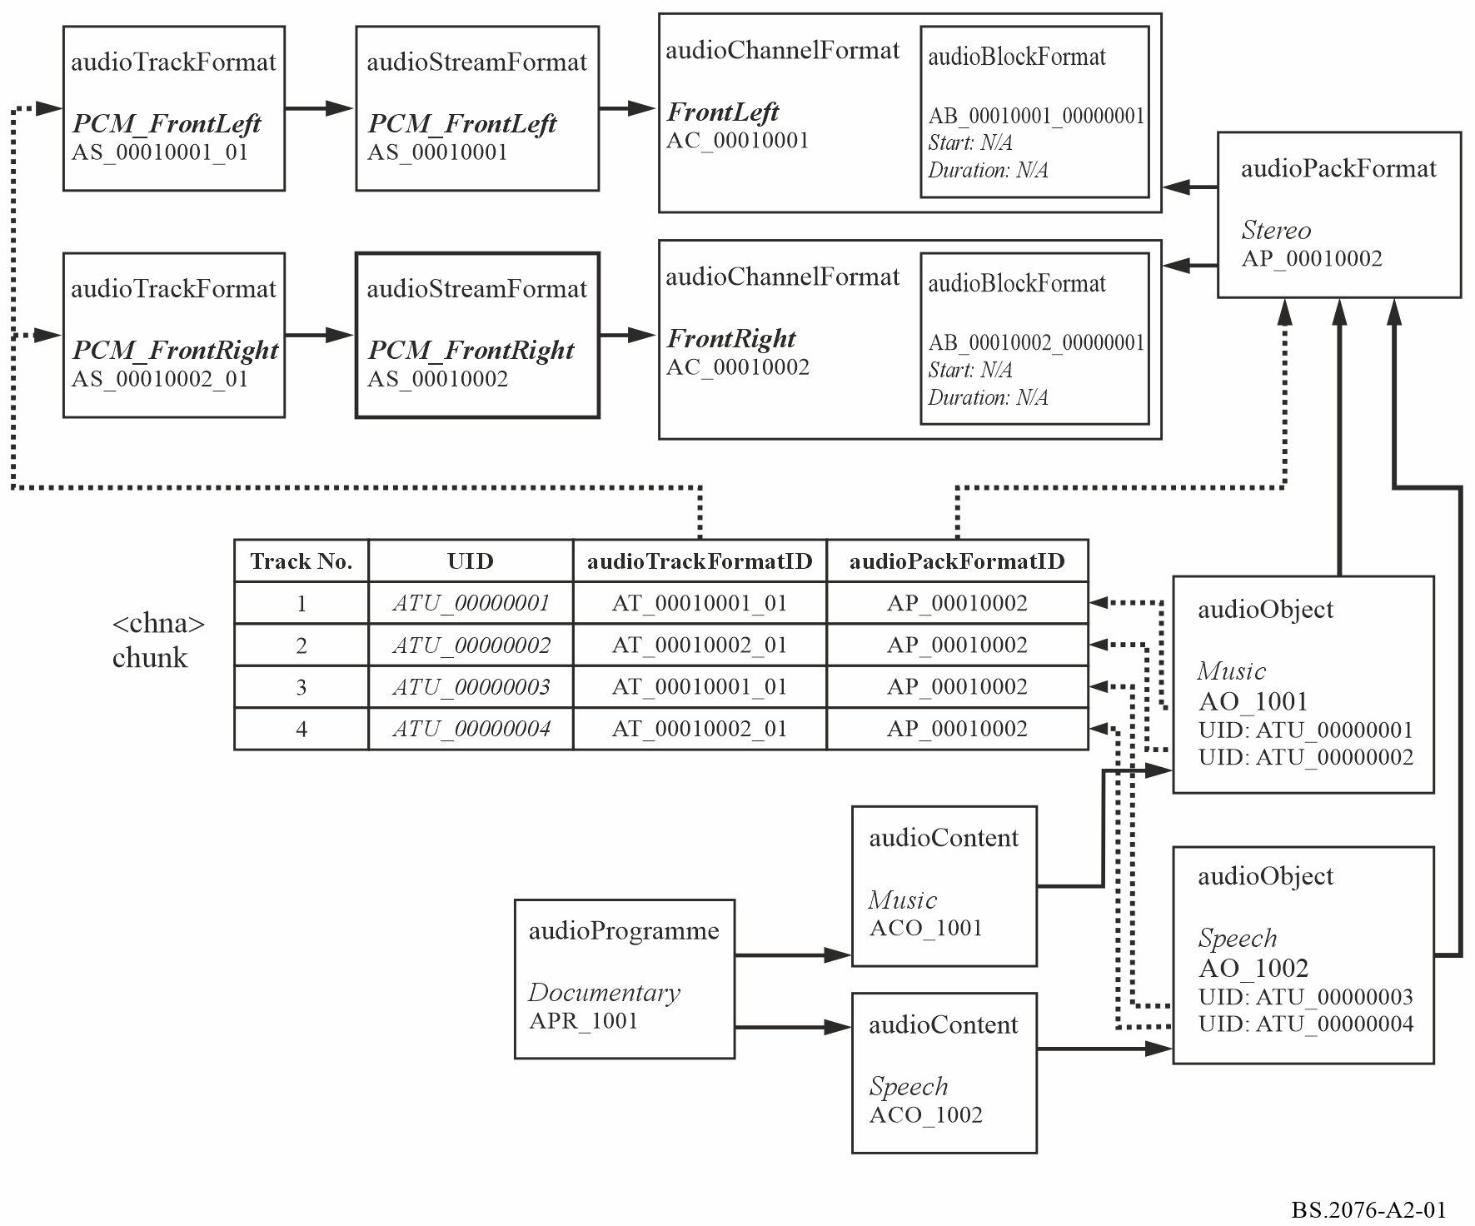

1.3 Sample code
This XML sample code does not include the audioFormatExtended parent element and the XML header for clarity.
The first excerpt of code covers the format elements, which could be contained within the common definitions reference file:

<!-- ############ -->
<!-- PACKS -->
<!-- ############ -->

<audioPackFormat audioPackFormatID="AP_00010002" audioPackFormatName="Stereo" typeLabel="0001" typeDefinition="DirectSpeakers">
<audioChannelFormatIDRef>AC_00010001</audioChannelFormatIDRef>
<audioChannelFormatIDRef>AC_00010002</audioChannelFormatIDRef>
</audioPackFormat>

<!-- ############ -->
<!-- CHANNELS -->
<!-- ############ -->

<audioChannelFormat audioChannelFormatID="AC_00010001" audioChannelFormatName="FrontLeft" typeLabel="0001" typeDefinition="DirectSpeakers">
<audioBlockFormat audioBlockFormatID="AB_00010001_00000001">
<speakerLabel>M+030</speakerLabel>
<position coordinate="azimuth">30.0</position>
<position coordinate="elevation">0.0</position>
<position coordinate="distance">1.0</position>
</audioBlockFormat>
</audioChannelFormat>

<audioChannelFormat audioChannelFormatID="AC_00010002" audioChannelFormatName="FrontRight" typeLabel="0001" typeDefinition="DirectSpeakers">
<audioBlockFormat audioBlockFormatID="AB_00010002_00000001">
<speakerLabel>M-030</speakerLabel>
<position coordinate="azimuth">-30.0</position>
<position coordinate="elevation">0.0</position>
<position coordinate="distance">1.0</position>
</audioBlockFormat>
</audioChannelFormat>

<!-- ############ -->
<!-- STREAMS -->
<!-- ############ -->

<audioStreamFormat audioStreamFormatID="AS_00010001" audioStreamFormatName="PCM_FrontLeft" formatLabel="0001" formatDefinition="PCM">
<audioChannelFormatIDRef>AC_00010001</audioChannelFormatIDRef>
<audioTrackFormatIDRef>AT_00010001_01</audioTrackFormatIDRef>
</audioStreamFormat>

<audioStreamFormat audioStreamFormatID="AS_00010002" audioStreamFormatName="PCM_FrontRight" formatLabel="0001" formatDefinition="PCM">
<audioChannelFormatIDRef>AC_00010002</audioChannelFormatIDRef>
<audioTrackFormatIDRef>AT_00010002_01</audioTrackFormatIDRef>
</audioStreamFormat>

<!-- ############ -->
<!-- AUDIO TRACKS -->
<!-- ############ -->

<audioTrackFormat audioTrackFormatID="AT_00010001_01" audioTrackFormatName="PCM_FrontLeft" formatLabel="0001" formatDefinition="PCM">
<audioStreamFormatIDRef>AS_00010001</audioStreamFormatIDRef>
</audioTrackFormat>

<audioTrackFormat audioTrackFormatID="AT_00010002_01" audioTrackFormatName="PCM_FrontRight" formatLabel="0001" formatDefinition="PCM">
<audioStreamFormatIDRef>AS_00010002</audioStreamFormatIDRef>
</audioTrackFormat>

The second excerpt covers the content part, which would have to be included in the <axml> chunk of the BWF file:

<!-- ############ -->
<!-- PROGRAMMES -->
<!-- ############ -->

<audioProgramme audioProgrammeID="APR_1001" audioProgrammeName="Documentary">
<audioContentIDRef>ACO_1001</audioContentIDRef>
<audioContentIDRef>ACO_1002</audioContentIDRef>
</audioProgramme>

<!-- ############ -->
<!-- CONTENTS -->
<!-- ############ -->

<audioContent audioContentID="ACO_1001" audioContentName="Music">
<audioObjectIDRef>AO_1001</audioObjectIDRef>
<loudnessMetadata>
<integratedLoudness>-28.0</integratedLoudness>
</loudnessMetadata>
</audioContent>

<audioContent audioContentID="ACO_1002" audioContentName="Speech">
<audioObjectIDRef>AO_1002</audioObjectIDRef>
<loudnessMetadata>
<integratedLoudness>-23.0</integratedLoudness>
</loudnessMetadata>
</audioContent>

<!-- ############ -->
<!-- OBJECTS -->
<!-- ############ -->

<audioObject audioObjectID="AO_1001" audioObjectName="Music" start="00:00:00.00000">
<audioPackFormatIDRef>AP_00010002</audioPackFormatIDRef>
<audioTrackUIDRef>ATU_00000001</audioTrackUIDRef>
<audioTrackUIDRef>ATU_00000002</audioTrackUIDRef>
</audioObject>

<audioObject audioObjectID="AO_1002" audioObjectName="Speech" start="00:00:00.00000">
<audioPackFormatIDRef>AP_00010002</audioPackFormatIDRef>
<audioTrackUIDRef>ATU_00000003</audioTrackUIDRef>
<audioTrackUIDRef>ATU_00000004</audioTrackUIDRef>
</audioObject>

<!-- ############ -->
<!-- AUDIO TRACK UIDs -->
<!-- ############ -->

<audioTrackUID UID="ATU_00000001">
<audioTrackFormatIDRef>AT_00010001_01</audioTrackFormatIDRef>
<audioPackFormatIDRef>AP_00010002</audioPackFormatIDRef>
</audioTrackUID>

<audioTrackUID UID="ATU_00000002">
<audioTrackFormatIDRef>AT_00010002_01</audioTrackFormatIDRef>
<audioPackFormatIDRef>AP_00010002</audioPackFormatIDRef>
</audioTrackUID>

<audioTrackUID UID="ATU_00000003">
<audioTrackFormatIDRef>AT_00010001_01</audioTrackFormatIDRef>
<audioPackFormatIDRef>AP_00010002</audioPackFormatIDRef>
</audioTrackUID>

<audioTrackUID UID="ATU_00000004">
<audioTrackFormatIDRef>AT_00010002_01</audioTrackFormatIDRef>
<audioPackFormatIDRef>AP_00010002</audioPackFormatIDRef>
</audioTrackUID>

2 Channel-based example optimized for PCM
The structure of this example results in the same rendered audio output as that described in § 1, however this version omits the use of both audioTrackFormat and audioStreamFormat elements as described in Annex 1, § 5.1.
This example demonstrates how to define two channels and a pack for stereo. As the essence is PCM, the track and stream definitions can be omitted. Two objects are defined, both stereo, but containing different content so there are 4 tracks used. This example uses a programme called ‘Documentary’ containing ‘Music’ and ‘Speech’ each defined as separate stereo objects.
The format-related elements in this example represent a tiny subset of the common reference set of definitions. In practice, this XML code would be part of the common reference file and would not have to be included in the BWF file. All that would be required is a <chna> chunk with the references to the audioChannelFormats and audioPackFormats and any extra XML required for audioObject, audioContent and audioProgramme.

2.1 Summary of elements
These are the elements in the format part of the description:
TABLE A2-3
Channel-based example format elements
Element | ID | Name | Description
audioChannelFormat &  audioBlockFormat | AC_00010001  AB_00010001_00000001 | FrontLeft | Describes channel as front left with a position and speaker reference
audioChannelFormat &  audioBlockFormat | AC_00010002  AB_00010002_00000001 | FrontRight | Describes channel as front right with a position and speaker reference
audioPackFormat | AP_00010002 | Stereo | Defines a stereo pack referring to two channels.

These are the elements in the content part of the description:
TABLE A2-4
Channel-based example content elements
Element | ID | Name | Description
audioObject | AO_1001 | Music | Object for ‘Music’, stereo format
audioObject | AO_1002 | Speech | Object for ‘Speech’, stereo format
audioContent | ACO_1001 | Music | Music content
audioContent | ACO_1002 | Speech | Speech content
audioProgramme | APR_1001 | Documentary | Programme ‘Documentary’ containing ‘Music’ and ‘Speech’ content

2.2 Element Relationships
The diagram in Fig. A2-2 shows how the defined elements relate to each other. The top half of the diagram covers the elements that describe the two-channel stereo format. The <chna> chunk in the middle shows how the four tracks are connected to the format definitions. The content definition elements are at the bottom of the diagram, with the audioObject elements containing the track UID references to the UIDs in the <chna> chunk.
Figure A2-2
Channel-based example diagram
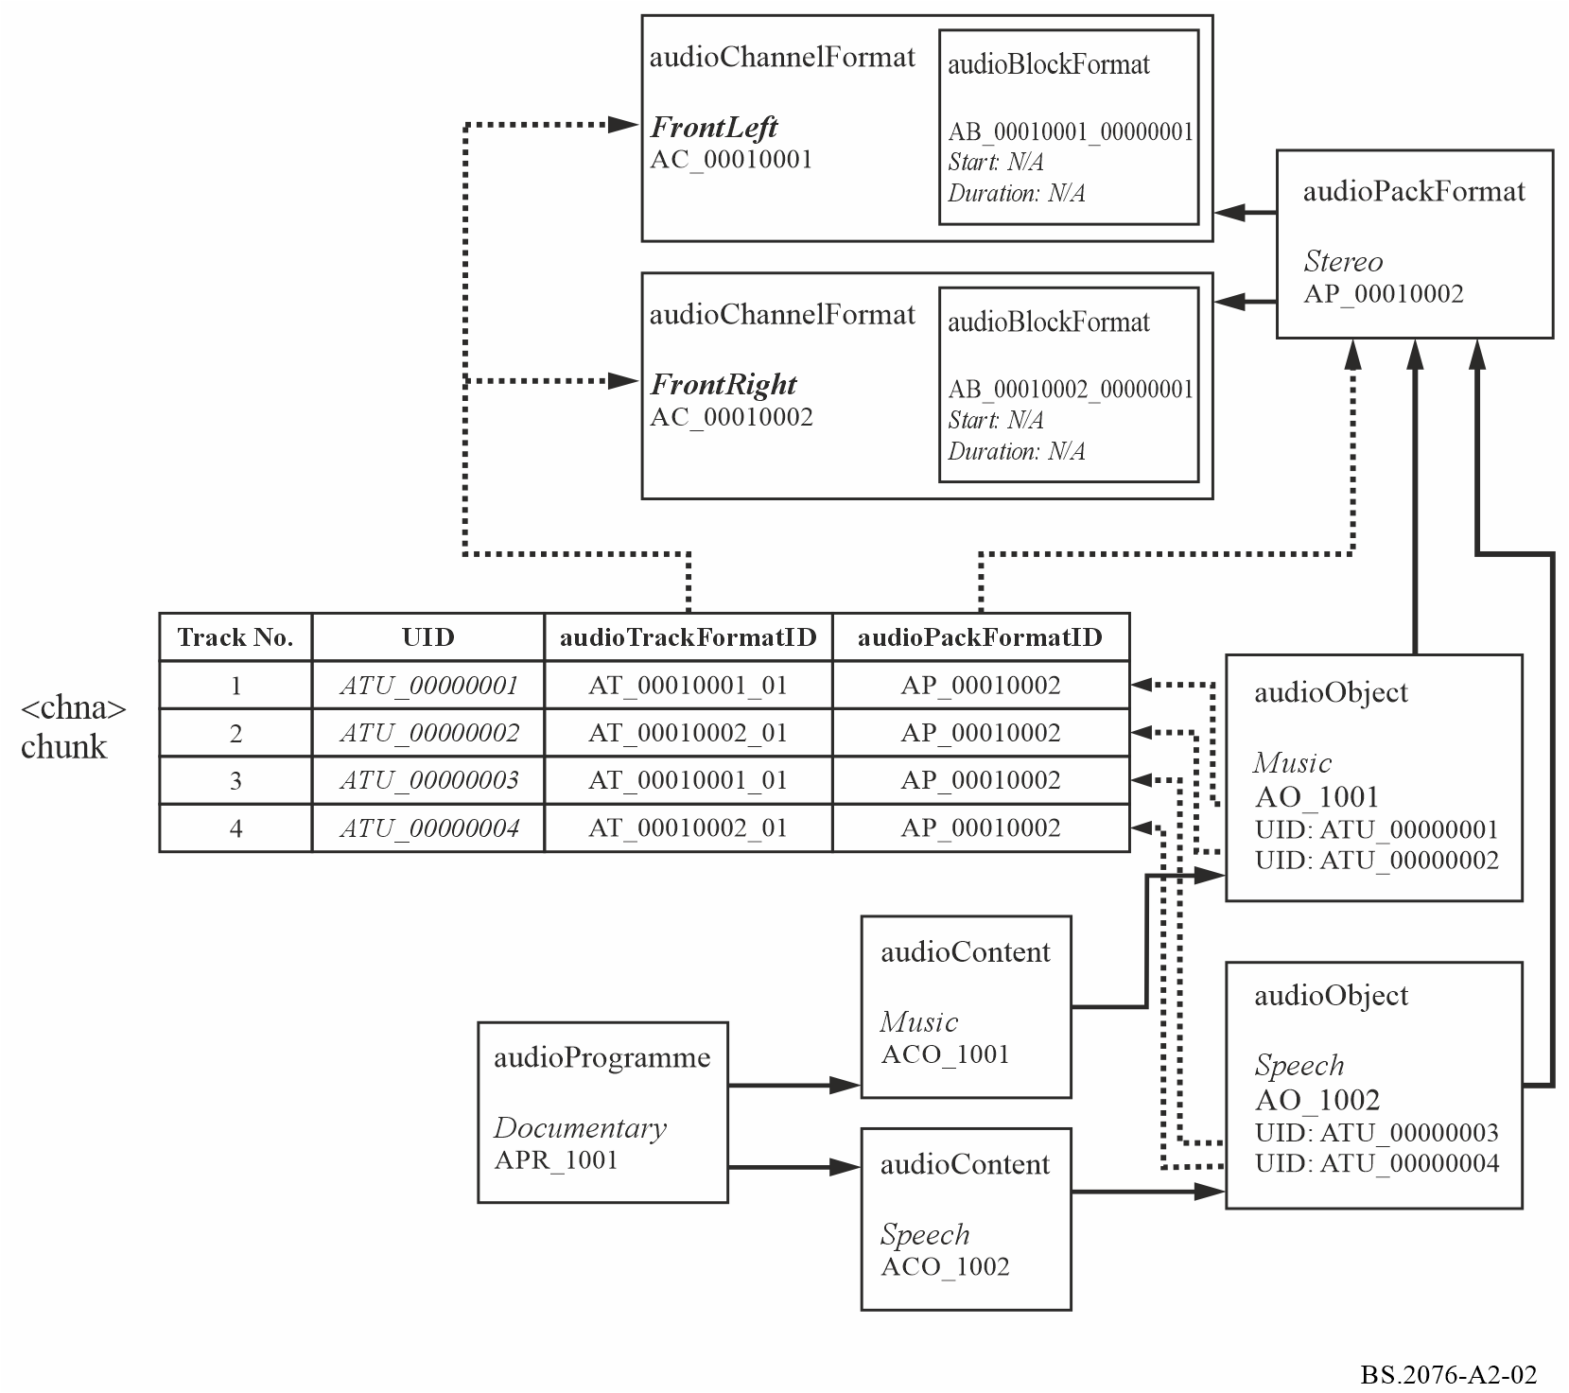

2.3 Sample code
This XML sample code does not include the audioFormatExtended parent element and the XML header for clarity.
The first excerpt of code covers the format elements, which could be contained within the common definitions reference file:

<!-- ############ -->
<!-- PACKS -->
<!-- ############ -->

<audioPackFormat audioPackFormatID="AP_00010002" audioPackFormatName="Stereo" typeLabel="0001" typeDefinition="DirectSpeakers">
<audioChannelFormatIDRef>AC_00010001</audioChannelFormatIDRef>
<audioChannelFormatIDRef>AC_00010002</audioChannelFormatIDRef>
</audioPackFormat>

<!-- ############ -->
<!-- CHANNELS -->
<!-- ############ -->

<audioChannelFormat audioChannelFormatID="AC_00010001" audioChannelFormatName="FrontLeft" typeLabel="0001" typeDefinition="DirectSpeakers">
<audioBlockFormat audioBlockFormatID="AB_00010001_00000001">
<speakerLabel>M+030</speakerLabel>
<position coordinate="azimuth">30.0</position>
<position coordinate="elevation">0.0</position>
<position coordinate="distance">1.0</position>
</audioBlockFormat>
</audioChannelFormat>

<audioChannelFormat audioChannelFormatID="AC_00010002" audioChannelFormatName="FrontRight" typeLabel="0001" typeDefinition="DirectSpeakers">
<audioBlockFormat audioBlockFormatID="AB_00010002_00000001">
<speakerLabel>M-030</speakerLabel>
<position coordinate="azimuth">-30.0</position>
<position coordinate="elevation">0.0</position>
<position coordinate="distance">1.0</position>
</audioBlockFormat>
</audioChannelFormat>

The second excerpt covers the content part, which would have to be included in the <axml> chunk of the BWF file:

<!-- ############ -->
<!-- PROGRAMMES -->
<!-- ############ -->

<audioProgramme audioProgrammeID="APR_1001" audioProgrammeName="Documentary">
<audioContentIDRef>ACO_1001</audioContentIDRef>
<audioContentIDRef>ACO_1002</audioContentIDRef>
</audioProgramme>

<!-- ############ -->
<!-- CONTENTS -->
<!-- ############ -->

<audioContent audioContentID="ACO_1001" audioContentName="Music">
<audioObjectIDRef>AO_1001</audioObjectIDRef>
<loudnessMetadata>
<integratedLoudness>-28.0</integratedLoudness>
</loudnessMetadata>
</audioContent>

<audioContent audioContentID="ACO_1002" audioContentName="Speech">
<audioObjectIDRef>AO_1002</audioObjectIDRef>
<loudnessMetadata>
<integratedLoudness>-23.0</integratedLoudness>
</loudnessMetadata>
</audioContent>

<!-- ############ -->
<!-- OBJECTS -->
<!-- ############ -->

<audioObject audioObjectID="AO_1001" audioObjectName="Music" start="00:00:00.00000">
<audioPackFormatIDRef>AP_00010002</audioPackFormatIDRef>
<audioTrackUIDRef>ATU_00000001</audioTrackUIDRef>
<audioTrackUIDRef>ATU_00000002</audioTrackUIDRef>
</audioObject>

<audioObject audioObjectID="AO_1002" audioObjectName="Speech" start="00:00:00.00000">
<audioPackFormatIDRef>AP_00010002</audioPackFormatIDRef>
<audioTrackUIDRef>ATU_00000003</audioTrackUIDRef>
<audioTrackUIDRef>ATU_00000004</audioTrackUIDRef>
</audioObject>

<!-- ############ -->
<!-- AUDIO TRACK UIDs -->
<!-- ############ -->

<audioTrackUID UID="ATU_00000001">
<audioChannelFormatIDRef>AC_00010001</audioChannelFormatIDRef>
<audioPackFormatIDRef>AP_00010002</audioPackFormatIDRef>
</audioTrackUID>

<audioTrackUID UID="ATU_00000002">
<audioChannelFormatIDRef>AC_00010002</audioChannelFormatIDRef>
<audioPackFormatIDRef>AP_00010002</audioPackFormatIDRef>
</audioTrackUID>

<audioTrackUID UID="ATU_00000003">
<audioChannelFormatIDRef>AC_00010001</audioChannelFormatIDRef>
<audioPackFormatIDRef>AP_00010002</audioPackFormatIDRef>
</audioTrackUID>

<audioTrackUID UID="ATU_00000004">
<audioChannelFormatIDRef>AC_00010002</audioChannelFormatIDRef>
<audioPackFormatIDRef>AP_00010002</audioPackFormatIDRef>
</audioTrackUID>

3 Object-based example
To demonstrate how the ADM can be used in object-based audio here is a simple example using a single object. This example uses multiple audioBlockFormats within an audioChannelFormat to describe the dynamic properties of an object called ‘Car’. The audioBlockFormats uses the start and duration attributes to frame the time dependent metadata, thus allowing the object’s position to move in space.

3.1 Summary of elements
These are the elements in the format part of the description:
TABLE A2-5
Object-based example format elements
Element | ID | Name | Description
audioTrackFormat | AT_00031001_01 | PCM_Car1 | Defines track as PCM
audioStreamFormat | AS_00031001 | PCM_Car1 | Defines stream as PCM
audioChannelFormat &  audioBlockFormat | AC_00031001  AB_00031001_00000001  AB_00031001_00000002  AB_00031001_00000003 | Car1 | Describes channel as an object type containing three blocks with different positional metadata in each.
audioPackFormat | AP_00031001 | Car | Defines a pack referring to one channel.

These are the elements in the content part of the description:
TABLE A2-6
Object-based exmaple content elements
Element | ID | Name | Description
audioObject | AO_1001 | Car | Object for ‘Car, stereo format
audioContent | ACO_1001 | Cars | ‘Cars’ content
audioProgramme | APR_1001 | CarsSounds | Programme ‘CarsSounds’ containing ‘Cars’ content

3.2 Element Relationships
The diagram in Fig. A2-3 shows how the defined elements relate to each other. The top half of the diagram covers the elements that describe the single channel object containing three blocks. The <chna> chunk in the middle shows how the single track is connected to the format definitions. The content definition elements are at the bottom of the diagram, with the audioObject element containing the track UID references to the UID in the <chna> chunk.
Figure A2-3
Object-based example diagram
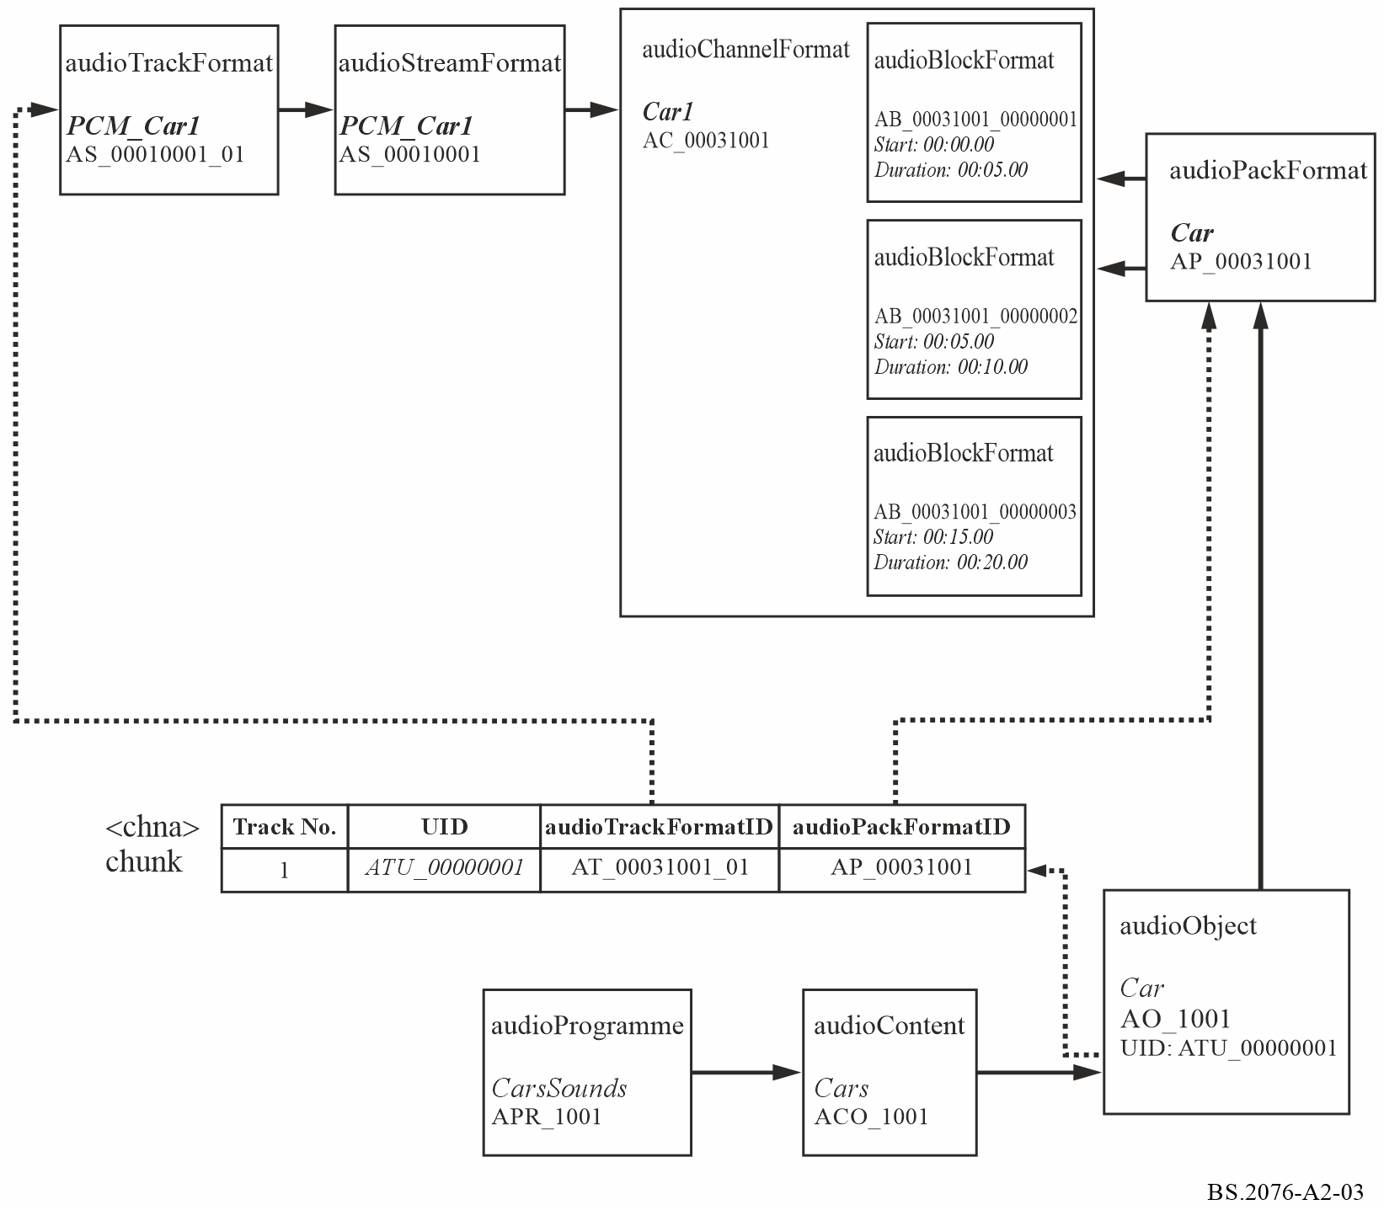

3.3 Sample code
This XML sample code does not include the audioFormatExtended parent element and the XML header for clarity. The excerpt of code covers both the format and content elements:

<!-- ############ -->
<!-- PROGRAMMES -->
<!-- ############ -->

<audioProgramme audioProgrammeID="APR_1001" audioProgrammeName="CarsSounds">
<audioContentIDRef>ACO_1001</audioContentIDRef>
</audioProgramme>

<!-- ############ -->
<!-- CONTENTS -->
<!-- ############ -->

<audioContent audioContentID="ACO_1001" audioContentName="Cars">
<audioObjectIDRef>AO_1001</audioObjectIDRef>
<loudnessMetadata>
<integratedLoudness>-23.0</integratedLoudness>
</loudnessMetadata>
</audioContent>

<!-- ############ -->
<!-- OBJECTS -->
<!-- ############ -->

<audioObject audioObjectID="AO_1001" audioObjectName="Car" start="00:00:00.00000">
<audioPackFormatIDRef>AP_00031001</audioPackFormatIDRef>
<audioTrackUIDRef>ATU_00000001</audioTrackUIDRef>
</audioObject>

<!-- ############ -->
<!-- PACKS -->
<!-- ############ -->

<audioPackFormat audioPackFormatID="AP_00031001" audioPackFormatName="Car" typeLabel="0003" typeDefinition="Objects">
<audioChannelFormatIDRef>AC_00031001</audioChannelFormatIDRef>
</audioPackFormat>

<!-- ############ -->
<!-- CHANNELS -->
<!-- ############ -->

<audioChannelFormat audioChannelFormatID="AC_00031001" audioChannelFormatName="Car1" typeLabel="0003" typeDefinition="Objects">
<audioBlockFormat audioBlockFormatID="AB_00031001_00000001" rtime="00:00:00.00000" duration="00:00:05.00000">
<position coordinate="azimuth">-22.5</position>
<position coordinate="elevation">5.0</position>
<position coordinate="distance">1.0</position>
</audioBlockFormat>
<audioBlockFormat audioBlockFormatID="AB_00031001_00000002" rtime="00:00:05.00000" duration="00:00:10.00000">
<position coordinate="azimuth">-24.5</position>
<position coordinate="elevation">6.0</position>
<position coordinate="distance">0.9</position>
</audioBlockFormat>
<audioBlockFormat audioBlockFormatID="AB_00031001_00000003" rtime="00:00:15.00000" duration="00:00:20.00000">
<position coordinate="azimuth">-26.5</position>
<position coordinate="elevation">7.0</position>
<position coordinate="distance">0.8</position>
</audioBlockFormat>
</audioChannelFormat>

<!-- ############ -->
<!-- STREAMS -->
<!-- ############ -->

<audioStreamFormat audioStreamFormatID="AS_00031001" audioStreamFormatName="PCM_Car1" formatLabel="0001" formatDefinition="PCM">
<audioChannelFormatIDRef>AC_00031001</audioChannelFormatIDRef>
<audioTrackFormatIDRef>AT_00031001_01</audioTrackFormatIDRef>
</audioStreamFormat>

<!-- ############ -->
<!-- AUDIO TRACKS -->
<!-- ############ -->

<audioTrackFormat audioTrackFormatID="AT_00031001_01" audioTrackFormatName="PCM_Car1" formatLabel="0001" formatDefinition="PCM">
<audioStreamFormatIDRef>AS_00031001</audioStreamFormatIDRef>
</audioTrackFormat>

4 Scene-based example
The other main type of audio is scene-based where the audio channels are representing Ambisonics/HOA components. Their use is very similar to that of the channel-based approach with the main difference being the parameters used within audioBlockFormat. This example shows a simple 1st order Ambisonics (using the N3D normalization) configuration using four channels mapped onto four tracks. Like the channel-based approach, the format elements would be defined in a common reference file so in practice would not need to be included in the BWF file itself.

4.1 Summary of elements
These are the elements in the format part of the description:
TABLE A2-7
Scene-based example format elements
Element | ID | Name | Description
audioTrackFormat | AT_00040101_01 | PCM_N3D_ACN_0 | Defines track as PCM
audioTrackFormat | AT_00040102_01 | PCM_N3D_ACN_1 | Defines track as PCM
audioTrackFormat | AT_00040103_01 | PCM_N3D_ACN_2 | Defines track as PCM
audioTrackFormat | AT_00040104_01 | PCM_N3D_ACN_3 | Defines track as PCM
audioStreamFormat | AS_00040101 | PCM_N3D_ACN_0 | Defines stream as PCM
audioStreamFormat | AS_00040102 | PCM_N3D_ACN_1 | Defines stream as PCM
TABLE A2-7 (end)
Element | ID | Name | Description
audioStreamFormat | AS_00040103 | PCM_N3D_ACN_2 | Defines stream as PCM
audioStreamFormat | AS_00040104 | PCM_N3D_ACN_3 | Defines stream as PCM
audioChannelFormat &  audioBlockFormat | AC_00040101  AB_00040101_00000001 | N3D_ACN_0 | Describes channel as  ACN0 HOA component
audioChannelFormat &  audioBlockFormat | AC_00040102  AB_00040102_00000001 | N3D_ACN_1 | Describes channel as ACN1 HOA component
audioChannelFormat &  audioBlockFormat | AC_00040103  AB_00040103_00000001 | N3D_ACN_2 | Describes channel as ACN2 HOA component
audioChannelFormat &  audioBlockFormat | AC_00040104  AB_00040104_00000001 | N3D_ACN_3 | Describes channel as ACN3 HOA component
audioPackFormat | AP_00040011 | 3D_order1_N3D_ACN | Defines a 1st order HOA pack referring to four ACN channels.

These are the elements in the content part of the description:
TABLE A2-8
Scene-based example content elements
Element | ID | Name | Description
audioObject | AO_1001 | BackgroundHOA | Object for ‘BackgroundHOA’, 1st order HOA format
audioContent | ACO_1001 | Background | ‘Background’ content
audioProgramme | APR_1001 | HOADemo | ‘HOADemo’ containing a ‘Background’content

4.2 Element Relationships
The diagram in Fig. A2-4 shows how the defined elements relate to each other. The top half of the diagram covers the elements that describe the four channels of the first order HOA (N3D method). The <chna> chunk in the middle shows how the four tracks are connected to the format definitions. The content definition elements are at the bottom of the diagram, with the audioObject element containing the track UID references to the UIDs in the <chna> chunk.
Figure A2-4
Scene-based example diagram
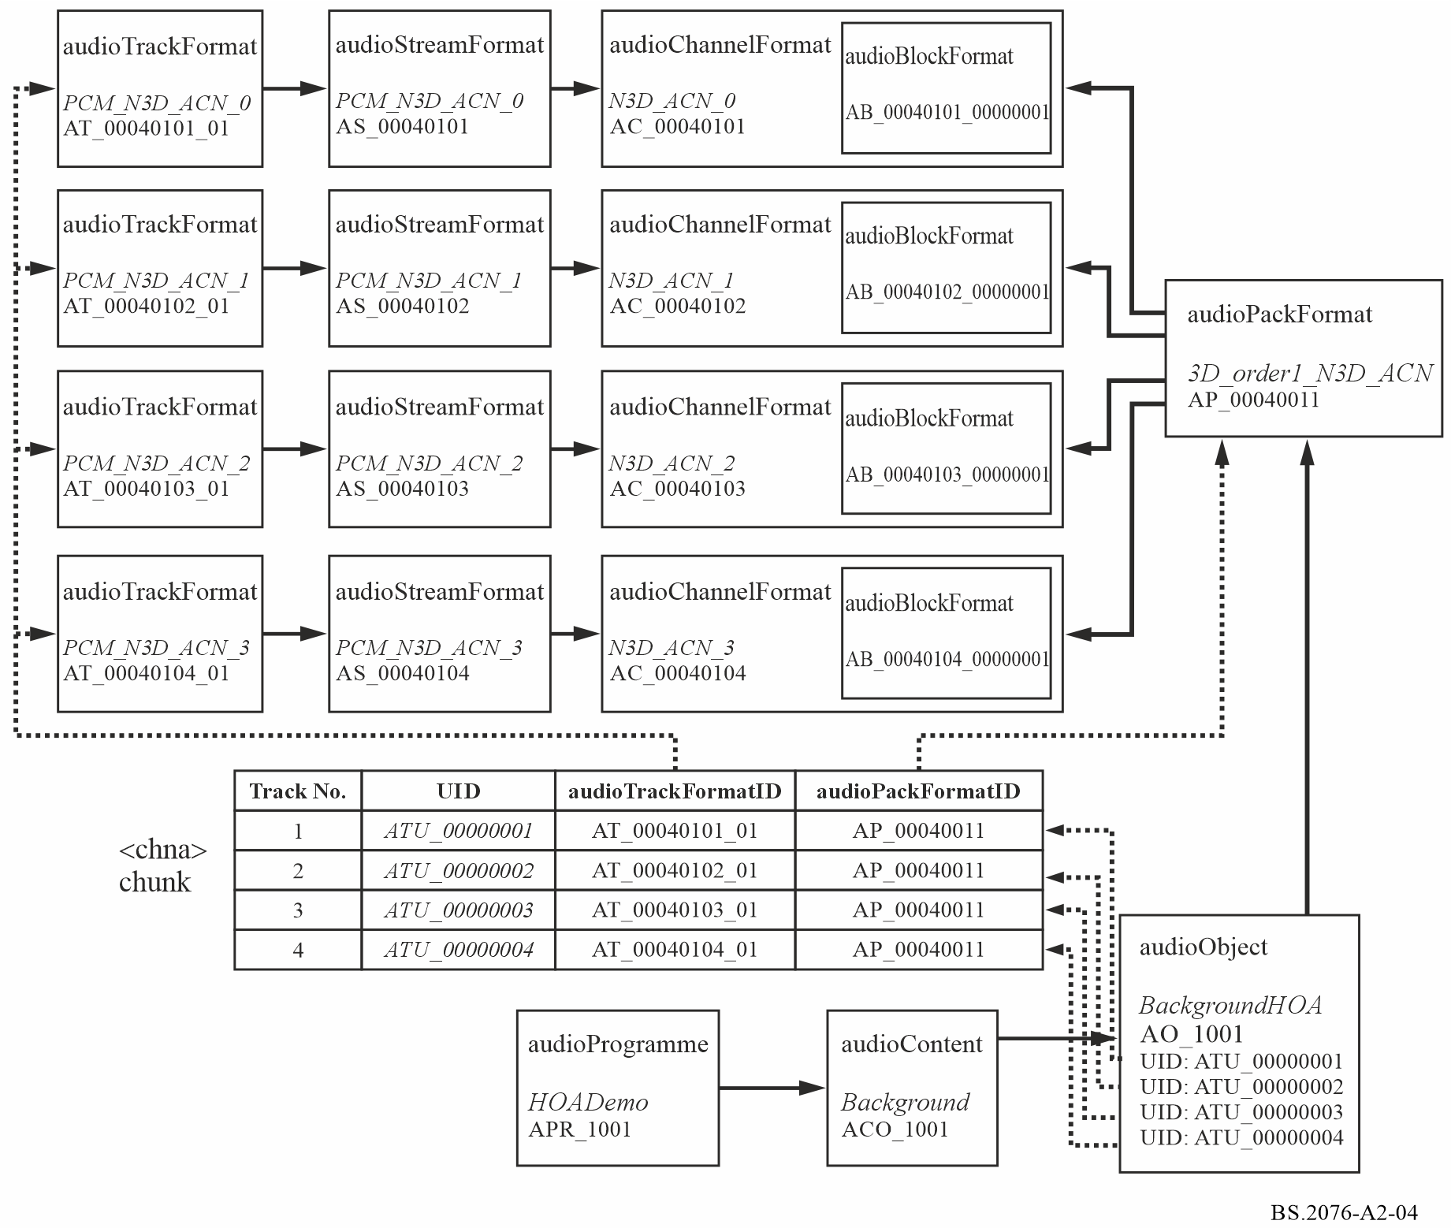

4.3 Sample code
This XML sample code does not include the audioFormatExtended parent element and the XML header for clarity. The first excerpt of code covers the format elements, which could be contained within the common reference file:

<!-- ############ -->
<!-- PACKS -->
<!-- ############ -->

<audioPackFormat audioPackFormatID="AP_00040011" audioPackFormatName="3D_order1_N3D_ACN" typeLabel="0004" typeDefinition="HOA">
<normalization>N3D</normalization>
<audioChannelFormatIDRef>AC_00040101</audioChannelFormatIDRef>
<audioChannelFormatIDRef>AC_00040102</audioChannelFormatIDRef>
<audioChannelFormatIDRef>AC_00040103</audioChannelFormatIDRef>
<audioChannelFormatIDRef>AC_00040104</audioChannelFormatIDRef>
</audioPackFormat>

<!-- ############ -->
<!-- CHANNELS -->
<!-- ############ -->

<audioChannelFormat audioChannelFormatID="AC_00040101" audioChannelFormatName="N3D_ACN_0" typeDefinition="HOA">
<audioBlockFormat audioBlockFormatID="AB_00040101_00000001">
<degree>0</degree>
<order>0</order>
<normalization>N3D</normalization>
</audioBlockFormat>
</audioChannelFormat>

<audioChannelFormat audioChannelFormatID="AC_00040102" audioChannelFormatName="N3D_ACN_1" typeDefinition="HOA">
<audioBlockFormat audioBlockFormatID="AB_00040102_00000001">
<degree>1</degree>
<order>-1</order>
<normalization>N3D</normalization>
</audioBlockFormat>
</audioChannelFormat>

<audioChannelFormat audioChannelFormatID="AC_00040103" audioChannelFormatName="N3D_ACN_2" typeDefinition="HOA">
<audioBlockFormat audioBlockFormatID="AB_00040103_00000001">
<degree>1</degree>
<order>0</order>
<normalization>N3D</normalization>
</audioBlockFormat>
</audioChannelFormat>

<audioChannelFormat audioChannelFormatID="AC_00040104" audioChannelFormatName="N3D_ACN_3" typeDefinition="HOA">
<audioBlockFormat audioBlockFormatID="AB_00040104_00000001">
<degree>1</degree>
<order>1</order>
<normalization>N3D</normalization>
</audioBlockFormat>
</audioChannelFormat>

<!-- ############ -->
<!-- STREAMS -->
<!-- ############ -->

<audioStreamFormat audioStreamFormatID="AS_00040101" audioStreamFormatName="PCM_N3D_ACN_0" formatLabel="0001" formatDefinition="PCM">
<audioChannelFormatIDRef>AC_00040101</audioChannelFormatIDRef>
<audioTrackFormatIDRef>AT_00040101_01</audioTrackFormatIDRef>
</audioStreamFormat>

<audioStreamFormat audioStreamFormatID="AS_00040102" audioStreamFormatName="PCM_N3D_ACN_1" formatLabel="0001" formatDefinition="PCM">
<audioChannelFormatIDRef>AC_00040102</audioChannelFormatIDRef>
<audioTrackFormatIDRef>AT_00040102_01</audioTrackFormatIDRef>
</audioStreamFormat>

<audioStreamFormat audioStreamFormatID="AS_00040103" audioStreamFormatName="PCM_N3D_ACN_2" formatLabel="0001" formatDefinition="PCM">
<audioChannelFormatIDRef>AC_00040103</audioChannelFormatIDRef>
<audioTrackFormatIDRef>AT_00040103_01</audioTrackFormatIDRef>
</audioStreamFormat>

<audioStreamFormat audioStreamFormatID="AS_00040104" audioStreamFormatName="PCM_N3D_ACN_3" formatLabel="0001" formatDefinition="PCM">
<audioChannelFormatIDRef>AC_00040104</audioChannelFormatIDRef>
<audioTrackFormatIDRef>AT_00040104_01</audioTrackFormatIDRef>
</audioStreamFormat>

<!-- ############ -->
<!-- AUDIO TRACKS -->
<!-- ############ -->

<audioTrackFormat audioTrackFormatID="AT_00040101_01" audioTrackFormatName="PCM_N3D_ACN_0" formatLabel="0001" formatDefinition="PCM">
<audioStreamFormatIDRef>AS_00040101</audioStreamFormatIDRef>
</audioTrackFormat>

<audioTrackFormat audioTrackFormatID="AT_00040102_01" audioTrackFormatName="PCM_N3D_ACN_1" formatLabel="0001" formatDefinition="PCM">
<audioStreamFormatIDRef>AS_00040102</audioStreamFormatIDRef>
</audioTrackFormat>

<audioTrackFormat audioTrackFormatID="AT_00040103_01" audioTrackFormatName="PCM_N3D_ACN_2" formatLabel="0001" formatDefinition="PCM">
<audioStreamFormatIDRef>AS_00040103</audioStreamFormatIDRef>
</audioTrackFormat>

<audioTrackFormat audioTrackFormatID="AT_00040104_01" audioTrackFormatName="PCM_N3D_ACN_3" formatLabel="0001" formatDefinition="PCM">
<audioStreamFormatIDRef>AS_00040104</audioStreamFormatIDRef>
</audioTrackFormat>

The second excerpt covers the content part, which would have to be included in the <axml> chunk of the BWF file:
<!-- ############ -->
<!-- PROGRAMMES -->
<!-- ############ -->

<audioProgramme audioProgrammeID="APR_1001" audioProgrammeName="HOADemo">
<audioContentIDRef>ACO_1001</audioContentIDRef>
</audioProgramme>

<!-- ############ -->
<!-- CONTENTS -->
<!-- ############ -->

<audioContent audioContentID="ACO_1001" audioContentName="Background">
<audioObjectIDRef>AO_1001</audioObjectIDRef>
</audioContent>

<!-- ############ -->
<!-- OBJECTS -->
<!-- ############ -->

<audioObject audioObjectID="AO_1001" audioObjectName="BackgroundHOA">
<audioPackFormatIDRef>AP_00040011</audioPackFormatIDRef>
<audioTrackUIDRef>ATU_00000001</audioTrackUIDRef>
<audioTrackUIDRef>ATU_00000002</audioTrackUIDRef>
<audioTrackUIDRef>ATU_00000003</audioTrackUIDRef>
<audioTrackUIDRef>ATU_00000004</audioTrackUIDRef>
</audioObject>

<!-- ############ -->
<!-- AUDIO TRACK UIDs -->
<!-- ############ -->

<audioTrackUID UID="ATU_00000001">
<audioTrackFormatIDRef>AT_00040101_01</audioTrackFormatIDRef>
<audioPackFormatIDRef>AP_00040011</audioPackFormatIDRef>
</audioTrackUID>

<audioTrackUID UID="ATU_00000002">
<audioTrackFormatIDRef>AT_00040102_01</audioTrackFormatIDRef>
<audioPackFormatIDRef>AP_00040011</audioPackFormatIDRef>
</audioTrackUID>

<audioTrackUID UID="ATU_00000003">
<audioTrackFormatIDRef>AT_00040103_01</audioTrackFormatIDRef>
<audioPackFormatIDRef>AP_00040011</audioPackFormatIDRef>
</audioTrackUID>

<audioTrackUID UID="ATU_00000004">
<audioTrackFormatIDRef>AT_00040104_01</audioTrackFormatIDRef>
<audioPackFormatIDRef>AP_00040011</audioPackFormatIDRef>
</audioTrackUID>

5 Personalized audio example
To demonstrate how the ADM can be used to describe personalized audio, here is an example using a combination of channel-based audio for the ambience/bed and object-based audio for the commentator objects. This example uses multiple audioProgramme elements that represent five different preset mixes for a sports programme: default mix, just the action, clear commentary, home team, and away team. The corresponding ADM XML tree contains four different audioContent elements to choose from: ambience, main commentary, home team biased commentary, and away team biased commentary.
TABLE A2-9
Personalized audio example mixes
 | Ambience | Main commentary 1 | Main commentary 2 | Home team biased commentary | Away team biased commentary
Default mix | • | • | •
Just the action | •
Clear commentary |  | • | •
Home team | • |  |  | •
Away team | • |  |  |  | •

5.1 Summary of elements
These are the elements in the format part of the description:
TABLE A2-10
Personalized example format elements
Element | ID | Name | Description
audioTrackFormat | AT_00010001_01 | PCM_FrontLeft | Defines track as PCM
audioStreamFormat | AS_00010001 | PCM_FrontLeft | Defines stream as PCM
audioChannelFormat &  audioBlockFormat | AC_00010001  AB_00010001_00000001 | FrontLeft | Describes channel as front left with a position and speaker reference
audioTrackFormat | AT_00010002_01 | PCM_FrontRight | Defines track as PCM
audioStreamFormat | AS_00010002 | PCM_FrontRight | Defines stream as PCM
audioChannelFormat &  audioBlockFormat | AC_00010002  AB_00010002_00000001 | FrontRight | Describes channel as front right with a position and speaker reference
audioTrackFormat | AT_00010003_01 | PCM_FrontCentre | Defines track as PCM
audioStreamFormat | AS_00010003 | PCM_FrontCentre | Defines stream as PCM
audioChannelFormat &  audioBlockFormat | AC_00010003  AB_00010003_00000001 | FrontCentre | Describes channel as front centre with a position and speaker reference
audioTrackFormat | AT_00010004_01 | PCM_LFE | Defines track as PCM
audioStreamFormat | AS_00010004 | PCM_LFE | Defines stream as PCM
audioChannelFormat &  audioBlockFormat | AC_00010004  AB_00010004_00000001 | LFE | Describes channel as LFE with a position and speaker reference
audioTrackFormat | AT_00010005_01 | PCM_SurroundLeft | Defines track as PCM
audioStreamFormat | AS_00010005 | PCM_SurroundLeft | Defines stream as PCM
audioChannelFormat &  audioBlockFormat | AC_00010005  AB_00010005_00000001 | SurroundLeft | Describes channel as surround left with a position and speaker reference
TABLE A2-10 (end)
Element | ID | Name | Description
audioTrackFormat | AT_00010006_01 | PCM_SurroundRight | Defines track as PCM
audioStreamFormat | AS_00010006 | PCM_SurroundRight | Defines stream as PCM
audioChannelFormat &  audioBlockFormat | AC_00010006  AB_00010006_00000001 | SurroundRight | Describes channel as surround right with a position and speaker reference
audioPackFormat | AP_00010003 | 5.1 | Defines a 5.1 pack referring to six channels.
audioTrackFormat | AT_00031001_01 | PCM_Main_Comm1 | Defines track as PCM
audioStreamFormat | AS_00031001 | PCM_Main_Comm1 | Defines stream as PCM
audioChannelFormat &  audioBlockFormat | AC_00031001  AB_00031001_00000001 | Main_Comm1 | Describes channel as an object type containing a single block with positional metadata.
audioTrackFormat | AT_00031002_01 | PCM_Main_Comm2 | Defines track as PCM
audioStreamFormat | AS_00031002 | PCM_Main_Comm2 | Defines stream as PCM
audioChannelFormat &  audioBlockFormat | AC_00031002  AB_00031002_00000001 | Main_Comm2 | Describes channel as an object type containing a single block with positional metadata.
audioTrackFormat | AT_00031003_01 | PCM_Home_Comm | Defines track as PCM
audioStreamFormat | AS_00031003 | PCM_Home_Comm | Defines stream as PCM
audioChannelFormat &  audioBlockFormat | AC_00031003  AB_00031003_00000001 | Home_Comm | Describes channel as an object type containing a single block with positional metadata.
audioTrackFormat | AT_00031004_01 | PCM_Away_Comm | Defines track as PCM
audioStreamFormat | AS_00031004 | PCM_Away_Comm | Defines stream as PCM
audioChannelFormat &  audioBlockFormat | AC_00031004  AB_00031004_00000001 | Away_Comm | Describes channel as an object type containing a single block with positional metadata.
audioPackFormat | AP_00031001 | MainComm1 | Defines a pack referring to one channel.
audioPackFormat | AP_00031002 | MainComm2 | Defines a pack referring to one channel.
audioPackFormat | AP_00031003 | HomeComm | Defines a pack referring to one channel.
audioPackFormat | AP_00031004 | AwayComm | Defines a pack referring to one channel.

TABLE A2-11
Personlized example content elements
Element | ID | Name | Description
audioObject | AO_1001 | Ambience | Object for ‘Ambience’, 5.1 format
audioContent | ACO_1001 | Ambience | ‘Ambience’ content
audioObject | AO_1002 | Main_Comm1 | Object for ‘Main_Comm1’, mono format
audioObject | AO_1003 | Main_Comm2 | Object for ‘Main_Comm2’, mono format
audioContent | ACO_1002 | Main_Comm | ‘Main_Comm’ content
audioObject | AO_1004 | Home_Comm | Object for ‘Home_Comm’, mono format
audioContent | ACO_1003 | Home_Comm | ‘Home_Comm’ content
audioObject | AO_1005 | Away_Comm | Object for ‘Away_Comm’, mono format
audioContent | ACO_1004 | Away_Comm | ‘Away_Comm’ content
audioProgramme | APR_1001 | DefaultMix | Programme ‘DefaultMix’ containing ‘Ambience’ and ‘Main_Comm” content
audioProgramme | APR_1002 | JustTheAction | Programme ‘JustTheAction’ containing only ‘Ambience’ content
audioProgramme | APR_1003 | ClearCommentary | Programme ‘ClearCommentary’ containing only ‘Main_Comm’ content
audioProgramme | APR_1004 | HomeTeam | Programme ‘HomeTeam’ containing ‘Ambience’ and ‘Home_Comm’ content
audioProgramme | APR_1005 | AwayTeam | Programme ‘AwayTeam’ containing ‘Ambience’ and ‘Away_Comm’ content

5.2 Element Relationships
The diagram in Fig. A2-5 shows how the defined elements relate to each other. The top half of the diagram covers the elements that describe the 5.1 channel ambience/bed and the 4 mono objects. The <chna> chunk in the middle shows how the tracks are connected to the format definitions. The content definition elements are at the bottom of the diagram, with the audioObject element containing the track UID references to the UID in the <chna> chunk.
Figure A2-5
Personalised audio example diagram
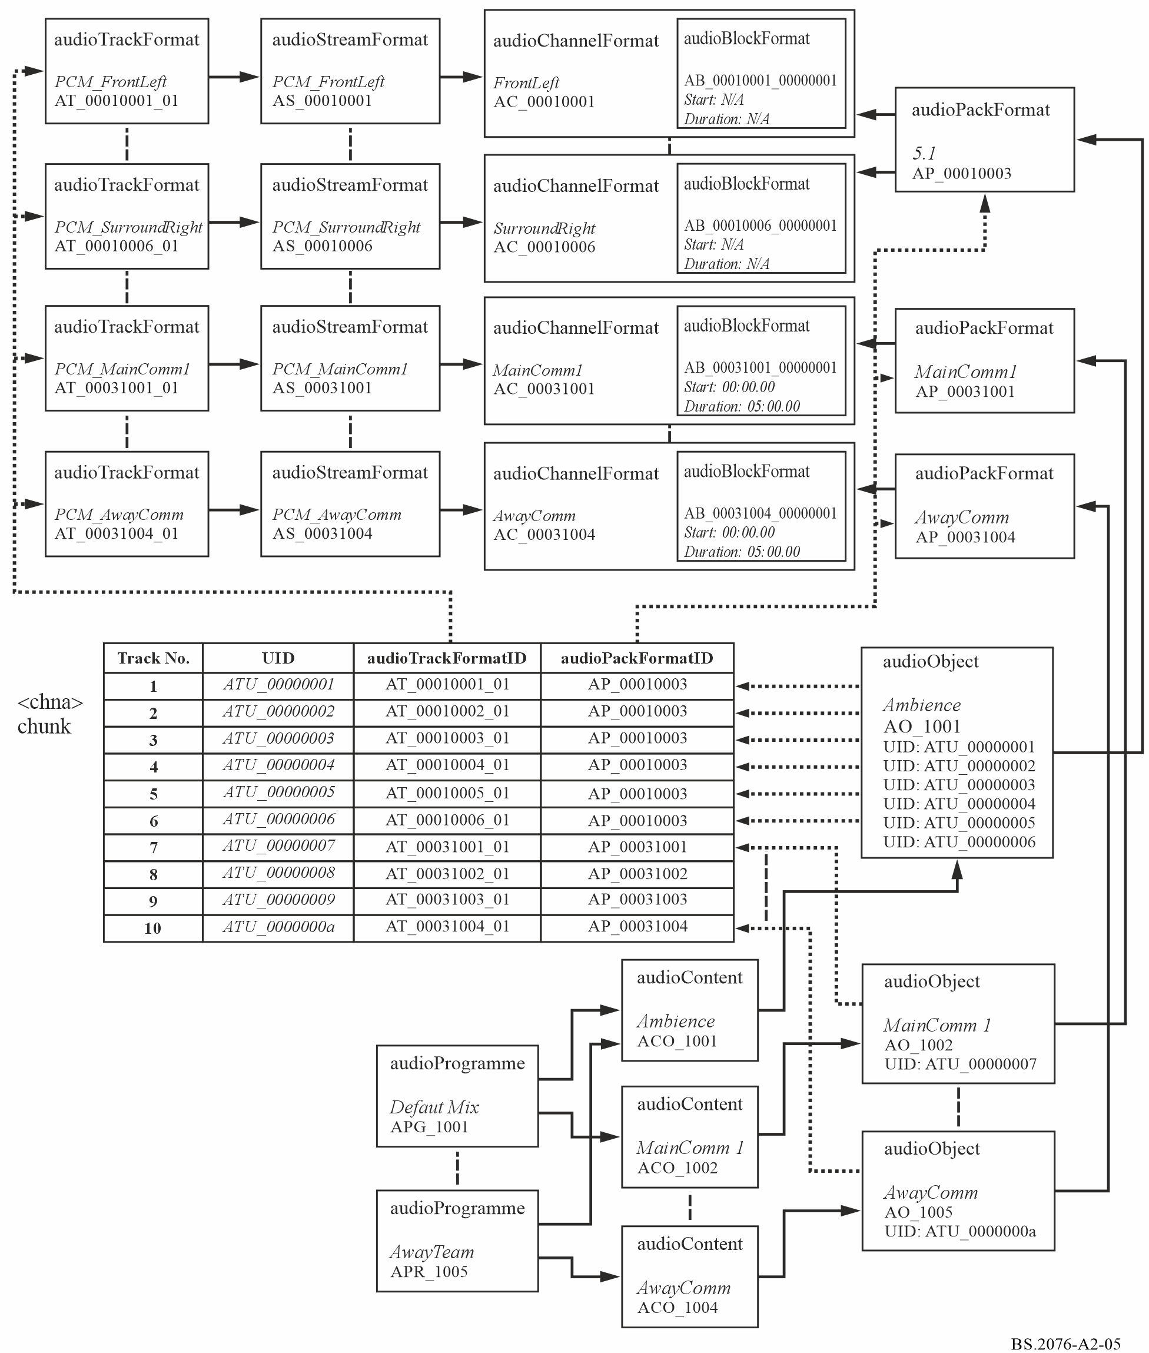

5.3 Sample code
This XML sample code does not include the audioFormatExtended parent element and the XML header for clarity. The excerpt of code covers both the format and content elements:
<!-- ############ -->
<!-- PROGRAMMES -->
<!-- ############ -->

<audioProgramme audioProgrammeID="APR_1001" audioProgrammeName="DefaultMix">
<audioContentIDRef>ACO_1001</audioContentIDRef>
<audioContentIDRef>ACO_1002</audioContentIDRef>
</audioProgramme>

<audioProgramme audioProgrammeID="APR_1002" audioProgrammeName="JustTheAction">
<audioContentIDRef>ACO_1001</audioContentIDRef>
</audioProgramme>

<audioProgramme audioProgrammeID="APR_1003" audioProgrammeName="ClearCommentary">
<audioContentIDRef>ACO_1002</audioContentIDRef>
</audioProgramme>

<audioProgramme audioProgrammeID="APR_1004" audioProgrammeName="HomeTeam">
<audioContentIDRef>ACO_1001</audioContentIDRef>
<audioContentIDRef>ACO_1003</audioContentIDRef>
</audioProgramme>

<audioProgramme audioProgrammeID="APR_1005" audioProgrammeName="AwayTeam">
<audioContentIDRef>ACO_1001</audioContentIDRef>
<audioContentIDRef>ACO_1004</audioContentIDRef>
</audioProgramme>

<!-- ############ -->
<!-- CONTENTS -->
<!-- ############ -->

<audioContent audioContentID="ACO_1001" audioContentName="Ambience">
<audioObjectIDRef>AO_1001</audioObjectIDRef>
<loudnessMetadata>
<integratedLoudness>-23.0</integratedLoudness>
</loudnessMetadata>
</audioContent>

<audioContent audioContentID="ACO_1002" audioContentName="Main_Comm">
<audioObjectIDRef>AO_1002</audioObjectIDRef>
<audioObjectIDRef>AO_1003</audioObjectIDRef>
<loudnessMetadata>
<integratedLoudness>-23.0</integratedLoudness>
</loudnessMetadata>
</audioContent>

<audioContent audioContentID="ACO_1003" audioContentName="Home_Comm">
<audioObjectIDRef>AO_1004</audioObjectIDRef>
<loudnessMetadata>
<integratedLoudness>-23.0</integratedLoudness>
</loudnessMetadata>
</audioContent>

<audioContent audioContentID="ACO_1004" audioContentName="AwayComm">
<audioObjectIDRef>AO_1005</audioObjectIDRef>
<loudnessMetadata>
<integratedLoudness>-23.0</integratedLoudness>
</loudnessMetadata>
</audioContent>

<!-- ############ -->
<!-- OBJECTS -->
<!-- ############ -->

<audioObject audioObjectID="AO_1001" audioObjectName="Ambience">
<audioPackFormatIDRef>AP_00010003</audioPackFormatIDRef>
<audioTrackUIDRef>ATU_00000001</audioTrackUIDRef>
<audioTrackUIDRef>ATU_00000002</audioTrackUIDRef>
<audioTrackUIDRef>ATU_00000003</audioTrackUIDRef>
<audioTrackUIDRef>ATU_00000004</audioTrackUIDRef>
<audioTrackUIDRef>ATU_00000005</audioTrackUIDRef>
<audioTrackUIDRef>ATU_00000006</audioTrackUIDRef>
</audioObject>

<audioObject audioObjectID="AO_1002" audioObjectName="Main_Comm1" start="00:00:00.00000">
<audioPackFormatIDRef>AP_00031001</audioPackFormatIDRef>
<audioTrackUIDRef>ATU_00000007</audioTrackUIDRef>
</audioObject>

<audioObject audioObjectID="AO_1003" audioObjectName="Main_Comm2" start="00:00:00.00000">
<audioPackFormatIDRef>AP_00031002</audioPackFormatIDRef>
<audioTrackUIDRef>ATU_00000008</audioTrackUIDRef>
</audioObject>

<audioObject audioObjectID="AO_1004" audioObjectName="Home_Comm" start="00:00:00.00000">
<audioPackFormatIDRef>AP_00031003</audioPackFormatIDRef>
<audioTrackUIDRef>ATU_00000009</audioTrackUIDRef>
</audioObject>

<audioObject audioObjectID="AO_1005" audioObjectName="Away_Comm" start="00:00:00.00000">
<audioPackFormatIDRef>AP_00031004</audioPackFormatIDRef>
<audioTrackUIDRef>ATU_0000000a</audioTrackUIDRef>
</audioObject>

<!-- ############ -->
<!-- PACKS -->
<!-- ############ -->

<audioPackFormat audioPackFormatID="AP_00010003" audioPackFormatName="5.1" typeLabel="0001" typeDefinition="DirectSpeakers">
<audioChannelFormatIDRef>AC_00010001</audioChannelFormatIDRef>
<audioChannelFormatIDRef>AC_00010002</audioChannelFormatIDRef>
<audioChannelFormatIDRef>AC_00010003</audioChannelFormatIDRef>
<audioChannelFormatIDRef>AC_00010004</audioChannelFormatIDRef>
<audioChannelFormatIDRef>AC_00010005</audioChannelFormatIDRef>
<audioChannelFormatIDRef>AC_00010006</audioChannelFormatIDRef>
</audioPackFormat>

<audioPackFormat audioPackFormatID="AP_00031001" audioPackFormatName="MainComm1" typeLabel="0003" typeDefinition="Objects">
<audioChannelFormatIDRef>AC_00031001</audioChannelFormatIDRef>
</audioPackFormat>

<audioPackFormat audioPackFormatID="AP_00031002" audioPackFormatName="MainComm2" typeLabel="0003" typeDefinition="Objects">
<audioChannelFormatIDRef>AC_00031002</audioChannelFormatIDRef>
</audioPackFormat>

<audioPackFormat audioPackFormatID="AP_00031003" audioPackFormatName="HomeComm" typeLabel="0003" typeDefinition="Objects">
<audioChannelFormatIDRef>AC_00031003</audioChannelFormatIDRef>
</audioPackFormat>

<audioPackFormat audioPackFormatID="AP_00031004" audioPackFormatName="AwayComm" typeLabel="0003" typeDefinition="Objects">
<audioChannelFormatIDRef>AC_00031004</audioChannelFormatIDRef>
</audioPackFormat>

<!-- ############ -->
<!-- CHANNELS -->
<!-- ############ -->

<audioChannelFormat audioChannelFormatID="AC_00010001" audioChannelFormatName="FrontLeft" typeLabel="0001" typeDefinition="DirectSpeakers">
<audioBlockFormat audioBlockFormatID="AB_00010001_00000001">
<speakerLabel>M+030</speakerLabel>
<position coordinate="azimuth">30.0</position>
<position coordinate="elevation">0.0</position>
<position coordinate="distance">1.0</position>
</audioBlockFormat>
</audioChannelFormat>

<audioChannelFormat audioChannelFormatID="AC_00010002" audioChannelFormatName="FrontRight" typeLabel="0001" typeDefinition="DirectSpeakers">
<audioBlockFormat audioBlockFormatID="AB_00010002_00000001">
<speakerLabel>M-030</speakerLabel>
<position coordinate="azimuth">-30.0</position>
<position coordinate="elevation">0.0</position>
<position coordinate="distance">1.0</position>
</audioBlockFormat>
</audioChannelFormat>

<audioChannelFormat audioChannelFormatID="AC_00010003" audioChannelFormatName="FrontCentre" typeLabel="0001" typeDefinition="DirectSpeakers">
<audioBlockFormat audioBlockFormatID="AB_00010003_00000001">
<speakerLabel>M+000</speakerLabel>
<position coordinate="azimuth">0.0</position>
<position coordinate="elevation">0.0</position>
<position coordinate="distance">1.0</position>
</audioBlockFormat>
</audioChannelFormat>

<audioChannelFormat audioChannelFormatID="AC_00010004" audioChannelFormatName="LFE" typeLabel="0001" typeDefinition="DirectSpeakers">
<frequency typeDefinition="lowPass">120</frequency>
<audioBlockFormat audioBlockFormatID="AB_00010004_00000001">
<speakerLabel>LFE</speakerLabel>
<position coordinate="azimuth">0.0</position>
<position coordinate="elevation">-20.0</position>
<position coordinate="distance">1.0</position>
</audioBlockFormat>
</audioChannelFormat>

<audioChannelFormat audioChannelFormatID="AC_00010005" audioChannelFormatName="SurroundLeft" typeLabel="0001" typeDefinition="DirectSpeakers">
<audioBlockFormat audioBlockFormatID="AB_00010005_00000001">
<speakerLabel>M+110</speakerLabel>
<position coordinate="azimuth">110.0</position>
<position coordinate="elevation">0.0</position>
<position coordinate="distance">1.0</position>
</audioBlockFormat>
</audioChannelFormat>

<audioChannelFormat audioChannelFormatID="AC_00010006" audioChannelFormatName="SurroundRight" typeLabel="0001" typeDefinition="DirectSpeakers">
<audioBlockFormat audioBlockFormatID="AB_00010006_00000001">
<speakerLabel>M-110</speakerLabel>
<position coordinate="azimuth">-110.0</position>
<position coordinate="elevation">0.0</position>
<position coordinate="distance">1.0</position>
</audioBlockFormat>
</audioChannelFormat>

<audioChannelFormat audioChannelFormatID="AC_00031001" audioChannelFormatName="MainComm1" typeLabel="0003" typeDefinition="Objects">
<audioBlockFormat audioBlockFormatID="AB_00031001_00000001" rtime="00:00:00.00000" duration="00:05:00.00000">
<position coordinate="X">-1.0</position>
<position coordinate="Y">1.0</position>
<position coordinate="Z">0.0</position>
</audioBlockFormat>
</audioChannelFormat>

<audioChannelFormat audioChannelFormatID="AC_00031002" audioChannelFormatName="MainComm2" typeLabel="0003" typeDefinition="Objects">
<audioBlockFormat audioBlockFormatID="AB_00031002_00000001" rtime="00:00:00.00000" duration="00:05:00.00000">
<position coordinate="X">1.0</position>
<position coordinate="Y">1.0</position>
<position coordinate="Z">0.0</position>
</audioBlockFormat>
</audioChannelFormat>

<audioChannelFormat audioChannelFormatID="AC_00031003" audioChannelFormatName="HomeComm" typeLabel="0003" typeDefinition="Objects">
<audioBlockFormat audioBlockFormatID="AB_00031003_00000001" rtime="00:00:00.00000" duration="00:05:00.00000">
<position coordinate="X">0.0</position>
<position coordinate="Y">1.0</position>
<position coordinate="Z">0.0</position>
</audioBlockFormat>
</audioChannelFormat>

<audioChannelFormat audioChannelFormatID="AC_00031004" audioChannelFormatName="AwayComm" typeLabel="0003" typeDefinition="Objects">
<audioBlockFormat audioBlockFormatID="AB_00031004_00000001" rtime="00:00:00.00000" duration="00:05:00.00000">
<position coordinate="X">0.0</position>
<position coordinate="Y">1.0</position>
<position coordinate="Z">0.0</position>
</audioBlockFormat>
</audioChannelFormat>

<!-- ############ -->
<!-- STREAMS -->
<!-- ############ -->

<audioStreamFormat audioStreamFormatID="AS_00010001" audioStreamFormatName="PCM_FrontLeft" formatLabel="0001" formatDefinition="PCM">
<audioChannelFormatIDRef>AC_00010001</audioChannelFormatIDRef>
<audioTrackFormatIDRef>AT_00010001_01</audioTrackFormatIDRef>
</audioStreamFormat>

<audioStreamFormat audioStreamFormatID="AS_00010002" audioStreamFormatName="PCM_FrontRight" formatLabel="0001" formatDefinition="PCM">
<audioChannelFormatIDRef>AC_00010002</audioChannelFormatIDRef>
<audioTrackFormatIDRef>AT_00010002_01</audioTrackFormatIDRef>
</audioStreamFormat>

<audioStreamFormat audioStreamFormatID="AS_00010003" audioStreamFormatName="PCM_FrontCentre" formatLabel="0001" formatDefinition="PCM">
<audioChannelFormatIDRef>AC_00010003</audioChannelFormatIDRef>
<audioTrackFormatIDRef>AT_00010003_01</audioTrackFormatIDRef>
</audioStreamFormat>

<audioStreamFormat audioStreamFormatID="AS_00010004" audioStreamFormatName="PCM_LFE" formatLabel="0001" formatDefinition="PCM">
<audioChannelFormatIDRef>AC_00010004</audioChannelFormatIDRef>
<audioTrackFormatIDRef>AT_00010004_01</audioTrackFormatIDRef>
</audioStreamFormat>

<audioStreamFormat audioStreamFormatID="AS_00010005" audioStreamFormatName="PCM_SurroundLeft" formatLabel="0001" formatDefinition="PCM">
<audioChannelFormatIDRef>AC_00010005</audioChannelFormatIDRef>
<audioTrackFormatIDRef>AT_00010005_01</audioTrackFormatIDRef>
</audioStreamFormat>

<audioStreamFormat audioStreamFormatID="AS_00010006" audioStreamFormatName="PCM_SurroundRight" formatLabel="0001" formatDefinition="PCM">
<audioChannelFormatIDRef>AC_00010006</audioChannelFormatIDRef>
<audioTrackFormatIDRef>AT_00010006_01</audioTrackFormatIDRef>
</audioStreamFormat>

<audioStreamFormat audioStreamFormatID="AS_00031001" audioStreamFormatName="PCM_MainComm1" formatLabel="0001" formatDefinition="PCM">
<audioChannelFormatIDRef>AC_00031001</audioChannelFormatIDRef>
<audioTrackFormatIDRef>AT_00031001_01</audioTrackFormatIDRef>
</audioStreamFormat>

<audioStreamFormat audioStreamFormatID="AS_00031002" audioStreamFormatName="PCM_MainComm2" formatLabel="0001" formatDefinition="PCM">
<audioChannelFormatIDRef>AC_00031002</audioChannelFormatIDRef>
<audioTrackFormatIDRef>AT_00031002_01</audioTrackFormatIDRef>
</audioStreamFormat>

<audioStreamFormat audioStreamFormatID="AS_00031003" audioStreamFormatName="PCM_HomeComm" formatLabel="0001" formatDefinition="PCM">
<audioChannelFormatIDRef>AC_00031003</audioChannelFormatIDRef>
<audioTrackFormatIDRef>AT_00031003_01</audioTrackFormatIDRef>
</audioStreamFormat>

<audioStreamFormat audioStreamFormatID="AS_00031004" audioStreamFormatName="PCM_AwayComm" formatLabel="0001" formatDefinition="PCM">
<audioChannelFormatIDRef>AC_00031004</audioChannelFormatIDRef>
<audioTrackFormatIDRef>AT_00031004_01</audioTrackFormatIDRef>
</audioStreamFormat>

<!-- ############ -->
<!-- AUDIO TRACKS -->
<!-- ############ -->

<audioTrackFormat audioTrackFormatID="AT_00010001_01" audioTrackFormatName="PCM_FrontLeft" formatLabel="0001" formatDefinition="PCM">
<audioStreamFormatIDRef>AS_00010001</audioStreamFormatIDRef>
</audioTrackFormat>

<audioTrackFormat audioTrackFormatID="AT_00010002_01" audioTrackFormatName="PCM_FrontRight" formatLabel="0001" formatDefinition="PCM">
<audioStreamFormatIDRef>AS_00010002</audioStreamFormatIDRef>
</audioTrackFormat>

<audioTrackFormat audioTrackFormatID="AT_00010003_01" audioTrackFormatName="PCM_FrontCentre" formatLabel="0001" formatDefinition="PCM">
<audioStreamFormatIDRef>AS_00010003</audioStreamFormatIDRef>
</audioTrackFormat>

<audioTrackFormat audioTrackFormatID="AT_00010004_01" audioTrackFormatName="PCM_LFE" formatLabel="0001" formatDefinition="PCM">
<audioStreamFormatIDRef>AS_00010004</audioStreamFormatIDRef>
</audioTrackFormat>

<audioTrackFormat audioTrackFormatID="AT_00010005_01" audioTrackFormatName="PCM_SurroundLeft" formatLabel="0001" formatDefinition="PCM">
<audioStreamFormatIDRef>AS_00010005</audioStreamFormatIDRef>
</audioTrackFormat>

<audioTrackFormat audioTrackFormatID="AT_00010006_01" audioTrackFormatName="PCM_SurroundRight" formatLabel="0001" formatDefinition="PCM">
<audioStreamFormatIDRef>AS_00010006</audioStreamFormatIDRef>
</audioTrackFormat>

<audioTrackFormat audioTrackFormatID="AT_00031001_01" audioTrackFormatName="PCM_MainComm1" formatLabel="0001" formatDefinition="PCM">
<audioStreamFormatIDRef>AS_00031001</audioStreamFormatIDRef>
</audioTrackFormat>

<audioTrackFormat audioTrackFormatID="AT_00031002_01" audioTrackFormatName="PCM_MainComm2" formatLabel="0001" formatDefinition="PCM">
<audioStreamFormatIDRef>AS_00031002</audioStreamFormatIDRef>
</audioTrackFormat>

<audioTrackFormat audioTrackFormatID="AT_00031003_01" audioTrackFormatName="PCM_HomeComm" formatLabel="0001" formatDefinition="PCM">
<audioStreamFormatIDRef>AS_00031003</audioStreamFormatIDRef>
</audioTrackFormat>

<audioTrackFormat audioTrackFormatID="AT_00031004_01" audioTrackFormatName="PCM_AwayComm" formatLabel="0001" formatDefinition="PCM">
<audioStreamFormatIDRef>AS_00031004</audioStreamFormatIDRef>
</audioTrackFormat>

<!-- ############ -->
<!-- AUDIO TRACK UIDs -->
<!-- ############ -->

<audioTrackUID UID="ATU_00000001">
<audioTrackFormatIDRef>AT_00010001_01</audioTrackFormatIDRef>
<audioPackFormatIDRef>AP_00010003</audioPackFormatIDRef>
</audioTrackUID>

<audioTrackUID UID="ATU_00000002">
<audioTrackFormatIDRef>AT_00010002_01</audioTrackFormatIDRef>
<audioPackFormatIDRef>AP_00010003</audioPackFormatIDRef>
</audioTrackUID>

<audioTrackUID UID="ATU_00000003">
<audioTrackFormatIDRef>AT_00010003_01</audioTrackFormatIDRef>
<audioPackFormatIDRef>AP_00010003</audioPackFormatIDRef>
</audioTrackUID>

<audioTrackUID UID="ATU_00000004">
<audioTrackFormatIDRef>AT_00010004_01</audioTrackFormatIDRef>
<audioPackFormatIDRef>AP_00010003</audioPackFormatIDRef>
</audioTrackUID>

<audioTrackUID UID="ATU_00000005">
<audioTrackFormatIDRef>AT_00010005_01</audioTrackFormatIDRef>
<audioPackFormatIDRef>AP_00010003</audioPackFormatIDRef>
</audioTrackUID>

<audioTrackUID UID="ATU_00000006">
<audioTrackFormatIDRef>AT_00010006_01</audioTrackFormatIDRef>
<audioPackFormatIDRef>AP_00010003</audioPackFormatIDRef>
</audioTrackUID>

<audioTrackUID UID="ATU_00000007">
<audioTrackFormatIDRef>AT_00031001_01</audioTrackFormatIDRef>
<audioPackFormatIDRef>AP_00031001</audioPackFormatIDRef>
</audioTrackUID>

<audioTrackUID UID="ATU_00000008">
<audioTrackFormatIDRef>AT_00031002_01</audioTrackFormatIDRef>
<audioPackFormatIDRef>AP_00031002</audioPackFormatIDRef>
</audioTrackUID>

<audioTrackUID UID="ATU_00000009">
<audioTrackFormatIDRef>AT_00031003_01</audioTrackFormatIDRef>
<audioPackFormatIDRef>AP_00031003</audioPackFormatIDRef>
</audioTrackUID>

<audioTrackUID UID="ATU_0000000a">
<audioTrackFormatIDRef>AT_00031004_01</audioTrackFormatIDRef>
<audioPackFormatIDRef>AP_00031004</audioPackFormatIDRef>
</audioTrackUID>

6 22.2 multichannel programme with an alternative dialogue example

6.1 Summary of elements
These are the elements in the format part of the description:
TABLE A2-12
22.2 example format elements
Element | ID | Name | Description
audioTrackFormat | AT_00010018_01 | PCM_FrontLeftWide | Defines track as PCM
audioStreamFormat | AS_00010018 | PCM_FrontLeftWide | Defines stream as PCM
audioChannelFormat &  audioBlockFormat | AC_00010018  AB_00010018_00000001 | FrontLeftWide | Describes channel as front left with a position and speaker reference
audioTrackFormat | AT_00010019_01 | PCM_FrontRightWide | Defines track as PCM
audioStreamFormat | AS_00010019 | PCM_FrontRightWide | Defines stream as PCM
audioChannelFormat &  audioBlockFormat | AC_00010019  AB_00010019_00000001 | FrontRightWide | Describes channel as front right with a position and speaker reference
audioTrackFormat | AT_00010003_01 | PCM_FrontCentre | Defines track as PCM
audioStreamFormat | AS_00010003 | PCM_FrontCentre | Defines stream as PCM
audioChannelFormat &  audioBlockFormat | AC_00010003  AB_00010003_00000001 | FrontCentre | Describes channel as front centre with a position and speaker reference
audioTrackFormat | AT_00010020_01 | PCM_LFE1 | Defines track as PCM
audioStreamFormat | AS_00010020 | PCM_LFE1 | Defines stream as PCM
audioChannelFormat &  audioBlockFormat | AC_00010020  AB_00010020_00000001 | LFE1 | Describes channel as LFE1 with a position and speaker reference
audioTrackFormat | AT_0001001c_01 | PCM_BackLeftMid | Defines track as PCM
audioStreamFormat | AS_0001001c | PCM_BackLeftMid | Defines stream as PCM
audioChannelFormat &  audioBlockFormat | AC_0001001c  AB_0001001c_00000001 | BackLeftMid | Describes channel as surround left with a position and speaker reference
audioTrackFormat | AT_0001001d_01 | PCM_BackRightMid | Defines track as PCM
audioStreamFormat | AS_0001001d | PCM_BackRightMid | Defines stream as PCM
audioChannelFormat &  audioBlockFormat | AC_0001001d  AB_0001001d_00000001 | BackRightMid | Describes channel as surround right with a position and speaker reference
audioTrackFormat | AT_00010001_01 | PCM_FrontLeft | Defines track as PCM
audioStreamFormat | AS_00010001 | PCM_FrontLeft | Defines stream as PCM
audioChannelFormat &  audioBlockFormat | AC_00010001  AB_00010001_00000001 | FrontLeft | Describes channel as front left centre with a position and speaker reference
audioTrackFormat | AT_00010002_01 | PCM_FrontRight | Defines track as PCM
audioStreamFormat | AS_00010002 | PCM_FrontRight | Defines stream as PCM
audioChannelFormat &  audioBlockFormat | AC_00010002  AB_00010002_00000001 | FrontRight | Describes channel as front right centre with a position and speaker reference
audioTrackFormat | AT_00010009_01 | PCM_BackCentre | Defines track as PCM
audioStreamFormat | AS_00010009 | PCM_BackCentre | Defines stream as PCM
audioChannelFormat &  audioBlockFormat | AC_00010009  AB_00010009_00000001 | BackCentre | Describes channel as back centre with a position and speaker reference
audioTrackFormat | AT_00010021_01 | PCM_LFE2 | Defines track as PCM
TABLE A2-12 (continued)
Element | ID | Name | Description
audioStreamFormat | AS_00010021 | PCM_LFE2 | Defines stream as PCM
audioChannelFormat &  audioBlockFormat | AC_00010021  AB_00010021_00000001 | LFE2 | Describes channel as LFE2 with a position and speaker reference
audioTrackFormat | AT_0001000a_01 | PCM_SideLeft | Defines track as PCM
audioStreamFormat | AS_0001000a | PCM_SideLeft | Defines stream as PCM
audioChannelFormat &  audioBlockFormat | AC_0001000a  AB_0001000a_00000001 | SideLeft | Describes channel as surround right with a position and speaker reference
audioTrackFormat | AT_0001000b_01 | PCM_SideRight | Defines track as PCM
audioStreamFormat | AS_0001000b | PCM_SideRight | Defines stream as PCM
audioChannelFormat &  audioBlockFormat | AC_0001000b  AB_0001000b_00000001 | SideRight | Describes channel as side right with a position and speaker reference
audioTrackFormat | AT_00010022_01 | PCM_TopFrontLeftMid | Defines track as PCM
audioStreamFormat | AS_00010022 | PCM_TopFrontLeftMid | Defines stream as PCM
audioChannelFormat &  audioBlockFormat | AC_00010022  AB_00010022_00000001 | TopFrontLeftMid | Describes channel as top front left with a position and speaker reference
audioTrackFormat | AT_00010023_01 | PCM_TopFrontRightMid | Defines track as PCM
audioStreamFormat | AS_00010023 | PCM_TopFrontRightMid | Defines stream as PCM
audioChannelFormat &  audioBlockFormat | AC_00010023  AB_00010023_00000001 | TopFrontRightMid | Describes channel as top front right with a position and speaker reference
audioTrackFormat | AT_0001000e_01 | PCM_TopFrontCentre | Defines track as PCM
audioStreamFormat | AS_0001000e | PCM_TopFrontCentre | Defines stream as PCM
audioChannelFormat &  audioBlockFormat | AC_0001000e  AB_0001000e_00000001 | TopFrontCentre | Describes channel as top front centre with a position and speaker reference
audioTrackFormat | AT_0001000c_01 | PCM_TopCentre | Defines track as PCM
audioStreamFormat | AS_0001000c | PCM_TopCentre | Defines stream as PCM
audioChannelFormat &  audioBlockFormat | AC_0001000c  AB_0001000c_00000001 | TopCentre | Describes channel as top centre with a position and speaker reference
audioTrackFormat | AT_0001001e_01 | PCM_TopBackLeftMid | Defines track as PCM
audioStreamFormat | AS_0001001e | PCM_TopBackLeftMid | Defines stream as PCM
audioChannelFormat &  audioBlockFormat | AC_0001001e  AB_0001001e_00000001 | TopBackLeftMid | Describes channel as top back left with a position and speaker reference
audioTrackFormat | AT_0001001f_01 | PCM_TopBackRightMid | Defines track as PCM
audioStreamFormat | AS_0001001f | PCM_TopBackRightMid | Defines stream as PCM
audioChannelFormat &  audioBlockFormat | AC_0001001f  AB_0001001f_00000001 | TopBackRightMid | Describes channel as top back right with a position and speaker reference
audioTrackFormat | AT_00010013_01 | PCM_TopSideLeft | Defines track as PCM
audioStreamFormat | AS_00010013 | PCM_TopSideLeft | Defines stream as PCM
audioChannelFormat &  audioBlockFormat | AC_00010013  AB_00010013_00000001 | TopSideLeft | Describes channel as top side left with a position and speaker reference
audioTrackFormat | AT_00010014_01 | PCM_TopSideRight | Defines track as PCM
audioStreamFormat | AS_00010014 | PCM_TopSideRight | Defines stream as PCM
TABLE A2-12 (end)
Element | ID | Name | Description
audioChannelFormat &  audioBlockFormat | AC_00010014  AB_00010014_00000001 | TopSideRight | Describes channel as top side right with a position and speaker reference
audioTrackFormat | AT_00010011_01 | PCM_TopBackCentre | Defines track as PCM
audioStreamFormat | AS_00010011 | PCM_TopBackCentre | Defines stream as PCM
audioChannelFormat &  audioBlockFormat | AC_00010011  AB_00010011_00000001 | TopBackCentre | Describes channel as top back centre with a position and speaker reference
audioTrackFormat | AT_00010015_01 | PCM_BottomFrontCentre | Defines track as PCM
audioStreamFormat | AS_00010015 | PCM_BottomFrontCentre | Defines stream as PCM
audioChannelFormat &  audioBlockFormat | AC_00010015  AB_00010015_00000001 | BottomFrontCentre | Describes channel as bottom front centre with a position and speaker reference
audioTrackFormat | AT_00010016_01 | PCM_BottomFrontLeftMid | Defines track as PCM
audioStreamFormat | AS_00010016 | PCM_BottomFrontLeftMid | Defines stream as PCM
audioChannelFormat &  audioBlockFormat | AC_00010016  AB_00010016_00000001 | BottomFrontLeftMid | Describes channel as bottom front left with a position and speaker reference
audioTrackFormat | AT_00010017_01 | PCM_BottomFrontRightMid | Defines track as PCM
audioStreamFormat | AS_00010017 | PCM_BottomFrontRightMid | Defines stream as PCM
audioChannelFormat &  audioBlockFormat | AC_00010017  AB_00010017_00000001 | BottomFrontRightMid | Describes channel as bottom front right with a position and speaker reference
audioPackFormat | AP_00010009 | 22.2 | Defines a 22.2 pack referring to 24 channels.

TABLE A2-13
22.2 example content elements
audioObject | AO_1001 | MainLanguage | Object for 'MainLanguage', 22.2 format
audioObject | AO_1002 | AlternativeLanguage | Object for 'AlternativeLanguage', 22.2 format
audioContent | ACO_1001 | MainLanguage | 'MainLanguage' content
audioContent | ACO_1002 | AlternativeLanguage | 'AlternativeLanguage' content
audioProgramme | APR_1001 | MainLanguage | Programme 'MainLanguage' containing 'MainLanguage' content
audioProgramme | APR_1002 | AlternativeLanguage | Programme 'AlternativeLanguage' containing 'AlternativeLanguage' content

6.2 Element relationships
The diagram in Fig. A2-6 shows how the defined elements relate to each other. The top half of the diagram covers the elements that describe the 22.2 channel and the one alternative dialogue object. The <chna> chunk in the middle shows how the tracks are connected to the format definitions. The content definition elements are at the bottom of the diagram, with the audioObject element containing the track UID references to the UID in the <chna> chunk.
Figure A2-6
22-channel example diagram
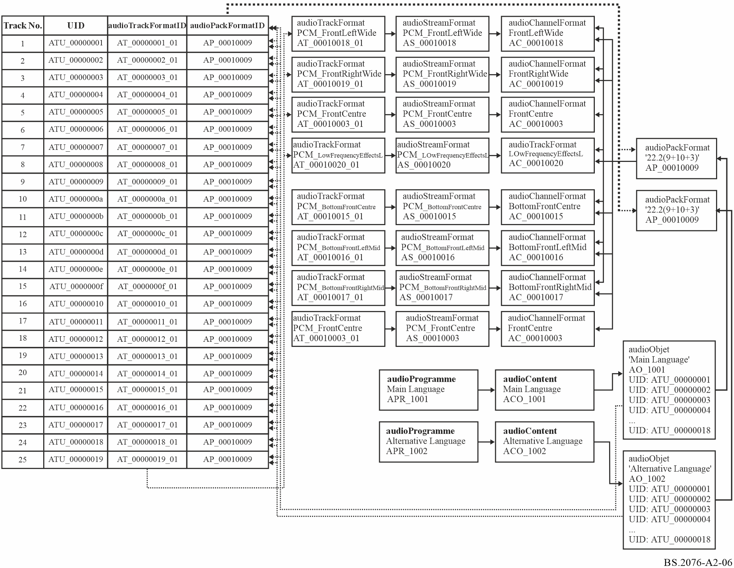

6.3 Sample code
This XML sample code does not include the audioFormatExtended parent element and the XML header for clarity. The excerpt of code covers both the format and content elements:

<!-- ############ -->
<!-- PROGRAMMES -->
<!-- ############ -->

<audioProgramme audioProgrammeID="APR_1001" audioProgrammeName="Main_Language">
<audioContentIDRef>ACO_1001</audioContentIDRef>
</audioProgramme>

<audioProgramme audioProgrammeID="APR_1002" audioProgrammeName="Alternative_Language">
<audioContentIDRef>ACO_1002</audioContentIDRef>
</audioProgramme>

<!-- ############ -->
<!-- CONTENTS -->
<!-- ############ -->

<audioContent audioContentID="ACO_1001" audioContentName="Main_Language">
<audioObjectIDRef>AO_1001</audioObjectIDRef>
<loudnessMetadata>
<integratedLoudness>-24.0</integratedLoudness>
</loudnessMetadata>
</audioContent>

<audioContent audioContentID="ACO_1002" audioContentName="Alternative_Language">
<audioObjectIDRef>AO_1002</audioObjectIDRef>
<loudnessMetadata>
<integratedLoudness>-24.0</integratedLoudness>
</loudnessMetadata>
</audioContent>

<!-- ############ -->
<!-- OBJECTS -->
<!-- ############ -->

<audioObject audioObjectID="AO_1001" audioObjectName="Main_Language">
<audioPackFormatIDRef>AP_00010009</audioPackFormatIDRef>
<audioTrackUIDRef>ATU_00000001</audioTrackUIDRef>
<audioTrackUIDRef>ATU_00000002</audioTrackUIDRef>
<audioTrackUIDRef>ATU_00000003</audioTrackUIDRef>
<audioTrackUIDRef>ATU_00000004</audioTrackUIDRef>
<audioTrackUIDRef>ATU_00000005</audioTrackUIDRef>
<audioTrackUIDRef>ATU_00000006</audioTrackUIDRef>
<audioTrackUIDRef>ATU_00000007</audioTrackUIDRef>
<audioTrackUIDRef>ATU_00000008</audioTrackUIDRef>
<audioTrackUIDRef>ATU_00000009</audioTrackUIDRef>
<audioTrackUIDRef>ATU_0000000a</audioTrackUIDRef>
<audioTrackUIDRef>ATU_0000000b</audioTrackUIDRef>
<audioTrackUIDRef>ATU_0000000c</audioTrackUIDRef>
<audioTrackUIDRef>ATU_0000000d</audioTrackUIDRef>
<audioTrackUIDRef>ATU_0000000e</audioTrackUIDRef>
<audioTrackUIDRef>ATU_0000000f</audioTrackUIDRef>
<audioTrackUIDRef>ATU_00000010</audioTrackUIDRef>
<audioTrackUIDRef>ATU_00000011</audioTrackUIDRef>
<audioTrackUIDRef>ATU_00000012</audioTrackUIDRef>
<audioTrackUIDRef>ATU_00000013</audioTrackUIDRef>
<audioTrackUIDRef>ATU_00000014</audioTrackUIDRef>
<audioTrackUIDRef>ATU_00000015</audioTrackUIDRef>
<audioTrackUIDRef>ATU_00000016</audioTrackUIDRef>
<audioTrackUIDRef>ATU_00000017</audioTrackUIDRef>
<audioTrackUIDRef>ATU_00000018</audioTrackUIDRef>
</audioObject>

<audioObject audioObjectID="AO_1002" audioObjectName="Alternative_Language">
<audioPackFormatIDRef>AP_00010009</audioPackFormatIDRef>
<audioTrackUIDRef>ATU_00000001</audioTrackUIDRef>
<audioTrackUIDRef>ATU_00000002</audioTrackUIDRef>
<audioTrackUIDRef>ATU_00000019</audioTrackUIDRef>
<audioTrackUIDRef>ATU_00000004</audioTrackUIDRef>
<audioTrackUIDRef>ATU_00000005</audioTrackUIDRef>
<audioTrackUIDRef>ATU_00000006</audioTrackUIDRef>
<audioTrackUIDRef>ATU_00000007</audioTrackUIDRef>
<audioTrackUIDRef>ATU_00000008</audioTrackUIDRef>
<audioTrackUIDRef>ATU_00000009</audioTrackUIDRef>
<audioTrackUIDRef>ATU_0000000a</audioTrackUIDRef>
<audioTrackUIDRef>ATU_0000000b</audioTrackUIDRef>
<audioTrackUIDRef>ATU_0000000c</audioTrackUIDRef>
<audioTrackUIDRef>ATU_0000000d</audioTrackUIDRef>
<audioTrackUIDRef>ATU_0000000e</audioTrackUIDRef>
<audioTrackUIDRef>ATU_0000000f</audioTrackUIDRef>
<audioTrackUIDRef>ATU_00000010</audioTrackUIDRef>
<audioTrackUIDRef>ATU_00000011</audioTrackUIDRef>
<audioTrackUIDRef>ATU_00000012</audioTrackUIDRef>
<audioTrackUIDRef>ATU_00000013</audioTrackUIDRef>
<audioTrackUIDRef>ATU_00000014</audioTrackUIDRef>
<audioTrackUIDRef>ATU_00000015</audioTrackUIDRef>
<audioTrackUIDRef>ATU_00000016</audioTrackUIDRef>
<audioTrackUIDRef>ATU_00000017</audioTrackUIDRef>
<audioTrackUIDRef>ATU_00000018</audioTrackUIDRef>
</audioObject>

<!-- ############ -->
<!-- PACKS -->
<!-- ############ -->

<audioPackFormat audioPackFormatID="AP_00010009" audioPackFormatName="22.2" typeLabel="0001" typeDefinition="DirectSpeakers">
<audioChannelFormatIDRef>AC_00010018</audioChannelFormatIDRef>
<audioChannelFormatIDRef>AC_00010019</audioChannelFormatIDRef>
<audioChannelFormatIDRef>AC_00010003</audioChannelFormatIDRef>
<audioChannelFormatIDRef>AC_00010020</audioChannelFormatIDRef>
<audioChannelFormatIDRef>AC_0001001c</audioChannelFormatIDRef>
<audioChannelFormatIDRef>AC_0001001d</audioChannelFormatIDRef>
<audioChannelFormatIDRef>AC_00010001</audioChannelFormatIDRef>
<audioChannelFormatIDRef>AC_00010002</audioChannelFormatIDRef>
<audioChannelFormatIDRef>AC_00010009</audioChannelFormatIDRef>
<audioChannelFormatIDRef>AC_00010021</audioChannelFormatIDRef>
<audioChannelFormatIDRef>AC_0001000a</audioChannelFormatIDRef>
<audioChannelFormatIDRef>AC_0001000b</audioChannelFormatIDRef>
<audioChannelFormatIDRef>AC_00010022</audioChannelFormatIDRef>
<audioChannelFormatIDRef>AC_00010023</audioChannelFormatIDRef>
<audioChannelFormatIDRef>AC_0001000e</audioChannelFormatIDRef>
<audioChannelFormatIDRef>AC_0001000c</audioChannelFormatIDRef>
<audioChannelFormatIDRef>AC_0001001e</audioChannelFormatIDRef>
<audioChannelFormatIDRef>AC_0001001f</audioChannelFormatIDRef>
<audioChannelFormatIDRef>AC_00010013</audioChannelFormatIDRef>
<audioChannelFormatIDRef>AC_00010014</audioChannelFormatIDRef>
<audioChannelFormatIDRef>AC_00010011</audioChannelFormatIDRef>
<audioChannelFormatIDRef>AC_00010015</audioChannelFormatIDRef>
<audioChannelFormatIDRef>AC_00010016</audioChannelFormatIDRef>
<audioChannelFormatIDRef>AC_00010017</audioChannelFormatIDRef>
</audioPackFormat>

<!-- ############ -->
<!-- CHANNELS -->
<!-- ############ -->

<audioChannelFormat audioChannelFormatID="AC_00010018" audioChannelFormatName="FrontLeftWide" typeLabel="0001" typeDefinition="DirectSpeakers">
<audioBlockFormat audioBlockFormatID="AB_00010018_00000001">
<speakerLabel>M+060</speakerLabel>
<position coordinate="azimuth">60.0</position>
<position coordinate="elevation">0.0</position>
<position coordinate="distance">1.0</position>
</audioBlockFormat>
</audioChannelFormat>

<audioChannelFormat audioChannelFormatID="AC_00010019" audioChannelFormatName="FrontRightWide" typeLabel="0001" typeDefinition="DirectSpeakers">
<audioBlockFormat audioBlockFormatID="AB_00010019_00000001">
<speakerLabel>M-060</speakerLabel>
<position coordinate="azimuth">-60.0</position>
<position coordinate="elevation">0.0</position>
<position coordinate="distance">1.0</position>
</audioBlockFormat>
</audioChannelFormat>

<audioChannelFormat audioChannelFormatID="AC_00010003" audioChannelFormatName="FrontCentre" typeLabel="0001" typeDefinition="DirectSpeakers">
<audioBlockFormat audioBlockFormatID="AB_00010003_00000001">
<speakerLabel>M+000</speakerLabel>
<position coordinate="azimuth">0.0</position>
<position coordinate="elevation">0.0</position>
<position coordinate="distance">1.0</position>
</audioBlockFormat>
</audioChannelFormat>

<audioChannelFormat audioChannelFormatID="AC_00010020" audioChannelFormatName="LFE1" typeLabel="0001" typeDefinition="DirectSpeakers">
<frequency typeDefinition="lowPass">120</frequency>
<audioBlockFormat audioBlockFormatID="AB_00010020_00000001">
<speakerLabel>LFE1</speakerLabel>
<position coordinate="azimuth">45.0</position>
<position coordinate="elevation">-30.0</position>
<position coordinate="distance">1.0</position>
</audioBlockFormat>
</audioChannelFormat>

<audioChannelFormat audioChannelFormatID="AC_0001001c" audioChannelFormatName="BackLeftMid" typeLabel="0001" typeDefinition="DirectSpeakers">
<audioBlockFormat audioBlockFormatID="AB_0001001c_00000001">
<speakerLabel>M+135</speakerLabel>
<position coordinate="azimuth">135.0</position>
<position coordinate="elevation">0.0</position>
<position coordinate="distance">1.0</position>
</audioBlockFormat>
</audioChannelFormat>

<audioChannelFormat audioChannelFormatID="AC_0001001d" audioChannelFormatName="BackRightMid" typeLabel="0001" typeDefinition="DirectSpeakers">
<audioBlockFormat audioBlockFormatID="AB_0001001d_00000001">
<speakerLabel>M-135</speakerLabel>
<position coordinate="azimuth">-135.0</position>
<position coordinate="elevation">0.0</position>
<position coordinate="distance">1.0</position>
</audioBlockFormat>
</audioChannelFormat>

<audioChannelFormat audioChannelFormatID="AC_00010001" audioChannelFormatName="FrontLeft" typeLabel="0001" typeDefinition="DirectSpeakers">
<audioBlockFormat audioBlockFormatID="AB_00010001_00000001">
<speakerLabel>M+030</speakerLabel>
<position coordinate="azimuth">30.0</position>
<position coordinate="elevation">0.0</position>
<position coordinate="distance">1.0</position>
</audioBlockFormat>
</audioChannelFormat>

<audioChannelFormat audioChannelFormatID="AC_00010002" audioChannelFormatName="FrontRight" typeLabel="0001" typeDefinition="DirectSpeakers">
<audioBlockFormat audioBlockFormatID="AB_00010002_00000001">
<speakerLabel>M-030</speakerLabel>
<position coordinate="azimuth">-30.0</position>
<position coordinate="elevation">0.0</position>
<position coordinate="distance">1.0</position>
</audioBlockFormat>
</audioChannelFormat>

<audioChannelFormat audioChannelFormatID="AC_00010009" audioChannelFormatName="BackCentre" typeLabel="0001" typeDefinition="DirectSpeakers">
<audioBlockFormat audioBlockFormatID="AB_00010009_00000001">
<speakerLabel>M+180</speakerLabel>
<position coordinate="azimuth">180.0</position>
<position coordinate="elevation">0.0</position>
<position coordinate="distance">1.0</position>
</audioBlockFormat>
</audioChannelFormat>

<audioChannelFormat audioChannelFormatID="AC_00010021" audioChannelFormatName="LFE2" typeLabel="0001" typeDefinition="DirectSpeakers">
<frequency typeDefinition="lowPass">120</frequency>
<audioBlockFormat audioBlockFormatID="AB_00010021_00000001">
<speakerLabel>LFE2</speakerLabel>
<position coordinate="azimuth">-45.0</position>
<position coordinate="elevation">-30.0</position>
<position coordinate="distance">1.0</position>
</audioBlockFormat>
</audioChannelFormat>

<audioChannelFormat audioChannelFormatID="AC_0001000a" audioChannelFormatName="SideLeft" typeLabel="0001" typeDefinition="DirectSpeakers">
<audioBlockFormat audioBlockFormatID="AB_0001000a_00000001">
<speakerLabel>M+090</speakerLabel>
<position coordinate="azimuth">90.0</position>
<position coordinate="elevation">0.0</position>
<position coordinate="distance">1.0</position>
</audioBlockFormat>
</audioChannelFormat>

<audioChannelFormat audioChannelFormatID="AC_0001000b" audioChannelFormatName="SideRight" typeLabel="0001" typeDefinition="DirectSpeakers">
<audioBlockFormat audioBlockFormatID="AB_0001000b_00000001">
<speakerLabel>M-090</speakerLabel>
<position coordinate="azimuth">-90.0</position>
<position coordinate="elevation">0.0</position>
<position coordinate="distance">1.0</position>
</audioBlockFormat>
</audioChannelFormat>

<audioChannelFormat audioChannelFormatID="AC_00010022" audioChannelFormatName="TopFrontLeftMid" typeLabel="0001" typeDefinition="DirectSpeakers">
<audioBlockFormat audioBlockFormatID="AB_00010022_00000001">
<speakerLabel>U+045</speakerLabel>
<position coordinate="azimuth">45.0</position>
<position coordinate="elevation">30.0</position>
<position coordinate="distance">1.0</position>
</audioBlockFormat>
</audioChannelFormat>

<audioChannelFormat audioChannelFormatID="AC_00010023" audioChannelFormatName="TopFrontRightMid" typeLabel="0001" typeDefinition="DirectSpeakers">
<audioBlockFormat audioBlockFormatID="AB_00010023_00000001">
<speakerLabel>U-045</speakerLabel>
<position coordinate="azimuth">-45.0</position>
<position coordinate="elevation">30.0</position>
<position coordinate="distance">1.0</position>
</audioBlockFormat>
</audioChannelFormat>

<audioChannelFormat audioChannelFormatID="AC_0001000e" audioChannelFormatName="TopFrontCentre" typeLabel="0001" typeDefinition="DirectSpeakers">
<audioBlockFormat audioBlockFormatID="AB_0001000e_00000001">
<speakerLabel>U+000</speakerLabel>
<position coordinate="azimuth">0.0</position>
<position coordinate="elevation">45.0</position>
<position coordinate="distance">1.0</position>
</audioBlockFormat>
</audioChannelFormat>

<audioChannelFormat audioChannelFormatID="AC_0001000c" audioChannelFormatName="TopCentre" typeLabel="0001" typeDefinition="DirectSpeakers">
<audioBlockFormat audioBlockFormatID="AB_0001000c_00000001">
<speakerLabel>T+000</speakerLabel>
<position coordinate="azimuth">0.0</position>
<position coordinate="elevation">90.0</position>
<position coordinate="distance">1.0</position>
</audioBlockFormat>
</audioChannelFormat>

<audioChannelFormat audioChannelFormatID="AC_0001001e" audioChannelFormatName="TopBackLeftMid" typeLabel="0001" typeDefinition="DirectSpeakers">
<audioBlockFormat audioBlockFormatID="AB_0001001e_00000001">
<speakerLabel>U+135</speakerLabel>
<position coordinate="azimuth">135.0</position>
<position coordinate="elevation">30.0</position>
<position coordinate="distance">1.0</position>
</audioBlockFormat>
</audioChannelFormat>

<audioChannelFormat audioChannelFormatID="AC_0001001f" audioChannelFormatName="TopBackRightMid" typeLabel="0001" typeDefinition="DirectSpeakers">
<audioBlockFormat audioBlockFormatID="AB_0001001f_00000001">
<speakerLabel>U-135</speakerLabel>
<position coordinate="azimuth">-135.0</position>
<position coordinate="elevation">30.0</position>
<position coordinate="distance">1.0</position>
</audioBlockFormat>
</audioChannelFormat>

<audioChannelFormat audioChannelFormatID="AC_00010013" audioChannelFormatName="TopSideLeft" typeLabel="0001" typeDefinition="DirectSpeakers">
<audioBlockFormat audioBlockFormatID="AB_00010013_00000001">
<speakerLabel>U+090</speakerLabel>
<position coordinate="azimuth">90.0</position>
<position coordinate="elevation">30.0</position>
<position coordinate="distance">1.0</position>
</audioBlockFormat>
</audioChannelFormat>

<audioChannelFormat audioChannelFormatID="AC_00010014" audioChannelFormatName="TopSideRight" typeLabel="0001" typeDefinition="DirectSpeakers">
<audioBlockFormat audioBlockFormatID="AB_00010014_00000001">
<speakerLabel>U-090</speakerLabel>
<position coordinate="azimuth">-90.0</position>
<position coordinate="elevation">30.0</position>
<position coordinate="distance">1.0</position>
</audioBlockFormat>
</audioChannelFormat>

<audioChannelFormat audioChannelFormatID="AC_00010011" audioChannelFormatName="TopBackCentre" typeLabel="0001" typeDefinition="DirectSpeakers">
<audioBlockFormat audioBlockFormatID="AB_00010011_00000001">
<speakerLabel>U+180</speakerLabel>
<position coordinate="azimuth">180.0</position>
<position coordinate="elevation">45.0</position>
<position coordinate="distance">1.0</position>
</audioBlockFormat>
</audioChannelFormat>

<audioChannelFormat audioChannelFormatID="AC_00010015" audioChannelFormatName="BottomFrontCentre" typeLabel="0001" typeDefinition="DirectSpeakers">
<audioBlockFormat audioBlockFormatID="AB_00010015_00000001">
<speakerLabel>B+000</speakerLabel>
<position coordinate="azimuth">0.0</position>
<position coordinate="elevation">-30.0</position>
<position coordinate="distance">1.0</position>
</audioBlockFormat>
</audioChannelFormat>

<audioChannelFormat audioChannelFormatID="AC_00010016" audioChannelFormatName="BottomFrontLeftMid" typeLabel="0001" typeDefinition="DirectSpeakers">
<audioBlockFormat audioBlockFormatID="AB_00010016_00000001">
<speakerLabel>B+045</speakerLabel>
<position coordinate="azimuth">45.0</position>
<position coordinate="elevation">-30.0</position>
<position coordinate="distance">1.0</position>
</audioBlockFormat>
</audioChannelFormat>

<audioChannelFormat audioChannelFormatID="AC_00010017" audioChannelFormatName="BottomFrontRightMid" typeLabel="0001" typeDefinition="DirectSpeakers">
<audioBlockFormat audioBlockFormatID="AB_00010017_00000001">
<speakerLabel>B-045</speakerLabel>
<position coordinate="azimuth">-45.0</position>
<position coordinate="elevation">-30.0</position>
<position coordinate="distance">1.0</position>
</audioBlockFormat>
</audioChannelFormat>

<!-- ############ -->
<!-- STREAMS -->
<!-- ############ -->

<audioStreamFormat audioStreamFormatID="AS_00010018" audioStreamFormatName="PCM_FrontLeftWide" formatLabel="0001" formatDefinition="PCM">
<audioChannelFormatIDRef>AC_00010018</audioChannelFormatIDRef>
<audioTrackFormatIDRef>AT_00010018_01</audioTrackFormatIDRef>
</audioStreamFormat>

<audioStreamFormat audioStreamFormatID="AS_00010019" audioStreamFormatName="PCM_FrontRightWide" formatLabel="0001" formatDefinition="PCM">
<audioChannelFormatIDRef>AC_00010019</audioChannelFormatIDRef>
<audioTrackFormatIDRef>AT_00010019_01</audioTrackFormatIDRef>
</audioStreamFormat>

<audioStreamFormat audioStreamFormatID="AS_00010003" audioStreamFormatName="PCM_FrontCentre" formatLabel="0001" formatDefinition="PCM">
<audioChannelFormatIDRef>AC_00010003</audioChannelFormatIDRef>
<audioTrackFormatIDRef>AT_00010003_01</audioTrackFormatIDRef>
</audioStreamFormat>

<audioStreamFormat audioStreamFormatID="AS_00010020" audioStreamFormatName="PCM_LFE1" formatLabel="0001" formatDefinition="PCM">
<audioChannelFormatIDRef>AC_00010020</audioChannelFormatIDRef>
<audioTrackFormatIDRef>AT_00010020_01</audioTrackFormatIDRef>
</audioStreamFormat>

<audioStreamFormat audioStreamFormatID="AS_0001001c" audioStreamFormatName="PCM_BackLeftMid" formatLabel="0001" formatDefinition="PCM">
<audioChannelFormatIDRef>AC_0001001c</audioChannelFormatIDRef>
<audioTrackFormatIDRef>AT_0001001c_01</audioTrackFormatIDRef>
</audioStreamFormat>

<audioStreamFormat audioStreamFormatID="AS_0001001d" audioStreamFormatName="PCM_BackRightMid" formatLabel="0001" formatDefinition="PCM">
<audioChannelFormatIDRef>AC_0001001d</audioChannelFormatIDRef>
<audioTrackFormatIDRef>AT_0001001d_01</audioTrackFormatIDRef>
</audioStreamFormat>

<audioStreamFormat audioStreamFormatID="AS_00010001" audioStreamFormatName="PCM_FrontLeft" formatLabel="0001" formatDefinition="PCM">
<audioChannelFormatIDRef>AC_00010001</audioChannelFormatIDRef>
<audioTrackFormatIDRef>AT_00010001_01</audioTrackFormatIDRef>
</audioStreamFormat>

<audioStreamFormat audioStreamFormatID="AS_00010002" audioStreamFormatName="PCM_FrontRight" formatLabel="0001" formatDefinition="PCM">
<audioChannelFormatIDRef>AC_00010002</audioChannelFormatIDRef>
<audioTrackFormatIDRef>AT_00010002_01</audioTrackFormatIDRef>
</audioStreamFormat>

<audioStreamFormat audioStreamFormatID="AS_00010009" audioStreamFormatName="PCM_BackCentre" formatLabel="0001" formatDefinition="PCM">
<audioChannelFormatIDRef>AC_00010009</audioChannelFormatIDRef>
<audioTrackFormatIDRef>AT_00010009_01</audioTrackFormatIDRef>
</audioStreamFormat>

<audioStreamFormat audioStreamFormatID="AS_00010021" audioStreamFormatName="PCM_LFE2" formatLabel="0001" formatDefinition="PCM">
<audioChannelFormatIDRef>AC_00010021</audioChannelFormatIDRef>
<audioTrackFormatIDRef>AT_00010021_01</audioTrackFormatIDRef>
</audioStreamFormat>

<audioStreamFormat audioStreamFormatID="AS_0001000a" audioStreamFormatName="PCM_SideLeft" formatLabel="0001" formatDefinition="PCM">
<audioChannelFormatIDRef>AC_0001000a</audioChannelFormatIDRef>
<audioTrackFormatIDRef>AT_0001000a_01</audioTrackFormatIDRef>
</audioStreamFormat>

<audioStreamFormat audioStreamFormatID="AS_0001000b" audioStreamFormatName="PCM_SideRight" formatLabel="0001" formatDefinition="PCM">
<audioChannelFormatIDRef>AC_0001000b</audioChannelFormatIDRef>
<audioTrackFormatIDRef>AT_0001000b_01</audioTrackFormatIDRef>
</audioStreamFormat>

<audioStreamFormat audioStreamFormatID="AS_00010022" audioStreamFormatName="PCM_TopFrontLeftMid" formatLabel="0001" formatDefinition="PCM">
<audioChannelFormatIDRef>AC_00010022</audioChannelFormatIDRef>
<audioTrackFormatIDRef>AT_00010022_01</audioTrackFormatIDRef>
</audioStreamFormat>

<audioStreamFormat audioStreamFormatID="AS_00010023" audioStreamFormatName="PCM_TopFrontRightMid" formatLabel="0001" formatDefinition="PCM">
<audioChannelFormatIDRef>AC_00010023</audioChannelFormatIDRef>
<audioTrackFormatIDRef>AT_00010023_01</audioTrackFormatIDRef>
</audioStreamFormat>

<audioStreamFormat audioStreamFormatID="AS_0001000e" audioStreamFormatName="PCM_TopFrontCentre" formatLabel="0001" formatDefinition="PCM">
<audioChannelFormatIDRef>AC_0001000e</audioChannelFormatIDRef>
<audioTrackFormatIDRef>AT_0001000e_01</audioTrackFormatIDRef>
</audioStreamFormat>

<audioStreamFormat audioStreamFormatID="AS_0001000c" audioStreamFormatName="PCM_TopCentre" formatLabel="0001" formatDefinition="PCM">
<audioChannelFormatIDRef>AC_0001000c</audioChannelFormatIDRef>
<audioTrackFormatIDRef>AT_0001000c_01</audioTrackFormatIDRef>
</audioStreamFormat>

<audioStreamFormat audioStreamFormatID="AS_0001001e" audioStreamFormatName="PCM_TopBackLeftMid" formatLabel="0001" formatDefinition="PCM">
<audioChannelFormatIDRef>AC_0001001e</audioChannelFormatIDRef>
<audioTrackFormatIDRef>AT_0001001e_01</audioTrackFormatIDRef>
</audioStreamFormat>

<audioStreamFormat audioStreamFormatID="AS_0001001f" audioStreamFormatName="PCM_TopBackRightMid" formatLabel="0001" formatDefinition="PCM">
<audioChannelFormatIDRef>AC_0001001f</audioChannelFormatIDRef>
<audioTrackFormatIDRef>AT_0001001f_01</audioTrackFormatIDRef>
</audioStreamFormat>

<audioStreamFormat audioStreamFormatID="AS_00010013" audioStreamFormatName="PCM_TopSideLeft" formatLabel="0001" formatDefinition="PCM">
<audioChannelFormatIDRef>AC_00010013</audioChannelFormatIDRef>
<audioTrackFormatIDRef>AT_00010013_01</audioTrackFormatIDRef>
</audioStreamFormat>

<audioStreamFormat audioStreamFormatID="AS_00010014" audioStreamFormatName="PCM_TopSideRight" formatLabel="0001" formatDefinition="PCM">
<audioChannelFormatIDRef>AC_00010014</audioChannelFormatIDRef>
<audioTrackFormatIDRef>AT_00010014_01</audioTrackFormatIDRef>
</audioStreamFormat>

<audioStreamFormat audioStreamFormatID="AS_00010011" audioStreamFormatName="PCM_TopBackCentre" formatLabel="0001" formatDefinition="PCM">
<audioChannelFormatIDRef>AC_00010011</audioChannelFormatIDRef>
<audioTrackFormatIDRef>AT_00010011_01</audioTrackFormatIDRef>
</audioStreamFormat>

<audioStreamFormat audioStreamFormatID="AS_00010015" audioStreamFormatName="PCM_BottomFrontCentre" formatLabel="0001" formatDefinition="PCM">
<audioChannelFormatIDRef>AC_00010015</audioChannelFormatIDRef>
<audioTrackFormatIDRef>AT_00010015_01</audioTrackFormatIDRef>
</audioStreamFormat>

<audioStreamFormat audioStreamFormatID="AS_00010016" audioStreamFormatName="PCM_BottomFrontLeftMid" formatLabel="0001" formatDefinition="PCM">
<audioChannelFormatIDRef>AC_00010016</audioChannelFormatIDRef>
<audioTrackFormatIDRef>AT_00010016_01</audioTrackFormatIDRef>
</audioStreamFormat>

<audioStreamFormat audioStreamFormatID="AS_00010017" audioStreamFormatName="PCM_BottomFrontRightMid" formatLabel="0001" formatDefinition="PCM">
<audioChannelFormatIDRef>AC_00010017</audioChannelFormatIDRef>
<audioTrackFormatIDRef>AT_00010017_01</audioTrackFormatIDRef>
</audioStreamFormat>

<!-- ############ -->
<!-- AUDIO TRACKS -->
<!-- ############ -->

<audioTrackFormat audioTrackFormatID="AT_00010018_01" audioTrackFormatName="PCM_FrontLeftWide" formatLabel="0001" formatDefinition="PCM">
<audioStreamFormatIDRef>AS_00010018</audioStreamFormatIDRef>
</audioTrackFormat>

<audioTrackFormat audioTrackFormatID="AT_00010019_01" audioTrackFormatName="PCM_FrontRightWide" formatLabel="0001" formatDefinition="PCM">
<audioStreamFormatIDRef>AS_00010019</audioStreamFormatIDRef>
</audioTrackFormat>

<audioTrackFormat audioTrackFormatID="AT_00010003_01" audioTrackFormatName="PCM_FrontCentre" formatLabel="0001" formatDefinition="PCM">
<audioStreamFormatIDRef>AS_00010003</audioStreamFormatIDRef>
</audioTrackFormat>

<audioTrackFormat audioTrackFormatID="AT_00010020_01" audioTrackFormatName="PCM_LFE1" formatLabel="0001" formatDefinition="PCM">
<audioStreamFormatIDRef>AS_00010020</audioStreamFormatIDRef>
</audioTrackFormat>

<audioTrackFormat audioTrackFormatID="AT_0001001c_01" audioTrackFormatName="PCM_BackLeftMid" formatLabel="0001" formatDefinition="PCM">
<audioStreamFormatIDRef>AS_0001001c</audioStreamFormatIDRef>
</audioTrackFormat>

<audioTrackFormat audioTrackFormatID="AT_0001001d_01" audioTrackFormatName="PCM_BackRightMid" formatLabel="0001" formatDefinition="PCM">
<audioStreamFormatIDRef>AS_0001001d</audioStreamFormatIDRef>
</audioTrackFormat>

<audioTrackFormat audioTrackFormatID="AT_00010001_01" audioTrackFormatName="PCM_FrontLeft" formatLabel="0001" formatDefinition="PCM">
<audioStreamFormatIDRef>AS_00010001</audioStreamFormatIDRef>
</audioTrackFormat>

<audioTrackFormat audioTrackFormatID="AT_00010002_01" audioTrackFormatName="PCM_FrontRight" formatLabel="0001" formatDefinition="PCM">
<audioStreamFormatIDRef>AS_00010002</audioStreamFormatIDRef>
</audioTrackFormat>

<audioTrackFormat audioTrackFormatID="AT_00010009_01" audioTrackFormatName="PCM_BackCentre" formatLabel="0001" formatDefinition="PCM">
<audioStreamFormatIDRef>AS_00010009</audioStreamFormatIDRef>
</audioTrackFormat>

<audioTrackFormat audioTrackFormatID="AT_00010021_01" audioTrackFormatName="PCM_LFE2" formatLabel="0001" formatDefinition="PCM">
<audioStreamFormatIDRef>AS_00010021</audioStreamFormatIDRef>
</audioTrackFormat>

<audioTrackFormat audioTrackFormatID="AT_0001000a_01" audioTrackFormatName="PCM_SideLeft" formatLabel="0001" formatDefinition="PCM">
<audioStreamFormatIDRef>AS_0001000a</audioStreamFormatIDRef>
</audioTrackFormat>

<audioTrackFormat audioTrackFormatID="AT_0001000b_01" audioTrackFormatName="PCM_SideRight" formatLabel="0001" formatDefinition="PCM">
<audioStreamFormatIDRef>AS_0001000b</audioStreamFormatIDRef>
</audioTrackFormat>

<audioTrackFormat audioTrackFormatID="AT_00010022_01" audioTrackFormatName="PCM_TopFrontLeftMid" formatLabel="0001" formatDefinition="PCM">
<audioStreamFormatIDRef>AS_00010022</audioStreamFormatIDRef>
</audioTrackFormat>

<audioTrackFormat audioTrackFormatID="AT_00010023_01" audioTrackFormatName="PCM_TopFrontRightMid" formatLabel="0001" formatDefinition="PCM">
<audioStreamFormatIDRef>AS_00010023</audioStreamFormatIDRef>
</audioTrackFormat>

<audioTrackFormat audioTrackFormatID="AT_0001000e_01" audioTrackFormatName="PCM_TopFrontCentre" formatLabel="0001" formatDefinition="PCM">
<audioStreamFormatIDRef>AS_0001000e</audioStreamFormatIDRef>
</audioTrackFormat>

<audioTrackFormat audioTrackFormatID="AT_0001000c_01" audioTrackFormatName="PCM_TopCentre" formatLabel="0001" formatDefinition="PCM">
<audioStreamFormatIDRef>AS_0001000c</audioStreamFormatIDRef>
</audioTrackFormat>

<audioTrackFormat audioTrackFormatID="AT_0001001e_01" audioTrackFormatName="PCM_TopBackLeftMid" formatLabel="0001" formatDefinition="PCM">
<audioStreamFormatIDRef>AS_0001001e</audioStreamFormatIDRef>
</audioTrackFormat>

<audioTrackFormat audioTrackFormatID="AT_0001001f_01" audioTrackFormatName="PCM_TopBackRightMid" formatLabel="0001" formatDefinition="PCM">
<audioStreamFormatIDRef>AS_0001001f</audioStreamFormatIDRef>
</audioTrackFormat>

<audioTrackFormat audioTrackFormatID="AT_00010013_01" audioTrackFormatName="PCM_TopSideLeft" formatLabel="0001" formatDefinition="PCM">
<audioStreamFormatIDRef>AS_00010013</audioStreamFormatIDRef>
</audioTrackFormat>

<audioTrackFormat audioTrackFormatID="AT_00010014_01" audioTrackFormatName="PCM_TopSideRight" formatLabel="0001" formatDefinition="PCM">
<audioStreamFormatIDRef>AS_00010014</audioStreamFormatIDRef>
</audioTrackFormat>

<audioTrackFormat audioTrackFormatID="AT_00010011_01" audioTrackFormatName="PCM_TopBackCentre" formatLabel="0001" formatDefinition="PCM">
<audioStreamFormatIDRef>AS_00010011</audioStreamFormatIDRef>
</audioTrackFormat>

<audioTrackFormat audioTrackFormatID="AT_00010015_01" audioTrackFormatName="PCM_BottomFrontCentre" formatLabel="0001" formatDefinition="PCM">
<audioStreamFormatIDRef>AS_00010015</audioStreamFormatIDRef>
</audioTrackFormat>

<audioTrackFormat audioTrackFormatID="AT_00010016_01" audioTrackFormatName="PCM_BottomFrontLeftMid" formatLabel="0001" formatDefinition="PCM">
<audioStreamFormatIDRef>AS_00010016</audioStreamFormatIDRef>
</audioTrackFormat>

<audioTrackFormat audioTrackFormatID="AT_00010017_01" audioTrackFormatName="PCM_BottomFrontRightMid" formatLabel="0001" formatDefinition="PCM">
<audioStreamFormatIDRef>AS_00010017</audioStreamFormatIDRef>
</audioTrackFormat>

<!-- ############ -->
<!-- AUDIO TRACK UIDs -->
<!-- ############ -->

<audioTrackUID UID="ATU_00000001">
<audioTrackFormatIDRef>AT_00010018_01</audioTrackFormatIDRef>
<audioPackFormatIDRef>AP_00010009</audioPackFormatIDRef>
</audioTrackUID>

<audioTrackUID UID="ATU_00000002">
<audioTrackFormatIDRef>AT_00010019_01</audioTrackFormatIDRef>
<audioPackFormatIDRef>AP_00010009</audioPackFormatIDRef>
</audioTrackUID>

<audioTrackUID UID="ATU_00000003">
<audioTrackFormatIDRef>AT_00010003_01</audioTrackFormatIDRef>
<audioPackFormatIDRef>AP_00010009</audioPackFormatIDRef>
</audioTrackUID>

<audioTrackUID UID="ATU_00000004">
<audioTrackFormatIDRef>AT_00010020_01</audioTrackFormatIDRef>
<audioPackFormatIDRef>AP_00010009</audioPackFormatIDRef>
</audioTrackUID>

<audioTrackUID UID="ATU_00000005">
<audioTrackFormatIDRef>AT_0001001c_01</audioTrackFormatIDRef>
<audioPackFormatIDRef>AP_00010009</audioPackFormatIDRef>
</audioTrackUID>

<audioTrackUID UID="ATU_00000006">
<audioTrackFormatIDRef>AT_0001001d_01</audioTrackFormatIDRef>
<audioPackFormatIDRef>AP_00010009</audioPackFormatIDRef>
</audioTrackUID>

<audioTrackUID UID="ATU_00000007">
<audioTrackFormatIDRef>AT_00010001_01</audioTrackFormatIDRef>
<audioPackFormatIDRef>AP_00010009</audioPackFormatIDRef>
</audioTrackUID>

<audioTrackUID UID="ATU_00000008">
<audioTrackFormatIDRef>AT_00010002_01</audioTrackFormatIDRef>
<audioPackFormatIDRef>AP_00010009</audioPackFormatIDRef>
</audioTrackUID>

<audioTrackUID UID="ATU_00000009">
<audioTrackFormatIDRef>AT_00010009_01</audioTrackFormatIDRef>
<audioPackFormatIDRef>AP_00010009</audioPackFormatIDRef>
</audioTrackUID>

<audioTrackUID UID="ATU_0000000a">
<audioTrackFormatIDRef>AT_00010021_01</audioTrackFormatIDRef>
<audioPackFormatIDRef>AP_00010009</audioPackFormatIDRef>
</audioTrackUID>

<audioTrackUID UID="ATU_0000000b">
<audioTrackFormatIDRef>AT_0001000a_01</audioTrackFormatIDRef>
<audioPackFormatIDRef>AP_00010009</audioPackFormatIDRef>
</audioTrackUID>

<audioTrackUID UID="ATU_0000000c">
<audioTrackFormatIDRef>AT_0001000b_01</audioTrackFormatIDRef>
<audioPackFormatIDRef>AP_00010009</audioPackFormatIDRef>
</audioTrackUID>

<audioTrackUID UID="ATU_0000000d">
<audioTrackFormatIDRef>AT_00010022_01</audioTrackFormatIDRef>
<audioPackFormatIDRef>AP_00010009</audioPackFormatIDRef>
</audioTrackUID>

<audioTrackUID UID="ATU_0000000e">
<audioTrackFormatIDRef>AT_00010023_01</audioTrackFormatIDRef>
<audioPackFormatIDRef>AP_00010009</audioPackFormatIDRef>
</audioTrackUID>

<audioTrackUID UID="ATU_0000000f">
<audioTrackFormatIDRef>AT_0001000e_01</audioTrackFormatIDRef>
<audioPackFormatIDRef>AP_00010009</audioPackFormatIDRef>
</audioTrackUID>

<audioTrackUID UID="ATU_00000010">
<audioTrackFormatIDRef>AT_0001000c_01</audioTrackFormatIDRef>
<audioPackFormatIDRef>AP_00010009</audioPackFormatIDRef>
</audioTrackUID>

<audioTrackUID UID="ATU_00000011">
<audioTrackFormatIDRef>AT_0001001e_01</audioTrackFormatIDRef>
<audioPackFormatIDRef>AP_00010009</audioPackFormatIDRef>
</audioTrackUID>

<audioTrackUID UID="ATU_00000012">
<audioTrackFormatIDRef>AT_0001001f_01</audioTrackFormatIDRef>
<audioPackFormatIDRef>AP_00010009</audioPackFormatIDRef>
</audioTrackUID>

<audioTrackUID UID="ATU_00000013">
<audioTrackFormatIDRef>AT_00010013_01</audioTrackFormatIDRef>
<audioPackFormatIDRef>AP_00010009</audioPackFormatIDRef>
</audioTrackUID>

<audioTrackUID UID="ATU_00000014">
<audioTrackFormatIDRef>AT_00010014_01</audioTrackFormatIDRef>
<audioPackFormatIDRef>AP_00010009</audioPackFormatIDRef>
</audioTrackUID>

<audioTrackUID UID="ATU_00000015">
<audioTrackFormatIDRef>AT_00010011_01</audioTrackFormatIDRef>
<audioPackFormatIDRef>AP_00010009</audioPackFormatIDRef>
</audioTrackUID>

<audioTrackUID UID="ATU_00000016">
<audioTrackFormatIDRef>AT_00010015_01</audioTrackFormatIDRef>
<audioPackFormatIDRef>AP_00010009</audioPackFormatIDRef>
</audioTrackUID>

<audioTrackUID UID="ATU_00000017">
<audioTrackFormatIDRef>AT_00010016_01</audioTrackFormatIDRef>
<audioPackFormatIDRef>AP_00010009</audioPackFormatIDRef>
</audioTrackUID>

<audioTrackUID UID="ATU_00000018">
<audioTrackFormatIDRef>AT_00010017_01</audioTrackFormatIDRef>
<audioPackFormatIDRef>AP_00010009</audioPackFormatIDRef>
</audioTrackUID>

<audioTrackUID UID="ATU_00000019">
<audioTrackFormatIDRef>AT_00010003_01</audioTrackFormatIDRef>
<audioPackFormatIDRef>AP_00010009</audioPackFormatIDRef>
</audioTrackUID>

7 Example of the use of the Matrix type
The example illustrates both an encoding and decoding matrices that are associated with each other, in this case the 5.1 to Lo/Ro downmix matrix. The audio tracks are the Lo/Ro channels, so the decoding matrix describes how these are converted back to channel-based channels (trivially in this case), and the encoding matrix that was used to produce these tracks.
In reality, an Lo/Ro downmix would more likely be specified using a single direct matrix, as the Lo/Ro channels are effectively channel-based. This example is used to illustrate the concept of an encoding and decoding matrix pair, where the decoding matrix is just a trivial identity matrix.

7.1 Summary of elements
These are the elements in the format part of the description:
TABLE A2-14
Matrix example format elements
Element | ID | Name | Description
audioTrackFormat | AT_00021103_01 | PCM_Lo/Ro_Decode_Left | Defines track as PCM
audioTrackFormat | AT_00021104_01 | PCM_Lo/Ro_Decode_Right | Defines track as PCM
audioStreamFormat | AS_00021103 | PCM_Lo/Ro_Decode_Left | Defines stream as PCM
audioStreamFormat | AS_00021104 | PCM_Lo/Ro_Decode_Right | Defines stream as PCM
audioChannelFormat &  audioBlockFormat | AC_00021003  AB_00021003_00000001 | Lo/Ro_Left | Describes channel as Lo matrix encoding
audioChannelFormat &  audioBlockFormat | AC_00021004  AB_00021004_00000001 | Lo/Ro_Right | Describes channel as Ro matrix encoding
audioChannelFormat &  audioBlockFormat | AC_00021103  AB_00021103_00000001 | Lo/Ro_Decode_Left | Describes channel as Lo matrix decoding
audioChannelFormat &  audioBlockFormat | AC_00021104  AB_00021104_00000001 | Lo/Ro_Decode_Right | Describes channel as Ro matrix decoding
audioPackFormat | AP_00021002 | Lo/Ro | Defines a Lo/Ro pack encoding matrix (from 5.1 channels).
audioPackFormat | AP_00021102 | Lo/Ro_Decode | Defines a Lo/Ro pack decoding matrix (to 2 channels).
These are the elements in the content part of the description:
TABLE A2-15
Matrix example content elements
Element | ID | Name | Description
audioObject | AO_1001 | Lo/Ro_Downmix | Object for Lo/Ro encoded channels

7.2 Element Relationships
The diagram in Fig. A2-7 shows how the defined elements relate to each other. The two audioTrackFormat and audioStreamFormat elements refer to audioChannelFormats that describe a decoding matrix. These are refered from an audioPackFormat element that describes the while decoding matrix. This audioPackFormat element also references another audioPackFormat element that describes an associated encoding matrix (which in turn references two encoding matrix audioChannelFormat elements). Each of the matrix audioPackFormat elements also reference ‘DirectSpeakers’ audioPackFormat elements, which are not included in the XML as they are common definitions (hence greyed out in the diagram).
The <chna> chunk at the bottom shows how the tracks are connected to the format definitions. The audioObject element containing the track UID references to the UID in the <chna> chunk, and references the decoding matrix audioPackFormat element.
Figure A2-7
Matrix example diagram
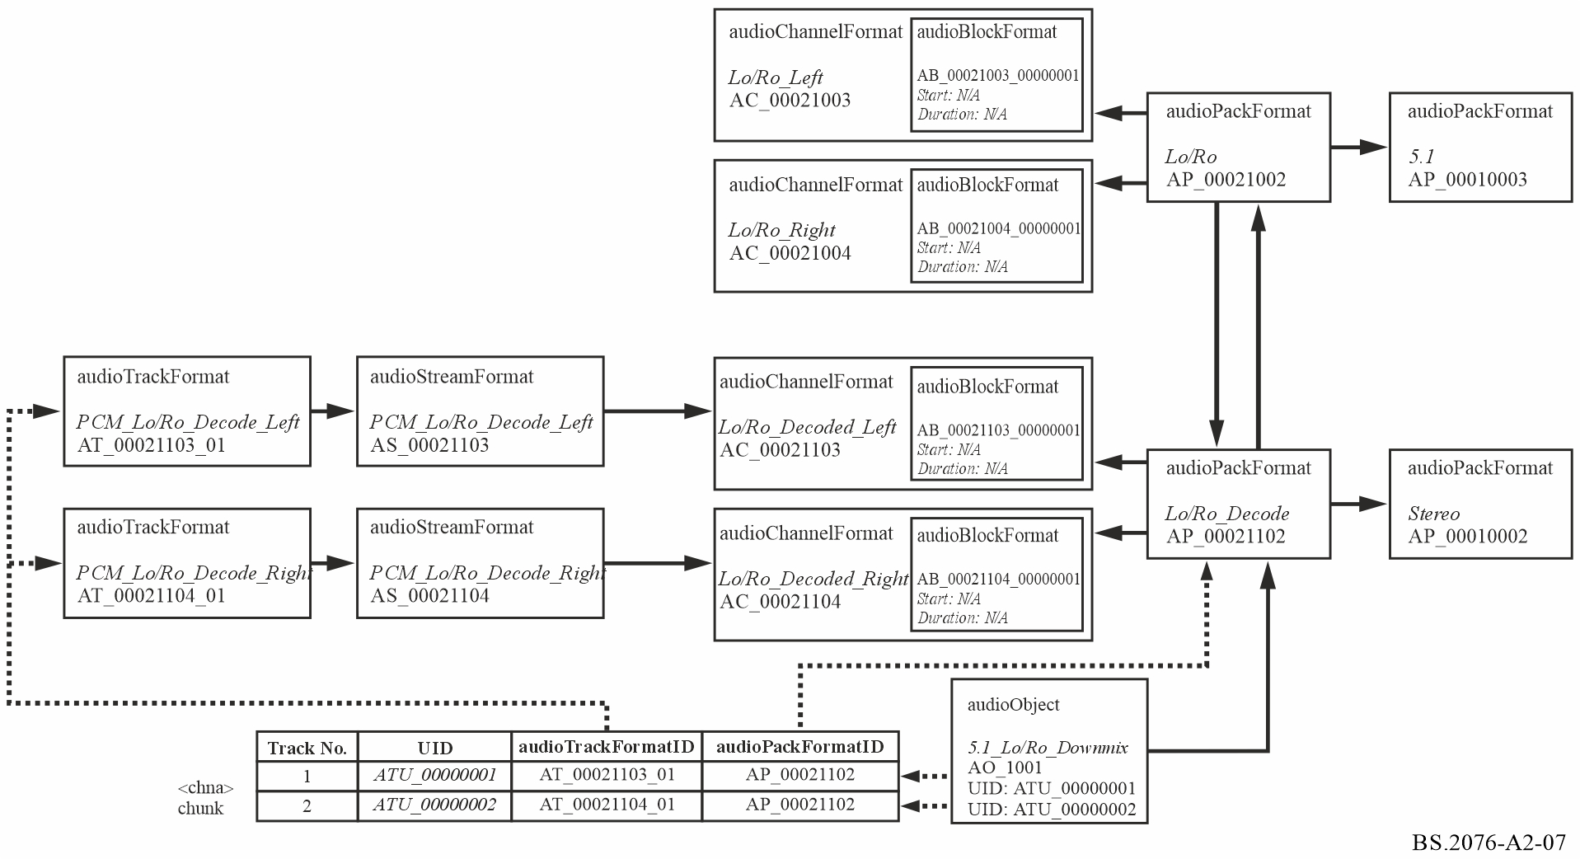

7.3 Sample code
This XML sample code does not include the audioFormatExtended parent element and the XML header for clarity. The elements that are in the common definitions (Recommendation ITU-R BS.2094) have also been removed for clarity. The code contains both the content and format parts, but omits the common definition elements that are referenced:

<!-- ############ -->
<!-- OBJECTS -->
<!-- ############ -->

<audioObject audioObjectID="AO_1001" audioObjectName="Lo/Ro_Downmix">
<audioPackFormatIDRef>AP_00021102</audioPackFormatIDRef>
<audioTrackUIDRef>ATU_00000001</audioTrackUIDRef>
<audioTrackUIDRef>ATU_00000002</audioTrackUIDRef>
</audioObject>

<!-- ############ -->
<!-- PACKS -->
<!-- ############ -->

<audioPackFormat audioPackFormatID="AP_00021002" audioPackFormatName="Lo/Ro" typeLabel="0002" typeDefinition="Matrix">
<decodePackFormatIDRef>AP_00021102</decodePackFormatIDRef>
<inputPackFormatIDRef>AP_00010003</inputPackFormatIDRef>
<audioChannelFormatIDRef>AC_00021003</audioChannelFormatIDRef>
<audioChannelFormatIDRef>AC_00021004</audioChannelFormatIDRef>
</audioPackFormat>

<audioPackFormat audioPackFormatID="AP_00021102" audioPackFormatName="Lo/Ro_Decode" typeLabel="0002" typeDefinition="Matrix">
<encodePackFormatIDRef>AP_00021002</encodePackFormatIDRef>
<outputPackFormatIDRef>AP_00010002</outputPackFormatIDRef>
<audioChannelFormatIDRef>AC_00021103</audioChannelFormatIDRef>
<audioChannelFormatIDRef>AC_00021104</audioChannelFormatIDRef>
</audioPackFormat>

<!-- ############ -->
<!-- CHANNELS -->
<!-- ############ -->

<audioChannelFormat audioChannelFormatID="AC_00021003" audioChannelFormatName="Lo/Ro_Left" typeLabel="0002" typeDefinition="Matrix">
<audioBlockFormat audioBlockFormatID="AB_00021003_00000001">
<matrix>
<coefficient gain="1.0">AC_00010001</coefficient>
<coefficient gain="cvar">AC_00010003</coefficient>
<coefficient gain="svar">AC_00010005</coefficient>
</matrix>
</audioBlockFormat>
</audioChannelFormat>

<audioChannelFormat audioChannelFormatID="AC_00021004" audioChannelFormatName="Lo/Ro_Right" typeLabel="0002" typeDefinition="Matrix">
<audioBlockFormat audioBlockFormatID="AB_00021004_00000001">
<matrix>
<coefficient gain="1.0">AC_00010002</coefficient>
<coefficient gain="cvar">AC_00010003</coefficient>
<coefficient gain="svar">AC_00010006</coefficient>
</matrix>
</audioBlockFormat>
</audioChannelFormat>

<audioChannelFormat audioChannelFormatID="AC_00021103" audioChannelFormatName="Lo/Ro_Decode_Left" typeLabel="0002" typeDefinition="Matrix">
<audioBlockFormat audioBlockFormatID="AB_00021103_00000001">
<outputChannelFormatIDRef>AC_00010001</outputChannelFormatIDRef>
<matrix>
<coefficient gain="1.0">AC_00021003</coefficient>
</matrix>
</audioBlockFormat>
</audioChannelFormat>

<audioChannelFormat audioChannelFormatID="AC_00021104" audioChannelFormatName="Lo/Ro_Decode_Right" typeLabel="0002" typeDefinition="Matrix">
<audioBlockFormat audioBlockFormatID="AB_00021104_00000001">
<outputChannelFormatIDRef>AC_00010002</outputChannelFormatIDRef>
<matrix>
<coefficient gain="1.0">AC_00021004</coefficient>
</matrix>
</audioBlockFormat>
</audioChannelFormat>

<!-- ############ -->
<!-- STREAMS -->
<!-- ############ -->

<audioStreamFormat audioStreamFormatID="AS_00021103" audioStreamFormatName="PCM_Lo/Ro_Deocde_Left" formatLabel="0001" formatDefinition="PCM">
<audioChannelFormatIDRef>AC_00021103</audioChannelFormatIDRef>
<audioTrackFormatIDRef>AT_00021103_01</audioTrackFormatIDRef>
</audioStreamFormat>

<audioStreamFormat audioStreamFormatID="AS_00021104" audioStreamFormatName="PCM_Lo/Ro_Decode_Right" formatLabel="0001" formatDefinition="PCM">
<audioChannelFormatIDRef>AC_00021104</audioChannelFormatIDRef>
<audioTrackFormatIDRef>AT_00021104_01</audioTrackFormatIDRef>
</audioStreamFormat>

<!-- ############ -->
<!-- AUDIO TRACKS -->
<!-- ############ -->

<audioTrackFormat audioTrackFormatID="AT_00021103_01" audioTrackFormatName="PCM_Lo/Ro_Decode_Left" formatLabel="0001" formatDefinition="PCM">
<audioStreamFormatIDRef>AS_00021103</audioStreamFormatIDRef>
</audioTrackFormat>

<audioTrackFormat audioTrackFormatID="AT_00021104_01" audioTrackFormatName="PCM_Lo/Ro_Decode_Right" formatLabel="0001" formatDefinition="PCM">
<audioStreamFormatIDRef>AS_00021104</audioStreamFormatIDRef>
</audioTrackFormat>

Annex 3
(informative)
Overview of changes in this edition (Recommendation ITU-R BS.2076-3)
This overview provides a list of updates and changes to this Recommendation from previous version(s).
i) Editorial changes and additional clarifying text / examples to ensure clear understanding, describing existing features in Recommendation ITU-R BS.2076-2:
Item | Description | Section(s)
1 | Expanded sample code to clearly illustrate use of audioTrackFormat, audioStreamFormat and audioChannelFormat elements, including the case for PCM when audioTrackFormat and audioStreamFormat are not present. | 5.9.3
2 | Added statement about format of vvvvvvvv part in audioTrackUID. | 6
3 | Clarification of what interaction is enabled when audioObject->interact is set to 1 but audioObject->audioObjectInteraction is not present | 12 and 13
4 | Reorganized common audioBlockFormat sub-elements for all typeDefintions into tables | 5.4.3
5 | Added an example of ADM usage for PCM that does not include elements audioTrackFormat and audioStreamFormat | Annex 2 2
6 | Moved "Overview of changes" from the beginning of the document to an Annex at the end of the document.

ii) Technical corrections and additional clarification text:
Item | Description | Section(s)
7 | Frequency element (200 changed to 120) used for LFE for alignment with other documents. | 5.3.2, Annex 2 5.3 and 6.3
8 | Added missing definition of shortform time formats and incorporated further time format refinements from other ADM related documents. | 5.13
9 | Corrected element audioChannelFormatIDRef to outputChannelFormatIDRef in final sentence. | 5.4.3.2

iii) Further technical changes including the definition of new elements and attributes:
Item | Description | Section(s)
10 | Addition of profileList | 5.10
11 | Interpolation time unit, added support for fractional representation to align with how other time units may use. | 5.13
12 | Addition of tagList. | 5.11
13 | Addition of Cartesian positions for DirectSpeakers and add Cartesian flag similar to Objects | 5.4.3.1
14 | Addition of coordinateMode in authoringInformation | 5.8.6
15 | Addition of new elements for definition of loudness measurement configuration. | 5.7.4 and 5.8.4

The informative Annex 2 provides examples of ADM usage. The informative Annex 3 gives an overview of the changes in this edition compared to the previous edition.

