Recommendation ITU-R BS.2051-2
(07/2018)
Advanced sound system for
programme production

BS Series
Broadcasting service (sound)

Foreword
The role of the Radiocommunication Sector is to ensure the rational, equitable, efficient and economical use of the radio-frequency spectrum by all radiocommunication services, including satellite services, and carry out studies without limit of frequency range on the basis of which Recommendations are adopted.
The regulatory and policy functions of the Radiocommunication Sector are performed by World and Regional Radiocommunication Conferences and Radiocommunication Assemblies supported by Study Groups.

Policy on Intellectual Property Right (IPR)
ITU-R policy on IPR is described in the Common Patent Policy for ITU-T/ITU-R/ISO/IEC referenced in Resolution ITU-R 1. Forms to be used for the submission of patent statements and licensing declarations by patent holders are available from http://www.itu.int/ITU-R/go/patents/en where the Guidelines for Implementation of the Common Patent Policy for ITU-T/ITU-R/ISO/IEC and the ITU-R patent information database can also be found.

Series of ITU-R Recommendations
(Also available online at http://www.itu.int/publ/R-REC/en)
Series | Title
BO | Satellite delivery
BR | Recording for production, archival and play-out; film for television
BS | Broadcasting service (sound)
BT | Broadcasting service (television)
F | Fixed service
M | Mobile, radiodetermination, amateur and related satellite services
P | Radiowave propagation
RA | Radio astronomy
RS | Remote sensing systems
S | Fixed-satellite service
SA | Space applications and meteorology
SF | Frequency sharing and coordination between fixed-satellite and fixed service systems
SM | Spectrum management
SNG | Satellite news gathering
TF | Time signals and frequency standards emissions
V | Vocabulary and related subjects

Note: This ITU-R Recommendation was approved in English under the procedure detailed in Resolution ITU-R 1.

Electronic Publication
Geneva, 2018

© ITU 2018
All rights reserved. No part of this publication may be reproduced, by any means whatsoever, without written permission of ITU.

RECOMMENDATION ITU-R BS.2051-2∗
Advanced sound system for programme production
(Question ITU-R 135-1/6)
(2014-2017-2018)
Scope
This Recommendation specifies an advanced sound system with and without accompanying picture. An advanced sound system is a system with a reproduction configuration beyond those specified in Recommendation ITU-R BS.775 or a system with any reproduction configuration that can support channel-based, object-based or scene-based input signals or their combination with metadata. An advanced sound system uses audio data in combination with an appropriate set of metadata to specify a sound scene to be delivered/broadcasted. The specifications include requirements for signalling the properties of advanced sound content and loudspeaker layout to be used in content production for advanced sound systems. The advanced sound system can apply to the sound component of television and expanded large screen digital imagery (LSDI) programmes, as well as for sound only programmes.
Keywords
Advanced sound system, channel-based sound system, object-based sound system, scene-based sound system, multichannel audio, loudspeaker layouts, headphones, immersive audio
The ITU Radiocommunication Assembly,
considering
a) that Recommendation ITU-R BS.775 – Multichannel stereophonic sound system with and without accompanying picture, specifies a multichannel stereophonic sound system with three front channels and two rear/side channels together with an optional low frequency effect (LFE) channel, as the highest level in a hierarchy of multichannel sound systems that range from 1/0 (monophonic) up to 3/2;
b) that Recommendation ITU-R BT.1769 – Parameter values for an expanded hierarchy of LSDI image formats for production and international programme exchange, specifies an expanded hierarchy of LSDI image formats for production and international programme exchange;
c) that Recommendation ITU-R BT.709 – Parameter values for the HDTV standards for production and international programme exchange, specifies HDTV system image parameters;
d) that Recommendation ITU-R BT.2020 – Parameter values for ultra-high definition television systems for production and international programme exchange, specifies UHDTV image system parameters;
e) that the wide field of view image presentation of expanded-LSDI, HDTV, and ultra-high definition television (UHDTV) programmes benefit from spatially enhanced sound beyond the 5.1 channel sound;
f) that Recommendation ITU-R BS.1909 – Performance requirements for an advanced multichannel stereophonic sound system for use with or without accompanying picture, specifies the requirements for an advanced sound system with or without accompanying picture;
g) that Report ITU-R BS.2159 – Multichannel sound technology in home and broadcasting applications, includes the results of subjective evaluation experiments on loudspeaker layout to meet the requirements described in Recommendation ITU-R BS.1909,
recommends
1 that static or dynamic metadata/descriptors meeting the requirements described in Annex 1 should be used to signal the properties of all audio signals used in an advanced sound system in order to fully represent the desired audio content;
2 that a system with a reproduction configuration beyond those specified in Recommendation ITU-R BS.775 or a system with any reproduction configurations described in Annex 1 that can support channel-based, object-based or scene-based input signals or their combination with audio-related metadata should be considered for production of advanced sound programmes;
3 that the appropriate number of audio elements and reproduction configurations in programme production should be a choice by agreement between the producer and the recipient in the programme exchange;
4 that consumer interactions with the received audio should be facilitated in the production and broadcast sound system and that its characteristics should be a choice by agreement between the producer and the recipient in the programme exchange,
further recommends
1 that further work should be conducted to provide information about the features of any advanced sound system according to this Recommendation to fulfil the quality requirements of Recommendation ITU-R BS.1909;
2 that only new sound systems to be used in broadcasting content production should be added in Annex 1. New sound systems should be a clear expansion from the other sound systems already specified in Annex 1 and their common parts should be as compatible as possible. Such sound systems should be specified by the loudspeaker layout (positions and their ranges), the channel labels and their ordering.

Annex 1
(normative)
Advanced sound system for programme production

1 Introduction
The sound system specified in this Recommendation is defined as an advanced sound system which allows the metadata associated with each audio stream to be static or dynamic for the duration of a programme. This, for example, allows a programme to be represented by elements made by a combination of object signals and channel signals. Attachment 1 provides additional information regarding application of advanced sound systems in broadcasting programme production. Channel-based audio is an audio representation in which the content is mixed during production to a predefined numbers of signal channels and each channel is associated with a loudspeaker at a specific static position. Each channel is reproduced by routing the channel to the associated loudspeaker, if present, or is routed to one or more available loudspeakers (e.g. via a channel downmix) so as to best represent playback on the intended loudspeaker. The production workflows, broadcasting networks and reproduction systems are defined by a set of loudspeaker positions. Examples are systems according to Recommendation ITU-R BS.775.
Object-based audio is an audio representation in which elements of the content are separate and accompanied by metadata which describe their relationships and allow a renderer to generate signals most appropriate to the playback system. The metadata may vary over time, for example to change the spatial position of an element of the content. An object-based approach also may allow users to interact with the audio content.
Scene-based audio is an audio representation in which the content is represented by a set of coefficient signals. These coefficient signals are the linear weights of spatial orthogonal basis functions (such as spherical or circular harmonics functions). The scene can then be reproduced by rendering these coefficient signals to a target loudspeaker layout or headphones. The programme production is decoupled from the reproduction and allows the creation of mixed programme material while being agnostic to the number and position of the target loudspeakers. An example of scene-based audio is Higher-Order Ambisonics (HOA).
Object-based, channel-based, and scene-based elements can be associated with each other or exist independently. To allow any combinations of object-, channel-, or scene-based elements, all signals should be accompanied by necessary metadata/descriptors, including time-independent (static) and/or time-dependent (dynamic) spatial position of the desired auditory event. These signals can be reproduced via a configuration of loudspeakers using a variety of rendering and/or mapping techniques.
Advanced sound programmes consist of the audio signals and the accompanying metadata.
Section 2 specifies requirements for metadata for sound content of the advanced sound system.
Section 3 describes loudspeaker layouts for the systems in production environments. Because a rendering or mapping process is needed for the reproduction of audio signals, the numbers and positions of loudspeakers are required to be well defined. This information enables rendering of the audio signals according to a predefined loudspeaker configuration in a reproduction scenario.
Section 4 specifies the usage of headphone playback of advanced sound system programmes.

2 Requirements for metadata/descriptors for sound content of advanced sound system content
All audio files and streams used in an advanced sound system will require suitable metadata to accompany them. Unlike simple fixed channel-based systems where channel ordering is often enough to define the channels, the advanced system will need complete descriptions for all the audio elements used to ensure they are handled correctly. Therefore, a metadata model that has been standardized by a standards organization is required to provide consistent definitions for the audio. This model should have the following requirements:
– Contain all information required to reproduce/render a programme in all reproduction scenarios given by Recommendation ITU-R BS.1909 based on a single representation.
– Be able to describe the format of any channel-, object- and scene-based audio element.
– Be flexible enough to describe any combination of elements.
– The metadata items should be fully described such that they can be used by any renderer.
– Be specified in an open XML schema to allow the metadata to be represented in XML (as its primary method, it could of course be translated to other formats such as JSON).
– Be able to be added to an existing audio file format.
– To allow commonly used definitions (in particular existing channel-based configurations) to be open and freely accessible from a reference set of definitions.

3 Loudspeaker configurations for advanced sound system
Channel-based signals (including those in an advanced sound system) require a loudspeaker setup where the number and positions of the loudspeakers are well defined. Object-based signals as well as scene-based signals can be reproduced via loudspeakers configured for channel-based signals or additional loudspeakers for other advanced rendering systems.
To ensure the loudspeaker configuration for the advanced multichannel sound system has a consistent definition, a set of parameters have been defined that specify each loudspeaker label, its position, and associated loudspeaker configurations as described in Table 1:
– SP Label: denoted by the initial of the layer name and the three-digit azimuth angle. ‘+/‒SC’ indicates a loudspeaker pair at the left and right edge of the screen (see Attachment 2 to Annex 1). The centre of the screen should be at an azimuth of 0 degrees.
– Azimuth: the azimuth angle expressed in degrees, positive values rotate to the left when facing the front.
– Elevation: the elevation angle expressed in degrees, positive values go up from the horizontal plane.
Sound Systems A, B and Z should be used with audio-related metadata for productions of advanced sound programmes.

TABLE 1
List of possible loudspeaker positions for advanced sound system, identification of the loudspeaker layouts
in form of “Upper + Middle + Bottom loudspeakers”
SP Label | Azimuth | Elevation | A | B | C | D | E | F | G | H | I | J
 |  |  | 0+2+0 | 0+5+0 | 2+5+0 | 4+5+0 | 4+5+1 | 3+7+0 | 4+9+0 | 9+10+3 | 0+7+0 | 4+7+0
M+000 | 0 | 0 |  | X | X | X | X | X | X | X | X | X
M+022 | +22.5 | 0
M-022 | ‒22.5 | 0
M+SC | Left edge  of display | 0 |  |  |  |  |  |  | X
M-SC | Right edge  of display | 0 |  |  |  |  |  |  | X
M+030 | +30 | 0 | X | X | X | X | X | X | X | X | X | X
M-030 | ‒30 | 0 | X | X | X | X | X | X | X | X | X | X
M+045 | +45 | 0
M-045 | ‒45 | 0
M+060 | +60 | 0 |  |  |  |  |  |  |  | X
M-060 | ‒60 | 0 |  |  |  |  |  |  |  | X
M+090 | +90 | 0 |  |  |  |  |  | X | X | X | X | X
M-090 | ‒90 | 0 |  |  |  |  |  | X | X | X | X | X
M+110 | +110 | 0 |  | X | X | X | X
M-110 | ‒110 | 0 |  | X | X | X | X
M+135 | +135 | 0 |  |  |  |  |  | X | X | X | X | X
M-135 | ‒135 | 0 |  |  |  |  |  | X | X | X | X | X
M+180 | +180 | 0 |  |  |  |  |  |  |  | X
U+000 | 0 | +30 |  |  |  |  |  |  |  | X
U+022 | +22.5 | +30
U-022 | ‒22.5 | +30
U+030 | +30 | +30 |  |  | X | X | X
U-030 | ‒30 | +30 |  |  | X | X | X
TABLE 1 (continued)
SP Label | Azimuth | Elevation | A | B | C | D | E | F | G | H | I | J
 |  |  | 0+2+0 | 0+5+0 | 2+5+0 | 4+5+0 | 4+5+1 | 3+7+0 | 4+9+0 | 9+10+3 | 0+7+0 | 4+7+0
U+045 | +45 | +30 |  |  |  |  |  | X | X | X |  | X
U-045 | ‒45 | +30 |  |  |  |  |  | X | X | X |  | X
U+060 | +60 | +30
U-060 | ‒60 | +30
U+090 | +90 | +30 |  |  |  |  |  |  |  | X
U-090 | ‒90 | +30 |  |  |  |  |  |  |  | X
U+110 | +110 | +30 |  |  |  | X | X
U-110 | ‒110 | +30 |  |  |  | X | X
U+135 | +135 | +30 |  |  |  |  |  |  | X | X |  | X
U-135 | ‒135 | +30 |  |  |  |  |  |  | X | X |  | X
U+180 | +180 | +30 |  |  |  |  |  |  |  | X
UH+180 | +180 | +45 |  |  |  |  |  | X
T+000 | – | +90 |  |  |  |  |  |  |  | X
B+000 | 0 | ‒30 |  |  |  |  | X |  |  | X
B+022 | +22.5 | ‒30
B-022 | ‒22.5 | ‒30
B+030 | +30 | ‒30
B-030 | ‒30 | ‒30
B+045 | +45 | ‒30 |  |  |  |  |  |  |  | X
B-045 | ‒45 | ‒30 |  |  |  |  |  |  |  | X
B+060 | +60 | ‒30
B-060 | ‒60 | ‒30
B+090 | +90 | ‒30
B-090 | ‒90 | ‒30
B+110 | +110 | ‒30
B-110 | ‒110 | ‒30
B+135 | +135 | ‒30

TABLE 1 (end)
SP Label | Azimuth | Elevation | A | B | C | D | E | F | G | H | I | J
 |  |  | 0+2+0 | 0+5+0 | 2+5+0 | 4+5+0 | 4+5+1 | 3+7+0 | 4+9+0 | 9+10+3 | 0+7+0 | 4+7+0
B-135 | ‒135 | ‒30
B+180 | +180 | ‒30
LFE1 | +45 | ‒30 |  | X | X | X | X | X | X | X | X | X
LFE2 | ‒45 | ‒30 |  |  |  |  |  | X |  | X

NOTE 1 – The loudspeakers are assumed to be on a sphere. When this is not the case they should preferably be time aligned (at the central listening position) with an accuracy of 100 μs.
NOTE 2 – The reproduction configurations marked with “*” should be used with audio-related metadata for productions of advanced sound programmes.
The loudspeaker layouts shown in Table 1 are illustrated in Table 2.

TABLE 2
Loudspeaker layouts for advanced sound system
Lower layer  Includes LFE loudspeakers | 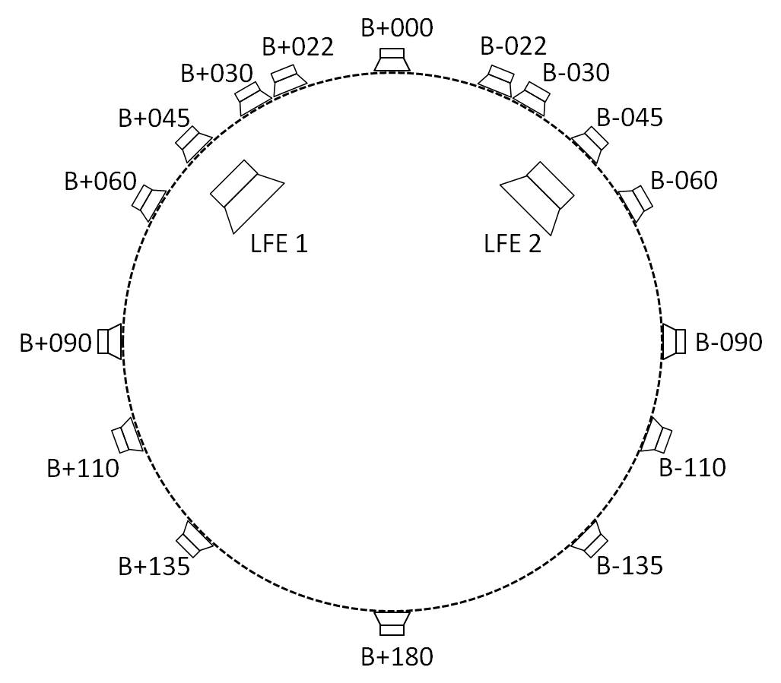
Middle layer  Same level as the listener | 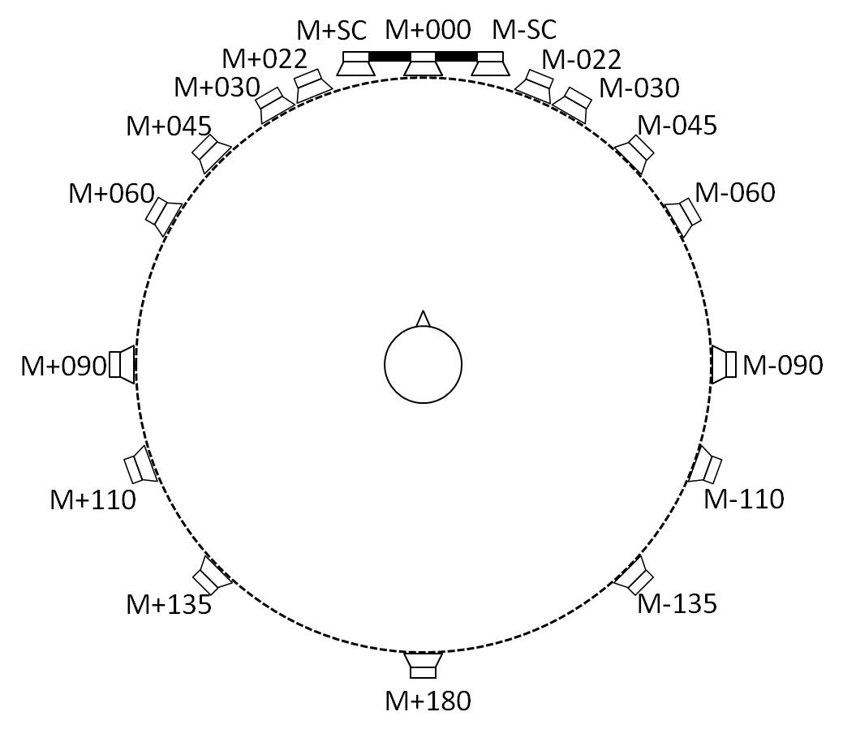
Upper layer  Includes overhead loudspeaker (T+000) | 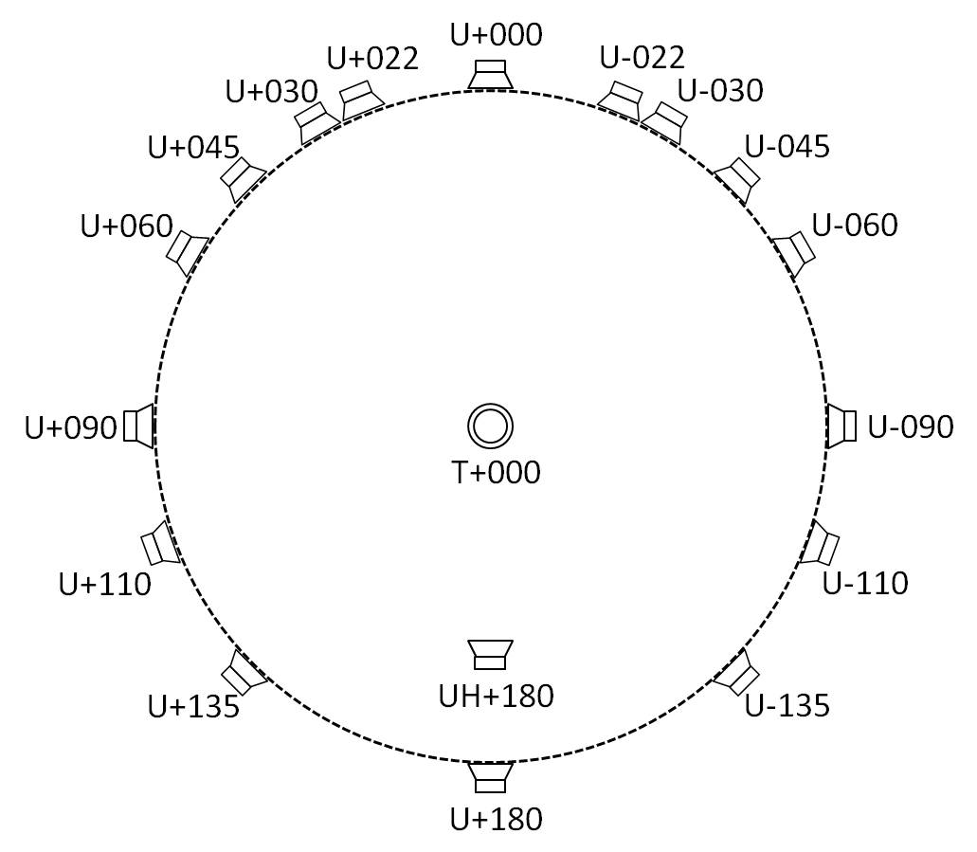

3.1 Loudspeaker positions in production environments
As various conditions may need to be considered for the practical design of loudspeaker set-ups in production studios such as room size, accompanying picture or other constraints, loudspeaker positions may have some azimuth angle and elevation angle variations. To ensure proper adaptation and rendering of channel-based elements, the loudspeaker positions used in the particular production environment should be stored as part of the metadata according to § 2. When the content is transferred to a different reproduction system/location, it should be ensured that the programme is adapted if necessary so that all quality requirements of the advanced sound system are met. The quality requirements are specified in Recommendation ITU-R BS.1909.
However, loudspeakers should be placed within the sectors defined by the azimuth and elevation range as given in Tables 3 to 12 to lessen the sound quality variations by loudspeaker positions differences. A pair of loudspeakers with a nominal azimuth whose magnitude is greater than 45 degrees should have positions that are perfectly symmetrical or symmetrical within 10 degrees for azimuth and elevation. Other pairs of loudspeakers should be perfectly symmetrical. Regardless of any asymmetry, actual loudspeaker positions should still be within the range specified. The notations “a .. b” in the Tables should be taken to mean the smaller of the two sectors that might be obtained by rotating clockwise or anti-clockwise between angle “a” and angle “b”.
TABLE 3
Loudspeaker configuration for Sound System A (0+2+0)
SP Label | Channel |  | Azimuth | Elevation
 | Label | Name | Range | Range
M+030 | L | Left | +30 | 0
M-030 | R | Right | –30 | 0

NOTE – This reproduction configuration should be used with audio-related metadata for productions of advanced sound programmes.
TABLE 4
Loudspeaker configuration for Sound System B (0+5+0)
(from Recommendation ITU-R BS.775)
SP Label | Channel |  | Azimuth | Elevation
 | Label | Name | Range | Range
M+030 | L | Left | +30 | 0
M-030 | R | Right | –30 | 0
M+000 | C | Centre | 0 | 0
LFE1 | LFE | Low frequency effects | – | –
M+110 | Ls | Left surround | +100 .. +120 | 0 .. +15
M-110 | Rs | Right surround | –100 .. –120 | 0 .. +15

NOTE – This reproduction configuration should be used with audio-related metadata for productions of advanced sound programmes.
TABLE 5
Loudspeaker configuration for Sound System C (2+5+0)
SP Label | Channel |  | Loudspeaker location, Polar
 |  |  | Azimuth | Elevation
 | Label | Name | Range | Range
M+030 | L | Left | +30 | 0
M-030 | R | Right | –30 | 0
M+000 | C | Centre | 0 | 0
LFE1 | LFE | Low frequency effects | – | –
M+110 | Ls | Left surround | +100 .. +120 | 0 .. +15
M-110 | Rs | Right surround | –100 .. –120 | 0 .. +15
U+030 | Ltf | Left top front | +30 .. +45 | +30 .. +55
U-030 | Rtf | Right top front | –30 .. –45 | +30 .. +55

TABLE 6
Loudspeaker configuration for Sound System D (4+5+0)
SP Label | Channel |  | Loudspeaker location, Polar
 |  |  | Azimuth | Elevation
 | Label | Name | Range | Range
M+030 | L | Left | +30 | 0
M-030 | R | Right | –30 | 0
M+000 | C | Centre | 0 | 0
LFE1 | LFE | Low frequency effects | – | –
M+110 | Ls | Left surround | +100 .. +120 | 0
M-110 | Rs | Right surround | –100 .. –120 | 0
U+030 | Ltf | Left top front | +30 .. +45 | +30 .. +55
U-030 | Rtf | Right top front | –30 .. –45 | +30 .. +55
U+110 | Ltr | Left top rear | +100 .. +135 | +30 .. +55
U-110 | Rtr | Right top rear | –100 .. –135 | +30 .. +55

TABLE 7
Loudspeaker configuration for Sound System E (4+5+1)
SP Label | Channel |  | Loudspeaker location, Polar
 |  |  | Azimuth | Elevation
 | Label | Name | Range | Range
M+030 | L | Left | +30 | 0
M-030 | R | Right | –30 | 0
M+000 | C | Centre | 0 | 0
LFE1 | LFE | Low frequency effects | – | –
M+110 | Ls | Left surround | +100 .. +120 | 0
M-110 | Rs | Right surround | –100 .. –120 | 0
U+030 | Ltf | Left top front | +30 .. +45 | +30 .. +55
U-030 | Rtf | Right top front | –30 .. –45 | +30 .. +55
U+110 | Ltr | Left top rear | +100 .. +135 | +30 .. +55
U-110 | Rtr | Right top rear | –100 .. –135 | +30 .. +55
B+000 | Cbf | Centre bottom front | 0 | –15 .. –30

TABLE 8
Loudspeaker configuration for Sound System F (3+7+0)
SP Label | Channel |  | Azimuth | Elevation
 | Label | Name | Range | Range
M+000 | C | Centre | 0 | 0
M+030 | L | Left | +30 | 0
M-030 | R | Right | –30 | 0
U+045 | LH | Left height | +30 .. +45 | +30 .. +45
U-045 | RH | Right height | –30 .. –45 | +30 .. +45
M+090 | LS | Left side | +60 .. +150 | 0
M-090 | RS | Right side | –60 .. –150 | 0
M+135 | LB | Left back | +60 .. +150 | 0
M-135 | RB | Right back | –60 .. –150 | 0
UH+180 | CH | Centre height | 180 | +45 .. +90
LFE1 | LFE1 | Left low frequency effects | +30 .. +90 | –15 .. –30
LFE2 | LFE2 | Right low frequency effects | –30 .. –90 | –15 .. –30
TABLE 9
Loudspeaker configuration for Sound System G (4+9+0)
SP Label | Channel |  | Loudspeaker location, Polar
 |  |  | Azimuth | Elevation
 | Label | Name | Range | Range
M+030 | L | Left | +30 .. +45 | 0
M-030 | R | Right | –30 .. –45 | 0
M+000 | C | Centre | 0 | 0
LFE1 | LFE | Low frequency effects | – | –
M+090 | Lss | Left side surround | +85 .. +110 | 0
M-090 | Rss | Right side surround | –85 .. –110 | 0
M+135 | Lrs | Left rear surround | +120 .. +150 | 0
M-135 | Rrs | Right rear surround | –120 .. –150 | 0
U+045 | Ltf | Left top front | +30 .. +45 | +30 .. +55
U-045 | Rtf | Right top front | –30 .. –45 | +30 .. +55
U+135 | Ltb | Left top back | +100 .. +150 | +30 .. +55
U-135 | Rtb | Right top back | –100 .. –150 | +30 .. +55
M+SC | Lsc | Left screen | Left screen edge | 0
M-SC | Rsc | Right screen | Right screen edge | 0

The angle α between two surround loudspeakers on the same side (i.e. left or right) should be in the range 30° ≤ α ≤ 60°, for the middle layer.

TABLE 10
Loudspeaker configuration for Sound System H (9+10+3)
SP Label | Channel |  | Azimuth | Elevation
 | Label | Name | Range | Range
M+060 | FL | Front left | +45 .. +60 | 0 .. +5
M-060 | FR | Front right | –45 .. –60 | 0 .. +5
M+000 | FC | Front centre | 0 | 0 .. +5
LFE1 | LFE1 | Low frequency effects-1 | +30 .. +90 | –15 .. –30
M+135 | BL | Back left | +110 .. +135 | 0 .. +15
M-135 | BR | Back right | –110 .. –135 | 0 .. +15
M+030 | FLc | Front left centre | +22.5 .. +30 | 0 .. +5
M-030 | FRc | Front right centre | –22.5 .. –30 | 0 .. +5
M+180 | BC | Back centre | +180 | 0 .. +15
LFE2 | LFE2 | Low frequency effects-2 | –30 .. –90 | –15 .. –30
M+090 | SiL | Side left | +90 | 0 .. +15
M-090 | SiR | Side right | –90 | 0 .. +15
U+045 | TpFL | Top front left | +45 .. +60 | +30 .. +45
U-045 | TpFR | Top front right | –45 .. –60 | +30 .. +45
U+000 | TpFC | Top front centre | 0 | +30 .. +45
T+000 | TpC | Top centre | – | +90
U+135 | TpBL | Top back left | +110 .. +135 | +30 .. +45
U-135 | TpBR | Top back right | –110 .. –135 | +30 .. +45
U+090 | TpSiL | Top side left | +90 | +30 .. +45
U-090 | TpSiR | Top side right | –90 | +30 .. +45
U+180 | TpBC | Top back centre | +180 | +30 .. +45
B+000 | BtFC | Bottom front centre | 0 | –15 .. –30
B+045 | BtFL | Bottom front left | +45 .. +60 | –15 .. –30
B-045 | BtFR | Bottom front right | –45 .. –60 | –15 .. –30

TABLE 11
Loudspeaker configuration for Sound System I (0+7+0)
SP Label | Channel |  | Azimuth | Elevation
 | Label | Name | Range | Range
M+030 | L | Left | +30 .. +45 | 0
M-030 | R | Right | –30 .. –45 | 0
M+000 | C | Centre | 0 | 0
LFE1 | LFE | Low frequency effects | – | –
M+090 | Lss | Left side surround | +85 .. +110 | 0
M-090 | Rss | Right side surround | –85 .. –110 | 0
M+135 | Lrs | Left rear surround | +120 .. +150 | 0
M-135 | Rrs | Right rear surround | –120 .. –150 | 0
The angle α between two surround loudspeakers on the same side (i.e. left or right) should be in the range 30° ≤ α ≤ 60°, for the middle layer.

TABLE 12
Loudspeaker configuration for Sound System J (4+7+0)
SP Label | Channel |  | Azimuth | Elevation
 | Label | Name | Range | Range
M+030 | L | Left | +30 .. +45 | 0
M-030 | R | Right | –30 .. –45 | 0
M+000 | C | Centre | 0 | 0
LFE1 | LFE | Low frequency effects | – | –
M+090 | Lss | Left side surround | +85 .. +110 | 0
M-090 | Rss | Right side surround | –85 .. –110 | 0
M+135 | Lrs | Left rear surround | +120 .. +150 | 0
M-135 | Rrs | Right rear surround | –120 .. –150 | 0
U+045 | Ltf | Left top front | +30 .. +45 | +30 .. +55
U-045 | Rtf | Right top front | –30 .. –45 | +30 .. +55
U+135 | Ltb | Left top back | +100 .. +150 | +30 .. +55
U-135 | Rtb | Right top back | –100 .. –150 | +30 .. +55
The angle α between two surround loudspeakers on the same side (i.e. left or right) should be in the range 30° ≤ α ≤ 60°, for the middle layer.

The loudspeaker layouts shown in Tables 3 to 12 are illustrated in Table 13.

TABLE 13
Loudspeaker layouts for advanced sound system
Sound system | Upper layer | Middle layer | Bottom layer
A (0+2+0) |  | 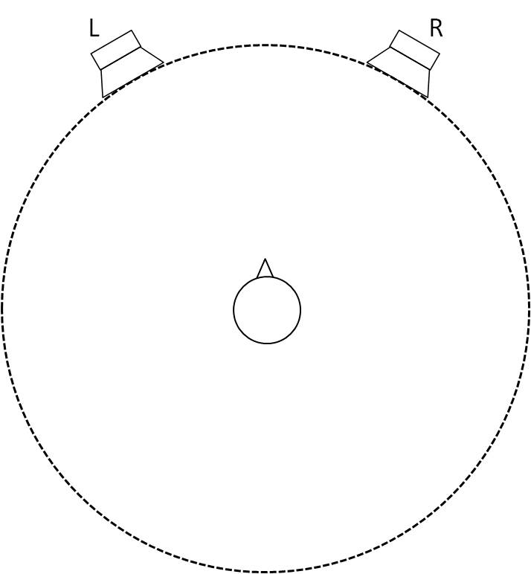
Upper layer
0/0/0 (Note)
Middle layer
2/0/0
Bottom layer
0/0/0
B (0+5+0) |  | 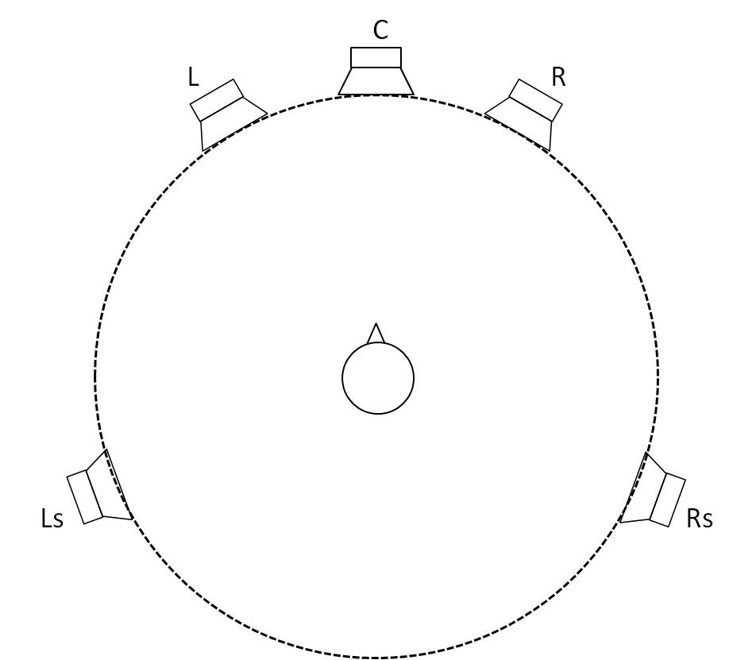 | 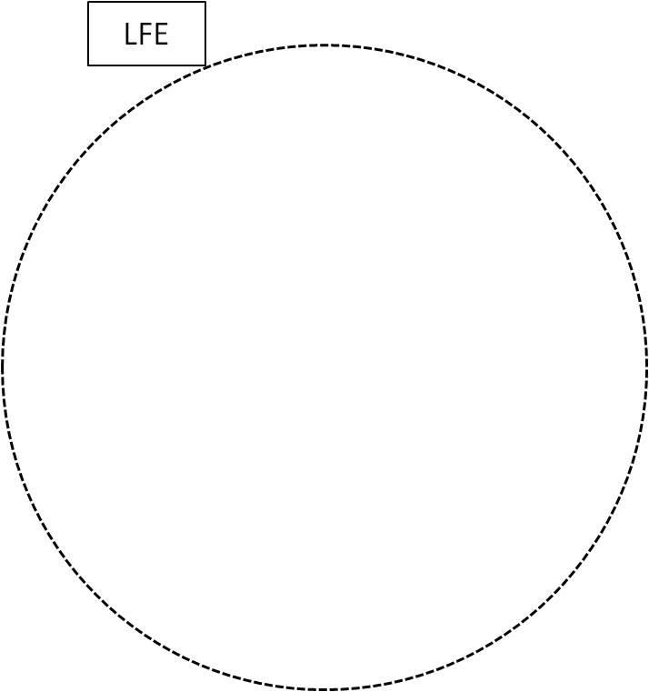
Upper layer
0/0/0
Middle layer
3/0/2
Bottom layer
0/0/0.1
C (2+5+0) | 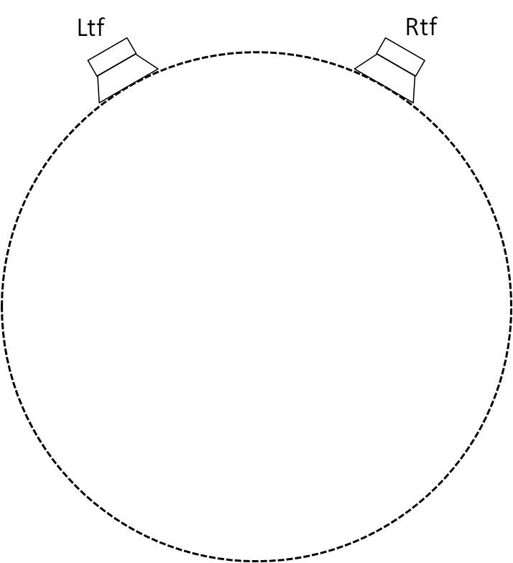
Upper layer
2/0/0
Middle layer
3/0/2
Bottom layer
0/0/0.1
D (4+5+0) | 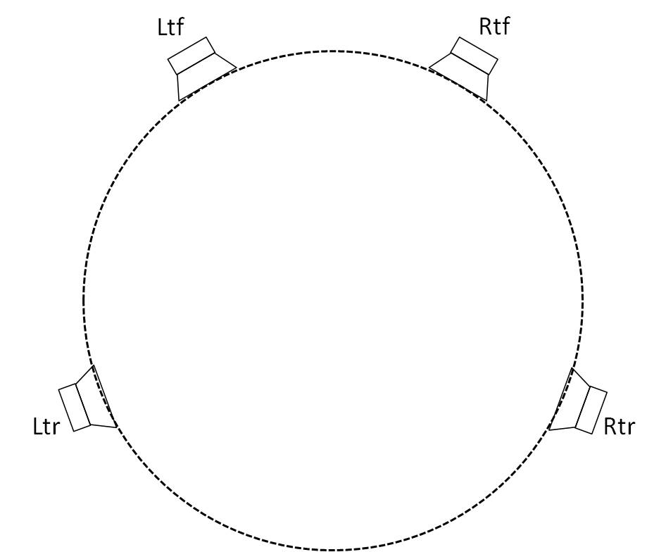
Upper layer
2/0/2
Middle layer
3/0/2
Bottom layer
0/0/0.1

TABLE 13 (continued)
Sound system | Upper layer | Middle layer | Bottom layer
E (4+5+1) |  |  | 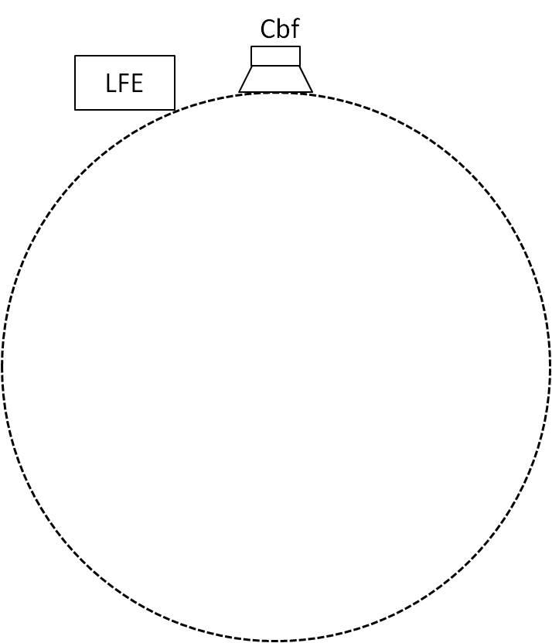
Upper layer
2/0/2
Middle layer
3/0/2
Bottom layer
1/0/0.1
F (3+7+0) | 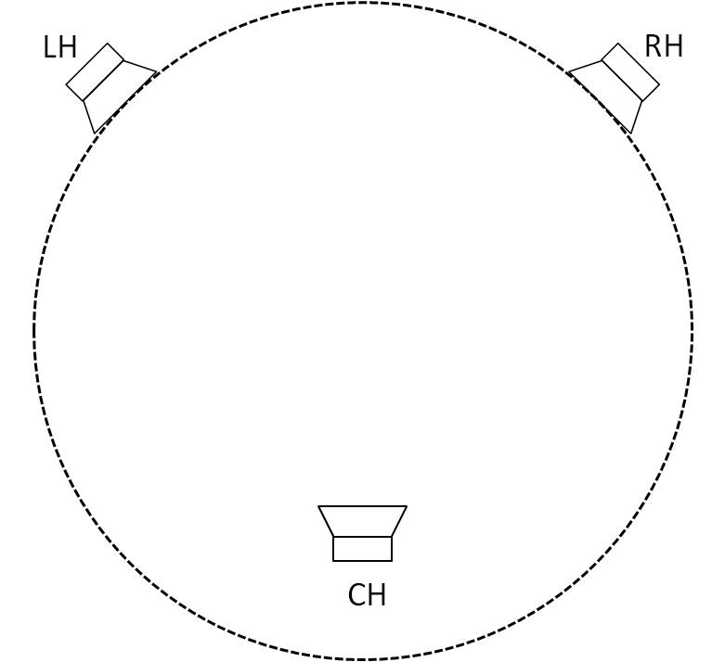 | 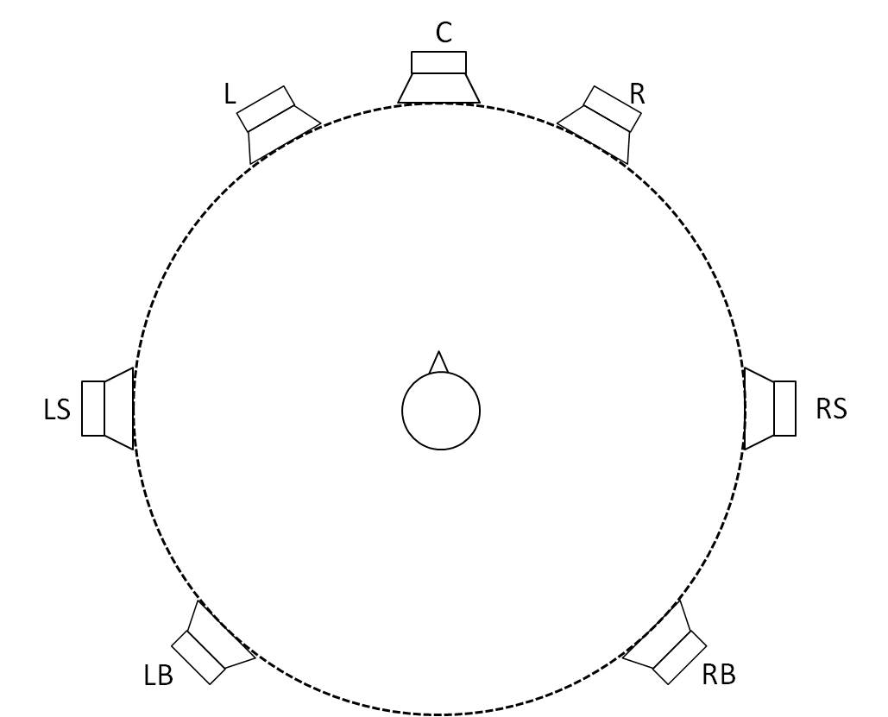 | 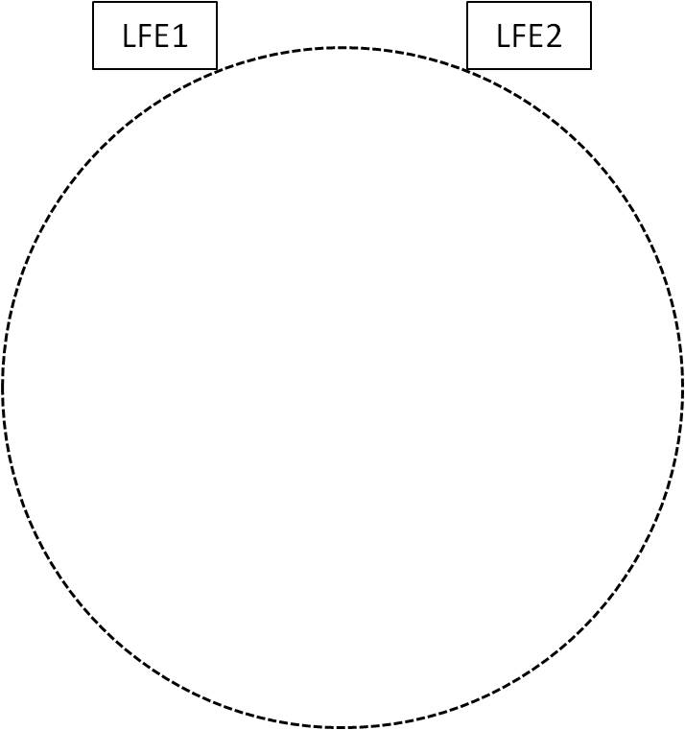
Upper layer
2/0/1
Middle layer
3/2/2
Bottom layer
0/0/0.2
G (4+9+0) | 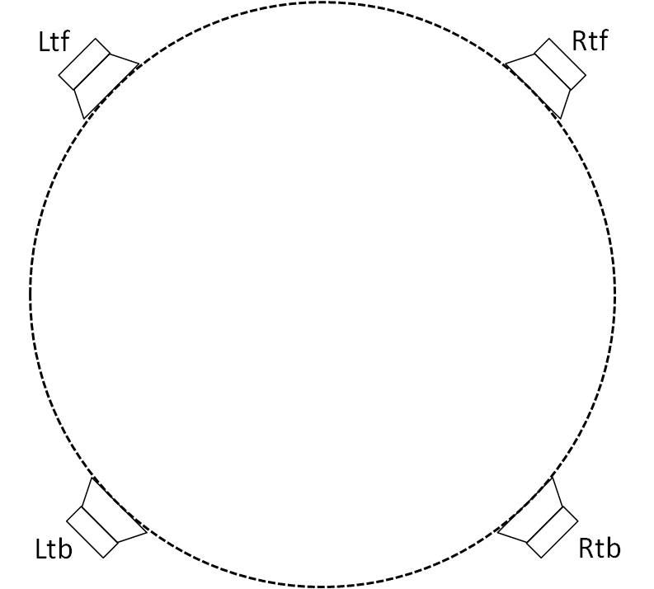 | 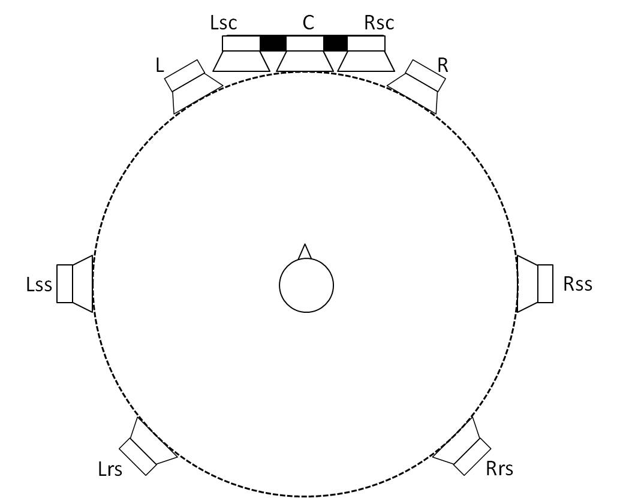
Upper layer
2/0/2
Middle layer
5/2/2
Bottom layer 0/0/0.1
H (9+10+3) | 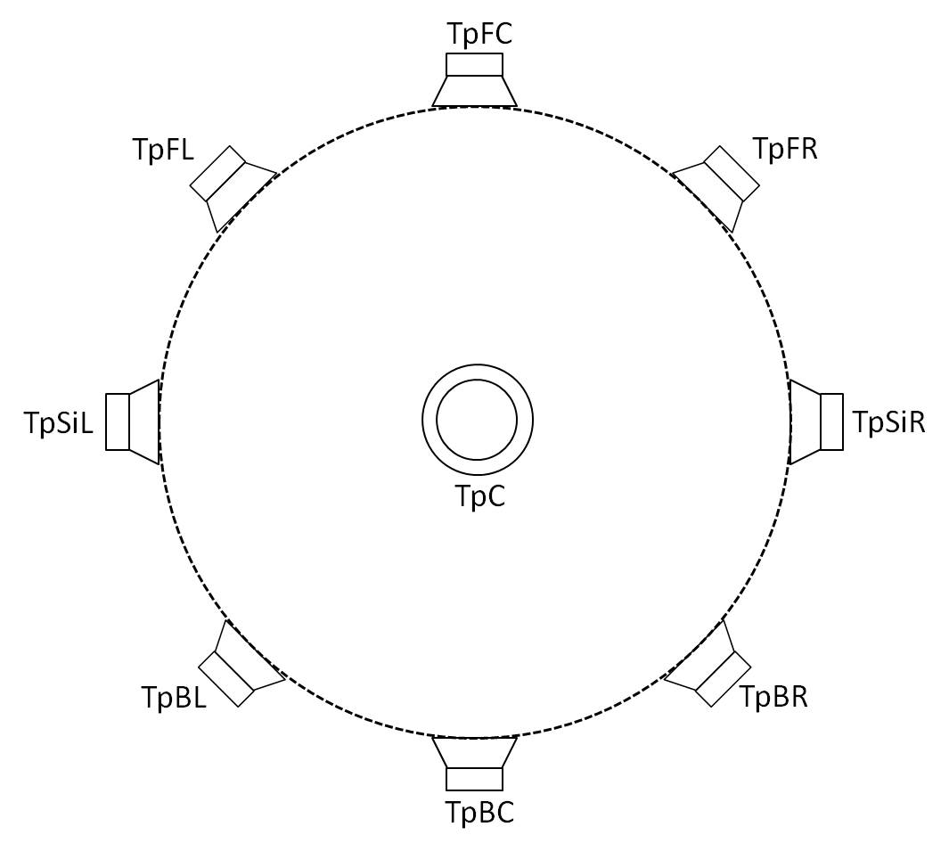 | 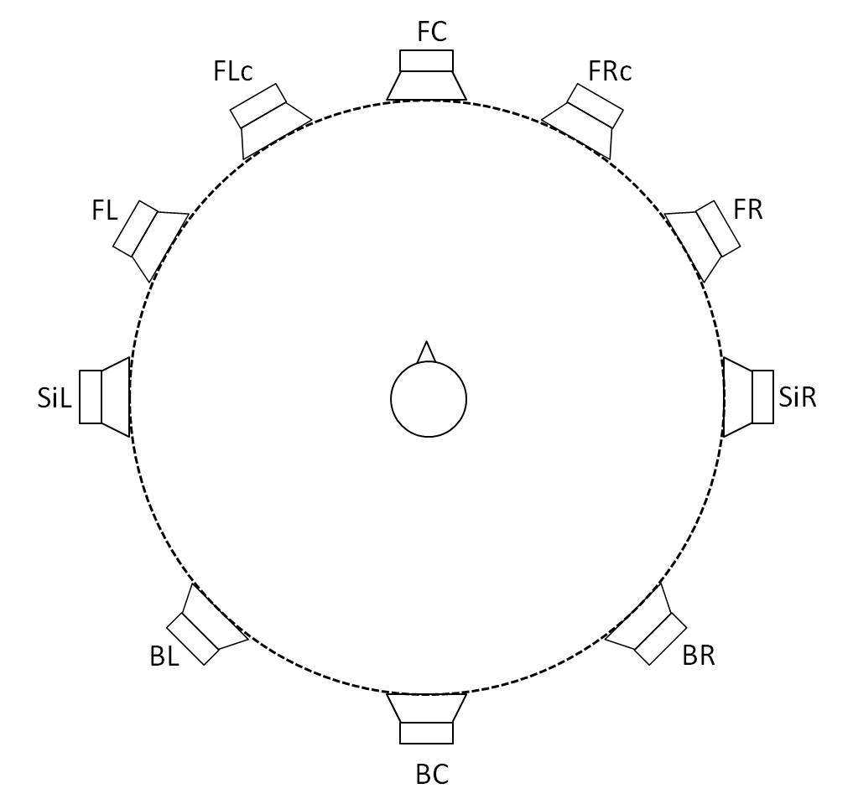 | 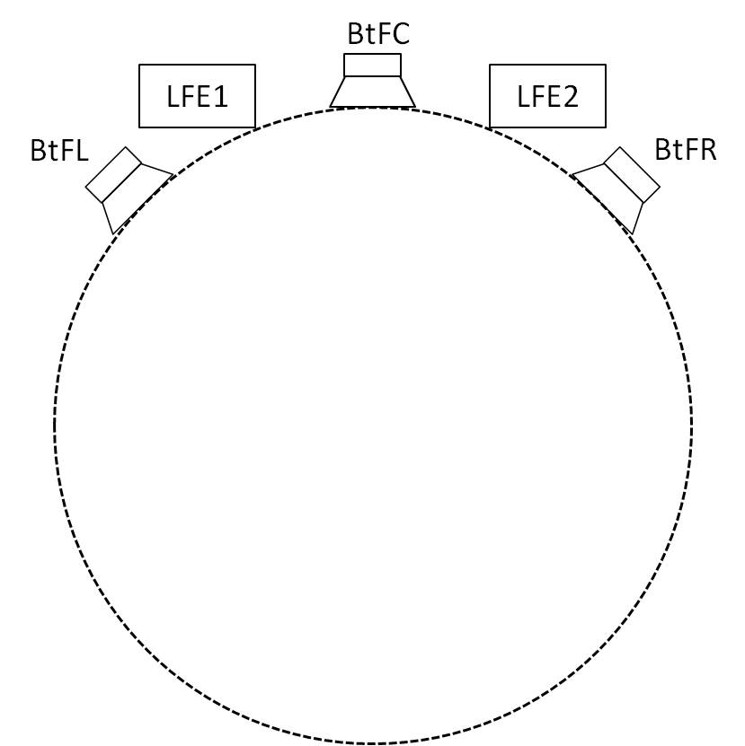
Upper layer
3/3/3
Middle layer
5/2/3
Bottom layer
3/0/0.2
TABLE 13 (end)
Sound system | Upper layer | Middle layer | Bottom layer
I (0+7+0) |  | 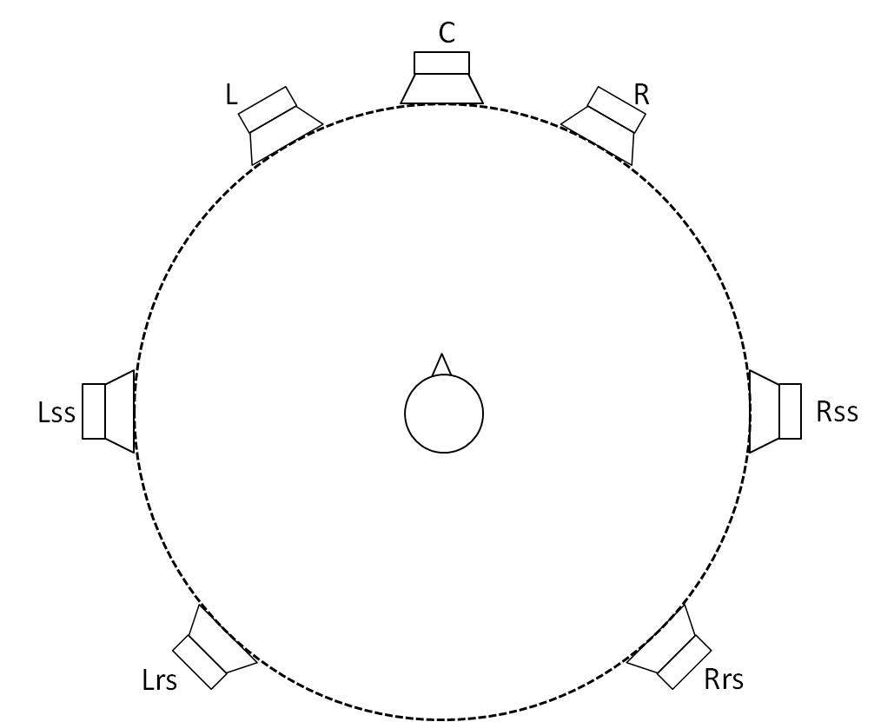
Upper layer
0/0/0
Middle layer
3/2/2
Bottom layer 0/0/0.1
J (4+7+0)
Upper layer
2/0/2
Middle layer
3/2/2
Bottom layer 0/0/0.1
NOTE – X/Y/Z.LFE identifies the number of front/side/rear (plus LFE) loudspeakers in each layer.

4 Headphone playback of advanced sound system productions
Considering the wide and growing usage of headphones, it is clear that content produced for advanced sound systems should also be usable for headphones. Some programmes are even produced only for headphone playback. Hence, the content producer should also be able to monitor the programme via headphones.
Table 14 defines the output configuration for headphone playback as system Z (headphones), with speaker labels for left and right headphone drivers. Table 14 uses the same format as Table 1 for the loudspeaker configurations, although the azimuth and elevation parameters do not apply to the case of headphones.
TABLE 14
Identification and labels for Sound System Z (headphones)
SP Label | Channel |  | Azimuth | Elevation | Z
 | Label | Name |  |  | Headphones
HP_L | HPL | Headphone  left ear | N/A | N/A | X
HP_R | HPR | Headphone  right ear | N/A | N/A | X

NOTE – This reproduction configuration should be used with audio-related metadata for productions of advanced sound programmes.

Attachment 1
to Annex 1
(informative)
Sound programme production and background of advanced sound system
In the process of mixing, a number of elements that depend on the nature of the production and signal acquisition process, typically determined by the audio engineer, are reduced to a representation of the creator intent, keeping only a reduced number of elements separate. The difference in production between a channel-based, object-based, scene-based and approaches which combine them is the method of mixing for the pre and final mixes. The channel-based approach means mixing all the elements into a predefined set of channels, whereas the hybrid channel-based + object-based approach allows the objects to be either mixed into channels or kept as separate objects. Similarly, in the hybrid scene-based + object-based approach the elements are either stored in a scene-based format (e.g. HOA) or kept as separate objects. In a pure object-based approach, all elements to recreate a certain experience are kept separate.
Existing production, live mixing and the post-production workflow of channel-based systems are the same as the hybrid model of channel-based stem-mix and objects. The delivery format of the final mix is different between the channel-based model and the hybrid model which delivers channel-based stem-mix signals and object signals.
Figure 1
Figure 2 shows how an example of a typical broadcast chain could look for an advanced sound system. The production can use any type of audio source and content, but it should be fully annotated with the correct metadata to describe the audio signals, and this is stored in a file format that can support this metadata.
The distribution stage will adapt the representations from production into a more compact representation which will retain or generate new metadata to allow further rendering. The distribution file or stream is then passed to the broadcast stage which will render it towards a particular broadcast format. Higher bandwidth broadcasts will allow to deliver and rendering many object and channels, whereas low bandwidth broadcasts may have to render down to more traditional stereo formats. The broadcast format should retain as much of the metadata as required for the receiver end.
Each receiver device will have its own renderer designed for the loudspeaker layouts possible for that device. For example, a Hi-fi will need something very flexible to allow multiple loudspeakers to have different placements, whereas a TV will have its internal loudspeakers fixed in known positions. Future content delivery will potentially receive a representation, which will maintain full flexibility for user interaction or personalization.
FIGURE 2

Attachment 2
to Annex 1
(informative)
Audio – Visual Spatial Alignment
As described in Recommendation ITU-R BS.775, image displays for television viewing vary in size, and are frequently narrower than the defined angular spacing between the main left and right loudspeakers (e.g. M+030 and M-030). As a result of this inconsistent relationship between sound and picture display width, audio and visual images cannot be reliably aligned.
Object-based audio systems can overcome this issue by describing the object location relative to the screen. Using metadata that describes the screen location, an object renderer can appropriately render screen-referenced objects to the available loudspeakers such that the audio and associated visual elements are spatially aligned.
A similar capability in the horizontal dimension can be achieved with a pure channel-based audio programme if screen-based audio elements are authored and distributed using a screen channel pair (Lsc and Rsc). In principle, the screen channels are played back using a loudspeaker pair at the left and right edge of the screen (M+SC and M-SC). In practice, the screen channel pair (Lsc and Rsc) can be rendered using existing loudspeakers (e.g. M+030, M+000, and M-030): if the screen is large and spans the space between M+030 and M-030, the Lsc and Rsc channels can be summed into the L and R channels for playback; if the screen is smaller, as is often the case in domestic use, the Lsc and Rsc channels can be panned appropriately (depending on screen size) between the L and C, and C and R channels, respectively, and then routed to the appropriate loudspeakers. While a domestic system would often not include screen loudspeakers, a production environment may choose to include screen loudspeakers for screen channel playback during content creation and validation.

∗ Radiocommunication Study Group 6 made editorial amendments to this Recommendation in the year 2019 in accordance with Resolution ITU-R 1.
An audio element is considered to be a signal with metadata which is either static for the duration of a programme or is dynamic. This enables the delivery of channel-based, object-based and scene-based content.

