RECOMMENDATION ITU-R BO.1784
Digital satellite broadcasting system with flexible configuration
(television, sound and data)
(Question ITU-R 3/6)

(2007)

Scope
This Recommendation is intended for the digital broadcasting-satellite service (BSS), when high flexibility in the system configuration and broadcasting interactivity is of importance allowing for a wide-ranging trade-off between operation under minimal C/N levels or maximum transmission capacity.
The ITU Radiocommunication Assembly,
considering
a) that the digital multiprogramme television systems for use by satellites have been developed in Recommendations ITU-R BO.1408 and ITU-R BO.1516, which are referred to as the current systems;
b) that recent developments in the field of channel coding and modulation have produced new techniques with performances approaching the Shannon limit;
c) that these new digital techniques would offer better spectrum and/or power efficiency, in comparison to the current systems, whilst maintaining the possibility to be flexibly configured to cope with the specific satellite bandwidth and power resources;
d) that the recommended system makes use of such techniques and thus allows for a wide-ranging trade-off between operation under minimal C/N levels or maximum transmission capacity, achieving appreciable gain over DVB-S (System A in Recommendation ITU-R BO.1516) depending on the selected DVB-S2 mode;
e) that the recommended system was developed to cover not only broadcasting, but also interactivity and contribution applications, such as contribution TV links and digital satellite news gathering (DSNG);
f) that a system covering all these application areas while keeping the single-chip decoder at reasonable complexity levels, would enable the reuse of the development for the mass market products for contribution or niche applications;
g) that the new adaptive coding and modulation (ACM) technique offered by the recommended system would allow a more efficient spectrum utilization for unicast applications in connection with a return path, through the optimization of the transmission parameters (i.e. modulation and coding) for each individual user, dependent on path conditions;
h) that the recommended system accommodates any input stream format, including single or multiple Motion Picture Experts Group (MPEG) Transport Streams (characterized by 188-byte packets), IP as well as asynchronous transfer mode (ATM) packets and continuous bit-streams;
j) that the recommended system would be capable to handle the variety of advanced audiovisual formats currently available and under definition,
further considering
a) that an ITU system Recommendation helps the market in establishing services based on standardized systems, thus avoiding the proliferation of proprietary developments, which is of benefit to both the end users and the industry in general;
b) that, in spite of the success of the current systems, a new specification to enable delivery of a significantly higher data rate in a given transponder bandwidth than the current systems are able to do, is appreciated by many satellite broadcasters, operators and manufacturers around the world;
c) that the requirement to offer high-definition television (HDTV) services will force broadcasters to look for more efficient methods of carrying these services within the existing transponders;
d) that the inherent flexibility of the recommended system would provide means to alleviate the influence of the atmospheric attenuations at the higher broadcasting-satellite service (BSS) bands (such as the 17 GHz and the 21 GHz BSS bands), which are intended to be used for HDTV services;
e) that the recommended system comprises backwards-compatible modes, allowing existing BSS receivers to continue working,
recommends
1 that the DVB-S2 system specified in ETSI EN 302 307 V 1.1.2: http://www.itu.int/ITU-R/study-groups/docs/rsg6-etsi/index.html (see Attachment 1) may be considered as a suitable system for the development of a system for satellite broadcasting with flexible configuration.
NOTE 1 – A description of the recommended system (System E) is provided in Annex 1, while Annex 2 contains comparison tables which list the recommended system (System E) along with the systems contained in Recommendation ITU-R BO.1516 (Systems A, B, C, D).

Annex 1
Main characteristics of the DVB-S2 system (referred to as System E)
DVB-S2 is the second-generation specification for satellite broadband applications developed by the DVB (Digital Video Broadcasting) Project in 2003 and became ETSI standard EN 302 307 in 2004.
EN 302 307 specifies framing structure, channel coding and modulation for different types of satellite applications:
– broadcasting of standard definition and high-definition TV (SDTV and HDTV);
– interactivity (including Internet access) for satellite broadcasting applications (for integrated receivers-decoders (IRDs) and personal computers);
– contribution applications, such as digital TV contribution, distribution and news gathering;
– data content distribution and internet trunking.
To be able to cover all the application areas while still keeping the single-chip decoder at reasonable complexity levels, DVB-S2 is structured as a tool-kit, thus enabling the use of mass market products also for contribution or niche applications.
The DVB-S2 system has been specified around three concepts: best transmission performance, approaching Shannon limit, total flexibility and reasonable receiver complexity.
To achieve the best performance-complexity trade-off, achieving an appreciable capacity gain over DVB-S for conventional broadcast applications, DVB-S2 benefits from more recent developments in channel coding and modulation: low-density parity check (LDPC) codes are adopted combined with quadrature phase shift keying (QPSK), 8-PSK, 16-APSK (amplitude and phase shift keying) and 32-APSK modulations, for the system to properly work on the non-linear satellite channel.
Framing structure allows maximum flexibility for a versatile system and synchronization also in worst-case configurations (low signal-to-noise ratios, SNR).
For interactive point-to-point applications such as IP unicasting in connection with a return path, the adoption of the ACM functionality allows to optimize the transmission parameters for each individual user on a frame-by-frame basis, dependant on path conditions, under closed-loop control via the return channel (connecting the receiver to the DVB-S2 uplink station via terrestrial or satellite links, signalling the receiver reception condition). This results in a further increase of the spectrum utilization efficiency of DVB-S2 over DVB-S, allowing the optimization of the space segment design, thus making possible a drastic reduction of the cost of satellite-based IP services.
DVB-S2 is so flexible that it can cope with any existing satellite transponder characteristics, with a large variety of spectrum efficiencies and associated SNR requirements. Furthermore it is designed to handle the variety of advanced audio-video formats currently under definition by the international bodies. DVB-S2 accommodates any input stream format, including single or multiple MPEG Transport Streams (characterized by 188-byte packets), IP as well as ATM packets and continuous bit-streams.
Backwards-compatible modes are also available, allowing existing legacy IRDs to continue working.
The DVB-S2 system structure
The DVB-S2 system is composed of a sequence of functional blocks, as described in Fig. 1. Signal generation is based on two levels of framing structures:
– BBFRAME at baseband (BB) level, carrying a variety of signalling bits, to configure the receiver flexibly according to the application scenario;
– PLFRAME at physical layer (PL) level, carrying few highly-protected signalling bits, to provide robust synchronization and signalling at the physical layer.
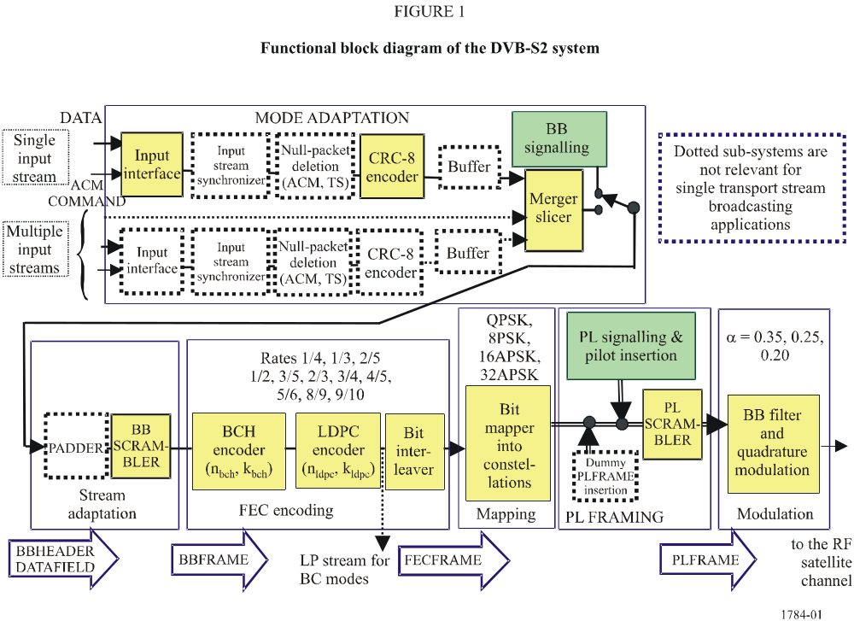
Depending on the application, DVB-S2 input sequences may be single or multiple MPEG transport streams (TS), single or multiple generic streams, either packetized or continuous. The block identified as Mode Adaptation provides input stream interfacing, input stream synchronization (optional), null-packet deletion (for ACM and transport stream input format only), CRC-8 coding for error detection at packet level in the receiver (for packetized input streams only), merging of input streams (for multiple input stream modes only) and slicing into data fields. A baseband header is then appended in front of the data field, to notify the receiver of the input stream format and Mode Adaptation type to notify the receiver of the input stream format and Mode Adaptation type: single or multiple input streams, generic or transport stream, constant coding and modulation (CCM) or ACM, and many other configuration details. Thanks to the forward error correction (FEC) protection (covering both the header and the data payload) and the wide length of the FEC frame, the baseband header can in fact contain many signalling bits without losing transmission efficiency or ruggedness against noise. It should be noted that the MPEG multiplex transport packets may be asynchronously mapped to the baseband frames.
Stream Adaptation is then applied, to provide padding in case the user data available for transmission are not sufficient to completely fill a BBFRAME, and baseband scrambling.
Forward error correction (FEC) encoding carries out the concatenation of BCH (Bose-Chaudhuri-Hochquenghem) outer code and low density parity check (LDPC) inner codes (rates 1/4, 1/3, 2/5, 1/2, 3/5, 2/3, 3/4, 4/5, 5/6, 8/9, 9/10). Depending on the application area, the FEC coded blocks (FEC frames) can have a length of 64 800 or 16 200 bits. When variable coding and modulation (VCM) or ACM are used, FEC and modulation mode are constant within a frame but may be changed in different frames; furthermore, the transmitted signal can contain a mix of normal and short code blocks. For backwards-compatible modes, the bit-stream at the output of the FEC encoder is further processed together with the DVB-S signal according to a specified procedure. Bit interleaving is then applied to FEC coded bits for 8-PSK, 16-APSK and 32-APSK to separate bits mapped onto the same transmission signal.
Mapping can be chosen among QPSK, 8-PSK, 16-APSK and 32-APSK constellations (see Fig. 2), depending on the application area. QPSK and 8-PSK are typically proposed for broadcast applications, since they are virtually constant envelope modulations and can be used in non-linear satellite transponders driven near saturation. The 16-APSK and 32-APSK modes, mainly targeted to contribution applications, can also be used for broadcasting, but these require a higher level of available C/N and the adoption of advanced pre-distortion methods in the uplink station to minimize the effect of transponder non-linearity. Whilst these modes are not as power efficient as the other modes, the spectrum efficiency is much greater. The 16-APSK and 32-APSK constellations have been optimized to operate over a non-linear transponder by placing the points on circles. Nevertheless their performances on a linear channel are comparable with those of 16-QAM and 32-QAM respectively.
By selecting the modulation constellation and code rates, spectrum efficiencies from 0.5 to 4.5 bits per symbol are available and can be chosen dependant on the capabilities and restrictions of the satellite transponder used.

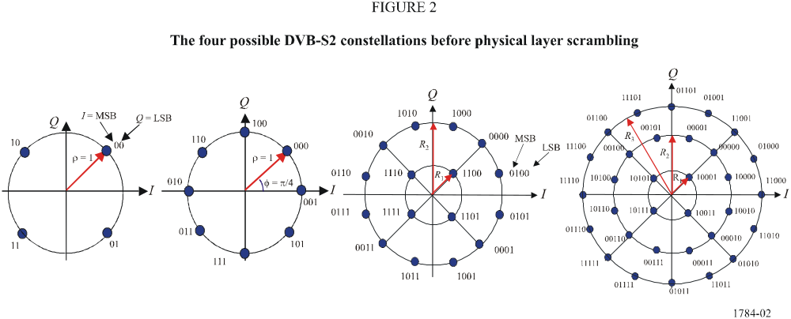
Physical layer framing has been designed to provide robust synchronization and signalling at the physical layer. Thus a receiver may synchronize (carrier and phase recovery, frame synchronization) and detect the modulation and coding parameters before demodulation and FEC decoding. The DVB-S2 physical layer signal is composed of a regular sequence of frames (see Fig. 3): within a frame, the modulation and coding scheme is homogeneous, but may change (in the adaptive coding and modulation configuration) in adjacent frames. Every frame is composed of a payload of 64 800 bits in the “normal frame” configuration, 16 200 bits in the “short frame” one, corresponding to an FEC code block. A header of 90 binary modulation symbols precedes the payload, containing synchronization and signalling information, to allow a receiver to synchronize (carrier and phase recovery, frame synchronization) and detect the modulation and coding parameters before demodulation and FEC decoding.
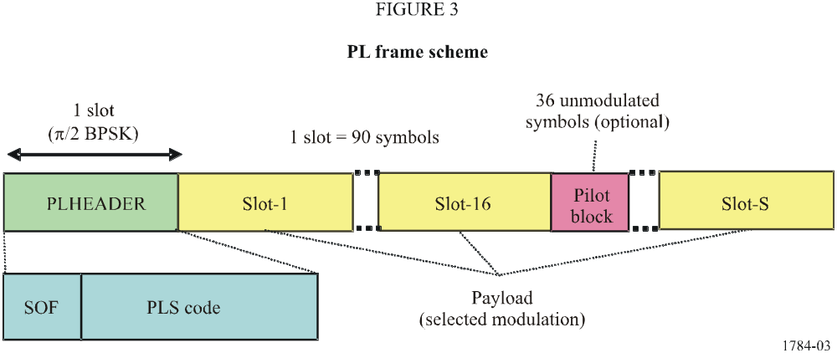

The first 26 binary symbols (the sequence 18D2E82_{HEX}) of the PL header identify the start of the PL frame (SOF, Start Of Frame), the remaining 64 symbols are used for signalling the system configuration. Since the PL header is the first entity to be decoded by the receiver, it could not be protected by the FEC scheme (i.e. BCH and LDPC). On the other hand, it had to be perfectly decodable under the worst-case link conditions (SNR of about −2.5 dB). Therefore, to minimally affect the global spectrum efficiency, the signalling information at this level has been reduced to 7 bits, 5 of which are used to indicate the modulation and coding configuration (MODCOD field), 1 for frame length (64 800 or 16 200 bits), 1 for presence/absence of pilots to facilitate receiver synchronization (as explained below). These bits are then highly protected by an interleaved first-order Reed-Muller block code with parameter rates (64, 7, t = 32), suitable for soft-decision correlation decoding.
Independently from the modulation scheme of the PLFRAME payload (FEC code block), the 90 binary symbols forming the PL header are π/2-BPSK modulated; this variant of the classical BPSK constellation introduces a π/4 rotation on even symbols and −π/4 on odd symbols, thus allowing a reduction of the radio-frequency signal envelope fluctuations.
The PL frame payload is composed of a different number of modulated symbols depending on the FEC length (64 800 or 16 200 bits) and the modulation constellation, but (excluding the optional pilots) the payload length is always a multiple of a slot of 90 symbols (see Fig. 3), thus showing periodicities which can be exploited by the frame synchronizer in the receiver: once the current PL header has been decoded, the decoder knows exactly the PL frame length and thus the position of the following SOF.
PL framing also provides for:
– optional dummy PL frame insertion, when no useful data is ready to be sent on the channel, and
– the insertion of optional pilots to facilitate receiver synchronization.
The DVB-S2 FEC codes are in fact so powerful that carrier recovery may become a serious problem for high-order modulations working at low SNRs in the presence of high levels of phase noise in satellite broadcasting low noise block (LNB) converters and tuners: this is particularly the case with some low-rate 8-PSK, 16-APSK and 32-APSK modes of DVB-S2. Pilots are unmodulated symbols, identified by I = Q = 1/√2, grouped in blocks of 36 symbols and inserted every 16 payload slots, thus giving a maximum capacity loss of approximately 2.4% when used.
Finally, scrambling for energy dispersal is carried out to comply with the Radio Regulations for spectrum occupancy and to transmit a sort of “signature” of the service operator, for a rapid identification in case of errors in the uplink procedures.
Baseband filtering and quadrature modulation is then applied, to shape the signal spectrum and to generate the RF signal. Square-root raised cosine filtering is used at the transmit side, with a choice of three roll-off factors: 0.35, 0.25 and 0.20, depending on the bandwidth restrictions.
Backwards-compatible modes
The large number of current BSS receivers (Recommendation ITU-R BO.1516) already installed makes it very difficult for many established broadcasters to think of an abrupt change of technology in favour of DVB-S2, especially where there is a receiver subsidy and for free-to-air public services. In such scenarios, backwards-compatibility may be required in the migration period, allowing legacy receivers to continue operating, while providing additional capacity and services to new, advanced receivers. At the end of the migration process, when the complete receiver population has migrated to DVB-S2, the transmitted signal could be modified to the non-backwards compatible mode, thus exploiting the full potential of DVB-S2.
Optional backwards-compatible (BC) modes have therefore been defined in DVB-S2, intended to send two transport streams on a single satellite channel. The first (high priority, HP) is compatible with DVB-S receivers (according to Recommendation ITU-R BO.1211) as well as with DVB-S2 receivers, while the second (low priority, LP) stream is compatible with DVB-S2 receivers only.
Backwards-compatibility can be optionally implemented according to two approaches:
– layered modulations, where a DVB-S2 signal and a DVB-S signal are asynchronously combined on the radio-frequency channel (therefore this operational mode does not require any specific tool in the DVB-S2 specification);
– hierarchical modulation, where the two HP and LP transport streams are synchronously combined at modulation symbol level on a non-uniform 8-PSK constellation (see Fig. 4).
NOTE 1 – Also other non-DVB broadcast systems (i.e. systems defined in Recommendation ITU-R BO.1516) based on QPSK may transmit a DVB-S2 LP stream, using the aforementioned hierarchical and layered modulation schemes.
In the hierarchical modulation approach, according to Fig. 5, the LP DVB-S2 compliant signal is BCH and LDPC-encoded, with LDPC code rates 1/4, 1/3, 1/2 or 3/5. Then the hierarchical mapper generates the non-uniform 8-PSK constellation: the two HP DVB-S bits define a QPSK constellation point (receivable by any conventional DVB-S IRD), while the single bit from the DVB-S2 LDPC encoder sets an additional rotation ±θ before transmission (producing a small degradation on DVB-S IRD performance, depending on the θ amplitude).
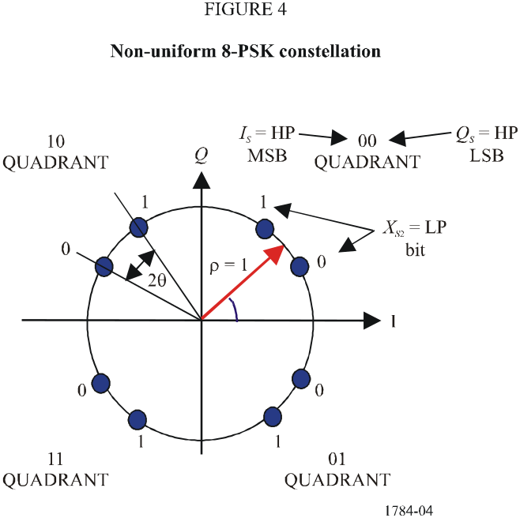

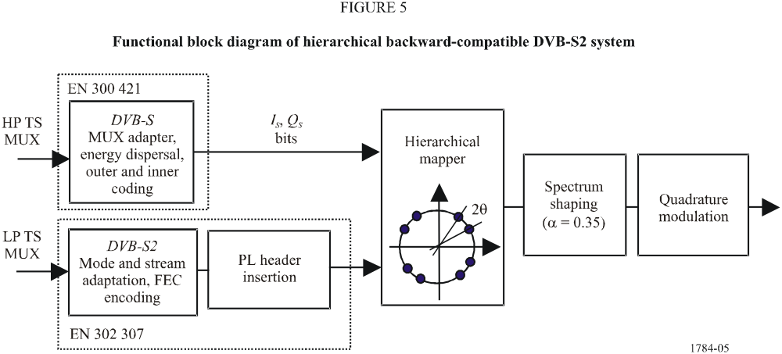

Analytically, the signal at the output of the hierarchical modulator can be written as:
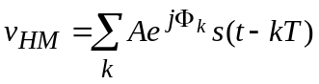
where the discrete phase Φ_{k} takes values in the range 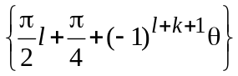for l = 3Q_{S} − 2I_{S} Q_{S} + I_{S} (four possible values 0, 1, 2, 3), Q_{S} and I_{S} defined in Fig. 4 and k = X_{S2} (two possible values 0, 1). Q_{S}, I_{S} and X_{S2} are defined in Fig. 4.
Since the resulting signal has a quasi-constant envelope, it can be transmitted in a single transponder driven near saturation.
Appendix 1 to this Annex contains some practical tests results for information.
Appendix 1
to Annex 1
Laboratory test results on DVB-S2 equipment
In order to verify the performance of DVB-S2, extensive laboratory tests have been carried out by Rai-CRIT on DVB-S2 equipment provided by seven different manufacturers in June 2006. The tests included AWGN performance, non-linear channel and phase noise degradation. The results clearly indicate that the equipment performance is in line with the simulation results presented in the DVB-S2 standard.
Single carrier and multicarrier configuration have been implemented and compared to DVB-S equivalent configurations, showing that DVB-S2 can offer excellent gains both in terms of capacity or performance and in terms of flexibility. Furthermore VCM and ACM configurations have been implemented, and the equipment capability verified.
Finally, it is to be noted that the equipment under test showed excellent interoperability performance.

1 Main test results
AWGN test
Measurements have been carried out on the AWGN channel respectively for QPSK, 8-PSK, 16-APSK and 32-APSK to assess the system performance both for the normal and for the short FECFRAME configuration. The symbol rate was of 27.5 MBd, except for 32-APSK where it was 20 MBd, and the roll-off 35%. The average results obtained in the measurements show that implementation losses, calculated as the ΔE_{s}/N₀@PER = 10⁻⁷ with respect to the simulation results indicated in Table 13 of EN 302 307, are in the range of 0.2 to 0.6 dB for QPSK, 0.2 to 0.9 dB for 8-PSK, 0.3 to 1.3 dB for 16-APSK, and 1.3 to 1.7 dB for 32-APSK.
SAT test
On the non-linear satellite channel, the laboratory test results confirm the simulation results as reported in Table H.1 of EN 302 307. The optimum operating point is 0 dB input back-off (IBO) for QPSK1/2, corresponding to an output back-off (OBO) of 0.3 dB, and giving a performance degradation of about 0.5 dB with respect to the AWGN channel. For 8-PSK the optimum operating point is 1 dB IBO, corresponding to an OBO of 0.4 dB, and giving a performance degradation of about 0.6 dB. For 16-APSK the optimum operating point is 4 dB IBO, corresponding to an OBO of 1.6 dB, and giving a performance degradation of about 3.0 dB. For 32-APSK the optimum operating point is 7 dB IBO, corresponding to an OBO of 3.2 dB, and giving a performance degradation of about 5.4 dB. If pilots are inserted in the transmitted signal, the performance improves by about 0.3 dB for 8-PSK and 1.0 dB for 16-APSK.
Additional tests have been carried out using signal precorrection in the modulator to reduce the non-linear effects on the demodulated signal and allow the system to work closer to the saturation point, also for higher order modulations, i.e. 16- and 32-APSK. For 16-APSK rate 3/4, the use of precorrection in the modulator allows the system to operate optimally at saturation, with a decrease of the satellite OBO of about 1.3 dB and a performance loss with respect to AWGN channel of about 1.5 dB, i.e. allowing a gain in performance with respect to the non-precorrected signal of about 1.5 dB.
Comparative examples of DVB-S and DVB-S2 for broadcast applications have been investigated, according to the following configurations:

TABLE 1
Comparative DVB-S/DVB-S2 scenarios for broadcast applications
System | DVB-S | DVB-S2 | DVB-S | DVB-S2
Channel bandwidth BW (MHz) | 36 | 36 | 36 | 36
Modulation and coding | QPSK 2/3 | QPSK 3/4 | QPSK 7/8 | 8-PSK 2/3
Roll-off α | 0.35 | 0.20 | 0.35 | 0.25
Symbol-rate (MBd) = 1.03*BW/(1 + α) | 27.5 | 30.9 | 27.5 | 29.7
C/N (in 27.5 MHz) (dB) | 4.7 | 4.9 | 7.6 | 7.6
Useful bit-rate (Mbit/s) | 33.8 | 46 (gain = 34%) | 44.4 | 58.8 (gain = 32%)

The satellite channel includes the travelling wave tube amplifier (TWTA) and output multiplex (OMUX) filter.
The results in Table 1 indicate that at the expense of a marginal increase of the C/N requirements (0 to 0.2 dB), the DVB-S2 system allows to increase the transmitted capacity dependent upon the mode, to up to and beyond 30%.
Phase noise test
Two different configurations have been considered for the phase noise tests:
– A contribution scenario, with a symbol rate of the transmitted signal of 5 MBd and the satellite amplifier operating in linearity.
– A satellite broadcasting scenario, with a symbol rate of the transmitted signal of 27.5 MBd and the satellite amplifier operating at the optimum back-off.
Results obtained for the contribution scenario indicate that the degradation introduced by the LNB phase noise is in the order of 0.3 dB for QPSK and 8-PSK, 1.2 dB for 16-APSK and 32-APSK. Furthermore pilots are not required for QPSK, while they start to be beneficial for 8-PSK; 16-APSK and 32-APSK need pilots to give good results.
The satellite broadcasting type scenario, with a larger symbol rate, is instead much less critical with respect to phase noise. The results indicate that the degradation introduced by the LNB phase noise is negligible for QPSK even without pilots, in the order of 0.1 dB for 8-PSK and 0.3 dB for 16-APSK with the use of pilots.
VCM and ACM tests
VCM tests have been carried out, demonstrating the receivers’ capability to adapt to the change of the transmission configuration. A sequence of FECFRAMEs has been generated and stored on an arbitrary waveform generator. Noise was then inserted to give different values of signal-to-noise ratio. Provided that the signal-to-noise ratio was larger than the minimum requested by a specific modulation and coding, the receiver was able to decode the corresponding FEC frame.
Finally ACM functionality was tested, to investigate the receivers’ capability to estimate the experienced signal-to-noise ratio, and the corresponding adaptivity of the modulator to change the modulation and coding. The results show that in a point-to-point connection the equipment is able to follow the signal-to-noise ratio variations and to adapt correspondingly.

2 Conclusions
The tests carried out at Rai-CRIT laboratories demonstrate that the DVB-S2 equipment is in line with the performance predicted by computer simulations, and allow to gain an important insight on the characteristics of the sophisticated modulation, channel coding, framing and synchronization techniques of the DVB-S2 system. In spite of the fact that the equipment being tested represents a first generation of equipment, and consequently some improvement of the receiver algorithms is certainly expected which will offer further enhancement in the performance, as an average, the results indicate that DVB-S2 is an excellent system, not only on paper, but also in the real hardware.
Furthermore, comparison with the performance of DVB-S in operative configurations, indicates that DVB-S2 offers an appreciable gain in capacity in CCM configurations both in single carrier and in multiple carrier per transponder configuration.
Finally, tests have been carried out by coupling modulators and demodulators of different manufacturers with the results that the equipment shows excellent interoperability.

Annex 2
Comparison of the DVB-S2 system (System E) with the system for digital
multiprogramme television emissions by satellite defined in
Recommendation ITU-R BO.1516
Table 2 includes information on both core functions (common elements) as well as additional essential functions for the four systems of Recommendation ITU-R BO.1516 (Systems A, B, C and D) and compares them with information regarding DVB-S2, indicated as System E.
The Radiocommunication Assembly, in § 6.1.2 of Resolution ITU-R 1, states that: “When Recommendations provide information on various systems relating to one particular radio application, they should be based on criteria relevant to the application, and should include, where possible, an evaluation of the recommended systems, using those criteria.” Table 3 provides this evaluation. Performance criteria relevant to these systems were selected, and the associated parametric values or capabilities of each of these systems are provided.
TABLE 2
Summary characteristics of digital broadband systems by satellite
a) Function
 | System A | System B | System C | System D | System E
Delivered services | SDTV and HDTV, sound, data and interactive data applications | SDTV and HDTV, sound, data and interactive data applications | SDTV and HDTV, sound, data and interactive data applications | SDTV and HDTV, sound, data and interactive data applications | SDTV and HDTV, sound, data and interactive data applications⁽¹⁾
Input signal format | MPEG-TS | Modified MPEG-TS | MPEG-TS | MPEG-TS | MPEG-TS/generic stream (e.g. IP)
Multiple input signal capability | No | No | No | Yes, 8 maximum | Yes, 255 maximum
Rain fade survivability | Determined by transmitter power and inner code rate | Determined by transmitter power and inner code rate | Determined by transmitter power and inner code rate | Hierarchical transmission is available in addition to the transmitter power and inner code rate | For broadcasting: determined by transmitter power and inner code rate.  For one-to-one and interactive services adaptive coding and modulation is available in addition to the transmitter power and inner code rate
Mobile reception | Not available and for future consideration | Not available and for future consideration | Not available and for future consideration | Not available and for future consideration | Not available and for future consideration
Flexible assignment of services bit rate | Available | Available | Available | Available | Available

TABLE 2 (continued)
a) Function (end)
 | System A | System B | System C | System D | System E
Common receiver design with other receiver systems | Systems A, B, C and D are possible | Systems A, B, C and D are possible | Systems A, B, C and D are possible | Systems A, B, C and D are possible | Backwards-compatible options towards systems A, B, C and D are possible
Commonality with other media (i.e. terrestrial, cable, etc.) | MPEG-TS basis | MPEG-ES (elementary stream) basis | MPEG-TS basis | MPEG-TS basis | MPEG-TS basis
In service? | Yes | Yes | Yes | Yes | Yes
Broadcasting station equipment | Available on the market | Available on the market | Available on the market | Available on the market | Available on the market
b) Performance
 | System A | System B | System C | System D | System E
Net data rate  (transmissible rate without parity) | Symbol rate (Rs) is not fixed. The following net data rates result from an example Rs of 27.776 MBaud:  1/2: 23.754 Mbit/s  2/3: 31.672 Mbit/s  3/4: 35.631 Mbit/s  5/6: 39.590 Mbit/s  7/8: 41.570 Mbit/s | 1/2: 17.69 Mbit/s  2/3: 23.58 Mbit/s  6/7: 30.32 Mbit/s | 19.5 MBd 29.3 MBd  5/11: 16.4 Mbit/s 24.5 Mbit/s  1/2: 18.0 Mbit/s 27.0 Mbit/s  3/5: 21.6 Mbit/s 32.4 Mbit/s  2/3: 24.0 Mbit/s 36.0 Mbit/s  3/4: 27.0 Mbit/s 40.5 Mbit/s  4/5: 28.8 Mbit/s 43.2 Mbit/s  5/6: 30.0 Mbit/s 45.0 Mbit/s  7/8: 31.5 Mbit/s 47.2 Mbit/s | Up to 52.2 Mbit/s  (at a symbol rate of 28.86 MBd) | Symbol rate (Rs) is not fixed. The following net data rates result from an example Rs of 27.776 MBd, normal FEC frame length and no pilots:  QPSK 1/2: 27.467 Mbit/s  QPSK 3/4: 41.316 Mbit/s  8-PSK 2/3: 55.014 Mbit/s  16-APSK 3/4: 82.404 Mbit/s
Upward extensibility | Yes | Yes | Yes | Yes | Yes
HDTV capability | Yes | Yes | Yes | Yes | Yes
Selectable conditional access | Yes | Yes | Yes | Yes | Yes

TABLE 2 (continued)
c) Technical characteristics (transmission)
 | System A | System B | System C | System D | System E
Modulation scheme | QPSK | QPSK | QPSK | TC8-PSK/QPSK/BPSK | QPSK/8-PSK/16-APSK/  32-APSK
Symbol rate | Not specified | Fixed 20 MBd | Variable 19.5 and 29.3 MBd | Not specified  (e.g. 28.86 MBd) | Not specified
Necessary bandwidth (−3 dB) | Not specified | 24 MHz | 19.5 and 29.3 MHz | Not specified  (e.g. 28.86 MHz) | Not specified
Roll-off rate | 0.35 (raised cosine) | 0.2 (raised cosine) | 0.55 and 0.33  (4th order Butterworth filter) | 0.35 (raised cosine) | 0.35, 0.25, 0.2 (raised cosine)
Outer code | Reed Solomon (204, 188, T = 8) | Reed Solomon (146, 130,  T = 8) | Reed Solomon (204, 188, T = 8) | Reed Solomon (204, 188,  T = 8) | BCH (N, K, T ) with parameters different according to the inner coding and frame length configuration
Outer code generator | Reed Solomon (255, 239, T = 8) | Reed Solomon (255,239, T = 8) | Reed Solomon (255, 239, T = 8) | Reed Solomon (255, 239,  T = 8) | BCH (N, K, T ) with parameters different according to the inner coding and frame length configuration
Outer code generator polynomial | (x + α⁰)(x + α¹) ... (x + α15)  where α = 02_{h} | (x + α⁰)(x + α¹) ... (x + α¹⁵)  where α = 02_{h} | (x + α¹)(x + α²) ... (x + α¹⁶)  where α = 02_{h} | (x + α0)(x + α¹) ... (x + α¹⁵)  where α = 02_{h} | Different according to the inner coding and frame length configuration
Field generator polynomial | x⁸ + x⁴ + x³ + x² + 1 | x⁸ + x⁴ + x³ + x² + 1 | x⁸ + x⁴ + x³ + x² + 1 | x⁸ + x⁴ + x³ + x² + 1 | Different according to the inner coding and frame length configuration
Randomization for energy dispersal | PRBS:  1 + x¹⁴ + x¹⁵ | None | PRBS:  1 + x + x³ + x¹² + x¹⁶ truncated for a period of 4 894 bytes | PRBS: 1 + x¹⁴ ⁺ x¹⁵ | PRBS: 1 + x¹⁴ ⁺ x¹⁵

TABLE 2 (continued)
c) Technical characteristics (transmission) (continued)
 | System A | System B | System C | System D | System E
Loading sequence into pseudo random binary sequence (PRBS) register | 100101010000000 | Not Applicable | 0001_{h} | 100101010000000 | 100101010000000
Randomization point | Before RS encoder | Not Applicable | After RS encoder | After RS encoder | Before BCH encoder/ after bit mapping and optional pilot insertion
Interleaving between inner and outer codes | Convolutional,  I = 12, M = 17 (Forney) | Convolutional,  N1 = 13, N2 = 146 (Ramsey II) | Convolutional,  I = 12, M = 19 (Forney) | Block (depth = 8) | ⁽²⁾
Inner coding | Convolutional | Convolutional | Convolutional | Convolutional,  trellis (8-PSK: TCM 2/3) | LDPC
Constraint length | K = 7 | K = 7 | K = 7 | K = 7 | Not Applicable
Basic code | 1/2 | 1/2 | 1/3 | 1/2 | Not Applicable
Generator polynomial | 171, 133 (octal) | 171, 133 (octal) | 117, 135, 161 (octal) | 171, 133 (octal) | Not Applicable
Inner code block length | Not Applicable | Not Applicable | Not Applicable | Not Applicable | Normal FEC frame = 64 800 bits  Short FEC frame =  16 200 bits

TABLE 2 (continued)
c) Technical characteristics (transmission) (end)
 | System A | System B | System C | System D | System E
Inner coding rate | 1/2, 2/3, 3/4, 5/6, 7/8 | 1/2, 2/3, 6/7 | 1/2, 2/3, 3/4, 3/5, 4/5, 5/6, 5/11, 7/8 | 1/2, 3/4, 2/3, 5/6, 7/8 | QPSK: 1/4,1/3,2/5,1/2, 3/5, 2/3, 3/4, 4/5, 5/6,8/9,9/10  8-PSK: 3/5, 2/3, 3/4, 5/6, 8/9, 9/10  16-APSK: 2/3, 3/4, 4/5, 5/6, 8/9, 9/10  32-APSK: 3/4, 4/5, 5/6, 8/9, 9/10
Transmission control | None | None | None | TMCC | Baseband and physical layer framing structure; optional pilots
Frame structure | None | None | None | 48 slot/frame  8 frame/super frame | Normal FEC frame = 64 800 bits  Short FEC frame = 16 200 bits
Packet size (bytes) | 188 | 130 | 188 | 188 | 188 for MPEG-TS  Not specified for GS
Transport layer | MPEG-2 | Non-MPEG | MPEG-2 | MPEG-2 | Not specified
Satellite downlink frequency range (GHz) | Originally designed for 11/12, not excluding other satellite frequency ranges | Originally designed for 11/12, not excluding other satellite frequency ranges | Originally designed for 11/12 and 4 satellite frequency ranges | Originally designed for 11/12, not excluding other satellite frequency ranges | Designed for 11/12 and 17/21, not excluding other satellite frequency ranges

TABLE 2 (continued)
d) Technical characteristics (source coding)

 |  | System A | System B | System C | System D | System E
Video source coding | Syntax | MPEG-2 | MPEG-2 | MPEG-2 | MPEG-2 | MPEG-4 AVC  MPEG-2  generic
Video source coding | Levels | At least main level | At least main level | At least main level | Main and high level | Level-3 and 4
Video source coding | Profiles | At least main profile | At least main profile | At least main profile | Main profile | Main profile
Aspect ratios |  | 4:3 16:9 (2.12:1 optionally) | 4:3 16:9 | 4:3 16:9 | 4:3 16:9 | 4:3 16:9 (2.12:1 optionally)
Image supported formats |  | Not restricted,  Recommended:  720 × 576 704 × 576  544 × 576 480 × 576  352 × 576 352 × 288 | 720 × 480  704 × 480  544 × 480  480 × 480  352 × 480  352 × 240  720 × 1 280  1 280 × 1 024  1 920 × 1 080 | 720(704) × 576  720(704) × 480  528 × 480  528 × 576  352 × 480  352 × 576  352 × 288  352 × 240 | 1 920 × 1 080  1 440 × 1 080  1 280 × 720  720 × 480  544 × 480  480 × 480  352 × 240^{(1),}*  176 × 120^{(1),}*  (* for hierarchical transmission) | Recommended for  MPEG-2:  720 × 576 704 × 576  544 × 576 480 × 576  352 × 576 352 × 288  Recommended for MPEG-4 AVC:  720 × 480 640 × 480  544 × 480 480 × 480  352 × 480 352 × 240  1 920 × 1 080 1 440 × 1 080  1 280 × 1 080 960 × 1 080  1 280 × 720 960 × 720  640 × 720
Frame rates at monitor (per s) |  | 25 | 29.97 | 25 or 29.97 | 29.97 or 59.94 | 25 or 50, 24, 30 or 60

TABLE 2 (end)
d) Technical characteristics (source coding) (end)
 | System A | System B | System C | System D | System E
Audio source decoding | MPEG-2, Layers I and II | MPEG-1, Layer II; ATSC A/53 (AC3) | ATSC A/53 or MPEG-2  Layers I and II | MPEG-2 AAC | MPEG-1 Layer I, MPEG-1 Layer II or MPEG-2 Layer II backward-compatible audio
Service information | ETS 300 468 | System B | ATSC A/56 SCTE DVS/011 | ETS 300 468 | Supported
EPG | ETS 300 707 | System B | User selectable | User selectable | Supported
Teletext | Supported | Not specified | Not specified | User selectable | Supported
Subtitling | Supported | Supported | Supported | Supported | Supported
Closed caption | Not specified | Yes | Yes | Supported | Not specified
⁽¹⁾ Also applicable to news gathering, interactive services and other satellite applications.
⁽²⁾ Although System E does not use an interleaver between the inner and outer codes, there is a bit interleaver before the symbol mapper (except for QPSK).

TABLE 3
Comparison characteristics table
Modulation and coding |  | System A |  | System B |  | System C |  | System D |  | System E
Modulation modes supported individually and on the same carrier |  | QPSK |  | QPSK |  | QPSK |  | 8-PSK, QPSK, and BPSK |  | QPSK, 8-PSK, 16-APSK, 32-APSK
Performance (define quasi-error-free (QEF) required C/N (bit/s/Hz)) |  | Spectral efficiency⁽¹⁾ | C/N for QEF⁽¹⁾ | Spectral efficiency | C/N for QEF⁽²⁾ | Spectral efficiency⁽³⁾ | C/N for QEF⁽⁴⁾ | Spectral efficiency | C/N for QEF⁽⁵⁾ | Spectral efficiency⁽⁷⁾ | C/N for QEF⁽⁶⁾
Modes Inner code
BPSK Conv. | 1/2 | Not used |  | Not used |  | Not used |  | 0.35 | 0.2 | Not used
QPSK | 1/4 | Not used |  | Not used |  | Not used |  | Not used |  | 0.49 | −2.3
QPSK | 1/3 | Not used |  | Not used |  | Not used |  | Not used |  | 0.66 | −1.2
QPSK | 2/5 | Not used |  | Not used |  | Not used |  | Not used |  | 0.79 | −0.3
QPSK | 5/11 | Not used |  | Not used |  | 0.54/0.63 | 2.8/3.0 | Not used |  | Not used
QPSK | 1/2 | 0.72 | 4.1 | 0.74 | 3.8 | 0.59/0.69 | 3.3/3.5 | 0.7 | 3.2 | 0.99 | 1.0
QPSK | 3/5 | Not used |  | Not used |  | 0.71/0.83 | 4.5/4.7 |  |  | 1.19 | 2.2
QPSK | 2/3 | 0.96 | 5.8 | 0.98 | 5 | 0.79/0.92 | 5.1/5.3 | 0.94 | 4.9 | 1.32 | 3.1
QPSK | 3/4 | 1.08 | 6.8 | Not used |  | 0.89/1.04 | 6.0/6.2 | 1.06 | 5.9 | 1.49 | 4.0
QPSK | 4/5 | Not used |  | Not used |  | 0.95/1.11 | 6.6/6.8 | Not used |  | 1.59 | 4.7
QPSK | 5/6 | 1.2 | 7.8 | Not used |  | 0.99/1.15 | 7.0/7.2 | 1.18 | 6.8 | 1.65 | 5.2
QPSK | 6/7 | Not used |  | 1.26 | 7.6 | Not used |  | Not used |  | Not used
QPSK | 7/8 | 1.26 | 8.4 | Not used |  | 1.04/1.21 | 7.7/7.9 | 1.24 | 7.4 | Not used
QPSK | 8/9 | Not used |  | Not used |  | Not used |  | Not used |  | 1.77 | 6.2
QPSK | 9/10 | Not used |  | Not used |  | Not used |  | Not used |  | 1.79 | 6.4

TABLE 3 (continued)
Modulation and coding |  | System A | System B | System C | System D |  | System E
8-PSK Trellis |  | Not used | Not used | Not used | 1.4 | 8.4 | Not used
8-PSK | 3/5 | Not used | Not used | Not used | Not used |  | 1.78 | 5.5
8-PSK | 2/3 | Not used | Not used | Not used | Not used |  | 1.98 | 6.6
8-PSK | 3/4 | Not used | Not used | Not used | Not used |  | 2.23 | 7.9
8-PSK | 5/6 | Not used | Not used | Not used | Not used |  | 2.48 | 9.3
8-PSK | 8/9 | Not used | Not used | Not used | Not used |  | 2.65 | 10.7
8-PSK | 9/10 | Not used | Not used | Not used | Not used |  | 2.68 | 11.0
16-APSK | 2/3 | Not used | Not used | Not used | Not used |  | 2.64 | 9.0
16-APSK | 3/4 | Not used | Not used | Not used | Not used |  | 2.97 | 10.2
16-APSK | 4/5 | Not used | Not used | Not used | Not used |  | 3.17 | 11.0
16-APSK | 5/6 | Not used | Not used | Not used | Not used |  | 3.30 | 11.6
16-APSK | 8/9 | Not used | Not used | Not used | Not used |  | 3.52 | 12.9
16-APSK | 9/10 | Not used | Not used | Not used | Not used |  | 3.57 | 13.1
32-APSK | 3/4 | Not used | Not used | Not used | Not used |  | 3.70 | 12.7
32-APSK | 4/5 | Not used | Not used | Not used | Not used |  | 3.95 | 13.6
32-APSK | 5/6 | Not used | Not used | Not used | Not used |  | 4.12 | 14.3
32-APSK | 8/9 | Not used | Not used | Not used | Not used |  | 4.40 | 15.7
32-APSK | 9/10 | Not used | Not used | Not used | Not used |  | 4.46 | 16.0
Capable of hierarchical modulation control? |  | No | No | No | Yes |  | Yes, in the backwards-compatible option
Symbol rate characteristics |  | Continuously variable | Fixed, 20 MBd | Variable, 19.5 or 29.3 MBd | Continuously variable |  | Continuously variable

TABLE 3 (end)
Transport and multiplexing | System A | System B | System C | System D | System E
Packet length (bytes) | 188 | 130 | 188 | 188 | 188 for TS, user definable up to 64K for GS. Variable length packet streams, unpacketized streams or packet lengths exceeding 64K are possible, treated as continuous streams
Transport streams supported | MPEG-2 | System B | MPEG-2 | MPEG-2 | MPEG-2 and generic stream (GS)
Transport stream correspondence with satellite channels | One stream/channel | One stream/channel | One stream/channel | 1 to 8 streams/channel | 1 to 255 streams/channel
Support for statistical multiplex of video streams | No limitation within a transport stream | No limitation within a transport stream | No limitation within a transport stream | No limitation within a transport stream. Also, may be possible across transport streams within a satellite channel | No limitations within a transport stream.  No limitations for generic streams
TWTA: travelling wave tube amplifier
IMUX: input multiplex
OMUX: output multiplex
⁽¹⁾ At a BER < 10⁻¹⁰. The C/N values for System A refer to computer simulation results achieved on a hypothetical satellite chain, including IMUX, TWTA and OMUX, with modulation roll-off of 0.35. They are based on the assumption of soft-decision Viterbi decoding in the receiver. A bandwidth to symbol rate ratio of 1.28 has been adopted. The figures for C/N include a calculated degradation of 0.2 dB due to bandwidth limitations on IMUX and OMUX filters, 0.8 dB non-linear distortion on TWTA at saturation and 0.8 dB modem degradation. The figures apply to BER = 2 × 10−4 before RS (204,188), which corresponds to QEF at the RS coder output. Degradation due to interference is not taken into account.
⁽²⁾ At a BER of 1 × 10⁻¹².
⁽³⁾ As calculated by 2(R_{c})(188/204)/1.55 or 2(R_{c})(188/204)/1.33 for System C normal and truncated transmit spectral shaping, respectively, where Rc is the convolutional code rate.
⁽⁴⁾ Theoretical QPSK (2-bit per symbol) E_{s}/N₀, i.e. C/N as measured in baud rate bandwidth for normal and truncated spectral shaping, respectively. Does not include hardware implementation margin or satellite transponder loss margin.
⁽⁵⁾ These values were derived from computer simulations and regarded as theoretical values. The values apply to BER = 2 × 10⁻⁴ before RS (204, 188) with baud rate bandwidth (Nyquist bandwidth). Does not include hardware implementation margin or satellite transponder loss margin.
⁽⁶⁾ These values were derived from computer simulations, 50 LDPC fixed-point decoding iterations, perfect carrier and synchronization recovery, no phase noise, AWGN channel. FEC frame length is 64 800 bits. The values apply to PER = 10⁻⁷, where PER is the ratio, after forward error correction at the receiver, between the useful transport stream packets (188 bytes) affected by error and the totally received ones. Does not include hardware implementation margin or satellite transponder loss margin.
⁽⁷⁾ Defined as the useful bit rate per unit symbol rate without pilots.

ATTACHMENT 1

EN 302 307 V1.1.2

______________

The word “shall” in this ETSI standard should be considered as “should” in this ITU-R Recommendation.
Input sequences may be single or multiple TSs, single or multiple generic streams (packetized or continuous).
Data processing in DVB-S2 may produce variable transmission delay. This block allows to guarantee constant-bit-rate and constant end-to-end transmission delay for packetized input stream.
To reduce the information rate and increase the error protection in the modulator. The process allows null-packets reinsertion in the receiver in the exact place where they originally were.
Maximum symbol rate available for the 32-APSK configuration. Above 20 MBd, the equipment performance is for the time being not guaranteed, since the clock speed and/or the FPGA density do not allow to perform the required number of LDPC decoder iterations. It can be expected that improvements of FPGA technology could in the near future allow to cover at full performance extreme baud rates.

