Recommendation ITU-R BO.1504-1
(02/2026)
BO Series: Satellite delivery
Effective utilization of spectrum assigned to the broadcasting-satellite service (sound)

Foreword
The role of the Radiocommunication Sector is to ensure the rational, equitable, efficient and economical use of the radio-frequency spectrum by all radiocommunication services, including satellite services, and carry out studies without limit of frequency range on the basis of which Recommendations are adopted.
The regulatory and policy functions of the Radiocommunication Sector are performed by World and Regional Radiocommunication Conferences and Radiocommunication Assemblies supported by Study Groups.

INTELLECTUAL PROPERTY RIGHTS
ITU draws attention to the possibility that the practice or implementation of this Recommendation may involve the use of a claimed Intellectual Property Right. ITU takes no position concerning the evidence, validity or applicability of claimed Intellectual Property Rights, whether asserted by ITU members or others outside of the Recommendation development process.
As of the date of approval of this Recommendation, ITU had received notice of intellectual property, protected by patents, which may be required to implement this Recommendation. However, implementers are cautioned that this may not represent the latest information and are therefore strongly urged to consult the appropriate ITU-R patent information available at https://www.itu.int/en/ITU-R/study-groups/Pages/itu-r-patent-information.aspx.

Series of ITU-R Recommendations
(Also available online at https://www.itu.int/publ/R-REC/en)
Series | Title
BO | Satellite delivery
BR | Recording for production, archival and play-out; film for television
BS | Broadcasting service (sound)
BT | Broadcasting service (television)
F | Fixed service
M | Mobile, radiodetermination, amateur and related satellite services
P | Radio-wave propagation
RA | Radio astronomy
RS | Remote sensing systems
S | Fixed-satellite service
SA | Space applications and meteorology
SF | Frequency sharing and coordination between fixed-satellite and fixed service systems
SM | Spectrum management
SNG | Satellite news gathering
TF | Time signals and frequency standards emissions
V | Vocabulary and related subjects

Note: This ITU-R Recommendation was approved in English under the procedure detailed in Resolution ITU-R 1.

Electronic Publication
Geneva, 2026
© ITU 2026
All rights reserved. No part of this publication may be reproduced, by any means whatsoever, without written permission of ITU.

RECOMMENDATION ITU-R BO.1504-1
Effective utilization of spectrum assigned to the broadcasting-satellite service (sound)*
(2000-2026)
Scope
This Recommendation provides guidelines to allow the most efficient use of the spectrum/orbit resource allocated to broadcasting-satellite service (BSS) (sound) bands in the frequency range 1 400-2 700 MHz.
Keywords
Digital sound broadcasting, broadcasting-satellite service, BSS
The ITU Radiocommunication Assembly,
considering
a) that Resolution 528 (Rev.WRC-19) calls for the convening of a competent conference to plan the use of the bands allocated to the broadcasting-satellite service (BSS) (sound);
b) that it is necessary to conduct the appropriate technical studies in ITU-R in order to prepare for such a conference;
c) that the studies requested by Resolution 528 (Rev.WRC-19) are complex and require urgent answers,
further considering
a) the limited amount of available spectrum, the near omnidirectional nature of the receiving antennas, especially for vehicular reception, which translates into negligible spectrum reuse through orbital separation, the wide coverage area of typical systems and the limitation in satellite antenna directivity at these frequencies due to practical physical size limitations, all this contributing to a potential for considerable intra-service interference;
b) that various types of BSS (sound) will be implemented before such a conference is convened;
c) the diversity of technical characteristics for the systems so far notified to the Radiocommunication Bureau (BR);
d) that administrations wishing to implement BSS (sound) could benefit from a set of spectrum management guidelines to enhance the effective use of the spectrum and provide equitable access,
noting
a) that there is a need to share the spectrum with other co-primary services and that many of these have a low tolerance to external interference and this will make management of the spectrum difficult;
b) that BSS (sound) receivers may also have low tolerance to external interference, since the receiving antennas need to be typically omni-directional;
c) that Appendix 3 of the Radio Regulations (RR) indicates the levels of emissions in the spurious domain that space stations need to meet to avoid interference into passive services;
d) that the spectrum management of BSS (sound) is further complicated by the need to cater for both the satellite and complementary terrestrial sound broadcasting services,
recommends
1 that in the interim period prior to the holding of a World Radiocommunication Conference as per Resolution 528 (Rev.WRC-19), the guidelines set out in Annex 1 should be used by administrations planning to notify a BSS (sound) system in order to allow for the most efficient use of the spectrum/orbit resource and facilitate the management of the allocated BSS (sound) bands in the frequency range 1 400-2 700 MHz. The rationale for these guidelines can be found in Annex 2;
2 that the technical studies required in preparation for the conference continue as a matter of urgency, and the results be the subject of (a) further Recommendation(s).

Annex 1
Spectrum management guidelines for BSS (sound)
1 To the maximum extent possible, parameters should be chosen according to the values shown in Table 1 (see Notes 1 and 2).
TABLE 1
Maximum transmit antenna side-lobe gain relative to the maximum antenna gain | −30 dB ⁽¹⁾
Equivalent emissions in the out-of-band (OoB) domain in the adjacent channel relative to the in-channel power ⁽²⁾ | −27 dB
Adjacent channel selectivity at the receiver | 35 dB
⁽¹⁾ This value might be relaxed for side lobes directed towards areas where no BSS (sound) using the same frequency band is expected to be implemented.
⁽²⁾ The variability of the channel bandwidth among the different sound BSS systems was taken into account by considering the integration of the energy per unit bandwidth (4 kHz) of the interferer, over the extent of its channel bandwidth, over the overlapping portion of the bandwidth of the interfered-with signal (see Annex 2).

NOTE 1 – Table 1 was developed assuming a spread of maximum pfd of 10 dB among the various BSS (sound) systems considered (see Annex 2). A reduced spread would be preferable since homogeneity in received pfd levels is an important factor in increasing the spectrum efficiency as described in Annex 2. If a system is outside the assumed range of maximum pfd: −128 to −138 dB(W/(m² · 4 kHz)), tighter or more relaxed values than those appearing in the Table would need to be considered.
NOTE 2 – The values in Table 1 were established based on the following partitioning of the interference: 40% of the noise budget (equivalent to a 2.2 dB margin for interference) is set aside for the aggregate interference from: two co-channel interferers and two adjacent channel interferers each contributing for 10% of the noise budget (equivalent to 10 dB additional interference isolation) (see Annex 2).
2 Although first generation BSS (sound) system implementations may be aimed at wide coverage services due to satellite transmit antenna size limitations, narrower beam implementations should be considered as the preferred solution as the satellite technology develops. The use of narrower beams will enhance the prospect of more satellite systems operating over a given geographical area and permit greater frequency reuse especially if the antenna side lobes are well controlled thus increasing the possibility of greater access to the limited spectrum resource.

Annex 2
Rationale for the guidelines to secure maximum spectrum efficiency in the introduction of BSS (sound) in the frequency range 1-3 GHz
The required discrimination between different BSS (sound) emissions to allow maximum frequency reuse and spectrum occupancy can be derived from four key factors. These are: the satellite transmit antenna directivity, the satellite transponder spectrum regrowth performance, the receiver channel selectivity and the receiver antenna directivity. With respect to the last factor, such receiving antenna directivity is minimal if the service is to be provided to vehicle and portable receivers. This receiving antenna directivity will therefore be neglected in the following discussion. The discrimination values available from the three first factors are compared to the isolation requirement between the various BSS (sound) systems. Given the required isolation among BSS (sound) systems, general guidelines can be deduced from such comparison.

1 Variables related to BSS (sound) intra-service sharing
The BSS (sound) can rely on a limited number of means to maximize the efficiency and utilization of the frequency bands that were allocated to it by WARC-92 (40 MHz at 1.5 GHz, 50 MHz at 2.3 GHz and 120 MHz at 2.5 GHz). When a number of satellite broadcasting systems are used to provide the service, they can only rely on the following means to secure enough isolation to avoid mutual interference:
– very large satellite orbital separation so that the potentially interfering satellite is beyond the horizon in the service area of interest;
– satellite transmit antenna discrimination: this translates into the possibility of reusing the spectrum if the two service areas of interest are geographically separated by the required minimum distance, reckoned as off-axis angle at the satellite antenna;
– receiver channel selectivity: adequate receiver selectivity will allow different systems covering the same area or adjacent areas to operate on channels closely spaced in frequency due to the adjacent channel rejection provided at the receiver;
– RF spectrum mask for OoB domain levels from the satellite transponder: this will also give the possibility of using channels closely spaced in frequency to cover the same service area or adjacent areas resulting in better use of the spectrum. Such OoB domain levels, usually caused by satellite transponder spectrum regrowth, would be seen at the receiver as on-channel interference for which the receiver selectivity would be of no help in improving the situation.
Unlike in the case of many other satellite services, no discrimination can be assumed from the receiving antenna because, by nature, this antenna is to have minimum directivity since it is to be used in a portable environment and mobile environment where the vehicle can be moving in all directions. This antenna has to have a broad beamwidth to allow reception by mobile receivers and therefore cannot discriminate between satellites on a geostationary-satellite orbit (GSO) or any other orbit. More directional antennas could be used for fixed and portable reception, and even for mobile reception if a tracking system is provided but the case of the near omnidirectional antenna should dictate the service constraints. In fact, some BSS (sound) system proponents plan to rely on the use of this broad receiving antenna beamwidth to secure some transmit diversity from more than one satellite. This absence of directivity from the receiving antenna makes the process of maximizing the efficiency of the orbit/spectrum resource much simpler, as will be seen below.
In order to identify the isolation required between different BSS (sound) systems to operate in a spectrum efficient manner, some criteria have to be established. For the purpose of this exercise, it is assumed that the satellite reception is noise limited (which is quite realistic for satellite systems which are inherently power limited). The interference falling in each adjacent channel should not be allowed to represent more than 10% of the noise budget. Also, it is assumed that there would be a maximum of two other systems operating on the same frequency which would interfere with the wanted signal. Each of these co-channel interferers would not be allowed to contribute for more than 10% of the noise budget. This results in a 10 dB additional isolation requirement for each co-channel and adjacent channel interferer resulting in a total of 2.2 dB interference allowance to be included in the link budget.

2 Intra-system interference
The three BSS (sound) systems for which most technical details are available have been reviewed to establish a range of required isolation values. System parameters were taken from the ITU-R Special Publication on BSS (sound) currently being updated – “Terrestrial and satellite digital sound broadcasting to vehicular, portable and fixed receivers in the VHF/UHF bands”. Table 2 summarizes the process used to generate the isolation values needed between systems of the same kind to allow reuse of the spectrum.
TABLE 2
Total isolation requirement for intra-system interference
 | Systems ⁽¹⁾  Parameters | System B | System D | System E ⁽²⁾
 | Minimum required Eb/N0 (dB) | 3.3 | 2.7 | 2.6
 | System implementation margin (dB) | 1 | 0.5 | 0
 | Hardware implementation margin (dB) | 0.5 | 1.8 | 2
 | Degradation due to uplink (dB) | 0.4 | 0 | 0.1
 | Interference allowance (dB) | 2.2 | 2.2 | 2.2
 | Fade allowance (dB) | 5 | 9.7 | 8.1
 | Additional allowance to limit interference to 10% of the noise budget (dB) | 10 | 10 | 10
 | Total isolation requirement (dB) | 22.4 | 26.9 | 25.0
⁽¹⁾ The three systems used are described in Recommendation ITU-R BO.1130 (System C is used only for terrestrial broadcasting, broadcasting service (sound)).
⁽²⁾ Interference value of System E is selected for calculation in this Table only. This value should not be used for any other purpose.

These figures establish the discrimination required in order to allow frequency reuse for each of the systems considered assuming the worst-case reception condition where the interfering signal is line-of-sight (LoS) at the receiver while the wanted signal is faded to the point where the signal is received at threshold.
Since the satellite transmit antenna discrimination is the only means of securing such isolation, the antenna pattern needs to produce such level of discrimination at the smallest possible off-axis angle. In order to maximize frequency reuse, the satellite transmit antenna needs to provide side-lobe rejection equal or better than the above isolation numbers. It means that the side-lobe plateau usually defined in reference antenna patterns has to be lower than 26.9 dB relative to the antenna gain at the edge of the beam in the case of System D. This value translates into a side-lobe rejection requirement of some 30 dB relative to the maximum antenna gain (gain differential is taken as typically 3 dB between centre and edge of beam). As can be seen, the information on the satellite transmit antenna side-lobe rejection is critical and should be provided to ITU-R as part of the application for any new system for comparison with the required isolation values.

3 Inter-system interference
This section covers the more complex situation where different systems are in operation and interfere with each other. Table 3 was developed to identify the maximum pfd levels produced by the three BSS (sound) systems documented in the ITU-R Special Publication on BSS (sound) currently being updated so that any differential between these pfd levels can be taken into account to define the required isolation values to avoid mutual interference among these systems. Table 3 gives the maximum spectral pfd produced at the centre of the beam for each system. The values to be used in the establishment of the isolation factors are actually a measure of the spectral density of the signal over 4 kHz. As an indication and for the purpose of comparison, the values declared to ITU-R as part of systems proposals, as given in the currently proposed ITU-R Special Publication on BSS (sound), were included. These isolation factors assume that the two interfering systems would occupy the same equivalent spectrum bandwidth. If it is not the case, the isolation factor was corrected accordingly (i.e. if System X occupies only half of the bandwidth of System Y, the isolation figure of System Y interfered by X would need to be reduced by 3 dB whereas the isolation value in the reverse direction would not change since the reception of System X would see its full channel being interfered by the broader bandwidth of System Y).
TABLE 3
Table of mutual isolation factors among BSS (sound) systems (single entry)
Systems  Parameters | System B | System D | System E
Bandwidth (kHz) | 293 | 1 840 | 25 000
Useful bit rate per channel (kbit/s) | 256 | 1 584 | 7 078
Required Eb/N0 at BER = 1 × 10−4 (dB) | 7.2 | 1.87 | 24.9
Required downlink C/N0 (dB) | 61.3 | 67.0 | 73.4
Receive figure-of-merit (dB(K−1)) | −22.2 | −13.0 | −21.8
Fade margin (dB) | 5.0 | 9.7 | 8.1
LoS pfd at edge of beam (−3 dB) (dB(W/m²)) | −115.3 | −114.1 | −95.4
Maximum calculated spectral pfd  (dB(W/(m² ⋅ 4 kHz))) | −131.0 | −137.7 | −128.5
TABLE 3 (end)
Systems  Parameters | System B | System D | System E
System B (interfered with) | 22.4 | 20.1 | 27.4
System D (interfered with) | 29.2 | 26.9 | 34.2
System E (interfered with) | 20.0 | 17.7 | 25.0

A table of required discrimination values for the mutual interference among systems was developed from the intra-system discrimination values established in Table 2. These intra-system values actually appear (in bold) on the diagonal of the last rows of Table 3. This Table also includes all the inter-system isolation values based on the combination of these intra-system discrimination values and the differentials between the maximum required spectral pfds among all systems.
As can be seen from Table 3, the inhomogeneity between systems pfds' results in larger required discriminations, ranging from 17.7 dB for the interference from the lowest power system (System D) into the highest power system (System E), to a required isolation as large as 34.2 dB for the reversed interference case. Unfortunately, such required isolation which would result on some 37.2 dB discrimination when the antenna gain differential between edge-of-beam and centre-of-beam is considered (typically 3 dB) would put unrealistic constraints on the design of the satellite transmit antennas in the case of the higher power systems in order to meet such tight side-lobe performance. The only way by which such isolation requirement can be reduced would be by co-locating the two satellites so that the worst case occurring when the wanted signal is faded and the interfering signal is received in LoS would be avoided, thus bringing down the requirement to some 29.6 dB.
Another way to deal with this situation would be to use an adjacent channel rather than the same channel in the areas outside of the satellite antenna main lobe to take advantage of the additional discrimination provided by the receiver and the satellite transponder selectivity for the interfering system as will be explained in the next paragraph. This would, however, be wasteful of spectrum. In the case where only the satellite antenna discrimination can be relied upon, these systems would be unlikely to be useable on the same frequency on the same side of the Earth. Such a situation would lead to a very inefficient use of the spectrum/orbit resource and should be avoided. It should be noted that, in order to secure spectrum efficiency, the requirements for satellite antenna discrimination and transponder selectivity would be higher in the case of the higher power systems.

4 Channel selectivity
Spectrum efficiency can be improved by different BSS systems operating on different frequencies. Ideally, one should be able to receive, in the same location, various systems on adjacent channels so that the full bandwidth (40 MHz at 1.5 GHz, 50 MHz at 2.3 GHz and 120 MHz at 2.5 GHz) could be accessed in the same service area. There are two factors which dictate the discrimination that is possible between two adjacent channels: the receiver selectivity and the amount of spectrum spill-over into adjacent channels that is generated by the satellite transponder.

5 Receiver selectivity
This performance characteristic is measured on receivers using two adjacent channels modulated by the same type of signal. The differential between the two signals received at the receiver for which the receiver starts to show some perceptible degradation determines the receiver adjacent channel selectivity. For the satellite case, the levels used for these signals are close to the receiver threshold level. In the case of System D, the receiver selectivity was measured at 40 dB. This shows that the adjacent channel discrimination from the receivers is better than the discrimination that is typically available from the satellite transmit antenna side-lobe rejection (typically between 25 and 30 dB).

6 Satellite transponder OoB domain levels
Because of the extra cost and the weight that a channel filter placed at the output of the transponder would represent, it is common practice to avoid it and try to reduce the spectrum regrowth produced by the transponder by controlling its linearity and back-off. However, such spectrum regrowth control at the satellite is difficult to do and costly in terms of an effective level of e.i.r.p.. As an example, the typical spectrum side-lobe level for a non-filtered QPSK modulated signal is −13 dB relative to the main channel. Proper pulse shaping, prefiltering, linearization of the transponder and use of an appropriate output back-off (OBO) allows a reduction of such side lobes to the −20 dB to −35 dB range as can be seen in Fig. 1 in the case of a multi-carrier modulation. Higher rejection than 30 dB is expected to create excessive loss of transponder efficiency as can be seen in Fig. 2. It can therefore be concluded that the satellite transponder OoB domain levels will be the controlling factor in the case of adjacent channel interference.
figure 1
Typical RF spectrum regrowth for a multi-carrier modulation amplified by a typical transponder (computer simulation)
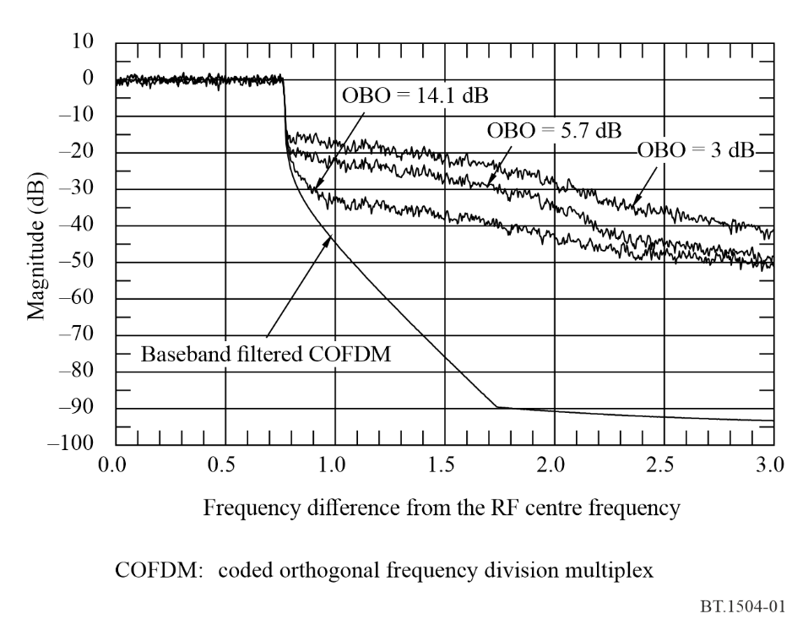
It is worth mentioning that, according to RR Appendix 3, the emissions in the spurious domain need to be limited at the edge of the frequency bands to protect the passive services. The limit used for space stations in RR Appendix 3 corresponds to some 34 dB rejection at a frequency equivalent to 250% of the channel bandwidth for a bandwidth of 1.5 MHz for emitted powers higher than 50 W. Although less constraining than the adjacent channel emission requirement, this gives an indication that the values are in the same range. ITU-R is considering rejection levels of 25 dB in the area of the first adjacent channel and 35 dB for the third adjacent channel onward.
Since adjacent channel OoB domain levels produced by the satellite fall within the channel of a receiver tuned to an adjacent channel, no rejection is possible in such case even though the receiver could discriminate the adjacent channel by a larger amount as seen above due to its IF channel filtering. It is therefore critical that the satellite transponder RF spectrum regrowth be controlled as tightly as possible.
figure 2
In-channel/out of channel ratio for single-carrier and multi-carrier modulation in a typical and perfectly linearized amplifiers
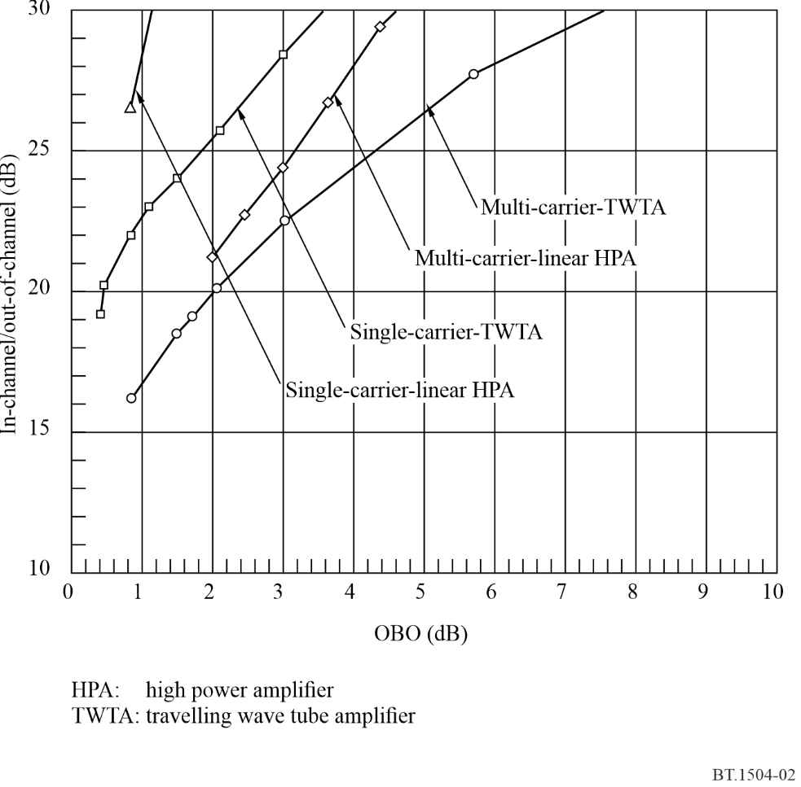
As a first approximation, such OoB domain levels can be assumed to be noise-like and therefore the discrimination values developed above for the co-channel case could be used (since such unwanted emissions would be received co-channel by a receiver tuned to the adjacent channel). In fact, the values indicated in Fig. 2 represent an integration of the interfering power within a bandwidth of 1.536 MHz and 1.84 MHz for the multi-carrier modulation and the single-carrier modulation (System D) respectively. The centre of this adjacent channel was assumed to be located at 1.736 MHz and 2.3 MHz for the respective systems.
The problem is, however, that this is part of a trade-off between transponder efficiency (or e.i.r.p.) and the level of OoB domain levels. This can be seen in Fig. 2 in the cases of a multi-carrier modulation and a single-carrier modulation (System D) going through a typical transponder and a perfectly linearized transponder. Higher rejection of OoB domain levels can be achieved with linearization of the satellite transponder and a small OBO in the case of a single-carrier constant envelope modulation and larger OOB domain levels in the case of multi-carrier. As can be seen from Fig. 2, the 27 dB required rejection value can be met for a relatively small amount of OOB domain levels in the case of a linearized HPA transmitting a single carrier modulation.
As can be seen in Table 2, the highest isolation value that would have to be provided in the case of a system interfering into itself is 26.9 dB. This would set the limit required for the adjacent channel side-lobe emission level. Much tighter restriction would be needed in some specific cases of different systems operating and interfering with each other (i.e. Systems B and E interfering into System D). If large values such as 34.2 dB discrimination are required, this could be achieved by the combination of geographically separated coverage areas and the use of adjacent channels, which would unfortunately be wasteful of the spectrum resource.

7 Coordination and planning procedures
The reason for the past tendency to plan broadcast bands has been, among other things, to avoid that some first-come systems would be implemented and would reduce the potential for the development of other systems by making an inefficient use of the resource. An attempt is made here at providing the means for maximizing the use of the spectrum resource.
In order to maximize the satellite e.i.r.p., a system proponent may try to saturate the transponder which will result in transmitting a large amount of energy outside its channel and preclude later implementation of other systems on these adjacent frequencies. If no care is taken in the implementation of initial systems in the BSS (sound), access to the spectrum/orbit resource by future systems may be reduced considerably. As a minimum, in order to secure the best use of the spectrum, any system should meet a carefully defined set of requirements in terms of OoB domain levels.
The means to make the best use of the spectrum resource by BSS (sound) can be identified as follows. First, a realistic but restricted range of system operational values has to be identified. Then, from this range, reference templates for the satellite transmit antenna side-lobe rejection, the satellite transponder OoB domain levels and a minimum receiver channel selectivity figure have to be developed.

8 Conclusions
Even before considering means to coordinate and plan the use of a common band for operation of a number of BSS (sound) systems, there are some general rules that should be developed and applied to secure an efficient use of the spectrum right from the start of deployment of the service. These are:
– the discrimination required between these systems should not be larger than the possible satellite antenna side-lobe rejection (typically 30 dB);
– the satellite transponder OoB domain levels in the adjacent channel relative to the main channel should not be higher than the isolation required between the various systems to be implemented (i.e. from 22.4 dB to 26.9 dB for intra-system interference and 17.7 dB to 34.2 dB for inter-system interference) to allow adjacent channel operation (of course, the receiver selectivity should provide for better discrimination than the satellite transponder OoB domain levels in order not to become predominant and therefore restrictive (i.e. 35 dB));
– any inhomogeneity between the systems used, in particular in their maximum pfd, should be avoided since it exacerbates the discrimination requirements. There is therefore a need to reduce the range of pfds generated by the various systems;
– the discrimination requirements from the satellite transmit antenna side-lobe rejection and the transponder OoB domain levels would tend to be more demanding in the case of the higher power systems since they are the ones producing the most interference.

* This Recommendation deals only with BSS (sound) intra-service sharing.

