Recommendation ITU-R BO.1130-5
(02/2026)
BO Series: Satellite delivery
Systems for digital satellite broadcasting to vehicular, portable and fixed receivers in the bands allocated to broadcasting-satellite service (sound) in the frequency range 1 400-2 700 MHz

Foreword
The role of the Radiocommunication Sector is to ensure the rational, equitable, efficient and economical use of the radio-frequency spectrum by all radiocommunication services, including satellite services, and carry out studies without limit of frequency range on the basis of which Recommendations are adopted.
The regulatory and policy functions of the Radiocommunication Sector are performed by World and Regional Radiocommunication Conferences and Radiocommunication Assemblies supported by Study Groups.

INTELLECTUAL PROPERTY RIGHTS
ITU draws attention to the possibility that the practice or implementation of this Recommendation may involve the use of a claimed Intellectual Property Right. ITU takes no position concerning the evidence, validity or applicability of claimed Intellectual Property Rights, whether asserted by ITU members or others outside of the Recommendation development process.
As of the date of approval of this Recommendation, ITU had received notice of intellectual property, protected by patents, which may be required to implement this Recommendation. However, implementers are cautioned that this may not represent the latest information and are therefore strongly urged to consult the appropriate ITU-R patent information available at https://www.itu.int/en/ITU-R/study-groups/Pages/itu-r-patent-information.aspx.

Series of ITU-R Recommendations
(Also available online at https://www.itu.int/publ/R-REC/en)
Series | Title
BO | Satellite delivery
BR | Recording for production, archival and play-out; film for television
BS | Broadcasting service (sound)
BT | Broadcasting service (television)
F | Fixed service
M | Mobile, radiodetermination, amateur and related satellite services
P | Radio-wave propagation
RA | Radio astronomy
RS | Remote sensing systems
S | Fixed-satellite service
SA | Space applications and meteorology
SF | Frequency sharing and coordination between fixed-satellite and fixed service systems
SM | Spectrum management
SNG | Satellite news gathering
TF | Time signals and frequency standards emissions
V | Vocabulary and related subjects

Note: This ITU-R Recommendation was approved in English under the procedure detailed in Resolution ITU-R 1.

Electronic Publication
Geneva, 2026
© ITU 2026
All rights reserved. No part of this publication may be reproduced, by any means whatsoever, without written permission of ITU.

RECOMMENDATION ITU-R BO.1130-5
Systems for digital satellite broadcasting to vehicular, portable and fixed receivers in the bands allocated to broadcasting-satellite service (sound) in the frequency range 1 400-2 700 MHz
(1994-1995-1999-2000-2001-2026)
Scope
This Recommendation contains descriptions of four different systems that can be used for the provision of digital broadcasting of sound to fixed and mobile receivers in allocated bands in the 1 400-2 700 MHz frequency range. The functioning of each of the five systems is described along with performance characteristics expected.
Keywords
Digital sound broadcasting, broadcasting-satellite service, BSS, System B, System D_{S}, System D_{H}, System E
The ITU Radiocommunication Assembly,
considering
a) that there is an increasing interest worldwide for digital sound broadcasting to vehicular, portable and fixed receivers in the broadcasting-satellite service (BSS) (sound) bands allocated at the World Administrative Radio Conference for Dealing with Frequency Allocations in Certain Parts of the Spectrum (Malaga-Torremolinos, 1992) (WARC-92), and that several satellite-based digital sound broadcasting services for national and supra-national coverage are being considered;
b) that the ITU-R has already adopted Recommendations ITU-R BS.774 and ITU-R BO.789 to indicate the necessary technical and operating characteristics for digital sound broadcasting systems to vehicular, portable and fixed receivers for terrestrial and satellite delivery, respectively;
c) that to conform with the requirements of Resolution ITU-R 1, where Recommendations provide information on multiple systems, an evaluation of the systems should be undertaken and the results of that evaluation should be included in the Recommendation;
d) that all four recommended systems (Digital Systems B, D_{S}, D_{H} and E) are sufficiently documented in the ITU-R;
e) that these four systems have been field-tested sufficiently, and that the results of these tests have been documented in the ITU-R;
f) that Digital System D_{H}, described in Annex 4, is considered in Recommendation ITU-R BS.1547 – Terrestrial component of systems for hybrid satellite/terrestrial digital sound broadcasting to vehicular, portable and fixed receivers in the frequency range 1 400-2 700 MHz;
g) that Resolution 1, digital sound broadcasting, of the 8th World Conference of Broadcasting Unions (Barbados, 24-25 April 1995) stated that continuing efforts should be made to see if a unique worldwide standard is achievable, and if not achievable, that maximum commonality of source coding, transport structure, channel coding and frequency band should be encouraged,
noting
a) that summaries of Digital Systems B, D_{S}, D_{H} and E are presented in Annex 1;
b) that the full system descriptions for Digital Systems B, D_{S}, D_{H} and E are given in Annexes 2, 3, 4 and 5,
recommends
1 that Digital Systems B, DS, D_{H} and E, as described in Annexes 1 through 5, should be used for satellite digital sound broadcasting services to vehicular, portable and fixed receivers in the frequency range 1 400-2 700 MHz;
2 that administrations that wish to implement BSS (sound) meeting some or all of the requirements as stated in Recommendation ITU-R BO.789, should use Table 1 to evaluate the respective merits of Digital Systems B, D_{S}, D_{H} and E.
NOTE 1 – Digital System C is for terrestrial use only.

TABLE 1
Performance of Digital Systems B, D_{S}, D_{H} and E evaluated on the basis of the recommended technical and operating characteristics listed in Recommendation ITU-R BO.789*, ⁽¹⁾
Characteristics from  Recommendation  ITU-R BO.789  (condensed wording) | Digital System B | Digital System D_{S} | Digital System D_{H} | Digital System E
1 Range of audio quality and types of reception. | Range is from 16 to 320 kbit/s per audio channel in increments of 16 kbit/s. Perceptual audio codec (PAC) source encoder at 160 kbit/s was used for most field tests.  The system is intended for vehicular, portable and fixed reception.^{(2), (3)} | Range is from 16 to 128 kbit/s per audio channel in increments of 16 kbit/s. MPEG-2 and MPEG-2.5 Layer III audio coding is used.  The system is intended for portable and fixed reception.^{(3), (4)} | Range is from 16 kbit/s to 128 kbit/s per audio channel in increments of 16 kbit/s. Each 16 kbit/s increment can be split into two 8 kbit/s services. MPEG-2 and MPEG-2.5 Layer III audio coding is used.  The system is intended for vehicular, portable and fixed reception. | Range is from 16 kbit/s to 320 kbit/s per audio channel in any increment size.  MPEG-2 AAC audio coding is used.  The system is intended for vehicular, portable and fixed reception.
2 Spectrum efficiency better than FM. | FM stereo quality achievable in less than 200 kHz bandwidth; co-channel and adjacent channel protection requirements much less than that for FM. (QPSK modulation with concatenated block and convolutional error correcting coding). | FM stereo quality achievable in less than 200 kHz bandwidth; co-channel and adjacent channel protection requirements much less than that for FM. (QPSK modulation with concatenated block and convolutional error correcting coding). | FM stereo quality achievable in less than 200 kHz bandwidth; co-channel and adjacent channel protection requirements much less than that for FM. (QPSK modulation with concatenated block and convolutional error correcting coding). | FM stereo quality achievable in less than 200 kHz bandwidth; co-channel and adjacent channel protection requirements much less than that for FM. (CDM based on QPSK modulation with concatenated block and convolutional error correcting coding).

TABLE 1 (continued)
Characteristics from  Recommendation  ITU-R BO.789  (condensed wording) | Digital System B | Digital System D_{S} | Digital System D_{H} | Digital System E
3 Performance in multipath and shadowing environments. | System is designed for maximizing link margin via satellite⁽³⁾ and for mitigation of multipath and Doppler spread effects in the complementary terrestrial mode.⁽²⁾  Shadowing is covered by use of on-channel repeaters.⁽²⁾ | The system is designed primarily for direct reception via satellite and in this mode multipath reception difficulties do not arise.⁽¹⁾  The satellite link margin is maximized to enhance the performance under direct satellite reception with some degree of shadowing.⁽³⁾ | The system is a hybrid satellite/terrestrial system designed for diversity reception of a TDM signal via satellite complemented by a terrestrially retransmitted MCM signal. MCM is especially designed for multipath operation. It works on the basis of a power summation of echoes falling within a given time interval. | System is especially designed for multipath environment. It works on the basis of receiving power summation of multipath using a RAKE receiver.  This feature allows the use of on-channel repeaters to cover shadowed areas. Also, more than 1-second blackout will be recovered using segmented convolutional bit wise interleaver.
4 Common receiver signal processing for satellite and terrestrial broadcasting. | Allows for the use of the same basic receiver for both satellite and terrestrial transmission, with an added equalization component required for terrestrial delivery.⁽²⁾ | For fixed and mobile applications in rural environments, the same basic receiver can be used provided the terrestrial augmentation (for indoor reception) is limited to micro-power gap fillers. Integrated or separate antennas can be used. | Receivers are being developed for reception in urban environments, including mobile applications. A TDM-MCM signal is radiated from terrestrial transmitters that repeat the satellite TDM.  Circular polarization used for satellite reception, vertical for terrestrial. External antennas used for mobile. | This system is based on the simultaneous reception from both satellite and complementary on-channel repeaters. Allows the use of the same receiver, from the RF front end to the audio and data output.  Adoption of MPEG-2 Systems achieves maximum interoperability among the same kind of digital broadcasting receivers, e.g. ISDB-S, -T, and DVB-T, -S through using future interconnection mechanism, i.e. IEEE 1394.
TABLE 1 (continued)
Characteristics from  Recommendation  ITU-R BO.789  (condensed wording) | Digital System B | Digital System D_{S} | Digital System D_{H} | Digital System E
5 Reconfiguration and quality vs. number of programmes trade-off. | Designed in 16 kbit/s building blocks to accommodate this feature. | A flexible 16 kbit/s building block multiplex is employed. Up to 8 blocks can be assigned to each broadcast channel in order to permit exchange of programme audio quality against number of services (programmes). Assignment to services is dynamically adjustable. FM quality audio is achieved at 64 kbits/s. All blocks are error protected. | A flexible 16 kbit/s building block multiplex is employed. Up to 8 blocks can be assigned to each broadcast channel in order to trade-off programme audio quality against number of services. Assignment to services is dynamically adjustable. FM-quality audio achieved at 64 kbit/s. All blocks are error protected. Data Service transports streamed data and data packets. | Multiplexing of payload data is based on MPEG-2 Systems. Audio data rate can be selected in any step in order to trade-off programme audio quality against the number of services.  Higher-data rate service is possible using more than one CDM channel per programme audio stream.
6 Extent of coverage vs. number of programme trade-offs. | Allowance for this trade-off is based on an information bit rate contained in steps of 32 kbit/s and a variable FEC rate.⁽²⁾ | The system is optimized for direct reception from satellite. The trade-off between extent of coverage and system throughput is fixed.⁽¹⁾ | The system is optimized for diversity reception from satellite(s) and terrestrial repeaters. The trade-off between extent of coverage and system throughput is fixed. | Data rate of single CDM channel can be selected from 236 kbit/s to 413 kbit/s through using punctured convolutional coding.  (Code rate can be selected from 1/2, 2/3, 3/4, 5/6 or 7/8).

TABLE 1 (continued)
Characteristics from  Recommendation  ITU-R BO.789  (condensed wording) | Digital System B | Digital System D_{S} | Digital System D_{H} | Digital System E
7 Common receiver for different means of programme delivery.
– Satellite coverage area. | – Allows satellite services for different coverage area sizes (limitations are due to satellite power⁽³⁾ and transmit antenna size). | – Allows satellite services for different coverage area sizes, (limitations are due to satellite power⁽³⁾ and transmit antenna size). | – Allows satellite services for different coverage area sizes, (limitations are due to satellite power⁽³⁾ and transmit antenna size). | – Allows satellite services for different coverage area sizes (limitations are due to satellite power⁽³⁾ and transmit antenna size).
– Mixed/hybrid. | – Mixed and hybrid use of satellite and complementary terrestrial services in the bands allocated for BSS (sound) by WARC-92.⁽²⁾ | – Not applicable. | – Allows hybrid use of satellite and complementary terrestrial transmissions in the bands allocated for BSS (sound) by WARC-92. A common receiver will receive the satellite TDM and the terrestrial MCM emissions which reinforce the satellite emissions. | – Allows the use of the same band as terrestrial sound broadcasting (mixed) as well as the use of terrestrial on-channel repeaters to reinforce the satellite coverage (hybrid) resulting in all these channels being received transparently by a common receiver.

TABLE 1 (continued)
Characteristics from  Recommendation  ITU-R BO.789  (condensed wording) | Digital System B | Digital System D_{S} | Digital System D_{H} | Digital System E
7 (continued)  – Terrestrial services. | – With terrestrial transmitters in the appropriate frequency bands.⁽²⁾ | – Terrestrial service is via LoS reception from satellite. Near beam centre, operating margins are sufficient to allow partially blocked terrestrial reception (such as by trees). Also, reception by high-speed aircraft uses small antennas mounted in LoS. | – Allows local, subnational and national services with TDM-MCM modulation in terrestrial single frequency networks and TDM-QPSK in satellite LoS via a common receiver. | – Allows local, subnational and national terrestrial services with the same modulation with a single transmitter or multiple transmitters operating in a single frequency network to take advantage of a common receiver.
– Cable distribution. | – Signal can be carried transparently by cable. | – Signal can be carried transparently by cable. | – Signal can be carried transparently by cable. | – Signal can be carried transparently by cable.
8 Programme-associated data (PAD) capability. | To be determined.⁽²⁾ | PAD comprising text (dynamic labels) and graphics with conditional access control can be delivered. | PAD comprising text (dynamic labels) and graphics with conditional access control can be delivered. | PAD multiplexing is based on MPEG-2 Systems. Data services are available using any CDM channel and a part of CDM channel.

TABLE 1 (continued)
Characteristics from  Recommendation  ITU-R BO.789  (condensed wording) | Digital System B | Digital System D_{S} | Digital System D_{H} | Digital System E
9 Value-added data capability. | Any 32 kbit/s block can be used for value added services; not tested.⁽²⁾ | Capacity in increments of 8 kbit/s up to the full 1.536 Mbit/s capacity of the multiplex can be assigned to independent data for the delivery of business data, paging, still pictures graphics, etc., under conditional access control if desired. A data connector is provided on the receivers for interfacing to information networks. | Capacity in increments of 8 kbit/s up to the full 1.536 Mbit/s capacity of the TDM can be assigned to independent data for the delivery of business data, paging, still pictures graphics, etc., under conditional access control if desired. A data connector is provided on the receivers for interfacing to information networks. | Capacity at any rate up to the full payload capacity (depends on the number of CDM channels multiplexed) can be assigned to independent data for the delivery of business data, paging, still pictures graphics, etc., under conditional access control if desired.
10 Flexible assignment of services. | To be determined.⁽²⁾ | The multiplex can be dynamically reconfigured in a fashion transparent to the user. | The multiplex can be dynamically reconfigured in a fashion transparent to the user. | The multiplex can be dynamically reconfigured in a fashion transparent to the user.
11 Compatibility of multiplex structure with OSI. | Capable, though not tested.⁽²⁾ | The system multiplex structure was developed to be in line with the OSI layered model. | Multiplex structure is compatible with the OSI layered model. | The system multiplex structure is fully compliant with MPEG-2 Systems architecture.

TABLE 1 (end)
Characteristics from  Recommendation  ITU-R BO.789  (condensed wording) | Digital System B | Digital System D_{S} | Digital System D_{H} | Digital System E
12 Receiver low-cost manufacturing. | With relatively simple design (low complexity) it is anticipated that relatively low-cost consumer receivers can be developed. | The system was specifically optimized to enable an initial low complexity portable receiver deployment. Several models of low cost receivers based on large scale integration mass production techniques are being manufactured. | The MCM-TDM signal processing will be embedded in microchips suitable for mass production. | The system was specifically optimized to enable an initial low complexity vehicular receiver deployment. A standardization group has been established to achieve low-cost receivers based on large scale integration mass production techniques.
Notes to Table 1:
CDM: code division multiplex
COFDM: coded orthogonal frequency division multiplex
DVB-S: digital video broadcasting using satellite
DVB-T: terrestrial digital video broadcasting
FEC: forward error correction
FIC: fast information channel
HTML: hypertext markup language
ISDB-S: integrated services digital broadcasting using satellite
ISDB-T: terrestrial integrated services digital broadcasting
JPEG: Joint Photographic Experts Group
MCM: multi-carrier modulation
LoS: line-of-sight
MPEG: Moving Pictures Experts Group
OSI: open system interconnection
QPSK: quadraphase shift keying
TDM: time division multiplex
Notes to Table 1 (end):
* Beyond the Annexes attached to this Recommendation, additional, detailed information on these systems appears in the ITU-R Special Publication on BSS (sound) currently being updated “Terrestrial and satellite digital sound broadcasting to vehicular, portable and fixed receivers in the VHF/UHF bands”.
⁽¹⁾ It is understood that some administrations may wish to develop digital BSS (sound) and BS systems that do not provide the entire range of characteristics listed in Recommendation ITU-R BO.789. For example, an administration may wish to have a service that provides the equivalent of monophonic FM audio intended primarily for reception by very low-cost fixed or portable receivers, rather than vehicle-mounted receivers. Nevertheless, it is understood that such administrations would endeavour to develop digital sound broadcasting systems that conform, to the extent practicable, with the characteristics cited in Recommendation ITU-R BO.789. Technology in this area of digital BSS (sound) is developing rapidly. Accordingly, if additional systems intending to meet the requirements given in Recommendation ITU-R BO.789 are developed, they may also be considered for Recommendation.
⁽²⁾ The current status of Digital System B is that it is a hardware prototype engineering model. Digital System B has been field-tested in vehicular operation over many hours via satellite on different satellites with varying coverage areas and in the laboratory by the developer and also by an independent testing organization. However, the tested receiver prototype did not include any channel equalization. Such equalization is necessary to permit operation in the multipath environment that is created by the terrestrial on-channel repeaters which are needed to permit vehicular and portable reception in urban areas. Nevertheless, results of laboratory tests performed on a channel equalizer operating at 300 ksymbols/s with simulated 1.5 and 2.3 GHz band propagation conditions (including realistic multipath and Doppler spreads) were reported.
⁽³⁾ In the case of single carrier transmission systems, there is a 7 dB advantage (Digital System DS) and a 5 dB advantage (Digital System E) in the satellite link margin for a given transponder power compared to that of a multicarrier transmission system (Digital System A). For Digital System B the 7 dB advantage over Digital System A becomes 3.5 dB when a channel equalizer is included in the receiver to allow for satellite/terrestrial hybrid reception.
⁽⁴⁾ Digital System DS has been demonstrated over satellite, and field-tested through helicopter tests, and results of end-to-end laboratory transmission tests have been reported. Digital System DS is now fully operational on the AfriStar and AsiaStar satellites. Digital System DH has been tested and validated both in the laboratory and the field at Erlangen, Germany in August 2000. Both the terrestrial and the satellite segments were tested. The satellite segment incorporated transmissions via the AfriStar satellite. Results of these tests have been reported. Digital System DH is designed to enhance system performance in those cases where terrestrial augmentation is employed and where multipath reception difficulties are expected in vehicular reception conditions. Multi carrier modulation incorporating COFDM has been selected for the terrestrial augmentation.

Annex 1
Annex description of digital BSS (sound) systems

1 Summary of Digital System B
Since available transponder power is at a premium on communications satellites, Digital System B, originally proposed by Voice of America/Jet Propulsion Laboratory (VOA/JPL), was designed to provide maximum efficiency on board a communications satellite. Use is made of QPSK coherent demodulation. Appropriate levels of error correction are included. Since complementary terrestrial use requires significant multipath rejection, an adaptive equaliser technique was designed to permit Digital System B to be a complete satellite/terrestrial broadcast delivery mechanism. Receiver cost is expected to be relatively low because the modulation methods and other aspects of the overall design are relatively simple. The system’s current status is that it is a hardware prototype engineering model.

2 Summary of Digital System D_{S}
Digital System D_{S}, also known as the WorldSpace system, is primarily designed to provide satellite digital audio and data broadcasting for fixed and portable reception. It has been designed to optimize performance for satellite service delivery in the 1 452-1 492 MHz band. This is achieved through the use of coherent QPSK demodulation with concatenated block and convolutional error correcting coding, and linear amplification. The choice of TDM/QPSK modulation allows for enhanced coverage for a given satellite transponder power. Digital System D_{S} provides for a flexible multiplex of digitized audio sources to be modulated onto a downlink TDM carrier. The Digital System D_{S} receiver uses state-of-the-art microwave and digital large-scale integrated circuit technology with the primary objective of achieving low-cost production and high-quality performance. Work is also proceeding on the development of techniques to allow hybrid satellite/terrestrial broadcasting systems using Digital System D_{S}.

3 Summary of Digital System D_{H}
Digital System D_{H}, also known as the hybrid satellite/terrestrial WorldSpace system, is designed to provide satellite digital audio and data broadcasting for vehicular, fixed and portable reception by inexpensive common receivers. The satellite delivery component of Digital System D_{H} is based on the same broadcast channel transport used in Digital System D_{S} but with several significant enhancements designed to improve LoS reception in areas partially shadowed by trees. These enhancements include fast QPSK phase ambiguity recovery, early/late time diversity and maximum likelihood combination of early/late time diversity signals.
It extends the system structure of Digital System D_{S} by adding the terrestrial delivery system component based on MCM. MCM is a multipath-resistant orthogonal frequency division multiplex technique that has gained wide acceptance for pervasive mobile reception from terrestrial emitters. The MCM extension improves upon the techniques which are common in systems such as Digital System A, which is one standard utilized for terrestrial digital audio broadcast services. MCM utilizes multiple frequencies to avoid frequency selective fades resulting from channel delay spread.

4 Summary of Digital System E
Digital System E, also known as the ARIB (Association of Radio Industries and Businesses) system, is designed to provide satellite and complementary terrestrial on-channel repeater services for high-quality audio and multimedia data for vehicular, portable and fixed reception. It has been designed to optimize performance for both satellite and terrestrial on-channel repeater service delivery in the 2 630-2 655 MHz band. This is achieved through the use of CDM based on QPSK modulation with concatenated block and convolutional error correcting coding. The Digital System E receiver uses state-of-the-art microwave and digital large-scale integrated circuit technology with the primary objective of achieving low-cost production and high-quality performance.

Annex 2
Digital System B

1 Introduction
Digital Sound Broadcasting System B is a flexible, bandwidth and power-efficient system for providing digital audio and data broadcasting, for reception by indoor/outdoor, fixed and portable, and mobile receivers. System B is designed for satellite or terrestrial, as well as hybrid broadcasting systems and is suitable for use in any broadcasting band.
System B allows a flexible multiplex of digitized audio and data sources to be modulated onto each carrier. This, together with a range of possible transmission rates, results in an efficient match between service provider requirements and transmitter power and bandwidth resources.
The System B receiver design is modular. A standard core receiver design provides the necessary capability for fixed and portable reception. This design is based on standard, well proven signal processing techniques for which low cost integrated circuits have been developed. Mitigation techniques, which are generally needed for mobile reception, are implemented as add-on processing functions.
In satellite broadcasting, the main impairment is signal blockage by buildings, trees, and other obstacles. Signal blockage produces very deep signal fades and it is generally not possible to completely compensate for it through link margin. Several mitigation techniques were developed or adapted during the design of the System B receiver. The System B receiver can support each of the following:
– time diversity (data retransmission): A delayed version of the data stream is multiplexed together with the original data and transmitter on the same carrier;
– reception diversity (antenna/receiver diversity): Two physically separated antennas/receivers receive and process the same signal;
– transmission diversity (satellite/transmitter diversity): The same data stream is transmitted by two physically separate transmitters on separate frequencies, each frequency is received by the one antenna, then processed independently;
– on-channel boosters (single frequency network): The same data stream is transmitted by two or more physically separate transmitters on the same frequency, then the composite received signal is processed by an equalizer.
In a terrestrial system with several on-channel transmitters, as well as in a satellite system with terrestrial on-channel boosters, System B will use equalization in the receiver. This is the only time the core receiver configuration is impacted. If a receiver does not perform equalization, it must have the capability to recognize and discard the training symbols which have been inserted into the data stream.

2 System overview
An overview of the System B design can be best obtained by examining the functional block diagram of the receiver (starting at the IF) presented in Fig. 1. Core receiver functions are shown as solid blocks, while the optional functions for performing mitigation of propagation problems are shown as dashed blocks.
After the desired carrier is selected by the receiver tuning section, the signal is translated down to a fixed IF frequency.
In the core receiver, carrier reconstruction takes place in a QPSK Costas loop, and symbols are detected by a matched filter with timing provided by a symbol tracking loop. After frame sync is established, the recovered symbols are decoded and demultiplexed. The Reed-Solomon (RS) decoder performs the additional function of marking data blocks which were not successfully decoded. This information is used by the audio decoder and can be used by the time or signal diversity combiner, if implemented in the receiver.
figure 1
Receiver functional block diagram
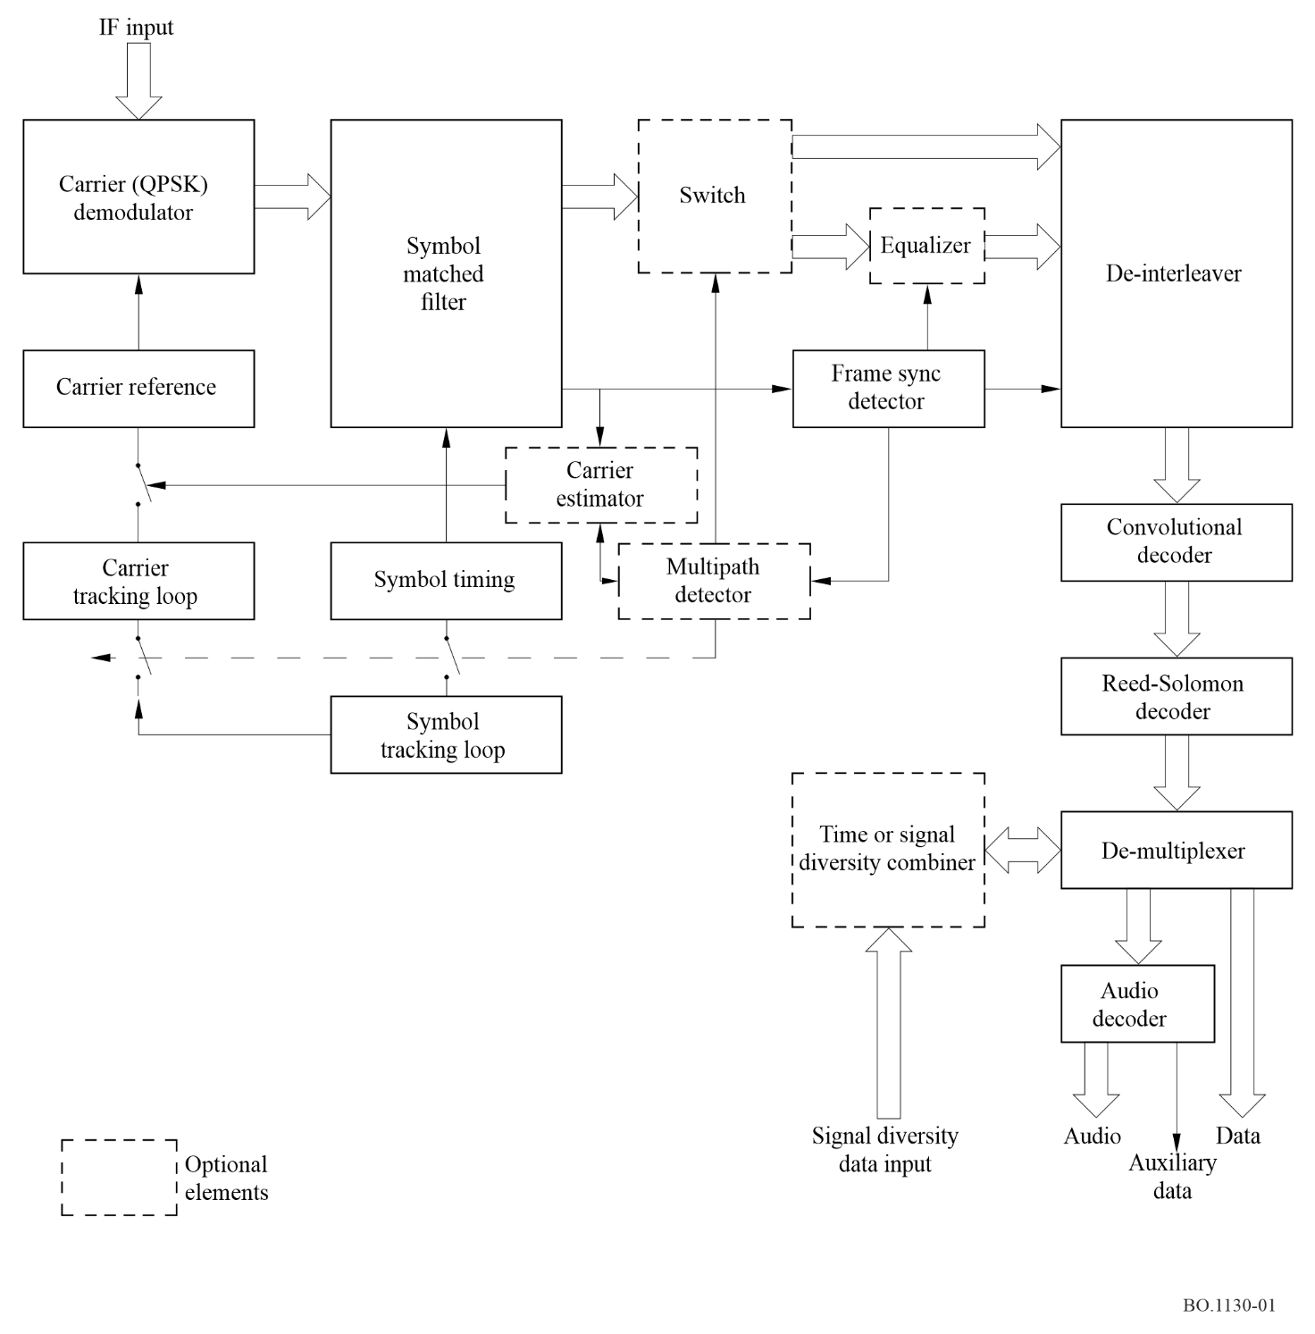
The selected digital audio source data is provided to the audio decoder while other digital data is provided to the appropriate data interfaces. Each audio encoder will have the capability of multiplexing asynchronous, program related data, with the audio data stream as shown in Fig. 1.
In a receiver equipped with an equalizer, the equalization can be disabled in the absence of multipath because the equalizer will introduce a nominal amount of performance degradation.
The presence of multipath can be detected automatically or the equalizer can be switched in manually if the receiver is to be operated in an area served by terrestrial transmitters. When the equalizer is operating, the carrier and symbol tracking loops are opened.
Time diversity is implemented by transmitting a delayed version of a data stream multiplexed together with the original. In the receiver, these two data streams are demultiplexed and time realigned. The data stream with the fewest errors is selected for output.
Signal diversity requires the independent processing of the signal, or of different frequency signals, up to the diversity combiner. The diversity combiner then performs the functions of time alignment and selection of the data stream containing the smallest number of errors.

3 System description
The processing layers of the System B transmitter and receiver are described block by block, referenced to the diagram of Fig. 2. Specifications are defined for each block as appropriate.

3.1 Transmitter
The transmitter performs all the processing functions needed to generate a single RF carrier. The process includes multiplexing all analogue audio and digital data sources to be combined onto one carrier, forward error correction encoding, and QPSK modulation.

3.1.1 Input interfaces
The transmitter accepts a set of sampled analogue audio signals, a set of asynchronous data sources associated with each audio source, and a set of independent synchronous data sources.

3.1.2 Audio encoding
A number of audio encoders are provided to handle the required number of limited bandwidth monaural, limited and full bandwidth stereo, and full bandwidth five channel surround sound channels.
Each encoder also accepts an asynchronous data channel, which is multiplexed with the audio data stream. The data rate of these channels varies dynamically according to the unused capacity of the audio channel.
The output of each audio encoder is a synchronous data stream with a data rate proportional to the audio bandwidth and quality. The rate ranges from a minimum of 16 kbit/s for limited bandwidth monaural, to approximately 320 kbit/s for five channels (exact rate to be determined by reference to MPEG-2 specifications). Audio encoder data rates are limited to multiples of 16 kbit/s.

3.1.3 Programme multiplexing
All digitized audio channels and data channels are multiplexed into a composite serial data stream. The output data rate will range from a minimum of 32 kbit/s to a maximum determined by the transmitting system bandwidth and power resources. This maximum is anticipated to be in the range of 1 to 10 Mbit/s.
Each allowed multiplex combination of audio sources and their rates, as well as data sources and their rates, will be assigned a unique transmission identifier number. This number will be used by the receiver to set up the data rate and demultiplexing configuration.
figure 2
System B block diagram
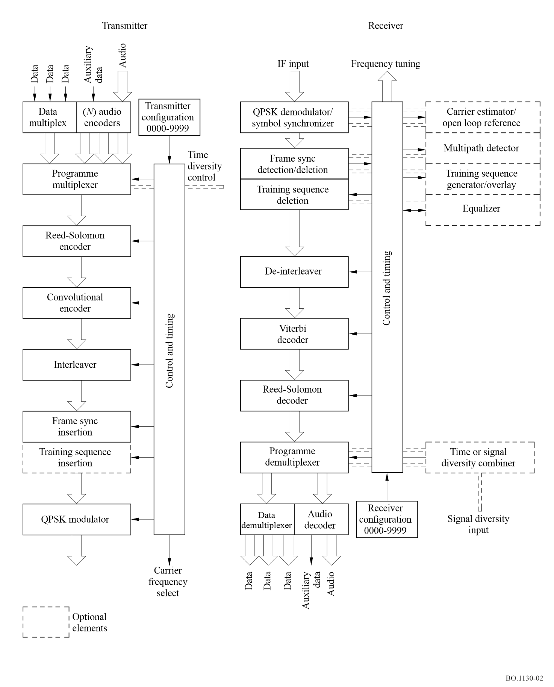

3.1.4 Error correction encoding
Error correction encoding of the composite data stream consists of rate 1/2, k = 7 convolutional encoding, preceded by RS (140,160) encoding.

3.1.5 Interleaving
A block interleaver is used to time interleave the composite data stream. The interleaver block length will be proportional to the composite data rate to provide an interleaver frame time on the order of 200 ms at any data rate.

3.1.6 Frame synchronization
A pseudo noise (PN) code word is inserted at the beginning of each interleaver frame. The interleaver frame sync will also have a unique relationship with the programme multiplexer frame.

3.1.7 Training sequence insertion
If the broadcast is to be received in an environment with on-channel repeaters, a known training symbol sequence will be inserted, with a training symbol placed every n data symbols, where n can range from 2 to 4. The presence of training symbols and their frequency will be also identified by the unique transmission identifier number.

3.1.8 Modulation
The final step in the process is QPSK modulation at an IF frequency. Pulse shaping will be used to constrain the bandwidth of the signal. From this point the modulated IF signal is translated to the appropriate carrier frequency for transmission. In a FDM approach, additional carriers are generated by duplicating the transmitter described above.

3.2 Receiver
After tuning to the desired carrier and translating the signal down to a fixed IF frequency, the receiver will perform the demodulation, decoding, and demultiplexing functions, as well as the digital to analogue conversion of the selected audio signal.
The receiver data rate and programme demultiplex configuration will be set up by inserting the unique transmission identifier number. The core receiver will be able to perform all required receive functions in a fixed or portable reception environment, where there is a stable signal with sufficient signal-to-noise ratio.
In mobile reception environments, where there are sufficient problems with signal blockage, the receiver will include the enhancements needed to accommodate time or signal diversity, or equalization if boosters are used.

3.2.1 Demodulation
Normally carrier demodulation takes place in a phase locked coherent QPSK demodulator, and symbols are detected by a matched filter with timing provided by a symbol tracking loop.
When equalization is used in the presence of echoes, the carrier and symbol tracking loops are opened. A fast Fourier transform (FFT) frequency estimator is used to set a fixed carrier demodulation reference. The symbol matched filter is sampled at twice the symbol rate and these samples are provided to the equalizer.

3.2.2 Frame synchronization
Interleaver frame synchronization is established through cross-correlation detection of the unique frame sync word. This process also removes the ambiguity produced by QPSK modulation.

3.2.3 Equalization
In the presence of echoes, there will be several closely spaced correlation peaks in the frame sync detector output. This information can be used to automatically switch in the equalizer. The equalizer uses a locally generated training sequence whose start is based on an estimate of the position of frame sync word. A comparison of the timing of the locally generated frame sync word and the frame sync detector output allows the equalizer to adjust for any timing error between the incoming symbols and locally generated symbol timing reference.
System B uses a lattice predictive decision feedback equalizer (lattice PDFE) design. The leeway allowed in the time spread of all the echoes is a function of the length of the equalizer. System B performance testing employed an equalizer with 22 forward taps and 4 feed back taps. The equalizer will acquire within 100 successive symbol times. Equalizer length can be increased if it is necessary to compensate for greater signal delay spread.

3.2.4 Training sequence deletion
At the output of the equalizer, the training sequence symbols are discarded. If a receiver without an equalizer works with a signal that contains training symbols, it also must discard these symbols. This is a simple process since the position of the training symbols is known in relation to the frame sync word.

3.2.5 De-Interleaving
The de-interleaver re-establishes the original time sequence of the detected symbols, as it existed in the transmitter prior to interleaving.

3.2.6 Error correction decoding
A Viterbi decoder, followed by a RS decoder, reduces the detected symbol error rate and converts the symbols back into data bits. If the RS decoder is unable to remove all the errors in a data block, it marks the data block as bad. This indication can later be used by the diversity combiner to select the better signal, as well as by the audio decoder to control audio output muting.

3.2.7 Programme demultiplexing
At this point the composite data stream is demultiplexed into separate digital data streams and the desired audio data stream is selected and routed to the audio decoder.
If time diversity is used, the programme demultiplexer separates the real time and delayed version of the data stream, and sends them to the diversity combiner for selection of the least corrupted data.
If an independent receiver is used for diversity reception, this is the point where the more robust output data is selected.

3.2.8 Audio decoding
The audio decoder converts the selected digital audio channel to analogue. It also demultiplexes the auxiliary data channel and provides the data to the appropriate output interface.
The interface from the programme demultiplexer provides not only recovered data and clock, but also a data quality indication from the RS decoder. This signal can be used to help control audio decoder muting during threshold signal conditions. This feature was used during testing of Digital System B with the AT&T PAC audio decoder, and disabled during tests with a MUSICAM audio decoder.

3.2.9 Output interfaces
Output interfaces consist of the selected audio channel and selected data channels. Data can be marked as good or bad using the RS data quality indicator. The data channels can drive displays in the receiver, or be routed to special purpose displays in data casting applications. Since more than one audio channel may exist in a transmission multiplex, the channels not selected for listening can be recorded for later playback.

4 Performance
The performance of System B is referenced to a set of standardized channel models: an additive white Gaussian noise (AWGN) channel; a satellite model for a single satellite signal; and a multiple (single frequency) signal model which can represent a satellite signal with terrestrial boosters or a purely terrestrial network.

4.1 AWGN channel
A clear line-of-sight satellite link can be approximated with an AWGN channel. There is very little multipath (Rician k factors generally below 10 dB) at satellite elevation angles above 20 degrees. The measured performance of a System B receiver over an AWGN channel is shown in Fig. 3. Also shown are some comparisons between theory, simulation, and measurement results.
Since System B can use several independent carriers in a FDM mode, carrier spacing is of interest. Figure 4 shows the measured performance degradation as a function of adjacent carrier spacing.
Spacing is given as a ratio of carrier separation (Hz) to transmitted symbol rate in symbols per second. In System B the symbol rate is equal to the data rate multiplied by the RS (160,140) overhead, multiplied by the training symbol overhead.

4.2 Satellite channel
The satellite channel changes for mobile reception because the satellite signal is randomly blocked by buildings, trees, and other obstacles. In order to evaluate System B performance under mobile reception conditions, a model was established through a satellite signal measurement over a specific test course in the Pasadena, California area. The test course takes 45 min to cover and includes a variety of reception conditions, including open, moderately shadowed, and severely shadowed segments. The satellite signal measurement was a narrow band measurement which yielded a dynamic range of over 35 dB. A time plot of the model is shown in Fig. 5. Figure 6 summarizes the statistics of the signal measurement.
figure 3
System B performance in AWGN
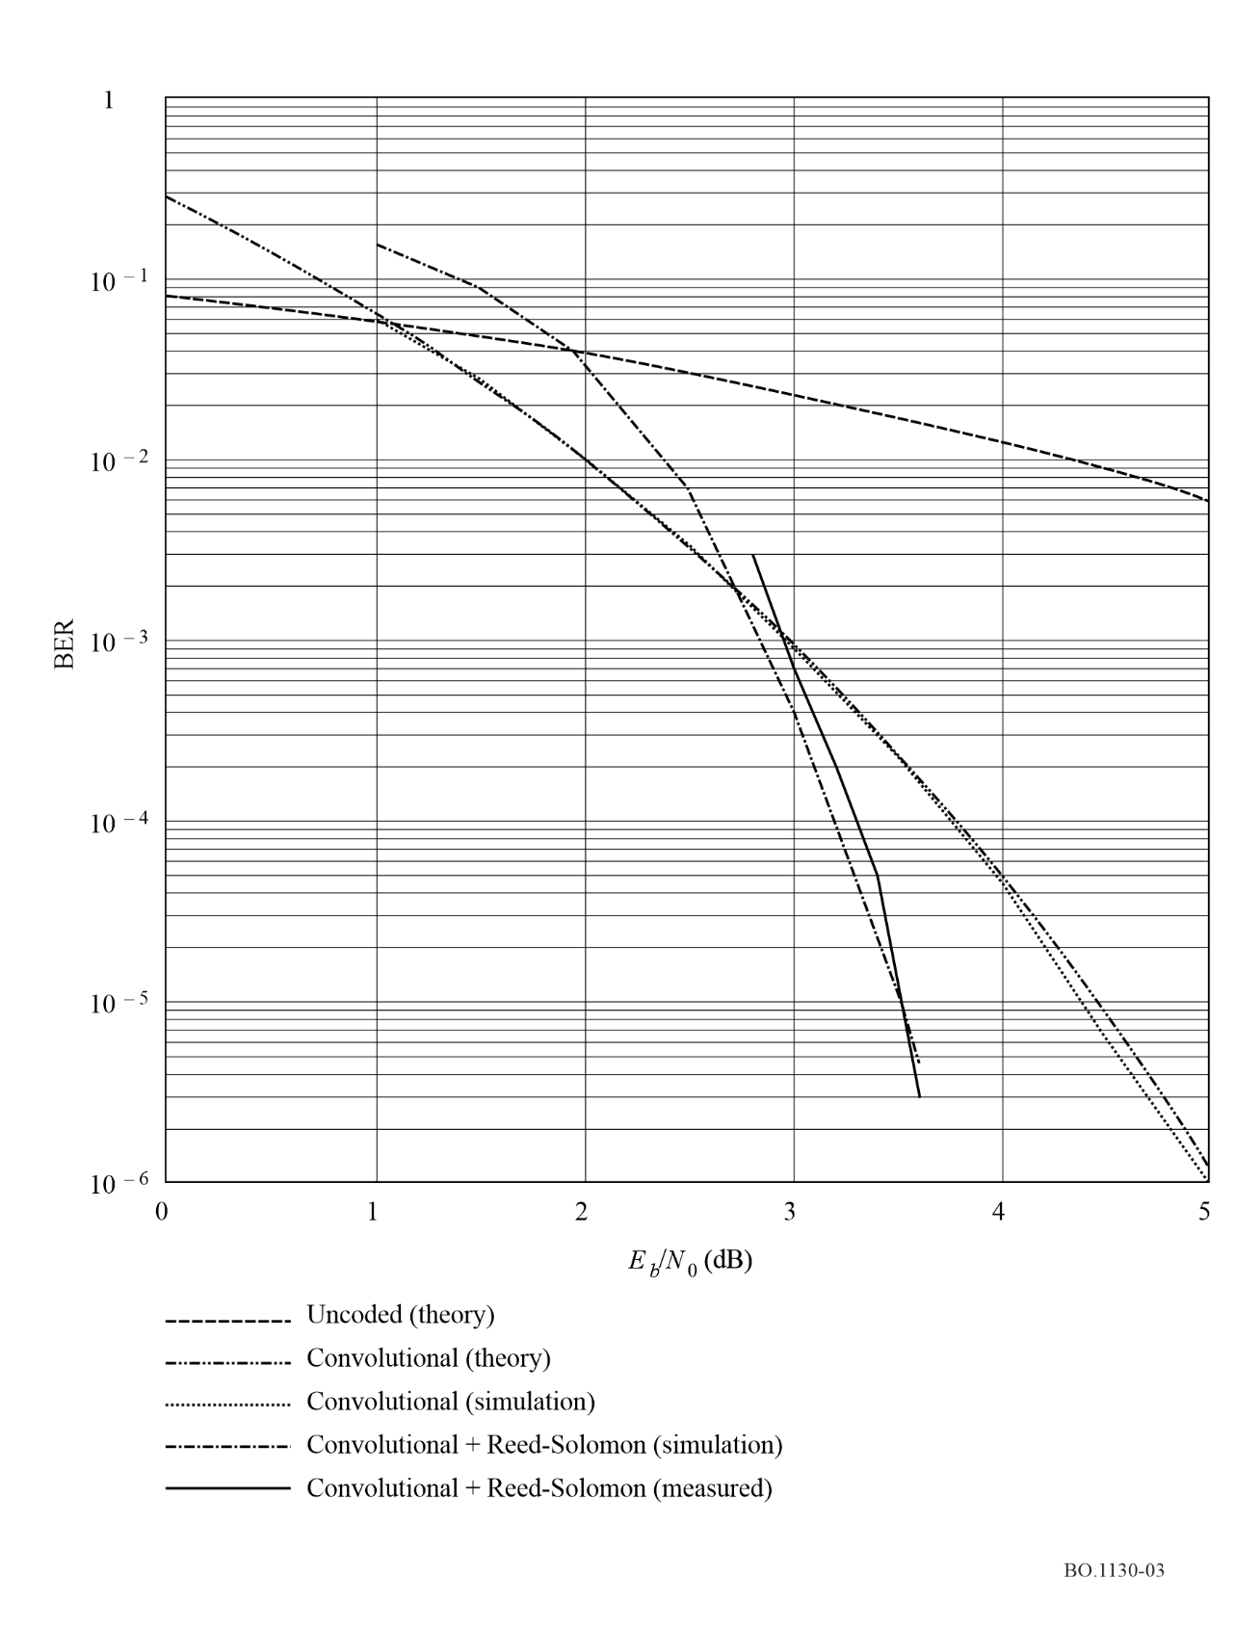

4.2.1 Time diversity
If only a single satellite signal is available, an effective mitigation technique is time diversity. A delayed version of a data stream is multiplexed with the original data stream, with the expectation that at least one version will not be blocked. The receiver realigns the two data streams in time and selects the one with the fewest errors. This can be done on the basis of the RS decoder error indication.
Retransmission of the data stream adds a 3 dB penalty to the system, however it can be shown that this is more effective than a 3 dB increase in link margin. Figures 7 and 8 show the effectiveness of time diversity, using the Pasadena channel model. Figure 7 shows the joint probability of a fade exceeding a range of link margins, averaged over all the model reception conditions. Note that most of the improvement occurs within about 4 s of delay. Figure 8 shows the joint fade probabilities, for a fixed 10 dB margin, separated by different reception conditions.
figure 4
Performance degradation as a function of carrier spacing
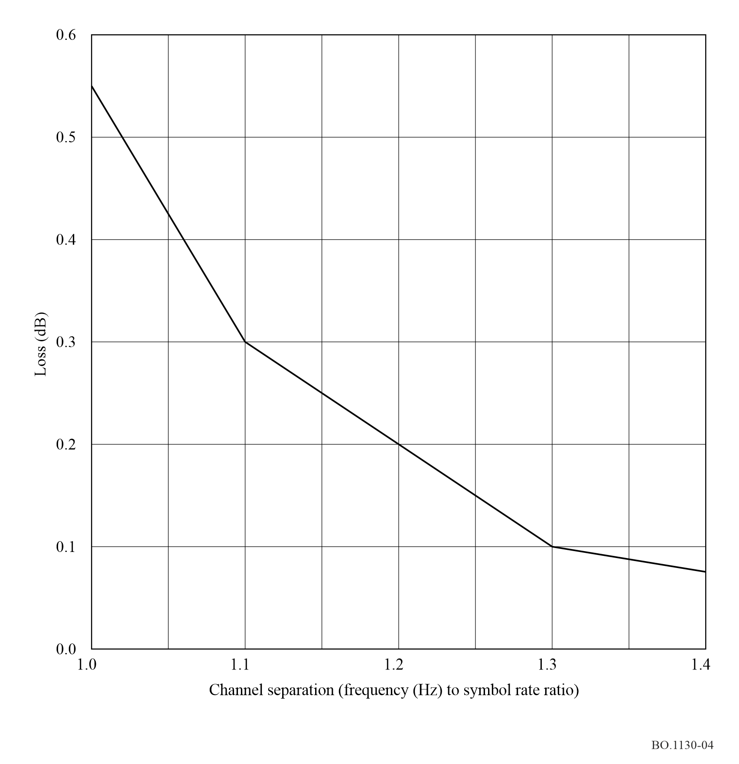

4.2.2 Satellite diversity
More than one satellite can be used to broadcast the same data stream, using separate frequencies and separate receivers for each signal. The expectation with this technique is that at least one of the signals will not be blocked because of the difference in direction from the receiver to the satellites.
The effectiveness of satellite diversity, as with time diversity, depends on the local geometry of the obstacles producing the signal blockage. Photogrammetric techniques have recently been applied to obtain the statistics on the effectiveness of satellite diversity. These techniques involve taking photographic images with a fish eye lens camera pointed at zenith, then analysing them to determine the percentage of sky that is clear, shadowed, or blocked. Satellite position can be overlaid on these images to give an assessment of diversity gain over a specific location or path.
figure 5
Satellite channel model
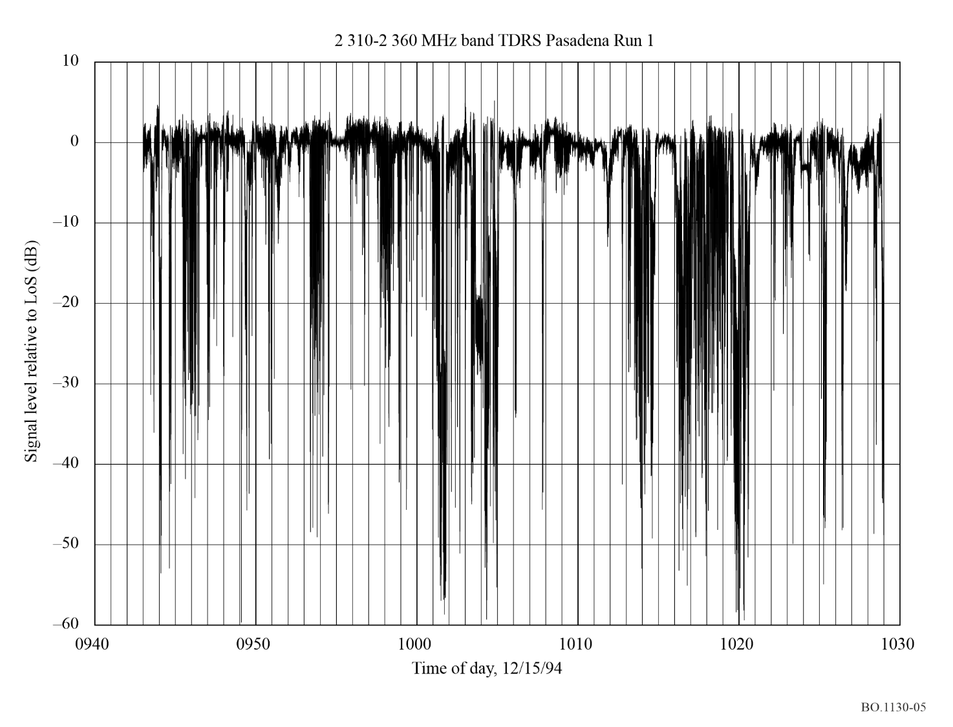

4.3 Single frequency network
A method for getting a satellite signal into very difficult reception areas is to use a network of on-channel terrestrial retransmitters. System B uses equalization to work in this signal environment. The only restriction in the use of equalization is that each signal is delayed at least one half symbol from every other. There is no restriction as to how close boosters are to each other if different delays are incorporated in each one. The maximum delay between boosters will be set by the number of stages incorporated into the equalizer.
figure 6
Satellite channel model statistics
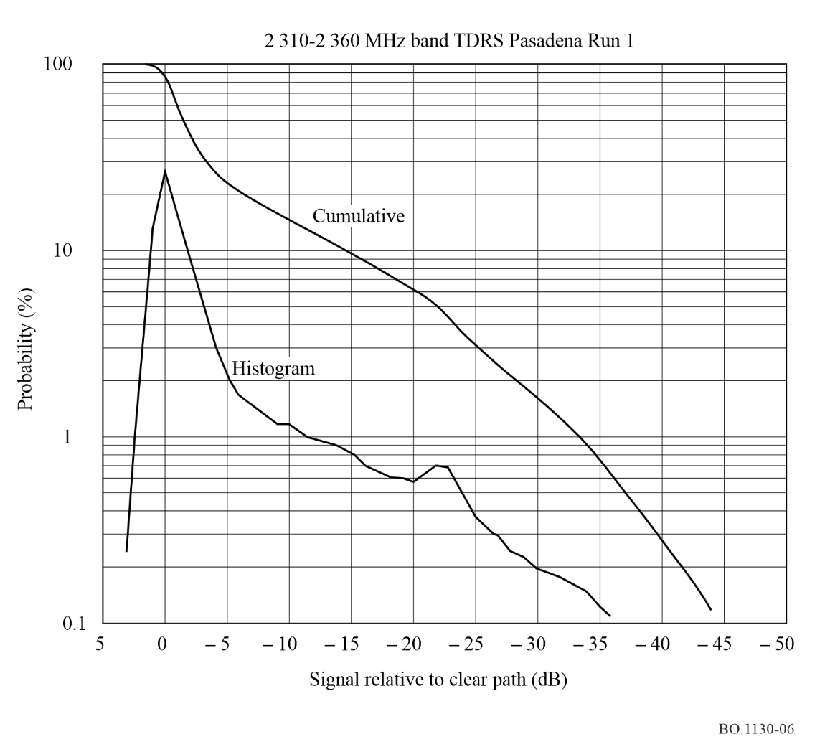

4.3.1 Channel models
Two signal models were set up to evaluate the performance of the System B equalizer. In addition, the effectiveness of signal reception diversity was evaluated.
The first is a Rician model, with one half the power in a direct signal component, and one quarter of the power in each of two Rayleigh components. The Doppler spread on the Rayleigh components was set to ±213 Hz, which corresponds to a vehicle speed of 100 km/h, at a carrier frequency of 2.3 GHz. The transmission rate is 300 000 symbols/s. E_{b}/N₀ is defined on the basis of total signal power and includes the effect of the training sequence overhead.
The second is a Rayleigh model, with three equal power Rayleigh signal components.

4.3.2 Equalizer performance
Initial trade-offs and performance evaluation were accomplished using a “short-cut” simulation approach that assumed signal time separation in integral symbol time periods and perfect symbol timing recovery. The results are shown in Fig. 9. The BER is uncoded error rate, before the Viterbi and RS decoding. An uncoded error rate of 1 × 10⁻² will be reduced to 1 × 10⁻⁶ by the decoding process.
figure 7
Joint fade probability vs. link margin
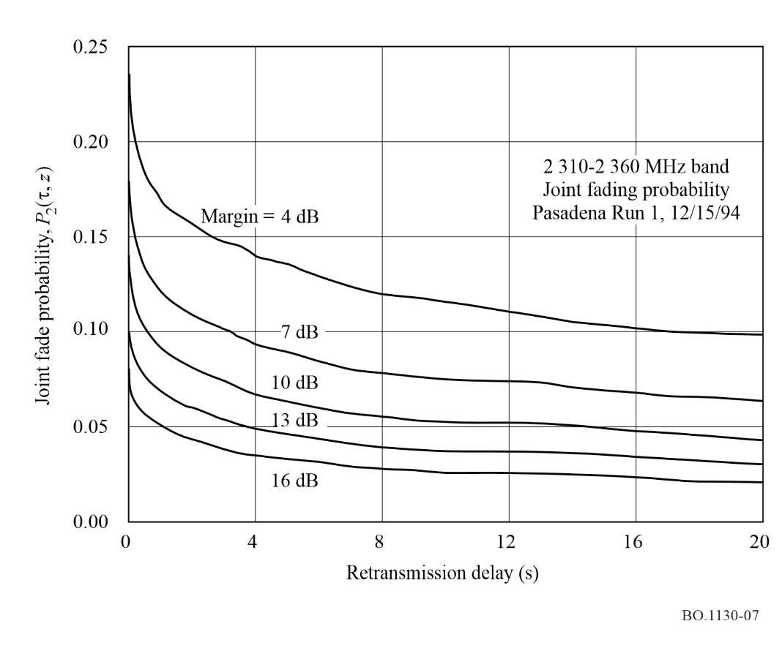
figure 8
Joint fade probability vs. Environment
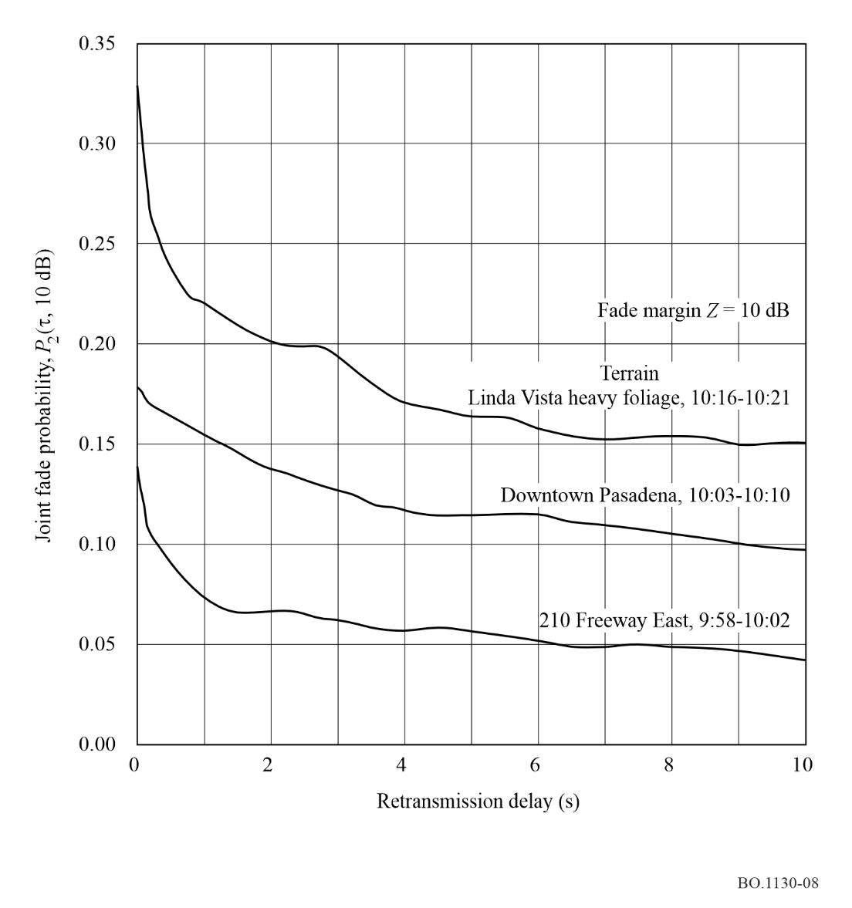
figure 9
System B ideal equalizer performance (uncoded)
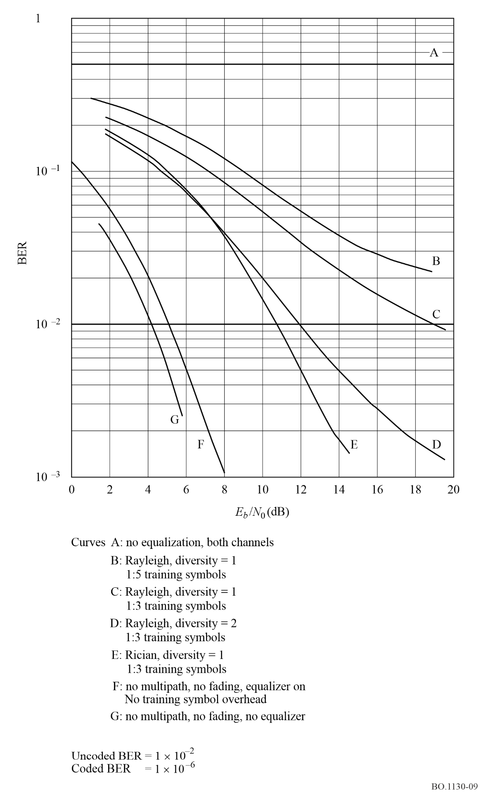
Figure 10 shows performance obtained with full scale simulation, including open loop operation of the carrier demodulation and symbol timing loops.
figure 10
System B equalizer performance (uncoded)
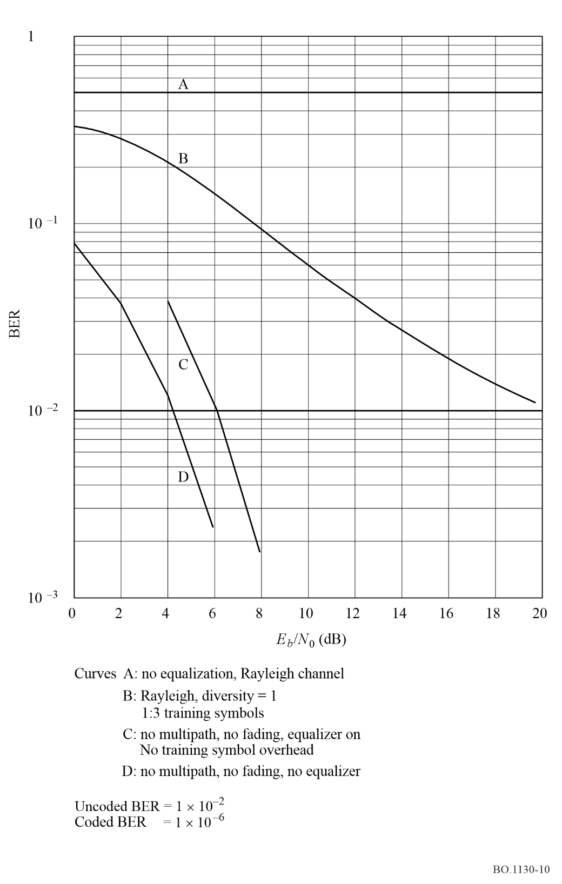

Annex 3
Digital System D_{S}

1 Introduction
Digital System D_{S} is designed to provide satellite digital audio and data broadcasting for reception by inexpensive indoor/outdoor fixed, portable and mobile receivers. It has been designed to optimize performance for satellite service delivery in the 1 452-1 492 MHz band. This is achieved through the use of coherent QPSK modulation with block and convolutional error coding, and linear amplification. Work is also proceeding on the development of techniques to allow hybrid satellite/terrestrial broadcasting systems using Digital System D_{S}.
Digital System D_{S} provides for a flexible multiplex of digitized audio sources to be modulated onto a downlink TDM carrier. It uses the OSI model as proposed in Recommendation ITU-R BT.807.

2 System overview
The broadcast downlink signal in Digital System D_{S} consists of a 3.68 Mbit/s TDM carrier which transports 96 prime rate channels (PRC) each bearing a 16 kbit/s prime rate increment of capacity. Multiple TDM downlink carriers are transmitted by a single satellite, with each carrier transmitted by a single high power amplifier (HPA) which can operate at saturation. A typical first generation satellite is capable of simultaneously radiating six such TDM downlink carriers (equivalent to 576 PRCs) using travelling wave tube amplifiers (TWTAs). The PRCs are grouped in broadcast channel (BC) frames, each of which can carry up to eight PRCs. The PRCs can be used individually or combined to provide service component rates of n x 16 kbit/s with n ranging from 1 to 8, thus providing considerable flexibility to the broadcast service providers.
Each TDM downlink carrier delivers 1.536 Mbit/s of traffic at baseband. The TDM traffic stream is divided into 96 channel time slots each carrying a 16 kbit/s PRC referenced to baseband. The addition of service control headers (SCHs), synchronization preambles and redundancy for FEC, increases the actual bit rate on each downlink TDM stream needed to carry the 96 PRC to 3.68 Mbit/s. QPSK modulation on the TDM downlink carriers, at a symbol rate of 1.84 Msymbols/s (2 bit/symbol), is used to transport the TDM stream to the receiver. Frequency spacing ranging from 2.3 to 3.0 MHz (see Note 1) between TDM carriers provides sufficient guardband to allow operation with minor to negligible intersymbol and adjacent channel interference at TWTA saturation in channels defined by square root raised cosine filters with aperture equalization applied on the transmit side. Small personal portable radios receive and select the channel slots from the TDM data streams to recover the digital baseband traffic information.
NOTE 1 – The required frequency spacing between the centre frequencies of the TDM carriers is a function of the geographic beam isolation and polarization isolation between adjacent carriers.
Table 2 summarizes the main technical characteristics of the system and Fig. 11 illustrates a block diagram of a typical satellite showing the use of both processing and transparent payloads.
TABLE 2
Summary of main system characteristics for Digital System D_{S}
Mission | Digital audio/data broadcast
Uplink format | Either SCPC/FDMA (processing payload) or  MCPC/TDM (transparent payload)
Downlink format | MCPC/TDM
Downlink frequency | 1 452-1 492 MHz band
Typical transponder e.i.r.p. (peak) | 53.5 dBW
Typical transponder e.i.r.p. EoC primary service area | 49 dBW
Typical transponder e.i.r.p. EoC secondary service area | 44 dBW
Modulation | Coherent QPSK
Threshold (at antenna input (0 dBi gain)) | −109 dBm
Error coding | Block and convolutional
EoC: edge of coverage
MCPC: multiple channels per carrier

A key feature of Digital System D_{S} is the ability to utilize a processing payload that includes an on-board baseband digital processor. The on-board demultiplexer-demodulator and routing switch connects multiple frequency division multiple access (FDMA) uplink channels to each downlink TDM digital stream. Figure 12 provides a block diagram of the end-to-end signal processing via a typical processing payload.
MPEG Layer III encoded audio signals are transported over the system formatted in prime rate increments of 16 kbit/s. From one to eight prime rate increments are multiplexed into BC. For each prime rate increment, 6 912 bits are assigned in a 0.432 s duration BC frame. These can be divided into several service components in the BC frame. A BC frame, as shown in Fig. 13, starts with a service control header (SCH). For each prime rate increment carried in the BC frame, the SCH contains 224 bits. With the addition of the SCH, each prime rate increment will contain 7 136 bits in the 0.432 s frame. The SCH provides information needed in the receiver to select service components and to allow a service originator to remotely control service-related functions. To identify and demultiplex service components, the SCH contains a service component control field (SCCF) for each service component. Radio functions thus controlled can include encryption of subscription services, service category selection, addressing subsets of users, displaying messages, enabling and disabling a service, etc. Broadcast frames are assembled at the service origination facility.
figure 11
Typical satellite communications payload for Digital System D_{s}
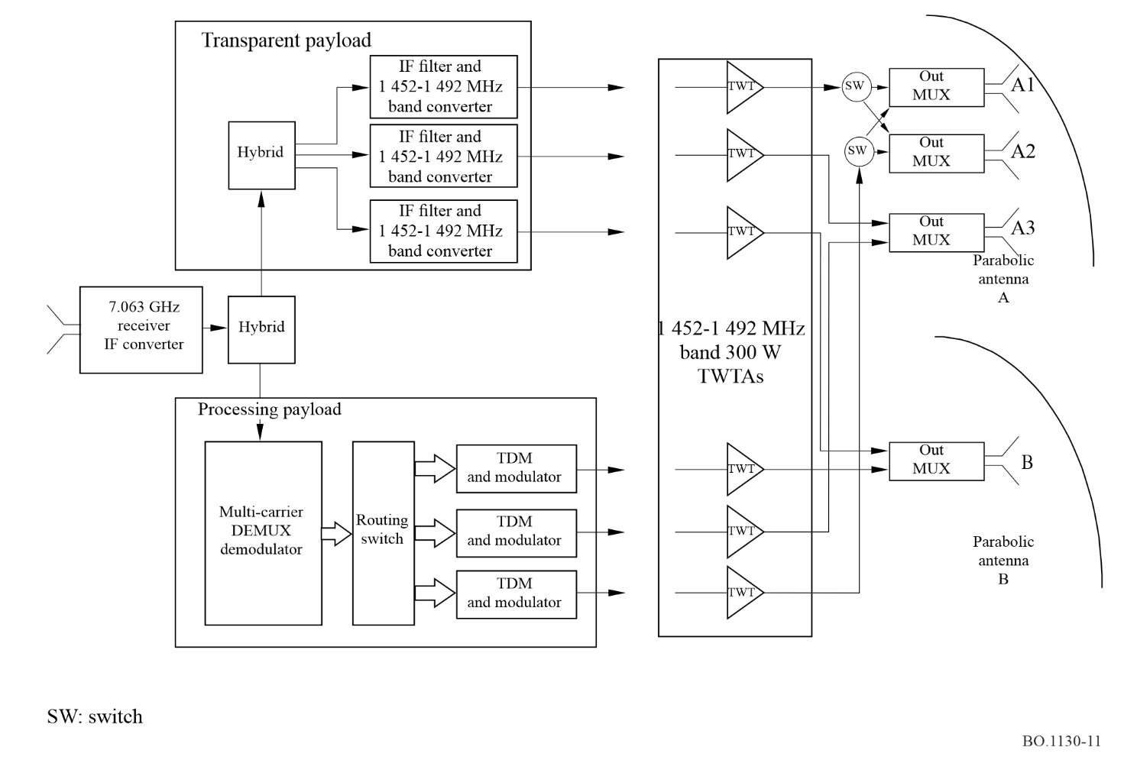
To prepare the signal for transmission, a broadcast channel frame of 0.432 s duration is assembled consisting of a service segment of n × 16 kbit/s (n × 6 912 bits per frame), plus an SCH segment of n × 518.5 bit/s (n × 224 bits per frame). Note that n is an integer ranging from 1 to 8. Thus, BCs are structured in multiples of n × 16.5185 kbit/s. The service segment of a BC can be further divided into separate service components intended for specific uses, such as music, speech, image, dynamic image and others. Service components are organized in terms of integer multiples of 8 kbit/s per component with a maximum of eight service components per BC. The assignment of service components may be dynamic. For example a music service component using 64 kbit/s may be dynamically converted to four 16 kbit/s voice service components in four languages to constitute a program mixing a single high-quality music service with a four-language voice service.
After assembly, the BC is next FEC coded by concatenating a RS (255,223) block coder, followed by a block interleaver, followed by a Rate 1/2 convolution coder. This coding multiplies the bit rate by a factor of 2 × 255/223. Thus, the coded BC rate is n × 37.77 kbit/s. FEC coded BC frames are next synchronously demultiplexed into n parallel PRCs, each containing 16 320 bits every BC frame period (0.432 s). Addition of a synchronization header raises the coded PRC to precisely 38 kbit/s (16 416 bits per frame). Coded PRCs are next differentially coded and QPSK modulated onto n SCPC-FDMA carriers and transmitted to the satellite.
figure 12
Typical end-to-end signal processing (processing payload) for Digital System D_{s}
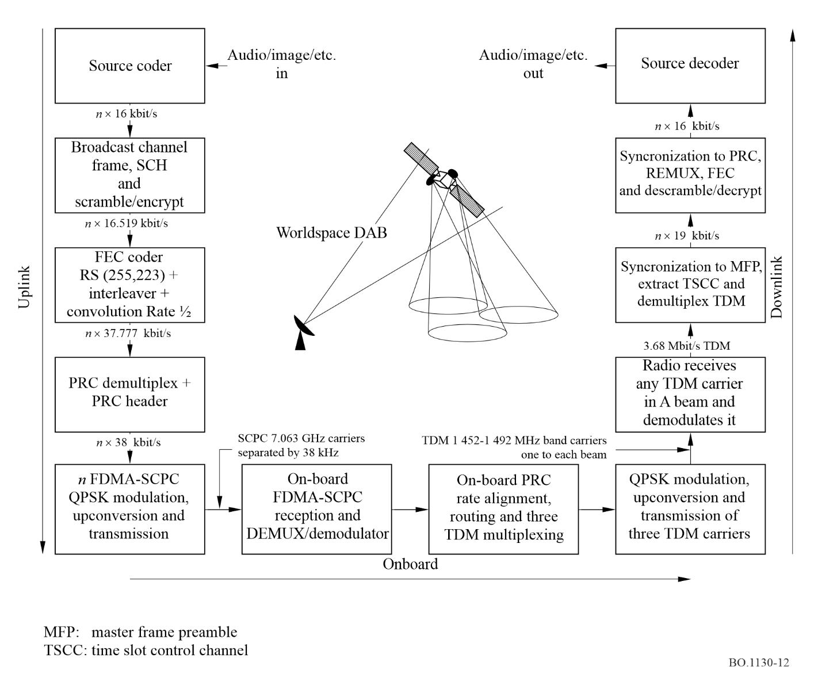
figure 13
Broadcast channel frame
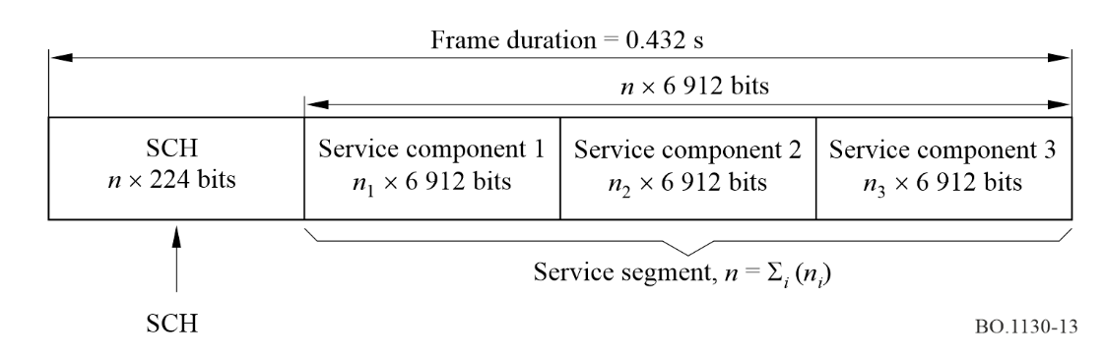
On board the satellite the coded prime rate uplink carriers are received in 48 PRC carrier groups, demultiplexed and demodulated to their individual baseband coded prime rates. A TDM frame assembler locates each PRC in one of 96 PRC time slot locations in a 0.138 s duration TDM frame. Each PRC time slot contains 5 244 bits and the frame contains 96 × 5 244 = 503 424 bits. The TDM frame is shown in Fig. 14. Each TDM frame starts with a 192 bit MFP followed by a 4 224 TSCC.
figure 14
Downlink TDM frame
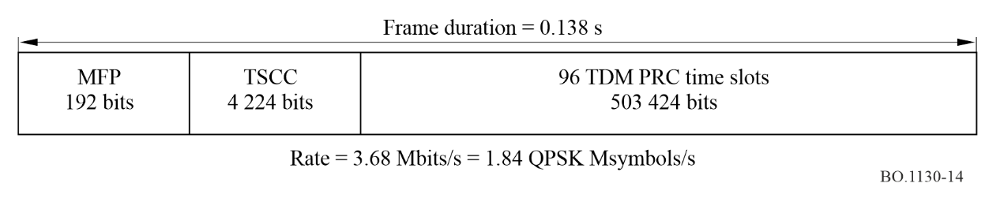
The MFP and TSCC are used by the radio receiver to synchronize to the TDM frame and to locate the PRCs comprising the various BCs carried in the frame and provide the information needed by a receiver to demultiplex the PRCs belonging to a selected BC and to reconstruct the BC. The TDM traffic stream is divided into 96 TDM time slots each carrying a 16 kbit/s PRC at a baseband rate of 1.536 Mbit/s. Due to the addition of SCHs, synchronization preambles and redundancy for FEC, the actual bit rate on each downlink TDM stream needed to carry the 96 PRCs is 3.68 Mbit/s. QPSK modulation on band carriers 1 452-1 492 MHz at a symbol rate of 1.84 Msymbols (2 bit/symbol) is used to transport the TDM stream to the receivers.
Digital System D_{S} may also be implemented using a transparent payload (sometimes referred to as a “bent-pipe transponder” or a “simple frequency-changing transponder”). Such a payload would convert uplink TDM carriers (typically operating in the 7 025-7 075 MHz band) to frequency locations in the downlink 1 452-1 492 MHz spectrum. The payload would contain no on-board processing or PRC routing capability. Each uplink TDM carrier is multiplexed to carry 96 × 16 kbit/s PRCs transmitted from hub terminals located in the uplink service area of the satellite. The TDM waveform format used on the uplink and downlink of a transparent payload is identical to that described above for a processing payload downlink. However, rather than its being assembled on board the satellite, it is assembled at an uplink TDM waveform earth station.

3 MPEG Layer III audio coding algorithm

3.1 General
ISO/MPEG Layer III is used in the Digital System D_{S} satellite sound broadcasting system. The three versions of Layer III widely used are the standardized schemes MPEG-1 Layer III and MPEG-2 (half sampling rate) Layer III and the extension MPEG-2.5 (quarter sampling rate). Using these various source coding options, the system can operate at digitally coded audio bit rates ranging from 16 kbit/s to 128 kbit/s in steps of 16 kbit/s to provide various audio quality equivalents such as CD stereo, FM stereo, FM monaural, AM stereo and AM monaural.
The general principles of the ISO/MPEG coding schemes, as well as the Layer III algorithm in particular, are the subject of many publications (e.g. [Brandenburg et al., 1992; Eberlein et al., 1993]). The PCM time signal is mapped in the frequency domain using a fast Fourier transform (FFT) implemented filterbank (in case of Layer III a hybrid FFT/discreet Fourier transform (DFT) implemented filterbank). A psychoacoustic model calculates the allowed perception thresholds of the audio signal in the frequency domain. A quantization and coding kernel applies frequency domain thresholds to the mapped audio frequency spectrum data. Finally the coded data is multiplexed with frame header and side information to build the bit stream. The decoder performs the inverse operations to recover the analogue audio signal.
Four basic features are the key factors for the high coding efficiency of Layer III compared to other coding schemes:
– High resolution in the frequency domain optimizes the noise spectrum shaping according to the demands of the psychoacoustic model.
– Entropy (i.e. Huffman) coding removes redundancy in a signal. Layer III uses 32 different Huffman tables that can be flexibly assigned to code the signal.
– Bit reservoir is a short time buffer that allows “bit rate saving” resulting in a constant coding quality.
– Advanced joint stereo coding methods achieve high compression rates with stereo signals. Layer III is the only layer which supports two stereo coding methods: mid/side stereo coding and intensity stereo coding.

3.2 MPEG-1 Layer III
The ISO/IEC Standard 11172, [ISO/IEC, 1993], better known as “MPEG-1” standard, was finalized in 1991. The audio part of the standard, ISO/IEC 11172-3, defines three algorithms, Layers I, II and III for coding of PCM audio signals with sampling rates of 48, 44.1 and 32 kHz. Layer III is the most powerful scheme among these layers and may operate at bit rates from 32 to 320 kbit/s per mono or stereo signal.

3.3 MPEG-2 Layer III (half sampling rate extension)
The MPEG-1 coding algorithms have mainly been designed for high-quality audio compression (CD-like quality) of mono- or stereophonic signals. When the MPEG-1 standard was established, it became obvious that an extension of the standard allowing lower sampling rates was necessary. Due to technical reasons optimal coding efficiency for very low bit rates (less than or equal to 32 kbit/channel) can only be achieved by using lower sampling rates. Consequently, the low sampling rate (LSR) extension of the MPEG-2 standard (ISO/IEC 13818-3 [ISO/IEC, 1998]) defines the use of the sampling rates 24, 22.05 and 16 kHz for bit rates down to 8 kbit/s.

3.4 MPEG-2.5 Layer III (extension toward very low sampling rates)
Although MPEG-2 Layer III half sampling rate allows bit rates down to 8 kbit/s, it was found that coding at bit rates between 8 and 16 kbit/channel can be further improved by using even lower sampling rates. As a result the extension of MPEG-2, called MPEG-2.5, operating at quarter sampling rate was defined. This extension is almost identical to MPEG-2 Layer III, but allows sampling rates of 12, 11.025 and 8 kHz for best possible audio quality for very low bit rates. Expert listening observations have shown that the perceived quality at low bit rates is significantly enhanced by use of reduced sampling rate.

3.5 Layer III audio quality – status and future improvements
With respect to high quality reproduction, audio bandwidth is the most important parameter. In the encoding process the bandwidth is chosen such that coding artifacts are kept as inaudible as possible. 128 kbit/s Layer III stereo provides CD-like quality, 64 kbit/s stereo delivers very good quality at a bandwidth of around 11 kHz, 16 kbit/s mono provides a “better than short wave quality”. Figure 15 shows an example for audio bandwidth vs. bit rate per channel for Layer III. It is important to note that MPEG Standards describe only the bit stream format and the decoding process rather than the encoding process. Thus, all improvements achieved in the encoder will result in better reproduced audio quality (e.g. higher bandwidth) at the decoder. Main topics of the ongoing optimization work on Layer III are:
– optimization of joint stereo techniques;
– improvement of the block switching mechanism;
– tuning of psychoacoustic parameters under various conditions.
figure 15
Example of audio bandwidth vs. bit rate for MPEG Layer III for Digital System D^{s}
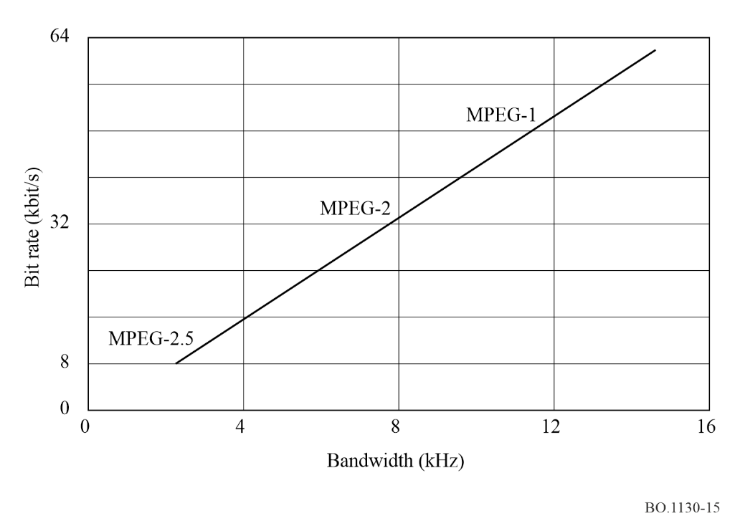
The results of this work are expected to further improve the high coding efficiency of the Layer III audio coding algorithm.

4 Radio receiver operation and interfaces

4.1 Receiver operation
Figure 16 shows the receiver block diagram for Digital System D_{S}.
figure 16
Receiver block diagram for Digital System D_{s}
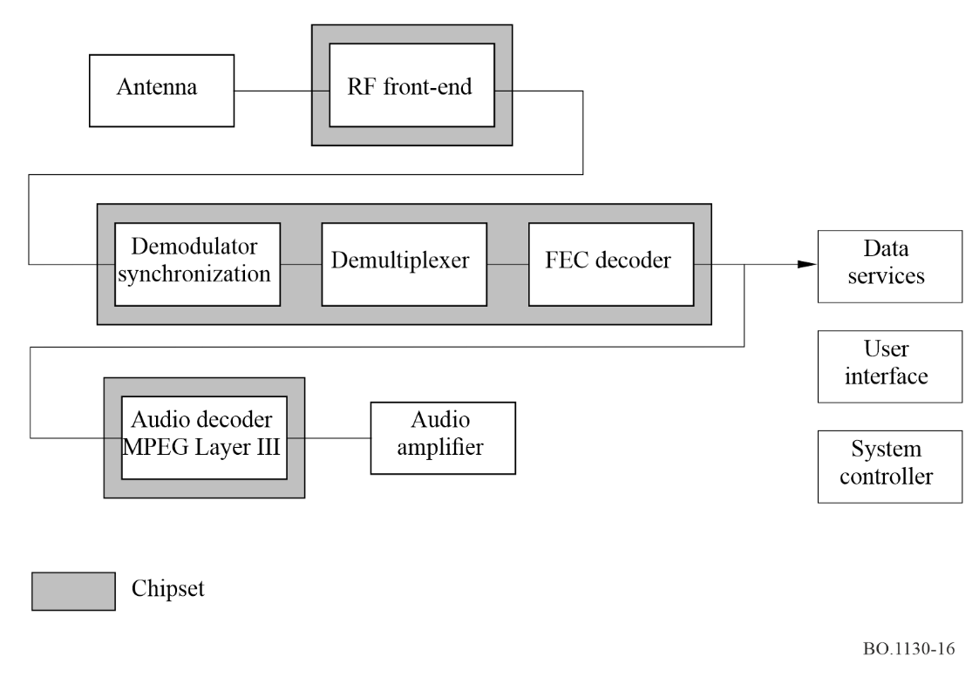

4.1.1 Antenna options
The antenna must be capable of receiving the different TDM carriers in the range of 1 452-1 492 MHz transmitted in both types of circular polarization. To achieve the specified minimum gain-to-temperature (G/T) ratio of −16.5 dB(K⁻¹) under an assumed Tsys of 160 K, a minimum antenna gain of 6 dBi is required.
Both polarizations are accessible with one antenna (at least for the portable application) by means of a semiconductor implemented polarization switch. The standard antenna is a single patch type, feeding two separate low noise amplifiers (LNAs) from taps delivering right-hand circular polarization (RHCP) and left-hand circular polarization (LHCP), respectively. The antenna is a half wavelength patch size of 6 cm × 6 cm with about 6 dBi gain. This antenna size has a beamwidth of approximately 100°, therefore requiring almost no pointing – an additional benefit for portable operation.
In poor reception conditions higher gain antennas of about 12 dBi can be used. The smaller beamwidth will necessitate some pointing of the antenna towards the satellite. This is supported by the receiver with its “signal quality” indicator. An important advantage of the higher antenna directivity is improved signal-to-interference ratio.
For the above reasons, the antenna is detachable, whereby the output signal of the active antenna is fed to the radio via cable and input connector. This configuration is especially beneficial for indoor environments with high signal penetration loss. The detached antenna can be mounted outdoors, or near a window enabling line-of-sight reception and delivering the signal to the receiver via an inserted coaxial cable. However as the cable insertion loss could unduly degrade the G/T performance, additional LNA gain is required to provide sufficient margin.
Other applicable high-gain antenna options are helixes in broadside or endfire mode. The azimuth tilt can be adjusted to match the local satellite reception azimuth. Another attractive approach for fixed location use is to place the standard patch as a feed into a parabolic dish reflector. In this application a receiver control signal for the polarization selection can be used.

4.1.2 Front end filtering
The receiver front end is of the dual conversion superheterodyne type. To achieve the required image rejection and to effectively attenuate out-of-band interference, a 3-pole filter consisting of high-Q dielectric coaxial resonators is used. After the first conversion to an IF of 115.244 MHz, the in-band selectivity is realized with a surface acoustic wave (SAW) filter. The passband corresponds to the TDM bandwidth increased slightly to allow for temperature tolerances of the first local oscillator and the filter itself. The shaping of the spectrum roll-off is fully implemented in the digital domain. This yields high precision that contributes favourably to the link margin.

4.1.3 Limitations due to receiver linearity (IP3)
Receiver immunity against interference is a function of front-end filter selectivity as well as the receiver linearity and large signal performance. As the receiver is to be a battery-powered portable, and is intended for cost-sensitive markets, power consumption has to be a primary concern. Consequently high linearity values are difficult to achieve. For the initial receivers, the specified minimum value, referenced to the receiver antenna connector, is IP3 = −40 dBm.
The input-referenced IP3 of the LNA implemented in the active antenna is −20 dBm. This leaves enough margin for improving the immunity to high level in-band interference by inserting filters between antenna output and receiver input.

4.1.4 Tuning to a TDM carrier
The 1 452-1 492 MHz band frequency reception range of 40 MHz bandwidth can accommodate 82 TDM carrier channels per polarization (on a 460 kHz raster). These potential TDM carrier positions will be accessed directly. The bandwidth of one TDM carrier is about 2.5 MHz and the fine resolution of this raster offers sufficient flexibility for frequency planning and interference countermeasures.

4.1.5 Demodulation
The output signal of the analogue tuner front end (the baseband at 1.84 Msymbols/s) is directly sampled and converted into the digital domain. The coherent demodulation of the QPSK bit stream into the I/Q components is performed by a complex mixer. After square root raised cosine Nyquist filtering of the complex signals, the symbol clock recovery is achieved by digital resampling. Intelligent control loops achieve reliable signal recovery at very low C/N levels. They exhibit robust tracking behaviour until near 0 dB C/N, and at BERs close to the theoretical limit.

4.1.6 TDM frame synchronization
The master frame synchronization block receives the demodulated symbol stream from the QPSK demodulator and performs the alignment, detecting the master frame preamble by correlation. The known pattern of the synchronization word is also used to correct the phase ambiguity inherent in QPSK demodulation.

4.1.7 Demultiplexing a BC
The TDM frame comprises three fields:
– the MFP needed for synchronization,
– the TSCC that contains information about the locations and organization of the PRC data and
– TDM PRC data field.
The PRCs data field contains 96 PRCs with 16 kbits net data rate, whereby one to eight of these PRCs can be grouped to build one BC. These BCs correspond to the data capacities chosen individually by the providers to meet the different requirements for audio quality and auxiliary data content.
The function of the TDM demultiplexer is to extract the selected BC from the bit stream. The symbols of the different PRCs belonging to the selected BC pass through the data stream recovery unit. Temporal misalignment between the PRC of the selected BC is removed using a “stuffing bit” technique.

4.1.8 FEC decoding a BC: Viterbi + de-interleave + RS
To achieve low bit error rates of 1 × 10⁻⁴ with the low C/N ratios, a powerful error-correcting method is applied. It consists of a cascade of Viterbi-convolutional decoding as the inner code, de-interleaving, and RS block decoding as the outer code. These protection mechanisms are applied at the BC level (and not the PRC level) to allow the receiver to apply them once only and on the level of the data rate of the single selected BC. The output of this module is the BC. The configuration of the BC is constructed of different service components belonging to the same service. The service structure and service component composition of the BC is transmitted in the SCH.

4.2 SCH functions: service types, subscription services
To enable optimum automatic selection of a service, the SCH provides the receiver with information such as service component type and number, language, program type and the label identifying the service provider. In addition to audio service, still image sequences or data services can also be transmitted. These will use different service component formats identified by the receiver from the SCH information. Encryption is an additional option. The selected encryption system uses three key parts: hardware key (to identify the receiver), user key (to identify the authorization), over-air key (to identify different service providers).
Table 3 provides a summary of the SCH functions.
TABLE 3
SCH functional summary for Digital System D_{S}
Field group | Field name | Purpose
Service preamble | Service preamble | Used to synchronize each service component
 | Bit rate index | Indicates the overall bit rate of the service
 | Encryption control | Provides information on which encryption type is in use if any
 | Auxiliary field content indicator 1 (ACI1) | This is a multi-use field that controls specific functionalities associated with the service. This indicator provides information about the purpose of the value contained in ADF1
Service control data | Auxiliary field content indicator 2 (ACI2) | Same as for ACI1 but controls ADF2
 | Number of service components (Nsc) | This field contains an indication of the number of service components contained in the BC and can vary from one to eight
 | Auxiliary data field 1 (ADF1) | Data field, with content defined by ACI1
 | ADF2 multi-frame start flag (SF) | Indicates the presence and start of a multiframe data field where the data is carried in successive frames within ADF2
 | ADF2 segment offset and length field (SOLF) | Contains the total number of segments in the multiframe minus one
 | Auxiliary data field 2 (ADF2) | Data field that contains the data type indicated by ACI2
TABLE 3 (end)
Field group | Field name | Purpose
Service component control data | Service component control field (SCCF) | Contains the information needed to demultiplex and decode each service component in the BC. Includes the bit rate, type (MPEG audio, etc.) and the program type (music, speech, etc.), and language of the SC
Auxiliary service | Dynamic labels | This is a serial byte stream whose field width varies according to the size of the BC. Can be used to send items such as the broadcaster name or associated advertisement material for display on the receiver

4.3 Decoding an audio service
The MPEG decoder receives the audio service component selected and demultiplexed from the BC. Initially the MPEG header and side information is extracted. The header contains information on the required decoding mode such as sampling rate, bit rate and stereo; whereas the side information holds the scale factors for the spectrum intervals, discrete cosine transform (DCT) block type and Huffman table selections. After a CRC check, the Huffman decoding and the DCT processing are performed. Finally, the digital output signals are converted into analogue form and fed to the audio line outputs and the speaker amplifier.

4.4 Overall RF/IF selectivity
Overall selectivity for a typical Digital System D_{S} receiver is illustrated by the protection ratio curve given in Fig. 17. The curve shows the level of a QPSK modulated interferer, Pint, plotted on the vertical axis (dBm) against frequency of the interferer plotted on the horizontal axis, needed to cause the BER at the output of the receiver’s QPSK demodulator to be 1 × 10⁻². The wanted signal was a QPSK modulated signal of −90 dBm level. Both signals were modulated by the 1.84 Msymbols/s TDM waveform. The shape of the selectivity curve is determined by five main parts:
– antenna selectivity (frequency and directivity),
– RF selectivity,
– 1st IF SAW filter selectivity,
– 2nd IF lowpass, and
– the digital spectrum shaping.

4.5 Receive BER objectives and margins
Due to the powerful error-correction schemes applied, the target BER of 1 × 10⁻⁴ can be met with C/N levels as low as 4.5 dB. As this carrier level is close to the noise floor in-channel interference must be minimized by appropriate arrangement of the selectivity determining parts.

4.6 Receiver protection against interference/augmentation strategies
In cases of moderate interference, selective pass and stop band filters or attenuators can be inserted between the antenna and receiver module. This can be augmented by the use of a high-gain antenna that can additionally attenuate the interference through its improved directivity. If the interference is very strong, high-gain antennas with an LNA meeting special requirements for linearity and selectivity can be applied as well.
figure 17
Protection ratio of typical receiver for Digital System D_{s}
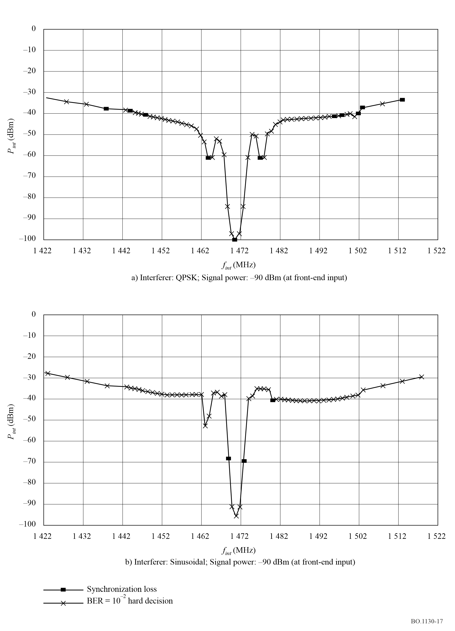

5 Link budgets
For typical power flux-densities (pfd’s) of −141.4 and −145.4 dB(W(m² · 4 kHz)), downlink margins are 9 and 5 dB, respectively, for a radio receiver with a G/T of −13 dB(K⁻¹). These pfds also correspond to the approximate −4 dB and −8 dB gain contours relative to the peak antenna gain in each beam.

5.1 Processing transponder
Table 4a) shows a typical link budget for the downlink of a processing transponder. The link budget is for a receive earth station with a G/T of −13.0 dB(K⁻¹) at an elevation angle of 30°.
The satellite antenna gain is 25.6 dB (−4 dB relative to peak) and the repeater output power is 300 W (2 × 150 W TWTAs operating in parallel). Output losses caused by the paralleling of the TWTAs, high power isolator, filter and waveguide losses sum to 1.3 dB. The TDM waveform results in a modulation loss of 0.3 dB. Thus the net downlink e.i.r.p. is 48.8 dBW (EOC).
Using a rate 1/2 Viterbi decoder and a RS block decoder, the theoretical value of E_{b}/N₀ required for a post FEC BER 1 × 10⁻⁴ is 2.7 dB. The implementation losses due to payload and prototype radio receiver hardware (HW) are specified to be 2.3 dB. Thus a C/N₀ of 67.0 dB(Hz) is required at the receiver input to support a data rate of 1 584 kbit/s.
With a receiver G/T of −13.0 dB(K⁻¹), a satellite e.i.r.p. of 48.8 dBW and atmospheric losses of 0.1 dB, the received C/N₀ is 76.7 dB(Hz) resulting in a margin of 9.7 dB. Receivers with other values of G/T or operating outside the − 4 dB down antenna contour would have different link margins.

5.2 Transparent transponder
Table 4b) shows a typical link budget for the downlink of a transparent transponder with the same radio receiver parameters as the processed mission. The link budget applies for one TDM with a nominal uplink C/(N0 + I0) of 82.4 dB(Hz) or C/N of 17.4 dB and the output backoff (OBO) due to uplink noise of 0.1 dB. With this value of OBO a satellite e.i.r.p. of 48.7 dBW yields a C/(N0 + I0) of 76.6 dB(Hz) at the prototype receiver input in the absence of any blockage or fade in the downlink (not including the retransmitted noise from the uplink, except as causing an additional satellite backoff). With an uplink C/(N0 + I0) of 82.4 dB(Hz) and the required C/(N0 + I0) at the receiver input of 67.2 dB(Hz), yields a total required C/(N0 + I0) in downlink is 67.3 dB(Hz), and a downlink margin of 9.3 dB. Similarly, for the worst-case variation of the uplink signal, the downlink margin can be shown to be 8.6 dB.

TABLE 4

a) Processing transponder downlink budget for Digital System D_{S} |  | b) Transparent transponder downlink budget for Digital System D_{S}

Downlink |  |  | Downlink
Frequency (GHz) | 1.48 |  | Frequency (GHz) | 1.48
Satellite |  |  | Satellite
Repeater output power (W) | 300.0 |  | Repeater output power (W) | 300.0
Output loss (dB) | 1.3 |  | Output loss (dB) | 1.3
OBO (dB) | 0.3 |  | OBO compression (dB) | 0.3
Antenna gain (dB) | 25.6 |  | Antenna gain at EoC (dB) | 25.6
e.i.r.p. (dBW) | 48.8 |  | Reference e.i.r.p. (dBW) | 48.8
Propagation |  |  | Propagation
Elevation (degrees) | 30.0 |  | Elevation (degrees) | 30.0
Distance (km) | 38 612.6 |  | Distance (km) | 38 612.6
Free space loss (dB) | 187.6 |  | Free space loss (dB) | 187.6
Pointing loss (dB) | 0.0 |  | Pointing loss (dB) | 0.0
Atmospheric loss (dB) | 0.1 |  | Atmospheric loss (dB) | 0.1
Radio receiver |  |  | Radio receiver
pfd (dB(W/m2)) | –114.1 |  | G/T (dB(K–1)) | –13.0
G/T (dB(K–1)) | –13.0 |  | Required Eb/N0 at 1 × 10–4 (dB) | 2.7
Received C/N0 (dB/Hz) | 76.7 |  | Hardware loss (dB) | 1.8
Required Eb/N0 at 1 × 10–4 (dB) | 2.7 |  | Intersymbol interference (dB) | 0.5
Hardware loss (dB) | 1.8 |  | Satellite HW loss | 0.2
Intersymbol interference (dB) | 0.5 |  | Bit rate (kHz) | 1 584.0
Bit rate (kHz) | 1 584.0 |  | Required C/N0 (dB(Hz)) | 67.2
Required C/N0 (dB(Hz)) | 67.0
Margin (dB) | 9.7

TABLE 4 (end)
 | Nominal conditions  on uplink: |  |  |  |  |  |  | Worst-case conditions on uplink:
 | Satellite |  |  |  |  |  |  | Satellite
 | OBO due to  Uplink C/(N + I) (dB) | 0.1 |  |  |  |  |  | OBO due to  Uplink C/(N + I) (dB) | 0.3
 | e.i.r.p. (dBW) | 48.7 |  |  |  |  |  | e.i.r.p. (dBW) | 48.5
 | Radio receiver |  |  |  |  |  |  | Radio receiver
 | pfd (dB(W/m²))  G/T (dB(K^{–1}))  Received C/N₀ (dB(Hz)) | –114.1  –13.0  76.6 |  |  |  |  |  | pfd (dB(W/m²))  G/T (dB(K^{–1}))  Received C/N₀ (dB(Hz)) | –114.4  –13.0  76.4
 | Uplink C/(N₀ + I₀) (dB) | 82.4 |  |  |  |  |  | Uplink C/(N₀ + I₀) (dB) | 76.4
 | Required C/(N₀ + I₀) (dB) | 67.2 |  |  |  |  |  | Required C/(N₀ + I₀) (dB) | 67.2
 | Required downlink  C/(N₀ + I₀) (dB) | 67.3 |  |  |  |  |  | Required downlink  C/(N₀ + I₀) (dB) | 67.8
 | Margin (dB) | 9.3 |  |  |  |  |  | Margin (dB) | 8.6

References

BRANDENBURG, K., STOLL, G., DEHERY, Y. F., JOHNSTON, J. D., KERKHOF, L. V. D. and SCHRÖDER, E. F. [1992] The ISO/MPEG-audio codec: A generic standard for coding of high quality digital audio. 92nd Audio Engineering Society (AES) Convention, Vienne, Austria. Preprint 3336.
EBERLEIN, E., POPP, H., GRILL, B. and HERRE, J. [1993] Layer III – A flexible coding standard, 94th AES Convention, Berlin, Germany. Preprint 3493.
ISO/IEC [1993] International Standard ISO 11172-3 – Information technology – Coding of moving pictures and associated audio for digital storage media up to 1.5 Mbit/s – Part 3: Audio.
ISO/IEC [1998] International Standard ISO 13818-3 – Information technology – Generic coding of moving pictures and associated audio information – Part 3: Audio.

Bibliography
ISO/IEC [1994] ISO/IEC JTC1/SC29/WG11 MPEG94/0848. Report on the subjective testing of coders at low sampling frequencies. Singapore.

Annex 4
Digital System D_{H}

1 Introduction
Digital System D_{H}, also known as the hybrid satellite/terrestrial WorldSpace system, is designed to provide satellite digital audio and data broadcasting for vehicular, fixed and portable reception by inexpensive common receivers. It extends the system structure of Digital System D_{S}, described in Annex 4. Digital System D_{S} was designed to optimize performance for satellite delivery using coherent QPSK modulation with block and convolutional coding, and non-linear amplification at TWTA saturation. It is now operating over Africa using the WorldSpace AfriStar satellite at 21° E and over Asia using the AsiaStar satellite at 105° E. The system provides for a flexible TDM of digitized audio and data sources to be modulated onto a downlink TDM carrier, and uses a hierarchical multiplex structure of three layers (physical, service and transport) that conforms to the OSI Model as recommended in Recommendation ITU-R BT.807.
Since launch of AfriStar in October 1998 Digital System D_{S} system has been delivering satellite direct digital broadcasting service over Africa. With the launch of AsiaStar in March 2000 the same service has started over Asia. Both satellites are delivering direct digital broadcast signal reception with very high margins of 4 to 13 dB within their outer beam coverage contour areas of 28 million km². Digital audio signals are being uplinked to transparent and processing payloads from diversely located uplink earth stations in the satellite global beams and broadcast via AfriStar over three 5.7° to 6° width beams covering Africa and the Middle East, and three more beams via AsiaStar from Indonesia and India to Korea and China. Four differently manufactured 1.5 GHz receivers receive these signals.
Digital System D_{H} extends the reception performance of Digital System D_{S} to deliver robust mobile reception performance to urban regions that suffer severe blockage by buildings and trees. A Digital System D_{H} architecture has now been specified. It provides terrestrial augmentation for digital sound broadcasting services in a mixed satellite/terrestrial configuration to mobile receivers as well as static and portable receivers. The development work has reached the stage where system validation testing has taken place using the AfriStar Satellite and a three-transmitter single frequency network in Erlangen, Germany. Further tests are planned in Pretoria, South Africa.
The satellite delivery component of Digital System D_{H} is based on the same TDM broadcast channel transport used in Digital System D_{S} but with several significant enhancements designed to improve line-of-sight reception in areas partially shadowed by trees. These enhancements include fast QPSK phase ambiguity recovery every 1.4375 ms, early/late time diversity and maximum likelihood combination of early/late time diversity signals.
The terrestrial delivery system component is based on MCM. MCM is a multipath-resistant orthogonal frequency division multiplex technique that has gained wide acceptance for pervasive mobile reception from terrestrial emitters. The MCM extension improves upon the techniques that are common in systems such as Digital System A, which is one standard used for terrestrial digital audio broadcast services. MCM utilizes multiple frequencies to avoid frequency selective fades thereby avoiding deleterious effects of delay spread. The MCM modulation scheme is most suitable for reliable reception in urban mobile environments, and leads to spectrum efficient solutions when single frequency networks are used.
A new Digital System D_{H} receiver design extends and improves upon the Digital System D_{S} design for satellite signal reception. It adds an MCM terrestrial reception branch to receive terrestrial signal single frequency network emissions. It uses two radio frequency tuner branches and demodulates the same TDM stream from both the satellite and terrestrial signal components. For its MCM extension, new terrestrial transport and physical layer specifications are added to the current service, transport and physical layers of Digital System D_{S}. Because the terrestrial transport directly modulates the TDM baseband symbols recovered by receivers at each terrestrial station of a terrestrial re-radiation network onto MCM carriers, the terrestrial transport is referred to as TDM-MCM.
The following sections describe in more detail the satellite and terrestrial retransmission components of Digital System D_{H}.
With the inclusion of the terrestrial delivery component, Digital System D_{H} can meet the service requirements stipulated not just in Recommendation ITU-R BO.789, but also Recommendation ITU-R BS.774 for satellite and complementary terrestrial delivery of digital sound broadcasting.

2 System overview

2.1 Layer structure of Digital System D_{H}
Digital System D_{H} uses the system layer structure illustrated in Fig. 18. It comprises service, transport and physical layers for both the TDM satellite segment and the TDM-MCM terrestrial repeater segment.

2.2 Satellite broadcast segment

2.2.1 Service layer
The service layer comprises audio, image and data source coders. WorldSpace uses a variation of ISO MPEG 2 Layer III called MPEG 2.5 Layer III for audio and ISO JPEG for image. The source data is organized into 432 ms broadcast channel frames in prime rate increments of 16 kbit/s. Prime rate increments are the building bricks of the baseband multiplex architecture. A broadcast channel frame can support up to eight service components, each carrying a rate from 8 kbit/s to 128 kbit/s, that can be individually accessed at the receiver. Each prime rate increment can support two 8 kbit/s service components. The sum of service component rates in a broadcast channel must not exceed 128 kbit/s. A broadcast channel transports a mix of services such as music, talk in selectable multiple languages, images associated with the latter and data in the form of packets or streaming. Each broadcast channel frame carries a service control header which at a receiver provides a broadcast channel frame synchronization preamble and the information needed identify the type of information carried, the information rate, the identity of the various services carried, ancillary information related to the various services, alpha-numeric text display, narrow casting of services, selection of the accessed services and authorization to access restricted and subscription services to individual users.
figure 18
The WorldSpace Digital System D_{H} signal layers with the MCM extension
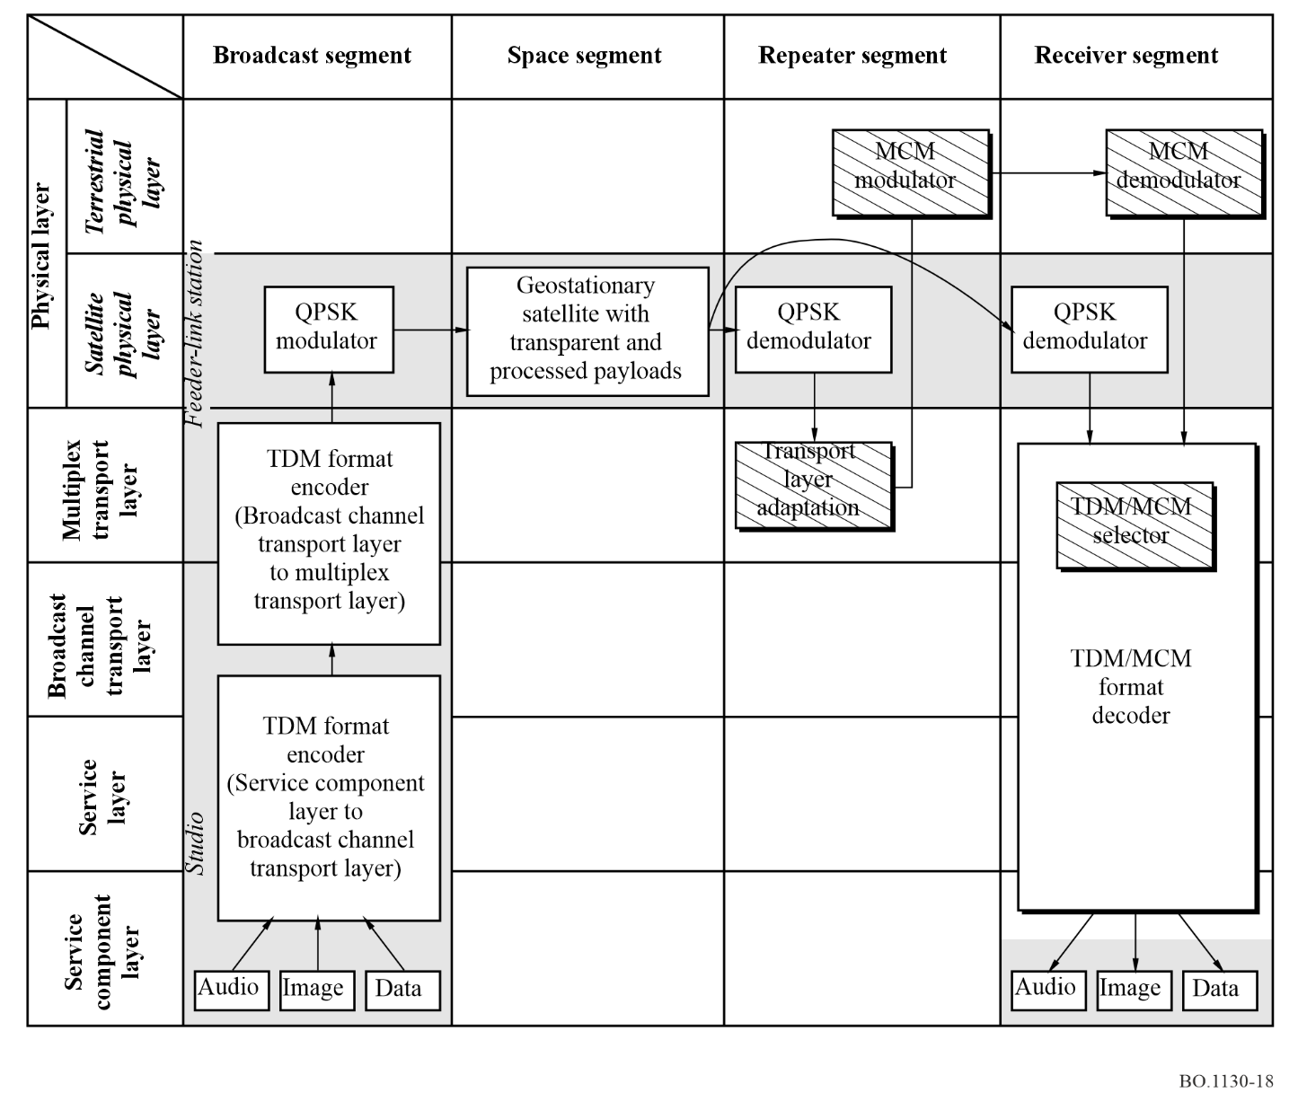

2.2.2 Transport layer

2.2.2.1 Time diversity only
For time diversity only using one satellite, the transport layer uses the architecture shown in Fig. 19. It accepts the bits of the broadcast channels from the service layer and first organizes them into symbols, each carrying two bits. FEC using the concatenation of an RS block coder and a convolution coder, next codes the symbols. Puncturing of the latter coder output creates two complementary companion error correction protected broadcast channels. One of the punctured broadcast channels is designated as the early channel. It is interleaved over a 432 ms frame to combat short-term reception fades. Its companion punctured broadcast channel, designated as the late channel, is delayed for approximately 4.32 s. This channel is intended for reception by the current standard WorldSpace receivers as well as by the new mobile radios. Also, it is not interleaved because doing so would render it incompatible for reception by a conventional WorldSpace receiver. The 4.32 s delay between the early and late broadcast channels provides long delay protection to combat blockages of satellite signal reception by bridges, short tunnels and trees as a vehicle travels along highways at typical speeds. The two companion punctured broadcast channels are next time division multiplexed into the TDM stream along with other mobile and non-mobile conventional broadcast channels. The system is intended to carry a mix of conventional broadcast channels for reception by the ordinary WorldSpace satellite broadcast receivers and complementary pairs of punctured broadcast channels, one early and one late, for reception by mobile receivers.
figure 19
Time diversity with a single satellite
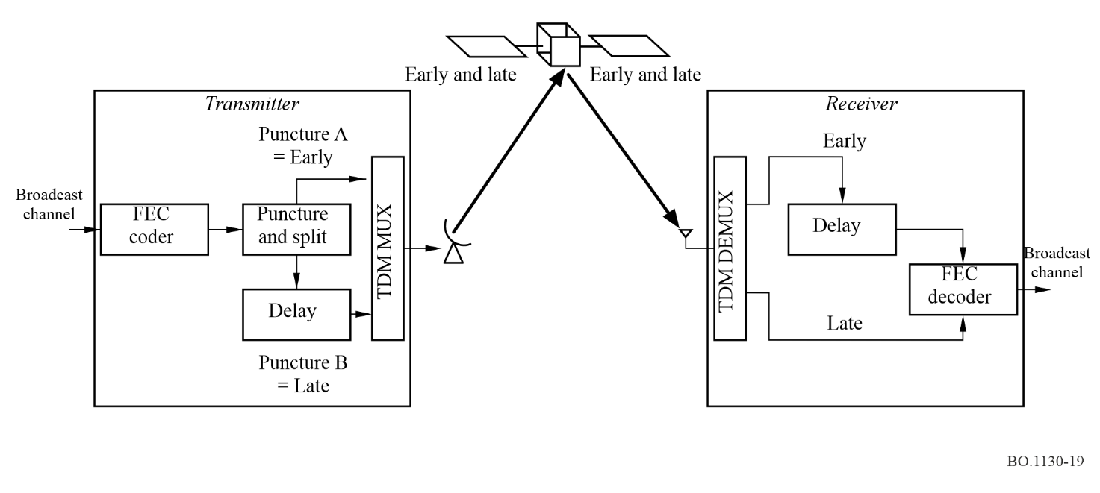

2.2.2.2 Time and space diversity
The satellite broadcast transport layer architecture for time and space diversity, illustrated in Fig. 20, uses two satellites spaced apart from one another by 15° to 35° along the geostationary orbit. It is best if the bisector between the satellites is centred over the intended earth coverage area. It uses the same early and late broadcast channel architecture described above for the time only diversity case. However, two TDM carriers are used, one transported by each satellite. Each may carry a mix of early and late broadcast channels or one can be designated to carry only early and the other only late. Also conventional broadcast channels not intended for mobile reception can be mixed with those for mobile. This is possible because every broadcast channel has its own broadcast channel identifier (BCID) that is used at the receiver to select specific broadcast channels from one or either of two received TDM stream(s).
figure 20
Space and time diversity with two satellites
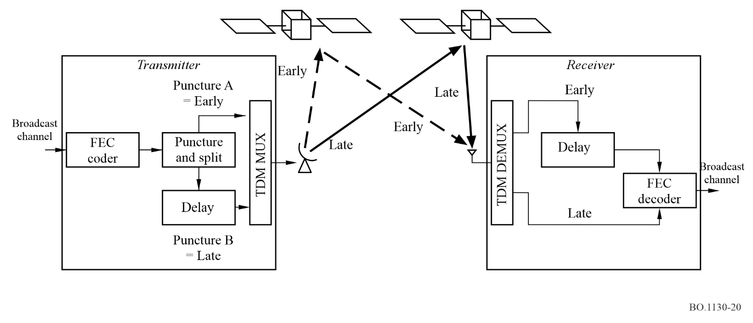

2.2.2.3 Broadcast Channel frame and FEC
Figure 21 shows a broadcast channel frame containing three service fields. Each service field carries a rate that is an integer multiple ni of the 16 kbit/s prime rate increment. Thus within each 432 ms frame, a service field i carrying a rate ni × 16 kbit/s has assigned to it ni × 6 912 bits. The bit rate of a service field has a range from 16 kbit/s to 128 kbit/s. Also the bit rate of a broadcast channel has a range from 16 kbit/s to 128 kbit/s. A broadcast channel can carry a maximum of eight service components that have rates ranging from 8 kbit/s to 128 kbit/s. Note that service components are in multiples of 8 kbit/s. Hence, whenever a service component’s rate is an odd multiple of 8 kbit/s, a dummy 8 kbit/s must be appended to produce an integer multiple of 16 kbit/s for the service fields in a broadcast channel. The total number of service fields in a broadcast channel is n = Σi (ni). To prepare for transport, each 6 912 bit service field prime rate increment of a broadcast channel is assigned 224 bits in a service control header bringing the number of bits per broadcast channel frame to n × 7 136. The broadcast channel frame is next FEC coded by a RS (223,255) block coder to yield an output of n × 8 160 bits per frame. To prepare for mobile service, the output of the RS coder is next supplied to a R 1/4 convolution coder whose output is split into two R 1/2 convolution coded broadcast channels, one destined to be the early broadcast channel and the other the late broadcast channel. At this point there are n × 16 320 bits assigned to the n service fields in each broadcast channel. The n service fields are next demultiplexed into n prime rate channels (PRCs). Adding a 96 bit preamble to each PRC brings the total to 16 416 bits per PRC.
figure 21
Broadcast channel frame
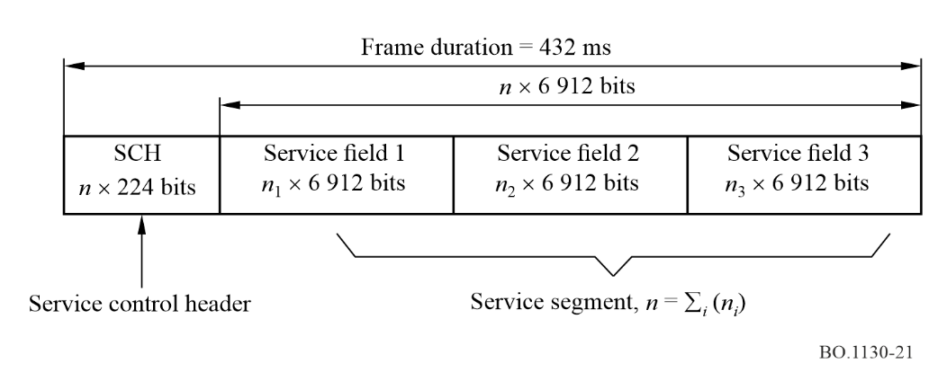

2.2.2.4 Terrestrial transport
If an originating studio is remote from an uplink station, the PRCs of a broadcast channel are transported to the station over terrestrial digital telephony links. This is typically done via Recommendation ITU-T G.736 digital telephony multiplexes. If the originating studio is collocated at or near the originating studio, the signals are simply transported over a local cable. The signal transported is that generated at the output of the RS block coded level. At this point the broadcast channels are said to be carried in a protected form. At the uplink stations the PRCs of the protected broadcast channels arriving from a multiplicity of origins are synchronously aligned by means of a plesiochronous buffer to prepare them for uplinking to the satellite. Next the PRCs of the protected broadcast channels are R 1/4 convolution coded and split by complementary puncturing into the R 1/2 convolutionally encoded early and late broadcast channels. The latter PRCs of the broadcast channels are next uplinked to the satellite communications payload. The system has two ways to transport via the satellite communications payload. One is that via a processing payload and the other that via a transparent payload.

2.2.2.5 Uplinking to the satellite
For the PRCs of broadcast channels destined to the processing payload, the uplink signals are transported in an FDMA format. Each FDMA signal comprises a 38 kbit/s QPSK modulated digital stream operating on carriers separated by 38 kHz in sets of 48 contiguous band carriers. Thus each 48 carrier set occupies 1 824 kHz of bandwidth. Six of these sets are uplinked to the satellite at frequencies located between 7 025 and 7 075 MHz. Onboard the satellite 96 PRCs of the FEC coded broadcast channels are demodulated to their symbol level, synchronously aligned. The PRCs of each broadcast channel can be routed to one, two or three TDM multiplexers. The routed symbols are time division multiplexed into 2 622 sets of 96 symbols each in a 138 ms TDM frame period. At the start of each TDM frame there are attached a 96 symbol MFP and a 2 112 symbol time slot control word (TSCW) making the entire frame 253 920 symbols long and yielding a symbol rate of 1 840 000 symbols/s. Hence, each TDM carrier requires a bandwidth of 2.3 MHz. For improved robustness in transport and reception, a pseudo-random symbol sequence is modulo-two added to scramble symbols of the TDM stream. Operationally, these TDM streams can support twenty-four 64 kbit/s broadcast channels for FM stereo quality audio service using the MPEG 2.5 Layer III source coder. Three processing payload TDM streams, QPSK modulated onto three carriers, are transmitted, one in each of three beams on different frequencies between 1 467 MHz and 1 492 MHz. In each of the three downlink beams, the beam centre e.i.r.p. of each carrier is 53.5 dBW. The −3 dB beamwidth is approximately 6°.
For the transparent payload, at the uplink station the PRCs of the R 1/2 convolutionally encoded broadcast channels signals are multiplexed onto a TDM carrier. An aggregate of 96 PRCs, converted to 2 bit symbols, is time multiplexed into 2 622 groups. Each group contains one symbol of the 96 PRCs carried in a TDM frame period of 0.138 s. To this is added an MFP of 96 symbols and a time slot control channel of 2 112 symbols to yield a total TDM frame of 253 920 symbols and a rate of 1.84 Mbit/s. The bandwidth needed to accommodate this TDM stream using QPSK modulation is typically 2.3 MHz. The 96 PRCs carried in the TDM stream carry the traffic of the mix of broadcast channels for both non-mobile and mobile services.
For broadcast channels intended only for non-mobile (direct-line-of-sight) reception, a R 1/2 convolutional coder is used after the RS coder. This R 1/2 convolution coder and the R 1/4 punctured to R 1/2 convolution coder used for the late mobile channel are compatible to the same receive side Viterbi decoder. In all other regards broadcast channel processing and TDM multiplexing for mobile and non-mobile receivers is the same.

2.3 MCM implementation
The TDM to MCM conversion of the satellite TDM symbol stream to a TDM-MCM signal for terrestrial re-radiation is illustrated in Fig. 22. For the time diversity only system, the resulting TDM-MCM signal is re-radiated by multiple terrestrial stations of a single frequency network (SFN).
figure 22
TDM to MCM conversion and terrestrial re-radiation
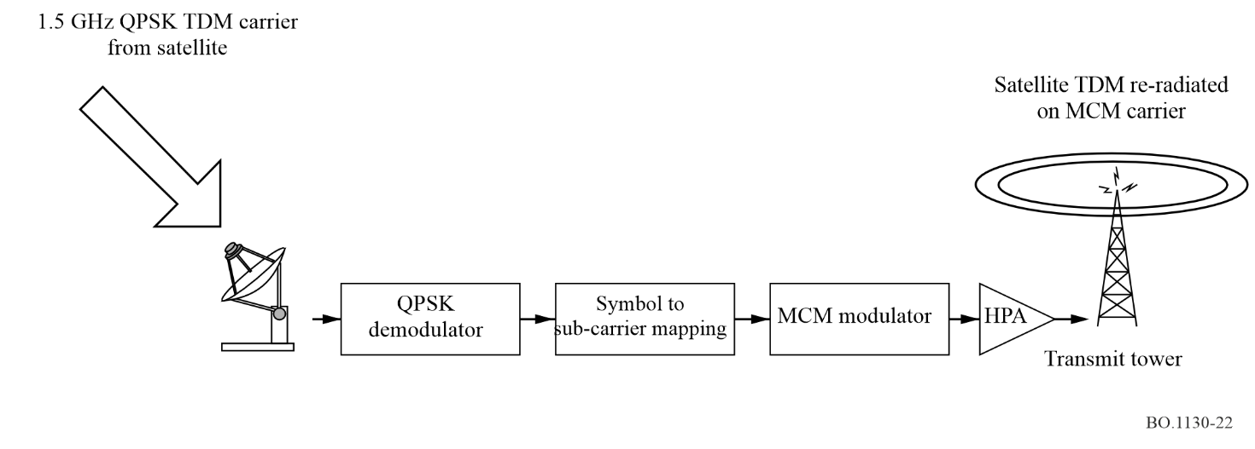
Using a 1.2 m diameter off-set-feed parabolic antenna connected to a WorldSpace receiver, the satellite QPSK TDM carrier is demodulated to its baseband TDM symbol signal form. It is next converted to a TDM-MCM form using the processing steps shown in Fig. 23. The TDM symbols are mapped to MCM sub-carrier symbols by constructing a multicarrier signal in the frequency domain. To do this the TDM symbols are first ordered into a row-column format, each column corresponding to an MCM symbol. The TDM symbol row elements of the column correspond to the individual MCM sub-carriers of an MCM symbol. To create the time domain signal for each MCM symbol, an inverse fast Fourier transform (IFFT) operates on the row elements of each column to generate a multiplicity of DQPSK signals, one for each TDM symbol. To mitigate intersymbol interference (ISI), a guard interval is inserted between MCM symbols by time domain compressing and repeating parts of the output sequence of the IFFT.
figure 23
TDM to MCM conversion
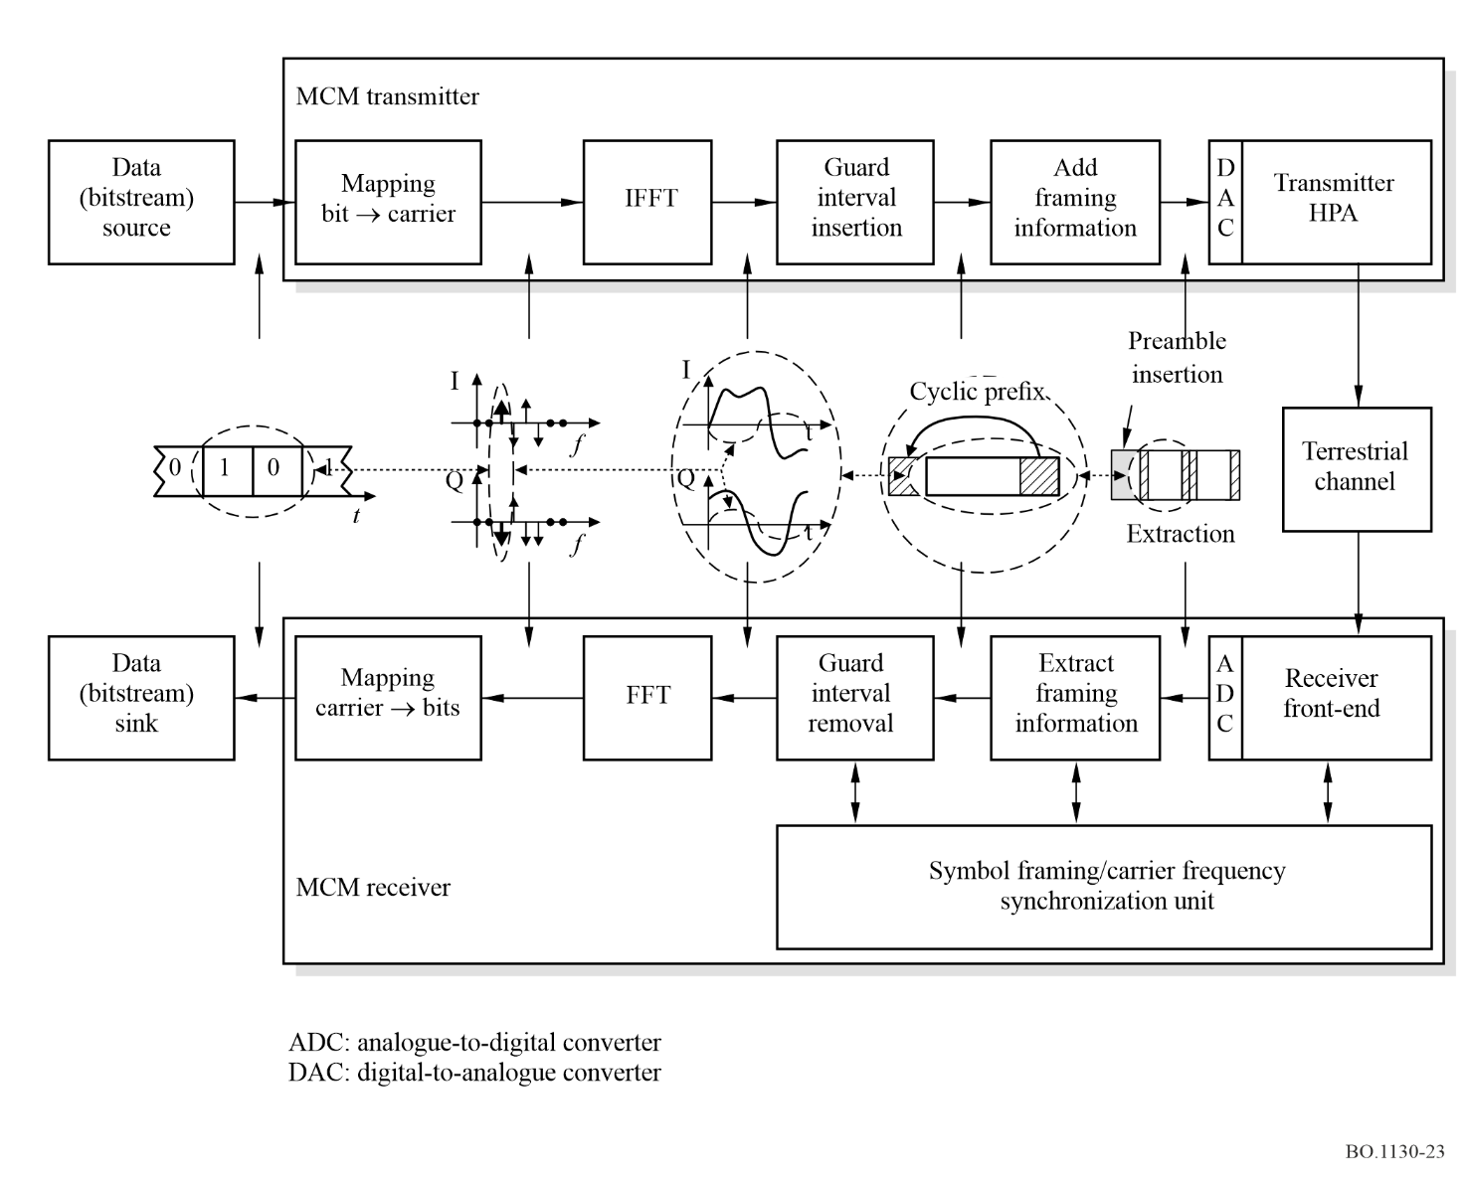
A time domain view of an MCM frame comprises a sequence of MCM symbols as shown in Fig. 24. Each MCM frame starts with an amplitude modulated synchronization sequence (AMSS) that is used at the receiver to recover MCM frame timing synchronization and carrier frequency and phase recovery. Each MCM frame comprises 23 MCM symbols. Each MCM symbol carries 552 DQPSK modulated carriers, one for each 2 bit TDM symbol plus one more carrier that is the phase reference for the DQPSK modulation. Each MCM symbol ends with a guard interval in which a time segment of length equal to the guard time but sampled at the start of the MCM symbol is repeated. The MCM frames are themselves formatted into a frame of 138 ms duration that is equal to the length of a TDM frame. At the receiver, this AMSS accommodates synchronization of the TDM frames recovered from the satellite and terrestrial paths.
figure 24
Time domain view of MCM frame
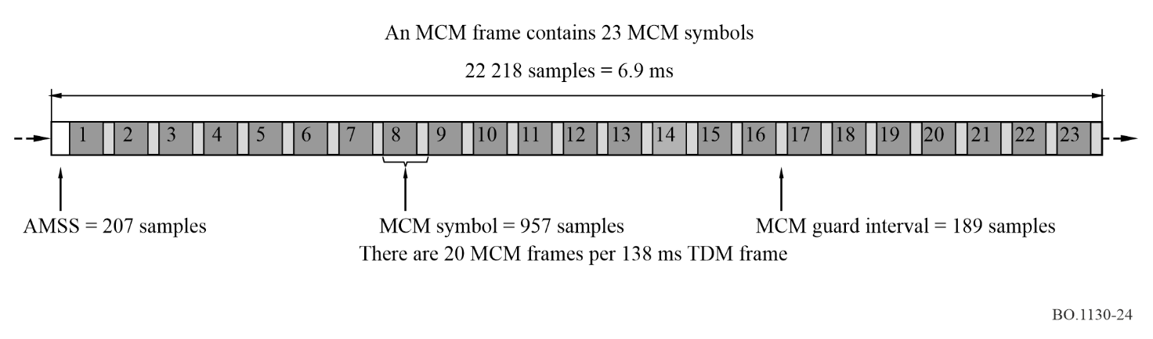

2.4 MCM waveform parameters
The MCM parameters being used for the mobile operations in the band 1 467-1 492 MHz are given in Table 5.
TABLE 5
MCM parameters
Parameter | Value
FFT length | 768
DQPSK active carriers | 552
DQPSK reference carrier | 1 per MCM symbol
TDM symbol MCM symbol mapping | 552 two bit TDM symbols per MCM symbol using DQPSK
MCM symbols per MCM frame | 23
MCM symbol frame length | 6.9 ms
Symbol duration | 297.21 μs
Guard interval | 58.70 μs included symbol duration
AMSS synchronization preamble  (at start of each MCM frame) | 64.29 μs
Framing | 20 MCM symbols (138 ms)
Sampling frequency | 3.22 MHz
Bandwidth | 2.32 MHz

Further details of the MCM signal construction are illustrated in Fig. 25.
figure 25
TDM-MCM processing steps summary
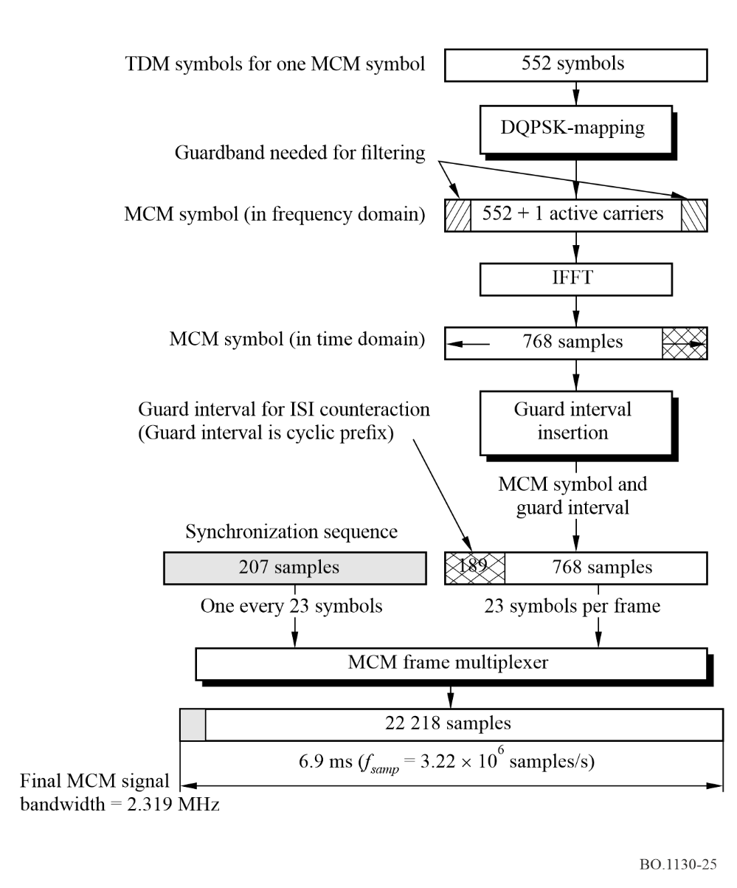
The theoretical spectrum of the MCM signal is shown in Fig. 26. Note the very rapid out-of-band fall-off that is typical of the MCM modulation process and aids in reduction of adjacent channel interference.

2.5 Time diversity delay between early and late broadcast channels
For time only diversity early and late broadcast channels may be transmitted as two different broadcast channels on one TDM carrier from one satellite and for time and space diversity from two separated satellites having, on two TDM carriers, one from each satellite.
Regarding the magnitude of the delay time needed for effective time diversity reception, experimental data from studies conducted in 1985 [DFVLR, 1985] in Europe and reported in 1986 [ICDSC-7, 1986] provide guidance. These experiments were performed via the MARECS-A satellite in geostationary orbit positioned at 15° W longitude. The data was collected for a vehicle travelling on rural highways at speed of 60 km/h. Results of specific interest here are plotted in Fig. 3b of the reference cited. A subset of the data taken from the latter figures is re-plotted here in Fig. 27.
Two curves are shown for mobile reception by a vehicle travelling on a highway at a speed of 60 km/h. One is without and the other with time diversity. They show the relationship between fade duration exceeded for 1% of the time in seconds on the vertical axis and receive threshold relative to mean received power (dB) on the horizontal axis. The curve without diversity shows that for a receive threshold of −10 dB the fade duration exceeds 4 s less that 1% of the time. With diversity the receive threshold is reduced to −2.7 dB. Conversely, fades having a duration of 4 s or less occur 99% of the time for a receive threshold of −10 dB without time diversity and −2.7 dB with time diversity. The system described in this text will have a delay time of 4.28 s.
figure 26
Theoretical MCM spectrum
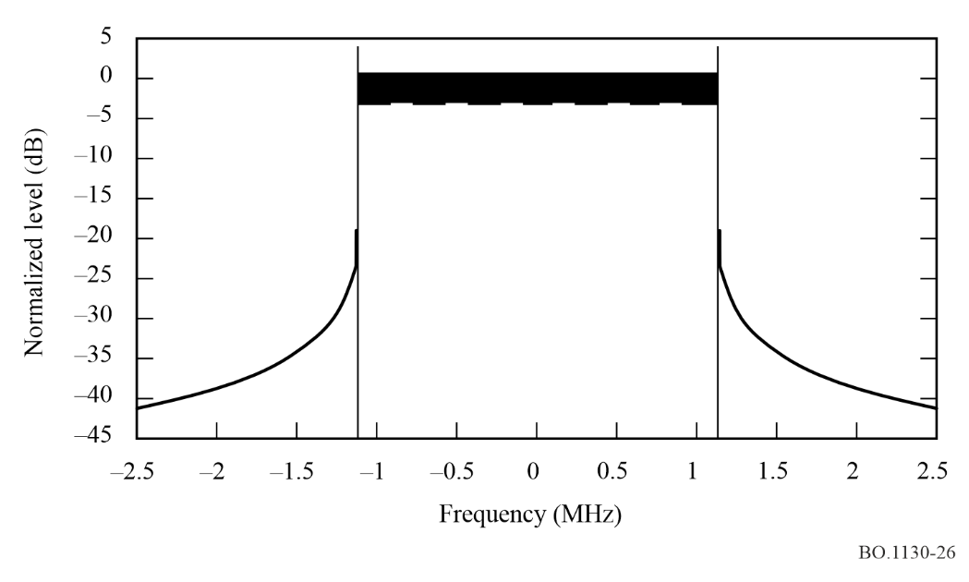
figure 27
Fade duration ≥ T_{f} vs. ratio of receive threshold to mean received power (dB) for a time share of fade = 1% for highway mobile reception with and without time diversity
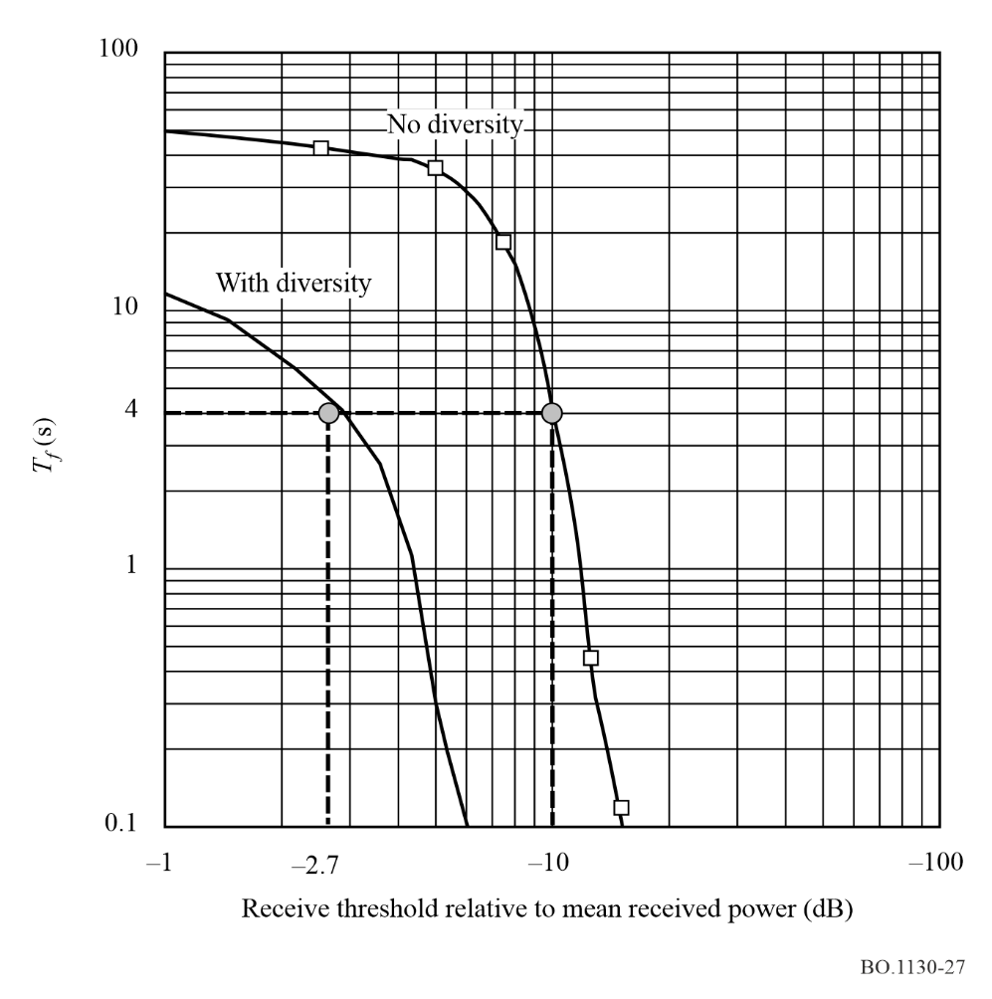

2.6 Receiving scenarios of hybrid satellite/terrestrial signals
The overall scenario of the mix of satellite LoS combined with terrestrial reinforcement for mobile reception is illustrated in Fig. 28. The scenario is composed of three regions which are discussed in the following.
figure 28
Reception scenarios
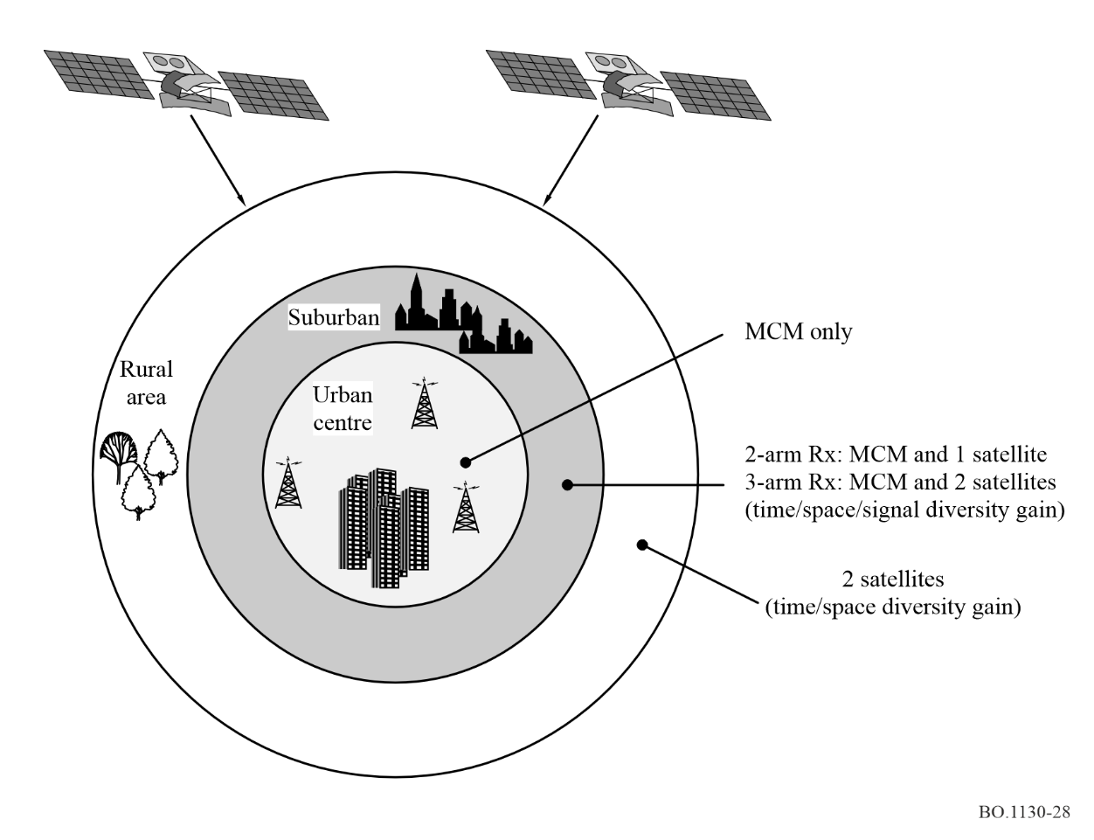

2.6.1 Outer region – Dominantly satellite reception region
The outermost region, shown as the outer annulus around a large city in Fig. 28, comprises mostly wide-open rural areas across which highways interconnect major cities and rural roads interconnect small towns. Along most of the highways and roads, LoS satellite reception will be possible for a large fraction of the time a vehicle moves along. However, inadvertently, a vehicle will encounter small regions where buildings and trees will interfere with direct LoS satellite reception even if time and space diversity are available. Thus, in many such rural regions, terrestrial reinforcement stations re-radiating the TDM-MCM signal will be installed, particularly, where the volume of service justifies doing so. These are likely to be 10 dBW to 20 dBW e.i.r.p. transmitters used principally for regions where the service availability using the satellite signals only would not be sufficient.

2.6.2 Intermediate region – Mix of satellite and terrestrial signals region
This is a transitional zone between intense urban and suburban/rural areas. It is composed of islands of tall housing and business clusters interspersed with a low rise suburban housing and rural settings. Thus, the satellite alone signal is likely to not be sufficient for full coverage. More intense use of terrestrial re-radiation is needed than in the rural region. As required by the topology, terrestrial repeaters radiating the TDM-MCM signal at power levels of 10 dBW to 20 dBW will be installed to provide the needed service availability.

2.6.3 Inner region – Dominant use of the terrestrial signal
For urban centres only terrestrial repeaters provide the coverage. Single frequency networks of multiple repeaters radiating the TDM-MCM signal at 30 dBW and higher are used to cover a complete urban centre if the coverage radius of one transmitter is not sufficient.

2.6.4 Vehicle transiting through the regions
As a vehicle transits toward the urban centre through the various regions of the scenario of Fig. 28, it will encounter various signal strengths and mixes of terrestrial re-radiated and satellite signals.
In open rural areas of the outer annulus, a vehicle will be a long distance, even over the radio horizon, from the nearest urban TDM-MCM re-radiators; hence, the satellite signal will dominate. In this case, a satellite receiver arm(s) will demodulate the TDM carrier(s), recover the early and late tuned broadcast channels and combine them by means maximum likelihood FEC decoding to recover the broadcast channel bits.
As the vehicle transits into the intermediate region, it will begin to encounter increasing levels of TDM-MCM signal. The receiver, using its FEC decoders, examines and compares the terrestrial and satellite signal quality in terms of estimated bit error ratios (BERter and BERsat). Receiver reception stays with the satellite signal as long as it continues to deliver a BERsat = Δ × BERter, Δ ≥ 1. When the latter condition becomes not true, receiver reception switches to the terrestrial signal. Only when the satellite signal BER decreases, such that BERter = Δ × BERsat, will reception switch again to the satellite signal. If BERter and BERsat are both too low for satisfactory reception, reception ceases. Values of Δ may be as great as 10.
A vehicle transiting in the intermediate region and also in the outer region will encounter towns, mountains and forests where LoS to the satellite(s) is blocked. TDM MCM terrestrial re-radiation repeaters are likely to be installed to achieve seamless coverage for travellers and local residents. Thus, a receiver will cycle between terrestrial reception and satellite reception as the receiver performs the quality processing and switching in terms of BER. It is important that such switching occur with a minimum of interrupt to the continuity of service. For audio services, inaudible interrupts may be tolerated, however, for data, such interrupts may cause the loss of service continuity. Measures to avoid such interrupts will be implemented.
When a transiting vehicle enters the centre region, reception is essentially 100% via the terrestrial signal. This is by design and involves the deliberate deployment of terrestrial re-radiators to accomplish pervasive coverage. Furthermore, once the receiver locks on to the terrestrial signal, the design of the signal quality comparator, as described above, is such as to inhibit return to satellite reception until the latter is dominantly the better. The value of Δ governs this aspect of the switching action.

2.7 Receiver architecture
Two receiver architectures are described in the following, one for time only diversity and the other for time and space diversity.
The time-only diversity receiver is shown in Fig. 29. It employs a combined antenna for satellite and terrestrial reception that connects to two receiver arms, one for satellite and the other for terrestrial. The satellite arm comprises a satellite tuner that selects a desired TDM satellite carrier, a QPSK demodulator to recover the TDM symbol stream, a TDM demultiplexer that selects a desired pair of complimentary early and late broadcast channels. An FEC decoder that uses a Viterbi maximum likelihood FEC trellis decoder synchronously combines the delayed early signal and the late signal. Delay of the early signal is implemented in the TDM demultiplexer. Precise synchronization needed for the combining is accomplished by aligning the preambles of the early and late broadcast channel frames. The post detection combiner is a switch that selects the broadcast channel of either the satellite or terrestrial receiver arm based on the quality measure previously described. The MCM arm of the receiver operates simultaneously and independently of the satellite. It tunes to the desired MCM carrier and demodulates it to the TDM symbol stream. From there on it operates precisely the same way as the satellite arm. The post detection combiner connects the terrestrial arm or the satellite arm to the output depending on its logic declaration as to which has the better quality. The selected broadcast channel is then demultiplexed into its constituent service components.
The time and space diversity receiver is shown in Fig. 30. It uses three arms, two for satellite signal reception and one for terrestrial signal reception. All three arms share the same antenna and LNA. One satellite signal will carry only early broadcast channels and the other only late broadcast channels. The third arm receives the terrestrial signal that comprises a TDM-MCM carrier transporting the TDM. The TDM transported via terrestrial re-radiation is that carrying only early broadcast channels received at the terrestrial re-radiating station directly from the satellite. Each satellite arm comprises a satellite tuner that selects a desired TDM satellite carrier, a QPSK demodulator to recover the TDM symbol stream and a TDM demultiplexer. One arm delivers the desired early broadcast channel and the other the companion late broadcast channel to a FEC decoder that uses a Viterbi maximum likelihood FEC trellis decoder to synchronously combine the delayed early signal and the late signal. The needed delay of the early signal is implemented in the TDM demultiplexer. Precise alignment needed for the Viterbi decoder combining is accomplished by aligning the preambles of the early and late broadcast channel frames. The MCM arm of the receiver operates simultaneously and independently of the satellite. It tunes to the MCM carrier and demodulates it to recover the TDM symbol stream, demultiplexes the TDM stream to recover the desired early broadcast channel and FEC decodes the latter in a Viterbi decoder. The latter broadcast channel will have to be delayed to bring it into synchronization with the broadcast channel recovered from the satellite arm. Some of the latter delay will have been introduced at the terrestrial reradiating stations as incidental in the conversion from TDM to TDM-MCM. Precise synchronization needed for post detection combining is accomplished by aligning the preambles of the early and late broadcast channel frames. The post detector combiner connects the terrestrial arm or the satellite arm to the output depending on its logic declaration as to which has the better quality. The selected broadcast channel is then demultiplexed into its constituent service components.
figure 29
Time-only diversity receiver
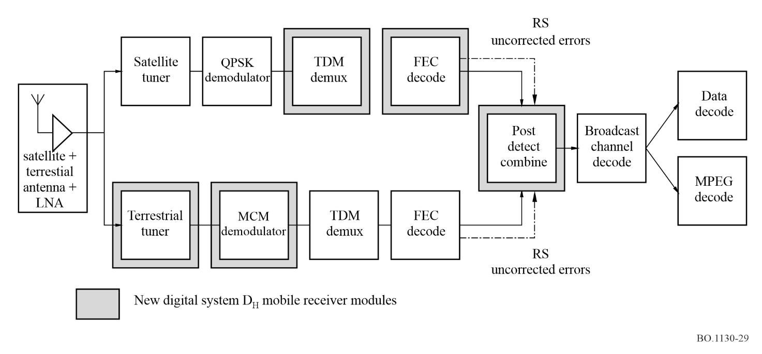
figure 30
Time and space diversity receiver
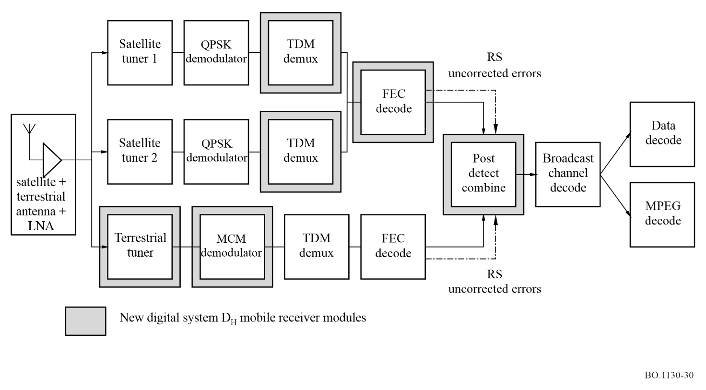

References

DFVLR [1985] German Aerospace Research and Test Establishment, now referred to as DLR, in connection with the Prosat/Prodat system.
ICDSC-7 [12-16 May, 1986] Seventh International Conference on Digital Satellite Communications. Proceedings of the ICDSC-7, p. 537-541. Munich, Germany.

Annex 5
Digital System E

1 Introduction
Digital System E is designed to provide satellite and complementary terrestrial on-channel repeater services for high-quality audio and multimedia data for vehicular, portable and fixed reception. It has been designed to optimize performance for both satellite and terrestrial on-channel repeater services delivery in the 2 630-2 655 MHz band. This is achieved through the use of CDM based on QPSK modulation with concatenated code using RS code and convolutional error correcting coding. The Digital System E receiver uses state-of-the-art microwave and digital large-scale integrated circuit technology with the primary objective of achieving low-cost production and high-quality performance.
The main features of this system are:
– This system is the first digital sound broadcasting system to be tested in field using the 2 630-2 655 MHz band that is assigned to BSS (sound) in some countries.
– MPEG-2 Systems architecture is adopted in order to achieve the flexible multiplexing of many broadcasting services and the interoperability with other digital broadcasting services. This is the first BSS (sound) system to adopt MPEG-2 Systems.
– MPEG-2 AAC is adopted for audio source coding. AAC gives the most efficient audio compression performance for high-quality audio broadcasting services.
– Vehicular reception is the main target of this system. Stable reception was confirmed in high-speed vehicles in the course of corroborative testing.
– Satellite signal can be received using omnidirectional single element antenna in the horizontal plane and a two-antenna diversity reception scheme for vehicles.

2 System overview
Figure 31 shows the system overview. This BSS (sound) system consists of a feeder-link earth station, a broadcasting satellite, two types of terrestrial gap-fillers, and portable, fixed and vehicular receivers.
The signal is transmitted from a feeder-link earth station to a broadcasting satellite at first, using a fixed-satellite service (FSS) uplink (the 14 GHz band for example). The signal is converted from the 14 GHz band to the 2.6 GHz band in the satellite. The 2.6 GHz band signal is amplified using a satellite transponder up to a desired level and this signal is broadcasted over the service area using a large transmitting antenna on the satellite.
The main programmes broadcast by this system are high-quality sound services in the first stage and multimedia services including data broadcasting in the following stage.
Listeners/viewers of this service can receive the broadcasting signal via the satellite using small antennas with low directivity. To generate enough e.i.r.p. for vehicular reception, the space station will need to be equipped with a large transmit antenna and high-power transponders.
The major issues related to signal propagation in the 2.6 GHz band are shadowing and blocking of the direct satellite path. This system uses two techniques to cope with the various types of shadowing and blocking.
figure 31
System overview
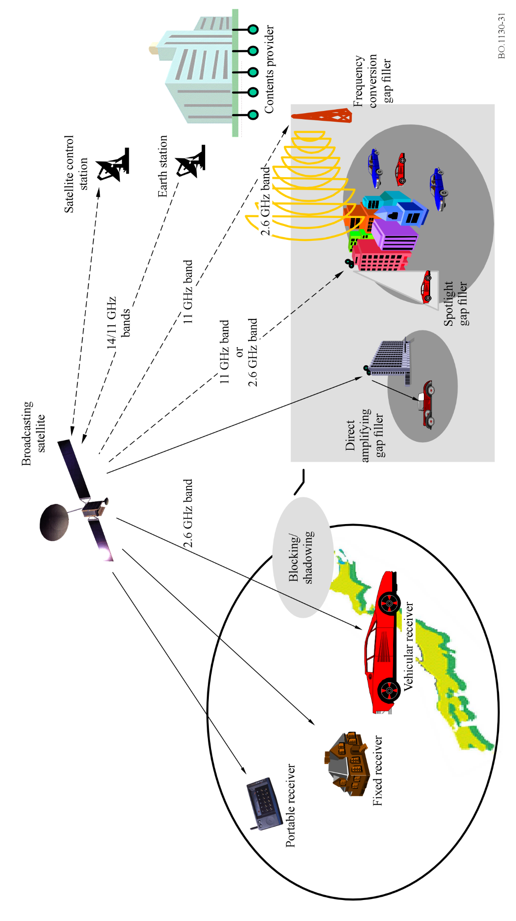
The first one is a bit-wise de-interleaver in the receiver to counter shadowing and blocking caused by small objects. This shadowing and blocking appears in a vehicular reception condition as solid bursts of noise in the received signal of up to approximately a second.
A solid burst of noise is distributed over a time period of several seconds using this de-interleaver to fit error-correcting capabilities of this system.
The second method to alleviate signal fades caused by shadowing and blocking is the inclusion of gap-fillers in the system design. Such gap-fillers retransmit the satellite signal. These gap-fillers are expected to cover the area blocked by, for example, buildings and large constructions. There are two types of gap-fillers in this system, the so-called direct amplifying gap-filler and the frequency conversion gap-filler to cover different types of blocked areas.
The direct amplifying gap-filler only amplifies the 2.6 GHz band signal broadcast from the satellite. This type of gap-filler is inherently limited to low gain amplifier to avoid undesired oscillation caused by signal coupling between transmitting and receiving antennas. This gap-filler covers a narrow area of direct path up to a 500 m long LoS area.
However, a frequency conversion gap-filler is intended to cover a large area within 3 km radius. The satellite fed signal is using a different frequency than the 2.6 GHz, for example, the 11 GHz band.
In such circumstances, multipath fading appears in the area where more than two broadcasting signals are received. In this broadcasting system, the CDM technique is adopted to secure a stable reception of the multipath-faded signal. By using a RAKE technique and antenna diversity in the receiver, a large improvement in the receiver’s performance is expected in the limited multipath-fading environment.
Spotlight type gap-filler also, shown in Fig. 31, could improve the multipath environments where CDM and RAKE receiver cannot decode properly without this gap-filler. This is a major feature of the CDM system. Spotlight gap-filler can either use amplification or frequency conversion to satisfy the specific requirement of the target area to be improved.
In CDM systems, different broadcasters will use different orthogonal codes for spreading the signal in order to broadcast their own programmes independently. Power flux-density (pfd) per unit bandwidth is relatively low because the CDM signal is spread over a wide frequency band.

3 Physical layer and modulation
Figure 32 shows the basic block diagram of the broadcasting system and Fig. 33 shows the detailed block diagram of CDM part of Fig. 32. In the following, the basic parameters and capabilities of channel coding and modulation of this broadcasting system are provided.
figure 32
Block diagram of broadcasting system
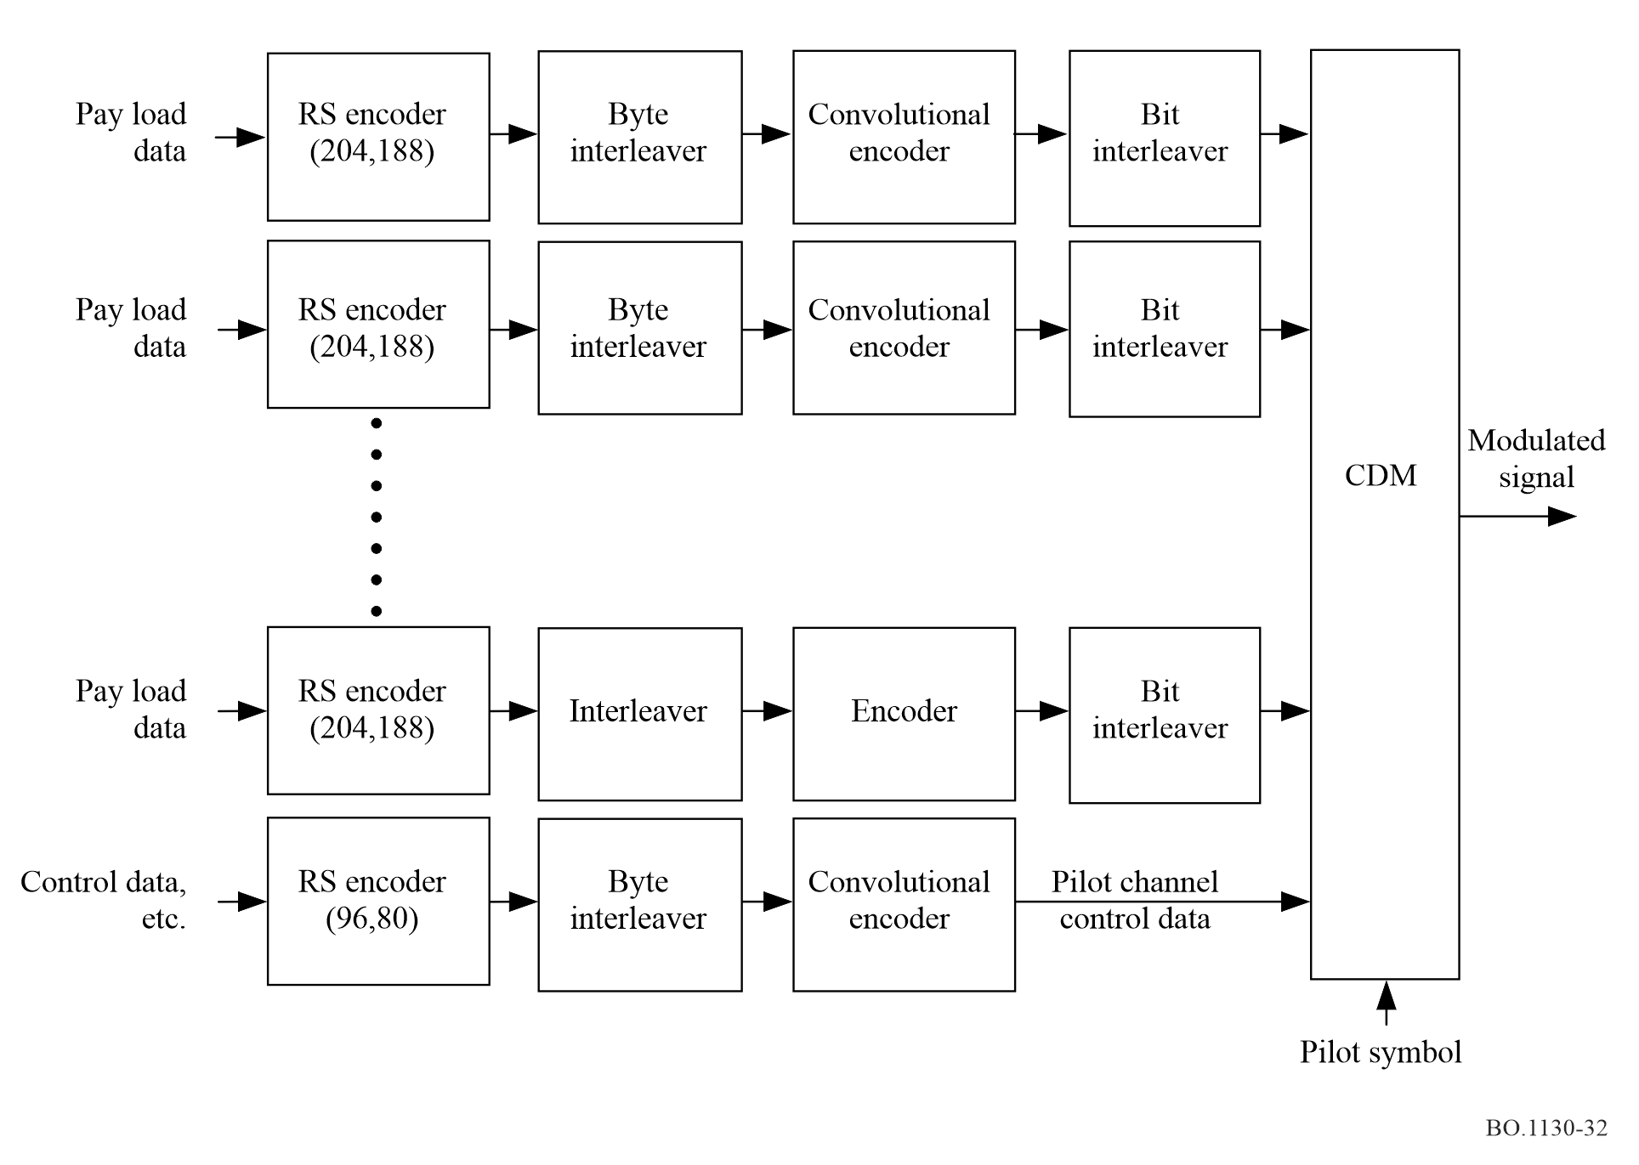

3.1 Frequency band
This system can be used in various frequency bands, but the main target is the 2 630-2 655 MHz band. Since this is the highest frequency band allocated to BSS (sound), the received signals are likely to experience the highest Doppler shift.

3.2 Bandwidth
Basic bandwidth is 25 MHz.

3.3 Polarization
Polarization is circular-polarization; however a complementary terrestrial repeater may use either circular-polarization or linear polarization.

3.4 Modulation
The CDM scheme is adopted for modulation both of the satellite link and the terrestrial gap filler link. As shown in Fig. 33, one data sequence is converted from serial bit stream to I and Q data sequences at first. After that, each I and Q data are spread by the same unique Walsh code (No. n) and a truncated M-sequence. These spread data are modulated into a QPSK signal. Modulated signals, each signal being identified by its Walsh code, are multiplexed with each other in the same frequency band.
figure 33
Detailed block diagram of CDM
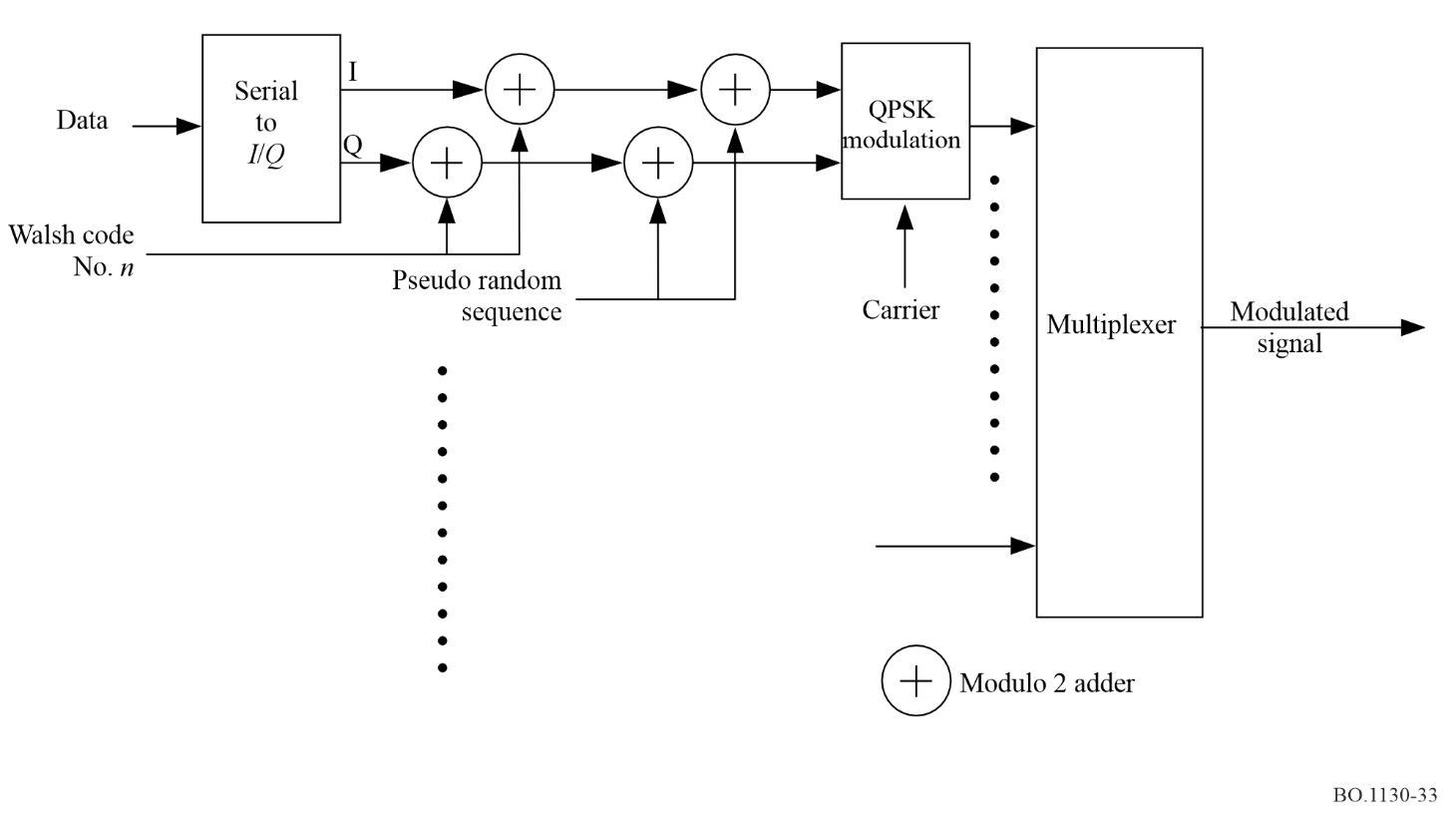

3.4.1 Modulation of carrier
One pilot channel and several broadcasting channels comprise one whole CDM modulated broadcasting system as shown in Fig. 32. A broadcasting channel and part of the pilot channel data stream uses QPSK modulation for the component modulation, while pilot symbols, frame synchronization symbols and a frame counter as defined in § 4.3, carried in the pilot channel data stream, are modulated using BPSK.

3.4.2 Symbol mapping
Symbol mapping of QPSK and BPSK is shown in Fig. 34. In this system, QPSK is demodulated using coherent phase detection.
FIGURE 34
Symbol mappings of QPSK and BPSK modulation
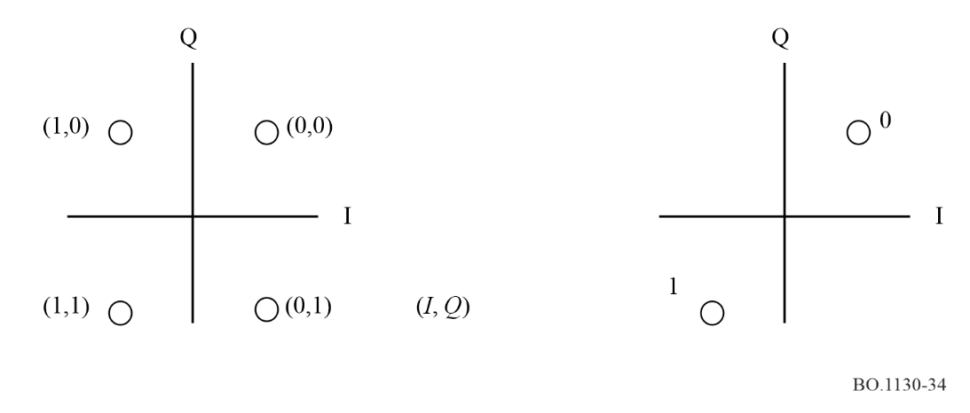

3.5 Chip rate
Chip rate is 16.384 MHz and processing gain is 64.

3.6 Signature sequence and spreading sequence
Walsh codes of 64-bit length and a truncated M sequence of 2048-bit length are adopted as the signature sequence and the spreading sequence respectively. This spreading sequence is obtained by truncating maximum length sequences of 4 095-bit length generated using 12-stage feedback shift register sequence.

3.7 Data spreading
Signature sequences and spreading sequences are modulo-2 added to the original I and Q sequence as shown in Fig. 33.

3.8 Roll-off factor
The transmitted signal is filtered by square-root raised cosine filter. The roll-off factor is 0.22.

3.9 The number of CDM channels
Theoretically, this system can multiplex 64 CDM channels because a 64-chip length Walsh code is adopted. In the corroborative testing, 30 CDM channels out of a possible 64 channels are multiplexed to achieve stable reception in multipath environment.

4 Channel coding

4.1 Error correction coding
Concatenated code comprised of a K = 7 convolutional code as inner code and shortened RS (204,188) code as outer code is adopted for forward error protection scheme.

4.1.1 Outer code
Outer code is the same as for other digital broadcasting systems. The original RS (255,235) code is defined as follows:
Code generator polynomial: g(x) = (x + λ0) (x + λ1) (x + λ2)…(x + λ15), where λ = 02h
Field generator polynomial: P(x) = x8 + x4 + x3 + x2 + 1
The shortened RS code can be implemented by adding 51 bytes, all set to zero, in front of the information bytes at the input of RS (255,239) encoder. After the RS coding procedure, these null bytes are discarded.

4.1.2 Inner code
K = 7 convolutional code is adopted as the inner code of this system. Any code rate can be selected from among 1/2, 2/3, 3/4, 5/6 and 7/8 by a puncturing technique for each broadcasting channel. These code rates are signalled through using control data of the pilot channel. Rate 1/2 convolutional code is used for the pilot channel.

4.2 Interleaving
Byte-wise convolutional interleaving is used between outer coding and inner coding. Furthermore, bit-wise convolutional interleaving with three segmented grouping is adopted after inner coding.

4.2.1 Byte-wise interleaving
Byte-wise interleaving is the same as for other digital broadcasting systems for example, DVB-S, DVB-T, ISDB-S and ISDB-T.

4.2.2 Bit-wise interleaving
Figure 35 shows the working mechanism of bit-wise interleaver, and Fig. 36 shows the conceptual diagram of a bit-wise interleaver and de-interleaver. The time delay of a bit-wise interleaver can be selected from eight possible positions defined in Table 6 for each broadcasting channel by using control data in pilot channel. In the corroborative testing, position 5 was selected; hence the bit-wise interleaver has about a 3.257 s delay to recover up to 1.2 s blackout of the received signal.
figure 35
Bit-wise interleaver
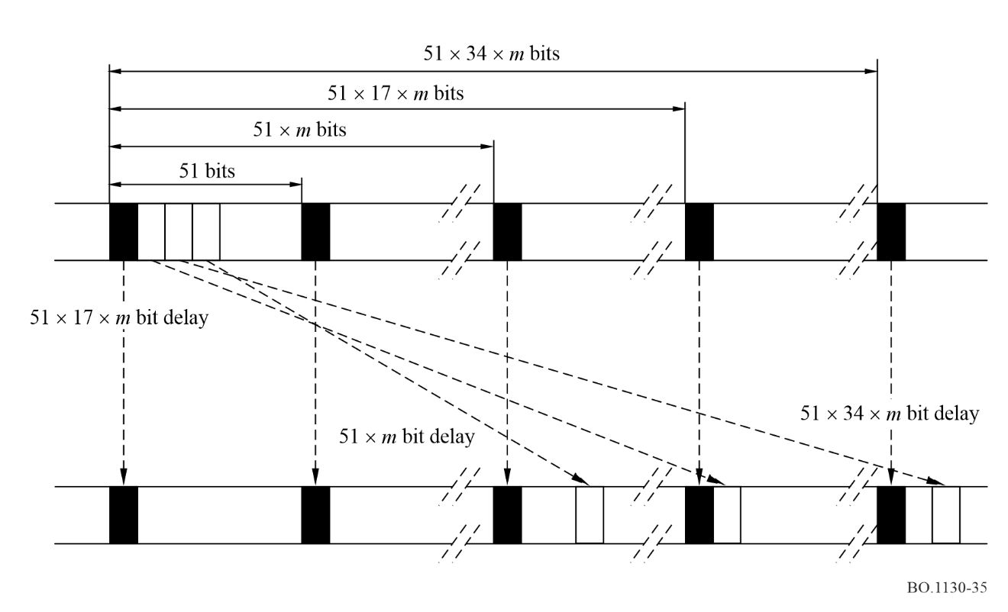
figure 36
Conceptual diagram of bit-wise interleaver and de-interleaver
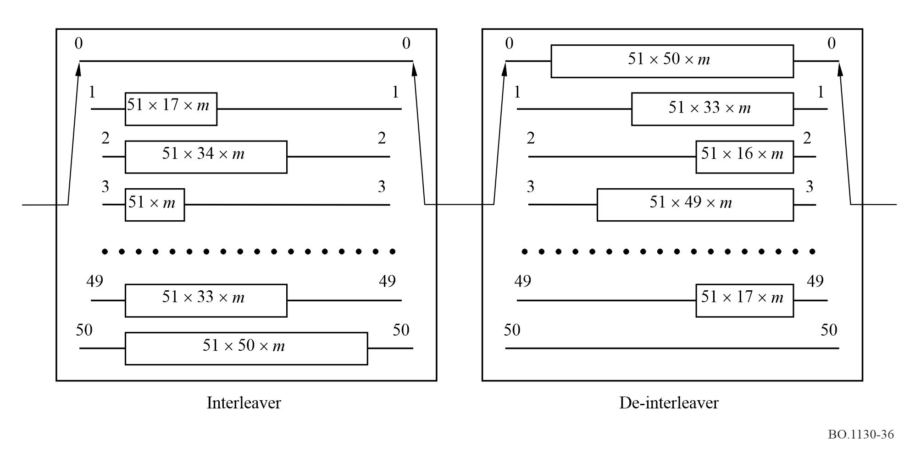
TABLE 6
Selectable positions of bit-wise interleaving size
Position | Value of parameter m
0 | 0
1 | 53
2 | 109
3 | 218
4 | 436
5 | 654
6 | 981
7 | 1 308

4.3 Pilot channel
Payload data is transmitted through broadcasting channels, while this system adopts a pilot channel to simplify the receiver’s synchronization and to transmit system control data.
A pilot channel has three functions. The first is to transmit the unique word for frame synchronization and frame counter for super frame synchronization. The second is to send a pilot symbol. The third is to transmit control data to facilitate the receiver functions.

4.3.1 Frame and super frame
Figure 37 shows the transmission frame and super transmission frame of this system.
figure 37
Frame and super frame in pilot channel
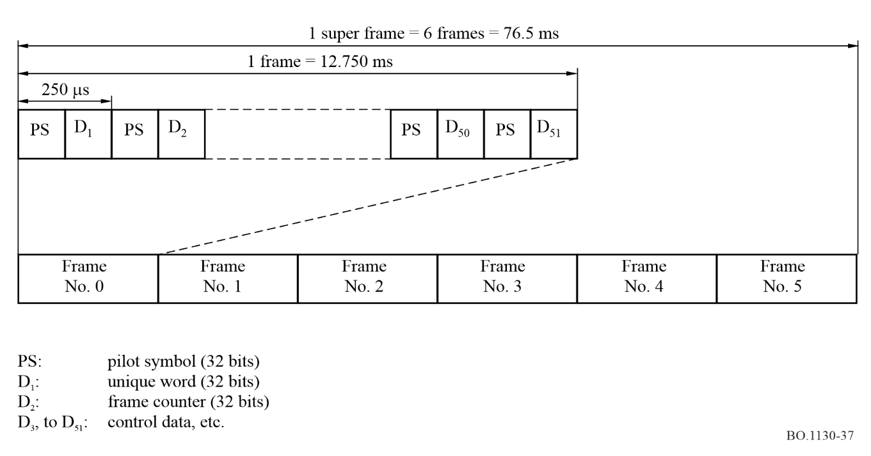
A pilot symbol is inserted every 250 μs as described in the next section. One transmission frame comprises 51 times of one pilot symbol insertion period that has a 12.75 ms time period. The first symbol D₁ (4 bytes or 32 bits) other than pilot symbols is the unique word.
Six times of transmission frame makes a super transmission frame that has a 76.5 ms time period. The second symbol D2 is the frame counter, which assists the receiver to establish super frame synchronization. Any broadcasting channel with an arbitrarily puncturing rate can be synchronized in one super frame time period because this is the least common multiplies of unit time intervals of each broadcasting channel with any possible puncture rate of convolutional code.

4.3.2 Pilot symbol
Special data embedded in the pilot channel are pilot symbols that are composed of 32-bit length continuing run of data 1. Using these pilot symbols, a receiver can analyse received signal profiles (path-search analysis) and these results are used to assist a RAKE receiver function. Pilot symbols are transmitted every 250 μs.
In order to improve the accuracy of path-search analysis, the pilot channel may have more signal power than a broadcasting channel. In the corroborative testing, the pilot channel had twice the signal power of a broadcasting channel.

5 Service multiplexing
ISO/IEC 13818-1 (MPEG-2 Systems) is adopted as the service multiplex. Considering maximum interoperability among a number of digital broadcasting systems, e.g. DVB-S, DVB-T, ISDB-S and ISDB-T, this system can exchange broadcasting data streams with other broadcasting systems through this interfacing point.
In this System, some services, which will come in the future, can be adopted if such future broadcasting services have adaptation capabilities in order to use MPEG-2 Systems.

6 Source coding

6.1 Audio source coding
MPEG-2 AAC (ISO/IEC 13818-7) is selected for this system. To use AAC bit stream in MPEG-2 Systems environment, audio data transport stream (ADTS) is adopted.

6.2 Data coding
Various types of data broadcasting are applicable including mono-media (e.g. video source coding, text) and multimedia (mixture of audio, video, text and data) as long as these data structures are MPEG-2 Systems compliant.

7 Example of an application of Digital System E

7.1 Satellite link
In this example, a geostationary station with a large transmission antenna is assumed. The feeder-link signal is fed from an earth station in the 14 GHz band while the service link (downlink) is to the Japanese area in the 2.6 GHz band. Major characteristics of the satellite are shown in the following:
– feeder-link signal frequency: 14 GHz band
– downlink frequency: 2 642.5 MHz
– downlink bandwidth (BW): 25 MHz
– e.i.r.p.: more than 67 dBW
(within service area, including antenna-pointing losses)

7.1.1 Spectrum
The spectrum of output signal from the satellite broadcasting station is shown in Fig. 38 in the case of 2 dB OBO. In this case, an output signal is simulated using a non-linear amplifier which has similar input/output characteristics to a typical satellite transponder.

7.1.2 BER vs. C/N₀ performances under AWGN environment
BER vs. C/N₀ performances under AWGN environment were measured for various kinds of OBO and frequency offset.
Figure 39 shows BER vs. C/N₀ performances for different OBO values of a satellite simulator. Unless otherwise noted, the following conditions were assumed in order to measure BER vs. C/N₀ performances described in this section:
– BER was measured at the point after Viterbi decoding;
– the coding rate used in convolutional coding was 1/2;
– the data rate after Viterbi decoder was 256 kbit/s;
– two-branch antenna diversity was used.
figure 38
Spectrum of output signal from satellite (2 dB OBO) (simulated using non-linear amplifier)
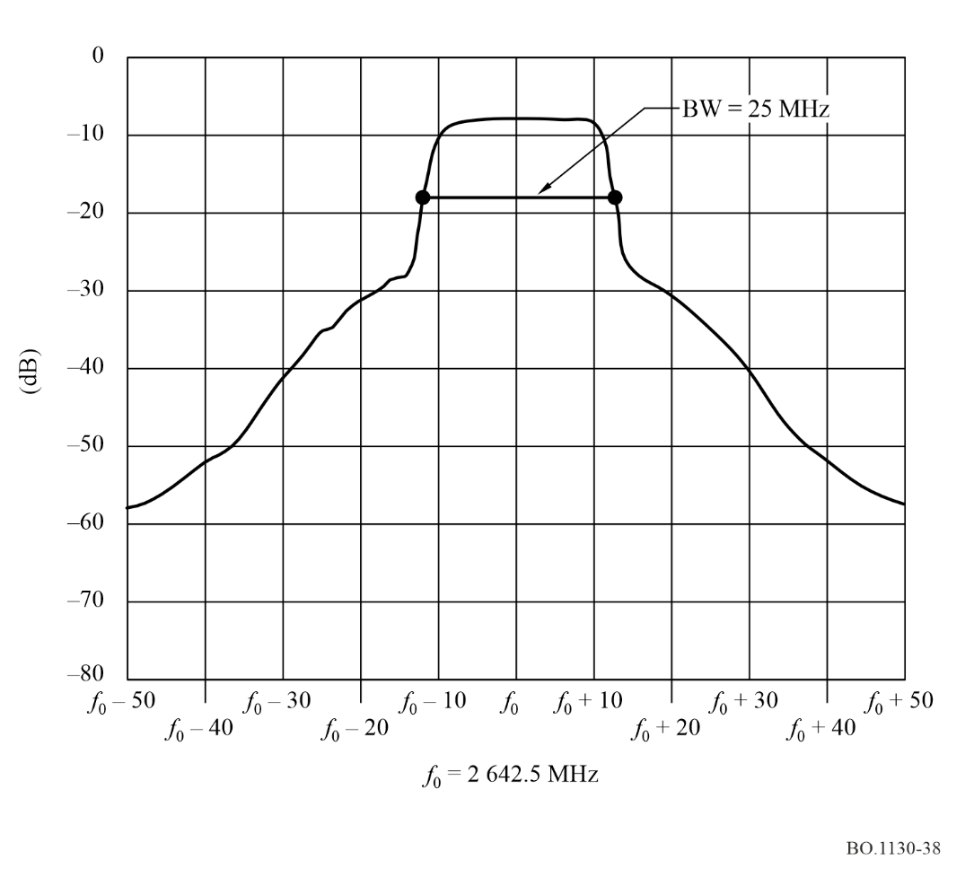
According to Fig. 39, when OBO of a satellite simulator is set at the operating point (= 2 dB), required C/N₀, which is defined in this system as C/N₀ where BER becomes 2 × 10⁻⁴, is 56.4 dB(Hz). Because the theoretical value of required C/N₀ for ideal receiver is 54.3 dB(Hz), measured implementation loss is 2.1 dB.
When OBO is set 1 dB smaller than operating point, required C/N₀ becomes 0.1 dB higher. On the other hand, when OBO is set 1 dB larger than operating point, required C/N₀ becomes 0.1 dB lower. Hence, degradations of BER performance due to this non-linearity are very small while its degradations may be observed.
Figure 40 shows BER vs. C/N₀ performances for different frequency offsets at the receiver. Note that OBO was 2 dB and other conditions other than frequency offset level were the same as Fig. 39. According to Fig. 40, degradation of required C/N₀ was 0.3 dB in each case of ±264 Hz (= ±1 × 10⁻⁷ at 2 642.5 GHz) frequency offset, hence the measured degradation due to the frequency offset up to ±264 Hz is small.
During these tests, the quality of received sound was monitored and it was confirmed that a degradation less than perceptible grade was not observed while the measured BER was less than 2 × 10⁻⁴ at the output of the Viterbi decoder. The function of programme selection was also checked and it was confirmed that the changing function to another programme worked successfully when the broadcast content was received correctly.
figure 39
BER versus C/N₀ under AWGN environment for different levels of transponder OBO
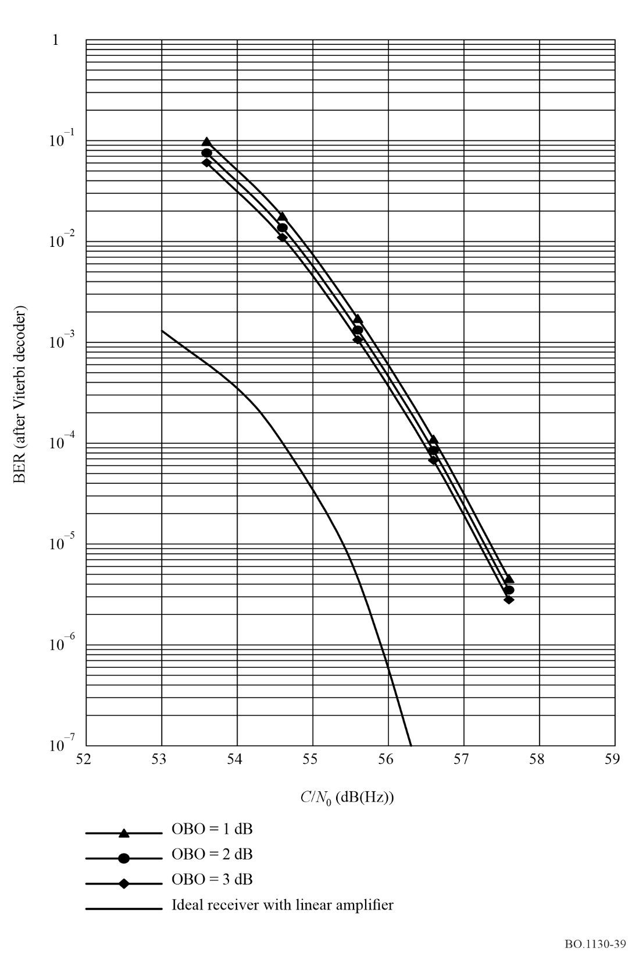
FIGURE 40
BER versus C/N₀ under AWGN environment for different frequency offsets
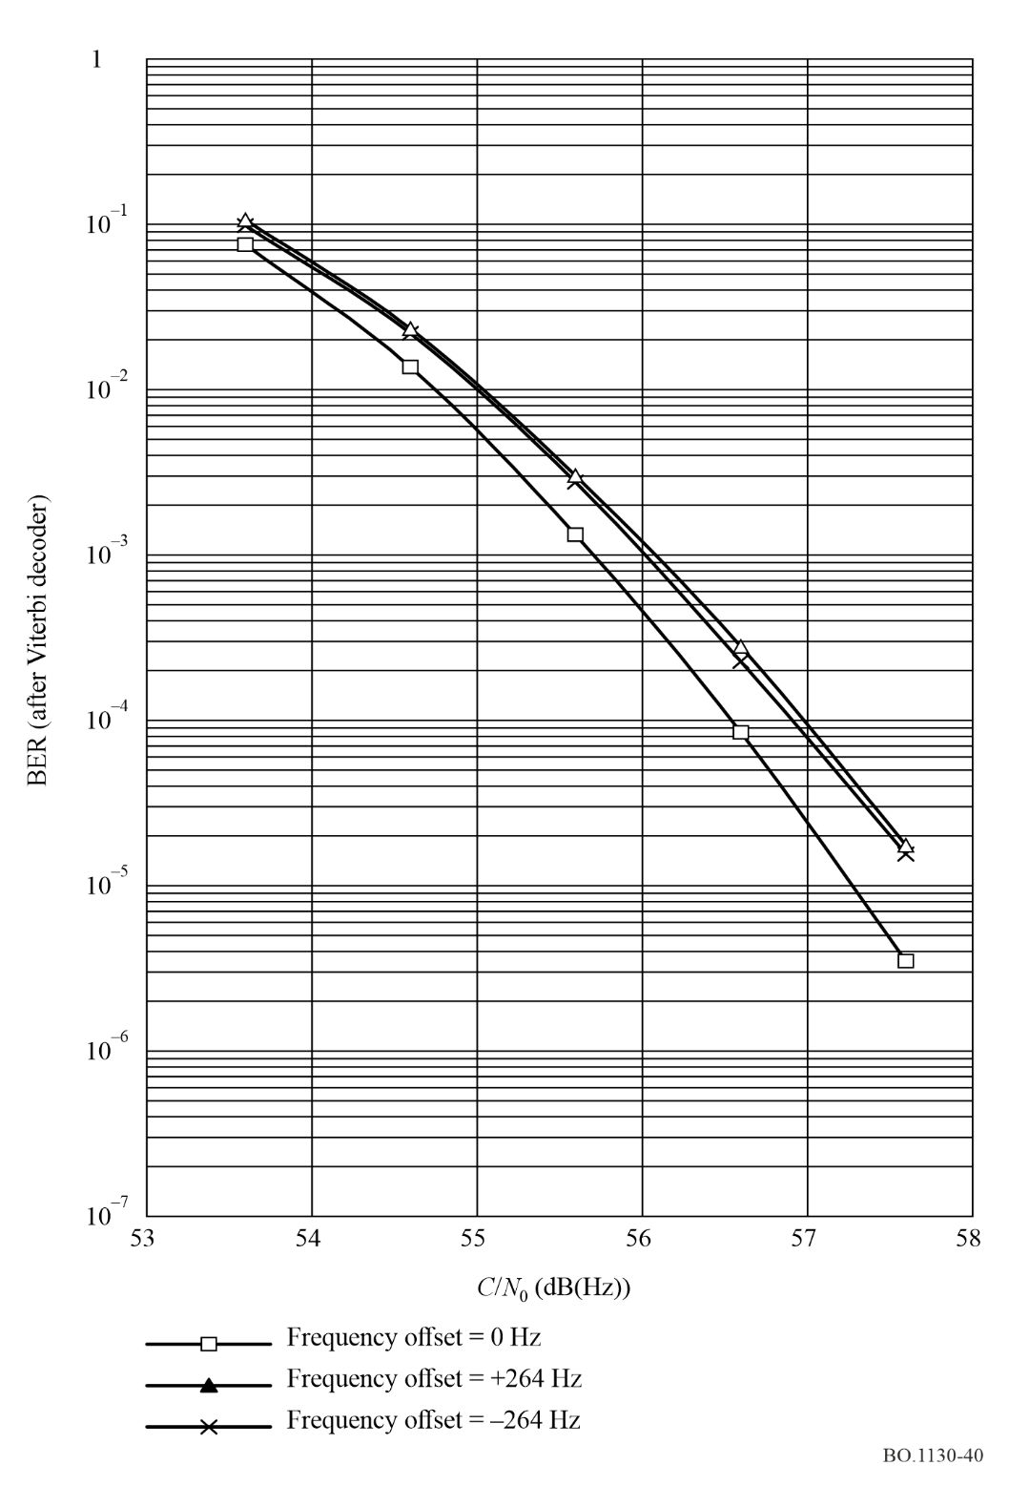

7.2 Gap filler

7.2.1 Direct amplifying gap filler
The main purpose of a direct amplifying gap filler is to receive the broadcasting signal directly from the broadcasting satellite, to amplify it, and to repeat it to the signal blocked area.
– Receiving frequency: 2 630-2 655 MHz
– Transmitting frequency: 2 630-2 655 MHz
– e.i.r.p.: 1.7 dBm
– Coverage area: LoS area up to 500 m from the station.

7.2.2 Frequency conversion gap filler
This equipment receives the 11/12 GHz bands feeder signal from the satellite, converts it to the 2.6 GHz band, amplifies it up to the desired level, and transmits it to the signal blocked area. The following are the major characteristics of the equipment:
– Receiving frequency: 11/12 GHz bands
– Transmitting frequency: 2 630-2 655 MHz
– e.i.r.p.: 60.7 dBm
– Coverage: circular area up to 3 km radius.

7.3 Experimental results of high-speed vehicular receptions
One of the main features of this system is its capability for vehicular reception. In the corroborative testing, high-speed vehicular reception was examined carefully in laboratory and field tests. Bit error rate vs. C/N₀ is shown in Fig. 41 for laboratory test result. There is only a small degradation of BER characteristics for 50 km/h, 100 km/h and 150 km/h. Field testing for high-speed vehicular reception was conducted at speeds up to 100 km/h on the Chuo highway along the west side of Tokyo metropolitan area.

7.4 Receiver model
Performances of typical vehicular receiver of this system are shown as follows and Fig. 42 depicts the block diagram of a typical vehicular receiver.
– Centre frequency: 2 642.5 MHz
– Input signal bandwidth: 25 MHz
– G/T: More than –21.8 dB(K^{–1})
Antenna gain: More than 2.5 dBi for satellite reception
More than 0 dBi for terrestrial reception
Noise figure: Less than 1.5 dB
– Demodulation: Pilot symbol aided coherent demodulation and RAKE receiver with six fingers
– Diversity: Two-antenna diversity
– Receiving filter: Square-root raised cosine roll-off filter (Roll-off factor is 22%)
– Decoding of convolutional code: Soft-decision Viterbi decoding
– Implementation loss: Less than 2 dB
(degradation from the theoretical
value at BER of 2 × 10^{–4})

figure 41
BER versus C/N₀ for high-speed reception (50 km/h, 100 km/h and 150 km/h)
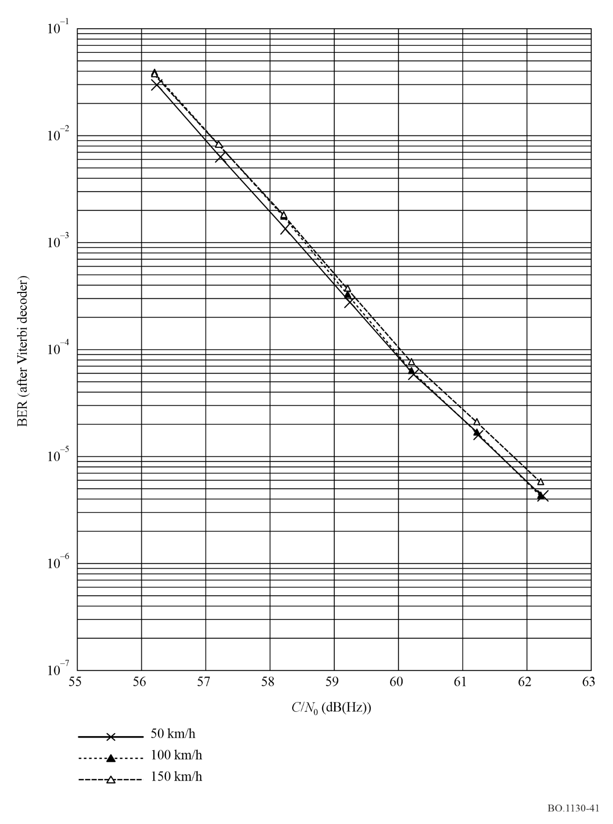

figure 42
Block diagram of typical receiver
