 | الا تحــاد الــدولي للاتصــالات  مكتب تقييس الاتصالات | 

 |  | جنيف، 16 سبتمبر 2022
المرجع:  الهاتف:  الفاكس:  البريد الإلكتروني: | TSB AAP-13  AAP/CL  +41 22 730 5860  +41 22 730 5853  tsbdir@itu.int | - إلى إدارات الدول الأعضاء في الاتحاد؛  - إلى أعضاء قطاع تقييس الاتصالات؛  - إلى المنتسبين إلى قطاع تقييس الاتصالات؛  - الهيئات الأكاديمية المنضمة إلى الاتحاد  نسخة إلى:  - رؤساء لجان الدراسات في قطاع تقييس الاتصالات ونوابهم؛  - مدير مكتب تنمية الاتصالات؛  - مدير مكتب الاتصالات الراديوية

الموضوع: حالة التوصيات الخاضعة لعملية الموافقة البديلة (AAP)

حضرات السادة والسيدات،
تحية طيبة وبعد،
تنطبق عملية الموافقة البديلة (AAP) المعرفة في التوصية ITU-T A.8 على التوصيات التي لا تنطوي على بعد سياسي أوتنظيمي ولا تتطلب بالتالي استشارة الدول الأعضاء رسمياً (انظر الرقم 246B من اتفاقية الاتحاد).
ويتضمن الملحق 1 لائحة بالنصوص التي تغيرت حالتها مقارنة بما جاء في إعلانات عملية الموافقة البديلة السابقة.
إذا رغبتم في تقديم تعليق بشأن توصية ما خاضعة لعملية الموافقة البديلة، فنرجو منكم استعمال استمارة التعليق على الخط المتوفّرة على موقع قطاع تقييس الاتصالات على صفحة عملية الموافقة البديلة https://www.itu.int/ITU-T/aap على المدخل الخاص بالتوصية المعنية (انظر الملحق (2. وبديلاً من ذلك، يمكنكم تقديم التعليقات باستكمال الاستمارة الواردة في الملحق 3 وإرسالها إلى أمانة لجنة الدراسات المعنية بالأمر.
وتجدر الإشارة إلى أنه يفضّل عدم إرسال تعليقات تقتصر على تأييد اعتماد النص قيد النظر.

وتفضلوا بقبول فائق الاحترام والتقدير.
تشيساب لي
مدير مكتب تقييس الاتصالات

الملحقات: 3

Annex 1
(to TSB AAP-13)

Status codes used in the AAP announcements:
LC = Last Call
LJ = Last Call Judgment (includes comment resolution)
AR = Additional Review
AJ = Additional Review Judgment (includes comment resolution)
SG = For Study Group approval
A = Approved
AT = Approved with typographic corrections
AC = Approved after Additional Review of Comments
NA = Not approved
TAP = Moved to TAP (ITU-T A.8 / § 5.2)
ITU-T website entry page:
https://www.itu.int/ITU-T
Alternative approval process (AAP) welcome page:
https://www.itu.int/ITU-T/aapinfo
Note – A tutorial on the ITU-T AAP application is available under the AAP welcome page
ITU-T website AAP Recommendation search page:
https://www.itu.int/ITU-T/aap/
Study Group web pages and contacts:
SG 2 | https://www.itu.int/ITU-T/studygroups/com02 | tsbsg2@itu.int
SG 3 | https://www.itu.int/ITU-T/studygroups/com03 | tsbsg3@itu.int
SG 5 | https://www.itu.int/ITU-T/studygroups/com05 | tsbsg5@itu.int
SG 9 | https://www.itu.int/ITU-T/studygroups/com09 | tsbsg9@itu.int
SG 11 | https://www.itu.int/ITU-T/studygroups/com11 | tsbsg11@itu.int
SG 12 | https://www.itu.int/ITU-T/studygroups/com12 | tsbsg12@itu.int
SG 13 | https://www.itu.int/ITU-T/studygroups/com13 | tsbsg13@itu.int
SG 15 | https://www.itu.int/ITU-T/studygroups/com15 | tsbsg15@itu.int
SG 16 | https://www.itu.int/ITU-T/studygroups/com16 | tsbsg16@itu.int
SG 17 | https://www.itu.int/ITU-T/studygroups/com17 | tsbsg17@itu.int
SG 20 | https://www.itu.int/ITU-T/studygroups/com20 | tsbsg20@itu.int

Situation concerning Study Group 5 Recommendations under AAP
Rec # | Title | Last Call (LC) Period |  |  |  | Additional Review (AR) Period |  |  |  | Status
Rec # | Title | LC Start | LC End | LC  Result | LJ  Result | AR Start | AR End | AR  Result | AJ  Result | Status
L.1480 (L.Enablement) | Enabling the Net Zero transition: Assessing how the use of ICT solutions impacts GHG emissions of other sectors (Summary) | 2022-07-16 | 2022-08-12 | LJ | AR | 2022-09-16 | 2022-10-06 |  |  | AR
Situation concerning Study Group 13 Recommendations under AAP
Rec # | Title | Last Call (LC) Period |  |  |  | Additional Review (AR) Period |  |  |  | Status
Rec # | Title | LC Start | LC End | LC  Result | LJ  Result | AR Start | AR End | AR  Result | AJ  Result | Status
Y.2086 (Y.DNI-fr) | Framework and Requirements of Decentralized Trustworthy Network Infrastructure (Summary) | 2021-08-16 | 2021-09-12 | LJ | SG |  |  |  |  | SG
Situation concerning Study Group 17 Recommendations under AAP
Rec # | Title | Last Call (LC) Period |  |  |  | Additional Review (AR) Period |  |  |  | Status
Rec # | Title | LC Start | LC End | LC  Result | LJ  Result | AR Start | AR End | AR  Result | AJ  Result | Status
X.1377 (X.ipscv) | Guidlines for an intrusion prevention system for connected vehicles (Summary) | 2022-09-16 | 2022-10-13 |  |  |  |  |  |  | LC
Z.161 | Testing and Test Control Notation version 3: TTCN-3 core language (Summary) | 2022-09-16 | 2022-10-13 |  |  |  |  |  |  | LC
Z.161.1 | Testing and Test Control Notation version 3: TTCN-3 language extensions: Support of interfaces with continuous signals (Summary) | 2022-09-16 | 2022-10-13 |  |  |  |  |  |  | LC
Z.161.2 | Testing and Test Control Notation version 3: TTCN-3 language extensions: Configuration and deployment support (Summary) | 2022-09-16 | 2022-10-13 |  |  |  |  |  |  | LC
Z.161.3 | Testing and Test Control Notation version 3: TTCN-3 language extensions: Advanced parameterization (Summary) | 2022-09-16 | 2022-10-13 |  |  |  |  |  |  | LC
Z.161.4 | Testing and Test Control Notation version 3: TTCN-3 language extensions: Behaviour types (Summary) | 2022-09-16 | 2022-10-13 |  |  |  |  |  |  | LC
Z.161.5 | Testing and Test Control Notation version 3: TTCN-3 language extensions: Performance and real time testing (Summary) | 2022-09-16 | 2022-10-13 |  |  |  |  |  |  | LC
Z.161.6 | Testing and Test Control Notation version 3: TTCN-3 language extensions: Advanced Matching (Summary) | 2022-09-16 | 2022-10-13 |  |  |  |  |  |  | LC
Z.161.7 | Testing and Test Control Notation version 3: TTCN-3 Language Extensions: Object-Oriented Features (Summary) | 2022-09-16 | 2022-10-13 |  |  |  |  |  |  | LC
Z.165 | Testing and Test Control Notation version 3: TTCN-3 runtime interface (TRI) (Summary) | 2022-09-16 | 2022-10-13 |  |  |  |  |  |  | LC
Z.165.1 | Testing and Test Control Notation version 3: TTCN-3 extension package: Extended TRI (Summary) | 2022-09-16 | 2022-10-13 |  |  |  |  |  |  | LC
Z.166 | Testing and Test Control Notation version 3: TTCN-3 control interface (TCI) (Summary) | 2022-09-16 | 2022-10-13 |  |  |  |  |  |  | LC
Z.167 | Testing and Test Control Notation version 3: Using ASN.1 with TTCN-3 (Summary) | 2022-09-16 | 2022-10-13 |  |  |  |  |  |  | LC

Annex 2
(to TSB AAP-13)
Using the on-line comment submission form
Comment submission
1) Go to AAP search Web page at https://www.itu.int/ITU-T/aap/
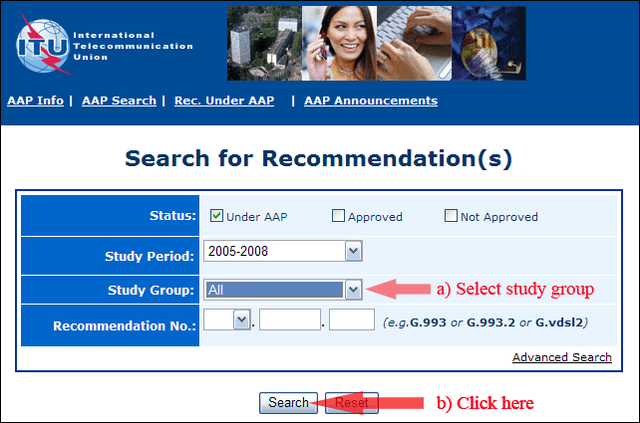
2) Select your Recommendation
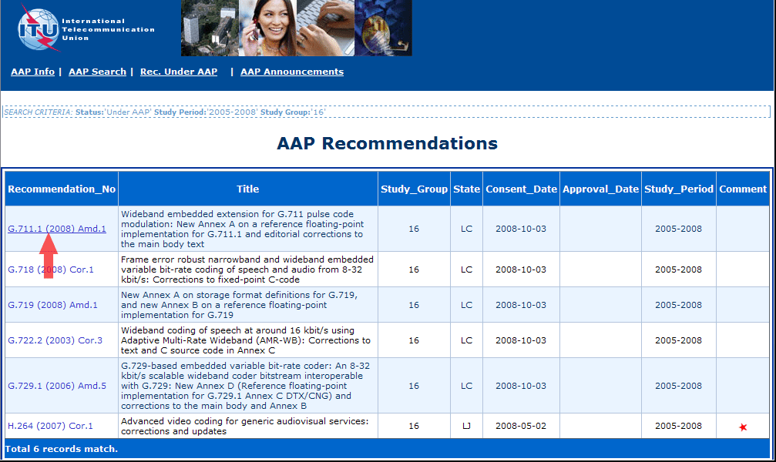
3) Click the "Submit Comment" button
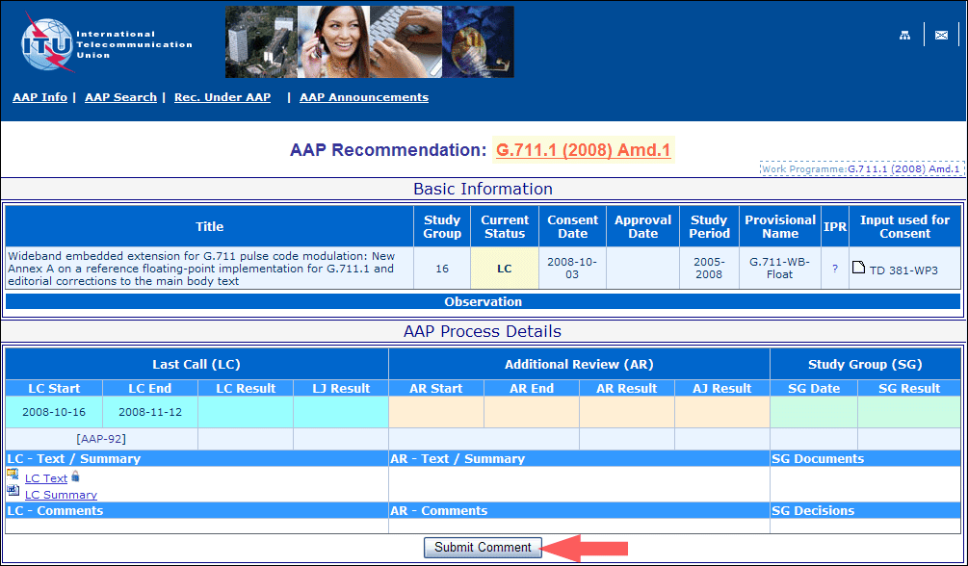
4) Complete the on-line form and click on "Submit"
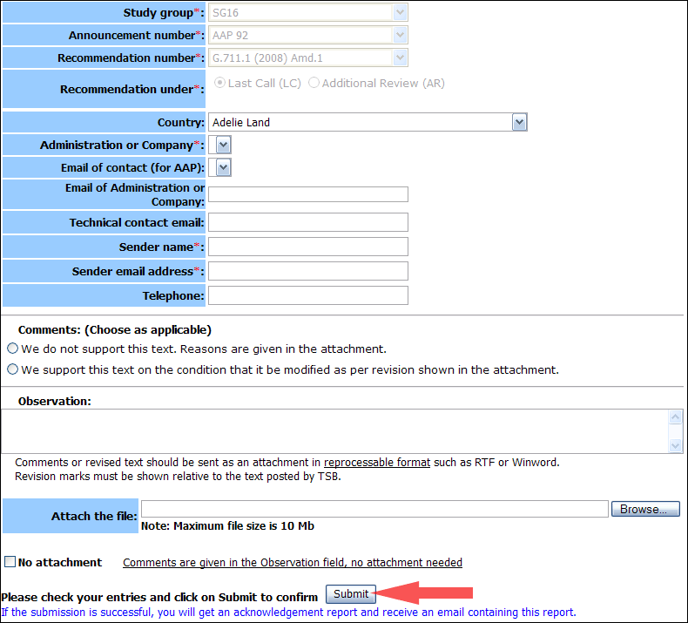
For more information, read the AAP tutorial on:
https://www.itu.int/ITU-T/aapinfo/files/AAPTutorial.pdf
Annex 3
(to TSB AAP-13)
Recommendations under LC/AR – Comment submission form
(Separate form for each Recommendation being commented upon)
ITU-T AAP comment submission form
Study Group:
Announcement number:
Recommendation number:
Date consented:
Recommendation under: | Last call (LC)  Additional Review (AR)
Country:
Administration/Company:
Name of AAP Contact Person:
Email of AAP Contact Person:
Sender name:
(if different from AAP Contact Person)
Sender email address:
Telephone:
Comments:  (Choose as applicable) | We do not support this text. Reasons are given in the attachment.  We support this text on the condition that it be modified as per revision shown in the attachment.
Observations:
No attachment: Comments are given in the Observation field, no attachment needed
To be returned to: email: tsbsg....@itu.int
[or fax +41 22 730 5853]
Comments or revised text should be sent as an attachment in RTF or WinWord format.
Revision marks must be shown relative to the text posted by TSB.

