 | International Telecommunication Union  Telecommunication Standardization Bureau

Geneva, 16 June 2021

Ref:  Tel:  Fax:  E-mail: | TSB AAP-106  AAP/CL  +41 22 730 5860  +41 22 730 5853  tsbdir@itu.int | – To Administrations of Member States of the Union;  – To ITU-T Sector Members;  – To ITU-T Associates;  – To ITU Academia  Copy:  – To the ITU-T Study Group Chairmen and Vice-Chairmen;  – To the Director of the Telecommunication Development Bureau;  – To the Director of the Radiocommunication Bureau

Subject: | Situation concerning Recommendations under the Alternative Approval Process (AAP)

Dear Sir/Madam,
The Alternative Approval Process (AAP) defined in Recommendation ITU-T A.8 applies to Recommendations that do not have policy or regulatory implications and which, therefore, do not require formal consultation of Member States (see ITU Convention 246B).
Annex 1 lists those texts whose status has changed compared with previous TSB AAP Announcements.
Any member wishing to submit a comment relative to a Recommendation under AAP is encouraged to use the on-line AAP comment submission form available on the page of the Recommendation via https://www.itu.int/ITU-T/aap (see Annex 2). Alternatively, comments may be submitted by completing the form in Annex 3 and sending it to the secretariat of the concerned study group.
Please note that comments that simply support adoption of the text in question are not encouraged.
Yours faithfully,
Chaesub Lee
Director of the Telecommunication Standardization Bureau
Annexes: 3

Annex 1
(to TSB AAP-106)

Status codes used in the AAP announcements:
LC = Last Call
LJ = Last Call Judgment (includes comment resolution)
AR = Additional Review
AJ = Additional Review Judgment (includes comment resolution)
SG = For Study Group approval
A = Approved
AT = Approved with typographic corrections
AC = Approved after Additional Review of Comments
NA = Not approved
TAP = Moved to TAP (ITU-T A.8 / § 5.2)
ITU-T website entry page:
https://www.itu.int/ITU-T
Alternative approval process (AAP) welcome page:
https://www.itu.int/ITU-T/aapinfo
Note – A tutorial on the ITU-T AAP application is available under the AAP welcome page
ITU-T website AAP Recommendation search page:
https://www.itu.int/ITU-T/aap/
Study Group web pages and contacts:
SG 2 | https://www.itu.int/ITU-T/studygroups/com02 | tsbsg2@itu.int
SG 3 | https://www.itu.int/ITU-T/studygroups/com03 | tsbsg3@itu.int
SG 5 | https://www.itu.int/ITU-T/studygroups/com05 | tsbsg5@itu.int
SG 9 | https://www.itu.int/ITU-T/studygroups/com09 | tsbsg9@itu.int
SG 11 | https://www.itu.int/ITU-T/studygroups/com11 | tsbsg11@itu.int
SG 12 | https://www.itu.int/ITU-T/studygroups/com12 | tsbsg12@itu.int
SG 13 | https://www.itu.int/ITU-T/studygroups/com13 | tsbsg13@itu.int
SG 15 | https://www.itu.int/ITU-T/studygroups/com15 | tsbsg15@itu.int
SG 16 | https://www.itu.int/ITU-T/studygroups/com16 | tsbsg16@itu.int
SG 17 | https://www.itu.int/ITU-T/studygroups/com17 | tsbsg17@itu.int
SG 20 | https://www.itu.int/ITU-T/studygroups/com20 | tsbsg20@itu.int

Situation concerning Study Group 2 Recommendations under AAP
Rec # | Title | Last Call (LC) Period |  |  |  | Additional Review (AR) Period |  |  |  | Status
Rec # | Title | LC Start | LC End | LC  Result | LJ  Result | AR Start | AR End | AR  Result | AJ  Result | Status
M.3365 (M.rvqms) | Requirements for QoE management of video in visual surveillance (Summary) | 2021-06-16 | 2021-07-13 |  |  |  |  |  |  | LC
Q.834.1 (2004) Amd.1 | ATM-PON requirements and managed entities for the network and network element views: Amendment 1 - Replace the reference to IEEE 802.1D by IEEE 802.1Q (Summary) | 2021-06-16 | 2021-07-13 |  |  |  |  |  |  | LC
Q.834.4 (2003) Amd.2 | A CORBA interface specification for Broadband Passive Optical Networks based on UML interface requirements: Amendment 2 - Replace the reference to IEEE 802.1D by IEEE 802.1Q (Summary) | 2021-06-16 | 2021-07-13 |  |  |  |  |  |  | LC
Q.838.1 (2004) Amd.1 | Requirements and analysis for the management interface of Ethernet Passive Optical Networks (EPON): Amendment 1 - Replace the reference to IEEE 802.1D by IEEE 802.1Q (Summary) | 2021-06-16 | 2021-07-13 |  |  |  |  |  |  | LC
Situation concerning Study Group 5 Recommendations under AAP
Rec # | Title | Last Call (LC) Period |  |  |  | Additional Review (AR) Period |  |  |  | Status
Rec # | Title | LC Start | LC End | LC  Result | LJ  Result | AR Start | AR End | AR  Result | AJ  Result | Status
K.50 (2018) Cor. 2 | Safe limits for operating voltages and currents in telecommunication systems powered over the network - Corrigendum 2 (Summary) | 2021-06-16 | 2021-07-13 |  |  |  |  |  |  | LC
L.1033 (L.HL_e-waste) | Guide for the institutions of higher learning to contribute in the effective life cycle management of e-equipment and e-waste (Summary) | 2021-06-16 | 2021-07-13 |  |  |  |  |  |  | LC
L.1050 (L.methodology_arch) | Methodology to identify the key equipment in order to assess the environmental impact and e-waste generation of different network architectures (Summary) | 2021-06-16 | 2021-07-13 |  |  |  |  |  |  | LC
L.1060 (L.GSP) | General principles for the green supply chain management of information and communication technology manufacturing industry (Summary) | 2021-06-16 | 2021-07-13 |  |  |  |  |  |  | LC
L.1317 (L.gee_bs) | Guidelines on energy efficient blockchain systems (Summary) | 2021-06-16 | 2021-07-13 |  |  |  |  |  |  | LC
L.1383 (L.SM_EN) | Smart energy solutions for cities and home applications (Summary) | 2021-06-16 | 2021-07-13 |  |  |  |  |  |  | LC
L.1471 (L.NetZero) | Guidance and criteria for information and communication technology organisations on setting Net Zero targets and strategies (Summary) | 2021-06-16 | 2021-07-13 |  |  |  |  |  |  | LC
Situation concerning Study Group 9 Recommendations under AAP
Rec # | Title | Last Call (LC) Period |  |  |  | Additional Review (AR) Period |  |  |  | Status
Rec # | Title | LC Start | LC End | LC  Result | LJ  Result | AR Start | AR End | AR  Result | AJ  Result | Status
J.1110 (J.fdx-fspec) | Functional requirements specification for self-interference cancellation function of in-band full-duplex in HFC based network (Summary) | 2021-05-16 | 2021-06-12 | A |  |  |  |  |  | A
J.1302 (J.CBCMS-part2) | The specification of cloud-based converged media service to support IP and Broadcast Cable TV - System Architecture (Summary) | 2021-05-16 | 2021-06-12 | A |  |  |  |  |  | A
J.1631 (J.cloud-vr-req) | Functional requirements of E2E network platform for Cloud-VR services (Summary) | 2021-05-16 | 2021-06-12 | LJ |  |  |  |  |  | LJ
Situation concerning Study Group 12 Recommendations under AAP
Rec # | Title | Last Call (LC) Period |  |  |  | Additional Review (AR) Period |  |  |  | Status
Rec # | Title | LC Start | LC End | LC  Result | LJ  Result | AR Start | AR End | AR  Result | AJ  Result | Status
P.57 | Artificial ears (Summary) | 2021-05-16 | 2021-06-12 | A |  |  |  |  |  | A
P.58 | Head and torso simulator for telephonometry (Summary) | 2021-05-16 | 2021-06-12 | A |  |  |  |  |  | A
P.383 (P.DHIP) | Technical requirements and test methods for digital wired or wireless headset interfaces (Summary) | 2021-05-16 | 2021-06-12 | A |  |  |  |  |  | A
P.700 | Calculation of loudness for speech communication (Summary) | 2021-05-16 | 2021-06-12 | A |  |  |  |  |  | A
P.808 | Subjective evaluation of speech quality with a crowdsourcing approach (Summary) | 2021-05-16 | 2021-06-12 | A |  |  |  |  |  | A
P.913 | Methods for the subjective assessment of video quality, audio quality and audiovisual quality of Internet video and distribution quality television in any environment (Summary) | 2021-05-16 | 2021-06-12 | A |  |  |  |  |  | A
P.1203.3 (2019) Cor.1 | Parametric bitstream-based quality assessment of progressive download and adaptive audiovisual streaming services over reliable transport - Quality integration module -Corrigendum 1 (Summary) | 2021-05-16 | 2021-06-12 | A |  |  |  |  |  | A
Y.1222 (2007) Cor.1 | Traffic control and congestion control in Ethernet-based networks- Corrigendum 1 (Summary) | 2021-05-16 | 2021-06-12 | A |  |  |  |  |  | A
Y.1545.1 (2017) Amd.1 | Framework for monitoring the quality of service of IP network services - Amendment 1 (Summary) | 2021-05-16 | 2021-06-12 | A |  |  |  |  |  | A
Y.1563 (2009) Cor.1 | Ethernet frame transfer and availability performance - Corrigendum 1 (Summary) | 2021-05-16 | 2021-06-12 | A |  |  |  |  |  | A
Y.1564 (2016) Cor.1 | Ethernet service activation test methodology - Corrigendum 1 (Summary) | 2021-05-16 | 2021-06-12 | A |  |  |  |  |  | A
Situation concerning Study Group 13 Recommendations under AAP
Rec # | Title | Last Call (LC) Period |  |  |  | Additional Review (AR) Period |  |  |  | Status
Rec # | Title | LC Start | LC End | LC  Result | LJ  Result | AR Start | AR End | AR  Result | AJ  Result | Status
Y.3178 (Y.ML-IMT2020-serv-prov) | Functional framework of AI-based network service provisioning in future networks including IMT-2020 (Summary) | 2021-04-01 | 2021-04-28 | LJ | AR | 2021-06-16 | 2021-07-06 |  |  | AR
Situation concerning Study Group 15 Recommendations under AAP
Rec # | Title | Last Call (LC) Period |  |  |  | Additional Review (AR) Period |  |  |  | Status
Rec # | Title | LC Start | LC End | LC  Result | LJ  Result | AR Start | AR End | AR  Result | AJ  Result | Status
G.7703 (G.8080/Y.1304) | Architecture for the automatically switched optical network (Summary) | 2021-05-01 | 2021-05-28 | LJ | AT |  |  |  |  | AT
G.9903 Amd.1 | Narrowband orthogonal frequency division multiplexing power line communication transceivers for G3-PLC networks - Amendment 1 (Summary) | 2021-05-01 | 2021-05-28 | LJ | AT |  |  |  |  | AT
Situation concerning Study Group 16 Recommendations under AAP
Rec # | Title | Last Call (LC) Period |  |  |  | Additional Review (AR) Period |  |  |  | Status
Rec # | Title | LC Start | LC End | LC  Result | LJ  Result | AR Start | AR End | AR  Result | AJ  Result | Status
F.735.2 (H.SDC) | Architecture and protocols for software-defined cameras (Summary) | 2021-05-16 | 2021-06-12 | A |  |  |  |  |  | A
F.740.2 (F.ARMS) | Requirements and reference framework for digital representation of cultural relics/artworks using augmented reality (Summary) | 2021-05-16 | 2021-06-12 | A |  |  |  |  |  | A
F.743.12 (F.ECVSReqs) | Requirements for edge computing in video surveillance (Summary) | 2021-05-16 | 2021-06-12 | A |  |  |  |  |  | A
F.748.12 (F.AI-DLFE) | Deep learning software framework evaluation methodology (Summary) | 2021-05-16 | 2021-06-12 | A |  |  |  |  |  | A
F.748.13 (F.AI-MLTF) | Technical framework for shared machine learning system (Summary) | 2021-05-16 | 2021-06-12 | A |  |  |  |  |  | A
F.749.13 (H.CUAV-AIF) | Framework and requirements for civilian unmanned aerial vehicle flight control using artificial intelligence (Summary) | 2021-05-16 | 2021-06-12 | A |  |  |  |  |  | A
F.749.14 (F.CUAV-C) | Requirements of coordination for civilian unmanned aerial vehicles (Summary) | 2021-05-16 | 2021-06-12 | A |  |  |  |  |  | A
F.749.4 (F.VS-AIMC) | Use cases and requirements for multimedia communication enabled vehicle systems using artificial intelligence (Summary) | 2021-05-16 | 2021-06-12 | A |  |  |  |  |  | A
H.222.0 (8th Ed.) | Information technology - Generic coding of moving pictures and associated audio information: Systems (Summary) | 2021-05-16 | 2021-06-12 | A |  |  |  |  |  | A
H.264 (V14) | Advanced video coding for generic audiovisual services (Summary) | 2021-06-16 | 2021-07-13 |  |  |  |  |  |  | LC
H.265 (V8) | High efficiency video coding (Summary) | 2021-06-16 | 2021-07-13 |  |  |  |  |  |  | LC
H.273 (V2) | Coding-independent code points for video signal type identification (Summary) | 2021-06-16 | 2021-07-13 |  |  |  |  |  |  | LC
H.644.4 (H.CDN-MECArch) | Architecture for mobile/multi-access edge computing enabled content delivery networks (Summary) | 2021-05-16 | 2021-06-12 | A |  |  |  |  |  | A
H.753 Cor.1 | Scene-based metadata for IPTV services: Correction of definition and abbreviation for Scene on Demand (Summary) | 2021-05-16 | 2021-06-12 | A |  |  |  |  |  | A
H.830.17 | Conformance of ITU-T H.810 personal health system: Services interface Part 17: Personal Health Device Observation Upload (POU) Sender (Summary) | 2021-05-16 | 2021-06-12 | A |  |  |  |  |  | A
H.830.18 | Conformance of ITU-T H.810 personal health system: Services interface Part 18: Personal Health Device Observation Upload (POU) Receiver (Summary) | 2021-05-16 | 2021-06-12 | A |  |  |  |  |  | A
H.862.4 (F.FW-OFT) | Framework for ICT olfactory function test systems (Summary) | 2021-05-16 | 2021-06-12 | A |  |  |  |  |  | A
H.862.5 (F.EMO-NN) | Emotion enabled multimodal user interface based on artificial neural networks (Summary) | 2021-05-16 | 2021-06-12 | A |  |  |  |  |  | A
T.627 (F.TSVSN) | Test specification for video surveillance networking (Summary) | 2021-05-16 | 2021-06-12 | A |  |  |  |  |  | A
T.801 (V2) | Information technology-JPEG 2000 image coding system - Extensions (Summary) | 2021-05-16 | 2021-06-12 | A |  |  |  |  |  | A
T.803 (V2) | Information technology-JPEG 2000 image coding system: Conformance testing (Summary) | 2021-05-16 | 2021-06-12 | A |  |  |  |  |  | A
T.804 (V3) | Information technology-JPEG 2000 image coding system: Reference software (Summary) | 2021-05-16 | 2021-06-12 | A |  |  |  |  |  | A
T.815 (V2) | Information technology - JPEG 2000 image coding system - Encapsulation of JPEG 2000 images into ISO/IEC 23008-12 (Summary) | 2021-05-16 | 2021-06-12 | A |  |  |  |  |  | A
T.873 (V2) | Information technology - Digital compression and coding of continuous-tone still images: Reference software (Summary) | 2021-05-16 | 2021-06-12 | A |  |  |  |  |  | A
Situation concerning Study Group 17 Recommendations under AAP
Rec # | Title | Last Call (LC) Period |  |  |  | Additional Review (AR) Period |  |  |  | Status
Rec # | Title | LC Start | LC End | LC  Result | LJ  Result | AR Start | AR End | AR  Result | AJ  Result | Status
X.1061 (X.ciag) | Cyber insurance acquisition guideline (Summary) | 2021-06-16 | 2021-07-13 |  |  |  |  |  |  | LC
X.1406 (X.stov) | Security threats to online voting system using distributed ledger technology (Summary) | 2021-06-16 | 2021-07-13 |  |  |  |  |  |  | LC
Z.100 | Specification and Description Language - Overview of SDL-2010 (Summary) | 2021-05-16 | 2021-06-12 | A |  |  |  |  |  | A
Z.100 Annex F2 | Specification and Description Language - Overview of SDL-2010 - SDL formal definition: Static semantics (Summary) | 2021-05-16 | 2021-06-12 | A |  |  |  |  |  | A
Z.100 Annex F3 | Specification and Description Language - Overview of SDL-2010 - SDL formal definition: Dynamic semantics (Summary) | 2021-05-16 | 2021-06-12 | A |  |  |  |  |  | A
Z.101 | Specification and Description Language - Basic SDL-2010 (Summary) | 2021-05-16 | 2021-06-12 | A |  |  |  |  |  | A
Z.102 | Specification and Description Language - Comprehensive SDL-2010 (Summary) | 2021-05-16 | 2021-06-12 | A |  |  |  |  |  | A
Z.103 | Specification and Description Language - Shorthand notation and annotation in SDL-2010 (Summary) | 2021-05-16 | 2021-06-12 | A |  |  |  |  |  | A
Z.104 | Specification and Description Language - Data and action language in SDL-2010 (Summary) | 2021-05-16 | 2021-06-12 | A |  |  |  |  |  | A
Z.105 | Specification and Description Language - SDL-2010 combined with ASN.1 modules (Summary) | 2021-05-16 | 2021-06-12 | A |  |  |  |  |  | A
Z.106 | Specification and Description Language - Common interchange format for SDL-2010 (Summary) | 2021-05-16 | 2021-06-12 | A |  |  |  |  |  | A
Z.107 | Specification and Description Language - Object-oriented data in SDL-2010 (Summary) | 2021-05-16 | 2021-06-12 | A |  |  |  |  |  | A
Situation concerning Study Group 20 Recommendations under AAP
Rec # | Title | Last Call (LC) Period |  |  |  | Additional Review (AR) Period |  |  |  | Status
Rec # | Title | LC Start | LC End | LC  Result | LJ  Result | AR Start | AR End | AR  Result | AJ  Result | Status
Y.4122 (Y.IoT-EC-GW) | Requirements and capability framework of edge computing-enabled gateway in the IoT (Summary) | 2021-06-16 | 2021-07-13 |  |  |  |  |  |  | LC
Y.4419 (Y.SUM) | Requirements and Capability Framework of Smart Utility Metering (SUM) (Summary) | 2021-06-16 | 2021-07-13 |  |  |  |  |  |  | LC
Y.4420 (Y.IoT-Lift) | Framework of IoT based monitoring and management for Lift (Summary) | 2021-06-16 | 2021-07-13 |  |  |  |  |  |  | LC

Annex 2
(to TSB AAP-106)
Using the on-line comment submission form
Comment submission
1) Go to AAP search Web page at https://www.itu.int/ITU-T/aap/
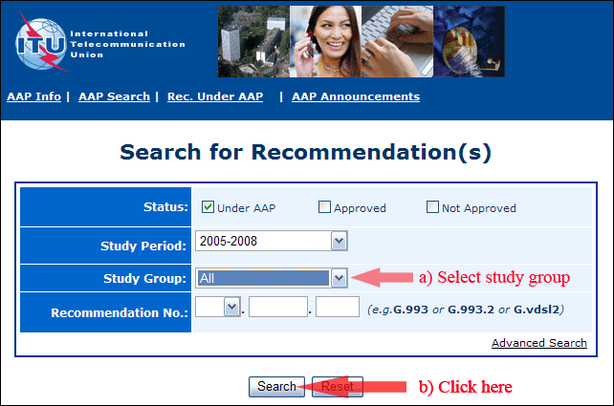
2) Select your Recommendation
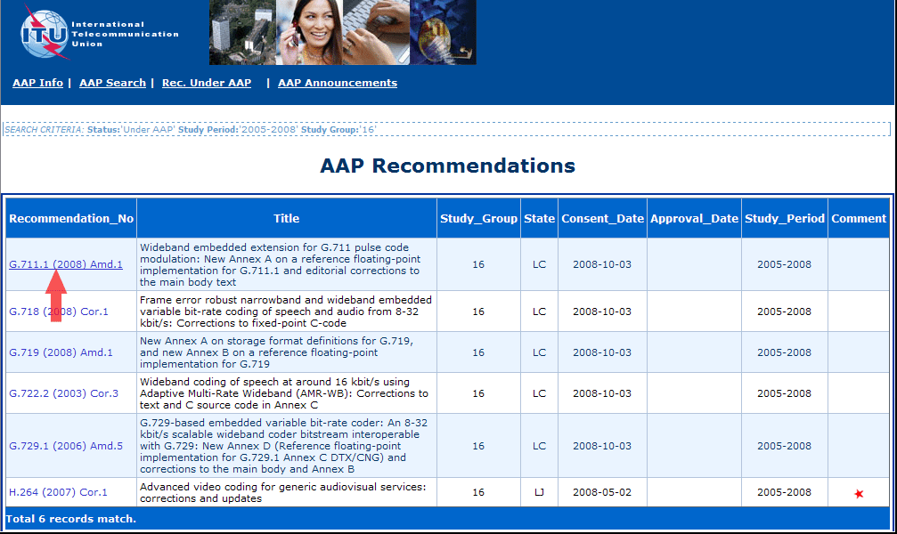
3) Click the "Submit Comment" button
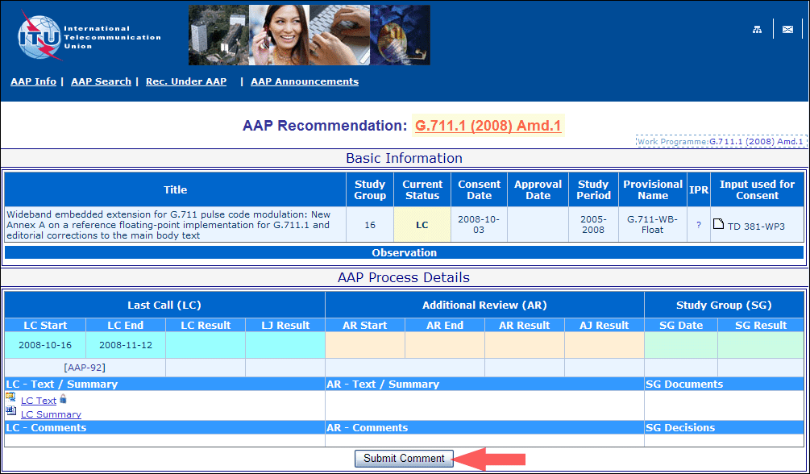
4) Complete the on-line form and click on "Submit"
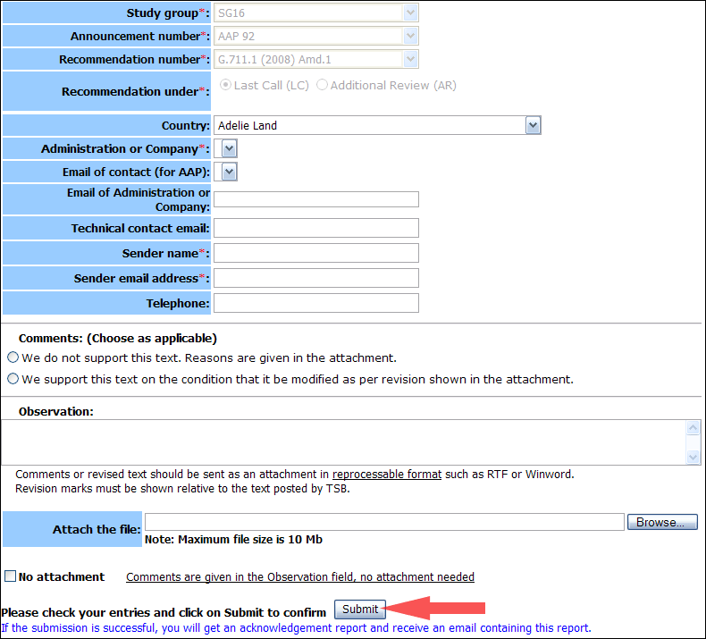
For more information, read the AAP tutorial on:
https://www.itu.int/ITU-T/aapinfo/files/AAPTutorial.pdf
Annex 3
(to TSB AAP-106)
Recommendations under LC/AR – Comment submission form
(Separate form for each Recommendation being commented upon)
ITU-T AAP comment submission form
Study Group:
Announcement number:
Recommendation number:
Date consented:
Recommendation under: | Last call (LC)  Additional Review (AR)
Country:
Administration/Company:
Name of AAP Contact Person:
Email of AAP Contact Person:
Sender name:
(if different from AAP Contact Person)
Sender email address:
Telephone:
Comments:  (Choose as applicable) | We do not support this text. Reasons are given in the attachment.  We support this text on the condition that it be modified as per revision shown in the attachment.
Observations:
No attachment: Comments are given in the Observation field, no attachment needed
To be returned to: email: tsbsg....@itu.int
[or fax +41 22 730 5853]
Comments or revised text should be sent as an attachment in RTF or WinWord format.
Revision marks must be shown relative to the text posted by TSB.

