 | Международный союз электросвязи  Бюро стандартизации электросвязи

Женева, 1 октября 2020

Осн.:  Тел.:  Факс:  Эл. почта: | TSB AAP-90  AAP/CL  +41 22 730 5860  +41 22 730 5853  tsbdir@itu.int | – Администрациям Государств – Членов Союза;  – Членам Сектора МСЭ-Т;  – Ассоциированным членам МСЭ-Т;  – Академическим организациям − Членам МСЭ  Копии:  – Председателям и заместителям председателей Исследовательских комиссий МСЭ-Т;  – Директору Бюро Развития Электросвязи;  – Директору Бюро Радиосвязи

Предмет: | Положение относительно Рекомендаций, рассматриваемых в соответствии с альтернативным процессом утверждения (АПУ)

Уважаемая госпожа,
уважаемый господин,

Альтернативный процесс утверждения (АПУ), определенный в Рекомендации МСЭ-Т А.8, распространяется на Рекомендации, которые не имеют политических или регламентарных последствий и которые поэтому не требуют официальных консультаций с Государствами-Членами (см. п. 246B Конвенции МСЭ).
В Приложении 1 содержится перечень текстов, статус которых изменился по сравнению с предыдущими объявлениями об АПУ БСЭ.
Если вы желаете представить замечания относительно какой-либо Рекомендации, рассматриваемой в соответствии с АПУ, рекомендуем Вам использовать онлайновую форму для представления замечаний по АПУ, которая размещена на странице этой Рекомендации в разделе веб-сайта МСЭ-Т, посвященном АПУ, по адресу: http://www.itu.int/ITU-T/aap/ (см. Приложение 2). Замечания можно представить иным способом, заполнив приведенную в Приложении 3 форму и направив ее в секретариат заинтересованной исследовательской комиссии.
Просим принять к сведению, что не рекомендуется представлять замечания, являющиеся не чем иным, как поддержкой рассматриваемого текста.
С уважением,
Чхе Суб Ли
Директор Бюро стандартизации электросвязи
Приложения: 3

Annex 1
(to TSB AAP-90)

Status codes used in the AAP announcements:
LC = Last Call
LJ = Last Call Judgment (includes comment resolution)
AR = Additional Review
AJ = Additional Review Judgment (includes comment resolution)
SG = For Study Group approval
A = Approved
AT = Approved with typographic corrections
AC = Approved after Additional Review of Comments
NA = Not approved
TAP = Moved to TAP (ITU-T A.8 / § 5.2)
ITU-T website entry page:
https://www.itu.int/ITU-T
Alternative approval process (AAP) welcome page:
https://www.itu.int/ITU-T/aapinfo
Note – A tutorial on the ITU-T AAP application is available under the AAP welcome page
ITU-T website AAP Recommendation search page:
https://www.itu.int/ITU-T/aap/
Study Group web pages and contacts:
SG 2 | https://www.itu.int/ITU-T/studygroups/com02 | tsbsg2@itu.int
SG 3 | https://www.itu.int/ITU-T/studygroups/com03 | tsbsg3@itu.int
SG 5 | https://www.itu.int/ITU-T/studygroups/com05 | tsbsg5@itu.int
SG 9 | https://www.itu.int/ITU-T/studygroups/com09 | tsbsg9@itu.int
SG 11 | https://www.itu.int/ITU-T/studygroups/com11 | tsbsg11@itu.int
SG 12 | https://www.itu.int/ITU-T/studygroups/com12 | tsbsg12@itu.int
SG 13 | https://www.itu.int/ITU-T/studygroups/com13 | tsbsg13@itu.int
SG 15 | https://www.itu.int/ITU-T/studygroups/com15 | tsbsg15@itu.int
SG 16 | https://www.itu.int/ITU-T/studygroups/com16 | tsbsg16@itu.int
SG 17 | https://www.itu.int/ITU-T/studygroups/com17 | tsbsg17@itu.int
SG 20 | https://www.itu.int/ITU-T/studygroups/com20 | tsbsg20@itu.int

Situation concerning Study Group 2 Recommendations under AAP
Rec # | Title | Last Call (LC) Period |  |  |  | Additional Review (AR) Period |  |  |  | Status
Rec # | Title | LC Start | LC End | LC  Result | LJ  Result | AR Start | AR End | AR  Result | AJ  Result | Status
M.3373 (M.rcsnsm) | Requirements for synergy management of cloud and SDN-based networks (Summary) | 2020-10-01 | 2020-10-28 |  |  |  |  |  |  | LC
Situation concerning Study Group 5 Recommendations under AAP
Rec # | Title | Last Call (LC) Period |  |  |  | Additional Review (AR) Period |  |  |  | Status
Rec # | Title | LC Start | LC End | LC  Result | LJ  Result | AR Start | AR End | AR  Result | AJ  Result | Status
L.1023 (L.CE_2) | Assessment method for Circular Scoring (Summary) | 2020-06-01 | 2020-06-28 | LJ | AR | 2020-09-01 | 2020-09-21 | AC |  | AC
L.1310 (Revision of ITU-T L.1310) | Energy efficiency metrics and measurement methods for telecommunication equipment (Summary) | 2020-06-01 | 2020-06-28 | LJ | AR | 2020-09-01 | 2020-09-21 | AC |  | AC
L.1331 (Revision of ITU-T L.1331) | Assessment of mobile network energy efficiency (Summary) | 2020-06-01 | 2020-06-28 | LJ | AR | 2020-09-01 | 2020-09-21 | AC |  | AC
Situation concerning Study Group 11 Recommendations under AAP
Rec # | Title | Last Call (LC) Period |  |  |  | Additional Review (AR) Period |  |  |  | Status
Rec # | Title | LC Start | LC End | LC  Result | LJ  Result | AR Start | AR End | AR  Result | AJ  Result | Status
Q.3058 (Q.NGNe-O-SA) | Signalling architecture of orchestration in NGNe (Summary) | 2020-09-01 | 2020-09-28 | A |  |  |  |  |  | A
Q.3059 (Q.SFD) | Signalling requirements for service function discovery (Summary) | 2020-09-01 | 2020-09-28 | A |  |  |  |  |  | A
Q.3060 (Q.ETN-DS) | Signalling architecture of the fast deployment emergency telecommunication network to be used in a natural disaster (Summary) | 2020-09-01 | 2020-09-28 | LJ |  |  |  |  |  | LJ
Q.3645 (Q.Pro-DES) | Protocol at interface between two distributed ENUM servers for IMS (Summary) | 2020-09-01 | 2020-09-28 | A |  |  |  |  |  | A
Q.3720 (Q.BNG-PAC) | Procedures for vBNG acceleration with programmable acceleration card (Summary) | 2020-09-01 | 2020-09-28 | A |  |  |  |  |  | A
Q.3915 (Q.BNGP) | Set of parameters of vBNG for monitoring (Summary) | 2020-09-01 | 2020-09-28 | A |  |  |  |  |  | A
Q.3961 (Q.PWS) | Parameters for evaluating bottleneck of web-browsing service (Summary) | 2020-09-01 | 2020-09-28 | A |  |  |  |  |  | A
Q.4062 (Q.FW_IoT/Test) | Framework for IoT Testing (Summary) | 2020-09-01 | 2020-09-28 | A |  |  |  |  |  | A
Q.4063 (Q.39_FW_Test_ID_IoT) | The framework of testing of identification systems used in IoT (Summary) | 2020-09-01 | 2020-09-28 | A |  |  |  |  |  | A
Q.4064 (Q.vbng-iop-reqts) | Interoperability testing requirements of virtual Broadband Network Gateway (Summary) | 2020-09-01 | 2020-09-28 | A |  |  |  |  |  | A
Q.4066 (Q.TP_AR) | Testing procedures of Augmented Reality applications (Summary) | 2020-09-01 | 2020-09-28 | A |  |  |  |  |  | A
Q.4100 (Q.HP2P-Arch) | Hybrid peer-to-peer (P2P) communications: Functional architecture (Summary) | 2020-09-01 | 2020-09-28 | A |  |  |  |  |  | A
Q.5052 (Q.DEV_DUI) | Addressing mobile devices with duplicate unique identifier (Summary) | 2020-09-01 | 2020-09-28 | A |  |  |  |  |  | A
X.609.10 (X.mp2p-srds) | Managed P2P communications: Signalling requirements for data streaming (Summary) | 2020-09-01 | 2020-09-28 | A |  |  |  |  |  | A
X.609.9 (X.mp2p-ocmp) | Managed P2P communications: Overlay content management protocol (Summary) | 2020-09-01 | 2020-09-28 | A |  |  |  |  |  | A
Situation concerning Study Group 13 Recommendations under AAP
Rec # | Title | Last Call (LC) Period |  |  |  | Additional Review (AR) Period |  |  |  | Status
Rec # | Title | LC Start | LC End | LC  Result | LJ  Result | AR Start | AR End | AR  Result | AJ  Result | Status
Y.2245 (Y.saic) | Service model of the Agriculture Information based Convergence Service (Summary) | 2020-09-01 | 2020-09-28 | A |  |  |  |  |  | A
Y.3055 (Y.trust-pdm) | Framework for Trust based Personal Data Management (Summary) | 2020-09-01 | 2020-09-28 | A |  |  |  |  |  | A
Y.3075 (Y.ICN-RF) | Requirements and capabilities of Information Centric Networking routing and forwarding based on control and user plane separation in IMT-2020 (Summary) | 2020-09-01 | 2020-09-28 | A |  |  |  |  |  | A
Y.3076 (Y.ICN- Edge) | Architecture of ICN-enabled Edge Network in IMT-2020 (Summary) | 2020-09-01 | 2020-09-28 | A |  |  |  |  |  | A
Y.3109 (Y.qos-ec-vr-req) | QoS requirements and framework for virtual reality delivery using mobile edge computing supported by IMT-2020 (Summary) | 2020-09-01 | 2020-09-28 | LJ |  |  |  |  |  | LJ
Y.3134 (Y.FMC-ReqMO) | IMT-2020 fixed mobile convergence functional requirements for management and orchestration (Summary) | 2020-09-01 | 2020-09-28 | A |  |  |  |  |  | A
Y.3136 (Y.FMC-SM) | Session management for fixed mobile convergence in IMT-2020 networks (Summary) | 2020-09-01 | 2020-09-28 | A |  |  |  |  |  | A
Y.3150 Rev. | High-level technical characteristics of network softwarization for IMT-2020 (Summary) | 2020-09-01 | 2020-09-28 | A |  |  |  |  |  | A
Y.3155 (Y.IMT2020-ESDP) | Enhanced SDN Data Plane for IMT-2020 (Summary) | 2020-09-01 | 2020-09-28 | A |  |  |  |  |  | A
Y.3156 (Y.IMT2020-NSAA-reqts) | Framework of network slicing with AI-assisted analysis in IMT-2020 networks (Summary) | 2020-09-01 | 2020-09-28 | A |  |  |  |  |  | A
Y.3176 (Y.ML-IMT2020-MP) | Machine learning marketplace integration in future networks including IMT-2020 (Summary) | 2020-09-01 | 2020-09-28 | A |  |  |  |  |  | A
Y.3525 (Y.cccsdaom-reqts) | Cloud computing - Requirements for cloud service development and operation management (Summary) | 2020-09-01 | 2020-09-28 | LJ |  |  |  |  |  | LJ
Y.3530 (Y.BaaS-reqts) | Cloud computing - Functional requirements for blockchain as a service (Summary) | 2020-09-01 | 2020-09-28 | A |  |  |  |  |  | A
Y.3531 (Y.MLaaS-reqts) | Cloud computing - Functional requirements for machine learning as a service (Summary) | 2020-09-01 | 2020-09-28 | A |  |  |  |  |  | A
Y.3605 (Y.BD-arch) | Big data - Reference architecture (Summary) | 2020-09-01 | 2020-09-28 | A |  |  |  |  |  | A
Y.3802 (Y.QKDN_Arch) | Quantum key distribution networks - Functional architecture (Summary) | 2020-09-01 | 2020-09-28 | LJ |  |  |  |  |  | LJ
Y.3803 (Y.QKDN_KM) | Quantum key distribution networks – Key management (Summary) | 2020-09-01 | 2020-09-28 | LJ |  |  |  |  |  | LJ
Y.3804 (Y.QKDN-CM) | Quantum Key Distribution Networks - Control and Management (Summary) | 2020-09-01 | 2020-09-28 | LJ |  |  |  |  |  | LJ
Situation concerning Study Group 15 Recommendations under AAP
Rec # | Title | Last Call (LC) Period |  |  |  | Additional Review (AR) Period |  |  |  | Status
Rec # | Title | LC Start | LC End | LC  Result | LJ  Result | AR Start | AR End | AR  Result | AJ  Result | Status
G.650.1 | Definitions and test methods for linear, deterministic attributes of single-mode fibre and cable (Summary) | 2020-10-01 | 2020-10-28 |  |  |  |  |  |  | LC
G.672 | Characteristics of multi-degree reconfigurable optical add/drop multiplexers (Summary) | 2020-10-01 | 2020-10-28 |  |  |  |  |  |  | LC
G.694.1 | Spectral grids for WDM applications: DWDM frequency grid (Summary) | 2020-10-01 | 2020-10-28 |  |  |  |  |  |  | LC
G.709.1/Y.1331.1 (2018) Amd.2 | Flexible OTN short-reach interfaces - Amendment 2 (Summary) | 2020-10-01 | 2020-10-28 |  |  |  |  |  |  | LC
G.709.3/Y.1331.3 | Flexible OTN long-reach interfaces (Summary) | 2020-10-01 | 2020-10-28 |  |  |  |  |  |  | LC
G.709/Y.1331 Amd.1 | Interfaces for the optical transport network (OTN) - Amendment 1 (Summary) | 2020-10-01 | 2020-10-28 |  |  |  |  |  |  | LC
G.798 Amd.3 | Characteristics of optical transport network hierarchy equipment functional blocks - Amendment 3 (Summary) | 2020-10-01 | 2020-10-28 |  |  |  |  |  |  | LC
G.807 Amd.1 | Generic functional architecture of the optical media network - Amendment 1 (Summary) | 2020-10-01 | 2020-10-28 |  |  |  |  |  |  | LC
G.872 Amd.1 | Architecture of the optical transport network - Amendment 1 (Summary) | 2020-10-01 | 2020-10-28 |  |  |  |  |  |  | LC
G.874 | Management aspects of optical transport network elements (Summary) | 2020-10-01 | 2020-10-28 |  |  |  |  |  |  | LC
G.971 | General features of optical submarine cable systems (Summary) | 2020-10-01 | 2020-10-28 |  |  |  |  |  |  | LC
G.972 | Definition of terms relevant to optical fibre submarine cable systems (Summary) | 2020-10-01 | 2020-10-28 |  |  |  |  |  |  | LC
G.977.1 | Transverse compatible DWDM applications for repeatered optical fibre submarine cable systems (Summary) | 2020-10-01 | 2020-10-28 |  |  |  |  |  |  | LC
G.984.5 (2014) Amd.2 | Gigabit-capable passive optical networks (G-PON): Enhancement band - Amendment 2 (Summary) | 2020-10-01 | 2020-10-28 |  |  |  |  |  |  | LC
G.987.2 (2016) Amd.2 | 10-Gigabit-capable passive optical networks (XG-PON): Physical media dependent (PMD) layer specification - Amendment 2 (Summary) | 2020-10-01 | 2020-10-28 |  |  |  |  |  |  | LC
G.989.2 Amd.1 | 40-Gigabit-capable passive optical networks 2 (NG-PON2): Physical media dependent (PMD) layer specification - Amendment 1 (Summary) | 2020-10-01 | 2020-10-28 |  |  |  |  |  |  | LC
G.994.1 Amd.2 | Handshake procedures for digital subscriber line transceivers - Amendment 2 (Summary) | 2020-10-01 | 2020-10-28 |  |  |  |  |  |  | LC
G.997.2 Amd.2 | Physical layer management for G.fast transceivers - Amendment 2 (Summary) | 2020-10-01 | 2020-10-28 |  |  |  |  |  |  | LC
G.997.3 (G.ploam-MGfast) | Physical layer management for MGfast transceivers (Summary) | 2020-10-01 | 2020-10-28 |  |  |  |  |  |  | LC
G.7701 Amd.2 | Common control aspects - Amendment 2 (Summary) | 2020-10-01 | 2020-10-28 |  |  |  |  |  |  | LC
G.7710/Y.1701 | Common equipment management function requirements (Summary) | 2020-10-01 | 2020-10-28 |  |  |  |  |  |  | LC
G.7718 | Framework for the management of MC components and functions (Summary) | 2020-10-01 | 2020-10-28 |  |  |  |  |  |  | LC
G.8011/Y.1307 | Ethernet service characteristics (Summary) | 2020-10-01 | 2020-10-28 |  |  |  |  |  |  | LC
G.8051/Y.1345 | Management aspects of the Ethernet Transport (ET) capable network element (Summary) | 2020-10-01 | 2020-10-28 |  |  |  |  |  |  | LC
G.8110.1 Amd.1 | Architecture of the Multi-Protocol Label Switching transport profile layer network - Amendment 1 (Summary) | 2020-10-01 | 2020-10-28 |  |  |  |  |  |  | LC
G.8112/Y.1371 | Interfaces for the MPLS transport profile layer network (Summary) | 2020-10-01 | 2020-10-28 |  |  |  |  |  |  | LC
G.8151/Y.1374 | Management aspects of the MPLS-TP network element (Summary) | 2020-10-01 | 2020-10-28 |  |  |  |  |  |  | LC
G.8261/Y.1361 Amd.2 | Timing and synchronization aspects in packet networks - Amendment 2 (Summary) | 2020-10-01 | 2020-10-28 |  |  |  |  |  |  | LC
G.8271.1/Y.1366.1 Amd.1 | Network limits for time synchronization in Packet networks with full timing support from the network - Amendment 1 (Summary) | 2020-10-01 | 2020-10-28 |  |  |  |  |  |  | LC
G.8273 (2018) Cor.1 | Framework of phase and time clocks - Corrigendum 1 (Summary) | 2020-10-01 | 2020-10-28 |  |  |  |  |  |  | LC
G.8273.2/Y.1368.2 | Timing characteristics of telecom boundary clocks and telecom time slave clocks for use with full timing support from the network (Summary) | 2020-10-01 | 2020-10-28 |  |  |  |  |  |  | LC
G.8273.3/Y.1368.3 | Timing characteristics of telecom transparent clocks for use with full timing support from the network (Summary) | 2020-10-01 | 2020-10-28 |  |  |  |  |  |  | LC
G.8275/Y.1369 | Architecture and requirements for packet-based time and phase distribution (Summary) | 2020-10-01 | 2020-10-28 |  |  |  |  |  |  | LC
G.8310 (G.mtn-arch) | Functional architecture for metro transport network (Summary) | 2020-10-01 | 2020-10-28 |  |  |  |  |  |  | LC
G.8312 (G.mtn) | Interfaces for a metro transport network (Summary) | 2020-10-01 | 2020-10-28 |  |  |  |  |  |  | LC
G.9701 (2020) Amd.3 | Fast access to subscriber terminals (G.fast) - Physical layer specification: Amendment 3 (Summary) | 2020-10-01 | 2020-10-28 |  |  |  |  |  |  | LC
G.9711 (G.mgfast-PHY) | Multi-gigabit fast access to subscriber terminals (MGfast) - Physical layer specification (New) (Summary) | 2020-10-01 | 2020-10-28 |  |  |  |  |  |  | LC
G.9806 Amd.1 | Higher speed bidirectional, single fibre, point-to-point optical access system (HS-PtP)- Amendment 1 (Summary) | 2020-10-01 | 2020-10-28 |  |  |  |  |  |  | LC
G.9807.1 (2016) Amd.2 | 10-Gigabit-capable symmetric passive optical network (XGS-PON) (Summary) | 2020-10-01 | 2020-10-28 |  |  |  |  |  |  | LC
G.9960 (2020) Cor.2 | Unified high-speed wire-line based home networking transceivers - System architecture and physical layer specification - Corrigendum 2 (Summary) | 2020-10-01 | 2020-10-28 |  |  |  |  |  |  | LC
G.9961 (2018) Amd.3 | Unified high-speed wireline-based home networking transceivers - Data link layer specification Amendment 3 (Summary) | 2020-10-01 | 2020-10-28 |  |  |  |  |  |  | LC
G.9963 Amd.1 | Unified high-speed wireline-based home networking transceivers - Multiple input/multiple output specification: Amendment 1 (Summary) | 2020-10-01 | 2020-10-28 |  |  |  |  |  |  | LC
G.9991 (2019) Amd.2 | High-speed indoor visible light communication transceiver - System architecture, physical layer and data link layer specification - Amendment 2 (Summary) | 2020-10-01 | 2020-10-28 |  |  |  |  |  |  | LC
G.9991 (2019) Cor.1 | High-speed indoor visible light communication transceiver - System architecture, physical layer and data link layer specification - Corrigendum 1 (Summary) | 2020-10-01 | 2020-10-28 |  |  |  |  |  |  | LC
L.111 (L.oha) | Optical fibre cables for in-home applications (Summary) | 2020-10-01 | 2020-10-28 |  |  |  |  |  |  | LC
L.151 | Installation of Optical Fibre Ground Wire (OPGW) cable (Summary) | 2020-10-01 | 2020-10-28 |  |  |  |  |  |  | LC
L.330 (L.tifm) | Telecommunication Infrastructure facility management (Summary) | 2020-10-01 | 2020-10-28 |  |  |  |  |  |  | LC
Situation concerning Study Group 16 Recommendations under AAP
Rec # | Title | Last Call (LC) Period |  |  |  | Additional Review (AR) Period |  |  |  | Status
Rec # | Title | LC Start | LC End | LC  Result | LJ  Result | AR Start | AR End | AR  Result | AJ  Result | Status
T.701.11 (H.ACC.AltText) | Guidance on audio descriptions (twin text of ISO/IEC TS 20071-11:2019, Information technology - Guidance on alternative text for images - Part 11) (Summary) | 2020-09-01 | 2020-09-28 | A |  |  |  |  |  | A
Situation concerning Study Group 17 Recommendations under AAP
Rec # | Title | Last Call (LC) Period |  |  |  | Additional Review (AR) Period |  |  |  | Status
Rec # | Title | LC Start | LC End | LC  Result | LJ  Result | AR Start | AR End | AR  Result | AJ  Result | Status
X.1052 | Information security management processes for telecommunication organizations (Summary) | 2020-10-01 | 2020-10-28 |  |  |  |  |  |  | LC
X.1218 (X.rdmase) | Requirements and Guidelines for Dynamic Malware Analysis in a Sandbox Environment (Summary) | 2020-10-01 | 2020-10-28 |  |  |  |  |  |  | LC
X.1374 (X.itssec-3) | Security requirements for external interfaces and devices with vehicle access capability (Summary) | 2020-10-01 | 2020-10-28 |  |  |  |  |  |  | LC
X.1375 (X.itssec-4) | Guidelines for intrusion detection system for in-vehicle networks (Summary) | 2020-10-01 | 2020-10-28 |  |  |  |  |  |  | LC
X.1400 (X.dlt-td) | Terms and definitions for distributed ledger technology (Summary) | 2020-10-01 | 2020-10-28 |  |  |  |  |  |  | LC
X.1404 (X.sa-dlt) | Security assurance for distributed ledger technology (Summary) | 2020-10-01 | 2020-10-28 |  |  |  |  |  |  | LC
X.1452 (X.tfss) | Guidelines for security services provided by operators (Summary) | 2020-10-01 | 2020-10-28 |  |  |  |  |  |  | LC
X.1710 (X.sec-QKDN-ov) | Security framework for quantum key distribution networks (Summary) | 2020-10-01 | 2020-10-28 |  |  |  |  |  |  | LC
X.1714 (X.cf-QKDN) | Key combination and confidential key supply for quantum key distribution networks (Summary) | 2020-10-01 | 2020-10-28 |  |  |  |  |  |  | LC
Z.161 | Testing and Test Control Notation version 3: TTCN-3 core language (Summary) | 2020-10-01 | 2020-10-28 |  |  |  |  |  |  | LC
Z.161.3 | Testing and Test Control Notation version 3: TTCN-3 language extensions: Advanced parameterization (Summary) | 2020-10-01 | 2020-10-28 |  |  |  |  |  |  | LC
Z.161.4 | Testing and Test Control Notation version 3: TTCN-3 language extensions: Behaviour types (Summary) | 2020-10-01 | 2020-10-28 |  |  |  |  |  |  | LC
Z.161.6 | Testing and Test Control Notation version 3: TTCN-3 language extensions: Advanced Matching (Summary) | 2020-10-01 | 2020-10-28 |  |  |  |  |  |  | LC
Z.161.7 | Testing and Test Control Notation version 3: TTCN-3 Language Extensions: Object-Oriented Features (Summary) | 2020-10-01 | 2020-10-28 |  |  |  |  |  |  | LC
Z.165.1 | Testing and Test Control Notation version 3: TTCN-3 extension package: Extended TRI (Summary) | 2020-10-01 | 2020-10-28 |  |  |  |  |  |  | LC
Z.166 | Testing and Test Control Notation version 3: TTCN-3 control interface (TCI) (Summary) | 2020-10-01 | 2020-10-28 |  |  |  |  |  |  | LC
Z.167 | Testing and Test Control Notation version 3: Using ASN.1 with TTCN-3 (Summary) | 2020-10-01 | 2020-10-28 |  |  |  |  |  |  | LC
Z.169 | Testing and Test Control Notation version 3: Using XML schema with TTCN-3 (Summary) | 2020-10-01 | 2020-10-28 |  |  |  |  |  |  | LC

Annex 2
(to TSB AAP-90)
Using the on-line comment submission form
Comment submission
1) Go to AAP search Web page at https://www.itu.int/ITU-T/aap/
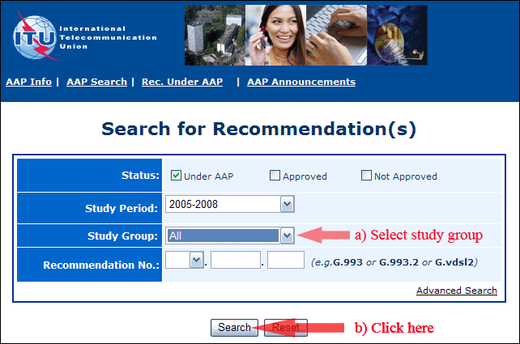
2) Select your Recommendation
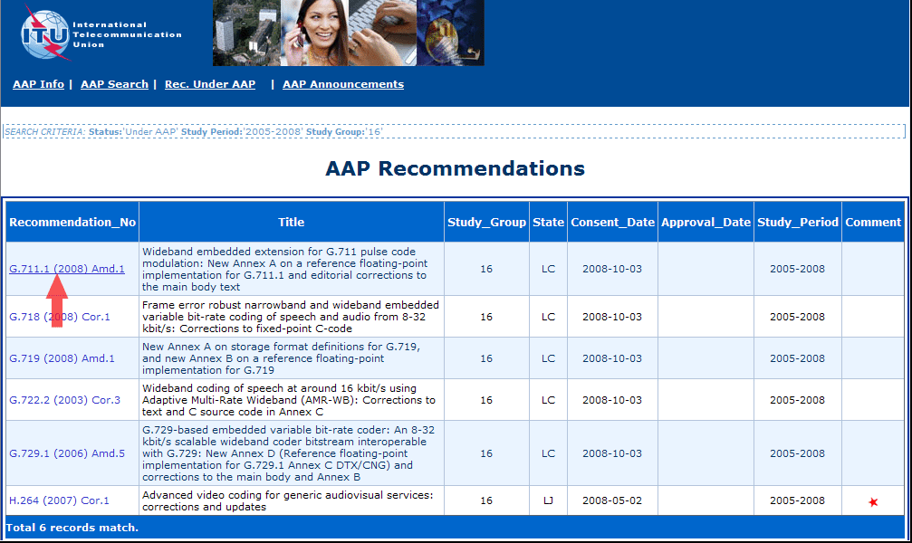
3) Click the "Submit Comment" button
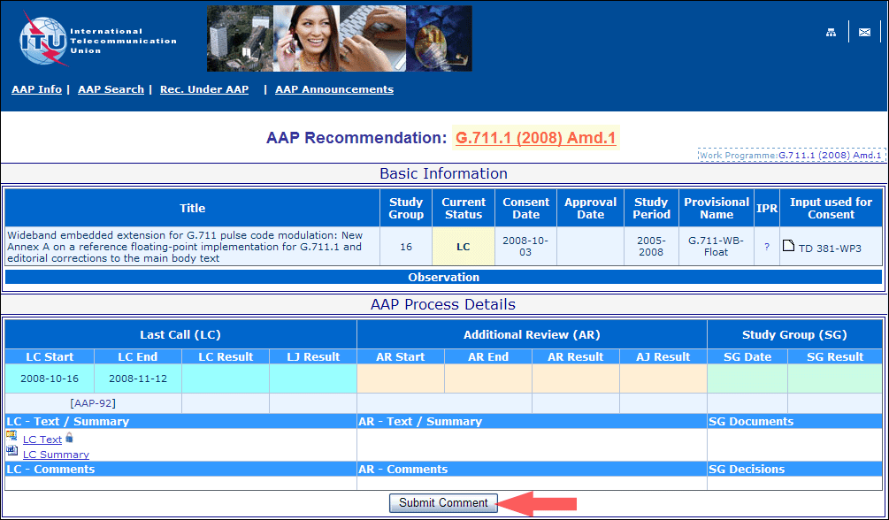
4) Complete the on-line form and click on "Submit"
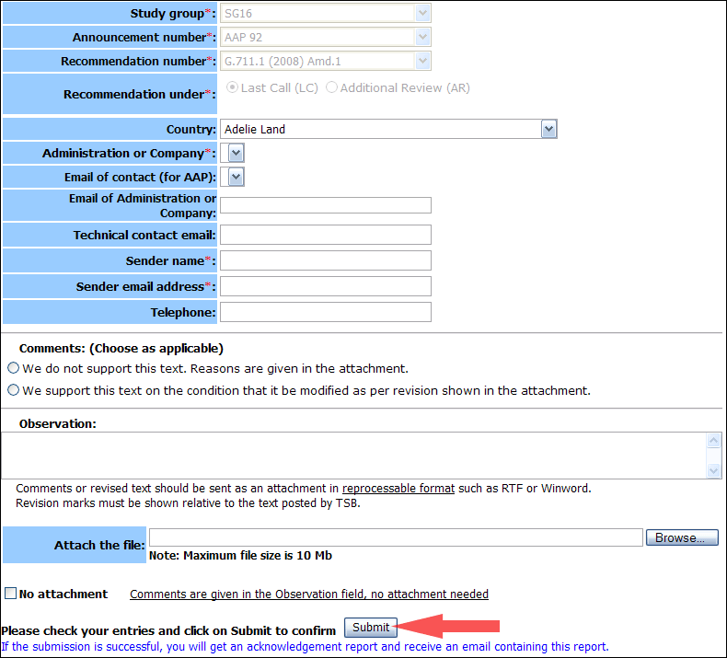
For more information, read the AAP tutorial on:
https://www.itu.int/ITU-T/aapinfo/files/AAPTutorial.pdf
Annex 3
(to TSB AAP-90)
Recommendations under LC/AR – Comment submission form
(Separate form for each Recommendation being commented upon)
ITU-T AAP comment submission form
Study Group:
Announcement number:
Recommendation number:
Date consented:
Recommendation under: | Last call (LC)  Additional Review (AR)
Country:
Administration/Company:
Name of AAP Contact Person:
Email of AAP Contact Person:
Sender name:
(if different from AAP Contact Person)
Sender email address:
Telephone:
Comments:  (Choose as applicable) | We do not support this text. Reasons are given in the attachment.  We support this text on the condition that it be modified as per revision shown in the attachment.
Observations:
No attachment: Comments are given in the Observation field, no attachment needed
To be returned to: email: tsbsg....@itu.int
[or fax +41 22 730 5853]
Comments or revised text should be sent as an attachment in RTF or WinWord format.
Revision marks must be shown relative to the text posted by TSB.

