 | International Telecommunication Union  Telecommunication Standardization Bureau

Geneva, 1 October 2020

Ref:  Tel:  Fax:  E-mail: | TSB AAP-90  AAP/CL  +41 22 730 5860  +41 22 730 5853  tsbdir@itu.int | – To Administrations of Member States of the Union;  – To ITU-T Sector Members;  – To ITU-T Associates;  – To ITU Academia  Copy:  – To the ITU-T Study Group Chairmen and Vice-Chairmen;  – To the Director of the Telecommunication Development Bureau;  – To the Director of the Radiocommunication Bureau

Subject: | Situation concerning Recommendations under the Alternative Approval Process (AAP)

Dear Sir/Madam,
The Alternative Approval Process (AAP) defined in Recommendation ITU-T A.8 applies to Recommendations that do not have policy or regulatory implications and which, therefore, do not require formal consultation of Member States (see ITU Convention 246B).
Annex 1 lists those texts whose status has changed compared with previous TSB AAP Announcements.
Any member wishing to submit a comment relative to a Recommendation under AAP is encouraged to use the on-line AAP comment submission form available on the page of the Recommendation via https://www.itu.int/ITU-T/aap (see Annex 2). Alternatively, comments may be submitted by completing the form in Annex 3 and sending it to the secretariat of the concerned study group.
Please note that comments that simply support adoption of the text in question are not encouraged.
Yours faithfully,
Chaesub Lee
Director of the Telecommunication Standardization Bureau
Annexes: 3

Annex 1
(to TSB AAP-90)

Status codes used in the AAP announcements:
LC = Last Call
LJ = Last Call Judgment (includes comment resolution)
AR = Additional Review
AJ = Additional Review Judgment (includes comment resolution)
SG = For Study Group approval
A = Approved
AT = Approved with typographic corrections
AC = Approved after Additional Review of Comments
NA = Not approved
TAP = Moved to TAP (ITU-T A.8 / § 5.2)
ITU-T website entry page:
https://www.itu.int/ITU-T
Alternative approval process (AAP) welcome page:
https://www.itu.int/ITU-T/aapinfo
Note – A tutorial on the ITU-T AAP application is available under the AAP welcome page
ITU-T website AAP Recommendation search page:
https://www.itu.int/ITU-T/aap/
Study Group web pages and contacts:
SG 2 | https://www.itu.int/ITU-T/studygroups/com02 | tsbsg2@itu.int
SG 3 | https://www.itu.int/ITU-T/studygroups/com03 | tsbsg3@itu.int
SG 5 | https://www.itu.int/ITU-T/studygroups/com05 | tsbsg5@itu.int
SG 9 | https://www.itu.int/ITU-T/studygroups/com09 | tsbsg9@itu.int
SG 11 | https://www.itu.int/ITU-T/studygroups/com11 | tsbsg11@itu.int
SG 12 | https://www.itu.int/ITU-T/studygroups/com12 | tsbsg12@itu.int
SG 13 | https://www.itu.int/ITU-T/studygroups/com13 | tsbsg13@itu.int
SG 15 | https://www.itu.int/ITU-T/studygroups/com15 | tsbsg15@itu.int
SG 16 | https://www.itu.int/ITU-T/studygroups/com16 | tsbsg16@itu.int
SG 17 | https://www.itu.int/ITU-T/studygroups/com17 | tsbsg17@itu.int
SG 20 | https://www.itu.int/ITU-T/studygroups/com20 | tsbsg20@itu.int

Situation concerning Study Group 2 Recommendations under AAP
Rec # | Title | Last Call (LC) Period |  |  |  | Additional Review (AR) Period |  |  |  | Status
Rec # | Title | LC Start | LC End | LC  Result | LJ  Result | AR Start | AR End | AR  Result | AJ  Result | Status
M.3373 (M.rcsnsm) | Requirements for synergy management of cloud and SDN-based networks (Summary) | 2020-10-01 | 2020-10-28 |  |  |  |  |  |  | LC
Situation concerning Study Group 5 Recommendations under AAP
Rec # | Title | Last Call (LC) Period |  |  |  | Additional Review (AR) Period |  |  |  | Status
Rec # | Title | LC Start | LC End | LC  Result | LJ  Result | AR Start | AR End | AR  Result | AJ  Result | Status
L.1023 (L.CE_2) | Assessment method for Circular Scoring (Summary) | 2020-06-01 | 2020-06-28 | LJ | AR | 2020-09-01 | 2020-09-21 | AC |  | AC
L.1310 (Revision of ITU-T L.1310) | Energy efficiency metrics and measurement methods for telecommunication equipment (Summary) | 2020-06-01 | 2020-06-28 | LJ | AR | 2020-09-01 | 2020-09-21 | AC |  | AC
L.1331 (Revision of ITU-T L.1331) | Assessment of mobile network energy efficiency (Summary) | 2020-06-01 | 2020-06-28 | LJ | AR | 2020-09-01 | 2020-09-21 | AC |  | AC
Situation concerning Study Group 11 Recommendations under AAP
Rec # | Title | Last Call (LC) Period |  |  |  | Additional Review (AR) Period |  |  |  | Status
Rec # | Title | LC Start | LC End | LC  Result | LJ  Result | AR Start | AR End | AR  Result | AJ  Result | Status
Q.3058 (Q.NGNe-O-SA) | Signalling architecture of orchestration in NGNe (Summary) | 2020-09-01 | 2020-09-28 | A |  |  |  |  |  | A
Q.3059 (Q.SFD) | Signalling requirements for service function discovery (Summary) | 2020-09-01 | 2020-09-28 | A |  |  |  |  |  | A
Q.3060 (Q.ETN-DS) | Signalling architecture of the fast deployment emergency telecommunication network to be used in a natural disaster (Summary) | 2020-09-01 | 2020-09-28 | LJ |  |  |  |  |  | LJ
Q.3645 (Q.Pro-DES) | Protocol at interface between two distributed ENUM servers for IMS (Summary) | 2020-09-01 | 2020-09-28 | A |  |  |  |  |  | A
Q.3720 (Q.BNG-PAC) | Procedures for vBNG acceleration with programmable acceleration card (Summary) | 2020-09-01 | 2020-09-28 | A |  |  |  |  |  | A
Q.3915 (Q.BNGP) | Set of parameters of vBNG for monitoring (Summary) | 2020-09-01 | 2020-09-28 | A |  |  |  |  |  | A
Q.3961 (Q.PWS) | Parameters for evaluating bottleneck of web-browsing service (Summary) | 2020-09-01 | 2020-09-28 | A |  |  |  |  |  | A
Q.4062 (Q.FW_IoT/Test) | Framework for IoT Testing (Summary) | 2020-09-01 | 2020-09-28 | A |  |  |  |  |  | A
Q.4063 (Q.39_FW_Test_ID_IoT) | The framework of testing of identification systems used in IoT (Summary) | 2020-09-01 | 2020-09-28 | A |  |  |  |  |  | A
Q.4064 (Q.vbng-iop-reqts) | Interoperability testing requirements of virtual Broadband Network Gateway (Summary) | 2020-09-01 | 2020-09-28 | A |  |  |  |  |  | A
Q.4066 (Q.TP_AR) | Testing procedures of Augmented Reality applications (Summary) | 2020-09-01 | 2020-09-28 | A |  |  |  |  |  | A
Q.4100 (Q.HP2P-Arch) | Hybrid peer-to-peer (P2P) communications: Functional architecture (Summary) | 2020-09-01 | 2020-09-28 | A |  |  |  |  |  | A
Q.5052 (Q.DEV_DUI) | Addressing mobile devices with duplicate unique identifier (Summary) | 2020-09-01 | 2020-09-28 | A |  |  |  |  |  | A
X.609.10 (X.mp2p-srds) | Managed P2P communications: Signalling requirements for data streaming (Summary) | 2020-09-01 | 2020-09-28 | A |  |  |  |  |  | A
X.609.9 (X.mp2p-ocmp) | Managed P2P communications: Overlay content management protocol (Summary) | 2020-09-01 | 2020-09-28 | A |  |  |  |  |  | A
Situation concerning Study Group 13 Recommendations under AAP
Rec # | Title | Last Call (LC) Period |  |  |  | Additional Review (AR) Period |  |  |  | Status
Rec # | Title | LC Start | LC End | LC  Result | LJ  Result | AR Start | AR End | AR  Result | AJ  Result | Status
Y.2245 (Y.saic) | Service model of the Agriculture Information based Convergence Service (Summary) | 2020-09-01 | 2020-09-28 | A |  |  |  |  |  | A
Y.3055 (Y.trust-pdm) | Framework for Trust based Personal Data Management (Summary) | 2020-09-01 | 2020-09-28 | A |  |  |  |  |  | A
Y.3075 (Y.ICN-RF) | Requirements and capabilities of Information Centric Networking routing and forwarding based on control and user plane separation in IMT-2020 (Summary) | 2020-09-01 | 2020-09-28 | A |  |  |  |  |  | A
Y.3076 (Y.ICN- Edge) | Architecture of ICN-enabled Edge Network in IMT-2020 (Summary) | 2020-09-01 | 2020-09-28 | A |  |  |  |  |  | A
Y.3109 (Y.qos-ec-vr-req) | QoS requirements and framework for virtual reality delivery using mobile edge computing supported by IMT-2020 (Summary) | 2020-09-01 | 2020-09-28 | LJ |  |  |  |  |  | LJ
Y.3134 (Y.FMC-ReqMO) | IMT-2020 fixed mobile convergence functional requirements for management and orchestration (Summary) | 2020-09-01 | 2020-09-28 | A |  |  |  |  |  | A
Y.3136 (Y.FMC-SM) | Session management for fixed mobile convergence in IMT-2020 networks (Summary) | 2020-09-01 | 2020-09-28 | A |  |  |  |  |  | A
Y.3150 Rev. | High-level technical characteristics of network softwarization for IMT-2020 (Summary) | 2020-09-01 | 2020-09-28 | A |  |  |  |  |  | A
Y.3155 (Y.IMT2020-ESDP) | Enhanced SDN Data Plane for IMT-2020 (Summary) | 2020-09-01 | 2020-09-28 | A |  |  |  |  |  | A
Y.3156 (Y.IMT2020-NSAA-reqts) | Framework of network slicing with AI-assisted analysis in IMT-2020 networks (Summary) | 2020-09-01 | 2020-09-28 | A |  |  |  |  |  | A
Y.3176 (Y.ML-IMT2020-MP) | Machine learning marketplace integration in future networks including IMT-2020 (Summary) | 2020-09-01 | 2020-09-28 | A |  |  |  |  |  | A
Y.3525 (Y.cccsdaom-reqts) | Cloud computing - Requirements for cloud service development and operation management (Summary) | 2020-09-01 | 2020-09-28 | LJ |  |  |  |  |  | LJ
Y.3530 (Y.BaaS-reqts) | Cloud computing - Functional requirements for blockchain as a service (Summary) | 2020-09-01 | 2020-09-28 | A |  |  |  |  |  | A
Y.3531 (Y.MLaaS-reqts) | Cloud computing - Functional requirements for machine learning as a service (Summary) | 2020-09-01 | 2020-09-28 | A |  |  |  |  |  | A
Y.3605 (Y.BD-arch) | Big data - Reference architecture (Summary) | 2020-09-01 | 2020-09-28 | A |  |  |  |  |  | A
Y.3802 (Y.QKDN_Arch) | Quantum key distribution networks - Functional architecture (Summary) | 2020-09-01 | 2020-09-28 | LJ |  |  |  |  |  | LJ
Y.3803 (Y.QKDN_KM) | Quantum key distribution networks – Key management (Summary) | 2020-09-01 | 2020-09-28 | LJ |  |  |  |  |  | LJ
Y.3804 (Y.QKDN-CM) | Quantum Key Distribution Networks - Control and Management (Summary) | 2020-09-01 | 2020-09-28 | LJ |  |  |  |  |  | LJ
Situation concerning Study Group 15 Recommendations under AAP
Rec # | Title | Last Call (LC) Period |  |  |  | Additional Review (AR) Period |  |  |  | Status
Rec # | Title | LC Start | LC End | LC  Result | LJ  Result | AR Start | AR End | AR  Result | AJ  Result | Status
G.650.1 | Definitions and test methods for linear, deterministic attributes of single-mode fibre and cable (Summary) | 2020-10-01 | 2020-10-28 |  |  |  |  |  |  | LC
G.672 | Characteristics of multi-degree reconfigurable optical add/drop multiplexers (Summary) | 2020-10-01 | 2020-10-28 |  |  |  |  |  |  | LC
G.694.1 | Spectral grids for WDM applications: DWDM frequency grid (Summary) | 2020-10-01 | 2020-10-28 |  |  |  |  |  |  | LC
G.709.1/Y.1331.1 (2018) Amd.2 | Flexible OTN short-reach interfaces - Amendment 2 (Summary) | 2020-10-01 | 2020-10-28 |  |  |  |  |  |  | LC
G.709.3/Y.1331.3 | Flexible OTN long-reach interfaces (Summary) | 2020-10-01 | 2020-10-28 |  |  |  |  |  |  | LC
G.709/Y.1331 Amd.1 | Interfaces for the optical transport network (OTN) - Amendment 1 (Summary) | 2020-10-01 | 2020-10-28 |  |  |  |  |  |  | LC
G.798 Amd.3 | Characteristics of optical transport network hierarchy equipment functional blocks - Amendment 3 (Summary) | 2020-10-01 | 2020-10-28 |  |  |  |  |  |  | LC
G.807 Amd.1 | Generic functional architecture of the optical media network - Amendment 1 (Summary) | 2020-10-01 | 2020-10-28 |  |  |  |  |  |  | LC
G.872 Amd.1 | Architecture of the optical transport network - Amendment 1 (Summary) | 2020-10-01 | 2020-10-28 |  |  |  |  |  |  | LC
G.874 | Management aspects of optical transport network elements (Summary) | 2020-10-01 | 2020-10-28 |  |  |  |  |  |  | LC
G.971 | General features of optical submarine cable systems (Summary) | 2020-10-01 | 2020-10-28 |  |  |  |  |  |  | LC
G.972 | Definition of terms relevant to optical fibre submarine cable systems (Summary) | 2020-10-01 | 2020-10-28 |  |  |  |  |  |  | LC
G.977.1 | Transverse compatible DWDM applications for repeatered optical fibre submarine cable systems (Summary) | 2020-10-01 | 2020-10-28 |  |  |  |  |  |  | LC
G.984.5 (2014) Amd.2 | Gigabit-capable passive optical networks (G-PON): Enhancement band - Amendment 2 (Summary) | 2020-10-01 | 2020-10-28 |  |  |  |  |  |  | LC
G.987.2 (2016) Amd.2 | 10-Gigabit-capable passive optical networks (XG-PON): Physical media dependent (PMD) layer specification - Amendment 2 (Summary) | 2020-10-01 | 2020-10-28 |  |  |  |  |  |  | LC
G.989.2 Amd.1 | 40-Gigabit-capable passive optical networks 2 (NG-PON2): Physical media dependent (PMD) layer specification - Amendment 1 (Summary) | 2020-10-01 | 2020-10-28 |  |  |  |  |  |  | LC
G.994.1 Amd.2 | Handshake procedures for digital subscriber line transceivers - Amendment 2 (Summary) | 2020-10-01 | 2020-10-28 |  |  |  |  |  |  | LC
G.997.2 Amd.2 | Physical layer management for G.fast transceivers - Amendment 2 (Summary) | 2020-10-01 | 2020-10-28 |  |  |  |  |  |  | LC
G.997.3 (G.ploam-MGfast) | Physical layer management for MGfast transceivers (Summary) | 2020-10-01 | 2020-10-28 |  |  |  |  |  |  | LC
G.7701 Amd.2 | Common control aspects - Amendment 2 (Summary) | 2020-10-01 | 2020-10-28 |  |  |  |  |  |  | LC
G.7710/Y.1701 | Common equipment management function requirements (Summary) | 2020-10-01 | 2020-10-28 |  |  |  |  |  |  | LC
G.7718 | Framework for the management of MC components and functions (Summary) | 2020-10-01 | 2020-10-28 |  |  |  |  |  |  | LC
G.8011/Y.1307 | Ethernet service characteristics (Summary) | 2020-10-01 | 2020-10-28 |  |  |  |  |  |  | LC
G.8051/Y.1345 | Management aspects of the Ethernet Transport (ET) capable network element (Summary) | 2020-10-01 | 2020-10-28 |  |  |  |  |  |  | LC
G.8110.1 Amd.1 | Architecture of the Multi-Protocol Label Switching transport profile layer network - Amendment 1 (Summary) | 2020-10-01 | 2020-10-28 |  |  |  |  |  |  | LC
G.8112/Y.1371 | Interfaces for the MPLS transport profile layer network (Summary) | 2020-10-01 | 2020-10-28 |  |  |  |  |  |  | LC
G.8151/Y.1374 | Management aspects of the MPLS-TP network element (Summary) | 2020-10-01 | 2020-10-28 |  |  |  |  |  |  | LC
G.8261/Y.1361 Amd.2 | Timing and synchronization aspects in packet networks - Amendment 2 (Summary) | 2020-10-01 | 2020-10-28 |  |  |  |  |  |  | LC
G.8271.1/Y.1366.1 Amd.1 | Network limits for time synchronization in Packet networks with full timing support from the network - Amendment 1 (Summary) | 2020-10-01 | 2020-10-28 |  |  |  |  |  |  | LC
G.8273 (2018) Cor.1 | Framework of phase and time clocks - Corrigendum 1 (Summary) | 2020-10-01 | 2020-10-28 |  |  |  |  |  |  | LC
G.8273.2/Y.1368.2 | Timing characteristics of telecom boundary clocks and telecom time slave clocks for use with full timing support from the network (Summary) | 2020-10-01 | 2020-10-28 |  |  |  |  |  |  | LC
G.8273.3/Y.1368.3 | Timing characteristics of telecom transparent clocks for use with full timing support from the network (Summary) | 2020-10-01 | 2020-10-28 |  |  |  |  |  |  | LC
G.8275/Y.1369 | Architecture and requirements for packet-based time and phase distribution (Summary) | 2020-10-01 | 2020-10-28 |  |  |  |  |  |  | LC
G.8310 (G.mtn-arch) | Functional architecture for metro transport network (Summary) | 2020-10-01 | 2020-10-28 |  |  |  |  |  |  | LC
G.8312 (G.mtn) | Interfaces for a metro transport network (Summary) | 2020-10-01 | 2020-10-28 |  |  |  |  |  |  | LC
G.9701 (2020) Amd.3 | Fast access to subscriber terminals (G.fast) - Physical layer specification: Amendment 3 (Summary) | 2020-10-01 | 2020-10-28 |  |  |  |  |  |  | LC
G.9711 (G.mgfast-PHY) | Multi-gigabit fast access to subscriber terminals (MGfast) - Physical layer specification (New) (Summary) | 2020-10-01 | 2020-10-28 |  |  |  |  |  |  | LC
G.9806 Amd.1 | Higher speed bidirectional, single fibre, point-to-point optical access system (HS-PtP)- Amendment 1 (Summary) | 2020-10-01 | 2020-10-28 |  |  |  |  |  |  | LC
G.9807.1 (2016) Amd.2 | 10-Gigabit-capable symmetric passive optical network (XGS-PON) (Summary) | 2020-10-01 | 2020-10-28 |  |  |  |  |  |  | LC
G.9960 (2020) Cor.2 | Unified high-speed wire-line based home networking transceivers - System architecture and physical layer specification - Corrigendum 2 (Summary) | 2020-10-01 | 2020-10-28 |  |  |  |  |  |  | LC
G.9961 (2018) Amd.3 | Unified high-speed wireline-based home networking transceivers - Data link layer specification Amendment 3 (Summary) | 2020-10-01 | 2020-10-28 |  |  |  |  |  |  | LC
G.9963 Amd.1 | Unified high-speed wireline-based home networking transceivers - Multiple input/multiple output specification: Amendment 1 (Summary) | 2020-10-01 | 2020-10-28 |  |  |  |  |  |  | LC
G.9991 (2019) Amd.2 | High-speed indoor visible light communication transceiver - System architecture, physical layer and data link layer specification - Amendment 2 (Summary) | 2020-10-01 | 2020-10-28 |  |  |  |  |  |  | LC
G.9991 (2019) Cor.1 | High-speed indoor visible light communication transceiver - System architecture, physical layer and data link layer specification - Corrigendum 1 (Summary) | 2020-10-01 | 2020-10-28 |  |  |  |  |  |  | LC
L.111 (L.oha) | Optical fibre cables for in-home applications (Summary) | 2020-10-01 | 2020-10-28 |  |  |  |  |  |  | LC
L.151 | Installation of Optical Fibre Ground Wire (OPGW) cable (Summary) | 2020-10-01 | 2020-10-28 |  |  |  |  |  |  | LC
L.330 (L.tifm) | Telecommunication Infrastructure facility management (Summary) | 2020-10-01 | 2020-10-28 |  |  |  |  |  |  | LC
Situation concerning Study Group 16 Recommendations under AAP
Rec # | Title | Last Call (LC) Period |  |  |  | Additional Review (AR) Period |  |  |  | Status
Rec # | Title | LC Start | LC End | LC  Result | LJ  Result | AR Start | AR End | AR  Result | AJ  Result | Status
T.701.11 (H.ACC.AltText) | Guidance on audio descriptions (twin text of ISO/IEC TS 20071-11:2019, Information technology - Guidance on alternative text for images - Part 11) (Summary) | 2020-09-01 | 2020-09-28 | A |  |  |  |  |  | A
Situation concerning Study Group 17 Recommendations under AAP
Rec # | Title | Last Call (LC) Period |  |  |  | Additional Review (AR) Period |  |  |  | Status
Rec # | Title | LC Start | LC End | LC  Result | LJ  Result | AR Start | AR End | AR  Result | AJ  Result | Status
X.1052 | Information security management processes for telecommunication organizations (Summary) | 2020-10-01 | 2020-10-28 |  |  |  |  |  |  | LC
X.1218 (X.rdmase) | Requirements and Guidelines for Dynamic Malware Analysis in a Sandbox Environment (Summary) | 2020-10-01 | 2020-10-28 |  |  |  |  |  |  | LC
X.1374 (X.itssec-3) | Security requirements for external interfaces and devices with vehicle access capability (Summary) | 2020-10-01 | 2020-10-28 |  |  |  |  |  |  | LC
X.1375 (X.itssec-4) | Guidelines for intrusion detection system for in-vehicle networks (Summary) | 2020-10-01 | 2020-10-28 |  |  |  |  |  |  | LC
X.1400 (X.dlt-td) | Terms and definitions for distributed ledger technology (Summary) | 2020-10-01 | 2020-10-28 |  |  |  |  |  |  | LC
X.1404 (X.sa-dlt) | Security assurance for distributed ledger technology (Summary) | 2020-10-01 | 2020-10-28 |  |  |  |  |  |  | LC
X.1452 (X.tfss) | Guidelines for security services provided by operators (Summary) | 2020-10-01 | 2020-10-28 |  |  |  |  |  |  | LC
X.1710 (X.sec-QKDN-ov) | Security framework for quantum key distribution networks (Summary) | 2020-10-01 | 2020-10-28 |  |  |  |  |  |  | LC
X.1714 (X.cf-QKDN) | Key combination and confidential key supply for quantum key distribution networks (Summary) | 2020-10-01 | 2020-10-28 |  |  |  |  |  |  | LC
Z.161 | Testing and Test Control Notation version 3: TTCN-3 core language (Summary) | 2020-10-01 | 2020-10-28 |  |  |  |  |  |  | LC
Z.161.3 | Testing and Test Control Notation version 3: TTCN-3 language extensions: Advanced parameterization (Summary) | 2020-10-01 | 2020-10-28 |  |  |  |  |  |  | LC
Z.161.4 | Testing and Test Control Notation version 3: TTCN-3 language extensions: Behaviour types (Summary) | 2020-10-01 | 2020-10-28 |  |  |  |  |  |  | LC
Z.161.6 | Testing and Test Control Notation version 3: TTCN-3 language extensions: Advanced Matching (Summary) | 2020-10-01 | 2020-10-28 |  |  |  |  |  |  | LC
Z.161.7 | Testing and Test Control Notation version 3: TTCN-3 Language Extensions: Object-Oriented Features (Summary) | 2020-10-01 | 2020-10-28 |  |  |  |  |  |  | LC
Z.165.1 | Testing and Test Control Notation version 3: TTCN-3 extension package: Extended TRI (Summary) | 2020-10-01 | 2020-10-28 |  |  |  |  |  |  | LC
Z.166 | Testing and Test Control Notation version 3: TTCN-3 control interface (TCI) (Summary) | 2020-10-01 | 2020-10-28 |  |  |  |  |  |  | LC
Z.167 | Testing and Test Control Notation version 3: Using ASN.1 with TTCN-3 (Summary) | 2020-10-01 | 2020-10-28 |  |  |  |  |  |  | LC
Z.169 | Testing and Test Control Notation version 3: Using XML schema with TTCN-3 (Summary) | 2020-10-01 | 2020-10-28 |  |  |  |  |  |  | LC

Annex 2
(to TSB AAP-90)
Using the on-line comment submission form
Comment submission
1) Go to AAP search Web page at https://www.itu.int/ITU-T/aap/
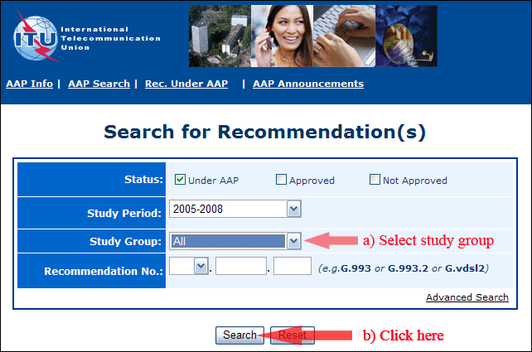
2) Select your Recommendation
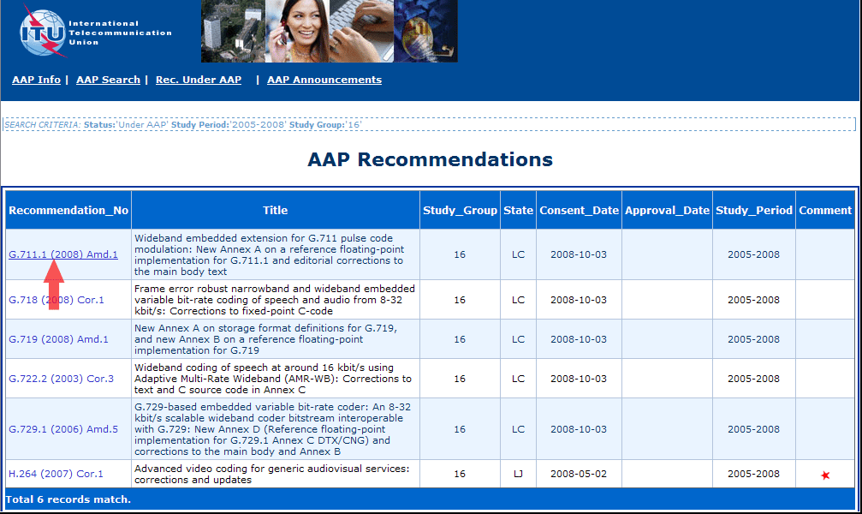
3) Click the "Submit Comment" button
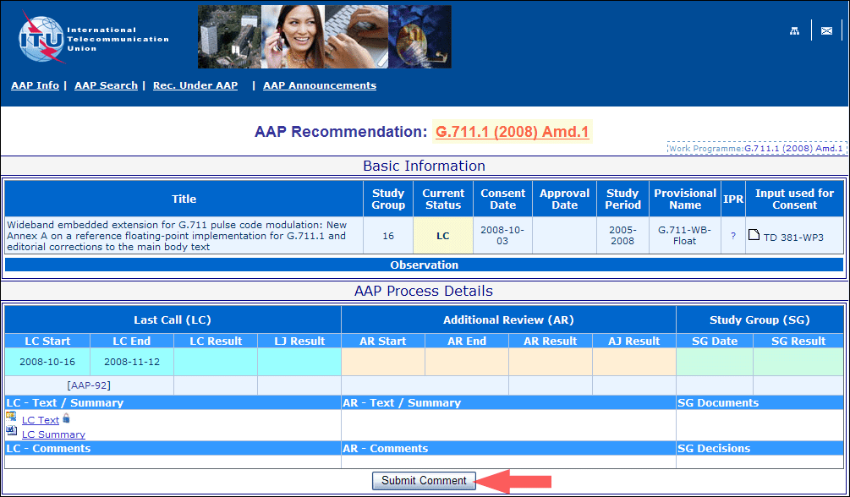
4) Complete the on-line form and click on "Submit"
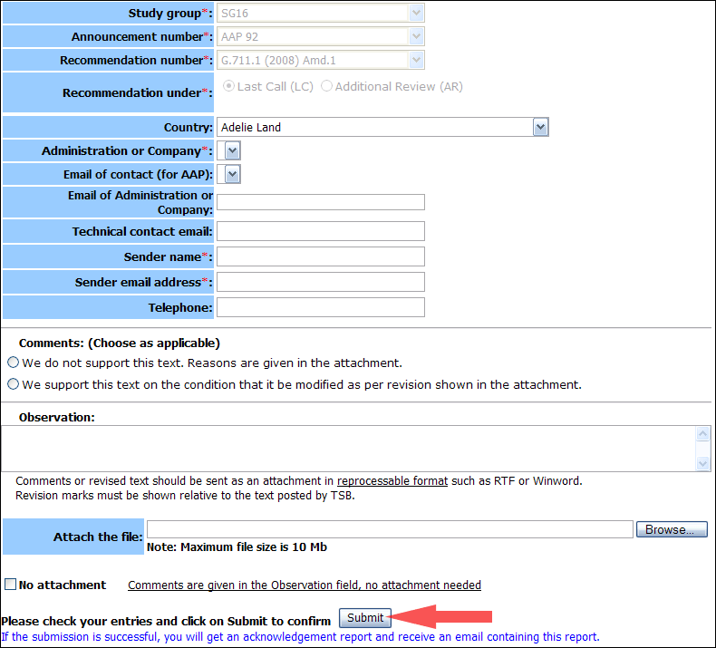
For more information, read the AAP tutorial on:
https://www.itu.int/ITU-T/aapinfo/files/AAPTutorial.pdf
Annex 3
(to TSB AAP-90)
Recommendations under LC/AR – Comment submission form
(Separate form for each Recommendation being commented upon)
ITU-T AAP comment submission form
Study Group:
Announcement number:
Recommendation number:
Date consented:
Recommendation under: | Last call (LC)  Additional Review (AR)
Country:
Administration/Company:
Name of AAP Contact Person:
Email of AAP Contact Person:
Sender name:
(if different from AAP Contact Person)
Sender email address:
Telephone:
Comments:  (Choose as applicable) | We do not support this text. Reasons are given in the attachment.  We support this text on the condition that it be modified as per revision shown in the attachment.
Observations:
No attachment: Comments are given in the Observation field, no attachment needed
To be returned to: email: tsbsg....@itu.int
[or fax +41 22 730 5853]
Comments or revised text should be sent as an attachment in RTF or WinWord format.
Revision marks must be shown relative to the text posted by TSB.

