Unión Internacional de Telecomunicaciones
Oficina de Normalización de las Telecomunicaciones

Ginebra, 16 de agosto de 2020

Ref:  Tel:  Fax:  Correo-e: | TSB AAP-87  AAP/CL  +41 22 730 5860  +41 22 730 5853  tsbdir@itu.int | – A las Administraciones de los Estados Miembros de la Unión;  – A los Miembros del Sector UIT-T;  – A los Asociados del UIT-T;  – A las Instituciones Académicas de la UIT  Copia:  – A los Presidentes y a los Vicepresidentes de las Comisiones de Estudio del UIT-T;  – Al Director de la Oficina de Desarrollo de las Telecomunicaciones;  – Al Director de la Oficina de Radiocomunicaciones

Asunto: | Situación de las Recomendaciones sometidas al proceso de aprobación alternativo (AAP)

Muy señora mía/Muy señor mío:

El proceso de aprobación alternativo (AAP) definido en la Recomendación A.8 del UIT-T se aplica a las Recomendaciones que no tienen consecuencias en materia de política o reglamentación y que no requieren, por lo tanto, la consulta formal de los Estados Miembros (véase el número 246B del Convenio de la UIT).
En el anexo 1 se enumera la lista de los textos cuyo estado ha cambiado con respecto a los anuncios TSB AAP precedentes.
Si desea formular un comentario en relación con una Recomendación sometida al AAP, le alentamos a utilizar el formulario de presentación de comentarios disponible en la página de la Recomendación que figura en el área AAP del sitio web del UIT-T, en la dirección https://www.itu.int/ITU-T/aap/ (véase también el anexo 2). Alternativamente, pueden presentarse comentarios completando el formulario del anexo 3 y remitiéndolo a la secretaría de la Comisión de Estudio correspondiente.
Le rogamos tenga en cuenta que no se alientan comentarios que se limiten a apoyar la adopción del texto en cuestión.
Le saluda atentamente,

Chaesub Lee
Director de la Oficina de
Normalización de las Telecomunicaciones
Anexos: 3

Annex 1
(to TSB AAP-87)

Status codes used in the AAP announcements:
LC = Last Call
LJ = Last Call Judgment (includes comment resolution)
AR = Additional Review
AJ = Additional Review Judgment (includes comment resolution)
SG = For Study Group approval
A = Approved
AT = Approved with typographic corrections
AC = Approved after Additional Review of Comments
NA = Not approved
TAP = Moved to TAP (ITU-T A.8 / § 5.2)
ITU-T website entry page:
https://www.itu.int/ITU-T
Alternative approval process (AAP) welcome page:
https://www.itu.int/ITU-T/aapinfo
Note – A tutorial on the ITU-T AAP application is available under the AAP welcome page
ITU-T website AAP Recommendation search page:
https://www.itu.int/ITU-T/aap/
Study Group web pages and contacts:
SG 2 | https://www.itu.int/ITU-T/studygroups/com02 | tsbsg2@itu.int
SG 3 | https://www.itu.int/ITU-T/studygroups/com03 | tsbsg3@itu.int
SG 5 | https://www.itu.int/ITU-T/studygroups/com05 | tsbsg5@itu.int
SG 9 | https://www.itu.int/ITU-T/studygroups/com09 | tsbsg9@itu.int
SG 11 | https://www.itu.int/ITU-T/studygroups/com11 | tsbsg11@itu.int
SG 12 | https://www.itu.int/ITU-T/studygroups/com12 | tsbsg12@itu.int
SG 13 | https://www.itu.int/ITU-T/studygroups/com13 | tsbsg13@itu.int
SG 15 | https://www.itu.int/ITU-T/studygroups/com15 | tsbsg15@itu.int
SG 16 | https://www.itu.int/ITU-T/studygroups/com16 | tsbsg16@itu.int
SG 17 | https://www.itu.int/ITU-T/studygroups/com17 | tsbsg17@itu.int
SG 20 | https://www.itu.int/ITU-T/studygroups/com20 | tsbsg20@itu.int

Situation concerning Study Group 9 Recommendations under AAP
Rec # | Title | Last Call (LC) Period |  |  |  | Additional Review (AR) Period |  |  |  | Status
 |  | LC Start | LC End | LC  Result | LJ  Result | AR Start | AR End | AR  Result | AJ  Result
J.1032 (J.twoway-dcas-part2) | Downloadable Conditional Access System for Bidirectional Network; System Architecture (Summary) | 2020-07-16 | 2020-08-12 | A |  |  |  |  |  | A
J.1033 (J.twoway-dcas-part3) | Downloadable Conditional Access System for Bidirectional Network; The Terminal (Summary) | 2020-07-16 | 2020-08-12 | A |  |  |  |  |  | A
J.1204 (J.stvos-sec) | The security framework of a smart TV operating system (Summary) | 2020-07-16 | 2020-08-12 | A |  |  |  |  |  | A
Situation concerning Study Group 16 Recommendations under AAP
Rec # | Title | Last Call (LC) Period |  |  |  | Additional Review (AR) Period |  |  |  | Status
 |  | LC Start | LC End | LC  Result | LJ  Result | AR Start | AR End | AR  Result | AJ  Result
F.735.1 (F.SDC) | Requirements for software defined camera (Summary) | 2020-07-16 | 2020-08-12 | A |  |  |  |  |  | A
F.743.11 (F.MPUVSReqs) | Requirements for video surveillance with mobile premises units (Summary) | 2020-07-16 | 2020-08-12 | A |  |  |  |  |  | A
F.743.20 (F.AFBDI) | Assessment framework for big data infrastructure (Summary) | 2020-07-16 | 2020-08-12 | AT |  |  |  |  |  | AT
F.743.21 (F.DAM) | Framework for data asset management (Summary) | 2020-07-16 | 2020-08-12 | AT |  |  |  |  |  | AT
F.746.10 (H.LLS-DIA) | Architecture for spontaneous dialog processing system for language learning (Summary) | 2020-07-16 | 2020-08-12 | AT |  |  |  |  |  | AT
F.746.11 (F.IQAS-INT) | Interfaces for intelligent question answering system (Summary) | 2020-07-16 | 2020-08-12 | AT |  |  |  |  |  | AT
F.748.11 (F.AI-DLPB) | Metrics and evaluation methods for deep neural network processor benchmark (Summary) | 2020-07-16 | 2020-08-12 | AT |  |  |  |  |  | AT
F.749.12 (H.CUAV-F) | Framework for communication application of civilian unmanned aerial vehicle (Summary) | 2020-07-16 | 2020-08-12 | AT |  |  |  |  |  | AT
F.749.3 (F.VM-URVMN) | Use cases and requirements for the vehicular multimedia networks (Summary) | 2020-07-16 | 2020-08-12 | A |  |  |  |  |  | A
F.751.0 (F.DLS) | Requirements for distributed ledger systems (Summary) | 2020-07-16 | 2020-08-12 | A |  |  |  |  |  | A
F.751.1 (F.DLT-AC) | Assessment criteria for distributed ledger technology (DLT) platforms (Summary) | 2020-07-16 | 2020-08-12 | A |  |  |  |  |  | A
F.751.2 (H.DLT) | Reference framework for distributed ledger technologies (Summary) | 2020-07-16 | 2020-08-12 | A |  |  |  |  |  | A
F.922 (F.ACC-ISSVReq) | Requirements of information service systems for visually impaired persons (Summary) | 2020-07-16 | 2020-08-12 | A |  |  |  |  |  | A
H.430.5 (H.ILE-PE) | Reference models for immersive live experience (ILE) presentation environment (Summary) | 2020-07-16 | 2020-08-12 | A |  |  |  |  |  | A
H.627 (V2) | Signalling and protocols for a video surveillance system (Summary) | 2020-07-16 | 2020-08-12 | A |  |  |  |  |  | A
H.644.3 (H.MCDN) | Functional architecture of multimedia content delivery networks (Summary) | 2020-07-16 | 2020-08-12 | A |  |  |  |  |  | A
H.702 (V2) | Accessibility profiles for IPTV systems (Summary) | 2020-07-16 | 2020-08-12 | A |  |  |  |  |  | A
H.704 (H.IPTV-EUIF.1) | Enhanced UI framework for IPTV terminal device - Gesture control interface (Summary) | 2020-07-16 | 2020-08-12 | A |  |  |  |  |  | A
H.841 (2020-06) | Conformance of ITU-T H.810 personal health system: Personal Health Devices interface Part 1: Optimized Exchange Protocol: Personal Health Device (Summary) | 2020-07-16 | 2020-08-12 | A |  |  |  |  |  | A
H.850.1 (2020-06) | Conformance of ITU-T H.810 personal health system: Personal Health Devices interface Part 10A: Transcoding for Bluetooth Low Energy: Personal Health Gateway - Thermometer (Summary) | 2020-07-16 | 2020-08-12 | A |  |  |  |  |  | A
H.850.2 (2020-06) | Conformance of ITU-T H.810 personal health system: Personal Health Devices interface Part 10B: Transcoding for Bluetooth Low Energy: Personal Health Gateway - Blood pressure (Summary) | 2020-07-16 | 2020-08-12 | A |  |  |  |  |  | A
H.850.3 (2020-06) | Conformance of ITU-T H.810 personal health system: Personal Health Devices interface Part 10C: Transcoding for Bluetooth Low Energy: Personal Health Gateway - Heart-rate (Summary) | 2020-07-16 | 2020-08-12 | A |  |  |  |  |  | A
H.850.4 (2020-06) | Conformance of ITU-T H.810 personal health system: Personal Health Devices interface Part 10D: Transcoding for Bluetooth Low Energy: Personal Health Gateway - Glucose meter (Summary) | 2020-07-16 | 2020-08-12 | A |  |  |  |  |  | A
H.850.5 (2020-06) | Conformance of ITU-T H.810 personal health system: Personal Health Devices interface Part 10E: Transcoding for Bluetooth Low Energy: Personal Health Gateway - Weighing scales (Summary) | 2020-07-16 | 2020-08-12 | A |  |  |  |  |  | A
H.850.6 (2020-06) | Conformance of ITU-T H.810 personal health system: Personal Health Devices interface Part 10F: Transcoding for Bluetooth Low Energy: Personal Health Gateway - Pulse oximeter (Summary) | 2020-07-16 | 2020-08-12 | A |  |  |  |  |  | A
H.850.7 (2020-06) | Conformance of ITU-T H.810 personal health system: Personal Health Devices interface Part 10G: Transcoding for Bluetooth Low Energy: Personal Health Gateway - Continuous glucose monitoring (Summary) | 2020-07-16 | 2020-08-12 | A |  |  |  |  |  | A
H.862.1 (F.DM-SLM) | Data model for sleep management services (Summary) | 2020-07-16 | 2020-08-12 | A |  |  |  |  |  | A
H.862.2 (F.AM-BS) | Framework of annotation methods for biosignal data (Summary) | 2020-07-16 | 2020-08-12 | A |  |  |  |  |  | A
H.862.3 (F.VMI-HS) | Requirements of voice management interface for human-care services (Summary) | 2020-07-16 | 2020-08-12 | A |  |  |  |  |  | A

Annex 2
(to TSB AAP-87)
Using the on-line comment submission form
Comment submission
1) Go to AAP search Web page at https://www.itu.int/ITU-T/aap/
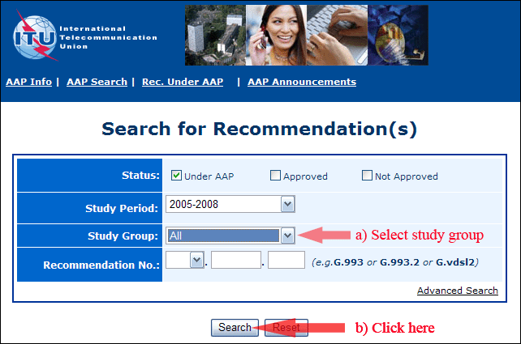
2) Select your Recommendation
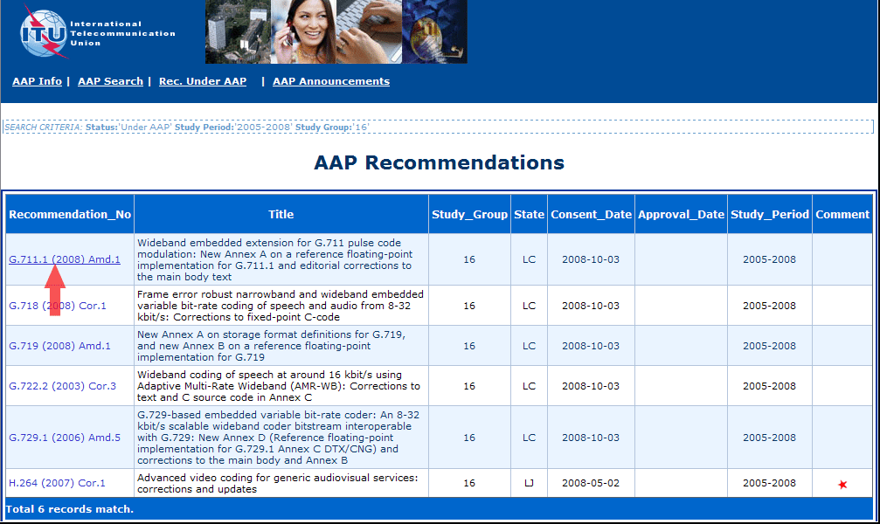
3) Click the "Submit Comment" button
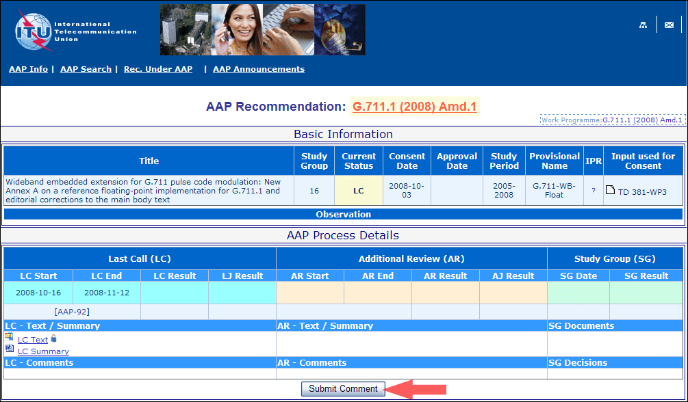
4) Complete the on-line form and click on "Submit"
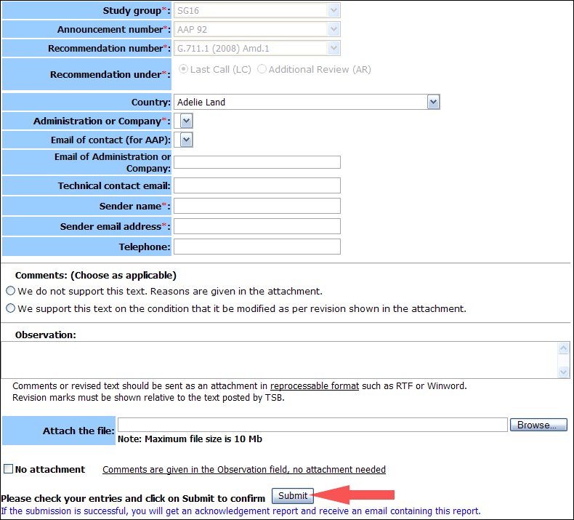
For more information, read the AAP tutorial on:
https://www.itu.int/ITU-T/aapinfo/files/AAPTutorial.pdf
Annex 3
(to TSB AAP-87)
Recommendations under LC/AR – Comment submission form
(Separate form for each Recommendation being commented upon)
ITU-T AAP comment submission form
Study Group:
Announcement number:
Recommendation number:
Date consented:
Recommendation under: | Last call (LC)  Additional Review (AR)
Country:
Administration/Company:
Name of AAP Contact Person:
Email of AAP Contact Person:
Sender name:
(if different from AAP Contact Person)
Sender email address:
Telephone:
Comments:  (Choose as applicable) | We do not support this text. Reasons are given in the attachment.  We support this text on the condition that it be modified as per revision shown in the attachment.
Observations:
No attachment: Comments are given in the Observation field, no attachment needed
To be returned to: email: tsbsg....@itu.int
[or fax +41 22 730 5853]
Comments or revised text should be sent as an attachment in RTF or WinWord format.
Revision marks must be shown relative to the text posted by TSB.

