Union Internationale des Telecommunications
Bureau de la normalisation des télécommunications

Genève, le 16 août 2020

Réf:  Tél:  Fax:  E-mail: | TSB AAP-87  AAP/CL  +41 22 730 5860  +41 22 730 5853  tsbdir@itu.int | – Aux administrations des Etats Membres de l'Union;  – Aux Membres du Secteur UIT-T;  – Aux Associés de l'UIT-T;  – Aux établissements universitaires participant aux travaux de l'UIT  Copie:  – Aux Présidents et Vice-Présidents des Commissions d'études de l'UIT-T;  – Au Directeur du Bureau de développement des télécommunications;  – Au Directeur du Bureau des radiocommunications

Objet: | Etat des Recommandations auxquelles s'applique la variante de la procédure d'approbation (AAP)

Madame, Monsieur,

La variante de la procédure d'approbation (AAP), définie dans la Recommandation UIT-T A.8, s'applique aux Recommandations qui n'ont pas d'incidence politique ou réglementaire et ne nécessitent donc pas une consultation formelle des Etats Membres (voir le numéro 246B de la Convention de l'UIT).
L'Annexe 1 énumère les textes dont le statut a changé par rapport aux annonces TSB AAP antérieures.
Si vous souhaitez soumettre des observations sur une Recommandation ayant fait l'objet de la procédure AAP, vous êtes encouragés à utiliser le formulaire en ligne de soumission des observations AAP, disponible dans l'espace AAP du site web de l'UIT-T à l'adresse https://www.itu.int/ITU-T/aap/, à la page de la Recommandation concernée (voir l'Annexe 2). Vous pouvez aussi soumettre vos observations en remplissant le formulaire figurant à l'Annexe 3 et en l'envoyant au secrétariat de la Commission d'études concernée.
Veuillez noter que les observations ayant simplement pour objet d'appuyer l'adoption du texte en question ne sont pas encouragées.
Veuillez agréer, Madame, Monsieur, l'assurance de ma considération distinguée.
Chaesub Lee
Directeur du Bureau de la normalisation des télécommunications

Annexes: 3

Annex 1
(to TSB AAP-87)

Status codes used in the AAP announcements:
LC = Last Call
LJ = Last Call Judgment (includes comment resolution)
AR = Additional Review
AJ = Additional Review Judgment (includes comment resolution)
SG = For Study Group approval
A = Approved
AT = Approved with typographic corrections
AC = Approved after Additional Review of Comments
NA = Not approved
TAP = Moved to TAP (ITU-T A.8 / § 5.2)
ITU-T website entry page:
https://www.itu.int/ITU-T
Alternative approval process (AAP) welcome page:
https://www.itu.int/ITU-T/aapinfo
Note – A tutorial on the ITU-T AAP application is available under the AAP welcome page
ITU-T website AAP Recommendation search page:
https://www.itu.int/ITU-T/aap/
Study Group web pages and contacts:
SG 2 | https://www.itu.int/ITU-T/studygroups/com02 | tsbsg2@itu.int
SG 3 | https://www.itu.int/ITU-T/studygroups/com03 | tsbsg3@itu.int
SG 5 | https://www.itu.int/ITU-T/studygroups/com05 | tsbsg5@itu.int
SG 9 | https://www.itu.int/ITU-T/studygroups/com09 | tsbsg9@itu.int
SG 11 | https://www.itu.int/ITU-T/studygroups/com11 | tsbsg11@itu.int
SG 12 | https://www.itu.int/ITU-T/studygroups/com12 | tsbsg12@itu.int
SG 13 | https://www.itu.int/ITU-T/studygroups/com13 | tsbsg13@itu.int
SG 15 | https://www.itu.int/ITU-T/studygroups/com15 | tsbsg15@itu.int
SG 16 | https://www.itu.int/ITU-T/studygroups/com16 | tsbsg16@itu.int
SG 17 | https://www.itu.int/ITU-T/studygroups/com17 | tsbsg17@itu.int
SG 20 | https://www.itu.int/ITU-T/studygroups/com20 | tsbsg20@itu.int

Situation concerning Study Group 9 Recommendations under AAP
Rec # | Title | Last Call (LC) Period |  |  |  | Additional Review (AR) Period |  |  |  | Status
 |  | LC Start | LC End | LC  Result | LJ  Result | AR Start | AR End | AR  Result | AJ  Result
J.1032 (J.twoway-dcas-part2) | Downloadable Conditional Access System for Bidirectional Network; System Architecture (Summary) | 2020-07-16 | 2020-08-12 | A |  |  |  |  |  | A
J.1033 (J.twoway-dcas-part3) | Downloadable Conditional Access System for Bidirectional Network; The Terminal (Summary) | 2020-07-16 | 2020-08-12 | A |  |  |  |  |  | A
J.1204 (J.stvos-sec) | The security framework of a smart TV operating system (Summary) | 2020-07-16 | 2020-08-12 | A |  |  |  |  |  | A
Situation concerning Study Group 16 Recommendations under AAP
Rec # | Title | Last Call (LC) Period |  |  |  | Additional Review (AR) Period |  |  |  | Status
 |  | LC Start | LC End | LC  Result | LJ  Result | AR Start | AR End | AR  Result | AJ  Result
F.735.1 (F.SDC) | Requirements for software defined camera (Summary) | 2020-07-16 | 2020-08-12 | A |  |  |  |  |  | A
F.743.11 (F.MPUVSReqs) | Requirements for video surveillance with mobile premises units (Summary) | 2020-07-16 | 2020-08-12 | A |  |  |  |  |  | A
F.743.20 (F.AFBDI) | Assessment framework for big data infrastructure (Summary) | 2020-07-16 | 2020-08-12 | AT |  |  |  |  |  | AT
F.743.21 (F.DAM) | Framework for data asset management (Summary) | 2020-07-16 | 2020-08-12 | AT |  |  |  |  |  | AT
F.746.10 (H.LLS-DIA) | Architecture for spontaneous dialog processing system for language learning (Summary) | 2020-07-16 | 2020-08-12 | AT |  |  |  |  |  | AT
F.746.11 (F.IQAS-INT) | Interfaces for intelligent question answering system (Summary) | 2020-07-16 | 2020-08-12 | AT |  |  |  |  |  | AT
F.748.11 (F.AI-DLPB) | Metrics and evaluation methods for deep neural network processor benchmark (Summary) | 2020-07-16 | 2020-08-12 | AT |  |  |  |  |  | AT
F.749.12 (H.CUAV-F) | Framework for communication application of civilian unmanned aerial vehicle (Summary) | 2020-07-16 | 2020-08-12 | AT |  |  |  |  |  | AT
F.749.3 (F.VM-URVMN) | Use cases and requirements for the vehicular multimedia networks (Summary) | 2020-07-16 | 2020-08-12 | A |  |  |  |  |  | A
F.751.0 (F.DLS) | Requirements for distributed ledger systems (Summary) | 2020-07-16 | 2020-08-12 | A |  |  |  |  |  | A
F.751.1 (F.DLT-AC) | Assessment criteria for distributed ledger technology (DLT) platforms (Summary) | 2020-07-16 | 2020-08-12 | A |  |  |  |  |  | A
F.751.2 (H.DLT) | Reference framework for distributed ledger technologies (Summary) | 2020-07-16 | 2020-08-12 | A |  |  |  |  |  | A
F.922 (F.ACC-ISSVReq) | Requirements of information service systems for visually impaired persons (Summary) | 2020-07-16 | 2020-08-12 | A |  |  |  |  |  | A
H.430.5 (H.ILE-PE) | Reference models for immersive live experience (ILE) presentation environment (Summary) | 2020-07-16 | 2020-08-12 | A |  |  |  |  |  | A
H.627 (V2) | Signalling and protocols for a video surveillance system (Summary) | 2020-07-16 | 2020-08-12 | A |  |  |  |  |  | A
H.644.3 (H.MCDN) | Functional architecture of multimedia content delivery networks (Summary) | 2020-07-16 | 2020-08-12 | A |  |  |  |  |  | A
H.702 (V2) | Accessibility profiles for IPTV systems (Summary) | 2020-07-16 | 2020-08-12 | A |  |  |  |  |  | A
H.704 (H.IPTV-EUIF.1) | Enhanced UI framework for IPTV terminal device - Gesture control interface (Summary) | 2020-07-16 | 2020-08-12 | A |  |  |  |  |  | A
H.841 (2020-06) | Conformance of ITU-T H.810 personal health system: Personal Health Devices interface Part 1: Optimized Exchange Protocol: Personal Health Device (Summary) | 2020-07-16 | 2020-08-12 | A |  |  |  |  |  | A
H.850.1 (2020-06) | Conformance of ITU-T H.810 personal health system: Personal Health Devices interface Part 10A: Transcoding for Bluetooth Low Energy: Personal Health Gateway - Thermometer (Summary) | 2020-07-16 | 2020-08-12 | A |  |  |  |  |  | A
H.850.2 (2020-06) | Conformance of ITU-T H.810 personal health system: Personal Health Devices interface Part 10B: Transcoding for Bluetooth Low Energy: Personal Health Gateway - Blood pressure (Summary) | 2020-07-16 | 2020-08-12 | A |  |  |  |  |  | A
H.850.3 (2020-06) | Conformance of ITU-T H.810 personal health system: Personal Health Devices interface Part 10C: Transcoding for Bluetooth Low Energy: Personal Health Gateway - Heart-rate (Summary) | 2020-07-16 | 2020-08-12 | A |  |  |  |  |  | A
H.850.4 (2020-06) | Conformance of ITU-T H.810 personal health system: Personal Health Devices interface Part 10D: Transcoding for Bluetooth Low Energy: Personal Health Gateway - Glucose meter (Summary) | 2020-07-16 | 2020-08-12 | A |  |  |  |  |  | A
H.850.5 (2020-06) | Conformance of ITU-T H.810 personal health system: Personal Health Devices interface Part 10E: Transcoding for Bluetooth Low Energy: Personal Health Gateway - Weighing scales (Summary) | 2020-07-16 | 2020-08-12 | A |  |  |  |  |  | A
H.850.6 (2020-06) | Conformance of ITU-T H.810 personal health system: Personal Health Devices interface Part 10F: Transcoding for Bluetooth Low Energy: Personal Health Gateway - Pulse oximeter (Summary) | 2020-07-16 | 2020-08-12 | A |  |  |  |  |  | A
H.850.7 (2020-06) | Conformance of ITU-T H.810 personal health system: Personal Health Devices interface Part 10G: Transcoding for Bluetooth Low Energy: Personal Health Gateway - Continuous glucose monitoring (Summary) | 2020-07-16 | 2020-08-12 | A |  |  |  |  |  | A
H.862.1 (F.DM-SLM) | Data model for sleep management services (Summary) | 2020-07-16 | 2020-08-12 | A |  |  |  |  |  | A
H.862.2 (F.AM-BS) | Framework of annotation methods for biosignal data (Summary) | 2020-07-16 | 2020-08-12 | A |  |  |  |  |  | A
H.862.3 (F.VMI-HS) | Requirements of voice management interface for human-care services (Summary) | 2020-07-16 | 2020-08-12 | A |  |  |  |  |  | A

Annex 2
(to TSB AAP-87)
Using the on-line comment submission form
Comment submission
1) Go to AAP search Web page at https://www.itu.int/ITU-T/aap/
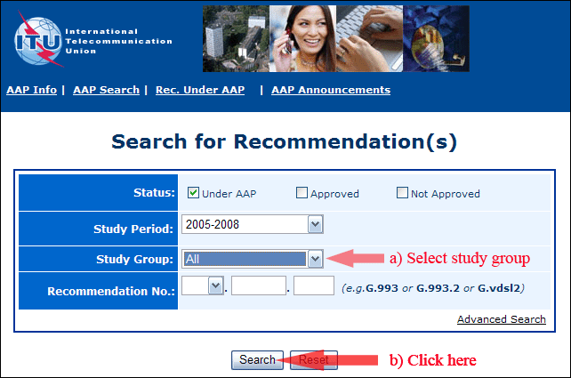
2) Select your Recommendation
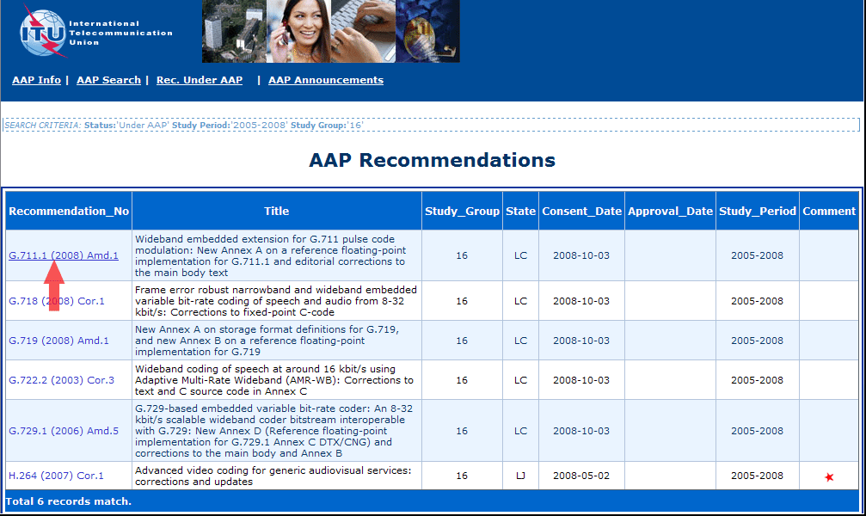
3) Click the "Submit Comment" button
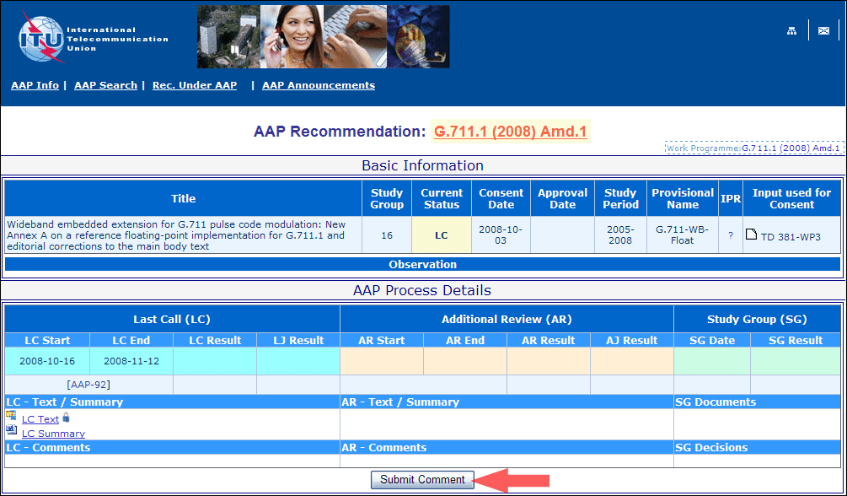
4) Complete the on-line form and click on "Submit"
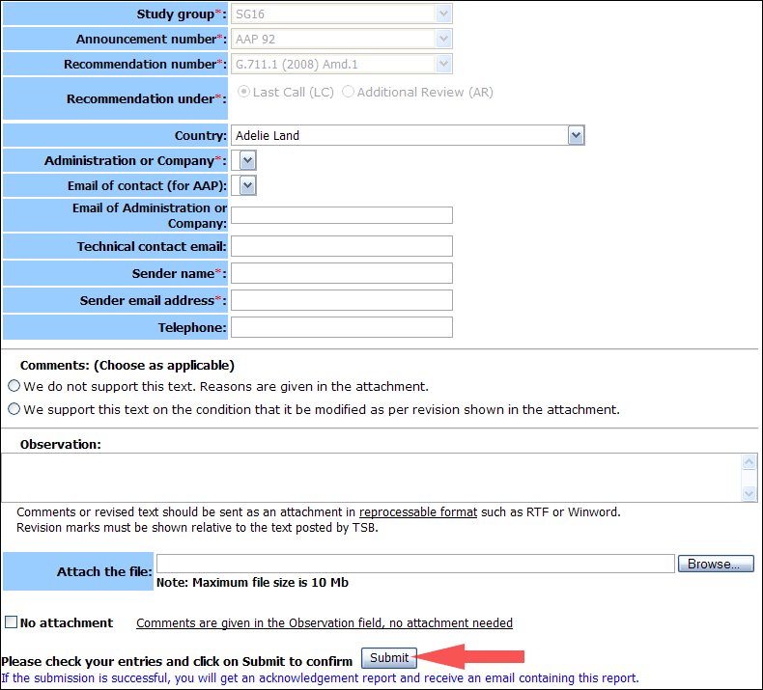
For more information, read the AAP tutorial on:
https://www.itu.int/ITU-T/aapinfo/files/AAPTutorial.pdf
Annex 3
(to TSB AAP-87)
Recommendations under LC/AR – Comment submission form
(Separate form for each Recommendation being commented upon)
ITU-T AAP comment submission form
Study Group:
Announcement number:
Recommendation number:
Date consented:
Recommendation under: | Last call (LC)  Additional Review (AR)
Country:
Administration/Company:
Name of AAP Contact Person:
Email of AAP Contact Person:
Sender name:
(if different from AAP Contact Person)
Sender email address:
Telephone:
Comments:  (Choose as applicable) | We do not support this text. Reasons are given in the attachment.  We support this text on the condition that it be modified as per revision shown in the attachment.
Observations:
No attachment: Comments are given in the Observation field, no attachment needed
To be returned to: email: tsbsg....@itu.int
[or fax +41 22 730 5853]
Comments or revised text should be sent as an attachment in RTF or WinWord format.
Revision marks must be shown relative to the text posted by TSB.

