Union Internationale des Telecommunications
Bureau de la normalisation des télécommunications

Genève, le 16 septembre 2019

Réf:  Tél:  Fax:  E-mail: | TSB AAP-66  AAP/CL  +41 22 730 5860  +41 22 730 5853  tsbdir@itu.int | – Aux administrations des Etats Membres de l'Union;  – Aux Membres du Secteur UIT-T;  – Aux Associés de l'UIT-T;  – Aux établissements universitaires participant aux travaux de l'UIT  Copie:  – Aux Présidents et Vice-Présidents des Commissions d'études de l'UIT-T;  – Au Directeur du Bureau de développement des télécommunications;  – Au Directeur du Bureau des radiocommunications

Objet: | Etat des Recommandations auxquelles s'applique la variante de la procédure d'approbation (AAP)

Madame, Monsieur,

La variante de la procédure d'approbation (AAP), définie dans la Recommandation UIT-T A.8, s'applique aux Recommandations qui n'ont pas d'incidence politique ou réglementaire et ne nécessitent donc pas une consultation formelle des Etats Membres (voir le numéro 246B de la Convention de l'UIT).
L'Annexe 1 énumère les textes dont le statut a changé par rapport aux annonces TSB AAP antérieures.
Si vous souhaitez soumettre des observations sur une Recommandation ayant fait l'objet de la procédure AAP, vous êtes encouragés à utiliser le formulaire en ligne de soumission des observations AAP, disponible dans l'espace AAP du site web de l'UIT-T à l'adresse https://www.itu.int/ITU-T/aap/, à la page de la Recommandation concernée (voir l'Annexe 2). Vous pouvez aussi soumettre vos observations en remplissant le formulaire figurant à l'Annexe 3 et en l'envoyant au secrétariat de la Commission d'études concernée.
Veuillez noter que les observations ayant simplement pour objet d'appuyer l'adoption du texte en question ne sont pas encouragées.
Veuillez agréer, Madame, Monsieur, l'assurance de ma considération distinguée.
Chaesub Lee
Directeur du Bureau de la normalisation des télécommunications

Annexes: 3

Annex 1
(to TSB AAP-66)

Status codes used in the AAP announcements:
LC = Last Call
LJ = Last Call Judgment (includes comment resolution)
AR = Additional Review
AJ = Additional Review Judgment (includes comment resolution)
SG = For Study Group approval
A = Approved
AT = Approved with typographic corrections
AC = Approved after Additional Review of Comments
NA = Not approved
TAP = Moved to TAP (ITU-T A.8 / § 5.2)
ITU-T website entry page:
https://www.itu.int/ITU-T
Alternative approval process (AAP) welcome page:
https://www.itu.int/ITU-T/aapinfo
Note – A tutorial on the ITU-T AAP application is available under the AAP welcome page
ITU-T website AAP Recommendation search page:
https://www.itu.int/ITU-T/aap/
Study Group web pages and contacts:
SG 2 | https://www.itu.int/ITU-T/studygroups/com02 | tsbsg2@itu.int
SG 3 | https://www.itu.int/ITU-T/studygroups/com03 | tsbsg3@itu.int
SG 5 | https://www.itu.int/ITU-T/studygroups/com05 | tsbsg5@itu.int
SG 9 | https://www.itu.int/ITU-T/studygroups/com09 | tsbsg9@itu.int
SG 11 | https://www.itu.int/ITU-T/studygroups/com11 | tsbsg11@itu.int
SG 12 | https://www.itu.int/ITU-T/studygroups/com12 | tsbsg12@itu.int
SG 13 | https://www.itu.int/ITU-T/studygroups/com13 | tsbsg13@itu.int
SG 15 | https://www.itu.int/ITU-T/studygroups/com15 | tsbsg15@itu.int
SG 16 | https://www.itu.int/ITU-T/studygroups/com16 | tsbsg16@itu.int
SG 17 | https://www.itu.int/ITU-T/studygroups/com17 | tsbsg17@itu.int
SG 20 | https://www.itu.int/ITU-T/studygroups/com20 | tsbsg20@itu.int

Situation concerning Study Group 9 Recommendations under AAP
Rec # | Title | Last Call (LC) Period |  |  |  | Additional Review (AR) Period |  |  |  | Status
 |  | LC Start | LC End | LC  Result | LJ  Result | AR Start | AR End | AR  Result | AJ  Result
J.1600 (J.pcnp-fmw) | Premium Cable Network Platform (PCNP) - Framework (Summary) | 2019-07-01 | 2019-07-28 | LJ | AR | 2019-09-16 | 2019-10-06 |  |  | AR
Situation concerning Study Group 12 Recommendations under AAP
Rec # | Title | Last Call (LC) Period |  |  |  | Additional Review (AR) Period |  |  |  | Status
 |  | LC Start | LC End | LC  Result | LJ  Result | AR Start | AR End | AR  Result | AJ  Result
G.1033 (G.DFS) | QoS and QoE aspects of digital financial services (Summary) | 2019-09-16 | 2019-10-13 |  |  |  |  |  |  | LC
Y.1540 | Internet protocol data communication service - IP packet transfer and availability performance parameters (Summary) | 2019-06-01 | 2019-06-28 | LJ | AR | 2019-09-16 | 2019-10-06 |  |  | AR
Situation concerning Study Group 17 Recommendations under AAP
Rec # | Title | Last Call (LC) Period |  |  |  | Additional Review (AR) Period |  |  |  | Status
 |  | LC Start | LC End | LC  Result | LJ  Result | AR Start | AR End | AR  Result | AJ  Result
X.500 | Edition 9 of Rec. ITU-T X.500 | ISO/IEC 9594-1 Information technology - Open Systems Interconnection - The Directory: Overview of concepts, models and services (Summary) | 2019-09-16 | 2019-10-13 |  |  |  |  |  |  | LC
X.501 | Edition 9 of Rec. ITU-T X.501 | ISO/IEC 9594-2 Information technology - Open Systems Interconnection - The Directory: Models (Summary) | 2019-09-16 | 2019-10-13 |  |  |  |  |  |  | LC
X.509 | Edition 9 of Rec. ITU-T X.509 | ISO/IEC 9594-8 Information technology - Open Systems Interconnection - The Directory: Public-key and attribute certificate frameworks (Summary) | 2019-09-16 | 2019-10-13 |  |  |  |  |  |  | LC
X.511 | Edition 9 of Rec. ITU-T X.511 | ISO/IEC 9594-3 Information technology - Open Systems Interconnection - The Directory: Abstract service definition (Summary) | 2019-09-16 | 2019-10-13 |  |  |  |  |  |  | LC
X.518 | Edition 9 of Rec. ITU-T X.518 | ISO/IEC 9594-4 Information technology - Open Systems Interconnection - The Directory: Procedures for distributed operation (Summary) | 2019-09-16 | 2019-10-13 |  |  |  |  |  |  | LC
X.519 | Edition 9 of Rec. ITU-T X.519 | ISO/IEC 9594-5 Information technology - Open Systems Interconnection - The Directory: Protocol specifications (Summary) | 2019-09-16 | 2019-10-13 |  |  |  |  |  |  | LC
X.520 | Edition 9 of Rec. ITU-T X.520 | ISO/IEC 9594-6 Information technology - Open Systems Interconnection - The Directory: Selected attribute types (Summary) | 2019-09-16 | 2019-10-13 |  |  |  |  |  |  | LC
X.521 | Edition 9 of Rec. ITU-T X.521 | ISO/IEC 9594-7 Information technology - Open Systems Interconnection - The Directory: Selected object classes (Summary) | 2019-09-16 | 2019-10-13 |  |  |  |  |  |  | LC
X.525 | Edition 9 of Rec. ITU-T X.525 | ISO/IEC 9594-9 Information technology - Open Systems Interconnection - The Directory: Replication (Summary) | 2019-09-16 | 2019-10-13 |  |  |  |  |  |  | LC
X.694 (2015) Cor.1 | Information technology - ASN.1 encoding rules: Mapping W3C XML schema definitions into ASN.1 Corrigendum 1 (Summary) | 2019-09-16 | 2019-10-13 |  |  |  |  |  |  | LC
X.893 (2007) Cor.1 | Information technology - Generic applications of ASN.1: Fast infoset security Technical Corrigendum 1 (Summary) | 2019-09-16 | 2019-10-13 |  |  |  |  |  |  | LC
Z.100 | Specification and Description Language - Overview of SDL-2010 (Summary) | 2019-09-16 | 2019-10-13 |  |  |  |  |  |  | LC
Z.100 Annex F1 | Specification and Description Language - Overview of SDL-2010 - SDL formal definition: General overview (Summary) | 2019-09-16 | 2019-10-13 |  |  |  |  |  |  | LC
Z.100 Annex F2 | Specification and Description Language - Overview of SDL-2010 - SDL formal definition: Static semantics (Summary) | 2019-09-16 | 2019-10-13 |  |  |  |  |  |  | LC
Z.100 Annex F3 | Specification and Description Language - Overview of SDL-2010 - SDL formal definition: Dynamic semantics (Summary) | 2019-09-16 | 2019-10-13 |  |  |  |  |  |  | LC
Z.101 | Specification and Description Language - Basic SDL-2010 (Summary) | 2019-09-16 | 2019-10-13 |  |  |  |  |  |  | LC
Z.102 | Specification and Description Language - Comprehensive SDL-2010 (Summary) | 2019-09-16 | 2019-10-13 |  |  |  |  |  |  | LC
Z.103 | Specification and Description Language - Shorthand notation and annotation in SDL-2010 (Summary) | 2019-09-16 | 2019-10-13 |  |  |  |  |  |  | LC
Z.104 | Specification and Description Language - Data and action language in SDL-2010 (Summary) | 2019-09-16 | 2019-10-13 |  |  |  |  |  |  | LC
Z.105 | Specification and Description Language - SDL-2010 combined with ASN.1 modules (Summary) | 2019-09-16 | 2019-10-13 |  |  |  |  |  |  | LC
Z.106 | Specification and Description Language - Common interchange format for SDL-2010 (Summary) | 2019-09-16 | 2019-10-13 |  |  |  |  |  |  | LC
Z.107 | Specification and Description Language - Object-oriented data in SDL-2010 (Summary) | 2019-09-16 | 2019-10-13 |  |  |  |  |  |  | LC
Z.161 | Testing and Test Control Notation version 3: TTCN-3 core language (Summary) | 2019-09-16 | 2019-10-13 |  |  |  |  |  |  | LC
Z.161.2 | Testing and Test Control Notation version 3: TTCN-3 language extensions: Configuration and deployment support (Summary) | 2019-09-16 | 2019-10-13 |  |  |  |  |  |  | LC
Z.161.6 | Testing and Test Control Notation version 3: TTCN-3 language extensions: Advanced Matching (Summary) | 2019-09-16 | 2019-10-13 |  |  |  |  |  |  | LC
Z.161.7 | Testing and Test Control Notation version 3: TTCN-3 Language Extensions: Object-Oriented Features (Summary) | 2019-09-16 | 2019-10-13 |  |  |  |  |  |  | LC
Z.166 | Testing and Test Control Notation version 3: TTCN-3 control interface (TCI) (Summary) | 2019-09-16 | 2019-10-13 |  |  |  |  |  |  | LC
Z.169 | Testing and Test Control Notation version 3: Using XML schema with TTCN-3 (Summary) | 2019-09-16 | 2019-10-13 |  |  |  |  |  |  | LC

Annex 2
(to TSB AAP-66)
Using the on-line comment submission form
Comment submission
1) Go to AAP search Web page at https://www.itu.int/ITU-T/aap/
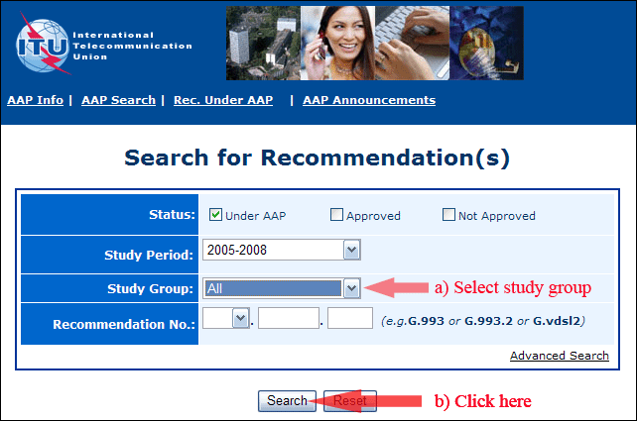
2) Select your Recommendation
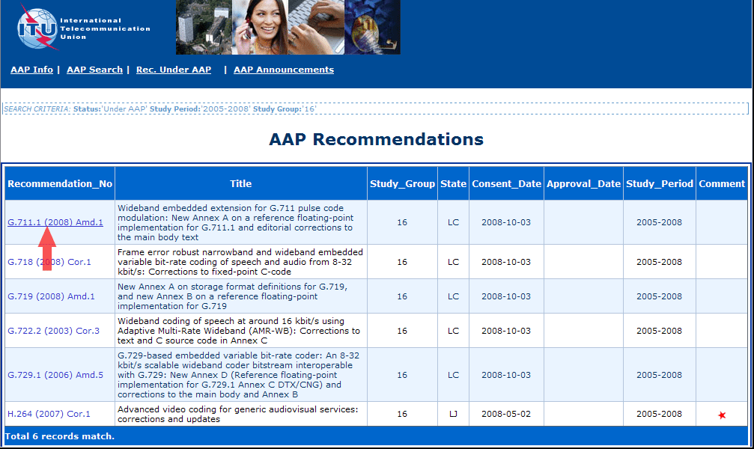
3) Click the "Submit Comment" button
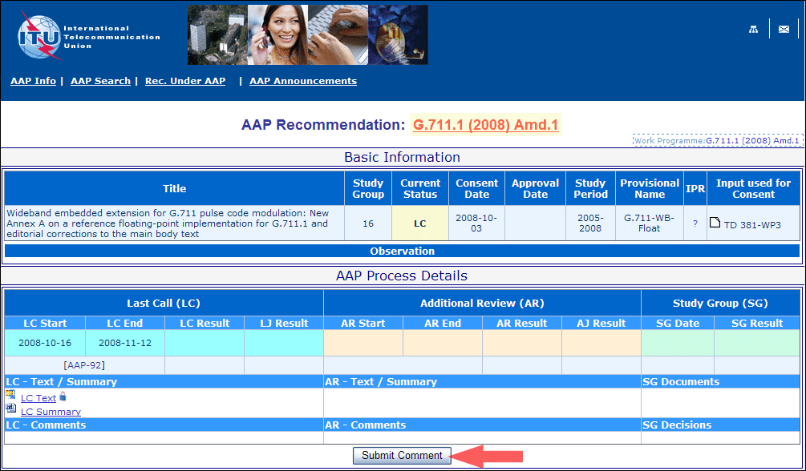
4) Complete the on-line form and click on "Submit"
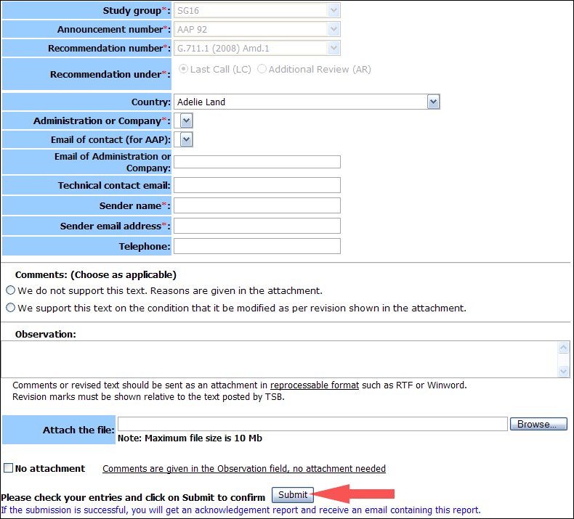
For more information, read the AAP tutorial on:
https://www.itu.int/ITU-T/aapinfo/files/AAPTutorial.pdf
Annex 3
(to TSB AAP-66)
Recommendations under LC/AR – Comment submission form
(Separate form for each Recommendation being commented upon)
ITU-T AAP comment submission form
Study Group:
Announcement number:
Recommendation number:
Date consented:
Recommendation under: | Last call (LC)  Additional Review (AR)
Country:
Administration/Company:
Name of AAP Contact Person:
Email of AAP Contact Person:
Sender name:
(if different from AAP Contact Person)
Sender email address:
Telephone:
Comments:  (Choose as applicable) | We do not support this text. Reasons are given in the attachment.  We support this text on the condition that it be modified as per revision shown in the attachment.
Observations:
No attachment: Comments are given in the Observation field, no attachment needed
To be returned to: email: tsbsg....@itu.int
[or fax +41 22 730 5853]
Comments or revised text should be sent as an attachment in RTF or WinWord format.
Revision marks must be shown relative to the text posted by TSB.

