International Telecommunication Union
Telecommunication Standardization Bureau

Geneva, 1 August 2019

Ref:  Tel:  Fax:  E-mail: | TSB AAP-63  AAP/CL  +41 22 730 5860  +41 22 730 5853  tsbdir@itu.int | – To Administrations of Member States of the Union;  – To ITU-T Sector Members;  – To ITU-T Associates;  – To ITU Academia  Copy:  – To the ITU-T Study Group Chairmen and Vice-Chairmen;  – To the Director of the Telecommunication Development Bureau;  – To the Director of the Radiocommunication Bureau

Subject: | Situation concerning Recommendations under the Alternative Approval Process (AAP)

Dear Sir/Madam,
The Alternative Approval Process (AAP) defined in Recommendation ITU-T A.8 applies to Recommendations that do not have policy or regulatory implications and which, therefore, do not require formal consultation of Member States (see ITU Convention 246B).
Annex 1 lists those texts whose status has changed compared with previous TSB AAP Announcements.
Any member wishing to submit a comment relative to a Recommendation under AAP is encouraged to use the on-line AAP comment submission form available on the page of the Recommendation via https://www.itu.int/ITU-T/aap (see Annex 2). Alternatively, comments may be submitted by completing the form in Annex 3 and sending it to the secretariat of the concerned study group.
Please note that comments that simply support adoption of the text in question are not encouraged.
Yours faithfully,
Chaesub Lee
Director of the Telecommunication Standardization Bureau
Annexes: 3

Annex 1
(to TSB AAP-63)

Status codes used in the AAP announcements:
LC = Last Call
LJ = Last Call Judgment (includes comment resolution)
AR = Additional Review
AJ = Additional Review Judgment (includes comment resolution)
SG = For Study Group approval
A = Approved
AT = Approved with typographic corrections
AC = Approved after Additional Review of Comments
NA = Not approved
TAP = Moved to TAP (ITU-T A.8 / § 5.2)
ITU-T website entry page:
https://www.itu.int/ITU-T
Alternative approval process (AAP) welcome page:
https://www.itu.int/ITU-T/aapinfo
Note – A tutorial on the ITU-T AAP application is available under the AAP welcome page
ITU-T website AAP Recommendation search page:
https://www.itu.int/ITU-T/aap/
Study Group web pages and contacts:
SG 2 | https://www.itu.int/ITU-T/studygroups/com02 | tsbsg2@itu.int
SG 3 | https://www.itu.int/ITU-T/studygroups/com03 | tsbsg3@itu.int
SG 5 | https://www.itu.int/ITU-T/studygroups/com05 | tsbsg5@itu.int
SG 9 | https://www.itu.int/ITU-T/studygroups/com09 | tsbsg9@itu.int
SG 11 | https://www.itu.int/ITU-T/studygroups/com11 | tsbsg11@itu.int
SG 12 | https://www.itu.int/ITU-T/studygroups/com12 | tsbsg12@itu.int
SG 13 | https://www.itu.int/ITU-T/studygroups/com13 | tsbsg13@itu.int
SG 15 | https://www.itu.int/ITU-T/studygroups/com15 | tsbsg15@itu.int
SG 16 | https://www.itu.int/ITU-T/studygroups/com16 | tsbsg16@itu.int
SG 17 | https://www.itu.int/ITU-T/studygroups/com17 | tsbsg17@itu.int
SG 20 | https://www.itu.int/ITU-T/studygroups/com20 | tsbsg20@itu.int

Situation concerning Study Group 9 Recommendations under AAP
Rec # | Title | Last Call (LC) Period |  |  |  | Additional Review (AR) Period |  |  |  | Status
 |  | LC Start | LC End | LC  Result | LJ  Result | AR Start | AR End | AR  Result | AJ  Result
J.207 (J.207rev) | Specification for integrated broadcast and broadband digital television application control framework (Summary) | 2019-07-01 | 2019-07-28 | A |  |  |  |  |  | A
J.216 (J.MHAv2) | Second-generation Modular Headend Architecture in systems for interactive cable television services - IP cable modems (Summary) | 2019-07-01 | 2019-07-28 | A |  |  |  |  |  | A
J.224 (J.5GDOCSIS) | Fifth-generation transmission systems for interactive cable television services - IP cable modems (Summary) | 2019-07-01 | 2019-07-28 | A |  |  |  |  |  | A
J.288 (J.288-rev) | Encapsulation of type length value (TLV) packet for cable transmission systems (Summary) | 2019-07-01 | 2019-07-28 | A |  |  |  |  |  | A
J.1026 (J.oneway-dcas-part1) | Downloadable Conditional Access System for Unidirectional Network; Requirements (Summary) | 2019-07-01 | 2019-07-28 | A |  |  |  |  |  | A
J.1027 (J.oneway-dcas-part2) | Downloadable Conditional Access System for Unidirectional Network; System Architecture (Summary) | 2019-07-01 | 2019-07-28 | A |  |  |  |  |  | A
J.1028 (J.oneway-dcas-part3) | Downloadable Conditional Access System for Unidirectional Network; Terminal System (Summary) | 2019-07-01 | 2019-07-28 | A |  |  |  |  |  | A
J.1202 (J.stvos-spec-arch) | The Architecture of Smart TV Operating System (Summary) | 2019-07-01 | 2019-07-28 | A |  |  |  |  |  | A
J.1210 (J.ipvb-req) | Requirements of IP Video Broadcast (IPVB) for CATV Networks (Summary) | 2019-07-01 | 2019-07-28 | A |  |  |  |  |  | A
J.1600 (J.pcnp-fmw) | Premium Cable Network Platform (PCNP) - Framework (Summary) | 2019-07-01 | 2019-07-28 | LJ |  |  |  |  |  | LJ
Situation concerning Study Group 11 Recommendations under AAP
Rec # | Title | Last Call (LC) Period |  |  |  | Additional Review (AR) Period |  |  |  | Status
 |  | LC Start | LC End | LC  Result | LJ  Result | AR Start | AR End | AR  Result | AJ  Result
Q.3741 (Q.SD-WAN) | Signalling Requirements for SD-WAN service (Summary) | 2019-07-01 | 2019-07-28 | A |  |  |  |  |  | A
Q.4043 (Q.vs-iop-reqts) | Interoperability testing requirements of virtual switch (Summary) | 2019-07-01 | 2019-07-28 | A |  |  |  |  |  | A
Q.5021 (Q.CE-APIMP) | Protocol for managing capability exposure APIs in IMT-2020 network (Summary) | 2019-07-01 | 2019-07-28 | A |  |  |  |  |  | A
Situation concerning Study Group 15 Recommendations under AAP
Rec # | Title | Last Call (LC) Period |  |  |  | Additional Review (AR) Period |  |  |  | Status
 |  | LC Start | LC End | LC  Result | LJ  Result | AR Start | AR End | AR  Result | AJ  Result
G.671 | Transmission characteristics of optical components and subsystems (Summary) | 2019-08-01 | 2019-08-28 |  |  |  |  |  |  | LC
G.709/Y.1331 (2016) Cor.2 | Interfaces for the optical transport network: Corrigendum 2 (Summary) | 2019-08-01 | 2019-08-28 |  |  |  |  |  |  | LC
G.798 (2017) Amd.2 | Characteristics of optical transport network hierarchy equipment functional blocks - Amendment 2 (Summary) | 2019-08-01 | 2019-08-28 |  |  |  |  |  |  | LC
G.807 (G.media) | Generic functional architecture of the optical media network (Summary) | 2019-08-01 | 2019-08-28 |  |  |  |  |  |  | LC
G.808.2 | Generic protection switching - ring protection (Summary) | 2019-08-01 | 2019-08-28 |  |  |  |  |  |  | LC
G.872 | Architecture of the Optical Transport network (OTN) (Summary) | 2019-08-01 | 2019-08-28 |  |  |  |  |  |  | LC
G.984.2 | Gigabit-capable Passive Optical Networks (GPON): Physical Media Dependent (PMD) layer specification (Summary) | 2019-08-01 | 2019-08-28 |  |  |  |  |  |  | LC
G.988 (2017) Amd.2 | ONU management and control interface (OMCI) specification: Amendment 2 (Summary) | 2019-08-01 | 2019-08-28 |  |  |  |  |  |  | LC
G.989.2 (2019) Cor.1 | 40-Gigabit-capable passive optical networks (NG PON2): Physical media dependent (PMD) layer specification: Corrigendum 1 (Summary) | 2019-08-01 | 2019-08-28 |  |  |  |  |  |  | LC
G.998.4 (2018) Cor.1 | Improved impulse noise protection for digital subscriber line (DSL) transceivers - Corrigendum 1 (Summary) | 2019-08-01 | 2019-08-28 |  |  |  |  |  |  | LC
G.7041/Y.1303 (2016) Amd.1 | Generic framing procedure - Amendment 1 (Summary) | 2019-08-01 | 2019-08-28 |  |  |  |  |  |  | LC
G.7710/Y.1701 | Common equipment management function requirements (Summary) | 2019-08-01 | 2019-08-28 |  |  |  |  |  |  | LC
G.7712/Y.1703 | Architecture and specification of data communication network (Summary) | 2019-08-01 | 2019-08-28 |  |  |  |  |  |  | LC
G.8013/Y.1731 (2015) Cor.2 | Operation, administration and maintenance (OAM) functions and mechanisms for Ethernet-based networks - Corrigendum 2 (Summary) | 2019-08-01 | 2019-08-28 |  |  |  |  |  |  | LC
G.8021/Y.1341 (2018) Cor.1 | Characteristics of Ethernet transport network equipment functional blocks - Corrigendum 1 (Summary) | 2019-08-01 | 2019-08-28 |  |  |  |  |  |  | LC
G.8132/Y.1383 (2017) Cor.1 | MPLS-TP shared ring protection - Corrigendum 1 (Summary) | 2019-08-01 | 2019-08-28 |  |  |  |  |  |  | LC
G.8133 (G.mtdh) | Dual-Homing Protection for MPLS-TP Pseudowires (Summary) | 2019-08-01 | 2019-08-28 |  |  |  |  |  |  | LC
G.8261/Y.1361 | Timing and synchronization aspects in packet networks (Summary) | 2019-08-01 | 2019-08-28 |  |  |  |  |  |  | LC
G.8262.1/Y.1362.1 (2019) Amd.1 | Timing characteristics of enhanced synchronous equipment slave clock: Amendment 1 (Summary) | 2019-08-01 | 2019-08-28 |  |  |  |  |  |  | LC
G.8265.1/Y.1365.1 (2014) Amd.1 | Precision time protocol telecom profile for frequency synchronization -Amendment 1 (Summary) | 2019-08-01 | 2019-08-28 |  |  |  |  |  |  | LC
G.8271.1/Y.1366.1 (2017) Amd.2 | Network limits for time synchronization in Packet networks - Amendment 2 (Summary) | 2019-08-01 | 2019-08-28 |  |  |  |  |  |  | LC
G.8272.1/Y.1367.1 (2016) Amd.2 | Timing characteristics of enhanced primary reference time clocks -Amendment 2 (Summary) | 2019-08-01 | 2019-08-28 |  |  |  |  |  |  | LC
G.8273.2/Y.1368.2 | Timing characteristics of telecom boundary clocks and telecom time slave clocks (Summary) | 2019-08-01 | 2019-08-28 |  |  |  |  |  |  | LC
G.8275.1/Y.1369.1 (2016) Amd.3 | Precision time protocol telecom profile for phase/time synchronization with full timing support from the network -Amendment 3 (Summary) | 2019-08-01 | 2019-08-28 |  |  |  |  |  |  | LC
G.8275.2/Y.1369.2 (2016) Amd.3 | Precision time protocol telecom profile for phase/time synchronization with partial timing support from the network (Summary) | 2019-08-01 | 2019-08-28 |  |  |  |  |  |  | LC
G.8275/Y.1369 (2017) Amd.2 | Architecture and requirements for packet-based time and phase distribution - Amendment 2 (Summary) | 2019-08-01 | 2019-08-28 |  |  |  |  |  |  | LC
G.9701 (2019) Amd.1 | Fast access to subscriber terminals (G.fast) - Physical layer specification - Amendment 1 (Summary) | 2019-08-01 | 2019-08-28 |  |  |  |  |  |  | LC
G.9701 (2019) Cor.1 | Fast access to subscriber terminals (G.fast) - Physical layer specification - Corrigendum 1 (Summary) | 2019-08-01 | 2019-08-28 |  |  |  |  |  |  | LC
G.9803 (2018) Amd.1 | Radio over fibre systems - Amendment 1 (Summary) | 2019-08-01 | 2019-08-28 |  |  |  |  |  |  | LC
G.9804.1 (G.hsp.req) | Higher Speed Passive Optical Networks: Requirements (Summary) | 2019-08-01 | 2019-08-28 |  |  |  |  |  |  | LC
L.208 (L.fdb) | Requirements for passive optical nodes: Fibre Distribution Box (Summary) | 2019-08-01 | 2019-08-28 |  |  |  |  |  |  | LC
Situation concerning Study Group 16 Recommendations under AAP
Rec # | Title | Last Call (LC) Period |  |  |  | Additional Review (AR) Period |  |  |  | Status
 |  | LC Start | LC End | LC  Result | LJ  Result | AR Start | AR End | AR  Result | AJ  Result
H.871 (F.WAAD) | Safe listening guidelines for personal sound amplifiers (Summary) | 2019-07-01 | 2019-07-28 | A |  |  |  |  |  | A

Annex 2
(to TSB AAP-63)
Using the on-line comment submission form
Comment submission
1) Go to AAP search Web page at https://www.itu.int/ITU-T/aap/
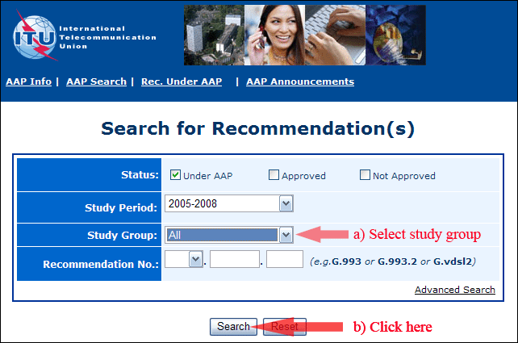
2) Select your Recommendation
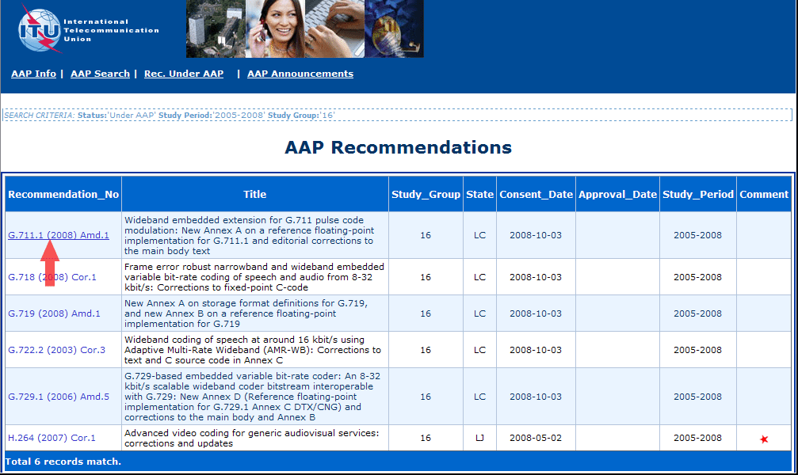
3) Click the "Submit Comment" button
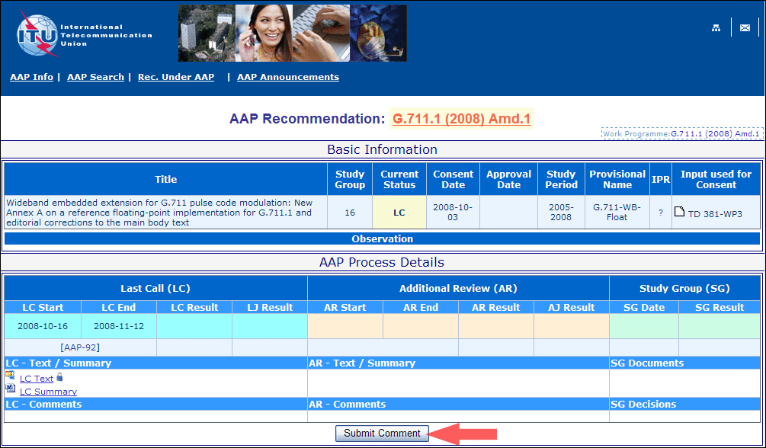
4) Complete the on-line form and click on "Submit"
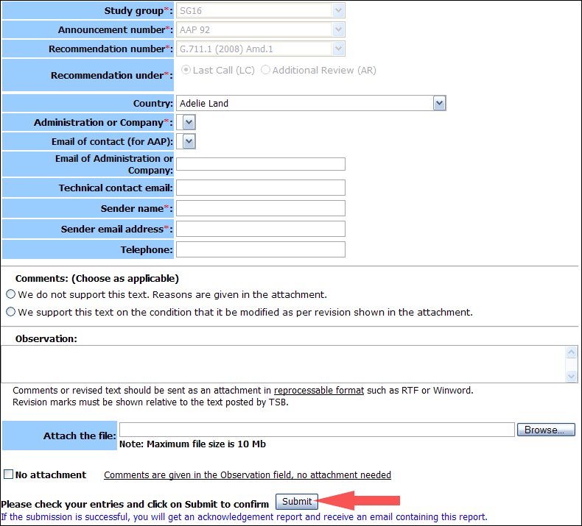
For more information, read the AAP tutorial on:
https://www.itu.int/ITU-T/aapinfo/files/AAPTutorial.pdf
Annex 3
(to TSB AAP-63)
Recommendations under LC/AR – Comment submission form
(Separate form for each Recommendation being commented upon)
ITU-T AAP comment submission form
Study Group:
Announcement number:
Recommendation number:
Date consented:
Recommendation under: | Last call (LC)  Additional Review (AR)
Country:
Administration/Company:
Name of AAP Contact Person:
Email of AAP Contact Person:
Sender name:
(if different from AAP Contact Person)
Sender email address:
Telephone:
Comments:  (Choose as applicable) | We do not support this text. Reasons are given in the attachment.  We support this text on the condition that it be modified as per revision shown in the attachment.
Observations:
No attachment: Comments are given in the Observation field, no attachment needed
To be returned to: email: tsbsg....@itu.int
[or fax +41 22 730 5853]
Comments or revised text should be sent as an attachment in RTF or WinWord format.
Revision marks must be shown relative to the text posted by TSB.

