国 际 电 信 联 盟
电信标准化局
2019年8月1日 ，日内瓦

参考号:  电话:  传真:  电子邮件: | 电信标准化局AAP-63  AAP/CL  +41 22 730 5860  +41 22 730 5853  tsbdir@itu.int | – 致国际电联成员国各主管部门；  – 致ITU-T各部门成员；  – 致ITU-T 部门准成员；  – 国际电联学术成员  抄送：  – 电信标准化局研究组主席和副主席；  – 电信发展局主任；  – 无线电通信局主任

事由: | 有关采用替换批准程序（AAP）处理的建议书的情况

先生/女士，
ITU-T A.8 建议书中规定的建议书替换批准程序 (AAP) 适用于那些不会产生政策或 监管影响、因而不需与成员国正式协商的建议书（见国际电联《公约》第246B款）。
附件1列出了那些在以往电信标准化局AAP预告后地位发生变化的案文。
如您希望针对某个适用AAP的建议书提出意见，请使用可在ITU-T网站AAP区域 （https://www.itu.int/ITU-T/aap）的“建议书”网页上获取的《AAP意见在线提交表格》 （见附件2）。或者，可填妥附件3 中的表格并将意见发送给相关研究组的秘书处。
敬请留意，我们不鼓励提交仅支持通过所涉案文而没有实质内容的意见。

顺致敬意！

李在摄
电信标准化局主任

附件：3件

Annex 1
(to TSB AAP-63)

Status codes used in the AAP announcements:
LC = Last Call
LJ = Last Call Judgment (includes comment resolution)
AR = Additional Review
AJ = Additional Review Judgment (includes comment resolution)
SG = For Study Group approval
A = Approved
AT = Approved with typographic corrections
AC = Approved after Additional Review of Comments
NA = Not approved
TAP = Moved to TAP (ITU-T A.8 / § 5.2)
ITU-T website entry page:
https://www.itu.int/ITU-T
Alternative approval process (AAP) welcome page:
https://www.itu.int/ITU-T/aapinfo
Note – A tutorial on the ITU-T AAP application is available under the AAP welcome page
ITU-T website AAP Recommendation search page:
https://www.itu.int/ITU-T/aap/
Study Group web pages and contacts:
SG 2 | https://www.itu.int/ITU-T/studygroups/com02 | tsbsg2@itu.int
SG 3 | https://www.itu.int/ITU-T/studygroups/com03 | tsbsg3@itu.int
SG 5 | https://www.itu.int/ITU-T/studygroups/com05 | tsbsg5@itu.int
SG 9 | https://www.itu.int/ITU-T/studygroups/com09 | tsbsg9@itu.int
SG 11 | https://www.itu.int/ITU-T/studygroups/com11 | tsbsg11@itu.int
SG 12 | https://www.itu.int/ITU-T/studygroups/com12 | tsbsg12@itu.int
SG 13 | https://www.itu.int/ITU-T/studygroups/com13 | tsbsg13@itu.int
SG 15 | https://www.itu.int/ITU-T/studygroups/com15 | tsbsg15@itu.int
SG 16 | https://www.itu.int/ITU-T/studygroups/com16 | tsbsg16@itu.int
SG 17 | https://www.itu.int/ITU-T/studygroups/com17 | tsbsg17@itu.int
SG 20 | https://www.itu.int/ITU-T/studygroups/com20 | tsbsg20@itu.int

Situation concerning Study Group 9 Recommendations under AAP
Rec # | Title | Last Call (LC) Period |  |  |  | Additional Review (AR) Period |  |  |  | Status
 |  | LC Start | LC End | LC  Result | LJ  Result | AR Start | AR End | AR  Result | AJ  Result
J.207 (J.207rev) | Specification for integrated broadcast and broadband digital television application control framework (Summary) | 2019-07-01 | 2019-07-28 | A |  |  |  |  |  | A
J.216 (J.MHAv2) | Second-generation Modular Headend Architecture in systems for interactive cable television services - IP cable modems (Summary) | 2019-07-01 | 2019-07-28 | A |  |  |  |  |  | A
J.224 (J.5GDOCSIS) | Fifth-generation transmission systems for interactive cable television services - IP cable modems (Summary) | 2019-07-01 | 2019-07-28 | A |  |  |  |  |  | A
J.288 (J.288-rev) | Encapsulation of type length value (TLV) packet for cable transmission systems (Summary) | 2019-07-01 | 2019-07-28 | A |  |  |  |  |  | A
J.1026 (J.oneway-dcas-part1) | Downloadable Conditional Access System for Unidirectional Network; Requirements (Summary) | 2019-07-01 | 2019-07-28 | A |  |  |  |  |  | A
J.1027 (J.oneway-dcas-part2) | Downloadable Conditional Access System for Unidirectional Network; System Architecture (Summary) | 2019-07-01 | 2019-07-28 | A |  |  |  |  |  | A
J.1028 (J.oneway-dcas-part3) | Downloadable Conditional Access System for Unidirectional Network; Terminal System (Summary) | 2019-07-01 | 2019-07-28 | A |  |  |  |  |  | A
J.1202 (J.stvos-spec-arch) | The Architecture of Smart TV Operating System (Summary) | 2019-07-01 | 2019-07-28 | A |  |  |  |  |  | A
J.1210 (J.ipvb-req) | Requirements of IP Video Broadcast (IPVB) for CATV Networks (Summary) | 2019-07-01 | 2019-07-28 | A |  |  |  |  |  | A
J.1600 (J.pcnp-fmw) | Premium Cable Network Platform (PCNP) - Framework (Summary) | 2019-07-01 | 2019-07-28 | LJ |  |  |  |  |  | LJ
Situation concerning Study Group 11 Recommendations under AAP
Rec # | Title | Last Call (LC) Period |  |  |  | Additional Review (AR) Period |  |  |  | Status
 |  | LC Start | LC End | LC  Result | LJ  Result | AR Start | AR End | AR  Result | AJ  Result
Q.3741 (Q.SD-WAN) | Signalling Requirements for SD-WAN service (Summary) | 2019-07-01 | 2019-07-28 | A |  |  |  |  |  | A
Q.4043 (Q.vs-iop-reqts) | Interoperability testing requirements of virtual switch (Summary) | 2019-07-01 | 2019-07-28 | A |  |  |  |  |  | A
Q.5021 (Q.CE-APIMP) | Protocol for managing capability exposure APIs in IMT-2020 network (Summary) | 2019-07-01 | 2019-07-28 | A |  |  |  |  |  | A
Situation concerning Study Group 15 Recommendations under AAP
Rec # | Title | Last Call (LC) Period |  |  |  | Additional Review (AR) Period |  |  |  | Status
 |  | LC Start | LC End | LC  Result | LJ  Result | AR Start | AR End | AR  Result | AJ  Result
G.671 | Transmission characteristics of optical components and subsystems (Summary) | 2019-08-01 | 2019-08-28 |  |  |  |  |  |  | LC
G.709/Y.1331 (2016) Cor.2 | Interfaces for the optical transport network: Corrigendum 2 (Summary) | 2019-08-01 | 2019-08-28 |  |  |  |  |  |  | LC
G.798 (2017) Amd.2 | Characteristics of optical transport network hierarchy equipment functional blocks - Amendment 2 (Summary) | 2019-08-01 | 2019-08-28 |  |  |  |  |  |  | LC
G.807 (G.media) | Generic functional architecture of the optical media network (Summary) | 2019-08-01 | 2019-08-28 |  |  |  |  |  |  | LC
G.808.2 | Generic protection switching - ring protection (Summary) | 2019-08-01 | 2019-08-28 |  |  |  |  |  |  | LC
G.872 | Architecture of the Optical Transport network (OTN) (Summary) | 2019-08-01 | 2019-08-28 |  |  |  |  |  |  | LC
G.984.2 | Gigabit-capable Passive Optical Networks (GPON): Physical Media Dependent (PMD) layer specification (Summary) | 2019-08-01 | 2019-08-28 |  |  |  |  |  |  | LC
G.988 (2017) Amd.2 | ONU management and control interface (OMCI) specification: Amendment 2 (Summary) | 2019-08-01 | 2019-08-28 |  |  |  |  |  |  | LC
G.989.2 (2019) Cor.1 | 40-Gigabit-capable passive optical networks (NG PON2): Physical media dependent (PMD) layer specification: Corrigendum 1 (Summary) | 2019-08-01 | 2019-08-28 |  |  |  |  |  |  | LC
G.998.4 (2018) Cor.1 | Improved impulse noise protection for digital subscriber line (DSL) transceivers - Corrigendum 1 (Summary) | 2019-08-01 | 2019-08-28 |  |  |  |  |  |  | LC
G.7041/Y.1303 (2016) Amd.1 | Generic framing procedure - Amendment 1 (Summary) | 2019-08-01 | 2019-08-28 |  |  |  |  |  |  | LC
G.7710/Y.1701 | Common equipment management function requirements (Summary) | 2019-08-01 | 2019-08-28 |  |  |  |  |  |  | LC
G.7712/Y.1703 | Architecture and specification of data communication network (Summary) | 2019-08-01 | 2019-08-28 |  |  |  |  |  |  | LC
G.8013/Y.1731 (2015) Cor.2 | Operation, administration and maintenance (OAM) functions and mechanisms for Ethernet-based networks - Corrigendum 2 (Summary) | 2019-08-01 | 2019-08-28 |  |  |  |  |  |  | LC
G.8021/Y.1341 (2018) Cor.1 | Characteristics of Ethernet transport network equipment functional blocks - Corrigendum 1 (Summary) | 2019-08-01 | 2019-08-28 |  |  |  |  |  |  | LC
G.8132/Y.1383 (2017) Cor.1 | MPLS-TP shared ring protection - Corrigendum 1 (Summary) | 2019-08-01 | 2019-08-28 |  |  |  |  |  |  | LC
G.8133 (G.mtdh) | Dual-Homing Protection for MPLS-TP Pseudowires (Summary) | 2019-08-01 | 2019-08-28 |  |  |  |  |  |  | LC
G.8261/Y.1361 | Timing and synchronization aspects in packet networks (Summary) | 2019-08-01 | 2019-08-28 |  |  |  |  |  |  | LC
G.8262.1/Y.1362.1 (2019) Amd.1 | Timing characteristics of enhanced synchronous equipment slave clock: Amendment 1 (Summary) | 2019-08-01 | 2019-08-28 |  |  |  |  |  |  | LC
G.8265.1/Y.1365.1 (2014) Amd.1 | Precision time protocol telecom profile for frequency synchronization -Amendment 1 (Summary) | 2019-08-01 | 2019-08-28 |  |  |  |  |  |  | LC
G.8271.1/Y.1366.1 (2017) Amd.2 | Network limits for time synchronization in Packet networks - Amendment 2 (Summary) | 2019-08-01 | 2019-08-28 |  |  |  |  |  |  | LC
G.8272.1/Y.1367.1 (2016) Amd.2 | Timing characteristics of enhanced primary reference time clocks -Amendment 2 (Summary) | 2019-08-01 | 2019-08-28 |  |  |  |  |  |  | LC
G.8273.2/Y.1368.2 | Timing characteristics of telecom boundary clocks and telecom time slave clocks (Summary) | 2019-08-01 | 2019-08-28 |  |  |  |  |  |  | LC
G.8275.1/Y.1369.1 (2016) Amd.3 | Precision time protocol telecom profile for phase/time synchronization with full timing support from the network -Amendment 3 (Summary) | 2019-08-01 | 2019-08-28 |  |  |  |  |  |  | LC
G.8275.2/Y.1369.2 (2016) Amd.3 | Precision time protocol telecom profile for phase/time synchronization with partial timing support from the network (Summary) | 2019-08-01 | 2019-08-28 |  |  |  |  |  |  | LC
G.8275/Y.1369 (2017) Amd.2 | Architecture and requirements for packet-based time and phase distribution - Amendment 2 (Summary) | 2019-08-01 | 2019-08-28 |  |  |  |  |  |  | LC
G.9701 (2019) Amd.1 | Fast access to subscriber terminals (G.fast) - Physical layer specification - Amendment 1 (Summary) | 2019-08-01 | 2019-08-28 |  |  |  |  |  |  | LC
G.9701 (2019) Cor.1 | Fast access to subscriber terminals (G.fast) - Physical layer specification - Corrigendum 1 (Summary) | 2019-08-01 | 2019-08-28 |  |  |  |  |  |  | LC
G.9803 (2018) Amd.1 | Radio over fibre systems - Amendment 1 (Summary) | 2019-08-01 | 2019-08-28 |  |  |  |  |  |  | LC
G.9804.1 (G.hsp.req) | Higher Speed Passive Optical Networks: Requirements (Summary) | 2019-08-01 | 2019-08-28 |  |  |  |  |  |  | LC
L.208 (L.fdb) | Requirements for passive optical nodes: Fibre Distribution Box (Summary) | 2019-08-01 | 2019-08-28 |  |  |  |  |  |  | LC
Situation concerning Study Group 16 Recommendations under AAP
Rec # | Title | Last Call (LC) Period |  |  |  | Additional Review (AR) Period |  |  |  | Status
 |  | LC Start | LC End | LC  Result | LJ  Result | AR Start | AR End | AR  Result | AJ  Result
H.871 (F.WAAD) | Safe listening guidelines for personal sound amplifiers (Summary) | 2019-07-01 | 2019-07-28 | A |  |  |  |  |  | A

Annex 2
(to TSB AAP-63)
Using the on-line comment submission form
Comment submission
1) Go to AAP search Web page at https://www.itu.int/ITU-T/aap/
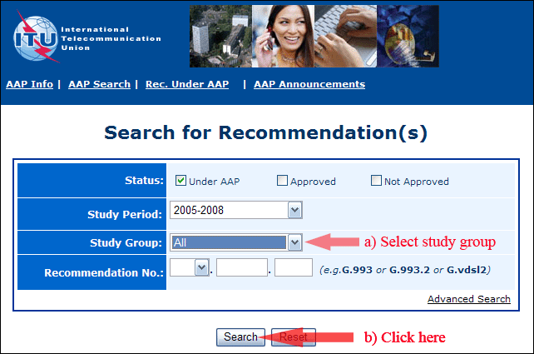
2) Select your Recommendation
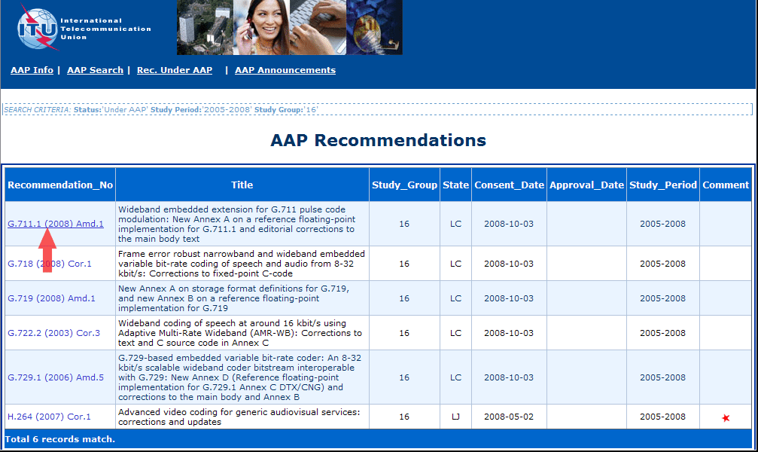
3) Click the "Submit Comment" button
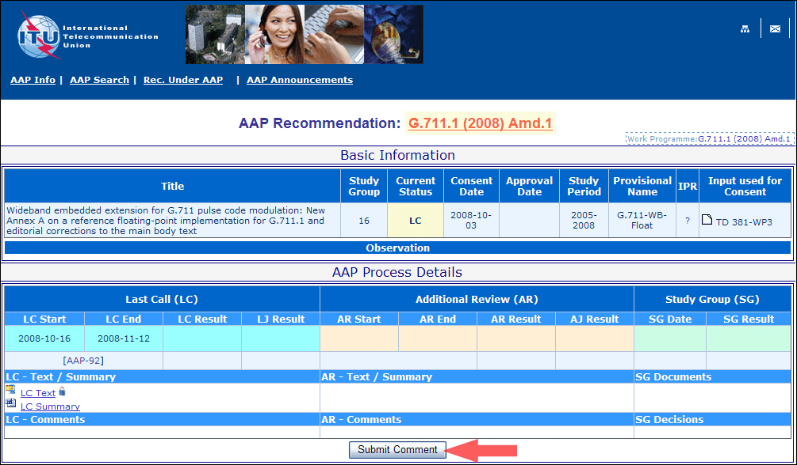
4) Complete the on-line form and click on "Submit"
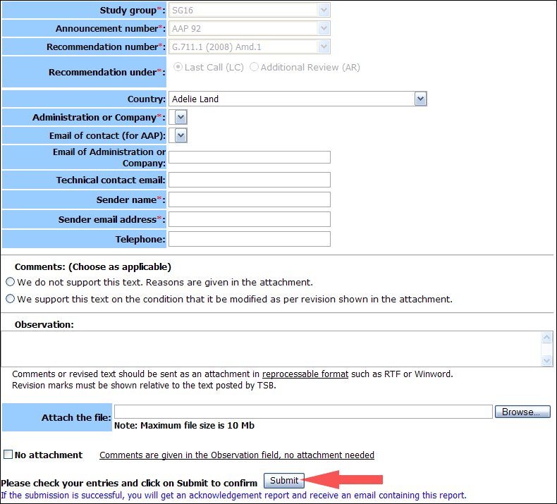
For more information, read the AAP tutorial on:
https://www.itu.int/ITU-T/aapinfo/files/AAPTutorial.pdf
Annex 3
(to TSB AAP-63)
Recommendations under LC/AR – Comment submission form
(Separate form for each Recommendation being commented upon)
ITU-T AAP comment submission form
Study Group:
Announcement number:
Recommendation number:
Date consented:
Recommendation under: | Last call (LC)  Additional Review (AR)
Country:
Administration/Company:
Name of AAP Contact Person:
Email of AAP Contact Person:
Sender name:
(if different from AAP Contact Person)
Sender email address:
Telephone:
Comments:  (Choose as applicable) | We do not support this text. Reasons are given in the attachment.  We support this text on the condition that it be modified as per revision shown in the attachment.
Observations:
No attachment: Comments are given in the Observation field, no attachment needed
To be returned to: email: tsbsg....@itu.int
[or fax +41 22 730 5853]
Comments or revised text should be sent as an attachment in RTF or WinWord format.
Revision marks must be shown relative to the text posted by TSB.

