Международный союз электросвязи
Бюро стандартизации электросвязи

Женева, 1 июля 2019

Осн.:  Тел.:  Факс:  Эл. почта: | TSB AAP-61  AAP/CL  +41 22 730 5860  +41 22 730 5853  tsbdir@itu.int | – Администрациям Государств – Членов Союза;  – Членам Сектора МСЭ-Т;  – Ассоциированным членам МСЭ-Т  Копии:  – Председателям и заместителям председателей Исследовательских комиссий МСЭ-Т;  – Директору Бюро Развития Электросвязи;  – Директору Бюро Радиосвязи

Предмет: | Положение относительно Рекомендаций, рассматриваемых в соответствии с альтернативным процессом утверждения (АПУ)

Уважаемая госпожа,
уважаемый господин,

Альтернативный процесс утверждения (АПУ), определенный в Рекомендации МСЭ-Т А.8, распространяется на Рекомендации, которые не имеют политических или регламентарных последствий и которые поэтому не требуют официальных консультаций с Государствами-Членами (см. п. 246B Конвенции МСЭ).
В Приложении 1 содержится перечень текстов, статус которых изменился по сравнению с предыдущими объявлениями об АПУ БСЭ.
Если вы желаете представить замечания относительно какой-либо Рекомендации, рассматриваемой в соответствии с АПУ, рекомендуем Вам использовать онлайновую форму для представления замечаний по АПУ, которая размещена на странице этой Рекомендации в разделе веб-сайта МСЭ-Т, посвященном АПУ, по адресу: http://www.itu.int/ITU-T/aap/ (см. Приложение 2). Замечания можно представить иным способом, заполнив приведенную в Приложении 3 форму и направив ее в секретариат заинтересованной исследовательской комиссии.
Просим принять к сведению, что не рекомендуется представлять замечания, являющиеся не чем иным, как поддержкой рассматриваемого текста.
С уважением,
Чхе Суб Ли
Директор Бюро стандартизации электросвязи
Приложения: 3

Annex 1
(to TSB AAP-61)

Status codes used in the AAP announcements:
LC = Last Call
LJ = Last Call Judgment (includes comment resolution)
AR = Additional Review
AJ = Additional Review Judgment (includes comment resolution)
SG = For Study Group approval
A = Approved
AT = Approved with typographic corrections
AC = Approved after Additional Review of Comments
NA = Not approved
TAP = Moved to TAP (ITU-T A.8 / § 5.2)
ITU-T website entry page:
http://www.itu.int/ITU-T
Alternative approval process (AAP) welcome page:
http://www.itu.int/ITU-T/aapinfo
Note – A tutorial on the ITU-T AAP application is available under the AAP welcome page
ITU-T website AAP Recommendation search page:
http://www.itu.int/ITU-T/aap/
Study Group web pages and contacts:
SG 2 | http://www.itu.int/ITU-T/studygroups/com02 | tsbsg2@itu.int
SG 3 | http://www.itu.int/ITU-T/studygroups/com03 | tsbsg3@itu.int
SG 5 | http://www.itu.int/ITU-T/studygroups/com05 | tsbsg5@itu.int
SG 9 | http://www.itu.int/ITU-T/studygroups/com09 | tsbsg9@itu.int
SG 11 | http://www.itu.int/ITU-T/studygroups/com11 | tsbsg11@itu.int
SG 12 | http://www.itu.int/ITU-T/studygroups/com12 | tsbsg12@itu.int
SG 13 | http://www.itu.int/ITU-T/studygroups/com13 | tsbsg13@itu.int
SG 15 | http://www.itu.int/ITU-T/studygroups/com15 | tsbsg15@itu.int
SG 16 | http://www.itu.int/ITU-T/studygroups/com16 | tsbsg16@itu.int
SG 17 | http://www.itu.int/ITU-T/studygroups/com17 | tsbsg17@itu.int
SG 20 | http://www.itu.int/ITU-T/studygroups/com20 | tsbsg20@itu.int

Situation concerning Study Group 9 Recommendations under AAP
Rec # | Title | Last Call (LC) Period |  |  |  | Additional Review (AR) Period |  |  |  | Status
 |  | LC Start | LC End | LC  Result | LJ  Result | AR Start | AR End | AR  Result | AJ  Result
J.207 (J.207rev) | Specification for integrated broadcast and broadband digital television application control framework (Summary) | 2019-07-01 | 2019-07-28 |  |  |  |  |  |  | LC
J.216 (J.MHAv2) | Second-generation Modular Headend Architecture in systems for interactive cable television services - IP cable modems (Summary) | 2019-07-01 | 2019-07-28 |  |  |  |  |  |  | LC
J.224 (J.5GDOCSIS) | Fifth-generation transmission systems for interactive cable television services - IP cable modems (Summary) | 2019-07-01 | 2019-07-28 |  |  |  |  |  |  | LC
J.288 (J.288-rev) | Encapsulation of type length value (TLV) packet for cable transmission systems (Summary) | 2019-07-01 | 2019-07-28 |  |  |  |  |  |  | LC
J.1026 (J.oneway-dcas-part1) | Downloadable Conditional Access System for Unidirectional Network; Requirements (Summary) | 2019-07-01 | 2019-07-28 |  |  |  |  |  |  | LC
J.1027 (J.oneway-dcas-part2) | Downloadable Conditional Access System for Unidirectional Network; System Architecture (Summary) | 2019-07-01 | 2019-07-28 |  |  |  |  |  |  | LC
J.1028 (J.oneway-dcas-part3) | Downloadable Conditional Access System for Unidirectional Network; Terminal System (Summary) | 2019-07-01 | 2019-07-28 |  |  |  |  |  |  | LC
J.1202 (J.stvos-spec-arch) | The Architecture of Smart TV Operating System (Summary) | 2019-07-01 | 2019-07-28 |  |  |  |  |  |  | LC
J.1210 (J.ipvb-req) | Requirements of IP Video Broadcast (IPVB) for CATV Networks (Summary) | 2019-07-01 | 2019-07-28 |  |  |  |  |  |  | LC
J.1600 (J.pcnp-fmw) | Premium Cable Network Platform (PCNP) - Framework (Summary) | 2019-07-01 | 2019-07-28 |  |  |  |  |  |  | LC
Situation concerning Study Group 11 Recommendations under AAP
Rec # | Title | Last Call (LC) Period |  |  |  | Additional Review (AR) Period |  |  |  | Status
 |  | LC Start | LC End | LC  Result | LJ  Result | AR Start | AR End | AR  Result | AJ  Result
Q.3741 (Q.SD-WAN) | Signalling Requirements for SD-WAN service (Summary) | 2019-07-01 | 2019-07-28 |  |  |  |  |  |  | LC
Q.4043 (Q.vs-iop-reqts) | Interoperability testing requirements of virtual switch (Summary) | 2019-07-01 | 2019-07-28 |  |  |  |  |  |  | LC
Q.5021 (Q.CE-APIMP) | Protocol for managing capability exposure APIs in IMT-2020 network (Summary) | 2019-07-01 | 2019-07-28 |  |  |  |  |  |  | LC
Situation concerning Study Group 12 Recommendations under AAP
Rec # | Title | Last Call (LC) Period |  |  |  | Additional Review (AR) Period |  |  |  | Status
 |  | LC Start | LC End | LC  Result | LJ  Result | AR Start | AR End | AR  Result | AJ  Result
E.806 (E.MTSM) | Measurement campaigns, monitoring systems and sampling methodologies to monitor the QoS in mobile networks (Summary) | 2019-06-01 | 2019-06-28 | A |  |  |  |  |  | A
G.107.1 | Wideband E-model (Summary) | 2019-06-01 | 2019-06-28 | A |  |  |  |  |  | A
G.107.2 | Fullband E-model (Summary) | 2019-06-01 | 2019-06-28 | A |  |  |  |  |  | A
G.1028 | End-to-end quality of service for voice over 4G mobile networks (Summary) | 2019-06-01 | 2019-06-28 | A |  |  |  |  |  | A
G.1028.2 (G.CSFB) | Assessment of the LTE circuit switched fall back - impact on voice QoS (Summary) | 2019-06-01 | 2019-06-28 | A |  |  |  |  |  | A
P.10/G.100 (2017) Amd. 1 | Vocabulary for performance, quality of service and quality of experience - Amendment 1: New definitions for inclusion in Recommendation ITU-T P.10/G.100 (Summary) | 2019-06-01 | 2019-06-28 | A |  |  |  |  |  | A
P.64 | Determination of sensitivity/frequency characteristics of local telephone systems (Summary) | 2019-06-01 | 2019-06-28 | A |  |  |  |  |  | A
P.700 (P.Loudness) | Calculation of loudness for speech communication (Summary) | 2019-06-01 | 2019-06-28 | A |  |  |  |  |  | A
P.863.1 | Application guide for Recommendation ITU-T P.863 (Summary) | 2019-06-01 | 2019-06-28 | A |  |  |  |  |  | A
P.1201.2 Cor.2 | Parametric non-intrusive assessment of audiovisual media streaming quality - Higher resolution application area - Corrigendum 2 (Summary) | 2019-06-01 | 2019-06-28 | A |  |  |  |  |  | A
Y.1540 | Internet protocol data communication service - IP packet transfer and availability performance parameters (Summary) | 2019-06-01 | 2019-06-28 | LJ |  |  |  |  |  | LJ
Situation concerning Study Group 13 Recommendations under AAP
Rec # | Title | Last Call (LC) Period |  |  |  | Additional Review (AR) Period |  |  |  | Status
 |  | LC Start | LC End | LC  Result | LJ  Result | AR Start | AR End | AR  Result | AJ  Result
Y.3172 (Y.IMT2020-ML-Arch) | Architectural framework for machine learning in future networks including IMT-2020 (Summary) | 2019-04-01 | 2019-04-28 | LJ | AR | 2019-06-01 | 2019-06-21 | AC |  | AC
Situation concerning Study Group 16 Recommendations under AAP
Rec # | Title | Last Call (LC) Period |  |  |  | Additional Review (AR) Period |  |  |  | Status
 |  | LC Start | LC End | LC  Result | LJ  Result | AR Start | AR End | AR  Result | AJ  Result
H.265 (V6) | High efficiency video coding (Summary) | 2019-06-01 | 2019-06-28 | LJ |  |  |  |  |  | LJ
H.871 (F.WAAD) | Safe listening guidelines for personal sound amplifiers (Summary) | 2019-07-01 | 2019-07-28 |  |  |  |  |  |  | LC
T.832 (V4) | Information technology - JPEG XR image coding system - Image coding specification (Summary) | 2019-06-01 | 2019-06-28 | LJ |  |  |  |  |  | LJ

Annex 2
(to TSB AAP-61)
Using the on-line comment submission form
Comment submission
1) Go to AAP search Web page at http://www.itu.int/ITU-T/aap/
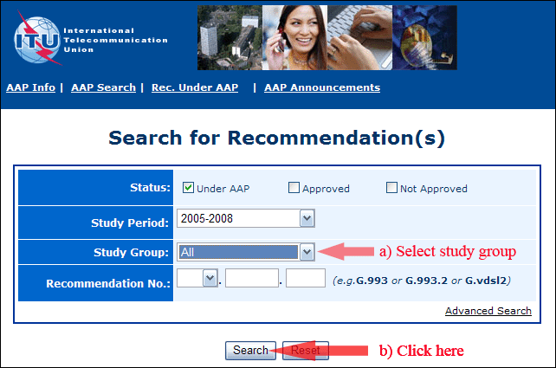
2) Select your Recommendation
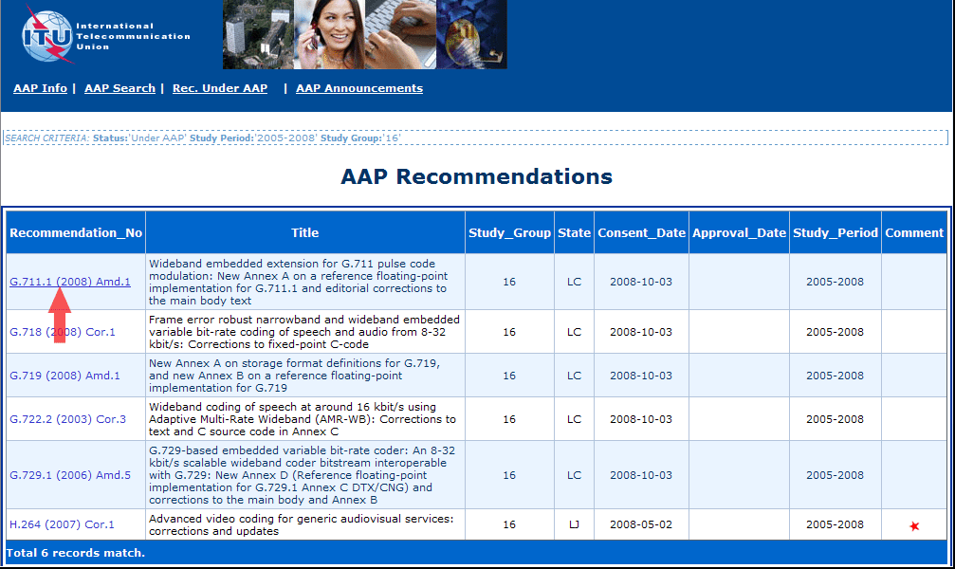
3) Click the "Submit Comment" button
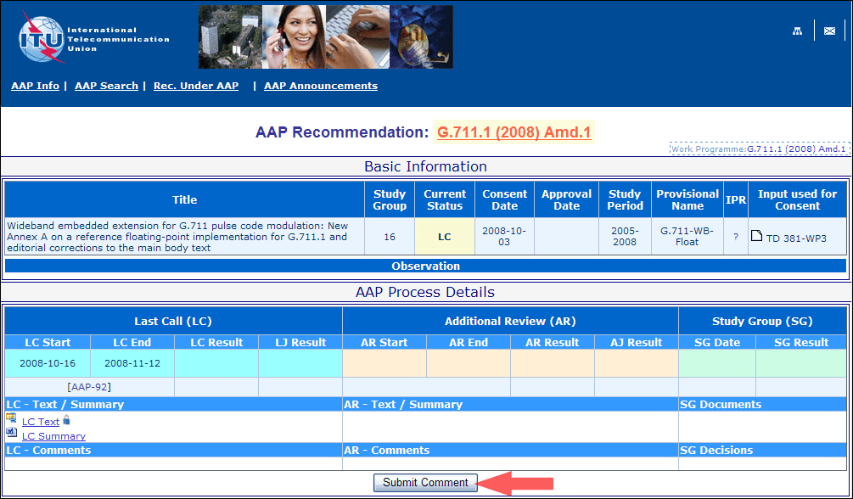
4) Complete the on-line form and click on "Submit"
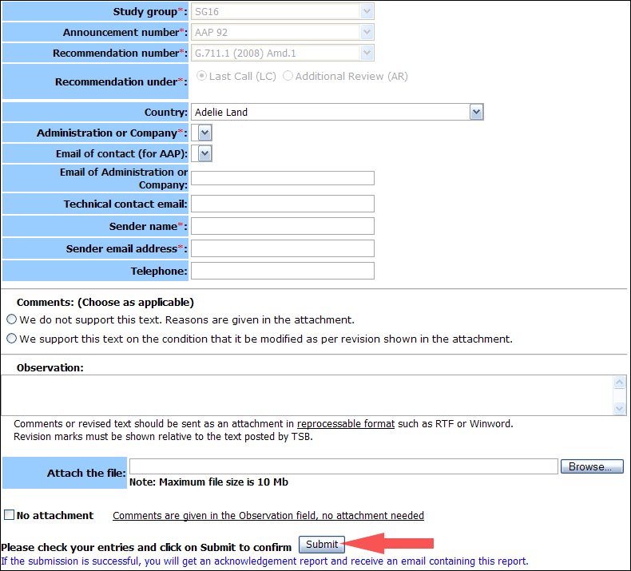
For more information, read the AAP tutorial on:
http://www.itu.int/ITU-T/aapinfo/files/AAPTutorial.pdf
Annex 3
(to TSB AAP-61)
Recommendations under LC/AR – Comment submission form
(Separate form for each Recommendation being commented upon)
ITU-T AAP comment submission form for the period 2009-2012
Study Group:
Announcement number:
Recommendation number:
Recommendation under: | Last call (LC)  Additional Review (AR)
Country:
Administration/Company:
Name of AAP Contact Person:
Email of AAP Contact Person:
Sender name:
(if different from AAP Contact Person)
Sender email address:
Telephone:
Comments:  (Choose as applicable) | We do not support this text. Reasons are given in the attachment.  We support this text on the condition that it be modified as per revision shown in the attachment.
Observations:
No attachment: Comments are given in the Observation field, no attachment needed
To be returned to: email: tsbsg....@itu.int
[or fax +41 22 730 5853]
Comments or revised text should be sent as an attachment in RTF or WinWord format.
Revision marks must be shown relative to the text posted by TSB.

