الا تحــاد الــدولي للاتصــالات
مكتب تقييس الاتصالات

 |  | جنيف، 16 يناير 2019
المرجع:  الهاتف:  الفاكس:  البريد الإلكتروني: | TSB AAP-50  AAP/CL  +41 22 730 5860  +41 22 730 5853  tsbdir@itu.int | - إلى إدارات الدول الأعضاء في الاتحاد؛  - إلى أعضاء قطاع تقييس الاتصالات؛  - إلى المنتسبين إلى قطاع تقييس الاتصالات  نسخة إلى:  - رؤساء لجان الدراسات في قطاع تقييس الاتصالات ونوابهم؛  - مدير مكتب تنمية الاتصالات؛  - مدير مكتب الاتصالات الراديوية

الموضوع: حالة التوصيات الخاضعة لعملية الموافقة البديلة (AAP)

حضرات السادة والسيدات،
تحية طيبة وبعد،
تنطبق عملية الموافقة البديلة (AAP) المعرفة في التوصية ITU-T A.8 على التوصيات التي لا تنطوي على بعد سياسي أوتنظيمي ولا تتطلب بالتالي استشارة الدول الأعضاء رسمياً (انظر الرقم 246B من اتفاقية الاتحاد).
ويتضمن الملحق 1 لائحة بالنصوص التي تغيرت حالتها مقارنة بما جاء في إعلانات عملية الموافقة البديلة السابقة.
إذا رغبتم في تقديم تعليق بشأن توصية ما خاضعة لعملية الموافقة البديلة، فنرجو منكم استعمال استمارة التعليق على الخط المتوفّرة على موقع قطاع تقييس الاتصالات على صفحة عملية الموافقة البديلة http://www.itu.int/ITU-T/aap على المدخل الخاص بالتوصية المعنية (انظر الملحق (2. وبديلاً من ذلك، يمكنكم تقديم التعليقات باستكمال الاستمارة الواردة في الملحق 3 وإرسالها إلى أمانة لجنة الدراسات المعنية بالأمر.
وتجدر الإشارة إلى أنه يفضّل عدم إرسال تعليقات تقتصر على تأييد اعتماد النص قيد النظر.

وتفضلوا بقبول فائق الاحترام والتقدير.
تشيساب لي
مدير مكتب تقييس الاتصالات

الملحقات: 3

Annex 1
(to TSB AAP-50)

Status codes used in the AAP announcements:
LC = Last Call
LJ = Last Call Judgment (includes comment resolution)
AR = Additional Review
AJ = Additional Review Judgment (includes comment resolution)
SG = For Study Group approval
A = Approved
AT = Approved with typographic corrections
AC = Approved after Additional Review of Comments
NA = Not approved
TAP = Moved to TAP (ITU-T A.8 / § 5.2)
ITU-T website entry page:
http://www.itu.int/ITU-T
Alternative approval process (AAP) welcome page:
http://www.itu.int/ITU-T/aapinfo
Note – A tutorial on the ITU-T AAP application is available under the AAP welcome page
ITU-T website AAP Recommendation search page:
http://www.itu.int/ITU-T/aap/
Study Group web pages and contacts:
SG 2 | http://www.itu.int/ITU-T/studygroups/com02 | tsbsg2@itu.int
SG 3 | http://www.itu.int/ITU-T/studygroups/com03 | tsbsg3@itu.int
SG 5 | http://www.itu.int/ITU-T/studygroups/com05 | tsbsg5@itu.int
SG 9 | http://www.itu.int/ITU-T/studygroups/com09 | tsbsg9@itu.int
SG 11 | http://www.itu.int/ITU-T/studygroups/com11 | tsbsg11@itu.int
SG 12 | http://www.itu.int/ITU-T/studygroups/com12 | tsbsg12@itu.int
SG 13 | http://www.itu.int/ITU-T/studygroups/com13 | tsbsg13@itu.int
SG 15 | http://www.itu.int/ITU-T/studygroups/com15 | tsbsg15@itu.int
SG 16 | http://www.itu.int/ITU-T/studygroups/com16 | tsbsg16@itu.int
SG 17 | http://www.itu.int/ITU-T/studygroups/com17 | tsbsg17@itu.int
SG 20 | http://www.itu.int/ITU-T/studygroups/com20 | tsbsg20@itu.int

Situation concerning Study Group 5 Recommendations under AAP
Rec # | Title | Last Call (LC) Period |  |  |  | Additional Review (AR) Period |  |  |  | Status
 |  | LC Start | LC End | LC  Result | LJ  Result | AR Start | AR End | AR  Result | AJ  Result
L.1015 (L.CEM) | Criteria for evaluation of the environmental impact of mobile phones (Summary) | 2018-10-16 | 2018-11-12 | LJ | AR | 2018-12-16 | 2019-01-11 | SG |  | SG
Situation concerning Study Group 9 Recommendations under AAP
Rec # | Title | Last Call (LC) Period |  |  |  | Additional Review (AR) Period |  |  |  | Status
 |  | LC Start | LC End | LC  Result | LJ  Result | AR Start | AR End | AR  Result | AJ  Result
J.1 (J.tda) | Terms, definitions and acronyms for television and sound transmission and integrated broadband cable networks (Summary) | 2018-12-16 | 2019-01-12 | A |  |  |  |  |  | A
J.298 (J.stb-cts) | Requirements and technical specifications of cable TV hybrid set-top box that has the compatibility with terrestrial and satellite TV transport (Summary) | 2018-12-16 | 2019-01-12 | LJ |  |  |  |  |  | LJ
J.302 (2016) Amd.1 | System specifications of augmented reality smart television service: Amendment 1 (Summary) | 2018-12-16 | 2019-01-12 | A |  |  |  |  |  | A
J.383 (J.atrans-tlvts) | Conversion of type length value (TLV) packet and transport stream for advanced cable transmission systems (Summary) | 2018-12-16 | 2019-01-12 | A |  |  |  |  |  | A
J.1108 (J.roip-trans) | Transmission specification for Radio over IP transmission system (Summary) | 2018-12-16 | 2019-01-12 | A |  |  |  |  |  | A
J.1109 (J.fdx-req) | Requirement for in-band full-duplex in HFC based network (Summary) | 2018-12-16 | 2019-01-12 | A |  |  |  |  |  | A
J.1201 (J.stvos-spec-req) | The functional requirements of smart TV operating system (Summary) | 2018-12-16 | 2019-01-12 | A |  |  |  |  |  | A
Situation concerning Study Group 12 Recommendations under AAP
Rec # | Title | Last Call (LC) Period |  |  |  | Additional Review (AR) Period |  |  |  | Status
 |  | LC Start | LC End | LC  Result | LJ  Result | AR Start | AR End | AR  Result | AJ  Result
G.191 (V6) | Software tools for speech and audio coding standardization (Summary) | 2018-12-16 | 2019-01-12 | A |  |  |  |  |  | A
G.1028.1 (G.ViLTE) | End-to-end QoS for Video Telephony over 4G mobile networks (Summary) | 2018-12-16 | 2019-01-12 | AR |  | 2019-01-16 | 2019-02-05 |  |  | AR
P.340 Amd.2 | Transmission characteristics and speech quality parameters of hands-free terminals - Amendment 2 (Summary) | 2018-12-16 | 2019-01-12 | A |  |  |  |  |  | A
P.811 (P.SOSH -P.SAT) | Subjective test methodology for evaluating Speech oriented stereo communication systems over headphones (Summary) | 2018-12-16 | 2019-01-12 | A |  |  |  |  |  | A
P.917 (P.QUITS) | Subjective test methodolgy for assessing impact of initial loading delay on user experience (Summary) | 2018-12-16 | 2019-01-12 | A |  |  |  |  |  | A
P.1100 | Narrowband hands-free communication in motor vehicles (Summary) | 2018-12-16 | 2019-01-12 | A |  |  |  |  |  | A
P.1110 | Wideband hands-free communication in motor vehicles (Summary) | 2018-12-16 | 2019-01-12 | A |  |  |  |  |  | A
P.1203.1 | Parametric bitstream-based quality assessment of progressive download and adaptive audiovisual streaming services over reliable transport - Video quality estimation module (Summary) | 2018-12-16 | 2019-01-12 | A |  |  |  |  |  | A
P.1203.3 | Parametric bitstream-based quality assessment of progressive download and adaptive audiovisual streaming services over reliable transport - Quality integration module (Summary) | 2018-12-16 | 2019-01-12 | A |  |  |  |  |  | A
Y.1550 (Y.cvms) | Considerations for Realizing Virtual Measurement Systems (Summary) | 2018-12-16 | 2019-01-12 | A |  |  |  |  |  | A
Situation concerning Study Group 15 Recommendations under AAP
Rec # | Title | Last Call (LC) Period |  |  |  | Additional Review (AR) Period |  |  |  | Status
 |  | LC Start | LC End | LC  Result | LJ  Result | AR Start | AR End | AR  Result | AJ  Result
G.989.2 | 40-Gigabit-capable passive optical networks 2 (NG-PON2): Physical media dependent (PMD) layer specification (Summary) | 2018-11-01 | 2018-11-28 | LJ | AR | 2019-01-16 | 2019-02-05 |  |  | AR
G.8262.1/Y.1362.1 | Timing characteristics of an enhanced synchronous equipment slave clock (Summary) | 2018-12-01 | 2019-01-11 | A |  |  |  |  |  | A
G.8273.2/Y.1368.2 Amd.2 | Timing characteristics of telecom boundary clocks and telecom time slave clocks- Amendment 2 (Summary) | 2018-12-01 | 2019-01-11 | A |  |  |  |  |  | A
Situation concerning Study Group 20 Recommendations under AAP
Rec # | Title | Last Call (LC) Period |  |  |  | Additional Review (AR) Period |  |  |  | Status
 |  | LC Start | LC End | LC  Result | LJ  Result | AR Start | AR End | AR  Result | AJ  Result
Y.4051 (Y.SCC-Terms) | Vocabulary for smart cities and communities (Summary) | 2019-01-16 | 2019-02-12 |  |  |  |  |  |  | LC
Y.4202 (Y.WPT-usecase) | Framework of wireless power transmission application service (Summary) | 2019-01-16 | 2019-02-12 |  |  |  |  |  |  | LC
Y.4203 (Y.IoT-things-description-reqts) | Requirements of things description in the Internet of things (Summary) | 2019-01-16 | 2019-02-12 |  |  |  |  |  |  | LC
Y.4204 (Y.Accessibility-IoT) | Accessibility requirements for the Internet of things applications and services (Summary) | 2019-01-16 | 2019-02-12 |  |  |  |  |  |  | LC
Y.4205 (Y.CrowdSystems) | Requirements and reference model of IoT-related crowdsourced systems (Summary) | 2019-01-16 | 2019-02-12 |  |  |  |  |  |  | LC
Y.4458 (Y.SSL) | Requirements and functional architecture of smart street light service (Summary) | 2019-01-16 | 2019-02-12 |  |  |  |  |  |  | LC
Y.4459 (Y.IoT-Interop) | An architecture for IoT interoperability (Summary) | 2019-01-16 | 2019-02-12 |  |  |  |  |  |  | LC
Y.4555 (Y.IoT-SQ-fns) | Service functionalities of self-quantification over Internet of things (Summary) | 2019-01-16 | 2019-02-12 |  |  |  |  |  |  | LC
Y.4556 (Y.SC-Residential) | Requirements and functional architecture of smart residential community (Summary) | 2019-01-16 | 2019-02-12 |  |  |  |  |  |  | LC
Y.4904 (Y.SSC-MM) | Smart sustainable cities maturity model (Summary) | 2019-01-16 | 2019-02-12 |  |  |  |  |  |  | LC
Y.4905 (Y.SSC-IA) | Smart sustainable city impact assessment (Summary) | 2019-01-16 | 2019-02-12 |  |  |  |  |  |  | LC

Annex 2
(to TSB AAP-50)
Using the on-line comment submission form
Comment submission
1) Go to AAP search Web page at http://www.itu.int/ITU-T/aap/
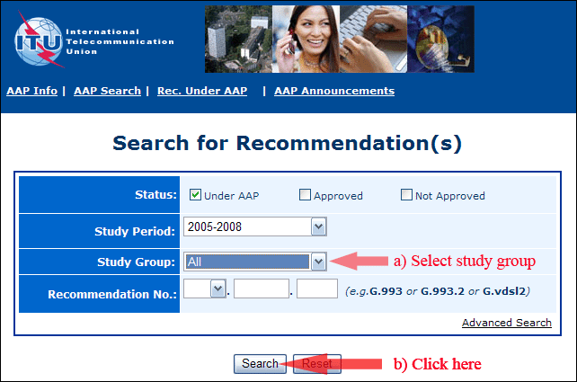
2) Select your Recommendation
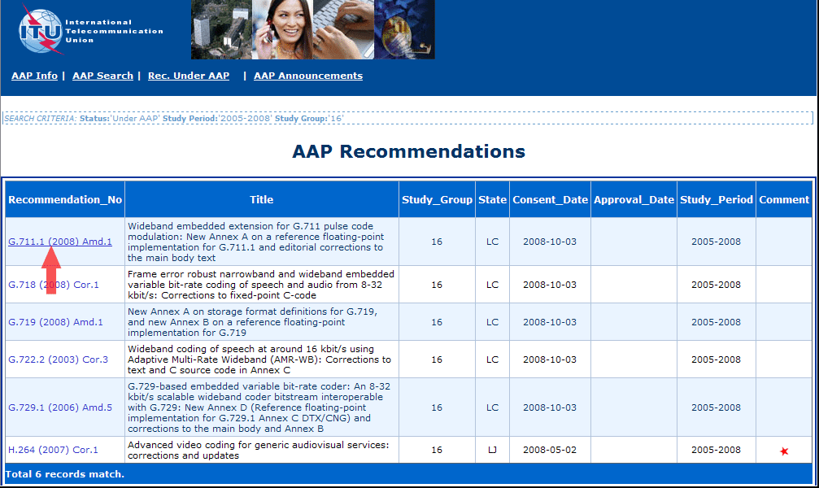
3) Click the "Submit Comment" button
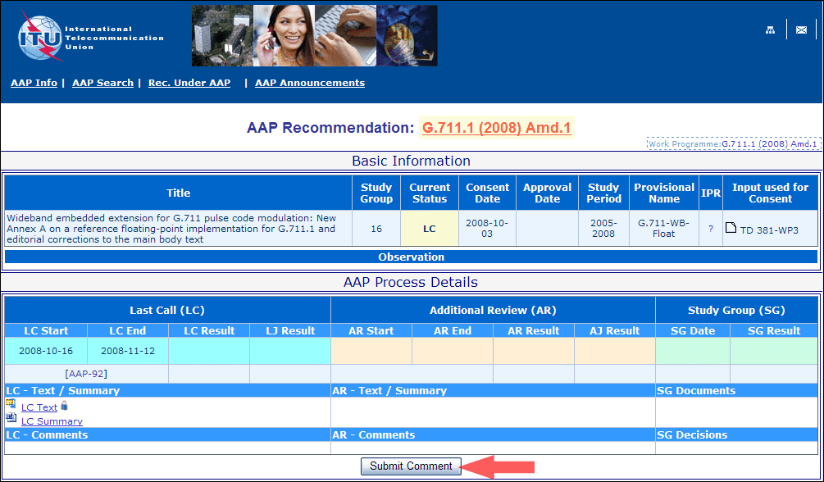
4) Complete the on-line form and click on "Submit"
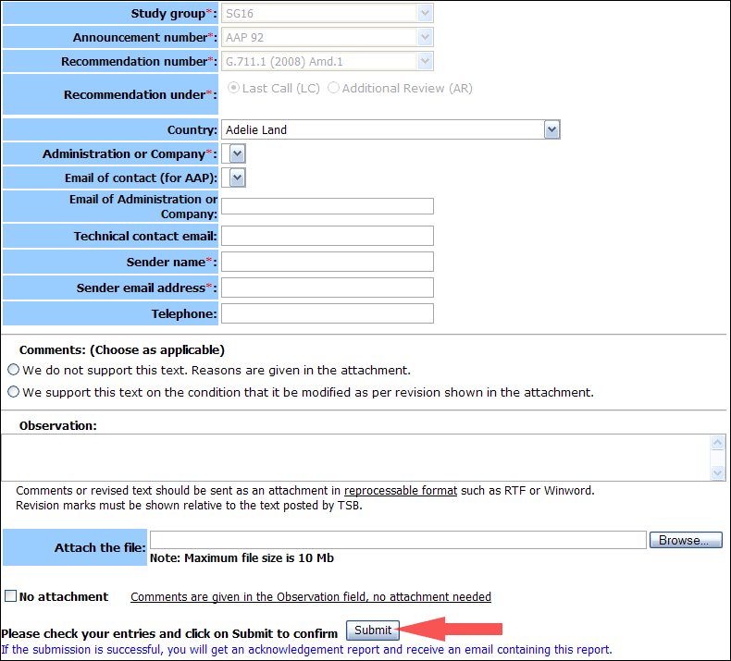
For more information, read the AAP tutorial on:
http://www.itu.int/ITU-T/aapinfo/files/AAPTutorial.pdf
Annex 3
(to TSB AAP-50)
Recommendations under LC/AR – Comment submission form
(Separate form for each Recommendation being commented upon)
ITU-T AAP comment submission form for the period 2009-2012
Study Group:
Announcement number:
Recommendation number:
Recommendation under: | Last call (LC)  Additional Review (AR)
Country:
Administration/Company:
Name of AAP Contact Person:
Email of AAP Contact Person:
Sender name:
(if different from AAP Contact Person)
Sender email address:
Telephone:
Comments:  (Choose as applicable) | We do not support this text. Reasons are given in the attachment.  We support this text on the condition that it be modified as per revision shown in the attachment.
Observations:
No attachment: Comments are given in the Observation field, no attachment needed
To be returned to: email: tsbsg....@itu.int
[or fax +41 22 730 5853]
Comments or revised text should be sent as an attachment in RTF or WinWord format.
Revision marks must be shown relative to the text posted by TSB.

