الا تحــاد الــدولي للاتصــالات
مكتب تقييس الاتصالات

 |  | جنيف، 1 ديسمبر 2018
المرجع:  الهاتف:  الفاكس:  البريد الإلكتروني: | TSB AAP-48  AAP/CL  +41 22 730 5860  +41 22 730 5853  tsbdir@itu.int | - إلى إدارات الدول الأعضاء في الاتحاد؛  - إلى أعضاء قطاع تقييس الاتصالات؛  - إلى المنتسبين إلى قطاع تقييس الاتصالات  نسخة إلى:  - رؤساء لجان الدراسات في قطاع تقييس الاتصالات ونوابهم؛  - مدير مكتب تنمية الاتصالات؛  - مدير مكتب الاتصالات الراديوية

الموضوع: حالة التوصيات الخاضعة لعملية الموافقة البديلة (AAP)

حضرات السادة والسيدات،
تحية طيبة وبعد،
تنطبق عملية الموافقة البديلة (AAP) المعرفة في التوصية ITU-T A.8 على التوصيات التي لا تنطوي على بعد سياسي أوتنظيمي ولا تتطلب بالتالي استشارة الدول الأعضاء رسمياً (انظر الرقم 246B من اتفاقية الاتحاد).
ويتضمن الملحق 1 لائحة بالنصوص التي تغيرت حالتها مقارنة بما جاء في إعلانات عملية الموافقة البديلة السابقة.
إذا رغبتم في تقديم تعليق بشأن توصية ما خاضعة لعملية الموافقة البديلة، فنرجو منكم استعمال استمارة التعليق على الخط المتوفّرة على موقع قطاع تقييس الاتصالات على صفحة عملية الموافقة البديلة http://www.itu.int/ITU-T/aap على المدخل الخاص بالتوصية المعنية (انظر الملحق (2. وبديلاً من ذلك، يمكنكم تقديم التعليقات باستكمال الاستمارة الواردة في الملحق 3 وإرسالها إلى أمانة لجنة الدراسات المعنية بالأمر.
وتجدر الإشارة إلى أنه يفضّل عدم إرسال تعليقات تقتصر على تأييد اعتماد النص قيد النظر.
لن تنشر أي إعلانات بخصوص عملية الموافقة البديلة يوم 1 يناير 2019 لأن الاتحاد سيكون مغلقاً. وبالتالي، سيتم تمديد الموعد النهائي لتقديم التعليقات على بعض النصوص فيما يخص عملية الموافقة البديلة.

وتفضلوا بقبول فائق الاحترام والتقدير.
تشيساب لي
مدير مكتب تقييس الاتصالات

الملحقات: 3

Annex 1
(to TSB AAP-48)

Status codes used in the AAP announcements:
LC = Last Call
LJ = Last Call Judgment (includes comment resolution)
AR = Additional Review
AJ = Additional Review Judgment (includes comment resolution)
SG = For Study Group approval
A = Approved
AT = Approved with typographic corrections
AC = Approved after Additional Review of Comments
NA = Not approved
TAP = Moved to TAP (ITU-T A.8 / § 5.2)
ITU-T website entry page:
http://www.itu.int/ITU-T
Alternative approval process (AAP) welcome page:
http://www.itu.int/ITU-T/aapinfo
Note – A tutorial on the ITU-T AAP application is available under the AAP welcome page
ITU-T website AAP Recommendation search page:
http://www.itu.int/ITU-T/aap/
Study Group web pages and contacts:
SG 2 | http://www.itu.int/ITU-T/studygroups/com02 | tsbsg2@itu.int
SG 3 | http://www.itu.int/ITU-T/studygroups/com03 | tsbsg3@itu.int
SG 5 | http://www.itu.int/ITU-T/studygroups/com05 | tsbsg5@itu.int
SG 9 | http://www.itu.int/ITU-T/studygroups/com09 | tsbsg9@itu.int
SG 11 | http://www.itu.int/ITU-T/studygroups/com11 | tsbsg11@itu.int
SG 12 | http://www.itu.int/ITU-T/studygroups/com12 | tsbsg12@itu.int
SG 13 | http://www.itu.int/ITU-T/studygroups/com13 | tsbsg13@itu.int
SG 15 | http://www.itu.int/ITU-T/studygroups/com15 | tsbsg15@itu.int
SG 16 | http://www.itu.int/ITU-T/studygroups/com16 | tsbsg16@itu.int
SG 17 | http://www.itu.int/ITU-T/studygroups/com17 | tsbsg17@itu.int
SG 20 | http://www.itu.int/ITU-T/studygroups/com20 | tsbsg20@itu.int

Situation concerning Study Group 15 Recommendations under AAP
Rec # | Title | Last Call (LC) Period |  |  |  | Additional Review (AR) Period |  |  |  | Status
 |  | LC Start | LC End | LC  Result | LJ  Result | AR Start | AR End | AR  Result | AJ  Result
G.651.1 | Characteristics of a 50/125 µm multimode graded index optical fibre cable for the optical access network (Summary) | 2018-11-01 | 2018-11-28 | A |  |  |  |  |  | A
G.672 | Characteristics of multi-degree reconfigurable optical add/drop multiplexers (Summary) | 2018-11-01 | 2018-11-28 | A |  |  |  |  |  | A
G.698.2 | Amplified multichannel DWDM applications with single channel optical interfaces (Summary) | 2018-11-01 | 2018-11-28 | A |  |  |  |  |  | A
G.698.4 Cor.1 | Multichannel bi-directional DWDM applications with port agnostic single-channel optical interfaces - Corrigendum 1 (Summary) | 2018-11-01 | 2018-11-28 | A |  |  |  |  |  | A
G.709.1/Y.1331.1 (2018) Amd.1 | Flexible OTN short-reach interface - Amendment 1 (Summary) | 2018-11-01 | 2018-11-28 | LJ |  |  |  |  |  | LJ
G.709.3/Y.1331.3 Amd.1 | Flexible OTN long-reach interfaces: Amendment 1 (Summary) | 2018-11-01 | 2018-11-28 | A |  |  |  |  |  | A
G.709/Y.1331 (2016) Amd.3 | Interfaces for the optical transport network (OTN): Amendment 3 (Summary) | 2018-11-01 | 2018-11-28 | LJ |  |  |  |  |  | LJ
G.988 Amd.1 | ONU management and control interface (OMCI) specification: Amendment 1 (Summary) | 2018-11-01 | 2018-11-28 | A |  |  |  |  |  | A
G.989.2 | 40-Gigabit-capable passive optical networks 2 (NG-PON2): Physical media dependent (PMD) layer specification (Summary) | 2018-11-01 | 2018-11-28 | LJ |  |  |  |  |  | LJ
G.989.3 (2015) Amd.2 | 40-Gigabit-capable passive optical networks (NG-PON2): Transmission convergence layer specification - Amendment 2 (Summary) | 2018-11-01 | 2018-11-28 | A |  |  |  |  |  | A
G.993.2 | Very high speed digital subscriber line transceivers 2 (VDSL2) (Summary) | 2018-11-01 | 2018-11-28 | LJ |  |  |  |  |  | LJ
G.993.5 | Self-FEXT cancellation (vectoring) for use with VDSL2 transceivers (Summary) | 2018-11-01 | 2018-11-28 | LJ |  |  |  |  |  | LJ
G.994.1 | Handshake procedures for digital subscriber line transceivers (Summary) | 2018-11-01 | 2018-11-28 | A |  |  |  |  |  | A
G.996.2 | Single-ended line testing for digital subscriber lines (DSL) (Summary) | 2018-11-01 | 2018-11-28 | AT |  |  |  |  |  | AT
G.997.1 | Physical layer management for digital subscriber line transceivers (Summary) | 2018-11-01 | 2018-11-28 | LJ |  |  |  |  |  | LJ
G.997.2 | Physical layer management for G.fast transceivers (Summary) | 2018-11-01 | 2018-11-28 | LJ |  |  |  |  |  | LJ
G.998.2 | Ethernet-based multi-pair bonding (Summary) | 2018-11-01 | 2018-11-28 | A |  |  |  |  |  | A
G.998.4 | Improved impulse noise protection for digital subscriber line (DSL) transceivers (Summary) | 2018-11-01 | 2018-11-28 | AT |  |  |  |  |  | AT
G.999.1 | Interface between the link layer and the physical layer for digital subscriber line (DSL) transceivers (Summary) | 2018-11-01 | 2018-11-28 | LJ |  |  |  |  |  | LJ
G.7721 (G.sync-mgmt) | Management Requirement and Information Model for Synchronization (Summary) | 2018-11-01 | 2018-11-28 | A |  |  |  |  |  | A
G.8011/Y.1307 | Ethernet service characteristics (Summary) | 2018-11-01 | 2018-11-28 | A |  |  |  |  |  | A
G.8013/Y.1731 Amd.1 | Operation, administration and maintenance (OAM) functions and mechanisms for Ethernet-based networks (Summary) | 2018-11-01 | 2018-11-28 | A |  |  |  |  |  | A
G.8023 (2018) Cor.1 | Characteristics of equipment functional blocks supporting Ethernet physical layer and FlexE interfaces - Corrigendum 1 (Summary) | 2018-11-01 | 2018-11-28 | A |  |  |  |  |  | A
G.8121.1/Y.1381.1 | Characteristics of MPLS-TP equipment functional blocks supporting ITU-T G.8113.1/Y.1372.1 OAM mechanisms (Summary) | 2018-11-01 | 2018-11-28 | A |  |  |  |  |  | A
G.8121.2/Y.1381.2 | Characteristics of MPLS-TP equipment functional blocks supporting ITU-T G.8113.2/Y.1372.2 OAM mechanisms (Summary) | 2018-11-01 | 2018-11-28 | A |  |  |  |  |  | A
G.8121/Y.1381 | Characteristics of MPLS-TP equipment functional blocks (Summary) | 2018-11-01 | 2018-11-28 | A |  |  |  |  |  | A
G.8131 Amd.3 | Linear protection switching for MPLS transport profile (Summary) | 2018-11-01 | 2018-11-28 | A |  |  |  |  |  | A
G.8151/Y.1374 | Management aspects of the MPLS-TP network element (Summary) | 2018-11-01 | 2018-11-28 | A |  |  |  |  |  | A
G.8251 | The control of jitter and wander within the optical transport network (OTN) (Summary) | 2018-11-01 | 2018-11-28 | A |  |  |  |  |  | A
G.8260 (2015) Amd.2 | Definitions and terminology for synchronization in packet networks: Amendment 2 (Summary) | 2018-11-01 | 2018-11-28 | AT |  |  |  |  |  | AT
G.8262 | Timing characteristics of synchronous equipment slave clock (Summary) | 2018-11-01 | 2018-11-28 | A |  |  |  |  |  | A
G.8262.1/Y.1362.1 | Timing characteristics of an enhanced synchronous equipment slave clock (Summary) | 2018-12-01 | 2019-01-11 |  |  |  |  |  |  | LC
G.8271 Amd.2 | Time and phase synchronization aspects of telecommunication networks - Amendment 2 (Summary) | 2018-11-01 | 2018-11-28 | AT |  |  |  |  |  | AT
G.8271.2 Amd.2 | Network limits for time synchronization in packet networks with partial timing support from the network - Amendment 2 (Summary) | 2018-11-01 | 2018-11-28 | A |  |  |  |  |  | A
G.8272 | Timing characteristics of primary reference time clocks (Summary) | 2018-11-01 | 2018-11-28 | A |  |  |  |  |  | A
G.8273.2/Y.1368.2 Amd.2 | Timing characteristics of telecom boundary clocks and telecom time slave clocks- Amendment 2 (Summary) | 2018-12-01 | 2019-01-11 |  |  |  |  |  |  | LC
G.8273.3/Y.1368.3 Amd.1 | Timing characteristics of telecom transparent clocks - Amendment 1 (Summary) | 2018-11-01 | 2018-11-28 | A |  |  |  |  |  | A
G.8275/Y.1369 Amd.1 | Architecture and requirements for packet-based time and phase delivery - Amendment 1 (Summary) | 2018-11-01 | 2018-11-28 | A |  |  |  |  |  | A
G.9701 | Fast access to subscriber terminals (G.fast) - Physical layer specification (Summary) | 2018-11-01 | 2018-11-28 | LJ |  |  |  |  |  | LJ
G.9803 (G.RoF) | Radio over Fiber systems (Summary) | 2018-11-01 | 2018-11-28 | A |  |  |  |  |  | A
G.9807.2 (2017) Amd.1 | 10 Gigabit-capable symmetrical passive optical networks (XG(S)-PON): Reach extension - Amendment 1 (Summary) | 2018-11-01 | 2018-11-28 | A |  |  |  |  |  | A
G.9960 | Unified high-speed wireline-based home networking transceivers - System architecture and physical layer specification (Summary) | 2018-11-01 | 2018-11-28 | A |  |  |  |  |  | A
G.9961 | Unified high-speed wire-line based home networking transceivers - Data link layer specification (Summary) | 2018-11-01 | 2018-11-28 | A |  |  |  |  |  | A
G.9962 | Unified high-speed wire-line based home networking transceivers - Management specification (Summary) | 2018-11-01 | 2018-11-28 | A |  |  |  |  |  | A
G.9963 | Unified high-speed wireline-based home networking transceivers - Multiple input/multiple output specification (Summary) | 2018-11-01 | 2018-11-28 | A |  |  |  |  |  | A
G.9978 | Secure admission in G.hn network (Summary) | 2018-11-01 | 2018-11-28 | A |  |  |  |  |  | A
G.9979 | Implementation of the generic mechanism in the IEEE 1905.1a-2014 Standard to include applicable ITU-T Recommendations (Summary) | 2018-11-01 | 2018-11-28 | A |  |  |  |  |  | A
G.9991 (G.vlc) | High speed indoor visible light communication transceiver - System architecture, physical layer and data link layer specification (Summary) | 2018-11-01 | 2018-11-28 | LJ |  |  |  |  |  | LJ
G.9992 (G.occ) | Indoor optical camera communication transceivers - System architecture, physical layer and data link layer specification (Summary) | 2018-11-01 | 2018-11-28 | LJ |  |  |  |  |  | LJ
L.109 (L.60) | Construction of optical/metallic hybrid cables (Summary) | 2018-11-01 | 2018-11-28 | A |  |  |  |  |  | A
L.163 (L.cci) | Criteria for optical cable installation with minimal existing infrastructure (Summary) | 2018-11-01 | 2018-11-28 | A |  |  |  |  |  | A
L.314 (L.85) | Optical fibre identification for the maintenance of optical access networks (Summary) | 2018-11-01 | 2018-11-28 | A |  |  |  |  |  | A
Situation concerning Study Group 16 Recommendations under AAP
Rec # | Title | Last Call (LC) Period |  |  |  | Additional Review (AR) Period |  |  |  | Status
 |  | LC Start | LC End | LC  Result | LJ  Result | AR Start | AR End | AR  Result | AJ  Result
H.782 (V2) | Digital signage: Metadata (Summary) | 2018-11-01 | 2018-11-28 | A |  |  |  |  |  | A
H.784 (H.DS-DCI) | Digital signage: Display device control interface (Summary) | 2018-11-01 | 2018-11-28 | A |  |  |  |  |  | A

Situation concerning Study Group 17 Recommendations under AAP
Rec # | Title | Last Call (LC) Period |  |  |  | Additional Review (AR) Period |  |  |  | Status
 |  | LC Start | LC End | LC  Result | LJ  Result | AR Start | AR End | AR  Result | AJ  Result
X.676 (X.orf-gs) | Object identifier-based resolution framework for IoT grouped services (Summary) | 2018-11-01 | 2018-11-28 | A |  |  |  |  |  | A
X.1277 (X.uaf) | FIDO Universal Authentication Framework (UAF) (Summary) | 2018-11-01 | 2018-11-28 | A |  |  |  |  |  | A
X.1278 (X.ctap) | Client To Authenticator Protocol/Universal 2-factor framework (Summary) | 2018-11-01 | 2018-11-28 | A |  |  |  |  |  | A

Annex 2
(to TSB AAP-48)
Using the on-line comment submission form
Comment submission
1) Go to AAP search Web page at http://www.itu.int/ITU-T/aap/
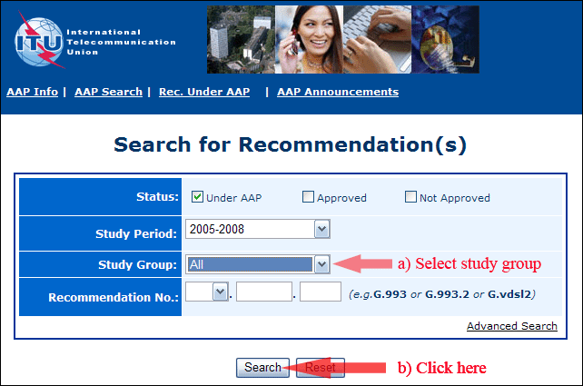
2) Select your Recommendation
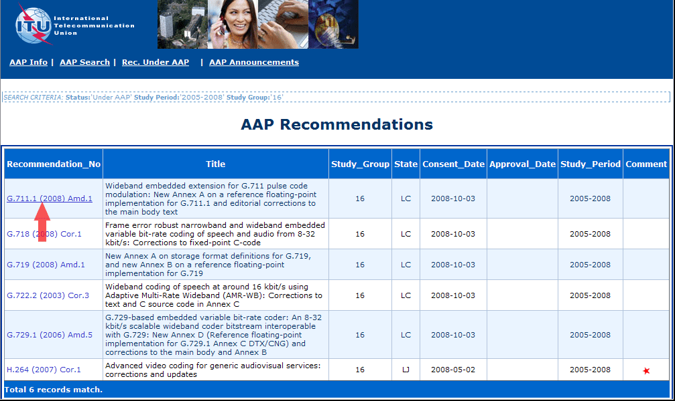
3) Click the "Submit Comment" button
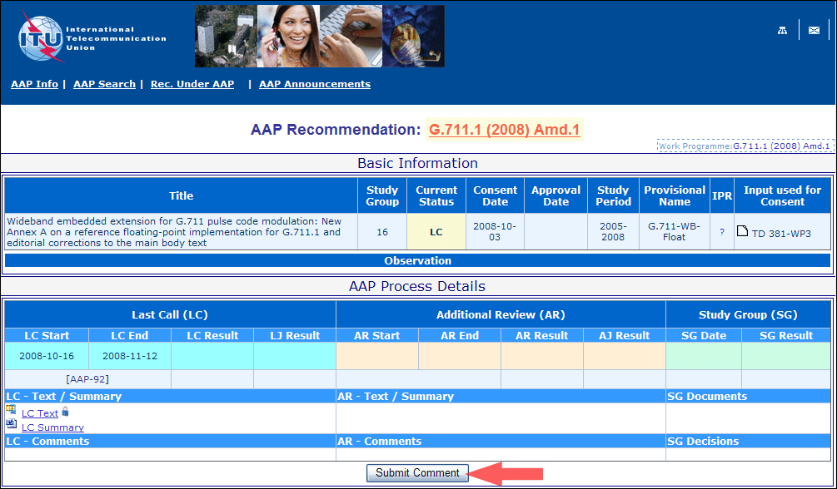
4) Complete the on-line form and click on "Submit"
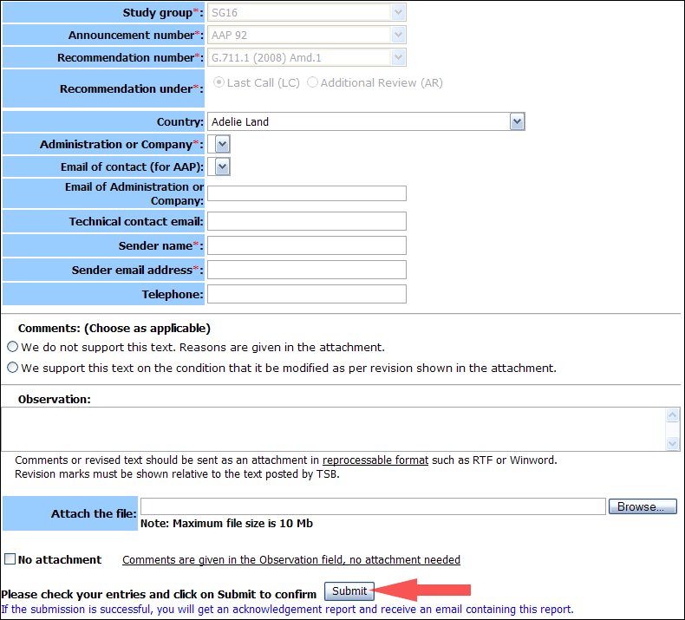
For more information, read the AAP tutorial on:
http://www.itu.int/ITU-T/aapinfo/files/AAPTutorial.pdf
Annex 3
(to TSB AAP-48)
Recommendations under LC/AR – Comment submission form
(Separate form for each Recommendation being commented upon)
ITU-T AAP comment submission form for the period 2009-2012
Study Group:
Announcement number:
Recommendation number:
Recommendation under: | Last call (LC)  Additional Review (AR)
Country:
Administration/Company:
Name of AAP Contact Person:
Email of AAP Contact Person:
Sender name:
(if different from AAP Contact Person)
Sender email address:
Telephone:
Comments:  (Choose as applicable) | We do not support this text. Reasons are given in the attachment.  We support this text on the condition that it be modified as per revision shown in the attachment.
Observations:
No attachment: Comments are given in the Observation field, no attachment needed
To be returned to: email: tsbsg....@itu.int
[or fax +41 22 730 5853]
Comments or revised text should be sent as an attachment in RTF or WinWord format.
Revision marks must be shown relative to the text posted by TSB.

