 | Международный союз электросвязи  Бюро стандартизации электросвязи | 

Женева, 1 августа 2018

Осн.:  Тел.:  Факс:  Эл. почта: | TSB AAP-40  AAP/CL  +41 22 730 5860  +41 22 730 5853  tsbdir@itu.int | – Администрациям Государств – Членов Союза;  – Членам Сектора МСЭ-Т;  – Ассоциированным членам МСЭ-Т  Копии:  – Председателям и заместителям председателей Исследовательских комиссий МСЭ-Т;  – Директору Бюро Развития Электросвязи;  – Директору Бюро Радиосвязи

Предмет: | Положение относительно Рекомендаций, рассматриваемых в соответствии с альтернативным процессом утверждения (АПУ)

Уважаемая госпожа,
уважаемый господин,

Альтернативный процесс утверждения (АПУ), определенный в Рекомендации МСЭ-Т А.8, распространяется на Рекомендации, которые не имеют политических или регламентарных последствий и которые поэтому не требуют официальных консультаций с Государствами-Членами (см. п. 246B Конвенции МСЭ).
В Приложении 1 содержится перечень текстов, статус которых изменился по сравнению с предыдущими объявлениями об АПУ БСЭ.
Если вы желаете представить замечания относительно какой-либо Рекомендации, рассматриваемой в соответствии с АПУ, рекомендуем Вам использовать онлайновую форму для представления замечаний по АПУ, которая размещена на странице этой Рекомендации в разделе веб-сайта МСЭ-Т, посвященном АПУ, по адресу: http://www.itu.int/ITU-T/aap/ (см. Приложение 2). Замечания можно представить иным способом, заполнив приведенную в Приложении 3 форму и направив ее в секретариат заинтересованной исследовательской комиссии.
Просим принять к сведению, что не рекомендуется представлять замечания, являющиеся не чем иным, как поддержкой рассматриваемого текста.
С уважением,
Чхе Суб Ли
Директор Бюро стандартизации электросвязи
Приложения: 3

Annex 1
(to TSB AAP-40)

Status codes used in the AAP announcements:
LC = Last Call
LJ = Last Call Judgment (includes comment resolution)
AR = Additional Review
AJ = Additional Review Judgment (includes comment resolution)
SG = For Study Group approval
A = Approved
AT = Approved with typographic corrections
AC = Approved after Additional Review of Comments
NA = Not approved
TAP = Moved to TAP (ITU-T A.8 / § 5.2)
ITU-T website entry page:
http://www.itu.int/ITU-T
Alternative approval process (AAP) welcome page:
http://www.itu.int/ITU-T/aapinfo
Note – A tutorial on the ITU-T AAP application is available under the AAP welcome page
ITU-T website AAP Recommendation search page:
http://www.itu.int/ITU-T/aap/
Study Group web pages and contacts:
SG 2 | http://www.itu.int/ITU-T/studygroups/com02 | tsbsg2@itu.int
SG 3 | http://www.itu.int/ITU-T/studygroups/com03 | tsbsg3@itu.int
SG 5 | http://www.itu.int/ITU-T/studygroups/com05 | tsbsg5@itu.int
SG 9 | http://www.itu.int/ITU-T/studygroups/com09 | tsbsg9@itu.int
SG 11 | http://www.itu.int/ITU-T/studygroups/com11 | tsbsg11@itu.int
SG 12 | http://www.itu.int/ITU-T/studygroups/com12 | tsbsg12@itu.int
SG 13 | http://www.itu.int/ITU-T/studygroups/com13 | tsbsg13@itu.int
SG 15 | http://www.itu.int/ITU-T/studygroups/com15 | tsbsg15@itu.int
SG 16 | http://www.itu.int/ITU-T/studygroups/com16 | tsbsg16@itu.int
SG 17 | http://www.itu.int/ITU-T/studygroups/com17 | tsbsg17@itu.int
SG 20 | http://www.itu.int/ITU-T/studygroups/com20 | tsbsg20@itu.int

Situation concerning Study Group 2 Recommendations under AAP
Rec # | Title | Last Call (LC) Period |  |  |  | Additional Review (AR) Period |  |  |  | Status
Rec # | Title | LC Start | LC End | LC  Result | LJ  Result | AR Start | AR End | AR  Result | AJ  Result | Status
M.3372 (M.rrmctm) | Requirements for resource management in cloud-aware telecommunication management system (Summary) | 2018-08-01 | 2018-08-28 |  |  |  |  |  |  | LC
Situation concerning Study Group 5 Recommendations under AAP
Rec # | Title | Last Call (LC) Period |  |  |  | Additional Review (AR) Period |  |  |  | Status
Rec # | Title | LC Start | LC End | LC  Result | LJ  Result | AR Start | AR End | AR  Result | AJ  Result | Status
K.20 (K.20) | Resistibility of telecommunication equipment installed in a telecommunication centre to overvoltages and overcurrents (Summary) | 2018-06-16 | 2018-07-13 | LJ |  |  |  |  |  | LJ
K.21 | Resistibility of telecommunication equipment installed in customer premises to overvoltages and overcurrents (Summary) | 2018-06-16 | 2018-07-13 | LJ |  |  |  |  |  | LJ
K.44 | Resistibility tests for telecommunication equipment exposed to overvoltages and overcurrents - Basic Recommendation (Summary) | 2018-06-16 | 2018-07-13 | LJ |  |  |  |  |  | LJ
K.45 | Resistibility of telecommunication equipment installed in the access and trunk networks to overvoltages and overcurrents (Summary) | 2018-06-16 | 2018-07-13 | A |  |  |  |  |  | A
K.90 | Evaluation techniques and working procedures for compliance with exposure limits of network operator personnel to power-frequency electromagnetic fields (Summary) | 2018-06-16 | 2018-07-13 | A |  |  |  |  |  | A
L.1351 (L.BMM) | Base station site energy parameter measurement methodology (Summary) | 2018-05-01 | 2018-05-28 | LJ | AR | 2018-08-01 | 2018-08-21 |  |  | AR
L.1450 (L.MAE) | Methodologies for the assessment of the environmental impact of the information and communication technology sector (Summary) | 2018-04-16 | 2018-05-13 | LJ | AR | 2018-08-01 | 2018-08-21 |  |  | AR
L.1460 (L.Connect2020 framework) | Connect 2020 greenhouse gases emissions – Guidelines (Summary) | 2018-04-16 | 2018-05-13 | LJ | AR | 2018-08-01 | 2018-08-21 |  |  | AR
Situation concerning Study Group 15 Recommendations under AAP
Rec # | Title | Last Call (LC) Period |  |  |  | Additional Review (AR) Period |  |  |  | Status
Rec # | Title | LC Start | LC End | LC  Result | LJ  Result | AR Start | AR End | AR  Result | AJ  Result | Status
G.695 | Optical interfaces for coarse wavelength division multiplexing applications (Summary) | 2018-02-16 | 2018-03-15 | LJ | AR | 2018-07-01 | 2018-07-21 | AC |  | AC
G.709.2 (G.709.otu4lr) | OTU4 long-reach interface (Summary) | 2018-02-16 | 2018-03-15 | LJ | AR | 2018-07-01 | 2018-07-21 | AC |  | AC
G.798 (2017) Amd.1 | Characteristics of optical transport network hierarchy equipment functional blocks (Summary) | 2018-02-16 | 2018-03-15 | LJ | AR | 2018-08-01 | 2018-08-21 |  |  | AR
G.959.1 | Optical transport networks physical layer interfaces (Summary) | 2018-02-16 | 2018-03-15 | LJ | AR | 2018-07-01 | 2018-07-21 | AC |  | AC
Situation concerning Study Group 16 Recommendations under AAP
Rec # | Title | Last Call (LC) Period |  |  |  | Additional Review (AR) Period |  |  |  | Status
Rec # | Title | LC Start | LC End | LC  Result | LJ  Result | AR Start | AR End | AR  Result | AJ  Result | Status
F.743.5 (H.CDN-FI) | Framework and interfaces for multimedia content delivery network (Summary) | 2018-08-01 | 2018-08-28 |  |  |  |  |  |  | LC
F.743.6 (F.NG-CDN) | Service requirements for next generation content delivery networks (Summary) | 2018-08-01 | 2018-08-28 |  |  |  |  |  |  | LC
F.746.7 (F.IQAS-META) | Metadata for intelligent question answering service (Summary) | 2018-08-01 | 2018-08-28 |  |  |  |  |  |  | LC
F.746.8 (F.USMReqs) | Requirements for unified status monitoring of networks and services (Summary) | 2018-08-01 | 2018-08-28 |  |  |  |  |  |  | LC
F.791 | Accessibility terms and definitions (Summary) | 2018-08-01 | 2018-08-28 |  |  |  |  |  |  | LC
F.921 (V2) | Audio-based indoor and outdoor network navigation system for persons with vision impairment (Summary) | 2018-08-01 | 2018-08-28 |  |  |  |  |  |  | LC
G.722.2 Annex C (2017) Corr. 1 | Wideband coding of speech at around 16 kbit/s using Adaptive Multi-Rate Wideband (AMR-WB): Annex C: Fixed-point C-code: Corrections to Table C.5 (Summary) | 2018-08-01 | 2018-08-28 |  |  |  |  |  |  | LC
H.222.0 (7th Ed.) | Information technology - Generic coding of moving pictures and associated audio information: Systems (Summary) | 2018-08-01 | 2018-08-28 |  |  |  |  |  |  | LC
H.430.1 (H.ILE-Reqs) | Requirements for immersive live experience (ILE) services (Summary) | 2018-08-01 | 2018-08-28 |  |  |  |  |  |  | LC
H.430.2 (H.ILE-FW) | Architectural framework for immersive live experience (ILE) services (Summary) | 2018-08-01 | 2018-08-28 |  |  |  |  |  |  | LC
H.430.3 (H.ILE-SS) | Service scenario of immersive live experience (ILE) (Summary) | 2018-08-01 | 2018-08-28 |  |  |  |  |  |  | LC
H.626.3 (H.VSSI-Arch) | Architecture for visual surveillance system interworking (Summary) | 2018-08-01 | 2018-08-28 |  |  |  |  |  |  | LC
H.626.4 (H.P2PVS-Arch) | Architecture for a point-to-point visual surveillance system (Summary) | 2018-08-01 | 2018-08-28 |  |  |  |  |  |  | LC
H.766 (H.IPTV-MAFR.14) | Lua for IPTV services (Summary) | 2018-08-01 | 2018-08-28 |  |  |  |  |  |  | LC
H.783 (H.DS-AM) | Digital signage: Audience measurement services (Summary) | 2018-08-01 | 2018-08-28 |  |  |  |  |  |  | LC
H.785.1 (H.DS-PISR) | Digital signage: Service requirements and a reference model on information services in public places via an interoperable service platform (Summary) | 2018-08-01 | 2018-08-28 |  |  |  |  |  |  | LC
H.820 (2018-07) (HSTP-H810-CATP) | Conformance of ITU-T H.810 personal health system: Conformity assessment test plan (Summary) | 2018-08-01 | 2018-08-28 |  |  |  |  |  |  | LC
H.830.13 (2018-07) | Conformance of ITU-T H.810 personal health system: Services interface Part 13: Capability Exchange: Health & Fitness Service sender (New) (Summary) | 2018-08-01 | 2018-08-28 |  |  |  |  |  |  | LC
H.830.14 (2018-07) | Conformance of ITU-T H.810 personal health system: Services interface Part 14: Capability Exchange: Health & Fitness Service receiver (New) (Summary) | 2018-08-01 | 2018-08-28 |  |  |  |  |  |  | LC
H.830.15 (2018-07) | Conformance of ITU-T H.810 personal health system: Services interface Part 15: FHIR Observation Upload: Health & Fitness Service sender (Summary) | 2018-08-01 | 2018-08-28 |  |  |  |  |  |  | LC
H.830.16 (2018-07) | Conformance of ITU-T H.810 personal health system: Services interface Part 16: FHIR Observation Upload: Health & Fitness Service receiver (New) (Summary) | 2018-08-01 | 2018-08-28 |  |  |  |  |  |  | LC
H.841 (2018-07) | Conformance of ITU-T H.810 personal health system: Personal Health Devices interface Part 1: Optimized Exchange Protocol: Personal Health Device (Rev) (Summary) | 2018-08-01 | 2018-08-28 |  |  |  |  |  |  | LC
H.842 (2018-07) | Conformance of ITU-T H.810 personal health system: Personal Health Devices interface Part 2: Optimized Exchange Protocol: Personal Health Gateway (Rev) (Summary) | 2018-08-01 | 2018-08-28 |  |  |  |  |  |  | LC
H.843 (2018-07) | Conformance of ITU-T H.810 personal health system: Personal Health Devices interface Part 3: Continua Design Guidelines: Personal Health Device (Rev) (Summary) | 2018-08-01 | 2018-08-28 |  |  |  |  |  |  | LC
H.844 (2018-07) | Conformance of ITU-T H.810 personal health system: Personal Health Devices interface Part 4: Continua Design Guidelines: Personal Health Gateway (Rev) (Summary) | 2018-08-01 | 2018-08-28 |  |  |  |  |  |  | LC
H.845.17 (2018-07) | Conformance of ITU-T H.810 personal health system: Personal Health Devices interface Part 5Q: Power status monitor (New) (Summary) | 2018-08-01 | 2018-08-28 |  |  |  |  |  |  | LC
H.845.2 (2018-07) | Conformance of ITU-T H.810 personal health system: Personal Health Devices interface Part 5B: Glucose meter (Rev) (Summary) | 2018-08-01 | 2018-08-28 |  |  |  |  |  |  | LC
H.846 (2018-07) | Conformance of ITU-T H.810 personal health system: Personal Health Devices interface Part 6: Personal Health Gateway (Rev) (Summary) | 2018-08-01 | 2018-08-28 |  |  |  |  |  |  | LC
H.849 (2018-07) | Conformance of ITU-T H.810 personal health system: Personal Health Devices interface Part 9: Transcoding for Bluetooth Low Energy: Personal Health Devices (Rev) (Summary) | 2018-08-01 | 2018-08-28 |  |  |  |  |  |  | LC
H.870 (F.SLD) | Guidelines for safe listening devices/systems (Summary) | 2018-08-01 | 2018-08-28 |  |  |  |  |  |  | LC
T.88 (V2) (T.88 Amd.4) | Information technology - Lossy/lossless coding of bi-level images (Summary) | 2018-08-01 | 2018-08-28 |  |  |  |  |  |  | LC

Annex 2
(to TSB AAP-40)
Using the on-line comment submission form
Comment submission
1) Go to AAP search Web page at http://www.itu.int/ITU-T/aap/
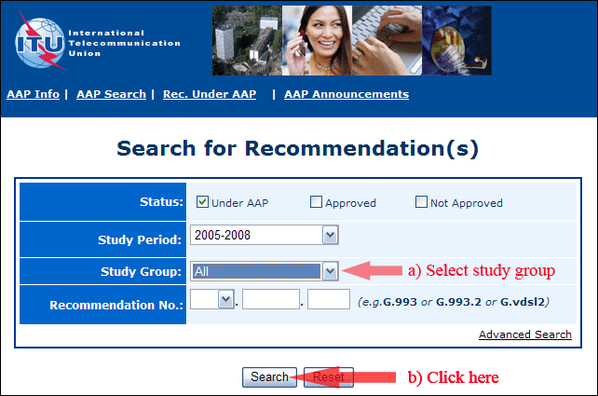
2) Select your Recommendation
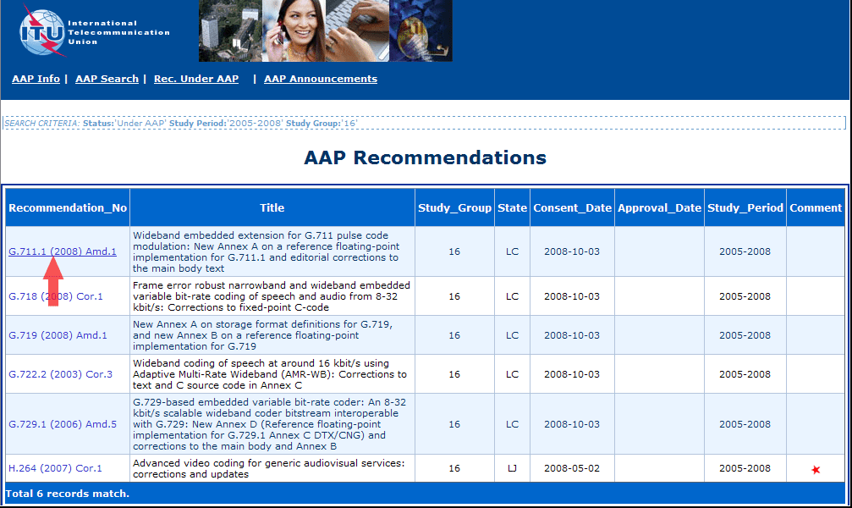
3) Click the "Submit Comment" button
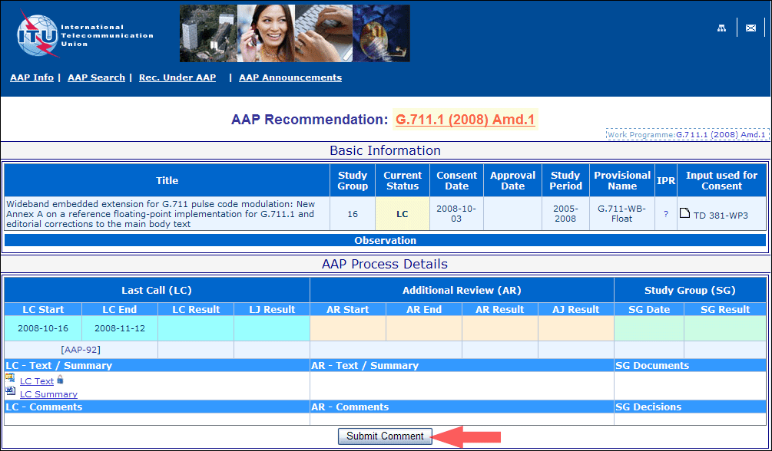
4) Complete the on-line form and click on "Submit"
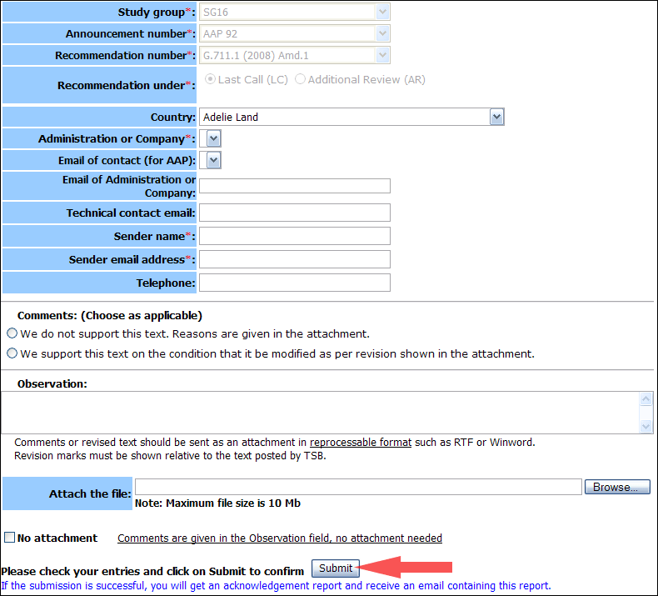
For more information, read the AAP tutorial on:
http://www.itu.int/ITU-T/aapinfo/files/AAPTutorial.pdf
Annex 3
(to TSB AAP-40)
Recommendations under LC/AR – Comment submission form
(Separate form for each Recommendation being commented upon)
ITU-T AAP comment submission form for the period 2009-2012
Study Group:
Announcement number:
Recommendation number:
Recommendation under: | Last call (LC)  Additional Review (AR)
Country:
Administration/Company:
Name of AAP Contact Person:
Email of AAP Contact Person:
Sender name:
(if different from AAP Contact Person)
Sender email address:
Telephone:
Comments:  (Choose as applicable) | We do not support this text. Reasons are given in the attachment.  We support this text on the condition that it be modified as per revision shown in the attachment.
Observations:
No attachment: Comments are given in the Observation field, no attachment needed
To be returned to: email: tsbsg....@itu.int
[or fax +41 22 730 5853]
Comments or revised text should be sent as an attachment in RTF or WinWord format.
Revision marks must be shown relative to the text posted by TSB.

