 | الا تحــاد الــدولي للاتصــالات  مكتب تقييس الاتصالات | 

 |  | جنيف، 1 اغسطس 2018
المرجع:  الهاتف:  الفاكس:  البريد الإلكتروني: | TSB AAP-40  AAP/CL  +41 22 730 5860  +41 22 730 5853  tsbdir@itu.int | - إلى إدارات الدول الأعضاء في الاتحاد؛  - إلى أعضاء قطاع تقييس الاتصالات؛  - إلى المنتسبين إلى قطاع تقييس الاتصالات  نسخة إلى:  - رؤساء لجان الدراسات في قطاع تقييس الاتصالات ونوابهم؛  - مدير مكتب تنمية الاتصالات؛  - مدير مكتب الاتصالات الراديوية

الموضوع: حالة التوصيات الخاضعة لعملية الموافقة البديلة (AAP)

حضرات السادة والسيدات،
تحية طيبة وبعد،
تنطبق عملية الموافقة البديلة (AAP) المعرفة في التوصية ITU-T A.8 على التوصيات التي لا تنطوي على بعد سياسي أوتنظيمي ولا تتطلب بالتالي استشارة الدول الأعضاء رسمياً (انظر الرقم 246B من اتفاقية الاتحاد).
ويتضمن الملحق 1 لائحة بالنصوص التي تغيرت حالتها مقارنة بما جاء في إعلانات عملية الموافقة البديلة السابقة.
إذا رغبتم في تقديم تعليق بشأن توصية ما خاضعة لعملية الموافقة البديلة، فنرجو منكم استعمال استمارة التعليق على الخط المتوفّرة على موقع قطاع تقييس الاتصالات على صفحة عملية الموافقة البديلة http://www.itu.int/ITU-T/aap على المدخل الخاص بالتوصية المعنية (انظر الملحق (2. وبديلاً من ذلك، يمكنكم تقديم التعليقات باستكمال الاستمارة الواردة في الملحق 3 وإرسالها إلى أمانة لجنة الدراسات المعنية بالأمر.
وتجدر الإشارة إلى أنه يفضّل عدم إرسال تعليقات تقتصر على تأييد اعتماد النص قيد النظر.

وتفضلوا بقبول فائق الاحترام والتقدير.
تشيساب لي
مدير مكتب تقييس الاتصالات

الملحقات: 3

Annex 1
(to TSB AAP-40)

Status codes used in the AAP announcements:
LC = Last Call
LJ = Last Call Judgment (includes comment resolution)
AR = Additional Review
AJ = Additional Review Judgment (includes comment resolution)
SG = For Study Group approval
A = Approved
AT = Approved with typographic corrections
AC = Approved after Additional Review of Comments
NA = Not approved
TAP = Moved to TAP (ITU-T A.8 / § 5.2)
ITU-T website entry page:
http://www.itu.int/ITU-T
Alternative approval process (AAP) welcome page:
http://www.itu.int/ITU-T/aapinfo
Note – A tutorial on the ITU-T AAP application is available under the AAP welcome page
ITU-T website AAP Recommendation search page:
http://www.itu.int/ITU-T/aap/
Study Group web pages and contacts:
SG 2 | http://www.itu.int/ITU-T/studygroups/com02 | tsbsg2@itu.int
SG 3 | http://www.itu.int/ITU-T/studygroups/com03 | tsbsg3@itu.int
SG 5 | http://www.itu.int/ITU-T/studygroups/com05 | tsbsg5@itu.int
SG 9 | http://www.itu.int/ITU-T/studygroups/com09 | tsbsg9@itu.int
SG 11 | http://www.itu.int/ITU-T/studygroups/com11 | tsbsg11@itu.int
SG 12 | http://www.itu.int/ITU-T/studygroups/com12 | tsbsg12@itu.int
SG 13 | http://www.itu.int/ITU-T/studygroups/com13 | tsbsg13@itu.int
SG 15 | http://www.itu.int/ITU-T/studygroups/com15 | tsbsg15@itu.int
SG 16 | http://www.itu.int/ITU-T/studygroups/com16 | tsbsg16@itu.int
SG 17 | http://www.itu.int/ITU-T/studygroups/com17 | tsbsg17@itu.int
SG 20 | http://www.itu.int/ITU-T/studygroups/com20 | tsbsg20@itu.int

Situation concerning Study Group 2 Recommendations under AAP
Rec # | Title | Last Call (LC) Period |  |  |  | Additional Review (AR) Period |  |  |  | Status
Rec # | Title | LC Start | LC End | LC  Result | LJ  Result | AR Start | AR End | AR  Result | AJ  Result | Status
M.3372 (M.rrmctm) | Requirements for resource management in cloud-aware telecommunication management system (Summary) | 2018-08-01 | 2018-08-28 |  |  |  |  |  |  | LC
Situation concerning Study Group 5 Recommendations under AAP
Rec # | Title | Last Call (LC) Period |  |  |  | Additional Review (AR) Period |  |  |  | Status
Rec # | Title | LC Start | LC End | LC  Result | LJ  Result | AR Start | AR End | AR  Result | AJ  Result | Status
K.20 (K.20) | Resistibility of telecommunication equipment installed in a telecommunication centre to overvoltages and overcurrents (Summary) | 2018-06-16 | 2018-07-13 | LJ |  |  |  |  |  | LJ
K.21 | Resistibility of telecommunication equipment installed in customer premises to overvoltages and overcurrents (Summary) | 2018-06-16 | 2018-07-13 | LJ |  |  |  |  |  | LJ
K.44 | Resistibility tests for telecommunication equipment exposed to overvoltages and overcurrents - Basic Recommendation (Summary) | 2018-06-16 | 2018-07-13 | LJ |  |  |  |  |  | LJ
K.45 | Resistibility of telecommunication equipment installed in the access and trunk networks to overvoltages and overcurrents (Summary) | 2018-06-16 | 2018-07-13 | A |  |  |  |  |  | A
K.90 | Evaluation techniques and working procedures for compliance with exposure limits of network operator personnel to power-frequency electromagnetic fields (Summary) | 2018-06-16 | 2018-07-13 | A |  |  |  |  |  | A
L.1351 (L.BMM) | Base station site energy parameter measurement methodology (Summary) | 2018-05-01 | 2018-05-28 | LJ | AR | 2018-08-01 | 2018-08-21 |  |  | AR
L.1450 (L.MAE) | Methodologies for the assessment of the environmental impact of the information and communication technology sector (Summary) | 2018-04-16 | 2018-05-13 | LJ | AR | 2018-08-01 | 2018-08-21 |  |  | AR
L.1460 (L.Connect2020 framework) | Connect 2020 greenhouse gases emissions – Guidelines (Summary) | 2018-04-16 | 2018-05-13 | LJ | AR | 2018-08-01 | 2018-08-21 |  |  | AR
Situation concerning Study Group 15 Recommendations under AAP
Rec # | Title | Last Call (LC) Period |  |  |  | Additional Review (AR) Period |  |  |  | Status
Rec # | Title | LC Start | LC End | LC  Result | LJ  Result | AR Start | AR End | AR  Result | AJ  Result | Status
G.695 | Optical interfaces for coarse wavelength division multiplexing applications (Summary) | 2018-02-16 | 2018-03-15 | LJ | AR | 2018-07-01 | 2018-07-21 | AC |  | AC
G.709.2 (G.709.otu4lr) | OTU4 long-reach interface (Summary) | 2018-02-16 | 2018-03-15 | LJ | AR | 2018-07-01 | 2018-07-21 | AC |  | AC
G.798 (2017) Amd.1 | Characteristics of optical transport network hierarchy equipment functional blocks (Summary) | 2018-02-16 | 2018-03-15 | LJ | AR | 2018-08-01 | 2018-08-21 |  |  | AR
G.959.1 | Optical transport networks physical layer interfaces (Summary) | 2018-02-16 | 2018-03-15 | LJ | AR | 2018-07-01 | 2018-07-21 | AC |  | AC
Situation concerning Study Group 16 Recommendations under AAP
Rec # | Title | Last Call (LC) Period |  |  |  | Additional Review (AR) Period |  |  |  | Status
Rec # | Title | LC Start | LC End | LC  Result | LJ  Result | AR Start | AR End | AR  Result | AJ  Result | Status
F.743.5 (H.CDN-FI) | Framework and interfaces for multimedia content delivery network (Summary) | 2018-08-01 | 2018-08-28 |  |  |  |  |  |  | LC
F.743.6 (F.NG-CDN) | Service requirements for next generation content delivery networks (Summary) | 2018-08-01 | 2018-08-28 |  |  |  |  |  |  | LC
F.746.7 (F.IQAS-META) | Metadata for intelligent question answering service (Summary) | 2018-08-01 | 2018-08-28 |  |  |  |  |  |  | LC
F.746.8 (F.USMReqs) | Requirements for unified status monitoring of networks and services (Summary) | 2018-08-01 | 2018-08-28 |  |  |  |  |  |  | LC
F.791 | Accessibility terms and definitions (Summary) | 2018-08-01 | 2018-08-28 |  |  |  |  |  |  | LC
F.921 (V2) | Audio-based indoor and outdoor network navigation system for persons with vision impairment (Summary) | 2018-08-01 | 2018-08-28 |  |  |  |  |  |  | LC
G.722.2 Annex C (2017) Corr. 1 | Wideband coding of speech at around 16 kbit/s using Adaptive Multi-Rate Wideband (AMR-WB): Annex C: Fixed-point C-code: Corrections to Table C.5 (Summary) | 2018-08-01 | 2018-08-28 |  |  |  |  |  |  | LC
H.222.0 (7th Ed.) | Information technology - Generic coding of moving pictures and associated audio information: Systems (Summary) | 2018-08-01 | 2018-08-28 |  |  |  |  |  |  | LC
H.430.1 (H.ILE-Reqs) | Requirements for immersive live experience (ILE) services (Summary) | 2018-08-01 | 2018-08-28 |  |  |  |  |  |  | LC
H.430.2 (H.ILE-FW) | Architectural framework for immersive live experience (ILE) services (Summary) | 2018-08-01 | 2018-08-28 |  |  |  |  |  |  | LC
H.430.3 (H.ILE-SS) | Service scenario of immersive live experience (ILE) (Summary) | 2018-08-01 | 2018-08-28 |  |  |  |  |  |  | LC
H.626.3 (H.VSSI-Arch) | Architecture for visual surveillance system interworking (Summary) | 2018-08-01 | 2018-08-28 |  |  |  |  |  |  | LC
H.626.4 (H.P2PVS-Arch) | Architecture for a point-to-point visual surveillance system (Summary) | 2018-08-01 | 2018-08-28 |  |  |  |  |  |  | LC
H.766 (H.IPTV-MAFR.14) | Lua for IPTV services (Summary) | 2018-08-01 | 2018-08-28 |  |  |  |  |  |  | LC
H.783 (H.DS-AM) | Digital signage: Audience measurement services (Summary) | 2018-08-01 | 2018-08-28 |  |  |  |  |  |  | LC
H.785.1 (H.DS-PISR) | Digital signage: Service requirements and a reference model on information services in public places via an interoperable service platform (Summary) | 2018-08-01 | 2018-08-28 |  |  |  |  |  |  | LC
H.820 (2018-07) (HSTP-H810-CATP) | Conformance of ITU-T H.810 personal health system: Conformity assessment test plan (Summary) | 2018-08-01 | 2018-08-28 |  |  |  |  |  |  | LC
H.830.13 (2018-07) | Conformance of ITU-T H.810 personal health system: Services interface Part 13: Capability Exchange: Health & Fitness Service sender (New) (Summary) | 2018-08-01 | 2018-08-28 |  |  |  |  |  |  | LC
H.830.14 (2018-07) | Conformance of ITU-T H.810 personal health system: Services interface Part 14: Capability Exchange: Health & Fitness Service receiver (New) (Summary) | 2018-08-01 | 2018-08-28 |  |  |  |  |  |  | LC
H.830.15 (2018-07) | Conformance of ITU-T H.810 personal health system: Services interface Part 15: FHIR Observation Upload: Health & Fitness Service sender (Summary) | 2018-08-01 | 2018-08-28 |  |  |  |  |  |  | LC
H.830.16 (2018-07) | Conformance of ITU-T H.810 personal health system: Services interface Part 16: FHIR Observation Upload: Health & Fitness Service receiver (New) (Summary) | 2018-08-01 | 2018-08-28 |  |  |  |  |  |  | LC
H.841 (2018-07) | Conformance of ITU-T H.810 personal health system: Personal Health Devices interface Part 1: Optimized Exchange Protocol: Personal Health Device (Rev) (Summary) | 2018-08-01 | 2018-08-28 |  |  |  |  |  |  | LC
H.842 (2018-07) | Conformance of ITU-T H.810 personal health system: Personal Health Devices interface Part 2: Optimized Exchange Protocol: Personal Health Gateway (Rev) (Summary) | 2018-08-01 | 2018-08-28 |  |  |  |  |  |  | LC
H.843 (2018-07) | Conformance of ITU-T H.810 personal health system: Personal Health Devices interface Part 3: Continua Design Guidelines: Personal Health Device (Rev) (Summary) | 2018-08-01 | 2018-08-28 |  |  |  |  |  |  | LC
H.844 (2018-07) | Conformance of ITU-T H.810 personal health system: Personal Health Devices interface Part 4: Continua Design Guidelines: Personal Health Gateway (Rev) (Summary) | 2018-08-01 | 2018-08-28 |  |  |  |  |  |  | LC
H.845.17 (2018-07) | Conformance of ITU-T H.810 personal health system: Personal Health Devices interface Part 5Q: Power status monitor (New) (Summary) | 2018-08-01 | 2018-08-28 |  |  |  |  |  |  | LC
H.845.2 (2018-07) | Conformance of ITU-T H.810 personal health system: Personal Health Devices interface Part 5B: Glucose meter (Rev) (Summary) | 2018-08-01 | 2018-08-28 |  |  |  |  |  |  | LC
H.846 (2018-07) | Conformance of ITU-T H.810 personal health system: Personal Health Devices interface Part 6: Personal Health Gateway (Rev) (Summary) | 2018-08-01 | 2018-08-28 |  |  |  |  |  |  | LC
H.849 (2018-07) | Conformance of ITU-T H.810 personal health system: Personal Health Devices interface Part 9: Transcoding for Bluetooth Low Energy: Personal Health Devices (Rev) (Summary) | 2018-08-01 | 2018-08-28 |  |  |  |  |  |  | LC
H.870 (F.SLD) | Guidelines for safe listening devices/systems (Summary) | 2018-08-01 | 2018-08-28 |  |  |  |  |  |  | LC
T.88 (V2) (T.88 Amd.4) | Information technology - Lossy/lossless coding of bi-level images (Summary) | 2018-08-01 | 2018-08-28 |  |  |  |  |  |  | LC

Annex 2
(to TSB AAP-40)
Using the on-line comment submission form
Comment submission
1) Go to AAP search Web page at http://www.itu.int/ITU-T/aap/
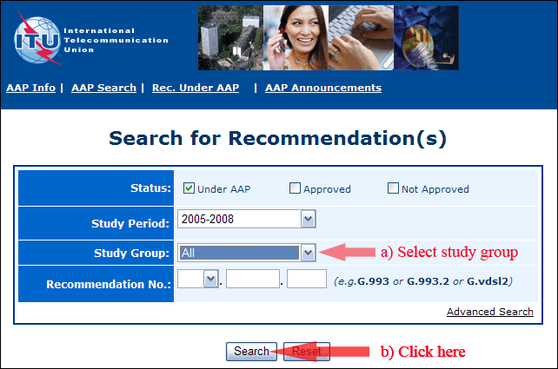
2) Select your Recommendation
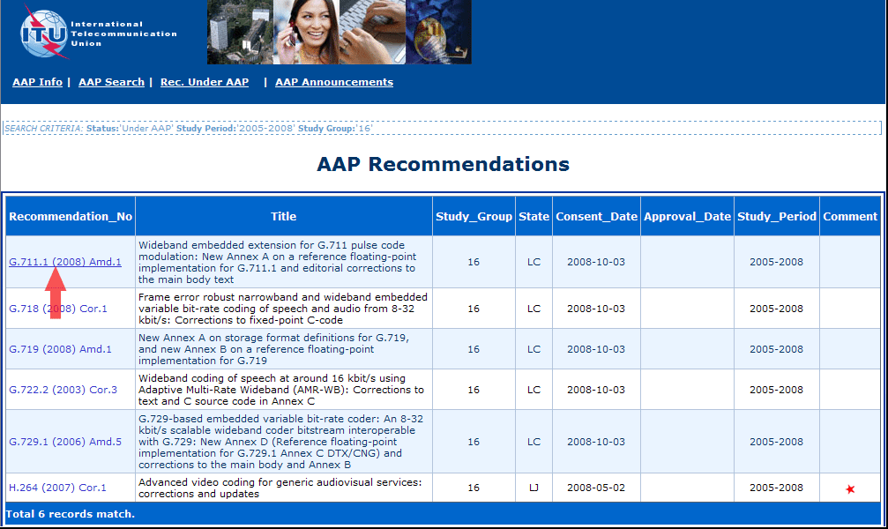
3) Click the "Submit Comment" button
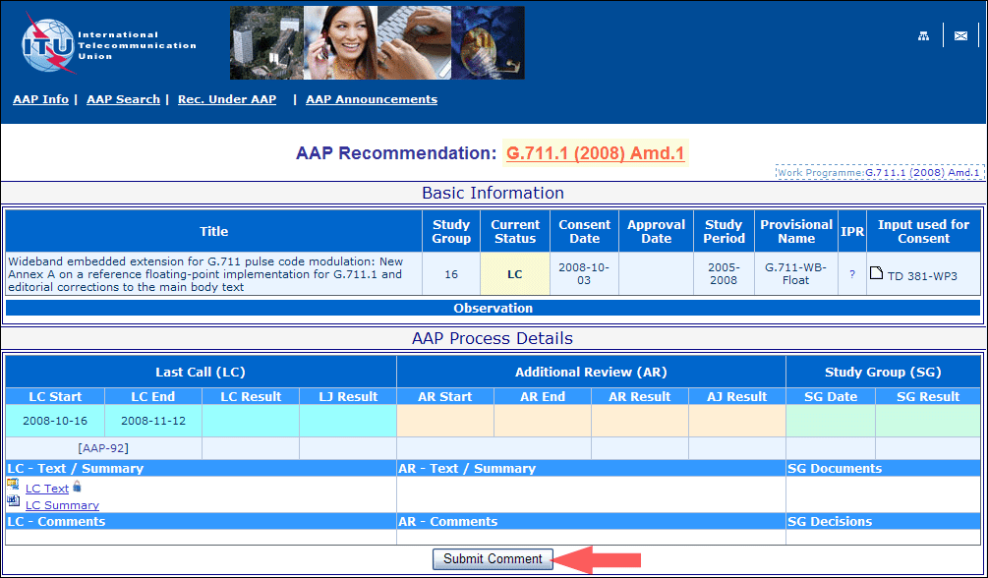
4) Complete the on-line form and click on "Submit"
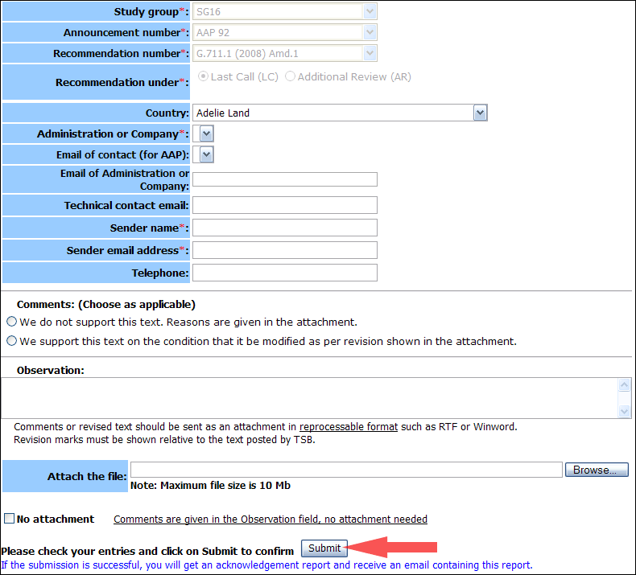
For more information, read the AAP tutorial on:
http://www.itu.int/ITU-T/aapinfo/files/AAPTutorial.pdf
Annex 3
(to TSB AAP-40)
Recommendations under LC/AR – Comment submission form
(Separate form for each Recommendation being commented upon)
ITU-T AAP comment submission form for the period 2009-2012
Study Group:
Announcement number:
Recommendation number:
Recommendation under: | Last call (LC)  Additional Review (AR)
Country:
Administration/Company:
Name of AAP Contact Person:
Email of AAP Contact Person:
Sender name:
(if different from AAP Contact Person)
Sender email address:
Telephone:
Comments:  (Choose as applicable) | We do not support this text. Reasons are given in the attachment.  We support this text on the condition that it be modified as per revision shown in the attachment.
Observations:
No attachment: Comments are given in the Observation field, no attachment needed
To be returned to: email: tsbsg....@itu.int
[or fax +41 22 730 5853]
Comments or revised text should be sent as an attachment in RTF or WinWord format.
Revision marks must be shown relative to the text posted by TSB.

