 | International Telecommunication Union  Telecommunication Standardization Bureau

Geneva, 16 June 2018

Ref:  Tel:  Fax:  E-mail: | TSB AAP-37  AAP/CL  +41 22 730 5860  +41 22 730 5853  tsbdir@itu.int | – To Administrations of Member States of the Union;  – To ITU-T Sector Members;  – To ITU-T Associates  Copy:  – To the ITU-T Study Group Chairmen and Vice-Chairmen;  – To the Director of the Telecommunication Development Bureau;  – To the Director of the Radiocommunication Bureau

Subject: | Situation concerning Recommendations under the Alternative Approval Process (AAP)

Dear Sir/Madam,
The Alternative Approval Process (AAP) defined in Rec. ITU-T A.8 applies to Recommendations which do not have policy or regulatory implications and which, therefore, do not require formal consultation of Member States (see ITU Convention 246B).
Annex 1 lists those texts whose status has changed compared with previous TSB AAP Announcements.
If you wish to submit a comment relative to a Recommendation under AAP, you are encouraged to use the on-line AAP comment submission form available on the page of the Recommendation in the AAP area of the ITU-T website at http://www.itu.int/ITU-T/aap (see Annex 2). Alternatively, comments can be submitted by completing the form in Annex 3 and sending it to the secretariat of the concerned study group.
Please note that comments that simply support adoption of the text in question are not encouraged.
Yours faithfully,
Chaesub Lee
Director of the Telecommunication Standardization Bureau
Annexes: 3

Annex 1
(to TSB AAP-37)

Status codes used in the AAP announcements:
LC = Last Call
LJ = Last Call Judgment (includes comment resolution)
AR = Additional Review
AJ = Additional Review Judgment (includes comment resolution)
SG = For Study Group approval
A = Approved
AT = Approved with typographic corrections
AC = Approved after Additional Review of Comments
NA = Not approved
TAP = Moved to TAP (ITU-T A.8 / § 5.2)
ITU-T website entry page:
http://www.itu.int/ITU-T
Alternative approval process (AAP) welcome page:
http://www.itu.int/ITU-T/aapinfo
Note – A tutorial on the ITU-T AAP application is available under the AAP welcome page
ITU-T website AAP Recommendation search page:
http://www.itu.int/ITU-T/aap/
Study Group web pages and contacts:
SG 2 | http://www.itu.int/ITU-T/studygroups/com02 | tsbsg2@itu.int
SG 3 | http://www.itu.int/ITU-T/studygroups/com03 | tsbsg3@itu.int
SG 5 | http://www.itu.int/ITU-T/studygroups/com05 | tsbsg5@itu.int
SG 9 | http://www.itu.int/ITU-T/studygroups/com09 | tsbsg9@itu.int
SG 11 | http://www.itu.int/ITU-T/studygroups/com11 | tsbsg11@itu.int
SG 12 | http://www.itu.int/ITU-T/studygroups/com12 | tsbsg12@itu.int
SG 13 | http://www.itu.int/ITU-T/studygroups/com13 | tsbsg13@itu.int
SG 15 | http://www.itu.int/ITU-T/studygroups/com15 | tsbsg15@itu.int
SG 16 | http://www.itu.int/ITU-T/studygroups/com16 | tsbsg16@itu.int
SG 17 | http://www.itu.int/ITU-T/studygroups/com17 | tsbsg17@itu.int
SG 20 | http://www.itu.int/ITU-T/studygroups/com20 | tsbsg20@itu.int

Situation concerning Study Group 5 Recommendations under AAP
Rec # | Title | Last Call (LC) Period |  |  |  | Additional Review (AR) Period |  |  |  | Status
Rec # | Title | LC Start | LC End | LC  Result | LJ  Result | AR Start | AR End | AR  Result | AJ  Result | Status
K.20 (K.20) | Resistibility of telecommunication equipment installed in a telecommunication centre to overvoltages and overcurrents (Summary) | 2018-06-16 | 2018-07-13 |  |  |  |  |  |  | LC
K.21 | Resistibility of telecommunication equipment installed in customer premises to overvoltages and overcurrents (Summary) | 2018-06-16 | 2018-07-13 |  |  |  |  |  |  | LC
K.44 | Resistibility tests for telecommunication equipment exposed to overvoltages and overcurrents - Basic Recommendation (Summary) | 2018-06-16 | 2018-07-13 |  |  |  |  |  |  | LC
K.45 | Resistibility of telecommunication equipment installed in the access and trunk networks to overvoltages and overcurrents (Summary) | 2018-06-16 | 2018-07-13 |  |  |  |  |  |  | LC
K.90 | Evaluation techniques and working procedures for compliance with exposure limits of network operator personnel to power-frequency electromagnetic fields (Summary) | 2018-06-16 | 2018-07-13 |  |  |  |  |  |  | LC
L.1030 (L.EWFrame) | E-waste management framework for countries (Summary) | 2018-05-16 | 2018-06-12 | A |  |  |  |  |  | A
Situation concerning Study Group 12 Recommendations under AAP
Rec # | Title | Last Call (LC) Period |  |  |  | Additional Review (AR) Period |  |  |  | Status
Rec # | Title | LC Start | LC End | LC  Result | LJ  Result | AR Start | AR End | AR  Result | AJ  Result | Status
E.802 Amd.2 | Amendment 2 to ITU-T E.802 - Updates and additional information on the degree of variability function in support of E.802 (Summary) | 2018-05-16 | 2018-06-12 | A |  |  |  |  |  | A
E.840 (E.NetPerfRank) | Statistical framework for end to end network-performance benchmark scoring and ranking (Summary) | 2018-05-16 | 2018-06-12 | A |  |  |  |  |  | A
G.1070 | Opinion model for video-telephony applications (Summary) | 2018-05-16 | 2018-06-12 | A |  |  |  |  |  | A
P.501 Amd.1 | Amendment 1 to ITU-T P.501 -Addition to P.501 - AM-FM test signal for super-wideband and fullband applications (Summary) | 2018-05-16 | 2018-06-12 | A |  |  |  |  |  | A
P.570 (P.TBN) | Artificial noise-fields in laboratory conditions (Summary) | 2018-05-16 | 2018-06-12 | A |  |  |  |  |  | A
P.808 (P.CROWD) | Subjective evaluation of speech quality with a crowdsourcing approach (Summary) | 2018-05-16 | 2018-06-12 | A |  |  |  |  |  | A
P.809 (P.GAME) | Subjective Evaluation Methods for Gaming Quality (Summary) | 2018-05-16 | 2018-06-12 | A |  |  |  |  |  | A
Y.1543 | Measurements in IP networks for inter-domain performance assessment (Summary) | 2018-05-16 | 2018-06-12 | A |  |  |  |  |  | A
Y.1546 Amd.1 | Amendment 1 to ITU-T Y.1546 - IP-Based Service Availability Function (Summary) | 2018-05-16 | 2018-06-12 | A |  |  |  |  |  | A
Situation concerning Study Group 15 Recommendations under AAP
Rec # | Title | Last Call (LC) Period |  |  |  | Additional Review (AR) Period |  |  |  | Status
Rec # | Title | LC Start | LC End | LC  Result | LJ  Result | AR Start | AR End | AR  Result | AJ  Result | Status
G.709/Y.1331 (2016) Amd.2 | Interfaces for the optical transport network (OTN): Amendment 2 (Summary) | 2018-02-16 | 2018-03-15 | LJ | AR | 2018-05-16 | 2018-06-05 | AC |  | AC
G.8021/Y.1341 | Characteristics of Ethernet transport network equipment functional blocks (Summary) | 2018-02-16 | 2018-03-15 | LJ | AR | 2018-05-16 | 2018-06-05 | AC |  | AC
G.8023 | Characteristics of equipment functional blocks supporting Ethernet physical layer and FlexE interfaces (Summary) | 2018-02-16 | 2018-03-15 | LJ | AR | 2018-05-16 | 2018-06-05 | AC |  | AC
Situation concerning Study Group 20 Recommendations under AAP
Rec # | Title | Last Call (LC) Period |  |  |  | Additional Review (AR) Period |  |  |  | Status
Rec # | Title | LC Start | LC End | LC  Result | LJ  Result | AR Start | AR End | AR  Result | AJ  Result | Status
Y.4118 (Y.IoT-AC-reqts) | Internet of Things requirements and technical capabilities for support of accounting and charging (Summary) | 2018-02-01 | 2018-02-28 | LJ | AR | 2018-05-16 | 2018-06-05 | AC |  | AC

Annex 2
(to TSB AAP-37)
Using the on-line comment submission form
Comment submission
1) Go to AAP search Web page at http://www.itu.int/ITU-T/aap/
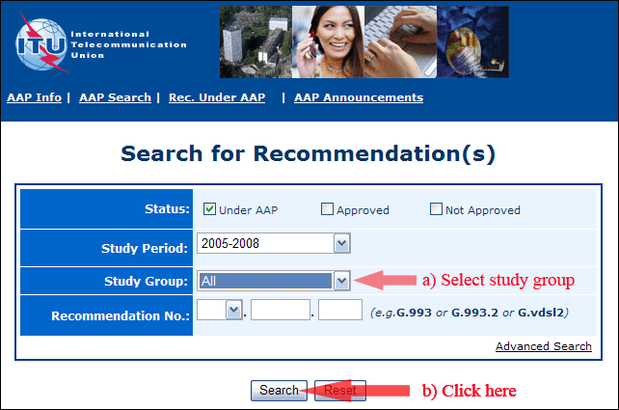
2) Select your Recommendation
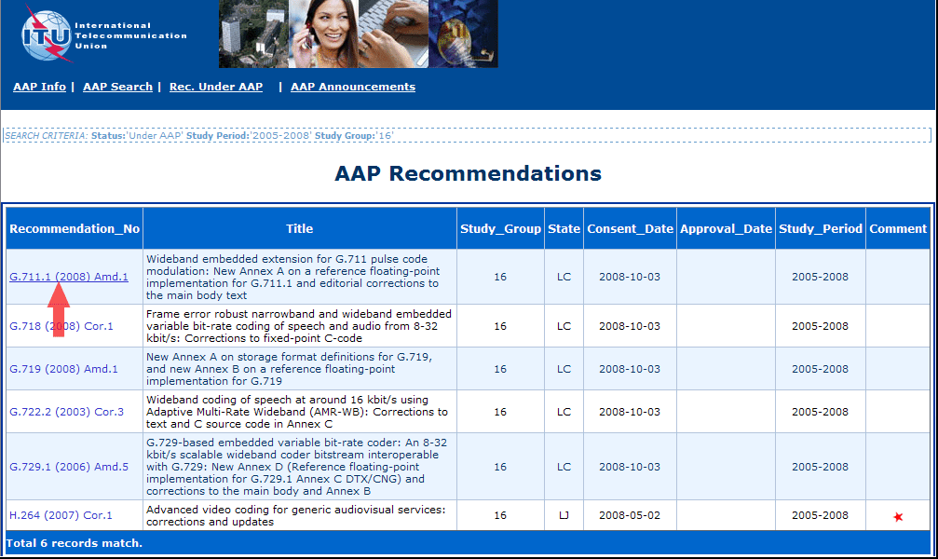
3) Click the "Submit Comment" button
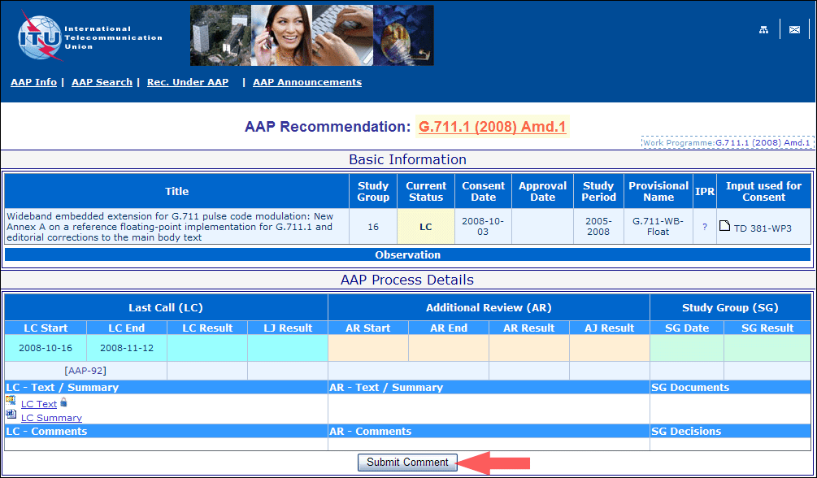
4) Complete the on-line form and click on "Submit"
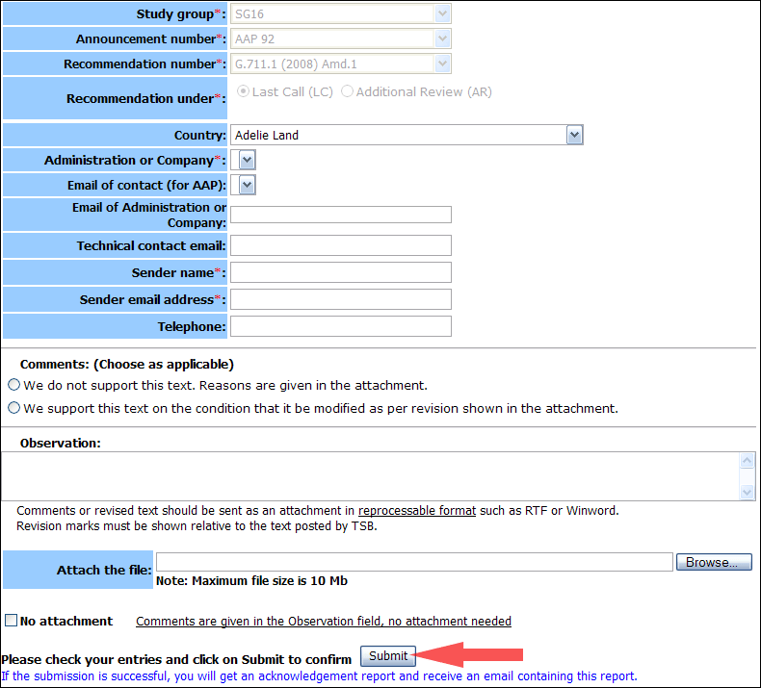
For more information, read the AAP tutorial on:
http://www.itu.int/ITU-T/aapinfo/files/AAPTutorial.pdf
Annex 3
(to TSB AAP-37)
Recommendations under LC/AR – Comment submission form
(Separate form for each Recommendation being commented upon)
ITU-T AAP comment submission form for the period 2009-2012
Study Group:
Announcement number:
Recommendation number:
Recommendation under: | Last call (LC)  Additional Review (AR)
Country:
Administration/Company:
Name of AAP Contact Person:
Email of AAP Contact Person:
Sender name:
(if different from AAP Contact Person)
Sender email address:
Telephone:
Comments:  (Choose as applicable) | We do not support this text. Reasons are given in the attachment.  We support this text on the condition that it be modified as per revision shown in the attachment.
Observations:
No attachment: Comments are given in the Observation field, no attachment needed
To be returned to: email: tsbsg....@itu.int
[or fax +41 22 730 5853]
Comments or revised text should be sent as an attachment in RTF or WinWord format.
Revision marks must be shown relative to the text posted by TSB.

