 | الا تحــاد الــدولي للاتصــالات  مكتب تقييس الاتصالات | 

 |  | جنيف، 16 ابريل 2018
المرجع:  الهاتف:  الفاكس:  البريد الإلكتروني: | TSB AAP-33  AAP/CL  +41 22 730 5860  +41 22 730 5853  tsbdir@itu.int | - إلى إدارات الدول الأعضاء في الاتحاد؛  - إلى أعضاء قطاع تقييس الاتصالات؛  - إلى المنتسبين إلى قطاع تقييس الاتصالات  نسخة إلى:  - رؤساء لجان الدراسات في قطاع تقييس الاتصالات ونوابهم؛  - مدير مكتب تنمية الاتصالات؛  - مدير مكتب الاتصالات الراديوية

الموضوع: حالة التوصيات الخاضعة لعملية الموافقة البديلة (AAP)

حضرات السادة والسيدات،
تحية طيبة وبعد،
تنطبق عملية الموافقة البديلة (AAP) المعرفة في التوصية ITU-T A.8 على التوصيات التي لا تنطوي على بعد سياسي أوتنظيمي ولا تتطلب بالتالي استشارة الدول الأعضاء رسمياً (انظر الرقم 246B من اتفاقية الاتحاد).
ويتضمن الملحق 1 لائحة بالنصوص التي تغيرت حالتها مقارنة بما جاء في إعلانات عملية الموافقة البديلة السابقة.
إذا رغبتم في تقديم تعليق بشأن توصية ما خاضعة لعملية الموافقة البديلة، فنرجو منكم استعمال استمارة التعليق على الخط المتوفّرة على موقع قطاع تقييس الاتصالات على صفحة عملية الموافقة البديلة http://www.itu.int/ITU-T/aap على المدخل الخاص بالتوصية المعنية (انظر الملحق (2. وبديلاً من ذلك، يمكنكم تقديم التعليقات باستكمال الاستمارة الواردة في الملحق 3 وإرسالها إلى أمانة لجنة الدراسات المعنية بالأمر.
وتجدر الإشارة إلى أنه يفضّل عدم إرسال تعليقات تقتصر على تأييد اعتماد النص قيد النظر.

وتفضلوا بقبول فائق الاحترام والتقدير.
تشيساب لي
مدير مكتب تقييس الاتصالات

الملحقات: 3

Annex 1
(to TSB AAP-33)

Status codes used in the AAP announcements:
LC = Last Call
LJ = Last Call Judgment (includes comment resolution)
AR = Additional Review
AJ = Additional Review Judgment (includes comment resolution)
SG = For Study Group approval
A = Approved
AT = Approved with typographic corrections
AC = Approved after Additional Review of Comments
NA = Not approved
TAP = Moved to TAP (ITU-T A.8 / § 5.2)
ITU-T website entry page:
http://www.itu.int/ITU-T
Alternative approval process (AAP) welcome page:
http://www.itu.int/ITU-T/aapinfo
Note – A tutorial on the ITU-T AAP application is available under the AAP welcome page
ITU-T website AAP Recommendation search page:
http://www.itu.int/ITU-T/aap/
Study Group web pages and contacts:
SG 2 | http://www.itu.int/ITU-T/studygroups/com02 | tsbsg2@itu.int
SG 3 | http://www.itu.int/ITU-T/studygroups/com03 | tsbsg3@itu.int
SG 5 | http://www.itu.int/ITU-T/studygroups/com05 | tsbsg5@itu.int
SG 9 | http://www.itu.int/ITU-T/studygroups/com09 | tsbsg9@itu.int
SG 11 | http://www.itu.int/ITU-T/studygroups/com11 | tsbsg11@itu.int
SG 12 | http://www.itu.int/ITU-T/studygroups/com12 | tsbsg12@itu.int
SG 13 | http://www.itu.int/ITU-T/studygroups/com13 | tsbsg13@itu.int
SG 15 | http://www.itu.int/ITU-T/studygroups/com15 | tsbsg15@itu.int
SG 16 | http://www.itu.int/ITU-T/studygroups/com16 | tsbsg16@itu.int
SG 17 | http://www.itu.int/ITU-T/studygroups/com17 | tsbsg17@itu.int
SG 20 | http://www.itu.int/ITU-T/studygroups/com20 | tsbsg20@itu.int

Situation concerning Study Group 5 Recommendations under AAP
Rec # | Title | Last Call (LC) Period |  |  |  | Additional Review (AR) Period |  |  |  | Status
Rec # | Title | LC Start | LC End | LC  Result | LJ  Result | AR Start | AR End | AR  Result | AJ  Result | Status
L.1021 (L.EPR) | Extended producer responsibility - Guidelines for sustainable e-waste management (Summary) | 2018-02-01 | 2018-02-28 | AR |  | 2018-03-16 | 2018-04-05 | AC |  | AC
L.1207 (L.400migration) | Progressive migration of a telecommunication/information and communication technology site to 400 VDC sources and distribution (Summary) | 2018-04-16 | 2018-05-13 |  |  |  |  |  |  | LC
L.1222 (L.ENST3supercap) | Innovative energy storage technology for stationary use - Part 3: Supercapacitor technology (Summary) | 2018-04-16 | 2018-05-13 |  |  |  |  |  |  | LC
L.1450 (L.MAE) | Methodologies for the assessment of the environmental impact of the information and communication technology sector (Summary) | 2018-04-16 | 2018-05-13 |  |  |  |  |  |  | LC
L.1460 (L.Connect2020 framework) | Connect 2020 greenhouse gases emissions – Guidelines (Summary) | 2018-04-16 | 2018-05-13 |  |  |  |  |  |  | LC
Situation concerning Study Group 13 Recommendations under AAP
Rec # | Title | Last Call (LC) Period |  |  |  | Additional Review (AR) Period |  |  |  | Status
Rec # | Title | LC Start | LC End | LC  Result | LJ  Result | AR Start | AR End | AR  Result | AJ  Result | Status
Y.3601 (Y.BigDataEX-reqts) | Big data - framework and requirements for data exchange (Summary) | 2017-12-16 | 2018-01-12 | LJ | AR | 2018-04-16 | 2018-05-06 |  |  | AR
Situation concerning Study Group 15 Recommendations under AAP
Rec # | Title | Last Call (LC) Period |  |  |  | Additional Review (AR) Period |  |  |  | Status
Rec # | Title | LC Start | LC End | LC  Result | LJ  Result | AR Start | AR End | AR  Result | AJ  Result | Status
G.984.5 (2014) Amd.1 | Gigabit-capable passive optical networks (G-PON): Enhancement band - Amendment 1 (Summary) | 2018-02-16 | 2018-03-15 | LJ | AR | 2018-04-16 | 2018-05-06 |  |  | AR
G.993.2 (2015) Amd.4 | Very high speed digital subscriber line transceivers 2 (VDSL2) - Amendment 4 (Summary) | 2018-02-16 | 2018-03-15 | LJ | AR | 2018-04-16 | 2018-05-06 |  |  | AR
Situation concerning Study Group 17 Recommendations under AAP
Rec # | Title | Last Call (LC) Period |  |  |  | Additional Review (AR) Period |  |  |  | Status
Rec # | Title | LC Start | LC End | LC  Result | LJ  Result | AR Start | AR End | AR  Result | AJ  Result | Status
X.680 Amd.1 (X.680 Amd.1) | Information technology – Abstract Syntax Notation One (ASN.1): Specification of basic notation Amendment 1 (Summary) | 2018-04-16 | 2018-05-13 |  |  |  |  |  |  | LC
X.680 Cor.3 (X.680 Cor.3) | Information technology - Abstract Syntax Notation One (ASN.1): Specification of basic notation Technical Corrigendum 3 (Summary) | 2018-04-16 | 2018-05-13 |  |  |  |  |  |  | LC
X.681 Cor.1 (X.681 Cor.1) | Information technology - Abstract Syntax Notation One (ASN.1): Information object specificationTechnical Corrigendum 1 (Summary) | 2018-04-16 | 2018-05-13 |  |  |  |  |  |  | LC
X.682 Cor.2 (X.682 Cor.2) | Information technology - Abstract Syntax Notation One (ASN.1): Constraint specification - Technical Corrigendum 2 (Summary) | 2018-04-16 | 2018-05-13 |  |  |  |  |  |  | LC
X.683 Cor.1 (X.683 Cor.1) | Information technology - Abstract Syntax Notation One (ASN.1): Parameterization of ASN.1 specifications Technical Corrigendum 1 (Summary) | 2018-04-16 | 2018-05-13 |  |  |  |  |  |  | LC
X.696 Cor.3 (X.696 Cor.3) | Information technology - ASN.1 encoding rules: Specification of Octet Encoding Rules (OER) Corrigendum 3 (Summary) | 2018-04-16 | 2018-05-13 |  |  |  |  |  |  | LC
X.1041 (X.voLTEsec-1) | Security framework for voice-over-long-term-evolution (VoLTE) network operation (Summary) | 2018-04-16 | 2018-05-13 |  |  |  |  |  |  | LC
X.1080.1 rev (X.1080.1 rev) | e-Health and world-wide telemedicines - Generic telecommunication protocol (Summary) | 2018-04-16 | 2018-05-13 |  |  |  |  |  |  | LC
X.1276 (X.te) | Authentication Step-Up Protocol and Metadata Version 1.0 (Summary) | 2018-04-16 | 2018-05-13 |  |  |  |  |  |  | LC

Annex 2
(to TSB AAP-33)
Using the on-line comment submission form
Comment submission
1) Go to AAP search Web page at http://www.itu.int/ITU-T/aap/
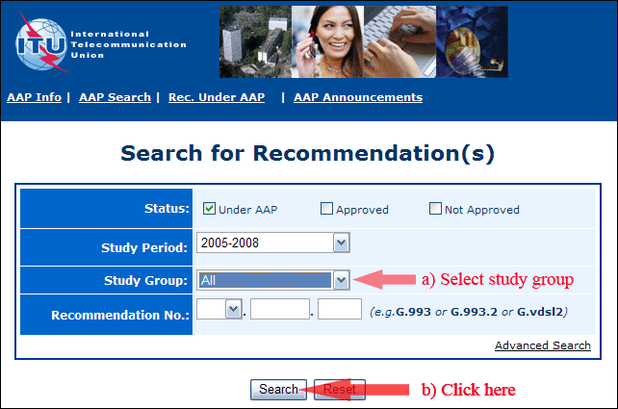
2) Select your Recommendation
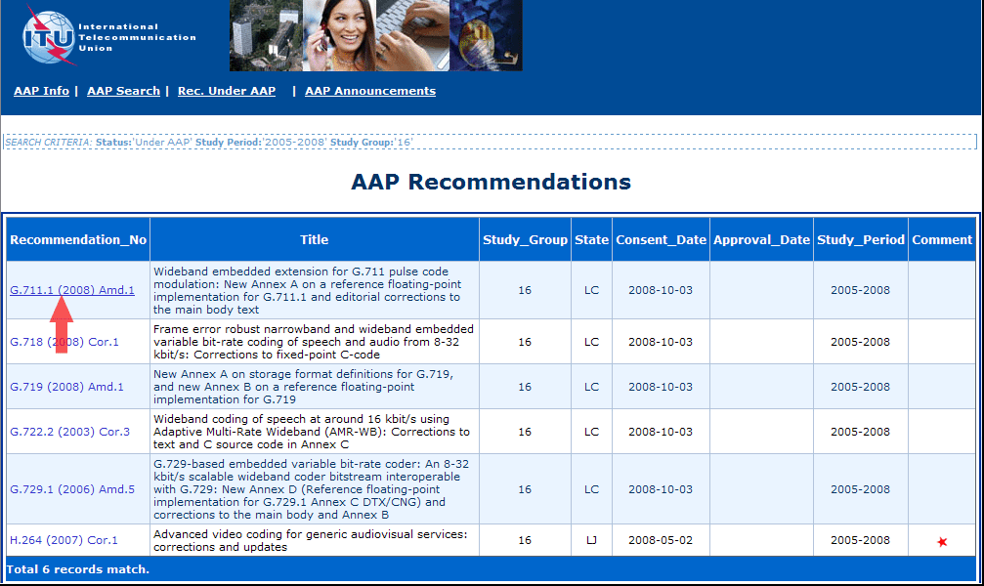
3) Click the "Submit Comment" button
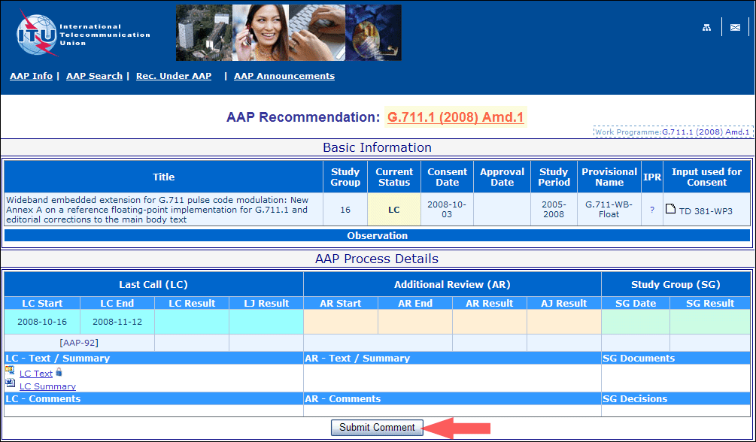
4) Complete the on-line form and click on "Submit"
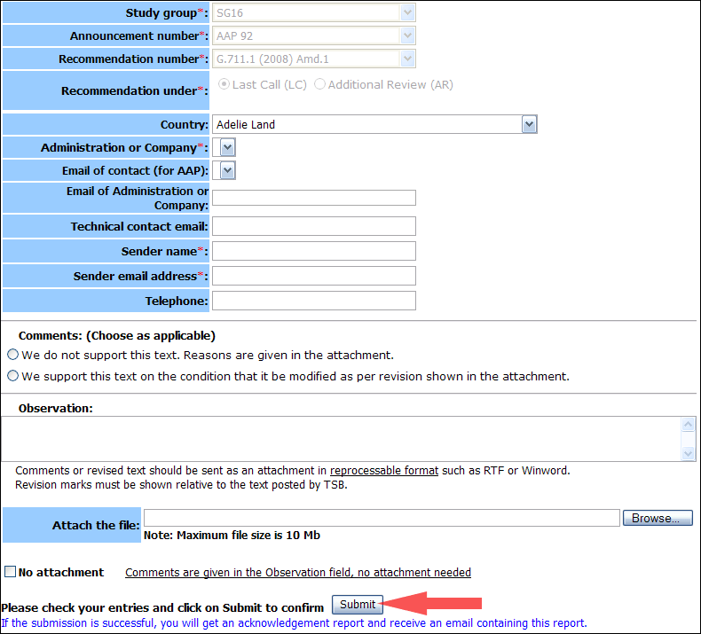
For more information, read the AAP tutorial on:
http://www.itu.int/ITU-T/aapinfo/files/AAPTutorial.pdf
Annex 3
(to TSB AAP-33)
Recommendations under LC/AR – Comment submission form
(Separate form for each Recommendation being commented upon)
ITU-T AAP comment submission form for the period 2009-2012
Study Group:
Announcement number:
Recommendation number:
Recommendation under: | Last call (LC)  Additional Review (AR)
Country:
Administration/Company:
Name of AAP Contact Person:
Email of AAP Contact Person:
Sender name:
(if different from AAP Contact Person)
Sender email address:
Telephone:
Comments:  (Choose as applicable) | We do not support this text. Reasons are given in the attachment.  We support this text on the condition that it be modified as per revision shown in the attachment.
Observations:
No attachment: Comments are given in the Observation field, no attachment needed
To be returned to: email: tsbsg....@itu.int
[or fax +41 22 730 5853]
Comments or revised text should be sent as an attachment in RTF or WinWord format.
Revision marks must be shown relative to the text posted by TSB.

