International Telecommunication Union
Telecommunication Standardization Bureau

Geneva, 16 April 2017

Ref:  Tel:  Fax:  E-mail: | TSB AAP-10  AAP/CL  +41 22 730 5860  +41 22 730 5853  tsbdir@itu.int | – To Administrations of Member States of the Union;  – To ITU-T Sector Members;  – To ITU-T Associates  Copy:  – To the ITU-T Study Group Chairmen and Vice-Chairmen;  – To the Director of the Telecommunication Development Bureau;  – To the Director of the Radiocommunication Bureau

Subject: | Situation concerning Recommendations under the Alternative Approval Process (AAP)

Dear Sir/Madam,
The Alternative Approval Process (AAP) defined in Rec. ITU-T A.8 applies to Recommendations which do not have policy or regulatory implications and which, therefore, do not require formal consultation of Member States (see ITU Convention 246B).
Annex 1 lists those texts whose status has changed compared with previous TSB AAP Announcements.
If you wish to submit a comment relative to a Recommendation under AAP, you are encouraged to use the on-line AAP comment submission form available on the page of the Recommendation in the AAP area of the ITU-T website at http://www.itu.int/ITU-T/aap (see Annex 2). Alternatively, comments can be submitted by completing the form in Annex 3 and sending it to the secretariat of the concerned study group.
Please note that comments that simply support adoption of the text in question are not encouraged.
Yours faithfully,
Chaesub Lee
Director of the Telecommunication Standardization Bureau
Annexes: 3

Annex 1
(to TSB AAP-10)

Status codes used in the AAP announcements:
LC = Last Call
LJ = Last Call Judgment (includes comment resolution)
AR = Additional Review
AJ = Additional Review Judgment (includes comment resolution)
SG = For Study Group approval
A = Approved
AT = Approved with typographic corrections
AC = Approved after Additional Review of Comments
NA = Not approved
TAP = Moved to TAP (ITU-T A.8 / § 5.2)
ITU-T website entry page:
http://www.itu.int/ITU-T
Alternative approval process (AAP) welcome page:
http://www.itu.int/ITU-T/aapinfo
Note – A tutorial on the ITU-T AAP application is available under the AAP welcome page
ITU-T website AAP Recommendation search page:
http://www.itu.int/ITU-T/aap/
Study Group web pages and contacts:
SG 2 | http://www.itu.int/ITU-T/studygroups/com02 | tsbsg2@itu.int
SG 3 | http://www.itu.int/ITU-T/studygroups/com03 | tsbsg3@itu.int
SG 5 | http://www.itu.int/ITU-T/studygroups/com05 | tsbsg5@itu.int
SG 9 | http://www.itu.int/ITU-T/studygroups/com09 | tsbsg9@itu.int
SG 11 | http://www.itu.int/ITU-T/studygroups/com11 | tsbsg11@itu.int
SG 12 | http://www.itu.int/ITU-T/studygroups/com12 | tsbsg12@itu.int
SG 13 | http://www.itu.int/ITU-T/studygroups/com13 | tsbsg13@itu.int
SG 15 | http://www.itu.int/ITU-T/studygroups/com15 | tsbsg15@itu.int
SG 16 | http://www.itu.int/ITU-T/studygroups/com16 | tsbsg16@itu.int
SG 17 | http://www.itu.int/ITU-T/studygroups/com17 | tsbsg17@itu.int
SG 20 | http://www.itu.int/ITU-T/studygroups/com20 | tsbsg20@itu.int

Situation concerning Study Group 5 Recommendations under AAP
Rec # | Title | Last Call (LC) Period |  |  |  | Additional Review (AR) Period |  |  |  | Status
 |  | LC Start | LC End | LC  Result | LJ  Result | AR Start | AR End | AR  Result | AJ  Result
L.1331 (L.mnee) | Assessment of mobile network energy efficiency (Summary) | 2016-11-16 | 2016-12-13 | LJ | AR | 2017-03-16 | 2017-04-05 | AC |  | AC
Situation concerning Study Group 15 Recommendations under AAP
Rec # | Title | Last Call (LC) Period |  |  |  | Additional Review (AR) Period |  |  |  | Status
 |  | LC Start | LC End | LC  Result | LJ  Result | AR Start | AR End | AR  Result | AJ  Result
G.994.1 (2012) Amd.8 | Handshake procedures for digital subscriber line transceivers: Amendment 8 (Summary) | 2016-10-01 | 2016-10-28 | LJ | AR | 2017-03-16 | 2017-04-05 | AC |  | AC
G.997.2 (2015) Amd.3 | Physical layer management for G.fast transceivers: Amendment 3 (Summary) | 2016-10-01 | 2016-10-28 | LJ | AR | 2017-03-16 | 2017-04-05 | AC |  | AC
G.9701 (2014) Amd.3 | Fast access to subscriber terminals (G.fast) - Physical layer specification: Amendment 3 (Summary) | 2016-10-01 | 2016-10-28 | LJ | AR | 2017-03-16 | 2017-04-05 | AC |  | AC
G.9701 (2014) Cor.3 | Fast access to subscriber terminals (G.fast) - Physical layer specification: Corrigendum 3 (Summary) | 2016-10-01 | 2016-10-28 | LJ | AR | 2017-03-16 | 2017-04-05 | AC |  | AC
Situation concerning Study Group 16 Recommendations under AAP
Rec # | Title | Last Call (LC) Period |  |  |  | Additional Review (AR) Period |  |  |  | Status
 |  | LC Start | LC End | LC  Result | LJ  Result | AR Start | AR End | AR  Result | AJ  Result
H.264 (V12) | Advanced video coding for generic audiovisual services (Summary) | 2017-03-16 | 2017-04-12 | A |  |  |  |  |  | A
H.821 | Conformance of ITU-T H.810 personal health system: Healthcare information system interface (Summary) | 2017-03-16 | 2017-04-12 | A |  |  |  |  |  | A
H.830.1 | Conformance of ITU-T H.810 personal health system: Services interface Part 1: Web services interoperability: Health & Fitness Service Sender (Summary) | 2017-03-16 | 2017-04-12 | A |  |  |  |  |  | A
H.830.10 | Conformance of ITU-T H.810 personal health system: Services interface Part 10: hData Observation Upload: Health & Fitness Service Receiver (Summary) | 2017-03-16 | 2017-04-12 | A |  |  |  |  |  | A
H.830.11 | Conformance of ITU-T H.810 personal health system: Services interface Part 11: Questionnaires: Health & Fitness Service Sender (Summary) | 2017-03-16 | 2017-04-12 | A |  |  |  |  |  | A
H.830.12 | Conformance of ITU-T H.810 personal health system: Services interface Part 12: Questionnaires: Health & Fitness Service Receiver (Summary) | 2017-03-16 | 2017-04-12 | A |  |  |  |  |  | A
H.830.2 | Conformance of ITU-T H.810 personal health system: Services interface Part 2: Web services interoperability: Health & Fitness Service Receiver (Summary) | 2017-03-16 | 2017-04-12 | A |  |  |  |  |  | A
H.830.3 | Conformance of ITU-T H.810 personal health system: Services interface Part 3: SOAP/ATNA: Health & Fitness Service Sender (Summary) | 2017-03-16 | 2017-04-12 | A |  |  |  |  |  | A
H.830.4 | Conformance of ITU-T H.810 personal health system: Services interface Part 4: SOAP/ATNA: Health & Fitness Service Receiver (Summary) | 2017-03-16 | 2017-04-12 | A |  |  |  |  |  | A
H.830.5 | Conformance of ITU-T H.810 personal health system: Services interface Part 5: PCD-01 HL7 Messages: Health & Fitness Service Sender (Summary) | 2017-03-16 | 2017-04-12 | A |  |  |  |  |  | A
H.830.6 | Conformance of ITU-T H.810 personal health system: Services interface Part 6: PCD-01 HL7 Messages: Health & Fitness Service Receiver (Summary) | 2017-03-16 | 2017-04-12 | A |  |  |  |  |  | A
H.830.7 | Conformance of ITU-T H.810 personal health system: Services interface Part 7: Consent Management: Health & Fitness Service Sender (Summary) | 2017-03-16 | 2017-04-12 | A |  |  |  |  |  | A
H.830.8 | Conformance of ITU-T H.810 personal health system: Services interface Part 8: Consent Management: Health & Fitness Service Receiver (Summary) | 2017-03-16 | 2017-04-12 | A |  |  |  |  |  | A
H.830.9 | Conformance of ITU-T H.810 personal health system: Services interface Part 9: hData Observation Upload: Health & Fitness Service Sender (Summary) | 2017-03-16 | 2017-04-12 | A |  |  |  |  |  | A
H.840 | Conformance of ITU-T H.810 personal health system: Personal Health Devices interface: USB host (Summary) | 2017-03-16 | 2017-04-12 | A |  |  |  |  |  | A
H.841 | Conformance of ITU-T H.810 personal health system: Personal Health Devices interface Part 1: Optimized Exchange Protocol: Personal Health Device (Summary) | 2017-03-16 | 2017-04-12 | A |  |  |  |  |  | A
H.842 | Conformance of ITU-T H.810 personal health system: Personal Health Devices interface Part 2: Optimized Exchange Protocol: Personal Health Gateway (Summary) | 2017-03-16 | 2017-04-12 | A |  |  |  |  |  | A
H.843 | Conformance of ITU-T H.810 personal health system: Personal Health Devices interface Part 3: Continua Design Guidelines: Personal Health Device (Summary) | 2017-03-16 | 2017-04-12 | A |  |  |  |  |  | A
H.844 | Conformance of ITU-T H.810 personal health system: Personal Health Devices interface Part 4: Continua Design Guidelines: Personal Health Gateway (Summary) | 2017-03-16 | 2017-04-12 | A |  |  |  |  |  | A
H.845.1 | Conformance of ITU-T H.810 personal health system: Personal Health Devices interface Part 5A: Weighing scales (Summary) | 2017-03-16 | 2017-04-12 | A |  |  |  |  |  | A
H.845.10 | Conformance of ITU-T H.810 personal health system: Personal Health Devices interface Part 5I: Insulin Pump (Summary) | 2017-03-16 | 2017-04-12 | A |  |  |  |  |  | A
H.845.11 | Conformance of ITU-T H.810 personal health system: Personal Health Devices interface Part 5K: Peak expiratory flow monitor (Summary) | 2017-03-16 | 2017-04-12 | A |  |  |  |  |  | A
H.845.12 | Conformance of ITU-T H.810 personal health system: Personal Health Devices interface Part 5L: Body composition analyser (Summary) | 2017-03-16 | 2017-04-12 | A |  |  |  |  |  | A
H.845.13 | Conformance of ITU-T H.810 personal health system: Personal Health Devices interface Part 5M: Basic electrocardiograph (Summary) | 2017-03-16 | 2017-04-12 | A |  |  |  |  |  | A
H.845.14 | Conformance of ITU-T H.810 personal health system: Personal Health Devices interface Part 5N: International normalized ratio (Summary) | 2017-03-16 | 2017-04-12 | A |  |  |  |  |  | A
H.845.15 | Conformance of ITU-T H.810 personal health system: Personal Health Devices interface Part 5O: Sleep apnoea breathing therapy equipment (Summary) | 2017-03-16 | 2017-04-12 | A |  |  |  |  |  | A
H.845.16 | Conformance of ITU-T H.810 personal health system: Personal Health Devices interface Part 5P: Continuous glucose monitor (Summary) | 2017-03-16 | 2017-04-12 | A |  |  |  |  |  | A
H.845.2 | Conformance of ITU-T H.810 personal health system: Personal Health Devices interface Part 5B: Glucose meter (Summary) | 2017-03-16 | 2017-04-12 | A |  |  |  |  |  | A
H.845.3 | Conformance of ITU-T H.810 personal health system: Personal Health Devices interface Part 5C: Pulse oximeter (Summary) | 2017-03-16 | 2017-04-12 | A |  |  |  |  |  | A
H.845.4 | Conformance of ITU-T H.810 personal health system: Personal Health Devices interface Part 5D: Blood pressure monitor (Summary) | 2017-03-16 | 2017-04-12 | A |  |  |  |  |  | A
H.845.5 | Conformance of ITU-T H.810 personal health system: Personal Health Devices interface Part 5E: Thermometer (Summary) | 2017-03-16 | 2017-04-12 | A |  |  |  |  |  | A
H.845.6 | Conformance of ITU-T H.810 personal health system: Personal Health Devices interface Part 5F: Cardiovascular fitness and activity monitor (Summary) | 2017-03-16 | 2017-04-12 | A |  |  |  |  |  | A
H.845.7 | Conformance of ITU-T H.810 personal health system: Personal Health Devices interface Part 5G: Strength fitness equipment (Summary) | 2017-03-16 | 2017-04-12 | A |  |  |  |  |  | A
H.845.8 | Conformance of ITU-T H.810 personal health system: Personal Health Devices interface Part 5H: Independent living activity hub (Summary) | 2017-03-16 | 2017-04-12 | A |  |  |  |  |  | A
H.845.9 | Conformance of ITU-T H.810 personal health system: Personal Health Devices interface Part 5I: Adherence monitor (Summary) | 2017-03-16 | 2017-04-12 | A |  |  |  |  |  | A
H.847 | Conformance of ITU-T H.810 personal health system: Personal Health Devices interface Part 7: Continua Design Guidelines for Bluetooth Low Energy: Personal Health Devices (Summary) | 2017-03-16 | 2017-04-12 | A |  |  |  |  |  | A
H.848 | Conformance of ITU-T H.810 personal health system: Personal Health Devices interface Part 8: Continua Design Guidelines for Bluetooth Low Energy: Personal Health Gateway (Summary) | 2017-03-16 | 2017-04-12 | A |  |  |  |  |  | A
Situation concerning Study Group 17 Recommendations under AAP
Rec # | Title | Last Call (LC) Period |  |  |  | Additional Review (AR) Period |  |  |  | Status
 |  | LC Start | LC End | LC  Result | LJ  Result | AR Start | AR End | AR  Result | AJ  Result
X.680 (2015) Cor.1 (X.680 (2015) Cor.1) | Information technology - Abstract Syntax Notation One (ASN.1): Specification of basic notation - Technical Corrigendum 1 (Summary) | 2017-04-16 | 2017-05-13 |  |  |  |  |  |  | LC
X.696 (2015) Cor.1 (X.696 (2015) Cor.1) | Information technology - ASN.1 encoding rules: Specification of Octet Encoding Rules (OER) - Technical Corrigendum 1 (Summary) | 2017-04-16 | 2017-05-13 |  |  |  |  |  |  | LC
X.1145 (X.websec-6) | Security framework and requirements for open capabilities of telecommunication services (Summary) | 2017-04-16 | 2017-05-13 |  |  |  |  |  |  | LC

Annex 2
(to TSB AAP-10)
Using the on-line comment submission form
Comment submission
1) Go to AAP search Web page at http://www.itu.int/ITU-T/aap/
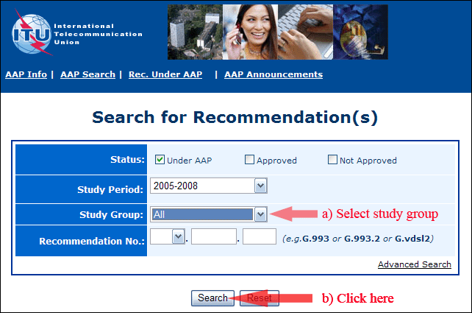
2) Select your Recommendation
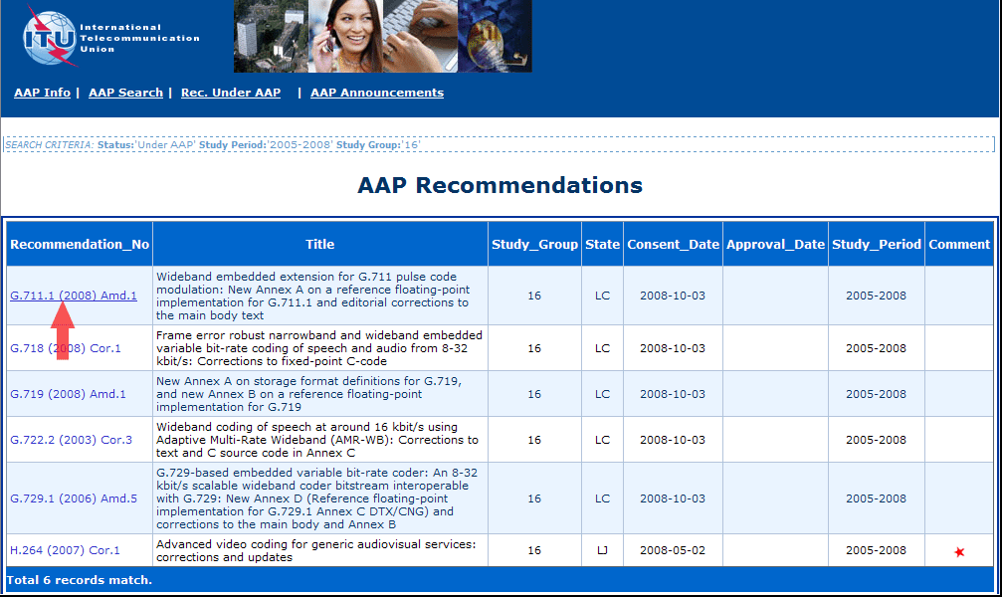
3) Click the "Submit Comment" button
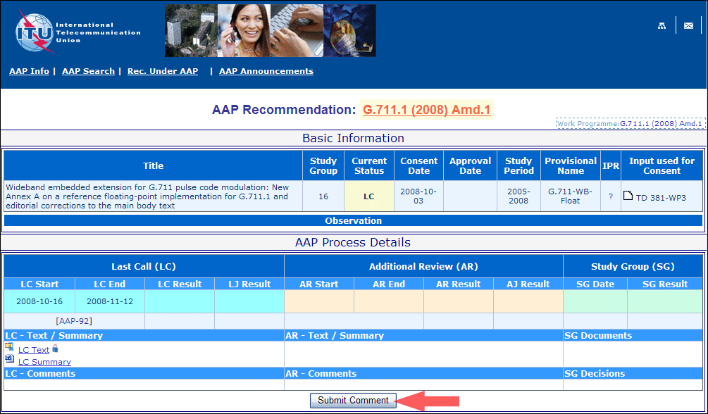
4) Complete the on-line form and click on "Submit"
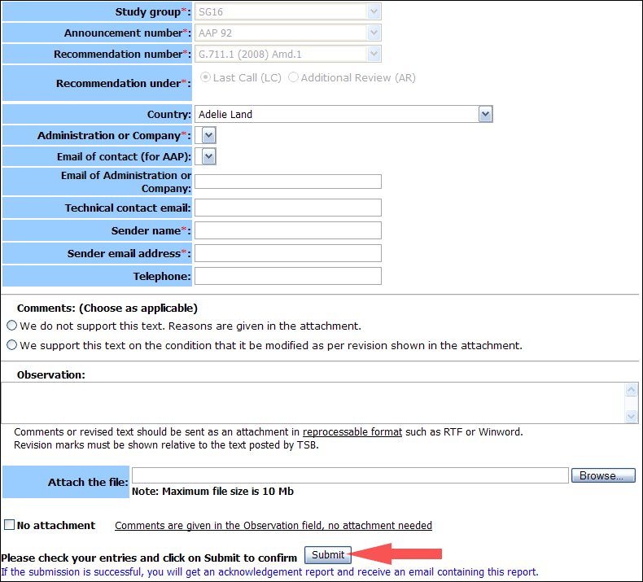
For more information, read the AAP tutorial on:
http://www.itu.int/ITU-T/aapinfo/files/AAPTutorial.pdf
Annex 3
(to TSB AAP-10)
Recommendations under LC/AR – Comment submission form
(Separate form for each Recommendation being commented upon)
ITU-T AAP comment submission form for the period 2009-2012
Study Group:
Announcement number:
Recommendation number:
Recommendation under: | Last call (LC)  Additional Review (AR)
Country:
Administration/Company:
Name of AAP Contact Person:
Email of AAP Contact Person:
Sender name:
(if different from AAP Contact Person)
Sender email address:
Telephone:
Comments:  (Choose as applicable) | We do not support this text. Reasons are given in the attachment.  We support this text on the condition that it be modified as per revision shown in the attachment.
Observations:
No attachment: Comments are given in the Observation field, no attachment needed
To be returned to: email: tsbsg....@itu.int
[or fax +41 22 730 5853]
Comments or revised text should be sent as an attachment in RTF or WinWord format.
Revision marks must be shown relative to the text posted by TSB.

