Международный союз электросвязи
Бюро стандартизации электросвязи

Женева, 16 марта 2017

Осн.:  Тел.:  Факс:  Эл. почта: | TSB AAP-8  AAP/CL  +41 22 730 5860  +41 22 730 5853  tsbdir@itu.int | – Администрациям Государств – Членов Союза;  – Членам Сектора МСЭ-Т;  – Ассоциированным членам МСЭ-Т  Копии:  – Председателям и заместителям председателей Исследовательских комиссий МСЭ-Т;  – Директору Бюро Развития Электросвязи;  – Директору Бюро Радиосвязи

Предмет: | Положение относительно Рекомендаций, рассматриваемых в соответствии с альтернативным процессом утверждения (АПУ)

Уважаемая госпожа,
уважаемый господин,

Альтернативный процесс утверждения (АПУ), определенный в Рекомендации МСЭ-Т А.8, распространяется на Рекомендации, которые не имеют политических или регламентарных последствий и которые поэтому не требуют официальных консультаций с Государствами-Членами (см. п. 246B Конвенции МСЭ).
В Приложении 1 содержится перечень текстов, статус которых изменился по сравнению с предыдущими объявлениями об АПУ БСЭ.
Если вы желаете представить замечания относительно какой-либо Рекомендации, рассматриваемой в соответствии с АПУ, рекомендуем Вам использовать онлайновую форму для представления замечаний по АПУ, которая размещена на странице этой Рекомендации в разделе веб-сайта МСЭ-Т, посвященном АПУ, по адресу: http://www.itu.int/ITU-T/aap/ (см. Приложение 2). Замечания можно представить иным способом, заполнив приведенную в Приложении 3 форму и направив ее в секретариат заинтересованной исследовательской комиссии.
Просим принять к сведению, что не рекомендуется представлять замечания, являющиеся не чем иным, как поддержкой рассматриваемого текста.
С уважением,
Чхе Суб Ли
Директор Бюро стандартизации электросвязи
Приложения: 3

Annex 1
(to TSB AAP-8)

Status codes used in the AAP announcements:
LC = Last Call
LJ = Last Call Judgment (includes comment resolution)
AR = Additional Review
AJ = Additional Review Judgment (includes comment resolution)
SG = For Study Group approval
A = Approved
AT = Approved with typographic corrections
AC = Approved after Additional Review of Comments
NA = Not approved
TAP = Moved to TAP (ITU-T A.8 / § 5.2)
ITU-T website entry page:
http://www.itu.int/ITU-T
Alternative approval process (AAP) welcome page:
http://www.itu.int/ITU-T/aapinfo
Note – A tutorial on the ITU-T AAP application is available under the AAP welcome page
ITU-T website AAP Recommendation search page:
http://www.itu.int/ITU-T/aap/
Study Group web pages and contacts:
SG 2 | http://www.itu.int/ITU-T/studygroups/com02 | tsbsg2@itu.int
SG 3 | http://www.itu.int/ITU-T/studygroups/com03 | tsbsg3@itu.int
SG 5 | http://www.itu.int/ITU-T/studygroups/com05 | tsbsg5@itu.int
SG 9 | http://www.itu.int/ITU-T/studygroups/com09 | tsbsg9@itu.int
SG 11 | http://www.itu.int/ITU-T/studygroups/com11 | tsbsg11@itu.int
SG 12 | http://www.itu.int/ITU-T/studygroups/com12 | tsbsg12@itu.int
SG 13 | http://www.itu.int/ITU-T/studygroups/com13 | tsbsg13@itu.int
SG 15 | http://www.itu.int/ITU-T/studygroups/com15 | tsbsg15@itu.int
SG 16 | http://www.itu.int/ITU-T/studygroups/com16 | tsbsg16@itu.int
SG 17 | http://www.itu.int/ITU-T/studygroups/com17 | tsbsg17@itu.int
SG 20 | http://www.itu.int/ITU-T/studygroups/com20 | tsbsg20@itu.int

Situation concerning Study Group 5 Recommendations under AAP
Rec # | Title | Last Call (LC) Period |  |  |  | Additional Review (AR) Period |  |  |  | Status
 |  | LC Start | LC End | LC  Result | LJ  Result | AR Start | AR End | AR  Result | AJ  Result
L.1331 (L.mnee) | Assessment of mobile network energy efficiency (Summary) | 2016-11-16 | 2016-12-13 | LJ | AR | 2017-03-16 | 2017-04-05 |  |  | AR
Situation concerning Study Group 12 Recommendations under AAP
Rec # | Title | Last Call (LC) Period |  |  |  | Additional Review (AR) Period |  |  |  | Status
 |  | LC Start | LC End | LC  Result | LJ  Result | AR Start | AR End | AR  Result | AJ  Result
E.802 Amd.1 | Amendment 1 New Annex A on guidelines on selection of representative samples (Summary) | 2017-02-01 | 2017-02-28 | A |  |  |  |  |  | A
E.811 (E.QMME) | Quality measurement strategy in major events (Summary) | 2017-02-01 | 2017-02-28 | A |  |  |  |  |  | A
E.847 (G.PoiCong) | Quality of service norms for time-division multiplexing interconnection between telecom networks (Summary) | 2017-02-01 | 2017-02-28 | A |  |  |  |  |  | A
P.381 | Technical requirements and test methods for the universal wired headset or headphone interface of digital mobile terminals (Summary) | 2017-02-01 | 2017-02-28 | A |  |  |  |  |  | A
P.501 | Test signals for use in telephonometry (Summary) | 2017-02-01 | 2017-02-28 | A |  |  |  |  |  | A
P.1100 | Narrowband hands-free communication in motor vehicles (Summary) | 2017-02-01 | 2017-02-28 | A |  |  |  |  |  | A
P.1110 | Wideband hands-free communication in motor vehicles (Summary) | 2017-02-01 | 2017-02-28 | A |  |  |  |  |  | A
P.1120 (P.carSFS) | Super-WideBand (SWB) and FullBand (FB) stereo hands-free communication in motor vehicles (Summary) | 2017-02-01 | 2017-02-28 | A |  |  |  |  |  | A
P.1140 (P.emergency) | Speech Quality Requirements for Emergency Calls (Summary) | 2017-02-01 | 2017-02-28 | A |  |  |  |  |  | A
P.1310 (P.SAM) | Spatial audio meetings quality evaluation (Summary) | 2017-02-01 | 2017-02-28 | A |  |  |  |  |  | A
Y.1545.1 (Y.FMIPQoS) | Framework for Monitoring the QoS of IP network services (Summary) | 2017-02-01 | 2017-02-28 | A |  |  |  |  |  | A
Situation concerning Study Group 15 Recommendations under AAP
Rec # | Title | Last Call (LC) Period |  |  |  | Additional Review (AR) Period |  |  |  | Status
 |  | LC Start | LC End | LC  Result | LJ  Result | AR Start | AR End | AR  Result | AJ  Result
G.994.1 (2012) Amd.8 | Handshake procedures for digital subscriber line transceivers: Amendment 8 (Summary) | 2016-10-01 | 2016-10-28 | LJ | AR | 2017-03-16 | 2017-04-05 |  |  | AR
G.997.2 (2015) Amd.3 | Physical layer management for G.fast transceivers: Amendment 3 (Summary) | 2016-10-01 | 2016-10-28 | LJ | AR | 2017-03-16 | 2017-04-05 |  |  | AR
G.9701 (2014) Amd.3 | Fast access to subscriber terminals (G.fast) - Physical layer specification: Amendment 3 (Summary) | 2016-10-01 | 2016-10-28 | LJ | AR | 2017-03-16 | 2017-04-05 |  |  | AR
G.9701 (2014) Cor.3 | Fast access to subscriber terminals (G.fast) - Physical layer specification: Corrigendum 3 (Summary) | 2016-10-01 | 2016-10-28 | LJ | AR | 2017-03-16 | 2017-04-05 |  |  | AR
Situation concerning Study Group 16 Recommendations under AAP
Rec # | Title | Last Call (LC) Period |  |  |  | Additional Review (AR) Period |  |  |  | Status
 |  | LC Start | LC End | LC  Result | LJ  Result | AR Start | AR End | AR  Result | AJ  Result
F.743.4 (F.VCDN-Reqs) | Functional requirements for virtual content delivery networks (Summary) | 2017-02-01 | 2017-02-28 | A |  |  |  |  |  | A
F.746.4 (F.DICN-Reqs) | Requirements for deployment of information centric networks (Summary) | 2017-02-01 | 2017-02-28 | A |  |  |  |  |  | A
F.747.9 (F.EMS-Arch) | Requirements and architecture for energy management services (Summary) | 2017-02-01 | 2017-02-28 | A |  |  |  |  |  | A
F.749.2 (F.VG-REQ) | Service requirements for vehicle gateway platforms (Summary) | 2017-02-01 | 2017-02-28 | A |  |  |  |  |  | A
F.921 (H.ACC-ANPV) | Audio-based network navigation system for persons with vision impairment (Summary) | 2017-02-01 | 2017-02-28 | AT |  |  |  |  |  | AT
H.222.0 (2014) Amd.3 Cor.1 | Information technology - Generic coding of moving pictures and associated audio information: Systems: Carriage of green metadata in MPEG-2 systems: Syntax correction for the green extension descriptor (Summary) | 2017-02-01 | 2017-02-28 | A |  |  |  |  |  | A
H.222.0 (2014) Amd.7 | Information technology - Generic coding of moving pictures and associated audio information: Systems: Virtual segmentation (Summary) | 2017-02-01 | 2017-02-28 | A |  |  |  |  |  | A
H.222.0 (2014) Amd.8 | Information technology - Generic coding of moving pictures and associated audio information: Systems: Signalling HDR and WCG video content in MPEG-2 systems (Summary) | 2017-02-01 | 2017-02-28 | A |  |  |  |  |  | A
H.222.0 (2014) Cor.2 | Information technology - Generic coding of moving pictures and associated audio information: Systems: STD buffer sizes for HEVC and miscellaneous editorial issues (Summary) | 2017-02-01 | 2017-02-28 | A |  |  |  |  |  | A
H.264 (V12) | Advanced video coding for generic audiovisual services (Summary) | 2017-03-16 | 2017-04-12 |  |  |  |  |  |  | LC
H.625 | Architecture for network-based speech-to-speech translation services (Summary) | 2017-02-01 | 2017-02-28 | A |  |  |  |  |  | A
H.627.1 (H.VSM-prot) | Protocols for mobile visual surveillance (Summary) | 2017-02-01 | 2017-02-28 | A |  |  |  |  |  | A
H.702 (2015) Cor.1 | Accessibility profiles for IPTV systems: Various corrections and clarifications (Summary) | 2017-02-01 | 2017-02-28 | A |  |  |  |  |  | A
H.763.2 (H.IPTV-MAFR.10) | Scalable vector graphics for IPTV services (Summary) | 2017-02-01 | 2017-02-28 | A |  |  |  |  |  | A
H.821 | Conformance of ITU-T H.810 personal health system: Healthcare information system interface (Summary) | 2017-03-16 | 2017-04-12 |  |  |  |  |  |  | LC
H.830.1 | Conformance of ITU-T H.810 personal health system: Services interface Part 1: Web services interoperability: Health & Fitness Service Sender (Summary) | 2017-03-16 | 2017-04-12 |  |  |  |  |  |  | LC
H.830.10 | Conformance of ITU-T H.810 personal health system: Services interface Part 10: hData Observation Upload: Health & Fitness Service Receiver (Summary) | 2017-03-16 | 2017-04-12 |  |  |  |  |  |  | LC
H.830.11 | Conformance of ITU-T H.810 personal health system: Services interface Part 11: Questionnaires: Health & Fitness Service Sender (Summary) | 2017-03-16 | 2017-04-12 |  |  |  |  |  |  | LC
H.830.12 | Conformance of ITU-T H.810 personal health system: Services interface Part 12: Questionnaires: Health & Fitness Service Receiver (Summary) | 2017-03-16 | 2017-04-12 |  |  |  |  |  |  | LC
H.830.2 | Conformance of ITU-T H.810 personal health system: Services interface Part 2: Web services interoperability: Health & Fitness Service Receiver (Summary) | 2017-03-16 | 2017-04-12 |  |  |  |  |  |  | LC
H.830.3 | Conformance of ITU-T H.810 personal health system: Services interface Part 3: SOAP/ATNA: Health & Fitness Service Sender (Summary) | 2017-03-16 | 2017-04-12 |  |  |  |  |  |  | LC
H.830.4 | Conformance of ITU-T H.810 personal health system: Services interface Part 4: SOAP/ATNA: Health & Fitness Service Receiver (Summary) | 2017-03-16 | 2017-04-12 |  |  |  |  |  |  | LC
H.830.5 | Conformance of ITU-T H.810 personal health system: Services interface Part 5: PCD-01 HL7 Messages: Health & Fitness Service Sender (Summary) | 2017-03-16 | 2017-04-12 |  |  |  |  |  |  | LC
H.830.6 | Conformance of ITU-T H.810 personal health system: Services interface Part 6: PCD-01 HL7 Messages: Health & Fitness Service Receiver (Summary) | 2017-03-16 | 2017-04-12 |  |  |  |  |  |  | LC
H.830.7 | Conformance of ITU-T H.810 personal health system: Services interface Part 7: Consent Management: Health & Fitness Service Sender (Summary) | 2017-03-16 | 2017-04-12 |  |  |  |  |  |  | LC
H.830.8 | Conformance of ITU-T H.810 personal health system: Services interface Part 8: Consent Management: Health & Fitness Service Receiver (Summary) | 2017-03-16 | 2017-04-12 |  |  |  |  |  |  | LC
H.830.9 | Conformance of ITU-T H.810 personal health system: Services interface Part 9: hData Observation Upload: Health & Fitness Service Sender (Summary) | 2017-03-16 | 2017-04-12 |  |  |  |  |  |  | LC
H.840 | Conformance of ITU-T H.810 personal health system: Personal Health Devices interface: USB host (Summary) | 2017-03-16 | 2017-04-12 |  |  |  |  |  |  | LC
H.841 | Conformance of ITU-T H.810 personal health system: Personal Health Devices interface Part 1: Optimized Exchange Protocol: Personal Health Device (Summary) | 2017-03-16 | 2017-04-12 |  |  |  |  |  |  | LC
H.842 | Conformance of ITU-T H.810 personal health system: Personal Health Devices interface Part 2: Optimized Exchange Protocol: Personal Health Gateway (Summary) | 2017-03-16 | 2017-04-12 |  |  |  |  |  |  | LC
H.843 | Conformance of ITU-T H.810 personal health system: Personal Health Devices interface Part 3: Continua Design Guidelines: Personal Health Device (Summary) | 2017-03-16 | 2017-04-12 |  |  |  |  |  |  | LC
H.844 | Conformance of ITU-T H.810 personal health system: Personal Health Devices interface Part 4: Continua Design Guidelines: Personal Health Gateway (Summary) | 2017-03-16 | 2017-04-12 |  |  |  |  |  |  | LC
H.845.1 | Conformance of ITU-T H.810 personal health system: Personal Health Devices interface Part 5A: Weighing scales (Summary) | 2017-03-16 | 2017-04-12 |  |  |  |  |  |  | LC
H.845.10 | Conformance of ITU-T H.810 personal health system: Personal Health Devices interface Part 5I: Insulin Pump (Summary) | 2017-03-16 | 2017-04-12 |  |  |  |  |  |  | LC
H.845.11 | Conformance of ITU-T H.810 personal health system: Personal Health Devices interface Part 5K: Peak expiratory flow monitor (Summary) | 2017-03-16 | 2017-04-12 |  |  |  |  |  |  | LC
H.845.12 | Conformance of ITU-T H.810 personal health system: Personal Health Devices interface Part 5L: Body composition analyser (Summary) | 2017-03-16 | 2017-04-12 |  |  |  |  |  |  | LC
H.845.13 | Conformance of ITU-T H.810 personal health system: Personal Health Devices interface Part 5M: Basic electrocardiograph (Summary) | 2017-03-16 | 2017-04-12 |  |  |  |  |  |  | LC
H.845.14 | Conformance of ITU-T H.810 personal health system: Personal Health Devices interface Part 5N: International normalized ratio (Summary) | 2017-03-16 | 2017-04-12 |  |  |  |  |  |  | LC
H.845.15 | Conformance of ITU-T H.810 personal health system: Personal Health Devices interface Part 5O: Sleep apnoea breathing therapy equipment (Summary) | 2017-03-16 | 2017-04-12 |  |  |  |  |  |  | LC
H.845.16 | Conformance of ITU-T H.810 personal health system: Personal Health Devices interface Part 5P: Continuous glucose monitor (Summary) | 2017-03-16 | 2017-04-12 |  |  |  |  |  |  | LC
H.845.2 | Conformance of ITU-T H.810 personal health system: Personal Health Devices interface Part 5B: Glucose meter (Summary) | 2017-03-16 | 2017-04-12 |  |  |  |  |  |  | LC
H.845.3 | Conformance of ITU-T H.810 personal health system: Personal Health Devices interface Part 5C: Pulse oximeter (Summary) | 2017-03-16 | 2017-04-12 |  |  |  |  |  |  | LC
H.845.4 | Conformance of ITU-T H.810 personal health system: Personal Health Devices interface Part 5D: Blood pressure monitor (Summary) | 2017-03-16 | 2017-04-12 |  |  |  |  |  |  | LC
H.845.5 | Conformance of ITU-T H.810 personal health system: Personal Health Devices interface Part 5E: Thermometer (Summary) | 2017-03-16 | 2017-04-12 |  |  |  |  |  |  | LC
H.845.6 | Conformance of ITU-T H.810 personal health system: Personal Health Devices interface Part 5F: Cardiovascular fitness and activity monitor (Summary) | 2017-03-16 | 2017-04-12 |  |  |  |  |  |  | LC
H.845.7 | Conformance of ITU-T H.810 personal health system: Personal Health Devices interface Part 5G: Strength fitness equipment (Summary) | 2017-03-16 | 2017-04-12 |  |  |  |  |  |  | LC
H.845.8 | Conformance of ITU-T H.810 personal health system: Personal Health Devices interface Part 5H: Independent living activity hub (Summary) | 2017-03-16 | 2017-04-12 |  |  |  |  |  |  | LC
H.845.9 | Conformance of ITU-T H.810 personal health system: Personal Health Devices interface Part 5I: Adherence monitor (Summary) | 2017-03-16 | 2017-04-12 |  |  |  |  |  |  | LC
H.847 | Conformance of ITU-T H.810 personal health system: Personal Health Devices interface Part 7: Continua Design Guidelines for Bluetooth Low Energy: Personal Health Devices (Summary) | 2017-03-16 | 2017-04-12 |  |  |  |  |  |  | LC
H.848 | Conformance of ITU-T H.810 personal health system: Personal Health Devices interface Part 8: Continua Design Guidelines for Bluetooth Low Energy: Personal Health Gateway (Summary) | 2017-03-16 | 2017-04-12 |  |  |  |  |  |  | LC
T.621 (F.MAFF-Reqs) | File structure for interactive mobile comic and animation content (Summary) | 2017-02-01 | 2017-02-28 | A |  |  |  |  |  | A

Annex 2
(to TSB AAP-8)
Using the on-line comment submission form
Comment submission
1) Go to AAP search Web page at http://www.itu.int/ITU-T/aap/
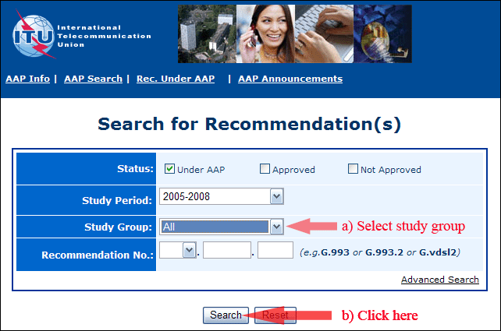
2) Select your Recommendation
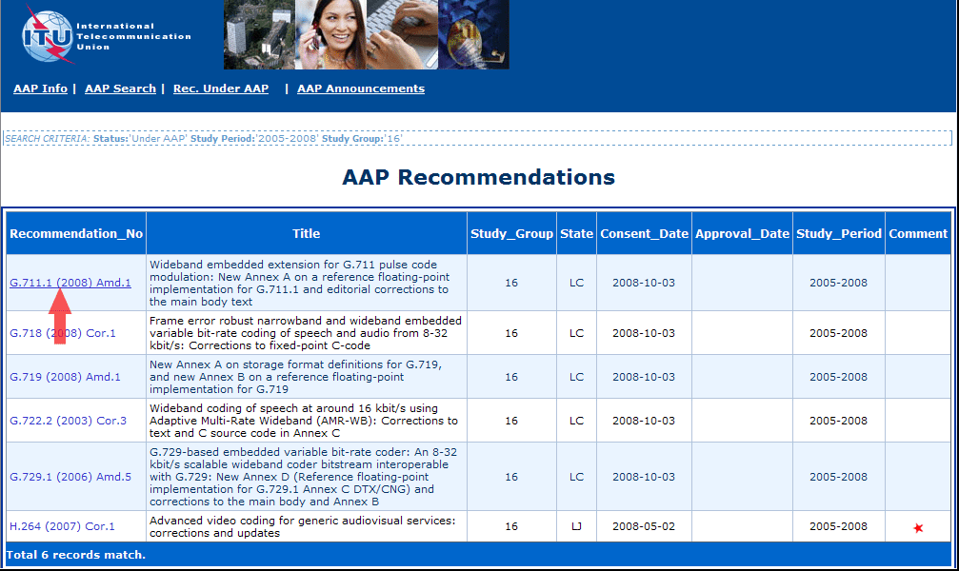
3) Click the "Submit Comment" button
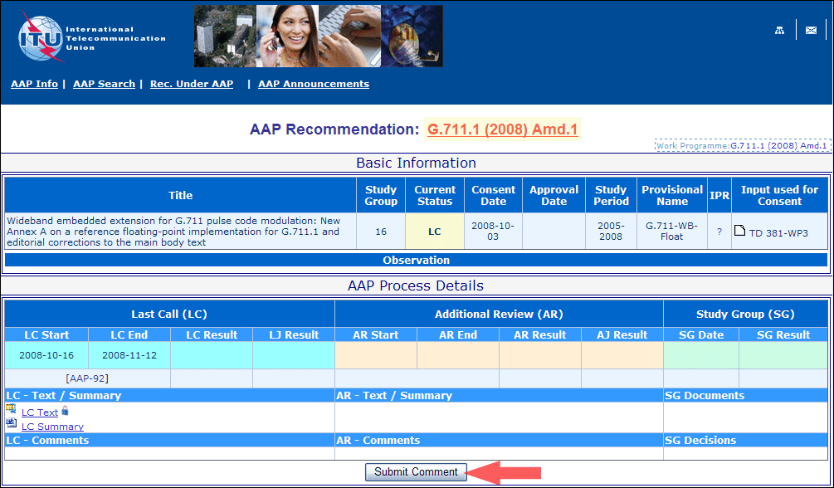
4) Complete the on-line form and click on "Submit"
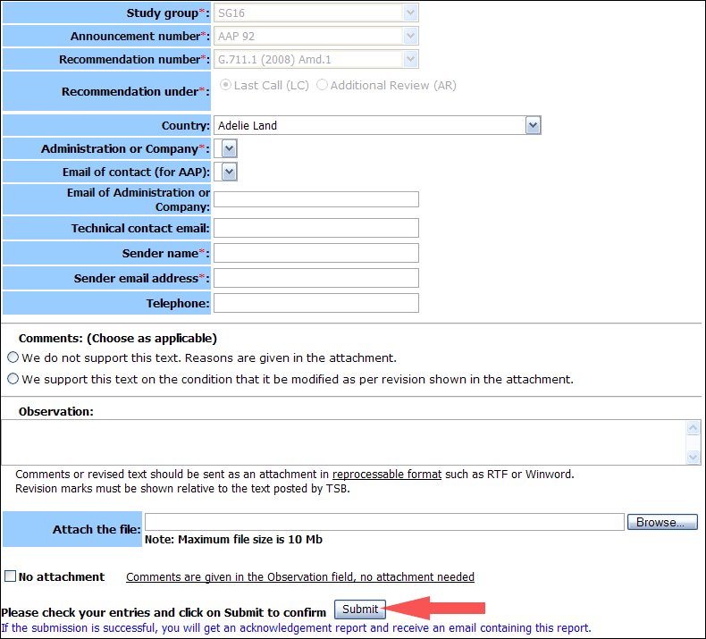
For more information, read the AAP tutorial on:
http://www.itu.int/ITU-T/aapinfo/files/AAPTutorial.pdf
Annex 3
(to TSB AAP-8)
Recommendations under LC/AR – Comment submission form
(Separate form for each Recommendation being commented upon)
ITU-T AAP comment submission form for the period 2009-2012
Study Group:
Announcement number:
Recommendation number:
Recommendation under: | Last call (LC)  Additional Review (AR)
Country:
Administration/Company:
Name of AAP Contact Person:
Email of AAP Contact Person:
Sender name:
(if different from AAP Contact Person)
Sender email address:
Telephone:
Comments:  (Choose as applicable) | We do not support this text. Reasons are given in the attachment.  We support this text on the condition that it be modified as per revision shown in the attachment.
Observations:
No attachment: Comments are given in the Observation field, no attachment needed
To be returned to: email: tsbsg....@itu.int
[or fax +41 22 730 5853]
Comments or revised text should be sent as an attachment in RTF or WinWord format.
Revision marks must be shown relative to the text posted by TSB.

