Международный союз электросвязи
Бюро стандартизации электросвязи

Женева, 1 ноября 2016

Осн.:  Тел.:  Факс:  Эл. почта: | TSB AAP-91  AAP/CL  +41 22 730 5860  +41 22 730 5853  tsbdir@itu.int | – Администрациям Государств – Членов Союза;  – Членам Сектора МСЭ-Т;  – Ассоциированным членам МСЭ-Т  Копии:  – Председателям и заместителям председателей Исследовательских комиссий МСЭ-Т;  – Директору Бюро Развития Электросвязи;  – Директору Бюро Радиосвязи

Предмет: | Положение относительно Рекомендаций, рассматриваемых в соответствии с альтернативным процессом утверждения (АПУ)

Уважаемая госпожа,
уважаемый господин,

Альтернативный процесс утверждения (АПУ), определенный в Рекомендации МСЭ-Т А.8, распространяется на Рекомендации, которые не имеют политических или регламентарных последствий и которые поэтому не требуют официальных консультаций с Государствами-Членами (см. п. 246B Конвенции МСЭ).
В Приложении 1 содержится перечень текстов, статус которых изменился по сравнению с предыдущими объявлениями об АПУ БСЭ.
Если вы желаете представить замечания относительно какой-либо Рекомендации, рассматриваемой в соответствии с АПУ, рекомендуем Вам использовать онлайновую форму для представления замечаний по АПУ, которая размещена на странице этой Рекомендации в разделе веб-сайта МСЭ-Т, посвященном АПУ, по адресу: http://www.itu.int/ITU-T/aap/ (см. Приложение 2). Замечания можно представить иным способом, заполнив приведенную в Приложении 3 форму и направив ее в секретариат заинтересованной исследовательской комиссии.
Просим принять к сведению, что не рекомендуется представлять замечания, являющиеся не чем иным, как поддержкой рассматриваемого текста.
С уважением,
Чхе Суб Ли
Директор Бюро стандартизации электросвязи
Приложения: 3

Annex 1
(to TSB AAP-91)

Status codes used in the AAP announcements:
LC = Last Call
LJ = Last Call Judgment (includes comment resolution)
AR = Additional Review
AJ = Additional Review Judgment (includes comment resolution)
SG = For Study Group approval
A = Approved
AT = Approved with typographic corrections
AC = Approved after Additional Review of Comments
NA = Not approved
TAP = Moved to TAP (ITU-T A.8 / § 5.2)
ITU-T website entry page:
http://www.itu.int/ITU-T
Alternative approval process (AAP) welcome page:
http://www.itu.int/ITU-T/aapinfo
Note – A tutorial on the ITU-T AAP application is available under the AAP welcome page
ITU-T website AAP Recommendation search page:
http://www.itu.int/ITU-T/aap/
Study Group web pages and contacts:
SG 2 | http://www.itu.int/ITU-T/studygroups/com02 | tsbsg2@itu.int
SG 3 | http://www.itu.int/ITU-T/studygroups/com03 | tsbsg3@itu.int
SG 5 | http://www.itu.int/ITU-T/studygroups/com05 | tsbsg5@itu.int
SG 9 | http://www.itu.int/ITU-T/studygroups/com09 | tsbsg9@itu.int
SG 11 | http://www.itu.int/ITU-T/studygroups/com11 | tsbsg11@itu.int
SG 12 | http://www.itu.int/ITU-T/studygroups/com12 | tsbsg12@itu.int
SG 13 | http://www.itu.int/ITU-T/studygroups/com13 | tsbsg13@itu.int
SG 15 | http://www.itu.int/ITU-T/studygroups/com15 | tsbsg15@itu.int
SG 16 | http://www.itu.int/ITU-T/studygroups/com16 | tsbsg16@itu.int
SG 17 | http://www.itu.int/ITU-T/studygroups/com17 | tsbsg17@itu.int
SG 20 | http://www.itu.int/ITU-T/studygroups/com20 | tsbsg20@itu.int

Situation concerning Study Group 2 Recommendations under AAP
Rec # | Title | Last Call (LC) Period |  |  |  | Additional Review (AR) Period |  |  |  | Status
 |  | LC Start | LC End | LC  Result | LJ  Result | AR Start | AR End | AR  Result | AJ  Result
M.3371 (M.rcsm) | Requirements for Service Management in Cloud-aware Telecommunication Management System (Summary) | 2016-10-01 | 2016-10-28 | LJ |  |  |  |  |  | LJ
Situation concerning Study Group 12 Recommendations under AAP
Rec # | Title | Last Call (LC) Period |  |  |  | Additional Review (AR) Period |  |  |  | Status
 |  | LC Start | LC End | LC  Result | LJ  Result | AR Start | AR End | AR  Result | AJ  Result
G.1071 (G.OM_HEVC) | Opinion model for network planning of video and audio streaming applications (Summary) | 2016-11-01 | 2016-11-28 |  |  |  |  |  |  | LC
P.1203 (P.NATS) | Parametric bitstream-based quality assessment of progressive download and adaptive audiovisual streaming services over reliable transport (Summary) | 2016-11-01 | 2016-11-28 |  |  |  |  |  |  | LC
P.1203.1 (P.NATS) | Parametric bitstream-based quality assessment of progressive download and adaptive audiovisual streaming services over reliable transport - video quality estimation module (Summary) | 2016-11-01 | 2016-11-28 |  |  |  |  |  |  | LC
P.1203.2 (P.NATS) | Parametric bitstream-based quality assessment of progressive download and adaptive audiovisual streaming services over reliable transport - audio quality estimation module (Summary) | 2016-11-01 | 2016-11-28 |  |  |  |  |  |  | LC
P.1203.3 (P.NATS) | Parametric bitstream-based quality assessment of progressive download and adaptive audiovisual streaming services over reliable transport - quality integration module (Summary) | 2016-11-01 | 2016-11-28 |  |  |  |  |  |  | LC
Situation concerning Study Group 15 Recommendations under AAP
Rec # | Title | Last Call (LC) Period |  |  |  | Additional Review (AR) Period |  |  |  | Status
 |  | LC Start | LC End | LC  Result | LJ  Result | AR Start | AR End | AR  Result | AJ  Result
G.994.1 (2012) Amd.8 | Handshake procedures for digital subscriber line transceivers: Amendment 8 (Summary) | 2016-10-01 | 2016-10-28 | LJ |  |  |  |  |  | LJ
G.994.1 (2012) Cor.1 | Handshake procedures for digital subscriber line transceivers: Corrigendum 1 (Summary) | 2016-10-01 | 2016-10-28 | A |  |  |  |  |  | A
G.997.2 (2015) Amd.3 | Physical layer management for G.fast transceivers: Amendment 3 (Summary) | 2016-10-01 | 2016-10-28 | LJ |  |  |  |  |  | LJ
G.997.2 (2015) Cor.2 | Physical layer management for G.fast transceivers: Corrigendum 2 (Summary) | 2016-10-01 | 2016-10-28 | LJ |  |  |  |  |  | LJ
G.9701 (2014) Amd.3 | Fast access to subscriber terminals (G.fast) - Physical layer specification: Amendment 3 (Summary) | 2016-10-01 | 2016-10-28 | LJ |  |  |  |  |  | LJ
G.9701 (2014) Cor.3 | Fast access to subscriber terminals (G.fast) - Physical layer specification: Corrigendum 3 (Summary) | 2016-10-01 | 2016-10-28 | LJ |  |  |  |  |  | LJ
Situation concerning Study Group 16 Recommendations under AAP
Rec # | Title | Last Call (LC) Period |  |  |  | Additional Review (AR) Period |  |  |  | Status
 |  | LC Start | LC End | LC  Result | LJ  Result | AR Start | AR End | AR  Result | AJ  Result
H.265 (V4) | High efficiency video coding (Summary) | 2016-10-01 | 2016-10-28 | A |  |  |  |  |  | A
H.265.1 (V2) (H.265.1 (V2)) | Conformance specification for ITU-T H.265 high efficiency video coding (Summary) | 2016-10-01 | 2016-10-28 | A |  |  |  |  |  | A
Situation concerning Study Group 17 Recommendations under AAP
Rec # | Title | Last Call (LC) Period |  |  |  | Additional Review (AR) Period |  |  |  | Status
 |  | LC Start | LC End | LC  Result | LJ  Result | AR Start | AR End | AR  Result | AJ  Result
Z.100 Annex F1 (Z.100 (2016) Annex F1) | Specification and Description Language - Overview of SDL-2010 - SDL formal definition: General overview (Summary) | 2016-10-01 | 2016-10-28 | A |  |  |  |  |  | A
Z.100 Annex F2 (Z.100 (2016) Annex F2) | Specification and Description Language - Overview of SDL-2010 - SDL formal definition: Static semantics (Summary) | 2016-10-01 | 2016-10-28 | AT |  |  |  |  |  | AT
Z.100 Annex F3 (Z.100 (2016) Annex F3) | Specification and Description Language - Overview of SDL-2010 - SDL formal definition: Dynamic semantics (Summary) | 2016-10-01 | 2016-10-28 | A |  |  |  |  |  | A

Annex 2
(to TSB AAP-91)
Using the on-line comment submission form
Comment submission
1) Go to AAP search Web page at http://www.itu.int/ITU-T/aap/
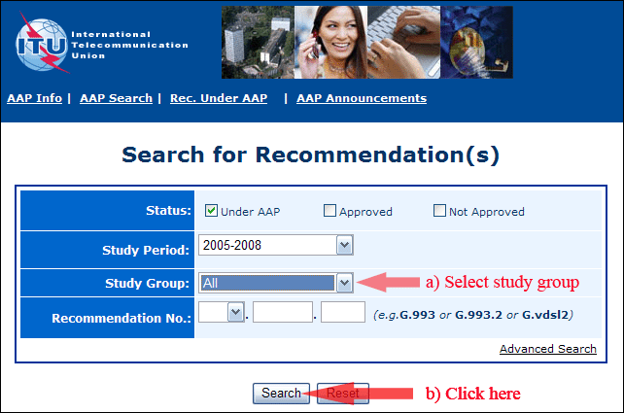
2) Select your Recommendation
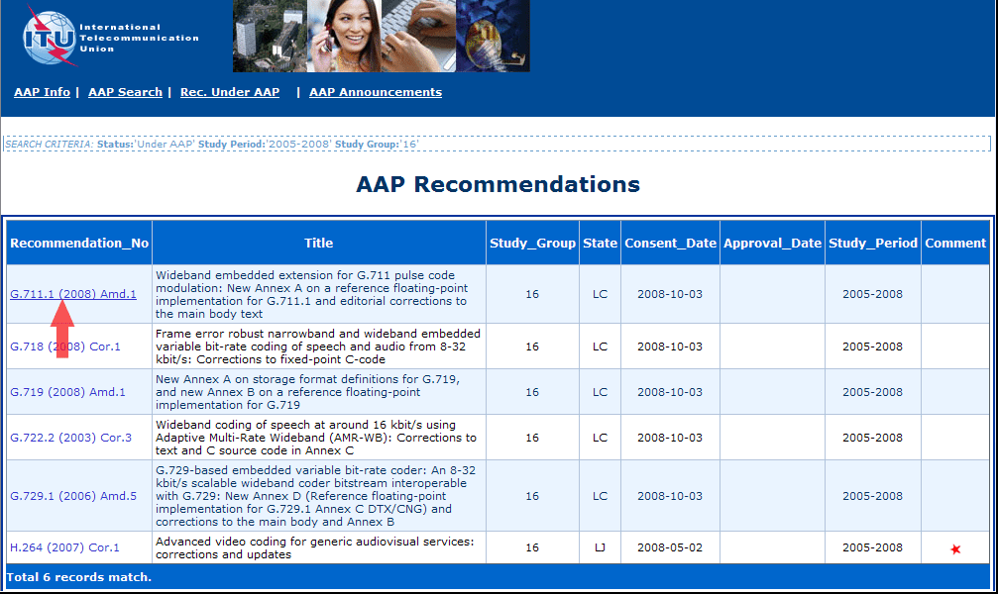
3) Click the "Submit Comment" button
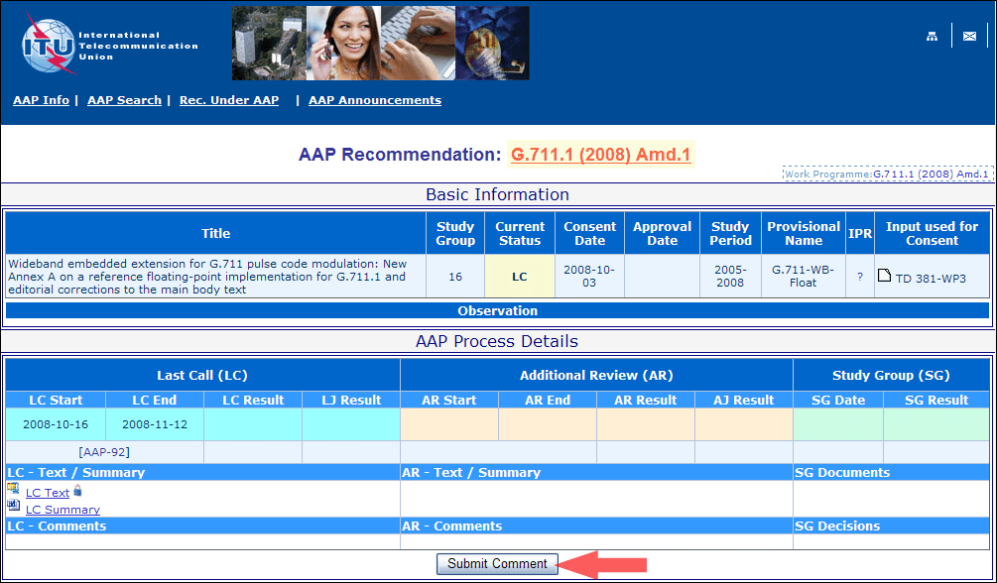
4) Complete the on-line form and click on "Submit"
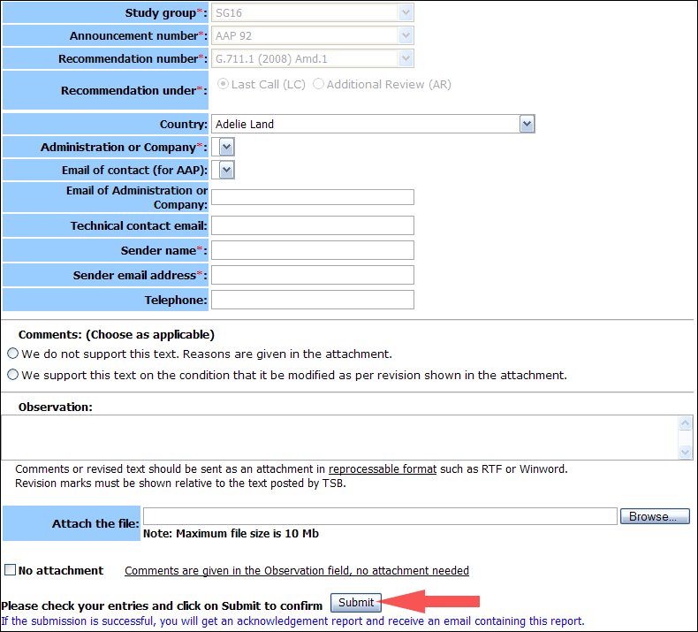
For more information, read the AAP tutorial on:
http://www.itu.int/ITU-T/aapinfo/files/AAPTutorial.pdf
Annex 3
(to TSB AAP-91)
Recommendations under LC/AR – Comment submission form
(Separate form for each Recommendation being commented upon)
ITU-T AAP comment submission form for the period 2009-2012
Study Group:
Announcement number:
Recommendation number:
Recommendation under: | Last call (LC)  Additional Review (AR)
Country:
Administration/Company:
Name of AAP Contact Person:
Email of AAP Contact Person:
Sender name:
(if different from AAP Contact Person)
Sender email address:
Telephone:
Comments:  (Choose as applicable) | We do not support this text. Reasons are given in the attachment.  We support this text on the condition that it be modified as per revision shown in the attachment.
Observations:
No attachment: Comments are given in the Observation field, no attachment needed
To be returned to: email: tsbsg....@itu.int
[or fax +41 22 730 5853]
Comments or revised text should be sent as an attachment in RTF or WinWord format.
Revision marks must be shown relative to the text posted by TSB.

