Union Internationale des Telecommunications
Bureau de la normalisation des télécommunications

Genève, le 16 octobre 2016

Réf:  Tél:  Fax:  E-mail: | TSB AAP-90  AAP/CL  +41 22 730 5860  +41 22 730 5853  tsbdir@itu.int | – Aux administrations des Etats Membres de l'Union;  – Aux Membres du Secteur UIT-T;  – Aux Associés de l'UIT-T  Copie:  – Aux Présidents et Vice-Présidents des Commissions d'études de l'UIT-T;  – Au Directeur du Bureau de développement des télécommunications;  – Au Directeur du Bureau des radiocommunications

Objet: | Etat des Recommandations auxquelles s'applique la variante de la procédure d'approbation (AAP)

Madame, Monsieur,

La variante de la procédure d'approbation (AAP), définie dans la Recommandation UIT-T A.8, s'applique aux Recommandations qui n'ont pas d'incidence politique ou réglementaire et ne nécessitent donc pas une consultation formelle des Etats Membres (voir le numéro 246B de la Convention de l'UIT).
L'Annexe 1 énumère les textes dont le statut a changé par rapport aux annonces TSB AAP antérieures.
Si vous souhaitez soumettre des observations sur une Recommandation ayant fait l'objet de la procédure AAP, vous êtes encouragés à utiliser le formulaire en ligne de soumission des observations AAP, disponible dans l'espace AAP du site web de l'UIT-T à l'adresse http://www.itu.int/ITU-T/aap/, à la page de la Recommandation concernée (voir l'Annexe 2). Vous pouvez aussi soumettre vos observations en remplissant le formulaire figurant à l'Annexe 3 et en l'envoyant au secrétariat de la Commission d'études concernée.
Veuillez noter que les observations ayant simplement pour objet d'appuyer l'adoption du texte en question ne sont pas encouragées.
Veuillez agréer, Madame, Monsieur, l'assurance de ma considération distinguée.
Chaesub Lee
Directeur du Bureau de la normalisation des télécommunications

Annexes: 3

Annex 1
(to TSB AAP-90)

Status codes used in the AAP announcements:
LC = Last Call
LJ = Last Call Judgment (includes comment resolution)
AR = Additional Review
AJ = Additional Review Judgment (includes comment resolution)
SG = For Study Group approval
A = Approved
AT = Approved with typographic corrections
AC = Approved after Additional Review of Comments
NA = Not approved
TAP = Moved to TAP (ITU-T A.8 / § 5.2)
ITU-T website entry page:
http://www.itu.int/ITU-T
Alternative approval process (AAP) welcome page:
http://www.itu.int/ITU-T/aapinfo
Note – A tutorial on the ITU-T AAP application is available under the AAP welcome page
ITU-T website AAP Recommendation search page:
http://www.itu.int/ITU-T/aap/
Study Group web pages and contacts:
SG 2 | http://www.itu.int/ITU-T/studygroups/com02 | tsbsg2@itu.int
SG 3 | http://www.itu.int/ITU-T/studygroups/com03 | tsbsg3@itu.int
SG 5 | http://www.itu.int/ITU-T/studygroups/com05 | tsbsg5@itu.int
SG 9 | http://www.itu.int/ITU-T/studygroups/com09 | tsbsg9@itu.int
SG 11 | http://www.itu.int/ITU-T/studygroups/com11 | tsbsg11@itu.int
SG 12 | http://www.itu.int/ITU-T/studygroups/com12 | tsbsg12@itu.int
SG 13 | http://www.itu.int/ITU-T/studygroups/com13 | tsbsg13@itu.int
SG 15 | http://www.itu.int/ITU-T/studygroups/com15 | tsbsg15@itu.int
SG 16 | http://www.itu.int/ITU-T/studygroups/com16 | tsbsg16@itu.int
SG 17 | http://www.itu.int/ITU-T/studygroups/com17 | tsbsg17@itu.int
SG 20 | http://www.itu.int/ITU-T/studygroups/com20 | tsbsg20@itu.int

Situation concerning Study Group 5 Recommendations under AAP
Rec # | Title | Last Call (LC) Period |  |  |  | Additional Review (AR) Period |  |  |  | Status
 |  | LC Start | LC End | LC  Result | LJ  Result | AR Start | AR End | AR  Result | AJ  Result
L.1002 (L.UPA portable) | External universal power adapter solutions for portable information and communication technology devices (Summary) | 2016-04-16 | 2016-05-13 | LJ | AR | 2016-08-16 | 2016-09-05 | SG |  | AC
L.1350 (L.RBS assessment) | Energy efficiency metric of base station site (Summary) | 2016-06-01 | 2016-06-28 | LJ | AR | 2016-09-16 | 2016-10-06 | A |  | A
L.1603 (L.KPIs-SSC-SDGs (L.KPI for SSC to reach ) | Key performance indicators for smart sustainable cities to assess the achievement of sustainable development goals (Summary) | 2016-08-01 | 2016-08-28 | LJ | AR | 2016-09-16 | 2016-10-06 | A |  | A
Situation concerning Study Group 9 Recommendations under AAP
Rec # | Title | Last Call (LC) Period |  |  |  | Additional Review (AR) Period |  |  |  | Status
 |  | LC Start | LC End | LC  Result | LJ  Result | AR Start | AR End | AR  Result | AJ  Result
J.94 | Service information for digital broadcasting in cable television systems (Summary) | 2016-09-16 | 2016-10-13 | A |  |  |  |  |  | A
J.196.2 (HiNoC2-phy) | Physical layer specification of second generation HiNoC (Summary) | 2016-09-16 | 2016-10-13 | A |  |  |  |  |  | A
J.196.3 (J.HiNoC2-mac) | Media Access Control (MAC) layer specification of second generation HiNoC (Summary) | 2016-09-16 | 2016-10-13 | A |  |  |  |  |  | A
J.223.2 (J.C-DOCSIS-spec) | Cabinet DOCSIS (C-DOCSIS) System Specification (Summary) | 2016-09-16 | 2016-10-13 | A |  |  |  |  |  | A
J.230 | Requirements for platform functionalities on the integration of cable STB and companion devices including mobile second screen devices (Summary) | 2016-09-16 | 2016-10-13 | A |  |  |  |  |  | A
J.297 (J.4kstb) | Requirements and functional specification of cable set top box for 4K ultra high definition television (Summary) | 2016-09-16 | 2016-10-13 | AR |  | 2016-10-16 | 2016-11-05 |  |  | AR
J.302 (J.arstv-spec) | System Specifications of Augmented Reality Smart Television Service (Summary) | 2016-09-16 | 2016-10-13 | A |  |  |  |  |  | A
J.1006 (J.ipvdrm) | Specification of IP-VOD DRM for cable television multiscreen system in Multi-DRM environment (Summary) | 2016-09-16 | 2016-10-13 | A |  |  |  |  |  | A
J.1104 (J.vodoc-cont) | Control specification for IP-based switched digital video using Data Over Cable Service Interface Specifications (Summary) | 2016-09-16 | 2016-10-13 | A |  |  |  |  |  | A
J.1105 (J.chswt-req) | Requirement of channel switching service over Hybrid Fiber and Coaxial based network (Summary) | 2016-09-16 | 2016-10-13 | A |  |  |  |  |  | A
Situation concerning Study Group 15 Recommendations under AAP
Rec # | Title | Last Call (LC) Period |  |  |  | Additional Review (AR) Period |  |  |  | Status
 |  | LC Start | LC End | LC  Result | LJ  Result | AR Start | AR End | AR  Result | AJ  Result
G.652 | Characteristics of a single-mode optical fibre cable (Summary) | 2016-10-16 | 2016-11-12 |  |  |  |  |  |  | LC
G.654 | Characteristics of a cut-off shifted single-mode optical fibre and cable (Summary) | 2016-10-16 | 2016-11-12 |  |  |  |  |  |  | LC
G.657 | Characteristics of a bending-loss insensitive single-mode optical fibre and cable (Summary) | 2016-10-16 | 2016-11-12 |  |  |  |  |  |  | LC
G.697 | Optical monitoring for dense wavelength division multiplexing systems (Summary) | 2016-10-16 | 2016-11-12 |  |  |  |  |  |  | LC
G.709.1/Y.1331.1 | Flexible OTN short-reach interface (Summary) | 2016-10-16 | 2016-11-12 |  |  |  |  |  |  | LC
G.709/Y.1331 (2016) Amd.1 | Interfaces for the Optical Transport Network (OTN): Amendment 1 (Summary) | 2016-10-16 | 2016-11-12 |  |  |  |  |  |  | LC
G.798 (2012) Amd.3 | Characteristics of optical transport network hierarchy equipment functional blocks: Amendment 3 (Summary) | 2016-10-16 | 2016-11-12 |  |  |  |  |  |  | LC
G.808 | Terminology for protection and restoration (Summary) | 2016-10-16 | 2016-11-12 |  |  |  |  |  |  | LC
G.813 (2003) Cor.2 | Timing characteristics of SDH equipment slave clocks (SEC)- Corrigendum 2 (Summary) | 2016-10-16 | 2016-11-12 |  |  |  |  |  |  | LC
G.870/Y.1352 | Terms and definitions for optical transport networks (Summary) | 2016-10-16 | 2016-11-12 |  |  |  |  |  |  | LC
G.872 | Architecture of optical transport networks (Summary) | 2016-10-16 | 2016-11-12 |  |  |  |  |  |  | LC
G.874.1 | Optical transport network (OTN): Protocol-neutral management information model for the network element view (Summary) | 2016-10-16 | 2016-11-12 |  |  |  |  |  |  | LC
G.971 | General features of optical fibre submarine cable systems (Summary) | 2016-10-16 | 2016-11-12 |  |  |  |  |  |  | LC
G.972 | Definition of terms relevant to optical fibre submarine cable systems (Summary) | 2016-10-16 | 2016-11-12 |  |  |  |  |  |  | LC
G.973 | Characteristics of repeaterless optical fibre submarine cable systems (Summary) | 2016-10-16 | 2016-11-12 |  |  |  |  |  |  | LC
G.979 | Characteristics of monitoring systems for optical submarine cable systems (Summary) | 2016-10-16 | 2016-11-12 |  |  |  |  |  |  | LC
G.989.3 (2015) Amd.1 (G.ngpon2.3) | Draft Amendment 1 to Recommendation ITU-T G.989.3 (2015) (Summary) | 2016-10-16 | 2016-11-12 |  |  |  |  |  |  | LC
G.993.2 (2015) Cor.1 | Very high speed digital subscriber line transceivers 2 (VDSL2): Corrigendum 1 (Summary) | 2016-10-16 | 2016-11-12 |  |  |  |  |  |  | LC
G.993.5 (2015) Amd.1 | Self-FEXT cancellation (vectoring) for use with VDSL2 transceivers: Amendment 1 (Summary) | 2016-10-16 | 2016-11-12 |  |  |  |  |  |  | LC
G.993.5 (2015) Cor.1 | Self-FEXT cancellation (vectoring) for use with VDSL2 transceivers: Corrigendum 1 (Summary) | 2016-10-16 | 2016-11-12 |  |  |  |  |  |  | LC
G.997.1 (2012) Cor.1 | Physical layer management for digital subscriber line transceivers - Corrigendum 1 (Summary) | 2016-10-16 | 2016-11-12 |  |  |  |  |  |  | LC
G.7701 (G.cca) | Common Control Aspects (Summary) | 2016-10-16 | 2016-11-12 |  |  |  |  |  |  | LC
G.7710/Y.1701 (2012) Amd.1 | Common equipment management function requirements: Amendment 1 (Summary) | 2016-10-16 | 2016-11-12 |  |  |  |  |  |  | LC
G.7711/Y.1702 | Generic protocol-neutral information model for transport resources (Summary) | 2016-10-16 | 2016-11-12 |  |  |  |  |  |  | LC
G.8011/Y.1307 | Ethernet service characteristics (Summary) | 2016-10-16 | 2016-11-12 |  |  |  |  |  |  | LC
G.8012/Y.1308 (2004) Amd.2 | Ethernet UNI and Ethernet over Transport NNI: Amendment 2 (Summary) | 2016-10-16 | 2016-11-12 |  |  |  |  |  |  | LC
G.8021/Y.1341 | Characteristics of Ethernet transport network equipment functional blocks (Summary) | 2016-10-16 | 2016-11-12 |  |  |  |  |  |  | LC
G.8032/Y.1344 (2015) Amd.1 | Ethernet ring protection switching: Amendment 1 (Summary) | 2016-10-16 | 2016-11-12 |  |  |  |  |  |  | LC
G.8052/Y.1346 | Protocol-neutral management information model for the Ethernet Transport capable network element (Summary) | 2016-10-16 | 2016-11-12 |  |  |  |  |  |  | LC
G.8101/Y.1355 | Terms and definitions for MPLS transport profile (Summary) | 2016-10-16 | 2016-11-12 |  |  |  |  |  |  | LC
G.8113.1/Y.1372.1 (2016) Cor.1 | Operations, administration and maintenance mechanisms for MPLS-TP in packet transport network - Corrigendum 1 (Summary) | 2016-10-16 | 2016-11-12 |  |  |  |  |  |  | LC
G.8121.1/Y.1381.1 (2016) Cor.1 | Characteristics of MPLS-TP equipment functional blocks supporting ITU-T G.8113.1/Y.1372.1 OAM mechanisms - Corrigendum 1 (Summary) | 2016-10-16 | 2016-11-12 |  |  |  |  |  |  | LC
G.8121.2/Y.1381.2 (2016) Cor.1 | Characteristics of MPLS-TP equipment functional blocks supporting ITU-T G.8113.2/Y.1372.2 OAM mechanisms - Corrigendum 1 (Summary) | 2016-10-16 | 2016-11-12 |  |  |  |  |  |  | LC
G.8121/Y.1381 -Cor.1 | Characteristics of MPLS-TP equipment functional blocks. Corrigendum 1 (Summary) | 2016-10-16 | 2016-11-12 |  |  |  |  |  |  | LC
G.8131/Y.1382 (2014) Amd.2 | Linear protection switching for MPLS transport profile (MPLS-TP): Amendment 2 (Summary) | 2016-10-16 | 2016-11-12 |  |  |  |  |  |  | LC
G.8152/Y.1375 | Protocol-neutral management information model for the MPLS-TP network element (Summary) | 2016-10-16 | 2016-11-12 |  |  |  |  |  |  | LC
G.8262/Y.1362 (2015) Cor.1 | Timing characteristics of a synchronous Ethernet equipment slave clock (EEC)- Corrigendum 1 (Summary) | 2016-10-16 | 2016-11-12 |  |  |  |  |  |  | LC
G.8266/Y.1376 | Timing characteristics of telecom grandmaster clocks for frequency synchronization (Summary) | 2016-10-16 | 2016-11-12 |  |  |  |  |  |  | LC
G.8272.1/Y.1367.1 | Timing characteristics of enhanced primary reference time clocks (Summary) | 2016-10-16 | 2016-11-12 |  |  |  |  |  |  | LC
G.8273.2/Y.1368.2 | Timing characteristics of telecom boundary clocks and telecom time slave clocks (Summary) | 2016-10-16 | 2016-11-12 |  |  |  |  |  |  | LC
G.9905 (2013) Amd.1 | Centralized metric-based source routing - Amendment 1 (Summary) | 2016-10-16 | 2016-11-12 |  |  |  |  |  |  | LC
G.9960 (2015) Cor.3 | Unified high-speed wireline-based home networking transceivers - System architecture and physical layer specification: Corrigendum 3 (Summary) | 2016-10-16 | 2016-11-12 |  |  |  |  |  |  | LC
G.9961 (2015) Cor.3 | Unified high-speed wireline-based home networking transceivers - Data link layer specification: Corrigendum 3 (Summary) | 2016-10-16 | 2016-11-12 |  |  |  |  |  |  | LC
G.9962 (2014) Cor.1 | Unified high-speed wireline-based home networking transceivers - Management specification: Corrigendum 1 (Summary) | 2016-10-16 | 2016-11-12 |  |  |  |  |  |  | LC
L.155 (ex.L83) | Low-impact trenching technique for FTTx networks (Summary) | 2016-10-16 | 2016-11-12 |  |  |  |  |  |  | LC
L.162 (L.coi) | Microduct technology and its applications (Summary) | 2016-10-16 | 2016-11-12 |  |  |  |  |  |  | LC
Situation concerning Study Group 16 Recommendations under AAP
Rec # | Title | Last Call (LC) Period |  |  |  | Additional Review (AR) Period |  |  |  | Status
 |  | LC Start | LC End | LC  Result | LJ  Result | AR Start | AR End | AR  Result | AJ  Result
H.264 (V11) | Advanced video coding for generic audiovisual services (Summary) | 2016-09-16 | 2016-10-13 | A |  |  |  |  |  | A
H.273 (H.STI) | Coding-independent code points for video signal type identification (Summary) | 2016-10-16 | 2016-11-12 |  |  |  |  |  |  | LC
Situation concerning Study Group 17 Recommendations under AAP
Rec # | Title | Last Call (LC) Period |  |  |  | Additional Review (AR) Period |  |  |  | Status
 |  | LC Start | LC End | LC  Result | LJ  Result | AR Start | AR End | AR  Result | AJ  Result
X.500 (X.500 (eighth edition)) | Information technology - Open Systems Interconnection - The Directory: Overview of concepts, models and services (Summary) | 2016-09-16 | 2016-10-13 | A |  |  |  |  |  | A
X.501 (X.501 (eighth edition)) | Information technology - Open Systems Interconnection - The Directory: Models (Summary) | 2016-09-16 | 2016-10-13 | A |  |  |  |  |  | A
X.509 (2012) Cor.3 (X.509 (2012) Cor.3) | Information technology - Open Systems Interconnection - The Directory: Public-key and attribute certificate frameworks - Technical Corrigendum 3 (Summary) | 2016-09-16 | 2016-10-13 | A |  |  |  |  |  | A
X.509 (X.509 (eighth edition)) | Information technology - Open Systems Interconnection - The Directory: Public-key and attribute certificate frameworks (Summary) | 2016-09-16 | 2016-10-13 | A |  |  |  |  |  | A
X.511 (X.511 (eighth edition)) | Information technology - Open Systems Interconnection - The Directory: Abstract service definition (Summary) | 2016-09-16 | 2016-10-13 | A |  |  |  |  |  | A
X.518 (X.518 (eighth edition)) | Information technology - Open Systems Interconnection - The Directory: Procedures for distributed operation (Summary) | 2016-09-16 | 2016-10-13 | A |  |  |  |  |  | A
X.519 (X.519 (eighth edition)) | Information technology - Open Systems Interconnection - The Directory: Protocols specifications (Summary) | 2016-09-16 | 2016-10-13 | A |  |  |  |  |  | A
X.520 (X.520 (eighth edition)) | Information technology - Open Systems Interconnection - The Directory: Selected attribute types (Summary) | 2016-09-16 | 2016-10-13 | A |  |  |  |  |  | A
X.521 (X.521 (eighth edition)) | Information technology - Open Systems Interconnection - The Directory: Selected object classes (Summary) | 2016-09-16 | 2016-10-13 | A |  |  |  |  |  | A
X.525 (X.525 (eighth edition)) | Information technology - Open Systems Interconnection - The Directory: Replication (Summary) | 2016-09-16 | 2016-10-13 | A |  |  |  |  |  | A
X.691 (2015) Cor.1 (X.691 (2015) Cor.1) | Information technology - Specification of Packed Encoding Rules (PER) - Technical Corrigendum 1 (Summary) | 2016-09-16 | 2016-10-13 | A |  |  |  |  |  | A
X.1038 (X.sdnsec-2) | Security requirements and reference architecture for software-defined networking (Summary) | 2016-09-16 | 2016-10-13 | A |  |  |  |  |  | A
X.1039 (X.1039 (X.tigsc)) | Technical security measures for implementation of ITU-T X.805 security dimensions (Summary) | 2016-09-16 | 2016-10-13 | A |  |  |  |  |  | A
X.1085 (X.bhsm) | Information technology - Security techniques - Telebiometric authentication framework using biometric hardware security module (Summary) | 2016-09-16 | 2016-10-13 | A |  |  |  |  |  | A
X.1087 (X.tam) | Technical and operational countermeasures for telebiometric applications using mobile devices (Summary) | 2016-09-16 | 2016-10-13 | A |  |  |  |  |  | A
Z.109 (Z.109) | Specification and Description Language - Unified modeling language profile for SDL-2010 (Summary) | 2016-09-16 | 2016-10-13 | A |  |  |  |  |  | A
Z.161 (Z.161 (2016)) | Testing and Test Control Notation version 3: TTCN-3 core language (Summary) | 2016-09-16 | 2016-10-13 | A |  |  |  |  |  | A
Z.164 (Z.164 (2016)) | Testing and Test Control Notation version 3: TTCN-3 operational semantics (Summary) | 2016-09-16 | 2016-10-13 | A |  |  |  |  |  | A
Z.166 (Z.166 (2016)) | Testing and Test Control Notation version 3: TTCN-3 control interface (TCI) (Summary) | 2016-09-16 | 2016-10-13 | A |  |  |  |  |  | A
Z.169 (Z.169 (2016)) | Testing and Test Control Notation version 3: Using XML schema with TTCN-3 (Summary) | 2016-09-16 | 2016-10-13 | A |  |  |  |  |  | A

Annex 2
(to TSB AAP-90)
Using the on-line comment submission form
Comment submission
1) Go to AAP search Web page at http://www.itu.int/ITU-T/aap/
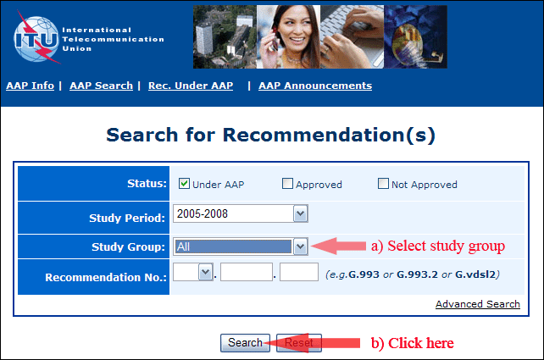
2) Select your Recommendation
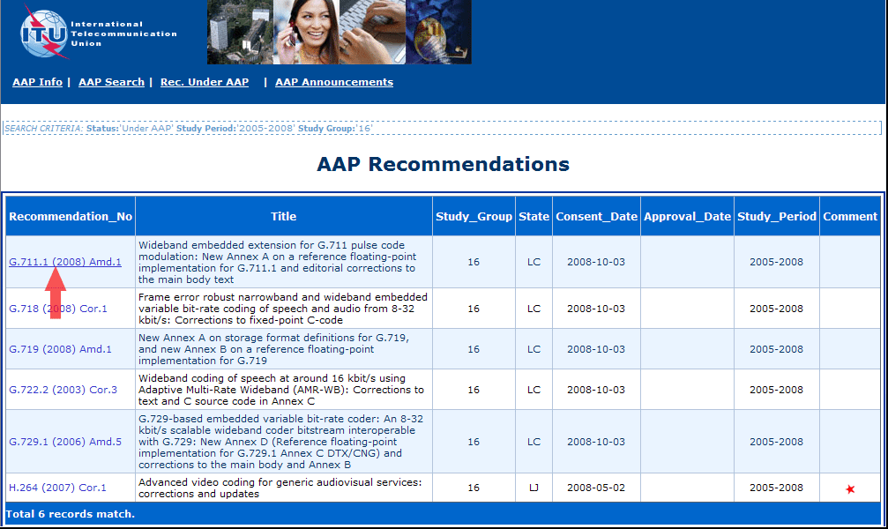
3) Click the "Submit Comment" button
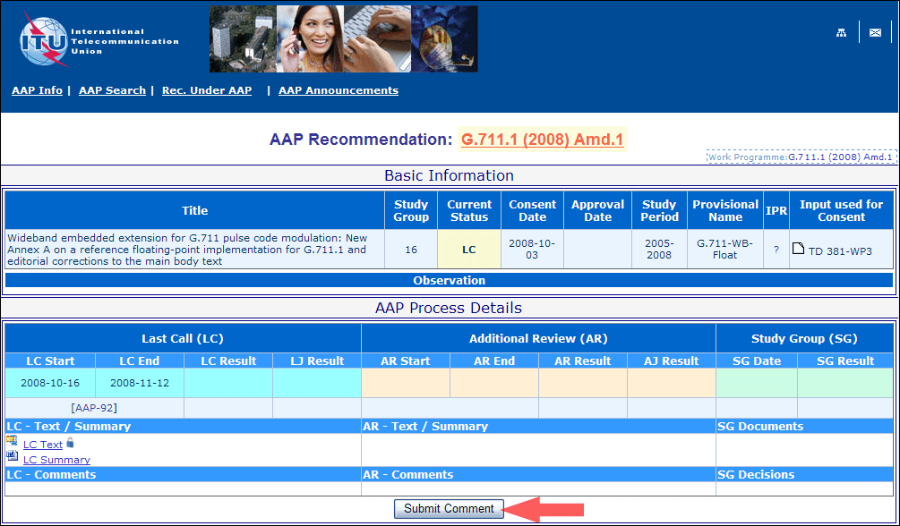
4) Complete the on-line form and click on "Submit"
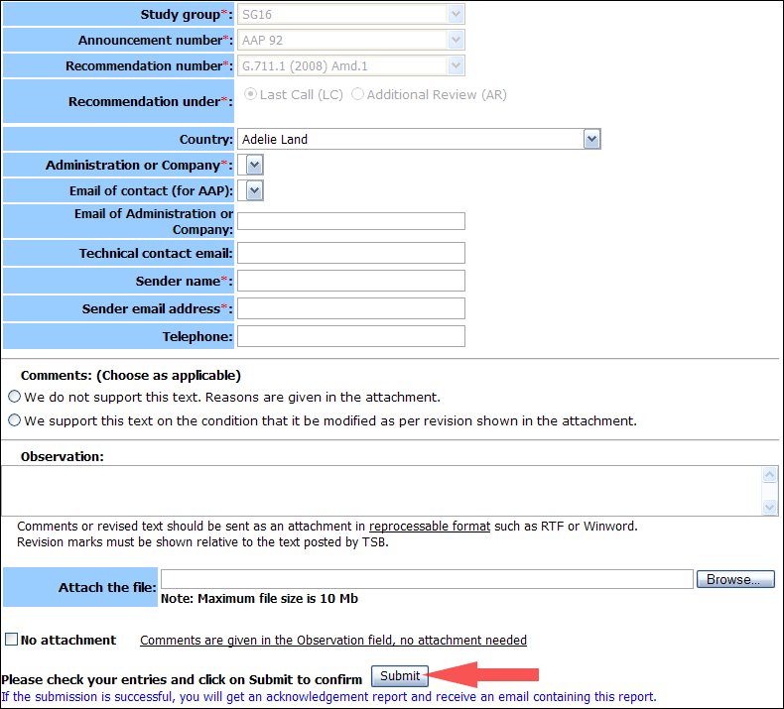
For more information, read the AAP tutorial on:
http://www.itu.int/ITU-T/aapinfo/files/AAPTutorial.pdf
Annex 3
(to TSB AAP-90)
Recommendations under LC/AR – Comment submission form
(Separate form for each Recommendation being commented upon)
ITU-T AAP comment submission form for the period 2009-2012
Study Group:
Announcement number:
Recommendation number:
Recommendation under: | Last call (LC)  Additional Review (AR)
Country:
Administration/Company:
Name of AAP Contact Person:
Email of AAP Contact Person:
Sender name:
(if different from AAP Contact Person)
Sender email address:
Telephone:
Comments:  (Choose as applicable) | We do not support this text. Reasons are given in the attachment.  We support this text on the condition that it be modified as per revision shown in the attachment.
Observations:
No attachment: Comments are given in the Observation field, no attachment needed
To be returned to: email: tsbsg....@itu.int
[or fax +41 22 730 5853]
Comments or revised text should be sent as an attachment in RTF or WinWord format.
Revision marks must be shown relative to the text posted by TSB.

