国 际 电 信 联 盟
电信标准化局
2016年10月16日 ，日内瓦

参考号:  电话:  传真:  电子邮件: | 电信标准化局AAP-90  AAP/CL  +41 22 730 5860  +41 22 730 5853  tsbdir@itu.int | – 致国际电联成员国各主管部门；  – 致ITU-T各部门成员；  – 致ITU-T 部门准成员  抄送：  – 电信标准化局研究组主席和副主席  – 电信发展局主任  – 无线电通信局主任

事由: | 有关采用替换批准程序（AAP）处理的建议书的情况

先生/女士，
ITU-T A.8 建议书中规定的建议书替换批准程序 (AAP) 适用于那些不会产生政策或 监管影响、因而不需与成员国正式协商的建议书（见国际电联《公约》第246B款）。
附件1列出了那些在以往电信标准化局AAP预告后地位发生变化的案文。
如您希望针对某个适用AAP的建议书提出意见，请使用可在ITU-T网站AAP区域 （http://www.itu.int/ITU-T/aap）的“建议书”网页上获取的《AAP意见在线提交表格》 （见附件2）。或者，可填妥附件3 中的表格并将意见发送给相关研究组的秘书处。
敬请留意，我们不鼓励提交仅支持通过所涉案文而没有实质内容的意见。

顺致敬意！

李在摄
电信标准化局主任

附件：3件

Annex 1
(to TSB AAP-90)

Status codes used in the AAP announcements:
LC = Last Call
LJ = Last Call Judgment (includes comment resolution)
AR = Additional Review
AJ = Additional Review Judgment (includes comment resolution)
SG = For Study Group approval
A = Approved
AT = Approved with typographic corrections
AC = Approved after Additional Review of Comments
NA = Not approved
TAP = Moved to TAP (ITU-T A.8 / § 5.2)
ITU-T website entry page:
http://www.itu.int/ITU-T
Alternative approval process (AAP) welcome page:
http://www.itu.int/ITU-T/aapinfo
Note – A tutorial on the ITU-T AAP application is available under the AAP welcome page
ITU-T website AAP Recommendation search page:
http://www.itu.int/ITU-T/aap/
Study Group web pages and contacts:
SG 2 | http://www.itu.int/ITU-T/studygroups/com02 | tsbsg2@itu.int
SG 3 | http://www.itu.int/ITU-T/studygroups/com03 | tsbsg3@itu.int
SG 5 | http://www.itu.int/ITU-T/studygroups/com05 | tsbsg5@itu.int
SG 9 | http://www.itu.int/ITU-T/studygroups/com09 | tsbsg9@itu.int
SG 11 | http://www.itu.int/ITU-T/studygroups/com11 | tsbsg11@itu.int
SG 12 | http://www.itu.int/ITU-T/studygroups/com12 | tsbsg12@itu.int
SG 13 | http://www.itu.int/ITU-T/studygroups/com13 | tsbsg13@itu.int
SG 15 | http://www.itu.int/ITU-T/studygroups/com15 | tsbsg15@itu.int
SG 16 | http://www.itu.int/ITU-T/studygroups/com16 | tsbsg16@itu.int
SG 17 | http://www.itu.int/ITU-T/studygroups/com17 | tsbsg17@itu.int
SG 20 | http://www.itu.int/ITU-T/studygroups/com20 | tsbsg20@itu.int

Situation concerning Study Group 5 Recommendations under AAP
Rec # | Title | Last Call (LC) Period |  |  |  | Additional Review (AR) Period |  |  |  | Status
 |  | LC Start | LC End | LC  Result | LJ  Result | AR Start | AR End | AR  Result | AJ  Result
L.1002 (L.UPA portable) | External universal power adapter solutions for portable information and communication technology devices (Summary) | 2016-04-16 | 2016-05-13 | LJ | AR | 2016-08-16 | 2016-09-05 | SG |  | AC
L.1350 (L.RBS assessment) | Energy efficiency metric of base station site (Summary) | 2016-06-01 | 2016-06-28 | LJ | AR | 2016-09-16 | 2016-10-06 | A |  | A
L.1603 (L.KPIs-SSC-SDGs (L.KPI for SSC to reach ) | Key performance indicators for smart sustainable cities to assess the achievement of sustainable development goals (Summary) | 2016-08-01 | 2016-08-28 | LJ | AR | 2016-09-16 | 2016-10-06 | A |  | A
Situation concerning Study Group 9 Recommendations under AAP
Rec # | Title | Last Call (LC) Period |  |  |  | Additional Review (AR) Period |  |  |  | Status
 |  | LC Start | LC End | LC  Result | LJ  Result | AR Start | AR End | AR  Result | AJ  Result
J.94 | Service information for digital broadcasting in cable television systems (Summary) | 2016-09-16 | 2016-10-13 | A |  |  |  |  |  | A
J.196.2 (HiNoC2-phy) | Physical layer specification of second generation HiNoC (Summary) | 2016-09-16 | 2016-10-13 | A |  |  |  |  |  | A
J.196.3 (J.HiNoC2-mac) | Media Access Control (MAC) layer specification of second generation HiNoC (Summary) | 2016-09-16 | 2016-10-13 | A |  |  |  |  |  | A
J.223.2 (J.C-DOCSIS-spec) | Cabinet DOCSIS (C-DOCSIS) System Specification (Summary) | 2016-09-16 | 2016-10-13 | A |  |  |  |  |  | A
J.230 | Requirements for platform functionalities on the integration of cable STB and companion devices including mobile second screen devices (Summary) | 2016-09-16 | 2016-10-13 | A |  |  |  |  |  | A
J.297 (J.4kstb) | Requirements and functional specification of cable set top box for 4K ultra high definition television (Summary) | 2016-09-16 | 2016-10-13 | AR |  | 2016-10-16 | 2016-11-05 |  |  | AR
J.302 (J.arstv-spec) | System Specifications of Augmented Reality Smart Television Service (Summary) | 2016-09-16 | 2016-10-13 | A |  |  |  |  |  | A
J.1006 (J.ipvdrm) | Specification of IP-VOD DRM for cable television multiscreen system in Multi-DRM environment (Summary) | 2016-09-16 | 2016-10-13 | A |  |  |  |  |  | A
J.1104 (J.vodoc-cont) | Control specification for IP-based switched digital video using Data Over Cable Service Interface Specifications (Summary) | 2016-09-16 | 2016-10-13 | A |  |  |  |  |  | A
J.1105 (J.chswt-req) | Requirement of channel switching service over Hybrid Fiber and Coaxial based network (Summary) | 2016-09-16 | 2016-10-13 | A |  |  |  |  |  | A
Situation concerning Study Group 15 Recommendations under AAP
Rec # | Title | Last Call (LC) Period |  |  |  | Additional Review (AR) Period |  |  |  | Status
 |  | LC Start | LC End | LC  Result | LJ  Result | AR Start | AR End | AR  Result | AJ  Result
G.652 | Characteristics of a single-mode optical fibre cable (Summary) | 2016-10-16 | 2016-11-12 |  |  |  |  |  |  | LC
G.654 | Characteristics of a cut-off shifted single-mode optical fibre and cable (Summary) | 2016-10-16 | 2016-11-12 |  |  |  |  |  |  | LC
G.657 | Characteristics of a bending-loss insensitive single-mode optical fibre and cable (Summary) | 2016-10-16 | 2016-11-12 |  |  |  |  |  |  | LC
G.697 | Optical monitoring for dense wavelength division multiplexing systems (Summary) | 2016-10-16 | 2016-11-12 |  |  |  |  |  |  | LC
G.709.1/Y.1331.1 | Flexible OTN short-reach interface (Summary) | 2016-10-16 | 2016-11-12 |  |  |  |  |  |  | LC
G.709/Y.1331 (2016) Amd.1 | Interfaces for the Optical Transport Network (OTN): Amendment 1 (Summary) | 2016-10-16 | 2016-11-12 |  |  |  |  |  |  | LC
G.798 (2012) Amd.3 | Characteristics of optical transport network hierarchy equipment functional blocks: Amendment 3 (Summary) | 2016-10-16 | 2016-11-12 |  |  |  |  |  |  | LC
G.808 | Terminology for protection and restoration (Summary) | 2016-10-16 | 2016-11-12 |  |  |  |  |  |  | LC
G.813 (2003) Cor.2 | Timing characteristics of SDH equipment slave clocks (SEC)- Corrigendum 2 (Summary) | 2016-10-16 | 2016-11-12 |  |  |  |  |  |  | LC
G.870/Y.1352 | Terms and definitions for optical transport networks (Summary) | 2016-10-16 | 2016-11-12 |  |  |  |  |  |  | LC
G.872 | Architecture of optical transport networks (Summary) | 2016-10-16 | 2016-11-12 |  |  |  |  |  |  | LC
G.874.1 | Optical transport network (OTN): Protocol-neutral management information model for the network element view (Summary) | 2016-10-16 | 2016-11-12 |  |  |  |  |  |  | LC
G.971 | General features of optical fibre submarine cable systems (Summary) | 2016-10-16 | 2016-11-12 |  |  |  |  |  |  | LC
G.972 | Definition of terms relevant to optical fibre submarine cable systems (Summary) | 2016-10-16 | 2016-11-12 |  |  |  |  |  |  | LC
G.973 | Characteristics of repeaterless optical fibre submarine cable systems (Summary) | 2016-10-16 | 2016-11-12 |  |  |  |  |  |  | LC
G.979 | Characteristics of monitoring systems for optical submarine cable systems (Summary) | 2016-10-16 | 2016-11-12 |  |  |  |  |  |  | LC
G.989.3 (2015) Amd.1 (G.ngpon2.3) | Draft Amendment 1 to Recommendation ITU-T G.989.3 (2015) (Summary) | 2016-10-16 | 2016-11-12 |  |  |  |  |  |  | LC
G.993.2 (2015) Cor.1 | Very high speed digital subscriber line transceivers 2 (VDSL2): Corrigendum 1 (Summary) | 2016-10-16 | 2016-11-12 |  |  |  |  |  |  | LC
G.993.5 (2015) Amd.1 | Self-FEXT cancellation (vectoring) for use with VDSL2 transceivers: Amendment 1 (Summary) | 2016-10-16 | 2016-11-12 |  |  |  |  |  |  | LC
G.993.5 (2015) Cor.1 | Self-FEXT cancellation (vectoring) for use with VDSL2 transceivers: Corrigendum 1 (Summary) | 2016-10-16 | 2016-11-12 |  |  |  |  |  |  | LC
G.997.1 (2012) Cor.1 | Physical layer management for digital subscriber line transceivers - Corrigendum 1 (Summary) | 2016-10-16 | 2016-11-12 |  |  |  |  |  |  | LC
G.7701 (G.cca) | Common Control Aspects (Summary) | 2016-10-16 | 2016-11-12 |  |  |  |  |  |  | LC
G.7710/Y.1701 (2012) Amd.1 | Common equipment management function requirements: Amendment 1 (Summary) | 2016-10-16 | 2016-11-12 |  |  |  |  |  |  | LC
G.7711/Y.1702 | Generic protocol-neutral information model for transport resources (Summary) | 2016-10-16 | 2016-11-12 |  |  |  |  |  |  | LC
G.8011/Y.1307 | Ethernet service characteristics (Summary) | 2016-10-16 | 2016-11-12 |  |  |  |  |  |  | LC
G.8012/Y.1308 (2004) Amd.2 | Ethernet UNI and Ethernet over Transport NNI: Amendment 2 (Summary) | 2016-10-16 | 2016-11-12 |  |  |  |  |  |  | LC
G.8021/Y.1341 | Characteristics of Ethernet transport network equipment functional blocks (Summary) | 2016-10-16 | 2016-11-12 |  |  |  |  |  |  | LC
G.8032/Y.1344 (2015) Amd.1 | Ethernet ring protection switching: Amendment 1 (Summary) | 2016-10-16 | 2016-11-12 |  |  |  |  |  |  | LC
G.8052/Y.1346 | Protocol-neutral management information model for the Ethernet Transport capable network element (Summary) | 2016-10-16 | 2016-11-12 |  |  |  |  |  |  | LC
G.8101/Y.1355 | Terms and definitions for MPLS transport profile (Summary) | 2016-10-16 | 2016-11-12 |  |  |  |  |  |  | LC
G.8113.1/Y.1372.1 (2016) Cor.1 | Operations, administration and maintenance mechanisms for MPLS-TP in packet transport network - Corrigendum 1 (Summary) | 2016-10-16 | 2016-11-12 |  |  |  |  |  |  | LC
G.8121.1/Y.1381.1 (2016) Cor.1 | Characteristics of MPLS-TP equipment functional blocks supporting ITU-T G.8113.1/Y.1372.1 OAM mechanisms - Corrigendum 1 (Summary) | 2016-10-16 | 2016-11-12 |  |  |  |  |  |  | LC
G.8121.2/Y.1381.2 (2016) Cor.1 | Characteristics of MPLS-TP equipment functional blocks supporting ITU-T G.8113.2/Y.1372.2 OAM mechanisms - Corrigendum 1 (Summary) | 2016-10-16 | 2016-11-12 |  |  |  |  |  |  | LC
G.8121/Y.1381 -Cor.1 | Characteristics of MPLS-TP equipment functional blocks. Corrigendum 1 (Summary) | 2016-10-16 | 2016-11-12 |  |  |  |  |  |  | LC
G.8131/Y.1382 (2014) Amd.2 | Linear protection switching for MPLS transport profile (MPLS-TP): Amendment 2 (Summary) | 2016-10-16 | 2016-11-12 |  |  |  |  |  |  | LC
G.8152/Y.1375 | Protocol-neutral management information model for the MPLS-TP network element (Summary) | 2016-10-16 | 2016-11-12 |  |  |  |  |  |  | LC
G.8262/Y.1362 (2015) Cor.1 | Timing characteristics of a synchronous Ethernet equipment slave clock (EEC)- Corrigendum 1 (Summary) | 2016-10-16 | 2016-11-12 |  |  |  |  |  |  | LC
G.8266/Y.1376 | Timing characteristics of telecom grandmaster clocks for frequency synchronization (Summary) | 2016-10-16 | 2016-11-12 |  |  |  |  |  |  | LC
G.8272.1/Y.1367.1 | Timing characteristics of enhanced primary reference time clocks (Summary) | 2016-10-16 | 2016-11-12 |  |  |  |  |  |  | LC
G.8273.2/Y.1368.2 | Timing characteristics of telecom boundary clocks and telecom time slave clocks (Summary) | 2016-10-16 | 2016-11-12 |  |  |  |  |  |  | LC
G.9905 (2013) Amd.1 | Centralized metric-based source routing - Amendment 1 (Summary) | 2016-10-16 | 2016-11-12 |  |  |  |  |  |  | LC
G.9960 (2015) Cor.3 | Unified high-speed wireline-based home networking transceivers - System architecture and physical layer specification: Corrigendum 3 (Summary) | 2016-10-16 | 2016-11-12 |  |  |  |  |  |  | LC
G.9961 (2015) Cor.3 | Unified high-speed wireline-based home networking transceivers - Data link layer specification: Corrigendum 3 (Summary) | 2016-10-16 | 2016-11-12 |  |  |  |  |  |  | LC
G.9962 (2014) Cor.1 | Unified high-speed wireline-based home networking transceivers - Management specification: Corrigendum 1 (Summary) | 2016-10-16 | 2016-11-12 |  |  |  |  |  |  | LC
L.155 (ex.L83) | Low-impact trenching technique for FTTx networks (Summary) | 2016-10-16 | 2016-11-12 |  |  |  |  |  |  | LC
L.162 (L.coi) | Microduct technology and its applications (Summary) | 2016-10-16 | 2016-11-12 |  |  |  |  |  |  | LC
Situation concerning Study Group 16 Recommendations under AAP
Rec # | Title | Last Call (LC) Period |  |  |  | Additional Review (AR) Period |  |  |  | Status
 |  | LC Start | LC End | LC  Result | LJ  Result | AR Start | AR End | AR  Result | AJ  Result
H.264 (V11) | Advanced video coding for generic audiovisual services (Summary) | 2016-09-16 | 2016-10-13 | A |  |  |  |  |  | A
H.273 (H.STI) | Coding-independent code points for video signal type identification (Summary) | 2016-10-16 | 2016-11-12 |  |  |  |  |  |  | LC
Situation concerning Study Group 17 Recommendations under AAP
Rec # | Title | Last Call (LC) Period |  |  |  | Additional Review (AR) Period |  |  |  | Status
 |  | LC Start | LC End | LC  Result | LJ  Result | AR Start | AR End | AR  Result | AJ  Result
X.500 (X.500 (eighth edition)) | Information technology - Open Systems Interconnection - The Directory: Overview of concepts, models and services (Summary) | 2016-09-16 | 2016-10-13 | A |  |  |  |  |  | A
X.501 (X.501 (eighth edition)) | Information technology - Open Systems Interconnection - The Directory: Models (Summary) | 2016-09-16 | 2016-10-13 | A |  |  |  |  |  | A
X.509 (2012) Cor.3 (X.509 (2012) Cor.3) | Information technology - Open Systems Interconnection - The Directory: Public-key and attribute certificate frameworks - Technical Corrigendum 3 (Summary) | 2016-09-16 | 2016-10-13 | A |  |  |  |  |  | A
X.509 (X.509 (eighth edition)) | Information technology - Open Systems Interconnection - The Directory: Public-key and attribute certificate frameworks (Summary) | 2016-09-16 | 2016-10-13 | A |  |  |  |  |  | A
X.511 (X.511 (eighth edition)) | Information technology - Open Systems Interconnection - The Directory: Abstract service definition (Summary) | 2016-09-16 | 2016-10-13 | A |  |  |  |  |  | A
X.518 (X.518 (eighth edition)) | Information technology - Open Systems Interconnection - The Directory: Procedures for distributed operation (Summary) | 2016-09-16 | 2016-10-13 | A |  |  |  |  |  | A
X.519 (X.519 (eighth edition)) | Information technology - Open Systems Interconnection - The Directory: Protocols specifications (Summary) | 2016-09-16 | 2016-10-13 | A |  |  |  |  |  | A
X.520 (X.520 (eighth edition)) | Information technology - Open Systems Interconnection - The Directory: Selected attribute types (Summary) | 2016-09-16 | 2016-10-13 | A |  |  |  |  |  | A
X.521 (X.521 (eighth edition)) | Information technology - Open Systems Interconnection - The Directory: Selected object classes (Summary) | 2016-09-16 | 2016-10-13 | A |  |  |  |  |  | A
X.525 (X.525 (eighth edition)) | Information technology - Open Systems Interconnection - The Directory: Replication (Summary) | 2016-09-16 | 2016-10-13 | A |  |  |  |  |  | A
X.691 (2015) Cor.1 (X.691 (2015) Cor.1) | Information technology - Specification of Packed Encoding Rules (PER) - Technical Corrigendum 1 (Summary) | 2016-09-16 | 2016-10-13 | A |  |  |  |  |  | A
X.1038 (X.sdnsec-2) | Security requirements and reference architecture for software-defined networking (Summary) | 2016-09-16 | 2016-10-13 | A |  |  |  |  |  | A
X.1039 (X.1039 (X.tigsc)) | Technical security measures for implementation of ITU-T X.805 security dimensions (Summary) | 2016-09-16 | 2016-10-13 | A |  |  |  |  |  | A
X.1085 (X.bhsm) | Information technology - Security techniques - Telebiometric authentication framework using biometric hardware security module (Summary) | 2016-09-16 | 2016-10-13 | A |  |  |  |  |  | A
X.1087 (X.tam) | Technical and operational countermeasures for telebiometric applications using mobile devices (Summary) | 2016-09-16 | 2016-10-13 | A |  |  |  |  |  | A
Z.109 (Z.109) | Specification and Description Language - Unified modeling language profile for SDL-2010 (Summary) | 2016-09-16 | 2016-10-13 | A |  |  |  |  |  | A
Z.161 (Z.161 (2016)) | Testing and Test Control Notation version 3: TTCN-3 core language (Summary) | 2016-09-16 | 2016-10-13 | A |  |  |  |  |  | A
Z.164 (Z.164 (2016)) | Testing and Test Control Notation version 3: TTCN-3 operational semantics (Summary) | 2016-09-16 | 2016-10-13 | A |  |  |  |  |  | A
Z.166 (Z.166 (2016)) | Testing and Test Control Notation version 3: TTCN-3 control interface (TCI) (Summary) | 2016-09-16 | 2016-10-13 | A |  |  |  |  |  | A
Z.169 (Z.169 (2016)) | Testing and Test Control Notation version 3: Using XML schema with TTCN-3 (Summary) | 2016-09-16 | 2016-10-13 | A |  |  |  |  |  | A

Annex 2
(to TSB AAP-90)
Using the on-line comment submission form
Comment submission
1) Go to AAP search Web page at http://www.itu.int/ITU-T/aap/
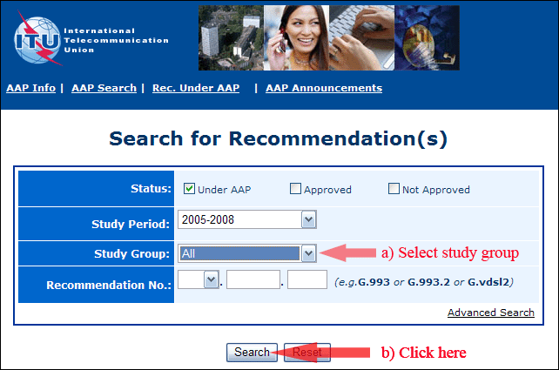
2) Select your Recommendation
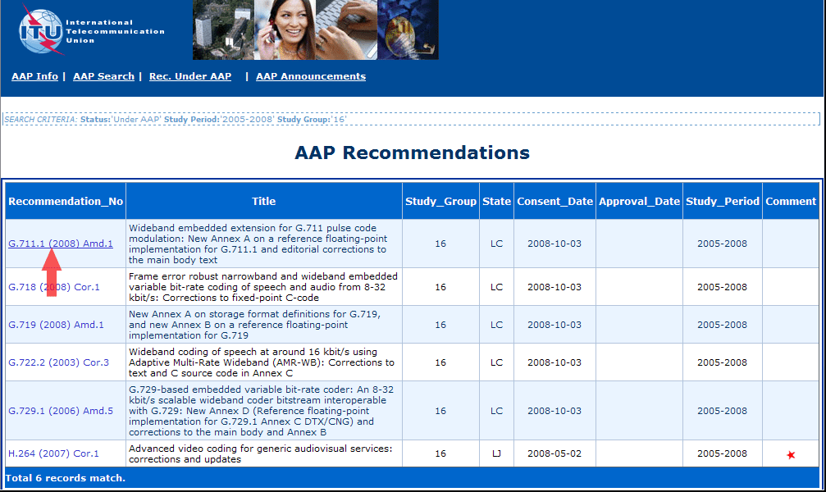
3) Click the "Submit Comment" button
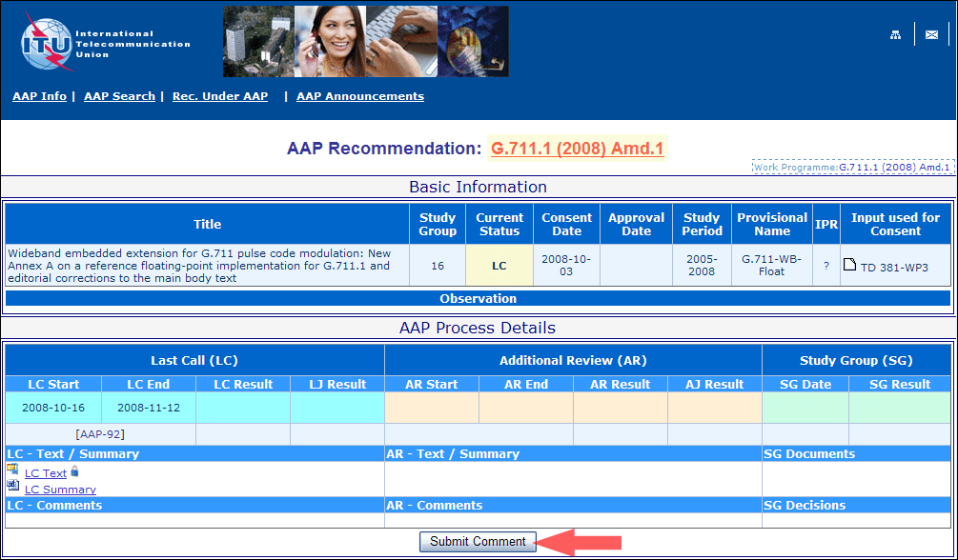
4) Complete the on-line form and click on "Submit"
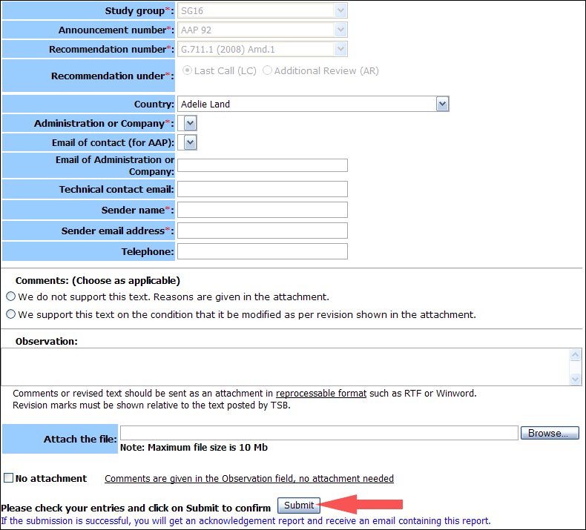
For more information, read the AAP tutorial on:
http://www.itu.int/ITU-T/aapinfo/files/AAPTutorial.pdf
Annex 3
(to TSB AAP-90)
Recommendations under LC/AR – Comment submission form
(Separate form for each Recommendation being commented upon)
ITU-T AAP comment submission form for the period 2009-2012
Study Group:
Announcement number:
Recommendation number:
Recommendation under: | Last call (LC)  Additional Review (AR)
Country:
Administration/Company:
Name of AAP Contact Person:
Email of AAP Contact Person:
Sender name:
(if different from AAP Contact Person)
Sender email address:
Telephone:
Comments:  (Choose as applicable) | We do not support this text. Reasons are given in the attachment.  We support this text on the condition that it be modified as per revision shown in the attachment.
Observations:
No attachment: Comments are given in the Observation field, no attachment needed
To be returned to: email: tsbsg....@itu.int
[or fax +41 22 730 5853]
Comments or revised text should be sent as an attachment in RTF or WinWord format.
Revision marks must be shown relative to the text posted by TSB.

