 | 国 际 电 信 联 盟  电信标准化局 | 
2016年7月16日 ，日内瓦

参考号:  电话:  传真:  电子邮件: | 电信标准化局AAP-84  AAP/CL  +41 22 730 5860  +41 22 730 5853  tsbdir@itu.int | – 致国际电联成员国各主管部门；  – 致ITU-T各部门成员；  – 致ITU-T 部门准成员  抄送：  – 电信标准化局研究组主席和副主席  – 电信发展局主任  – 无线电通信局主任

事由: | 有关采用替换批准程序（AAP）处理的建议书的情况

先生/女士，
ITU-T A.8 建议书中规定的建议书替换批准程序 (AAP) 适用于那些不会产生政策或 监管影响、因而不需与成员国正式协商的建议书（见国际电联《公约》第246B款）。
附件1列出了那些在以往电信标准化局AAP预告后地位发生变化的案文。
如您希望针对某个适用AAP的建议书提出意见，请使用可在ITU-T网站AAP区域 （http://www.itu.int/ITU-T/aap）的“建议书”网页上获取的《AAP意见在线提交表格》 （见附件2）。或者，可填妥附件3 中的表格并将意见发送给相关研究组的秘书处。
敬请留意，我们不鼓励提交仅支持通过所涉案文而没有实质内容的意见。

顺致敬意！

李在摄
电信标准化局主任

附件：3件

Annex 1
(to TSB AAP-84)

Status codes used in the AAP announcements:
LC = Last Call
LJ = Last Call Judgment (includes comment resolution)
AR = Additional Review
AJ = Additional Review Judgment (includes comment resolution)
SG = For Study Group approval
A = Approved
AT = Approved with typographic corrections
AC = Approved after Additional Review of Comments
NA = Not approved
TAP = Moved to TAP (ITU-T A.8 / § 5.2)
ITU-T website entry page:
http://www.itu.int/ITU-T
Alternative approval process (AAP) welcome page:
http://www.itu.int/ITU-T/aapinfo
Note – A tutorial on the ITU-T AAP application is available under the AAP welcome page
ITU-T website AAP Recommendation search page:
http://www.itu.int/ITU-T/aap/
Study Group web pages and contacts:
SG 2 | http://www.itu.int/ITU-T/studygroups/com02 | tsbsg2@itu.int
SG 3 | http://www.itu.int/ITU-T/studygroups/com03 | tsbsg3@itu.int
SG 5 | http://www.itu.int/ITU-T/studygroups/com05 | tsbsg5@itu.int
SG 9 | http://www.itu.int/ITU-T/studygroups/com09 | tsbsg9@itu.int
SG 11 | http://www.itu.int/ITU-T/studygroups/com11 | tsbsg11@itu.int
SG 12 | http://www.itu.int/ITU-T/studygroups/com12 | tsbsg12@itu.int
SG 13 | http://www.itu.int/ITU-T/studygroups/com13 | tsbsg13@itu.int
SG 15 | http://www.itu.int/ITU-T/studygroups/com15 | tsbsg15@itu.int
SG 16 | http://www.itu.int/ITU-T/studygroups/com16 | tsbsg16@itu.int
SG 17 | http://www.itu.int/ITU-T/studygroups/com17 | tsbsg17@itu.int
SG 20 | http://www.itu.int/ITU-T/studygroups/com20 | tsbsg20@itu.int

Situation concerning Study Group 5 Recommendations under AAP
Rec # | Title | Last Call (LC) Period |  |  |  | Additional Review (AR) Period |  |  |  | Status
Rec # | Title | LC Start | LC End | LC  Result | LJ  Result | AR Start | AR End | AR  Result | AJ  Result | Status
K.50 | Safe limits of operating voltages and currents for telecommunication systems powered over the network (Summary) | 2016-06-16 | 2016-07-13 | A |  |  |  |  |  | A
L.1102 (L.RareMetals-Label) | Use of printed labels for communicating information on rare metals in information and communication technology goods (Summary) | 2016-06-16 | 2016-07-13 | A |  |  |  |  |  | A
Situation concerning Study Group 11 Recommendations under AAP
Rec # | Title | Last Call (LC) Period |  |  |  | Additional Review (AR) Period |  |  |  | Status
Rec # | Title | LC Start | LC End | LC  Result | LJ  Result | AR Start | AR End | AR  Result | AJ  Result | Status
Q.3960 (Q.FW_Int_sp_test) | Framework of Internet speed measurements for the fixed and mobile networks (Summary) | 2016-01-16 | 2016-02-12 | LJ | SG |  |  |  |  | AC
Situation concerning Study Group 15 Recommendations under AAP
Rec # | Title | Last Call (LC) Period |  |  |  | Additional Review (AR) Period |  |  |  | Status
Rec # | Title | LC Start | LC End | LC  Result | LJ  Result | AR Start | AR End | AR  Result | AJ  Result | Status
G.7041/Y.1303 | Generic Framing Procedure (GFP) (Summary) | 2016-03-16 | 2016-04-12 | LJ | AR | 2016-07-16 | 2016-08-05 |  |  | AR
G.8271/Y.1366 | Time and phase synchronization aspects of Packet Networks (Summary) | 2016-03-16 | 2016-04-12 | LJ | AR | 2016-06-16 | 2016-07-06 | AC |  | AC
Situation concerning Study Group 16 Recommendations under AAP
Rec # | Title | Last Call (LC) Period |  |  |  | Additional Review (AR) Period |  |  |  | Status
Rec # | Title | LC Start | LC End | LC  Result | LJ  Result | AR Start | AR End | AR  Result | AJ  Result | Status
F.743.2 (F.CSVSReqs) | Requirements for cloud storage in visual surveillance (Summary) | 2016-06-16 | 2016-07-13 | A |  |  |  |  |  | A
F.743.3 (F.VSSIReqs) | Requirements for visual surveillance system interworking (Summary) | 2016-06-16 | 2016-07-13 | A |  |  |  |  |  | A
F.745 | Functional requirements for network-based speech-to-speech translation services (Summary) | 2016-06-16 | 2016-07-13 | A |  |  |  |  |  | A
G.799.1/Y.1451.1 (V2) | Functionality and interface specifications for GSTN transport network equipment for interconnecting GSTN and IP networks (Summary) | 2016-06-16 | 2016-07-13 | A |  |  |  |  |  | A
H.222.0 (2014) Amd.1 Cor.2 | Information technology - Generic coding of moving pictures and associated audio information: Systems: Delivery of timeline for external data: Clarifications and corrections on pause flag, URL construction and adaptation field syntax (Summary) | 2016-06-16 | 2016-07-13 | A |  |  |  |  |  | A
H.222.0 (2014) Amd.4 | Information technology - Generic coding of moving pictures and associated audio information: Systems: New Profiles and Levels for MPEG-4 audio descriptor (Summary) | 2016-06-16 | 2016-07-13 | A |  |  |  |  |  | A
H.222.0 (2014) Amd.5 | Information technology - Generic coding of moving pictures and associated audio information: Systems: Carriage of MPEG-H 3D audio over MPEG-2 systems (Summary) | 2016-06-16 | 2016-07-13 | A |  |  |  |  |  | A
H.222.0 (2014) Amd.6 | Information technology - Generic coding of moving pictures and associated audio information: Systems: Carriage of quality metadata in MPEG-2 systems (Summary) | 2016-06-16 | 2016-07-13 | A |  |  |  |  |  | A
H.222.0 (2014) Cor.1 | Information technology - Generic coding of moving pictures and associated audio information: Systems: Correction to PES header table and removal of semantic element from clause 2.6.61 (Summary) | 2016-06-16 | 2016-07-13 | A |  |  |  |  |  | A
H.248.50 | Gateway control protocol: NAT traversal toolkit packages (Summary) | 2016-06-16 | 2016-07-13 | A |  |  |  |  |  | A
H.265.2 (V3) (H.265.2 (V3)) | Reference software for ITU-T H.265 high efficiency video coding (Summary) | 2016-07-16 | 2016-08-12 |  |  |  |  |  |  | LC
H.703 (H.IPTV-EUIF) | Enhanced user interface framework for IPTV terminal devices (Summary) | 2016-06-16 | 2016-07-13 | A |  |  |  |  |  | A
H.723 (H.IPTV-TDES.4) | IPTV Terminal Device: Mobile model (Summary) | 2016-06-16 | 2016-07-13 | A |  |  |  |  |  | A
H.742.0 (H.IPTV-UVS) | Use of video sensor devices for IPTV services: Architecture and requirements (Summary) | 2016-06-16 | 2016-07-13 | A |  |  |  |  |  | A
H.810 | Interoperability design guidelines for personal connected health systems (Summary) | 2016-06-16 | 2016-07-13 | A |  |  |  |  |  | A
H.811 | Interoperability design guidelines for personal health systems: Personal health devices interface (Summary) | 2016-06-16 | 2016-07-13 | A |  |  |  |  |  | A
H.812 | Interoperability design guidelines for personal health systems: Services interface: Common certified capability class (Summary) | 2016-06-16 | 2016-07-13 | A |  |  |  |  |  | A
H.812.1 | Interoperability design guidelines for personal health systems: Services interface: Observation upload certified capability class (Summary) | 2016-06-16 | 2016-07-13 | A |  |  |  |  |  | A
H.812.2 | Interoperability design guidelines for personal health systems: Services interface: Questionnaires (Summary) | 2016-06-16 | 2016-07-13 | A |  |  |  |  |  | A
H.812.3 | Interoperability design guidelines for personal health systems: Services interface: Capability exchange certified capability class (Summary) | 2016-06-16 | 2016-07-13 | A |  |  |  |  |  | A
H.812.4 | Interoperability design guidelines for personal health systems: Services interface: Authenticated persistent session capability (Summary) | 2016-06-16 | 2016-07-13 | A |  |  |  |  |  | A
H.813 | Interoperability design guidelines for personal health systems: Healthcare information system (HIS) interface (Summary) | 2016-06-16 | 2016-07-13 | A |  |  |  |  |  | A
H.821 (H.EH-HRN-01) | Conformance of ITU-T H.810 personal health devices: Health record network (HRN) interface (Summary) | 2016-06-16 | 2016-07-13 | A |  |  |  |  |  | A
H.830.1 (H.EH-WAN.1) | Conformance of ITU-T H.810 personal health devices: WAN Interface Part 1: Web services interoperability: Sender (Summary) | 2016-06-16 | 2016-07-13 | A |  |  |  |  |  | A
H.830.10 (H.EH-WAN-10) | Conformance of ITU-T H.810 personal health devices: WAN interface Part 10: hData observation upload: Receiver (Summary) | 2016-06-16 | 2016-07-13 | A |  |  |  |  |  | A
H.830.11 (H.EH-WAN-11) | Conformance of ITU-T H.810 personal health devices: WAN interface Part 11: Questionnaires: Sender (Summary) | 2016-06-16 | 2016-07-13 | A |  |  |  |  |  | A
H.830.12 (H.EH-WAN-12) | Conformance of ITU-T H.810 personal health devices: WAN interface Part 12: Questionnaires: Receiver (Summary) | 2016-06-16 | 2016-07-13 | A |  |  |  |  |  | A
H.830.2 (H.EH-WAN.2) | Conformance of ITU-T H.810 personal health devices: WAN Interface Part 2: Web services interoperability: Receiver (Summary) | 2016-06-16 | 2016-07-13 | A |  |  |  |  |  | A
H.830.3 (H.EH-WAN.3) | Conformance of ITU-T H.810 personal health devices: WAN Interface Part 3: SOAP/ATNA: Sender (Summary) | 2016-06-16 | 2016-07-13 | A |  |  |  |  |  | A
H.830.4 (H.EH-WAN.4) | Conformance of ITU-T H.810 personal health devices: WAN Interface Part 4: SOAP/ATNA: Receiver (Summary) | 2016-06-16 | 2016-07-13 | A |  |  |  |  |  | A
H.830.5 (H.EH-WAN.5) | Conformance of ITU-T H.810 personal health devices: WAN Interface Part 5: PCD-01 HL7 messages: Sender (Summary) | 2016-06-16 | 2016-07-13 | A |  |  |  |  |  | A
H.830.6 (H.EH-WAN.6) | Conformance of ITU-T H.810 personal health devices: WAN Interface Part 6: PCD-01 HL7 Messages: Receiver (Summary) | 2016-06-16 | 2016-07-13 | A |  |  |  |  |  | A
H.830.7 (H.EH-WAN.7) | Conformance of ITU-T H.810 personal health devices: WAN Interface Part 7: Consent management: Sender (Summary) | 2016-06-16 | 2016-07-13 | A |  |  |  |  |  | A
H.830.8 (H.EH-WAN.8) | Conformance of ITU-T H.810 personal health devices: WAN Interface Part 8: Consent management: Receiver (Summary) | 2016-06-16 | 2016-07-13 | A |  |  |  |  |  | A
H.830.9 (H.EH-WAN-9) | Conformance of ITU-T H.810 personal health devices: WAN interface Part 9: hData observation upload: Sender (Summary) | 2016-06-16 | 2016-07-13 | A |  |  |  |  |  | A
H.840 (H.EH-PAN-USB) | Conformance of ITU-T H.810 personal health devices: PAN/LAN/TAN: USB host (Summary) | 2016-06-16 | 2016-07-13 | A |  |  |  |  |  | A
H.841 | Conformance of ITU-T H.810 personal health devices: PAN/LAN/TAN interface Part 1: Optimized exchange protocol: Agent (Summary) | 2016-06-16 | 2016-07-13 | A |  |  |  |  |  | A
H.842 (H.EH-PAN-02) | Conformance of ITU-T H.810 personal health devices: PAN/LAN/TAN interface Part 2: Optimized exchange protocol: Manager (Summary) | 2016-06-16 | 2016-07-13 | A |  |  |  |  |  | A
H.843 (H.EH-PAN-03) | Conformance of ITU-T H.810 personal health devices: PAN/LAN/TAN interface Part 3: Continua Design Guidelines: Agent (Summary) | 2016-06-16 | 2016-07-13 | A |  |  |  |  |  | A
H.844 (H.EH-PAN-04) | Conformance of ITU-T H.810 personal health devices: PAN/LAN/TAN interface Part 4: Continua Design Guidelines: Manager (Summary) | 2016-06-16 | 2016-07-13 | A |  |  |  |  |  | A
H.845.1 (H.EH-PAN-05.01) | Conformance of ITU-T H.810 personal health devices: PAN/LAN/TAN interface Part 5A: Weighing scales: Agent (Summary) | 2016-06-16 | 2016-07-13 | A |  |  |  |  |  | A
H.845.11 (H.EH-PAN-05.11) | Conformance of ITU-T H.810 personal health devices: PAN/LAN/TAN interface Part 5K: Peak expiratory flow monitor: Agent (Summary) | 2016-06-16 | 2016-07-13 | A |  |  |  |  |  | A
H.845.12 (H.EH-PAN-05.12) | Conformance of ITU-T H.810 personal health devices: PAN/LAN/TAN interface Part 5L: Body composition analyser: Agent (Summary) | 2016-06-16 | 2016-07-13 | A |  |  |  |  |  | A
H.845.13 (H.EH-PAN-05.13) | Conformance of ITU-T H.810 personal health devices: PAN/LAN/TAN interface Part 5M: Basic electrocardiograph: Agent (Summary) | 2016-06-16 | 2016-07-13 | A |  |  |  |  |  | A
H.845.14 | Conformance of ITU-T H.810 personal health devices: PAN/LAN/TAN interface Part 5N: International normalized ratio: Agent (Summary) | 2016-06-16 | 2016-07-13 | A |  |  |  |  |  | A
H.845.15 (H.EH-PAN-05.15) | Conformance of ITU-T H.810 personal health devices: PAN/LAN/TAN interface Part 5O: Sleep apnoea breathing therapy equipment: Agent (Summary) | 2016-06-16 | 2016-07-13 | A |  |  |  |  |  | A
H.845.2 (H.EH-PAN-05.02) | Conformance of ITU-T H.810 personal health devices: PAN/LAN/TAN interface Part 5B: Glucose meter: Agent (Summary) | 2016-06-16 | 2016-07-13 | A |  |  |  |  |  | A
H.845.3 (H.EH-PAN-05.03) | Conformance of ITU-T H.810 personal health devices: PAN/LAN/TAN interface Part 5C: Pulse oximeter: Agent (Summary) | 2016-06-16 | 2016-07-13 | A |  |  |  |  |  | A
H.845.4 (H.EH-PAN-05.04) | Conformance of ITU-T H.810 personal health devices: PAN/LAN/TAN interface Part 5D: Blood pressure monitor: Agent (Summary) | 2016-06-16 | 2016-07-13 | A |  |  |  |  |  | A
H.845.5 | Conformance of ITU-T H.810 personal health devices: PAN/LAN/TAN interface Part 5E: Thermometer: Agent (Summary) | 2016-06-16 | 2016-07-13 | A |  |  |  |  |  | A
H.845.6 (H.EH-PAN-05.06) | Conformance of ITU-T H.810 personal health devices: PAN/LAN/TAN interface Part 5F: Cardiovascular fitness and activity monitor: Agent (Summary) | 2016-06-16 | 2016-07-13 | A |  |  |  |  |  | A
H.845.7 | Conformance of ITU-T H.810 personal health devices: PAN/LAN/TAN interface Part 5G: Strength fitness equipment: Agent (Summary) | 2016-06-16 | 2016-07-13 | A |  |  |  |  |  | A
H.845.8 (H.EH-PAN-05.08) | Conformance of ITU-T H.810 personal health devices: PAN/LAN/TAN interface Part 5H: Independent living activity hub: Agent (Summary) | 2016-06-16 | 2016-07-13 | A |  |  |  |  |  | A
H.845.9 (H.EH-PAN-05.09) | Conformance of ITU-T H.810 personal health devices: PAN/LAN/TAN interface Part 5I: Medication adherence monitor: Agent (Summary) | 2016-06-16 | 2016-07-13 | A |  |  |  |  |  | A
H.846 | Conformance of ITU-T H.810 personal health devices: PAN/LAN/TAN interface Part 6: Device specializations: Manager (Summary) | 2016-06-16 | 2016-07-13 | A |  |  |  |  |  | A
H.847 | Conformance of ITU-T H.810 personal health devices: PAN/LAN/TAN interface Part 7: Bluetooth low energy (BLE): Agent (Summary) | 2016-06-16 | 2016-07-13 | A |  |  |  |  |  | A
H.848 | Conformance of ITU-T H.810 personal health devices: PAN/LAN/TAN interface Part 8: Bluetooth low energy (BLE): Manager (Summary) | 2016-06-16 | 2016-07-13 | A |  |  |  |  |  | A
H.849 | Conformance of ITU-T H.810 personal health devices: PAN/LAN/TAN interface Part 9: Transcoding for Bluetooth low energy (BLE): Agent (Summary) | 2016-06-16 | 2016-07-13 | A |  |  |  |  |  | A
H.850 | Conformance of ITU-T H.810 personal health devices: PAN/LAN/TAN Interface Part 10: Transcoding for Bluetooth low energy (BLE): Manager (Summary) | 2016-06-16 | 2016-07-13 | A |  |  |  |  |  | A
T.832 (V3) | Information technology – JPEG XR image coding - revision to define a media type code (Summary) | 2016-07-16 | 2016-08-12 |  |  |  |  |  |  | LC
T.835 (V3) | Information technology - JPEG XR image coding system - Reference software (Summary) | 2016-07-16 | 2016-08-12 |  |  |  |  |  |  | LC

Annex 2
(to TSB AAP-84)
Using the on-line comment submission form
Comment submission
1) Go to AAP search Web page at http://www.itu.int/ITU-T/aap/
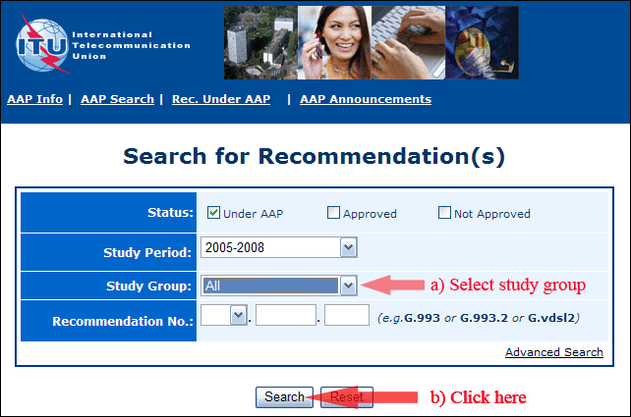
2) Select your Recommendation
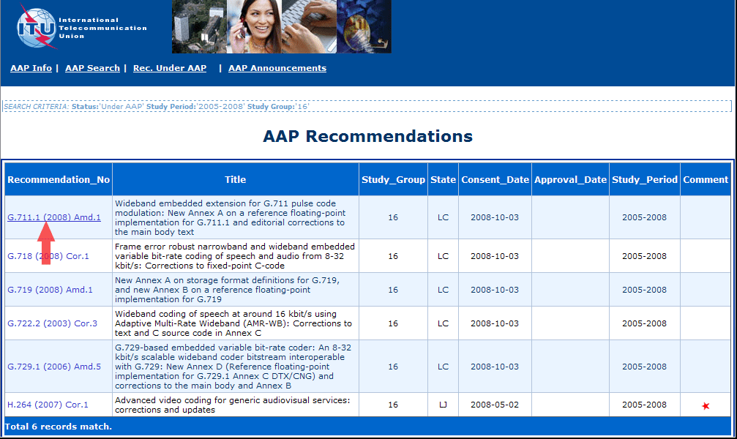
3) Click the "Submit Comment" button
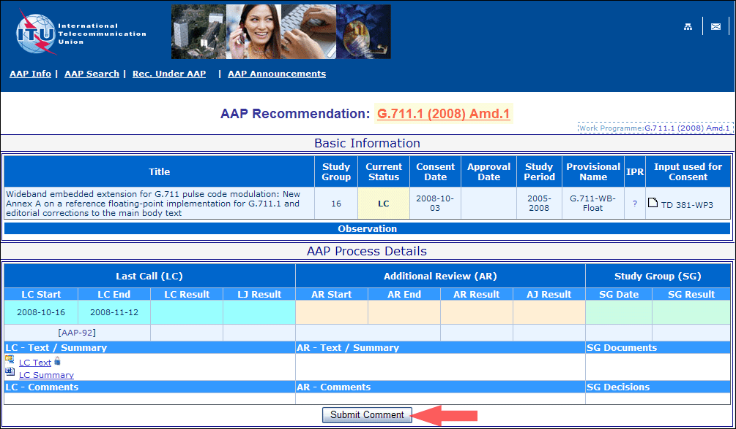
4) Complete the on-line form and click on "Submit"
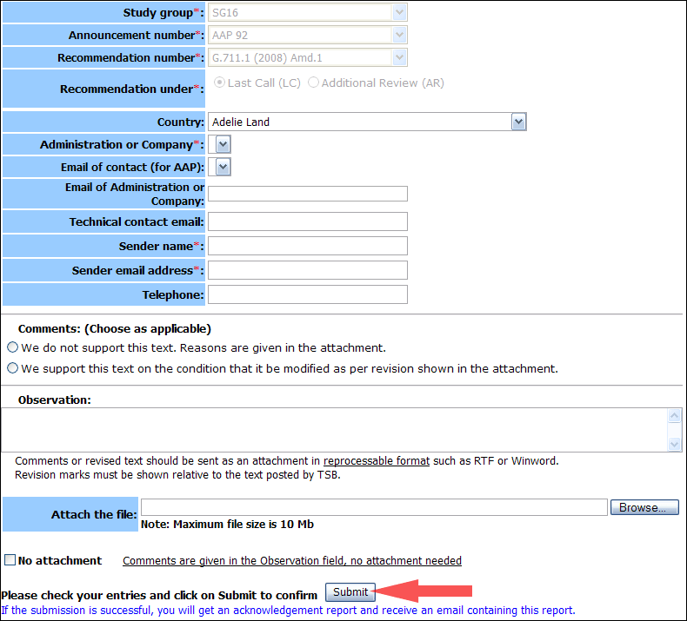
For more information, read the AAP tutorial on:
http://www.itu.int/ITU-T/aapinfo/files/AAPTutorial.pdf
Annex 3
(to TSB AAP-84)
Recommendations under LC/AR – Comment submission form
(Separate form for each Recommendation being commented upon)
ITU-T AAP comment submission form for the period 2009-2012
Study Group:
Announcement number:
Recommendation number:
Recommendation under: | Last call (LC)  Additional Review (AR)
Country:
Administration/Company:
Name of AAP Contact Person:
Email of AAP Contact Person:
Sender name:
(if different from AAP Contact Person)
Sender email address:
Telephone:
Comments:  (Choose as applicable) | We do not support this text. Reasons are given in the attachment.  We support this text on the condition that it be modified as per revision shown in the attachment.
Observations:
No attachment: Comments are given in the Observation field, no attachment needed
To be returned to: email: tsbsg....@itu.int
[or fax +41 22 730 5853]
Comments or revised text should be sent as an attachment in RTF or WinWord format.
Revision marks must be shown relative to the text posted by TSB.

