 | Международный союз электросвязи  Бюро стандартизации электросвязи | 

Женева, 1 апреля 2016

Осн.:  Тел.:  Факс:  Эл. почта: | TSB AAP-77  AAP/CL  +41 22 730 5860  +41 22 730 5853  tsbdir@itu.int | – Администрациям Государств – Членов Союза;  – Членам Сектора МСЭ-Т;  – Ассоциированным членам МСЭ-Т  Копии:  – Председателям и заместителям председателей Исследовательских комиссий МСЭ-Т;  – Директору Бюро Развития Электросвязи;  – Директору Бюро Радиосвязи

Предмет: | Положение относительно Рекомендаций, рассматриваемых в соответствии с альтернативным процессом утверждения (АПУ)

Уважаемая госпожа,
уважаемый господин,

Альтернативный процесс утверждения (АПУ), определенный в Рекомендации МСЭ-Т А.8, распространяется на Рекомендации, которые не имеют политических или регламентарных последствий и которые поэтому не требуют официальных консультаций с Государствами-Членами (см. п. 246B Конвенции МСЭ).
В Приложении 1 содержится перечень текстов, статус которых изменился по сравнению с предыдущими объявлениями об АПУ БСЭ.
Если вы желаете представить замечания относительно какой-либо Рекомендации, рассматриваемой в соответствии с АПУ, рекомендуем Вам использовать онлайновую форму для представления замечаний по АПУ, которая размещена на странице этой Рекомендации в разделе веб-сайта МСЭ-Т, посвященном АПУ, по адресу: http://www.itu.int/ITU-T/aap/ (см. Приложение 2). Замечания можно представить иным способом, заполнив приведенную в Приложении 3 форму и направив ее в секретариат заинтересованной исследовательской комиссии.
Просим принять к сведению, что не рекомендуется представлять замечания, являющиеся не чем иным, как поддержкой рассматриваемого текста.
С уважением,
Чхе Суб Ли
Директор Бюро стандартизации электросвязи
Приложения: 3

Annex 1
(to TSB AAP-77)

Status codes used in the AAP announcements:
LC = Last Call
LJ = Last Call Judgment (includes comment resolution)
AR = Additional Review
AJ = Additional Review Judgment (includes comment resolution)
SG = For Study Group approval
A = Approved
AT = Approved with typographic corrections
AC = Approved after Additional Review of Comments
NA = Not approved
TAP = Moved to TAP (ITU-T A.8 / § 5.2)
ITU-T website entry page:
http://www.itu.int/ITU-T
Alternative approval process (AAP) welcome page:
http://www.itu.int/ITU-T/aapinfo
Note – A tutorial on the ITU-T AAP application is available under the AAP welcome page
ITU-T website AAP Recommendation search page:
http://www.itu.int/ITU-T/aap/
Study Group web pages and contacts:
SG 2 | http://www.itu.int/ITU-T/studygroups/com02 | tsbsg2@itu.int
SG 3 | http://www.itu.int/ITU-T/studygroups/com03 | tsbsg3@itu.int
SG 5 | http://www.itu.int/ITU-T/studygroups/com05 | tsbsg5@itu.int
SG 9 | http://www.itu.int/ITU-T/studygroups/com09 | tsbsg9@itu.int
SG 11 | http://www.itu.int/ITU-T/studygroups/com11 | tsbsg11@itu.int
SG 12 | http://www.itu.int/ITU-T/studygroups/com12 | tsbsg12@itu.int
SG 13 | http://www.itu.int/ITU-T/studygroups/com13 | tsbsg13@itu.int
SG 15 | http://www.itu.int/ITU-T/studygroups/com15 | tsbsg15@itu.int
SG 16 | http://www.itu.int/ITU-T/studygroups/com16 | tsbsg16@itu.int
SG 17 | http://www.itu.int/ITU-T/studygroups/com17 | tsbsg17@itu.int

Situation concerning Study Group 2 Recommendations under AAP
Rec # | Title | Last Call (LC) Period |  |  |  | Additional Review (AR) Period |  |  |  | Status
Rec # | Title | LC Start | LC End | LC  Result | LJ  Result | AR Start | AR End | AR  Result | AJ  Result | Status
M.3070/Y.3521 (M.oe2eccm/Y.oe2eccm) | Overview of end-to-end cloud computing management (Summary) | 2016-02-16 | 2016-03-14 | LJ | AT |  |  |  |  | AT
Situation concerning Study Group 13 Recommendations under AAP
Rec # | Title | Last Call (LC) Period |  |  |  | Additional Review (AR) Period |  |  |  | Status
Rec # | Title | LC Start | LC End | LC  Result | LJ  Result | AR Start | AR End | AR  Result | AJ  Result | Status
Y.3521/M.3070 (M.oe2eccm/Y.oe2eccm) | Overview of end-to-end cloud computing management (Summary) | 2016-02-16 | 2016-03-14 | LJ | AT |  |  |  |  | AT
Situation concerning Study Group 15 Recommendations under AAP
Rec # | Title | Last Call (LC) Period |  |  |  | Additional Review (AR) Period |  |  |  | Status
Rec # | Title | LC Start | LC End | LC  Result | LJ  Result | AR Start | AR End | AR  Result | AJ  Result | Status
G.987.1 | 10-Gigabit-capable passive optical networks (XG-PON): General requirements (Summary) | 2016-03-01 | 2016-03-28 | A |  |  |  |  |  | A
G.988 (2012) Amd.2 | ONU management and control interface (OMCI) specification: Amendment 2 (Summary) | 2016-03-01 | 2016-03-28 | LJ |  |  |  |  |  | LJ
G.993.2 (2015) Amd.2 | Very high speed digital subscriber line transceivers 2 (VDSL2): Amendment 2 (Summary) | 2016-03-01 | 2016-03-28 | A |  |  |  |  |  | A
G.997.1 (2012) Amd.6 | Physical layer management for digital subscriber line transceivers: Amendment 6 (Summary) | 2016-03-01 | 2016-03-28 | A |  |  |  |  |  | A
G.997.2 (2015) Amd.1 | Physical layer management for G.fast transceivers: Amendment 1 (Summary) | 2016-03-01 | 2016-03-28 | LJ |  |  |  |  |  | LJ
G.997.2 (2015) Cor.1 | Physical layer management for G.fast transceivers: Corrigendum 1 (Summary) | 2016-03-01 | 2016-03-28 | A |  |  |  |  |  | A
G.8275.1/Y.1369.1 | Precision time protocol telecom profile for phase/time synchronization with full timing support from the network (Summary) | 2016-04-01 | 2016-04-28 |  |  |  |  |  |  | LC
G.8275.2/Y.1369.2 | Precision time Protocol Telecom Profile for time/phase synchronization with partial timing support from the network (Summary) | 2016-04-01 | 2016-04-28 |  |  |  |  |  |  | LC
G.9701 (2014) Amd.1 | Fast access to subscriber terminals (G.fast) - Physical layer specification: Amendment 1 (Summary) | 2016-03-01 | 2016-03-28 | LJ |  |  |  |  |  | LJ
G.9701 (2014) Cor.2 | Fast access to subscriber terminals (G.fast) - Physical layer specification: Corrigendum 2 (Summary) | 2016-03-01 | 2016-03-28 | LJ |  |  |  |  |  | LJ
Situation concerning Study Group 17 Recommendations under AAP
Rec # | Title | Last Call (LC) Period |  |  |  | Additional Review (AR) Period |  |  |  | Status
Rec # | Title | LC Start | LC End | LC  Result | LJ  Result | AR Start | AR End | AR  Result | AJ  Result | Status
X.509 (2012) Cor.2 | Information technology - Open Systems Interconnection - The Directory: Public-key and attribute certificate frameworks - Technical Corrigendum 2 (Summary) | 2016-04-01 | 2016-04-28 |  |  |  |  |  |  | LC
X.894 (X.cms) | Information technology - Generic applications of ASN.1 - Cryptographic Message Syntax - Generic applications of ASN.1 - Cryptographic Message Syntax (Summary) | 2016-04-01 | 2016-04-28 |  |  |  |  |  |  | LC
X.1033 (X.gsiiso) | Guidelines on security of the individual information service provided by the operators (Summary) | 2016-04-01 | 2016-04-28 |  |  |  |  |  |  | LC
X.1051 (X.1051rev) | Information technology - Security techniques - Code of practice for Information security controls based on ISO/IEC 27002 for telecommunications organizations (Summary) | 2016-04-01 | 2016-04-28 |  |  |  |  |  |  | LC
Z.100 (Z.100) | Specification and Description Language: Overview of SDL-2010 (Summary) | 2016-04-01 | 2016-04-28 |  |  |  |  |  |  | LC
Z.101 | Specification and Description Language: Basic SDL-2010 (Summary) | 2016-04-01 | 2016-04-28 |  |  |  |  |  |  | LC
Z.102 | Specification and Description Language: Comprehensive SDL-2010 (Summary) | 2016-04-01 | 2016-04-28 |  |  |  |  |  |  | LC
Z.103 | Specification and Description Language: Shorthand notation and annotation in SDL-2010 (Summary) | 2016-04-01 | 2016-04-28 |  |  |  |  |  |  | LC
Z.104 (Z.104) | Specification and Description Language: Data and action language in SDL-2010 (Summary) | 2016-04-01 | 2016-04-28 |  |  |  |  |  |  | LC
Z.105 | Specification and Description Language: SDL-2010 combined with ASN.1 modules (Summary) | 2016-04-01 | 2016-04-28 |  |  |  |  |  |  | LC
Z.106 (Z.106) | Specification and Description Language: Common interchange format for SDL-2010 (Summary) | 2016-04-01 | 2016-04-28 |  |  |  |  |  |  | LC
Z.107 | Specification and Description Language: Object-oriented data in SDL-2010 (Summary) | 2016-04-01 | 2016-04-28 |  |  |  |  |  |  | LC
Z.111 | Notations and guidelines for the definition of ITU-T languages (Summary) | 2016-04-01 | 2016-04-28 |  |  |  |  |  |  | LC

Annex 2
(to TSB AAP-77)
Using the on-line comment submission form
Comment submission
1) Go to AAP search Web page at http://www.itu.int/ITU-T/aap/
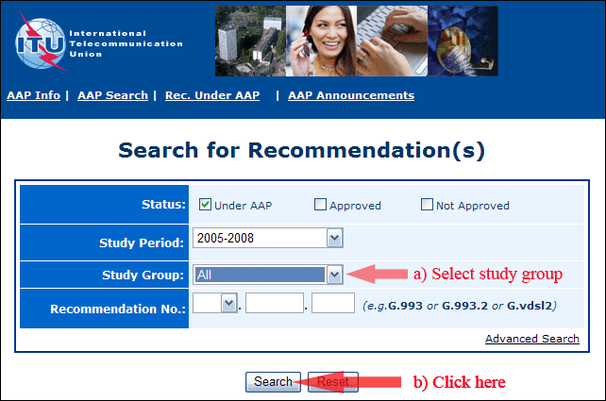
2) Select your Recommendation
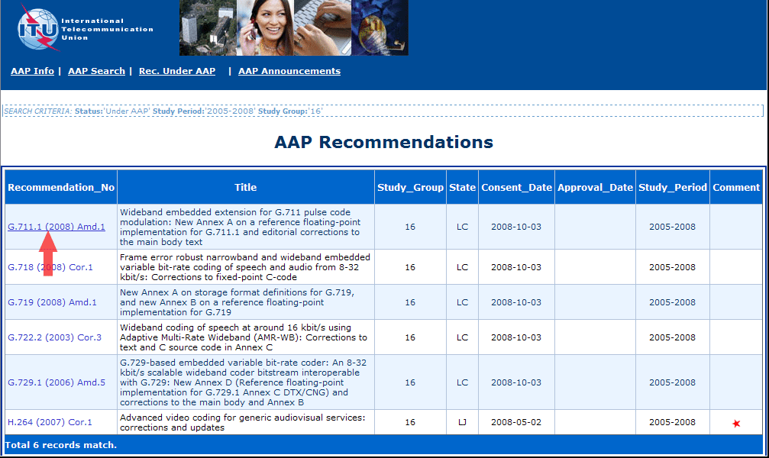
3) Click the "Submit Comment" button
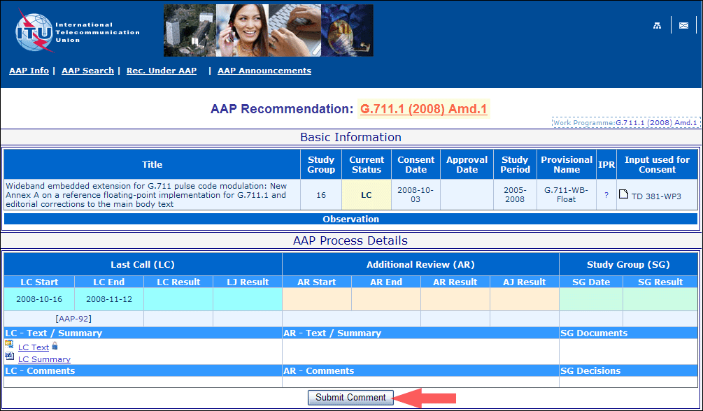
4) Complete the on-line form and click on "Submit"
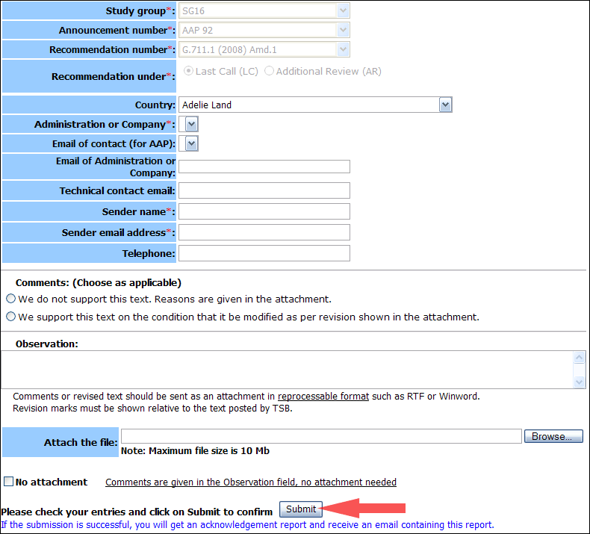
For more information, read the AAP tutorial on:
http://www.itu.int/ITU-T/aapinfo/files/AAPTutorial.pdf
Annex 3
(to TSB AAP-77)
Recommendations under LC/AR – Comment submission form
(Separate form for each Recommendation being commented upon)
ITU-T AAP comment submission form for the period 2009-2012
Study Group:
Announcement number:
Recommendation number:
Recommendation under: | Last call (LC)  Additional Review (AR)
Country:
Administration/Company:
Name of AAP Contact Person:
Email of AAP Contact Person:
Sender name:
(if different from AAP Contact Person)
Sender email address:
Telephone:
Comments:  (Choose as applicable) | We do not support this text. Reasons are given in the attachment.  We support this text on the condition that it be modified as per revision shown in the attachment.
Observations:
No attachment: Comments are given in the Observation field, no attachment needed
To be returned to: email: tsbsg....@itu.int
[or fax +41 22 730 5853]
Comments or revised text should be sent as an attachment in RTF or WinWord format.
Revision marks must be shown relative to the text posted by TSB.

