 | الا تحــاد الــدولي للاتصــالات  مكتب تقييس الاتصالات | 

 |  | جنيف، 1 ابريل 2016
المرجع:  الهاتف:  الفاكس:  البريد الإلكتروني: | TSB AAP-77  AAP/CL  +41 22 730 5860  +41 22 730 5853  tsbdir@itu.int | - إلى إدارات الدول الأعضاء في الاتحاد؛  - إلى أعضاء قطاع تقييس الاتصالات؛  - إلى المنتسبين إلى قطاع تقييس الاتصالات  نسخة إلى:  - رؤساء لجان الدراسات في قطاع تقييس الاتصالات ونوابهم؛  - مدير مكتب تنمية الاتصالات؛  - مدير مكتب الاتصالات الراديوية

الموضوع: حالة التوصيات الخاضعة لعملية الموافقة البديلة (AAP)

حضرات السادة والسيدات،
تحية طيبة وبعد،
تنطبق عملية الموافقة البديلة (AAP) المعرفة في التوصية ITU-T A.8 على التوصيات التي لا تنطوي على بعد سياسي أوتنظيمي ولا تتطلب بالتالي استشارة الدول الأعضاء رسمياً (انظر الرقم 246B من اتفاقية الاتحاد).
ويتضمن الملحق 1 لائحة بالنصوص التي تغيرت حالتها مقارنة بما جاء في إعلانات عملية الموافقة البديلة السابقة.
إذا رغبتم في تقديم تعليق بشأن توصية ما خاضعة لعملية الموافقة البديلة، فنرجو منكم استعمال استمارة التعليق على الخط المتوفّرة على موقع قطاع تقييس الاتصالات على صفحة عملية الموافقة البديلة http://www.itu.int/ITU-T/aap على المدخل الخاص بالتوصية المعنية (انظر الملحق (2. وبديلاً من ذلك، يمكنكم تقديم التعليقات باستكمال الاستمارة الواردة في الملحق 3 وإرسالها إلى أمانة لجنة الدراسات المعنية بالأمر.
وتجدر الإشارة إلى أنه يفضّل عدم إرسال تعليقات تقتصر على تأييد اعتماد النص قيد النظر.

وتفضلوا بقبول فائق الاحترام والتقدير.
تشيساب لي
مدير مكتب تقييس الاتصالات

الملحقات: 3

Annex 1
(to TSB AAP-77)

Status codes used in the AAP announcements:
LC = Last Call
LJ = Last Call Judgment (includes comment resolution)
AR = Additional Review
AJ = Additional Review Judgment (includes comment resolution)
SG = For Study Group approval
A = Approved
AT = Approved with typographic corrections
AC = Approved after Additional Review of Comments
NA = Not approved
TAP = Moved to TAP (ITU-T A.8 / § 5.2)
ITU-T website entry page:
http://www.itu.int/ITU-T
Alternative approval process (AAP) welcome page:
http://www.itu.int/ITU-T/aapinfo
Note – A tutorial on the ITU-T AAP application is available under the AAP welcome page
ITU-T website AAP Recommendation search page:
http://www.itu.int/ITU-T/aap/
Study Group web pages and contacts:
SG 2 | http://www.itu.int/ITU-T/studygroups/com02 | tsbsg2@itu.int
SG 3 | http://www.itu.int/ITU-T/studygroups/com03 | tsbsg3@itu.int
SG 5 | http://www.itu.int/ITU-T/studygroups/com05 | tsbsg5@itu.int
SG 9 | http://www.itu.int/ITU-T/studygroups/com09 | tsbsg9@itu.int
SG 11 | http://www.itu.int/ITU-T/studygroups/com11 | tsbsg11@itu.int
SG 12 | http://www.itu.int/ITU-T/studygroups/com12 | tsbsg12@itu.int
SG 13 | http://www.itu.int/ITU-T/studygroups/com13 | tsbsg13@itu.int
SG 15 | http://www.itu.int/ITU-T/studygroups/com15 | tsbsg15@itu.int
SG 16 | http://www.itu.int/ITU-T/studygroups/com16 | tsbsg16@itu.int
SG 17 | http://www.itu.int/ITU-T/studygroups/com17 | tsbsg17@itu.int

Situation concerning Study Group 2 Recommendations under AAP
Rec # | Title | Last Call (LC) Period |  |  |  | Additional Review (AR) Period |  |  |  | Status
Rec # | Title | LC Start | LC End | LC  Result | LJ  Result | AR Start | AR End | AR  Result | AJ  Result | Status
M.3070/Y.3521 (M.oe2eccm/Y.oe2eccm) | Overview of end-to-end cloud computing management (Summary) | 2016-02-16 | 2016-03-14 | LJ | AT |  |  |  |  | AT
Situation concerning Study Group 13 Recommendations under AAP
Rec # | Title | Last Call (LC) Period |  |  |  | Additional Review (AR) Period |  |  |  | Status
Rec # | Title | LC Start | LC End | LC  Result | LJ  Result | AR Start | AR End | AR  Result | AJ  Result | Status
Y.3521/M.3070 (M.oe2eccm/Y.oe2eccm) | Overview of end-to-end cloud computing management (Summary) | 2016-02-16 | 2016-03-14 | LJ | AT |  |  |  |  | AT
Situation concerning Study Group 15 Recommendations under AAP
Rec # | Title | Last Call (LC) Period |  |  |  | Additional Review (AR) Period |  |  |  | Status
Rec # | Title | LC Start | LC End | LC  Result | LJ  Result | AR Start | AR End | AR  Result | AJ  Result | Status
G.987.1 | 10-Gigabit-capable passive optical networks (XG-PON): General requirements (Summary) | 2016-03-01 | 2016-03-28 | A |  |  |  |  |  | A
G.988 (2012) Amd.2 | ONU management and control interface (OMCI) specification: Amendment 2 (Summary) | 2016-03-01 | 2016-03-28 | LJ |  |  |  |  |  | LJ
G.993.2 (2015) Amd.2 | Very high speed digital subscriber line transceivers 2 (VDSL2): Amendment 2 (Summary) | 2016-03-01 | 2016-03-28 | A |  |  |  |  |  | A
G.997.1 (2012) Amd.6 | Physical layer management for digital subscriber line transceivers: Amendment 6 (Summary) | 2016-03-01 | 2016-03-28 | A |  |  |  |  |  | A
G.997.2 (2015) Amd.1 | Physical layer management for G.fast transceivers: Amendment 1 (Summary) | 2016-03-01 | 2016-03-28 | LJ |  |  |  |  |  | LJ
G.997.2 (2015) Cor.1 | Physical layer management for G.fast transceivers: Corrigendum 1 (Summary) | 2016-03-01 | 2016-03-28 | A |  |  |  |  |  | A
G.8275.1/Y.1369.1 | Precision time protocol telecom profile for phase/time synchronization with full timing support from the network (Summary) | 2016-04-01 | 2016-04-28 |  |  |  |  |  |  | LC
G.8275.2/Y.1369.2 | Precision time Protocol Telecom Profile for time/phase synchronization with partial timing support from the network (Summary) | 2016-04-01 | 2016-04-28 |  |  |  |  |  |  | LC
G.9701 (2014) Amd.1 | Fast access to subscriber terminals (G.fast) - Physical layer specification: Amendment 1 (Summary) | 2016-03-01 | 2016-03-28 | LJ |  |  |  |  |  | LJ
G.9701 (2014) Cor.2 | Fast access to subscriber terminals (G.fast) - Physical layer specification: Corrigendum 2 (Summary) | 2016-03-01 | 2016-03-28 | LJ |  |  |  |  |  | LJ
Situation concerning Study Group 17 Recommendations under AAP
Rec # | Title | Last Call (LC) Period |  |  |  | Additional Review (AR) Period |  |  |  | Status
Rec # | Title | LC Start | LC End | LC  Result | LJ  Result | AR Start | AR End | AR  Result | AJ  Result | Status
X.509 (2012) Cor.2 | Information technology - Open Systems Interconnection - The Directory: Public-key and attribute certificate frameworks - Technical Corrigendum 2 (Summary) | 2016-04-01 | 2016-04-28 |  |  |  |  |  |  | LC
X.894 (X.cms) | Information technology - Generic applications of ASN.1 - Cryptographic Message Syntax - Generic applications of ASN.1 - Cryptographic Message Syntax (Summary) | 2016-04-01 | 2016-04-28 |  |  |  |  |  |  | LC
X.1033 (X.gsiiso) | Guidelines on security of the individual information service provided by the operators (Summary) | 2016-04-01 | 2016-04-28 |  |  |  |  |  |  | LC
X.1051 (X.1051rev) | Information technology - Security techniques - Code of practice for Information security controls based on ISO/IEC 27002 for telecommunications organizations (Summary) | 2016-04-01 | 2016-04-28 |  |  |  |  |  |  | LC
Z.100 (Z.100) | Specification and Description Language: Overview of SDL-2010 (Summary) | 2016-04-01 | 2016-04-28 |  |  |  |  |  |  | LC
Z.101 | Specification and Description Language: Basic SDL-2010 (Summary) | 2016-04-01 | 2016-04-28 |  |  |  |  |  |  | LC
Z.102 | Specification and Description Language: Comprehensive SDL-2010 (Summary) | 2016-04-01 | 2016-04-28 |  |  |  |  |  |  | LC
Z.103 | Specification and Description Language: Shorthand notation and annotation in SDL-2010 (Summary) | 2016-04-01 | 2016-04-28 |  |  |  |  |  |  | LC
Z.104 (Z.104) | Specification and Description Language: Data and action language in SDL-2010 (Summary) | 2016-04-01 | 2016-04-28 |  |  |  |  |  |  | LC
Z.105 | Specification and Description Language: SDL-2010 combined with ASN.1 modules (Summary) | 2016-04-01 | 2016-04-28 |  |  |  |  |  |  | LC
Z.106 (Z.106) | Specification and Description Language: Common interchange format for SDL-2010 (Summary) | 2016-04-01 | 2016-04-28 |  |  |  |  |  |  | LC
Z.107 | Specification and Description Language: Object-oriented data in SDL-2010 (Summary) | 2016-04-01 | 2016-04-28 |  |  |  |  |  |  | LC
Z.111 | Notations and guidelines for the definition of ITU-T languages (Summary) | 2016-04-01 | 2016-04-28 |  |  |  |  |  |  | LC

Annex 2
(to TSB AAP-77)
Using the on-line comment submission form
Comment submission
1) Go to AAP search Web page at http://www.itu.int/ITU-T/aap/
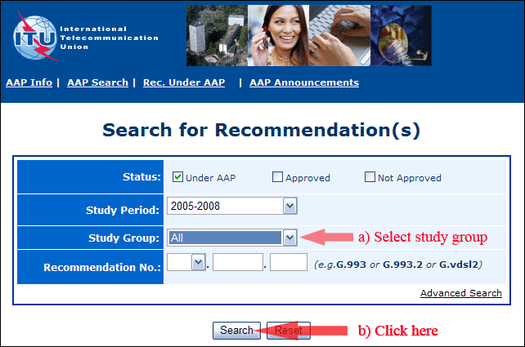
2) Select your Recommendation
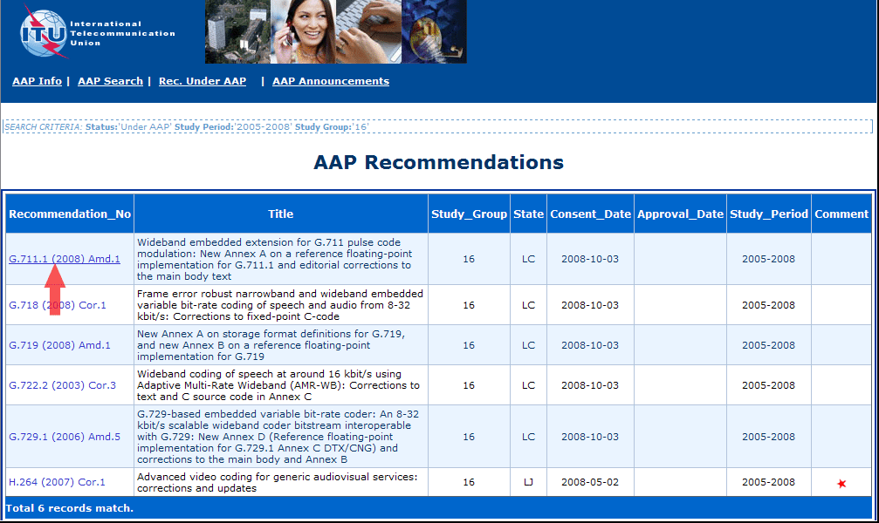
3) Click the "Submit Comment" button
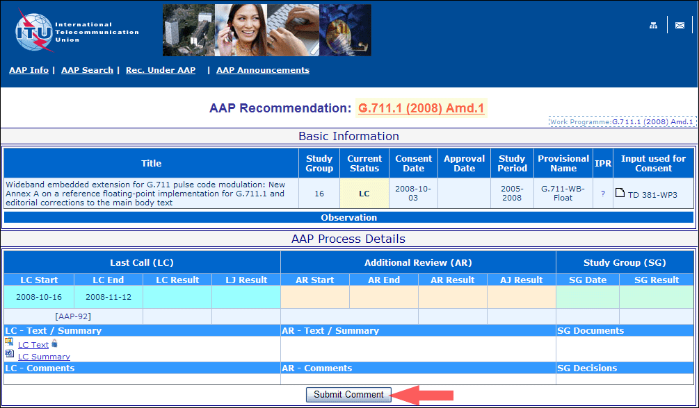
4) Complete the on-line form and click on "Submit"
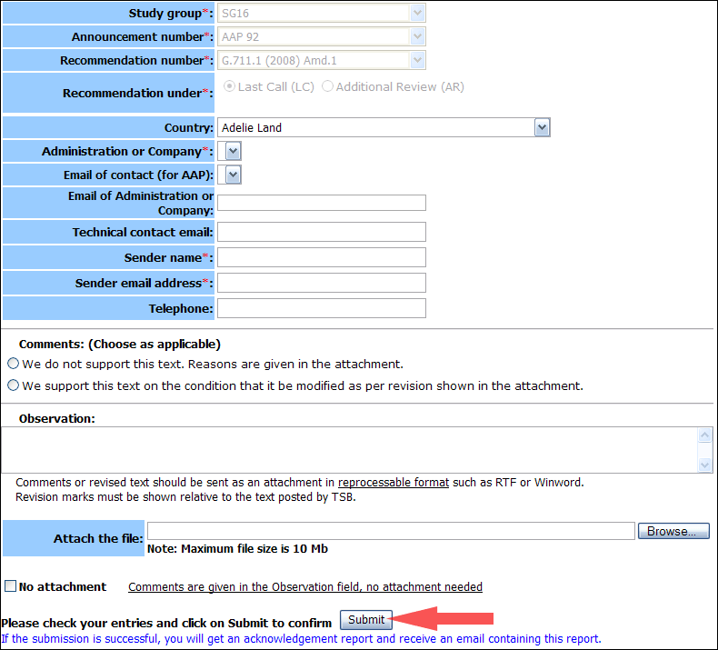
For more information, read the AAP tutorial on:
http://www.itu.int/ITU-T/aapinfo/files/AAPTutorial.pdf
Annex 3
(to TSB AAP-77)
Recommendations under LC/AR – Comment submission form
(Separate form for each Recommendation being commented upon)
ITU-T AAP comment submission form for the period 2009-2012
Study Group:
Announcement number:
Recommendation number:
Recommendation under: | Last call (LC)  Additional Review (AR)
Country:
Administration/Company:
Name of AAP Contact Person:
Email of AAP Contact Person:
Sender name:
(if different from AAP Contact Person)
Sender email address:
Telephone:
Comments:  (Choose as applicable) | We do not support this text. Reasons are given in the attachment.  We support this text on the condition that it be modified as per revision shown in the attachment.
Observations:
No attachment: Comments are given in the Observation field, no attachment needed
To be returned to: email: tsbsg....@itu.int
[or fax +41 22 730 5853]
Comments or revised text should be sent as an attachment in RTF or WinWord format.
Revision marks must be shown relative to the text posted by TSB.

