International Telecommunication Union
Telecommunication Standardization Bureau

Geneva, 1 December 2015

Ref:  Tel:  Fax:  E-mail: | TSB AAP-70  AAP/CL  +41 22 730 5860  +41 22 730 5853  tsbdir@itu.int | – To Administrations of Member States of the Union;  – To ITU-T Sector Members;  – To ITU-T Associates  Copy:  – To the ITU-T Study Group Chairmen and Vice-Chairmen;  – To the Director of the Telecommunication Development Bureau;  – To the Director of the Radiocommunication Bureau

Subject: | Situation concerning Recommendations under the Alternative Approval Process (AAP)

Dear Sir/Madam,
The Alternative Approval Process (AAP) defined in Rec. ITU-T A.8 applies to Recommendations which do not have policy or regulatory implications and which, therefore, do not require formal consultation of Member States (see ITU Convention 246B).
Annex 1 lists those texts whose status has changed compared with previous TSB AAP Announcements.
If you wish to submit a comment relative to a Recommendation under AAP, you are encouraged to use the on-line AAP comment submission form available on the page of the Recommendation in the AAP area of the ITU-T website at http://www.itu.int/ITU-T/aap (see Annex 2). Alternatively, comments can be submitted by completing the form in Annex 3 and sending it to the secretariat of the concerned study group.
Please note that comments that simply support adoption of the text in question are not encouraged.
Yours faithfully,
Chaesub Lee
Director of the Telecommunication Standardization Bureau
Annexes: 3

Annex 1
(to TSB AAP-70)

Status codes used in the AAP announcements:
LC = Last Call
LJ = Last Call Judgment (includes comment resolution)
AR = Additional Review
AJ = Additional Review Judgment (includes comment resolution)
SG = For Study Group approval
A = Approved
AT = Approved with typographic corrections
AC = Approved after Additional Review of Comments
NA = Not approved
TAP = Moved to TAP (ITU-T A.8 / § 5.2)
ITU-T website entry page:
http://www.itu.int/ITU-T
Alternative approval process (AAP) welcome page:
http://www.itu.int/ITU-T/aapinfo
Note – A tutorial on the ITU-T AAP application is available under the AAP welcome page
ITU-T website AAP Recommendation search page:
http://www.itu.int/ITU-T/aap/
Study Group web pages and contacts:
SG 2 | http://www.itu.int/ITU-T/studygroups/com02 | tsbsg2@itu.int
SG 3 | http://www.itu.int/ITU-T/studygroups/com03 | tsbsg3@itu.int
SG 5 | http://www.itu.int/ITU-T/studygroups/com05 | tsbsg5@itu.int
SG 9 | http://www.itu.int/ITU-T/studygroups/com09 | tsbsg9@itu.int
SG 11 | http://www.itu.int/ITU-T/studygroups/com11 | tsbsg11@itu.int
SG 12 | http://www.itu.int/ITU-T/studygroups/com12 | tsbsg12@itu.int
SG 13 | http://www.itu.int/ITU-T/studygroups/com13 | tsbsg13@itu.int
SG 15 | http://www.itu.int/ITU-T/studygroups/com15 | tsbsg15@itu.int
SG 16 | http://www.itu.int/ITU-T/studygroups/com16 | tsbsg16@itu.int
SG 17 | http://www.itu.int/ITU-T/studygroups/com17 | tsbsg17@itu.int

Situation concerning Study Group 5 Recommendations under AAP
Rec # | Title | Last Call (LC) Period |  |  |  | Additional Review (AR) Period |  |  |  | Status
 |  | LC Start | LC End | LC  Result | LJ  Result | AR Start | AR End | AR  Result | AJ  Result
K.107 (K.hvps2) | Method for determining the impedance to earth of earthing systems (Summary) | 2015-11-01 | 2015-11-28 | A |  |  |  |  |  | A
K.108 (K.jup) | Joint-use of poles by telecommunication and solidly earthed power lines (Summary) | 2015-11-01 | 2015-11-28 | A |  |  |  |  |  | A
K.109 (K.tup) | Installation of telecommunication equipment on utility poles (Summary) | 2015-11-01 | 2015-11-28 | A |  |  |  |  |  | A
K.111 (K.ntt) | Protection of surrounding structures of telecommunication towers against lightning (Summary) | 2015-11-01 | 2015-11-28 | A |  |  |  |  |  | A
K.113 (K.maps) | Generation of radiofrequency electromagnetic fields (RF-EMF) level maps (Summary) | 2015-11-01 | 2015-11-28 | A |  |  |  |  |  | A
K.114 (K.bts_emc) | Electromagnetic compatibility requirements and measurement methods for digital cellular mobile communication base station equipment (Summary) | 2015-11-01 | 2015-11-28 | A |  |  |  |  |  | A
K.115 (K.secmiti) | Mitigation methods against electromagnetic security threats (Summary) | 2015-11-01 | 2015-11-28 | A |  |  |  |  |  | A
K.116 (K.ter_emc) | EMC requirements and test methods for radio telecommunication terminal equipment (Summary) | 2015-11-01 | 2015-11-28 | A |  |  |  |  |  | A
L.1302 (L. Assessment_DC) | Assessment of energy efficiency on infrastructure in data centre and telecom centre (Summary) | 2015-11-01 | 2015-11-28 | A |  |  |  |  |  | A
L.1502 (L.Infrastructure Adaptation) | Adapting information and communication technology infrastructure to the effects of climate change (Summary) | 2015-11-01 | 2015-11-28 | A |  |  |  |  |  | A
L.1503 (L.Cities Adaptation) | Information and communication technologies for climate change adaptation in cities (Summary) | 2015-11-01 | 2015-11-28 | LJ |  |  |  |  |  | LJ
Situation concerning Study Group 15 Recommendations under AAP
Rec # | Title | Last Call (LC) Period |  |  |  | Additional Review (AR) Period |  |  |  | Status
 |  | LC Start | LC End | LC  Result | LJ  Result | AR Start | AR End | AR  Result | AJ  Result
G.9701 (2014) Cor.1 | Fast access to subscriber terminals (G.fast) - Physical layer specification: Corrigendum 1 (Summary) | 2015-08-01 | 2015-08-28 | LJ | AR | 2015-11-01 | 2015-11-21 | AC |  | AC
G.9960 (2015) Amd.1 | Unified high-speed wireline-based home networking transceivers - System architecture and physical layer specification: Amendment 1 (Summary) | 2015-08-01 | 2015-08-28 | LJ | AR | 2015-11-01 | 2015-11-21 | AC |  | AC
G.9960 (2015) Cor.1 | Unified high-speed wireline-based home networking transceivers - System architecture and physical layer specification: Corrigendum 1 (Summary) | 2015-08-01 | 2015-08-28 | LJ | AR | 2015-11-01 | 2015-11-21 | AC |  | AC
G.9961 (2015) Amd.1 (G.hn) | Unified high-speed wire-line based home networking transceivers - Data link layer specification: Amendment 1 (Summary) | 2015-08-01 | 2015-08-28 | LJ | AR | 2015-11-01 | 2015-11-21 | AC |  | AC
G.9961 (2015) Cor.1 (G.hn) | Unified high-speed wire-line based home networking transceivers - Data link layer specification: Corrigendum 1 (Summary) | 2015-08-01 | 2015-08-28 | LJ | AR | 2015-11-01 | 2015-11-21 | AC |  | AC
Situation concerning Study Group 16 Recommendations under AAP
Rec # | Title | Last Call (LC) Period |  |  |  | Additional Review (AR) Period |  |  |  | Status
 |  | LC Start | LC End | LC  Result | LJ  Result | AR Start | AR End | AR  Result | AJ  Result
F.746.3 (H.IQAS) | Intelligent question answering service framework (Summary) | 2015-11-01 | 2015-11-28 | A |  |  |  |  |  | A
F.747.8 (F.IoT-ASM) | Requirements and reference architecture for audience-selectable media service framework in the IoT environment (Summary) | 2015-11-01 | 2015-11-28 | A |  |  |  |  |  | A
F.748.2 (F.MS-ref) | Machine socialization: Overview and reference model (Summary) | 2015-11-01 | 2015-11-28 | A |  |  |  |  |  | A
F.748.3 (F.MS-RM) | Machine socialization: Relation management and descriptions in IoT applications (Summary) | 2015-11-01 | 2015-11-28 | A |  |  |  |  |  | A
F.748.5 (F.M2M-RA) | Requirements and reference architecture of M2M service layer (Summary) | 2015-11-01 | 2015-11-28 | A |  |  |  |  |  | A
F.749.1 (H.VG-FAM, ex H.VGP-FAM) | Functional requirements for vehicle gateways (Summary) | 2015-11-01 | 2015-11-28 | A |  |  |  |  |  | A
F.791 (F.ACC-TERM, ex HSTP.ACC-TERM) | Accessibility terms and definitions (Summary) | 2015-11-01 | 2015-11-28 | A |  |  |  |  |  | A
H.222.0 (2014) Amd.1 Cor.1 | Information technology - Generic coding of moving pictures and associated audio information: Systems: Delivery of Timeline for External Data: Adding cets_byte_range_descriptor to table U-2 (Summary) | 2015-11-01 | 2015-11-28 | A |  |  |  |  |  | A
H.248.41 | Gateway control protocol: IP domain connection package (Summary) | 2015-11-01 | 2015-11-28 | A |  |  |  |  |  | A
H.248.78 (H.248.78 Amd.1) | Gateway control protocol: Bearer-level message backhauling and application level gateway (Summary) | 2015-11-01 | 2015-11-28 | A |  |  |  |  |  | A
H.248.94 (H.248.WEBRTC) | Gateway control protocol: Web-based real-time communication services - H.248 protocol support and profile guidelines (Summary) | 2015-11-01 | 2015-11-28 | A |  |  |  |  |  | A
H.248.95 (H.248.RTPMUX) | Gateway control protocol: H.248 Support for RTP multiplexing (Summary) | 2015-11-01 | 2015-11-28 | A |  |  |  |  |  | A
H.248.96 (H.248.STGROUP) | Gateway control protocol: H.248 Stream grouping and aggregation (Summary) | 2015-11-01 | 2015-11-28 | A |  |  |  |  |  | A
H.248.97 (H.248.SCTP) | Gateway Control Protocol: H.248 support for control of SCTP bearer connections (New) (Summary) | 2015-11-01 | 2015-11-28 | A |  |  |  |  |  | A
H.460.27 (H.460.SessionID) | End-to-end session identifier for H.323 systems (Summary) | 2015-11-01 | 2015-11-28 | A |  |  |  |  |  | A
H.622.2 (H.VHN) | Service capabilities and framework for virtual home networks (Summary) | 2015-11-01 | 2015-11-28 | A |  |  |  |  |  | A
H.623 (H.WoT-SA) | Web of things service architecture (Summary) | 2015-11-01 | 2015-11-28 | A |  |  |  |  |  | A
H.702 (H.IPTV-ACCProf) | Accessibility profiles for IPTV systems (Summary) | 2015-11-01 | 2015-11-28 | A |  |  |  |  |  | A
H.752 (H.IPTV-CPI, ex H.IPTV-CPMD) | Multimedia content provisioning interface for IPTV services (Summary) | 2015-11-01 | 2015-11-28 | A |  |  |  |  |  | A
H.772 (H.IPTV-TDD) | IPTV terminal device discovery (Summary) | 2015-11-01 | 2015-11-28 | A |  |  |  |  |  | A
H.810 (H.810.R) | Interoperability design guidelines for personal health systems (Summary) | 2015-11-01 | 2015-11-28 | A |  |  |  |  |  | A
H.811 (H.81x-TPL-IF) | Interoperability design guidelines for personal health systems: PAN/LAN/TAN interface (Summary) | 2015-11-01 | 2015-11-28 | A |  |  |  |  |  | A
H.812 (H.81x-WAN-IF) | Interoperability design guidelines for personal health systems: WAN interface: Common certified device class (Summary) | 2015-11-01 | 2015-11-28 | A |  |  |  |  |  | A
H.812.1 (H.81x-WAN-IF.1) | Interoperability design guidelines for personal health systems: WAN interface: Observation upload certified device class (Summary) | 2015-11-01 | 2015-11-28 | A |  |  |  |  |  | A
H.812.2 (H.81x-WAN-IF.2) | Interoperability design guidelines for personal health systems: WAN interface: Questionnaires (Summary) | 2015-11-01 | 2015-11-28 | A |  |  |  |  |  | A
H.812.3 (H.81x-WAN-IF.3) | Interoperability design guidelines for personal health systems: WAN interface: Capability exchange certified device class (Summary) | 2015-11-01 | 2015-11-28 | A |  |  |  |  |  | A
H.812.4 (H.81x-WAN-IF.4) | Interoperability design guidelines for personal health systems: WAN interface: Authenticated persistent session device class (Summary) | 2015-11-01 | 2015-11-28 | A |  |  |  |  |  | A
H.813 (H.81x-HRN-IF) | Interoperability design guidelines for personal health systems: Health record network (HRN) interface (Summary) | 2015-11-01 | 2015-11-28 | A |  |  |  |  |  | A
H.830.10 (H.EH-WAN-10) | Conformance testing: WAN interface Part 10: hData observation upload: Receiver (Summary) | 2015-11-01 | 2015-11-28 | A |  |  |  |  |  | A
H.830.11 (H.EH-WAN-11) | Conformance testing: WAN interface Part 11: Questionnaires: Sender (Summary) | 2015-11-01 | 2015-11-28 | A |  |  |  |  |  | A
H.830.12 (H.EH-WAN-12) | Conformance testing: WAN interface Part 12: Questionnaires: Receiver (Summary) | 2015-11-01 | 2015-11-28 | A |  |  |  |  |  | A
H.830.9 (H.EH-WAN-9) | Conformance testing: WAN interface Part 9: hData observation upload: Sender (Summary) | 2015-11-01 | 2015-11-28 | A |  |  |  |  |  | A
H.845.15 (H.EH-PAN-05.15) | Conformance testing: PAN/LAN/TAN interface Part 5O: Sleep apnoea breathing therapy equipment: Agent (Summary) | 2015-11-01 | 2015-11-28 | A |  |  |  |  |  | A
T.24 Cor.1 | Standardized digitized image set: Clarifications in Table 1 (Summary) | 2015-11-01 | 2015-11-28 | A |  |  |  |  |  | A
T.38 | Procedures for real-time Group 3 facsimile communication over IP networks (Summary) | 2015-11-01 | 2015-11-28 | A |  |  |  |  |  | A
T.800 | Information technology - JPEG 2000 image coding system: Core coding system (Summary) | 2015-11-01 | 2015-11-28 | A |  |  |  |  |  | A

Annex 2
(to TSB AAP-70)
Using the on-line comment submission form
Comment submission
1) Go to AAP search Web page at http://www.itu.int/ITU-T/aap/
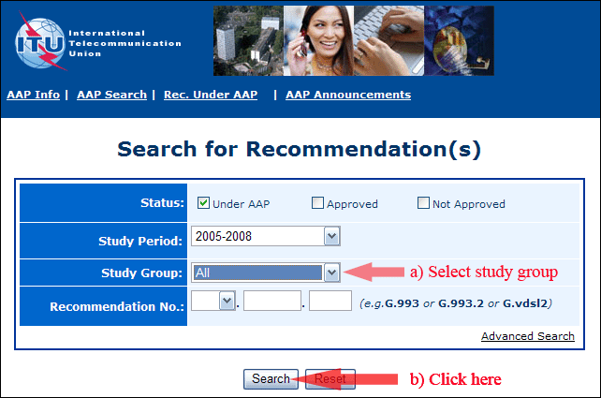
2) Select your Recommendation
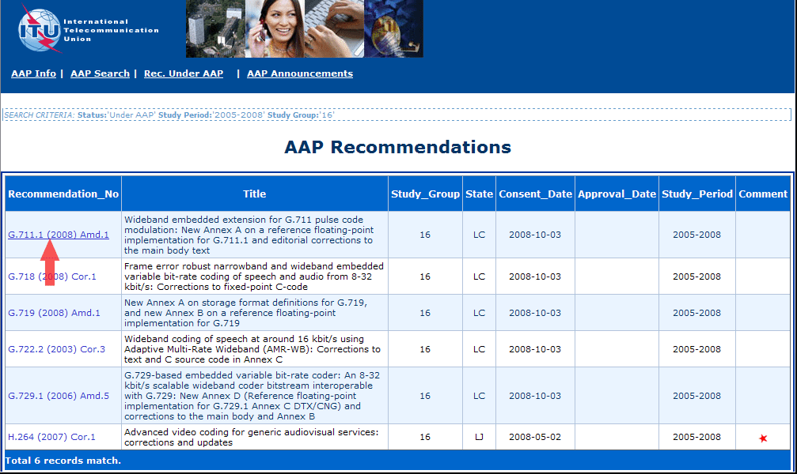
3) Click the "Submit Comment" button
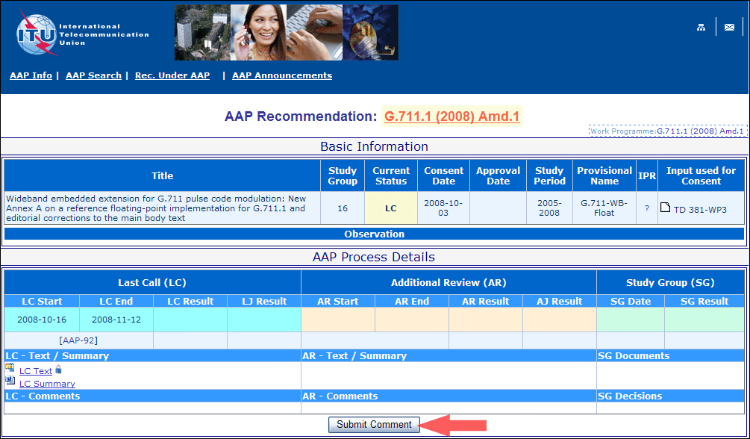
4) Complete the on-line form and click on "Submit"
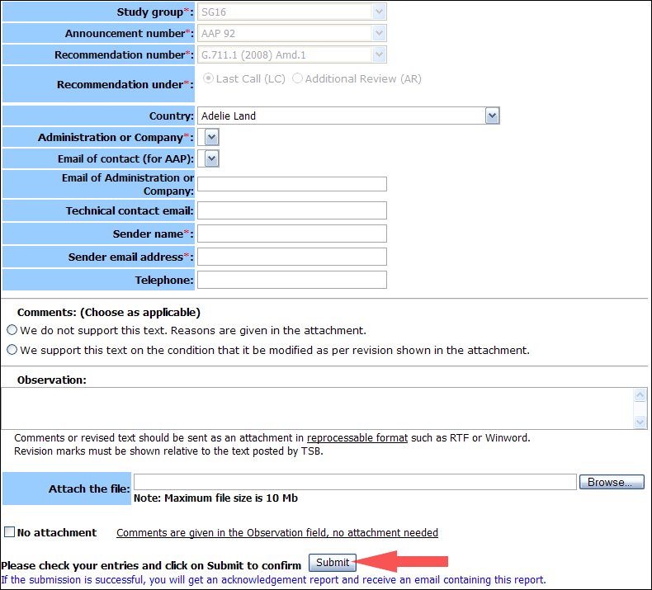
For more information, read the AAP tutorial on:
http://www.itu.int/ITU-T/aapinfo/files/AAPTutorial.pdf
Annex 3
(to TSB AAP-70)
Recommendations under LC/AR – Comment submission form
(Separate form for each Recommendation being commented upon)
ITU-T AAP comment submission form for the period 2009-2012
Study Group:
Announcement number:
Recommendation number:
Recommendation under: | Last call (LC)  Additional Review (AR)
Country:
Administration/Company:
Name of AAP Contact Person:
Email of AAP Contact Person:
Sender name:
(if different from AAP Contact Person)
Sender email address:
Telephone:
Comments:  (Choose as applicable) | We do not support this text. Reasons are given in the attachment.  We support this text on the condition that it be modified as per revision shown in the attachment.
Observations:
No attachment: Comments are given in the Observation field, no attachment needed
To be returned to: email: tsbsg....@itu.int
[or fax +41 22 730 5853]
Comments or revised text should be sent as an attachment in RTF or WinWord format.
Revision marks must be shown relative to the text posted by TSB.

