 | Union Internationale des Telecommunications  Bureau de la normalisation des télécommunications | 

Genève, le 1 novembre 2015

Réf:  Tél:  Fax:  E-mail: | TSB AAP-68  AAP/CL  +41 22 730 5860  +41 22 730 5853  tsbdir@itu.int | – Aux administrations des Etats Membres de l'Union;  – Aux Membres du Secteur UIT-T;  – Aux Associés de l'UIT-T  Copie:  – Aux Présidents et Vice-Présidents des Commissions d'études de l'UIT-T;  – Au Directeur du Bureau de développement des télécommunications;  – Au Directeur du Bureau des radiocommunications

Objet: | Etat des Recommandations auxquelles s'applique la variante de la procédure d'approbation (AAP)

Madame, Monsieur,

La variante de la procédure d'approbation (AAP), définie dans la Recommandation UIT-T A.8, s'applique aux Recommandations qui n'ont pas d'incidence politique ou réglementaire et ne nécessitent donc pas une consultation formelle des Etats Membres (voir le numéro 246B de la Convention de l'UIT).
L'Annexe 1 énumère les textes dont le statut a changé par rapport aux annonces TSB AAP antérieures.
Si vous souhaitez soumettre des observations sur une Recommandation ayant fait l'objet de la procédure AAP, vous êtes encouragés à utiliser le formulaire en ligne de soumission des observations AAP, disponible dans l'espace AAP du site web de l'UIT-T à l'adresse http://www.itu.int/ITU-T/aap/, à la page de la Recommandation concernée (voir l'Annexe 2). Vous pouvez aussi soumettre vos observations en remplissant le formulaire figurant à l'Annexe 3 et en l'envoyant au secrétariat de la Commission d'études concernée.
Veuillez noter que les observations ayant simplement pour objet d'appuyer l'adoption du texte en question ne sont pas encouragées.
Veuillez agréer, Madame, Monsieur, l'assurance de ma considération distinguée.
Chaesub Lee
Directeur du Bureau de la normalisation des télécommunications

Annexes: 3

Annex 1
(to TSB AAP-68)

Status codes used in the AAP announcements:
LC = Last Call
LJ = Last Call Judgment (includes comment resolution)
AR = Additional Review
AJ = Additional Review Judgment (includes comment resolution)
SG = For Study Group approval
A = Approved
AT = Approved with typographic corrections
AC = Approved after Additional Review of Comments
NA = Not approved
TAP = Moved to TAP (ITU-T A.8 / § 5.2)
ITU-T website entry page:
http://www.itu.int/ITU-T
Alternative approval process (AAP) welcome page:
http://www.itu.int/ITU-T/aapinfo
Note – A tutorial on the ITU-T AAP application is available under the AAP welcome page
ITU-T website AAP Recommendation search page:
http://www.itu.int/ITU-T/aap/
Study Group web pages and contacts:
SG 2 | http://www.itu.int/ITU-T/studygroups/com02 | tsbsg2@itu.int
SG 3 | http://www.itu.int/ITU-T/studygroups/com03 | tsbsg3@itu.int
SG 5 | http://www.itu.int/ITU-T/studygroups/com05 | tsbsg5@itu.int
SG 9 | http://www.itu.int/ITU-T/studygroups/com09 | tsbsg9@itu.int
SG 11 | http://www.itu.int/ITU-T/studygroups/com11 | tsbsg11@itu.int
SG 12 | http://www.itu.int/ITU-T/studygroups/com12 | tsbsg12@itu.int
SG 13 | http://www.itu.int/ITU-T/studygroups/com13 | tsbsg13@itu.int
SG 15 | http://www.itu.int/ITU-T/studygroups/com15 | tsbsg15@itu.int
SG 16 | http://www.itu.int/ITU-T/studygroups/com16 | tsbsg16@itu.int
SG 17 | http://www.itu.int/ITU-T/studygroups/com17 | tsbsg17@itu.int

Situation concerning Study Group 5 Recommendations under AAP
Rec # | Title | Last Call (LC) Period |  |  |  | Additional Review (AR) Period |  |  |  | Status
Rec # | Title | LC Start | LC End | LC  Result | LJ  Result | AR Start | AR End | AR  Result | AJ  Result | Status
K.107 (K.hvps2) | Method for determining the impedance to earth of earthing systems (Summary) | 2015-11-01 | 2015-11-28 |  |  |  |  |  |  | LC
K.108 (K.jup) | Joint-use of poles by telecommunication and solidly earthed power lines (Summary) | 2015-11-01 | 2015-11-28 |  |  |  |  |  |  | LC
K.109 (K.tup) | Installation of telecommunication equipment on utility poles (Summary) | 2015-11-01 | 2015-11-28 |  |  |  |  |  |  | LC
K.111 (K.ntt) | Protection of surrounding structures of telecommunication towers against lightning (Summary) | 2015-11-01 | 2015-11-28 |  |  |  |  |  |  | LC
K.113 (K.maps) | Generation of radiofrequency electromagnetic fields (RF-EMF) level maps (Summary) | 2015-11-01 | 2015-11-28 |  |  |  |  |  |  | LC
K.114 (K.bts_emc) | Electromagnetic compatibility requirements and measurement methods for digital cellular mobile communication base station equipment (Summary) | 2015-11-01 | 2015-11-28 |  |  |  |  |  |  | LC
K.115 (K.secmiti) | Mitigation methods against electromagnetic security threats (Summary) | 2015-11-01 | 2015-11-28 |  |  |  |  |  |  | LC
K.116 (K.ter_emc) | EMC requirements and test methods for radio telecommunication terminal equipment (Summary) | 2015-11-01 | 2015-11-28 |  |  |  |  |  |  | LC
L.1302 (L. Assessment_DC) | Assessment of energy efficiency on infrastructure in data centre and telecom centre (Summary) | 2015-11-01 | 2015-11-28 |  |  |  |  |  |  | LC
L.1440 (L.methodology_ICT in citi) | Methodology for environmental impact assessment of information and communication technologies at city level (Summary) | 2015-02-16 | 2015-03-15 | LJ | AR | 2015-08-01 | 2015-08-21 | SG |  | AC
L.1502 (L.Infrastructure Adaptation) | Adapting information and communication technology infrastructure to the effects of climate change (Summary) | 2015-11-01 | 2015-11-28 |  |  |  |  |  |  | LC
L.1503 (L.Cities Adaptation) | Information and communication technologies for climate change adaptation in cities (Summary) | 2015-11-01 | 2015-11-28 |  |  |  |  |  |  | LC
Situation concerning Study Group 15 Recommendations under AAP
Rec # | Title | Last Call (LC) Period |  |  |  | Additional Review (AR) Period |  |  |  | Status
Rec # | Title | LC Start | LC End | LC  Result | LJ  Result | AR Start | AR End | AR  Result | AJ  Result | Status
G.989 | 40-Gigabit-capable passive optical network (NG PON2): Definitions, abbreviations and acronyms (Summary) | 2015-07-16 | 2015-08-12 | LJ | AR | 2015-10-01 | 2015-10-21 | AC |  | AC
G.989.3 (G.ngpon2.3) | 40-Gigabit-capable passive optical networks (NG PON2): Transmission Convergence Layer Specification (Summary) | 2015-07-16 | 2015-08-12 | LJ | AR | 2015-10-01 | 2015-10-21 | AC |  | AC
G.9701 (2014) Cor.1 | Fast access to subscriber terminals (G.fast) - Physical layer specification: Corrigendum 1 (Summary) | 2015-08-01 | 2015-08-28 | LJ | AR | 2015-11-01 | 2015-11-21 |  |  | AR
G.9960 (2015) Amd.1 | Unified high-speed wireline-based home networking transceivers - System architecture and physical layer specification: Amendment 1 (Summary) | 2015-08-01 | 2015-08-28 | LJ | AR | 2015-11-01 | 2015-11-21 |  |  | AR
G.9960 (2015) Cor.1 | Unified high-speed wireline-based home networking transceivers - System architecture and physical layer specification: Corrigendum 1 (Summary) | 2015-08-01 | 2015-08-28 | LJ | AR | 2015-11-01 | 2015-11-21 |  |  | AR
G.9961 (2015) Amd.1 (G.hn) | Unified high-speed wire-line based home networking transceivers - Data link layer specification: Amendment 1 (Summary) | 2015-08-01 | 2015-08-28 | LJ | AR | 2015-11-01 | 2015-11-21 |  |  | AR
G.9961 (2015) Cor.1 (G.hn) | Unified high-speed wire-line based home networking transceivers - Data link layer specification: Corrigendum 1 (Summary) | 2015-08-01 | 2015-08-28 | LJ | AR | 2015-11-01 | 2015-11-21 |  |  | AR
Situation concerning Study Group 16 Recommendations under AAP
Rec # | Title | Last Call (LC) Period |  |  |  | Additional Review (AR) Period |  |  |  | Status
Rec # | Title | LC Start | LC End | LC  Result | LJ  Result | AR Start | AR End | AR  Result | AJ  Result | Status
F.746.3 (H.IQAS) | Intelligent question answering service framework (Summary) | 2015-11-01 | 2015-11-28 |  |  |  |  |  |  | LC
F.747.8 (F.IoT-ASM) | Requirements and reference architecture for audience-selectable media service framework in the IoT environment (Summary) | 2015-11-01 | 2015-11-28 |  |  |  |  |  |  | LC
F.748.2 (F.MS-ref) | Machine socialization: Overview and reference model (Summary) | 2015-11-01 | 2015-11-28 |  |  |  |  |  |  | LC
F.748.3 (F.MS-RM) | Machine socialization: Relation management and descriptions in IoT applications (Summary) | 2015-11-01 | 2015-11-28 |  |  |  |  |  |  | LC
F.748.5 (F.M2M-RA) | Requirements and reference architecture of M2M service layer (Summary) | 2015-11-01 | 2015-11-28 |  |  |  |  |  |  | LC
F.749.1 (H.VG-FAM, ex H.VGP-FAM) | Functional requirements for vehicle gateways (Summary) | 2015-11-01 | 2015-11-28 |  |  |  |  |  |  | LC
F.791 (F.ACC-TERM, ex HSTP.ACC-TERM) | Accessibility terms and definitions (Summary) | 2015-11-01 | 2015-11-28 |  |  |  |  |  |  | LC
H.222.0 (2014) Amd.1 Cor.1 | Information technology - Generic coding of moving pictures and associated audio information: Systems: Delivery of Timeline for External Data: Adding cets_byte_range_descriptor to table U-2 (Summary) | 2015-11-01 | 2015-11-28 |  |  |  |  |  |  | LC
H.248.41 | Gateway control protocol: IP domain connection package (Summary) | 2015-11-01 | 2015-11-28 |  |  |  |  |  |  | LC
H.248.78 (H.248.78 Amd.1) | Gateway control protocol: Bearer-level message backhauling and application level gateway (Summary) | 2015-11-01 | 2015-11-28 |  |  |  |  |  |  | LC
H.248.94 (H.248.WEBRTC) | Gateway control protocol: Web-based real-time communication services - H.248 protocol support and profile guidelines (Summary) | 2015-11-01 | 2015-11-28 |  |  |  |  |  |  | LC
H.248.95 (H.248.RTPMUX) | Gateway control protocol: H.248 Support for RTP multiplexing (Summary) | 2015-11-01 | 2015-11-28 |  |  |  |  |  |  | LC
H.248.96 (H.248.STGROUP) | Gateway control protocol: H.248 Stream grouping and aggregation (Summary) | 2015-11-01 | 2015-11-28 |  |  |  |  |  |  | LC
H.248.97 (H.248.SCTP) | Gateway Control Protocol: H.248 support for control of SCTP bearer connections (New) (Summary) | 2015-11-01 | 2015-11-28 |  |  |  |  |  |  | LC
H.460.27 (H.460.SessionID) | End-to-end session identifier for H.323 systems (Summary) | 2015-11-01 | 2015-11-28 |  |  |  |  |  |  | LC
H.622.2 (H.VHN) | Service capabilities and framework for virtual home networks (Summary) | 2015-11-01 | 2015-11-28 |  |  |  |  |  |  | LC
H.623 (H.WoT-SA) | Web of things service architecture (Summary) | 2015-11-01 | 2015-11-28 |  |  |  |  |  |  | LC
H.702 (H.IPTV-ACCProf) | Accessibility profiles for IPTV systems (Summary) | 2015-11-01 | 2015-11-28 |  |  |  |  |  |  | LC
H.752 (H.IPTV-CPI, ex H.IPTV-CPMD) | Multimedia content provisioning interface for IPTV services (Summary) | 2015-11-01 | 2015-11-28 |  |  |  |  |  |  | LC
H.772 (H.IPTV-TDD) | IPTV terminal device discovery (Summary) | 2015-11-01 | 2015-11-28 |  |  |  |  |  |  | LC
H.810 (H.810.R) | Interoperability design guidelines for personal health systems (Summary) | 2015-11-01 | 2015-11-28 |  |  |  |  |  |  | LC
H.811 (H.81x-TPL-IF) | Interoperability design guidelines for personal health systems: PAN/LAN/TAN interface (Summary) | 2015-11-01 | 2015-11-28 |  |  |  |  |  |  | LC
H.812 (H.81x-WAN-IF) | Interoperability design guidelines for personal health systems: WAN interface: Common certified device class (Summary) | 2015-11-01 | 2015-11-28 |  |  |  |  |  |  | LC
H.812.1 (H.81x-WAN-IF.1) | Interoperability design guidelines for personal health systems: WAN interface: Observation upload certified device class (Summary) | 2015-11-01 | 2015-11-28 |  |  |  |  |  |  | LC
H.812.2 (H.81x-WAN-IF.2) | Interoperability design guidelines for personal health systems: WAN interface: Questionnaires (Summary) | 2015-11-01 | 2015-11-28 |  |  |  |  |  |  | LC
H.812.3 (H.81x-WAN-IF.3) | Interoperability design guidelines for personal health systems: WAN interface: Capability exchange certified device class (Summary) | 2015-11-01 | 2015-11-28 |  |  |  |  |  |  | LC
H.812.4 (H.81x-WAN-IF.4) | Interoperability design guidelines for personal health systems: WAN interface: Authenticated persistent session device class (Summary) | 2015-11-01 | 2015-11-28 |  |  |  |  |  |  | LC
H.813 (H.81x-HRN-IF) | Interoperability design guidelines for personal health systems: Health record network (HRN) interface (Summary) | 2015-11-01 | 2015-11-28 |  |  |  |  |  |  | LC
H.830.10 (H.EH-WAN-10) | Conformance testing: WAN interface Part 10: hData observation upload: Receiver (Summary) | 2015-11-01 | 2015-11-28 |  |  |  |  |  |  | LC
H.830.11 (H.EH-WAN-11) | Conformance testing: WAN interface Part 11: Questionnaires: Sender (Summary) | 2015-11-01 | 2015-11-28 |  |  |  |  |  |  | LC
H.830.12 (H.EH-WAN-12) | Conformance testing: WAN interface Part 12: Questionnaires: Receiver (Summary) | 2015-11-01 | 2015-11-28 |  |  |  |  |  |  | LC
H.830.9 (H.EH-WAN-9) | Conformance testing: WAN interface Part 9: hData observation upload: Sender (Summary) | 2015-11-01 | 2015-11-28 |  |  |  |  |  |  | LC
H.845.15 (H.EH-PAN-05.15) | Conformance testing: PAN/LAN/TAN interface Part 5O: Sleep apnoea breathing therapy equipment: Agent (Summary) | 2015-11-01 | 2015-11-28 |  |  |  |  |  |  | LC
T.24 Cor.1 | Standardized digitized image set: Clarifications in Table 1 (Summary) | 2015-11-01 | 2015-11-28 |  |  |  |  |  |  | LC
T.38 | Procedures for real-time Group 3 facsimile communication over IP networks (Summary) | 2015-11-01 | 2015-11-28 |  |  |  |  |  |  | LC
T.800 | Information technology - JPEG 2000 image coding system: Core coding system (Summary) | 2015-11-01 | 2015-11-28 |  |  |  |  |  |  | LC
Situation concerning Study Group 17 Recommendations under AAP
Rec # | Title | Last Call (LC) Period |  |  |  | Additional Review (AR) Period |  |  |  | Status
Rec # | Title | LC Start | LC End | LC  Result | LJ  Result | AR Start | AR End | AR  Result | AJ  Result | Status
X.1155 (X.sap-5) | Guidelines on local linkable anonymous authentication for electronic services (Summary) | 2015-10-01 | 2015-10-28 | A |  |  |  |  |  | A
X.1314 Cor.1 | Security requirements and framework of ubiquitous networking - Corrigendum 1 (Summary) | 2015-10-01 | 2015-10-28 | A |  |  |  |  |  | A
X.1601 | Security framework for cloud computing (Summary) | 2015-10-01 | 2015-10-28 | A |  |  |  |  |  | A
Z.161 | Testing and Test Control Notation version 3: TTCN-3 core language (Summary) | 2015-10-01 | 2015-10-28 | A |  |  |  |  |  | A
Z.161.1 | Testing and Test Control Notation version 3: TTCN-3 language extensions: Support of interfaces with continuous signals (Summary) | 2015-10-01 | 2015-10-28 | A |  |  |  |  |  | A
Z.161.2 | Testing and Test Control Notation version 3: TTCN-3 language extensions: Configuration and deployment support (Summary) | 2015-10-01 | 2015-10-28 | A |  |  |  |  |  | A
Z.161.3 | Testing and Test Control Notation version 3: TTCN-3 language extensions: Advanced parameterization (Summary) | 2015-10-01 | 2015-10-28 | A |  |  |  |  |  | A
Z.161.4 | Testing and Test Control Notation version 3: TTCN-3 language extensions: Behaviour types (Summary) | 2015-10-01 | 2015-10-28 | A |  |  |  |  |  | A
Z.161.5 | Testing and Test Control Notation version 3: TTCN-3 Language extensions: Performance and real time testing (Summary) | 2015-10-01 | 2015-10-28 | A |  |  |  |  |  | A
Z.165 | Testing and Test Control Notation version 3: TTCN-3 runtime interface (TRI) (Summary) | 2015-10-01 | 2015-10-28 | A |  |  |  |  |  | A
Z.165.1 | Testing and Test Control Notation version 3: TTCN-3 language extensions: Extended TRI (Summary) | 2015-10-01 | 2015-10-28 | A |  |  |  |  |  | A
Z.166 | Testing and Test Control Notation version 3: TTCN-3 control interface (TCI) (Summary) | 2015-10-01 | 2015-10-28 | A |  |  |  |  |  | A
Z.168 | Testing and Test Control Notation version 3: The IDL to TTCN-3 mapping (Summary) | 2015-10-01 | 2015-10-28 | A |  |  |  |  |  | A
Z.169 | Testing and Test Control Notation version 3: Using XML schema with TTCN-3 (Summary) | 2015-10-01 | 2015-10-28 | A |  |  |  |  |  | A

Annex 2
(to TSB AAP-68)
Using the on-line comment submission form
Comment submission
1) Go to AAP search Web page at http://www.itu.int/ITU-T/aap/
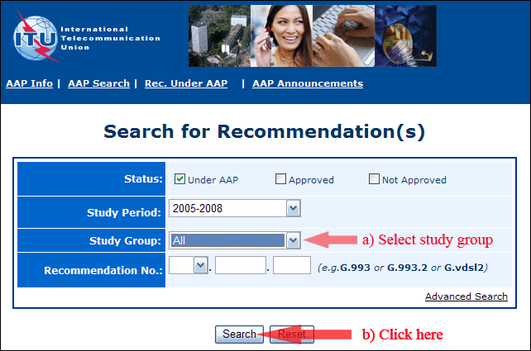
2) Select your Recommendation
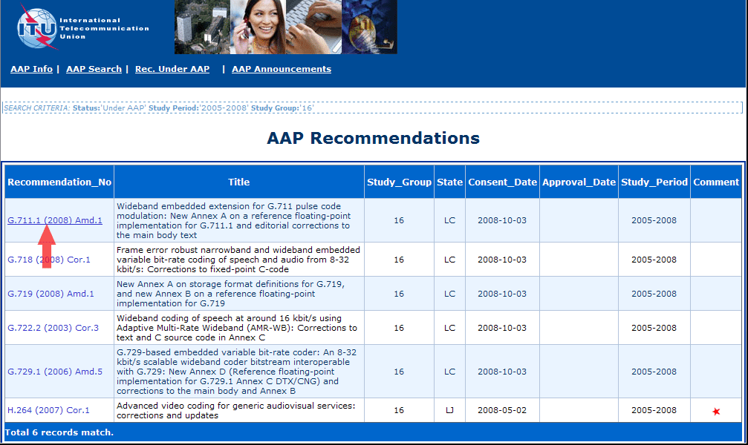
3) Click the "Submit Comment" button
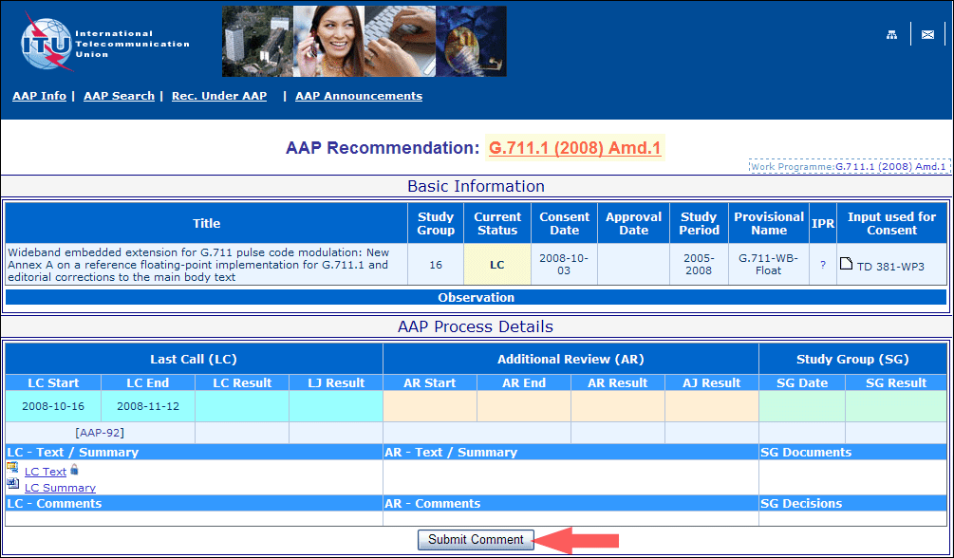
4) Complete the on-line form and click on "Submit"
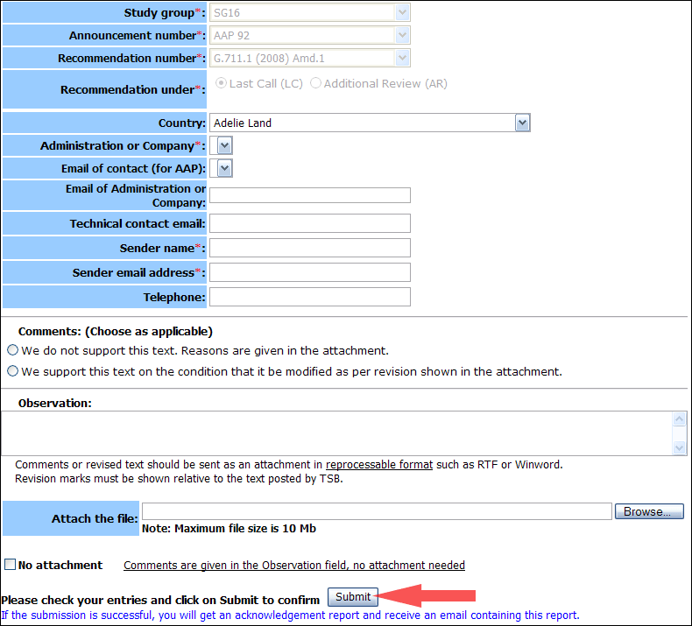
For more information, read the AAP tutorial on:
http://www.itu.int/ITU-T/aapinfo/files/AAPTutorial.pdf
Annex 3
(to TSB AAP-68)
Recommendations under LC/AR – Comment submission form
(Separate form for each Recommendation being commented upon)
ITU-T AAP comment submission form for the period 2009-2012
Study Group:
Announcement number:
Recommendation number:
Recommendation under: | Last call (LC)  Additional Review (AR)
Country:
Administration/Company:
Name of AAP Contact Person:
Email of AAP Contact Person:
Sender name:
(if different from AAP Contact Person)
Sender email address:
Telephone:
Comments:  (Choose as applicable) | We do not support this text. Reasons are given in the attachment.  We support this text on the condition that it be modified as per revision shown in the attachment.
Observations:
No attachment: Comments are given in the Observation field, no attachment needed
To be returned to: email: tsbsg....@itu.int
[or fax +41 22 730 5853]
Comments or revised text should be sent as an attachment in RTF or WinWord format.
Revision marks must be shown relative to the text posted by TSB.

