国 际 电 信 联 盟
电信标准化局
2015年11月1日 ，日内瓦

参考号:  电话:  传真:  电子邮件: | 电信标准化局AAP-68  AAP/CL  +41 22 730 5860  +41 22 730 5853  tsbdir@itu.int | – 致国际电联成员国各主管部门；  – 致ITU-T各部门成员；  – 致ITU-T 部门准成员  抄送：  – 电信标准化局研究组主席和副主席  – 电信发展局主任  – 无线电通信局主任

事由: | 有关采用替换批准程序（AAP）处理的建议书的情况

先生/女士，
ITU-T A.8 建议书中规定的建议书替换批准程序 (AAP) 适用于那些不会产生政策或 监管影响、因而不需与成员国正式协商的建议书（见国际电联《公约》第246B款）。
附件1列出了那些在以往电信标准化局AAP预告后地位发生变化的案文。
如您希望针对某个适用AAP的建议书提出意见，请使用可在ITU-T网站AAP区域 （http://www.itu.int/ITU-T/aap）的“建议书”网页上获取的《AAP意见在线提交表格》 （见附件2）。或者，可填妥附件3 中的表格并将意见发送给相关研究组的秘书处。
敬请留意，我们不鼓励提交仅支持通过所涉案文而没有实质内容的意见。

顺致敬意！

李在摄
电信标准化局主任

附件：3件

Annex 1
(to TSB AAP-68)

Status codes used in the AAP announcements:
LC = Last Call
LJ = Last Call Judgment (includes comment resolution)
AR = Additional Review
AJ = Additional Review Judgment (includes comment resolution)
SG = For Study Group approval
A = Approved
AT = Approved with typographic corrections
AC = Approved after Additional Review of Comments
NA = Not approved
TAP = Moved to TAP (ITU-T A.8 / § 5.2)
ITU-T website entry page:
http://www.itu.int/ITU-T
Alternative approval process (AAP) welcome page:
http://www.itu.int/ITU-T/aapinfo
Note – A tutorial on the ITU-T AAP application is available under the AAP welcome page
ITU-T website AAP Recommendation search page:
http://www.itu.int/ITU-T/aap/
Study Group web pages and contacts:
SG 2 | http://www.itu.int/ITU-T/studygroups/com02 | tsbsg2@itu.int
SG 3 | http://www.itu.int/ITU-T/studygroups/com03 | tsbsg3@itu.int
SG 5 | http://www.itu.int/ITU-T/studygroups/com05 | tsbsg5@itu.int
SG 9 | http://www.itu.int/ITU-T/studygroups/com09 | tsbsg9@itu.int
SG 11 | http://www.itu.int/ITU-T/studygroups/com11 | tsbsg11@itu.int
SG 12 | http://www.itu.int/ITU-T/studygroups/com12 | tsbsg12@itu.int
SG 13 | http://www.itu.int/ITU-T/studygroups/com13 | tsbsg13@itu.int
SG 15 | http://www.itu.int/ITU-T/studygroups/com15 | tsbsg15@itu.int
SG 16 | http://www.itu.int/ITU-T/studygroups/com16 | tsbsg16@itu.int
SG 17 | http://www.itu.int/ITU-T/studygroups/com17 | tsbsg17@itu.int

Situation concerning Study Group 5 Recommendations under AAP
Rec # | Title | Last Call (LC) Period |  |  |  | Additional Review (AR) Period |  |  |  | Status
 |  | LC Start | LC End | LC  Result | LJ  Result | AR Start | AR End | AR  Result | AJ  Result
K.107 (K.hvps2) | Method for determining the impedance to earth of earthing systems (Summary) | 2015-11-01 | 2015-11-28 |  |  |  |  |  |  | LC
K.108 (K.jup) | Joint-use of poles by telecommunication and solidly earthed power lines (Summary) | 2015-11-01 | 2015-11-28 |  |  |  |  |  |  | LC
K.109 (K.tup) | Installation of telecommunication equipment on utility poles (Summary) | 2015-11-01 | 2015-11-28 |  |  |  |  |  |  | LC
K.111 (K.ntt) | Protection of surrounding structures of telecommunication towers against lightning (Summary) | 2015-11-01 | 2015-11-28 |  |  |  |  |  |  | LC
K.113 (K.maps) | Generation of radiofrequency electromagnetic fields (RF-EMF) level maps (Summary) | 2015-11-01 | 2015-11-28 |  |  |  |  |  |  | LC
K.114 (K.bts_emc) | Electromagnetic compatibility requirements and measurement methods for digital cellular mobile communication base station equipment (Summary) | 2015-11-01 | 2015-11-28 |  |  |  |  |  |  | LC
K.115 (K.secmiti) | Mitigation methods against electromagnetic security threats (Summary) | 2015-11-01 | 2015-11-28 |  |  |  |  |  |  | LC
K.116 (K.ter_emc) | EMC requirements and test methods for radio telecommunication terminal equipment (Summary) | 2015-11-01 | 2015-11-28 |  |  |  |  |  |  | LC
L.1302 (L. Assessment_DC) | Assessment of energy efficiency on infrastructure in data centre and telecom centre (Summary) | 2015-11-01 | 2015-11-28 |  |  |  |  |  |  | LC
L.1440 (L.methodology_ICT in citi) | Methodology for environmental impact assessment of information and communication technologies at city level (Summary) | 2015-02-16 | 2015-03-15 | LJ | AR | 2015-08-01 | 2015-08-21 | SG |  | AC
L.1502 (L.Infrastructure Adaptation) | Adapting information and communication technology infrastructure to the effects of climate change (Summary) | 2015-11-01 | 2015-11-28 |  |  |  |  |  |  | LC
L.1503 (L.Cities Adaptation) | Information and communication technologies for climate change adaptation in cities (Summary) | 2015-11-01 | 2015-11-28 |  |  |  |  |  |  | LC
Situation concerning Study Group 15 Recommendations under AAP
Rec # | Title | Last Call (LC) Period |  |  |  | Additional Review (AR) Period |  |  |  | Status
 |  | LC Start | LC End | LC  Result | LJ  Result | AR Start | AR End | AR  Result | AJ  Result
G.989 | 40-Gigabit-capable passive optical network (NG PON2): Definitions, abbreviations and acronyms (Summary) | 2015-07-16 | 2015-08-12 | LJ | AR | 2015-10-01 | 2015-10-21 | AC |  | AC
G.989.3 (G.ngpon2.3) | 40-Gigabit-capable passive optical networks (NG PON2): Transmission Convergence Layer Specification (Summary) | 2015-07-16 | 2015-08-12 | LJ | AR | 2015-10-01 | 2015-10-21 | AC |  | AC
G.9701 (2014) Cor.1 | Fast access to subscriber terminals (G.fast) - Physical layer specification: Corrigendum 1 (Summary) | 2015-08-01 | 2015-08-28 | LJ | AR | 2015-11-01 | 2015-11-21 |  |  | AR
G.9960 (2015) Amd.1 | Unified high-speed wireline-based home networking transceivers - System architecture and physical layer specification: Amendment 1 (Summary) | 2015-08-01 | 2015-08-28 | LJ | AR | 2015-11-01 | 2015-11-21 |  |  | AR
G.9960 (2015) Cor.1 | Unified high-speed wireline-based home networking transceivers - System architecture and physical layer specification: Corrigendum 1 (Summary) | 2015-08-01 | 2015-08-28 | LJ | AR | 2015-11-01 | 2015-11-21 |  |  | AR
G.9961 (2015) Amd.1 (G.hn) | Unified high-speed wire-line based home networking transceivers - Data link layer specification: Amendment 1 (Summary) | 2015-08-01 | 2015-08-28 | LJ | AR | 2015-11-01 | 2015-11-21 |  |  | AR
G.9961 (2015) Cor.1 (G.hn) | Unified high-speed wire-line based home networking transceivers - Data link layer specification: Corrigendum 1 (Summary) | 2015-08-01 | 2015-08-28 | LJ | AR | 2015-11-01 | 2015-11-21 |  |  | AR
Situation concerning Study Group 16 Recommendations under AAP
Rec # | Title | Last Call (LC) Period |  |  |  | Additional Review (AR) Period |  |  |  | Status
 |  | LC Start | LC End | LC  Result | LJ  Result | AR Start | AR End | AR  Result | AJ  Result
F.746.3 (H.IQAS) | Intelligent question answering service framework (Summary) | 2015-11-01 | 2015-11-28 |  |  |  |  |  |  | LC
F.747.8 (F.IoT-ASM) | Requirements and reference architecture for audience-selectable media service framework in the IoT environment (Summary) | 2015-11-01 | 2015-11-28 |  |  |  |  |  |  | LC
F.748.2 (F.MS-ref) | Machine socialization: Overview and reference model (Summary) | 2015-11-01 | 2015-11-28 |  |  |  |  |  |  | LC
F.748.3 (F.MS-RM) | Machine socialization: Relation management and descriptions in IoT applications (Summary) | 2015-11-01 | 2015-11-28 |  |  |  |  |  |  | LC
F.748.5 (F.M2M-RA) | Requirements and reference architecture of M2M service layer (Summary) | 2015-11-01 | 2015-11-28 |  |  |  |  |  |  | LC
F.749.1 (H.VG-FAM, ex H.VGP-FAM) | Functional requirements for vehicle gateways (Summary) | 2015-11-01 | 2015-11-28 |  |  |  |  |  |  | LC
F.791 (F.ACC-TERM, ex HSTP.ACC-TERM) | Accessibility terms and definitions (Summary) | 2015-11-01 | 2015-11-28 |  |  |  |  |  |  | LC
H.222.0 (2014) Amd.1 Cor.1 | Information technology - Generic coding of moving pictures and associated audio information: Systems: Delivery of Timeline for External Data: Adding cets_byte_range_descriptor to table U-2 (Summary) | 2015-11-01 | 2015-11-28 |  |  |  |  |  |  | LC
H.248.41 | Gateway control protocol: IP domain connection package (Summary) | 2015-11-01 | 2015-11-28 |  |  |  |  |  |  | LC
H.248.78 (H.248.78 Amd.1) | Gateway control protocol: Bearer-level message backhauling and application level gateway (Summary) | 2015-11-01 | 2015-11-28 |  |  |  |  |  |  | LC
H.248.94 (H.248.WEBRTC) | Gateway control protocol: Web-based real-time communication services - H.248 protocol support and profile guidelines (Summary) | 2015-11-01 | 2015-11-28 |  |  |  |  |  |  | LC
H.248.95 (H.248.RTPMUX) | Gateway control protocol: H.248 Support for RTP multiplexing (Summary) | 2015-11-01 | 2015-11-28 |  |  |  |  |  |  | LC
H.248.96 (H.248.STGROUP) | Gateway control protocol: H.248 Stream grouping and aggregation (Summary) | 2015-11-01 | 2015-11-28 |  |  |  |  |  |  | LC
H.248.97 (H.248.SCTP) | Gateway Control Protocol: H.248 support for control of SCTP bearer connections (New) (Summary) | 2015-11-01 | 2015-11-28 |  |  |  |  |  |  | LC
H.460.27 (H.460.SessionID) | End-to-end session identifier for H.323 systems (Summary) | 2015-11-01 | 2015-11-28 |  |  |  |  |  |  | LC
H.622.2 (H.VHN) | Service capabilities and framework for virtual home networks (Summary) | 2015-11-01 | 2015-11-28 |  |  |  |  |  |  | LC
H.623 (H.WoT-SA) | Web of things service architecture (Summary) | 2015-11-01 | 2015-11-28 |  |  |  |  |  |  | LC
H.702 (H.IPTV-ACCProf) | Accessibility profiles for IPTV systems (Summary) | 2015-11-01 | 2015-11-28 |  |  |  |  |  |  | LC
H.752 (H.IPTV-CPI, ex H.IPTV-CPMD) | Multimedia content provisioning interface for IPTV services (Summary) | 2015-11-01 | 2015-11-28 |  |  |  |  |  |  | LC
H.772 (H.IPTV-TDD) | IPTV terminal device discovery (Summary) | 2015-11-01 | 2015-11-28 |  |  |  |  |  |  | LC
H.810 (H.810.R) | Interoperability design guidelines for personal health systems (Summary) | 2015-11-01 | 2015-11-28 |  |  |  |  |  |  | LC
H.811 (H.81x-TPL-IF) | Interoperability design guidelines for personal health systems: PAN/LAN/TAN interface (Summary) | 2015-11-01 | 2015-11-28 |  |  |  |  |  |  | LC
H.812 (H.81x-WAN-IF) | Interoperability design guidelines for personal health systems: WAN interface: Common certified device class (Summary) | 2015-11-01 | 2015-11-28 |  |  |  |  |  |  | LC
H.812.1 (H.81x-WAN-IF.1) | Interoperability design guidelines for personal health systems: WAN interface: Observation upload certified device class (Summary) | 2015-11-01 | 2015-11-28 |  |  |  |  |  |  | LC
H.812.2 (H.81x-WAN-IF.2) | Interoperability design guidelines for personal health systems: WAN interface: Questionnaires (Summary) | 2015-11-01 | 2015-11-28 |  |  |  |  |  |  | LC
H.812.3 (H.81x-WAN-IF.3) | Interoperability design guidelines for personal health systems: WAN interface: Capability exchange certified device class (Summary) | 2015-11-01 | 2015-11-28 |  |  |  |  |  |  | LC
H.812.4 (H.81x-WAN-IF.4) | Interoperability design guidelines for personal health systems: WAN interface: Authenticated persistent session device class (Summary) | 2015-11-01 | 2015-11-28 |  |  |  |  |  |  | LC
H.813 (H.81x-HRN-IF) | Interoperability design guidelines for personal health systems: Health record network (HRN) interface (Summary) | 2015-11-01 | 2015-11-28 |  |  |  |  |  |  | LC
H.830.10 (H.EH-WAN-10) | Conformance testing: WAN interface Part 10: hData observation upload: Receiver (Summary) | 2015-11-01 | 2015-11-28 |  |  |  |  |  |  | LC
H.830.11 (H.EH-WAN-11) | Conformance testing: WAN interface Part 11: Questionnaires: Sender (Summary) | 2015-11-01 | 2015-11-28 |  |  |  |  |  |  | LC
H.830.12 (H.EH-WAN-12) | Conformance testing: WAN interface Part 12: Questionnaires: Receiver (Summary) | 2015-11-01 | 2015-11-28 |  |  |  |  |  |  | LC
H.830.9 (H.EH-WAN-9) | Conformance testing: WAN interface Part 9: hData observation upload: Sender (Summary) | 2015-11-01 | 2015-11-28 |  |  |  |  |  |  | LC
H.845.15 (H.EH-PAN-05.15) | Conformance testing: PAN/LAN/TAN interface Part 5O: Sleep apnoea breathing therapy equipment: Agent (Summary) | 2015-11-01 | 2015-11-28 |  |  |  |  |  |  | LC
T.24 Cor.1 | Standardized digitized image set: Clarifications in Table 1 (Summary) | 2015-11-01 | 2015-11-28 |  |  |  |  |  |  | LC
T.38 | Procedures for real-time Group 3 facsimile communication over IP networks (Summary) | 2015-11-01 | 2015-11-28 |  |  |  |  |  |  | LC
T.800 | Information technology - JPEG 2000 image coding system: Core coding system (Summary) | 2015-11-01 | 2015-11-28 |  |  |  |  |  |  | LC
Situation concerning Study Group 17 Recommendations under AAP
Rec # | Title | Last Call (LC) Period |  |  |  | Additional Review (AR) Period |  |  |  | Status
 |  | LC Start | LC End | LC  Result | LJ  Result | AR Start | AR End | AR  Result | AJ  Result
X.1155 (X.sap-5) | Guidelines on local linkable anonymous authentication for electronic services (Summary) | 2015-10-01 | 2015-10-28 | A |  |  |  |  |  | A
X.1314 Cor.1 | Security requirements and framework of ubiquitous networking - Corrigendum 1 (Summary) | 2015-10-01 | 2015-10-28 | A |  |  |  |  |  | A
X.1601 | Security framework for cloud computing (Summary) | 2015-10-01 | 2015-10-28 | A |  |  |  |  |  | A
Z.161 | Testing and Test Control Notation version 3: TTCN-3 core language (Summary) | 2015-10-01 | 2015-10-28 | A |  |  |  |  |  | A
Z.161.1 | Testing and Test Control Notation version 3: TTCN-3 language extensions: Support of interfaces with continuous signals (Summary) | 2015-10-01 | 2015-10-28 | A |  |  |  |  |  | A
Z.161.2 | Testing and Test Control Notation version 3: TTCN-3 language extensions: Configuration and deployment support (Summary) | 2015-10-01 | 2015-10-28 | A |  |  |  |  |  | A
Z.161.3 | Testing and Test Control Notation version 3: TTCN-3 language extensions: Advanced parameterization (Summary) | 2015-10-01 | 2015-10-28 | A |  |  |  |  |  | A
Z.161.4 | Testing and Test Control Notation version 3: TTCN-3 language extensions: Behaviour types (Summary) | 2015-10-01 | 2015-10-28 | A |  |  |  |  |  | A
Z.161.5 | Testing and Test Control Notation version 3: TTCN-3 Language extensions: Performance and real time testing (Summary) | 2015-10-01 | 2015-10-28 | A |  |  |  |  |  | A
Z.165 | Testing and Test Control Notation version 3: TTCN-3 runtime interface (TRI) (Summary) | 2015-10-01 | 2015-10-28 | A |  |  |  |  |  | A
Z.165.1 | Testing and Test Control Notation version 3: TTCN-3 language extensions: Extended TRI (Summary) | 2015-10-01 | 2015-10-28 | A |  |  |  |  |  | A
Z.166 | Testing and Test Control Notation version 3: TTCN-3 control interface (TCI) (Summary) | 2015-10-01 | 2015-10-28 | A |  |  |  |  |  | A
Z.168 | Testing and Test Control Notation version 3: The IDL to TTCN-3 mapping (Summary) | 2015-10-01 | 2015-10-28 | A |  |  |  |  |  | A
Z.169 | Testing and Test Control Notation version 3: Using XML schema with TTCN-3 (Summary) | 2015-10-01 | 2015-10-28 | A |  |  |  |  |  | A

Annex 2
(to TSB AAP-68)
Using the on-line comment submission form
Comment submission
1) Go to AAP search Web page at http://www.itu.int/ITU-T/aap/
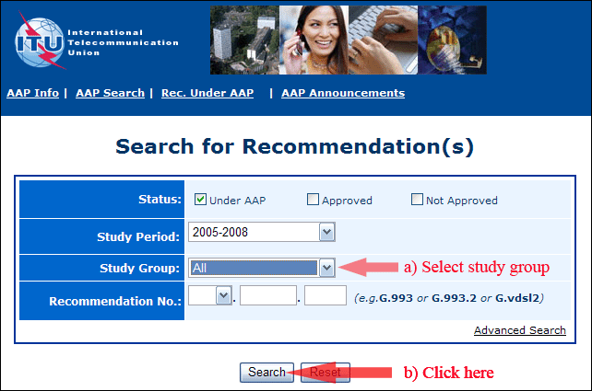
2) Select your Recommendation
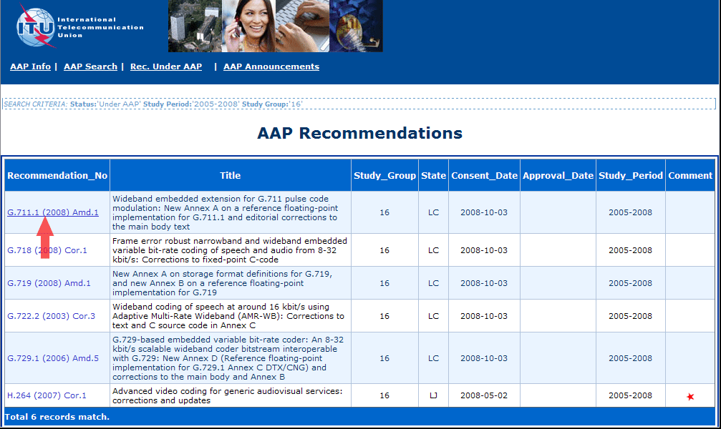
3) Click the "Submit Comment" button
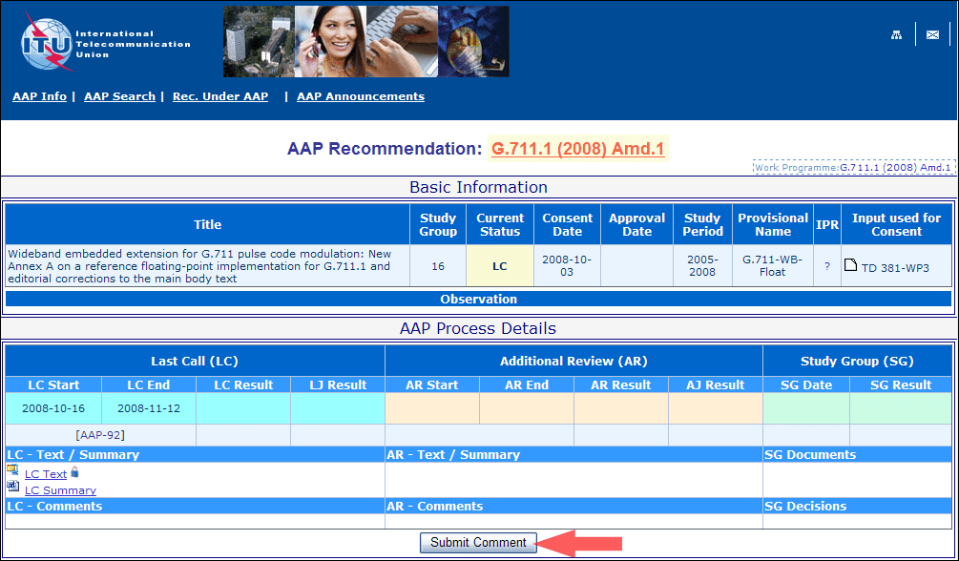
4) Complete the on-line form and click on "Submit"
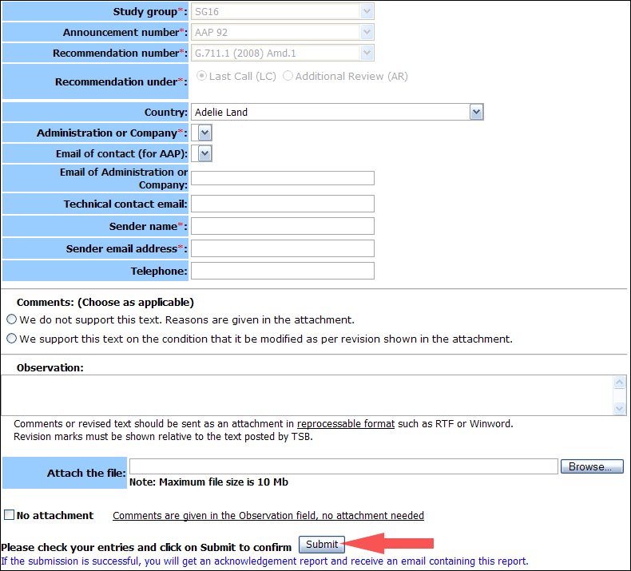
For more information, read the AAP tutorial on:
http://www.itu.int/ITU-T/aapinfo/files/AAPTutorial.pdf
Annex 3
(to TSB AAP-68)
Recommendations under LC/AR – Comment submission form
(Separate form for each Recommendation being commented upon)
ITU-T AAP comment submission form for the period 2009-2012
Study Group:
Announcement number:
Recommendation number:
Recommendation under: | Last call (LC)  Additional Review (AR)
Country:
Administration/Company:
Name of AAP Contact Person:
Email of AAP Contact Person:
Sender name:
(if different from AAP Contact Person)
Sender email address:
Telephone:
Comments:  (Choose as applicable) | We do not support this text. Reasons are given in the attachment.  We support this text on the condition that it be modified as per revision shown in the attachment.
Observations:
No attachment: Comments are given in the Observation field, no attachment needed
To be returned to: email: tsbsg....@itu.int
[or fax +41 22 730 5853]
Comments or revised text should be sent as an attachment in RTF or WinWord format.
Revision marks must be shown relative to the text posted by TSB.

