 | Unión Internacional de Telecomunicaciones  Oficina de Normalización de las Telecomunicaciones | 

Ginebra, 16 de enero de 2015

Ref:  Tel:  Fax:  Correo-e: | TSB AAP-49  AAP/CL  +41 22 730 5860  +41 22 730 5853  tsbdir@itu.int | – A las Administraciones de los Estados Miembros de la Unión;  – A los Miembros del Sector UIT-T;  – A los Asociados del UIT-T  Copia:  – A los Presidentes y a los Vicepresidentes de las Comisiones de Estudio del UIT-T;  – Al Director de la Oficina de Desarrollo de las Telecomunicaciones;  – Al Director de la Oficina de Radiocomunicaciones

Asunto: | Situación de las Recomendaciones sometidas al proceso de aprobación alternativo (AAP)

Muy señora mía/Muy señor mío:

El proceso de aprobación alternativo (AAP) definido en la Recomendación A.8 del UIT-T se aplica a las Recomendaciones que no tienen consecuencias en materia de política o reglamentación y que no requieren, por lo tanto, la consulta formal de los Estados Miembros (véase el número 246B del Convenio de la UIT).
En el anexo 1 se enumera la lista de los textos cuyo estado ha cambiado con respecto a los anuncios TSB AAP precedentes.
Si desea formular un comentario en relación con una Recomendación sometida al AAP, le alentamos a utilizar el formulario de presentación de comentarios disponible en la página de la Recomendación que figura en el área AAP del sitio web del UIT-T, en la dirección http://www.itu.int/ITU-T/aap/ (véase también el anexo 2). Alternativamente, pueden presentarse comentarios completando el formulario del anexo 3 y remitiéndolo a la secretaría de la Comisión de Estudio correspondiente.
Le rogamos tenga en cuenta que no se alientan comentarios que se limiten a apoyar la adopción del texto en cuestión.
Le saluda atentamente,

Chaesub Lee
Director de la Oficina de
Normalización de las Telecomunicaciones
Anexos: 3

Annex 1
(to TSB AAP-49)

Status codes used in the AAP announcements:
LC = Last Call
LJ = Last Call Judgment (includes comment resolution)
AR = Additional Review
AJ = Additional Review Judgment (includes comment resolution)
SG = For Study Group approval
A = Approved
AT = Approved with typographic corrections
AC = Approved after Additional Review of Comments
NA = Not approved
TAP = Moved to TAP (ITU-T A.8 / § 5.2)
ITU-T website entry page:
http://www.itu.int/ITU-T
Alternative approval process (AAP) welcome page:
http://www.itu.int/ITU-T/aapinfo
Note – A tutorial on the ITU-T AAP application is available under the AAP welcome page
ITU-T website AAP Recommendation search page:
http://www.itu.int/ITU-T/aap/
Study Group web pages and contacts:
SG 2 | http://www.itu.int/ITU-T/studygroups/com02 | tsbsg2@itu.int
SG 3 | http://www.itu.int/ITU-T/studygroups/com03 | tsbsg3@itu.int
SG 5 | http://www.itu.int/ITU-T/studygroups/com05 | tsbsg5@itu.int
SG 9 | http://www.itu.int/ITU-T/studygroups/com09 | tsbsg9@itu.int
SG 11 | http://www.itu.int/ITU-T/studygroups/com11 | tsbsg11@itu.int
SG 12 | http://www.itu.int/ITU-T/studygroups/com12 | tsbsg12@itu.int
SG 13 | http://www.itu.int/ITU-T/studygroups/com13 | tsbsg13@itu.int
SG 15 | http://www.itu.int/ITU-T/studygroups/com15 | tsbsg15@itu.int
SG 16 | http://www.itu.int/ITU-T/studygroups/com16 | tsbsg16@itu.int
SG 17 | http://www.itu.int/ITU-T/studygroups/com17 | tsbsg17@itu.int

Situation concerning Study Group 5 Recommendations under AAP
Rec # | Title | Last Call (LC) Period |  |  |  | Additional Review (AR) Period |  |  |  | Status
Rec # | Title | LC Start | LC End | LC  Result | LJ  Result | AR Start | AR End | AR  Result | AJ  Result | Status
L.1002 (L.adapter Phase 2 (L.UPA portable)) | External universal power adapter solutions for portable information and communication technology devices (Summary) | 2014-01-16 | 2014-02-12 | LJ | AR | 2014-06-01 | 2014-06-21 | SG |  | NA
L.1501 (L.Countries Adaptation) | Best practices on how countries can utilize ICTs to adapt to the effects of climate change (Summary) | 2014-06-01 | 2014-06-28 | LJ | AR | 2014-12-01 | 2014-12-21 | A |  | A
Situation concerning Study Group 11 Recommendations under AAP
Rec # | Title | Last Call (LC) Period |  |  |  | Additional Review (AR) Period |  |  |  | Status
Rec # | Title | LC Start | LC End | LC  Result | LJ  Result | AR Start | AR End | AR  Result | AJ  Result | Status
Q.3315 (Q.SBNG) | Signalling requirements for flexible network service combination on Broadband Network Gateway (Summary) | 2014-12-16 | 2015-01-12 | A |  |  |  |  |  | A
Q.3615 (Q.ProGeoSMS) | Protocol for GeoSMS (Summary) | 2014-08-01 | 2014-08-28 | LJ | SG |  |  |  |  | SG
Situation concerning Study Group 12 Recommendations under AAP
Rec # | Title | Last Call (LC) Period |  |  |  | Additional Review (AR) Period |  |  |  | Status
Rec # | Title | LC Start | LC End | LC  Result | LJ  Result | AR Start | AR End | AR  Result | AJ  Result | Status
P.1100 | Narrowband hands-free communication in motor vehicles (Summary) | 2014-12-16 | 2015-01-12 | A |  |  |  |  |  | A
P.1110 | Wideband hands-free communication in motor vehicles (Summary) | 2014-12-16 | 2015-01-12 | A |  |  |  |  |  | A
P.1311 (P.SAM-Part 1) | Method for determining the intelligibility of multiple concurrent talkers (Summary) | 2014-10-01 | 2014-10-28 | LJ | AR | 2014-12-01 | 2014-12-21 | A |  | A
Situation concerning Study Group 13 Recommendations under AAP
Rec # | Title | Last Call (LC) Period |  |  |  | Additional Review (AR) Period |  |  |  | Status
Rec # | Title | LC Start | LC End | LC  Result | LJ  Result | AR Start | AR End | AR  Result | AJ  Result | Status
Y.2068 (Y.IoT-funct-framework) | Functional framework and capabilities of the Internet of Things (Summary) | 2014-12-16 | 2015-01-12 | LJ |  |  |  |  |  | LJ
Y.2070 (Y.HEMS-arch) | Requirements and architecture of home energy management system and home network services (Summary) | 2014-12-16 | 2015-01-12 | A |  |  |  |  |  | A
Y.2074 (Y.IoT-DD-Reqts) | Requirements for Internet of Things devices and operation of Internet of Things applications during disaster (Summary) | 2014-12-16 | 2015-01-12 | A |  |  |  |  |  | A
Y.2303 (Y.NICE-awareness-arch) | Network Intelligence Capability Enhancement - Awareness functional architecture (Summary) | 2014-12-16 | 2015-01-12 | A |  |  |  |  |  | A
Situation concerning Study Group 15 Recommendations under AAP
Rec # | Title | Last Call (LC) Period |  |  |  | Additional Review (AR) Period |  |  |  | Status
Rec # | Title | LC Start | LC End | LC  Result | LJ  Result | AR Start | AR End | AR  Result | AJ  Result | Status
G.695 | Optical interfaces for coarse wavelength division multiplexing (CWDM) applications (Summary) | 2014-12-16 | 2015-01-12 | A |  |  |  |  |  | A
G.709/Y.1331 (2012) Amd.4 | Interfaces for the Optical Transport Network (OTN): Amendment 4 (Summary) | 2014-12-16 | 2015-01-12 | AT |  |  |  |  |  | AT
G.709/Y.1331 (2012) Cor.2 | Interfaces for the Optical Transport Network (OTN): Corrigendum 2 (Summary) | 2014-12-16 | 2015-01-12 | A |  |  |  |  |  | A
G.783 (2006) Cor.1 | Characteristics of synchronous digital hierarchy (SDH) equipment functional blocks: Corrigendum 1 (Summary) | 2014-12-16 | 2015-01-12 | A |  |  |  |  |  | A
G.798 (2012) Amd.2 | Characteristics of optical transport network hierarchy equipment functional blocks: Amendment 2 (Summary) | 2014-12-16 | 2015-01-12 | A |  |  |  |  |  | A
G.977 | Characteristics of optically amplified optical fibre submarine cable systems (Summary) | 2014-12-16 | 2015-01-12 | A |  |  |  |  |  | A
G.993.2 | Very high speed digital subscriber line transceivers 2 (VDSL2) (Summary) | 2014-12-16 | 2015-01-12 | A |  |  |  |  |  | A
G.993.2 (2011) Amd.6 | Very high speed digital subscriber line transceivers 2 (VDSL2): Amendment 6 (Summary) | 2015-01-16 | 2015-02-12 |  |  |  |  |  |  | LC
G.993.5 | Self-FEXT cancellation (vectoring) for use with VDSL2 transceivers (Summary) | 2014-12-16 | 2015-01-12 | A |  |  |  |  |  | A
G.994.1 (2012) Amd.5 | Handshake procedures for digital subscriber line transceivers: Amendment 5 (Summary) | 2015-01-16 | 2015-02-12 |  |  |  |  |  |  | LC
G.997.1 (2012) Amd.4 | Physical layer management for digital subscriber line transceivers: Amendment 4 (Summary) | 2015-01-16 | 2015-02-12 |  |  |  |  |  |  | LC
G.997.2 | Physical layer management for FAST transceivers (Summary) | 2015-01-16 | 2015-02-12 |  |  |  |  |  |  | LC
G.998.4 | Improved impulse noise protection for DSL transceivers (Summary) | 2014-12-16 | 2015-01-12 | A |  |  |  |  |  | A
G.998.4 (2010) Amd.4 | Improved impulse noise protection for DSL transceivers: Amendment 4 (Summary) | 2015-01-16 | 2015-02-12 |  |  |  |  |  |  | LC
G.7041/Y.1303 (2011) Amd.3 | Generic Framing Procedure (GFP): Amendment 3 (Summary) | 2014-12-16 | 2015-01-12 | A |  |  |  |  |  | A
G.7714.1/Y.1705.1 | Protocol for automatic discovery in transport networks (Summary) | 2014-12-16 | 2015-01-12 | A |  |  |  |  |  | A
G.8011/Y.1307 | Ethernet over Transport – Ethernet service characteristics (Summary) | 2014-12-16 | 2015-01-12 | A |  |  |  |  |  | A
G.8013/Y.1731 (2013) Amd.1 | OAM functions and mechanisms for Ethernet-based networks: Amendment 1 (Summary) | 2014-12-16 | 2015-01-12 | LJ |  |  |  |  |  | LJ
G.8021/Y.1341 | Characteristics of Ethernet Transport network equipment functional blocks (Summary) | 2014-12-16 | 2015-01-12 | LJ |  |  |  |  |  | LJ
G.8031/Y.1342 | Ethernet linear protection switching (Summary) | 2014-12-16 | 2015-01-12 | A |  |  |  |  |  | A
G.8101/Y.1355 | Terms and definitions for MPLS transport profile (Summary) | 2014-12-16 | 2015-01-12 | A |  |  |  |  |  | A
G.8112/Y.1371 (2012) Cor.1 | Interfaces for the MPLS Transport Profile (MPLS-TP) layer network: Corrigendum 1 (Summary) | 2014-12-16 | 2015-01-12 | A |  |  |  |  |  | A
G.8151/Y.1374 | Management aspects of the MPLS-TP network element (Summary) | 2014-12-16 | 2015-01-12 | A |  |  |  |  |  | A
G.8201 (2011) Cor.1 | Error performance parameters and objectives for multi-operator international paths within optical transport networks: Corrigendum 1 (Summary) | 2014-12-16 | 2015-01-12 | A |  |  |  |  |  | A
G.8261/Y.1361 (2013) Amd.1 | Timing and synchronization aspects in packet networks: Amendment 1 (Summary) | 2014-12-16 | 2015-01-12 | A |  |  |  |  |  | A
G.8262/Y.1362 | Timing characteristics of a synchronous Ethernet equipment slave clock (EEC) (Summary) | 2014-12-16 | 2015-01-12 | A |  |  |  |  |  | A
G.8264/Y.1364 (2014) Amd.1 | Distribution of timing information through packet networks: Amendment 1 (Summary) | 2014-12-16 | 2015-01-12 | A |  |  |  |  |  | A
G.8271.1/Y.1366.1 (2013) Amd.2 | Network limits for time synchronization in Packet networks: Amendment 2 (Summary) | 2014-12-16 | 2015-01-12 | A |  |  |  |  |  | A
G.8271/Y.1366 (2012) Amd.2 | Time and phase synchronization aspects of Packet Networks: Amendment 2 (Summary) | 2014-12-16 | 2015-01-12 | A |  |  |  |  |  | A
G.8272/Y.1367 | Timing characteristics of primary reference time clock (Summary) | 2014-12-16 | 2015-01-12 | A |  |  |  |  |  | A
G.8273.2/Y.1368.2 (2014) Amd.1 | Timing characteristics of telecom boundary clocks and telecom time slave clocks: Amendment 1 (Summary) | 2014-12-16 | 2015-01-12 | A |  |  |  |  |  | A
G.8273/Y.1368 (2013) Amd.1 | Framework of phase and time clocks: Amendment 1 (Summary) | 2014-12-16 | 2015-01-12 | A |  |  |  |  |  | A
G.8275.1/Y.1369.1 (2014) Cor.1 | Precision time protocol telecom profile for phase/time synchronization with full timing support from the network: Corrigendum 1 (Summary) | 2014-12-16 | 2015-01-12 | A |  |  |  |  |  | A
G.8275/Y.1369 (2013) Amd.1 | Architecture and requirements for packet-based time and phase delivery: Amendment 1 (Summary) | 2014-12-16 | 2015-01-12 | A |  |  |  |  |  | A
G.9802 (G.multi) | Control aspects of multiple wavelength passive optical networks (Summary) | 2014-12-16 | 2015-01-12 | LJ |  |  |  |  |  | LJ
G.9959 | Short range narrowband digital radiocommunication transceivers – PHY and MAC layer specifications (Summary) | 2014-12-16 | 2015-01-12 | A |  |  |  |  |  | A
G.9960 | Unified high-speed wire-line based home networking transceivers - System architecture and physical layer specification (Summary) | 2015-01-16 | 2015-02-12 |  |  |  |  |  |  | LC
G.9961 (G.hn) | Unified high-speed wire-line based home networking transceivers - Data link layer specification (Summary) | 2015-01-16 | 2015-02-12 |  |  |  |  |  |  | LC
G.9963 (G.hn-MIMO) | Unified high-speed wire-line based home networking transceivers - Multiple input/multiple output specification (Summary) | 2015-01-16 | 2015-02-12 |  |  |  |  |  |  | LC
L.25 | Optical fibre cable network maintenance (Summary) | 2014-12-16 | 2015-01-12 | A |  |  |  |  |  | A
L.36 | Single-mode fibre optical connectors (Summary) | 2014-12-16 | 2015-01-12 | A |  |  |  |  |  | A
L.94 (L.gpsm) | Use of the Global Navigation Satellite System (GNSS) to create a referenced network map (Summary) | 2014-12-16 | 2015-01-12 | A |  |  |  |  |  | A
Situation concerning Study Group 16 Recommendations under AAP
Rec # | Title | Last Call (LC) Period |  |  |  | Additional Review (AR) Period |  |  |  | Status
Rec # | Title | LC Start | LC End | LC  Result | LJ  Result | AR Start | AR End | AR  Result | AJ  Result | Status
H.831 (H.EH-WAN.1) | ITU-T H.810 personal health devices conformance: WAN Interface Part 1: Web services interoperability: Sender (Summary) | 2014-12-16 | 2015-01-12 | A |  |  |  |  |  | A
H.832 (H.EH-WAN.2) | ITU-T H.810 personal health devices conformance: WAN Interface Part 2: Web services interoperability: Receiver (Summary) | 2014-12-16 | 2015-01-12 | A |  |  |  |  |  | A
H.833 (H.EH-WAN.3) | ITU-T H.810 personal health devices conformance: WAN Interface Part 3: SOAP/ATNA: Sender (Summary) | 2014-12-16 | 2015-01-12 | A |  |  |  |  |  | A
H.834 (H.EH-WAN.4) | ITU-T H.810 personal health devices conformance: WAN Interface Part 4: SOAP/ATNA: Receiver (Summary) | 2014-12-16 | 2015-01-12 | A |  |  |  |  |  | A
H.835 (H.EH-WAN.5) | ITU-T H.810 personal health devices conformance: WAN Interface Part 5: PCD-01 HL7 messages: Sender (Summary) | 2014-12-16 | 2015-01-12 | A |  |  |  |  |  | A
H.836 (H.EH-WAN.6) | ITU-T H.810 personal health devices conformance: WAN Interface Part 6: PCD-01 HL7 Messages: Receiver (Summary) | 2014-12-16 | 2015-01-12 | A |  |  |  |  |  | A
H.837 (H.EH-WAN.7) | ITU-T H.810 personal health devices conformance: WAN Interface Part 7: Consent management: Sender (Summary) | 2014-12-16 | 2015-01-12 | A |  |  |  |  |  | A
H.838 (H.EH-WAN.8) | ITU-T H.810 personal health devices conformance: WAN Interface Part 8: Consent management: Receiver (Summary) | 2014-12-16 | 2015-01-12 | A |  |  |  |  |  | A
H.840 (H.EH-PAN-USB) | ITU-T H.810 personal health devices conformance: PAN/LAN/TAN: USB host (Summary) | 2014-12-16 | 2015-01-12 | A |  |  |  |  |  | A
H.841 (H.EH-PAN-01) | ITU-T H.810 personal health devices conformance: PAN/LAN/TAN Interface Part 1: Optimized Exchange Protocol (IEEE 11073-20601a-2010): Agent (Summary) | 2014-12-16 | 2015-01-12 | A |  |  |  |  |  | A
H.842 (H.EH-PAN-02) | ITU-T H.810 personal health devices conformance: PAN/LAN/TAN Interface Part 2: Optimized exchange protocol (IEEE 11073-20601a-2010): Manager (Summary) | 2014-12-16 | 2015-01-12 | A |  |  |  |  |  | A
H.843 (H.EH-PAN-03) | ITU-T H.810 personal health devices conformance: PAN/LAN/TAN Interface Part 3: Continua Design Guidelines: Agent (Summary) | 2014-12-16 | 2015-01-12 | A |  |  |  |  |  | A
H.844 (H.EH-PAN-04) | ITU-T H.810 personal health devices conformance: PAN/LAN/TAN Interface Part 4: Continua Design Guidelines: Manager (Summary) | 2014-12-16 | 2015-01-12 | AT |  |  |  |  |  | AT
H.845.1 (H.EH-PAN-05.01) | ITU-T H.810 personal health devices conformance: PAN/LAN/TAN Interface Part 5A: Weighing scale: Agent (Summary) | 2014-12-16 | 2015-01-12 | A |  |  |  |  |  | A
H.845.11 (H.EH-PAN-05.11) | ITU-T H.810 personal health devices conformance: PAN/LAN/TAN Interface Part 5K: Peak expiratory flow monitor: Agent (Summary) | 2014-12-16 | 2015-01-12 | A |  |  |  |  |  | A
H.845.12 (H.EH-PAN-05.12) | ITU-T H.810 personal health devices conformance: PAN/LAN/TAN Interface Part 5L: Body composition analyser: Agent (Summary) | 2014-12-16 | 2015-01-12 | A |  |  |  |  |  | A
H.845.13 (H.EH-PAN-05.13) | ITU-T H.810 personal health devices conformance: PAN/LAN/TAN Interface Part 5M: Basic electrocardiograph: Agent (Summary) | 2014-12-16 | 2015-01-12 | A |  |  |  |  |  | A
H.845.14 (H.EH-PAN-05.14) | ITU-T H.810 personal health devices conformance: PAN/LAN/TAN Interface Part 5N: International normalized ratio: Agent (Summary) | 2014-12-16 | 2015-01-12 | A |  |  |  |  |  | A
H.845.2 (H.EH-PAN-05.02) | ITU-T H.810 personal health devices conformance: PAN/LAN/TAN Interface Part 5B: Glucose meter: Agent (Summary) | 2014-12-16 | 2015-01-12 | A |  |  |  |  |  | A
H.845.3 (H.EH-PAN-05.03) | ITU-T H.810 personal health devices conformance: PAN/LAN/TAN Interface Part 5C: Pulse oximeter: Agent (Summary) | 2014-12-16 | 2015-01-12 | A |  |  |  |  |  | A
H.845.4 (H.EH-PAN-05.04) | ITU-T H.810 personal health devices conformance: PAN/LAN/TAN Interface Part 5D: Blood Pressure Monitor: Agent (Summary) | 2014-12-16 | 2015-01-12 | A |  |  |  |  |  | A
H.845.5 (H.EH-PAN-05.05) | ITU-T H.810 personal health devices conformance: PAN/LAN/TAN Interface Part 5E: Thermometer: Agent (Summary) | 2014-12-16 | 2015-01-12 | A |  |  |  |  |  | A
H.845.6 (H.EH-PAN-05.06) | ITU-T H.810 personal health devices conformance: PAN/LAN/TAN Interface Part 5F: Cardiovascular fitness and activity monitor: Agent (Summary) | 2014-12-16 | 2015-01-12 | A |  |  |  |  |  | A
H.845.7 (H.EH-PAN-05.07) | ITU-T H.810 personal health devices conformance: PAN/LAN/TAN Interface Part 5G: Strength fitness equipment: Agent (Summary) | 2014-12-16 | 2015-01-12 | A |  |  |  |  |  | A
H.845.8 (H.EH-PAN-05.08) | ITU-T H.810 personal health devices conformance: PAN/LAN/TAN Interface Part 5H: Independent living activity hub: Agent (Summary) | 2014-12-16 | 2015-01-12 | AT |  |  |  |  |  | AT
H.845.9 (H.EH-PAN-05.09) | ITU-T H.810 personal health devices conformance: PAN/LAN/TAN Interface Part 5I: Medication adherence monitor: Agent (Summary) | 2014-12-16 | 2015-01-12 | A |  |  |  |  |  | A
H.846 (H.EH-PAN-06) | ITU-T H.810 personal health devices conformance: PAN/LAN/TAN Interface Part 6: Device specializations: Manager (Summary) | 2014-12-16 | 2015-01-12 | A |  |  |  |  |  | A
H.847 (H.EH-PAN-07) | ITU-T H.810 personal health devices conformance: PAN/LAN/TAN Interface Part 7: Bluetooth low energy: Agent (Summary) | 2014-12-16 | 2015-01-12 | A |  |  |  |  |  | A
H.848 (H.EH-PAN-08) | ITU-T H.810 personal health devices conformance: PAN/LAN/TAN Interface Part 8: Bluetooth low energy: Manager (Summary) | 2014-12-16 | 2015-01-12 | A |  |  |  |  |  | A
H.849 (H.EH-PAN-09) | ITU-T H.810 personal health devices conformance: PAN/LAN/TAN Interface Part 9: Transcoding for Bluetooth low energy: Agent (Summary) | 2014-12-16 | 2015-01-12 | A |  |  |  |  |  | A
H.850 (H.EH-PAN-10) | ITU-T H.810 personal health devices conformance: PAN/LAN/TAN Interface Part 10: Transcoding for Bluetooth low energy: Manager (Summary) | 2014-12-16 | 2015-01-12 | A |  |  |  |  |  | A
Situation concerning Study Group 17 Recommendations under AAP
Rec # | Title | Last Call (LC) Period |  |  |  | Additional Review (AR) Period |  |  |  | Status
Rec # | Title | LC Start | LC End | LC  Result | LJ  Result | AR Start | AR End | AR  Result | AJ  Result | Status
X.1341 (X.cmail) | Certified mail transport and certified post office protocols (Summary) | 2014-11-01 | 2014-11-28 | LJ | SG |  |  |  |  | SG
Z.100 Annex F1 | Specification and Description Language - Overview of SDL-2010 - Annex F1 - SDL-2010 formal definition: General overview (Summary) | 2014-12-16 | 2015-01-12 | A |  |  |  |  |  | A
Z.100 Annex F2 | Specification and Description Language - Overview of SDL-2010 - Annex F2 - SDL-2010 formal definition: Static semantics (Summary) | 2014-12-16 | 2015-01-12 | A |  |  |  |  |  | A
Z.100 Annex F3 | Specification and Description Language - Overview of SDL-2010 - Annex F3 - SDL-2010 formal definition: Dynamic semantics (Summary) | 2014-12-16 | 2015-01-12 | A |  |  |  |  |  | A

Annex 2
(to TSB AAP-49)
Using the on-line comment submission form
Comment submission
1) Go to AAP search Web page at http://www.itu.int/ITU-T/aap/
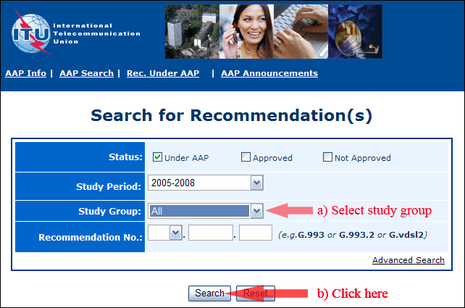
2) Select your Recommendation
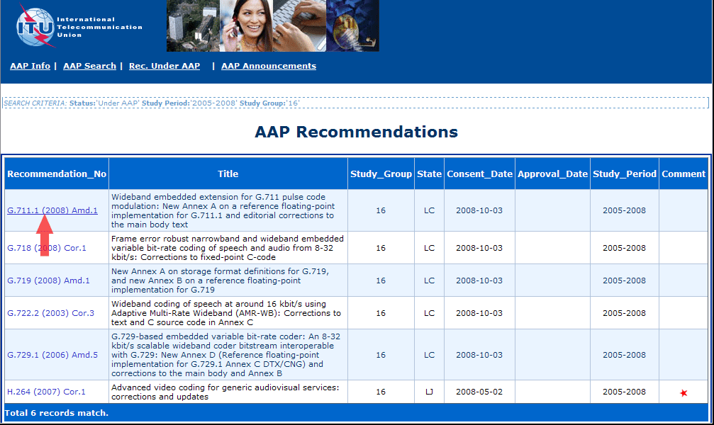
3) Click the "Submit Comment" button
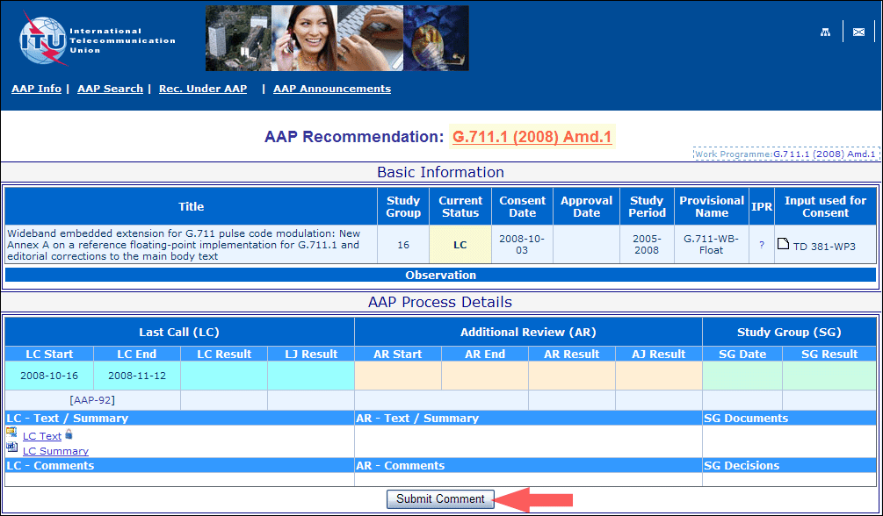
4) Complete the on-line form and click on "Submit"
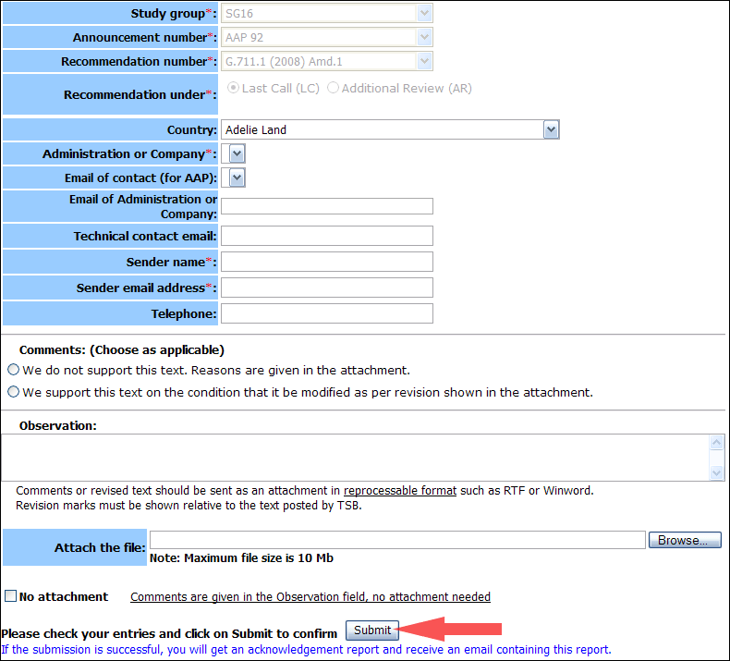
For more information, read the AAP tutorial on:
http://www.itu.int/ITU-T/aapinfo/files/AAPTutorial.pdf
Annex 3
(to TSB AAP-49)
Recommendations under LC/AR – Comment submission form
(Separate form for each Recommendation being commented upon)
ITU-T AAP comment submission form for the period 2009-2012
Study Group:
Announcement number:
Recommendation number:
Recommendation under: | Last call (LC)  Additional Review (AR)
Country:
Administration/Company:
Name of AAP Contact Person:
Email of AAP Contact Person:
Sender name:
(if different from AAP Contact Person)
Sender email address:
Telephone:
Comments:  (Choose as applicable) | We do not support this text. Reasons are given in the attachment.  We support this text on the condition that it be modified as per revision shown in the attachment.
Observations:
No attachment: Comments are given in the Observation field, no attachment needed
To be returned to: email: tsbsg....@itu.int
[or fax +41 22 730 5853]
Comments or revised text should be sent as an attachment in RTF or WinWord format.
Revision marks must be shown relative to the text posted by TSB.

